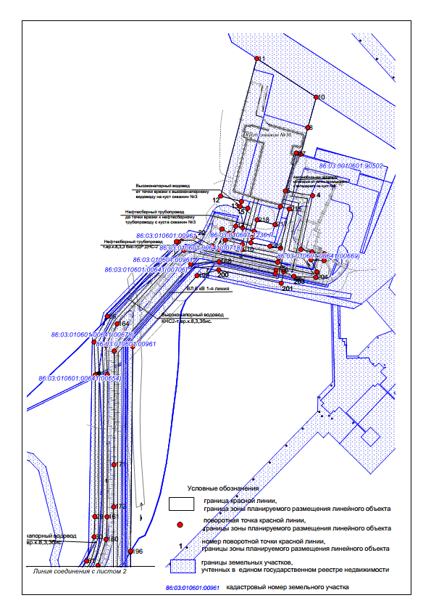
Основная часть проекта планировки территории для размещения объекта капитального строительства, расположенного на территориях двух муниципальных образований Ханты-Мансийского автономного округа – Югры, «Обустройство Западно-Асомкинского месторождения нефти. Куст скважин №3 бис».
Землепользователь ОАО «Славнефть-Мегионнефтегаз».
М 1:4000
Чертеж красных линий
Чертеж границ зон планируемого размещения линейных объектов

Приложение 37
к постановлению правительства
Ханты-Мансийского
автономного округа − Югры
от 8 ноября 2018 года № 23-нп

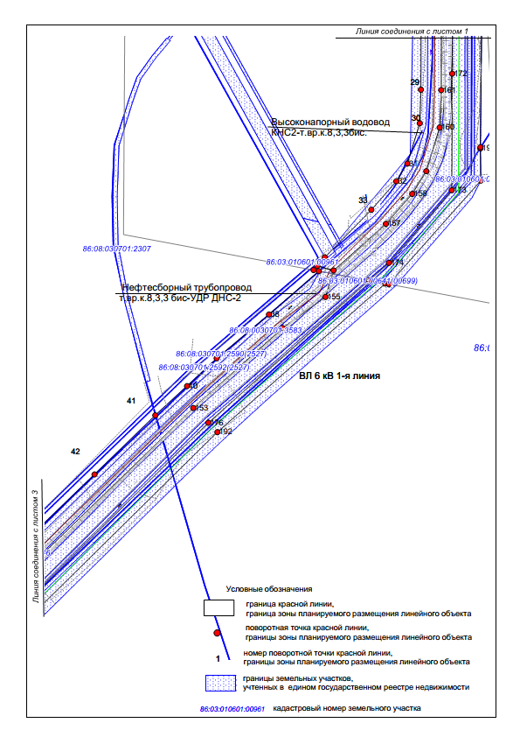

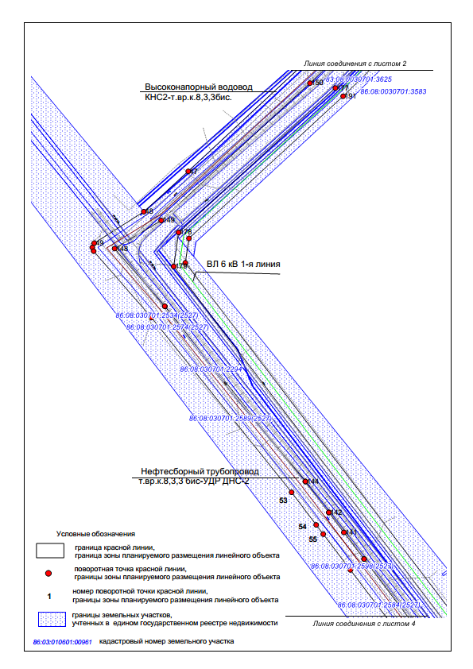

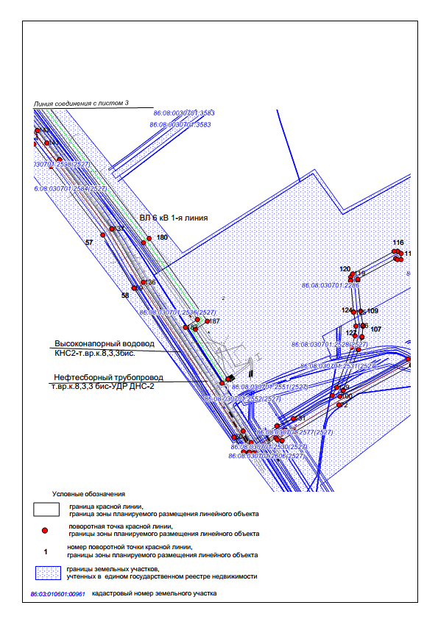

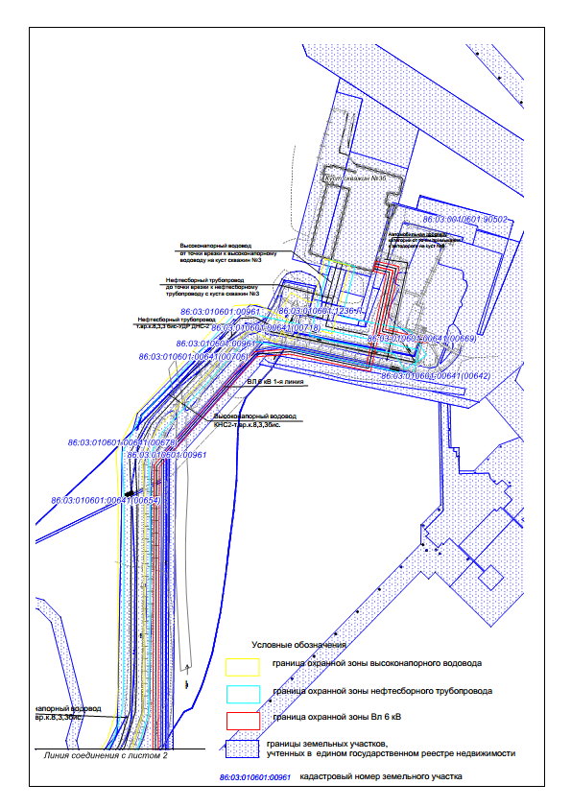

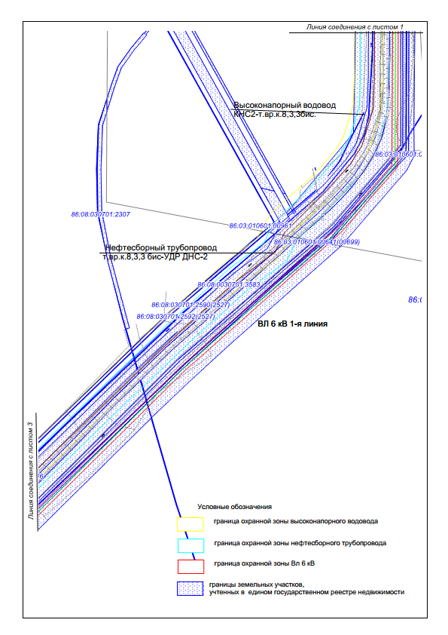

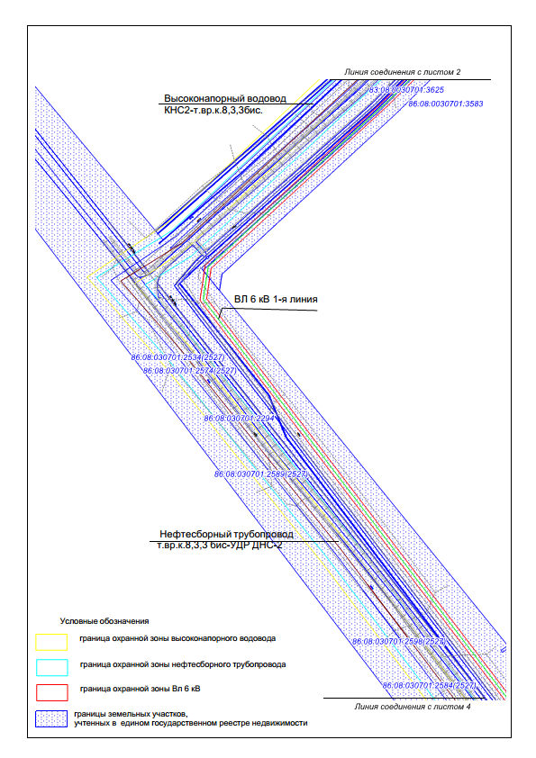

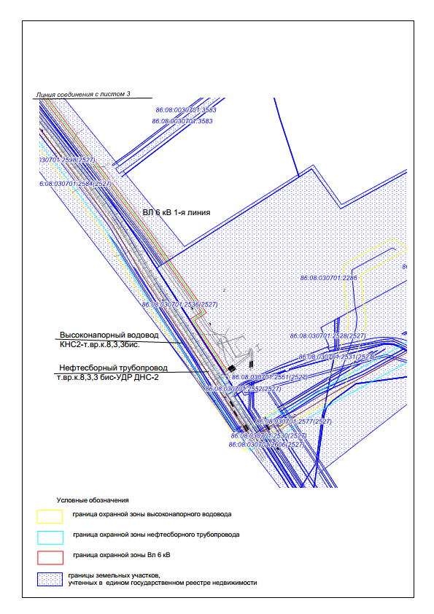

Каталог координат характерных точек границ зоны планируемого размещения линейных объектов, красных линий

№ | X | Y
1 | 948092.75 | 3561096.21
2 | 948097.13 | 3561065.68
3 | 948103.88 | 3561037.27
4 | 948240.65 | 3561066.82
5 | 948252.29 | 3560997.51
6 | 948349.09 | 3561025.59
7 | 948346.04 | 3561036.48
8 | 948413.49 | 3561055.02
9 | 948413.49 | 3561055.04
10 | 948490.99 | 3561076.30
11 | 948589.23 | 3560924.95
12 | 948239.58 | 3560832.93
13 | 948225.65 | 3560885.70
14 | 948213.13 | 3560882.40
15 | 948208.58 | 3560902.16
16 | 948159.11 | 3560888.61
17 | 948163.12 | 3560871.48
18 | 948142.46 | 3560865.95
19 | 948145.06 | 3560854.83
20 | 948155.76 | 3560836.01
21 | 948112.98 | 3560811.34
22 | 948136.26 | 3560766.25
23 | 948133.55 | 3560734.96
24 | 948122.76 | 3560725.18
25 | 948123.81 | 3560720.07
26 | 947933.42 | 3560544.22
27 | 947868.57 | 3560510.42
28 | 947784.55 | 3560513.34
29 | 947424.65 | 3560512.23
30 | 947373.24 | 3560510.40
31 | 947311.58 | 3560491.54
32 | 947284.50 | 3560474.53
33 | 947240.87 | 3560436.18
34 | 947168.18 | 3560364.81
35 | 947155.07 | 3560353.25
36 | 947148.63 | 3560347.76
37 | 947147.12 | 3560355.80
38 | 947080.71 | 3560279.36
39 | 947013.77 | 3560199.20
40 | 946971.17 | 3560153.96
41 | 946926.51 | 3560105.21
42 | 946835.97 | 3560012.14
43 | 946743.36 | 3559916.36
44 | 946664.78 | 3559834.34
45 | 946630.39 | 3559798.89
46 | 946556.04 | 3559721.63
47 | 946364.48 | 3559516.04
48 | 946292.99 | 3559437.27
49 | 946236.98 | 3559349.17
50 | 946229.44 | 3559345.74
51 | 946222.88 | 3559348.19
52 | 946105.04 | 3559450.69
53 | 945794.54 | 3559699.50
54 | 945736.77 | 3559743.26
55 | 945720.24 | 3559755.78
56 | 945656.76 | 3559803.88
57 | 945462.76 | 3559950.88
58 | 945312.60 | 3560038.81
59 | 945312.08 | 3560039.13
60 | 944890.31 | 3560321.84
61 | 944848.84 | 3560348.64
62 | 944845.61 | 3560362.04
63 | 944845.87 | 3560362.47
64 | 944847.79 | 3560365.44
65 | 944845.05 | 3560377.54
66 | 944845.47 | 3560378.21
67 | 944888.21 | 3560440.31
68 | 944883.03 | 3560443.88
69 | 944880.04 | 3560457.11
70 | 944880.46 | 3560457.78
71 | 944906.55 | 3560495.67
72 | 944981.47 | 3560618.72
73 | 945094.03 | 3560824.41
74 | 945094.14 | 3560824.61
75 | 945094.65 | 3560825.40
76 | 945136.50 | 3560884.35
77 | 945137.42 | 3560885.46
78 | 945164.50 | 3560913.83
79 | 945214.00 | 3560973.35
80 | 945230.21 | 3560997.00
81 | 945244.11 | 3560999.60
82 | 945275.42 | 3560978.16
83 | 945285.54 | 3560980.04
84 | 945288.86 | 3560977.76
85 | 945291.85 | 3560974.51
86 | 945288.12 | 3560966.15
87 | 945284.01 | 3560960.15
88 | 945283.44 | 3560959.85
89 | 945283.19 | 3560959.52
90 | 945282.95 | 3560959.59
91 | 945275.76 | 3560955.81
92 | 945270.10 | 3560957.55
93 | 945241.06 | 3560977.45
94 | 945230.24 | 3560961.66
95 | 945229.68 | 3560960.92
96 | 945179.67 | 3560900.78
97 | 945179.21 | 3560900.27
98 | 945152.38 | 3560872.17
99 | 945111.29 | 3560814.30
100 | 945005.70 | 3560621.33
101 | 945021.94 | 3560630.46
102 | 945023.38 | 3560631.12
103 | 945138.16 | 3560673.48
104 | 945138.86 | 3560673.71
105 | 945172.74 | 3560683.46
106 | 945174.51 | 3560683.80
107 | 945204.03 | 3560686.75
108 | 945206.63 | 3560686.66
109 | 945246.97 | 3560680.08
110 | 945334.15 | 3560671.83
111 | 945337.82 | 3560671.92
112 | 945396.26 | 3560779.21
113 | 945393.33 | 3560784.00
114 | 945393.20 | 3560794.21
115 | 945410.39 | 3560794.42
116 | 945416.34 | 3560784.71
117 | 945416.47 | 3560784.49
118 | 945416.59 | 3560774.71
119 | 945352.62 | 3560657.29
120 | 945344.09 | 3560652.08
121 | 945334.05 | 3560651.82
122 | 945333.80 | 3560651.82
123 | 945332.86 | 3560651.86
124 | 945244.75 | 3560660.20
125 | 945244.08 | 3560660.29
126 | 945204.71 | 3560666.72
127 | 945177.40 | 3560664.00
128 | 945144.74 | 3560654.59
129 | 945031.05 | 3560612.64
130 | 945007.88 | 3560599.60
131 | 944942.57 | 3560489.38
132 | 944922.52 | 3560444.48
133 | 944921.79 | 3560443.13
134 | 944874.70 | 3560370.23
135 | 944907.49 | 3560347.66
136 | 945328.81 | 3560065.23
137 | 945479.49 | 3559977.00
138 | 945480.48 | 3559976.34
139 | 945676.11 | 3559828.11
140 | 945676.12 | 3559828.11
141 | 945723.38 | 3559792.30
142 | 945758.67 | 3559765.57
143 | 945758.68 | 3559765.56
144 | 945813.49 | 3559724.02
145 | 945813.70 | 3559723.86
146 | 946124.77 | 3559474.62
147 | 946125.08 | 3559474.37
148 | 946227.38 | 3559385.36
149 | 946277.30 | 3559468.02
150 | 946521.25 | 3559732.07
151 | 946582.11 | 3559795.05
152 | 946605.39 | 3559820.45
153 | 946937.70 | 3560163.35
154 | 947059.94 | 3560300.40
155 | 947107.56 | 3560366.01
156 | 947148.10 | 3560378.40
157 | 947219.44 | 3560458.62
158 | 947265.29 | 3560498.92
159 | 947299.86 | 3560520.37
160 | 947366.81 | 3560540.85
161 | 947423.91 | 3560543.20
162 | 947785.03 | 3560544.33
163 | 947859.40 | 3560540.58
164 | 947914.61 | 3560569.01
165 | 948101.73 | 3560739.25
166 | 948051.55 | 3560973.91
167 | 948041.85 | 3560971.80
168 | 948072.65 | 3560828.68
169 | 948066.60 | 3560756.73
170 | 947845.64 | 3560561.54
171 | 947556.32 | 3560560.77
172 | 947449.25 | 3560560.27
173 | 947270.78 | 3560559.44
174 | 947159.74 | 3560463.17
175 | 947132.78 | 3560432.67
176 | 946915.22 | 3560186.51
177 | 946512.50 | 3559777.25
178 | 946256.00 | 3559498.87
179 | 946195.81 | 3559490.27
180 | 945440.91 | 3560065.77
181 | 945223.41 | 3560218.60
182 | 945201.27 | 3560184.23
183 | 945043.40 | 3560288.03
184 | 945053.86 | 3560305.06
185 | 945054.32 | 3560304.77
186 | 945195.65 | 3560212.62
187 | 945218.46 | 3560246.64
188 | 945452.88 | 3560081.79
189 | 946202.24 | 3559510.95
190 | 946245.55 | 3559517.30
191 | 946497.91 | 3559790.92
192 | 946900.77 | 3560200.34
193 | 947128.08 | 3560457.55
194 | 947127.09 | 3560463.02
195 | 947285.69 | 3560604.00
196 | 947334.77 | 3560603.33
197 | 947336.75 | 3560603.40
198 | 947856.68 | 3560608.75
199 | 948037.37 | 3560772.65
200 | 948051.84 | 3560828.01
201 | 948017.89 | 3560987.25
202 | 948047.35 | 3560993.57
203 | 948035.34 | 3561019.14
204 | 948032.57 | 3561075.05
205 | 948046.19 | 3561078.72
206 | 948046.74 | 3561078.37
207 | 948077.33 | 3561062.78
208 | 948075.42 | 3561096.21
209 | 948083.01 | 3560980.77
210 | 948103.22 | 3560886.31
211 | 948116.71 | 3560888.17
212 | 948128.02 | 3560844.28
213 | 948102.98 | 3560829.07
214 | 948071.10 | 3560978.18
215 | 948206.96 | 3561007.77
216 | 948212.65 | 3560985.03
217 | 948166.82 | 3560971.41
218 | 948178.90 | 3560925.51
219 | 948150.23 | 3560917.84
220 | 948134.76 | 3560913.71
221 | 948134.62 | 3560913.67
222 | 948120.85 | 3560909.99
223 | 948111.80 | 3560958.55
224 | 948107.04 | 3560985.34
225 | 944909.91 | 3560465.28
226 | 944904.57 | 3560453.33
227 | 944904.57 | 3560453.33
228 | 944902.61 | 3560454.68

