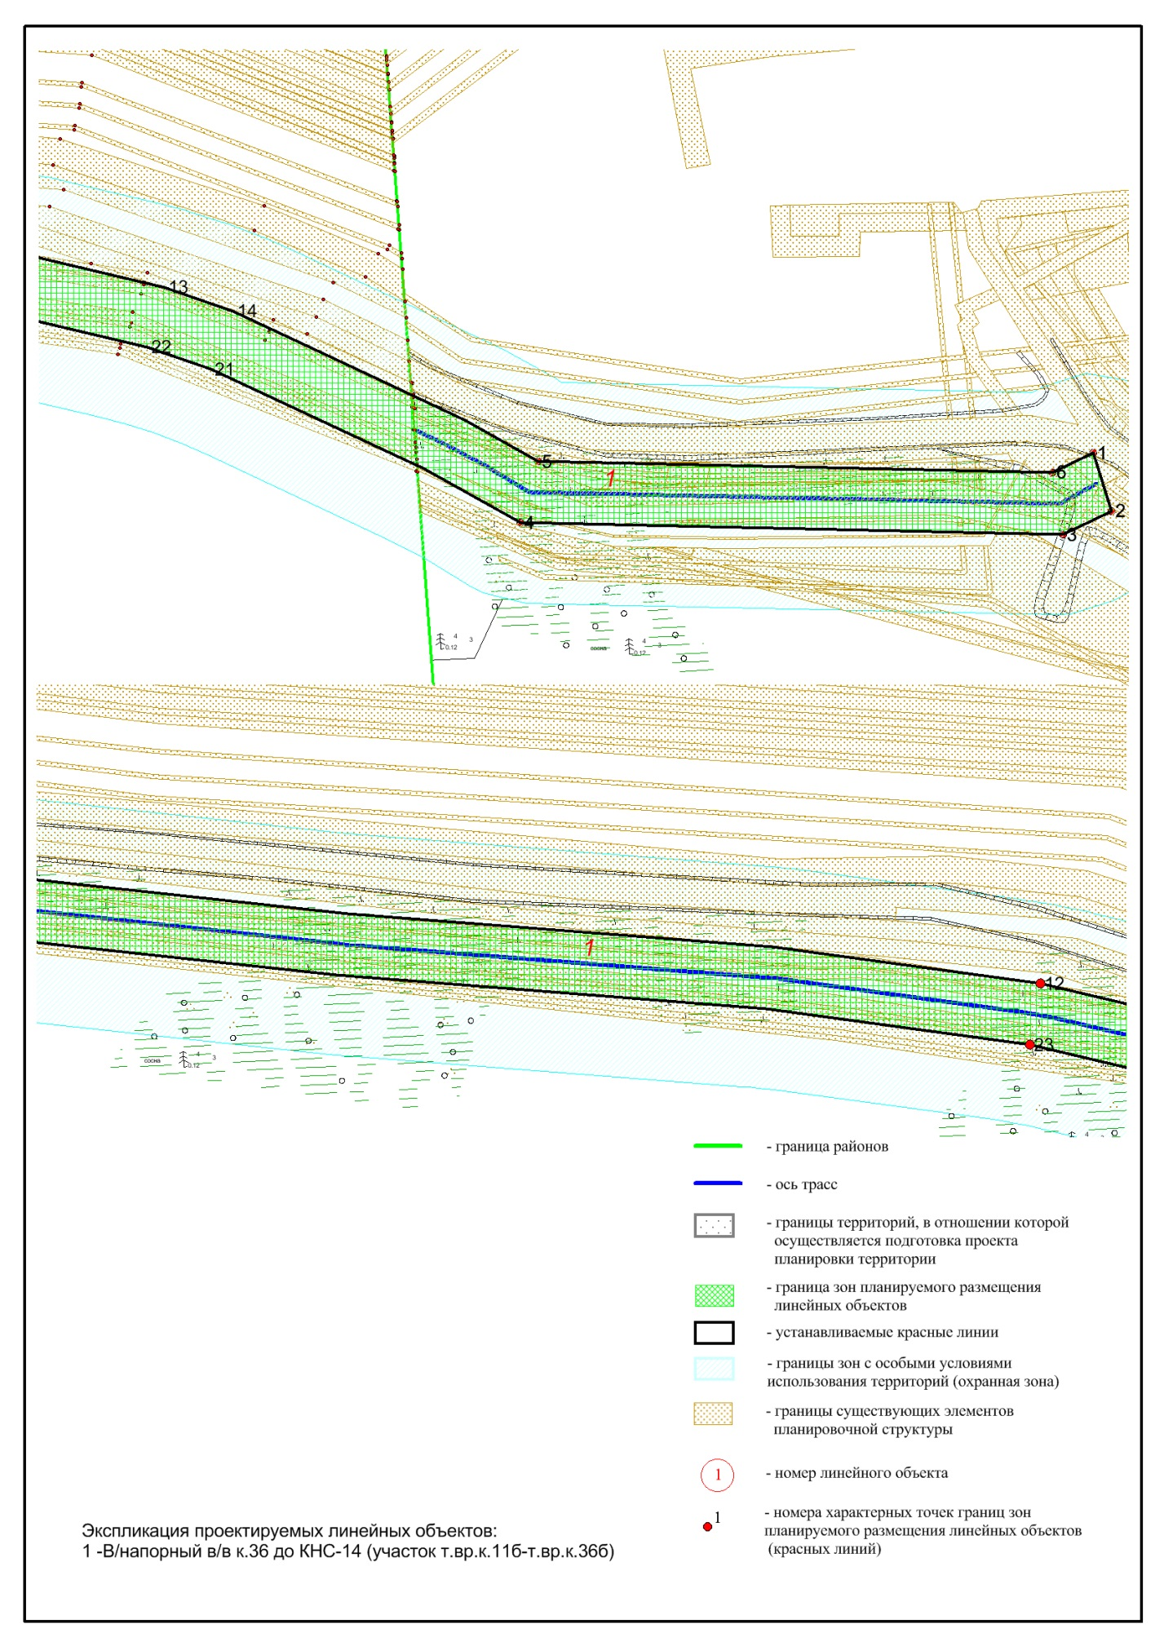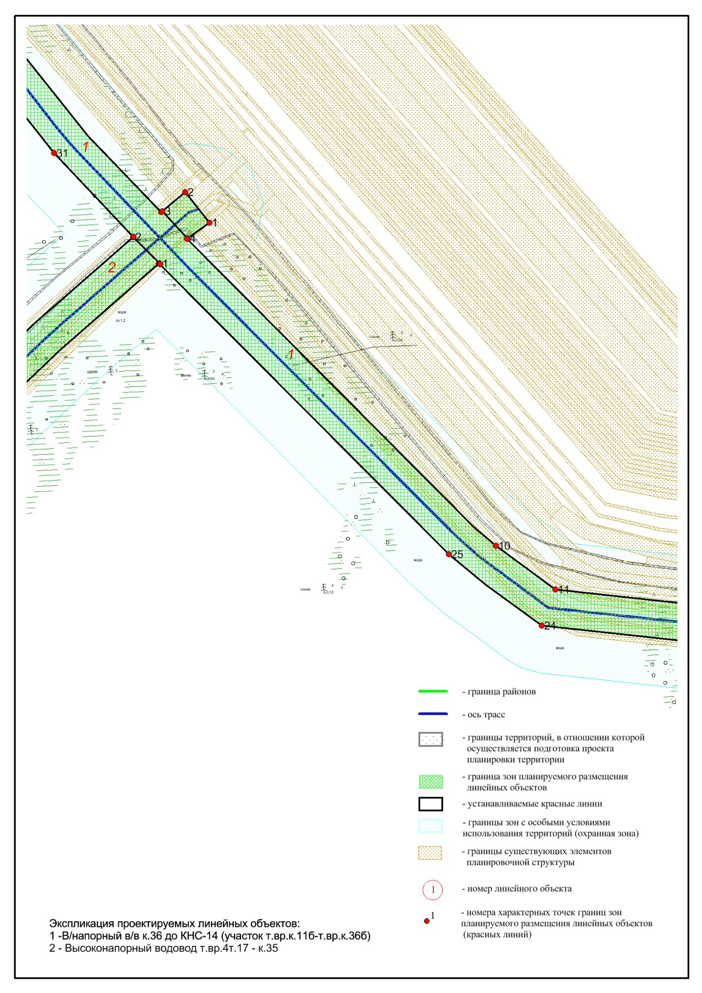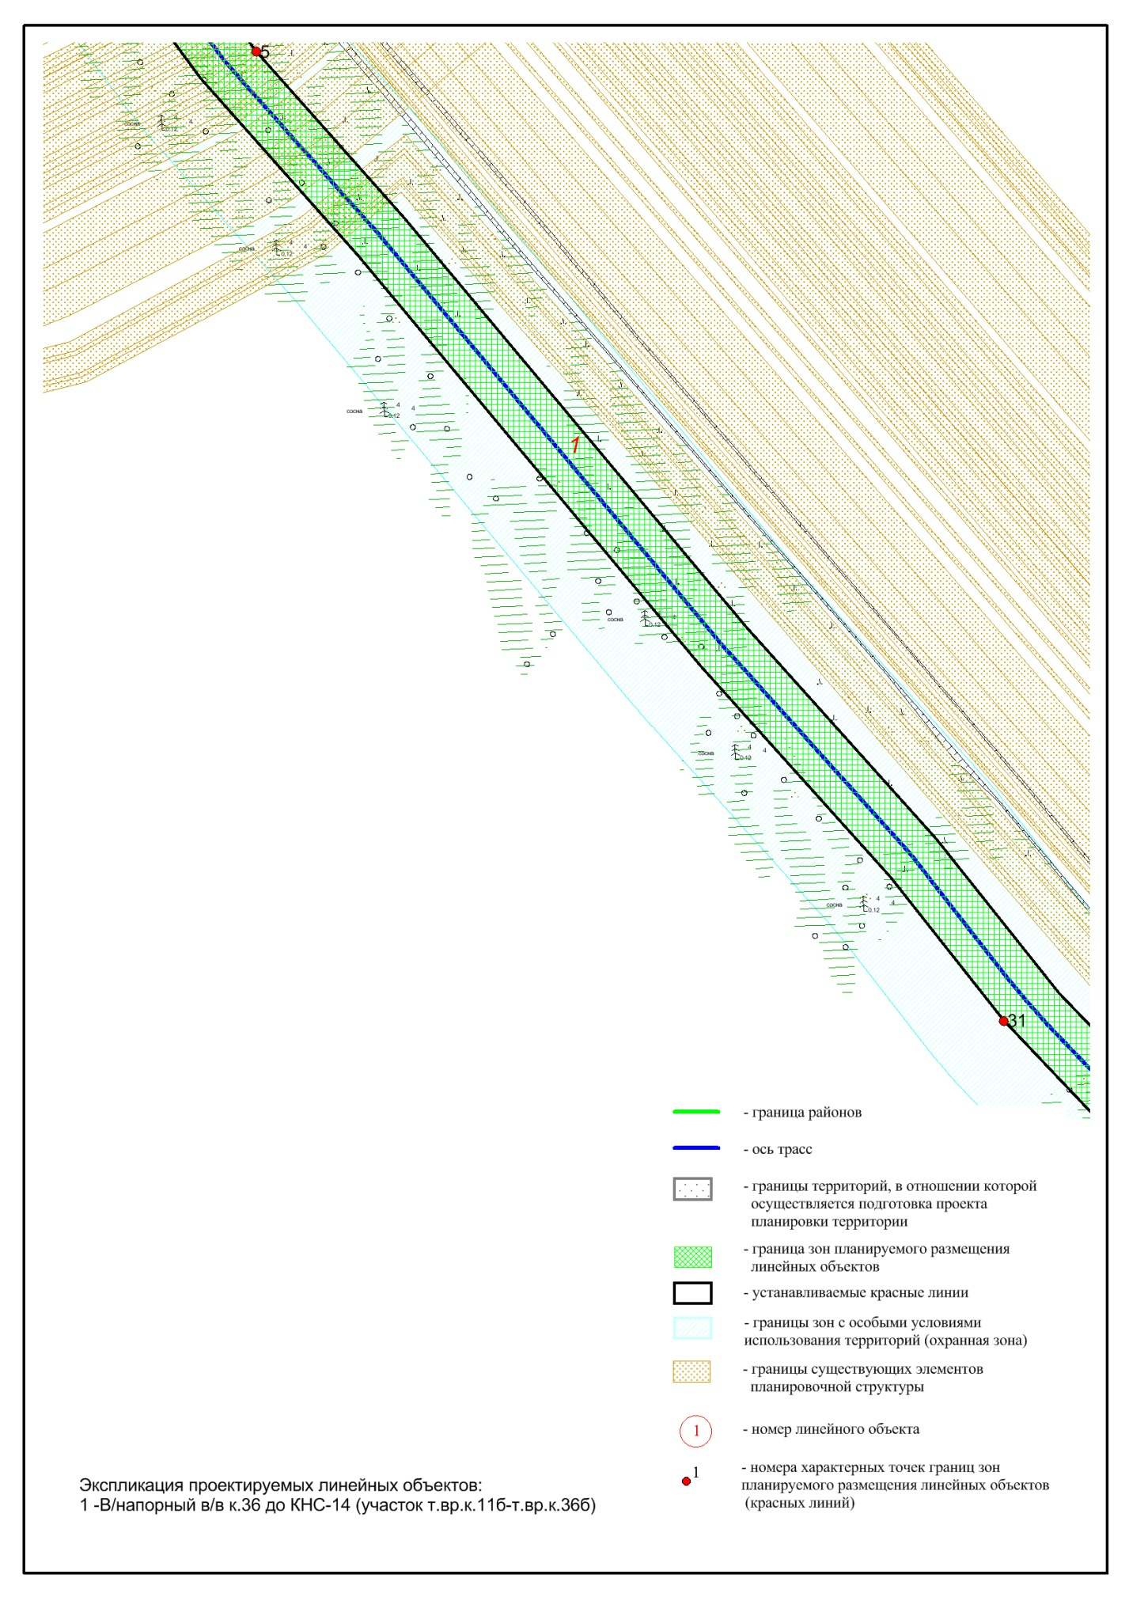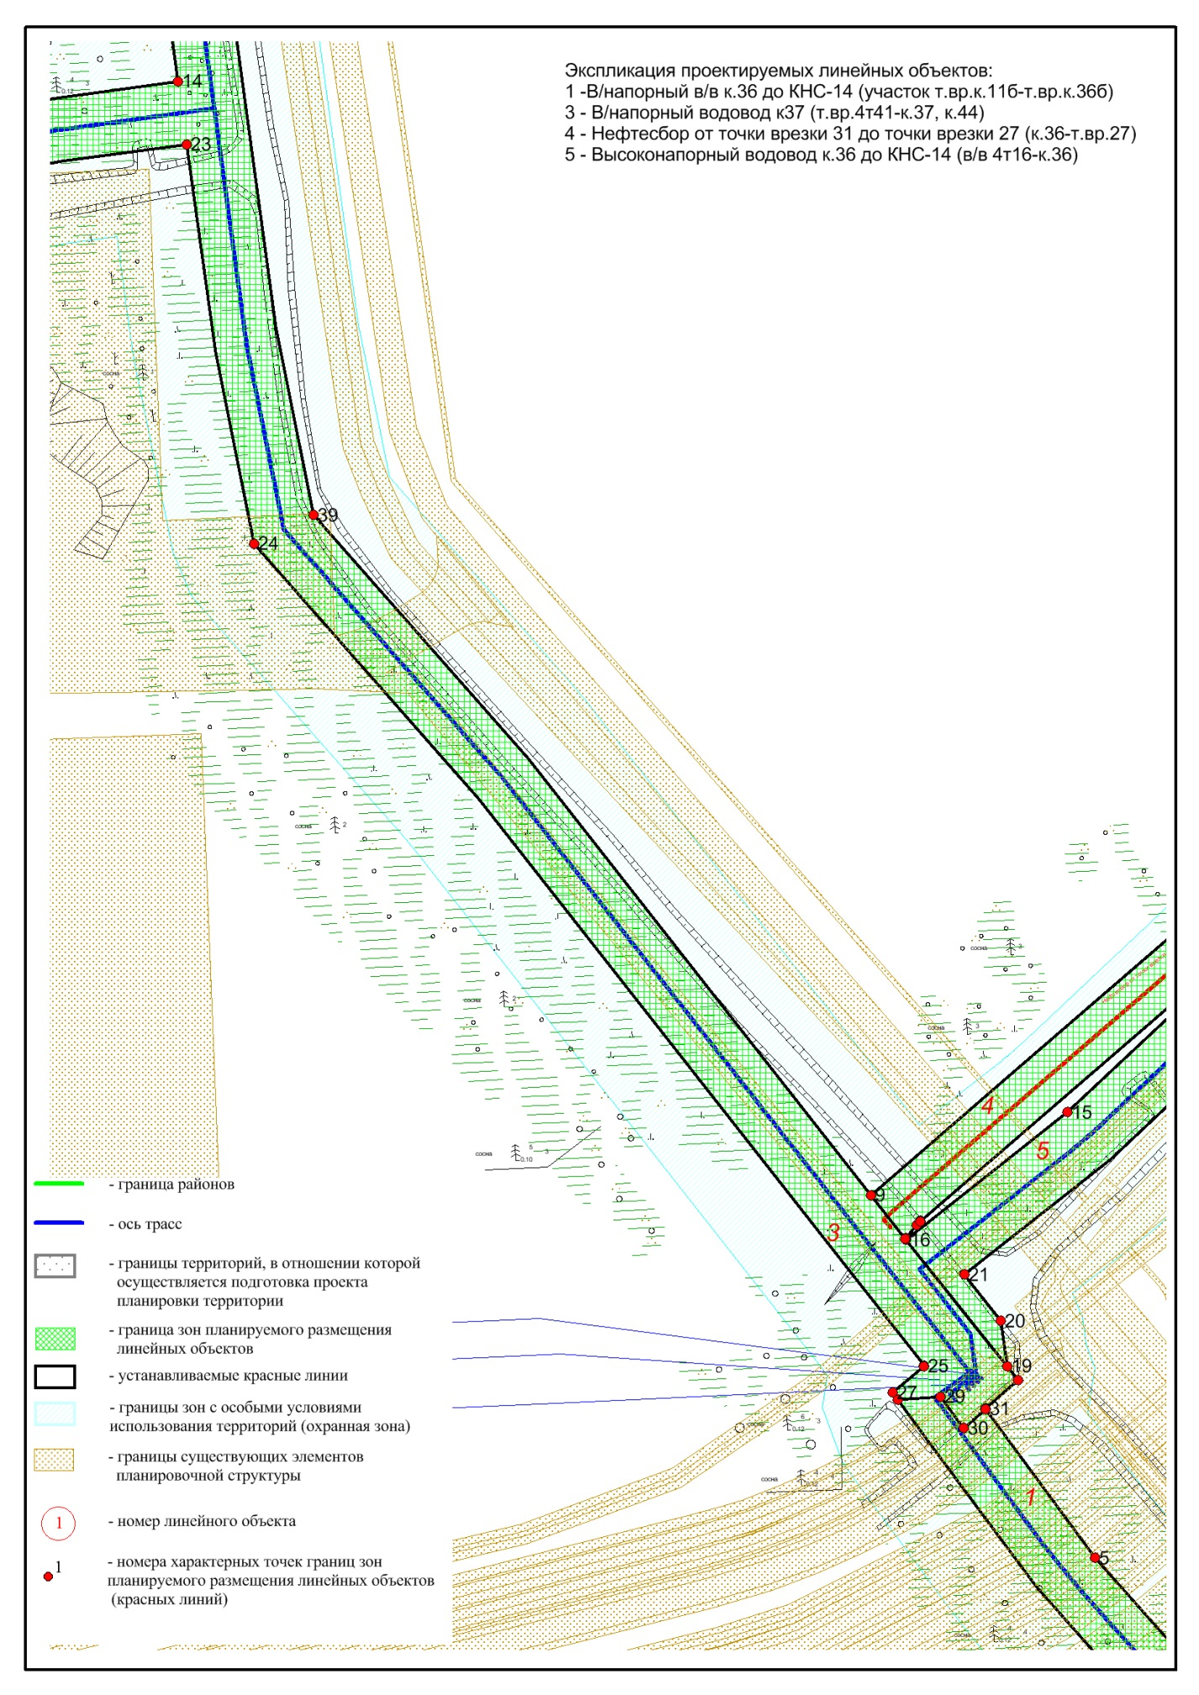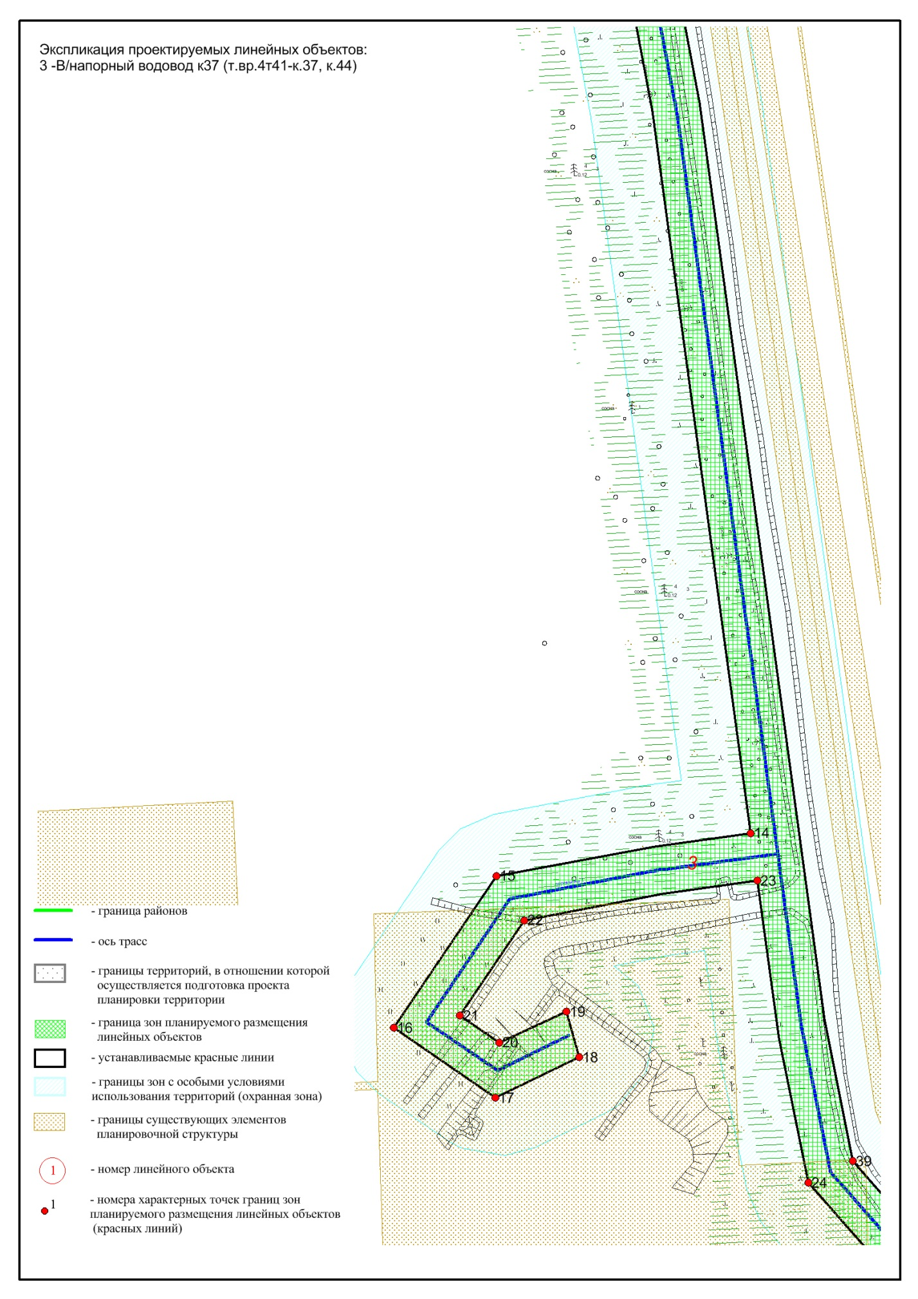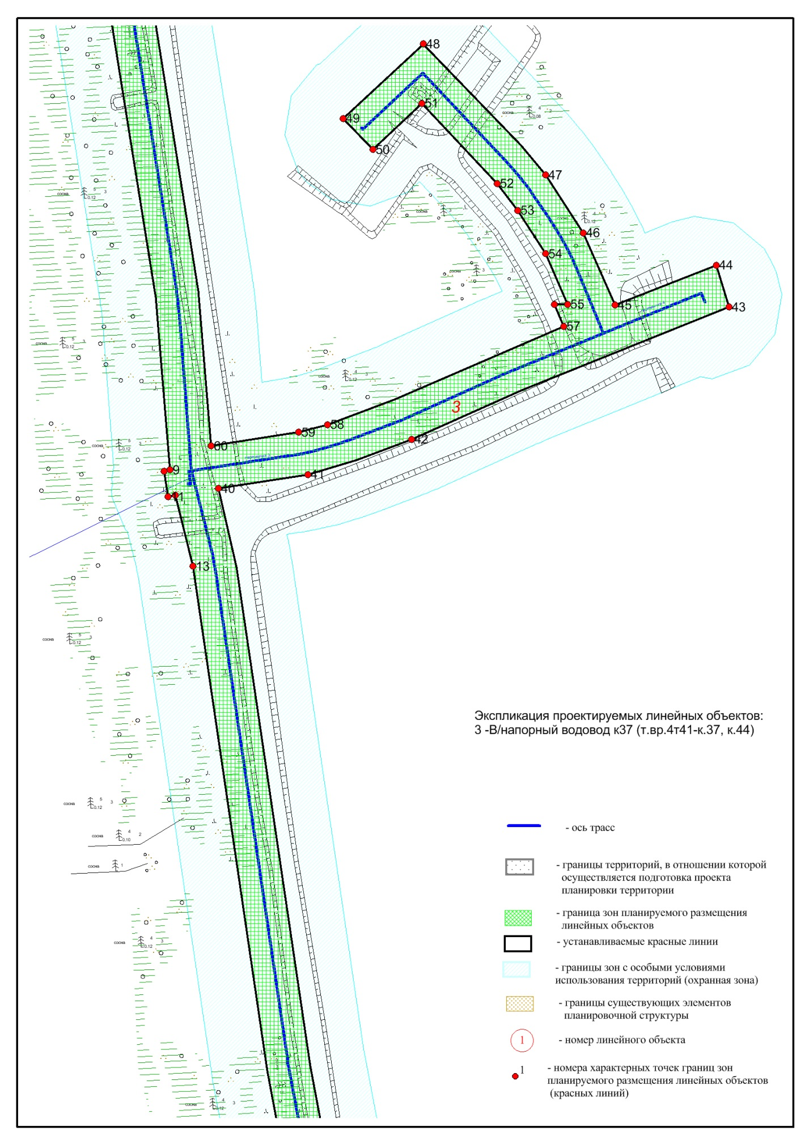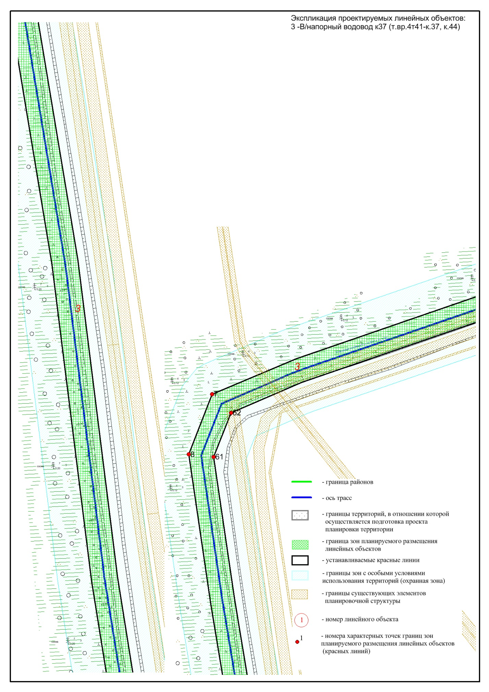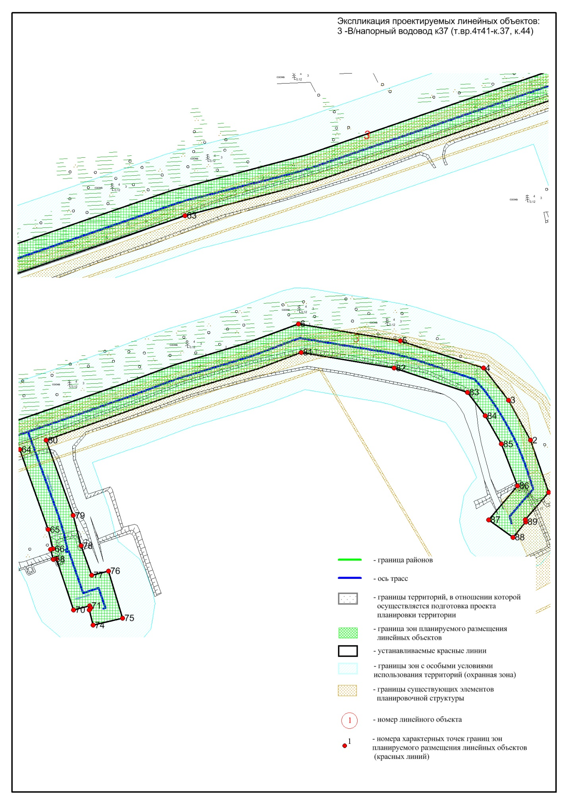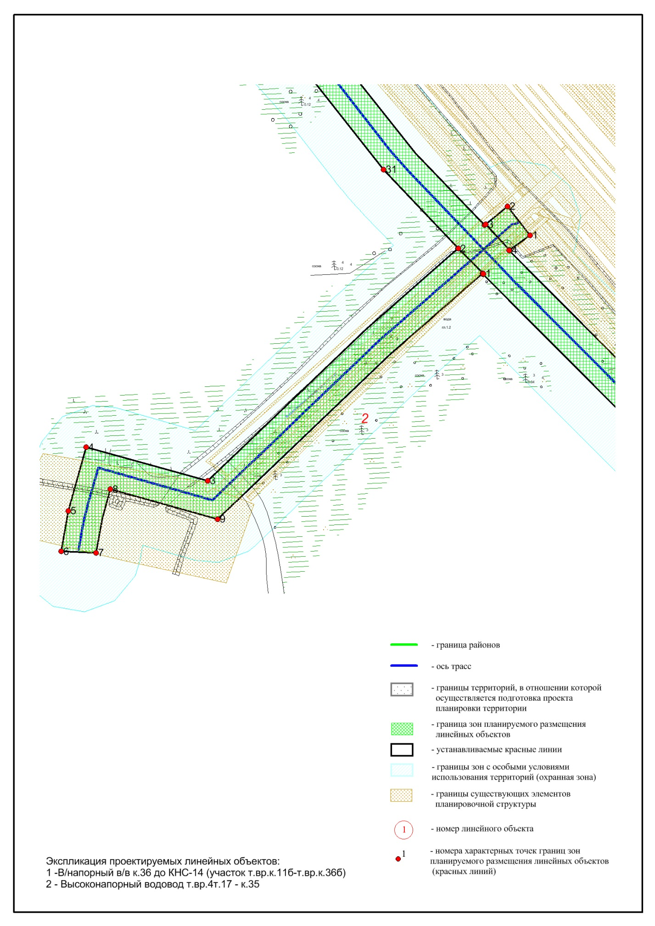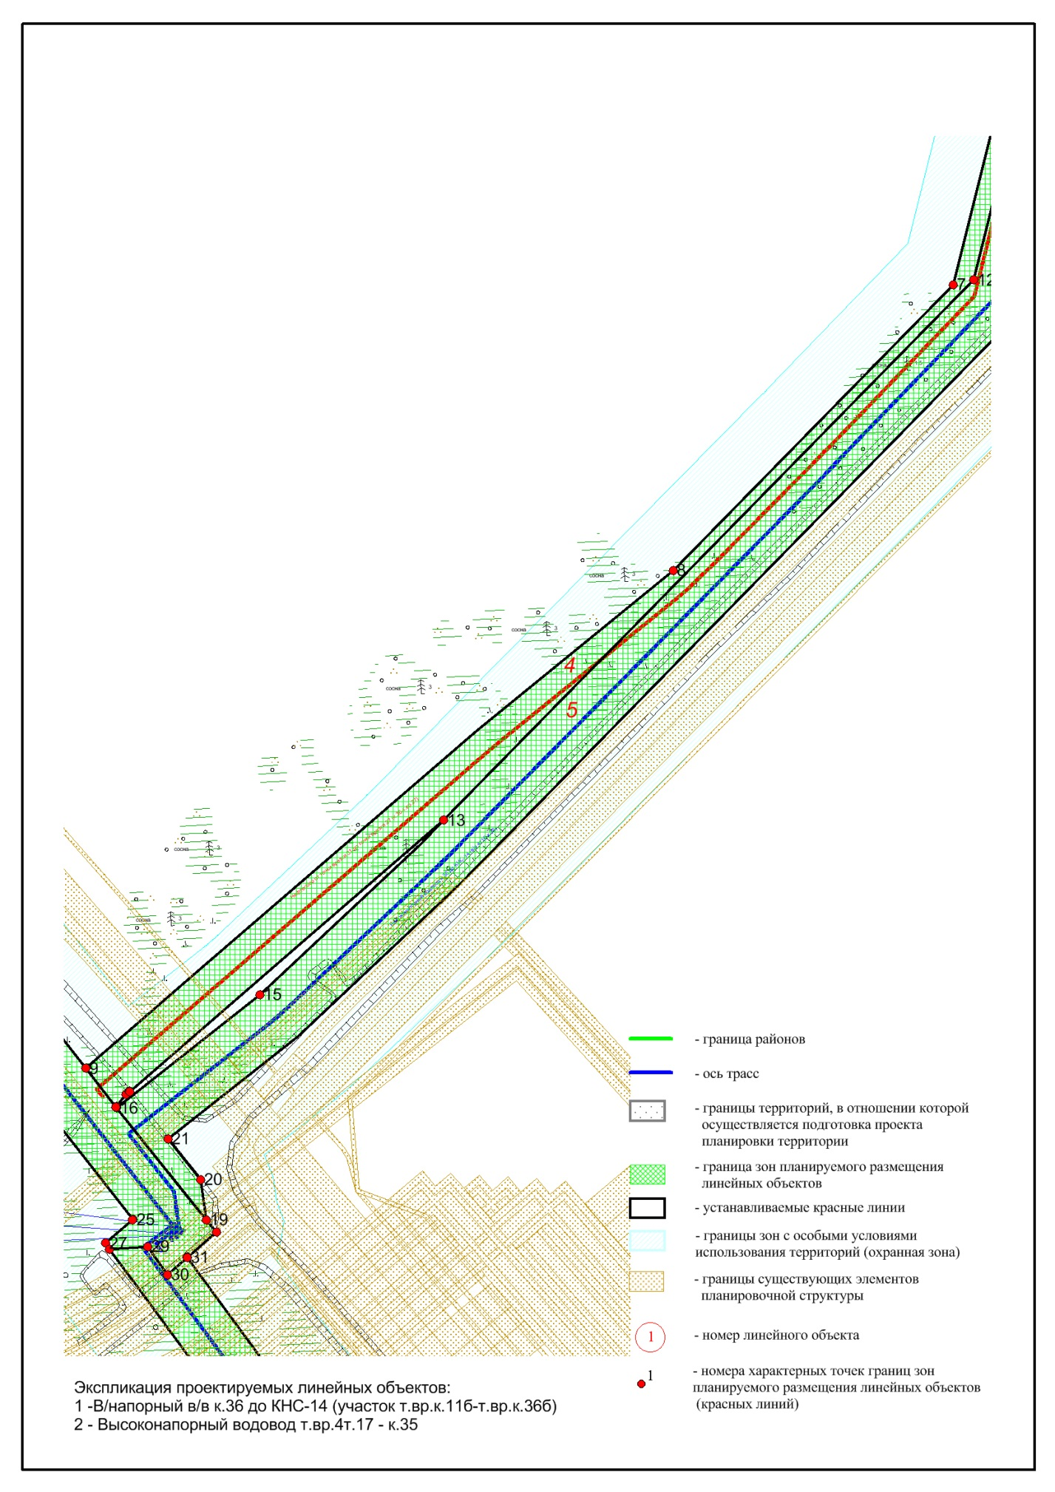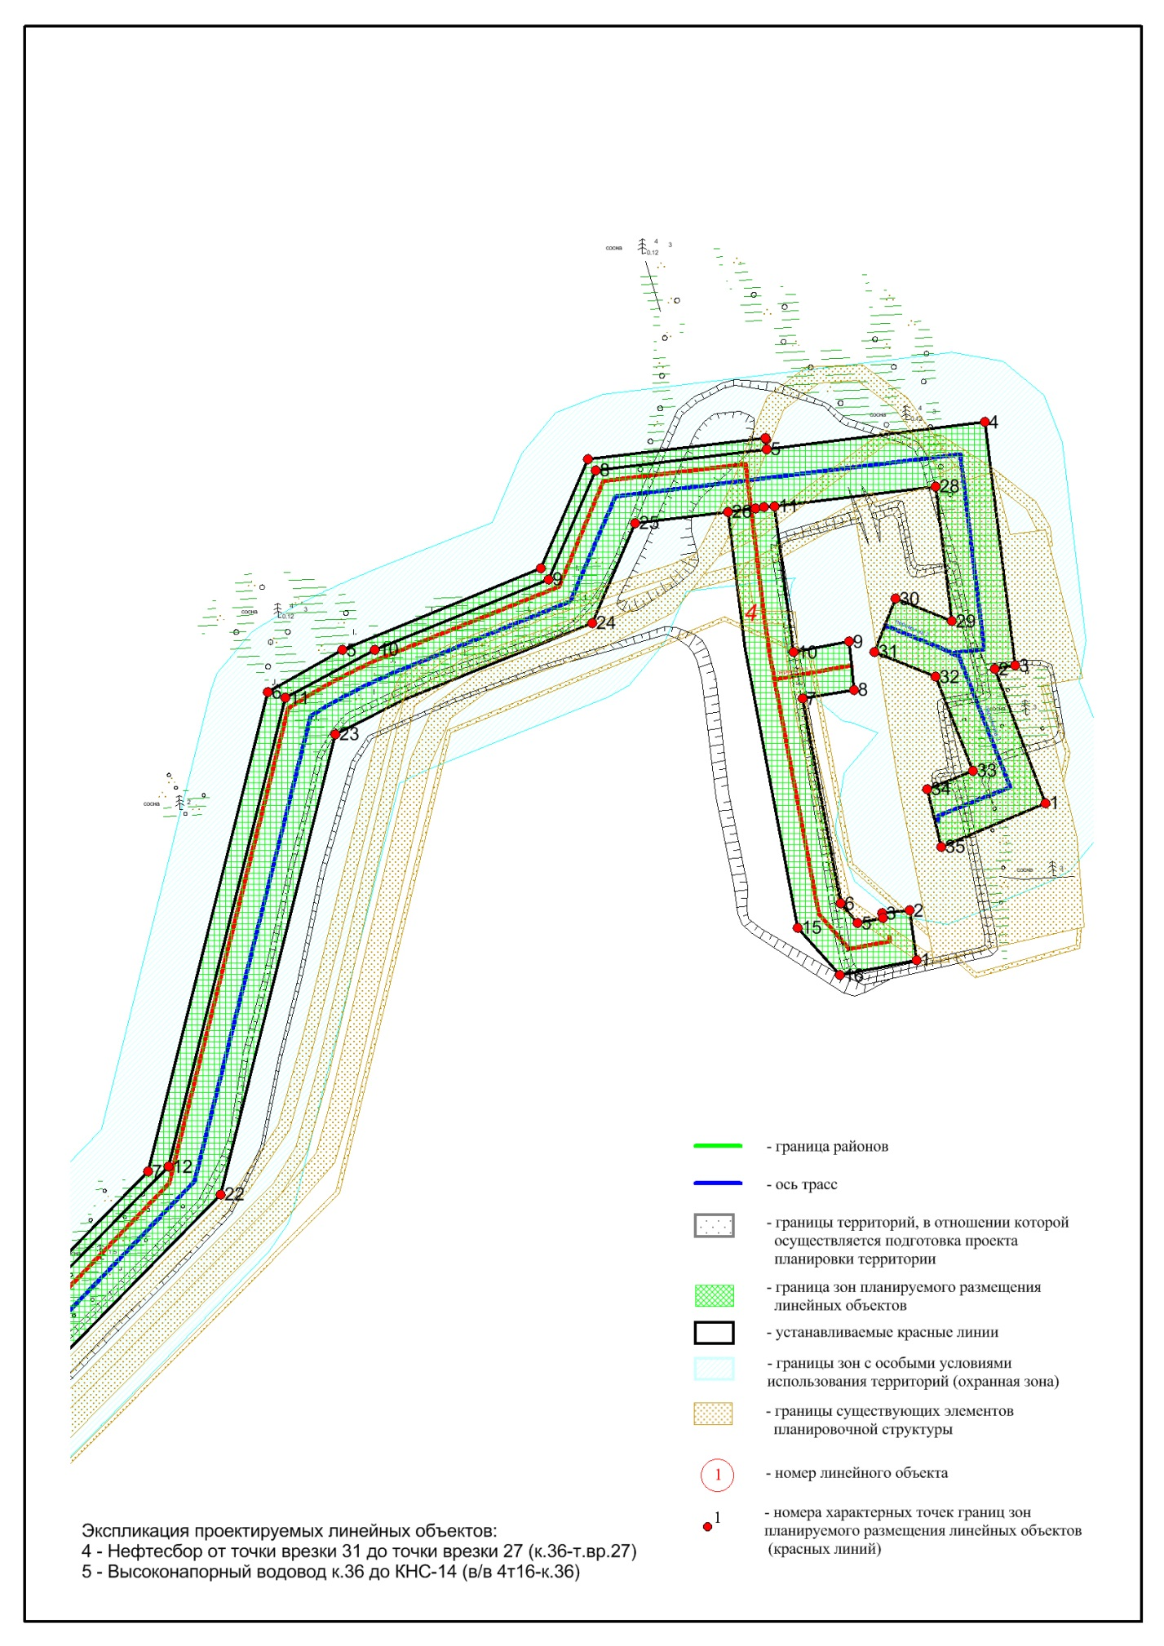
Основная часть проекта планировки территории для размещения объекта капитального строительства (линейного), расположенного на территории двух муниципальных образований Ханты-Мансийского автономного округа – Югры, «Нефтесборные сети и высоконапорные водоводы Нонг-Еганского месторождения (11-я очередь)»
Землепользователь: ООО «ЛУКОЙЛ – Западная Сибирь» ТПП «Покачевнефтегаз» Масштаб 1:5 000

Приложение 1
к приказу Департамента строительства Ханты-Мансийского
автономного округа – Югры
от 24 января 2019 года № 2-нп

Лист 1 из 53

Нижневартовский район

1 | 1058805.13 | 4329173.84
2 | 1058831.98 | 4329168.28
3 | 1058824.9 | 4329149.06
4 | 1058851.2 | 4328918.52
5 | 1058824.48 | 4328907.86
6 | 1058796.57 | 4329151.2

Сургутский район

Номер | X | Y
0
1 | 1057649.55 | 3644215.73
2 | 1057680.29 | 3644150.01
3 | 1057691.06 | 3644118.98
4 | 1057707.18 | 3644050.62
5 | 1057772.85 | 3643423.97
6 | 1057820.22 | 3643362.48
7 | 1058037.88 | 3643145.76
8 | 1058050.02 | 3643162.8
9 | 1058073.06 | 3643144.44
10 | 1058057.98 | 3643126.18
11 | 1058115.69 | 3643071.07
12 | 1058621.94 | 3642646.8
13 | 1058623.42 | 3642645.81
14 | 1058613.67 | 3642634.53
15 | 1058635.91 | 3642660.25
16 | 1058654.9 | 3642642.78
17 | 1058636.78 | 3642659.45
18 | 1058642.03 | 3642655.25
19 | 1058662.12 | 3642652.44
20 | 1058682.44 | 3642636.37
21 | 1059096.17 | 3643062.54
22 | 1059320.36 | 3643118.41
23 | 1059374.5 | 3643243.41
24 | 1059423.31 | 3643264.28
25 | 1059429.93 | 3643318.86
26 | 1059428.79 | 3643309.4
27 | 1059226.11 | 3643343.38
28 | 1059203 | 3643364.24
29 | 1059210.4 | 3643401.44
30 | 1059234.63 | 3643397.94
31 | 1059233.14 | 3643384.66
32 | 1059230.71 | 3643384.96
33 | 1059228.43 | 3643372.8
34 | 1059238.02 | 3643364.54
35 | 1059337.78 | 3643345.78
36 | 1059341.94 | 3643370.83
37 | 1059351.82 | 3643369.89
38 | 1059345.36 | 3643334.68
39 | 1059351.85 | 3643369.97
40 | 1059355.85 | 3643369.52
41 | 1059349.29 | 3643333.96
42 | 1059355.85 | 3643369.52
43 | 1059365.43 | 3643368.61
44 | 1059360.39 | 3643341.53
45 | 1059431.53 | 3643332.19
46 | 1059430.41 | 3643322.85
47 | 1059441.02 | 3643410.53
48 | 1059375.41 | 3643418.47
49 | 1059386.39 | 3643391.32
50 | 1059360.45 | 3643380.81
51 | 1059348.32 | 3643410.77
52 | 1059302.58 | 3643428.99
53 | 1059293.6 | 3643406.49
54 | 1059265.62 | 3643413.59
55 | 1059286.76 | 3643464.27
56 | 1059352.18 | 3643439.37
57 | 1059353.8 | 3643449.51
58 | 1059472.41 | 3643434.8
59 | 1059459.26 | 3643328.56
60 | 1059464.78 | 3643327.84
61 | 1059454.49 | 3643241.24
62 | 1059401.36 | 3643218.49
63 | 1059361.35 | 3643121.73
64 | 1059340.83 | 3643085.28
65 | 1059107.4 | 3643027.12
66 | 1058965.18 | 3642887.79
67 | 1058717.43 | 3642595.26
68 | 1058710.06 | 3642601.05
69 | 1059017.15 | 3642349.73
70 | 1060290.91 | 3642147.16
71 | 1060300.05 | 3642205.2
72 | 1060322.84 | 3642272.59
73 | 1060408.61 | 3642478.57
74 | 1060435.7 | 3642470.23
75 | 1060409.88 | 3642404.48
76 | 1060456.78 | 3642383.92
77 | 1060494.28 | 3642359.52
78 | 1060579.25 | 3642280.32
79 | 1060530.97 | 3642228.08
80 | 1060510.88 | 3642247.53
81 | 1060540.71 | 3642279.28
82 | 1060488.78 | 3642328.03
83 | 1060471.32 | 3642341.51
84 | 1060443.17 | 3642359.45
85 | 1060410.34 | 3642373.75
86 | 1060410.19 | 3642365.09
87 | 1060385.22 | 3642375.97
88 | 1060396.08 | 3642371.22
89 | 1060332.33 | 3642218.04
90 | 1060327.41 | 3642199.21
91 | 1060318.53 | 3642142.56
92 | 1061550.35 | 3641965.37
93 | 1061601.45 | 3641985.6
94 | 1061729.58 | 3642337.59
95 | 1061846.39 | 3642708.11
96 | 1061766.59 | 3642736.63
97 | 1061747.54 | 3642741.45
98 | 1061746.84 | 3642739.01
99 | 1061736.98 | 3642741.94
100 | 1061737.46 | 3642744.97
101 | 1061686.68 | 3642762.1
102 | 1061690.89 | 3642778.17
103 | 1061688.51 | 3642778.99
104 | 1061686.67 | 3642777.73
105 | 1061671.5 | 3642781.35
106 | 1061678.53 | 3642810.8
107 | 1061725.32 | 3642796.99
108 | 1061721.2 | 3642780.2
109 | 1061750.47 | 3642769.53
110 | 1061780.62 | 3642761.56
111 | 1061855.51 | 3642734.59
112 | 1061943.02 | 3642989.14
113 | 1061927.39 | 3643081.82
114 | 1061903.33 | 3643155.14
115 | 1061879.95 | 3643172.91
116 | 1061851.91 | 3643188.99
117 | 1061810.18 | 3643205.17
118 | 1061776.3 | 3643176.35
119 | 1061758.99 | 3643200.74
120 | 1061774.23 | 3643213.39
121 | 1061776.53 | 3643212.9
122 | 1061803.63 | 3643236.32
123 | 1061855.64 | 3643218.25
124 | 1061895.42 | 3643196.26
125 | 1061927.39 | 3643171.21
126 | 1061954.66 | 3643088.22
127 | 1061971.37 | 3642986.38
128 | 1061623.09 | 3641963.56
129 | 1061553.3 | 3641936.63
130 | 1060303 | 3642115.73
131 | 1060302.03 | 3642112.07
132 | 1060285.57 | 3642114.74
133 | 1060286.57 | 3642119.33
134 | 1060240.46 | 3642130.63
135 | 1059208.28 | 3642290.19
136 | 1059183.36 | 3642141.73
137 | 1059094.81 | 3642081.89
138 | 1059053.99 | 3642141.08
139 | 1059077.68 | 3642190.05
140 | 1059104.2 | 3642182.64
141 | 1059086.21 | 3642143.55
142 | 1059101.84 | 3642120.4
143 | 1059157.41 | 3642157.97
144 | 1059180.54 | 3642293.97
145 | 1059004.5 | 3642323.67
146 | 1058642.25 | 3642618.71
147 | 1058631.69 | 3642603.89
148 | 1058545.01 | 3642668.06
149 | 1058039.51 | 3643105.11
150 | 1057853.13 | 3642904.29
151 | 1057879.99 | 3642806.95
152 | 1057829.11 | 3642792.55
153 | 1057796.46 | 3642787.02
154 | 1057795.32 | 3642814.73
155 | 1057846.31 | 3642826.27
156 | 1057822.43 | 3642912.22
157 | 1058019.28 | 3643124.49
158 | 1057799.48 | 3643343.66
159 | 1057745.69 | 3643413.88
160 | 1057679.64 | 3644045.71
161 | 1057664.08 | 3644111.48
162 | 1057654.21 | 3644139.77
163 | 1057617.64 | 3644218.15
1 | 1057649.55 | 3644215.73
0
1 | 1058840.93 | 3642773.49
2 | 1058704.39 | 3642615.34
3 | 1058698.26 | 3642610.31
4 | 1058706.81 | 3642603.61
5 | 1058697.84 | 3642610.65
1 | 1058840.93 | 3642773.49
0
1 | 1058875.15 | 3642798.63
2 | 1058706.76 | 3642603.54
3 | 1058706.81 | 3642603.61
1 | 1058875.15 | 3642798.63
0
1 | 1058030.83 | 3643113.42
2 | 1057965.76 | 3643039.15
1 | 1058030.83 | 3643113.42
0
1 | 1059458.75 | 3643424.43
2 | 1059445.97 | 3643318.69
1 | 1059458.75 | 3643424.43
0
1 | 1058955.2 | 3642896.87
2 | 1058875.15 | 3642798.63
3 | 1058909.29 | 3642840.51
4 | 1058870.79 | 3642802.78
5 | 1058909.28 | 3642840.51
1 | 1058955.2 | 3642896.87
0
1 | 1058650.41 | 3642637.91
2 | 1058645.58 | 3642632.64
3 | 1058647.66 | 3642634.9
4 | 1058629.18 | 3642614.77
1 | 1058650.41 | 3642637.91
0
1 | 1058958.14 | 3642894.17
2 | 1058934.79 | 3642865.52
3 | 1058934.78 | 3642865.51
4 | 1058876.58 | 3642794.13
1 | 1058958.14 | 3642894.17
0
1 | 1059441.94 | 3643318.47
2 | 1059434.38 | 3643255.97
1 | 1059441.94 | 3643318.47

