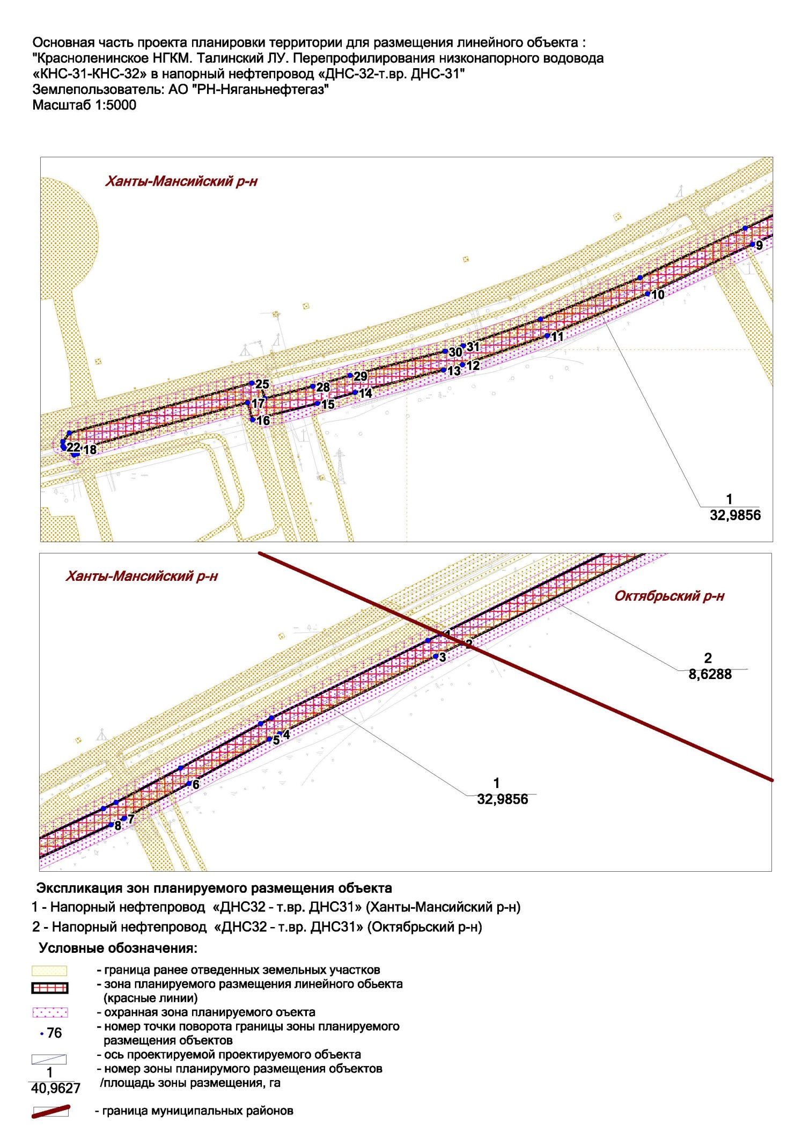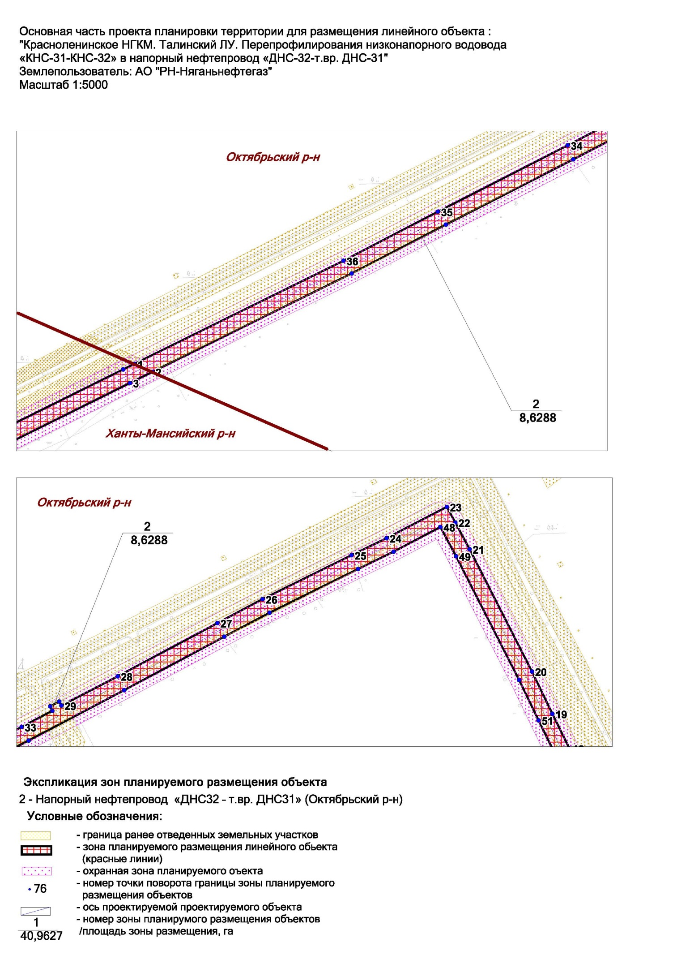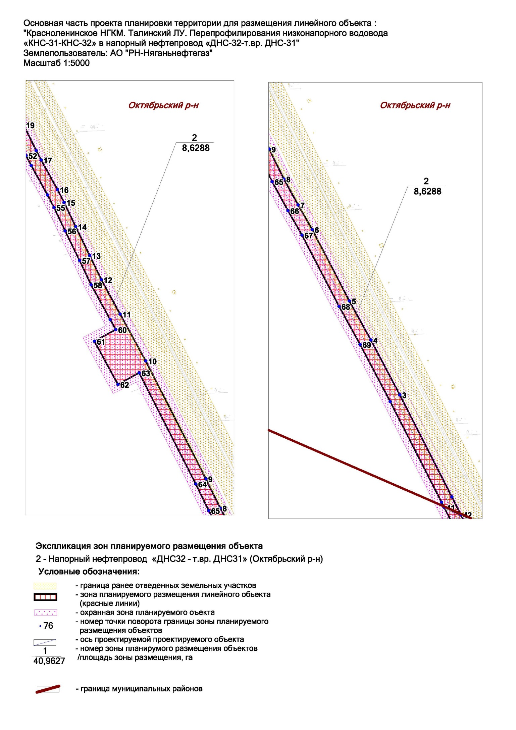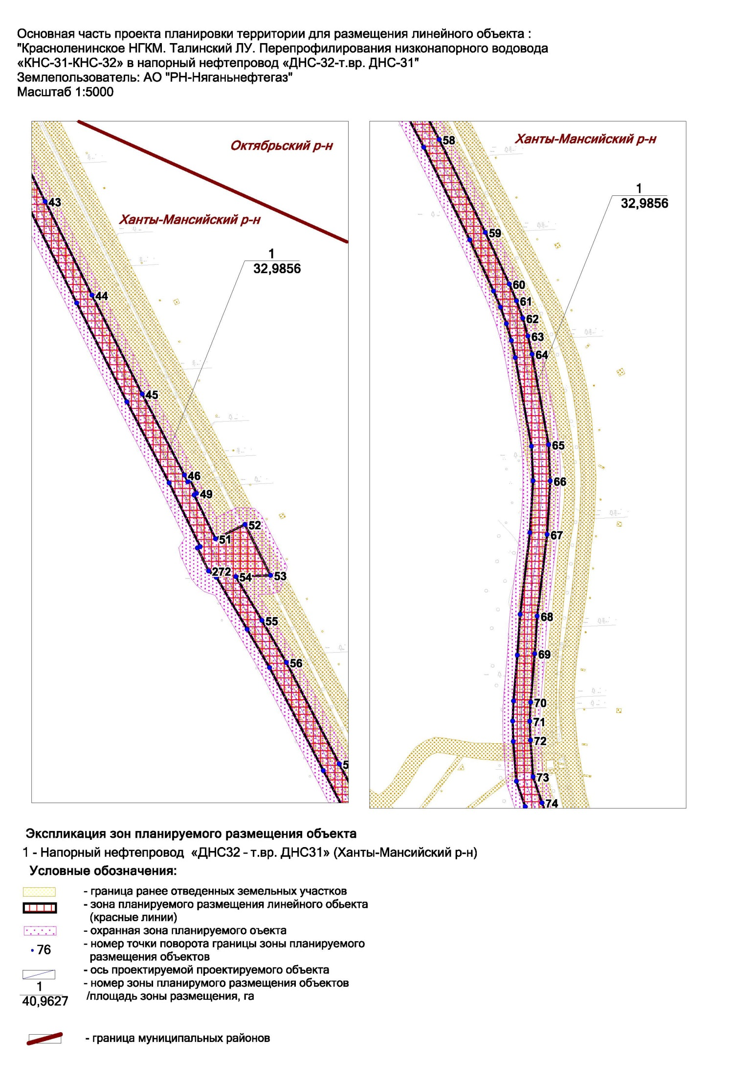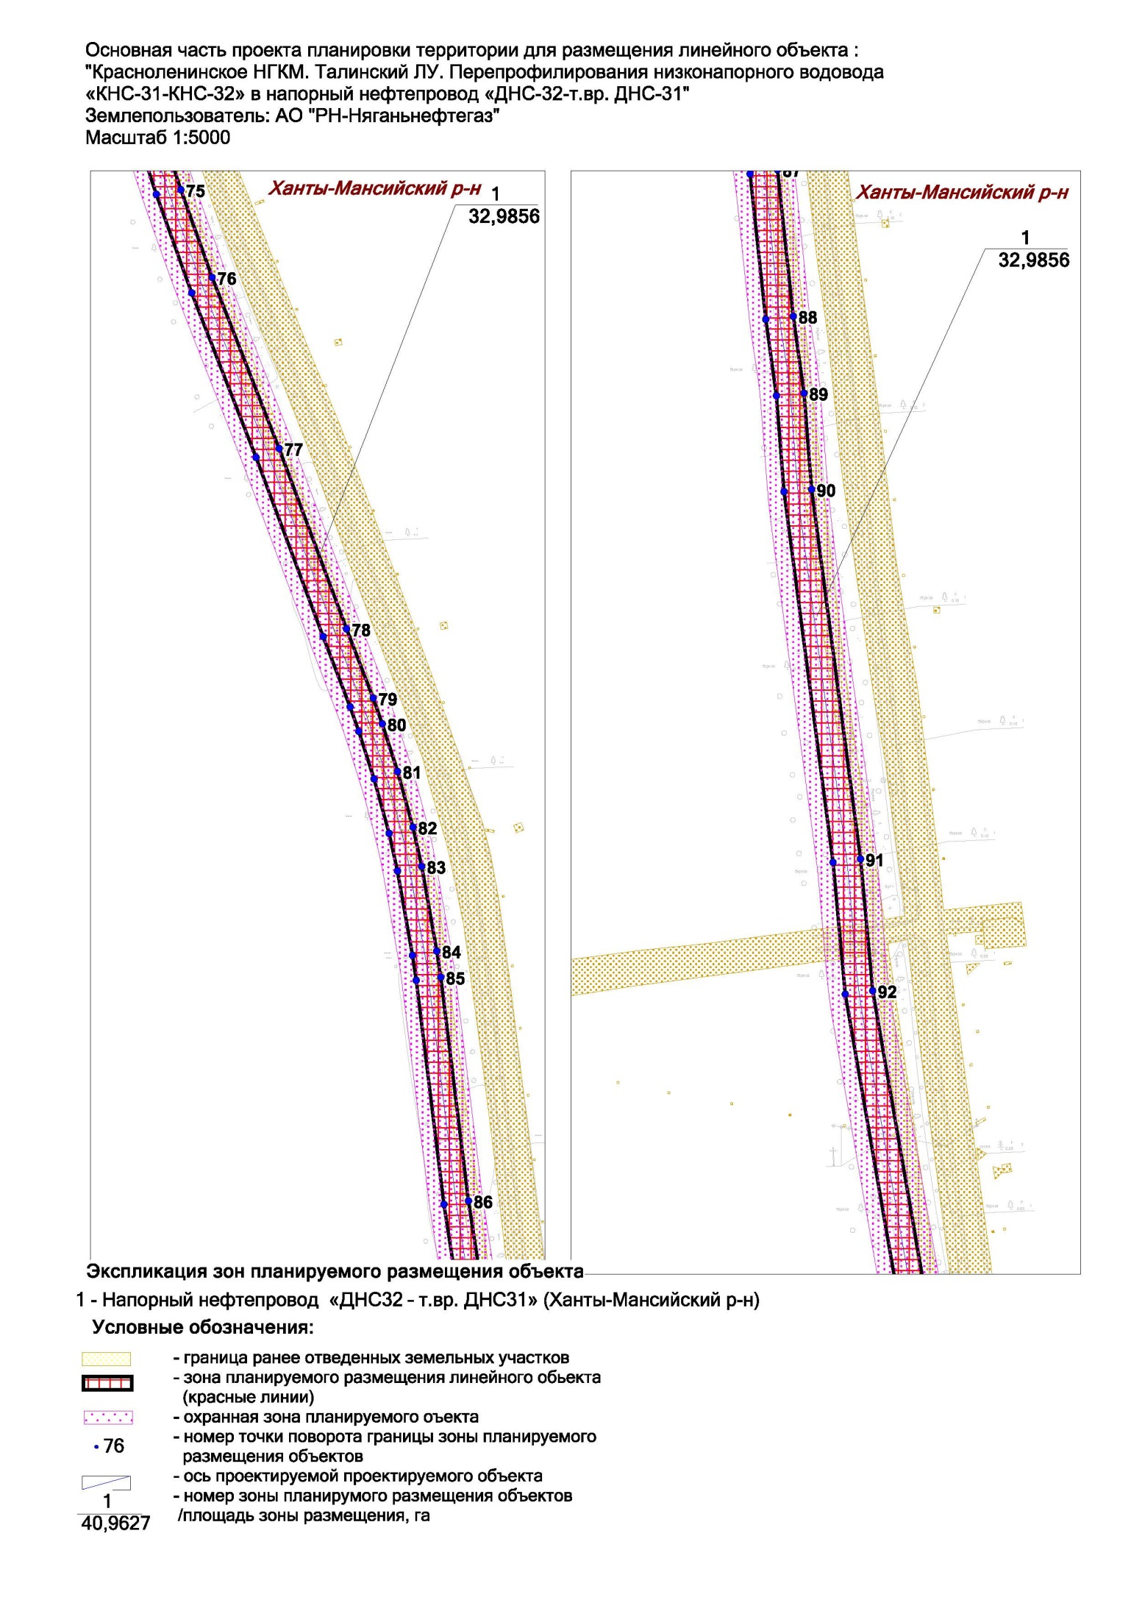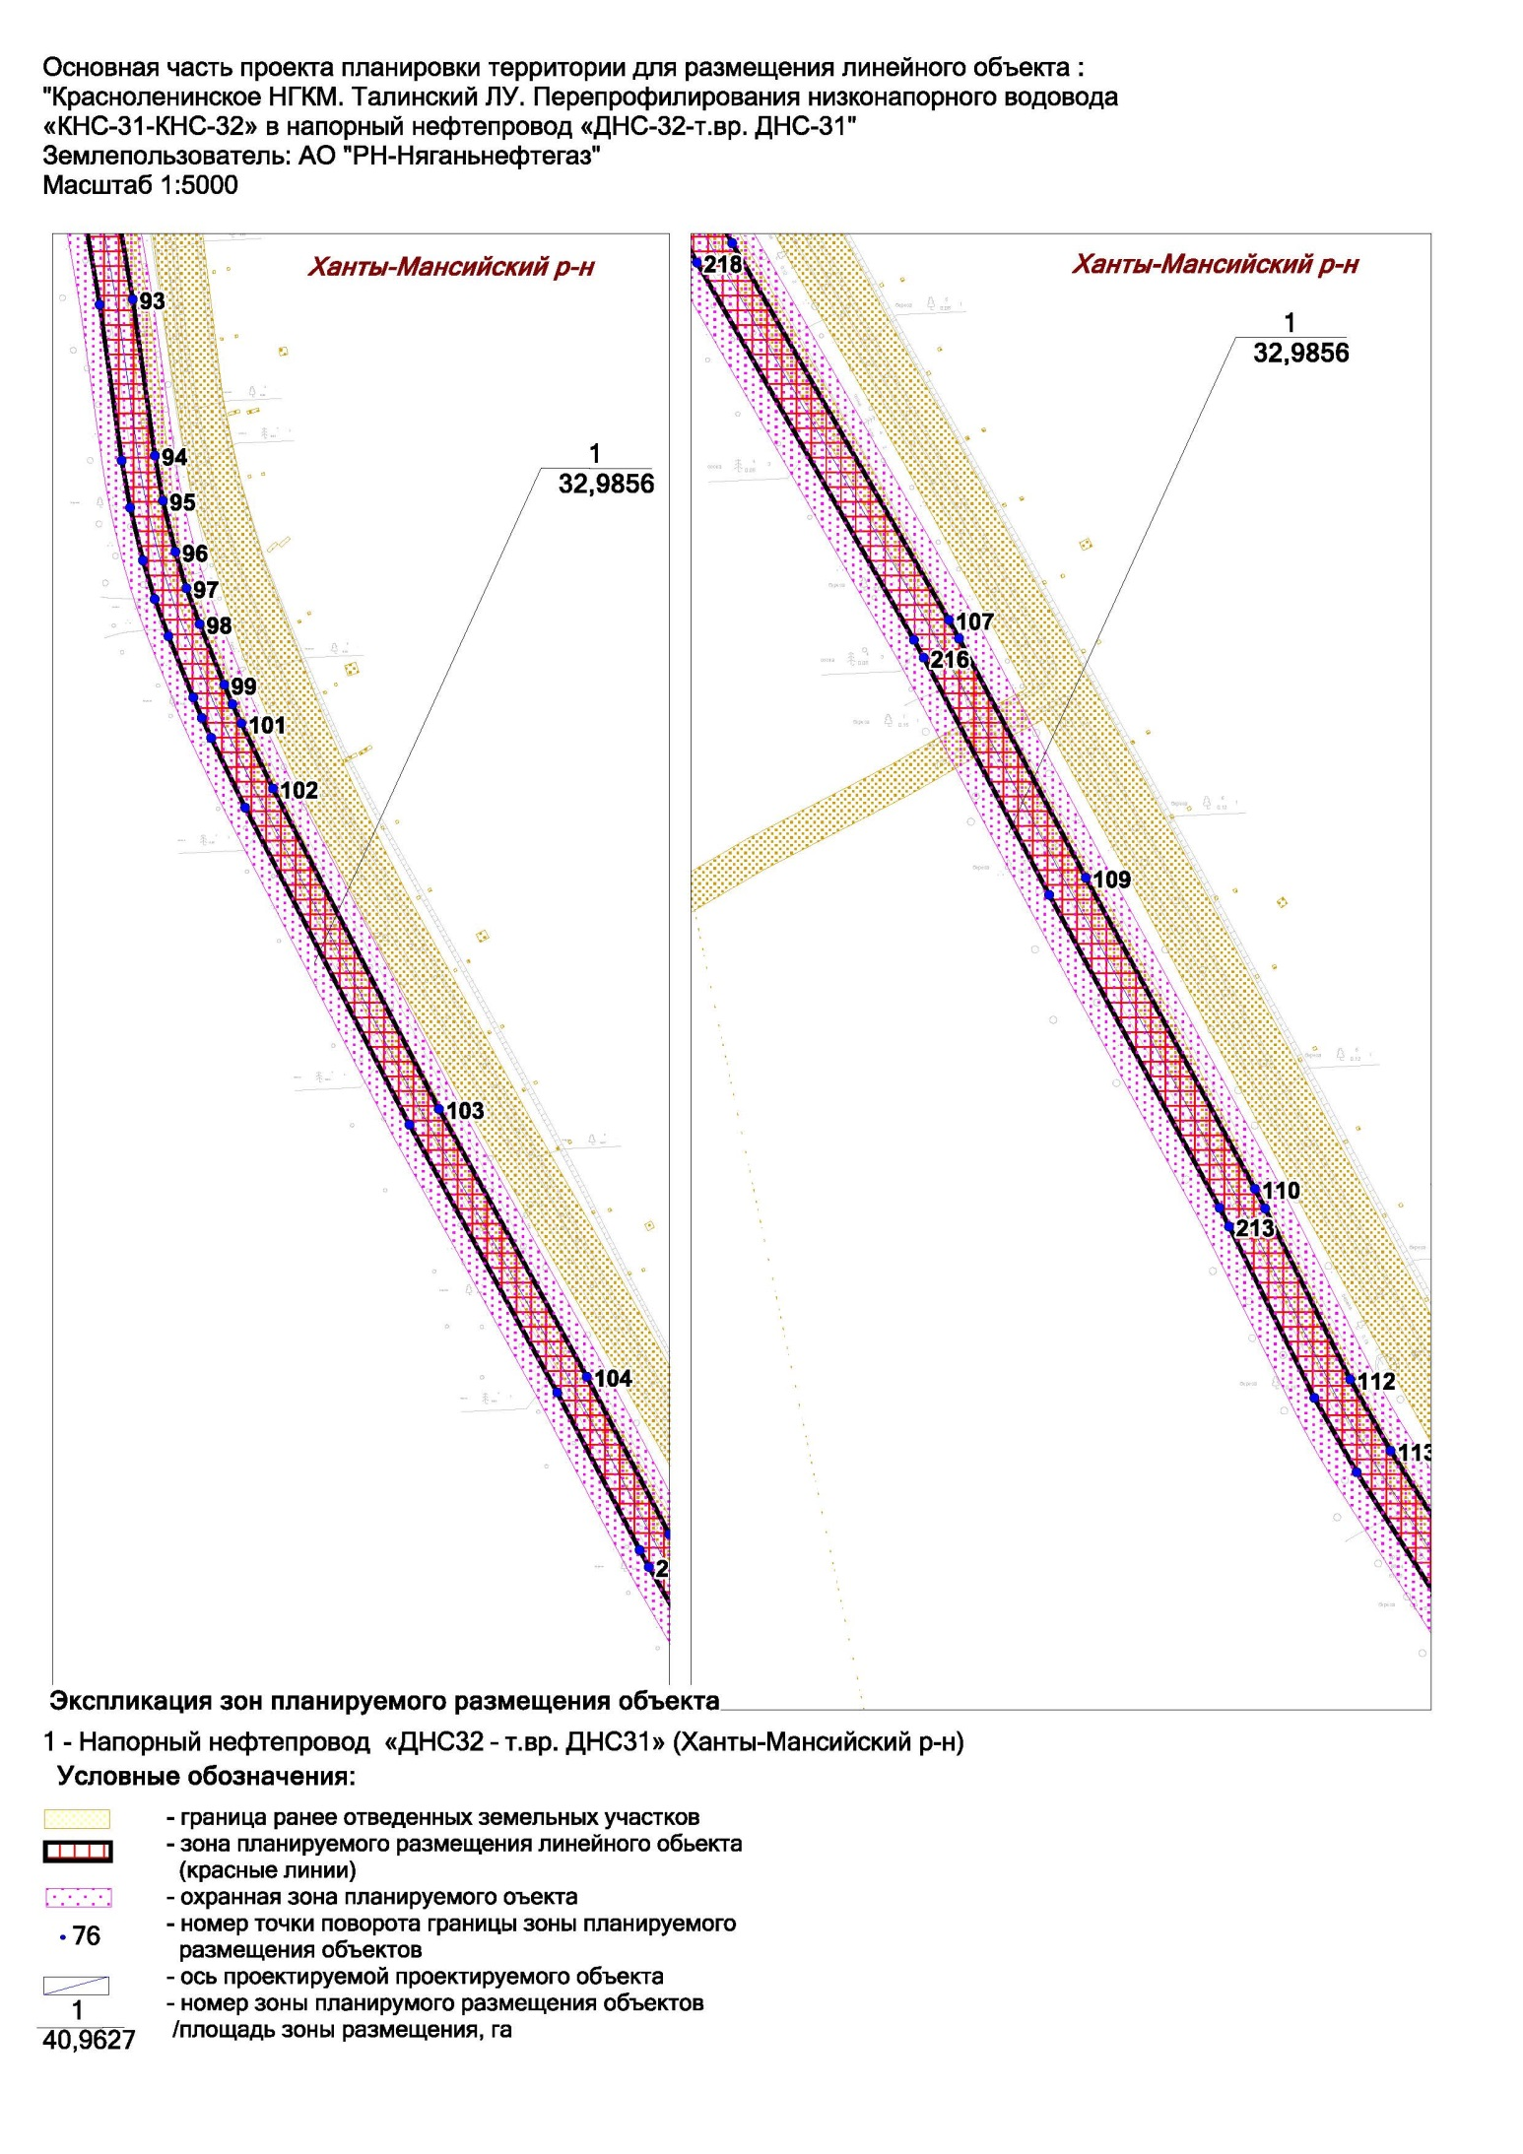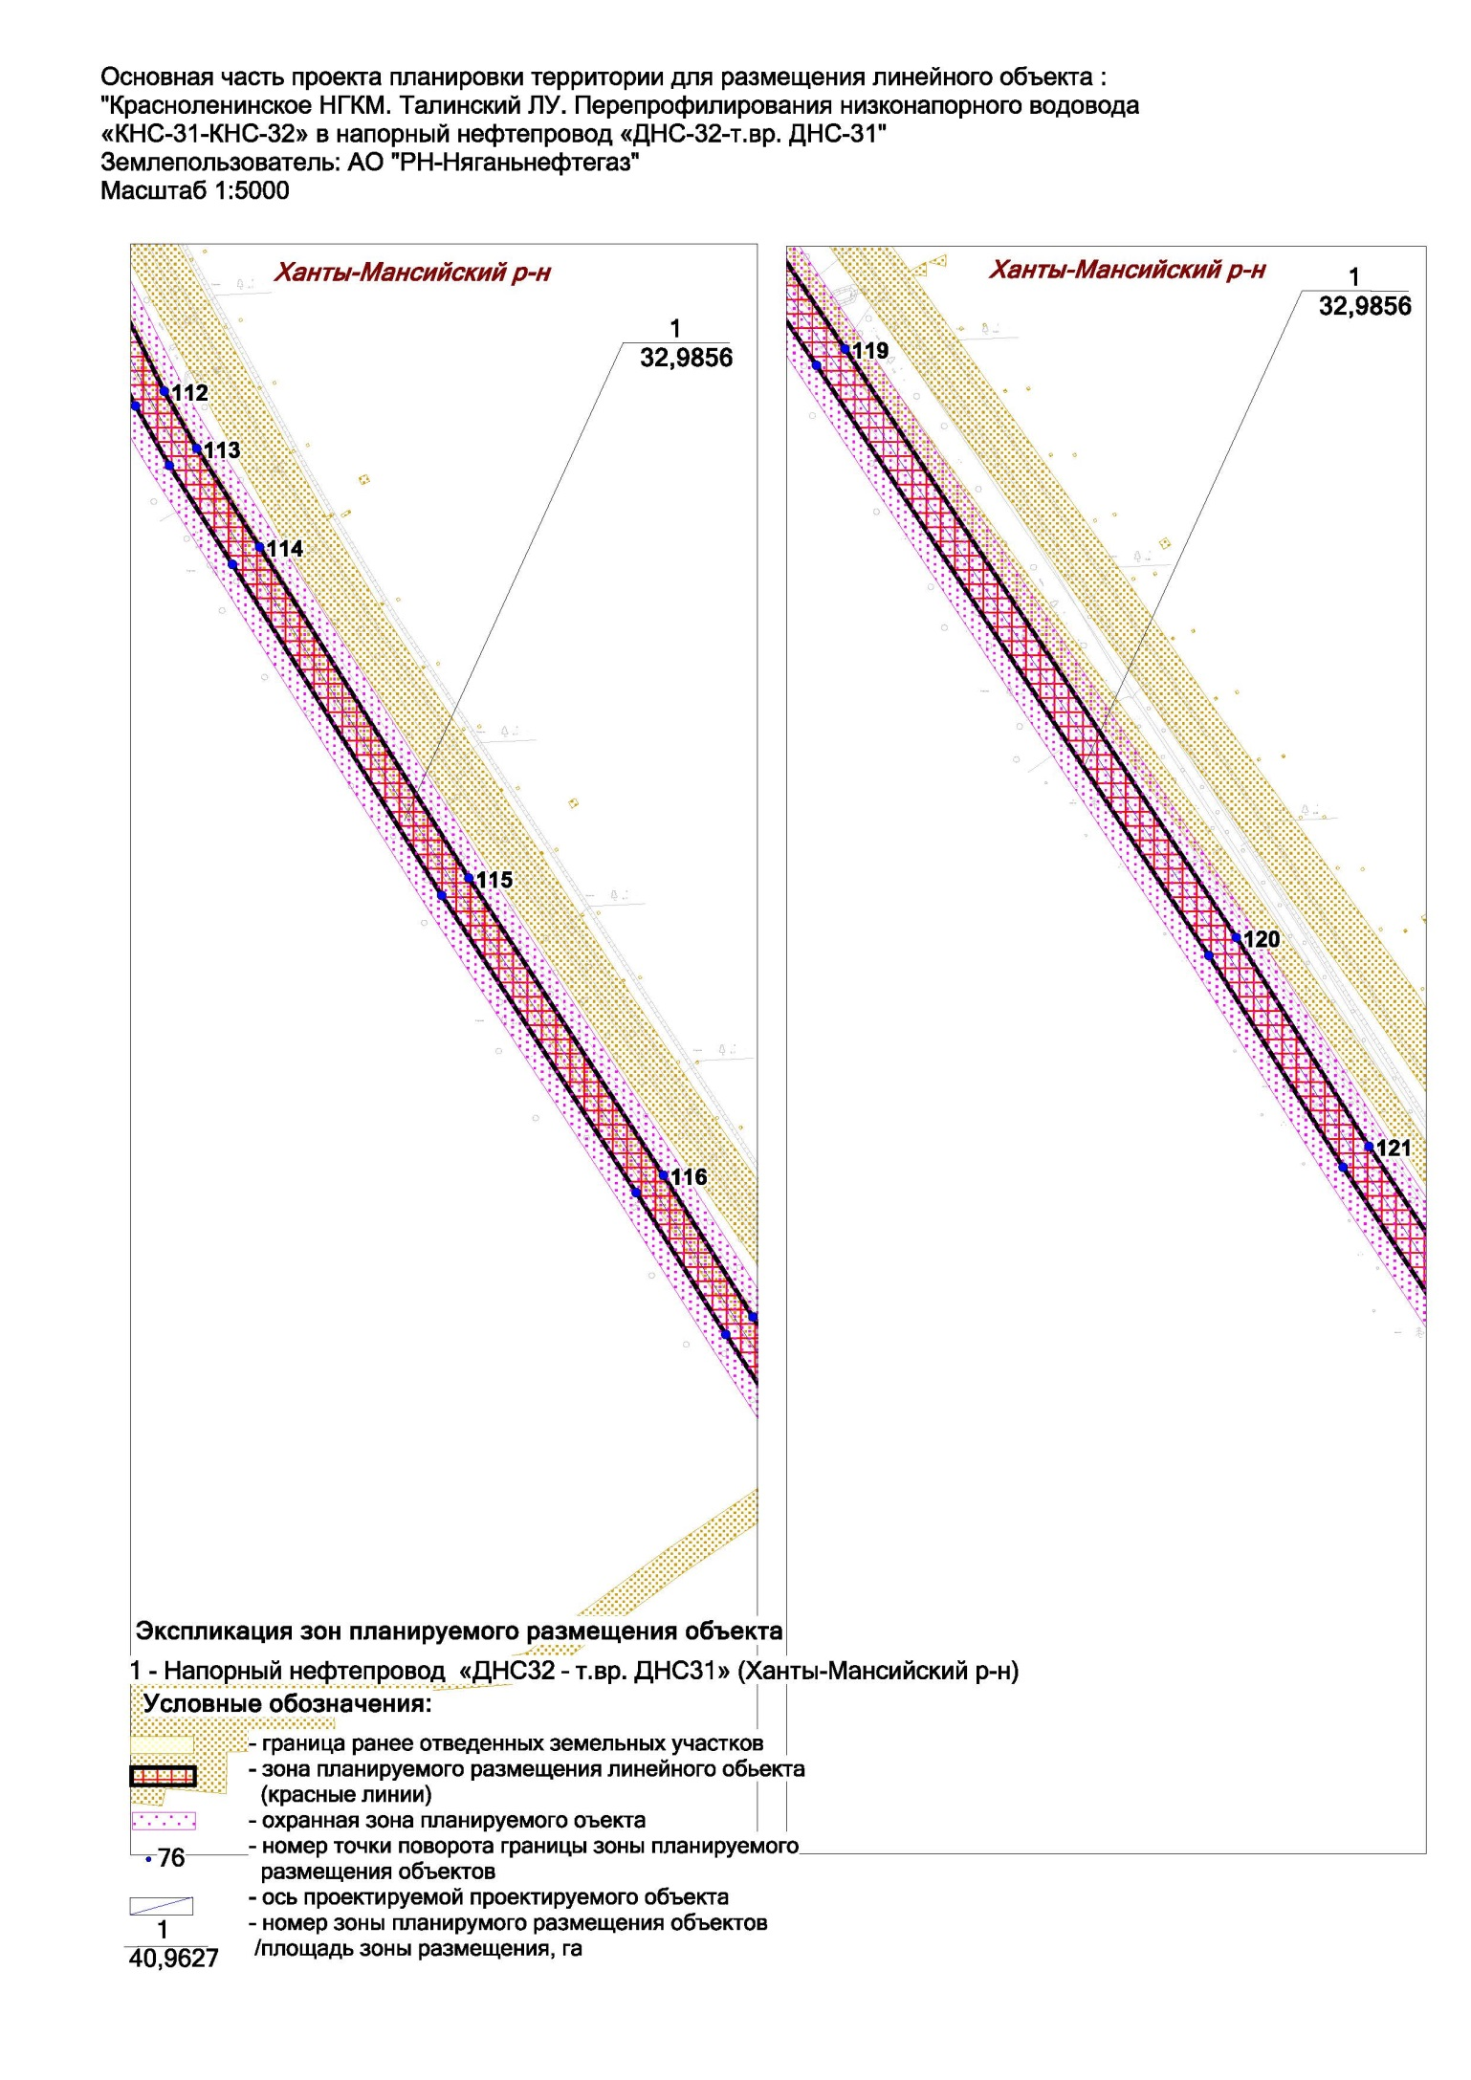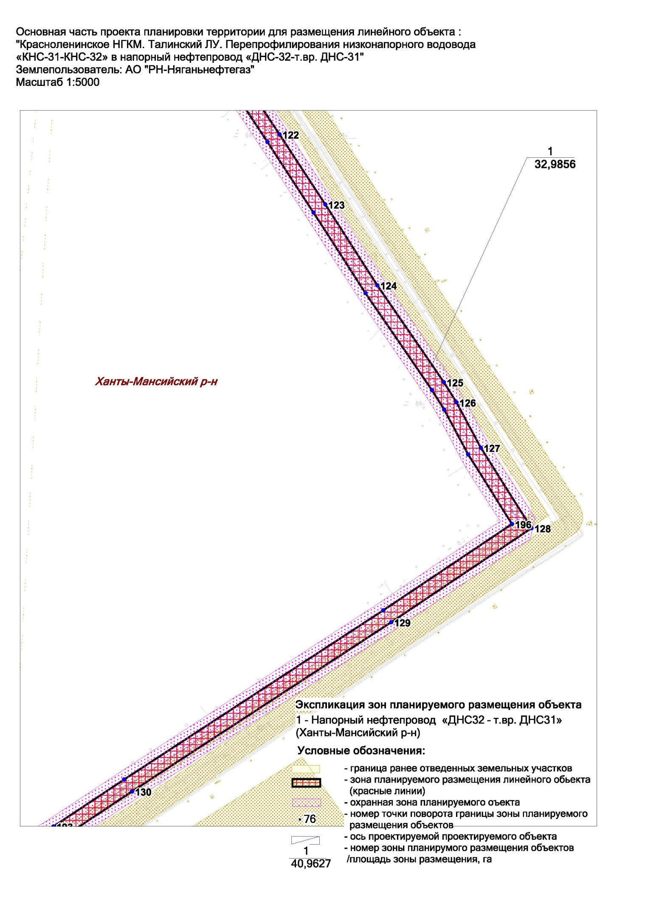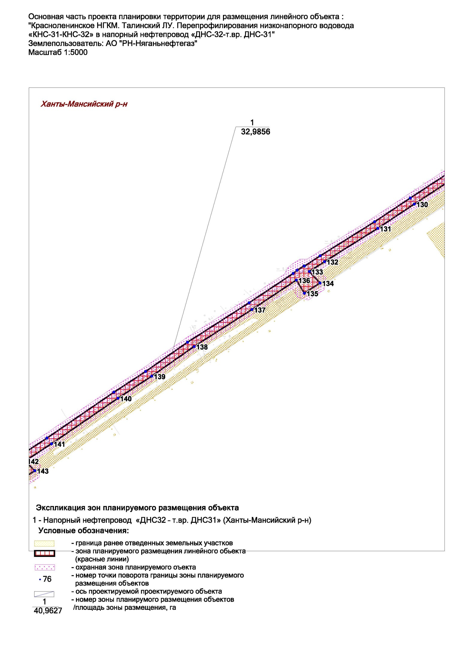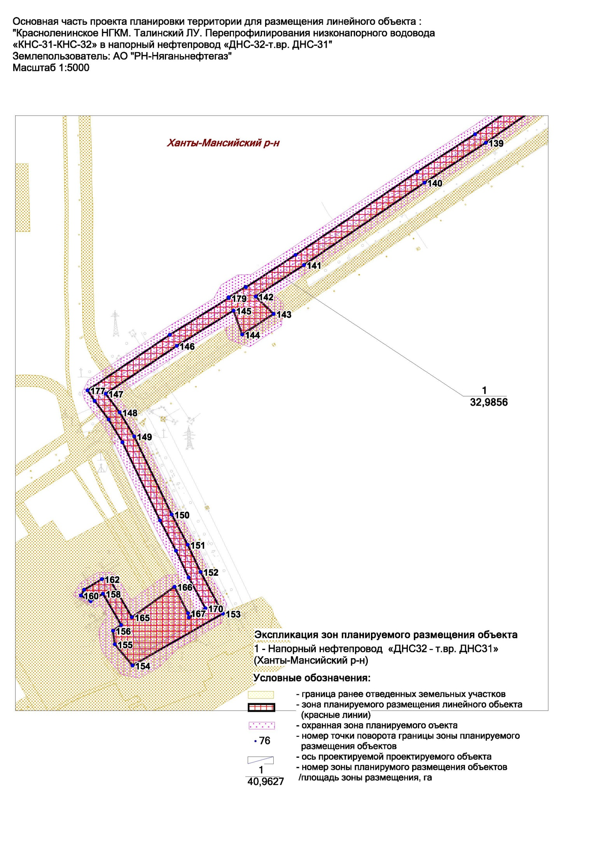
Основная часть проекта планировки территории для размещения объекта капитального строительства, расположенного на территориях двух муниципальных
образования Ханты-Мансийского автономного округа – Югры, «Красноленинское НГКМ. Талинский ЛУ. Перепрофилирования низконапорного водовода «КНС-31-КНС-32» в напорный нефтепровод «ДНС-32-т.вр.ДНС-31»
Землепользователь: АО «РН-Няганьнефтегаз»
Масштаб 1:5000

Приложение 29
к приказу Департамента строительства Ханты-Мансийского
автономного округа – Югры
от 8 ноября 2018 года № 23-нп

Основная часть проекта планировки территории для размещения объекта капитального строительства, расположенного на территориях двух муниципальных образования Ханты-Мансийского автономного округа – Югры, «Красноленинское НГКМ. Талинский ЛУ. Перепрофилирования низконапорного водовода «КНС-31-КНС-32» в напорный нефтепровод «ДНС-32-т.вр.ДНС-31»
Землепользователь: АО «РН-Няганьнефтегаз»
Масштаб 1:5000

Основная часть проекта планировки территории для размещения объекта капитального строительства, расположенного на территориях двух муниципальных образования Ханты-Мансийского автономного округа – Югры, «Красноленинское НГКМ. Талинский ЛУ. Перепрофилирования низконапорного водовода «КНС-31-КНС-32» в напорный нефтепровод «ДНС-32-т.вр.ДНС-31»
Землепользователь: АО «РН-Няганьнефтегаз»
Масштаб 1:5000

Основная часть проекта планировки территории для размещения объекта капитального строительства, расположенного на территориях двух муниципальных образования Ханты-Мансийского автономного округа – Югры, «Красноленинское НГКМ. Талинский ЛУ. Перепрофилирования низконапорного водовода «КНС-31-КНС-32» в напорный нефтепровод «ДНС-32-т.вр.ДНС-31»
Землепользователь: АО «РН-Няганьнефтегаз»
Масштаб 1:5000

Основная часть проекта планировки территории для размещения объекта капитального строительства, расположенного на территориях двух муниципальных образования Ханты-Мансийского автономного округа – Югры, «Красноленинское НГКМ. Талинский ЛУ. Перепрофилирования низконапорного водовода «КНС-31-КНС-32» в напорный нефтепровод «ДНС-32-т.вр.ДНС-31»
Землепользователь: АО «РН-Няганьнефтегаз»
Масштаб 1:5000

Основная часть проекта планировки территории для размещения объекта капитального строительства, расположенного на территориях двух муниципальных образования Ханты-Мансийского автономного округа – Югры, «Красноленинское НГКМ. Талинский ЛУ. Перепрофилирования низконапорного водовода «КНС-31-КНС-32» в напорный нефтепровод «ДНС-32-т.вр.ДНС-31»
Землепользователь: АО «РН-Няганьнефтегаз»
Масштаб 1:5000

Основная часть проекта планировки территории для размещения объекта капитального строительства, расположенного на территориях двух муниципальных образования Ханты-Мансийского автономного округа – Югры, «Красноленинское НГКМ. Талинский ЛУ. Перепрофилирования низконапорного водовода «КНС-31-КНС-32» в напорный нефтепровод «ДНС-32-т.вр.ДНС-31»
Землепользователь: АО «РН-Няганьнефтегаз»
Масштаб 1:5000

Основная часть проекта планировки территории для размещения объекта капитального строительства, расположенного на территориях двух муниципальных образования Ханты-Мансийского автономного округа – Югры, «Красноленинское НГКМ. Талинский ЛУ. Перепрофилирования низконапорного водовода «КНС-31-КНС-32» в напорный нефтепровод «ДНС-32-т.вр.ДНС-31»
Землепользователь: АО «РН-Няганьнефтегаз»
Масштаб 1:5000

Основная часть проекта планировки территории для размещения объекта капитального строительства, расположенного на территориях двух муниципальных образования Ханты-Мансийского автономного округа – Югры, «Красноленинское НГКМ. Талинский ЛУ. Перепрофилирования низконапорного водовода «КНС-31-КНС-32» в напорный нефтепровод «ДНС-32-т.вр.ДНС-31»
Землепользователь: АО «РН-Няганьнефтегаз»
Масштаб 1:5000

Основная часть проекта планировки территории для размещения объекта капитального строительства, расположенного на территориях двух муниципальных образования Ханты-Мансийского автономного округа – Югры, «Красноленинское НГКМ. Талинский ЛУ. Перепрофилирования низконапорного водовода «КНС-31-КНС-32» в напорный нефтепровод «ДНС-32-т.вр.ДНС-31»
Землепользователь: АО «РН-Няганьнефтегаз»
Масштаб 1:5000

Ханты-Мансийский район

Обозначение характерных точек | X | Y
1 | 986967.47 | 2528551.2
2 | 986955.35 | 2528578.64
3 | 986938.46 | 2528544.39
4 | 986838.1 | 2528341.79
5 | 986831.04 | 2528328.51
6 | 986773.4 | 2528224.33
7 | 986728.52 | 2528140.32
8 | 986720.12 | 2528123.19
9 | 986670.79 | 2528016.63
10 | 986606.73 | 2527880.3
11 | 986552.36 | 2527750.1
12 | 986514.69 | 2527640.17
13 | 986507.78 | 2527615.56
14 | 986478.67 | 2527500.84
15 | 986464.42 | 2527451.88
16 | 986443.36 | 2527367.93
17 | 986465.62 | 2527361.37
18 | 986405.69 | 2527143.22
19 | 986399.12 | 2527140.52
20 | 986397.63 | 2527136.47
21 | 986406.07 | 2527123.67
22 | 986408.74 | 2527121.97
23 | 986414.88 | 2527121.69
24 | 986425.97 | 2527130.17
25 | 986490.73 | 2527366.85
26 | 986492.94 | 2527377.43
27 | 986470.83 | 2527383.77
28 | 986486.63 | 2527445.93
29 | 986500.78 | 2527494.49
30 | 986532.12 | 2527617.74
31 | 986539.1 | 2527640.94
32 | 986573.62 | 2527741.36
33 | 986627.57 | 2527870.58
34 | 986691.65 | 2528006.94
35 | 986740.94 | 2528113.4
36 | 986749 | 2528129.84
37 | 986793.67 | 2528213.45
38 | 986851.18 | 2528317.41
39 | 986858.56 | 2528331.29
40 | 986959.11 | 2528534.26
41 | 985951.97 | 2530850.2
42 | 985937.31 | 2530883.4
43 | 985775.56 | 2530965.25
44 | 985650.5 | 2531027.92
45 | 985518.47 | 2531095.02
46 | 985410.03 | 2531151.64
47 | 985401.11 | 2531155.99
48 | 985403.12 | 2531159.32
49 | 985385.73 | 2531167.84
50 | 985383.5 | 2531164.59
51 | 985324.94 | 2531193.19
52 | 985344 | 2531232.67
53 | 985276.09 | 2531266.82
54 | 985274.49 | 2531220.32
55 | 985215.82 | 2531255.32
56 | 985159.63 | 2531287.95
57 | 985024.14 | 2531358.69
58 | 984944.7 | 2531400.64
59 | 984820.55 | 2531462.4
60 | 984751.67 | 2531494.45
61 | 984729.2 | 2531504.08
62 | 984705.87 | 2531512.47
63 | 984682.08 | 2531519.44
64 | 984657.91 | 2531524.98
65 | 984536.98 | 2531547.09
66 | 984488.58 | 2531549.32
67 | 984416.82 | 2531545.02
68 | 984307.82 | 2531531.91
69 | 984257.67 | 2531528.57
70 | 984192.75 | 2531523.06
71 | 984167.28 | 2531521.98
72 | 984141.8 | 2531522.83
73 | 984093.24 | 2531526.28
74 | 984058.38 | 2531538.27
75 | 983994.24 | 2531559.2
76 | 983912.48 | 2531588.46
77 | 983752.95 | 2531650.8
78 | 983584.73 | 2531713.79
79 | 983520.27 | 2531738.54
80 | 983496.32 | 2531746.98
81 | 983451.94 | 2531761.27
82 | 983399.97 | 2531775.67
83 | 983363.33 | 2531783.76
84 | 983284.49 | 2531797.84
85 | 983260.07 | 2531801.52
86 | 983051.48 | 2531827.37
87 | 982874.53 | 2531854.8
88 | 982752.68 | 2531868.02
89 | 982688.85 | 2531876.91
90 | 982608.88 | 2531883.25
91 | 982301.72 | 2531923.85
92 | 982192.26 | 2531934.01
93 | 981865.56 | 2531990.8
94 | 981758.28 | 2532005.97
95 | 981727.22 | 2532011.49
96 | 981692.14 | 2532019.98
97 | 981667.18 | 2532027.58
98 | 981642.64 | 2532036.68
99 | 981600.89 | 2532053.57
100 | 981587.52 | 2532059.24
101 | 981574.33 | 2532065.35
102 | 981529.66 | 2532087.06
103 | 981309.62 | 2532200.99
104 | 981125.77 | 2532302.42
105 | 981017.63 | 2532359.09
106 | 981006.28 | 2532365.25
107 | 980790.58 | 2532489.19
108 | 980779.91 | 2532495.12
109 | 980642.93 | 2532567.56
110 | 980464.95 | 2532664.42
111 | 980453.7 | 2532670.22
112 | 980355.74 | 2532718.97
113 | 980314.98 | 2532742.03
114 | 980244.66 | 2532786.95
115 | 980008.18 | 2532936.43
116 | 979795.9 | 2533075.26
117 | 979694.74 | 2533139.07
118 | 979583.67 | 2533211.59
119 | 979452.74 | 2533299.88
120 | 979040.98 | 2533573.55
121 | 978894.82 | 2533666.18
122 | 978679.25 | 2533809.02
123 | 978566.35 | 2533882.76
124 | 978436.16 | 2533966.77
125 | 978280.05 | 2534073.99
126 | 978247.52 | 2534094.39
127 | 978174.38 | 2534133.65
128 | 978044.79 | 2534215.38
129 | 977893.28 | 2533989.04
130 | 977620.65 | 2533571.09
131 | 977543.2 | 2533454.29
132 | 977437.55 | 2533284.98
133 | 977406.2 | 2533236.36
134 | 977369.79 | 2533270.42
135 | 977337.2 | 2533220.82
136 | 977378.96 | 2533194.84
137 | 977285.24 | 2533053.37
138 | 977167.68 | 2532868.83
139 | 977073.42 | 2532733.68
140 | 977003.28 | 2532626.14
141 | 976858.69 | 2532414.35
142 | 976803.32 | 2532329.54
143 | 976772.91 | 2532361.16
144 | 976736.69 | 2532305.98
145 | 976778.66 | 2532290.59
146 | 976716.78 | 2532191.11
147 | 976632.69 | 2532066.16
148 | 976600.03 | 2532090.77
149 | 976557.94 | 2532116.23
150 | 976420.69 | 2532182.13
151 | 976367.59 | 2532210.19
152 | 976319.99 | 2532232.78
153 | 976246.68 | 2532271.96
154 | 976155.58 | 2532113.28
155 | 976192.82 | 2532082.17
156 | 976216.55 | 2532079.01
157 | 976226.81 | 2532093.38
158 | 976281.57 | 2532061.5
159 | 976268.66 | 2532039.98
160 | 976278.62 | 2532022.73
161 | 976288.48 | 2532028.31
162 | 976307.21 | 2532059.54
163 | 976309.1 | 2532067.75
164 | 976303.26 | 2532075.32
165 | 976240.3 | 2532112.25
166 | 976293.78 | 2532187.09
167 | 976247.48 | 2532210.74
168 | 976239.85 | 2532212.3
169 | 976250.4 | 2532231.5
170 | 976256.02 | 2532241.28
171 | 976310.13 | 2532212
172 | 976357.19 | 2532189.67
173 | 976410.38 | 2532161.57
174 | 976547.58 | 2532095.69
175 | 976587.59 | 2532071.42
176 | 976620.24 | 2532046.78
177 | 976638.62 | 2532034.42
178 | 976736.13 | 2532178.68
179 | 976800.71 | 2532282.5
180 | 976802.04 | 2532282.01
181 | 976820.33 | 2532311.87
182 | 976819.69 | 2532312.53
183 | 976876.43 | 2532399.52
184 | 977022.34 | 2532613.28
185 | 977088.43 | 2532714.72
186 | 977181.17 | 2532847.82
187 | 977306.76 | 2533044.28
188 | 977400.08 | 2533185.09
189 | 977410.16 | 2533197.68
190 | 977424.09 | 2533219.63
191 | 977423.27 | 2533220.4
192 | 977456.1 | 2533271.27
193 | 977564.27 | 2533444.48
194 | 977639.79 | 2533558.33
195 | 977912.47 | 2533976.37
196 | 978051.52 | 2534183.98
197 | 978163.47 | 2534113.39
198 | 978235.99 | 2534074.48
199 | 978267.22 | 2534054.9
200 | 978423.49 | 2533947.58
201 | 978553.35 | 2533863.78
202 | 978667.24 | 2533789.4
203 | 978880.29 | 2533648.19
204 | 979028.31 | 2533554.36
205 | 979441.23 | 2533279.91
206 | 979570.97 | 2533192.41
207 | 979682.14 | 2533119.83
208 | 979783.48 | 2533055.9
209 | 979995.79 | 2532917.05
210 | 980232.13 | 2532767.67
211 | 980302.67 | 2532722.61
212 | 980345.27 | 2532698.49
213 | 980443.37 | 2532649.67
214 | 980454.09 | 2532644.14
215 | 980633.2 | 2532546.68
216 | 980768.94 | 2532474.91
217 | 980779.14 | 2532469.23
218 | 980995.11 | 2532345.14
219 | 981006.86 | 2532338.76
220 | 981114.97 | 2532282.11
221 | 981298.71 | 2532180.74
222 | 981516.46 | 2532067.98
223 | 981564.36 | 2532044.61
224 | 981578.11 | 2532038.25
225 | 981592.12 | 2532032.3
226 | 981634.26 | 2532015.26
227 | 981659.66 | 2532005.84
228 | 981686.27 | 2531997.74
229 | 981722.49 | 2531988.98
230 | 981754.87 | 2531983.22
231 | 981861.84 | 2531968.09
232 | 982189.38 | 2531911.19
233 | 982299 | 2531901
234 | 982606.98 | 2531860.33
235 | 982686.7 | 2531854.01
236 | 982750.1 | 2531845.16
237 | 982871.04 | 2531832.06
238 | 983048.26 | 2531804.59
239 | 983257.19 | 2531778.7
240 | 983280.49 | 2531775.19
241 | 983359.12 | 2531761.15
242 | 983394.15 | 2531753.41
243 | 983444.94 | 2531739.36
244 | 983489.17 | 2531725.12
245 | 983512.05 | 2531717.06
246 | 983577.64 | 2531691.88
247 | 983744.71 | 2531629.33
248 | 983898.07 | 2531569.35
249 | 983989.95 | 2531536.35
250 | 984053.14 | 2531515.78
251 | 984087.16 | 2531504.04
252 | 984140.28 | 2531499.88
253 | 984167.6 | 2531498.98
254 | 984194.48 | 2531500.12
255 | 984255.61 | 2531505.35
256 | 984310.11 | 2531509.02
257 | 984419.44 | 2531522.17
258 | 984488.72 | 2531526.32
259 | 984534.75 | 2531524.2
260 | 984653.21 | 2531502.46
261 | 984676.13 | 2531497.23
262 | 984698.59 | 2531490.65
263 | 984720.62 | 2531482.74
264 | 984742.21 | 2531473.48
265 | 984810.67 | 2531441.62
266 | 984934.19 | 2531380.18
267 | 985015.29 | 2531337.36
268 | 985152.86 | 2531265.42
269 | 985204.08 | 2531235.54
270 | 985273.6 | 2531194.44
271 | 985273.59 | 2531194.17
272 | 985281.93 | 2531183.99
273 | 985312.69 | 2531169.02
274 | 985314.54 | 2531172.67
275 | 985399.59 | 2531131.15
276 | 985508 | 2531074.53
277 | 985640.08 | 2531007.42
278 | 985765.34 | 2530944.64

Октябрьский район

Обозначение характерных точек | X | Y
1 | 985937.31 | 2530883.4
2 | 985972.4 | 2530865.64
3 | 986174.85 | 2530762.35
4 | 986283.6 | 2530704.99
5 | 986361.16 | 2530662.22
6 | 986502.43 | 2530588.76
7 | 986551.41 | 2530560.62
8 | 986602.8 | 2530532.4
9 | 986662.21 | 2530503.32
10 | 986902.2 | 2530380.99
11 | 986997.39 | 2530328.85
12 | 987067.43 | 2530290.36
13 | 987116.58 | 2530267
14 | 987175.43 | 2530238.3
15 | 987224.73 | 2530214.87
16 | 987250.74 | 2530201.4
17 | 987310.89 | 2530168.13
18 | 987330.18 | 2530158.08
19 | 987382.4 | 2530132.44
20 | 987446.24 | 2530101.6
21 | 987630.57 | 2530007.47
22 | 987670.62 | 2529986.11
23 | 987694.22 | 2529973.17
24 | 987647.19 | 2529882.37
25 | 987621.42 | 2529829.39
26 | 987555.17 | 2529695.19
27 | 987519.16 | 2529627.01
28 | 987438.97 | 2529476.78
29 | 987394.87 | 2529391.76
30 | 987400.85 | 2529388.49
31 | 987393.77 | 2529374.87
32 | 987386.9 | 2529377.92
33 | 987362.52 | 2529331.66
34 | 987299.72 | 2529210.27
35 | 987198.73 | 2529012.83
36 | 987124.27 | 2528869.2
37 | 986967.47 | 2528551.2
38 | 986955.35 | 2528578.64
39 | 987104.86 | 2528881.76
40 | 987179.13 | 2529025.01
41 | 987278.29 | 2529218.9
42 | 987342.15 | 2529342.32
43 | 987418.1 | 2529486.52
44 | 987498.65 | 2529637.43
45 | 987534.79 | 2529705.84
46 | 987600.66 | 2529839.32
47 | 987626.71 | 2529892.82
48 | 987663.95 | 2529963.58
49 | 987620.02 | 2529987.03
50 | 987433.41 | 2530082.32
51 | 987372.55 | 2530111.66
52 | 987319.95 | 2530137.47
53 | 987299.78 | 2530147.99
54 | 987239.75 | 2530181.18
55 | 987214.46 | 2530194.29
56 | 987166.75 | 2530216.96
57 | 987106.6 | 2530246.29
58 | 987057.04 | 2530269.83
59 | 986986.19 | 2530308.76
60 | 986965.85 | 2530319.9
61 | 986942.19 | 2530276.49
62 | 986854.39 | 2530324.36
63 | 986877.93 | 2530367.54
64 | 986651.79 | 2530482.82
65 | 986597.7 | 2530509.18
66 | 986540.1 | 2530540.58
67 | 986491.6 | 2530568.46
68 | 986350.2 | 2530642
69 | 986274.66 | 2530683.69
70 | 986161.65 | 2530743.27
71 | 985961.94 | 2530845.15
72 | 985951.97 | 2530850.2

