Приложение 3
к приказу Департамента строительства
Ханты-Мансийского
автономного округа – Югры
от 8 ноября 2018 года № 23-нп

Основная часть проекта межевания территории для размещения объекта капитального строительства, расположенного на территории двух муниципальных образований
Ханты-Мансийского автономного округа – Югры,
«Обустройство Чапровского месторождения.
Кусты 1, 1а, 2, 2а, 4, 4а, 5, 5а и коридоры коммуникаций»
Землепользователь: АО «НК «Конданефть»

Приложение 1
к постановлению Правительства
Ханты-Мансийского
автономного округа – Югры
от ________________ №________

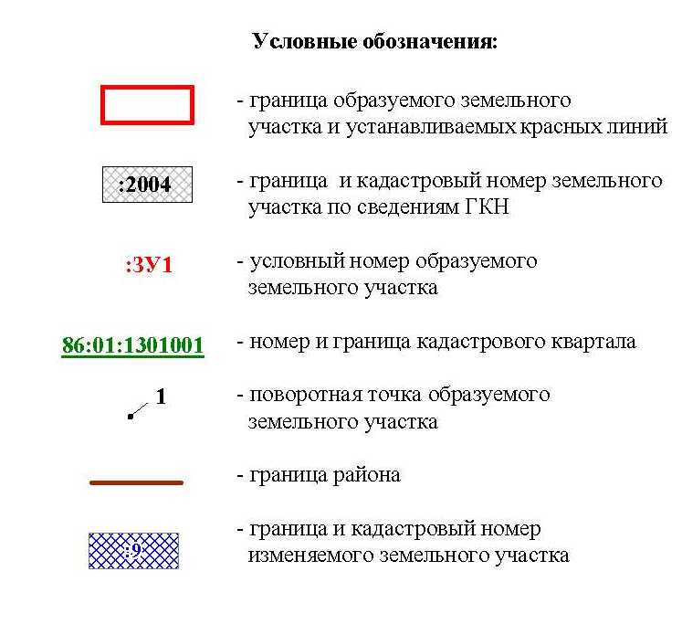

Основная часть проекта межевания территории для размещения объекта капитального строительства, расположенного на территории двух муниципальных образований
Ханты-Мансийского автономного округа – Югры
«Обустройство Чапровского месторождения.
Кусты 1, 1а, 2, 2а, 4, 4а, 5, 5а и коридоры коммуникаций»
Землепользователь: АО «НК «Конданефть»

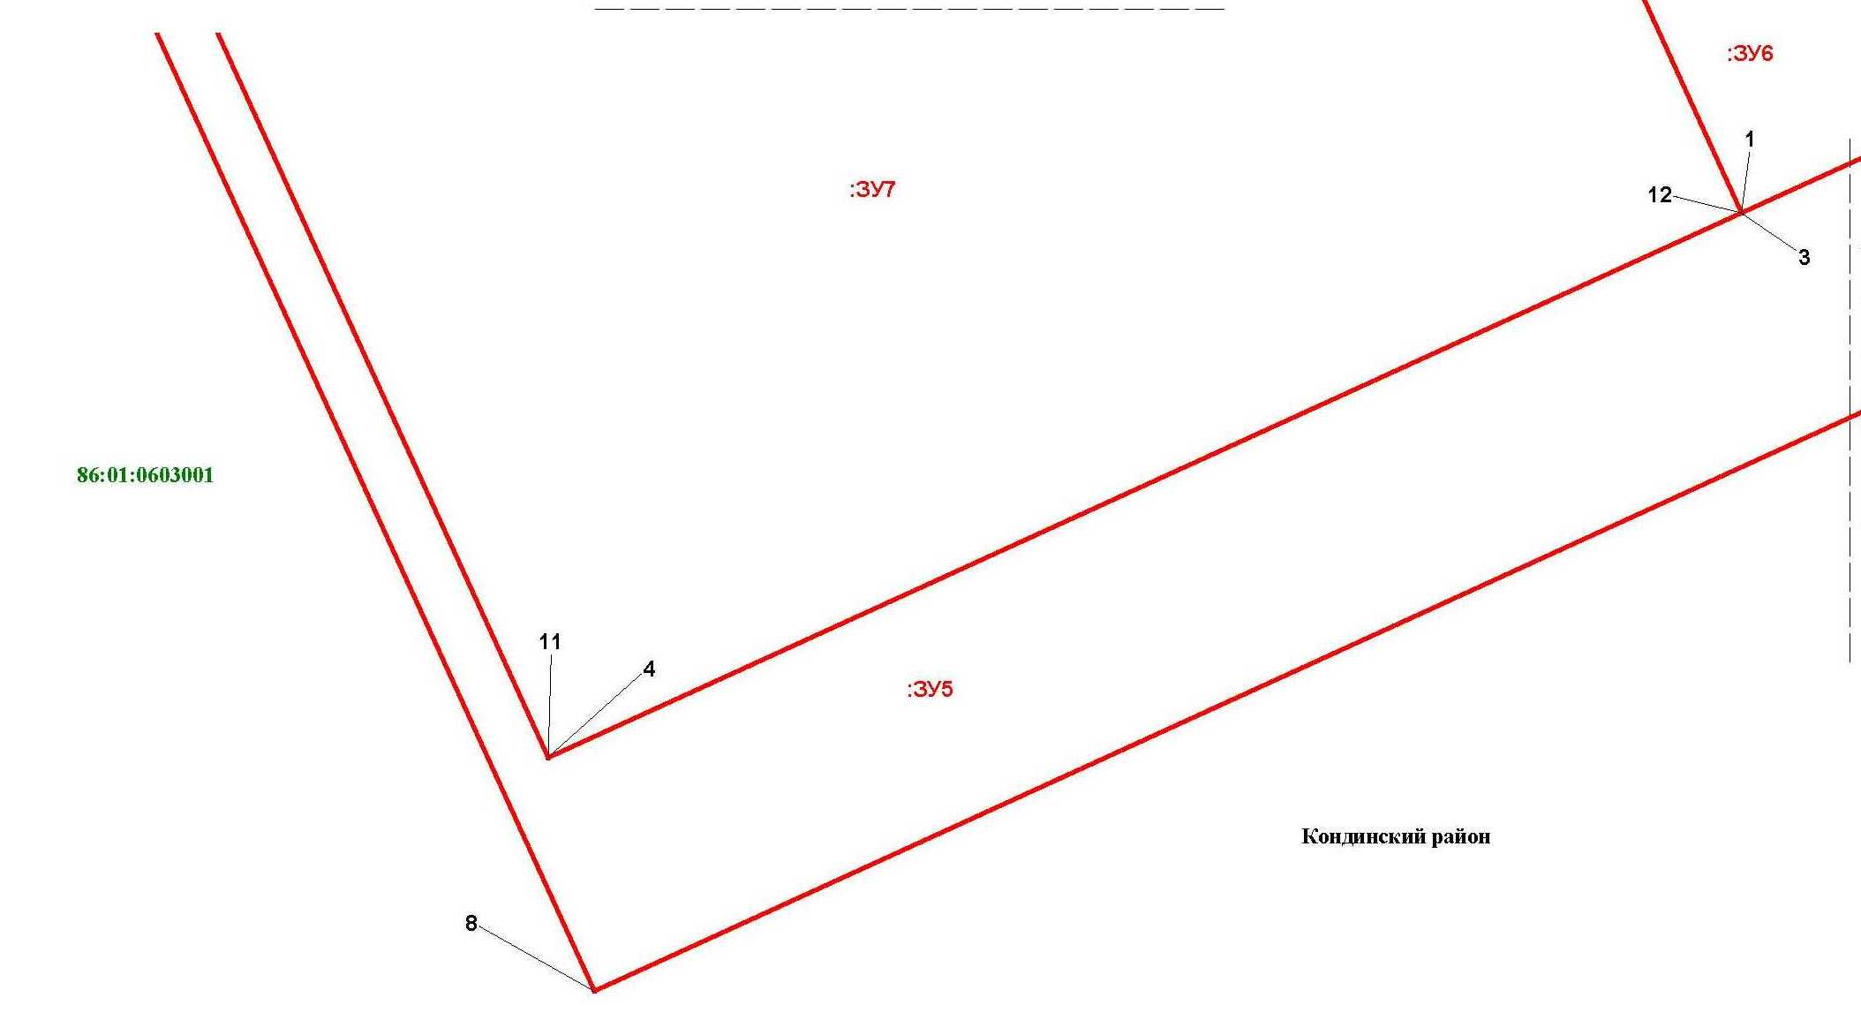

Основная часть проекта межевания территории для размещения объекта капитального строительства, расположенного на территории двух муниципальных образований
Ханты-Мансийского автономного округа – Югры,
«Обустройство Чапровского месторождения.
Кусты 1, 1а, 2, 2а, 4, 4а, 5, 5а и коридоры коммуникаций»
Землепользователь: АО «НК «Конданефть»
Масштаб 1:2000

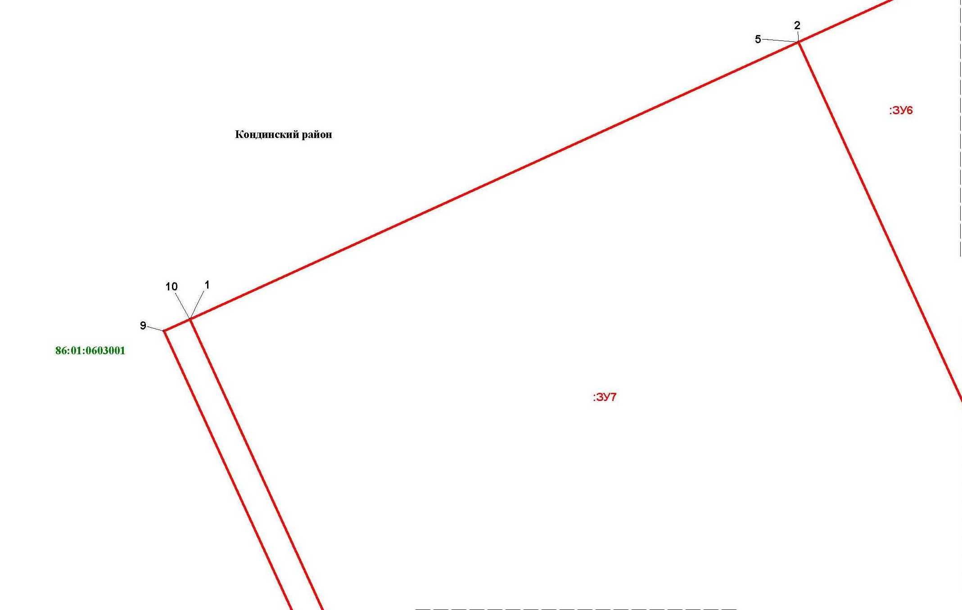

Лист 3 из 65
Линия совмещения с листом 4

Основная часть проекта межевания территории для размещения объекта капитального строительства, расположенного на территории двух муниципальных образований
Ханты-Мансийского автономного округа – Югры,
«Обустройство Чапровского месторождения.
Кусты 1, 1а, 2, 2а, 4, 4а, 5, 5а и коридоры коммуникаций»
Землепользователь: АО «НК «Конданефть»
Масштаб 1:2000

Основная часть проекта межевания территории для размещения объекта капитального строительства, расположенного на территории двух муниципальных образований
Ханты-Мансийского автономного округа – Югры
«Обустройство Чапровского месторождения.
Кусты 1, 1а, 2, 2а, 4, 4а, 5, 5а и коридоры коммуникаций»
Землепользователь: АО «НК «Конданефть»

Основная часть проекта межевания территории для размещения объекта капитального строительства, расположенного на территории двух муниципальных образований
Ханты-Мансийского автономного округа – Югры
«Обустройство Чапровского месторождения.
Кусты 1, 1а, 2, 2а, 4, 4а, 5, 5а и коридоры коммуникаций»
Землепользователь: АО «НК «Конданефть»

Основная часть проекта межевания территории для размещения объекта капитального строительства, расположенного на территории двух муниципальных образований
Ханты-Мансийского автономного округа – Югры
«Обустройство Чапровского месторождения.
Кусты 1, 1а, 2, 2а, 4, 4а, 5, 5а и коридоры коммуникаций»
Землепользователь: АО «НК «Конданефть»

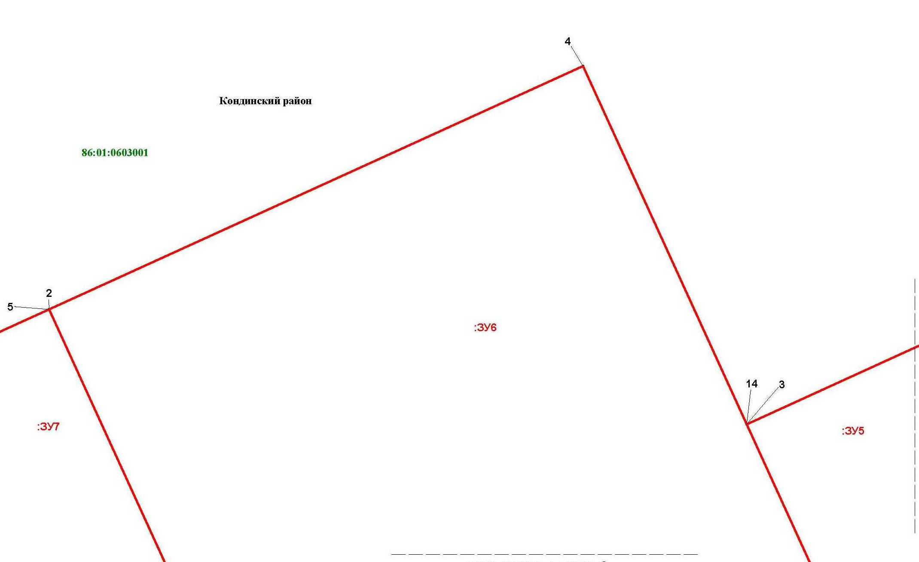

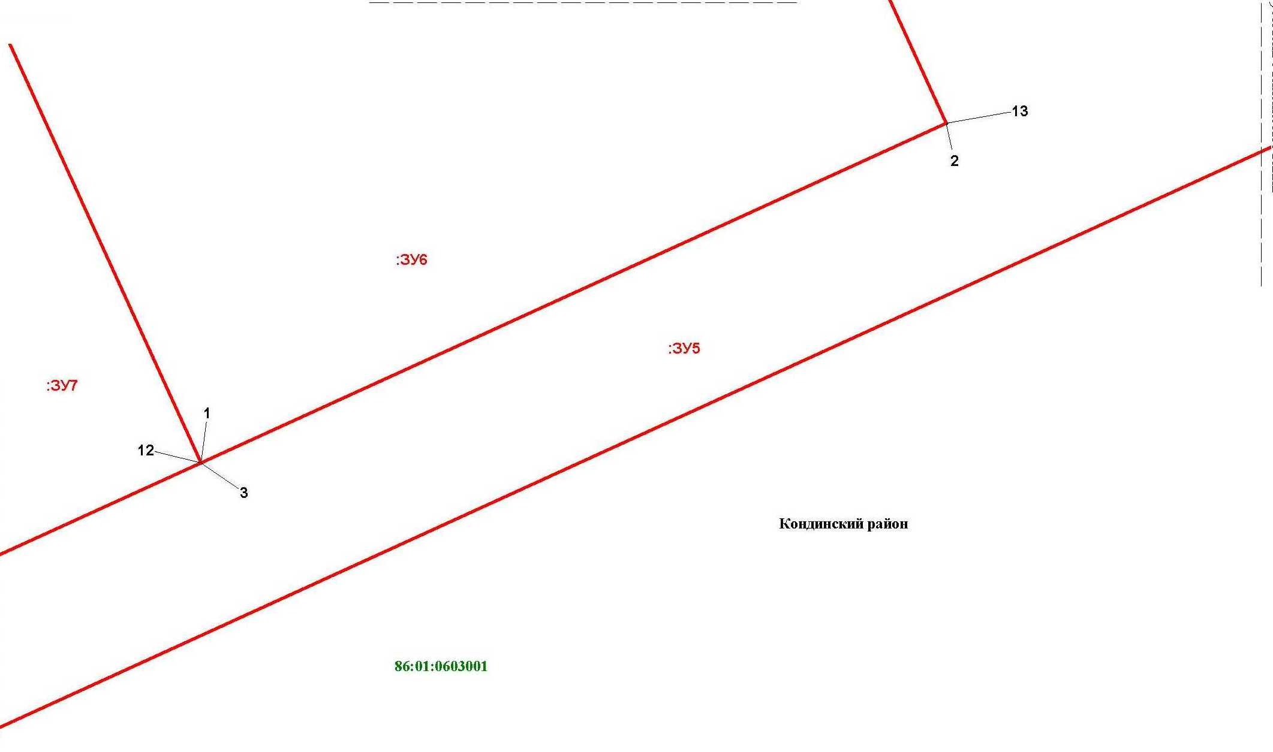

Линия совмещения с листом
7

Основная часть проекта межевания территории для размещения объекта капитального строительства, расположенного на территории двух муниципальных образований
Ханты-Мансийского автономного округа – Югры,
«Обустройство Чапровского месторождения.
Кусты 1, 1а, 2, 2а, 4, 4а, 5, 5а и коридоры коммуникаций»
Землепользователь: АО «НК «Конданефть»
Масштаб 1:2000

Линия совмещения с листом
7

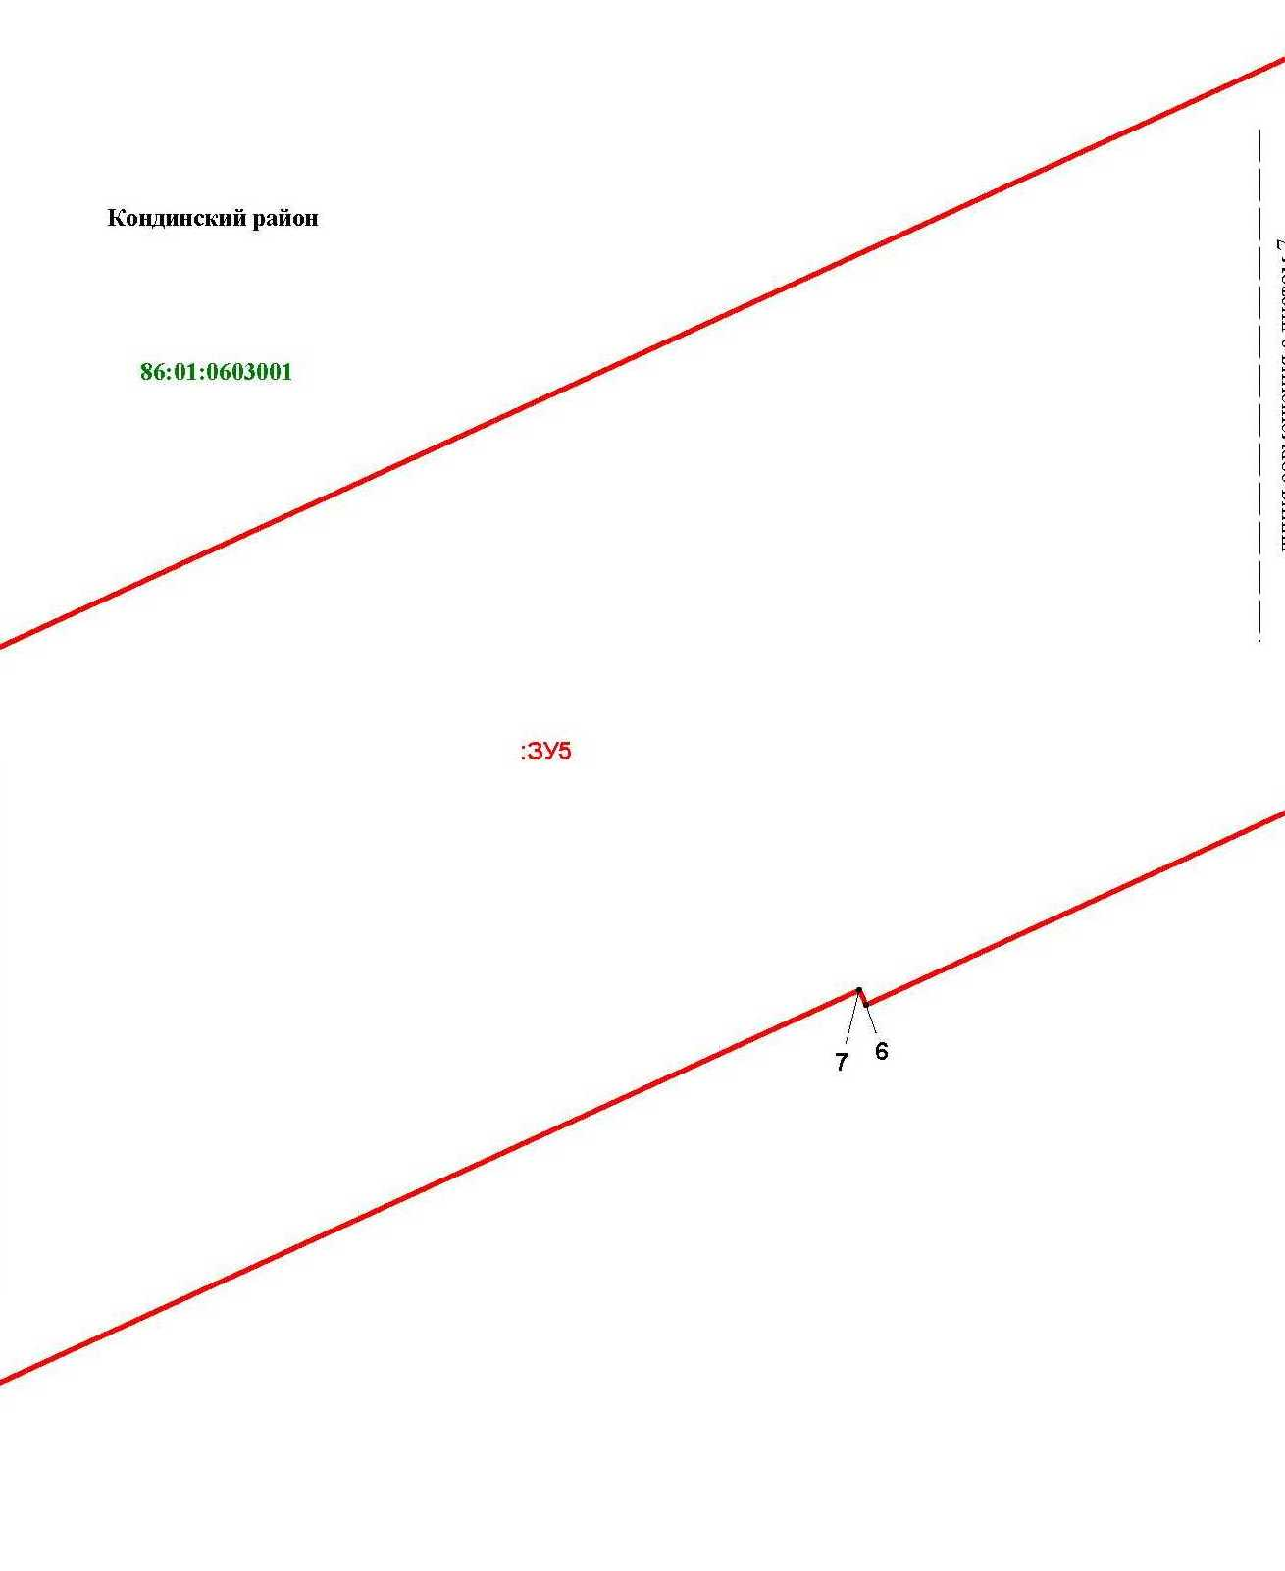

Основная часть проекта межевания территории для размещения объекта капитального строительства, расположенного на территории двух муниципальных образований
Ханты-Мансийского автономного округа – Югры,
«Обустройство Чапровского месторождения.
Кусты 1, 1а, 2, 2а, 4, 4а, 5, 5а и коридоры коммуникаций»
Землепользователь: АО «НК «Конданефть»
Масштаб 1:2000

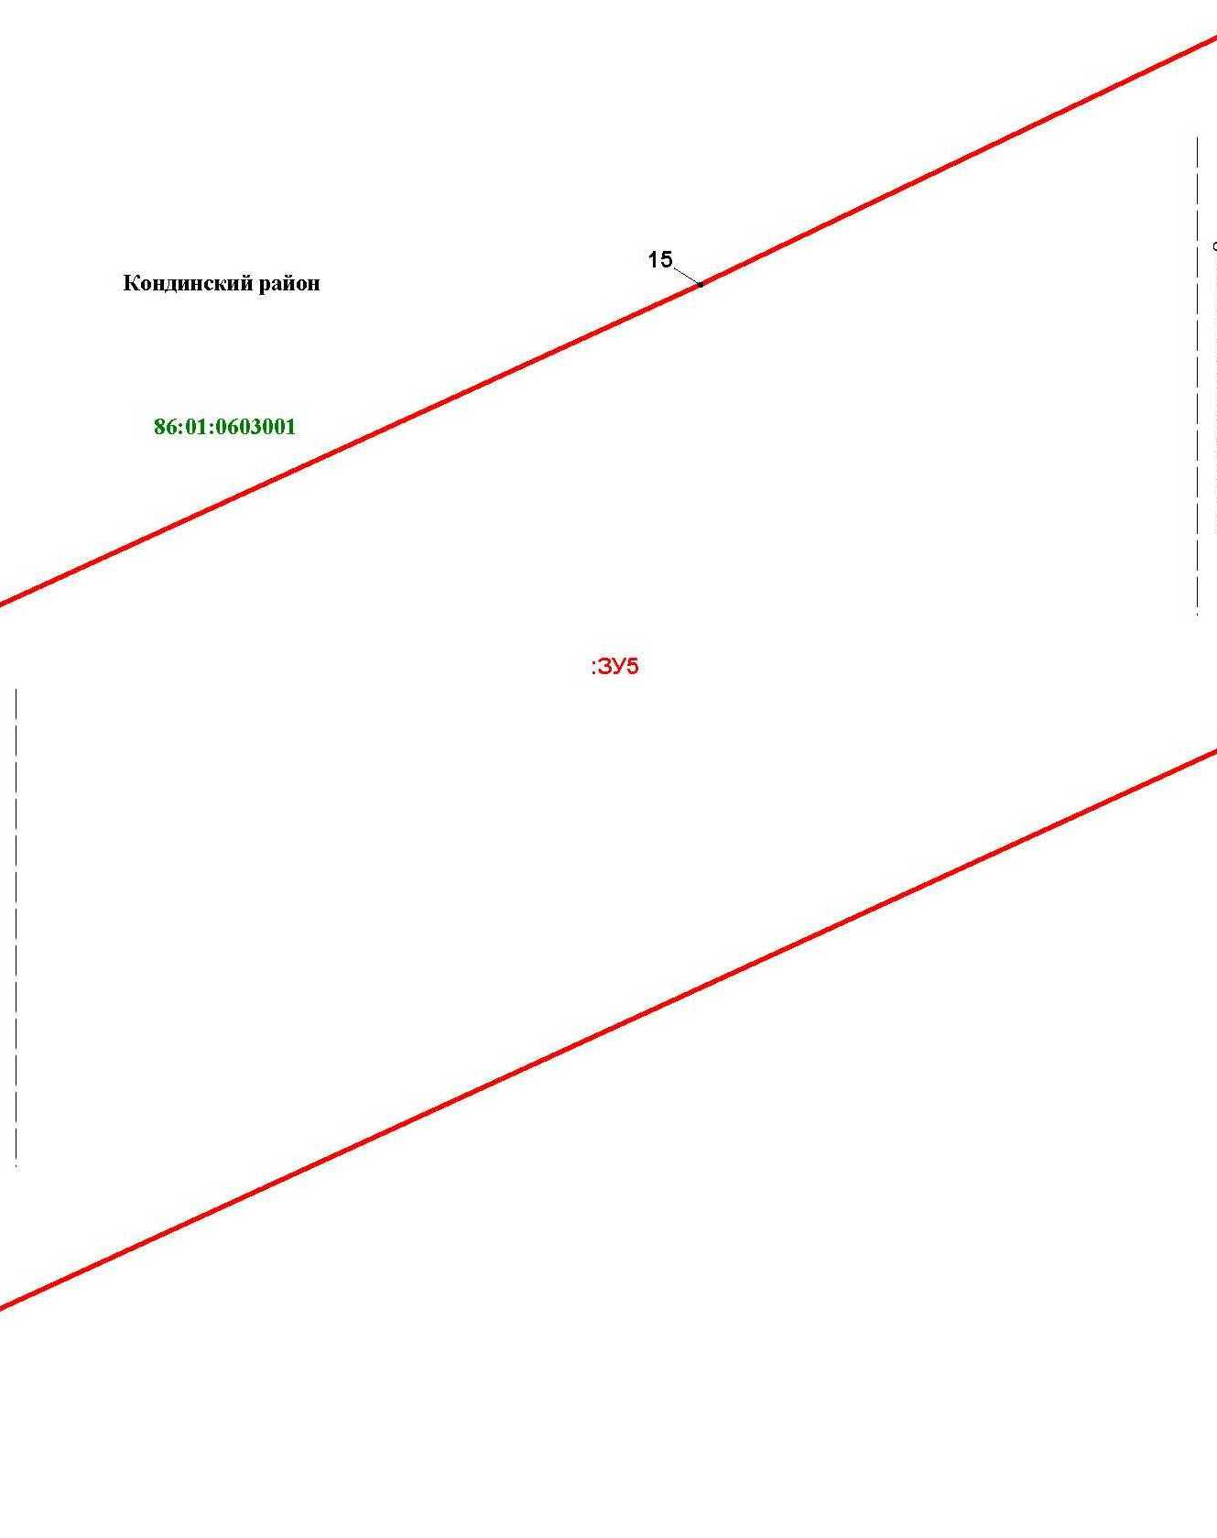

Основная часть проекта межевания территории для размещения объекта капитального строительства, расположенного на территории двух муниципальных образований
Ханты-Мансийского автономного округа – Югры,
«Обустройство Чапровского месторождения.
Кусты 1, 1а, 2, 2а, 4, 4а, 5, 5а и коридоры коммуникаций»
Землепользователь: АО «НК «Конданефть»
Масштаб 1:2000

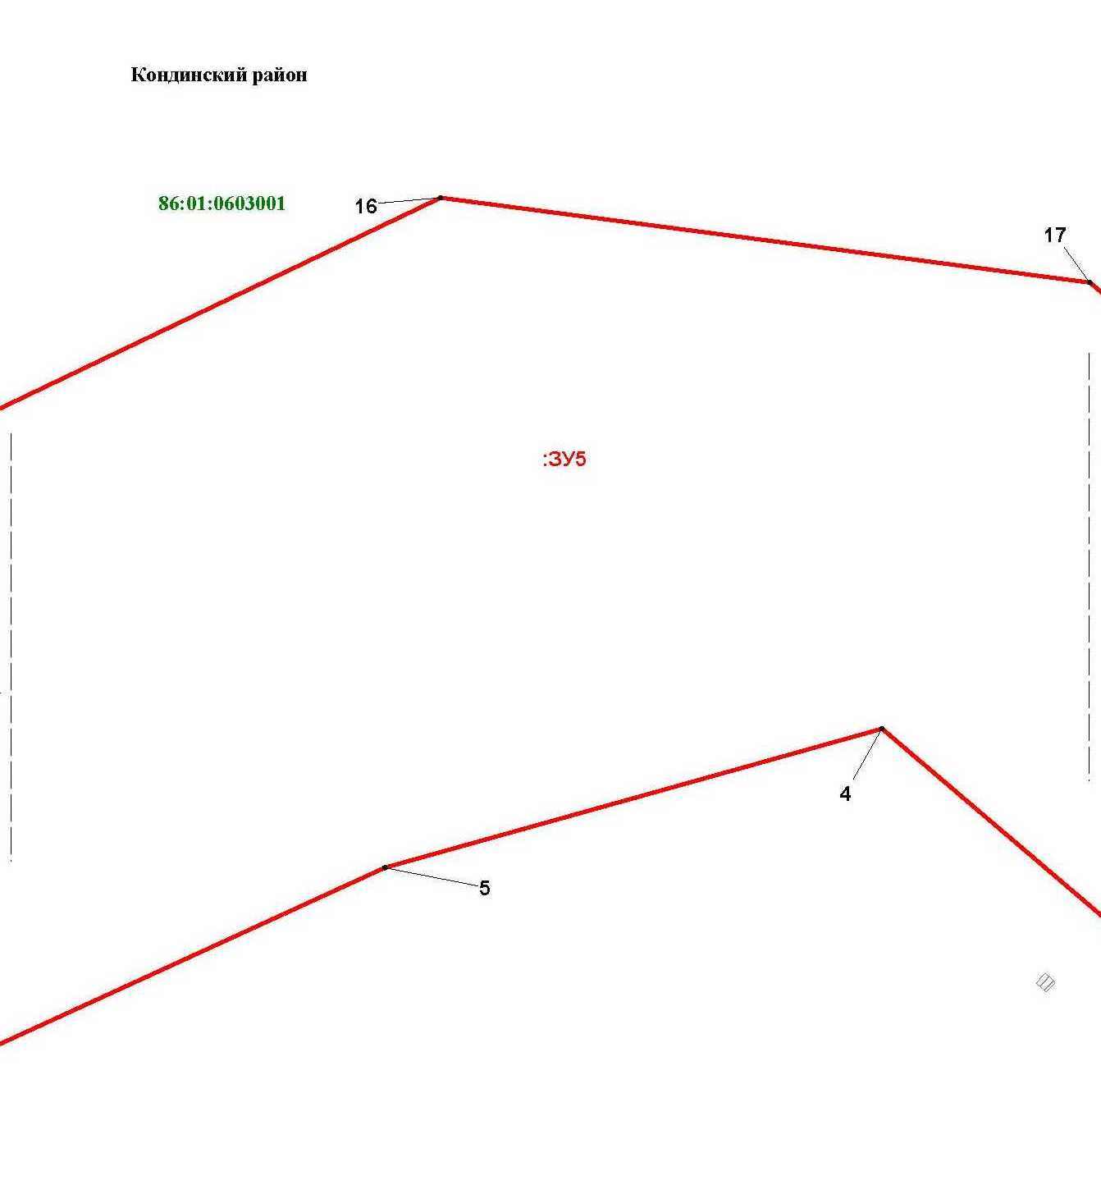

Основная часть проекта межевания территории для размещения объекта капитального строительства, расположенного на территории двух муниципальных образований
Ханты-Мансийского автономного округа – Югры,
«Обустройство Чапровского месторождения.
Кусты 1, 1а, 2, 2а, 4, 4а, 5, 5а и коридоры коммуникаций»
Землепользователь: АО «НК «Конданефть»
Масштаб 1:2000

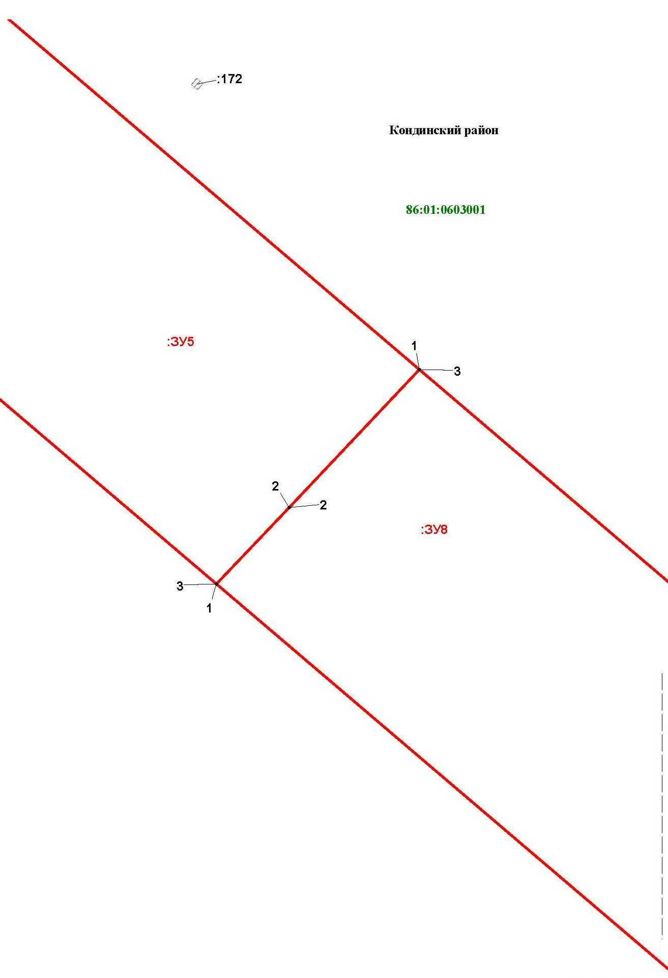

Линия совмещения с листом 8

Основная часть проекта межевания территории для размещения объекта капитального строительства, расположенного на территории двух муниципальных образований
Ханты-Мансийского автономного округа – Югры
«Обустройство Чапровского месторождения.
Кусты 1, 1а, 2, 2а, 4, 4а, 5, 5а и коридоры коммуникаций»
Землепользователь: АО «НК «Конданефть»

Основная часть проекта межевания территории для размещения объекта капитального строительства, расположенного на территории двух муниципальных образований
Ханты-Мансийского автономного округа – Югры,
«Обустройство Чапровского месторождения.
Кусты 1, 1а, 2, 2а, 4, 4а, 5, 5а и коридоры коммуникаций»
Землепользователь: АО «НК «Конданефть»
Масштаб 1:2000

Основная часть проекта межевания территории для размещения объекта капитального строительства, расположенного на территории двух муниципальных образований
Ханты-Мансийского автономного округа – Югры,
«Обустройство Чапровского месторождения.
Кусты 1, 1а, 2, 2а, 4, 4а, 5, 5а и коридоры коммуникаций»
Землепользователь: АО «НК «Конданефть»
Масштаб 1:2000

Основная часть проекта межевания территории для размещения объекта капитального строительства, расположенного на территории двух муниципальных образований
Ханты-Мансийского автономного округа – Югры,
«Обустройство Чапровского месторождения.
Кусты 1, 1а, 2, 2а, 4, 4а, 5, 5а и коридоры коммуникаций»
Землепользователь: АО «НК «Конданефть»
Масштаб 1:2000

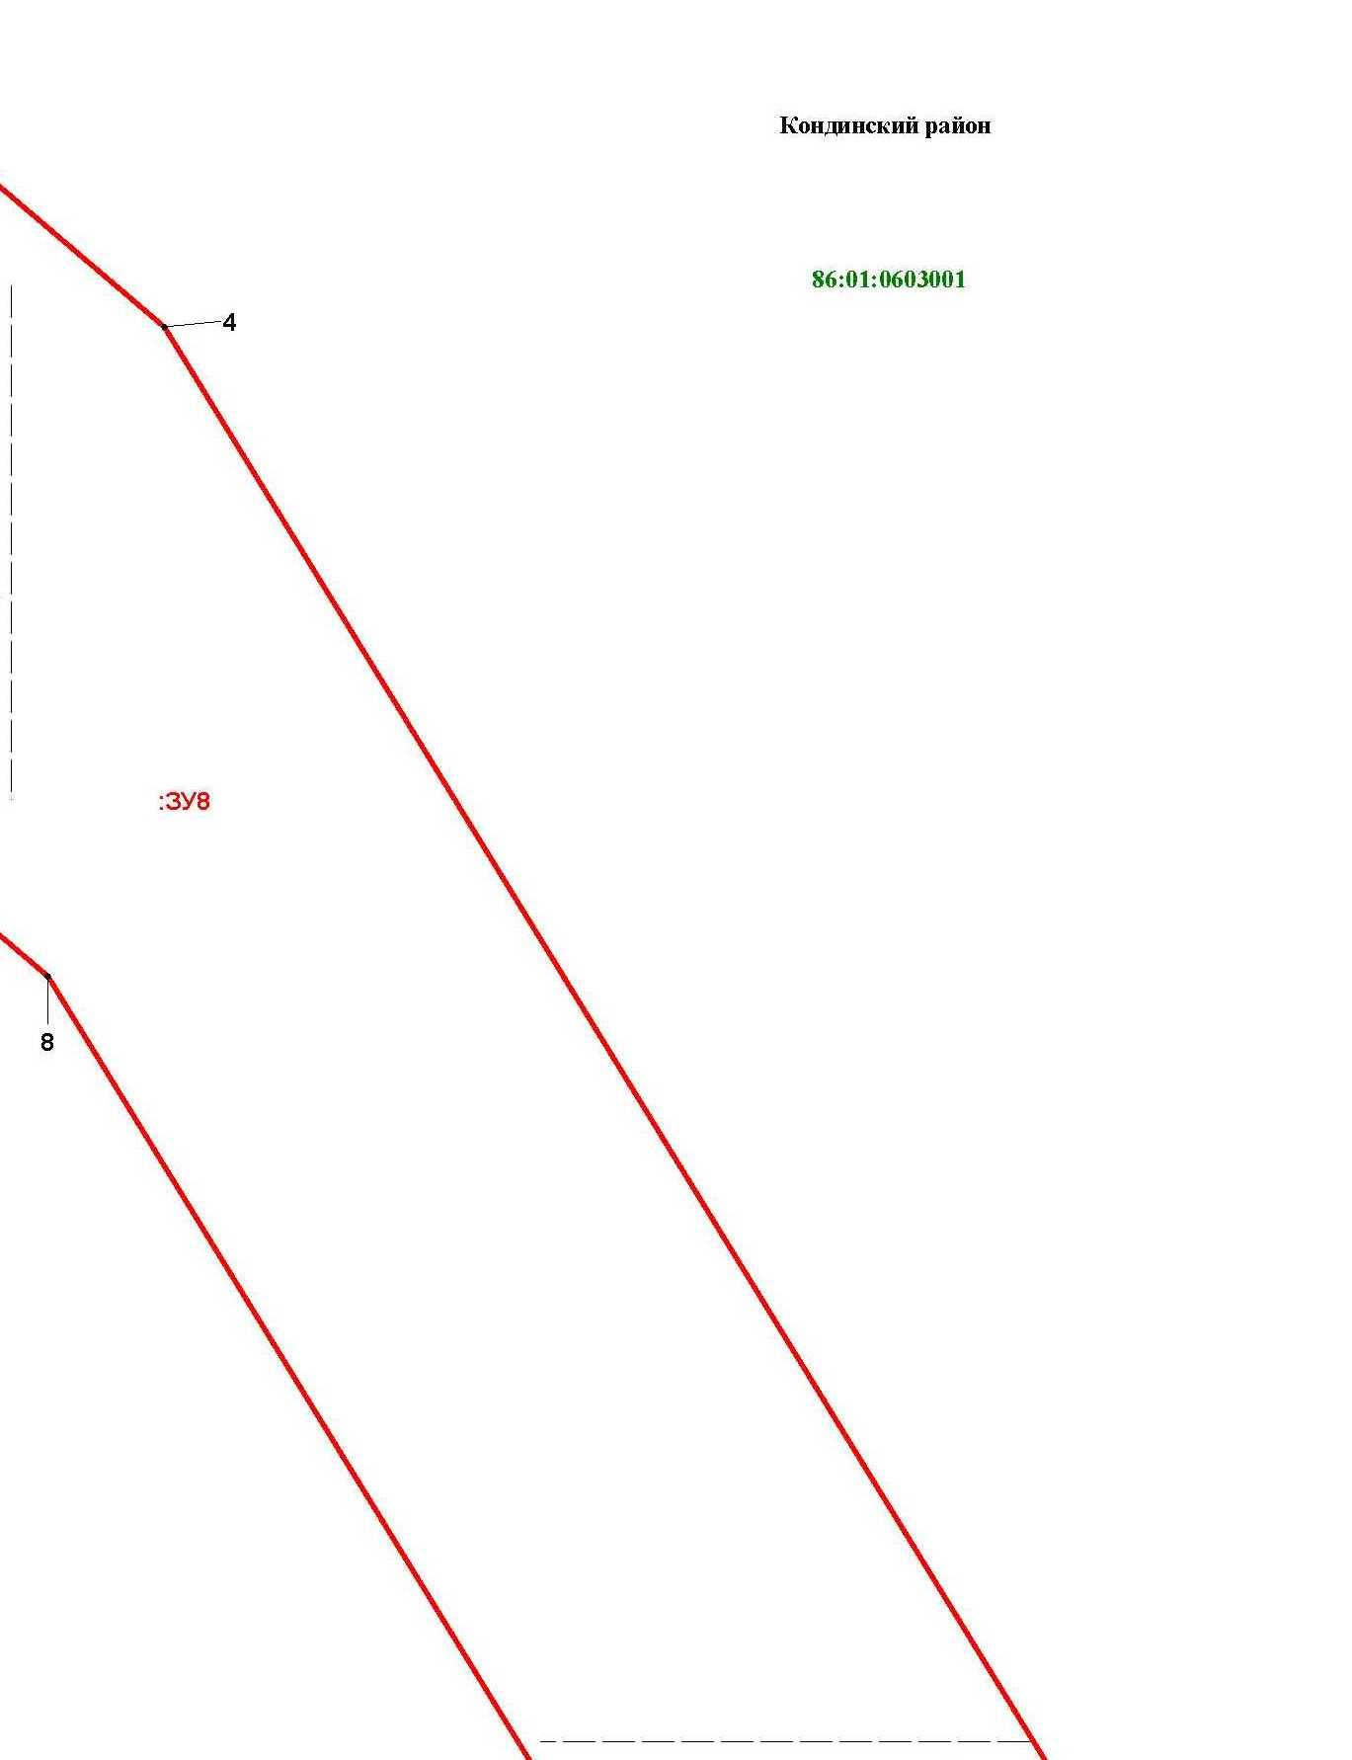

Линия совмещения с листом 10

Основная часть проекта межевания территории для размещения объекта капитального строительства, расположенного на территории двух муниципальных образований
Ханты-Мансийского автономного округа – Югры,
«Обустройство Чапровского месторождения.
Кусты 1, 1а, 2, 2а, 4, 4а, 5, 5а и коридоры коммуникаций»
Землепользователь: АО «НК «Конданефть»
Масштаб 1:2000

Линия совмещения с листом 12

Линия совмещения с листом 11

Основная часть проекта межевания территории для размещения объекта капитального строительства, расположенного на территории двух муниципальных образований
Ханты-Мансийского автономного округа – Югры
«Обустройство Чапровского месторождения.
Кусты 1, 1а, 2, 2а, 4, 4а, 5, 5а и коридоры коммуникаций»
Землепользователь: АО «НК «Конданефть»

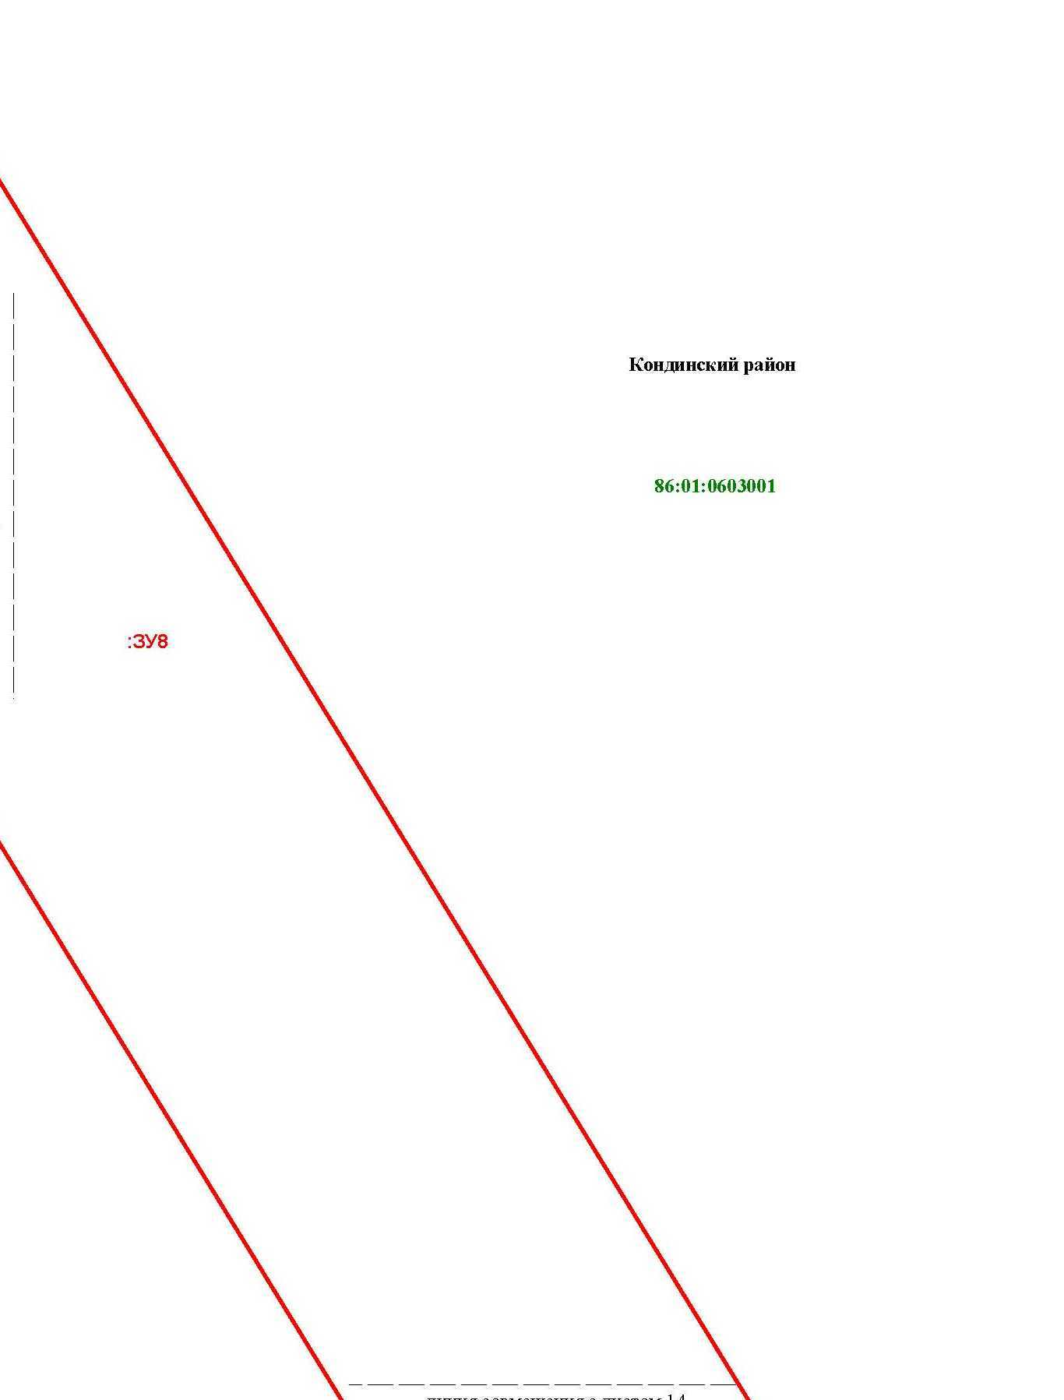

Линия совмещения с листом 15

Линия совмещения с листом 15

Основная часть проекта межевания территории для размещения объекта капитального строительства, расположенного на территории двух муниципальных образований
Ханты-Мансийского автономного округа – Югры,
«Обустройство Чапровского месторождения.
Кусты 1, 1а, 2, 2а, 4, 4а, 5, 5а и коридоры коммуникаций»
Землепользователь: АО «НК «Конданефть»
Масштаб 1:2000

Линия совмещения с листом 13
Линия совмещения с листом 16

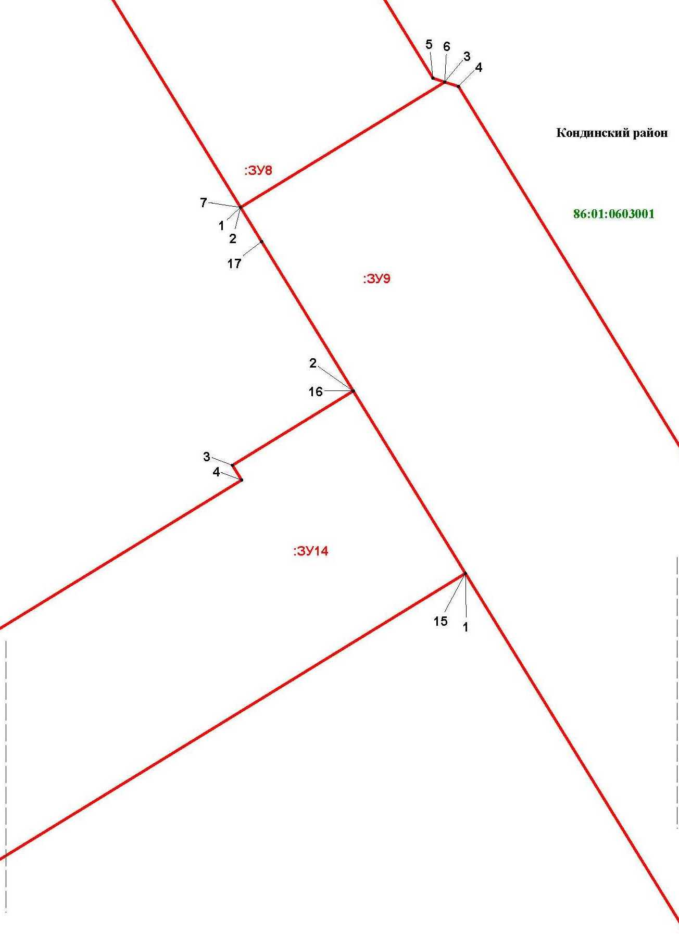

Основная часть проекта межевания территории для размещения объекта капитального строительства, расположенного на территории двух муниципальных образований
Ханты-Мансийского автономного округа – Югры,
«Обустройство Чапровского месторождения.
Кусты 1, 1а, 2, 2а, 4, 4а, 5, 5а и коридоры коммуникаций»
Землепользователь: АО «НК «Конданефть»
Масштаб 1:2000

Линия совмещения с листом 14

Основная часть проекта межевания территории для размещения объекта капитального строительства, расположенного на территории двух муниципальных образований
Ханты-Мансийского автономного округа – Югры,
«Обустройство Чапровского месторождения.
Кусты 1, 1а, 2, 2а, 4, 4а, 5, 5а и коридоры коммуникаций»
Землепользователь: АО «НК «Конданефть»
Масштаб 1:2000

Линия совмещения с листом 18

Линия совмещения с листом 15

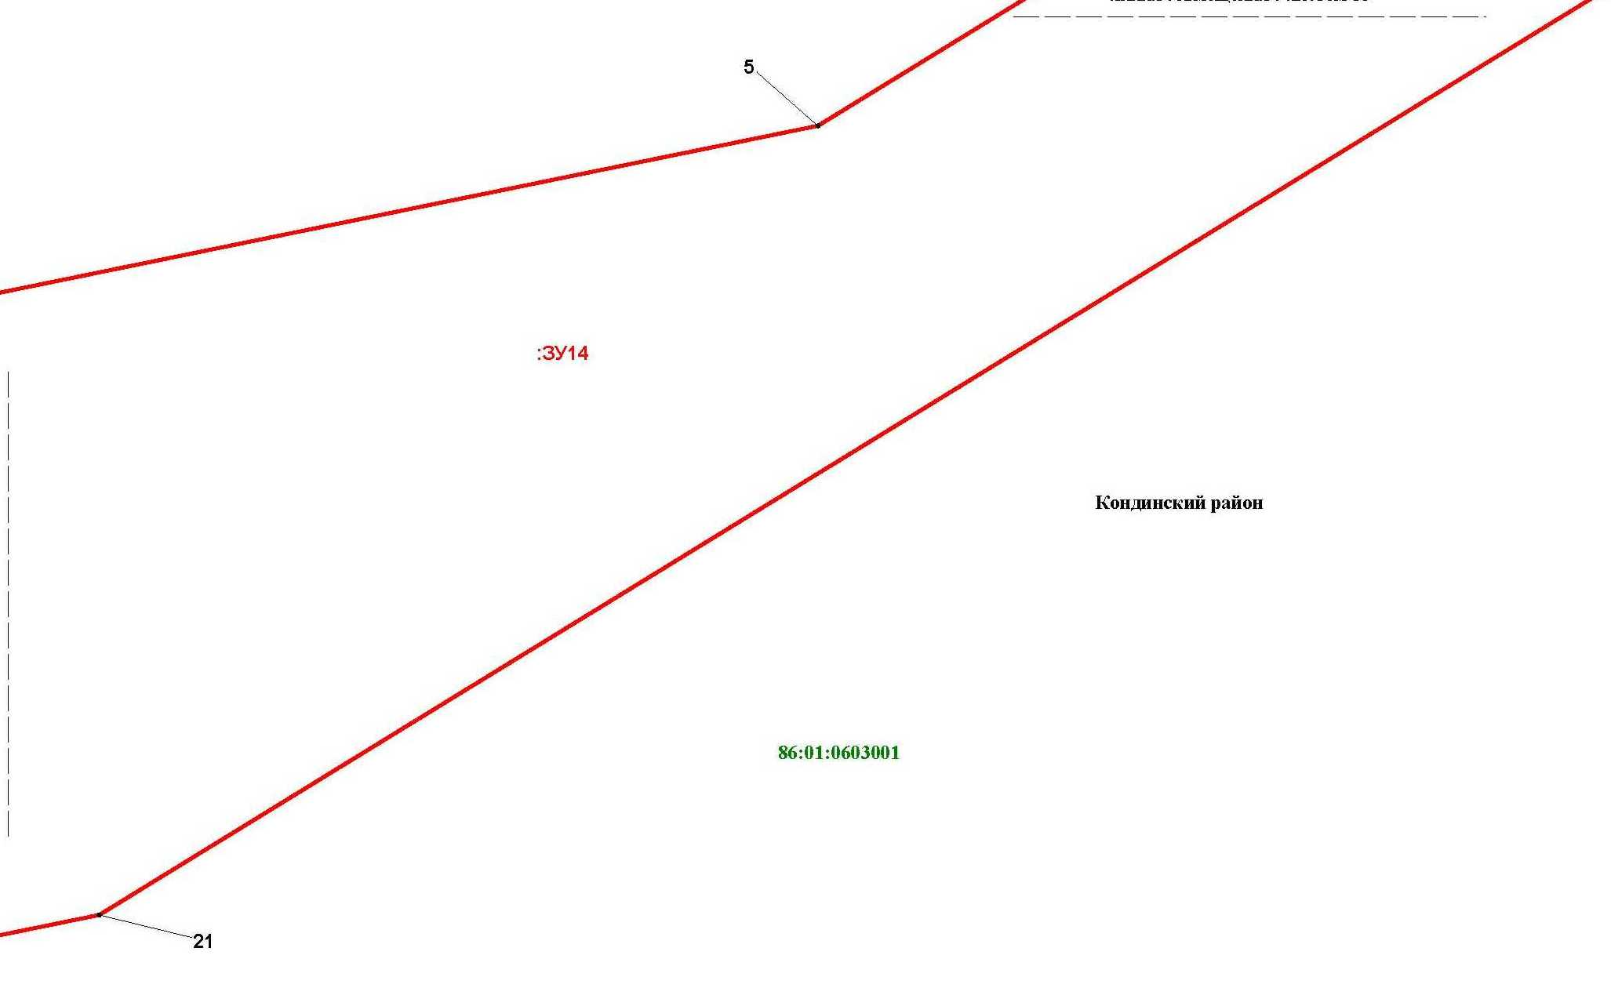

Основная часть проекта межевания территории для размещения объекта капитального строительства, расположенного на территории двух муниципальных образований
Ханты-Мансийского автономного округа – Югры,
«Обустройство Чапровского месторождения.
Кусты 1, 1а, 2, 2а, 4, 4а, 5, 5а и коридоры коммуникаций»
Землепользователь: АО «НК «Конданефть»
Масштаб 1:2000

Линия совмещения с листом 16

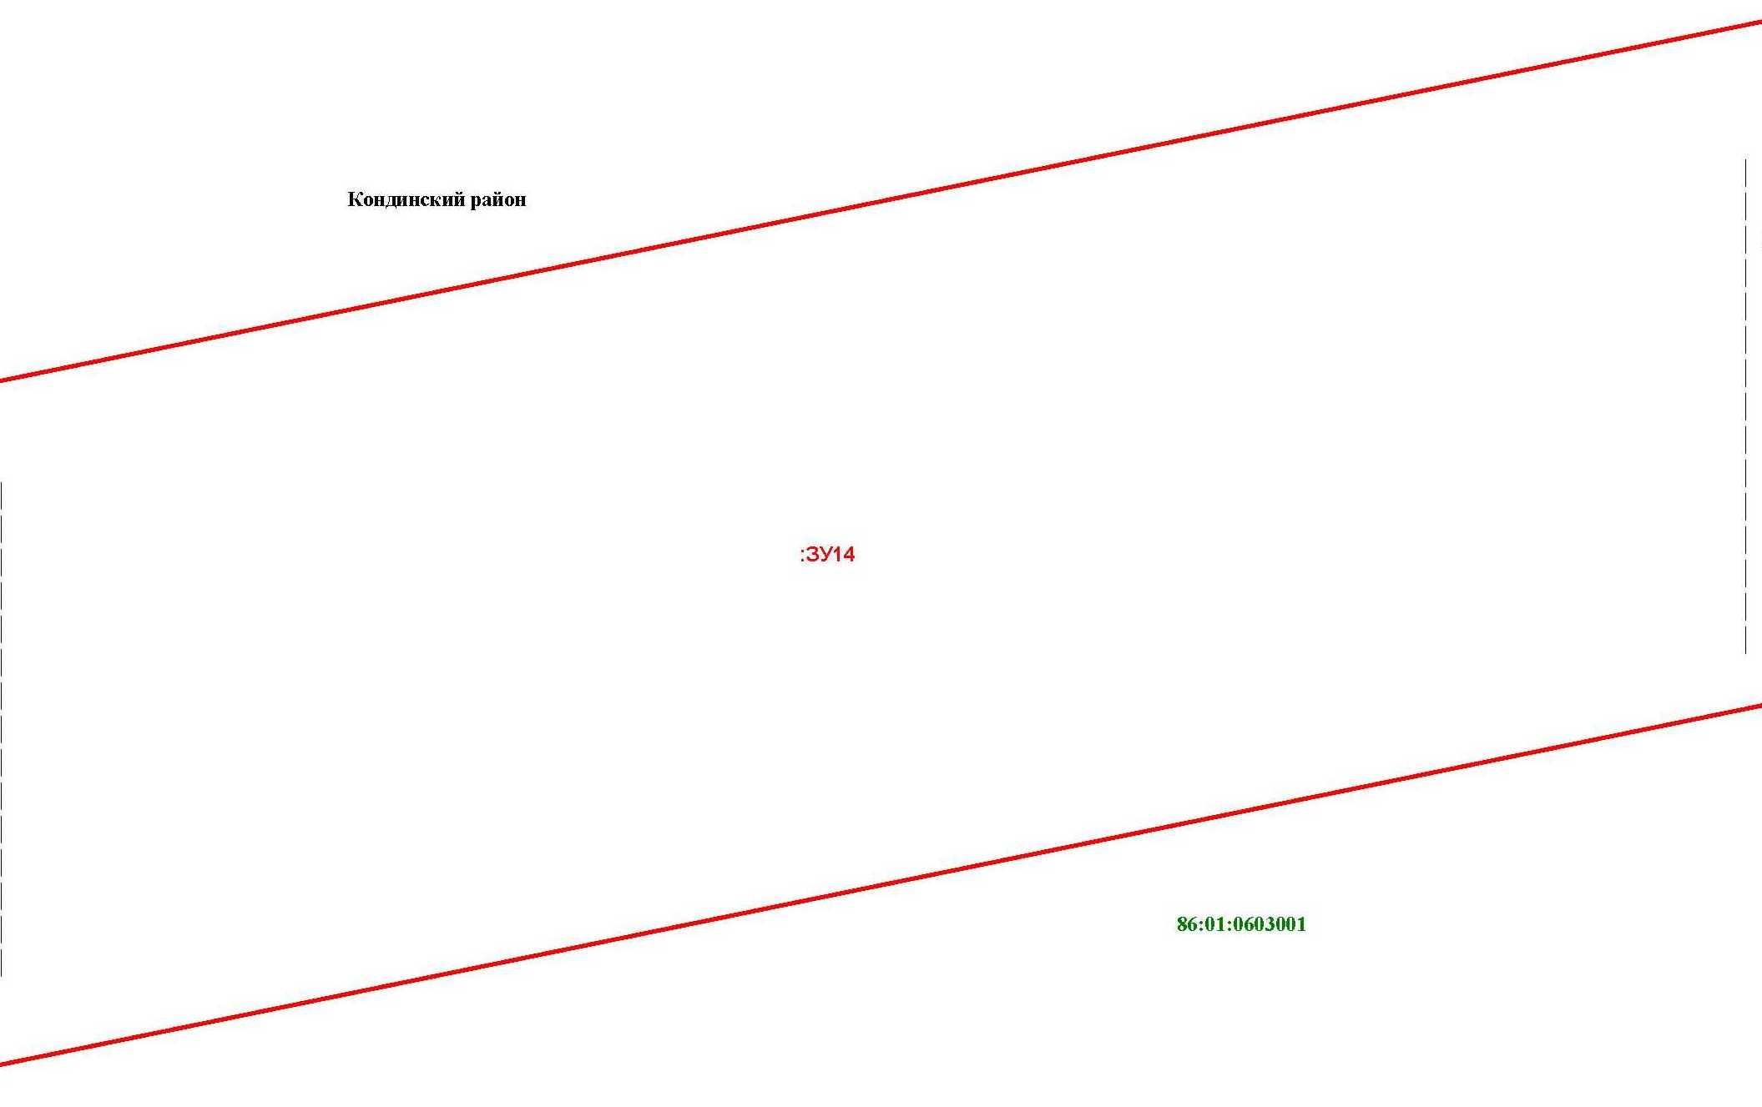

Основная часть проекта межевания территории для размещения объекта капитального строительства, расположенного на территории двух муниципальных образований
Ханты-Мансийского автономного округа – Югры,
«Обустройство Чапровского месторождения.
Кусты 1, 1а, 2, 2а, 4, 4а, 5, 5а и коридоры коммуникаций»
Землепользователь: АО «НК «Конданефть»
Масштаб 1:2000

Линия совмещения с листом 17

Основная часть проекта межевания территории для размещения объекта капитального строительства, расположенного на территории двух муниципальных образований
Ханты-Мансийского автономного округа – Югры,
«Обустройство Чапровского месторождения.
Кусты 1, 1а, 2, 2а, 4, 4а, 5, 5а и коридоры коммуникаций»
Землепользователь: АО «НК «Конданефть»
Масштаб 1:2000

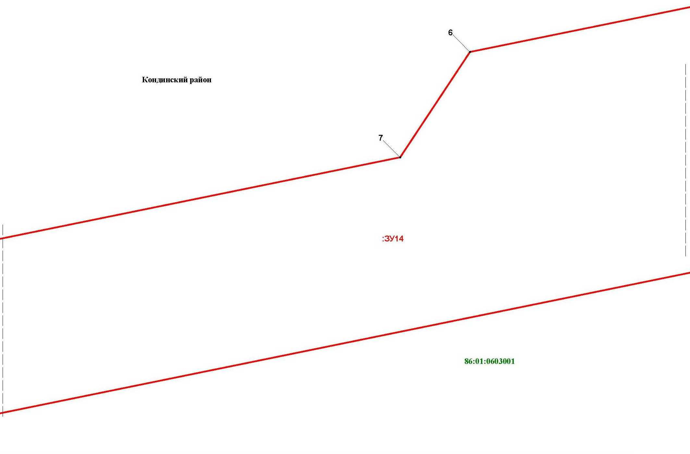

Основная часть проекта межевания территории для размещения объекта капитального строительства, расположенного на территории двух муниципальных образований
Ханты-Мансийского автономного округа – Югры,
«Обустройство Чапровского месторождения.
Кусты 1, 1а, 2, 2а, 4, 4а, 5, 5а и коридоры коммуникаций»
Землепользователь: АО «НК «Конданефть»
Масштаб 1:2000

Линия совмещения с листом
219

Линия совмещения с листом 18

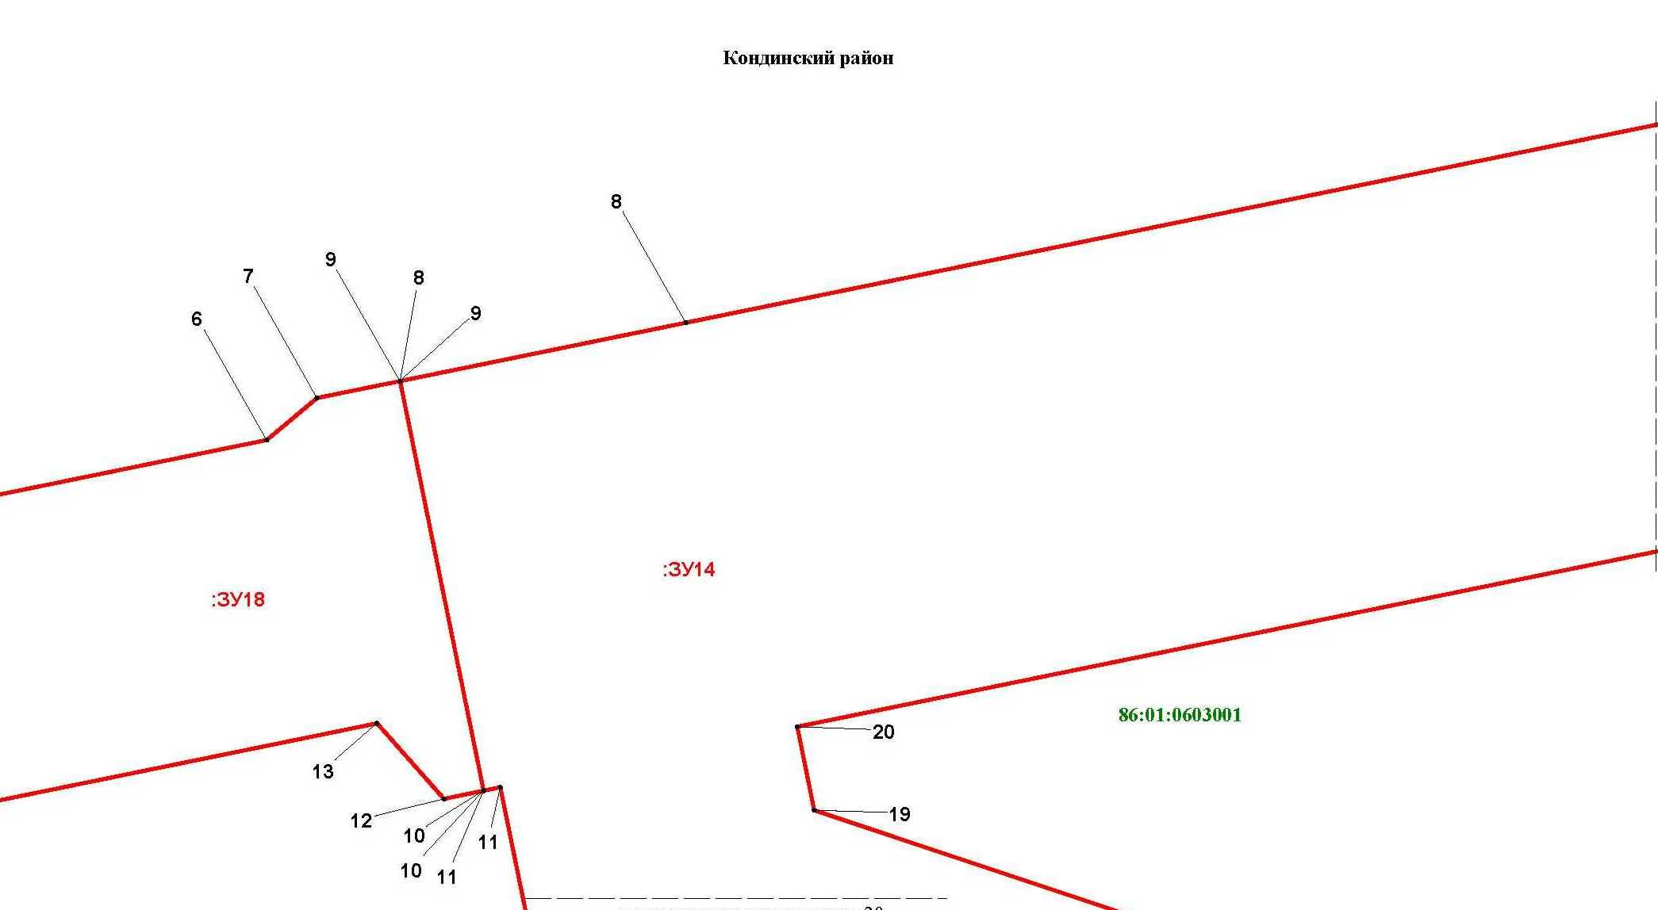

Основная часть проекта межевания территории для размещения объекта капитального строительства, расположенного на территории двух муниципальных образований
Ханты-Мансийского автономного округа – Югры,
«Обустройство Чапровского месторождения.
Кусты 1, 1а, 2, 2а, 4, 4а, 5, 5а и коридоры коммуникаций»
Землепользователь: АО «НК «Конданефть»
Масштаб 1:2000

Основная часть проекта межевания территории для размещения объекта капитального строительства, расположенного на территории двух муниципальных образований
Ханты-Мансийского автономного округа – Югры
«Обустройство Чапровского месторождения.
Кусты 1, 1а, 2, 2а, 4, 4а, 5, 5а и коридоры коммуникаций»
Землепользователь: АО «НК «Конданефть»

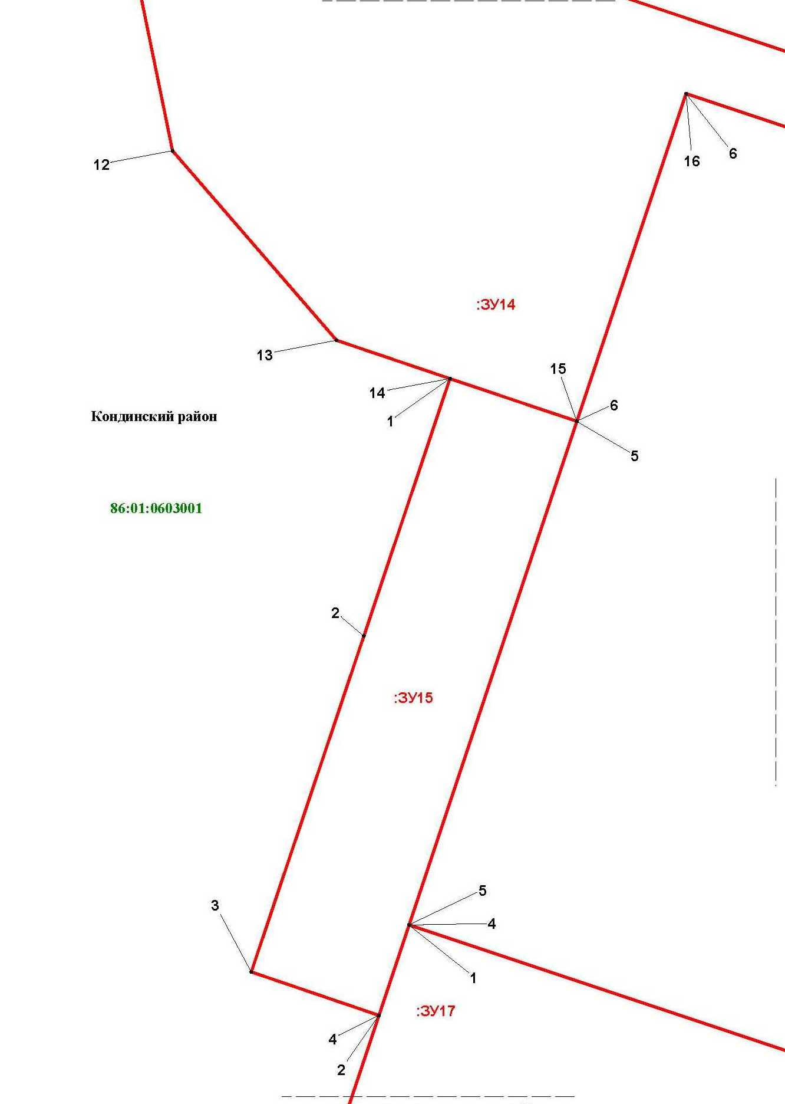

Линия совмещения с листом
2
1

Основная часть проекта межевания территории для размещения объекта капитального строительства, расположенного на территории двух муниципальных образований
Ханты-Мансийского автономного округа – Югры,
«Обустройство Чапровского месторождения.
Кусты 1, 1а, 2, 2а, 4, 4а, 5, 5а и коридоры коммуникаций»
Землепользователь: АО «НК «Конданефть»
Масштаб 1:2000

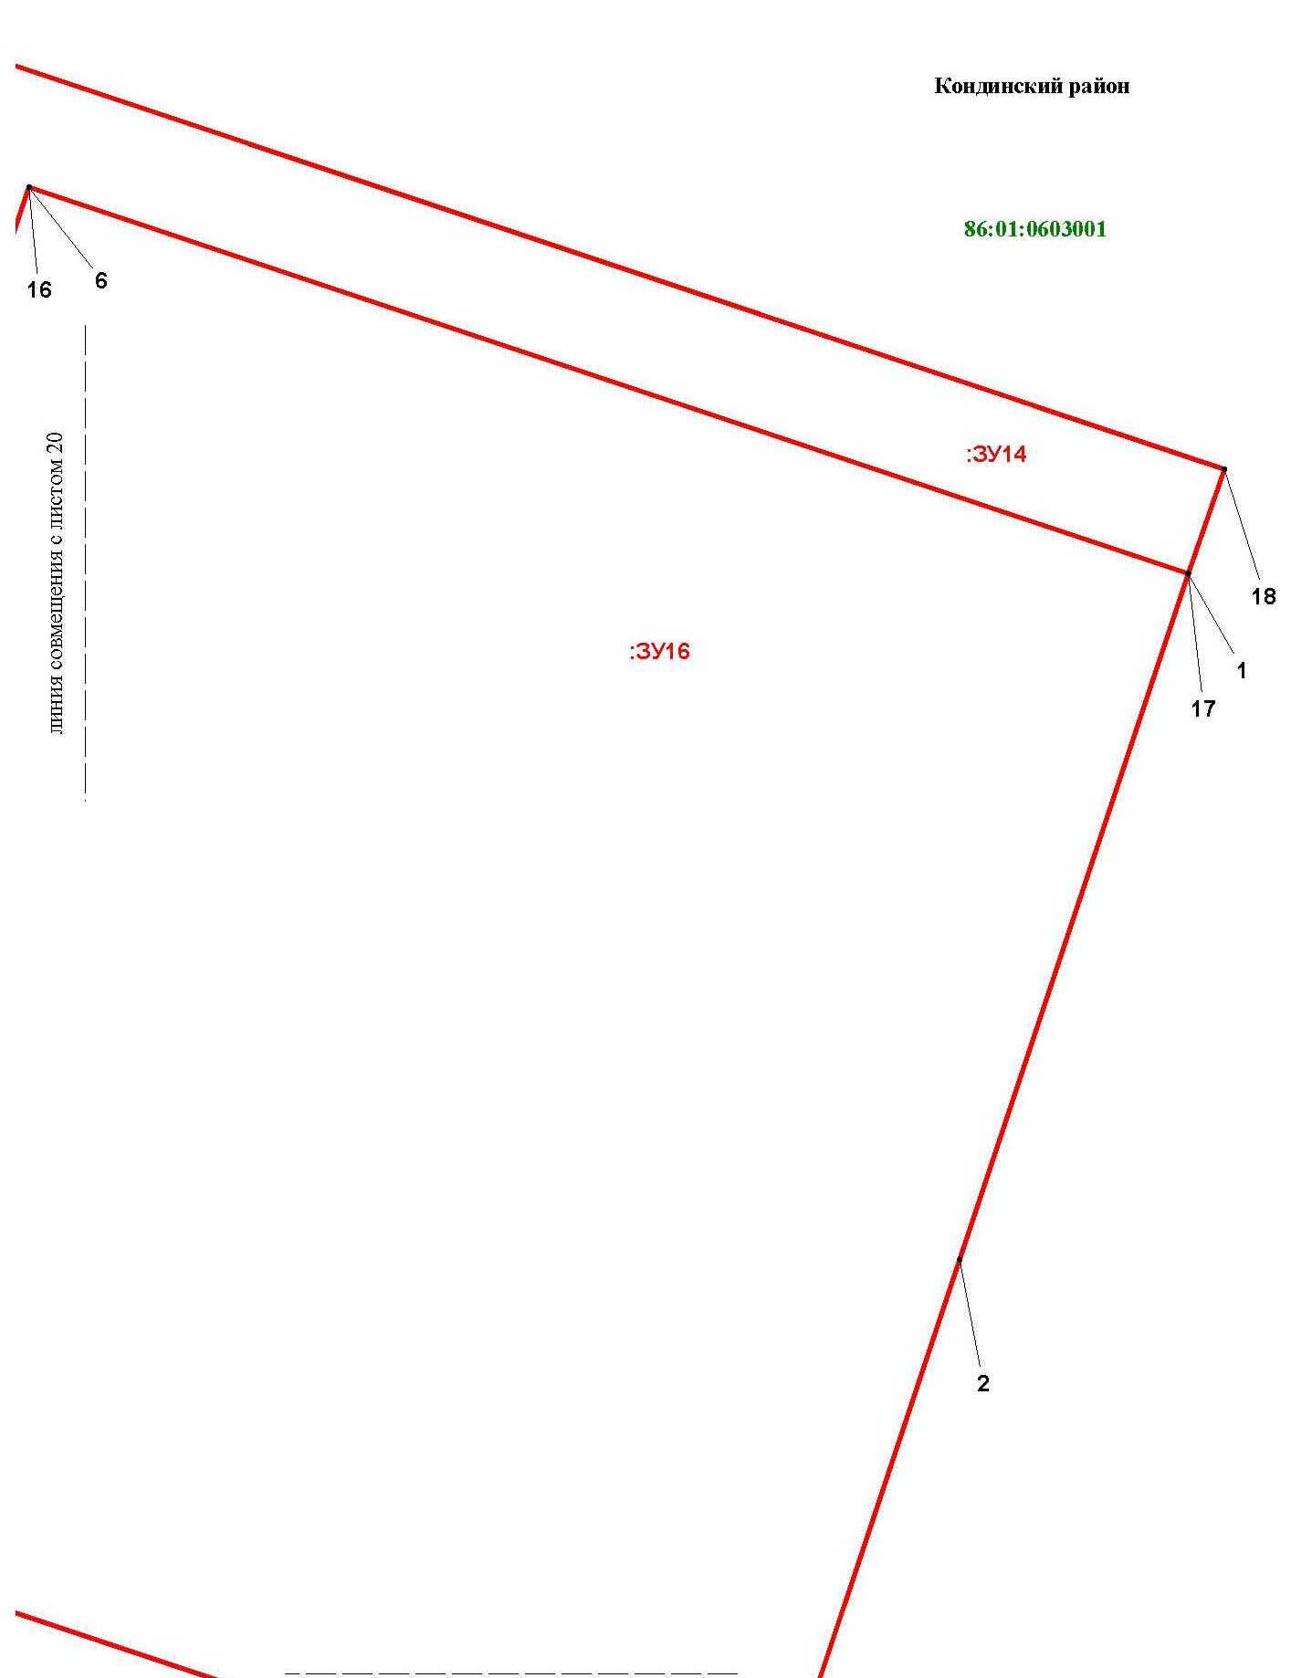

Основная часть проекта межевания территории для размещения объекта капитального строительства, расположенного на территории двух муниципальных образований
Ханты-Мансийского автономного округа – Югры,
«Обустройство Чапровского месторождения.
Кусты 1, 1а, 2, 2а, 4, 4а, 5, 5а и коридоры коммуникаций»
Землепользователь: АО «НК «Конданефть»
Масштаб 1:2000

Основная часть проекта межевания территории для размещения объекта капитального строительства, расположенного на территории двух муниципальных образований
Ханты-Мансийского автономного округа – Югры,
«Обустройство Чапровского месторождения.
Кусты 1, 1а, 2, 2а, 4, 4а, 5, 5а и коридоры коммуникаций»
Землепользователь: АО «НК «Конданефть»
Масштаб 1:2000

Линия совмещения с листом 22
Линия совмещения с листом
2
3

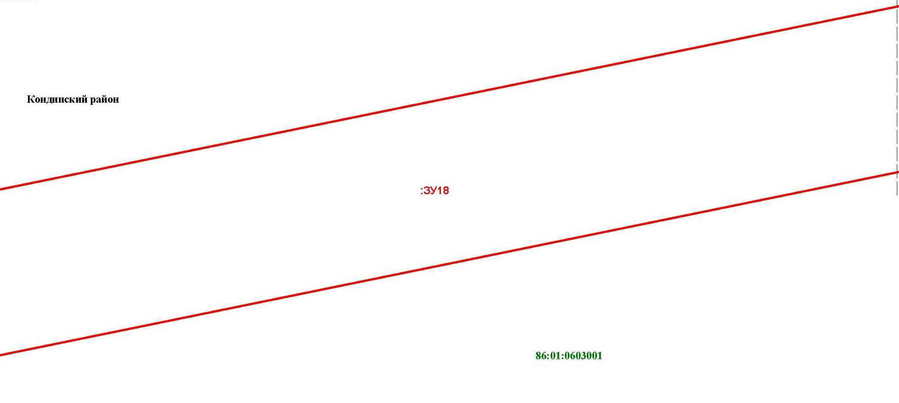

Основная часть проекта межевания территории для размещения объекта капитального строительства, расположенного на территории двух муниципальных образований
Ханты-Мансийского автономного округа – Югры,
«Обустройство Чапровского месторождения.
Кусты 1, 1а, 2, 2а, 4, 4а, 5, 5а и коридоры коммуникаций»
Землепользователь: АО «НК «Конданефть»
Масштаб 1:2000

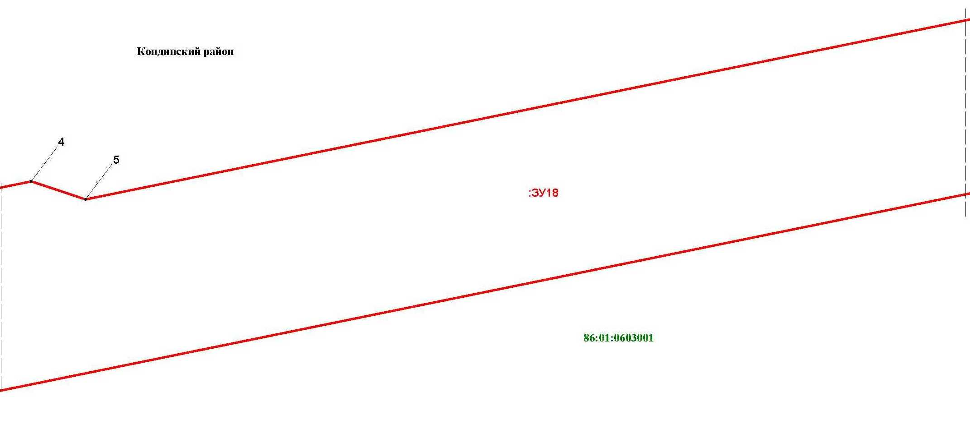

Линия совмещения с листом 26

Основная часть проекта межевания территории для размещения объекта капитального строительства, расположенного на территории двух муниципальных образований
Ханты-Мансийского автономного округа – Югры
«Обустройство Чапровского месторождения.
Кусты 1, 1а, 2, 2а, 4, 4а, 5, 5а и коридоры коммуникаций»
Землепользователь: АО «НК «Конданефть»

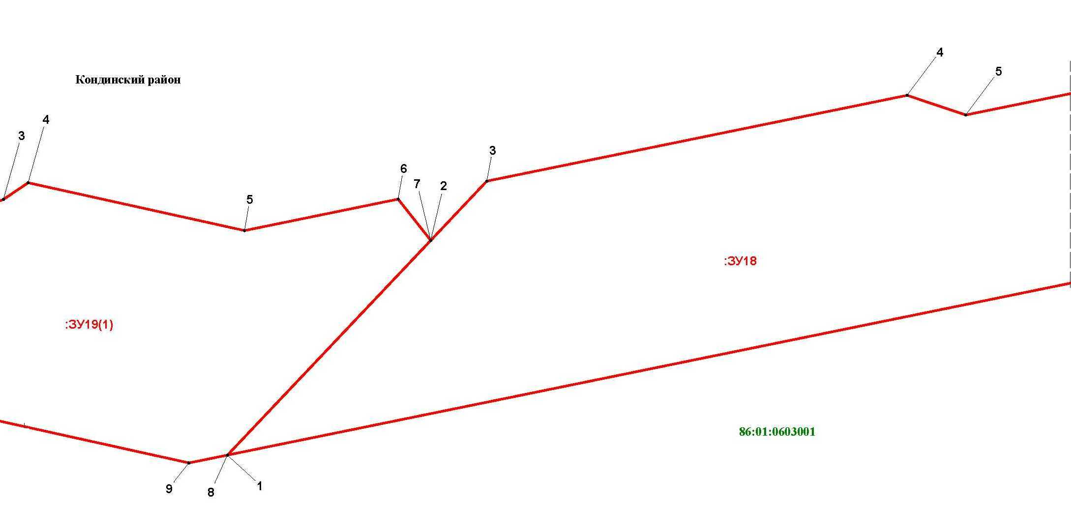

Основная часть проекта межевания территории для размещения объекта капитального строительства, расположенного на территории двух муниципальных образований
Ханты-Мансийского автономного округа – Югры,
«Обустройство Чапровского месторождения.
Кусты 1, 1а, 2, 2а, 4, 4а, 5, 5а и коридоры коммуникаций»
Землепользователь: АО «НК «Конданефть»
Масштаб 1:2000

Линия совмещения с листом
2
6

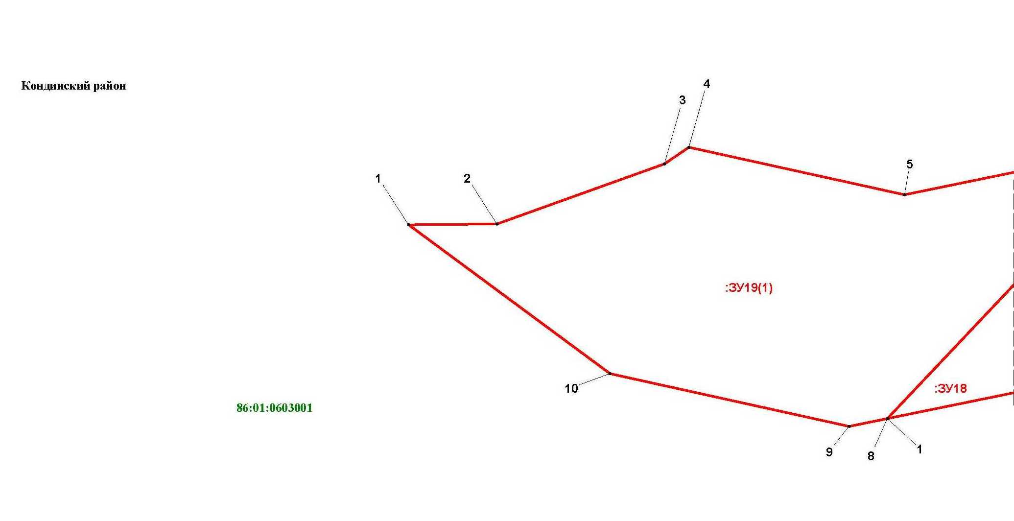

Основная часть проекта межевания территории для размещения объекта капитального строительства, расположенного на территории двух муниципальных образований
Ханты-Мансийского автономного округа – Югры,
«Обустройство Чапровского месторождения.
Кусты 1, 1а, 2, 2а, 4, 4а, 5, 5а и коридоры коммуникаций»
Землепользователь: АО «НК «Конданефть»
Масштаб 1:2000

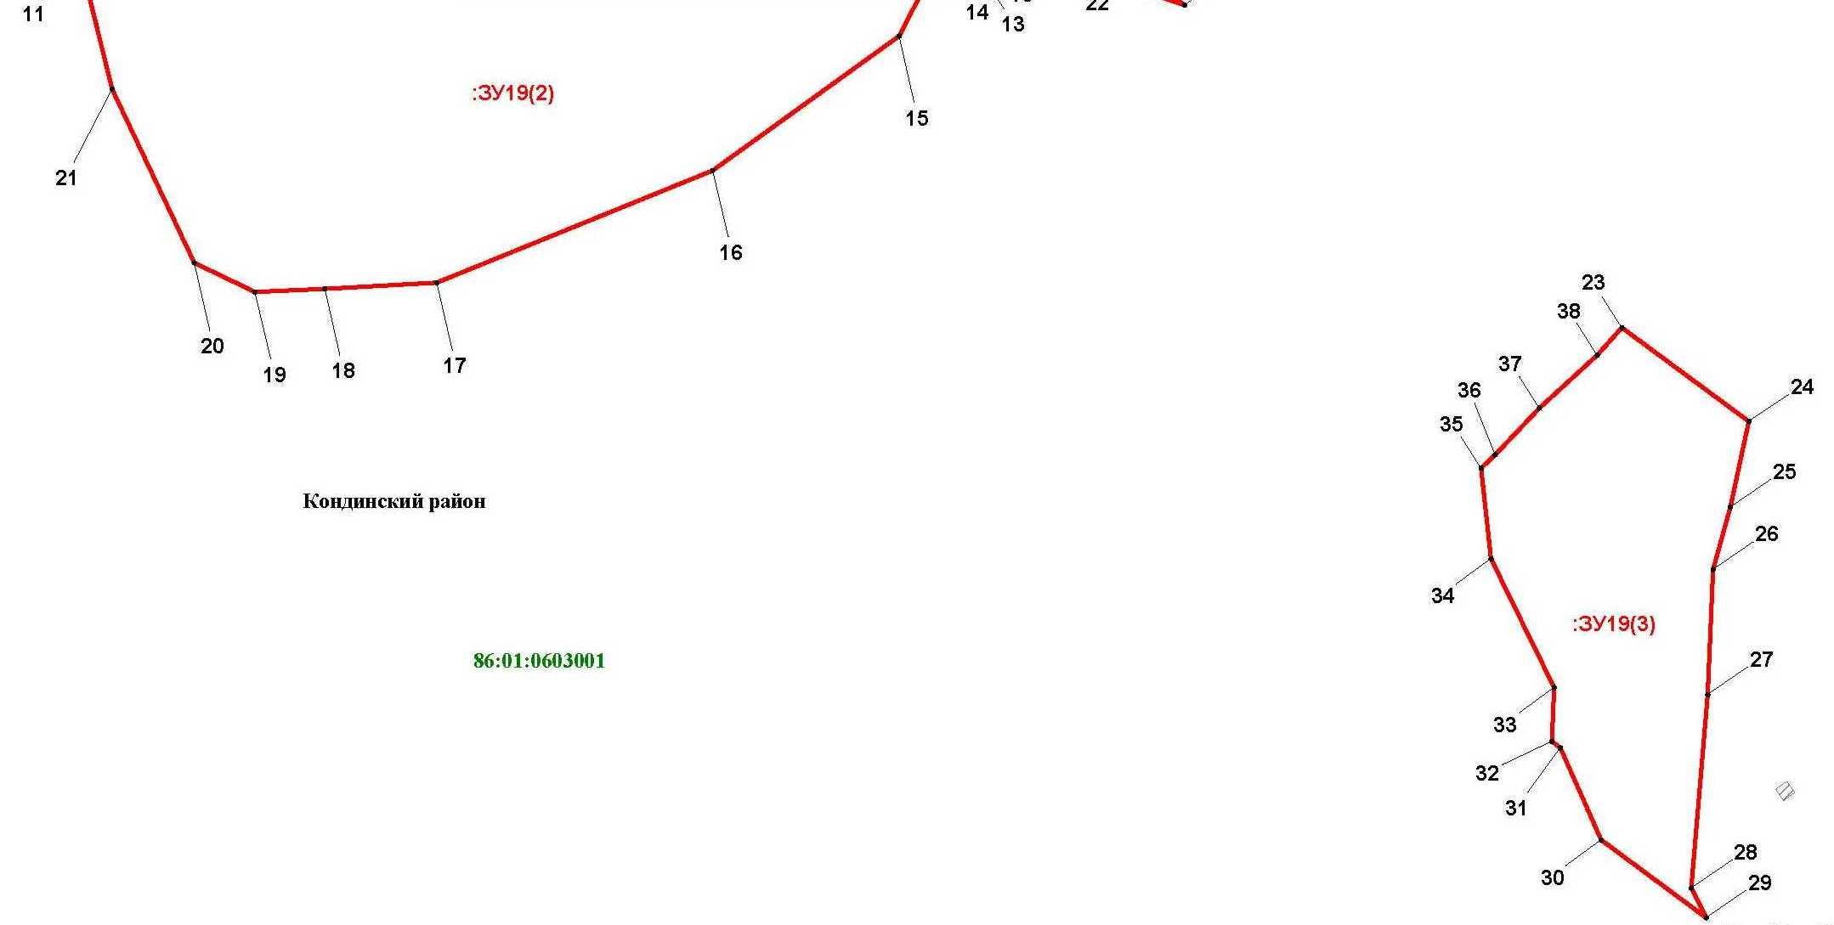

Основная часть проекта межевания территории для размещения объекта капитального строительства, расположенного на территории двух муниципальных образований
Ханты-Мансийского автономного округа – Югры
«Обустройство Чапровского месторождения.
Кусты 1, 1а, 2, 2а, 4, 4а, 5, 5а и коридоры коммуникаций»
Землепользователь: АО «НК «Конданефть»

Основная часть проекта межевания территории для размещения объекта капитального строительства, расположенного на территории двух муниципальных образований
Ханты-Мансийского автономного округа – Югры,
«Обустройство Чапровского месторождения.
Кусты 1, 1а, 2, 2а, 4, 4а, 5, 5а и коридоры коммуникаций»
Землепользователь: АО «НК «Конданефть»
Масштаб 1:2000

Основная часть проекта межевания территории для размещения объекта капитального строительства, расположенного на территории двух муниципальных образований
Ханты-Мансийского автономного округа – Югры,
«Обустройство Чапровского месторождения.
Кусты 1, 1а, 2, 2а, 4, 4а, 5, 5а и коридоры коммуникаций»
Землепользователь: АО «НК «Конданефть»
Масштаб 1:2000

Линия совмещения с листом 27
Линия совмещения с листом
28

Линия совмещения с листом
30

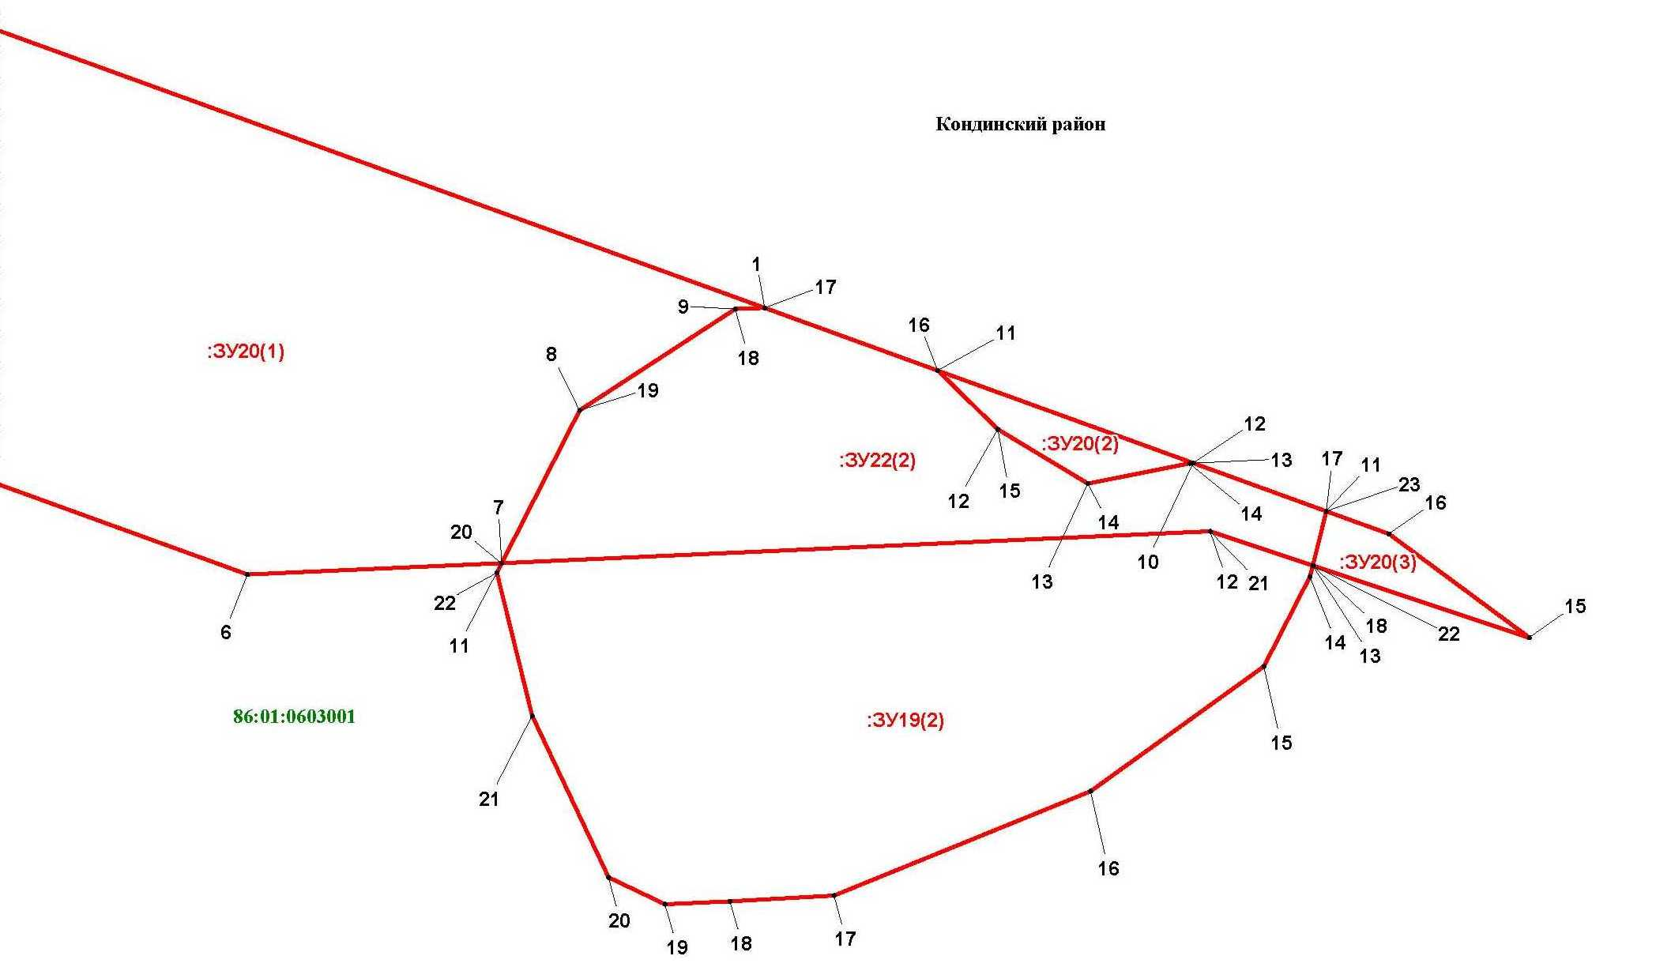

Основная часть проекта межевания территории для размещения объекта капитального строительства, расположенного на территории двух муниципальных образований
Ханты-Мансийского автономного округа – Югры,
«Обустройство Чапровского месторождения.
Кусты 1, 1а, 2, 2а, 4, 4а, 5, 5а и коридоры коммуникаций»
Землепользователь: АО «НК «Конданефть»
Масштаб 1:2000

Линия совмещения с листом
29

Линия совмещения с листом
31

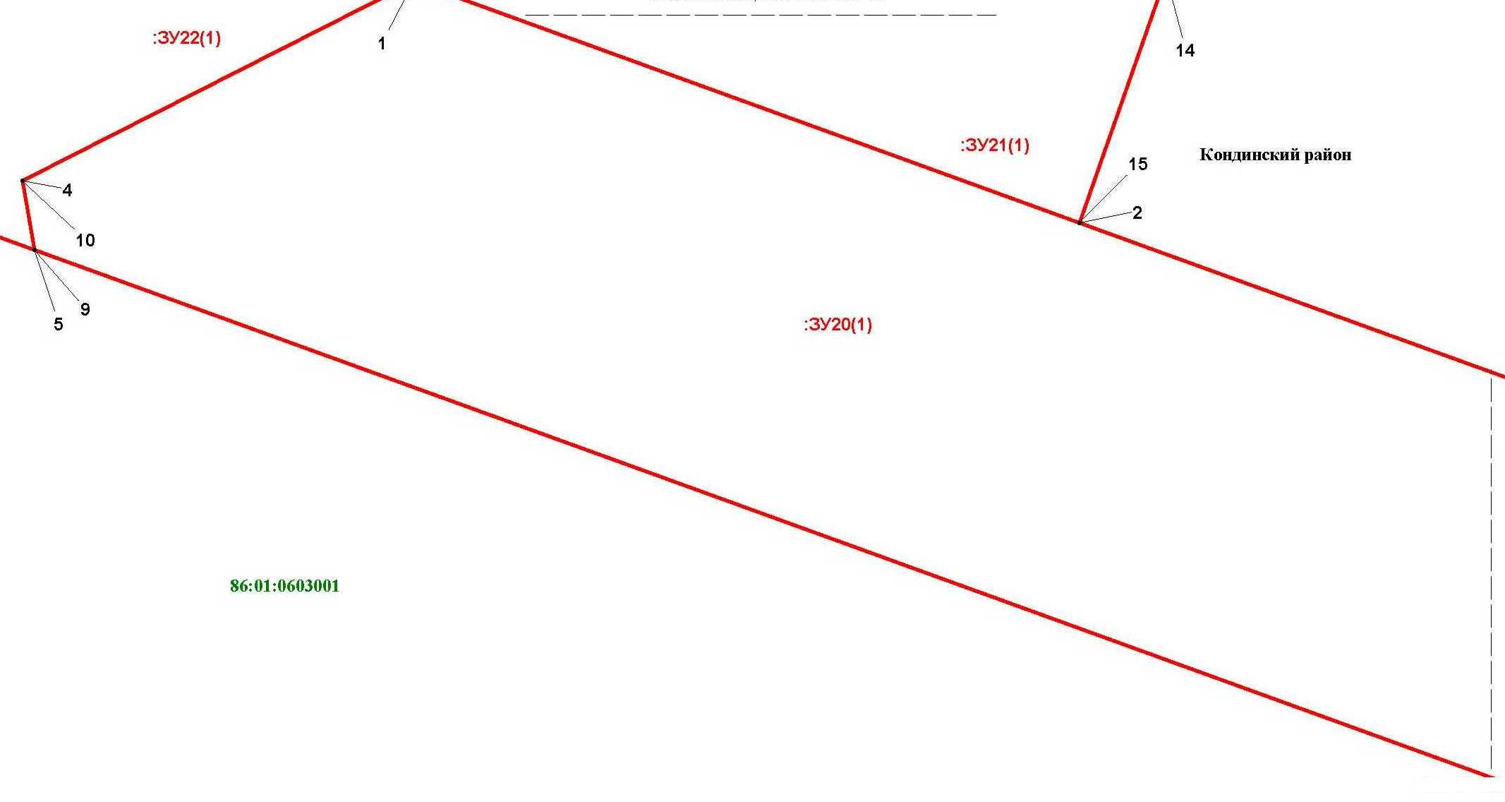

Линия совмещения с листом 31

Линия совмещения с листом
31

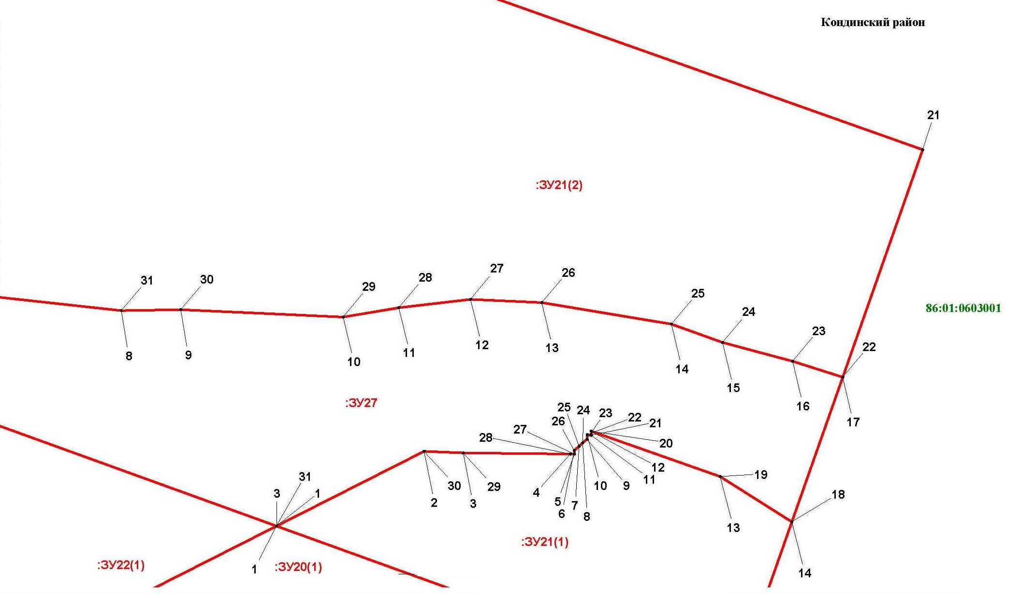

Основная часть проекта межевания территории для размещения объекта капитального строительства, расположенного на территории двух муниципальных образований
Ханты-Мансийского автономного округа – Югры,
«Обустройство Чапровского месторождения.
Кусты 1, 1а, 2, 2а, 4, 4а, 5, 5а и коридоры коммуникаций»
Землепользователь: АО «НК «Конданефть»
Масштаб 1:2000

Линия совмещения с листом
31

Линия совмещения с листом
31

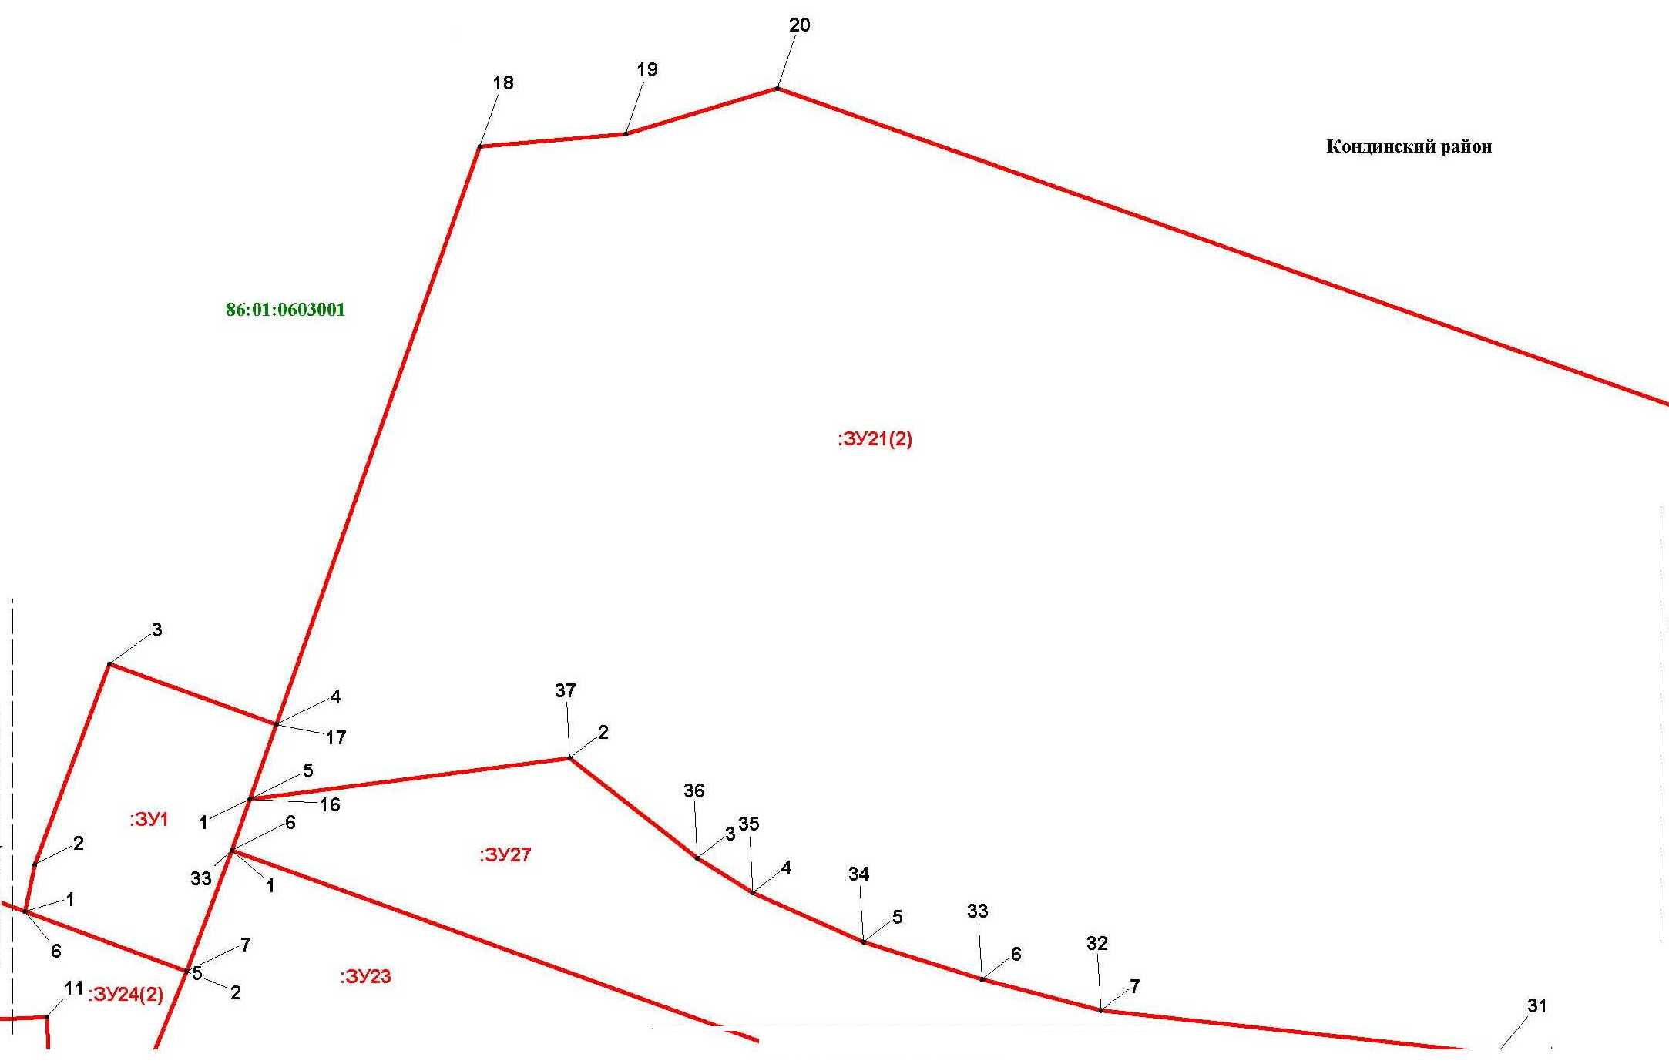

Линия совмещения с листом 33

Основная часть проекта межевания территории для размещения объекта капитального строительства, расположенного на территории двух муниципальных образований
Ханты-Мансийского автономного округа – Югры,
«Обустройство Чапровского месторождения.
Кусты 1, 1а, 2, 2а, 4, 4а, 5, 5а и коридоры коммуникаций»
Землепользователь: АО «НК «Конданефть»
Масштаб 1:2000

Линия совмещения с листом
34

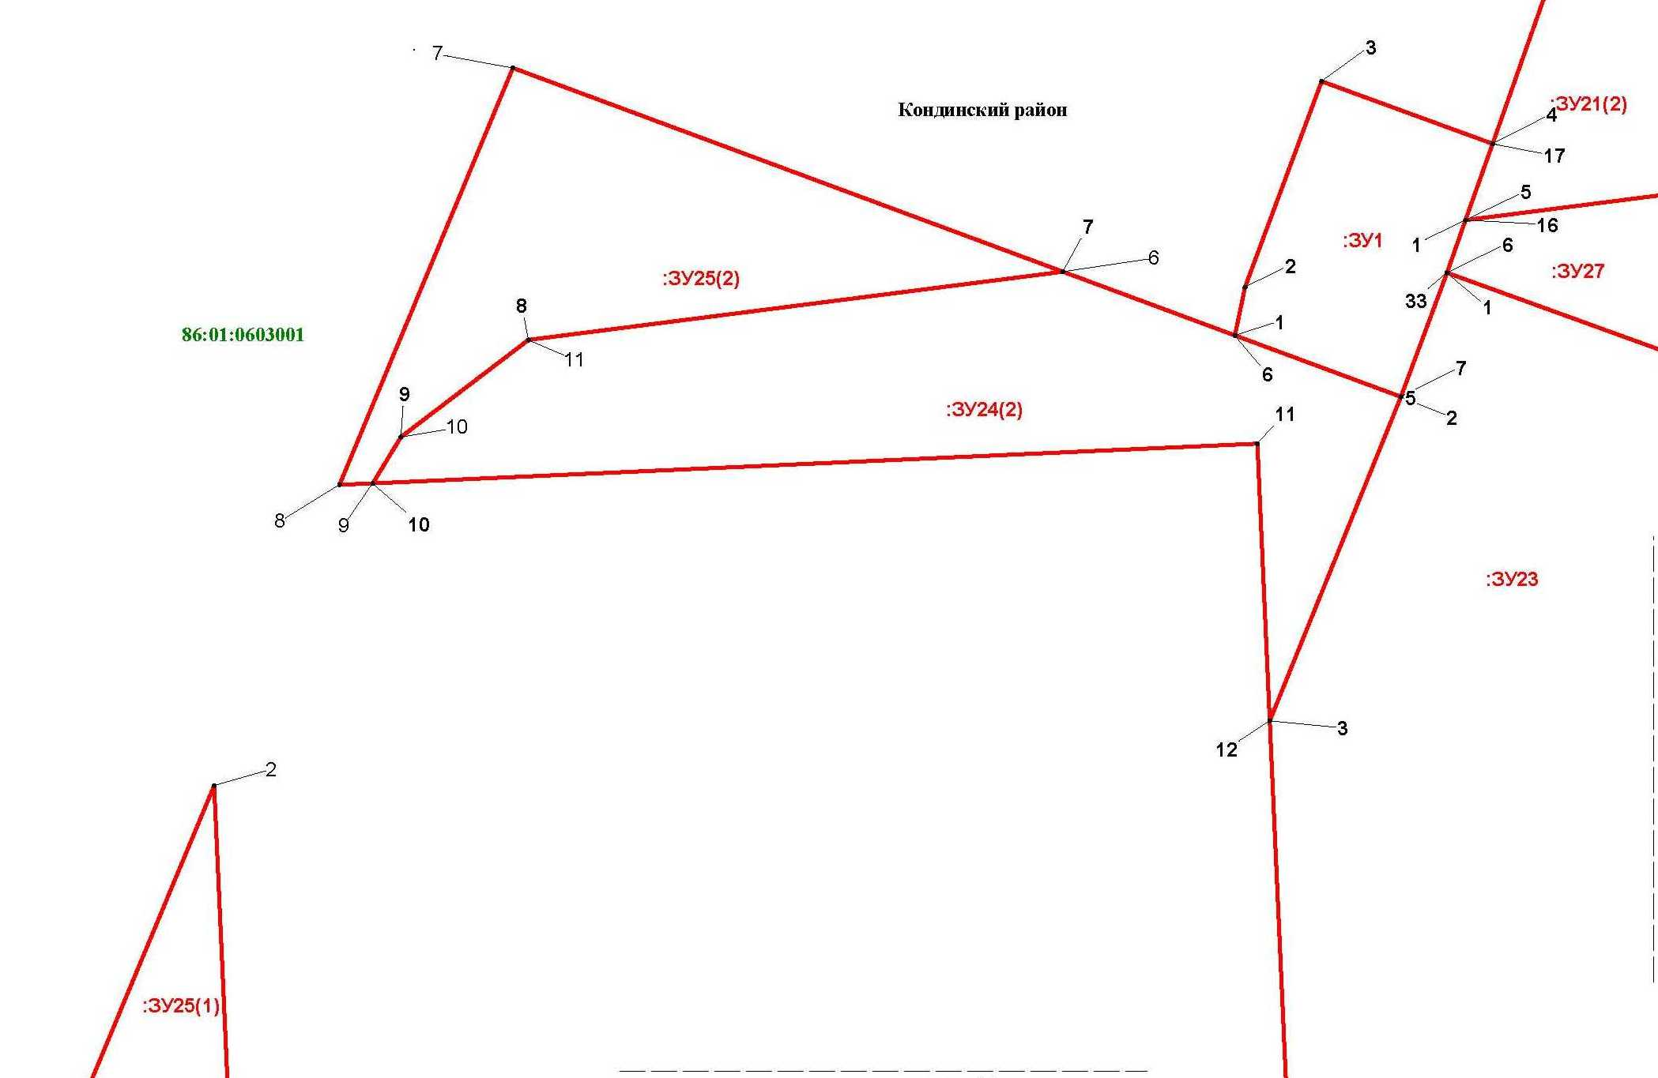
Основная часть проекта межевания территории для размещения объекта капитального строительства, расположенного на территории двух муниципальных образований
Ханты-Мансийского автономного округа – Югры,
«Обустройство Чапровского месторождения.
Кусты 1, 1а, 2, 2а, 4, 4а, 5, 5а и коридоры коммуникаций»
Землепользователь: АО «НК «Конданефть»
Масштаб 1:2000

Линия совмещения с листом
35

Линия совмещения с листом 32

Основная часть проекта межевания территории для размещения объекта капитального строительства, расположенного на территории двух муниципальных образований
Ханты-Мансийского автономного округа – Югры,
«Обустройство Чапровского месторождения.
Кусты 1, 1а, 2, 2а, 4, 4а, 5, 5а и коридоры коммуникаций»
Землепользователь: АО «НК «Конданефть»
Масштаб 1:2000

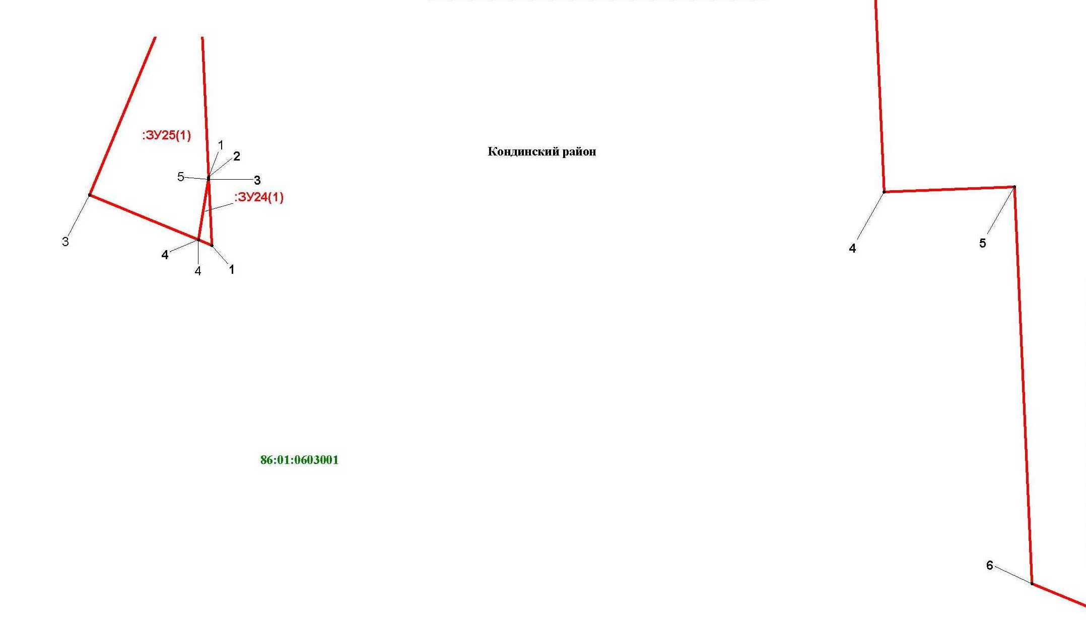
Линия совмещения с листом
34

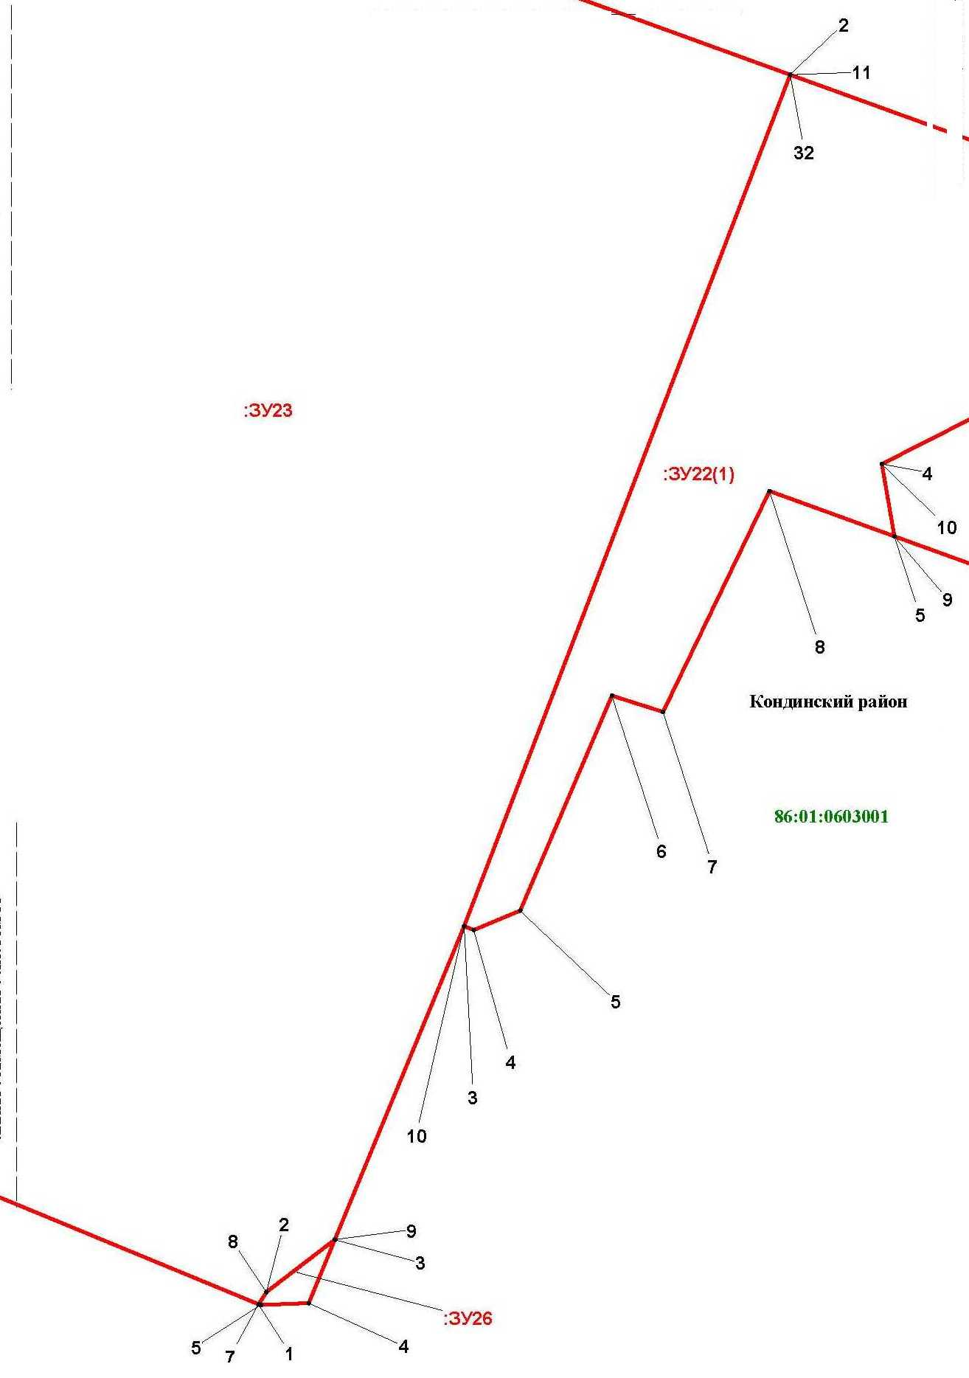

Линия совмещения с листом 34

Линия совмещения с листом
32

Основная часть проекта межевания территории для размещения объекта капитального строительства, расположенного на территории двух муниципальных образований
Ханты-Мансийского автономного округа – Югры,
«Обустройство Чапровского месторождения.
Кусты 1, 1а, 2, 2а, 4, 4а, 5, 5а и коридоры коммуникаций»
Землепользователь: АО «НК «Конданефть»
Масштаб 1:2000

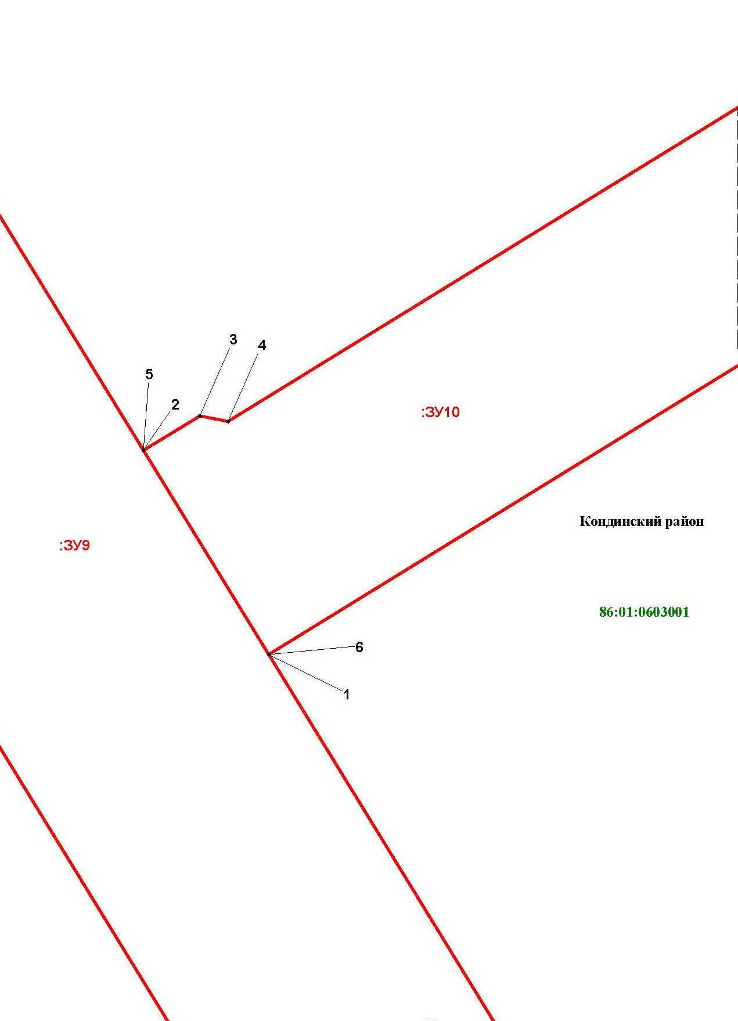

Основная часть проекта межевания территории для размещения объекта капитального строительства, расположенного на территории двух муниципальных образований
Ханты-Мансийского автономного округа – Югры
«Промысловый нефтепровод «ЦПС Кондинское-ДНС с УПСВ Западно-Эргинское»
Землепользователь: АО «НК «Конданефть»

Линия совмещения с листом 35

Линия совмещения с листом
38

Основная часть проекта межевания территории для размещения объекта капитального строительства, расположенного на территории двух муниципальных образований
Ханты-Мансийского автономного округа – Югры,
«Обустройство Чапровского месторождения.
Кусты 1, 1а, 2, 2а, 4, 4а, 5, 5а и коридоры коммуникаций»
Землепользователь: АО «НК «Конданефть»
Масштаб 1:2000

Линия совмещения с листом 39

Линия совмещения с листом 39

Основная часть проекта межевания территории для размещения объекта капитального строительства, расположенного на территории двух муниципальных образований
Ханты-Мансийского автономного округа – Югры,
«Обустройство Чапровского месторождения.
Кусты 1, 1а, 2, 2а, 4, 4а, 5, 5а и коридоры коммуникаций»
Землепользователь: АО «НК «Конданефть»
Масштаб 1:2000

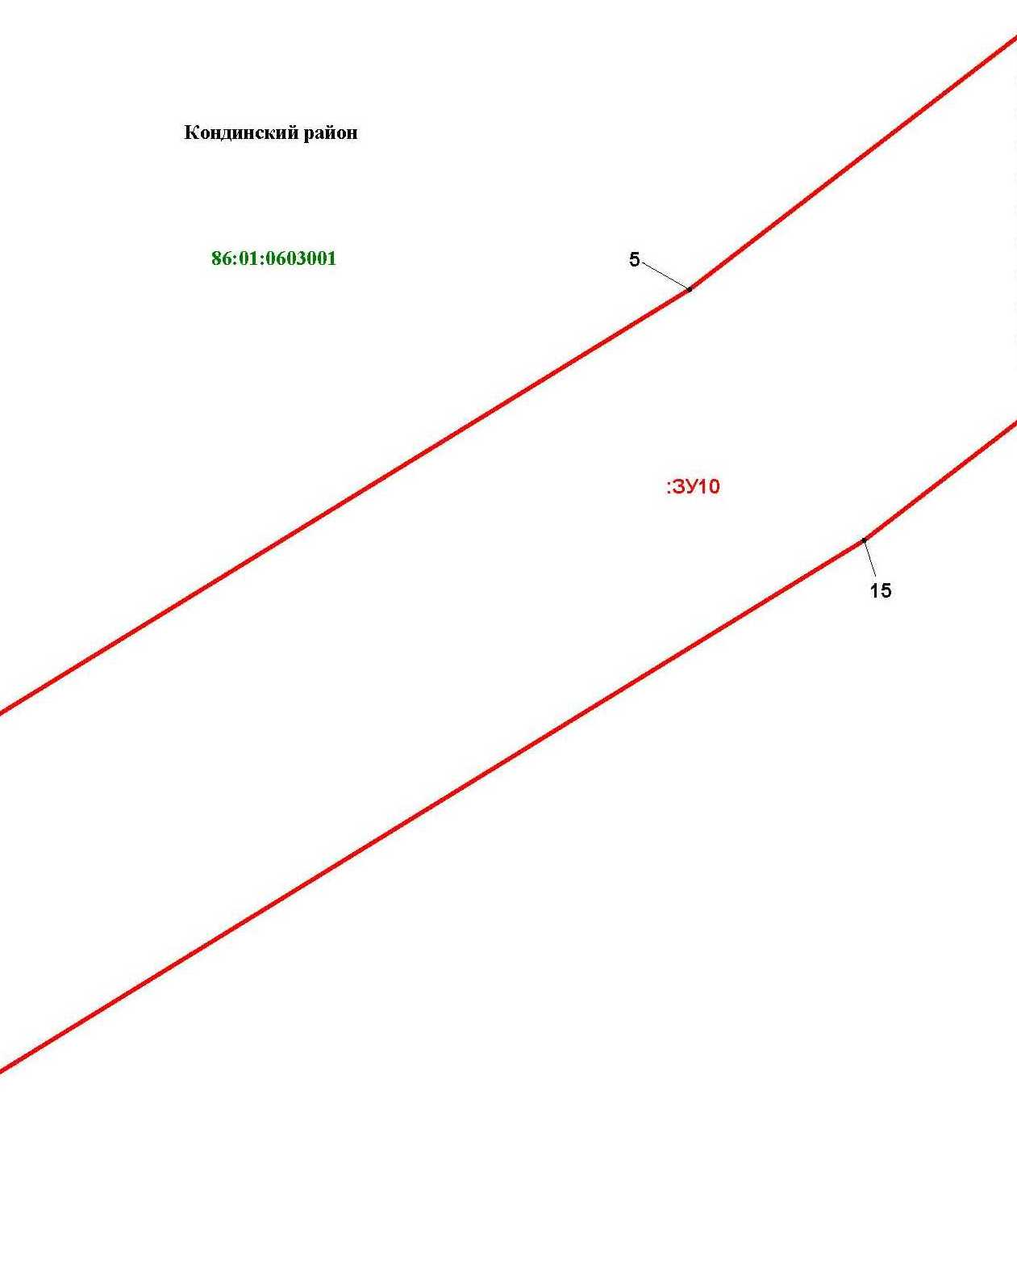
Линия совмещения с листом 37

Основная часть проекта межевания территории для размещения объекта капитального строительства, расположенного на территории двух муниципальных образований
Ханты-Мансийского автономного округа – Югры
«Промысловый нефтепровод «ЦПС Кондинское-ДНС с УПСВ Западно-Эргинское»
Землепользователь: АО «НК «Конданефть»

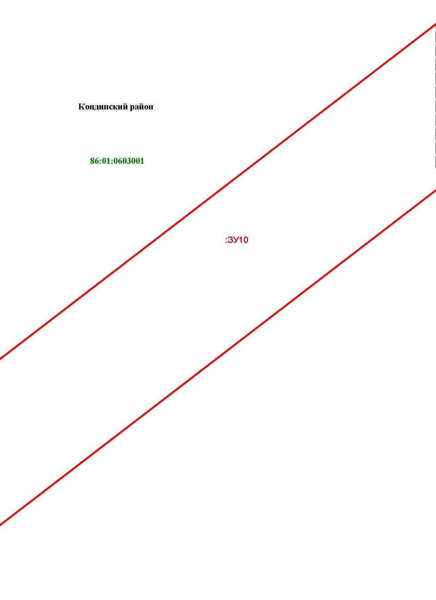
Линия совмещения с листом 38

Линия совмещения с листом 13

Основная часть проекта межевания территории для размещения объекта капитального строительства, расположенного на территории двух муниципальных образований
Ханты-Мансийского автономного округа – Югры,
«Обустройство Чапровского месторождения.
Кусты 1, 1а, 2, 2а, 4, 4а, 5, 5а и коридоры коммуникаций»
Землепользователь: АО «НК «Конданефть»
Масштаб 1:2000

Линия совмещения с листом 41

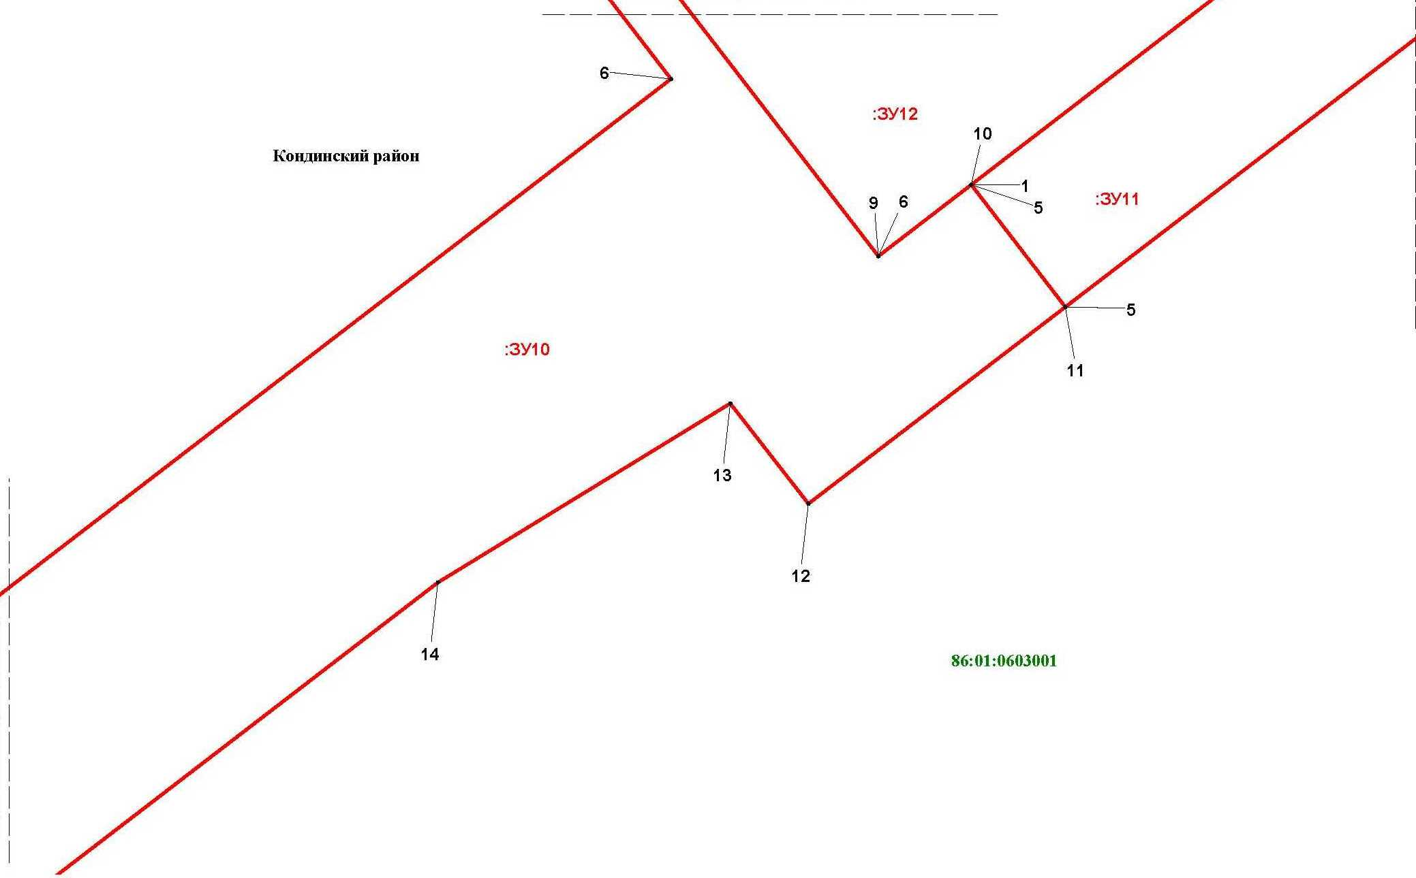

Основная часть проекта межевания территории для размещения объекта капитального строительства, расположенного на территории двух муниципальных образований
Ханты-Мансийского автономного округа – Югры,
«Обустройство Чапровского месторождения.
Кусты 1, 1а, 2, 2а, 4, 4а, 5, 5а и коридоры коммуникаций»
Землепользователь: АО «НК «Конданефть»
Масштаб 1:2000

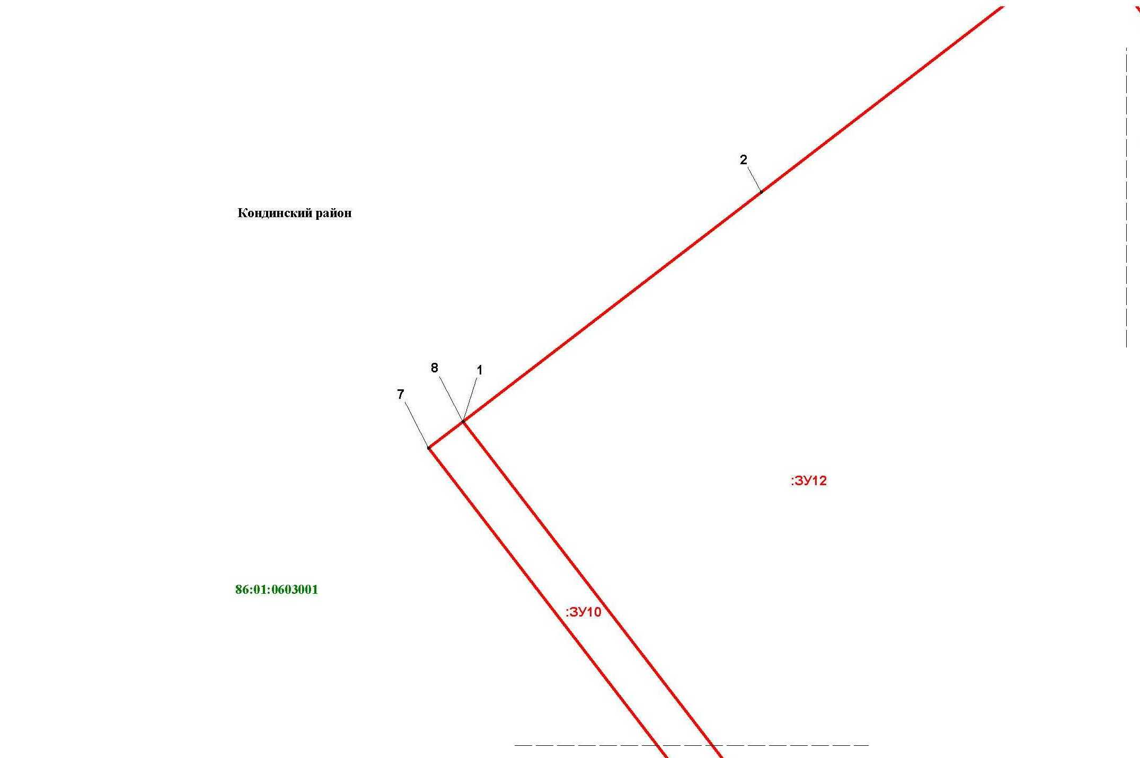

Линия совмещения с листом 41

Основная часть проекта межевания территории для размещения объекта капитального строительства, расположенного на территории двух муниципальных образований
Ханты-Мансийского автономного округа – Югры,
«Обустройство Чапровского месторождения.
Кусты 1, 1а, 2, 2а, 4, 4а, 5, 5а и коридоры коммуникаций»
Землепользователь: АО «НК «Конданефть»
Масштаб 1:2000

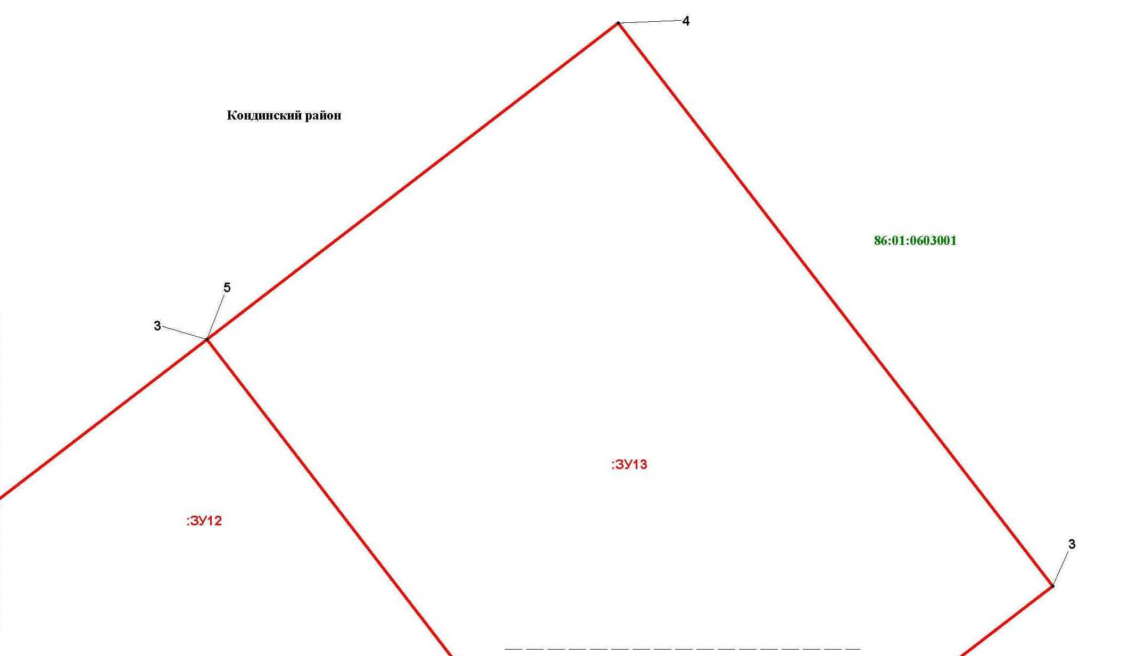

Основная часть проекта межевания территории для размещения объекта капитального строительства, расположенного на территории двух муниципальных образований
Ханты-Мансийского автономного округа – Югры,
«Обустройство Чапровского месторождения.
Кусты 1, 1а, 2, 2а, 4, 4а, 5, 5а и коридоры коммуникаций»
Землепользователь: АО «НК «Конданефть»
Масштаб 1:2000

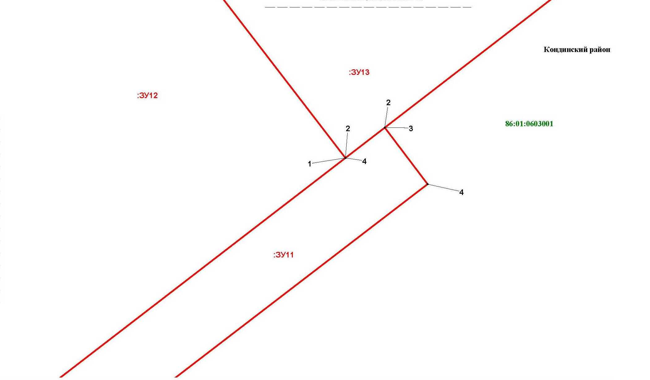
Линия совмещения с листом 43

Основная часть проекта межевания территории для размещения объекта капитального строительства, расположенного на территории двух муниципальных образований
Ханты-Мансийского автономного округа – Югры,
«Обустройство Чапровского месторождения.
Кусты 1, 1а, 2, 2а, 4, 4а, 5, 5а и коридоры коммуникаций»
Землепользователь: АО «НК «Конданефть»
Масштаб 1:2000

Основная часть проекта межевания территории для размещения объекта капитального строительства, расположенного на территории двух муниципальных образований
Ханты-Мансийского автономного округа – Югры,
«Обустройство Чапровского месторождения.
Кусты 1, 1а, 2, 2а, 4, 4а, 5, 5а и коридоры коммуникаций»
Землепользователь: АО «НК «Конданефть»
Масштаб 1:2000

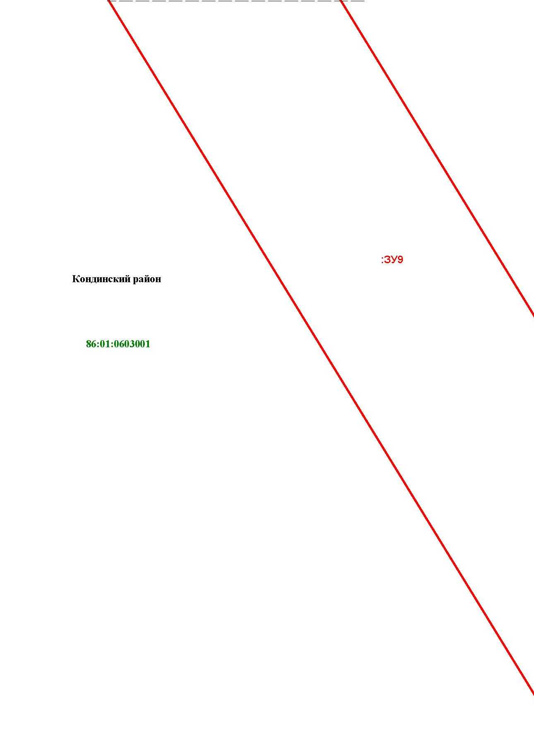

Линия совмещения с листом 44

Линия совмещения с листом 45

Основная часть проекта межевания территории для размещения объекта капитального строительства, расположенного на территории двух муниципальных образований
Ханты-Мансийского автономного округа – Югры,
«Обустройство Чапровского месторождения.
Кусты 1, 1а, 2, 2а, 4, 4а, 5, 5а и коридоры коммуникаций»
Землепользователь: АО «НК «Конданефть»
Масштаб 1:2000

Линия совмещения с листом 45

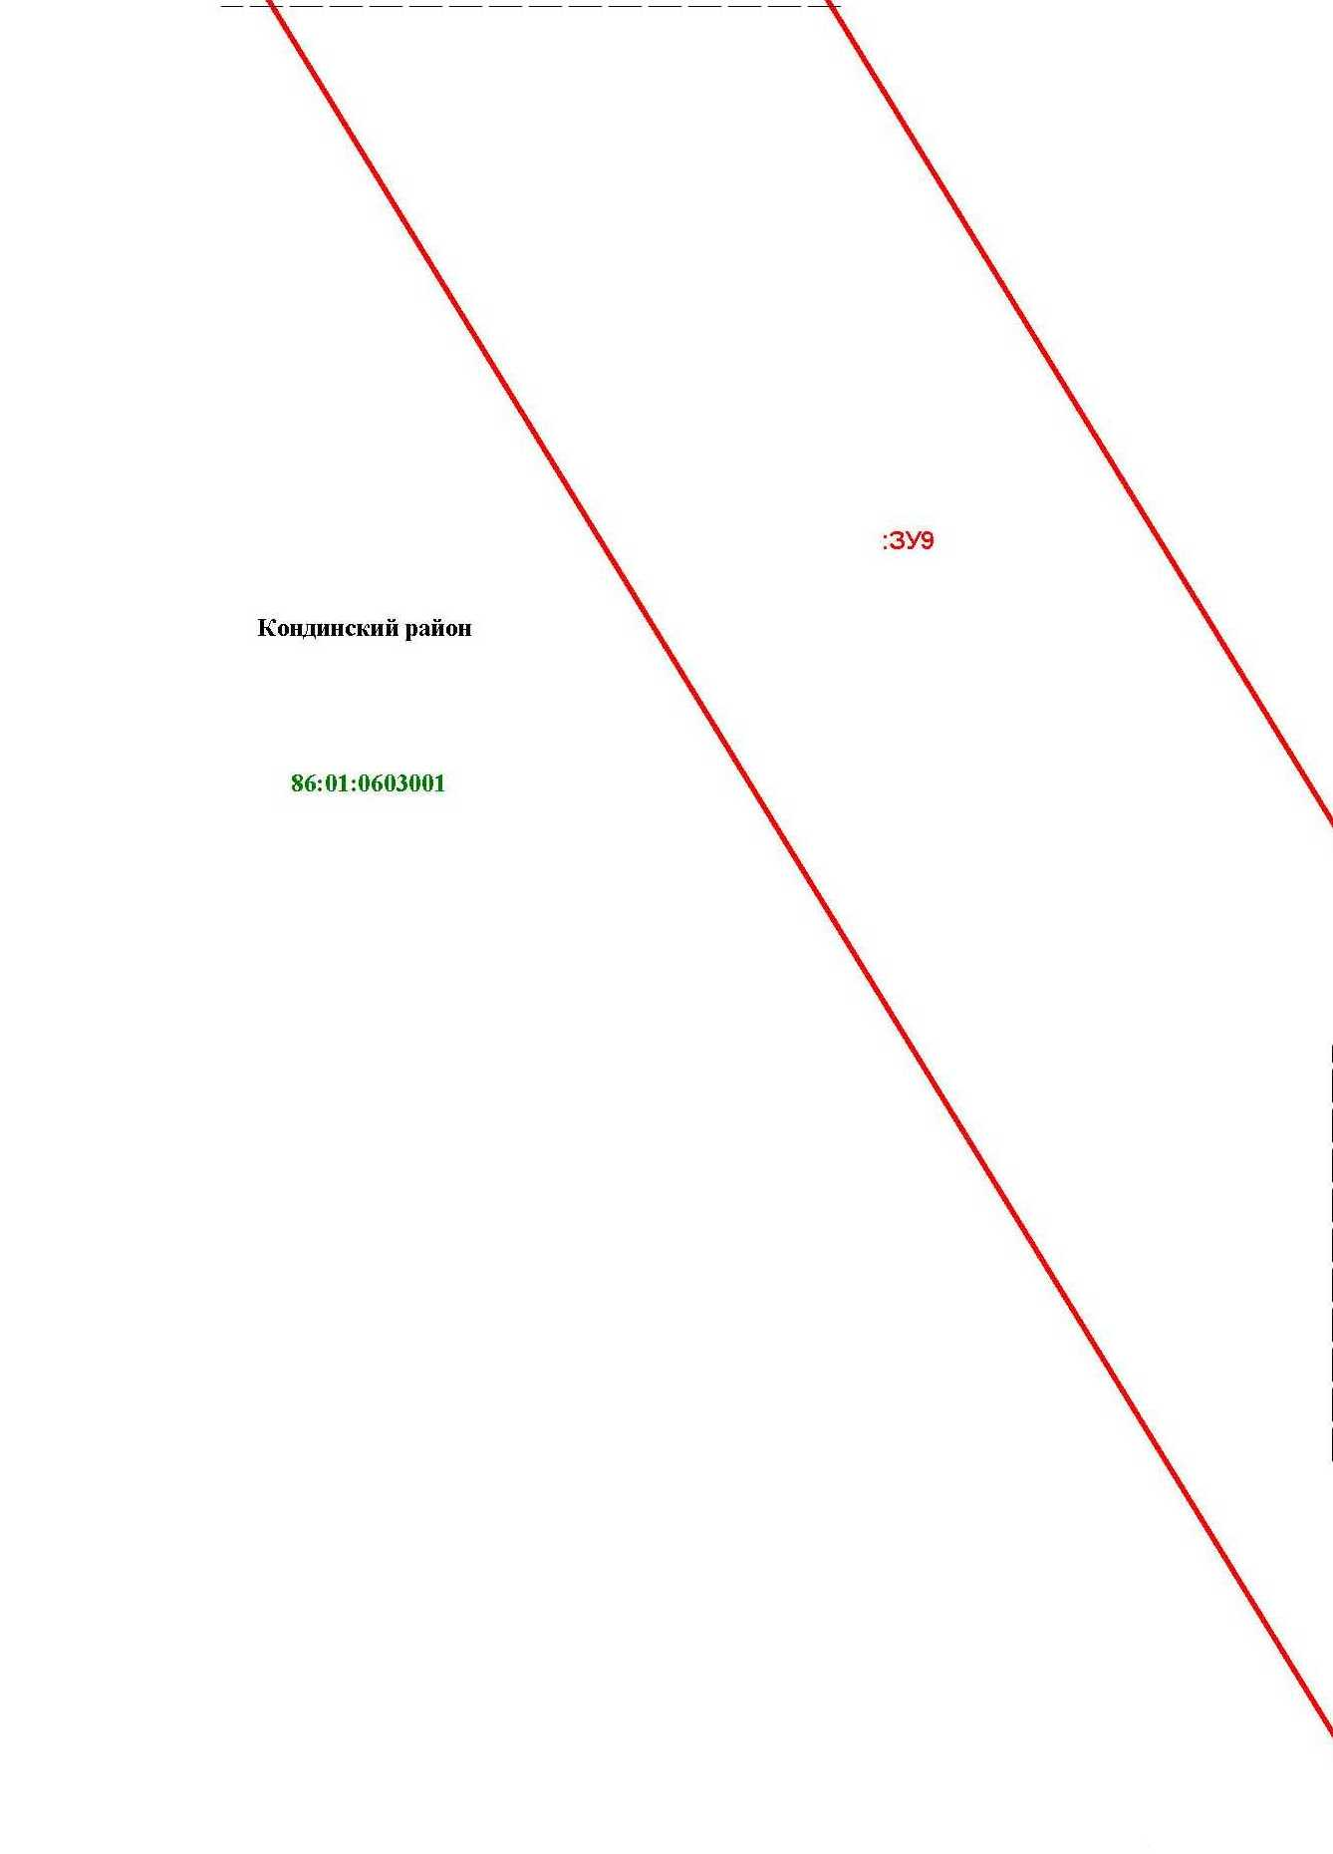

Основная часть проекта межевания территории для размещения объекта капитального строительства, расположенного на территории двух муниципальных образований
Ханты-Мансийского автономного округа – Югры,
«Обустройство Чапровского месторождения.
Кусты 1, 1а, 2, 2а, 4, 4а, 5, 5а и коридоры коммуникаций»
Землепользователь: АО «НК «Конданефть»
Масштаб 1:2000

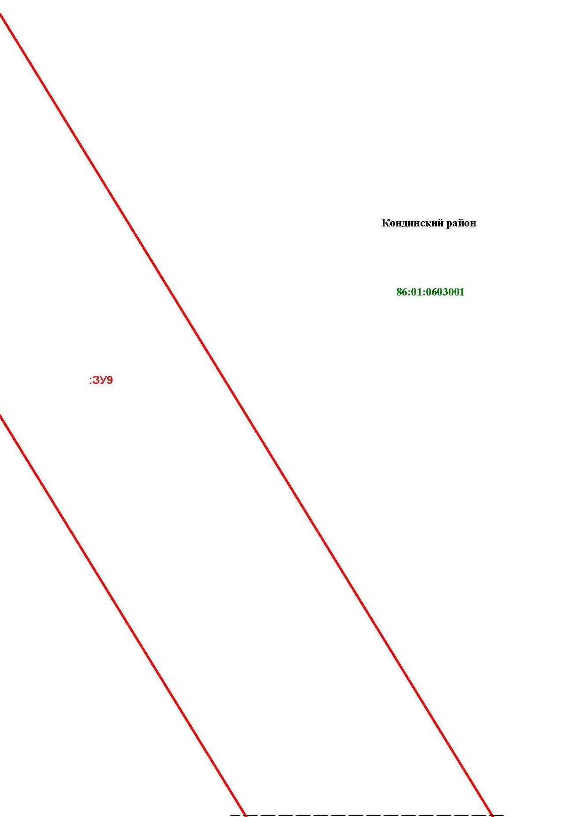

Основная часть проекта межевания территории для размещения объекта капитального строительства, расположенного на территории двух муниципальных образований
Ханты-Мансийского автономного округа – Югры,
«Обустройство Чапровского месторождения.
Кусты 1, 1а, 2, 2а, 4, 4а, 5, 5а и коридоры коммуникаций»
Землепользователь: АО «НК «Конданефть»
Масштаб 1:2000

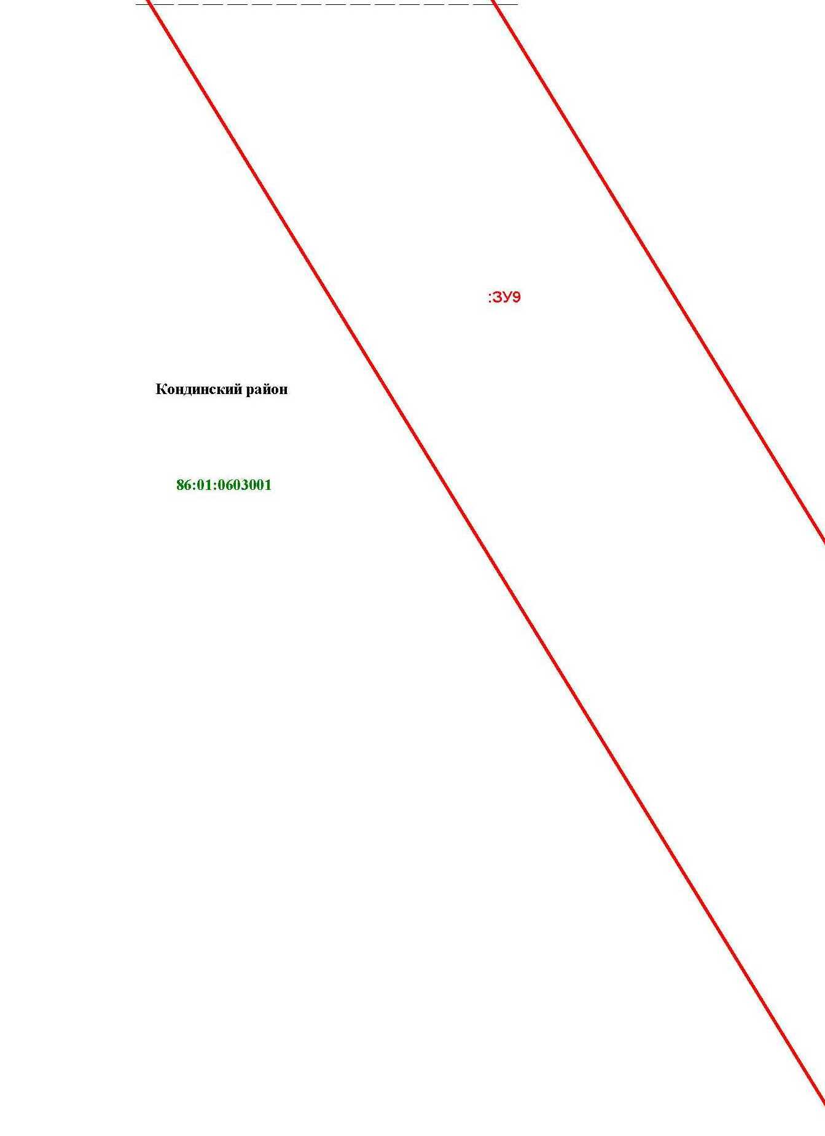

Основная часть проекта межевания территории для размещения объекта капитального строительства, расположенного на территории двух муниципальных образований
Ханты-Мансийского автономного округа – Югры
«Промысловый нефтепровод «ЦПС Кондинское-ДНС с УПСВ Западно-Эргинское»
Землепользователь: АО «НК «Конданефть»

Основная часть проекта межевания территории для размещения объекта капитального строительства, расположенного на территории двух муниципальных образований
Ханты-Мансийского автономного округа – Югры,
«Обустройство Чапровского месторождения.
Кусты 1, 1а, 2, 2а, 4, 4а, 5, 5а и коридоры коммуникаций»
Землепользователь: АО «НК «Конданефть»
Масштаб 1:2000

Линия совмещения с листом
51

Основная часть проекта межевания территории для размещения объекта капитального строительства, расположенного на территории двух муниципальных образований
Ханты-Мансийского автономного округа – Югры,
«Обустройство Чапровского месторождения.
Кусты 1, 1а, 2, 2а, 4, 4а, 5, 5а и коридоры коммуникаций»
Землепользователь: АО «НК «Конданефть»
Масштаб 1:2000

Основная часть проекта межевания территории для размещения объекта капитального строительства, расположенного на территории двух муниципальных образований
Ханты-Мансийского автономного округа – Югры,
«Обустройство Чапровского месторождения.
Кусты 1, 1а, 2, 2а, 4, 4а, 5, 5а и коридоры коммуникаций»
Землепользователь: АО «НК «Конданефть»
Масштаб 1:2000

Линия совмещения с листом
52

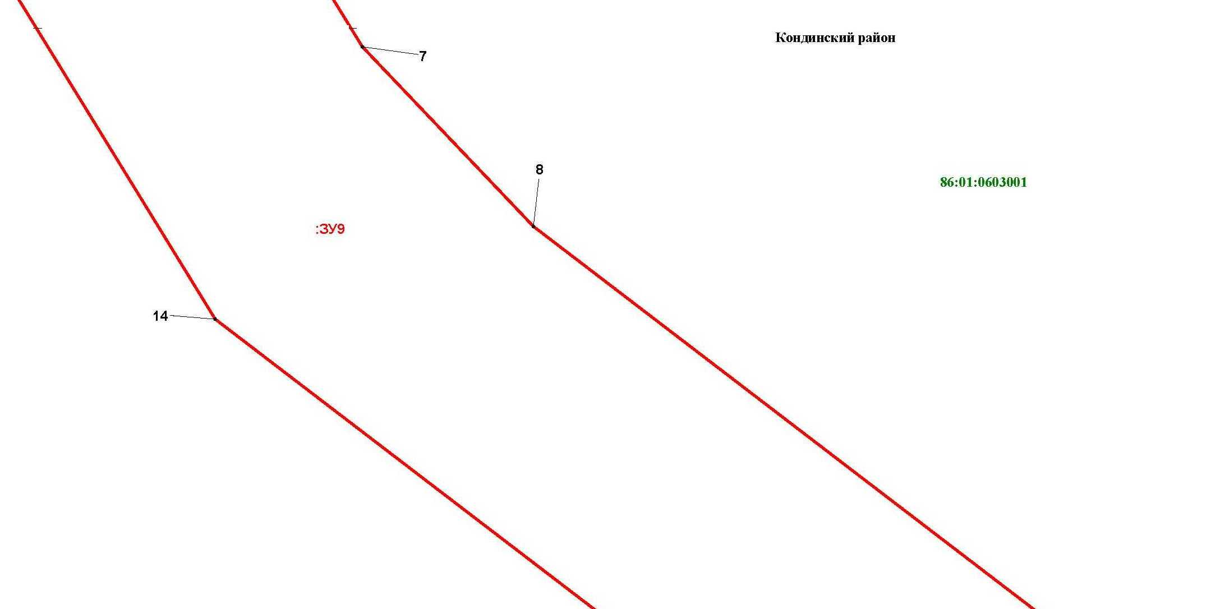

Основная часть проекта межевания территории для размещения объекта капитального строительства, расположенного на территории двух муниципальных образований
Ханты-Мансийского автономного округа – Югры,
«Обустройство Чапровского месторождения.
Кусты 1, 1а, 2, 2а, 4, 4а, 5, 5а и коридоры коммуникаций»
Землепользователь: АО «НК «Конданефть»
Масштаб 1:2000

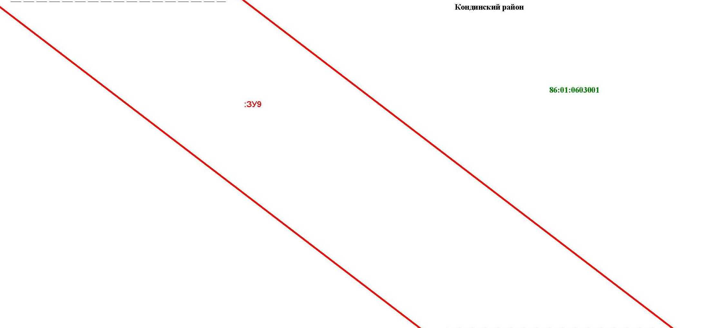

Основная часть проекта межевания территории для размещения объекта капитального строительства, расположенного на территории двух муниципальных образований
Ханты-Мансийского автономного округа – Югры,
«Обустройство Чапровского месторождения.
Кусты 1, 1а, 2, 2а, 4, 4а, 5, 5а и коридоры коммуникаций»
Землепользователь: АО «НК «Конданефть»
Масштаб 1:2000

Линия совмещения с листом
55

Основная часть проекта межевания территории для размещения объекта капитального строительства, расположенного на территории двух муниципальных образований
Ханты-Мансийского автономного округа – Югры
«Обустройство Чапровского месторождения.
Кусты 1, 1а, 2, 2а, 4, 4а, 5, 5а и коридоры коммуникаций»
Землепользователь: АО «НК «Конданефть»

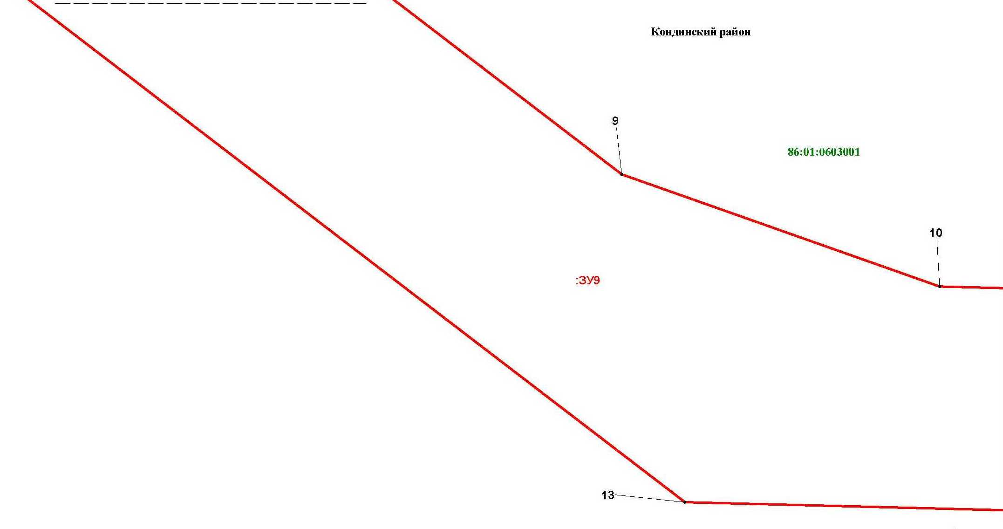

Основная часть проекта межевания территории для размещения объекта капитального строительства, расположенного на территории двух муниципальных образований
Ханты-Мансийского автономного округа – Югры,
«Обустройство Чапровского месторождения.
Кусты 1, 1а, 2, 2а, 4, 4а, 5, 5а и коридоры коммуникаций»
Землепользователь: АО «НК «Конданефть»
Масштаб 1:2000

Основная часть проекта межевания территории для размещения объекта капитального строительства, расположенного на территории двух муниципальных образований
Ханты-Мансийского автономного округа – Югры,
«Обустройство Чапровского месторождения.
Кусты 1, 1а, 2, 2а, 4, 4а, 5, 5а и коридоры коммуникаций»
Землепользователь: АО «НК «Конданефть»
Масштаб 1:2000

Основная часть проекта межевания территории для размещения объекта капитального строительства, расположенного на территории двух муниципальных образований
Ханты-Мансийского автономного округа – Югры,
«Обустройство Чапровского месторождения.
Кусты 1, 1а, 2, 2а, 4, 4а, 5, 5а и коридоры коммуникаций»
Землепользователь: АО «НК «Конданефть»
Масштаб 1:2000

Линия совмещения с листом 56
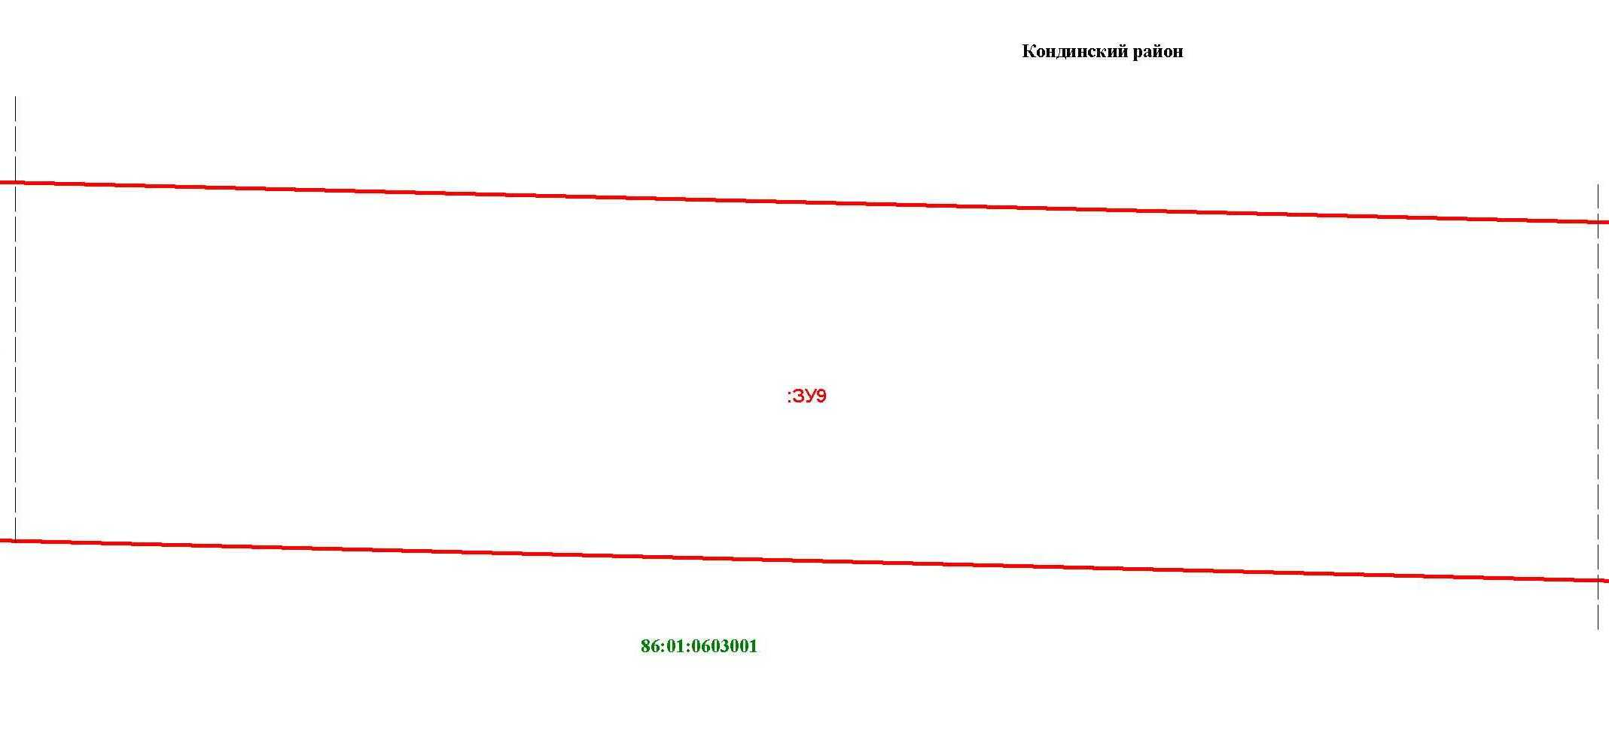

Основная часть проекта межевания территории для размещения объекта капитального строительства, расположенного на территории двух муниципальных образований
Ханты-Мансийского автономного округа – Югры,
«Обустройство Чапровского месторождения.
Кусты 1, 1а, 2, 2а, 4, 4а, 5, 5а и коридоры коммуникаций»
Землепользователь: АО «НК «Конданефть»
Масштаб 1:2000

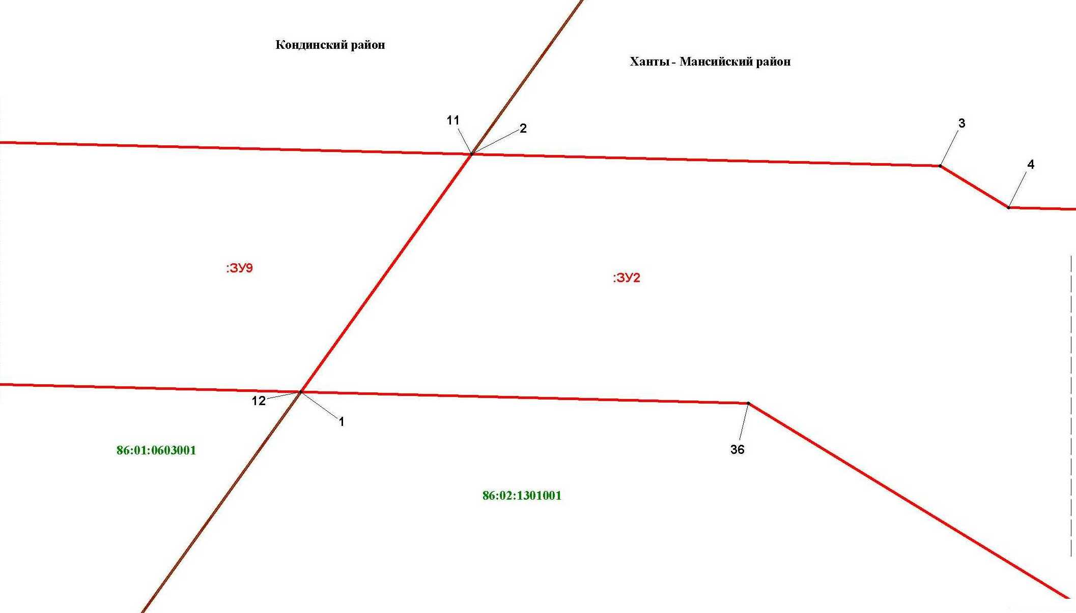

Основная часть проекта межевания территории для размещения объекта капитального строительства, расположенного на территории двух муниципальных образований
Ханты-Мансийского автономного округа – Югры
«Промысловый нефтепровод «ЦПС Кондинское-ДНС с УПСВ Западно-Эргинское»
Землепользователь: АО «НК «Конданефть»

Основная часть проекта межевания территории для размещения объекта капитального строительства, расположенного на территории двух муниципальных образований
Ханты-Мансийского автономного округа – Югры
«Обустройство Чапровского месторождения.
Кусты 1, 1а, 2, 2а, 4, 4а, 5, 5а и коридоры коммуникаций»
Землепользователь: АО «НК «Конданефть»

Линия совмещения с листом 57

Основная часть проекта межевания территории для размещения объекта капитального строительства, расположенного на территории двух муниципальных образований
Ханты-Мансийского автономного округа – Югры,
«Обустройство Чапровского месторождения.
Кусты 1, 1а, 2, 2а, 4, 4а, 5, 5а и коридоры коммуникаций»
Землепользователь: АО «НК «Конданефть»
Масштаб 1:2000

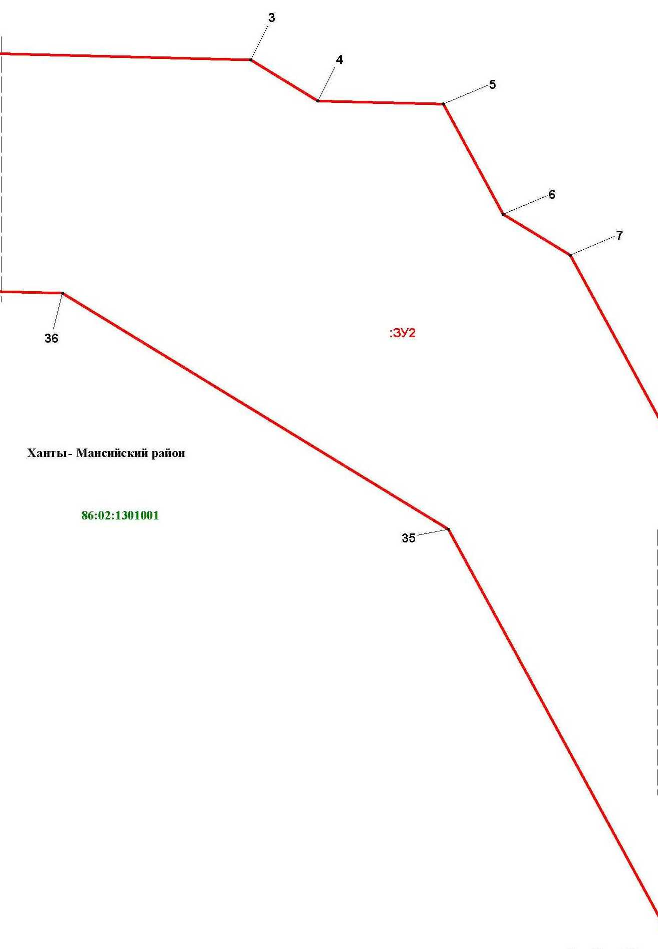

Линия совмещения с листом 58

Основная часть проекта межевания территории для размещения объекта капитального строительства, расположенного на территории двух муниципальных образований
Ханты-Мансийского автономного округа – Югры,
«Обустройство Чапровского месторождения.
Кусты 1, 1а, 2, 2а, 4, 4а, 5, 5а и коридоры коммуникаций»
Землепользователь: АО «НК «Конданефть»
Масштаб 1:2000

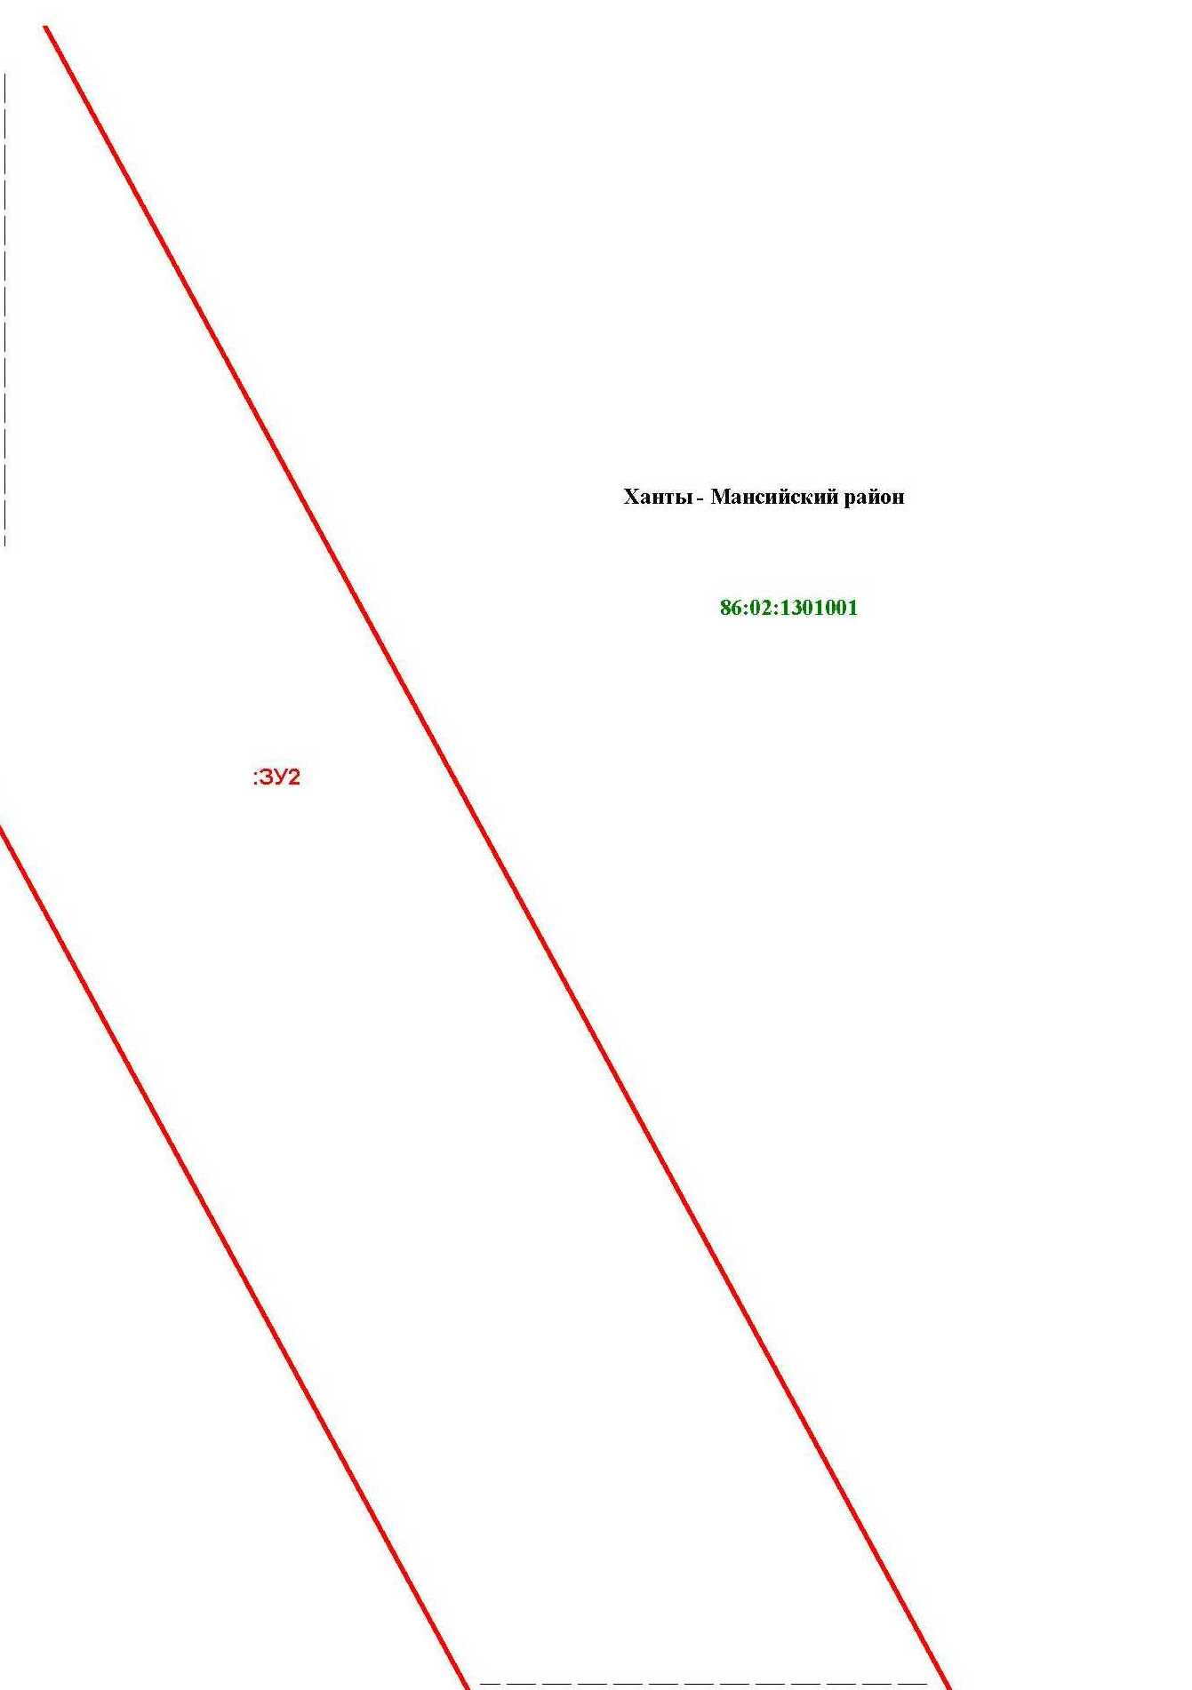
Основная часть проекта межевания территории для размещения объекта капитального строительства, расположенного на территории двух муниципальных образований
Ханты-Мансийского автономного округа – Югры
«Обустройство Чапровского месторождения.
Кусты 1, 1а, 2, 2а, 4, 4а, 5, 5а и коридоры коммуникаций»
Землепользователь: АО «НК «Конданефть»

Основная часть проекта межевания территории для размещения объекта капитального строительства, расположенного на территории двух муниципальных образований
Ханты-Мансийского автономного округа – Югры,
«Обустройство Чапровского месторождения.
Кусты 1, 1а, 2, 2а, 4, 4а, 5, 5а и коридоры коммуникаций»
Землепользователь: АО «НК «Конданефть»
Масштаб 1:2000

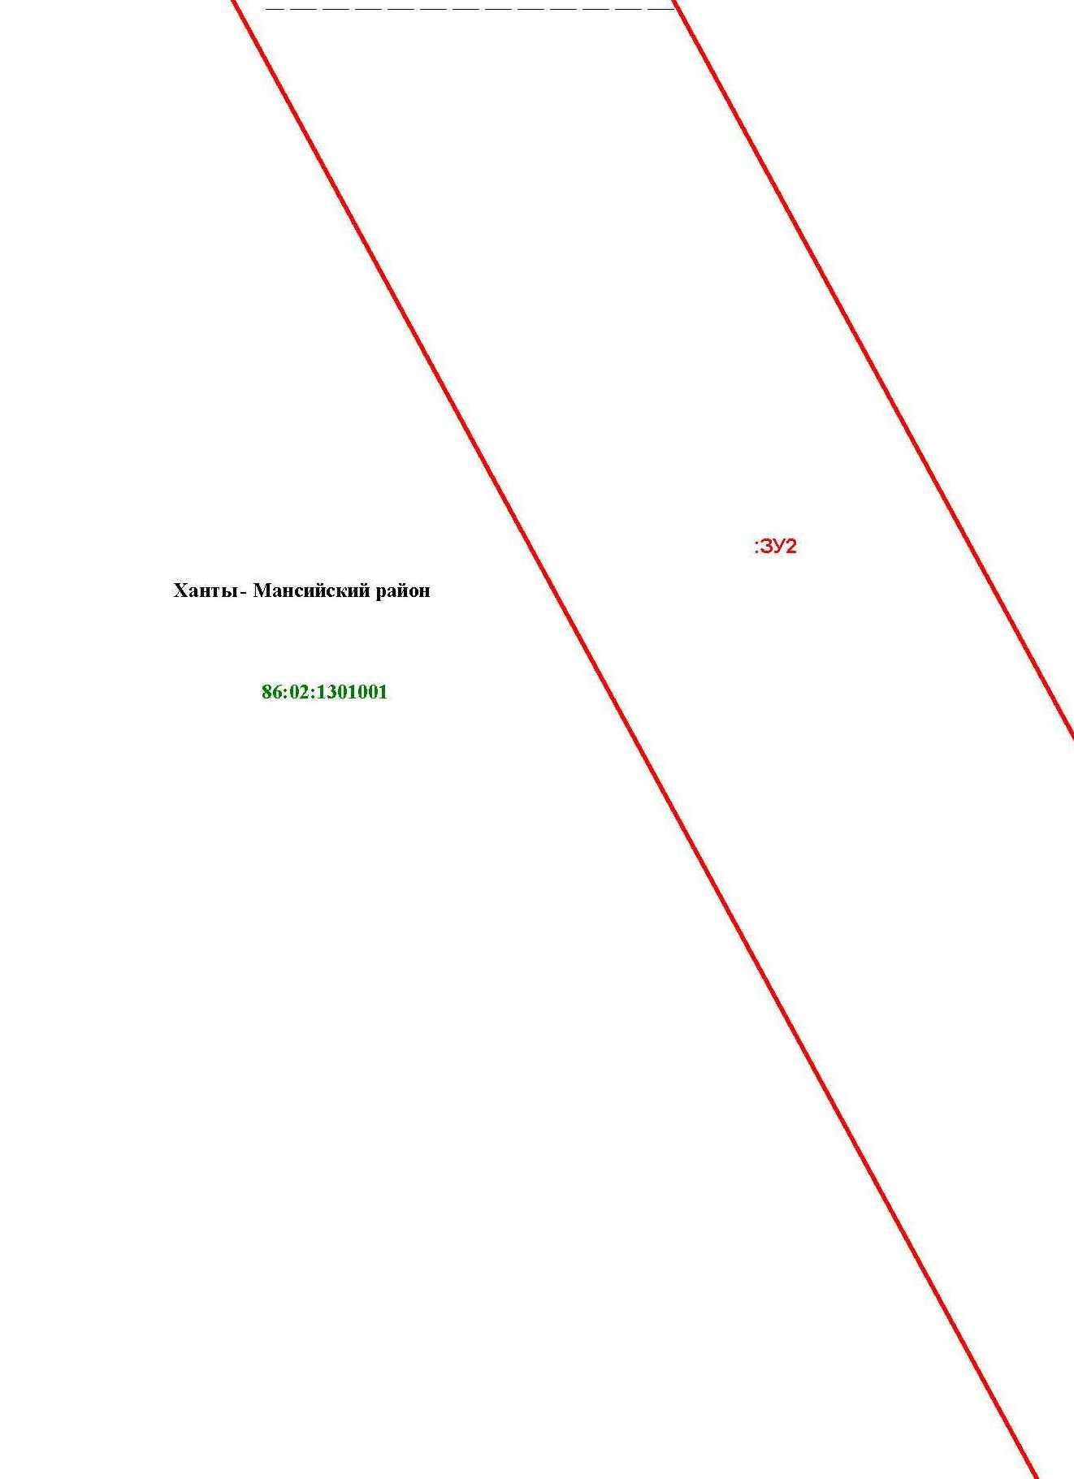

Линия совмещения с листом 59
Основная часть проекта межевания территории для размещения объекта капитального строительства, расположенного на территории двух муниципальных образований
Ханты-Мансийского автономного округа – Югры,
«Обустройство Чапровского месторождения.
Кусты 1, 1а, 2, 2а, 4, 4а, 5, 5а и коридоры коммуникаций»
Землепользователь: АО «НК «Конданефть»
Масштаб 1:2000

Основная часть проекта межевания территории для размещения объекта капитального строительства, расположенного на территории двух муниципальных образований
Ханты-Мансийского автономного округа – Югры
«Обустройство Чапровского месторождения.
Кусты 1, 1а, 2, 2а, 4, 4а, 5, 5а и коридоры коммуникаций»
Землепользователь: АО «НК «Конданефть»

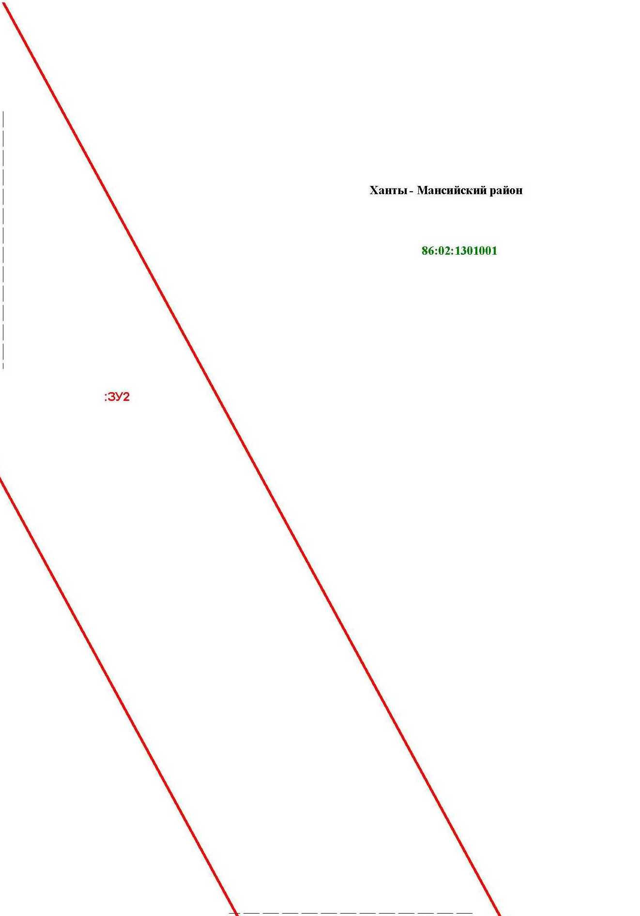

Линия совмещения с листом 61

Основная часть проекта межевания территории для размещения объекта капитального строительства, расположенного на территории двух муниципальных образований
Ханты-Мансийского автономного округа – Югры,
«Обустройство Чапровского месторождения.
Кусты 1, 1а, 2, 2а, 4, 4а, 5, 5а и коридоры коммуникаций»
Землепользователь: АО «НК «Конданефть»
Масштаб 1:2000

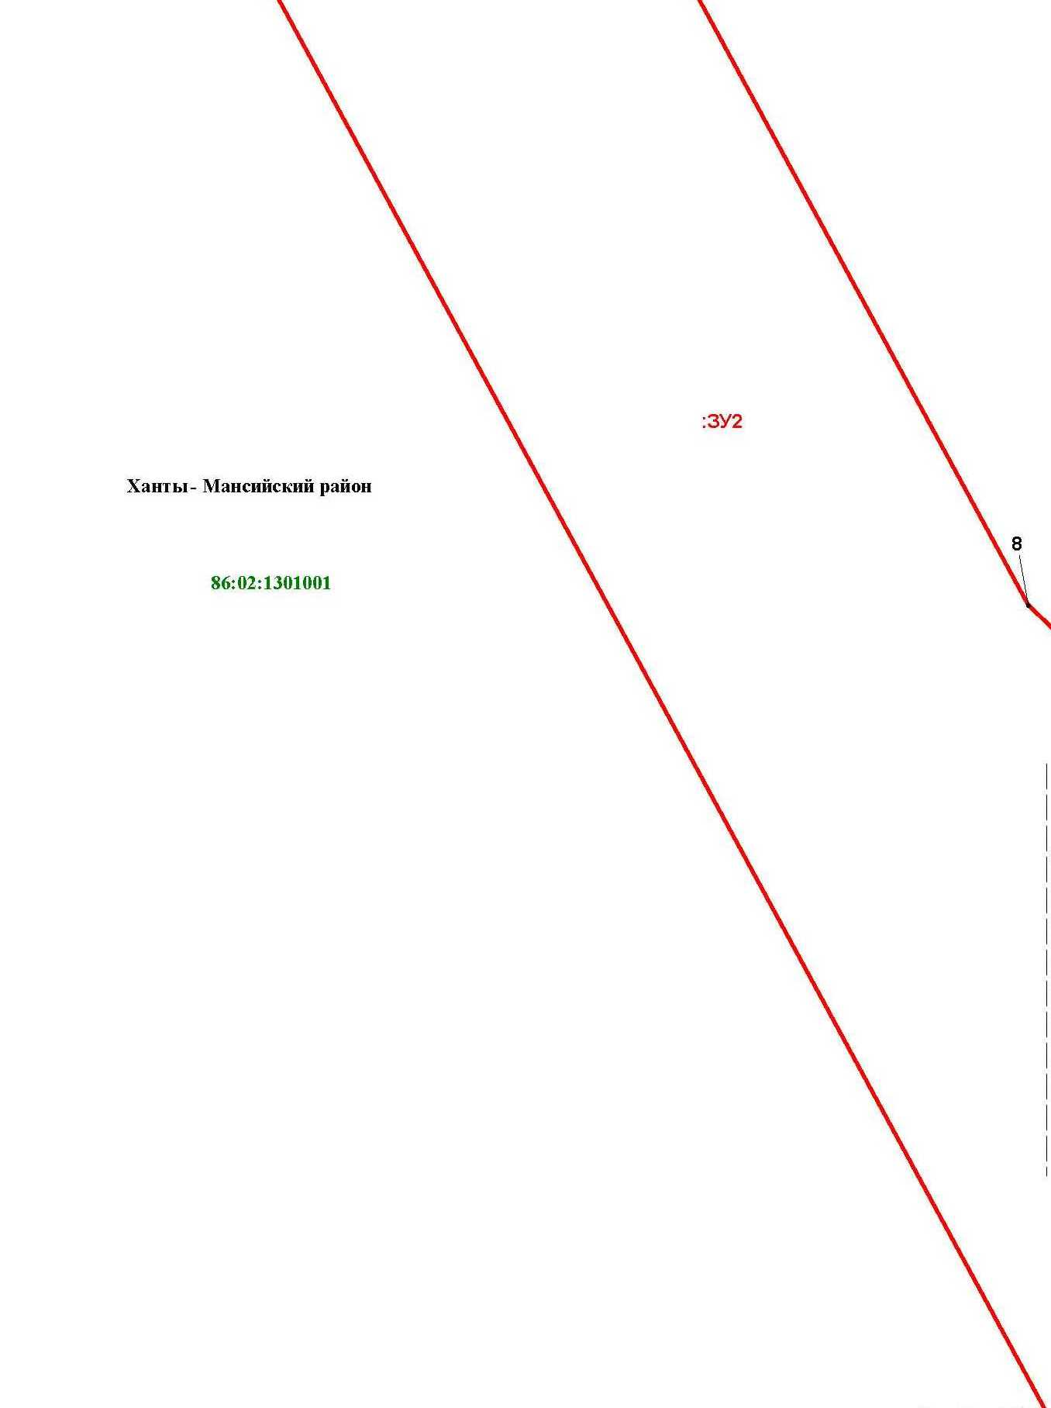

Основная часть проекта межевания территории для размещения объекта капитального строительства, расположенного на территории двух муниципальных образований
Ханты-Мансийского автономного округа – Югры,
«Обустройство Чапровского месторождения.
Кусты 1, 1а, 2, 2а, 4, 4а, 5, 5а и коридоры коммуникаций»
Землепользователь: АО «НК «Конданефть»
Масштаб 1:2000

Линия совмещения с листом 62

Линия совмещения с листом 68

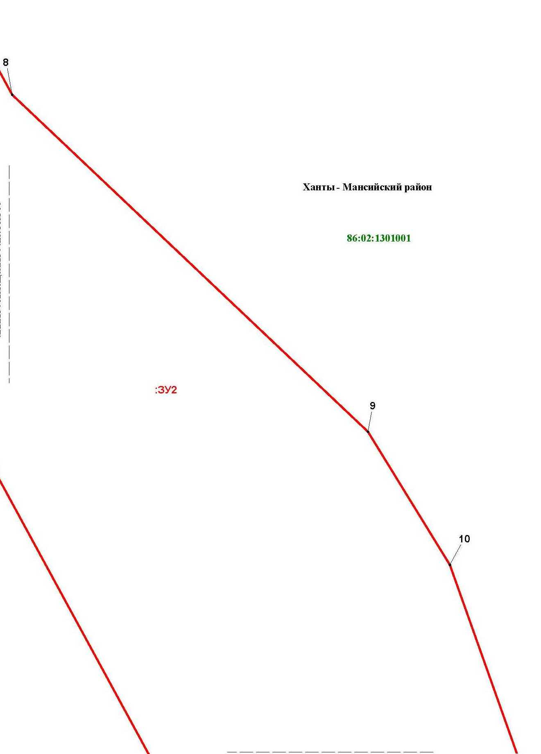

Основная часть проекта межевания территории для размещения объекта капитального строительства, расположенного на территории двух муниципальных образований
Ханты-Мансийского автономного округа – Югры
«Обустройство Чапровского месторождения.
Кусты 1, 1а, 2, 2а, 4, 4а, 5, 5а и коридоры коммуникаций»
Землепользователь: АО «НК «Конданефть»

Линия совмещения с листом 67

Основная часть проекта межевания территории для размещения объекта капитального строительства, расположенного на территории двух муниципальных образований
Ханты-Мансийского автономного округа – Югры,
«Обустройство Чапровского месторождения.
Кусты 1, 1а, 2, 2а, 4, 4а, 5, 5а и коридоры коммуникаций»
Землепользователь: АО «НК «Конданефть»
Масштаб 1:2000

Линия совмещения с листом 68

Линия совмещения с листом 64

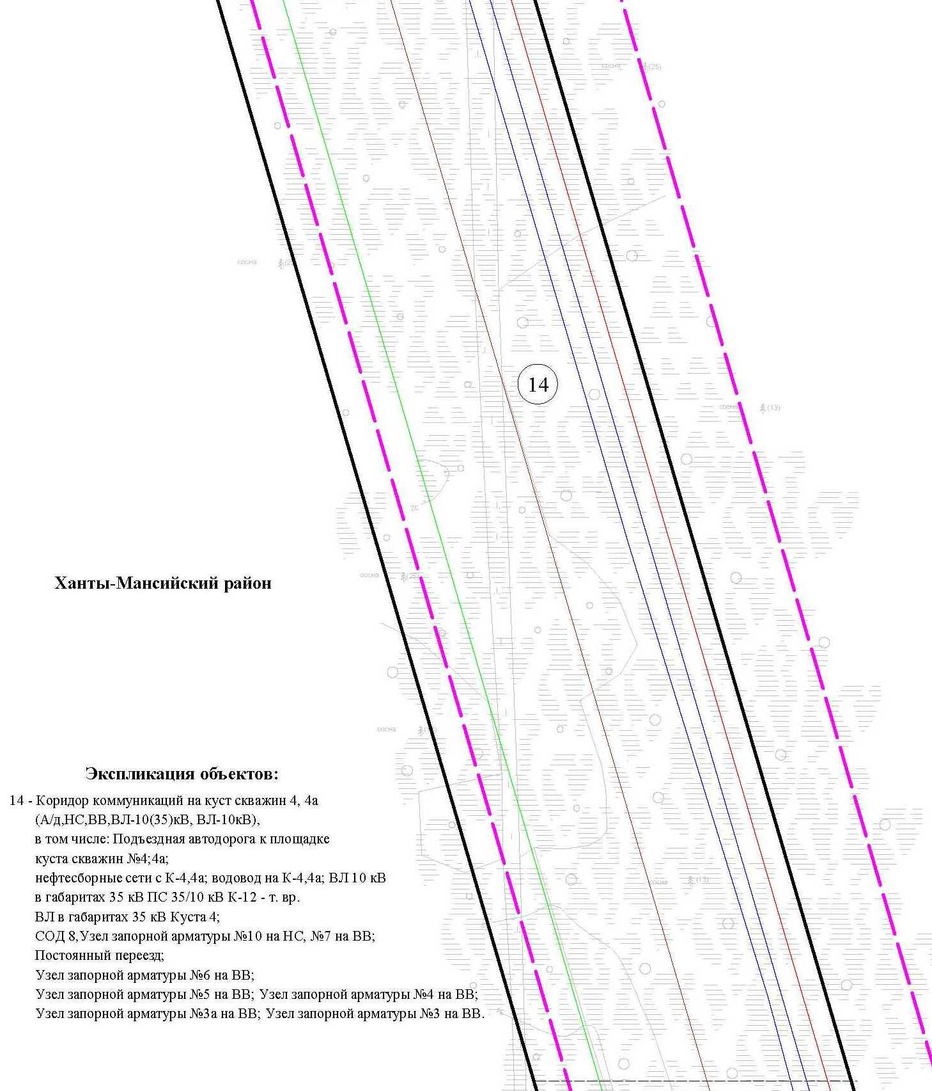
Основная часть проекта межевания территории для размещения объекта капитального строительства, расположенного на территории двух муниципальных образований
Ханты-Мансийского автономного округа – Югры,
«Обустройство Чапровского месторождения.
Кусты 1, 1а, 2, 2а, 4, 4а, 5, 5а и коридоры коммуникаций»
Землепользователь: АО «НК «Конданефть»
Масштаб 1:2000

Основная часть проекта межевания территории для размещения объекта капитального строительства, расположенного на территории двух муниципальных образований
Ханты-Мансийского автономного округа – Югры,
«Обустройство Чапровского месторождения.
Кусты 1, 1а, 2, 2а, 4, 4а, 5, 5а и коридоры коммуникаций»
Землепользователь: АО «НК «Конданефть»
Масштаб 1:2000

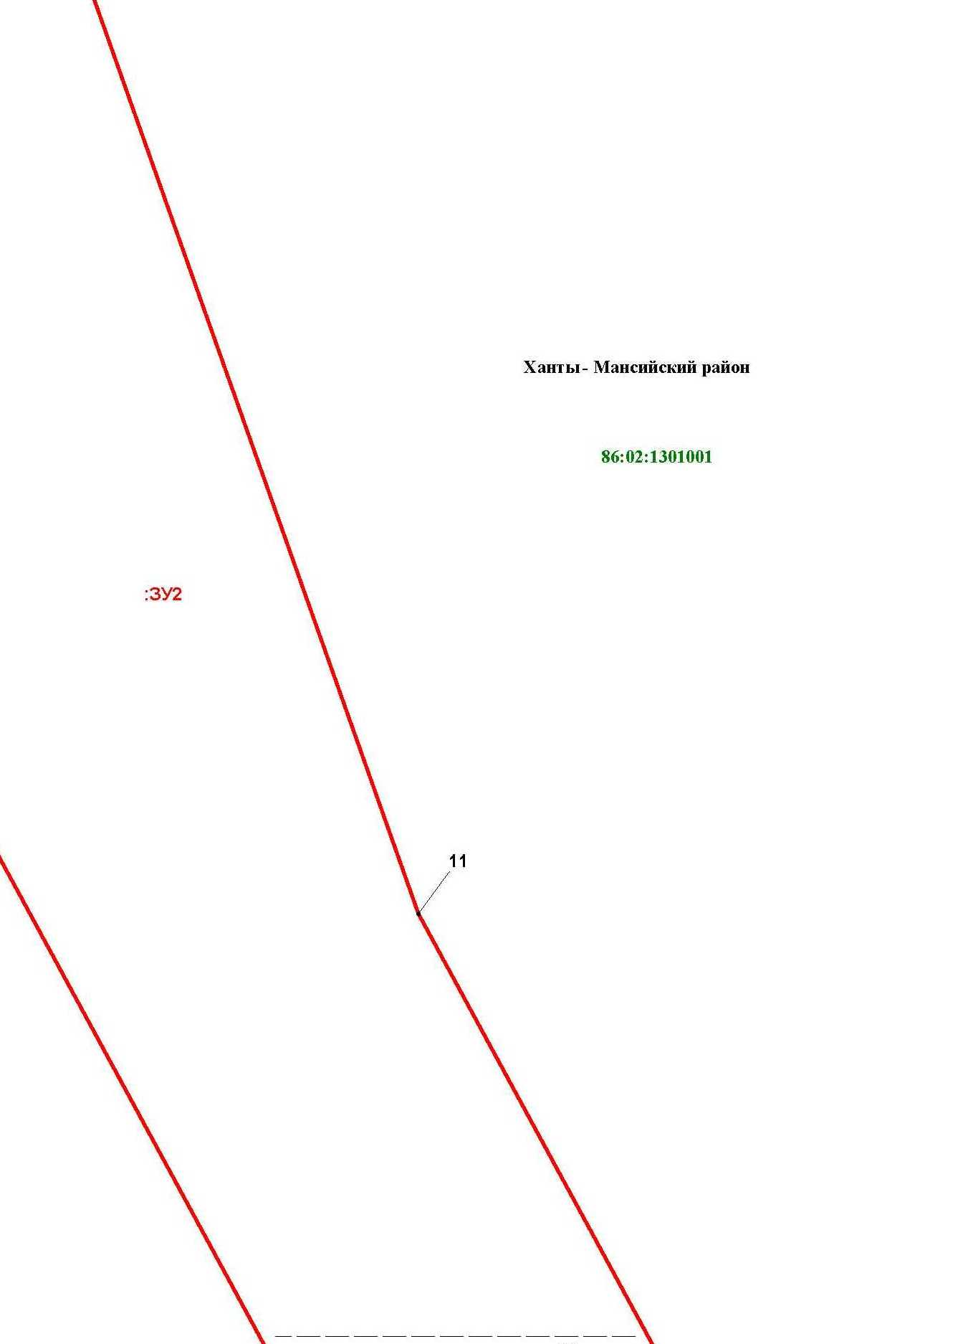
Линия совмещения с листом 65

Линия совмещения с листом 73

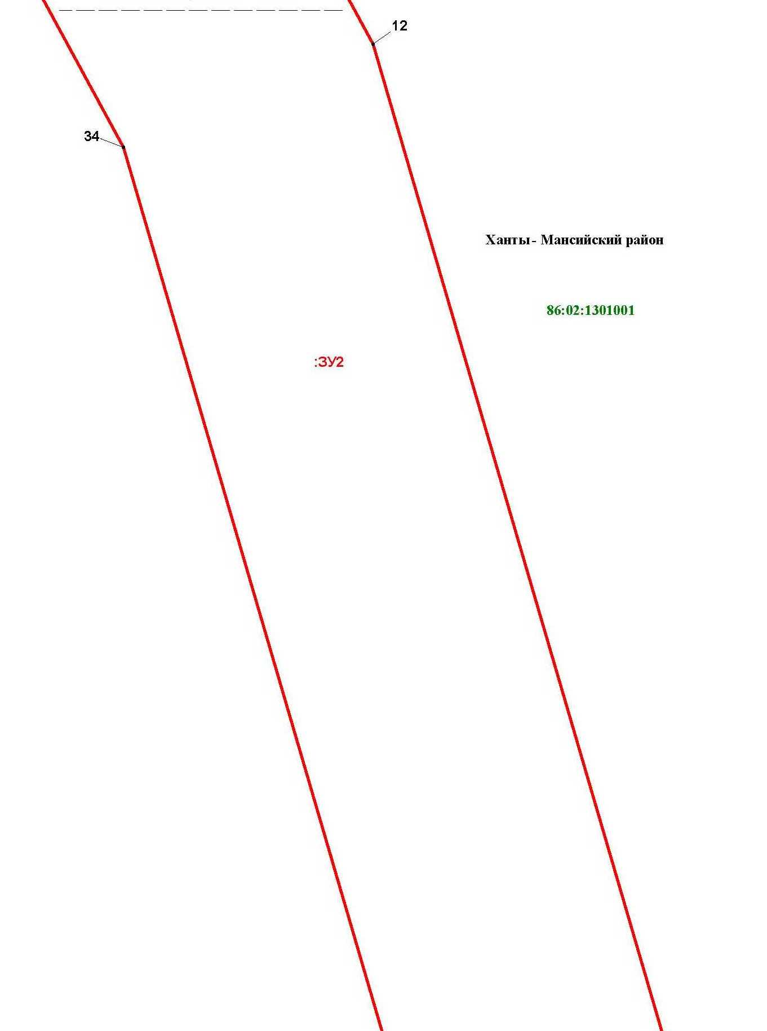

Основная часть проекта межевания территории для размещения объекта капитального строительства, расположенного на территории двух муниципальных образований
Ханты-Мансийского автономного округа – Югры
«Обустройство Чапровского месторождения.
Кусты 1, 1а, 2, 2а, 4, 4а, 5, 5а и коридоры коммуникаций»
Землепользователь: АО «НК «Конданефть»

Основная часть проекта межевания территории для размещения объекта капитального строительства, расположенного на территории двух муниципальных образований
Ханты-Мансийского автономного округа – Югры,
«Обустройство Чапровского месторождения.
Кусты 1, 1а, 2, 2а, 4, 4а, 5, 5а и коридоры коммуникаций»
Землепользователь: АО «НК «Конданефть»
Масштаб 1:2000

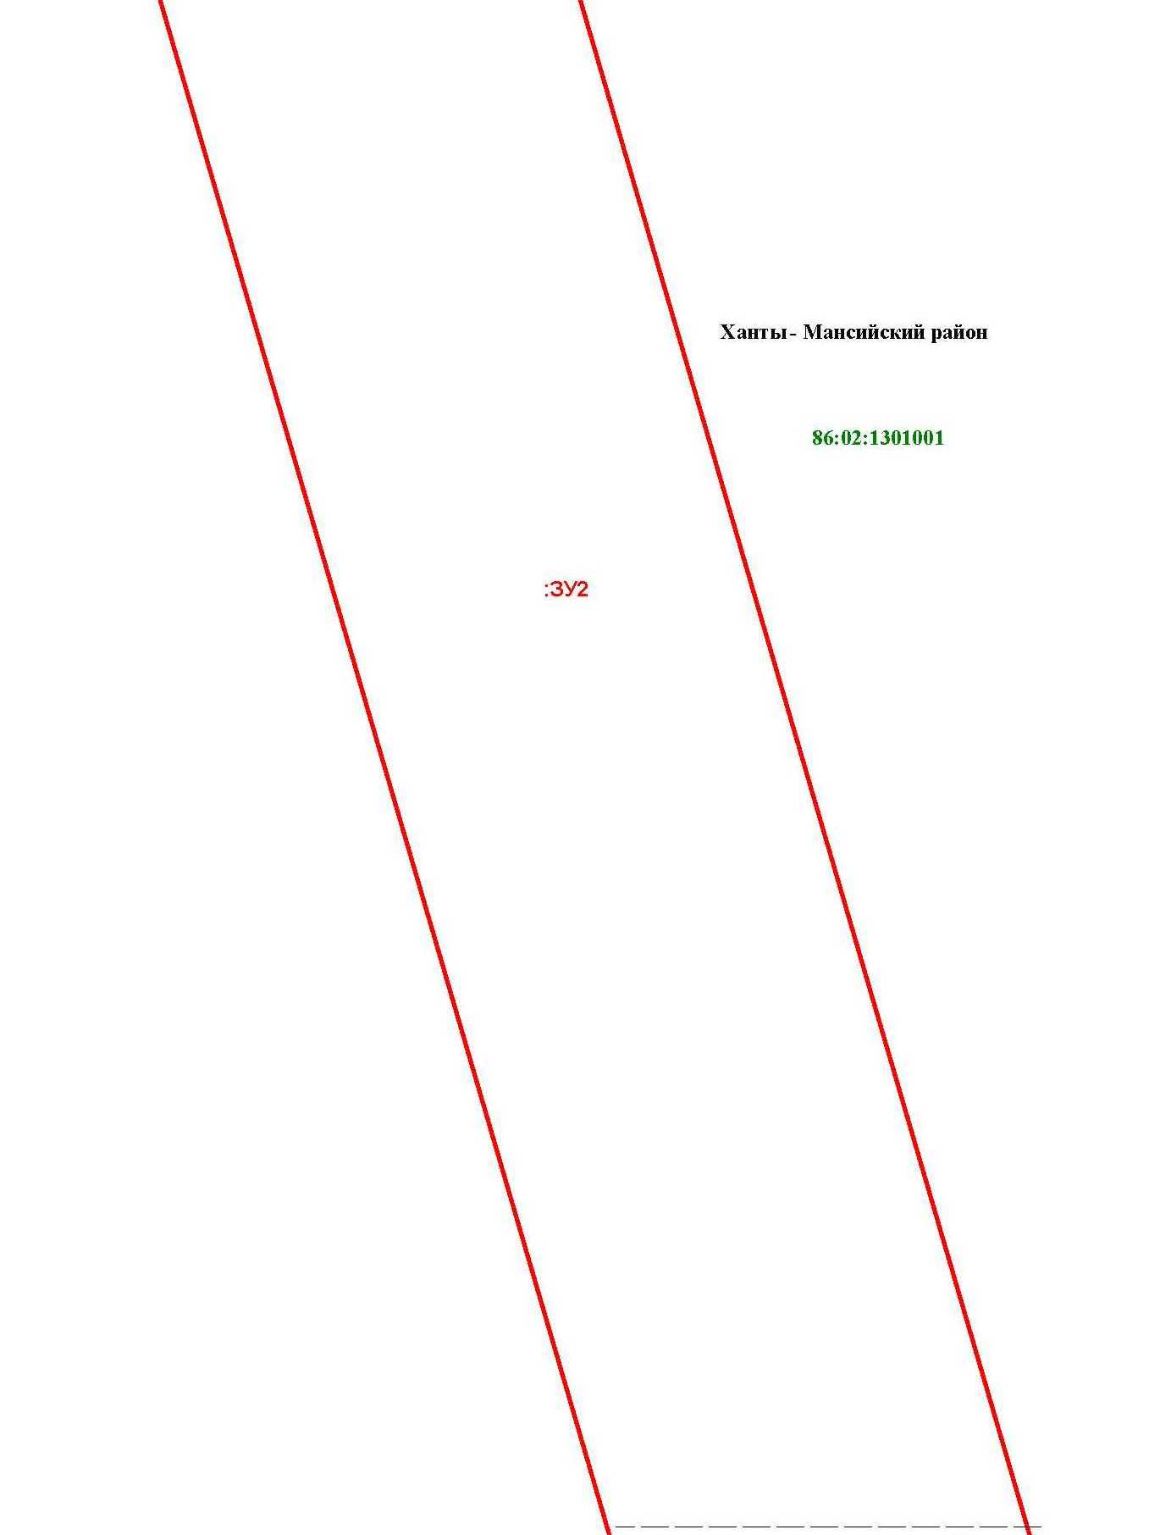

Основная часть проекта межевания территории для размещения объекта капитального строительства, расположенного на территории двух муниципальных образований
Ханты-Мансийского автономного округа – Югры,
«Обустройство Чапровского месторождения.
Кусты 1, 1а, 2, 2а, 4, 4а, 5, 5а и коридоры коммуникаций»
Землепользователь: АО «НК «Конданефть»
Масштаб 1:2000

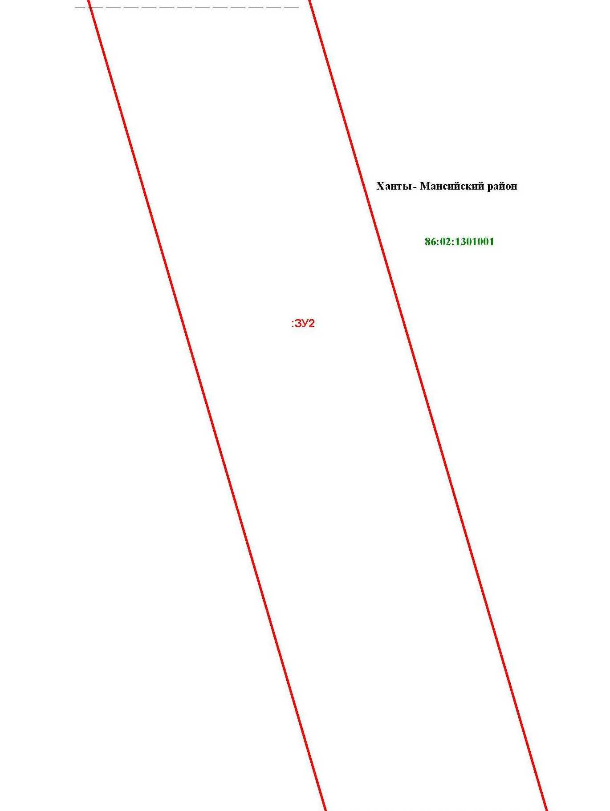

Основная часть проекта межевания территории для размещения объекта капитального строительства, расположенного на территории двух муниципальных образований
Ханты-Мансийского автономного округа – Югры,
«Обустройство Чапровского месторождения.
Кусты 1, 1а, 2, 2а, 4, 4а, 5, 5а и коридоры коммуникаций»
Землепользователь: АО «НК «Конданефть»
Масштаб 1:2000

Линия совмещения с листом 70

Основная часть проекта межевания территории для размещения объекта капитального строительства, расположенного на территории двух муниципальных образований
Ханты-Мансийского автономного округа – Югры
«Обустройство Чапровского месторождения.
Кусты 1, 1а, 2, 2а, 4, 4а, 5, 5а и коридоры коммуникаций»
Землепользователь: АО «НК «Конданефть»

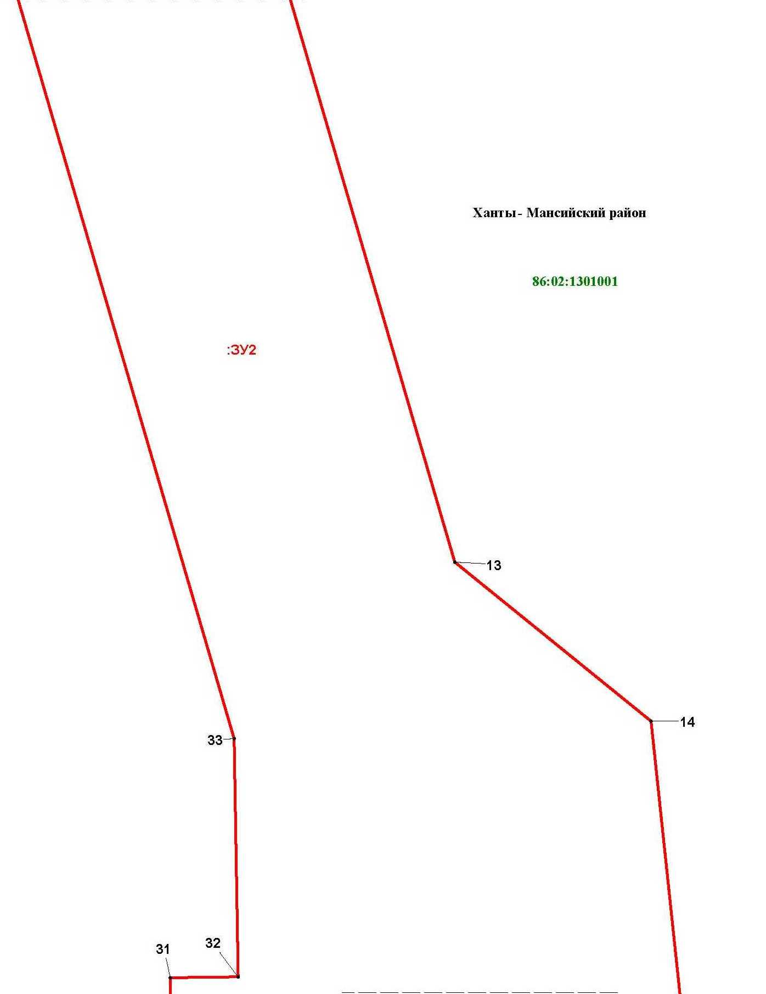

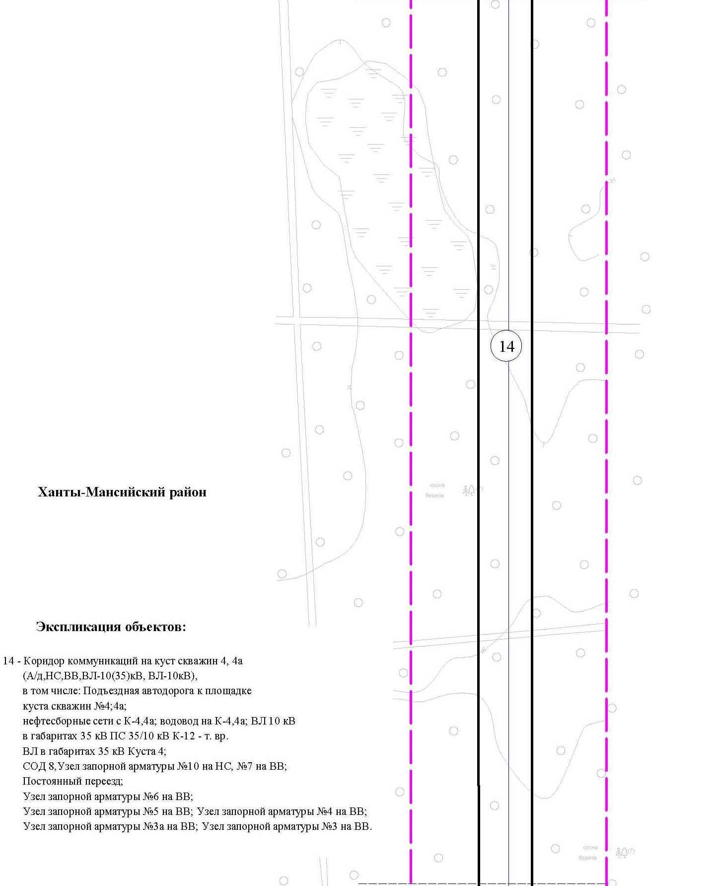

Основная часть проекта межевания территории для размещения объекта капитального строительства, расположенного на территории двух муниципальных образований
Ханты-Мансийского автономного округа – Югры,
«Обустройство Чапровского месторождения.
Кусты 1, 1а, 2, 2а, 4, 4а, 5, 5а и коридоры коммуникаций»
Землепользователь: АО «НК «Конданефть»
Масштаб 1:2000

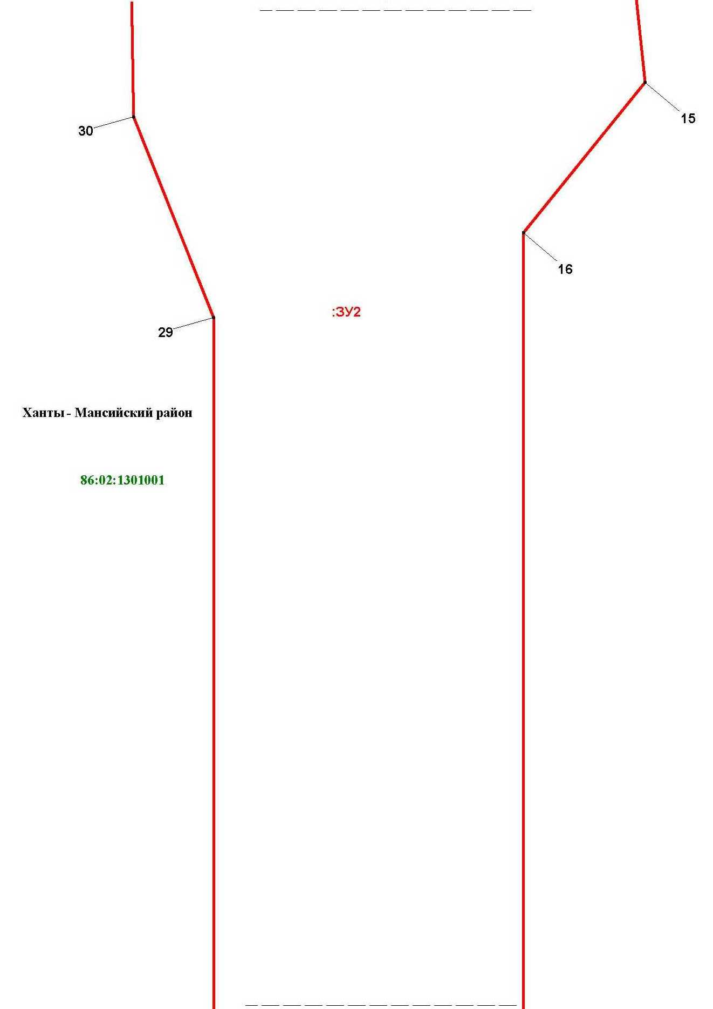

Основная часть проекта межевания территории для размещения объекта капитального строительства, расположенного на территории двух муниципальных образований
Ханты-Мансийского автономного округа – Югры,
«Обустройство Чапровского месторождения.
Кусты 1, 1а, 2, 2а, 4, 4а, 5, 5а и коридоры коммуникаций»
Землепользователь: АО «НК «Конданефть»
Масштаб 1:2000

Линия совмещения с листом
82

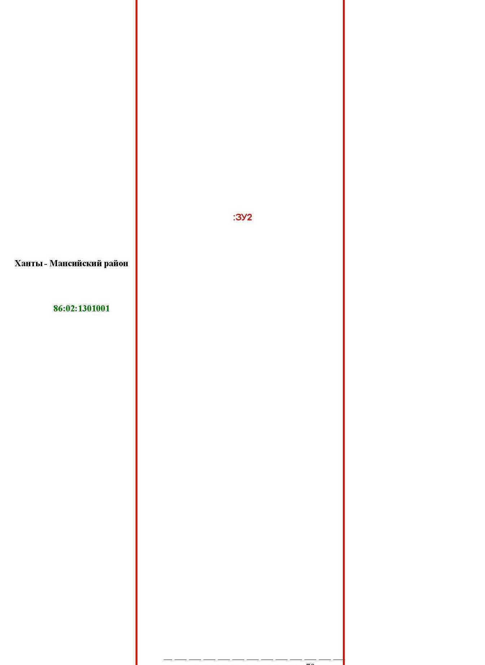

Основная часть проекта межевания территории для размещения объекта капитального строительства, расположенного на территории двух муниципальных образований
Ханты-Мансийского автономного округа – Югры,
«Обустройство Чапровского месторождения.
Кусты 1, 1а, 2, 2а, 4, 4а, 5, 5а и коридоры коммуникаций»
Землепользователь: АО «НК «Конданефть»
Масштаб 1:2000

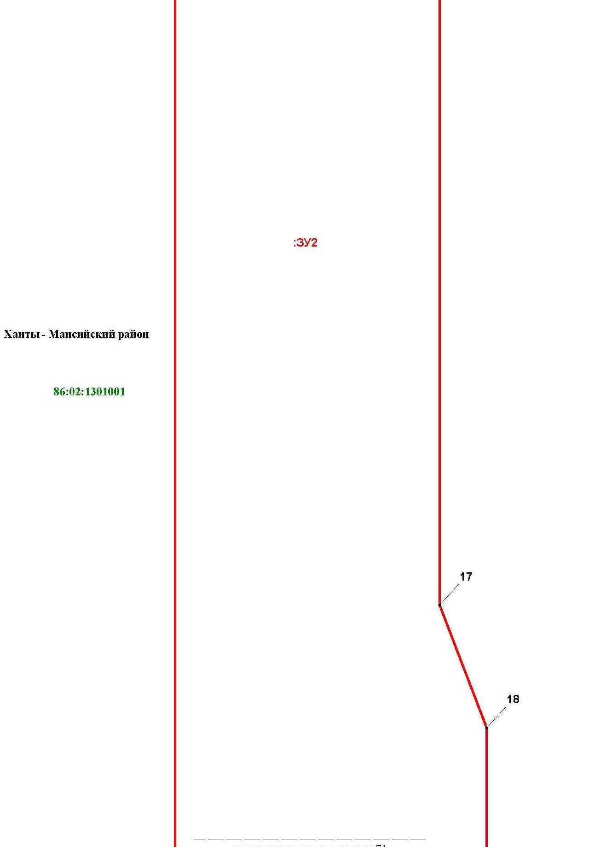

Основная часть проекта межевания территории для размещения объекта капитального строительства, расположенного на территории двух муниципальных образований
Ханты-Мансийского автономного округа – Югры,
«Обустройство Чапровского месторождения.
Кусты 1, 1а, 2, 2а, 4, 4а, 5, 5а и коридоры коммуникаций»
Землепользователь: АО «НК «Конданефть»
Масштаб 1:2000

Основная часть проекта межевания территории для размещения объекта капитального строительства, расположенного на территории двух муниципальных образований
Ханты-Мансийского автономного округа – Югры,
«Обустройство Чапровского месторождения.
Кусты 1, 1а, 2, 2а, 4, 4а, 5, 5а и коридоры коммуникаций»
Землепользователь: АО «НК «Конданефть»
Масштаб 1:2000

Основная часть проекта межевания территории для размещения объекта капитального строительства, расположенного на территории двух муниципальных образований
Ханты-Мансийского автономного округа – Югры
«Обустройство Чапровского месторождения.
Кусты 1, 1а, 2, 2а, 4, 4а, 5, 5а и коридоры коммуникаций»
Землепользователь: АО «НК «Конданефть»

Основная часть проекта межевания территории для размещения объекта капитального строительства, расположенного на территории двух муниципальных образований
Ханты-Мансийского автономного округа – Югры,
«Обустройство Чапровского месторождения.
Кусты 1, 1а, 2, 2а, 4, 4а, 5, 5а и коридоры коммуникаций»
Землепользователь: АО «НК «Конданефть»
Масштаб 1:2000

Линия совмещения с листом 76

Основная часть проекта межевания территории для размещения объекта капитального строительства, расположенного на территории двух муниципальных образований
Ханты-Мансийского автономного округа – Югры
«Промысловый нефтепровод «ЦПС Кондинское-ДНС с УПСВ Западно-Эргинское»
Землепользователь: АО «НК «Конданефть»

Основная часть проекта межевания территории для размещения объекта капитального строительства, расположенного на территории двух муниципальных образований
Ханты-Мансийского автономного округа – Югры,
«Обустройство Чапровского месторождения.
Кусты 1, 1а, 2, 2а, 4, 4а, 5, 5а и коридоры коммуникаций»
Землепользователь: АО «НК «Конданефть»
Масштаб 1:2000

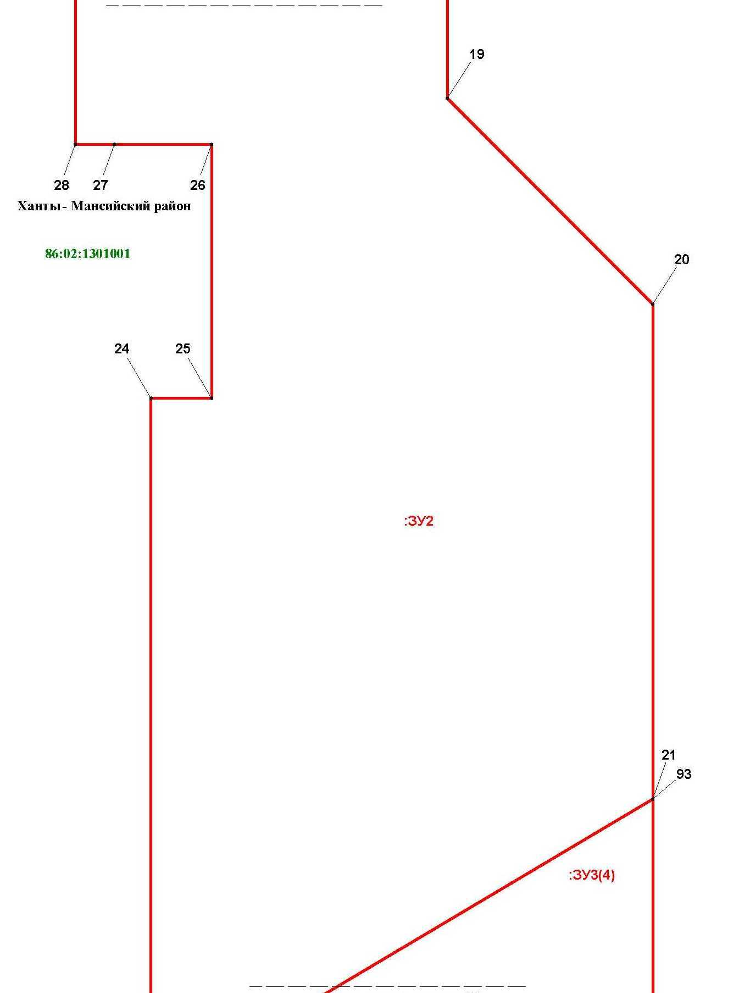

Основная часть проекта межевания территории для размещения объекта капитального строительства, расположенного на территории двух муниципальных образований
Ханты-Мансийского автономного округа – Югры
«Промысловый нефтепровод «ЦПС Кондинское-ДНС с УПСВ Западно-Эргинское»
Землепользователь: АО «НК «Конданефть»

Основная часть проекта межевания территории для размещения объекта капитального строительства, расположенного на территории двух муниципальных образований
Ханты-Мансийского автономного округа – Югры,
«Обустройство Чапровского месторождения.
Кусты 1, 1а, 2, 2а, 4, 4а, 5, 5а и коридоры коммуникаций»
Землепользователь: АО «НК «Конданефть»
Масштаб 1:2000

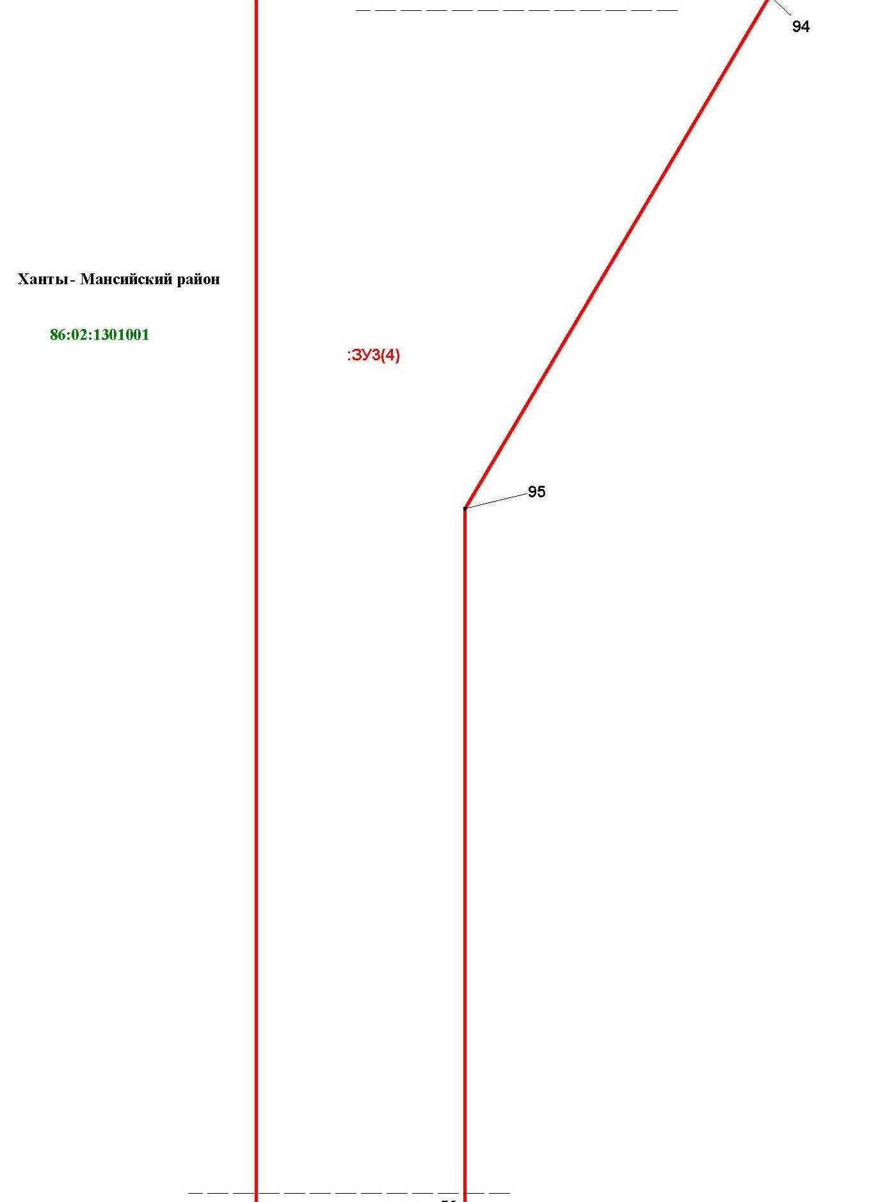

Основная часть проекта межевания территории для размещения объекта капитального строительства, расположенного на территории двух муниципальных образований
Ханты-Мансийского автономного округа – Югры
«Промысловый нефтепровод «ЦПС Кондинское-ДНС с УПСВ Западно-Эргинское»
Землепользователь: АО «НК «Конданефть»

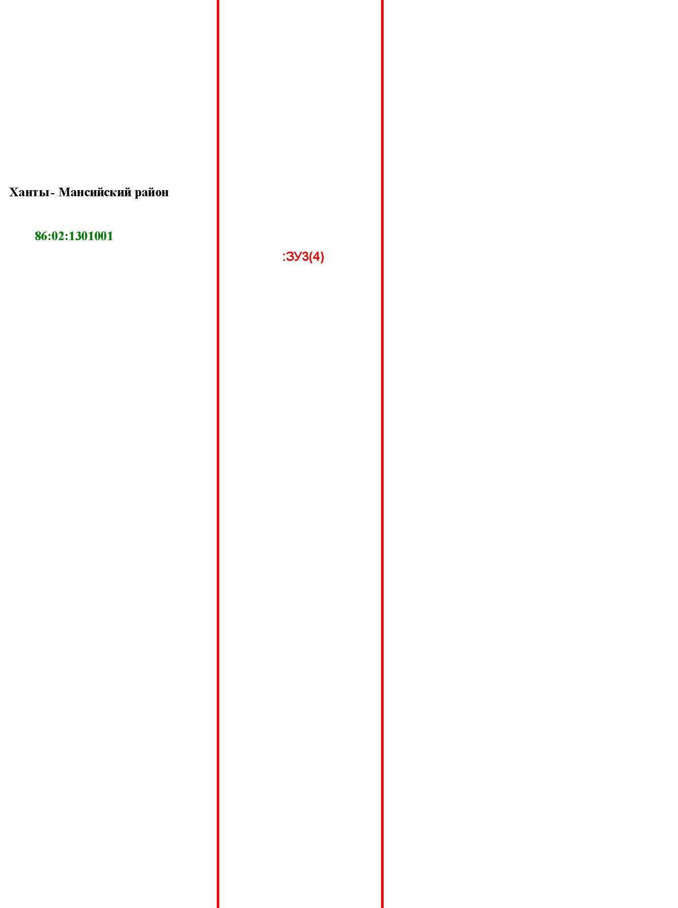

Основная часть проекта межевания территории для размещения объекта капитального строительства, расположенного на территории двух муниципальных образований
Ханты-Мансийского автономного округа – Югры
«Обустройство Чапровского месторождения.
Кусты 1, 1а, 2, 2а, 4, 4а, 5, 5а и коридоры коммуникаций»
Землепользователь: АО «НК «Конданефть»

Основная часть проекта межевания территории для размещения объекта капитального строительства, расположенного на территории двух муниципальных образований
Ханты-Мансийского автономного округа – Югры,
«Обустройство Чапровского месторождения.
Кусты 1, 1а, 2, 2а, 4, 4а, 5, 5а и коридоры коммуникаций»
Землепользователь: АО «НК «Конданефть»
Масштаб 1:2000

Основная часть проекта межевания территории для размещения объекта капитального строительства, расположенного на территории двух муниципальных образований
Ханты-Мансийского автономного округа – Югры
«Обустройство Чапровского месторождения.
Кусты 1, 1а, 2, 2а, 4, 4а, 5, 5а и коридоры коммуникаций»
Землепользователь: АО «НК «Конданефть»

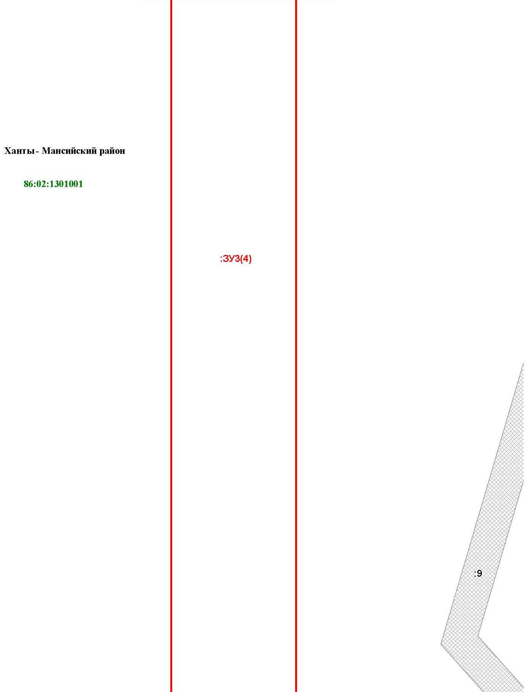

Основная часть проекта межевания территории для размещения объекта капитального строительства, расположенного на территории двух муниципальных образований
Ханты-Мансийского автономного округа – Югры,
«Обустройство Чапровского месторождения.
Кусты 1, 1а, 2, 2а, 4, 4а, 5, 5а и коридоры коммуникаций»
Землепользователь: АО «НК «Конданефть»
Масштаб 1:2000

Линия совмещения с листом 81

Основная часть проекта межевания территории для размещения объекта капитального строительства, расположенного на территории двух муниципальных образований
Ханты-Мансийского автономного округа – Югры
«Обустройство Чапровского месторождения.
Кусты 1, 1а, 2, 2а, 4, 4а, 5, 5а и коридоры коммуникаций»
Землепользователь: АО «НК «Конданефть»

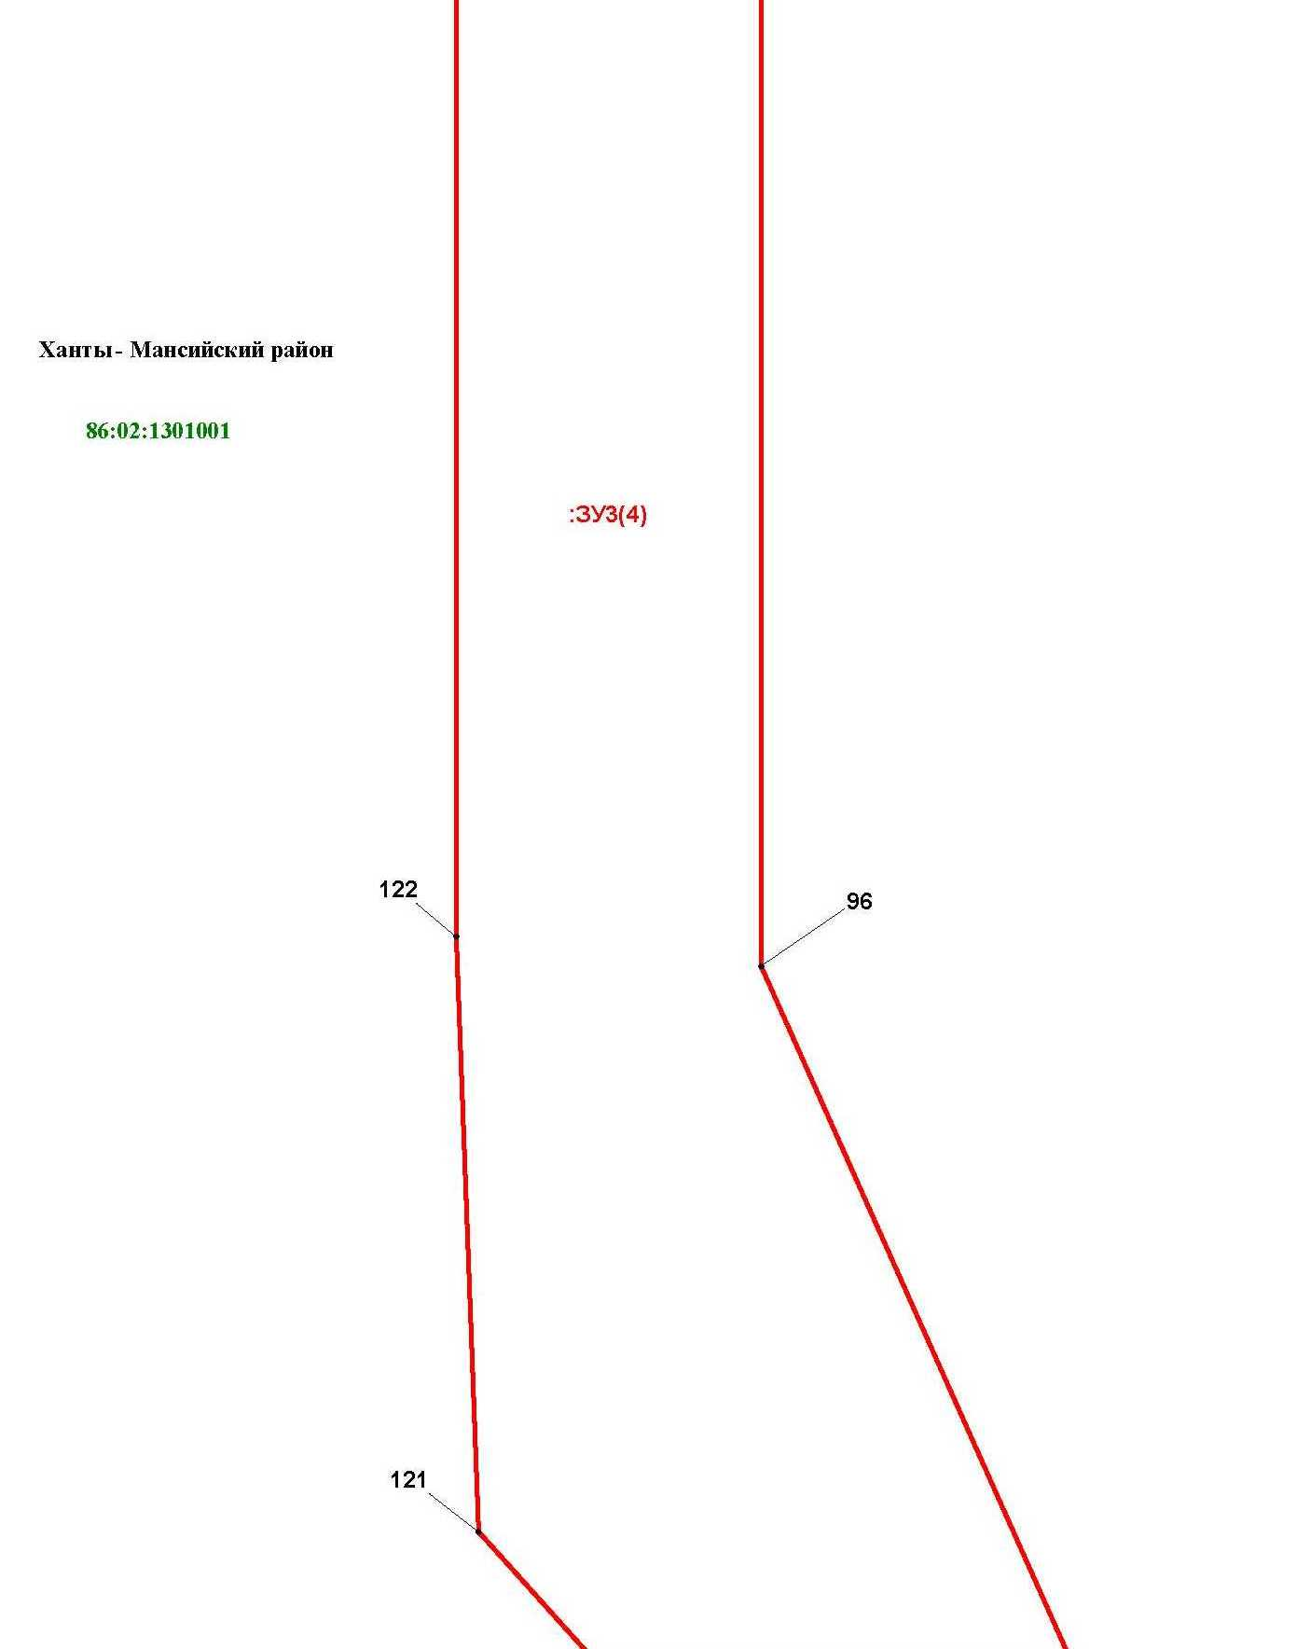

Основная часть проекта межевания территории для размещения объекта капитального строительства, расположенного на территории двух муниципальных образований
Ханты-Мансийского автономного округа – Югры,
«Обустройство Чапровского месторождения.
Кусты 1, 1а, 2, 2а, 4, 4а, 5, 5а и коридоры коммуникаций»
Землепользователь: АО «НК «Конданефть»
Масштаб 1:2000

Линия совмещения с листом 99
Линия совмещения с листом 82

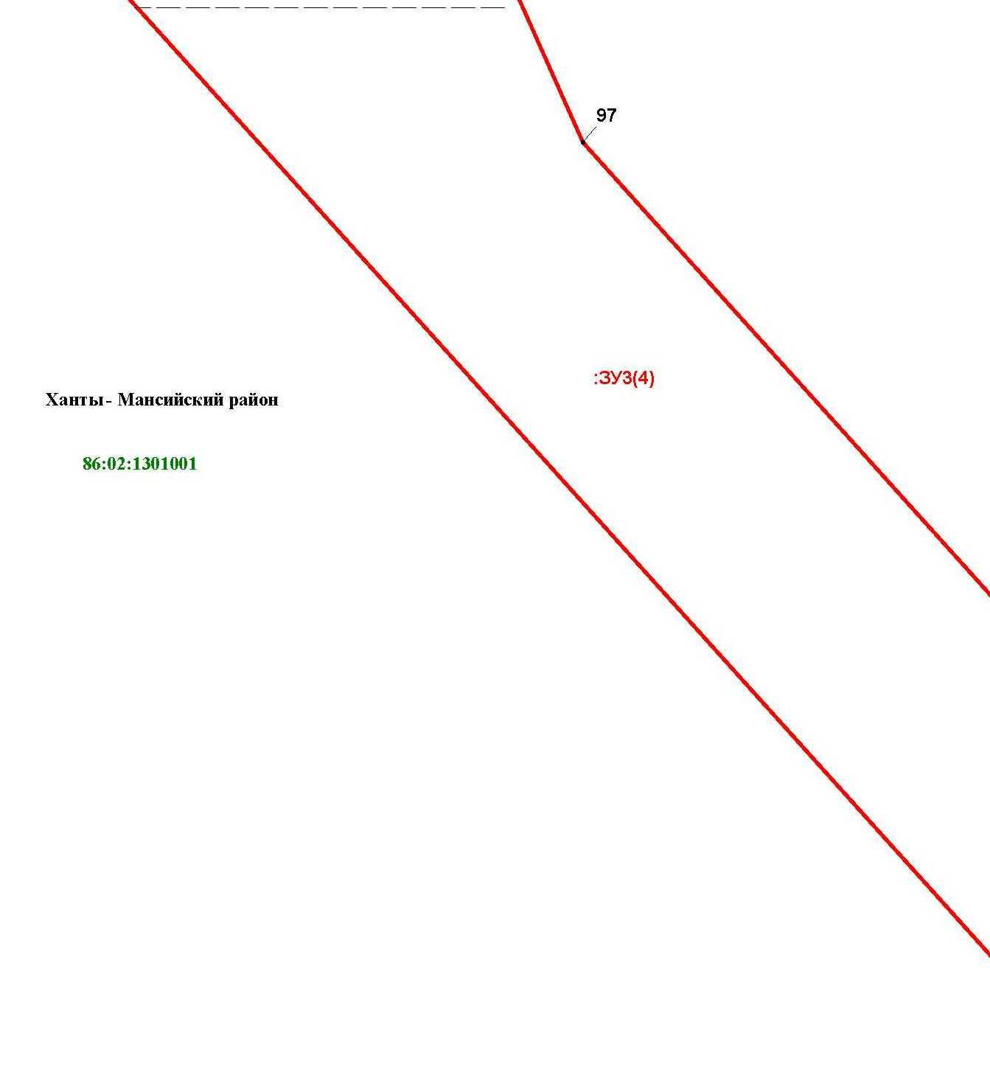

Линия совмещения с листом 81

Основная часть проекта межевания территории для размещения объекта капитального строительства, расположенного на территории двух муниципальных образований
Ханты-Мансийского автономного округа – Югры,
«Обустройство Чапровского месторождения.
Кусты 1, 1а, 2, 2а, 4, 4а, 5, 5а и коридоры коммуникаций»
Землепользователь: АО «НК «Конданефть»
Масштаб 1:2000

Линия совмещения с листом 98

Основная часть проекта межевания территории для размещения объекта капитального строительства, расположенного на территории двух муниципальных образований
Ханты-Мансийского автономного округа – Югры,
«Обустройство Чапровского месторождения.
Кусты 1, 1а, 2, 2а, 4, 4а, 5, 5а и коридоры коммуникаций»
Землепользователь: АО «НК «Конданефть»
Масштаб 1:2000

Линия совмещения с листом 99

Основная часть проекта межевания территории для размещения объекта капитального строительства, расположенного на территории двух муниципальных образований
Ханты-Мансийского автономного округа – Югры
«Обустройство Чапровского месторождения.
Кусты 1, 1а, 2, 2а, 4, 4а, 5, 5а и коридоры коммуникаций»
Землепользователь: АО «НК «Конданефть»

Линия совмещения с листом 83

Основная часть проекта межевания территории для размещения объекта капитального строительства, расположенного на территории двух муниципальных образований
Ханты-Мансийского автономного округа – Югры,
«Обустройство Чапровского месторождения.
Кусты 1, 1а, 2, 2а, 4, 4а, 5, 5а и коридоры коммуникаций»
Землепользователь: АО «НК «Конданефть»
Масштаб 1:2000

Линия совмещения с листом 103

Основная часть проекта межевания территории для размещения объекта капитального строительства, расположенного на территории двух муниципальных образований
Ханты-Мансийского автономного округа – Югры,
«Обустройство Чапровского месторождения.
Кусты 1, 1а, 2, 2а, 4, 4а, 5, 5а и коридоры коммуникаций»
Землепользователь: АО «НК «Конданефть»
Масштаб 1:2000

Линия совмещения с листом 84

Линия совмещения с листом 102

Основная часть проекта межевания территории для размещения объекта капитального строительства, расположенного на территории двух муниципальных образований
Ханты-Мансийского автономного округа – Югры,
«Обустройство Чапровского месторождения.
Кусты 1, 1а, 2, 2а, 4, 4а, 5, 5а и коридоры коммуникаций»
Землепользователь: АО «НК «Конданефть»
Масштаб 1:2000

Линия совмещения с листом 85

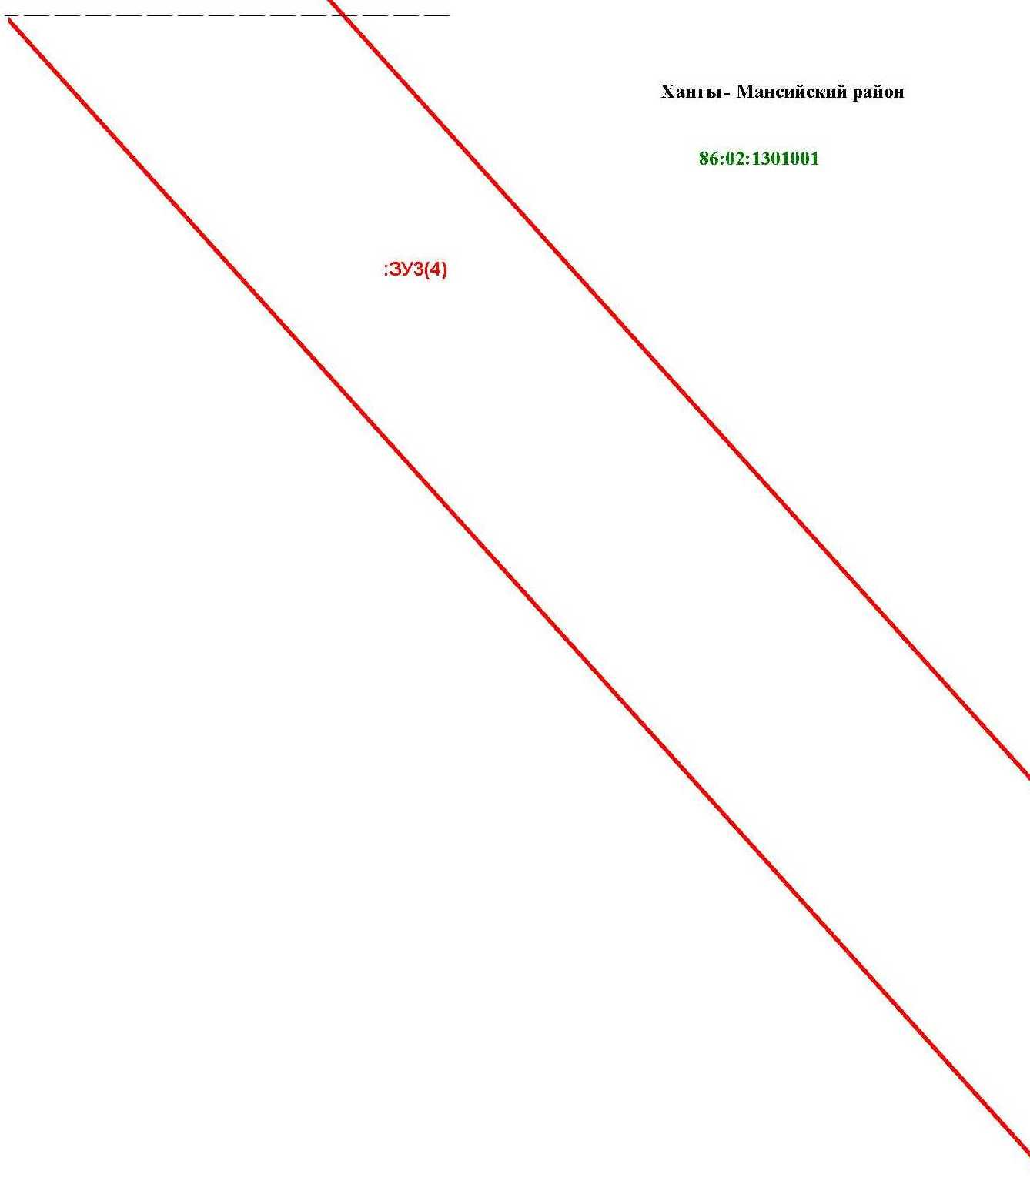

Линия совмещения с листом 103

Основная часть проекта межевания территории для размещения объекта капитального строительства, расположенного на территории двух муниципальных образований
Ханты-Мансийского автономного округа – Югры
«Обустройство Чапровского месторождения.
Кусты 1, 1а, 2, 2а, 4, 4а, 5, 5а и коридоры коммуникаций»
Землепользователь: АО «НК «Конданефть»

Линия совмещения с листом 86

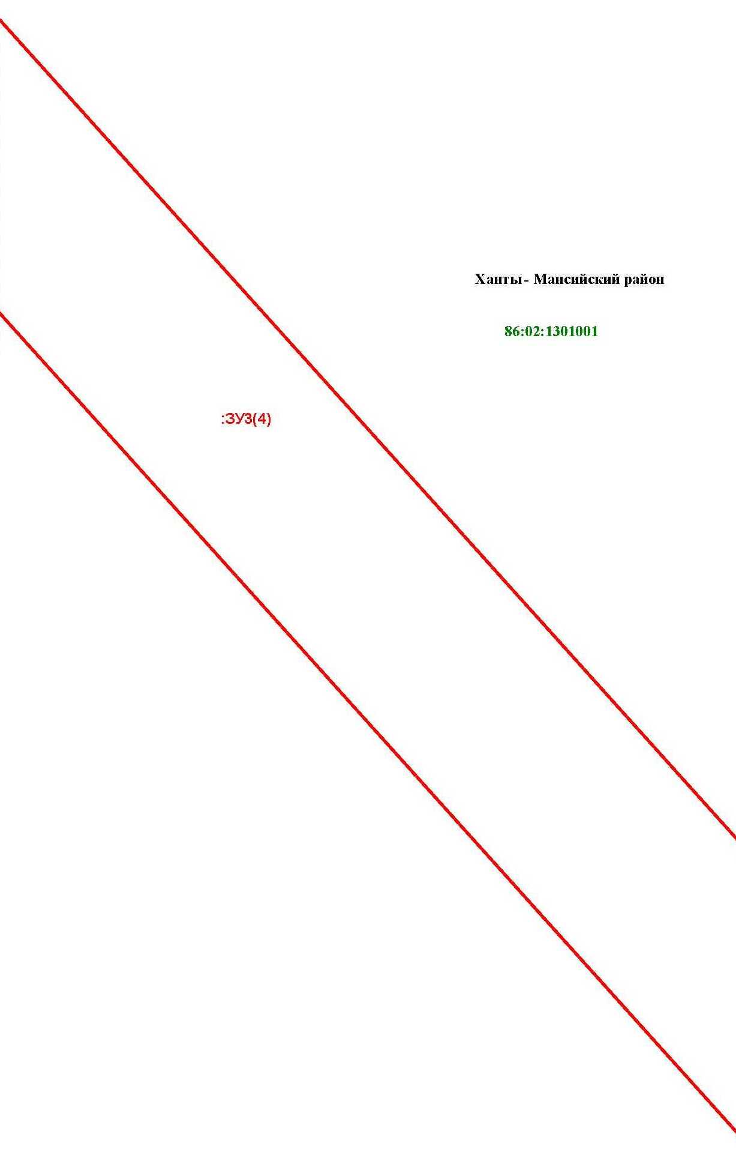

Основная часть проекта межевания территории для размещения объекта капитального строительства, расположенного на территории двух муниципальных образований
Ханты-Мансийского автономного округа – Югры,
«Обустройство Чапровского месторождения.
Кусты 1, 1а, 2, 2а, 4, 4а, 5, 5а и коридоры коммуникаций»
Землепользователь: АО «НК «Конданефть»
Масштаб 1:2000

Линия совмещения с листом 105

Основная часть проекта межевания территории для размещения объекта капитального строительства, расположенного на территории двух муниципальных образований
Ханты-Мансийского автономного округа – Югры,
«Обустройство Чапровского месторождения.
Кусты 1, 1а, 2, 2а, 4, 4а, 5, 5а и коридоры коммуникаций»
Землепользователь: АО «НК «Конданефть»
Масштаб 1:2000

Линия совмещения с листом 87

Основная часть проекта межевания территории для размещения объекта капитального строительства, расположенного на территории двух муниципальных образований
Ханты-Мансийского автономного округа – Югры,
«Обустройство Чапровского месторождения.
Кусты 1, 1а, 2, 2а, 4, 4а, 5, 5а и коридоры коммуникаций»
Землепользователь: АО «НК «Конданефть»
Масштаб 1:2000

Основная часть проекта межевания территории для размещения объекта капитального строительства, расположенного на территории двух муниципальных образований
Ханты-Мансийского автономного округа – Югры
«Обустройство Чапровского месторождения.
Кусты 1, 1а, 2, 2а, 4, 4а, 5, 5а и коридоры коммуникаций»
Землепользователь: АО «НК «Конданефть»

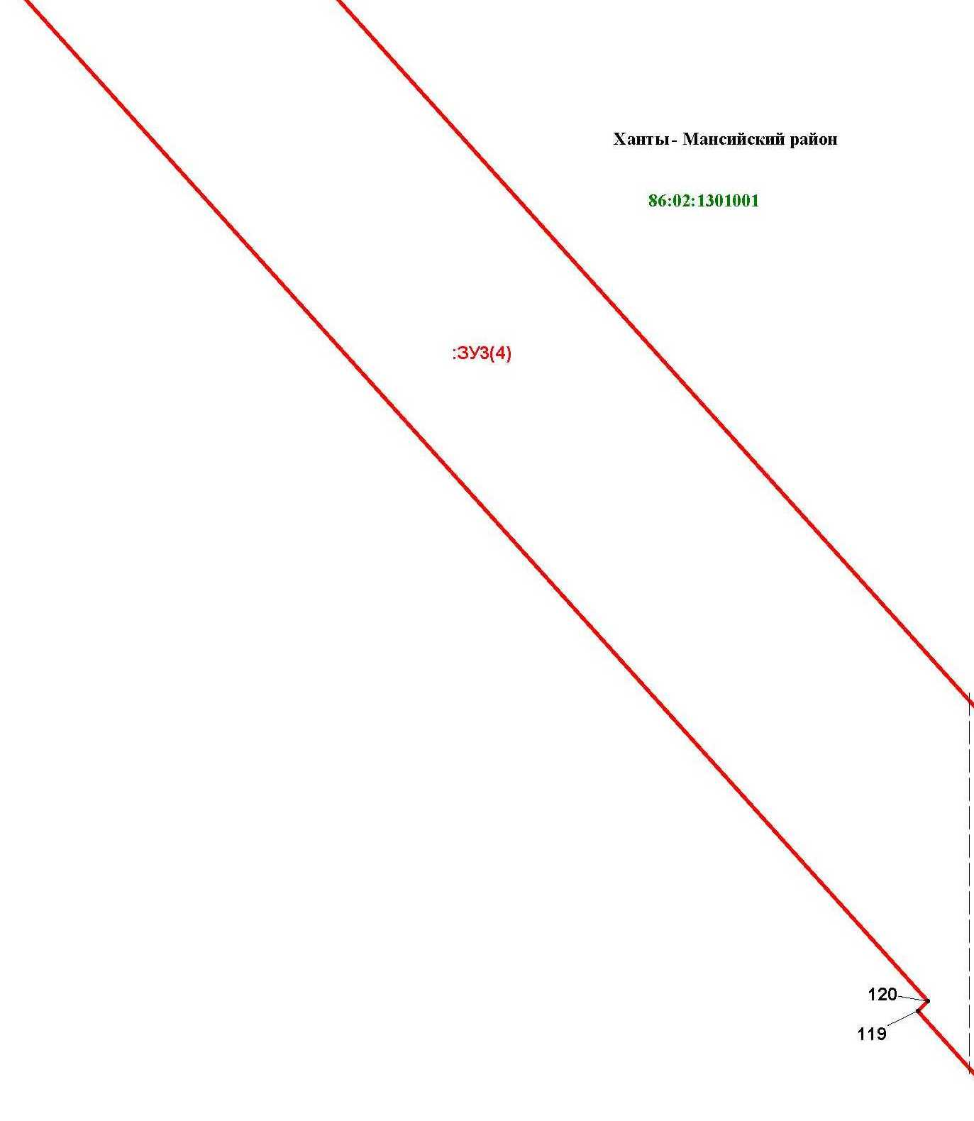

Линия совмещения с листом 88

Основная часть проекта межевания территории для размещения объекта капитального строительства, расположенного на территории двух муниципальных образований
Ханты-Мансийского автономного округа – Югры
«Промысловый нефтепровод «ЦПС Кондинское-ДНС с УПСВ Западно-Эргинское»
Землепользователь: АО «НК «Конданефть»

Линия совмещения с листом 107

Линия совмещения с листом 90

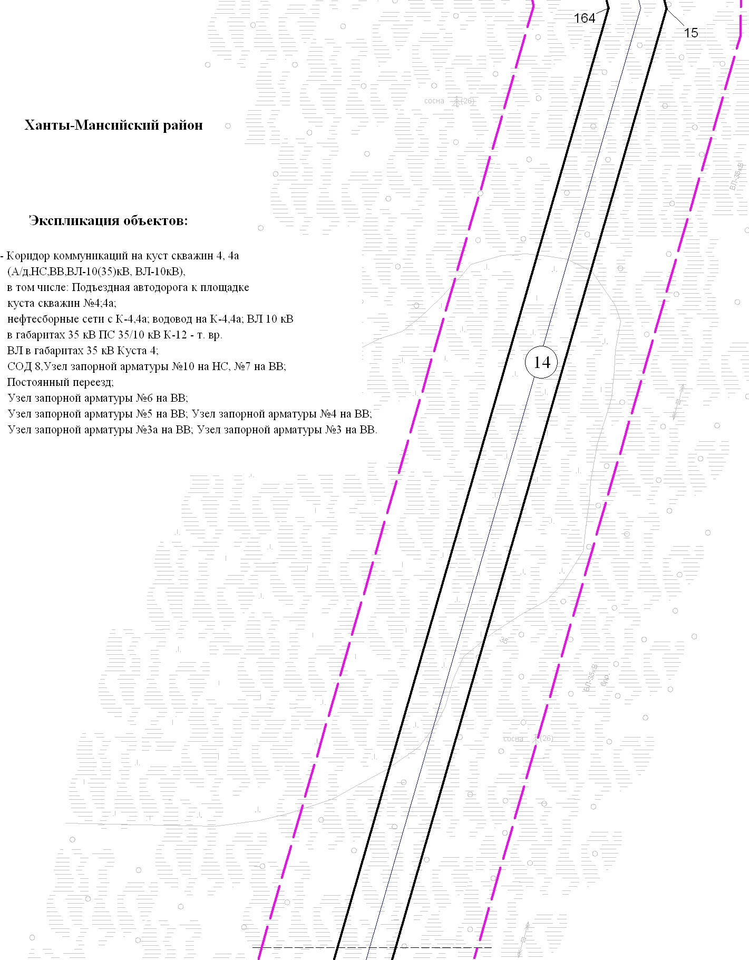

Линия совмещения с листом 109
Основная часть проекта межевания территории для размещения объекта капитального строительства, расположенного на территории двух муниципальных образований
Ханты-Мансийского автономного округа – Югры,
«Обустройство Чапровского месторождения.
Кусты 1, 1а, 2, 2а, 4, 4а, 5, 5а и коридоры коммуникаций»
Землепользователь: АО «НК «Конданефть»
Масштаб 1:2000

Линия совмещения с листом 91

Основная часть проекта межевания территории для размещения объекта капитального строительства, расположенного на территории двух муниципальных образований
Ханты-Мансийского автономного округа – Югры,
«Обустройство Чапровского месторождения.
Кусты 1, 1а, 2, 2а, 4, 4а, 5, 5а и коридоры коммуникаций»
Землепользователь: АО «НК «Конданефть»
Масштаб 1:2000

Линия совмещения с листом 111

Линия совмещения с листом 110

Основная часть проекта межевания территории для размещения объекта капитального строительства, расположенного на территории двух муниципальных образований
Ханты-Мансийского автономного округа – Югры
«Обустройство Чапровского месторождения.
Кусты 1, 1а, 2, 2а, 4, 4а, 5, 5а и коридоры коммуникаций»
Землепользователь: АО «НК «Конданефть»

Линия совмещения с листом 92

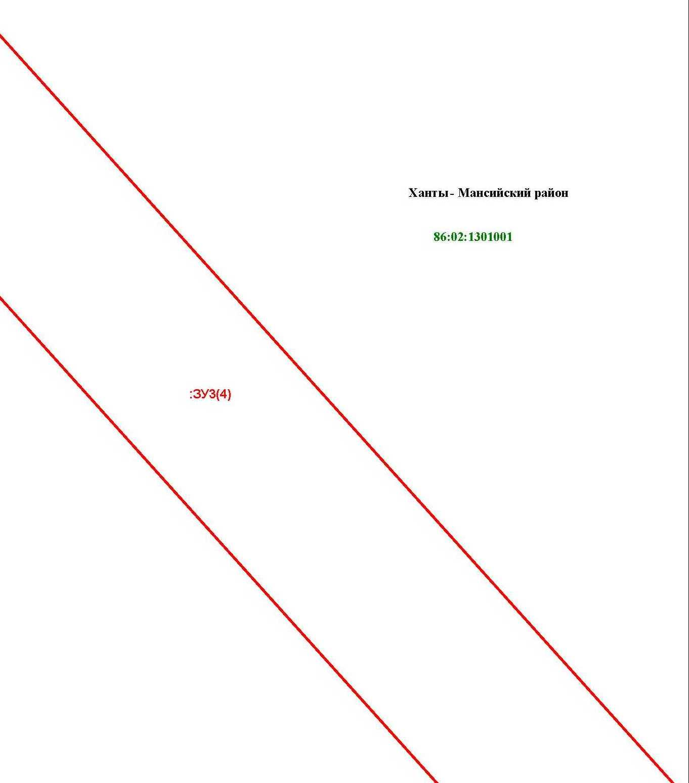

Линия совмещения с листом 93

Линия совмещения с листом 112

Основная часть проекта межевания территории для размещения объекта капитального строительства, расположенного на территории двух муниципальных образований
Ханты-Мансийского автономного округа – Югры,
«Обустройство Чапровского месторождения.
Кусты 1, 1а, 2, 2а, 4, 4а, 5, 5а и коридоры коммуникаций»
Землепользователь: АО «НК «Конданефть»
Масштаб 1:2000

Линия совмещения с листом 114

Основная часть проекта межевания территории для размещения объекта капитального строительства, расположенного на территории двух муниципальных образований
Ханты-Мансийского автономного округа – Югры,
«Обустройство Чапровского месторождения.
Кусты 1, 1а, 2, 2а, 4, 4а, 5, 5а и коридоры коммуникаций»
Землепользователь: АО «НК «Конданефть»
Масштаб 1:2000

Линия совмещения с листом 94

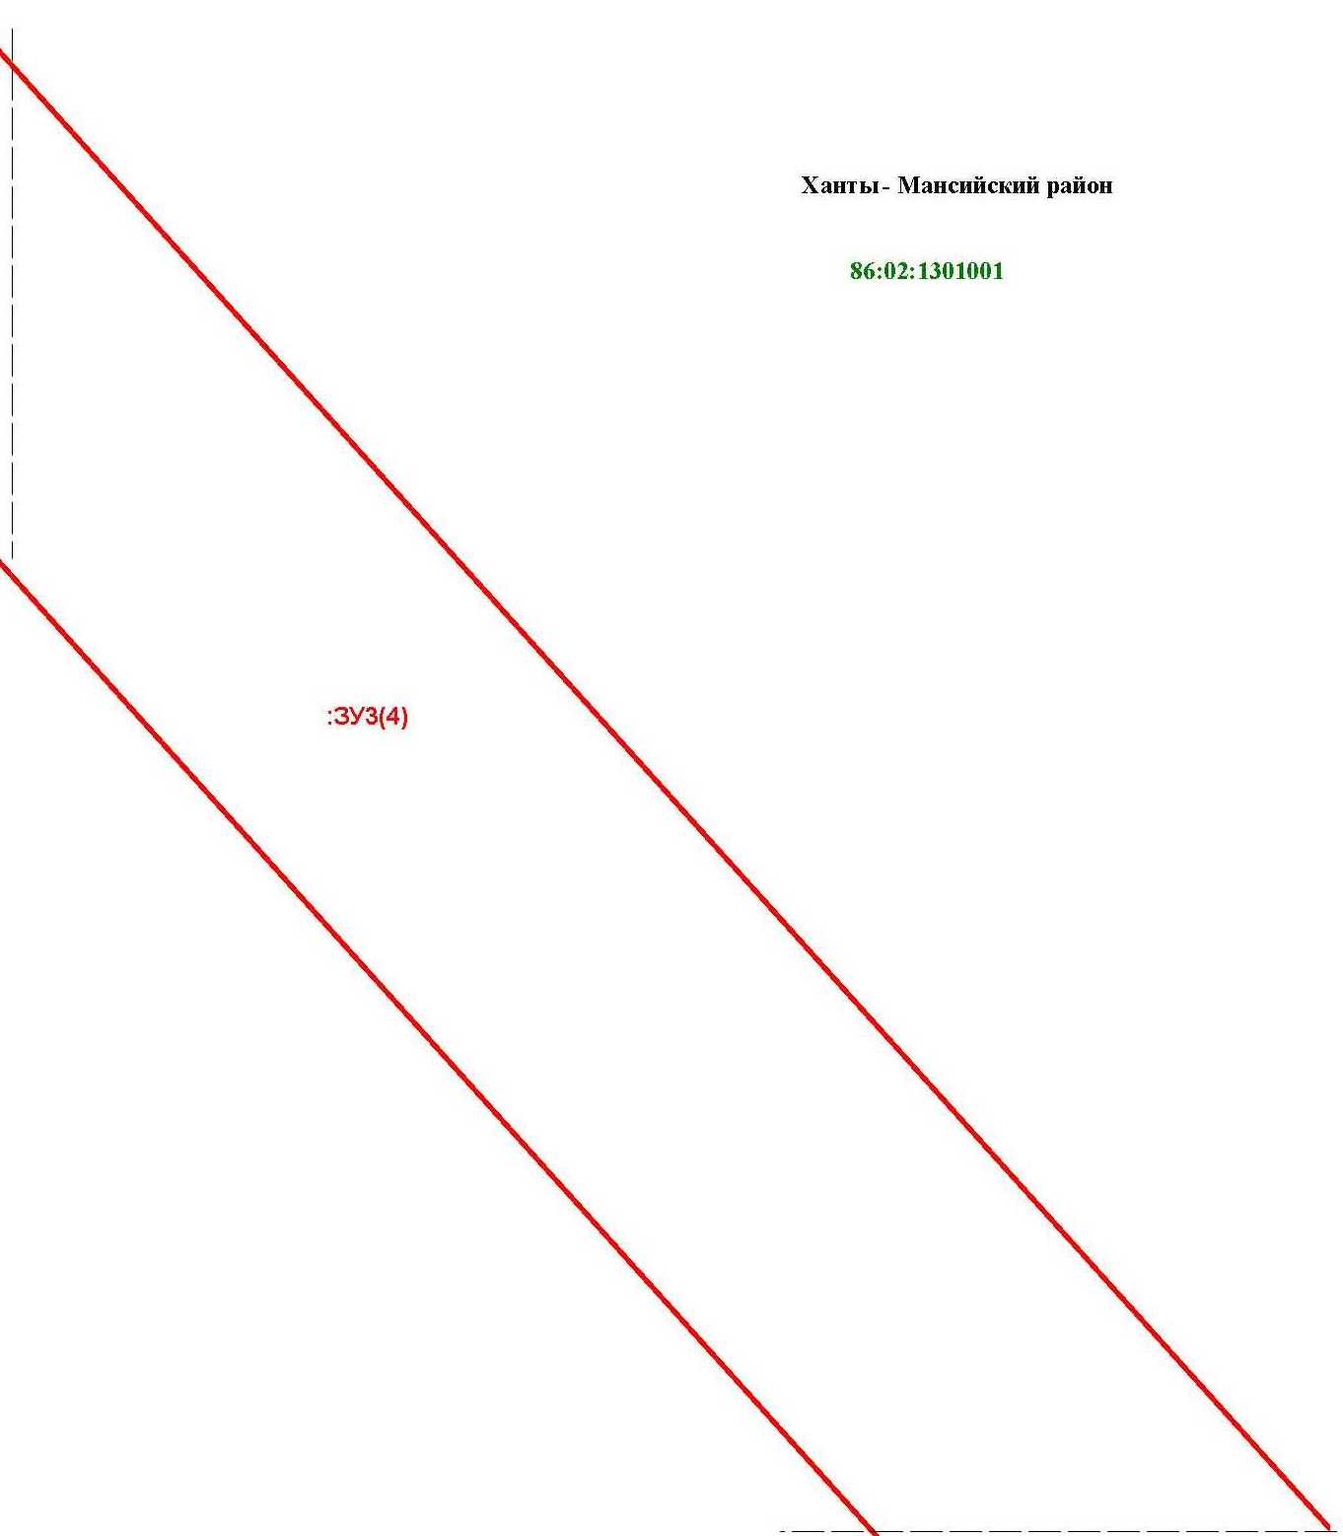

Основная часть проекта межевания территории для размещения объекта капитального строительства, расположенного на территории двух муниципальных образований
Ханты-Мансийского автономного округа – Югры
«Промысловый нефтепровод «ЦПС Кондинское-ДНС с УПСВ Западно-Эргинское»
Землепользователь: АО «НК «Конданефть»

Основная часть проекта межевания территории для размещения объекта капитального строительства, расположенного на территории двух муниципальных образований
Ханты-Мансийского автономного округа – Югры,
«Обустройство Чапровского месторождения.
Кусты 1, 1а, 2, 2а, 4, 4а, 5, 5а и коридоры коммуникаций»
Землепользователь: АО «НК «Конданефть»
Масштаб 1:2000

Линия совмещения с листом 95

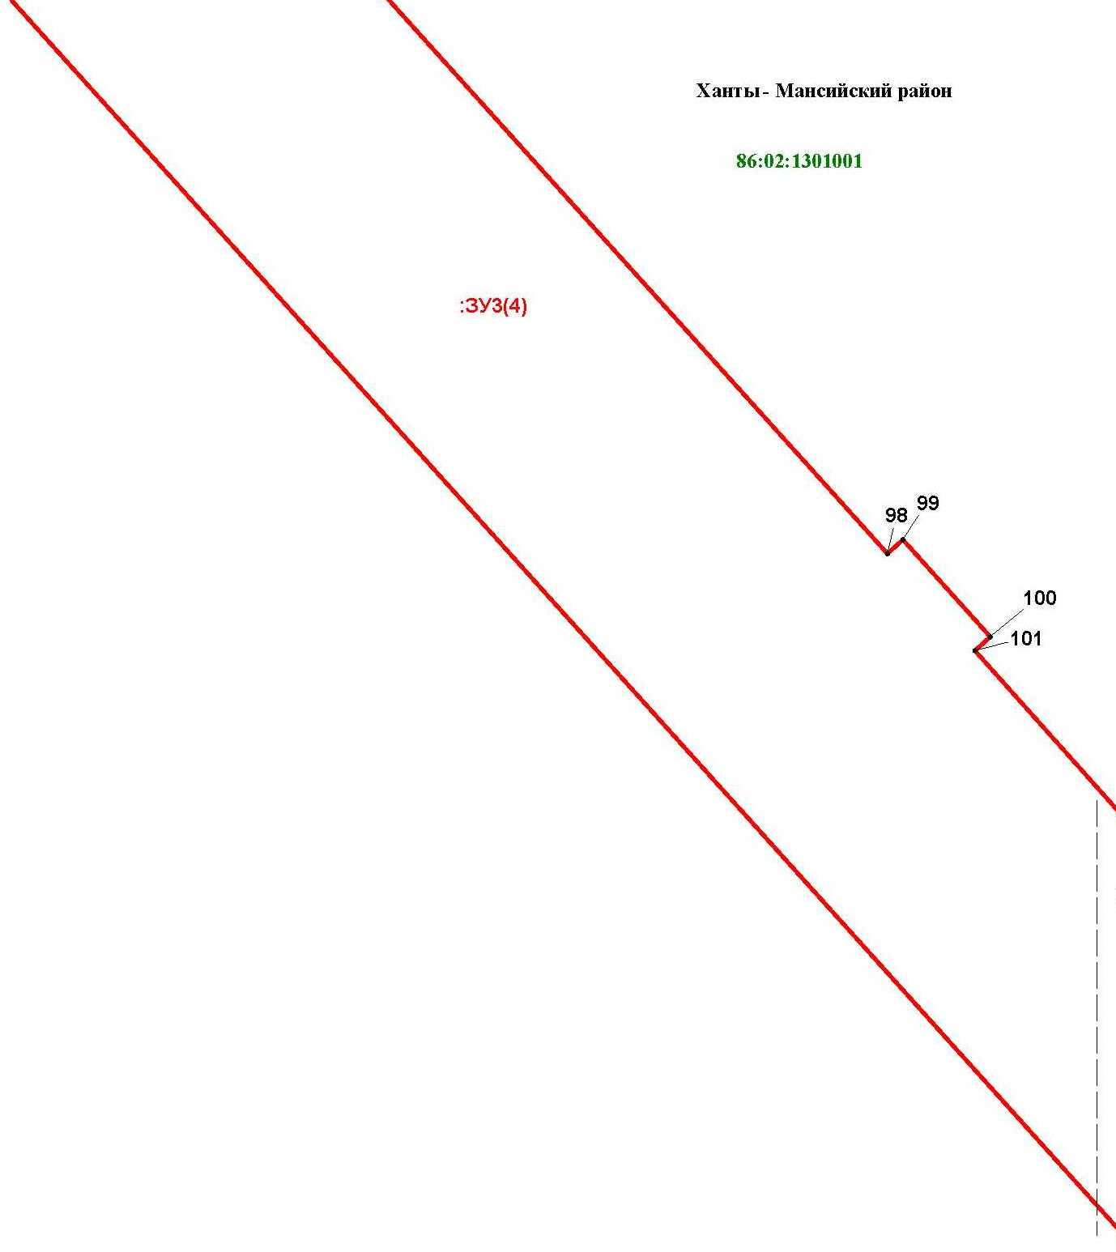

Основная часть проекта межевания территории для размещения объекта капитального строительства, расположенного на территории двух муниципальных образований
Ханты-Мансийского автономного округа – Югры
«Промысловый нефтепровод «ЦПС Кондинское-ДНС с УПСВ Западно-Эргинское»
Землепользователь: АО «НК «Конданефть»

Линия совмещения с листом 117

Основная часть проекта межевания территории для размещения объекта капитального строительства, расположенного на территории двух муниципальных образований
Ханты-Мансийского автономного округа – Югры,
«Обустройство Чапровского месторождения.
Кусты 1, 1а, 2, 2а, 4, 4а, 5, 5а и коридоры коммуникаций»
Землепользователь: АО «НК «Конданефть»
Масштаб 1:2000

Линия совмещения с листом 120

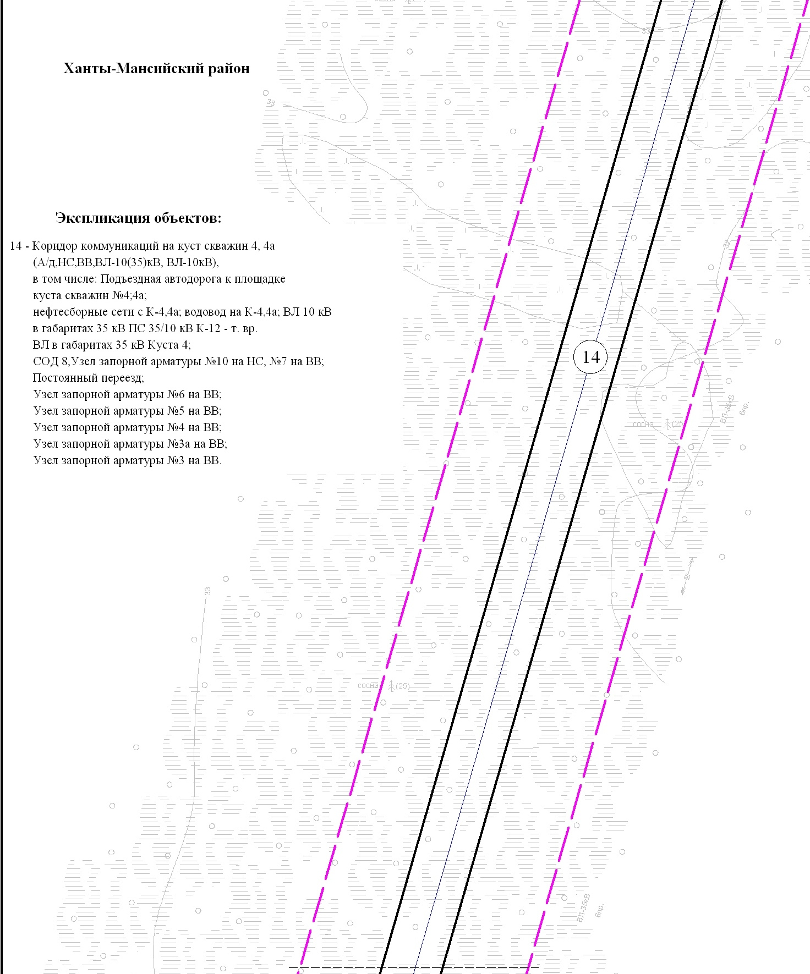

Основная часть проекта межевания территории для размещения объекта капитального строительства, расположенного на территории двух муниципальных образований
Ханты-Мансийского автономного округа – Югры
«Промысловый нефтепровод «ЦПС Кондинское-ДНС с УПСВ Западно-Эргинское»
Землепользователь: АО «НК «Конданефть»

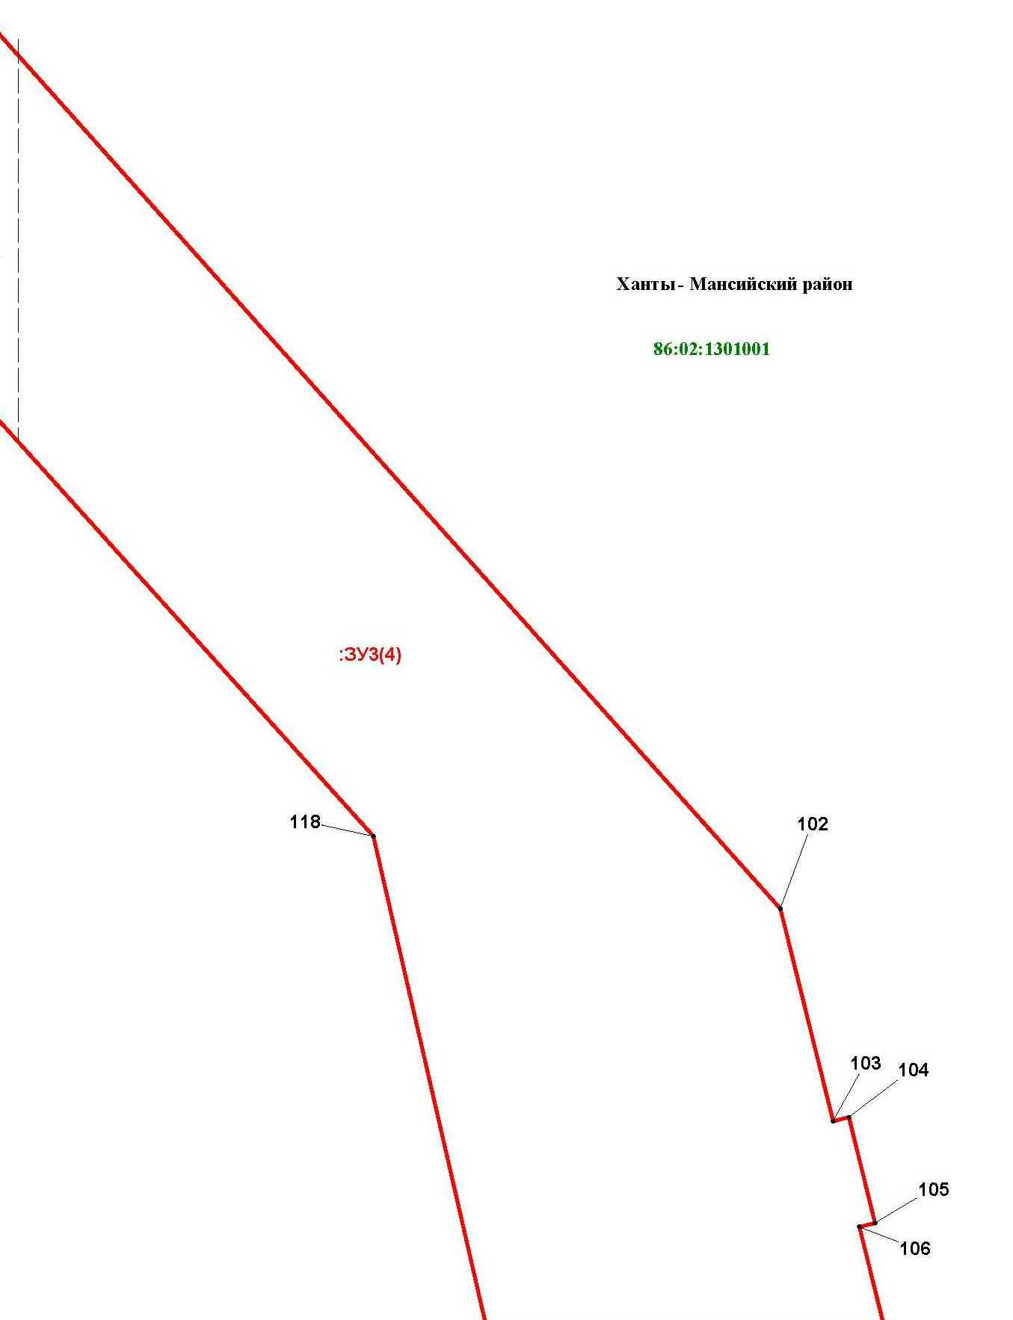

Основная часть проекта межевания территории для размещения объекта капитального строительства, расположенного на территории двух муниципальных образований
Ханты-Мансийского автономного округа – Югры,
«Обустройство Чапровского месторождения.
Кусты 1, 1а, 2, 2а, 4, 4а, 5, 5а и коридоры коммуникаций»
Землепользователь: АО «НК «Конданефть»
Масштаб 1:2000

Линия совмещения с листом 97
Линия совмещения с листом 122

Основная часть проекта межевания территории для размещения объекта капитального строительства, расположенного на территории двух муниципальных образований
Ханты-Мансийского автономного округа – Югры
«Промысловый нефтепровод «ЦПС Кондинское-ДНС с УПСВ Западно-Эргинское»
Землепользователь: АО «НК «Конданефть»

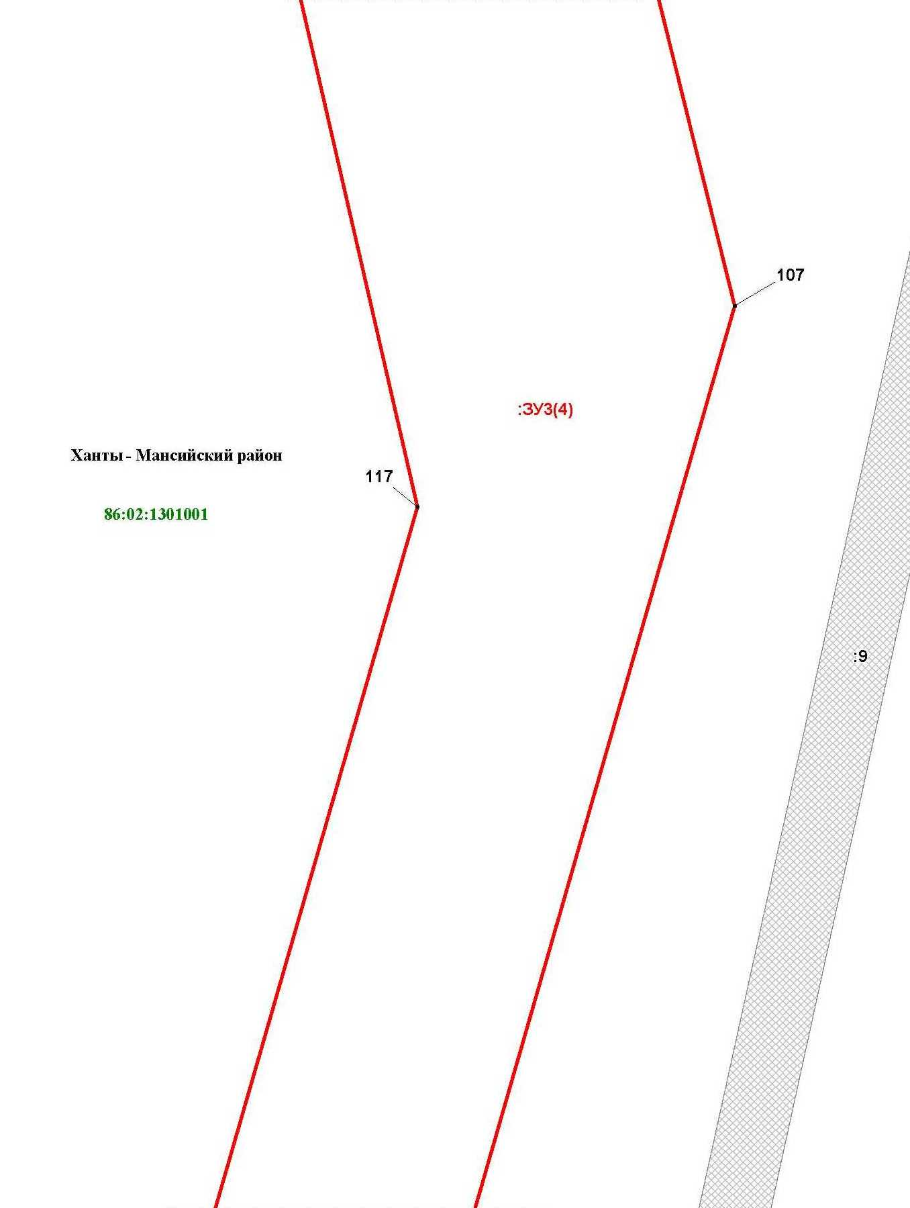

Основная часть проекта межевания территории для размещения объекта капитального строительства, расположенного на территории двух муниципальных образований
Ханты-Мансийского автономного округа – Югры,
«Обустройство Чапровского месторождения.
Кусты 1, 1а, 2, 2а, 4, 4а, 5, 5а и коридоры коммуникаций»
Землепользователь: АО «НК «Конданефть»
Масштаб 1:2000

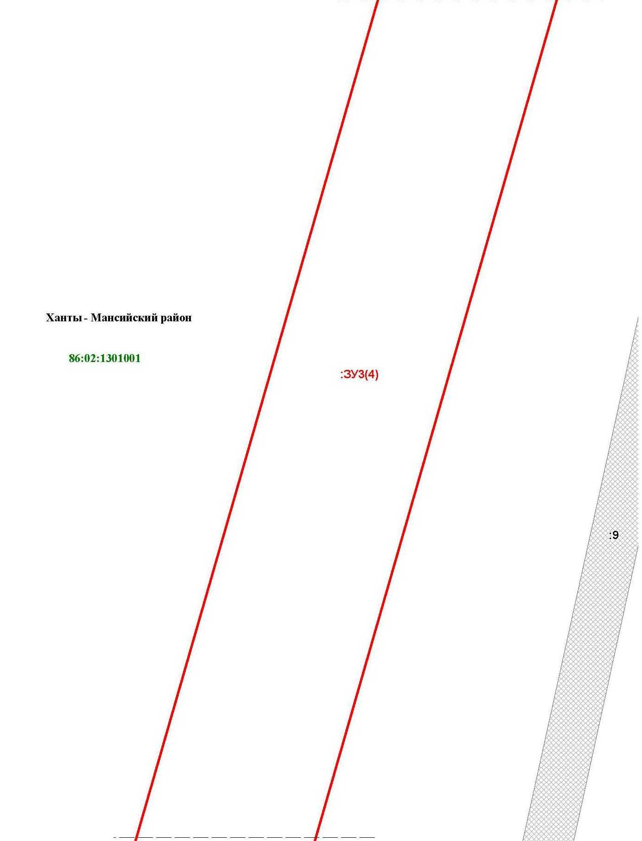

Основная часть проекта межевания территории для размещения объекта капитального строительства, расположенного на территории двух муниципальных образований
Ханты-Мансийского автономного округа – Югры,
«Обустройство Чапровского месторождения.
Кусты 1, 1а, 2, 2а, 4, 4а, 5, 5а и коридоры коммуникаций»
Землепользователь: АО «НК «Конданефть»
Масштаб 1:2000

Основная часть проекта межевания территории для размещения объекта капитального строительства, расположенного на территории двух муниципальных образований
Ханты-Мансийского автономного округа – Югры
«Обустройство Чапровского месторождения.
Кусты 1, 1а, 2, 2а, 4, 4а, 5, 5а и коридоры коммуникаций»
Землепользователь: АО «НК «Конданефть»

Линия совмещения с листом 100
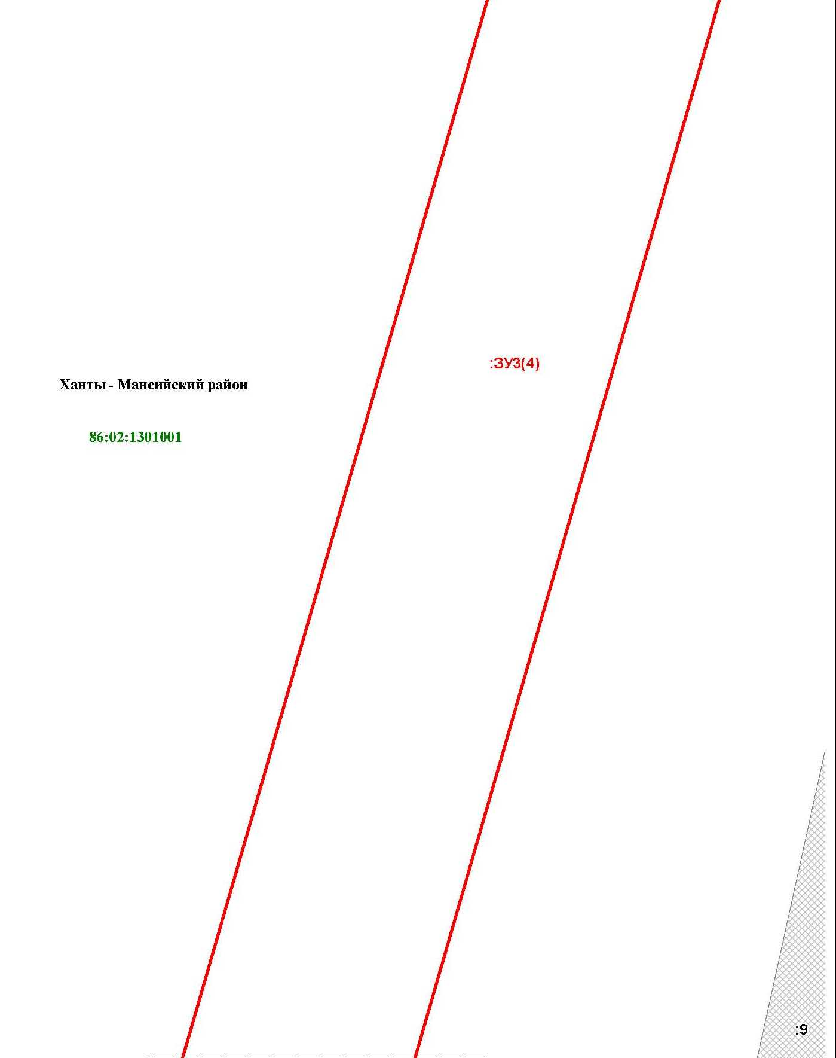

Основная часть проекта межевания территории для размещения объекта капитального строительства, расположенного на территории двух муниципальных образований
Ханты-Мансийского автономного округа – Югры,
«Обустройство Чапровского месторождения.
Кусты 1, 1а, 2, 2а, 4, 4а, 5, 5а и коридоры коммуникаций»
Землепользователь: АО «НК «Конданефть»
Масштаб 1:2000

Основная часть проекта межевания территории для размещения объекта капитального строительства, расположенного на территории двух муниципальных образований
Ханты-Мансийского автономного округа – Югры
«Обустройство Чапровского месторождения.
Кусты 1, 1а, 2, 2а, 4, 4а, 5, 5а и коридоры коммуникаций»
Землепользователь: АО «НК «Конданефть»

Линия совмещения с листом 101
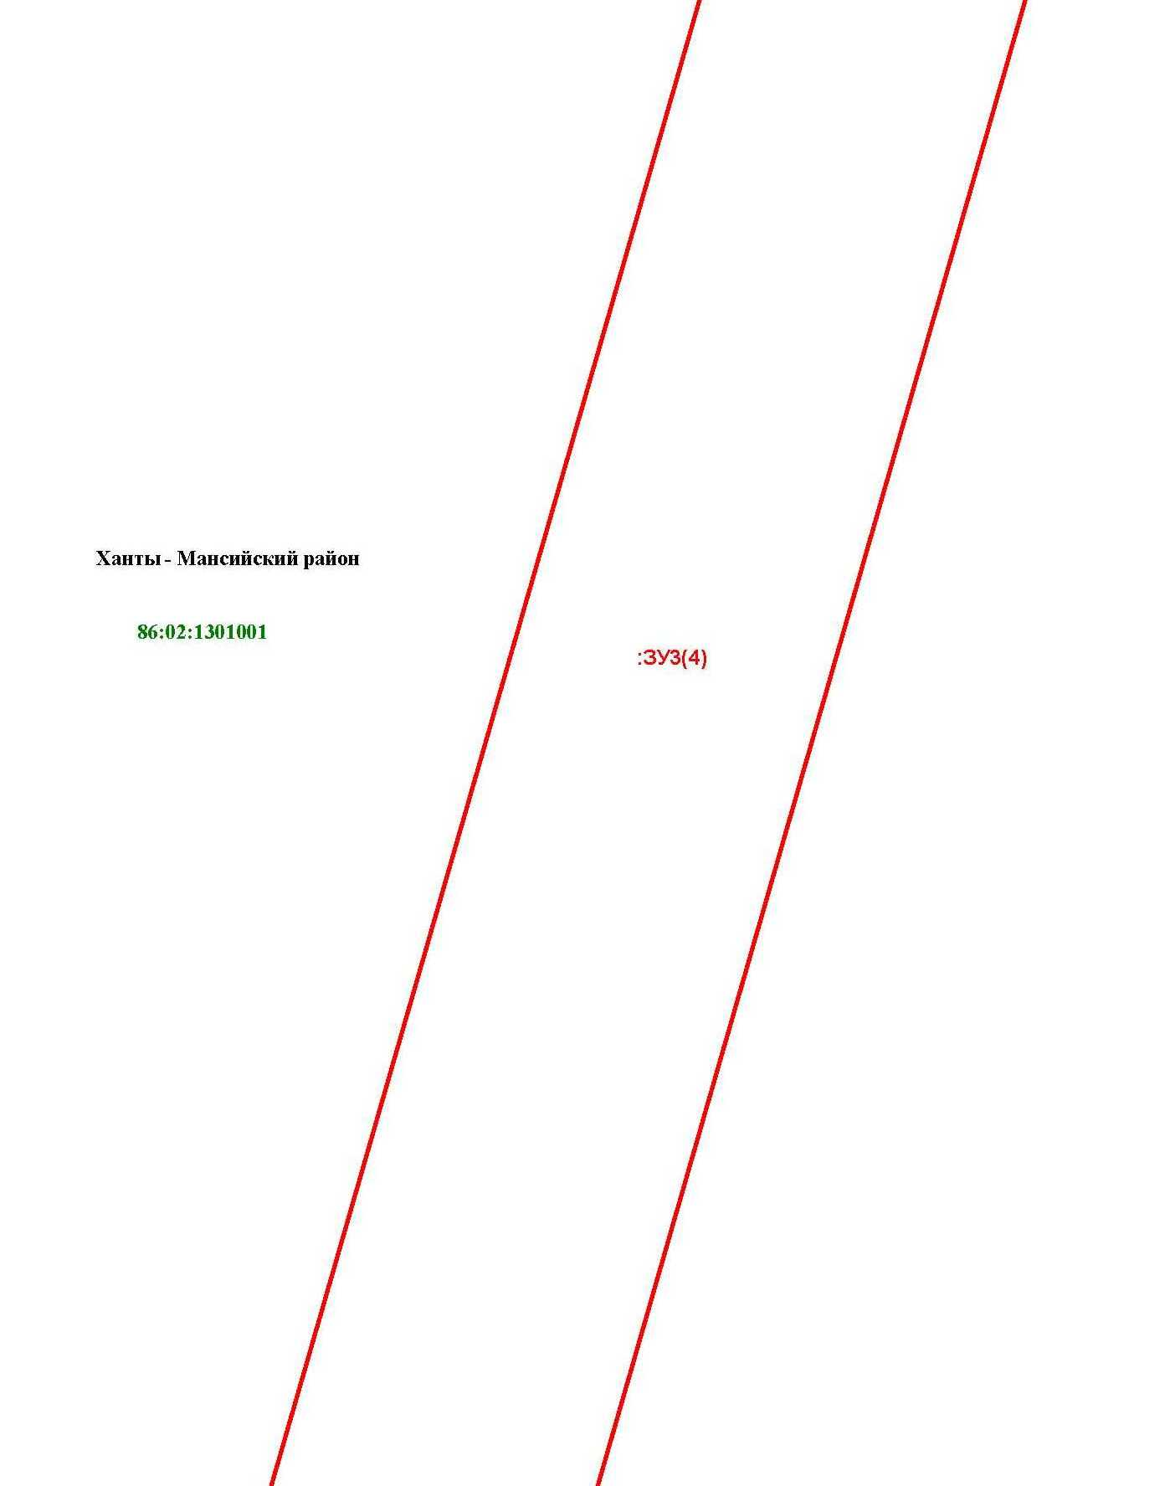

Основная часть проекта межевания территории для размещения объекта капитального строительства, расположенного на территории двух муниципальных образований
Ханты-Мансийского автономного округа – Югры,
«Обустройство Чапровского месторождения.
Кусты 1, 1а, 2, 2а, 4, 4а, 5, 5а и коридоры коммуникаций»
Землепользователь: АО «НК «Конданефть»
Масштаб 1:2000

Основная часть проекта межевания территории для размещения объекта капитального строительства, расположенного на территории двух муниципальных образований
Ханты-Мансийского автономного округа – Югры
«Обустройство Чапровского месторождения.
Кусты 1, 1а, 2, 2а, 4, 4а, 5, 5а и коридоры коммуникаций»
Землепользователь: АО «НК «Конданефть»

Линия совмещения

с листом 100

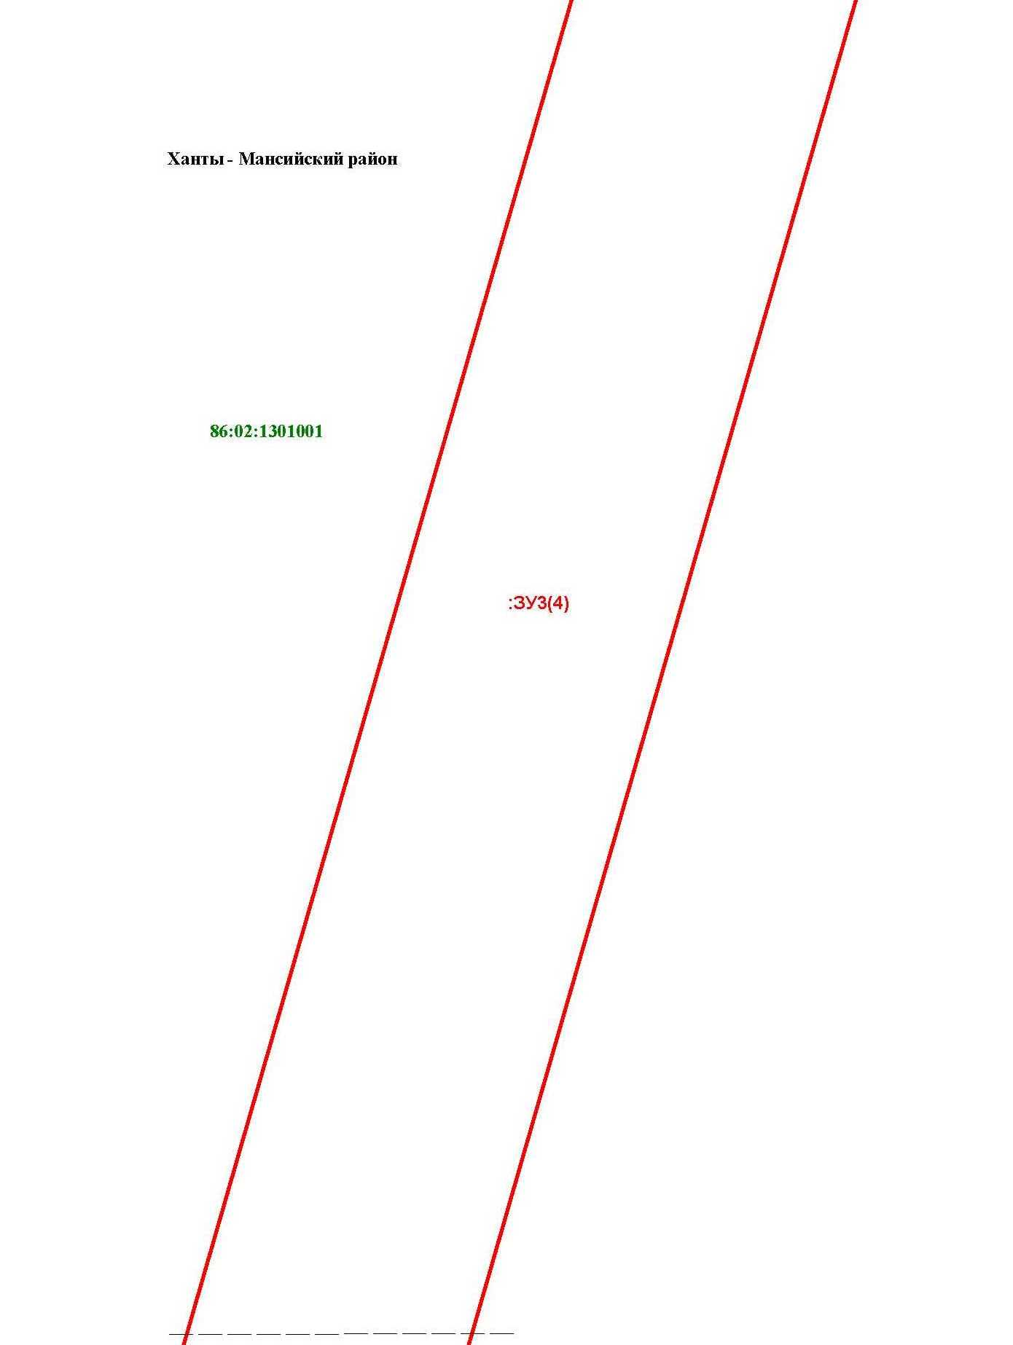

Линия совмещения с листом 129
Основная часть проекта межевания территории для размещения объекта капитального строительства, расположенного на территории двух муниципальных образований
Ханты-Мансийского автономного округа – Югры,
«Обустройство Чапровского месторождения.
Кусты 1, 1а, 2, 2а, 4, 4а, 5, 5а и коридоры коммуникаций»
Землепользователь: АО «НК «Конданефть»
Масштаб 1:2000

Основная часть проекта межевания территории для размещения объекта капитального строительства, расположенного на территории двух муниципальных образований
Ханты-Мансийского автономного округа – Югры
«Обустройство Чапровского месторождения.
Кусты 1, 1а, 2, 2а, 4, 4а, 5, 5а и коридоры коммуникаций»
Землепользователь: АО «НК «Конданефть»

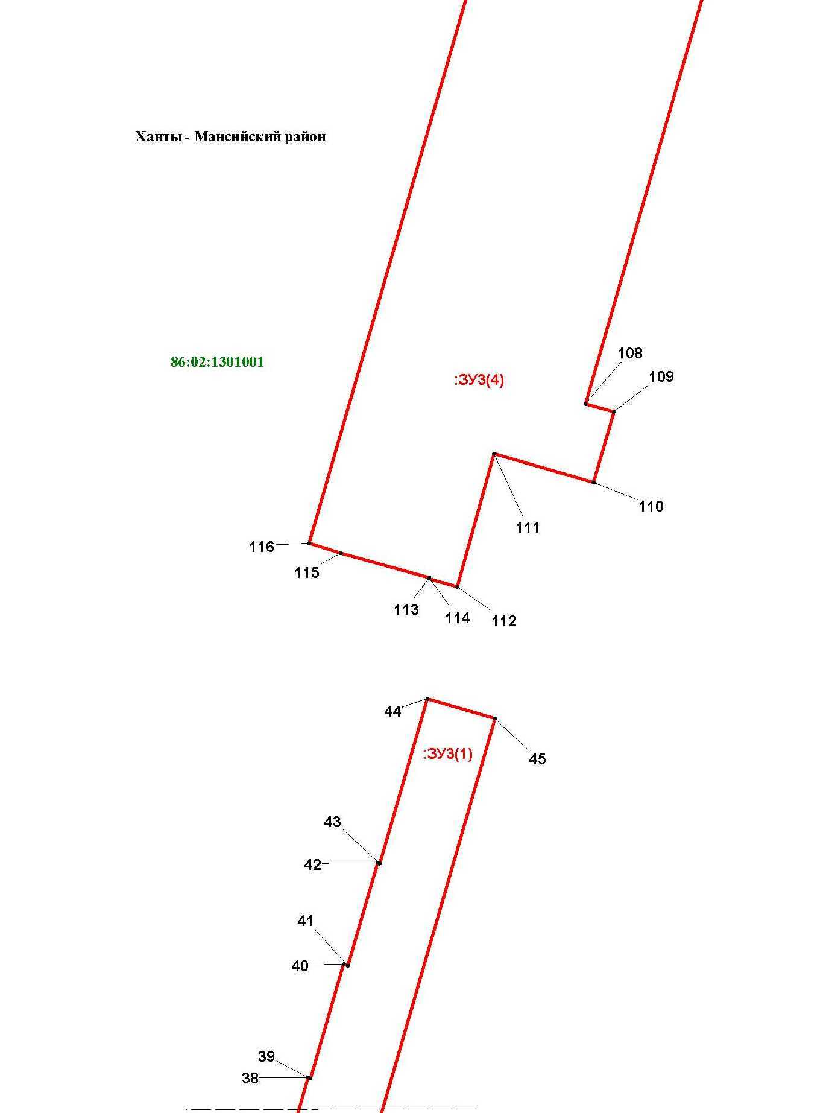

Линия совмещения с листом 131
Основная часть проекта межевания территории для размещения объекта капитального строительства, расположенного на территории двух муниципальных образований
Ханты-Мансийского автономного округа – Югры,
«Обустройство Чапровского месторождения.
Кусты 1, 1а, 2, 2а, 4, 4а, 5, 5а и коридоры коммуникаций»
Землепользователь: АО «НК «Конданефть»
Масштаб 1:2000

Линия совмещения с листом 133

Основная часть проекта межевания территории для размещения объекта капитального строительства, расположенного на территории двух муниципальных образований
Ханты-Мансийского автономного округа – Югры
«Обустройство Чапровского месторождения.
Кусты 1, 1а, 2, 2а, 4, 4а, 5, 5а и коридоры коммуникаций»
Землепользователь: АО «НК «Конданефть»

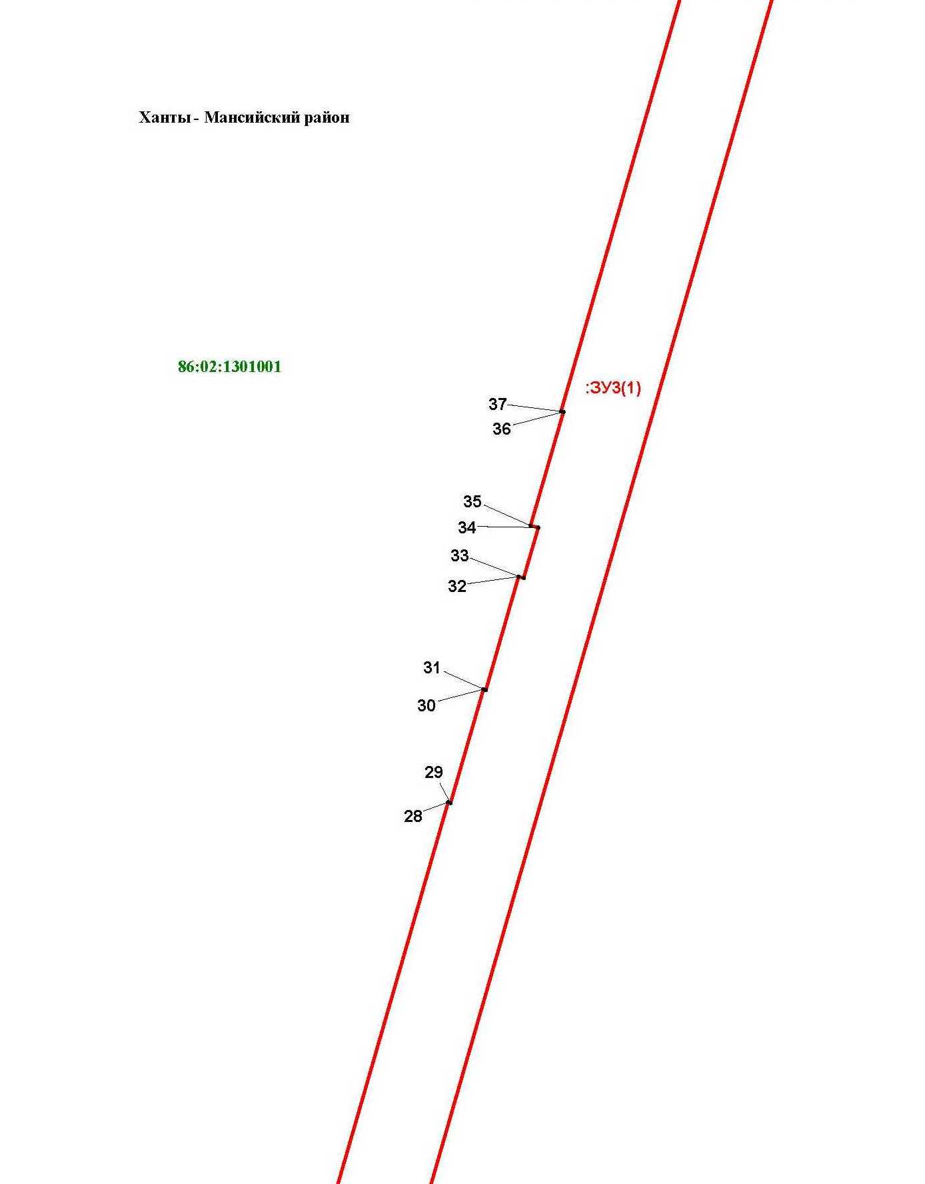

Основная часть проекта межевания территории для размещения объекта капитального строительства, расположенного на территории двух муниципальных образований
Ханты-Мансийского автономного округа – Югры,
«Обустройство Чапровского месторождения.
Кусты 1, 1а, 2, 2а, 4, 4а, 5, 5а и коридоры коммуникаций»
Землепользователь: АО «НК «Конданефть»
Масштаб 1:2000

Основная часть проекта межевания территории для размещения объекта капитального строительства, расположенного на территории двух муниципальных образований
Ханты-Мансийского автономного округа – Югры,
«Обустройство Чапровского месторождения.
Кусты 1, 1а, 2, 2а, 4, 4а, 5, 5а и коридоры коммуникаций»
Землепользователь: АО «НК «Конданефть»
Масштаб 1:2000

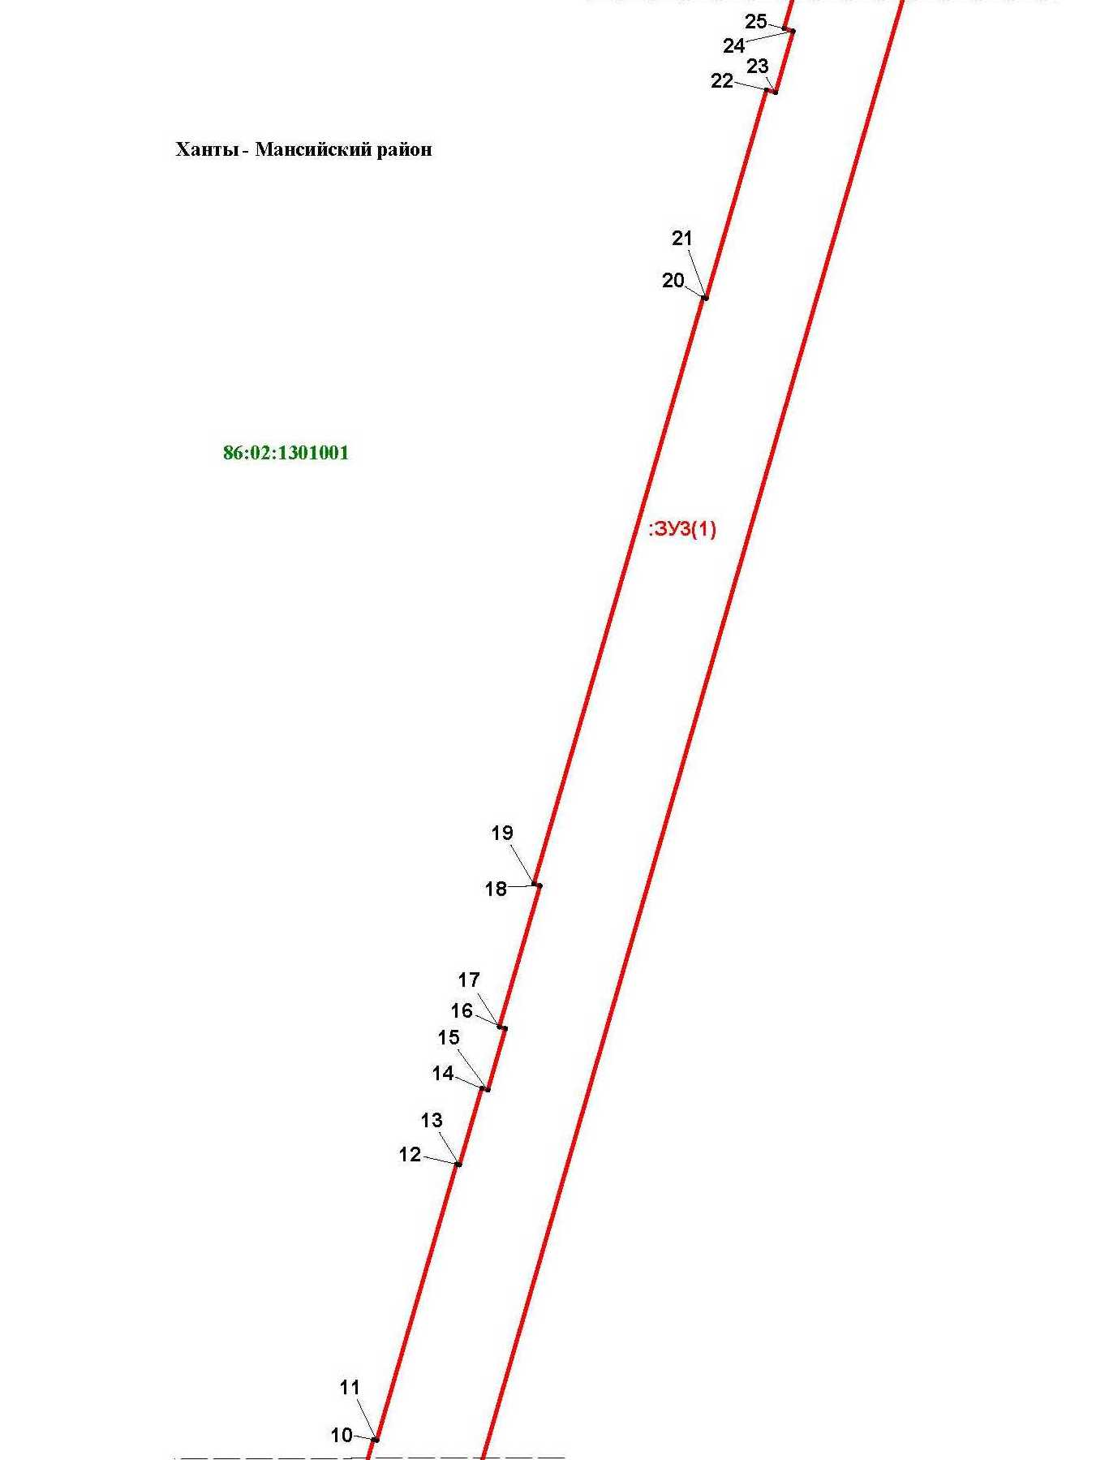

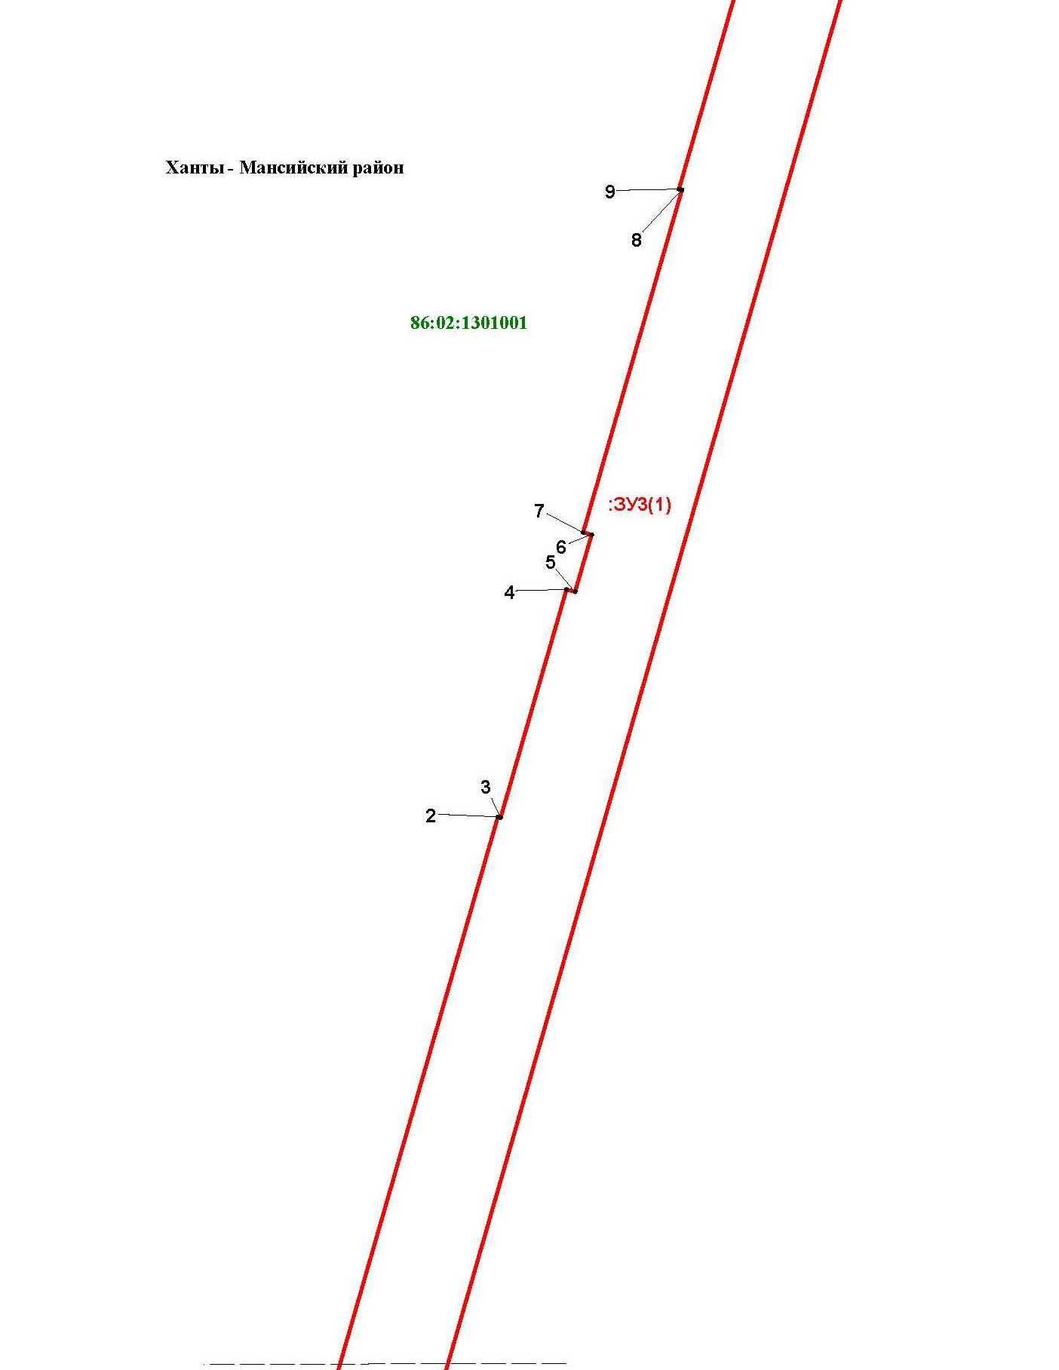

Основная часть проекта межевания территории для размещения объекта капитального строительства, расположенного на территории двух муниципальных образований
Ханты-Мансийского автономного округа – Югры,
«Обустройство Чапровского месторождения.
Кусты 1, 1а, 2, 2а, 4, 4а, 5, 5а и коридоры коммуникаций»
Землепользователь: АО «НК «Конданефть»
Масштаб 1:2000

Основная часть проекта межевания территории для размещения объекта капитального строительства, расположенного на территории двух муниципальных образований
Ханты-Мансийского автономного округа – Югры,
«Обустройство Чапровского месторождения.
Кусты 1, 1а, 2, 2а, 4, 4а, 5, 5а и коридоры коммуникаций»
Землепользователь: АО «НК «Конданефть»
Масштаб 1:2000

Линия совмещения с листом 101

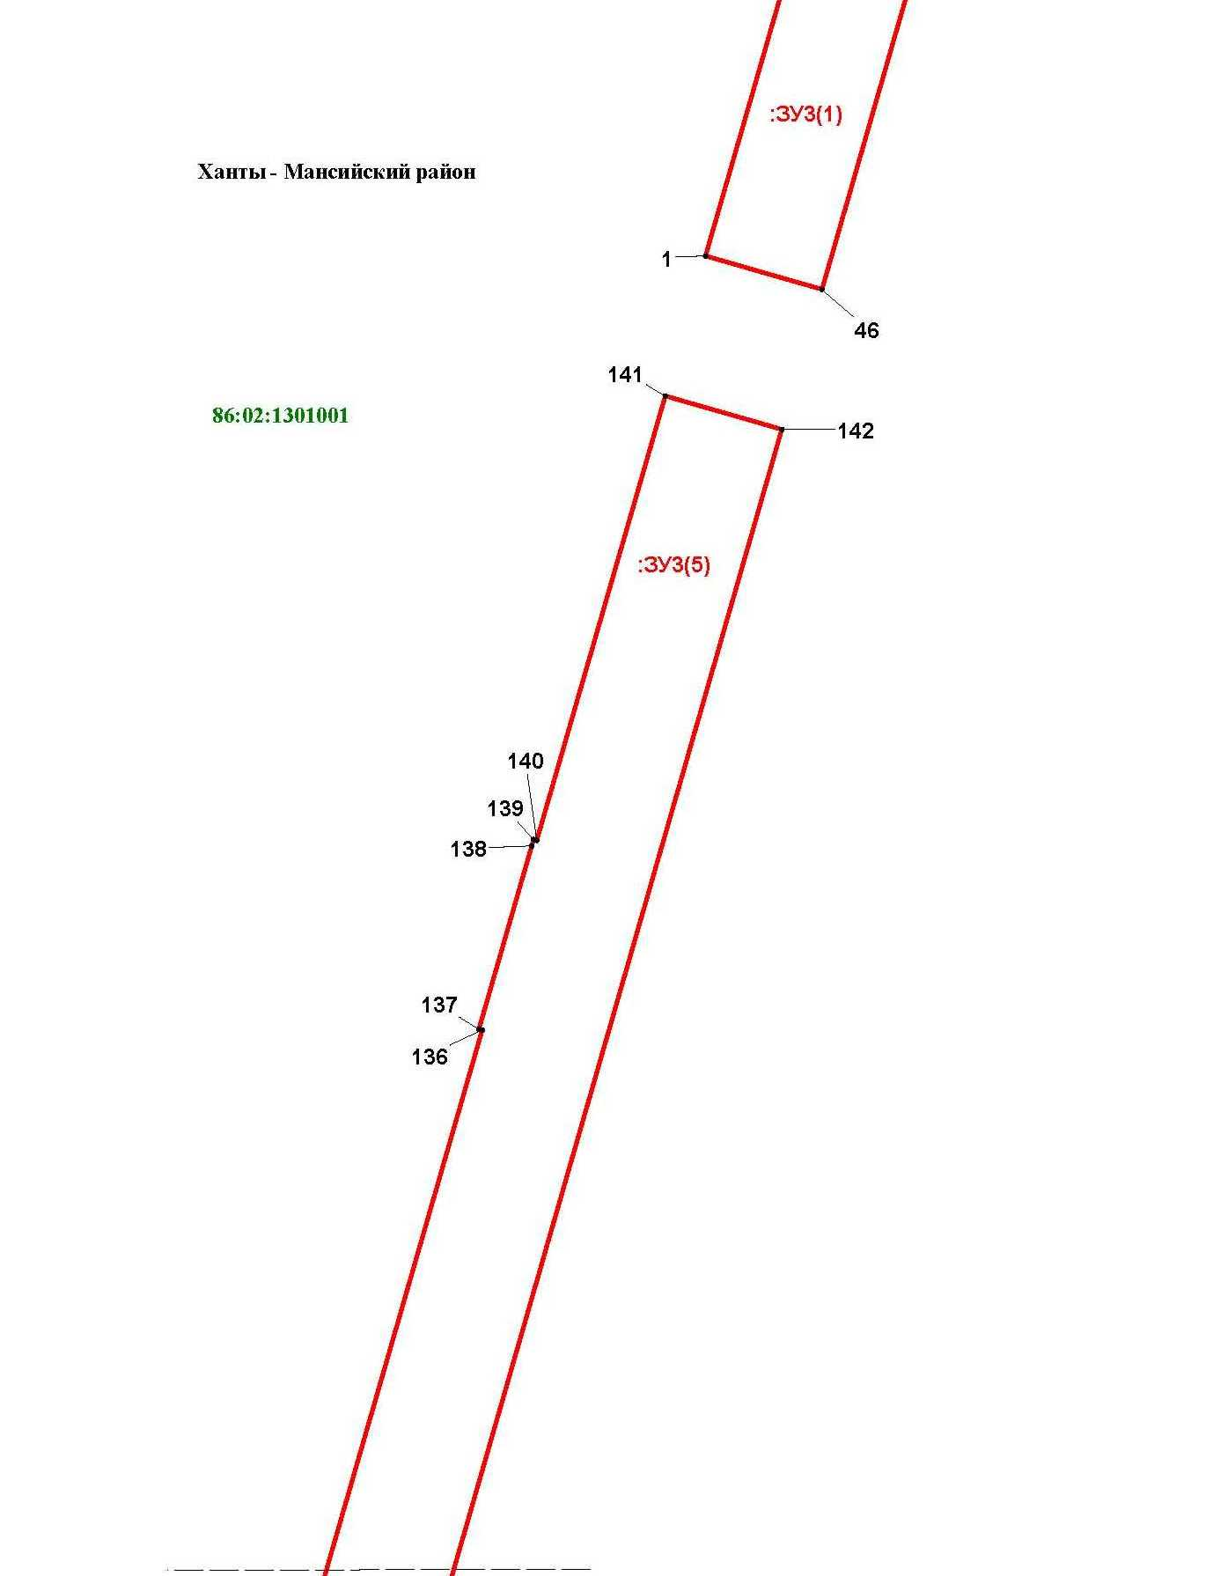

Основная часть проекта межевания территории для размещения объекта капитального строительства, расположенного на территории двух муниципальных образований
Ханты-Мансийского автономного округа – Югры,
«Обустройство Чапровского месторождения.
Кусты 1, 1а, 2, 2а, 4, 4а, 5, 5а и коридоры коммуникаций»
Землепользователь: АО «НК «Конданефть»
Масштаб 1:2000

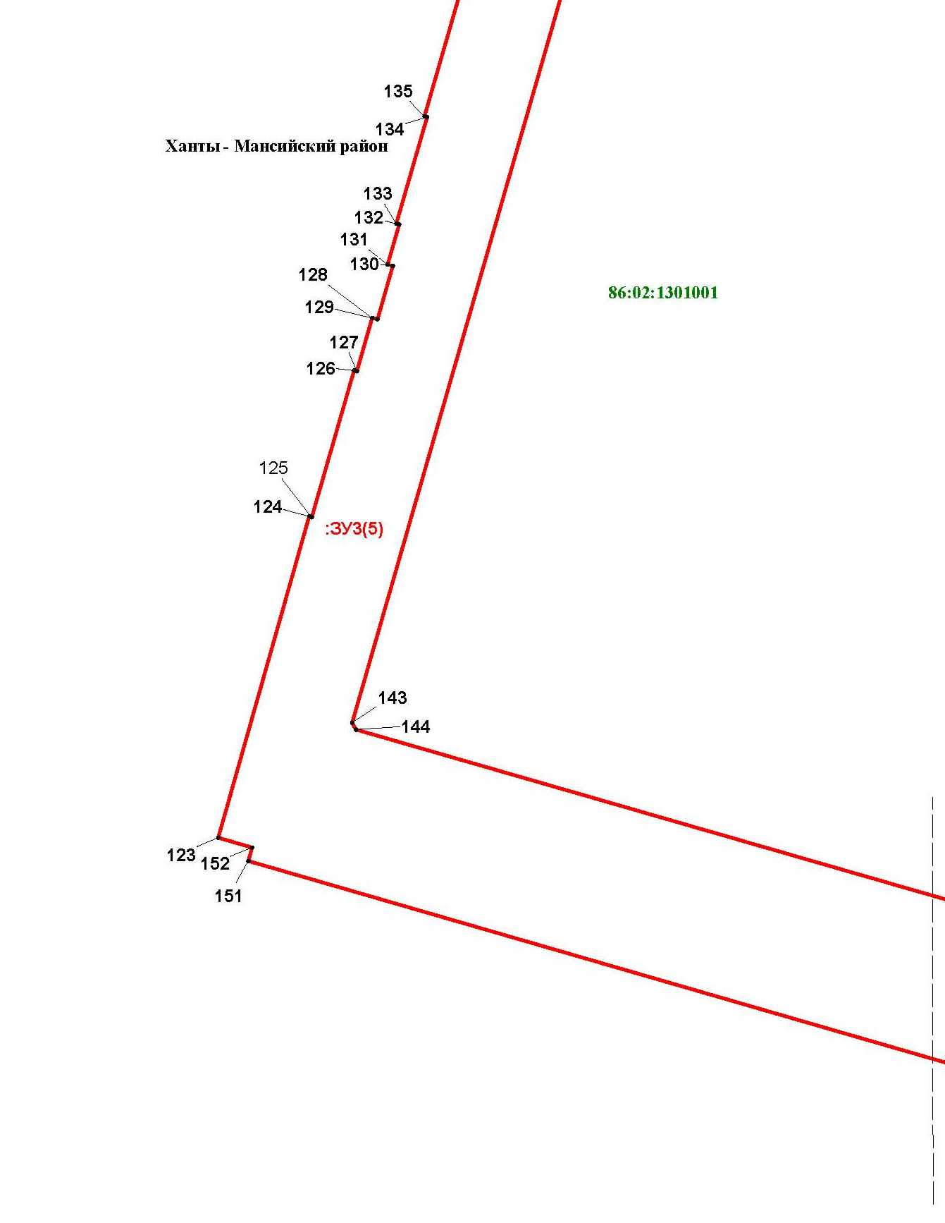

Основная часть проекта межевания территории для размещения объекта капитального строительства, расположенного на территории двух муниципальных образований
Ханты-Мансийского автономного округа – Югры,
«Обустройство Чапровского месторождения.
Кусты 1, 1а, 2, 2а, 4, 4а, 5, 5а и коридоры коммуникаций»
Землепользователь: АО «НК «Конданефть»
Масштаб 1:2000

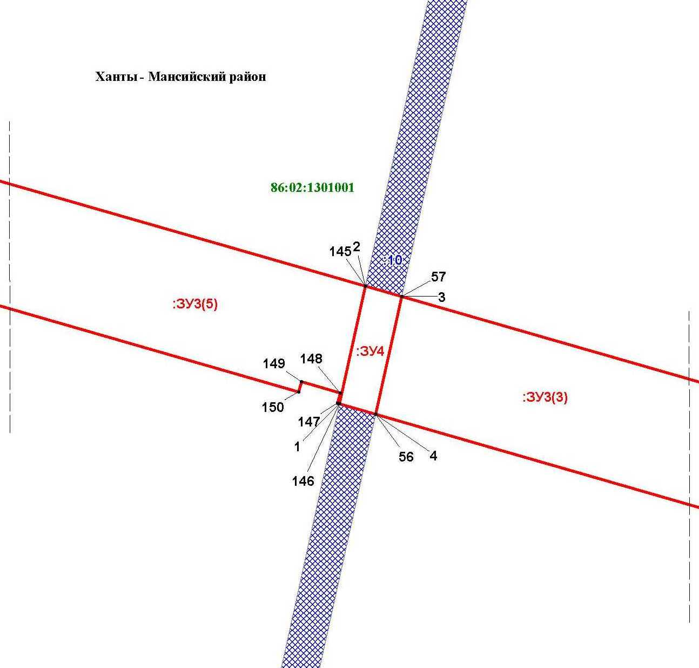

Основная часть проекта межевания территории для размещения объекта капитального строительства, расположенного на территории двух муниципальных образований
Ханты-Мансийского автономного округа – Югры,
«Обустройство Чапровского месторождения.
Кусты 1, 1а, 2, 2а, 4, 4а, 5, 5а и коридоры коммуникаций»
Землепользователь: АО «НК «Конданефть»
Масштаб 1:2000

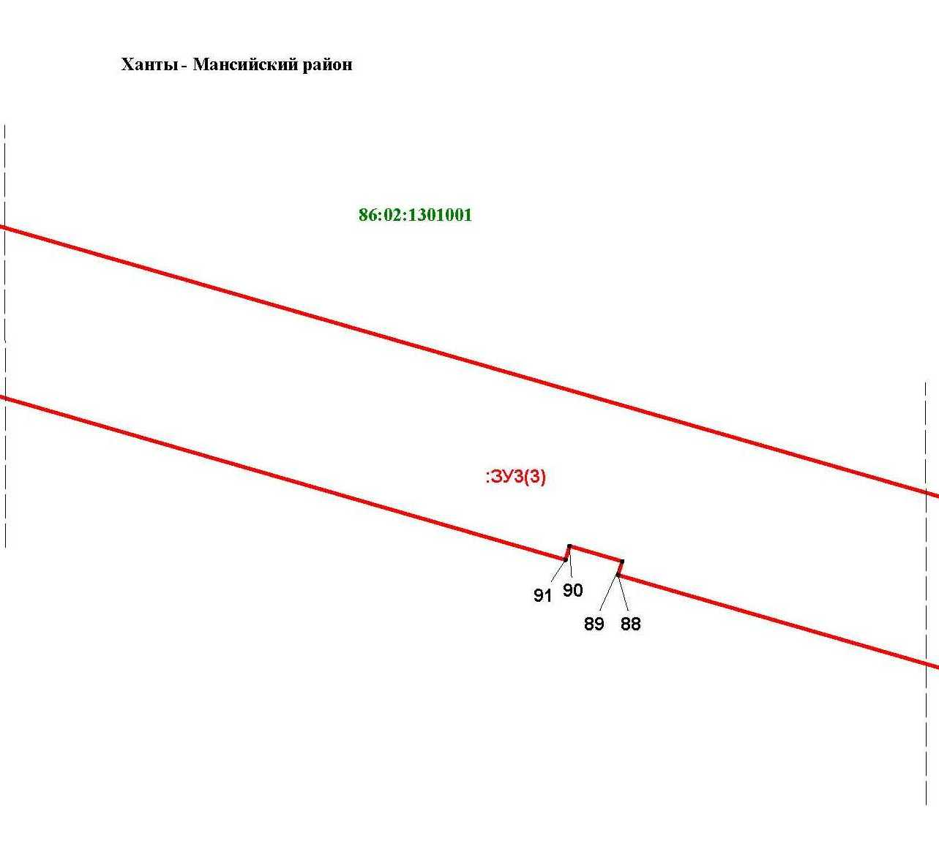

Основная часть проекта межевания территории для размещения объекта капитального строительства, расположенного на территории двух муниципальных образований
Ханты-Мансийского автономного округа – Югры,
«Обустройство Чапровского месторождения.
Кусты 1, 1а, 2, 2а, 4, 4а, 5, 5а и коридоры коммуникаций»
Землепользователь: АО «НК «Конданефть»
Масштаб 1:2000

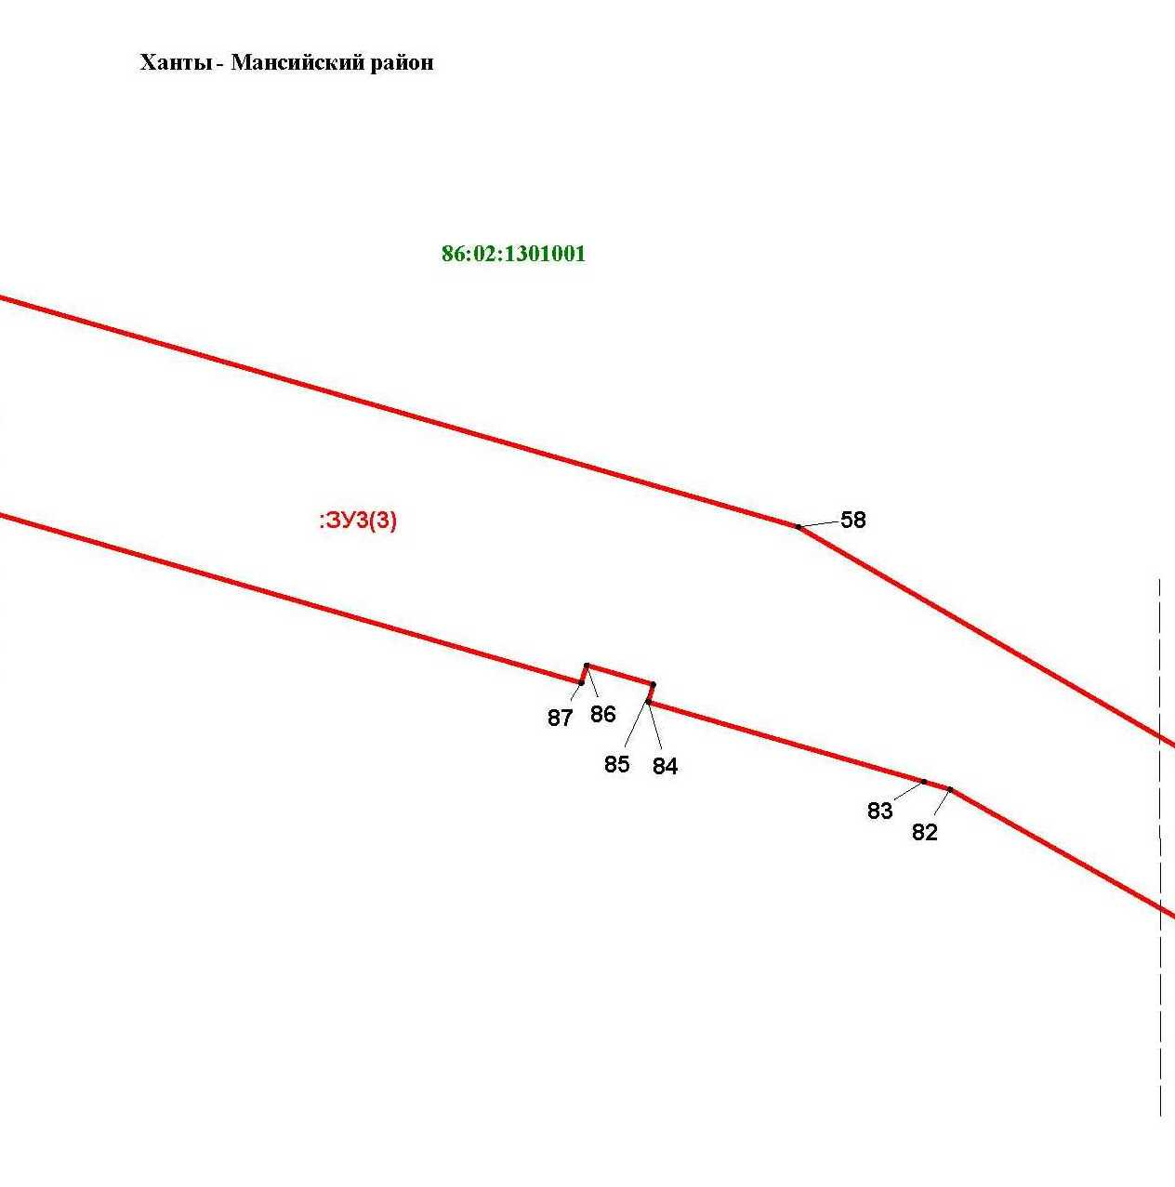

Основная часть проекта межевания территории для размещения объекта капитального строительства, расположенного на территории двух муниципальных образований
Ханты-Мансийского автономного округа – Югры,
«Обустройство Чапровского месторождения.
Кусты 1, 1а, 2, 2а, 4, 4а, 5, 5а и коридоры коммуникаций»
Землепользователь: АО «НК «Конданефть»
Масштаб 1:2000

Основная часть проекта межевания территории для размещения объекта капитального строительства, расположенного на территории двух муниципальных образований
Ханты-Мансийского автономного округа – Югры,
«Обустройство Чапровского месторождения.
Кусты 1, 1а, 2, 2а, 4, 4а, 5, 5а и коридоры коммуникаций»
Землепользователь: АО «НК «Конданефть»
Масштаб 1:2000

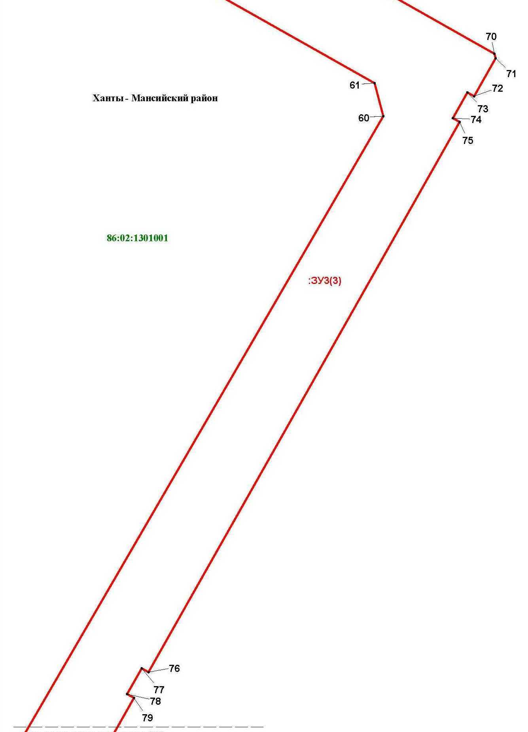

Основная часть проекта межевания территории для размещения объекта капитального строительства, расположенного на территории двух муниципальных образований
Ханты-Мансийского автономного округа – Югры,
«Обустройство Чапровского месторождения.
Кусты 1, 1а, 2, 2а, 4, 4а, 5, 5а и коридоры коммуникаций»
Землепользователь: АО «НК «Конданефть»
Масштаб 1:2000

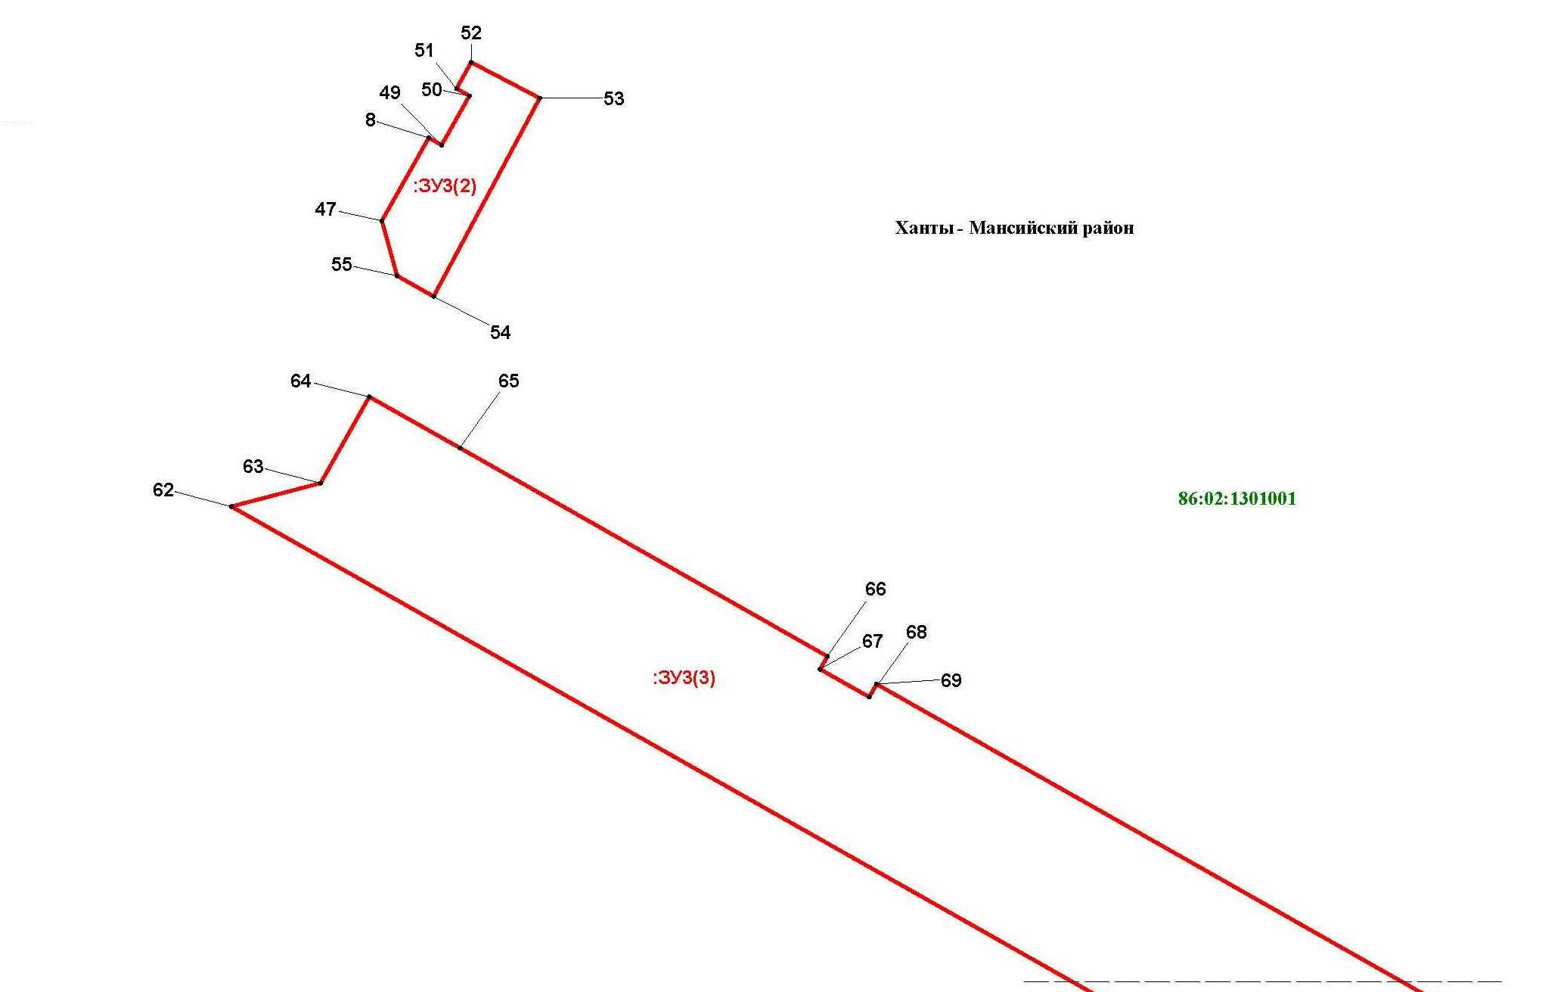

Каталог координат точек образуемого земельного участка
Основная часть проекта межевания территории для размещения объекта капитального строительства, расположенного на территории двух муниципальных образований
Ханты-Мансийского автономного округа – Югры,
«Обустройство Чапровского месторождения.
Кусты 1, 1а, 2, 2а, 4, 4а, 5, 5а и коридоры коммуникаций»
Землепользователь: АО «НК «Конданефть»

№ точки | Х | У
1 | 2 | 3
:ЗУ1
1 | 902224.26 | 2686562.78
2 | 902395.00 | 2686093.70
3 | 902328.78 | 2686069.08
4 | 902313.32 | 2686065.86
5 | 902293.56 | 2686119.18
6 | 902333.48 | 2686134.06
7 | 902178.30 | 2686562.64
:ЗУ2
1 | 898929.94 | 2696337.78
2 | 899048.84 | 2696423.00
3 | 899042.98 | 2696656.90
4 | 899022.12 | 2696691.02
5 | 899020.54 | 2696754.76
6 | 898964.50 | 2696785.22
7 | 898943.64 | 2696819.32
8 | 897502.74 | 2697602.56
9 | 897293.60 | 2697823.30
10 | 897210.94 | 2697874.04
11 | 896612.22 | 2698086.60
12 | 896375.70 | 2698215.18
13 | 894665.22 | 2698716.04
14 | 894591.76 | 2698806.88
15 | 894405.72 | 2698826.56
16 | 894334.96 | 2698769.32
17 | 893118.76 | 2698769.32
18 | 893051.02 | 2698795.32
19 | 891971.98 | 2698795.32
20 | 891876.98 | 2698890.32
21 | 891648.62 | 2698890.32
22 | 891527.56 | 2698686.34
23 | 891527.56 | 2698658.32
24 | 891833.56 | 2698658.32

1 | 2 | 3
25 | 891833.56 | 2698686.34
26 | 891950.72 | 2698686.34
27 | 891950.72 | 2698641.46
28 | 891950.72 | 2698623.32
29 | 894294.98 | 2698623.32
30 | 894389.42 | 2698585.70
31 | 894473.22 | 2698584.34
32 | 894473.62 | 2698615.78
33 | 894583.60 | 2698613.86
34 | 896329.28 | 2698102.68
35 | 898804.32 | 2696757.32
36 | 898924.34 | 2696561.12
:ЗУ3
1 | 880771.62 | 2701386.78
2 | 881043.08 | 2701465.14
3 | 881042.80 | 2701466.10
4 | 881119.66 | 2701488.28
5 | 881118.84 | 2701491.16
6 | 881138.06 | 2701496.70
7 | 881138.88 | 2701493.82
8 | 881254.18 | 2701527.10
9 | 881254.46 | 2701526.14
10 | 881393.76 | 2701566.34
11 | 881393.50 | 2701567.30
12 | 881479.96 | 2701592.26
13 | 881479.68 | 2701593.22
14 | 881503.70 | 2701600.16
15 | 881503.14 | 2701602.08
16 | 881522.36 | 2701607.62
17 | 881522.92 | 2701605.70
18 | 881567.12 | 2701618.46
19 | 881567.66 | 2701616.54
20 | 881751.18 | 2701669.50
21 | 881750.90 | 2701670.46
22 | 881816.24 | 2701689.32
Основная часть проекта межевания территории для размещения объекта капитального строительства, расположенного на территории двух муниципальных образований
Ханты-Мансийского автономного округа – Югры,
«Обустройство Чапровского месторождения.
Кусты 1, 1а, 2, 2а, 4, 4а, 5, 5а и коридоры коммуникаций»
Землепользователь: АО «НК «Конданефть»

Основная часть проекта межевания территории для размещения объекта капитального строительства, расположенного на территории двух муниципальных образований
Ханты-Мансийского автономного округа – Югры,
«Обустройство Чапровского месторождения.
Кусты 1, 1а, 2, 2а, 4, 4а, 5, 5а и коридоры коммуникаций»
Землепользователь: АО «НК «Конданефть»

1 | 2 | 3
23 | 881815.40 | 2701692.20
24 | 881834.62 | 2701697.74
25 | 881835.46 | 2701694.86
26 | 881864.28 | 2701703.18
27 | 881864.56 | 2701702.22
28 | 882042.30 | 2701753.52
29 | 882042.02 | 2701754.48
30 | 882085.26 | 2701766.96
31 | 882084.98 | 2701767.92
32 | 882128.22 | 2701780.40
33 | 882127.66 | 2701782.32
34 | 882146.88 | 2701787.88
35 | 882147.70 | 2701784.98
36 | 882190.94 | 2701797.46
37 | 882191.22 | 2701796.50
38 | 882373.76 | 2701849.20
39 | 882373.48 | 2701850.16
40 | 882421.52 | 2701864.02
41 | 882420.98 | 2701865.94
42 | 882464.20 | 2701878.42
43 | 882463.94 | 2701879.38
44 | 882533.32 | 2701899.40
45 | 882525.06 | 2701927.88
46 | 880761.94 | 2701420.42
47 | 880755.46 | 2702470.58
48 | 880783.34 | 2702486.30
49 | 880780.88 | 2702490.66
50 | 880797.42 | 2702499.98
51 | 880799.88 | 2702495.62
52 | 880808.66 | 2702500.56
53 | 880796.64 | 2702523.62
54 | 880730.08 | 2702487.96
55 | 880737.06 | 2702475.62
56 | 879937.58 | 2701615.54
57 | 879993.04 | 2701627.78
58 | 879803.30 | 2702287.02

Основная часть проекта межевания территории для размещения объекта капитального строительства, расположенного на территории двух муниципальных образований
Ханты-Мансийского автономного округа – Югры,
«Обустройство Чапровского месторождения.
Кусты 1, 1а, 2, 2а, 4, 4а, 5, 5а и коридоры коммуникаций»
Землепользователь: АО «НК «Конданефть»

1 | 2 | 3
59 | 879693.00 | 2702477.02
60 | 880383.10 | 2702877.66
61 | 880404.26 | 2702872.06
62 | 880659.56 | 2702420.00
63 | 880667.44 | 2702449.94
64 | 880696.38 | 2702466.30
65 | 880679.16 | 2702496.82
66 | 880609.26 | 2702620.20
67 | 880604.90 | 2702617.74
68 | 880595.54 | 2702634.28
69 | 880599.90 | 2702636.74
70 | 880423.14 | 2702949.00
71 | 880420.32 | 2702949.80
72 | 880395.90 | 2702936.00
73 | 880398.38 | 2702931.64
74 | 880381.84 | 2702922.30
75 | 880379.38 | 2702926.64
76 | 880025.94 | 2702726.84
77 | 880028.40 | 2702722.48
78 | 880011.86 | 2702713.14
79 | 880009.40 | 2702717.48
80 | 879634.02 | 2702505.26
81 | 879633.24 | 2702502.44
82 | 879731.58 | 2702328.54
83 | 879733.64 | 2702321.36
84 | 879755.42 | 2702246.04
85 | 879760.22 | 2702247.42
86 | 879765.48 | 2702229.18
87 | 879760.68 | 2702227.78
88 | 879836.46 | 2701965.52
89 | 879841.26 | 2701966.90
90 | 879846.54 | 2701948.64
91 | 879841.74 | 2701947.26
92 | 891527.56 | 2698686.34
93 | 891648.62 | 2698890.32
94 | 891503.82 | 2698890.32
95 | 891300.14 | 2698769.32

Основная часть проекта межевания территории для размещения объекта капитального строительства, расположенного на территории двух муниципальных образований
Ханты-Мансийского автономного округа – Югры,
«Обустройство Чапровского месторождения.
Кусты 1, 1а, 2, 2а, 4, 4а, 5, 5а и коридоры коммуникаций»
Землепользователь: АО «НК «Конданефть»

1 | 2 | 3
96 | 889715.78 | 2698769.32
97 | 889487.38 | 2698871.20
98 | 885704.30 | 2702277.34
99 | 885708.66 | 2702282.16
100 | 885678.18 | 2702309.60
101 | 885673.84 | 2702304.78
102 | 885351.38 | 2702592.78
103 | 885279.14 | 2702610.72
104 | 885280.46 | 2702616.04
105 | 885244.54 | 2702624.94
106 | 885243.24 | 2702619.64
107 | 885074.26 | 2702661.58
108 | 882657.44 | 2701965.98
109 | 882654.18 | 2701978.00
110 | 882624.42 | 2701969.42
111 | 882636.54 | 2701927.50
112 | 882580.46 | 2701911.98
113 | 882583.90 | 2701900.06
114 | 882584.26 | 2701900.18
115 | 882594.60 | 2701862.98
116 | 882598.84 | 2701849.62
117 | 884998.20 | 2702541.50
118 | 885376.00 | 2702454.52
119 | 887149.36 | 2700857.78
120 | 887152.90 | 2700861.32
121 | 889561.78 | 2698692.34
122 | 889723.80 | 2698686.32
123 | 880067.42 | 2701184.18
124 | 880183.18 | 2701216.94
125 | 880182.90 | 2701217.90
126 | 880235.74 | 2701233.16
127 | 880235.46 | 2701234.12
128 | 880254.68 | 2701239.66
129 | 880254.14 | 2701241.58
130 | 880273.34 | 2701247.14

Основная часть проекта межевания территории для размещения объекта капитального строительства, расположенного на территории двух муниципальных образований
Ханты-Мансийского автономного округа – Югры,
«Обустройство Чапровского месторождения.
Кусты 1, 1а, 2, 2а, 4, 4а, 5, 5а и коридоры коммуникаций»
Землепользователь: АО «НК «Конданефть»

1 | 2 | 3
131 | 880273.90 | 2701245.22
132 | 880288.32 | 2701249.38
133 | 880288.60 | 2701248.42
134 | 880327.02 | 2701259.50
135 | 880327.30 | 2701258.54
136 | 880548.28 | 2701322.32
137 | 880548.56 | 2701321.36
138 | 880601.40 | 2701336.62
139 | 880603.32 | 2701337.16
140 | 880603.04 | 2701338.12
141 | 880731.26 | 2701375.14
142 | 880721.58 | 2701408.80
143 | 880108.88 | 2701232.46
144 | 880106.44 | 2701233.80
145 | 879997.96 | 2701610.72
146 | 879942.50 | 2701598.54
147 | 879942.78 | 2701597.56
148 | 879947.58 | 2701598.96
149 | 879952.86 | 2701580.70
150 | 879948.04 | 2701579.32
151 | 880059.08 | 2701195.04
152 | 880063.88 | 2701196.42
:ЗУ4
1 | 879942.50 | 2701598.54
2 | 879997.96 | 2701610.72
3 | 879993.06 | 2701627.78
4 | 879937.58 | 2701615.54
:ЗУ5
1 | 904008.72 | 2690829.72
2 | 903940.02 | 2690764.86
3 | 903902.04 | 2690728.58
4 | 904070.72 | 2690530.48
5 | 904027.68 | 2690376.54
6 | 903802.18 | 2689884.26
7 | 903806.04 | 2689882.48

Основная часть проекта межевания территории для размещения объекта капитального строительства, расположенного на территории двух муниципальных образований
Ханты-Мансийского автономного округа – Югры,
«Обустройство Чапровского месторождения.
Кусты 1, 1а, 2, 2а, 4, 4а, 5, 5а и коридоры коммуникаций»
Землепользователь: АО «НК «Конданефть»

1 | 2 | 3
8 | 903394.14 | 2688980.38
9 | 903764.02 | 2688811.30
10 | 903770.68 | 2688825.90
11 | 903461.36 | 2688967.02
12 | 903618.04 | 2689310.48
13 | 903762.06 | 2689626.18
14 | 903859.20 | 2689581.86
15 | 904128.94 | 2690171.92
16 | 904235.08 | 2690393.78
17 | 904208.84 | 2690594.84
:ЗУ6
1 | 903618.04 | 2689310.48
2 | 903762.06 | 2689626.18
3 | 903859.20 | 2689581.86
4 | 904071.40 | 2689485.06
5 | 903927.36 | 2689169.36
:ЗУ7
1 | 903770.68 | 2688825.90
2 | 903927.36 | 2689169.36
3 | 903618.04 | 2689310.48
4 | 903461.36 | 2688967.02
:ЗУ8
1 | 903902.04 | 2690728.58
2 | 903940.02 | 2690764.86
3 | 904008.72 | 2690829.72
4 | 903652.06 | 2691248.28
5 | 902589.80 | 2691900.94
6 | 902587.92 | 2691906.72
7 | 902526.70 | 2691807.08
8 | 903485.08 | 2691218.26
:ЗУ9
1 | 902526.70 | 2691807.08
2 | 902526.70 | 2691807.08
3 | 902587.92 | 2691906.72
4 | 902585.76 | 2691913.40

Основная часть проекта межевания территории для размещения объекта капитального строительства, расположенного на территории двух муниципальных образований
Ханты-Мансийского автономного округа – Югры,
«Обустройство Чапровского месторождения.
Кусты 1, 1а, 2, 2а, 4, 4а, 5, 5а и коридоры коммуникаций»
Землепользователь: АО «НК «Конданефть»

1 | 2 | 3
5 | 902299.32 | 2692089.38
6 | 902210.16 | 2692144.16
7 | 900025.38 | 2693486.46
8 | 899943.96 | 2693563.90
9 | 899151.30 | 2694599.42
10 | 899090.12 | 2694772.78
11 | 899048.84 | 2696423.00
12 | 898929.94 | 2696337.78
13 | 898972.56 | 2694633.84
14 | 899901.90 | 2693419.78
15 | 902348.12 | 2691916.80
16 | 902437.16 | 2691862.10
17 | 902510.02 | 2691817.34
:ЗУ10
1 | 902210.16 | 2692144.16
2 | 902299.32 | 2692089.38
3 | 902314.30 | 2692114.10
4 | 902311.90 | 2692126.36
5 | 902578.96 | 2692561.12
6 | 903054.92 | 2693179.92
7 | 903245.56 | 2693033.40
8 | 903258.20 | 2693049.86
9 | 902988.80 | 2693257.28
10 | 903015.48 | 2693291.92
11 | 902969.82 | 2693326.94
12 | 902896.38 | 2693231.16
13 | 902933.80 | 2693202.04
14 | 902867.02 | 2693093.06
15 | 902500.08 | 2692616.04
:ЗУ11
1 | 903015.48 | 2693291.92
2 | 903219.10 | 2693556.40
3 | 903244.02 | 2693588.74
4 | 903197.58 | 2693623.88
5 | 902969.82 | 2693326.94

Основная часть проекта межевания территории для размещения объекта капитального строительства, расположенного на территории двух муниципальных образований
Ханты-Мансийского автономного округа – Югры,
«Обустройство Чапровского месторождения.
Кусты 1, 1а, 2, 2а, 4, 4а, 5, 5а и коридоры коммуникаций»
Землепользователь: АО «НК «Конданефть»

1 | 2 | 3
:ЗУ12
1 | 903258.20 | 2693049.86
2 | 903368.34 | 2693192.92
3 | 903488.50 | 2693348.98
4 | 903219.10 | 2693556.40
5 | 903015.48 | 2693291.92
6 | 902988.80 | 2693257.28
:ЗУ13
1 | 903219.10 | 2693556.40
2 | 903244.02 | 2693588.74
3 | 903370.52 | 2693752.92
4 | 903639.80 | 2693545.40
5 | 903488.50 | 2693348.98
:ЗУ14
1 | 902348.12 | 2691916.80
2 | 902437.16 | 2691862.10
3 | 902400.92 | 2691803.14
4 | 902393.68 | 2691807.58
5 | 902043.08 | 2691236.96
6 | 901866.14 | 2690369.86
7 | 901783.54 | 2690315.26
8 | 901672.94 | 2689773.28
9 | 901654.24 | 2689681.72
10 | 901522.96 | 2689708.50
11 | 901524.02 | 2689713.78
12 | 901411.56 | 2689736.80
13 | 901329.90 | 2689807.56
14 | 901313.44 | 2689856.38
15 | 901295.02 | 2689911.08
16 | 901436.18 | 2689958.16
17 | 901328.64 | 2690280.70
18 | 901357.68 | 2690290.78
19 | 901516.70 | 2689814.36
20 | 901543.44 | 2689808.90
21 | 901787.36 | 2691004.14

Основная часть проекта межевания территории для размещения объекта капитального строительства, расположенного на территории двух муниципальных образований
Ханты-Мансийского автономного округа – Югры,
«Обустройство Чапровского месторождения.
Кусты 1, 1а, 2, 2а, 4, 4а, 5, 5а и коридоры коммуникаций»
Землепользователь: АО «НК «Конданефть»

1 | 2 | 3
:ЗУ15
1 | 901313.44 | 2689856.38
2 | 901202.56 | 2689819.26
3 | 901057.88 | 2689770.80
4 | 901039.16 | 2689825.78
5 | 901078.06 | 2689838.76
6 | 901295.02 | 2689911.08
:ЗУ16
1 | 901328.64 | 2690280.70
2 | 901137.84 | 2690217.08
3 | 900970.52 | 2690161.30
4 | 901078.06 | 2689838.76
5 | 901295.02 | 2689911.08
6 | 901436.18 | 2689958.16
:ЗУ17
1 | 901078.06 | 2689838.76
2 | 901039.16 | 2689825.78
3 | 900811.50 | 2689749.88
4 | 900703.94 | 2690072.42
5 | 900970.52 | 2690161.30
:ЗУ18
1 | 901 247.60 | 2 688 219.52
2 | 901 358.64 | 2 688 324.56
3 | 901 389.32 | 2 688 353.56
4 | 901 433.64 | 2 688 570.68
5 | 901 423.50 | 2 688 601.06
6 | 901 635.34 | 2 689 639.06
7 | 901 648.82 | 2 689 655.12
8 | 901 654.24 | 2 689 681.72
9 | 901 654.24 | 2 689 681.72
10 | 901 522.96 | 2 689 708.50
11 | 901 522.96 | 2 689 708.50
12 | 901 520.34 | 2 689 695.76
13 | 901 544.56 | 2 689 674.32
:ЗУ19

Основная часть проекта межевания территории для размещения объекта капитального строительства, расположенного на территории двух муниципальных образований
Ханты-Мансийского автономного округа – Югры,
«Обустройство Чапровского месторождения.
Кусты 1, 1а, 2, 2а, 4, 4а, 5, 5а и коридоры коммуникаций»
Землепользователь: АО «НК «Конданефть»

1 | 2 | 3
1 | 901348.16 | 2687971.04
2 | 901348.54 | 2688016.88
3 | 901379.78 | 2688103.80
4 | 901388.42 | 2688116.54
5 | 901363.76 | 2688228.36
6 | 901379.96 | 2688307.70
7 | 901358.64 | 2688324.56
8 | 901247.60 | 2688219.52
9 | 901243.54 | 2688199.66
10 | 901270.94 | 2688075.62
11 | 901833.24 | 2687204.56
12 | 901843.46 | 2687432.38
13 | 901832.46 | 2687465.38
14 | 901828.88 | 2687464.50
15 | 901799.98 | 2687449.64
16 | 901759.82 | 2687393.88
17 | 901726.28 | 2687311.42
18 | 901724.42 | 2687277.94
19 | 901723.48 | 2687257.00
20 | 901732.14 | 2687238.88
21 | 901784.10 | 2687214.34
22 | 901830.08 | 2687202.96
23 | 901712.80 | 2687665.66
24 | 901684.76 | 2687703.66
25 | 901659.10 | 2687698.14
26 | 901640.44 | 2687692.92
27 | 901603.00 | 2687691.32
28 | 901545.12 | 2687686.42
29 | 901536.30 | 2687690.92
30 | 901559.52 | 2687659.46
31 | 901587.12 | 2687647.32
32 | 901589.00 | 2687644.76
33 | 901605.16 | 2687645.48
34 | 901643.64 | 2687626.52
35 | 901670.78 | 2687623.58

Основная часть проекта межевания территории для размещения объекта капитального строительства, расположенного на территории двух муниципальных образований
Ханты-Мансийского автономного округа – Югры,
«Обустройство Чапровского месторождения.
Кусты 1, 1а, 2, 2а, 4, 4а, 5, 5а и коридоры коммуникаций»
Землепользователь: АО «НК «Конданефть»

1 | 2 | 3
36 | 901674.76 | 2687627.82
37 | 901688.70 | 2687641.02
38 | 901704.58 | 2687658.32
:ЗУ20
1 | 901915.24 | 2687289.16
2 | 902066.14 | 2686872.44
3 | 902152.92 | 2686632.76
4 | 902081.28 | 2686491.78
5 | 902056.40 | 2686496.10
6 | 901829.56 | 2687122.78
7 | 901833.24 | 2687204.56
8 | 901882.32 | 2687229.56
9 | 901914.92 | 2687279.68
10 | 901865.36 | 2687426.90
11 | 901895.08 | 2687344.82
12 | 901876.26 | 2687364.12
13 | 901858.82 | 2687393.06
14 | 901865.30 | 2687425.72
15 | 901809.24 | 2687534.98
16 | 901842.58 | 2687489.84
17 | 901849.86 | 2687469.74
18 | 901832.46 | 2687465.38
:ЗУ21
1 | 902152.92 | 2686632.76
2 | 902192.32 | 2686710.32
3 | 902191.44 | 2686730.90
4 | 902190.88 | 2686787.30
5 | 902190.88 | 2686789.40
6 | 902192.78 | 2686789.30
7 | 902194.88 | 2686791.82
8 | 902196.78 | 2686793.74
9 | 902198.66 | 2686795.96
10 | 902200.98 | 2686796.06
11 | 902200.76 | 2686798.28
12 | 902202.86 | 2686798.18

Основная часть проекта межевания территории для размещения объекта капитального строительства, расположенного на территории двух муниципальных образований
Ханты-Мансийского автономного округа – Югры,
«Обустройство Чапровского месторождения.
Кусты 1, 1а, 2, 2а, 4, 4а, 5, 5а и коридоры коммуникаций»
Землепользователь: АО «НК «Конданефть»

1 | 2 | 3
13 | 902178.98 | 2686865.94
14 | 902155.06 | 2686903.64
15 | 902066.14 | 2686872.44
16 | 902350.36 | 2686140.00
17 | 902374.98 | 2686148.68
18 | 902565.56 | 2686215.82
19 | 902569.68 | 2686263.90
20 | 902584.82 | 2686314.00
21 | 902351.16 | 2686972.42
22 | 902231.36 | 2686930.40
23 | 902239.72 | 2686904.02
24 | 902249.62 | 2686867.18
25 | 902259.24 | 2686840.40
26 | 902270.60 | 2686772.22
27 | 902272.32 | 2686734.78
28 | 902267.94 | 2686697.02
29 | 902263.00 | 2686667.80
30 | 902266.90 | 2686582.50
31 | 902266.40 | 2686551.20
32 | 902280.68 | 2686420.66
33 | 902290.94 | 2686381.44
34 | 902303.20 | 2686342.32
35 | 902319.50 | 2686305.84
36 | 902330.90 | 2686287.54
37 | 902363.84 | 2686245.48
:ЗУ22
1 | 902293.56 | 2686119.18
2 | 902293.56 | 2686119.18
3 | 902189.32 | 2686077.08
4 | 902152.92 | 2686632.76
5 | 902215.38 | 2686460.26
6 | 901922.22 | 2686347.98
7 | 901920.86 | 2686351.24
8 | 901927.52 | 2686367.26
9 | 902001.56 | 2686398.80

Основная часть проекта межевания территории для размещения объекта капитального строительства, расположенного на территории двух муниципальных образований
Ханты-Мансийского автономного округа – Югры,
«Обустройство Чапровского месторождения.
Кусты 1, 1а, 2, 2а, 4, 4а, 5, 5а и коридоры коммуникаций»
Землепользователь: АО «НК «Конданефть»

1 | 2 | 3
10 | 901995.92 | 2686416.44
11 | 902071.98 | 2686453.10
12 | 902056.40 | 2686496.10
13 | 902081.28 | 2686491.78
14 | 901849.86 | 2687469.74
15 | 901865.36 | 2687426.90
16 | 901865.30 | 2687425.72
17 | 901858.82 | 2687393.06
18 | 901876.26 | 2687364.12
19 | 901895.08 | 2687344.82
20 | 901915.24 | 2687289.16
21 | 901914.92 | 2687279.68
22 | 901882.32 | 2687229.56
23 | 901833.24 | 2687204.56
24 | 901843.46 | 2687432.38
25 | 901832.46 | 2687465.38
:ЗУ23
1 | 902333.50 | 2686134.06
2 | 902293.56 | 2686119.18
3 | 902189.32 | 2686077.08
4 | 902038.72 | 2686083.84
5 | 902041.34 | 2686149.58
6 | 901841.02 | 2686158.38
7 | 901792.00 | 2686277.18
8 | 901796.18 | 2686279.86
9 | 901814.26 | 2686303.42
10 | 901922.22 | 2686347.98
11 | 902215.38 | 2686460.26
:ЗУ24
1 | 902011.78 | 2685744.72
2 | 902046.24 | 2685743.16
3 | 902045.08 | 2685742.98
4 | 902014.58 | 2685737.92
5 | 902293.56 | 2686119.18
6 | 902313.32 | 2686065.86

Основная часть проекта межевания территории для размещения объекта капитального строительства, расположенного на территории двух муниципальных образований
Ханты-Мансийского автономного округа – Югры,
«Обустройство Чапровского месторождения.
Кусты 1, 1а, 2, 2а, 4, 4а, 5, 5а и коридоры коммуникаций»
Землепользователь: АО «НК «Конданефть»

1 | 2 | 3
7 | 902333.80 | 2686010.58
8 | 902311.86 | 2685838.74
9 | 902280.58 | 2685797.68
10 | 902265.74 | 2685788.68
11 | 902278.52 | 2686073.06
12 | 902189.32 | 2686077.08
:ЗУ25
1 | 902046.24 | 2685743.16
2 | 902168.48 | 2685737.66
3 | 902037.22 | 2685683.06
4 | 902014.58 | 2685737.92
5 | 902045.08 | 2685742.98
6 | 902333.80 | 2686010.58
7 | 902399.38 | 2685833.72
8 | 902265.26 | 2685777.94
9 | 902265.74 | 2685788.68
10 | 902280.58 | 2685797.68
11 | 902311.86 | 2685838.74
:ЗУ26
1 | 901792.00 | 2686277.18
2 | 901796.18 | 2686279.86
3 | 901814.26 | 2686303.42
4 | 901792.44 | 2686294.42
5 | 901791.70 | 2686277.90
:ЗУ27
1 | 902350.36 | 2686140.00
2 | 902363.84 | 2686245.48
3 | 902330.90 | 2686287.54
4 | 902319.50 | 2686305.84
5 | 902303.20 | 2686342.32
6 | 902290.94 | 2686381.44
7 | 902280.68 | 2686420.66
8 | 902266.40 | 2686551.20
9 | 902266.90 | 2686582.50
10 | 902263.00 | 2686667.80

Основная часть проекта межевания территории для размещения объекта капитального строительства, расположенного на территории двух муниципальных образований
Ханты-Мансийского автономного округа – Югры,
«Обустройство Чапровского месторождения.
Кусты 1, 1а, 2, 2а, 4, 4а, 5, 5а и коридоры коммуникаций»
Землепользователь: АО «НК «Конданефть»

1 | 2 | 3
11 | 902267.94 | 2686697.02
12 | 902272.32 | 2686734.78
13 | 902270.60 | 2686772.22
14 | 902259.24 | 2686840.40
15 | 902249.62 | 2686867.18
16 | 902239.72 | 2686904.02
17 | 902231.36 | 2686930.40
18 | 902155.06 | 2686903.64
19 | 902178.98 | 2686865.94
20 | 902202.86 | 2686798.18
21 | 902200.76 | 2686798.28
22 | 902200.98 | 2686796.06
23 | 902198.66 | 2686795.96
24 | 902196.78 | 2686793.74
25 | 902194.88 | 2686791.82
26 | 902192.78 | 2686789.30
27 | 902190.88 | 2686789.40
28 | 902190.88 | 2686787.30
29 | 902191.44 | 2686730.90
30 | 902192.32 | 2686710.32
31 | 902152.92 | 2686632.76
32 | 902215.38 | 2686460.26
33 | 902333.50 | 2686134.06

