Основная часть проекта планировки территории для размещения объекта капитального строительства, расположенного на территории двух муниципальных образований Ханты-Мансийского автономного округа – Югры, «Инженерная подготовка площадки поисково-разведочного бурения скважины 1п-л3 Ляминского 3 лицензионного участка»
Землепользователь: ООО «НК «Югранефтепром»

Приложение 33
к приказу Департамента строительства Ханты-Мансийского
автономного округа – Югры
от 8 ноября 2018 года № 23-нп

Приложение 1
к приказу Департамента строительства Ханты-Мансийского
автономного округа – Югры
от ________________ № _____-нп

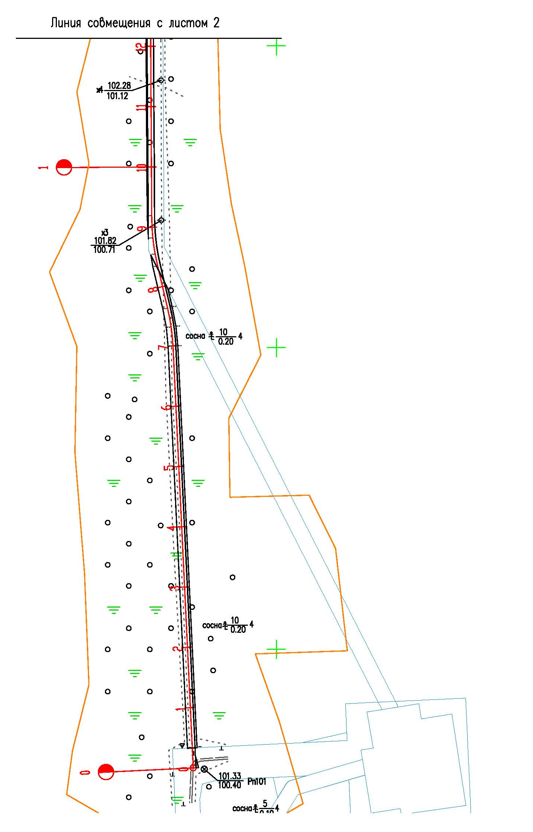

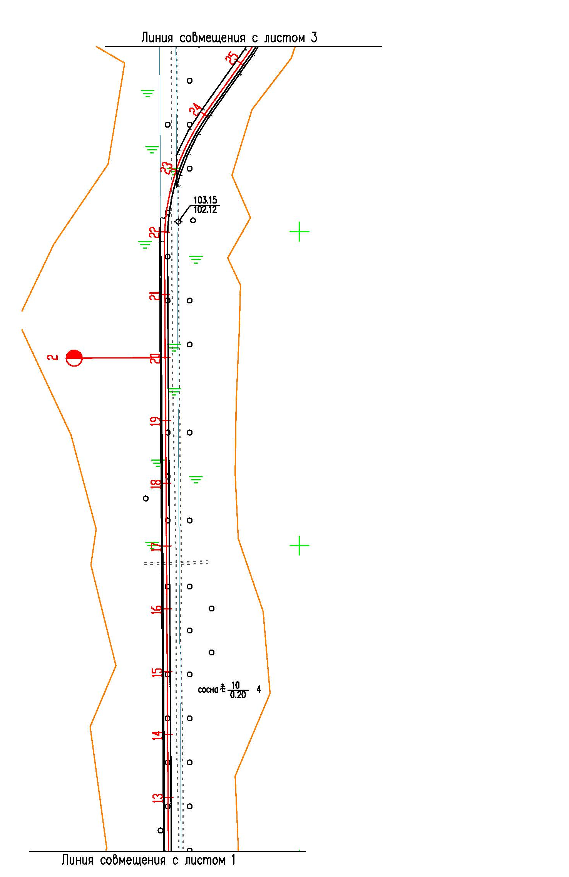

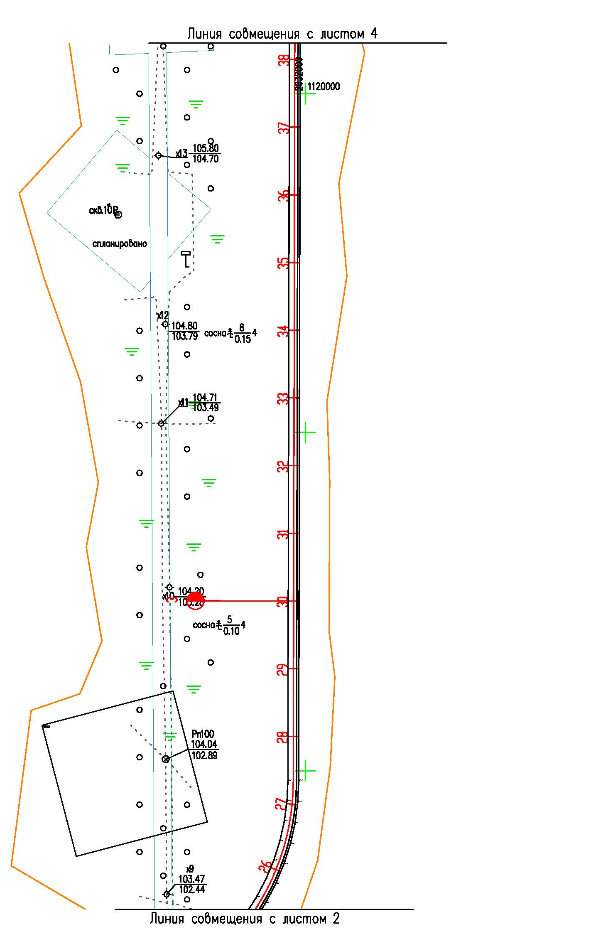

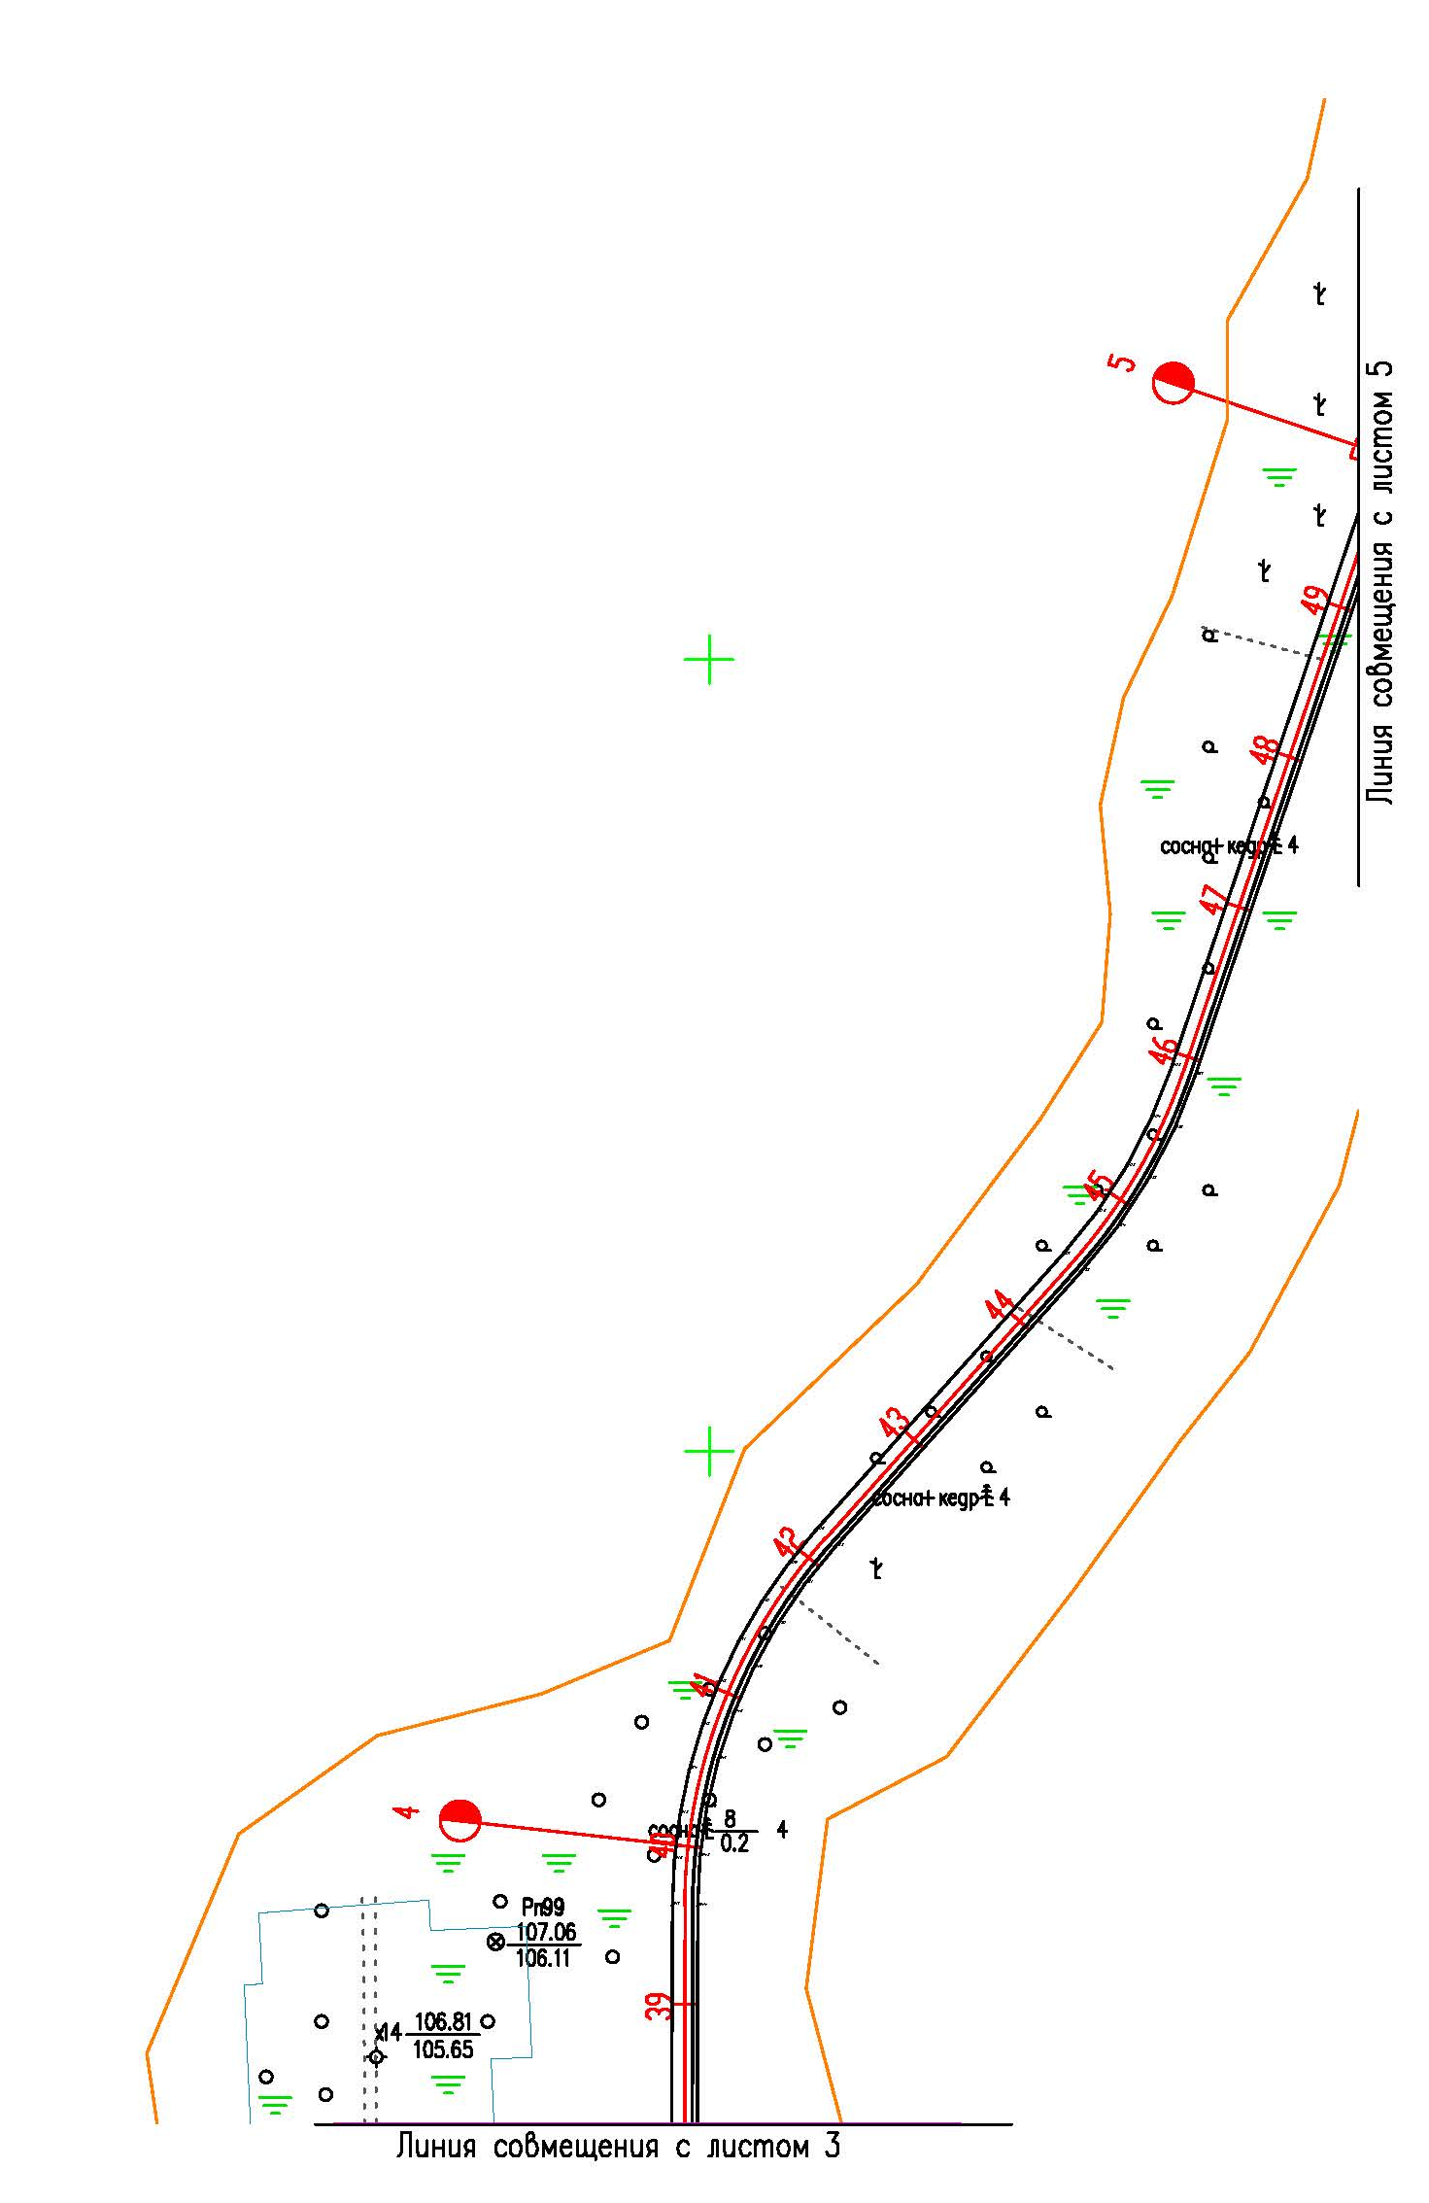

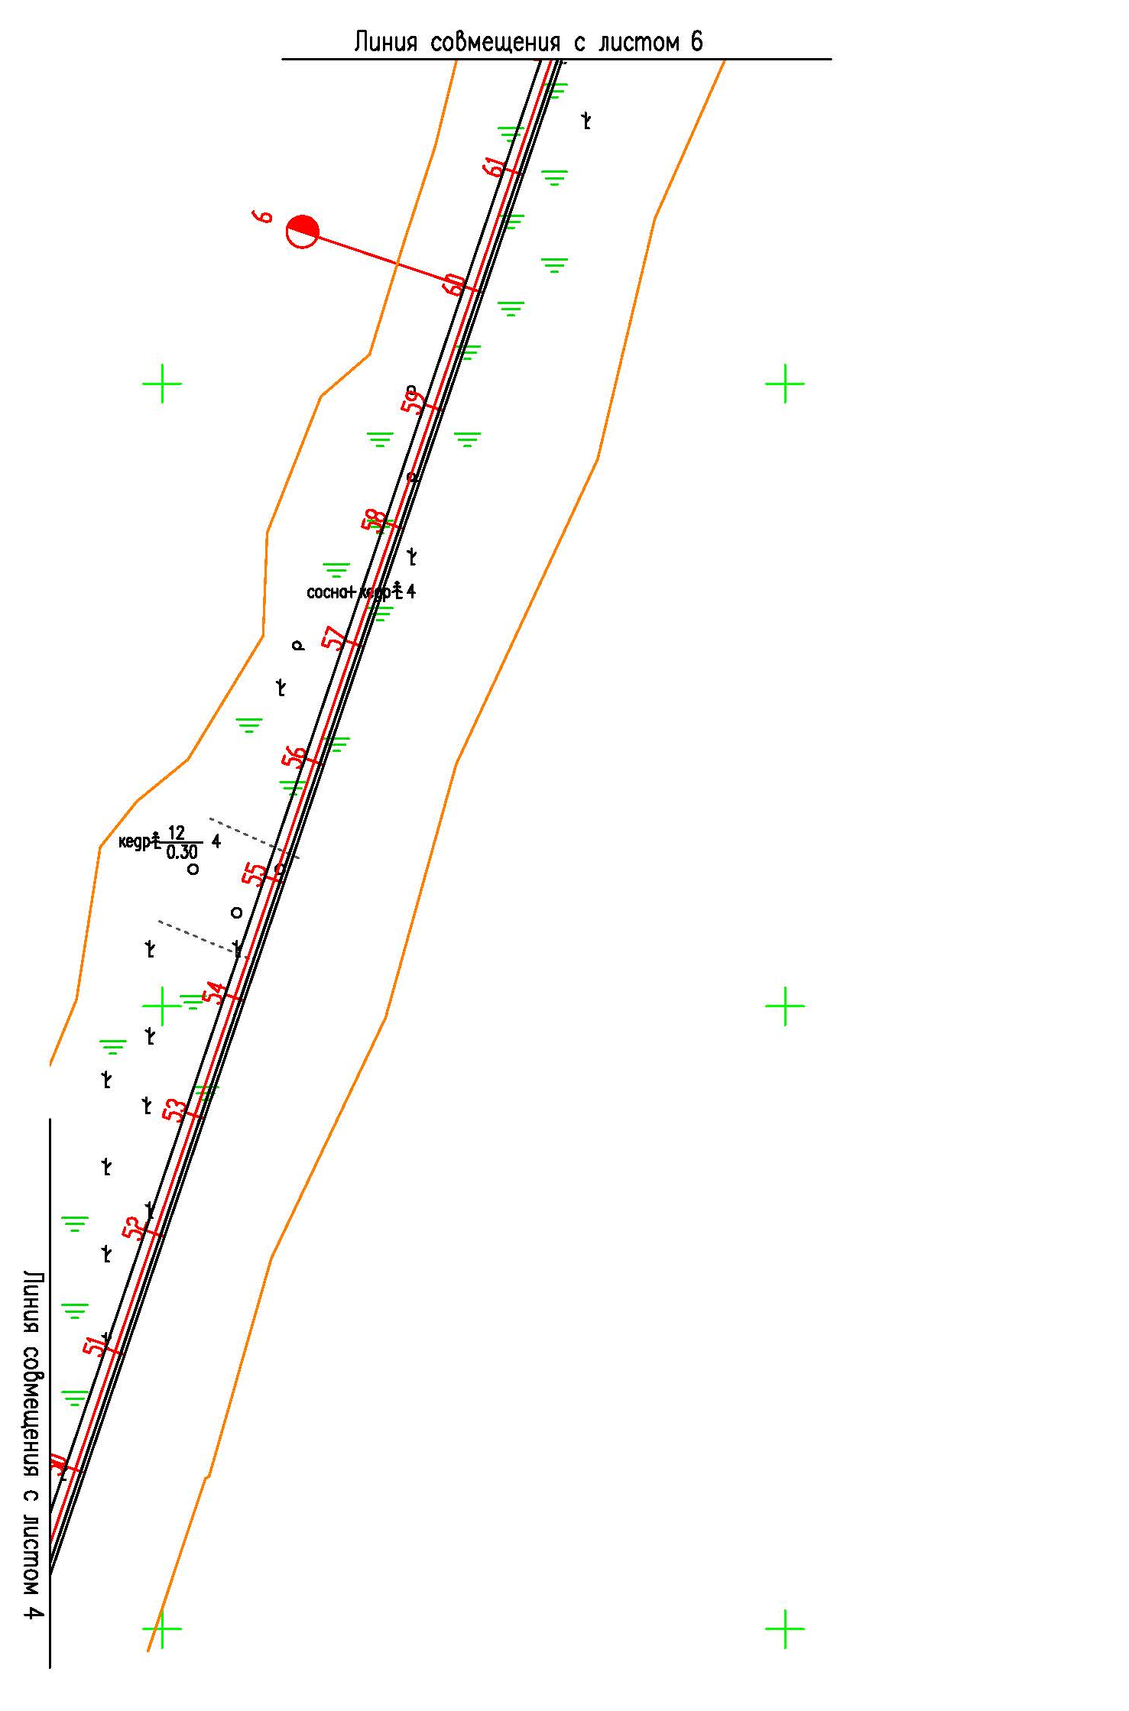

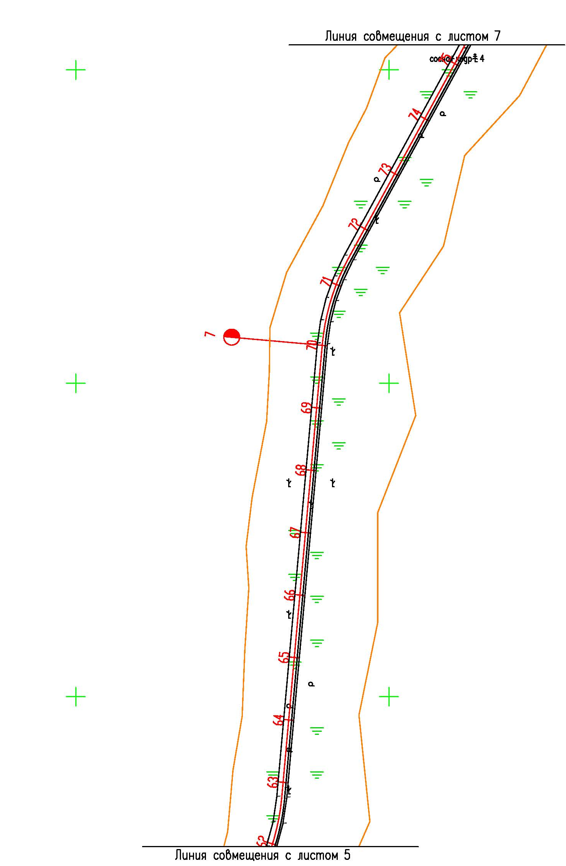

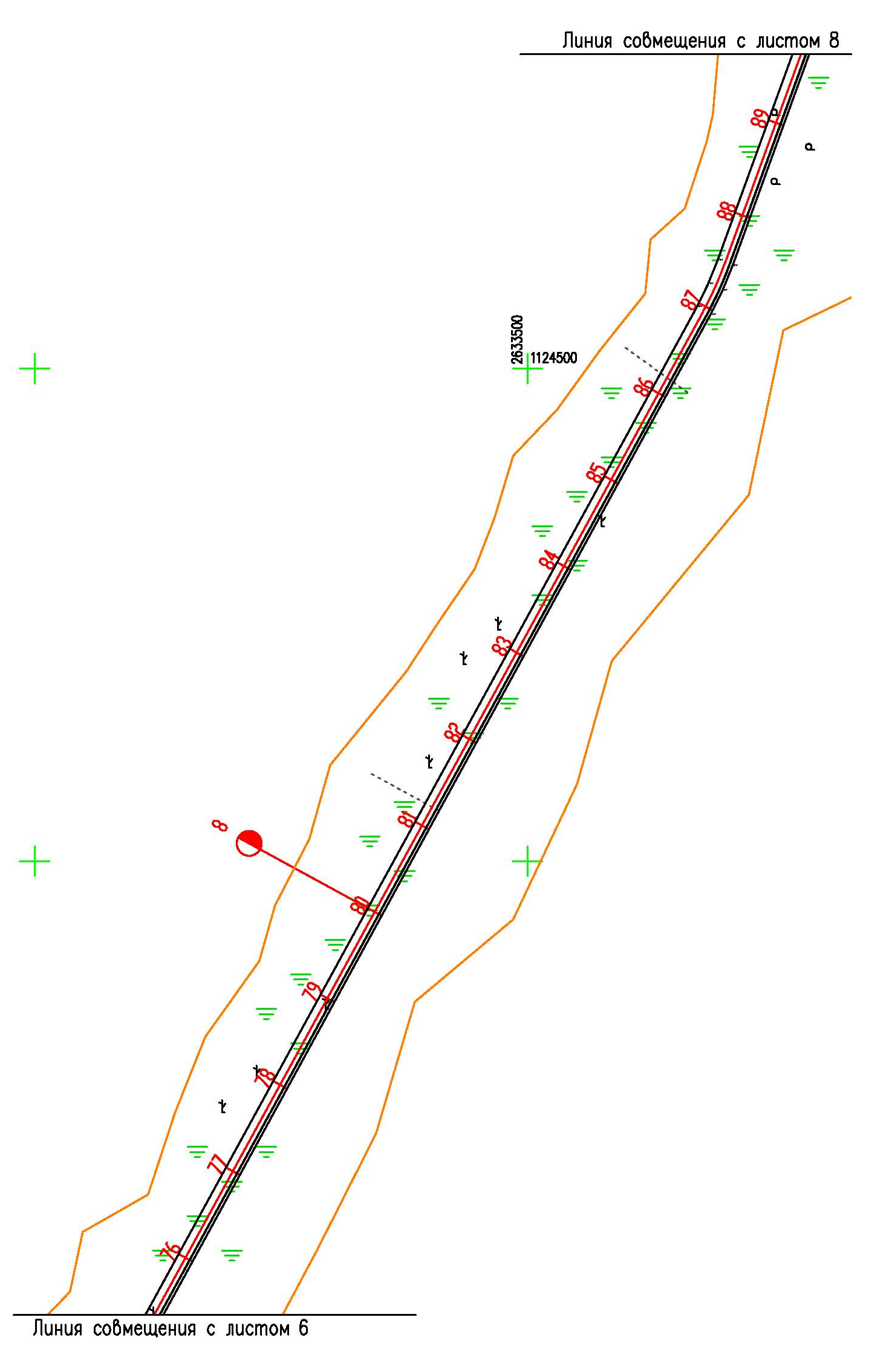

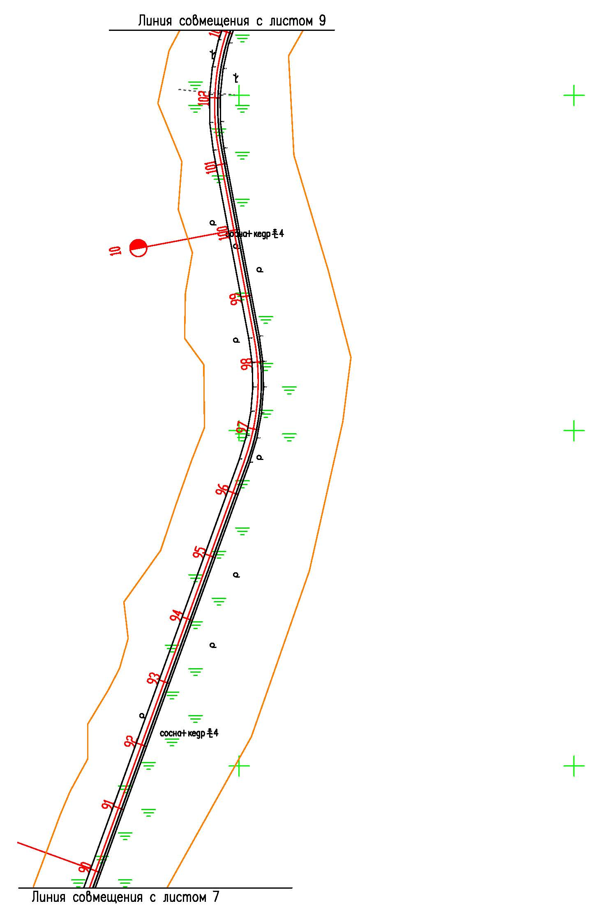

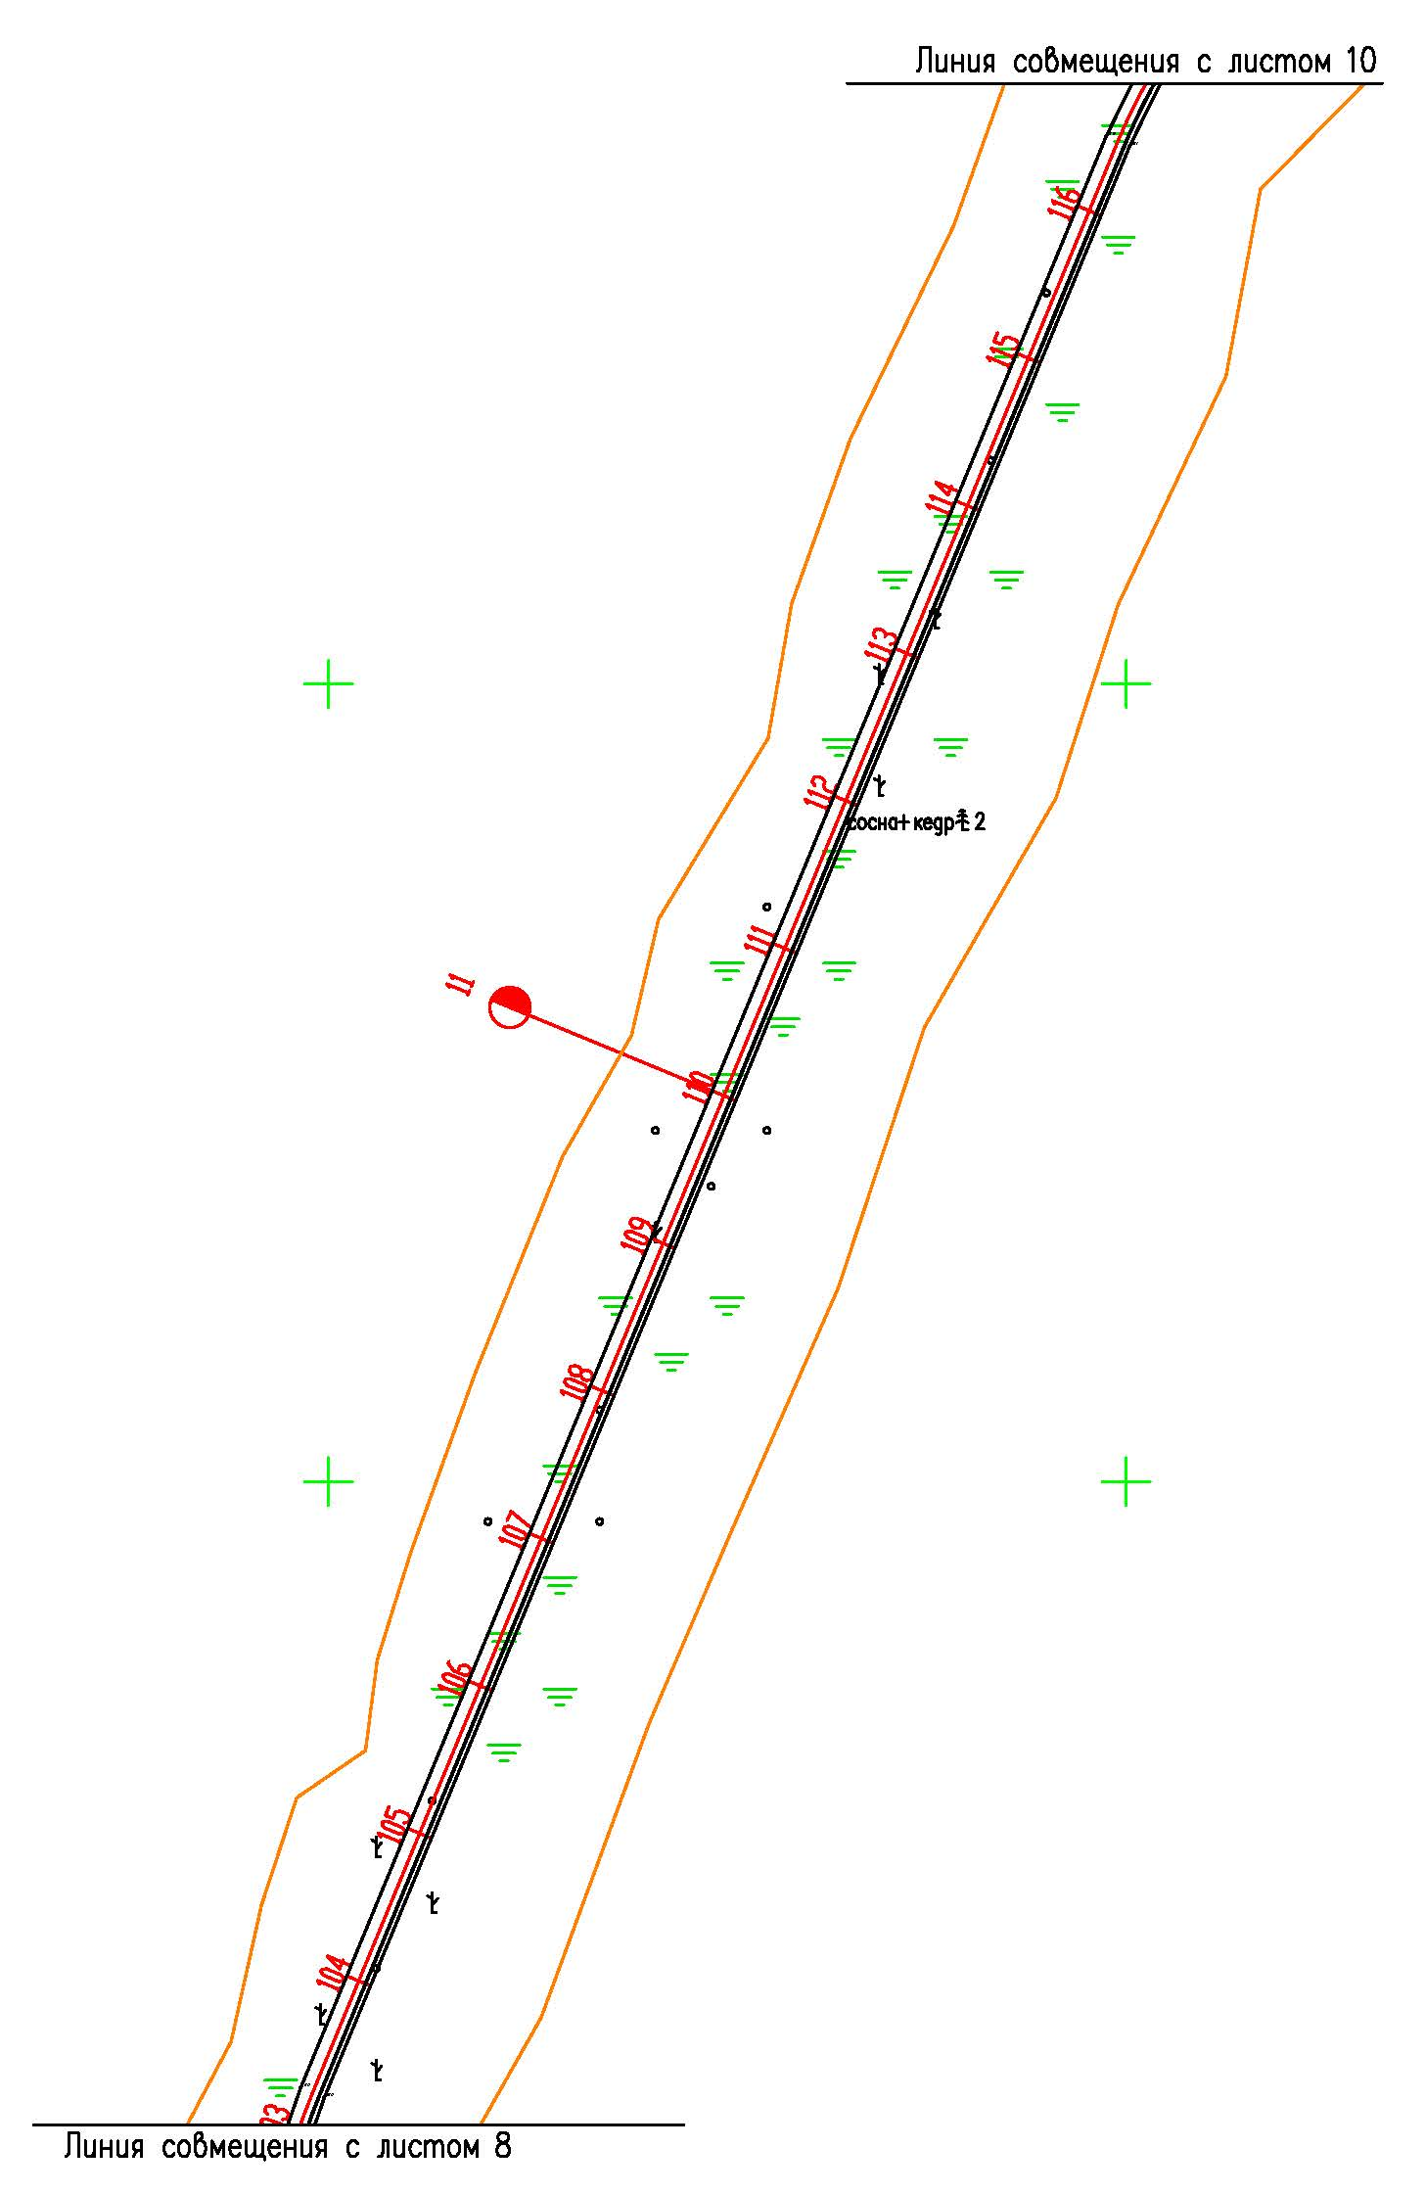

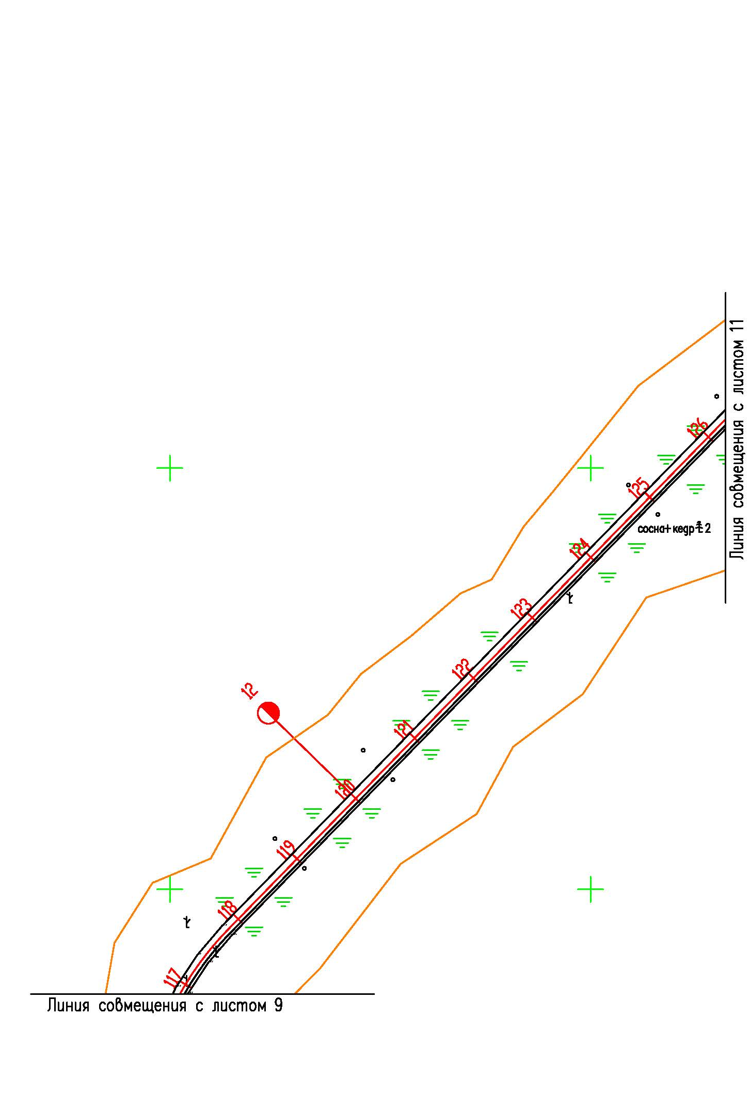

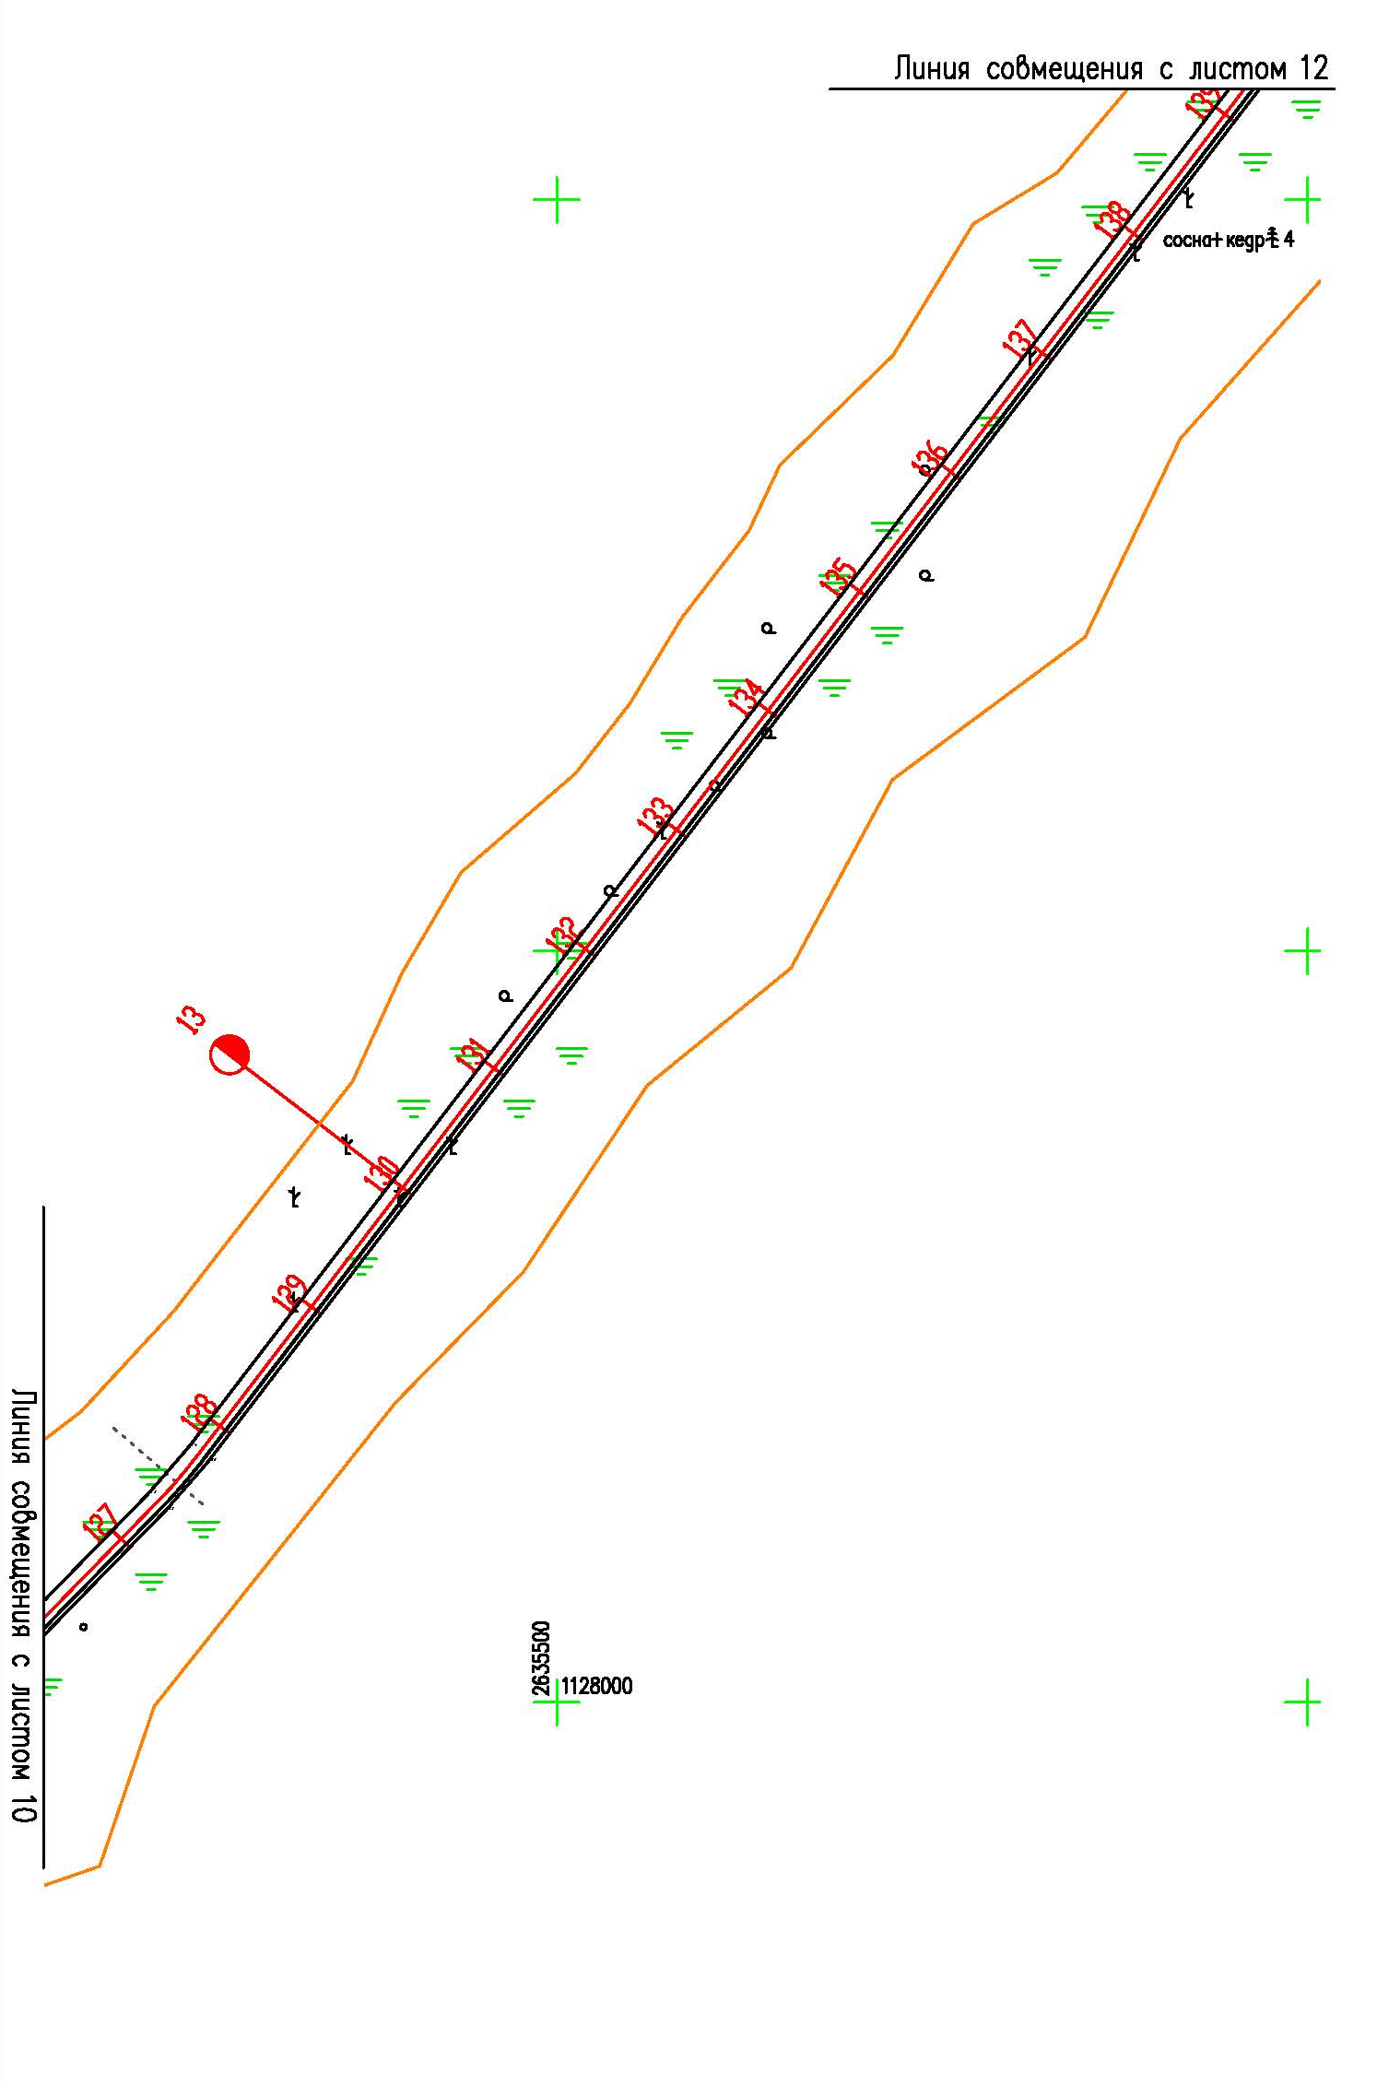

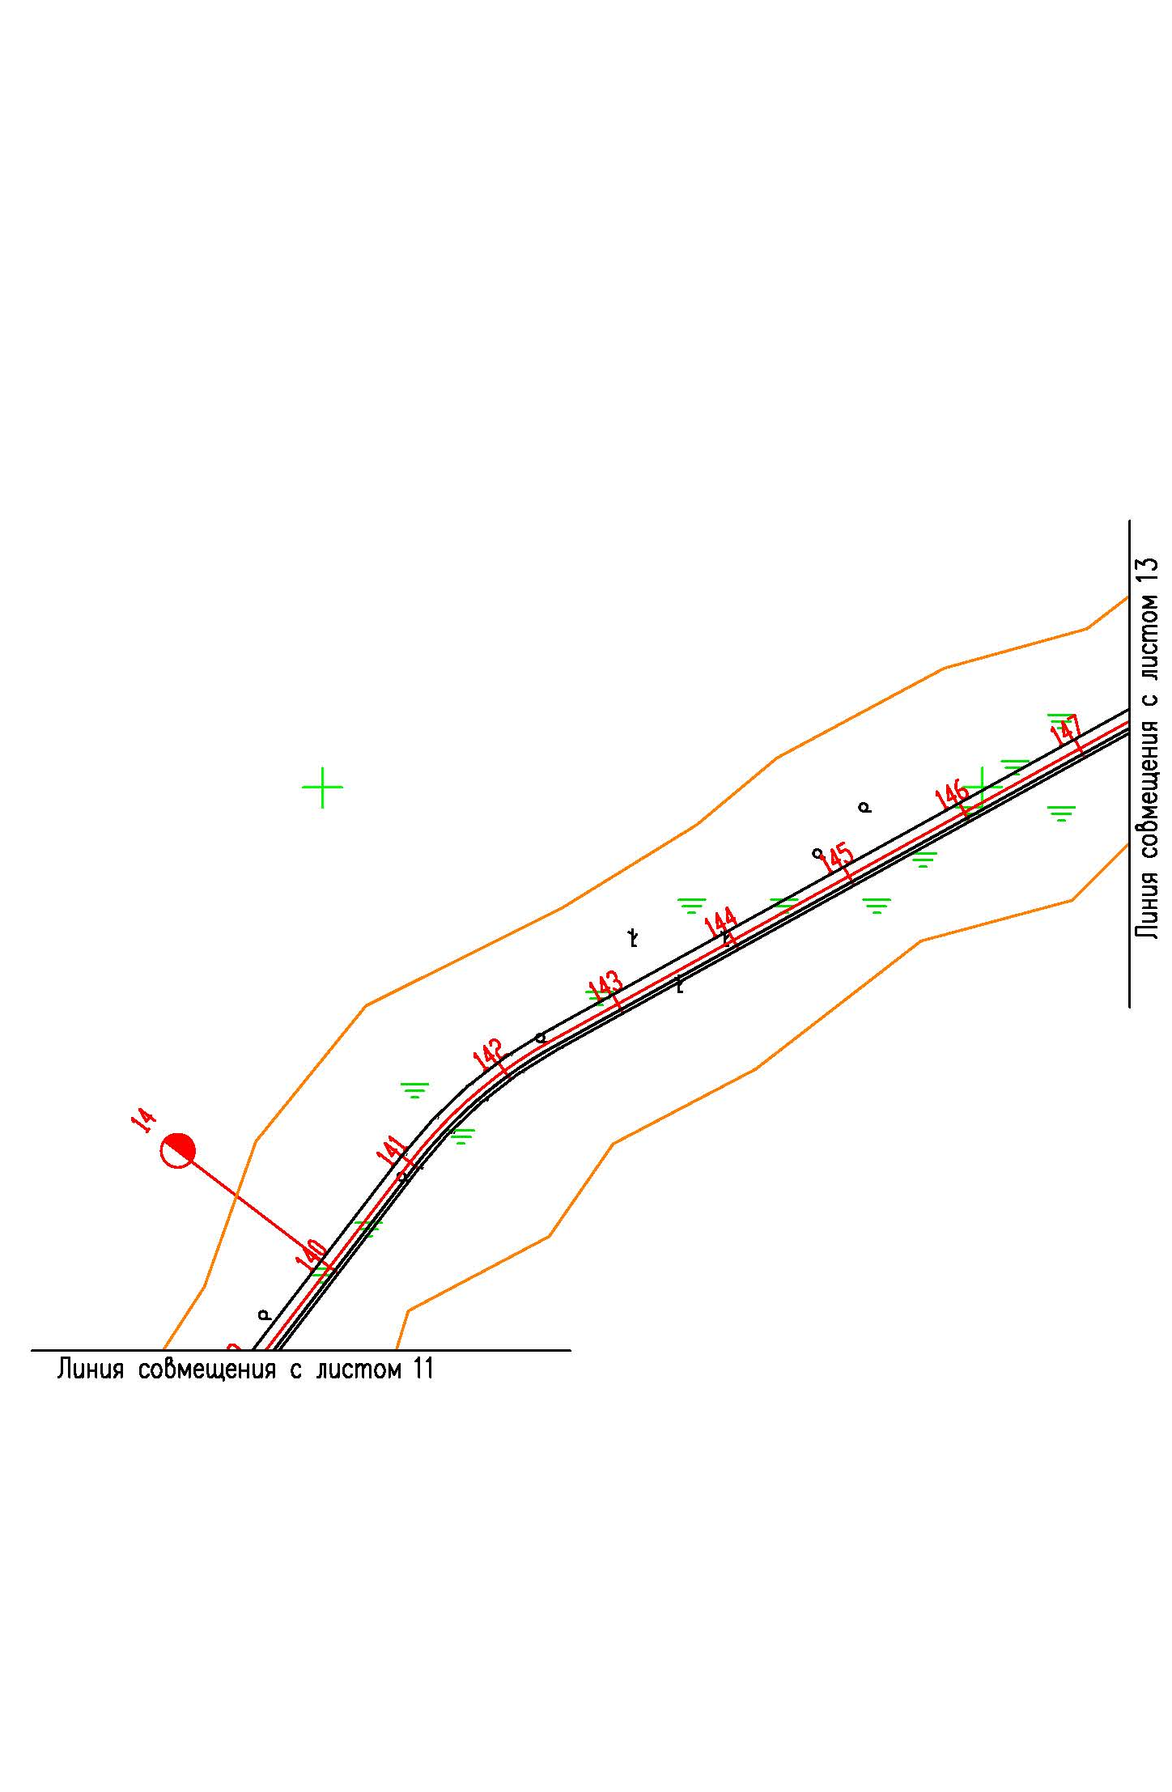

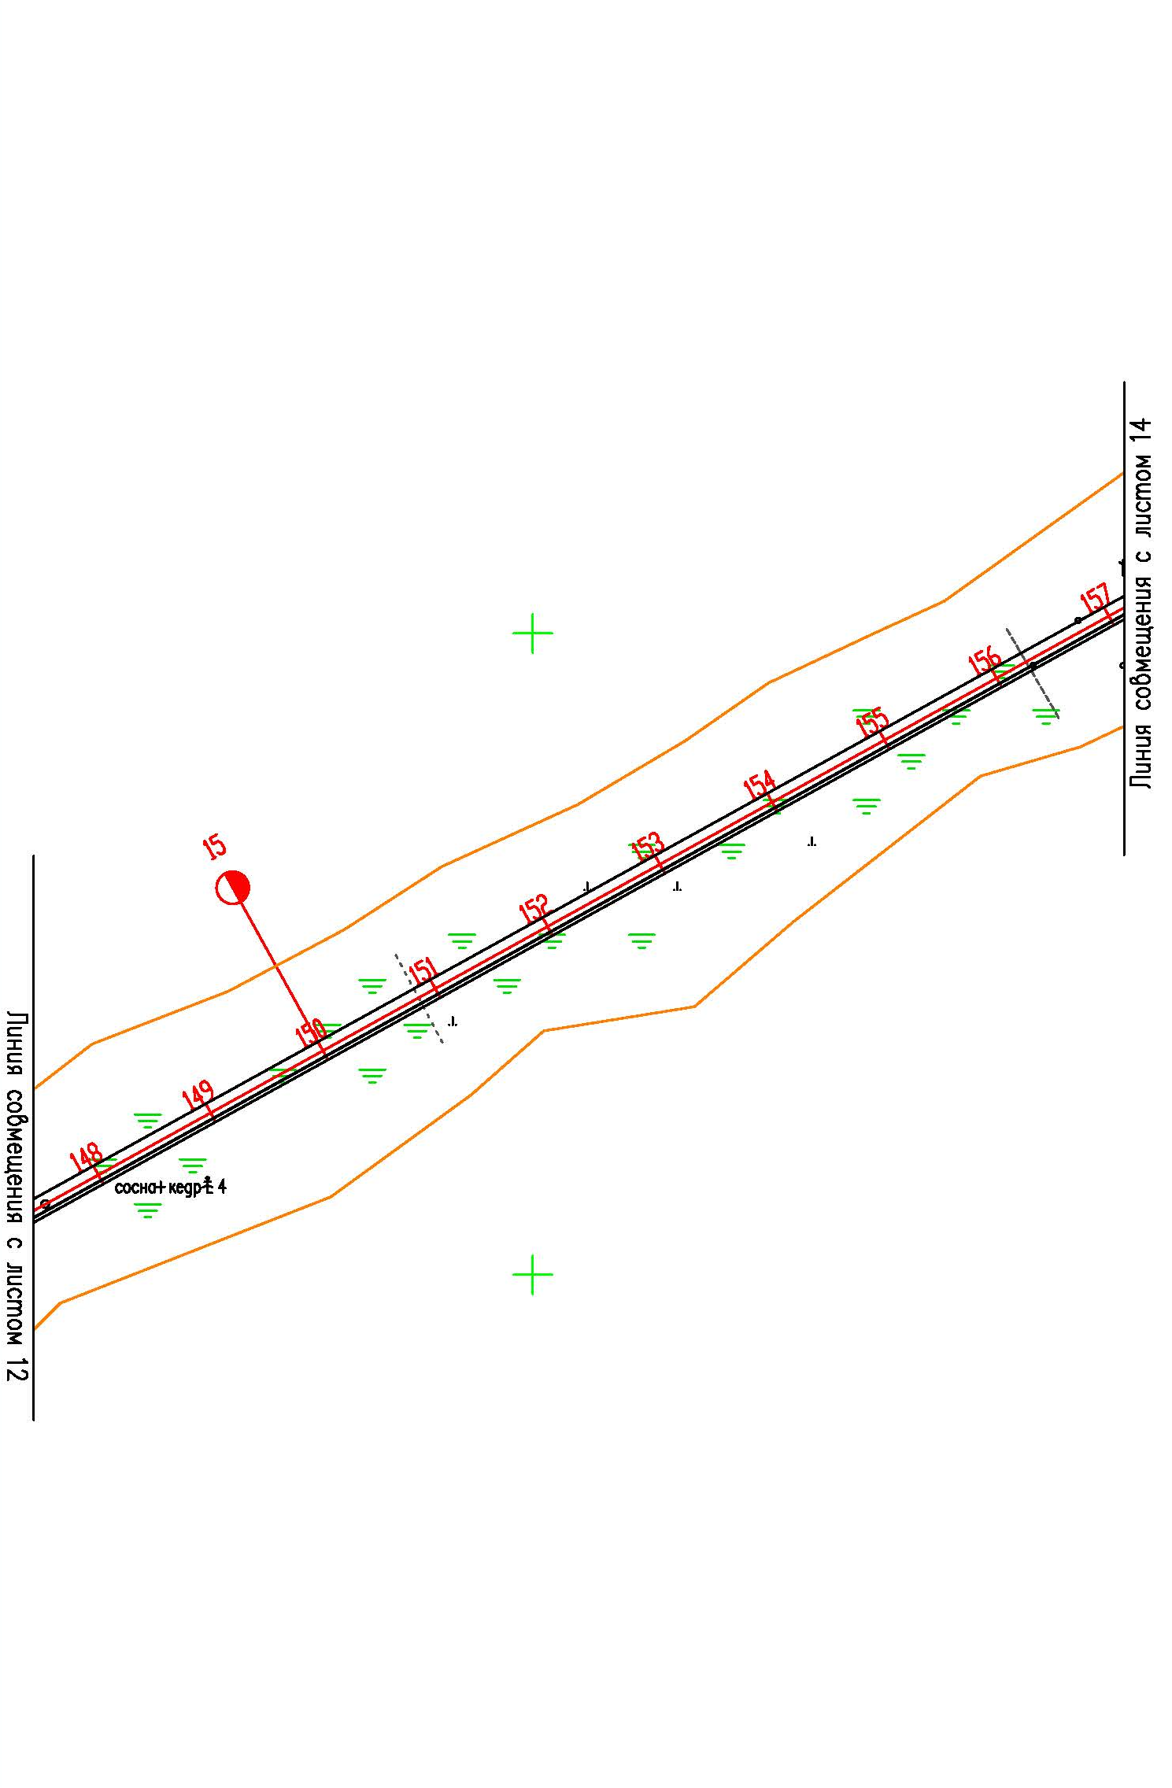

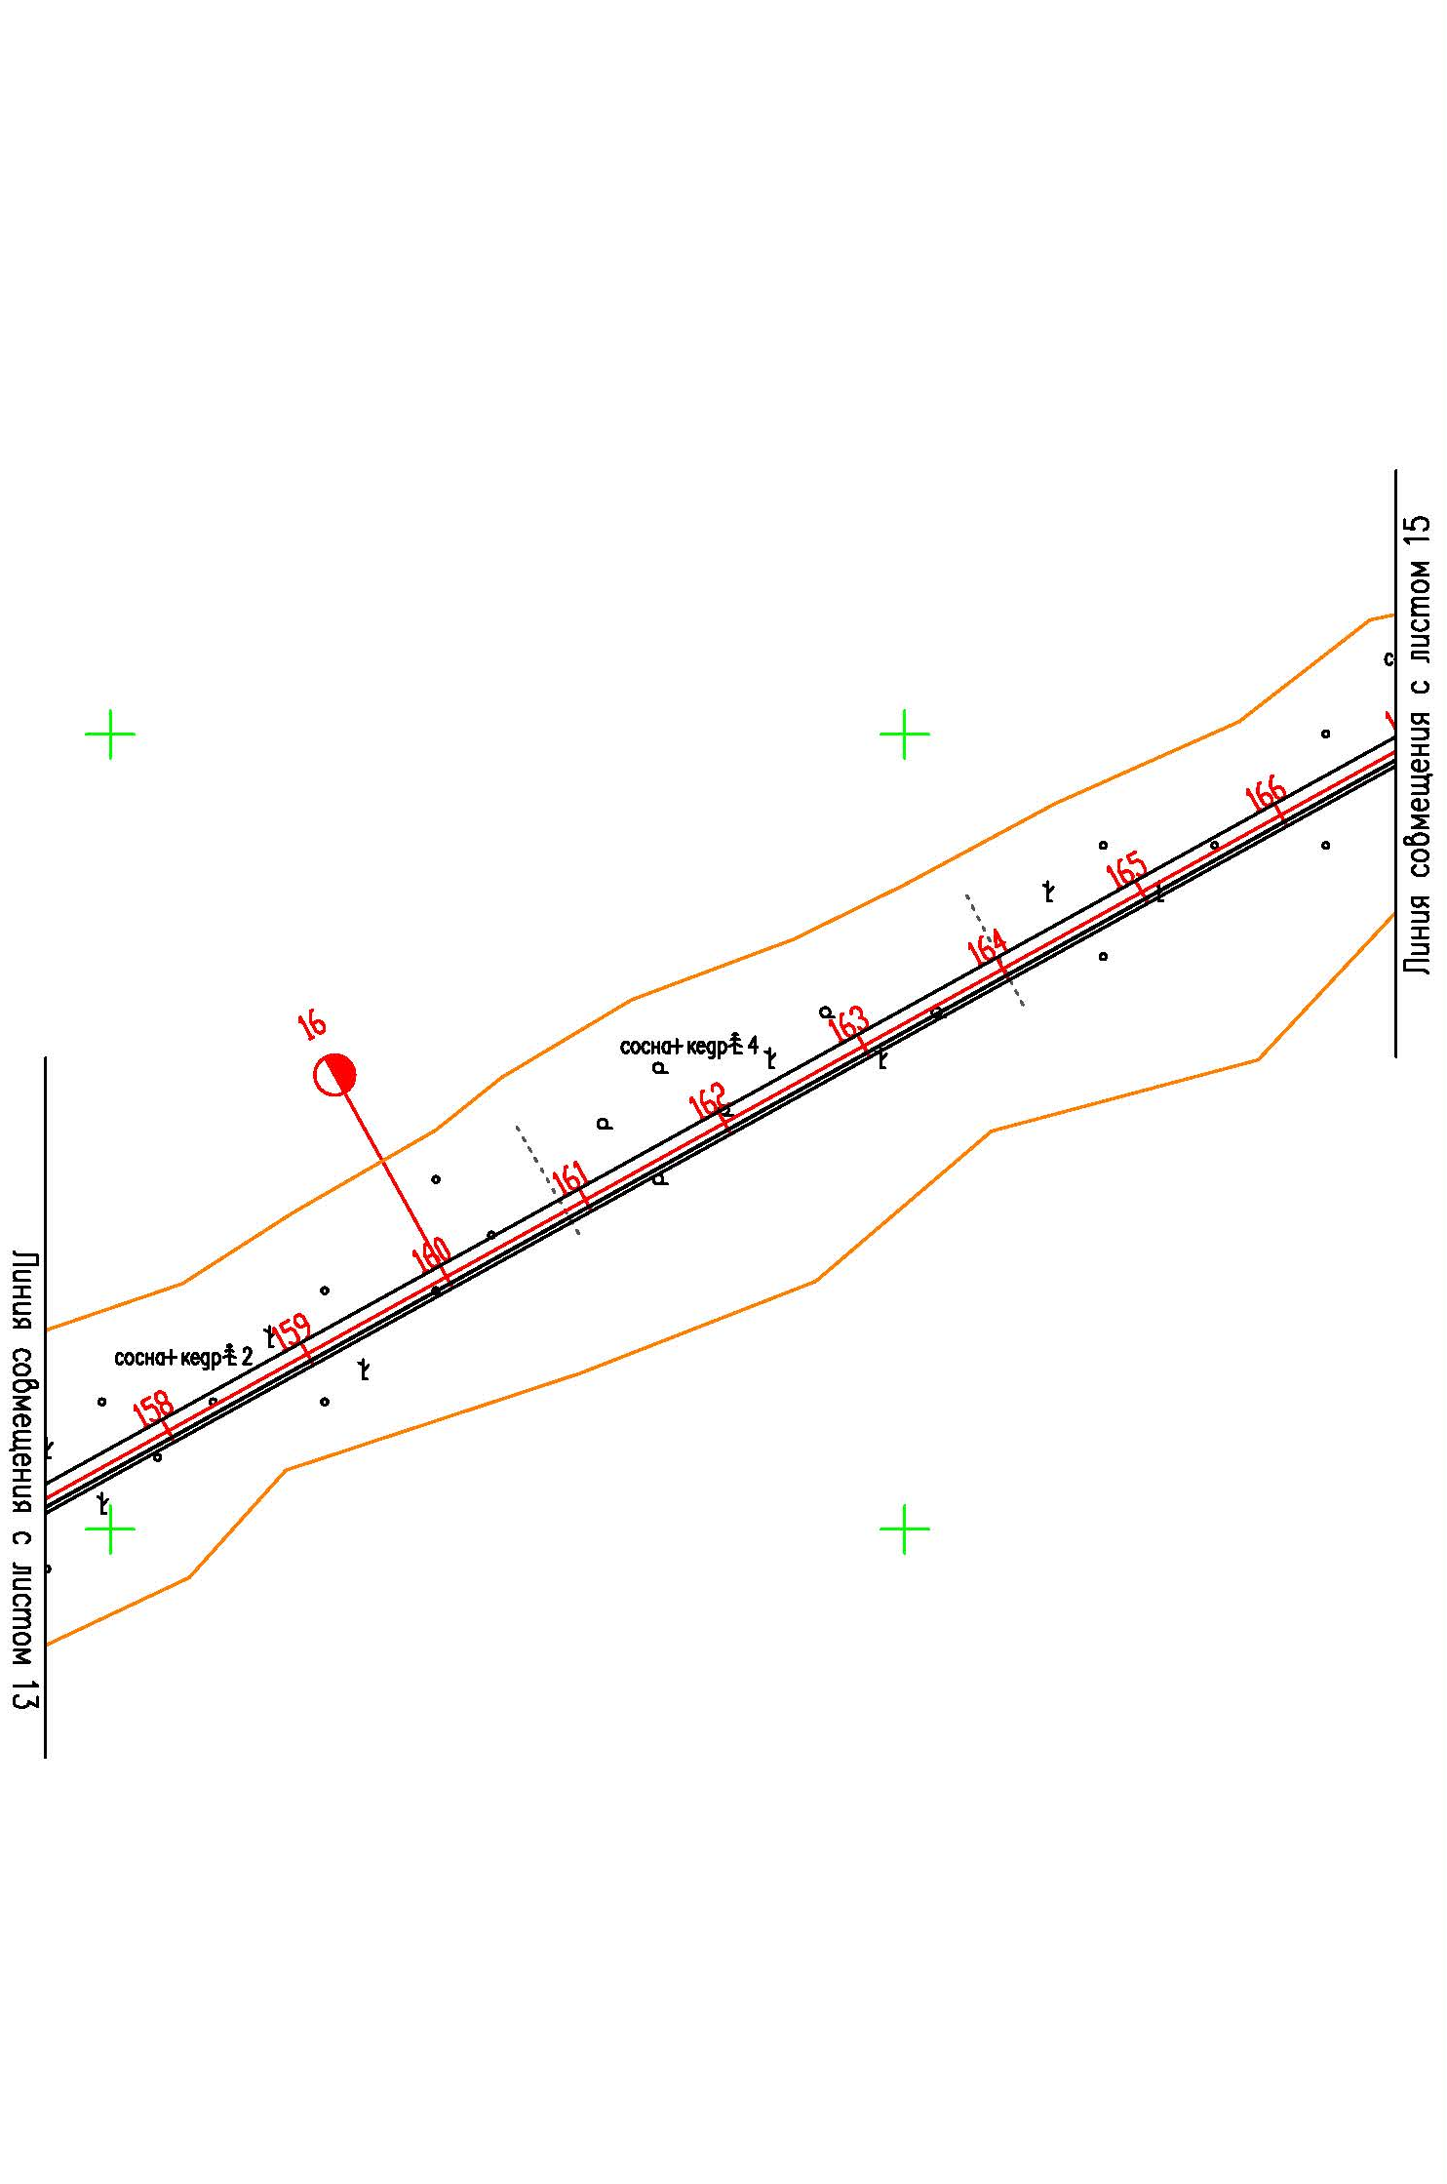

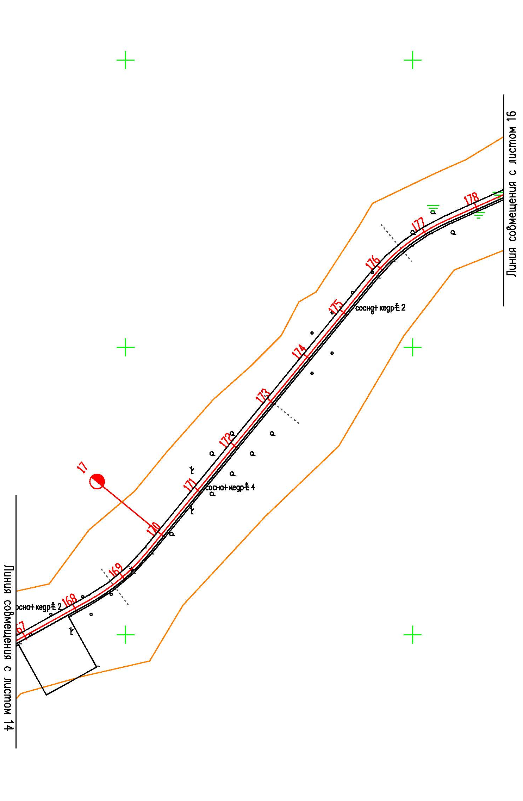

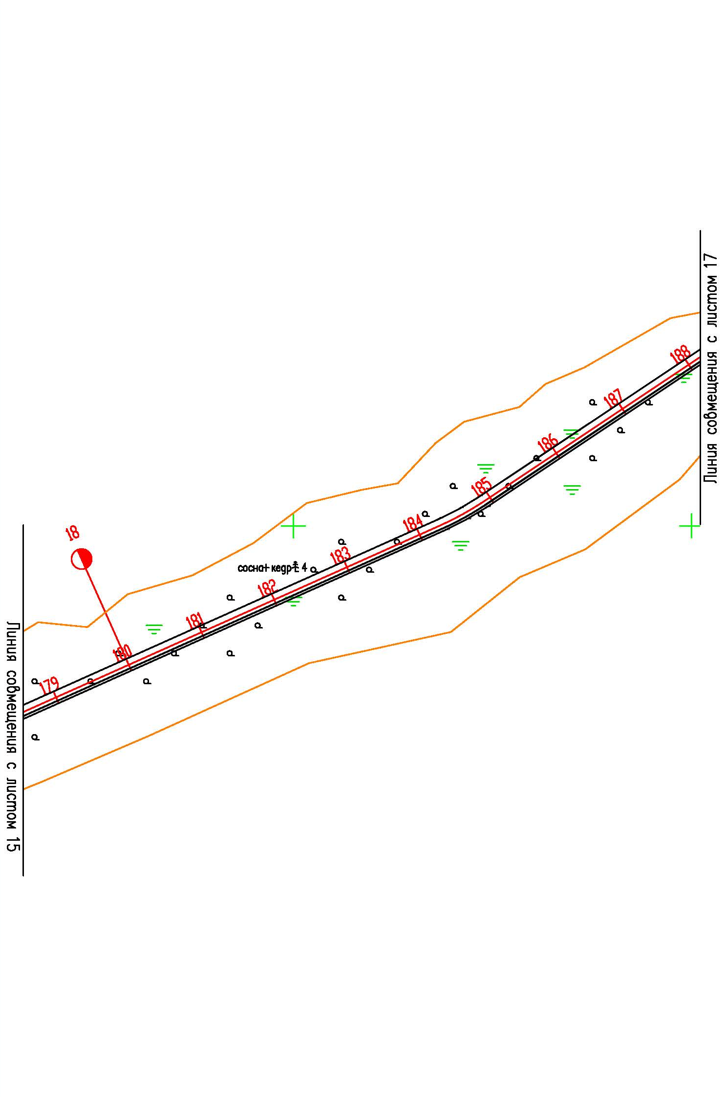

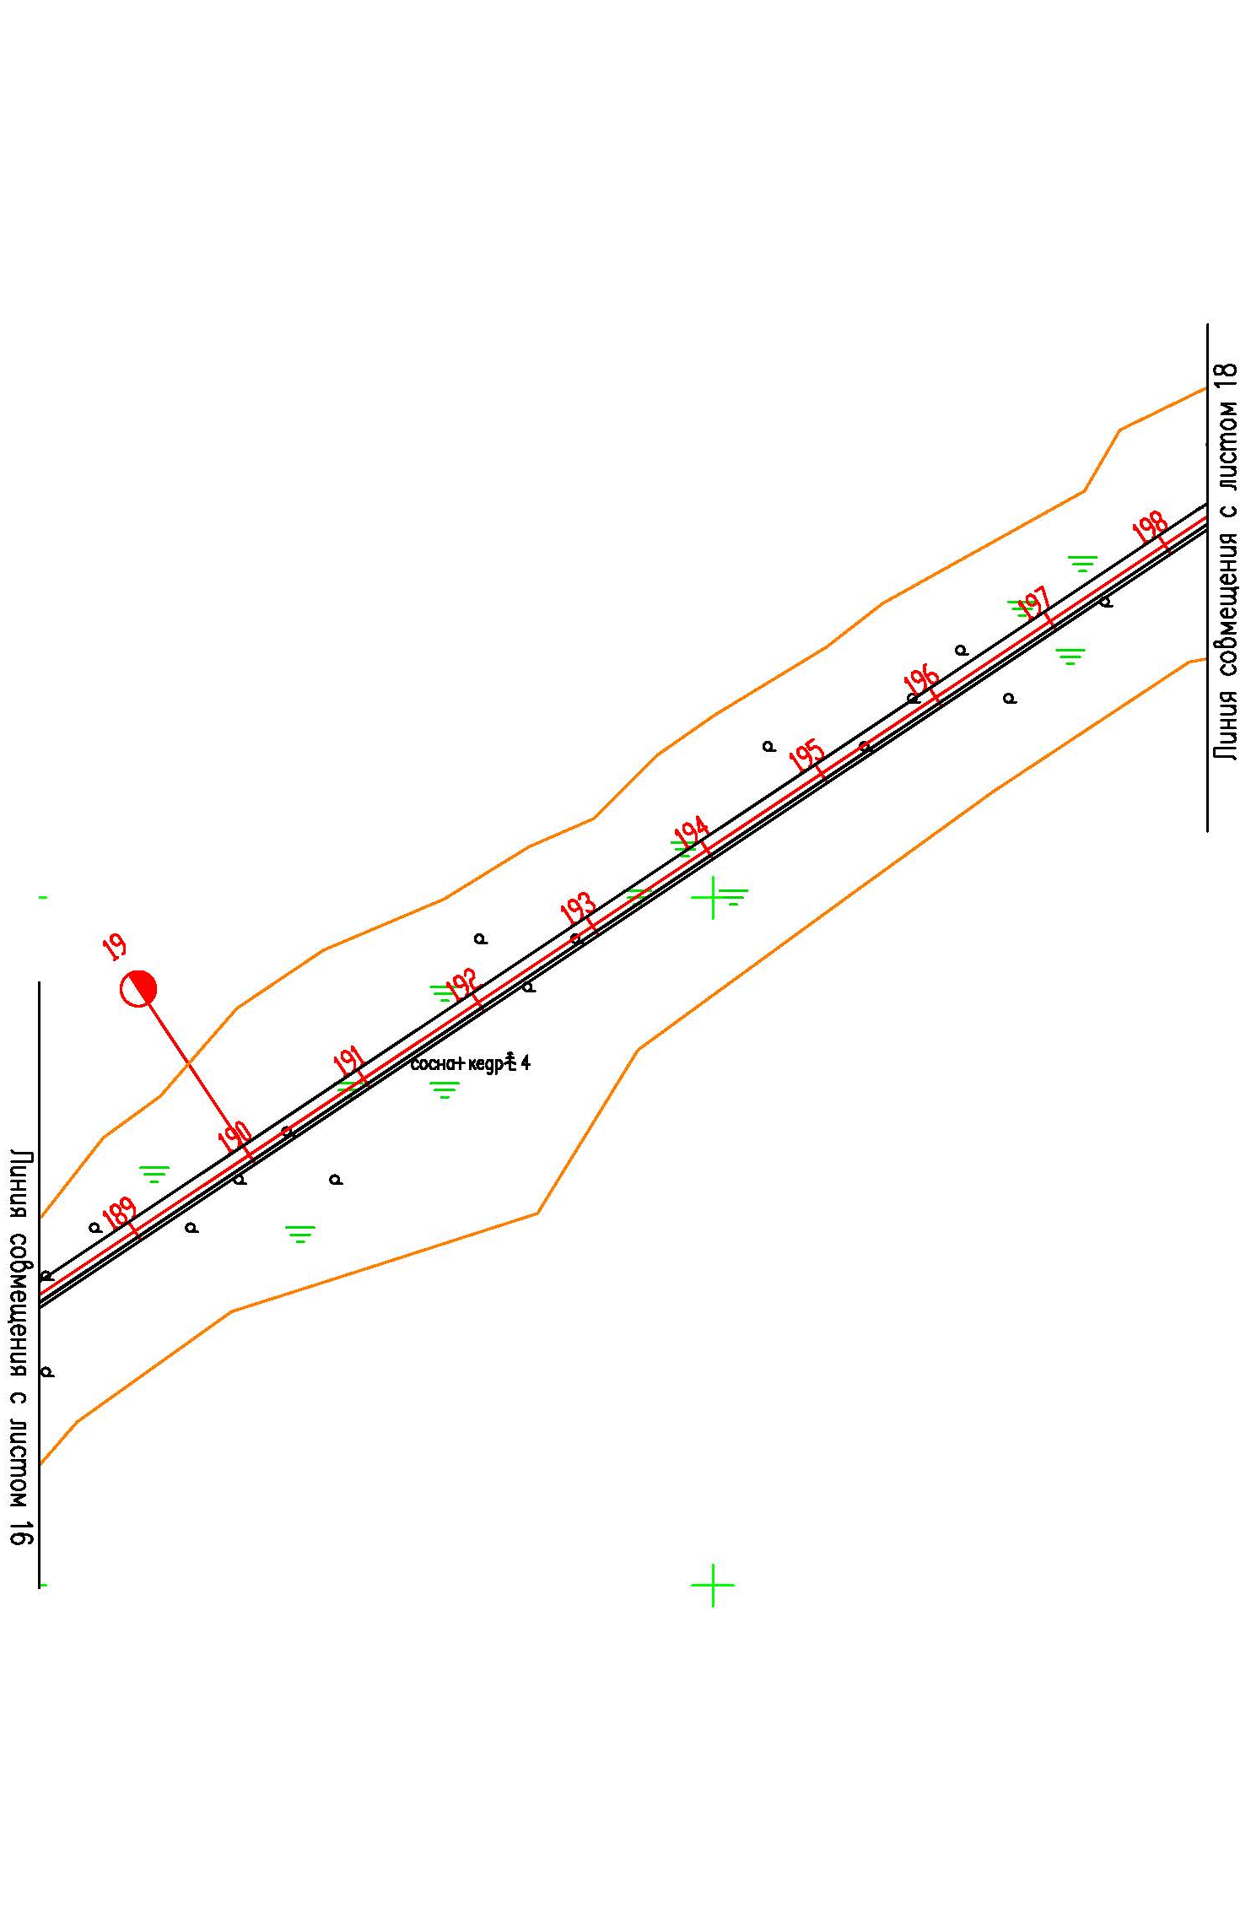

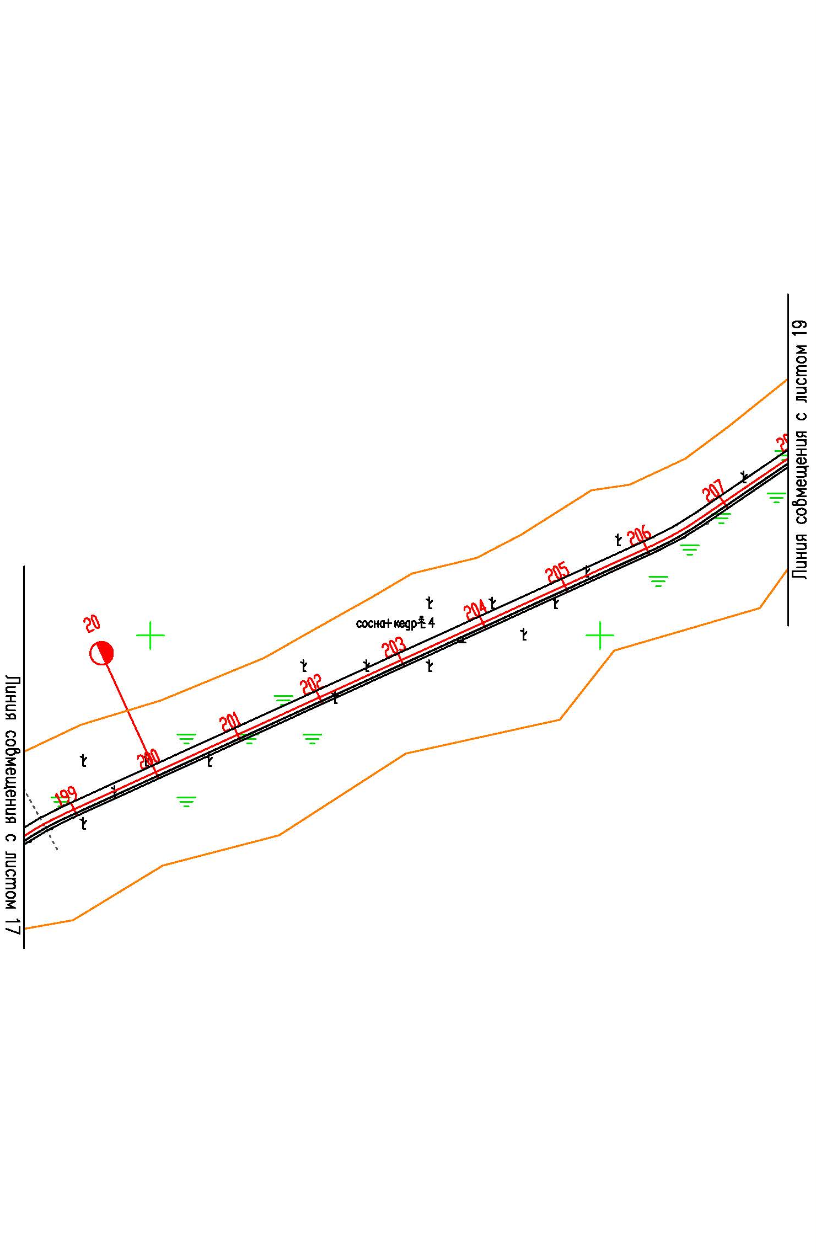

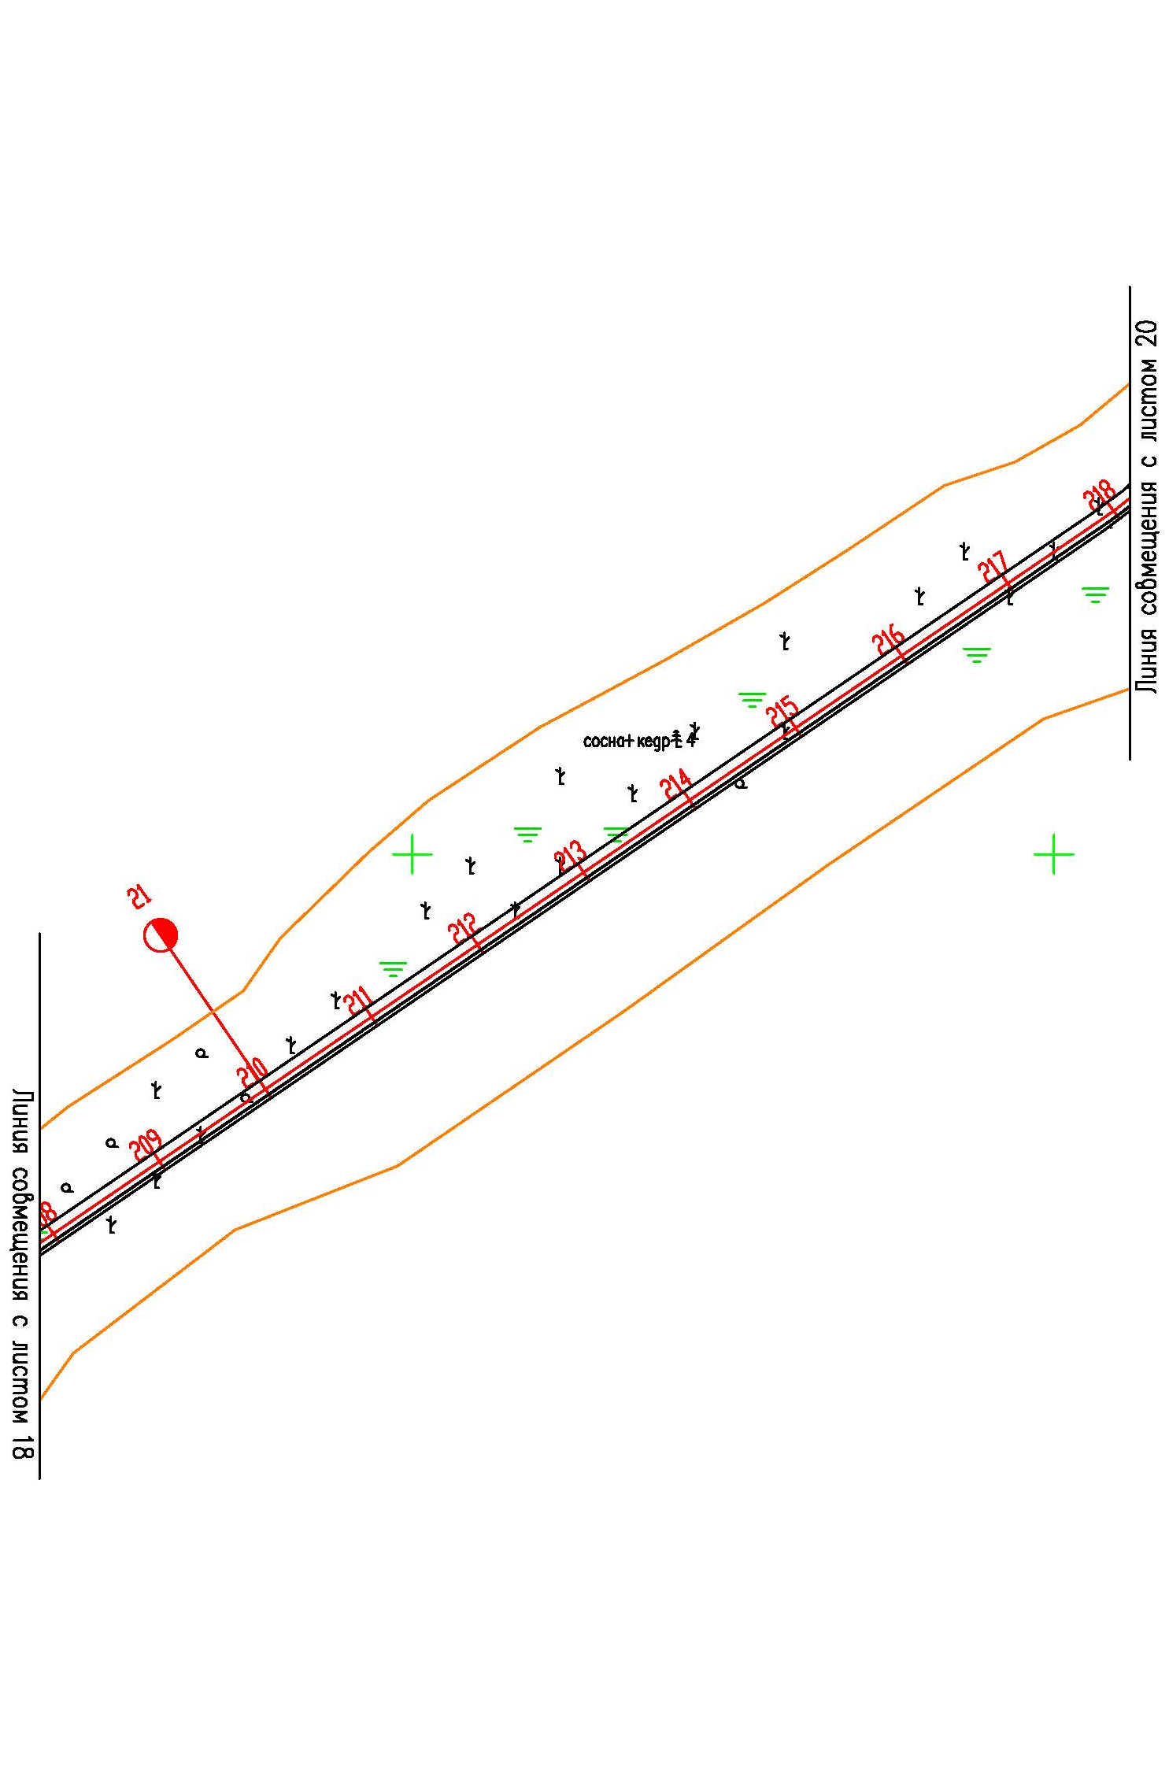

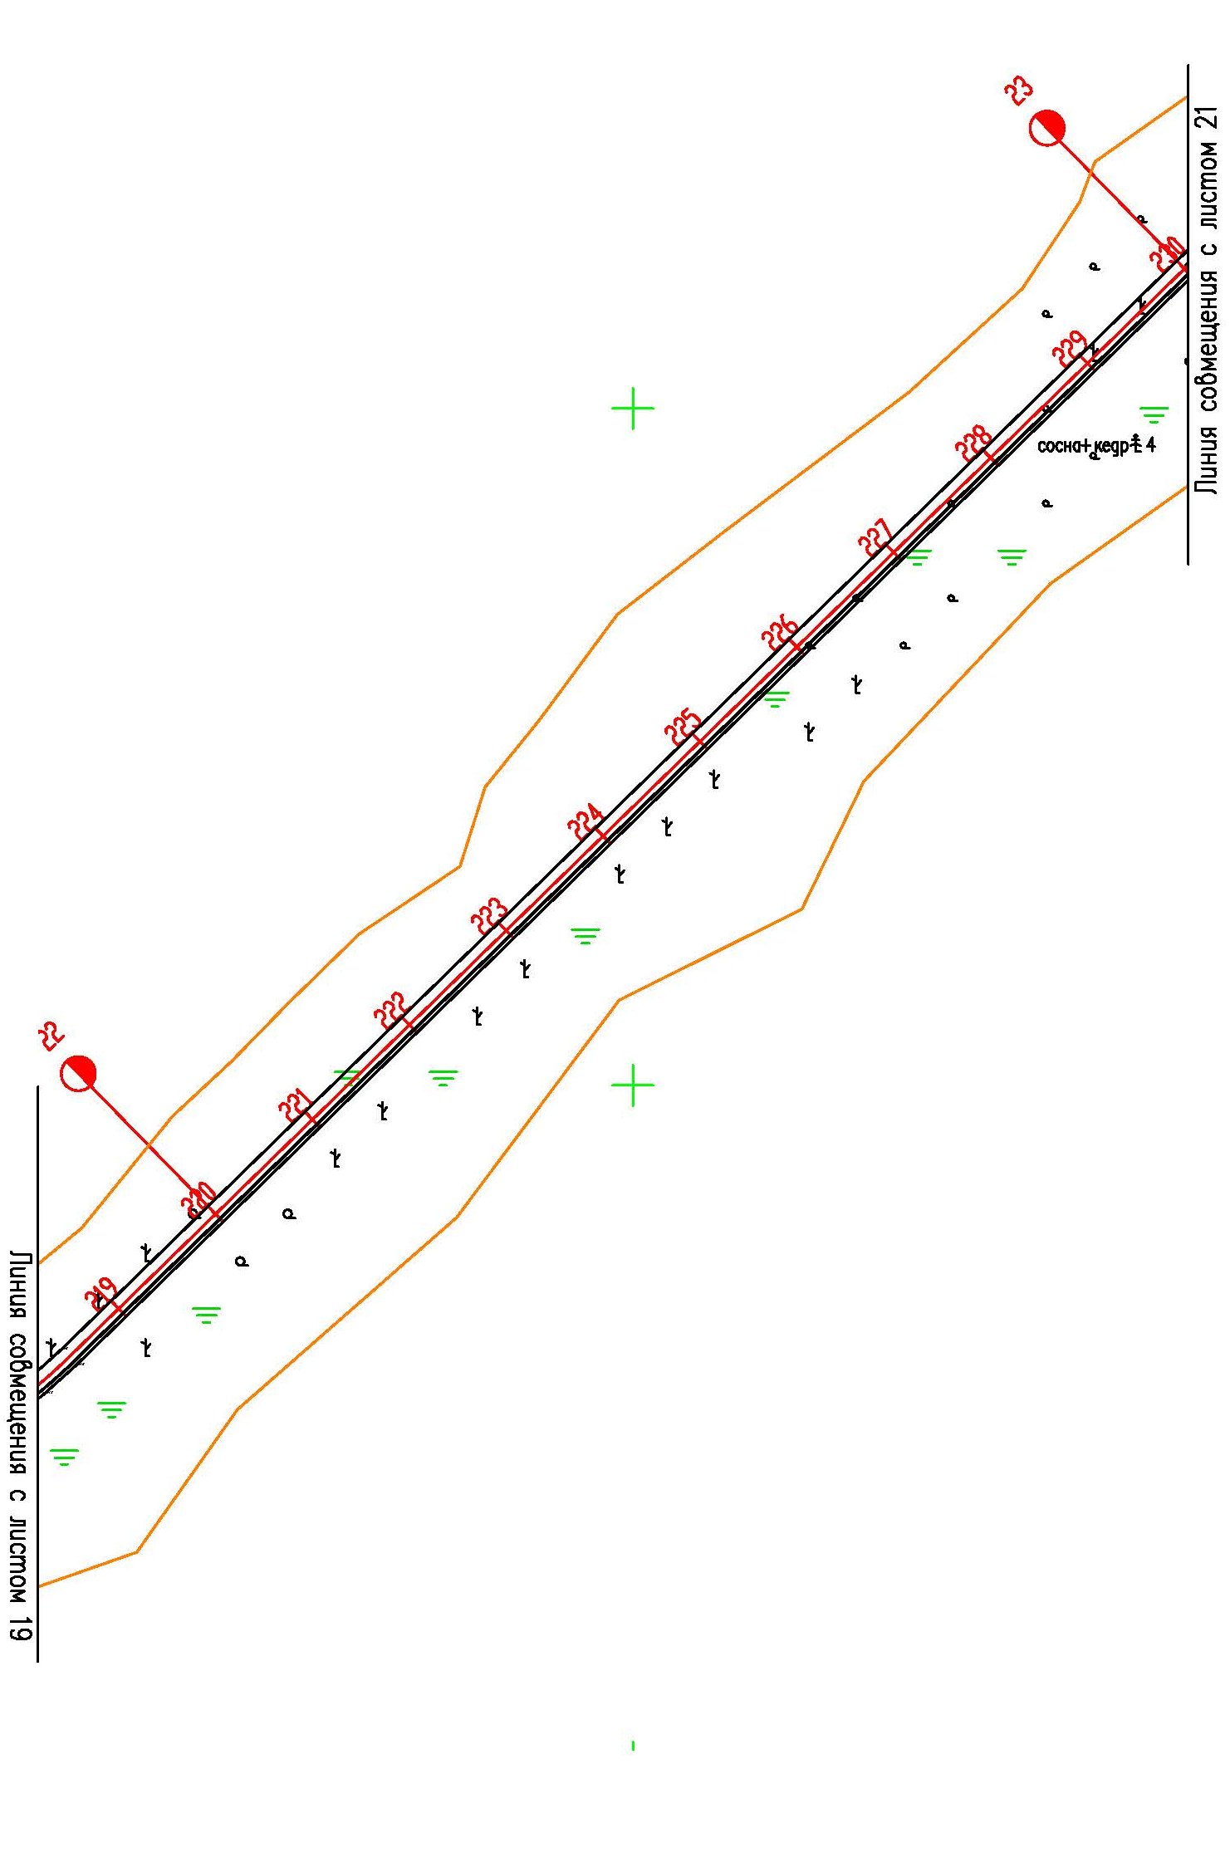

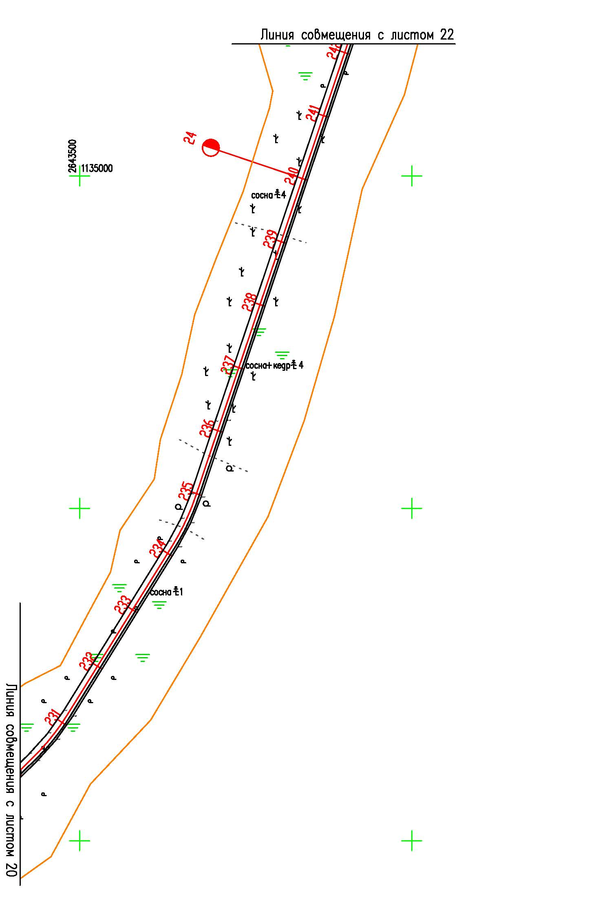

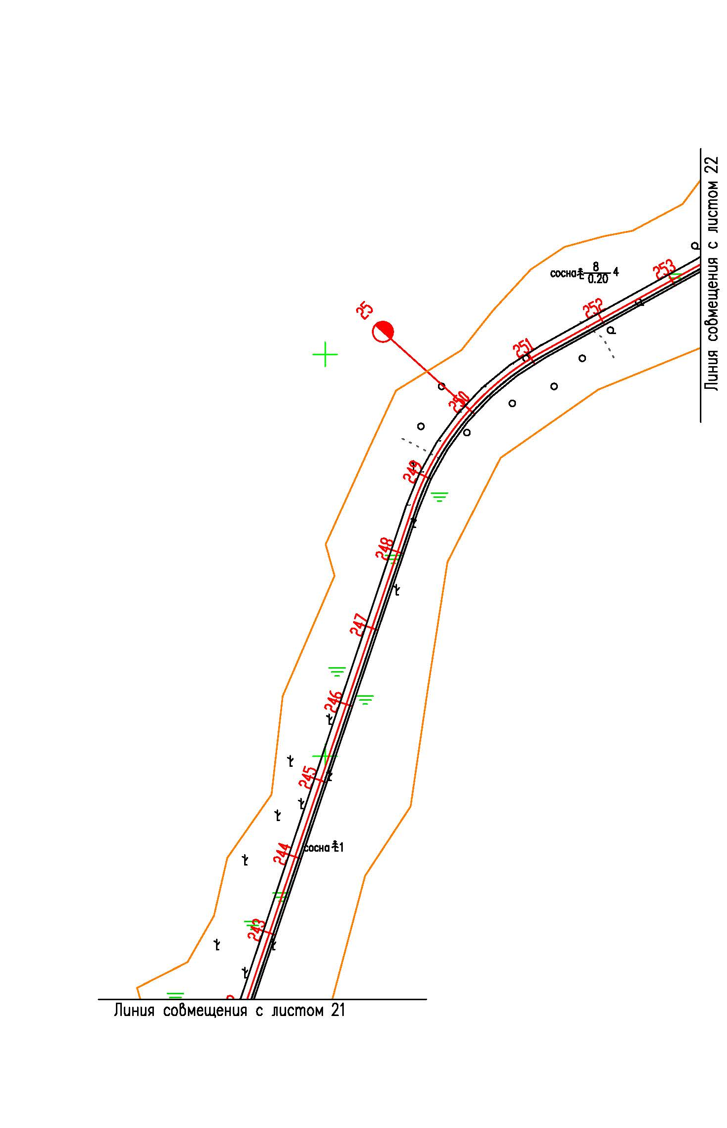

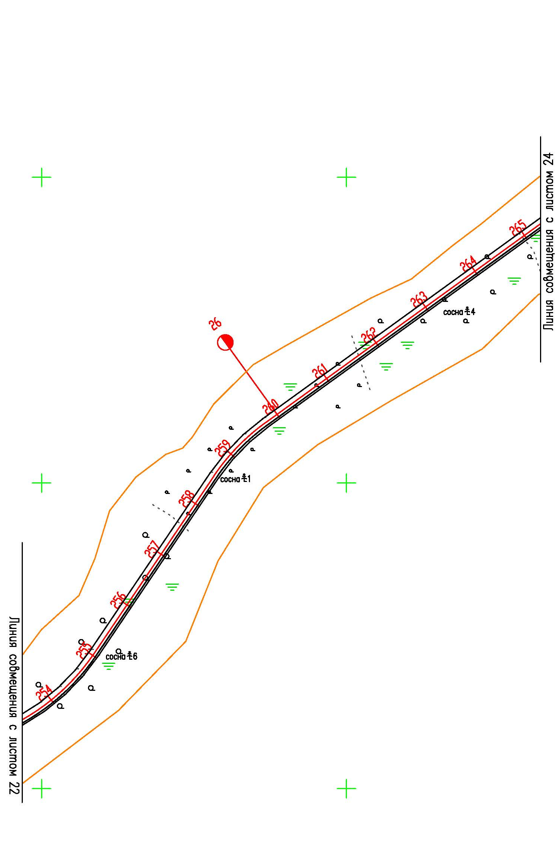

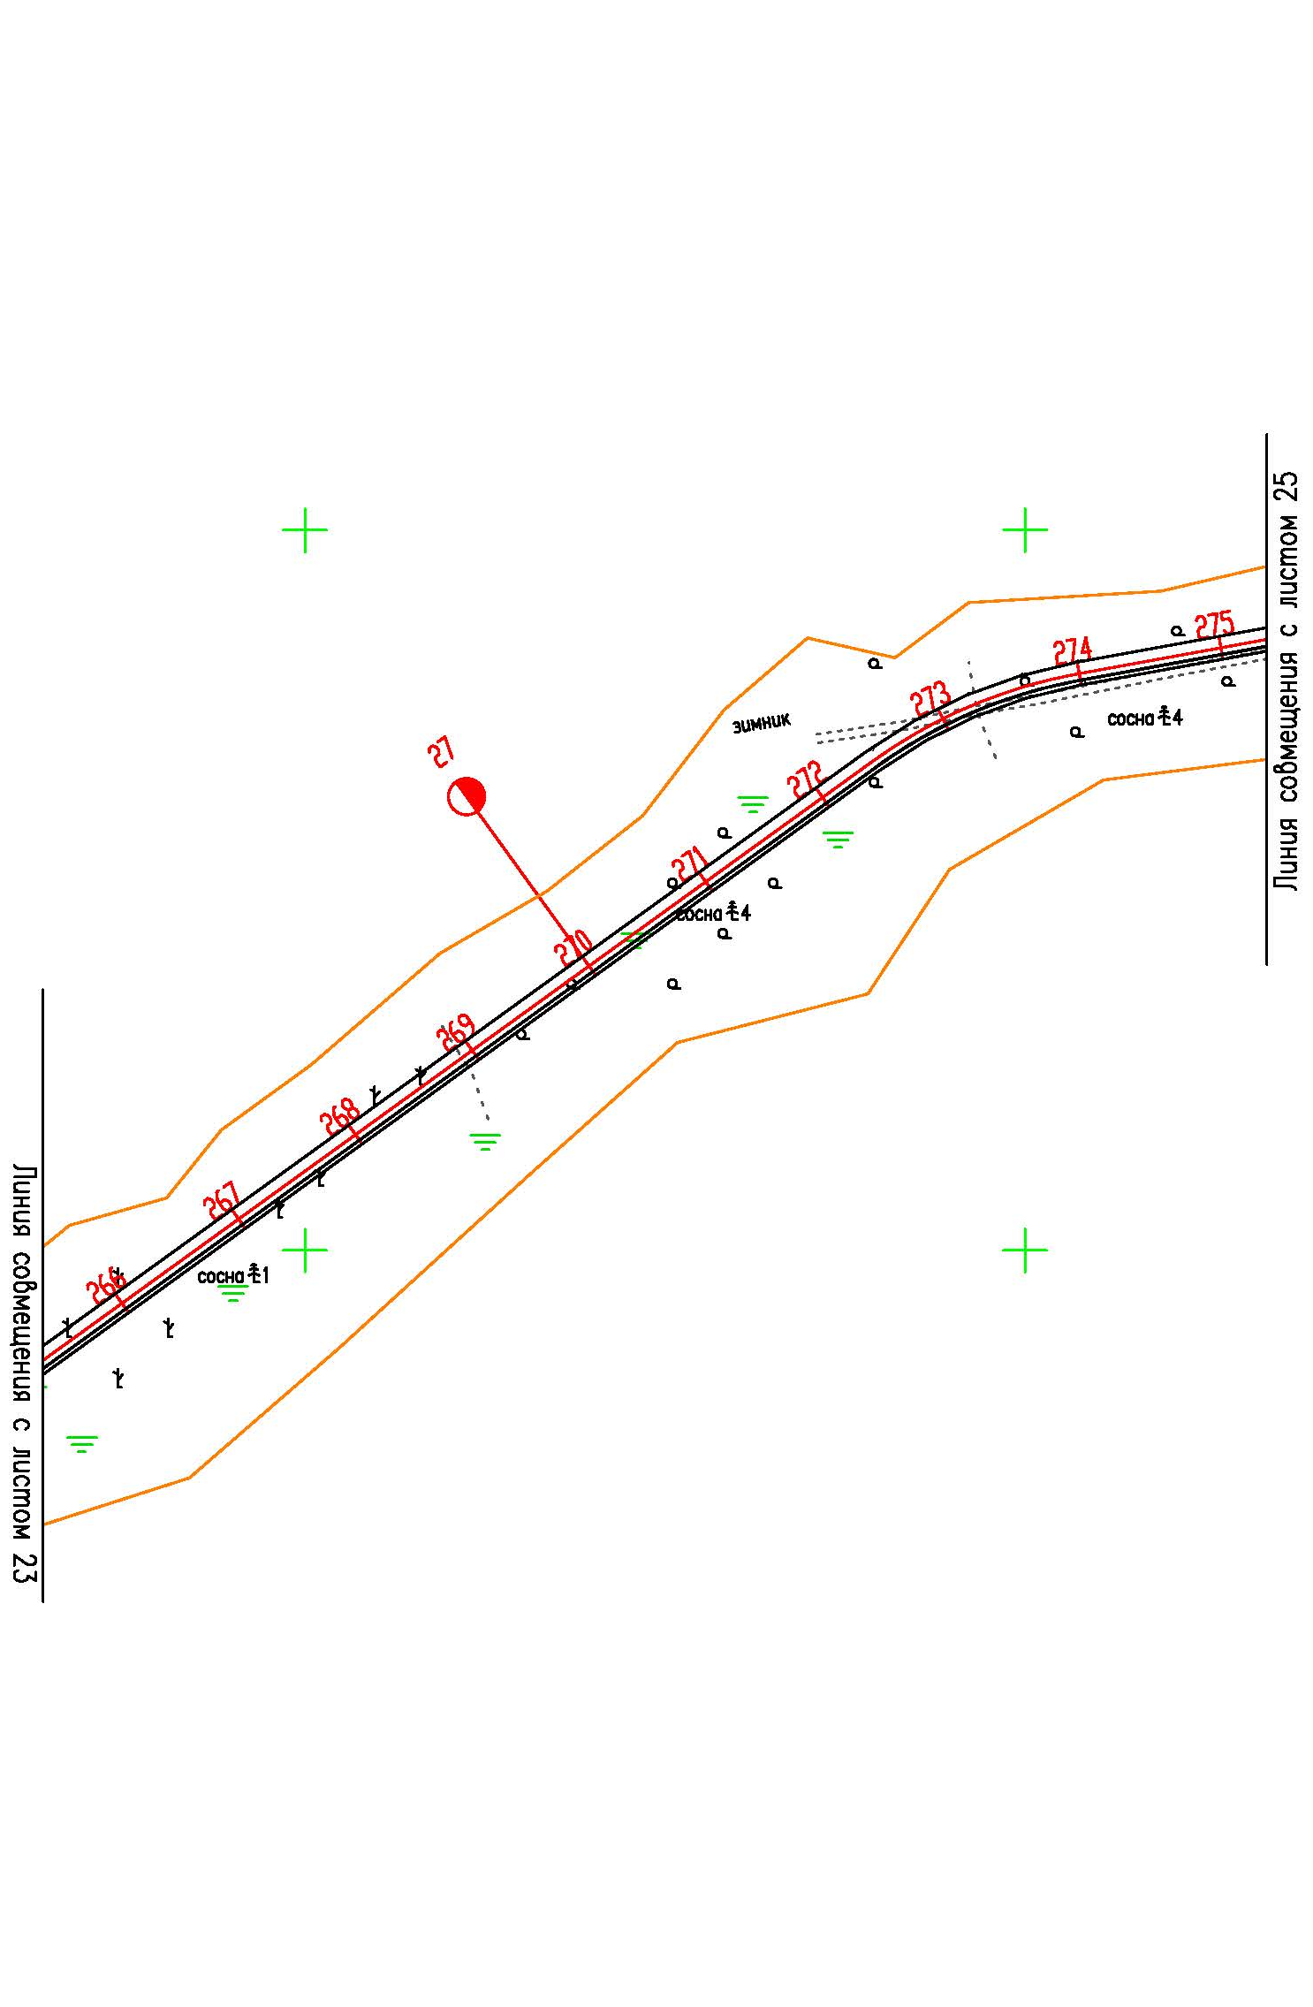

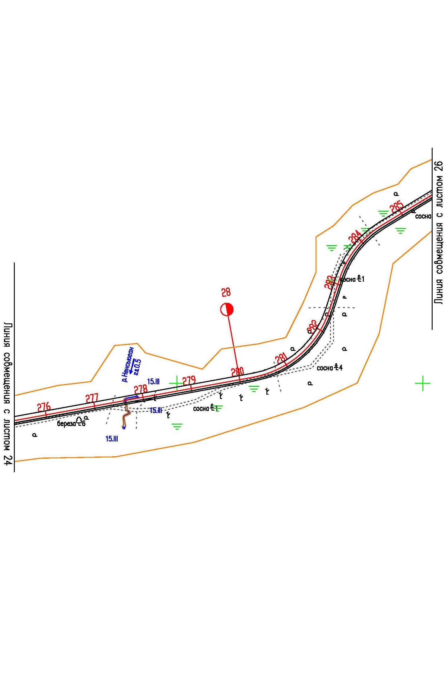

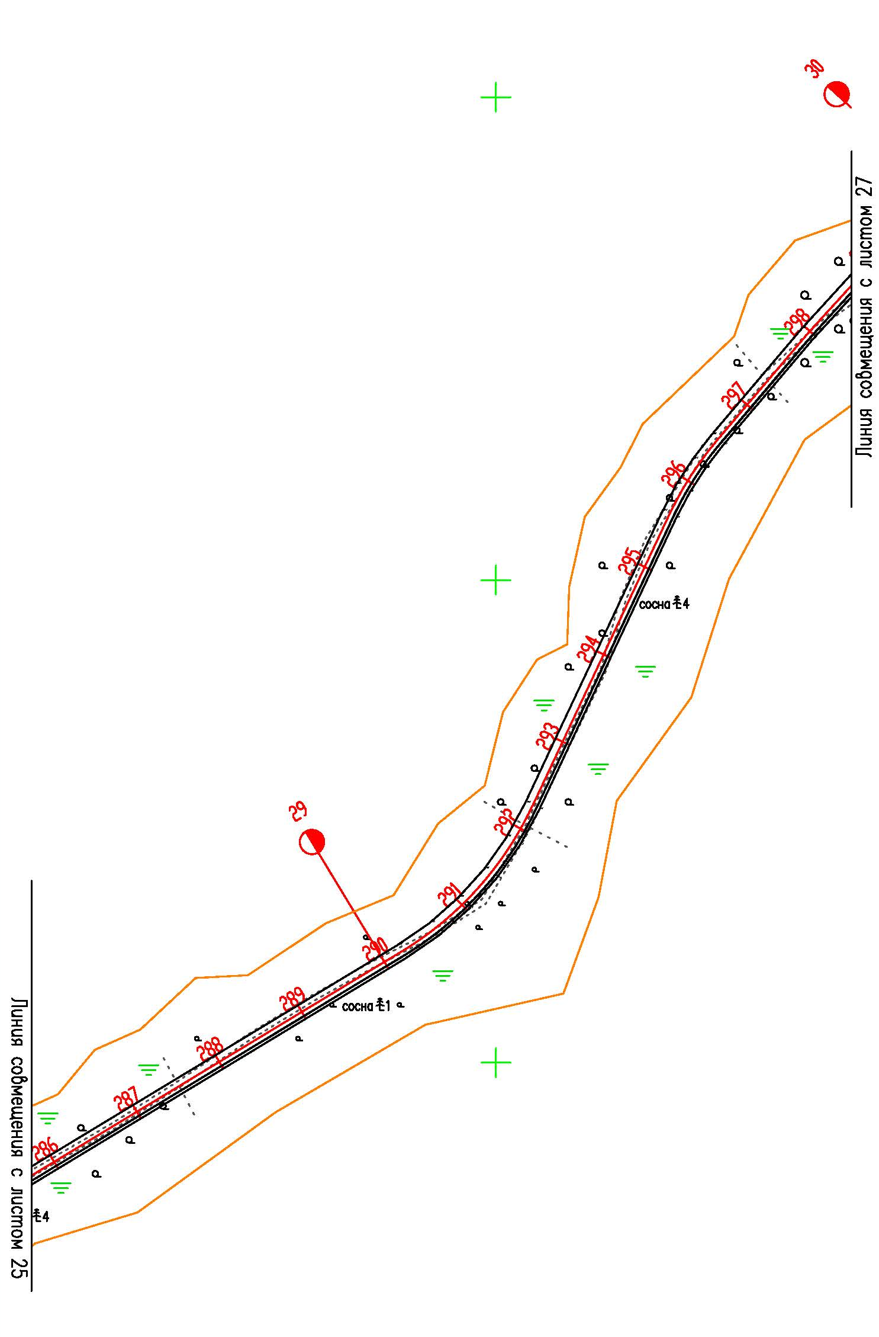

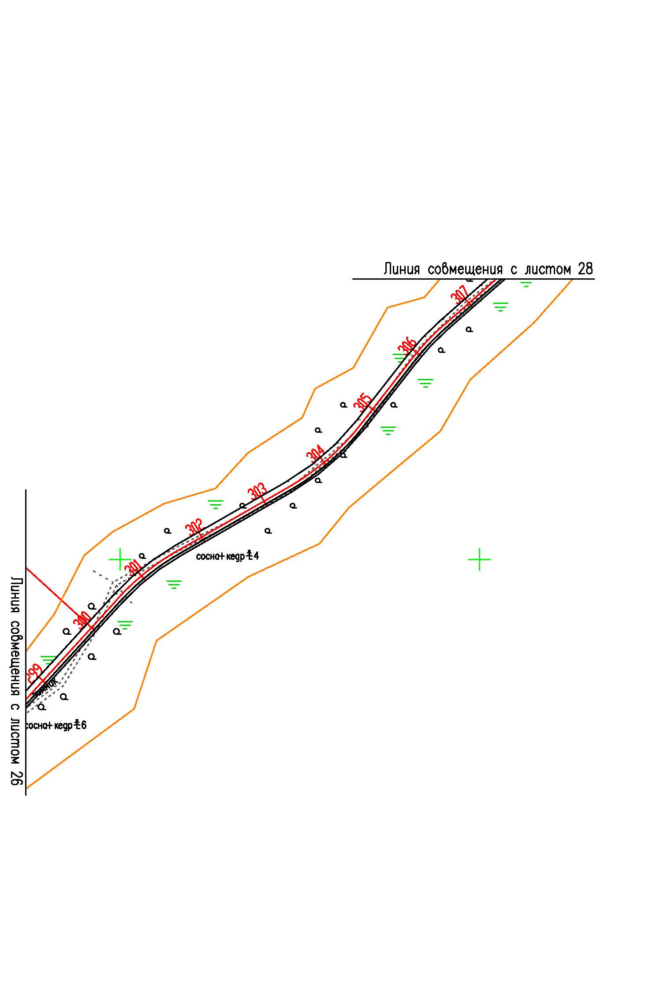

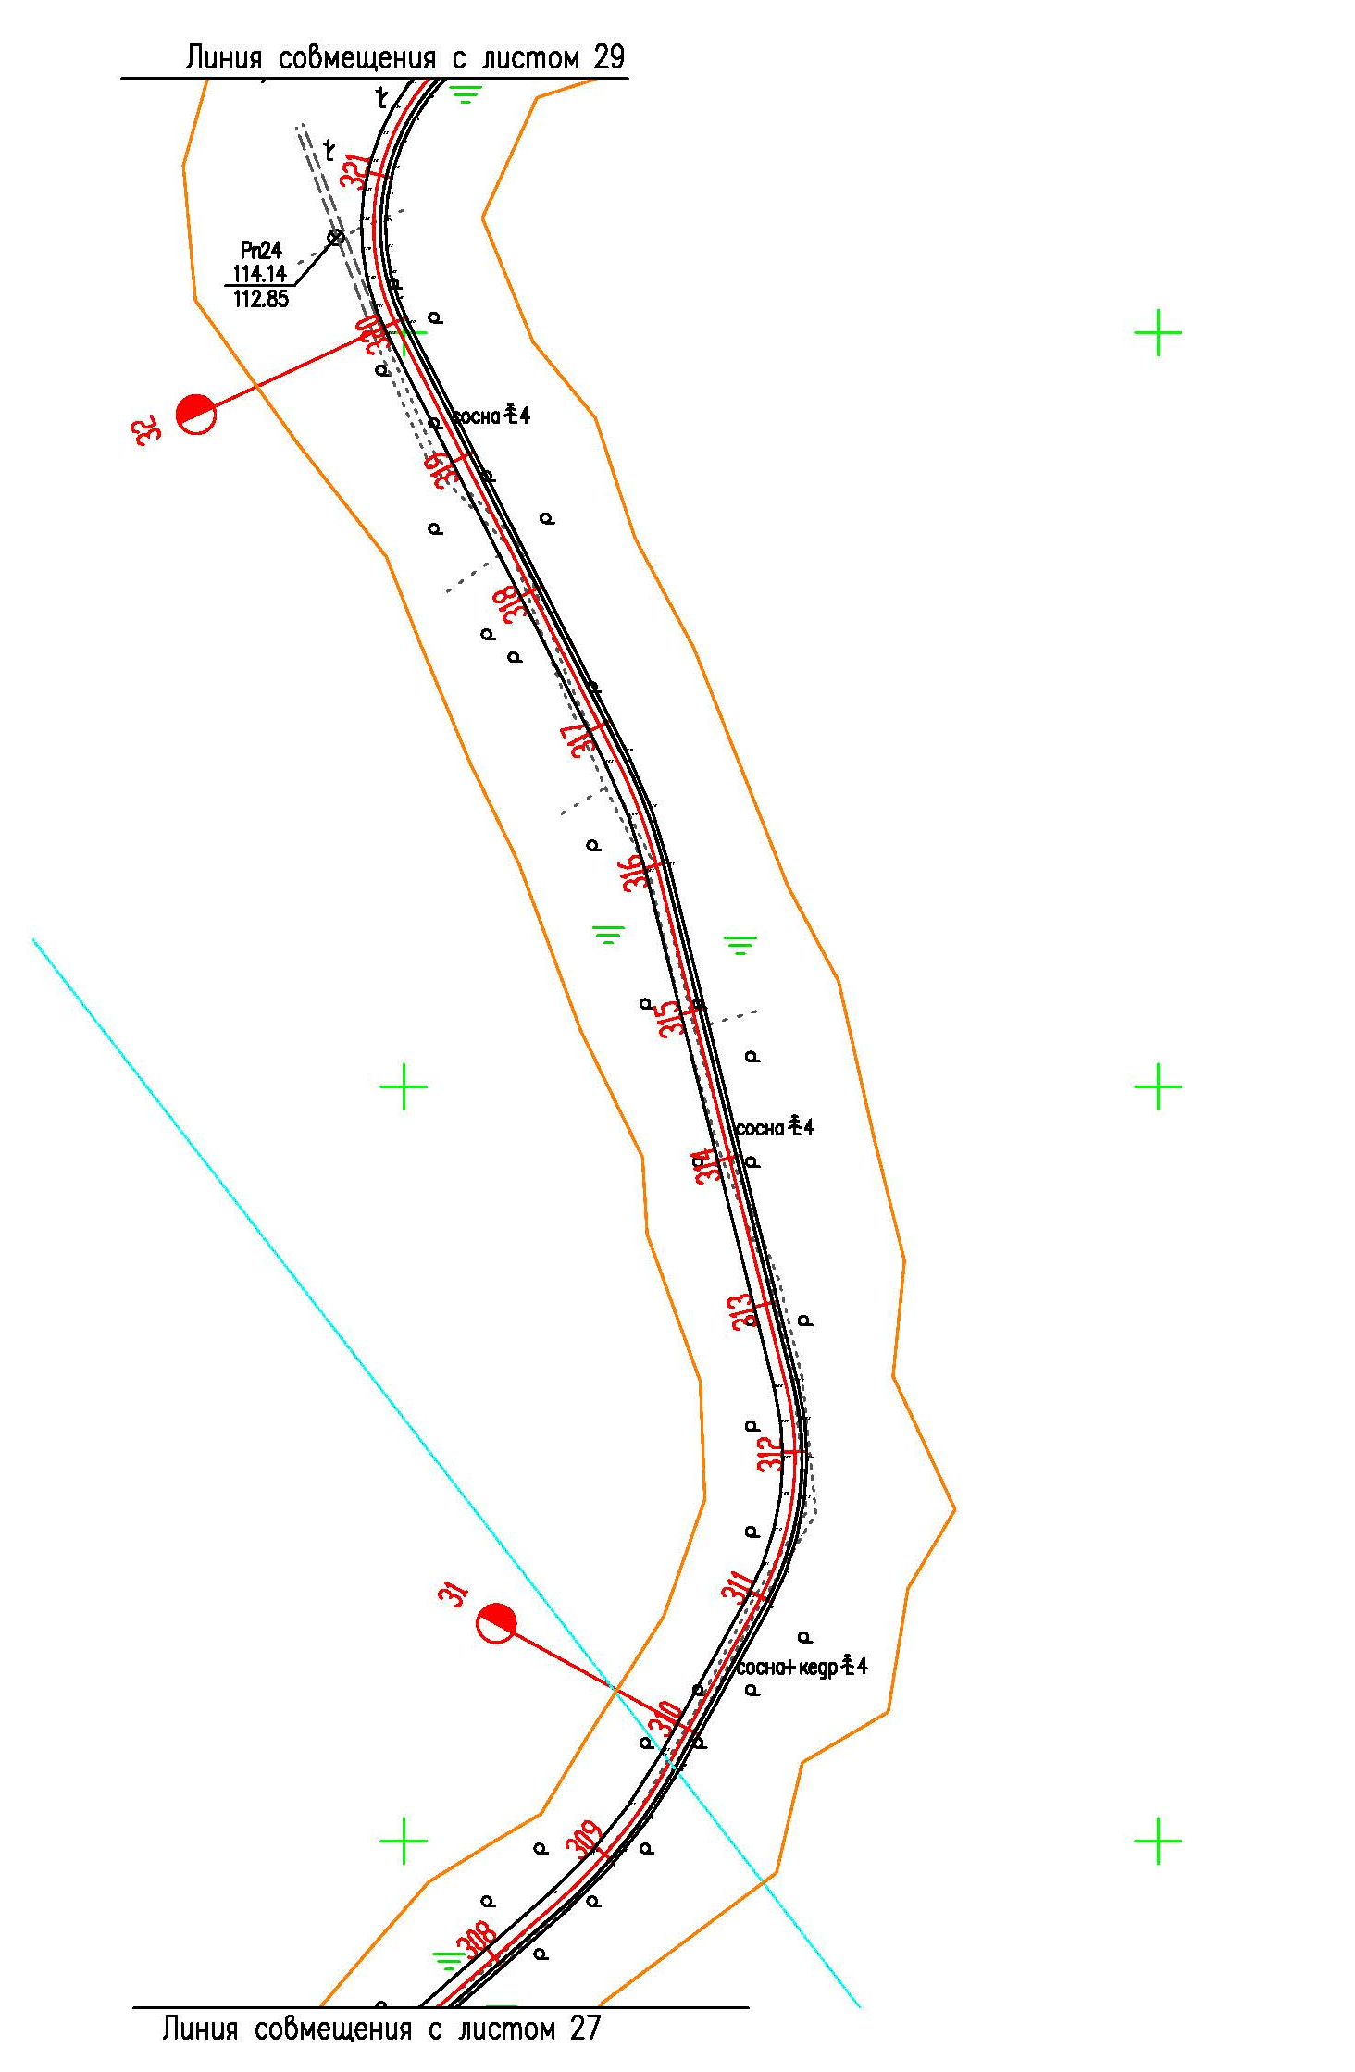

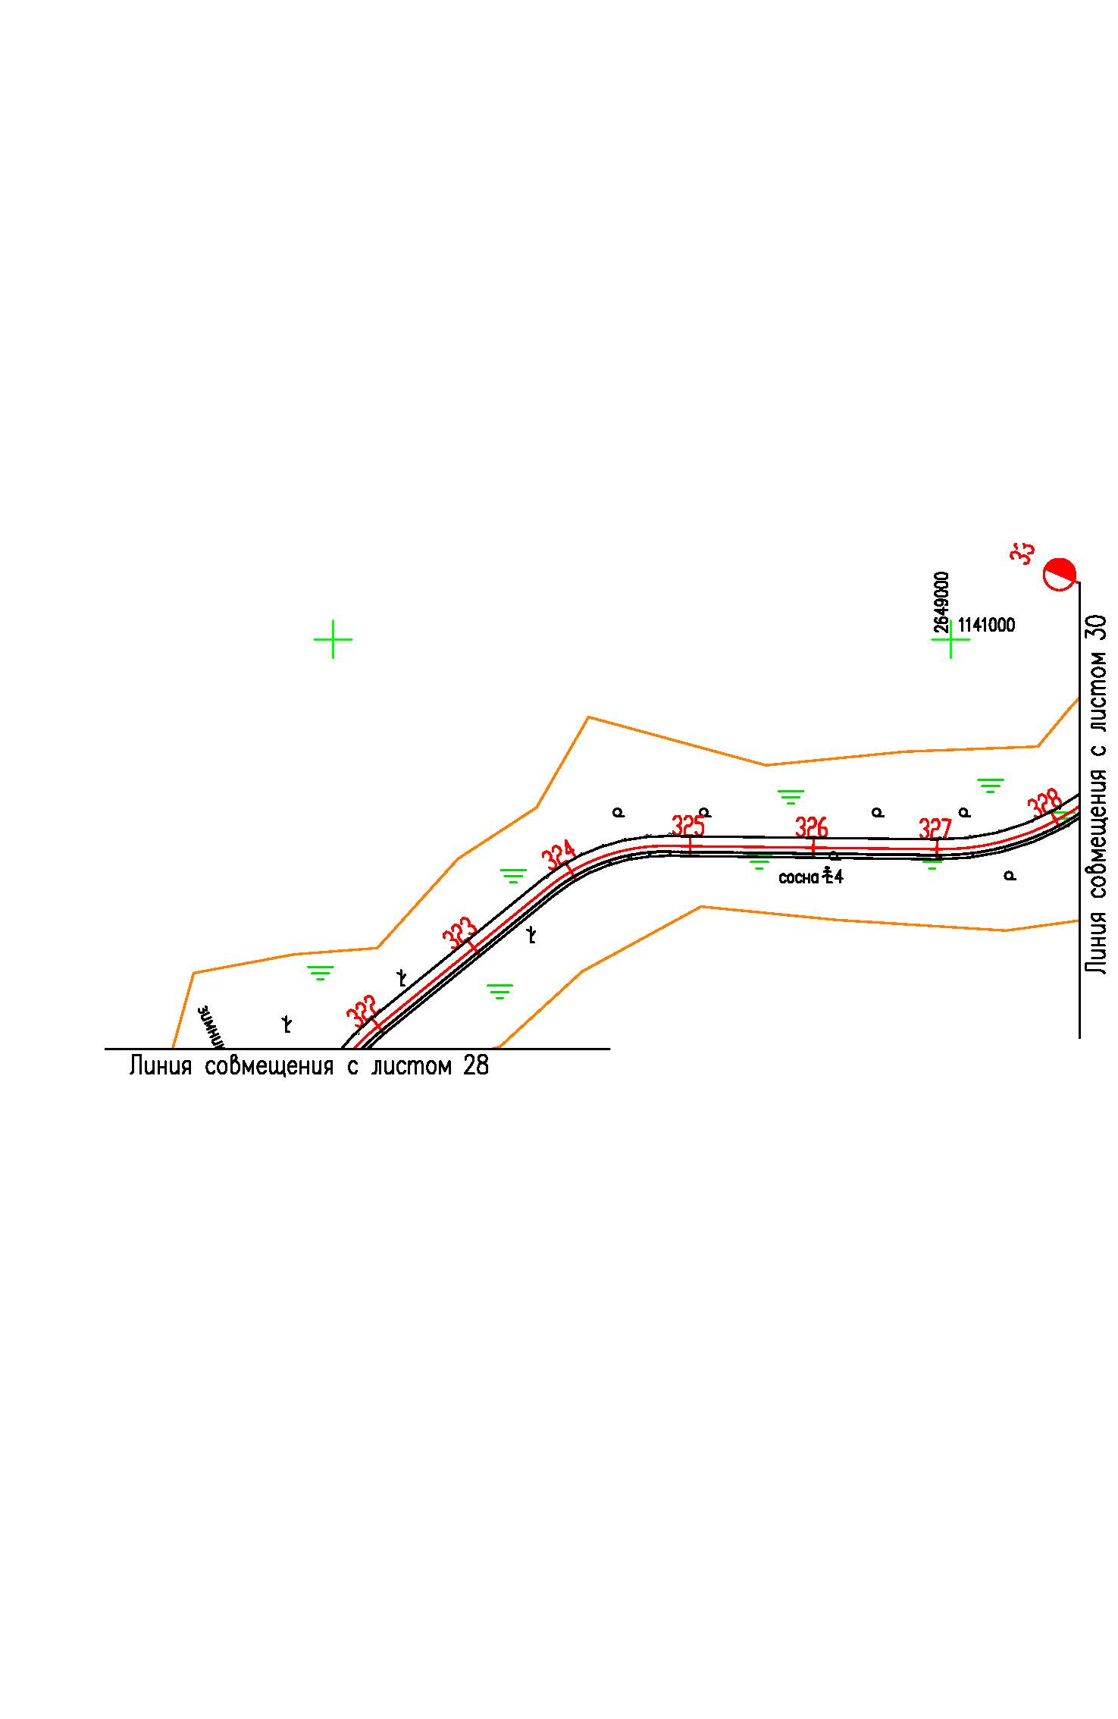

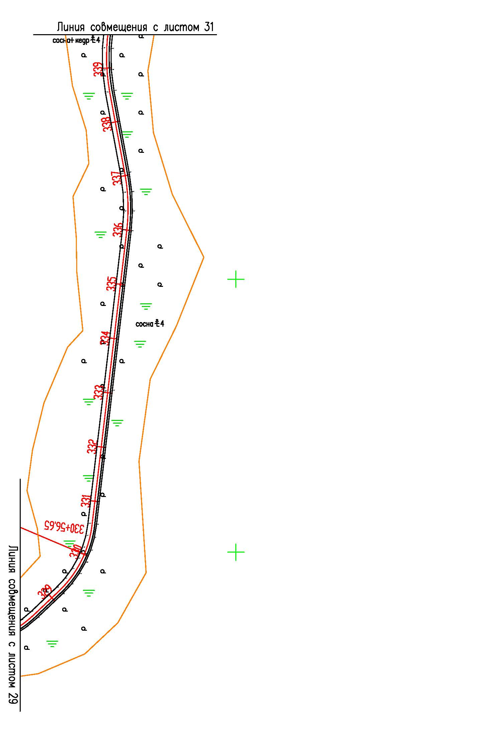

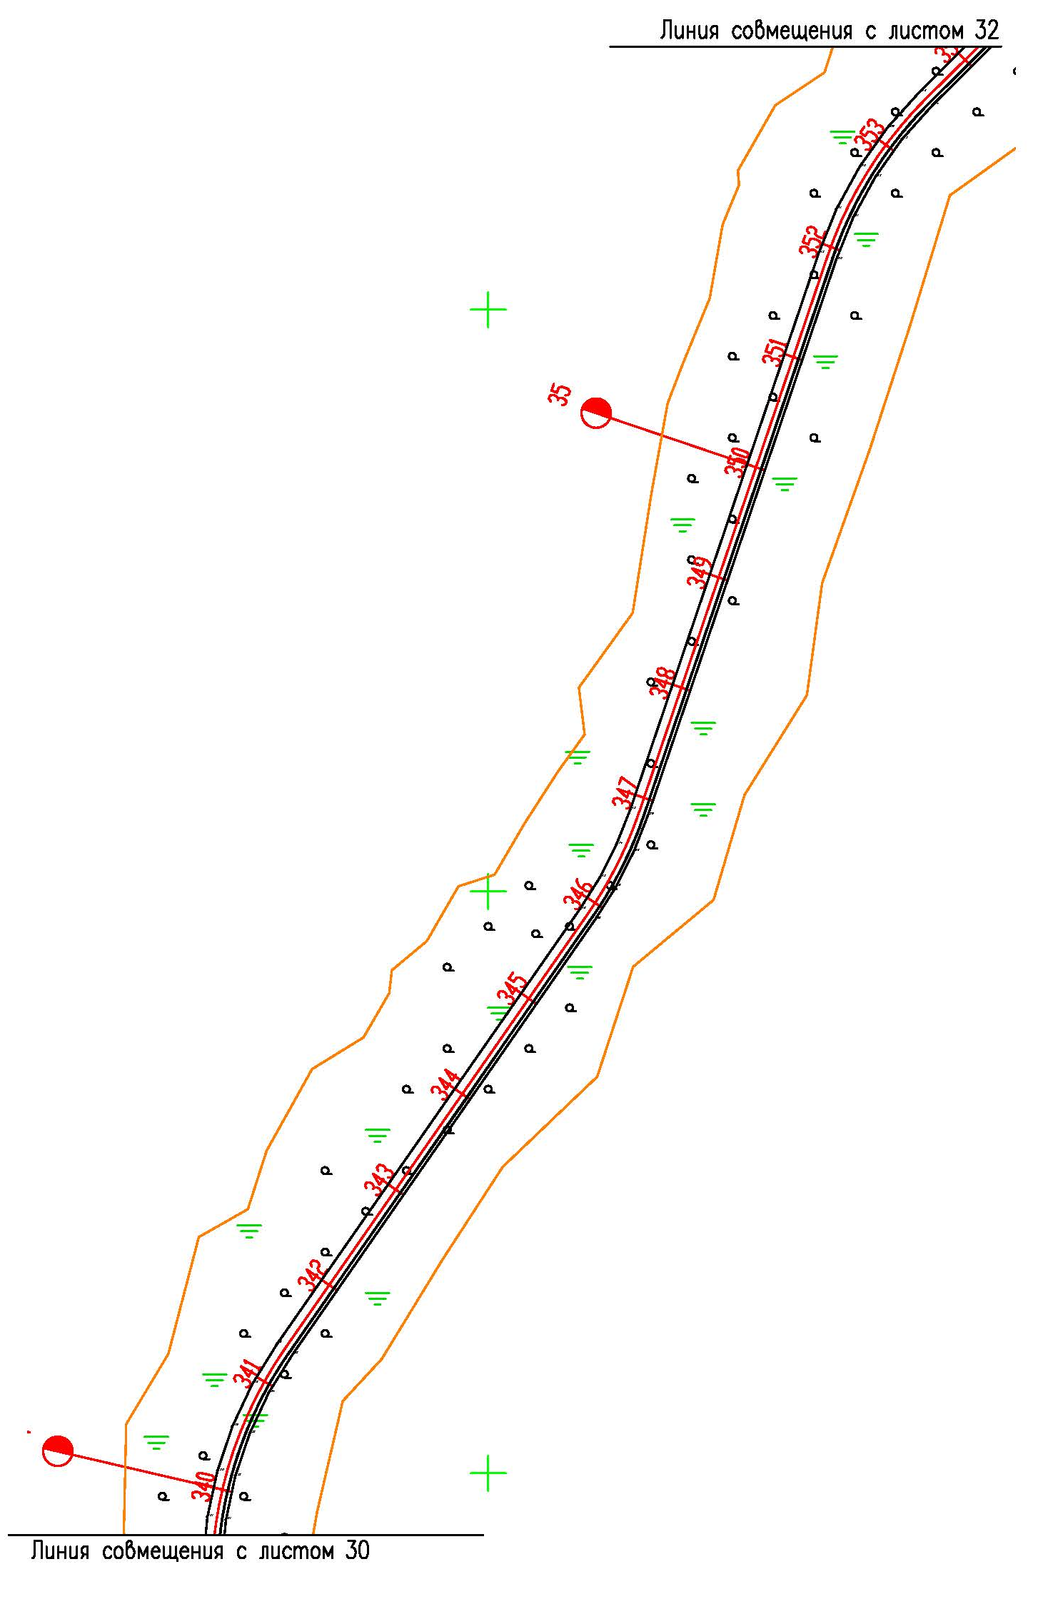

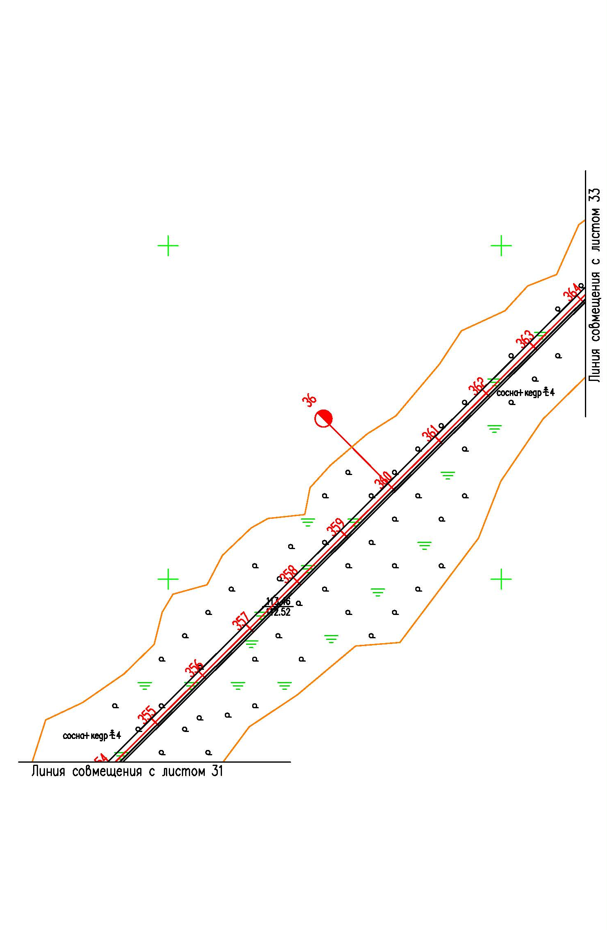

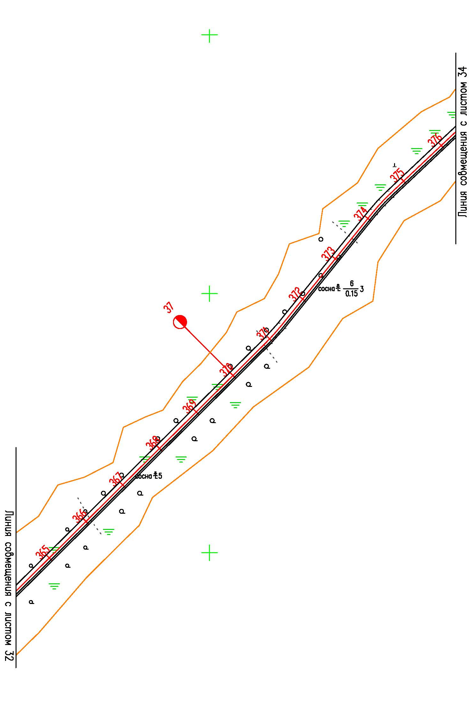

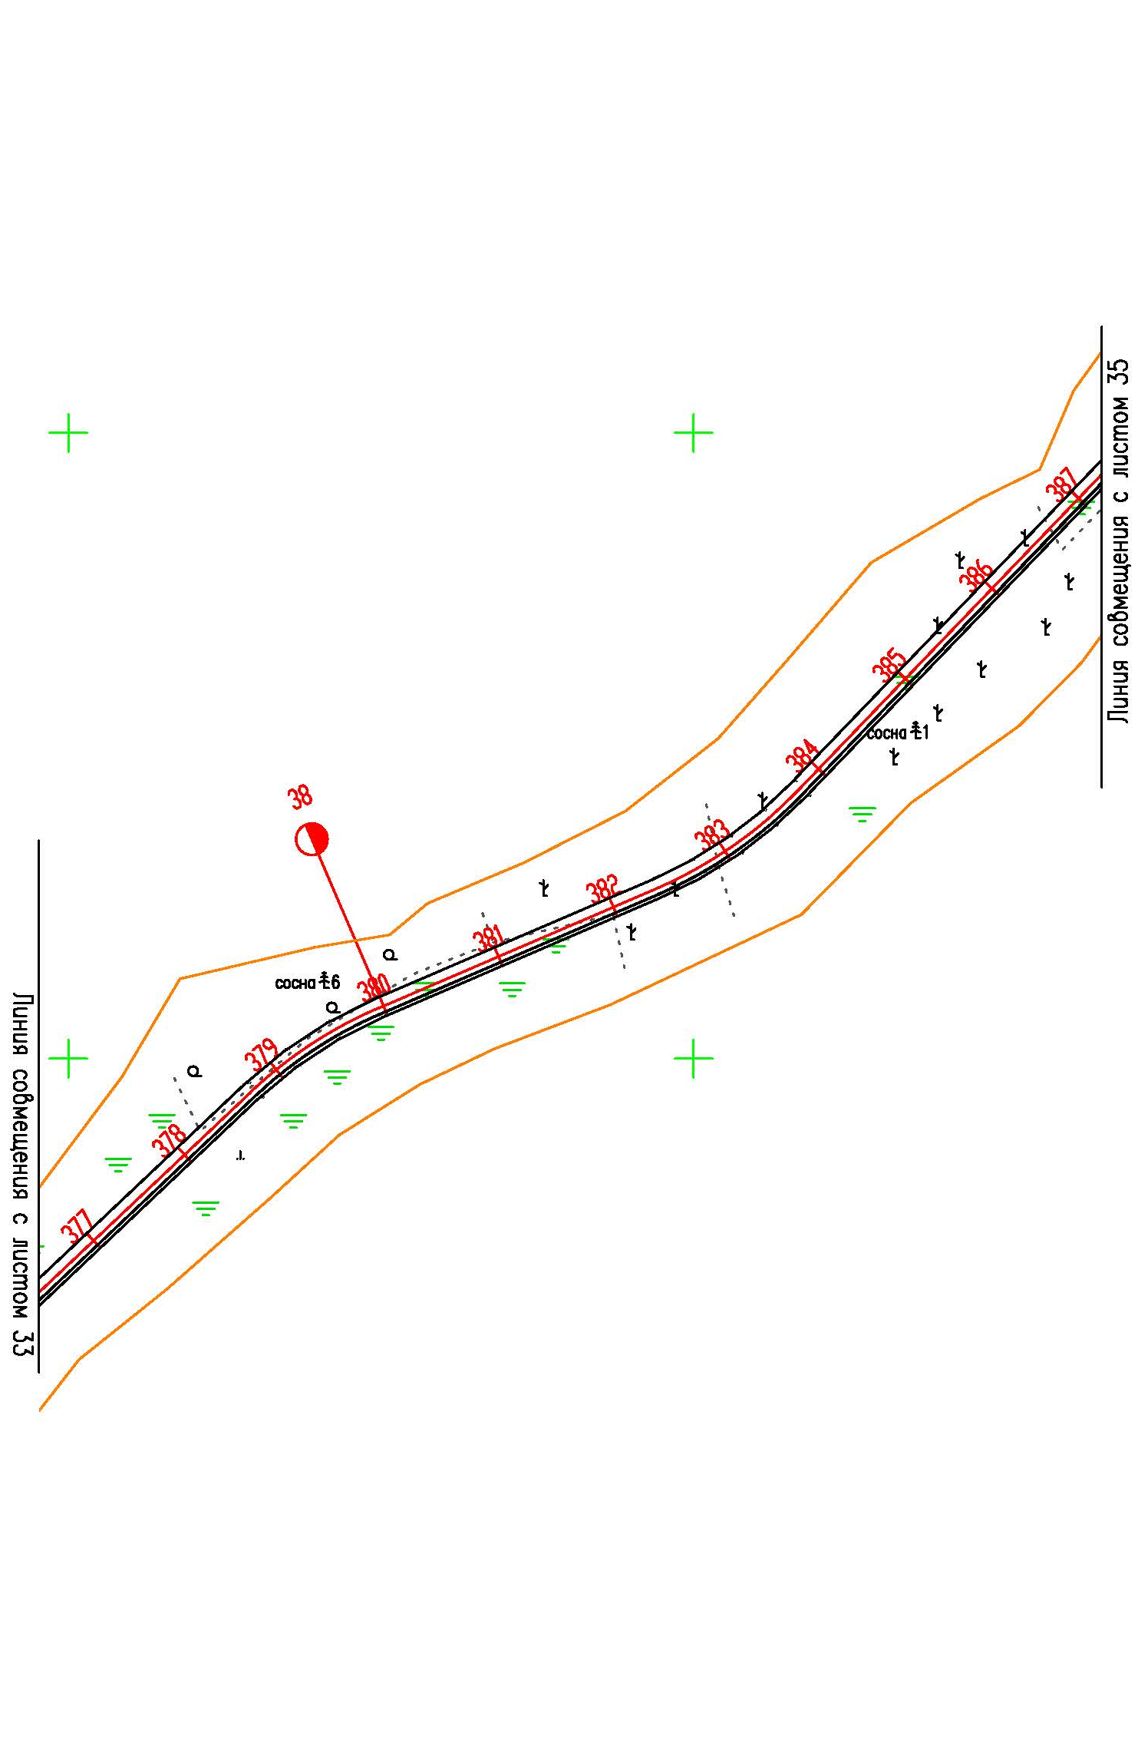

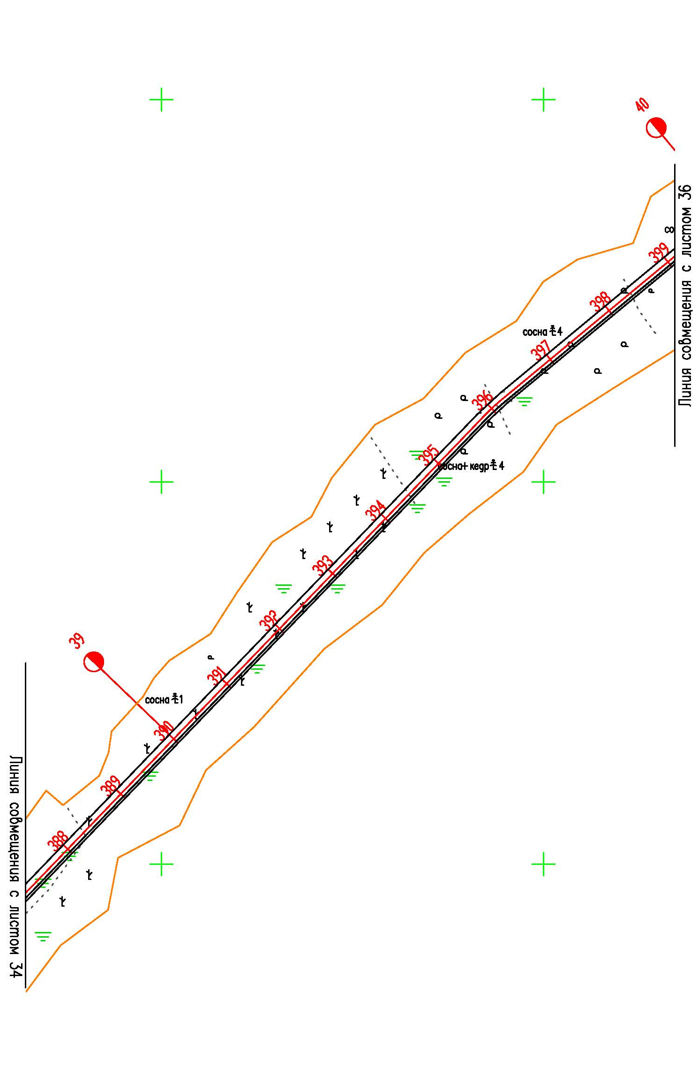

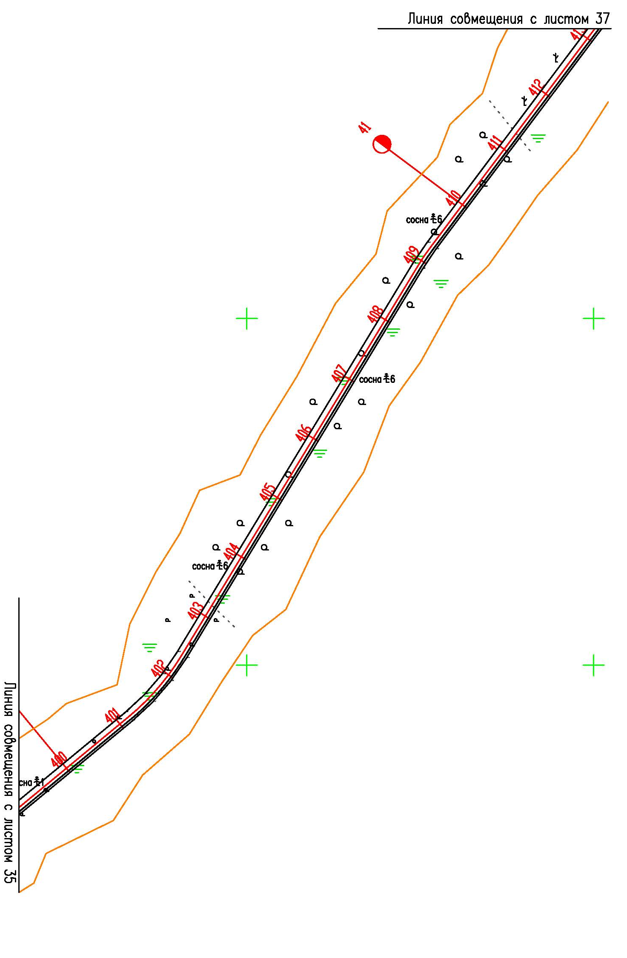

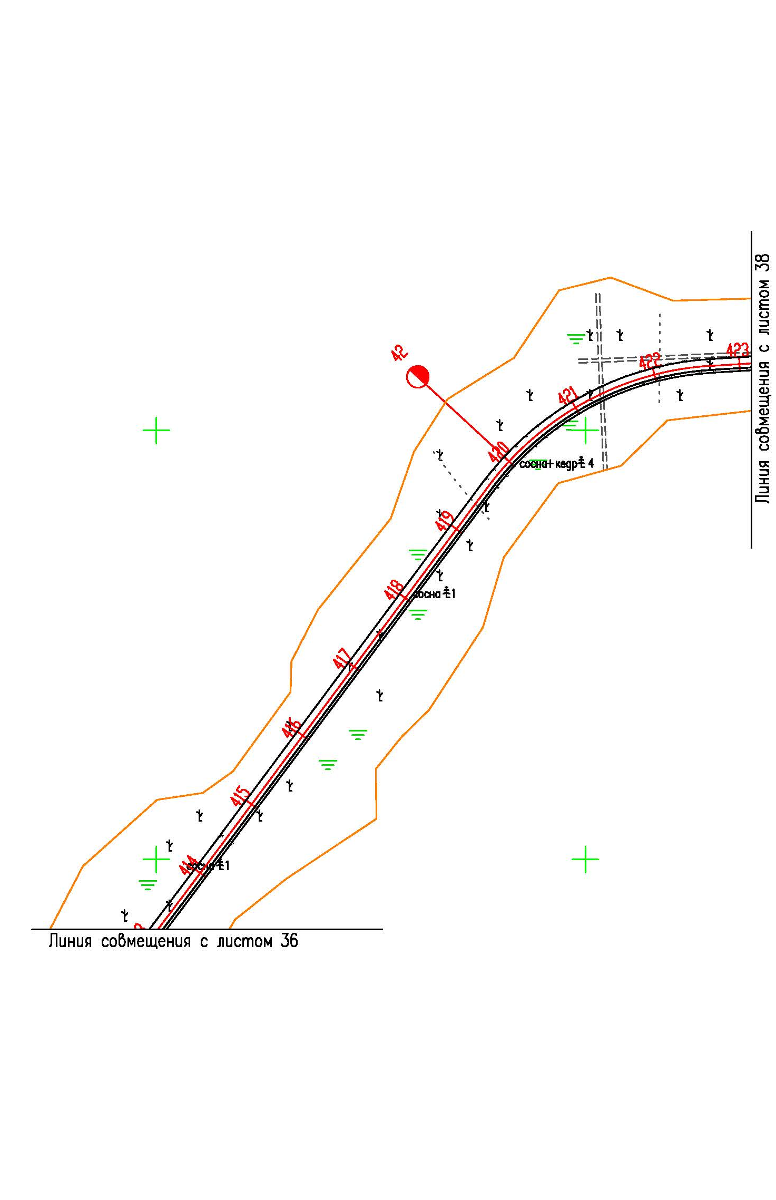

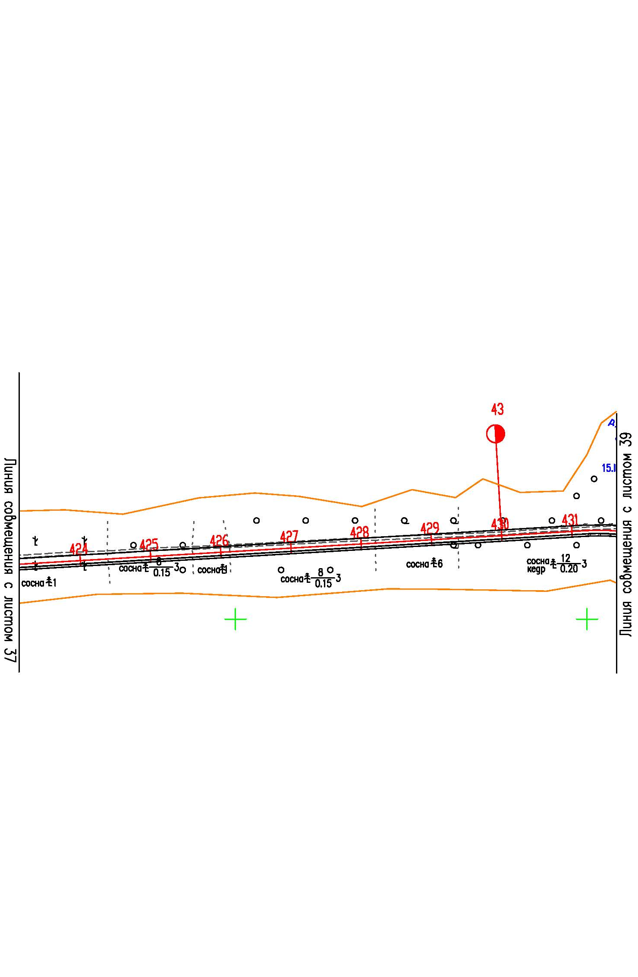

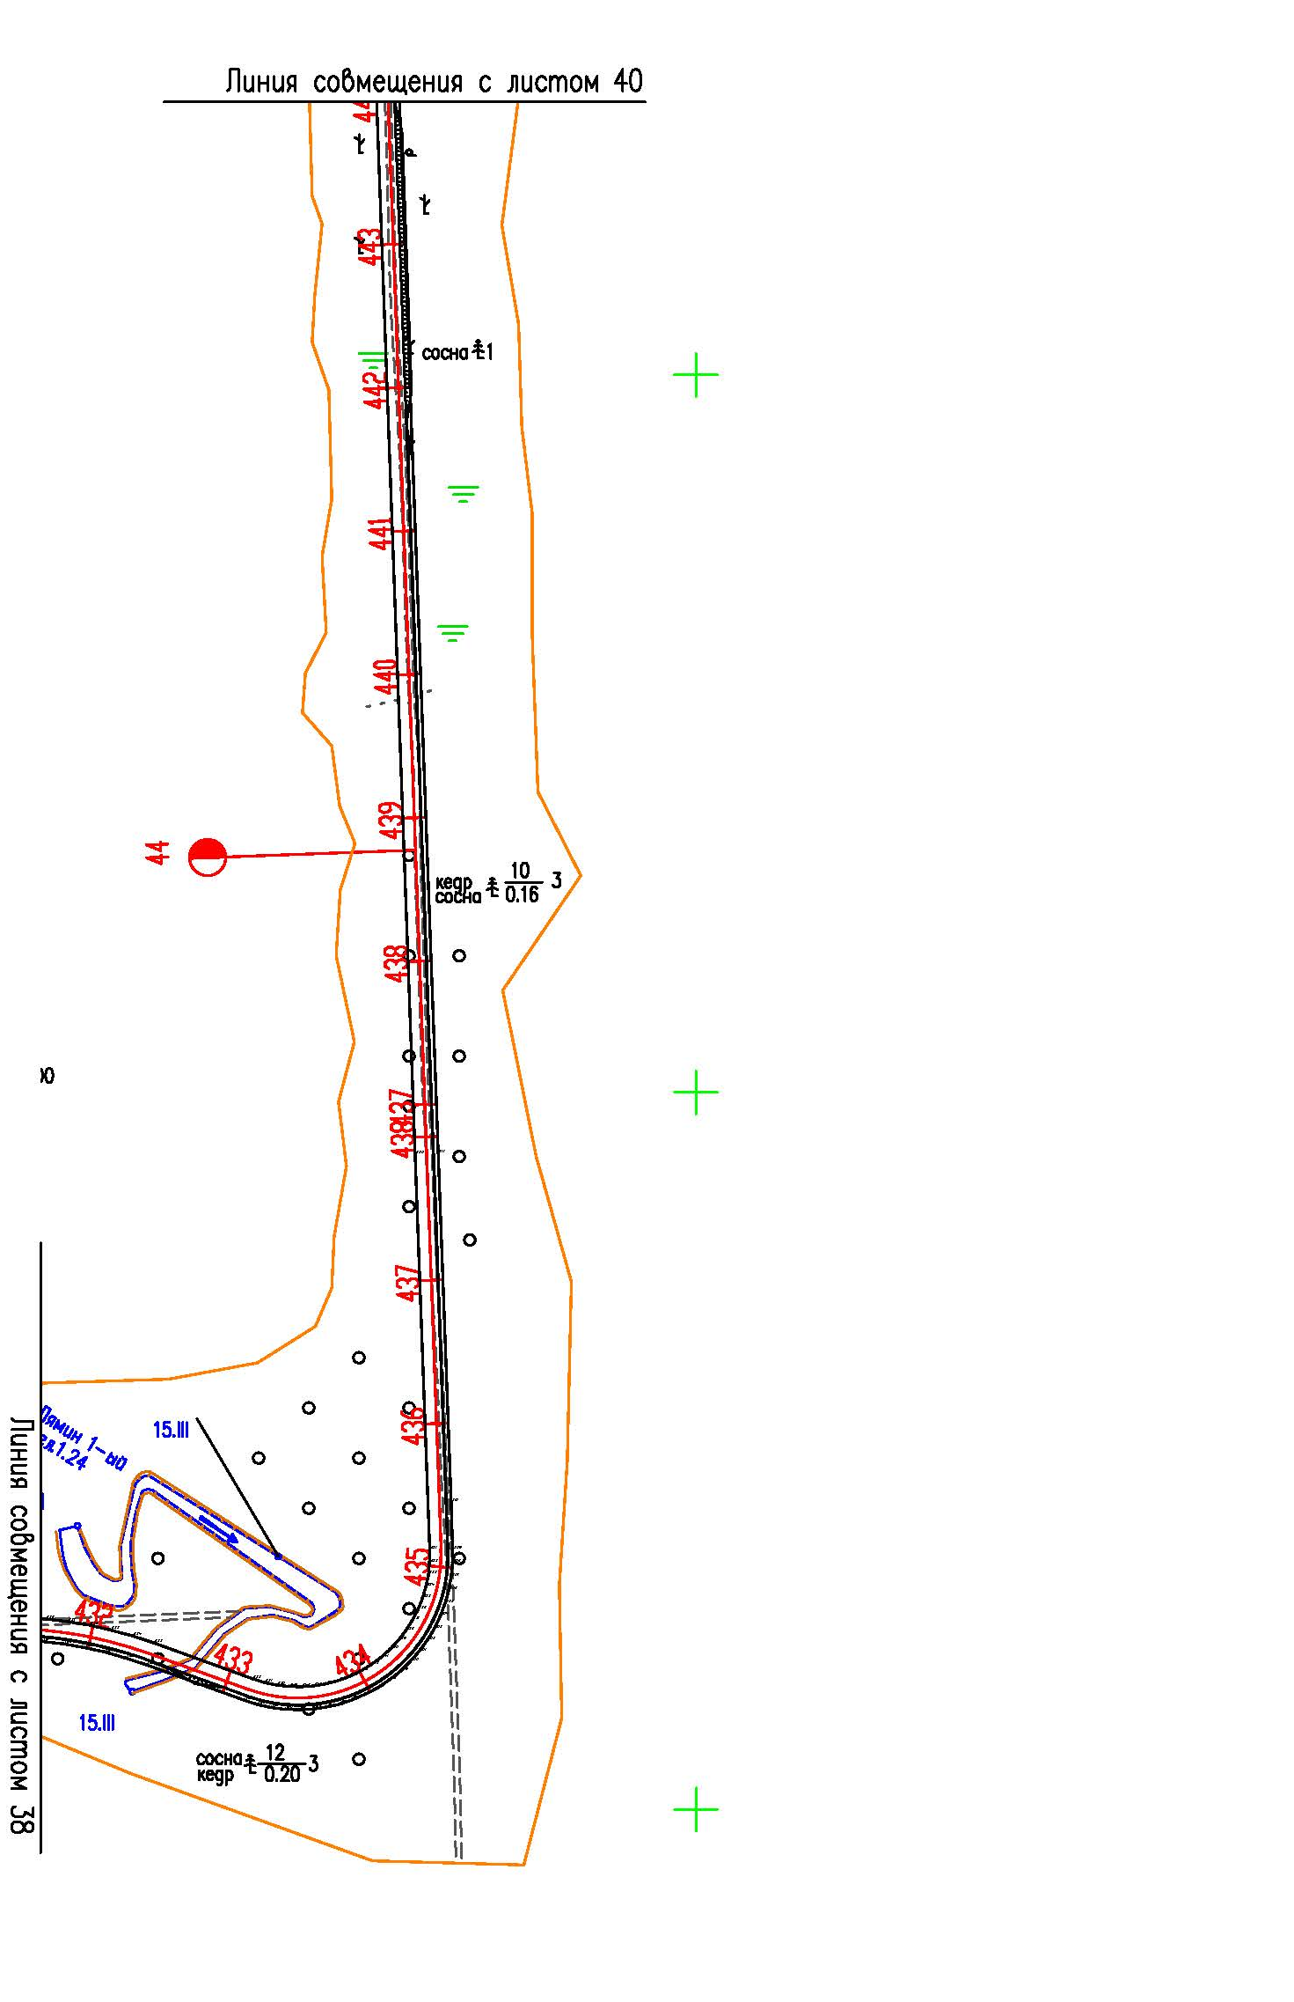

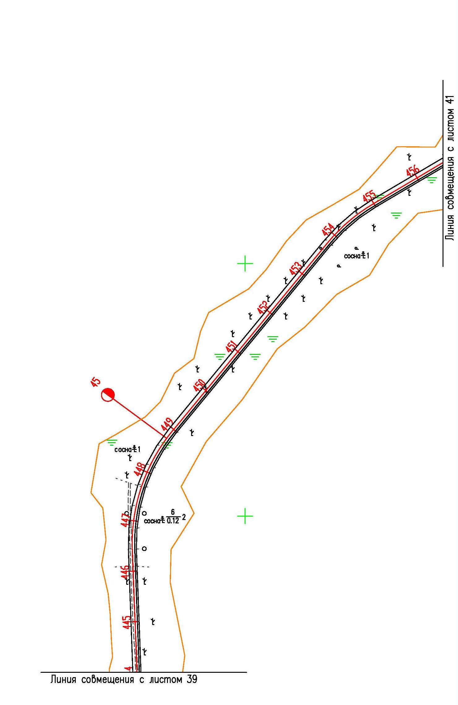

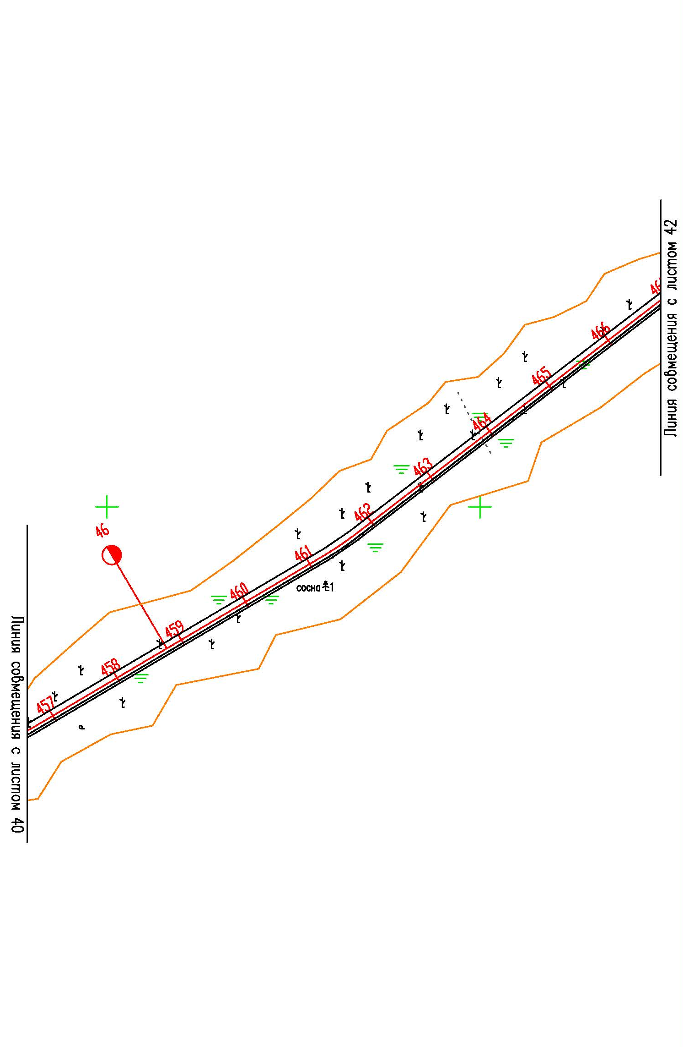

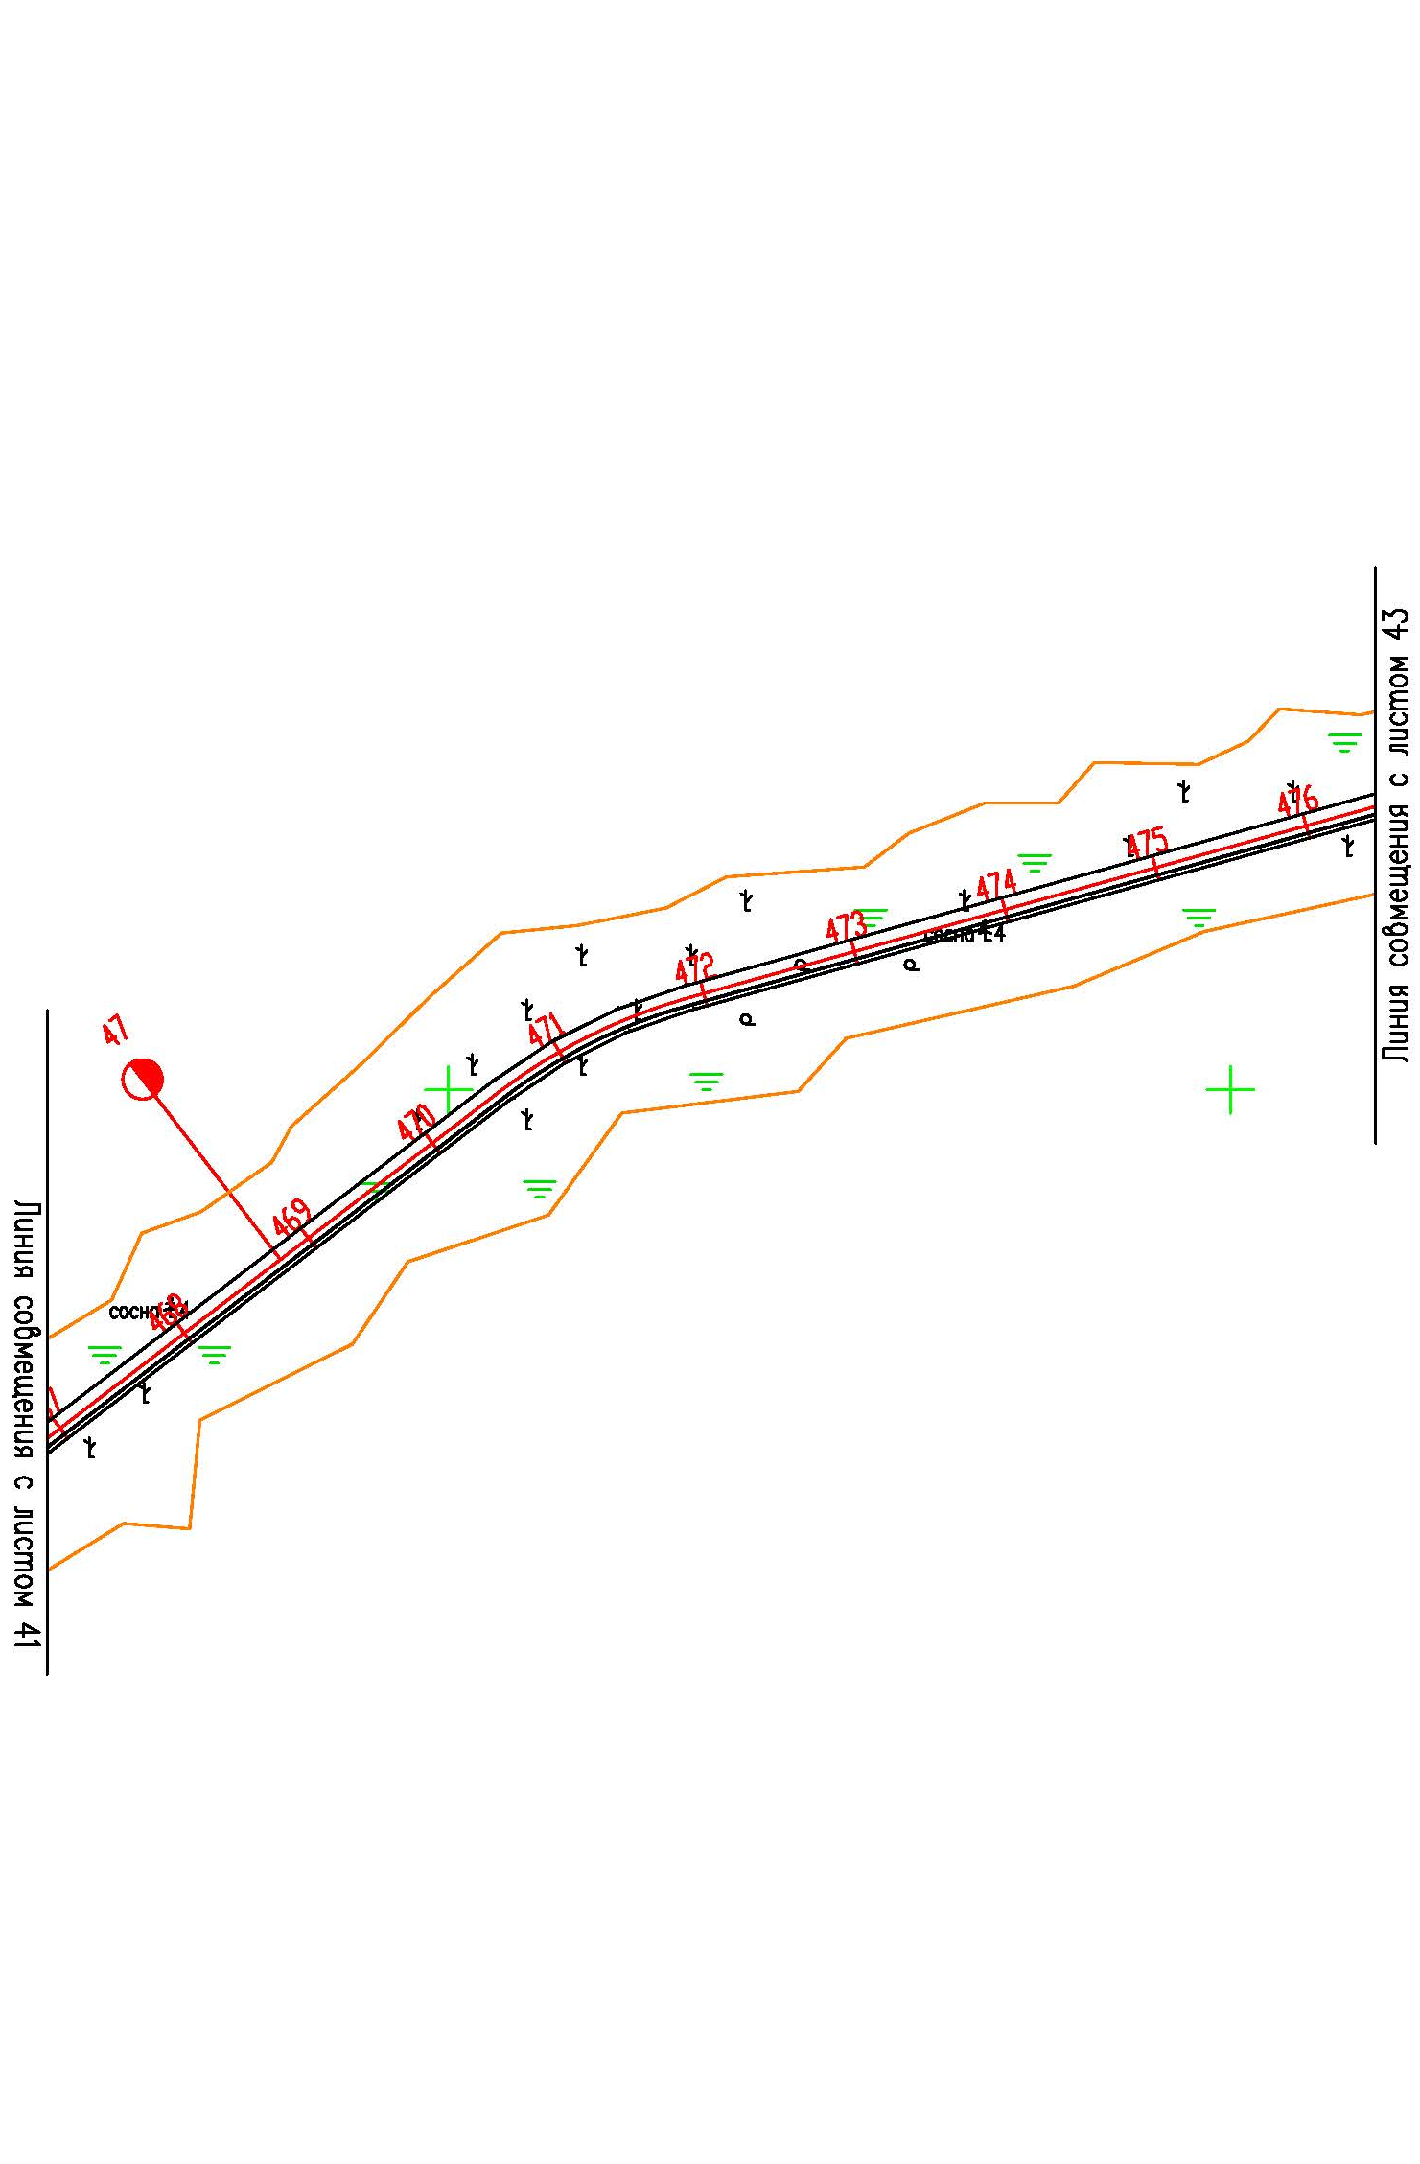

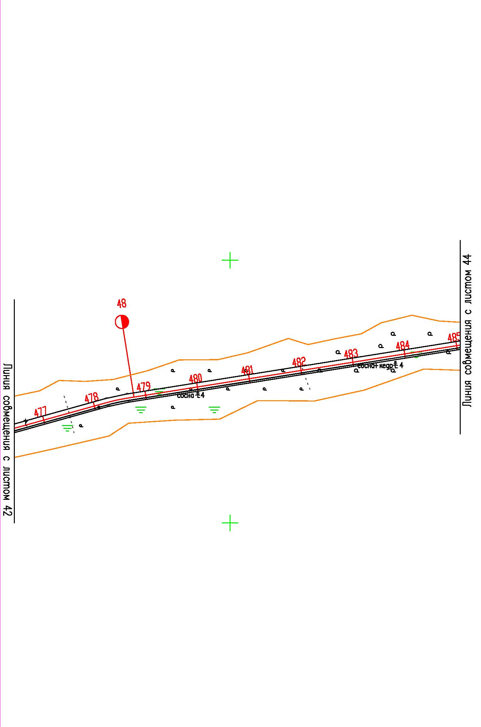

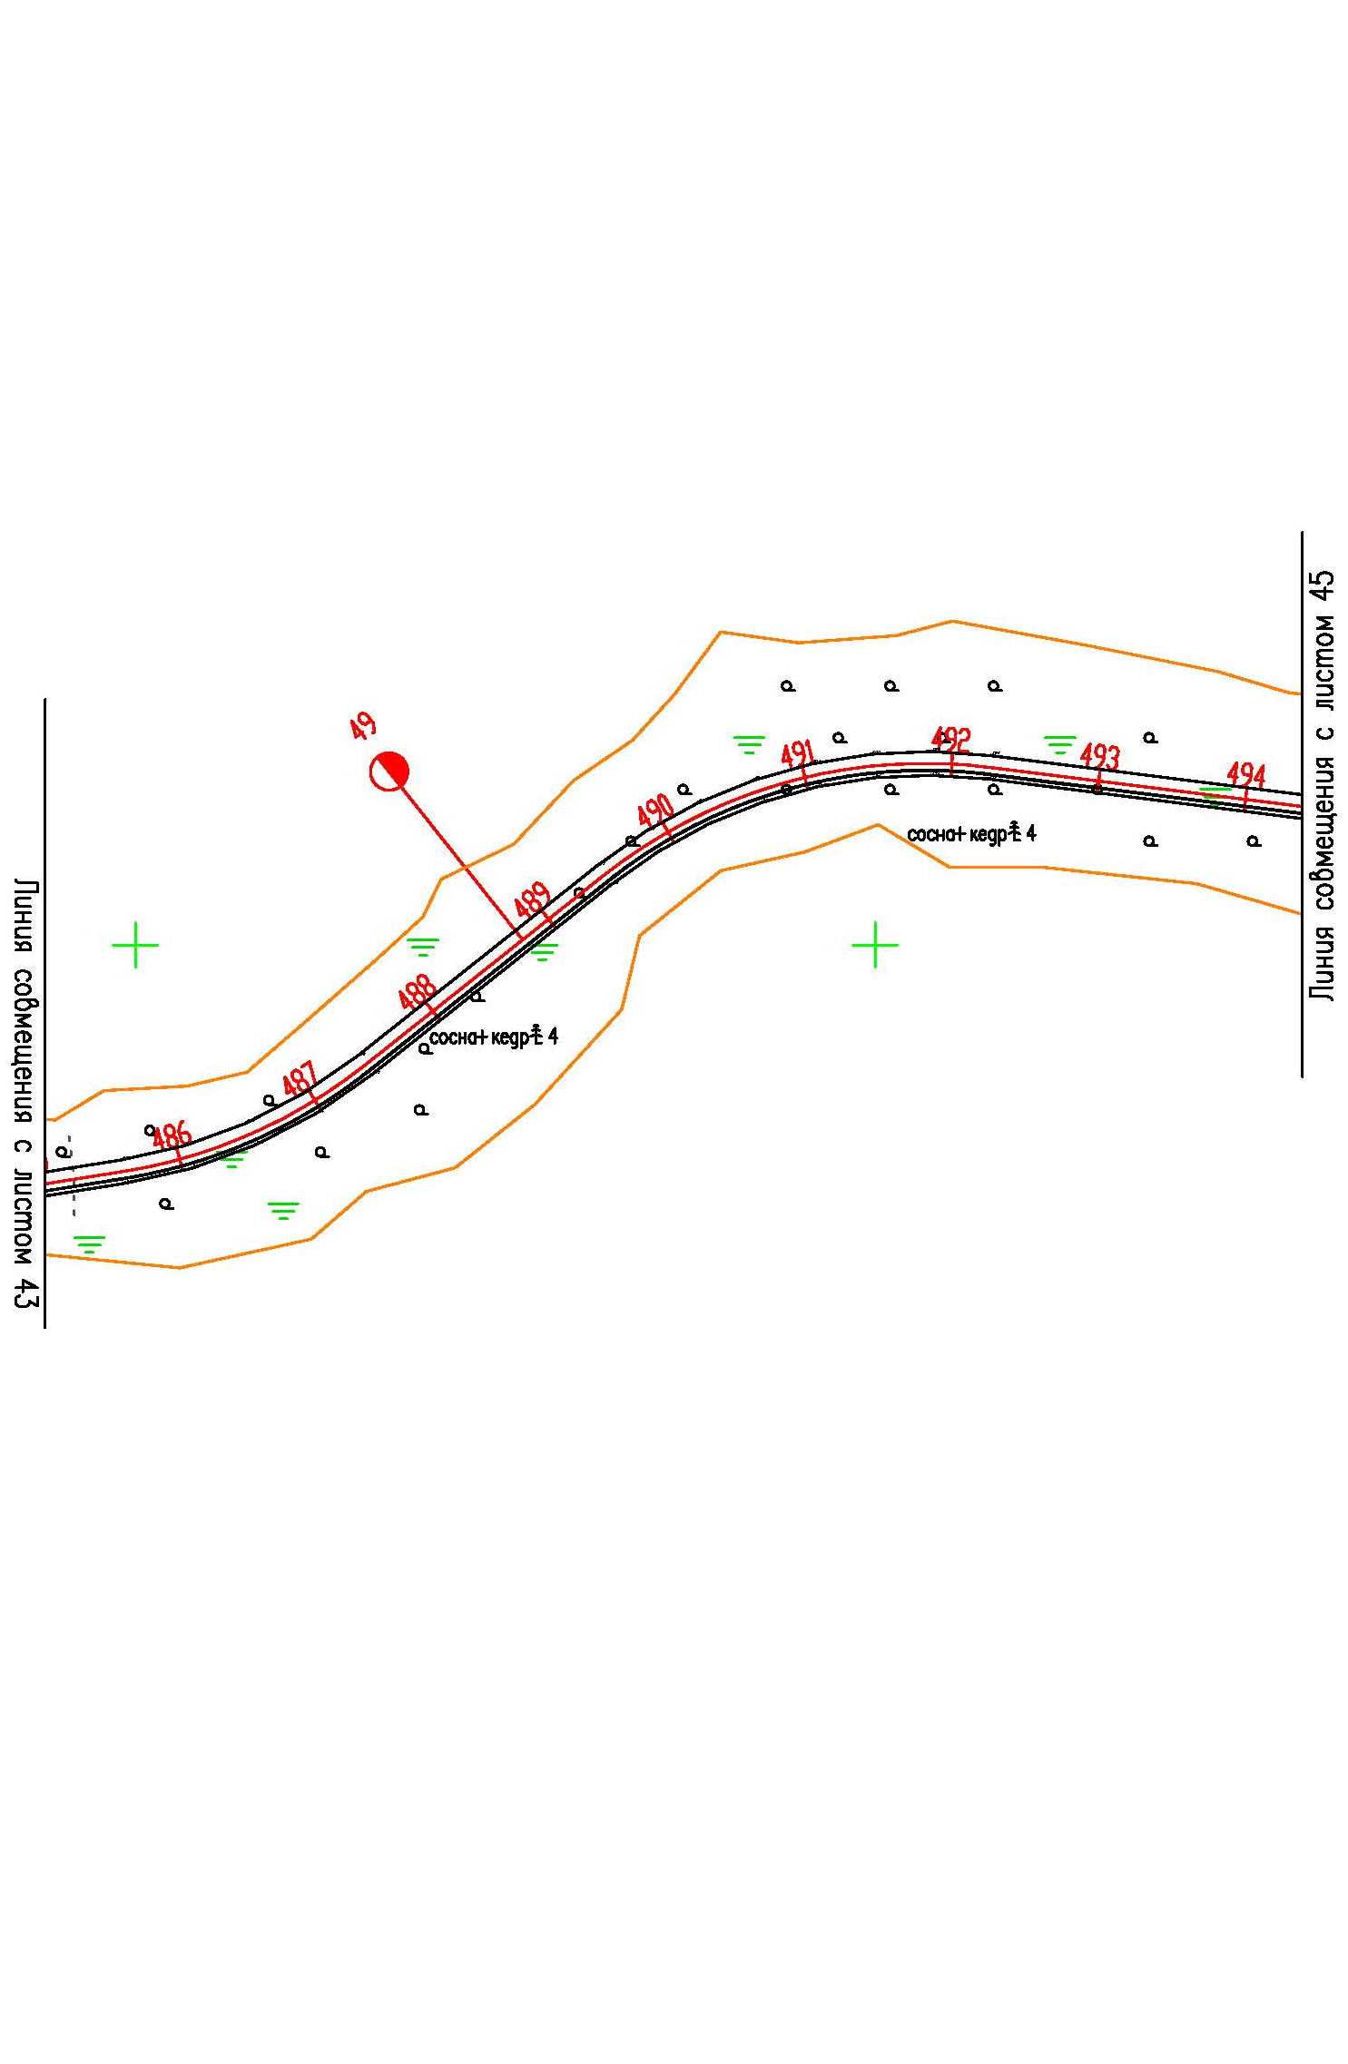

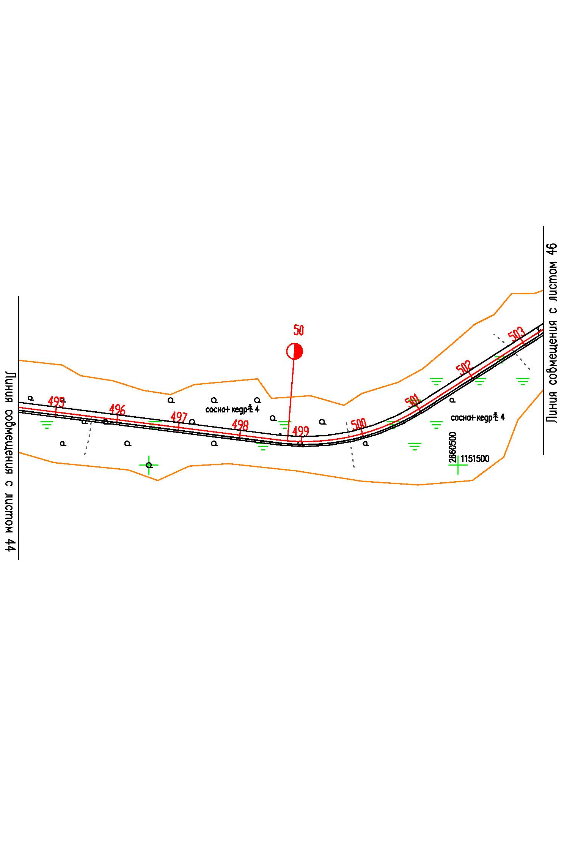

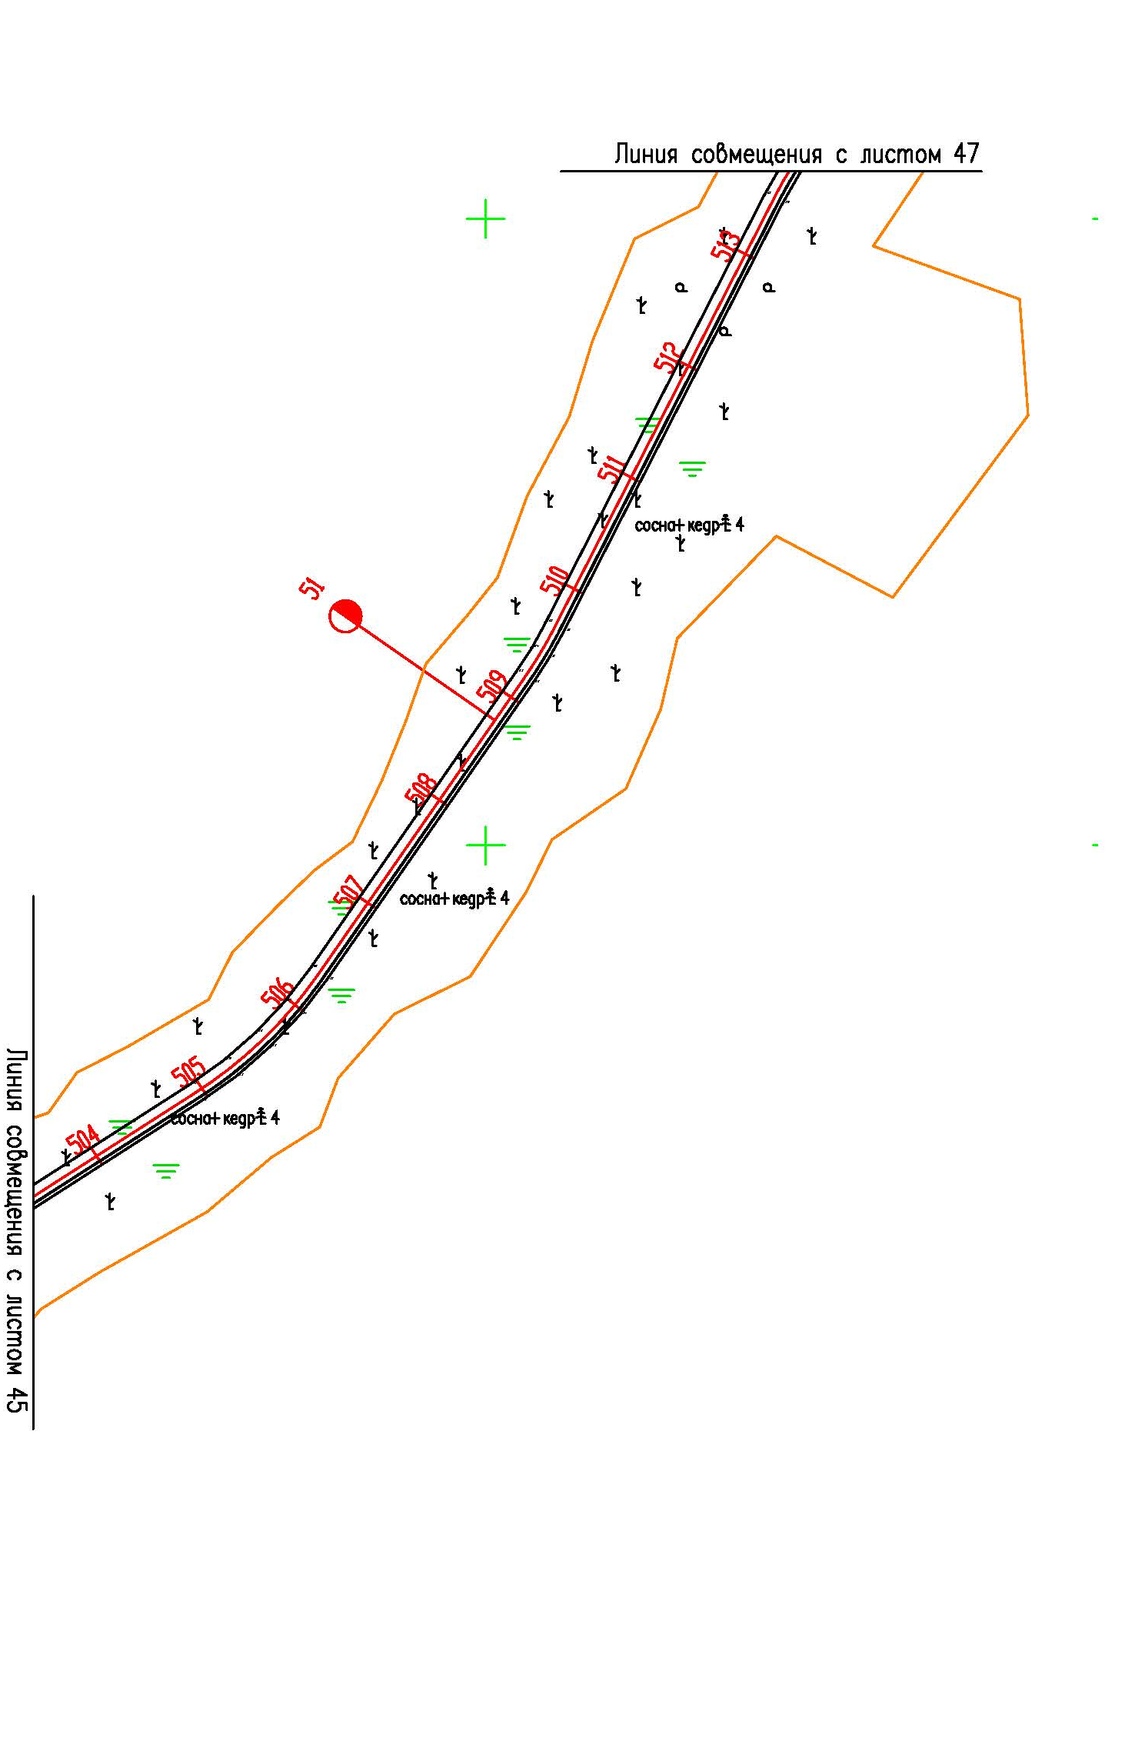

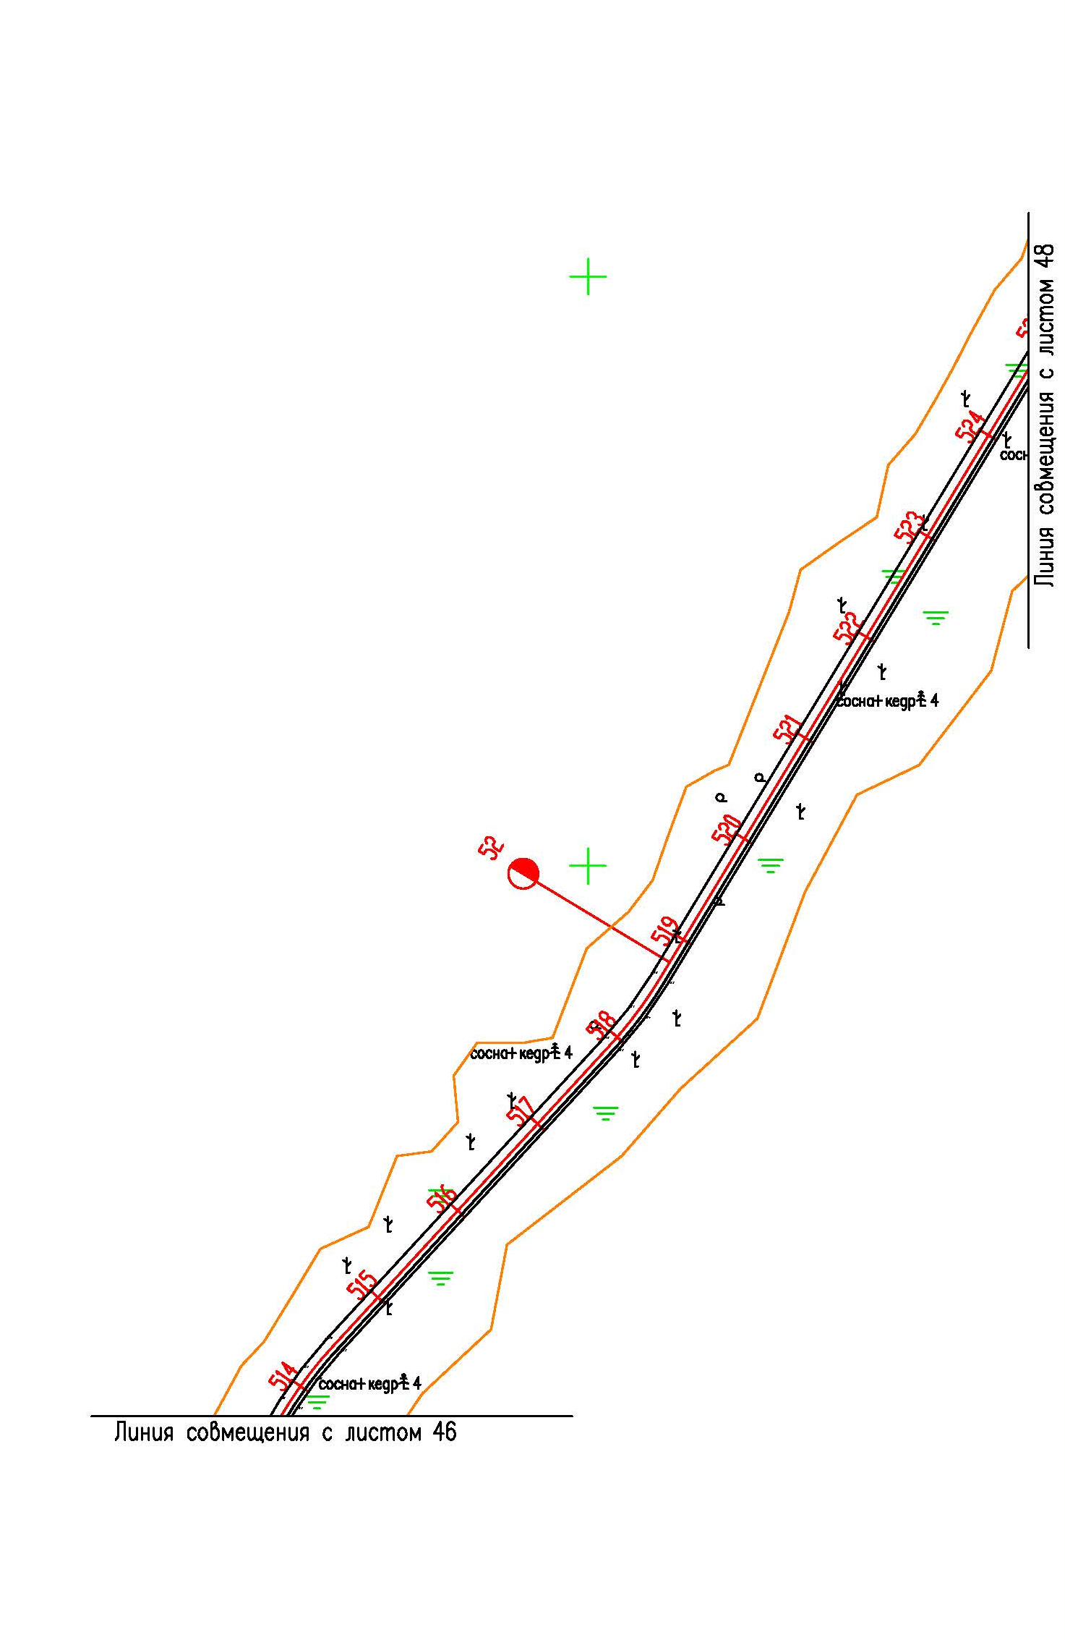

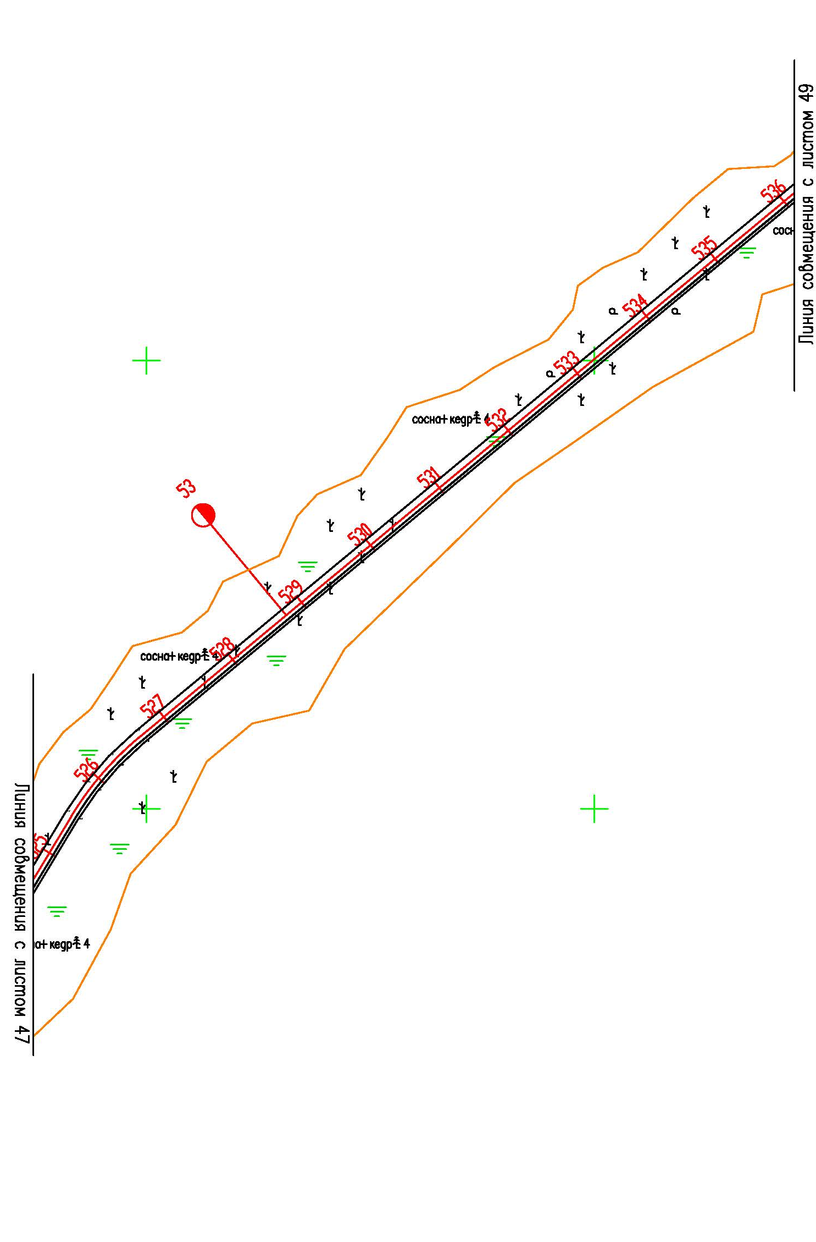

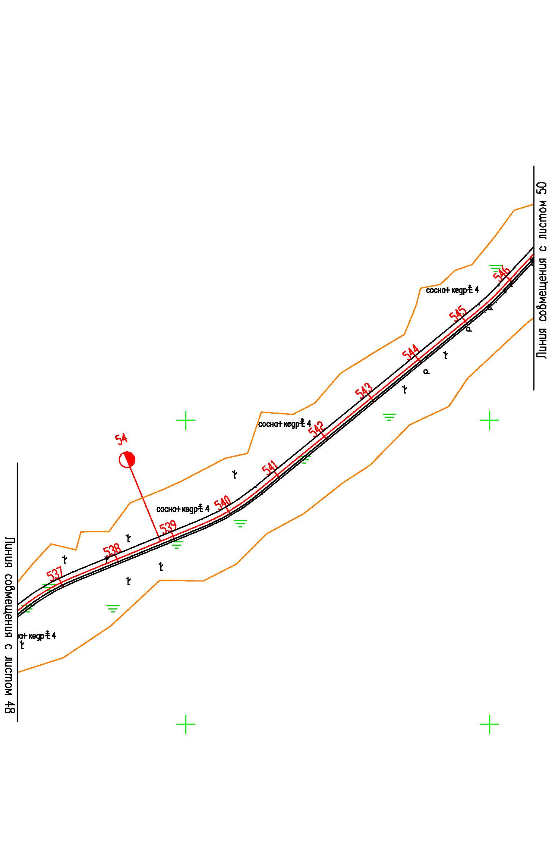

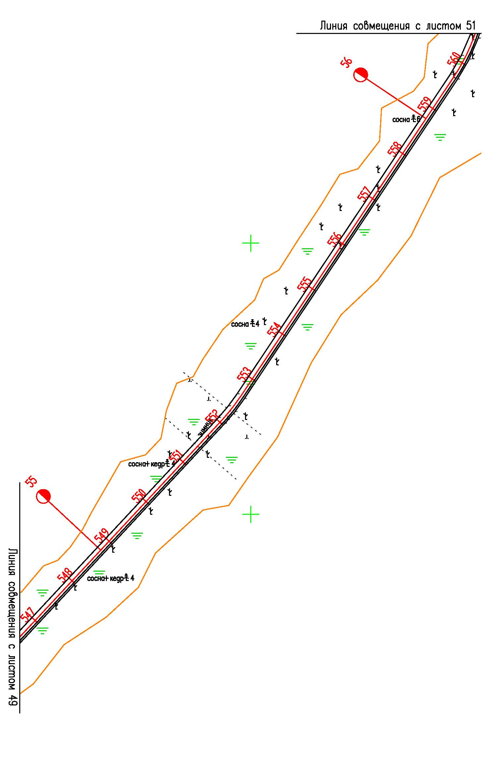

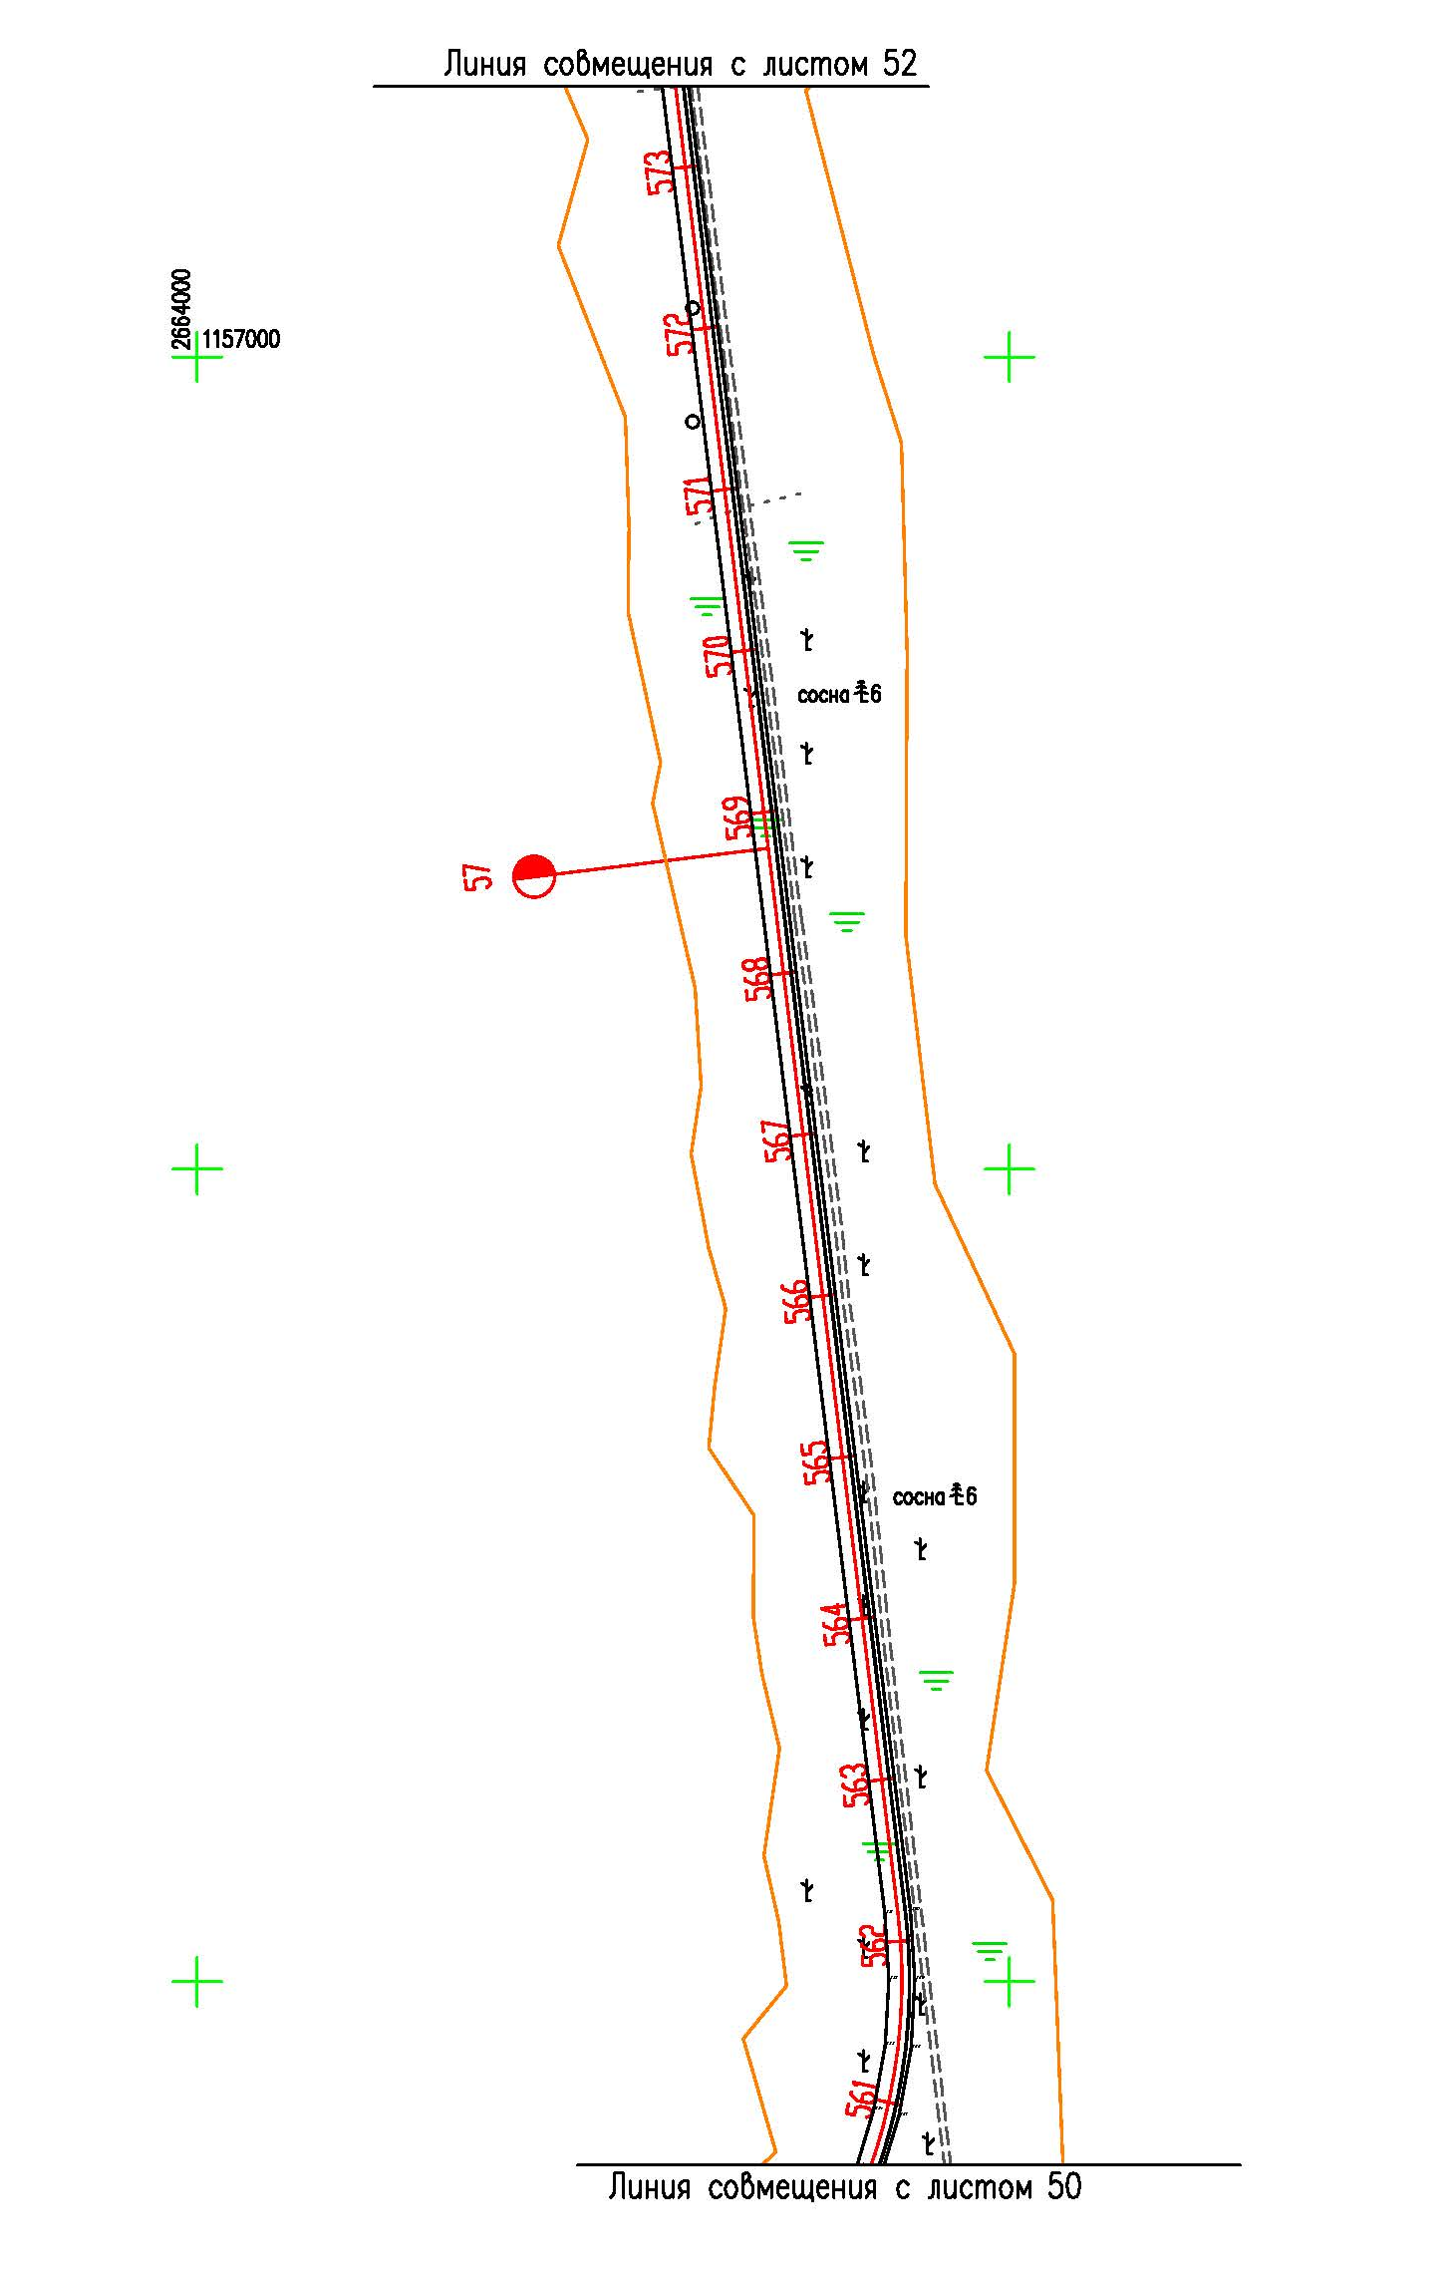

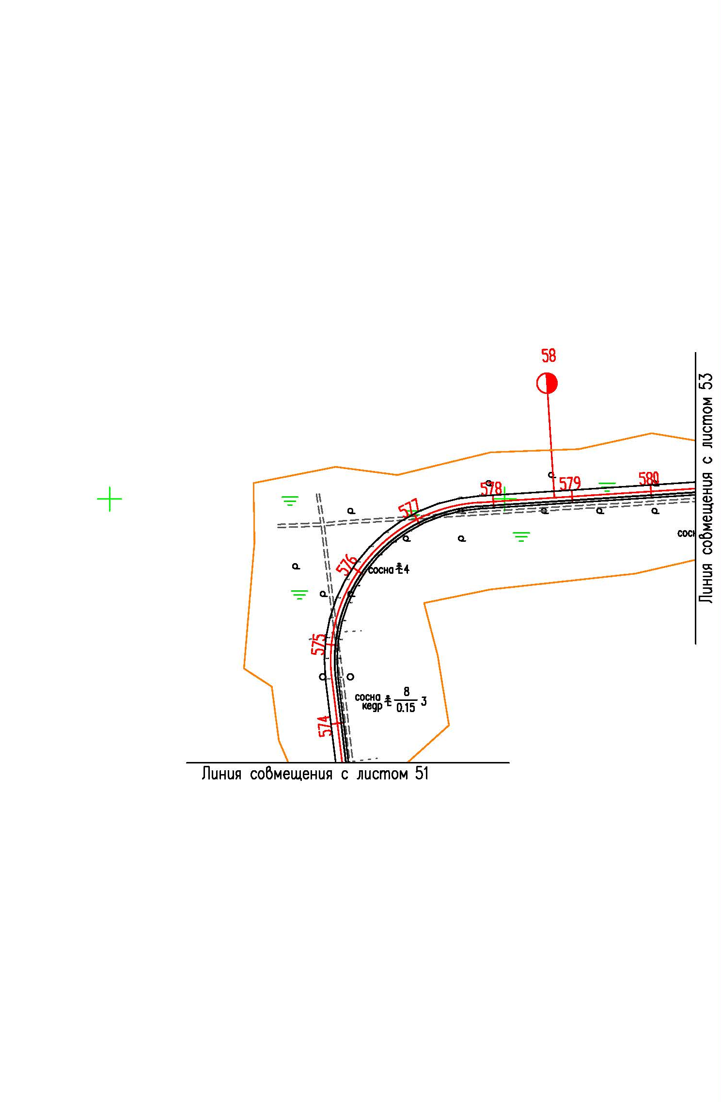

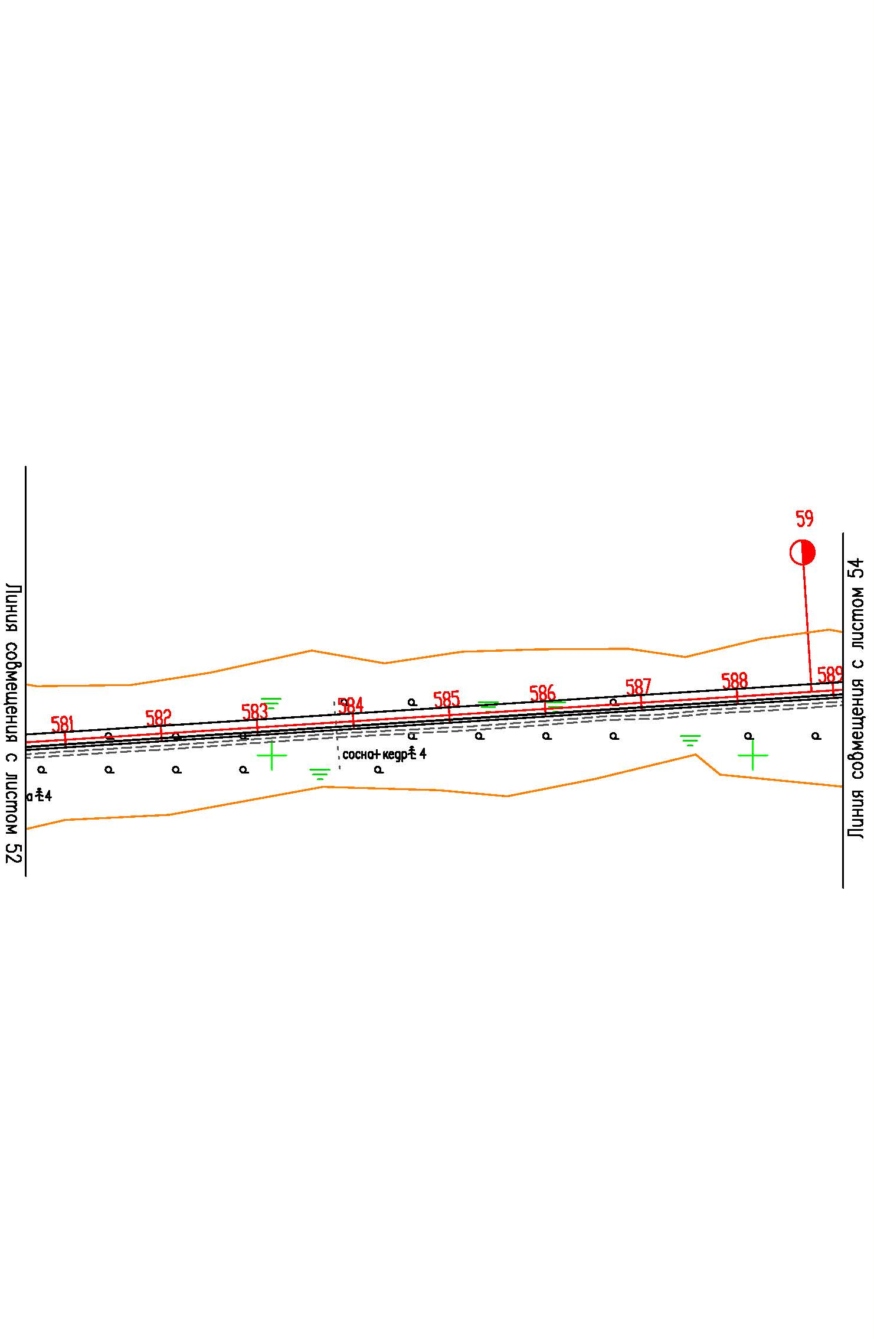

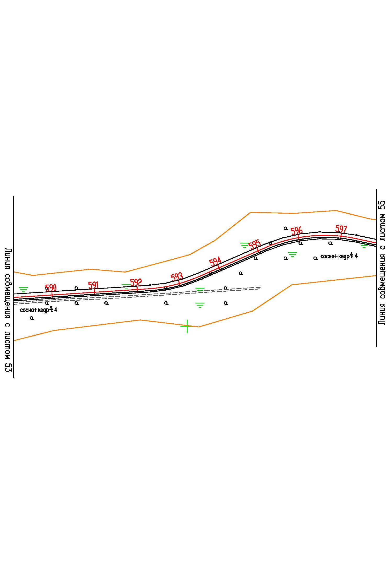

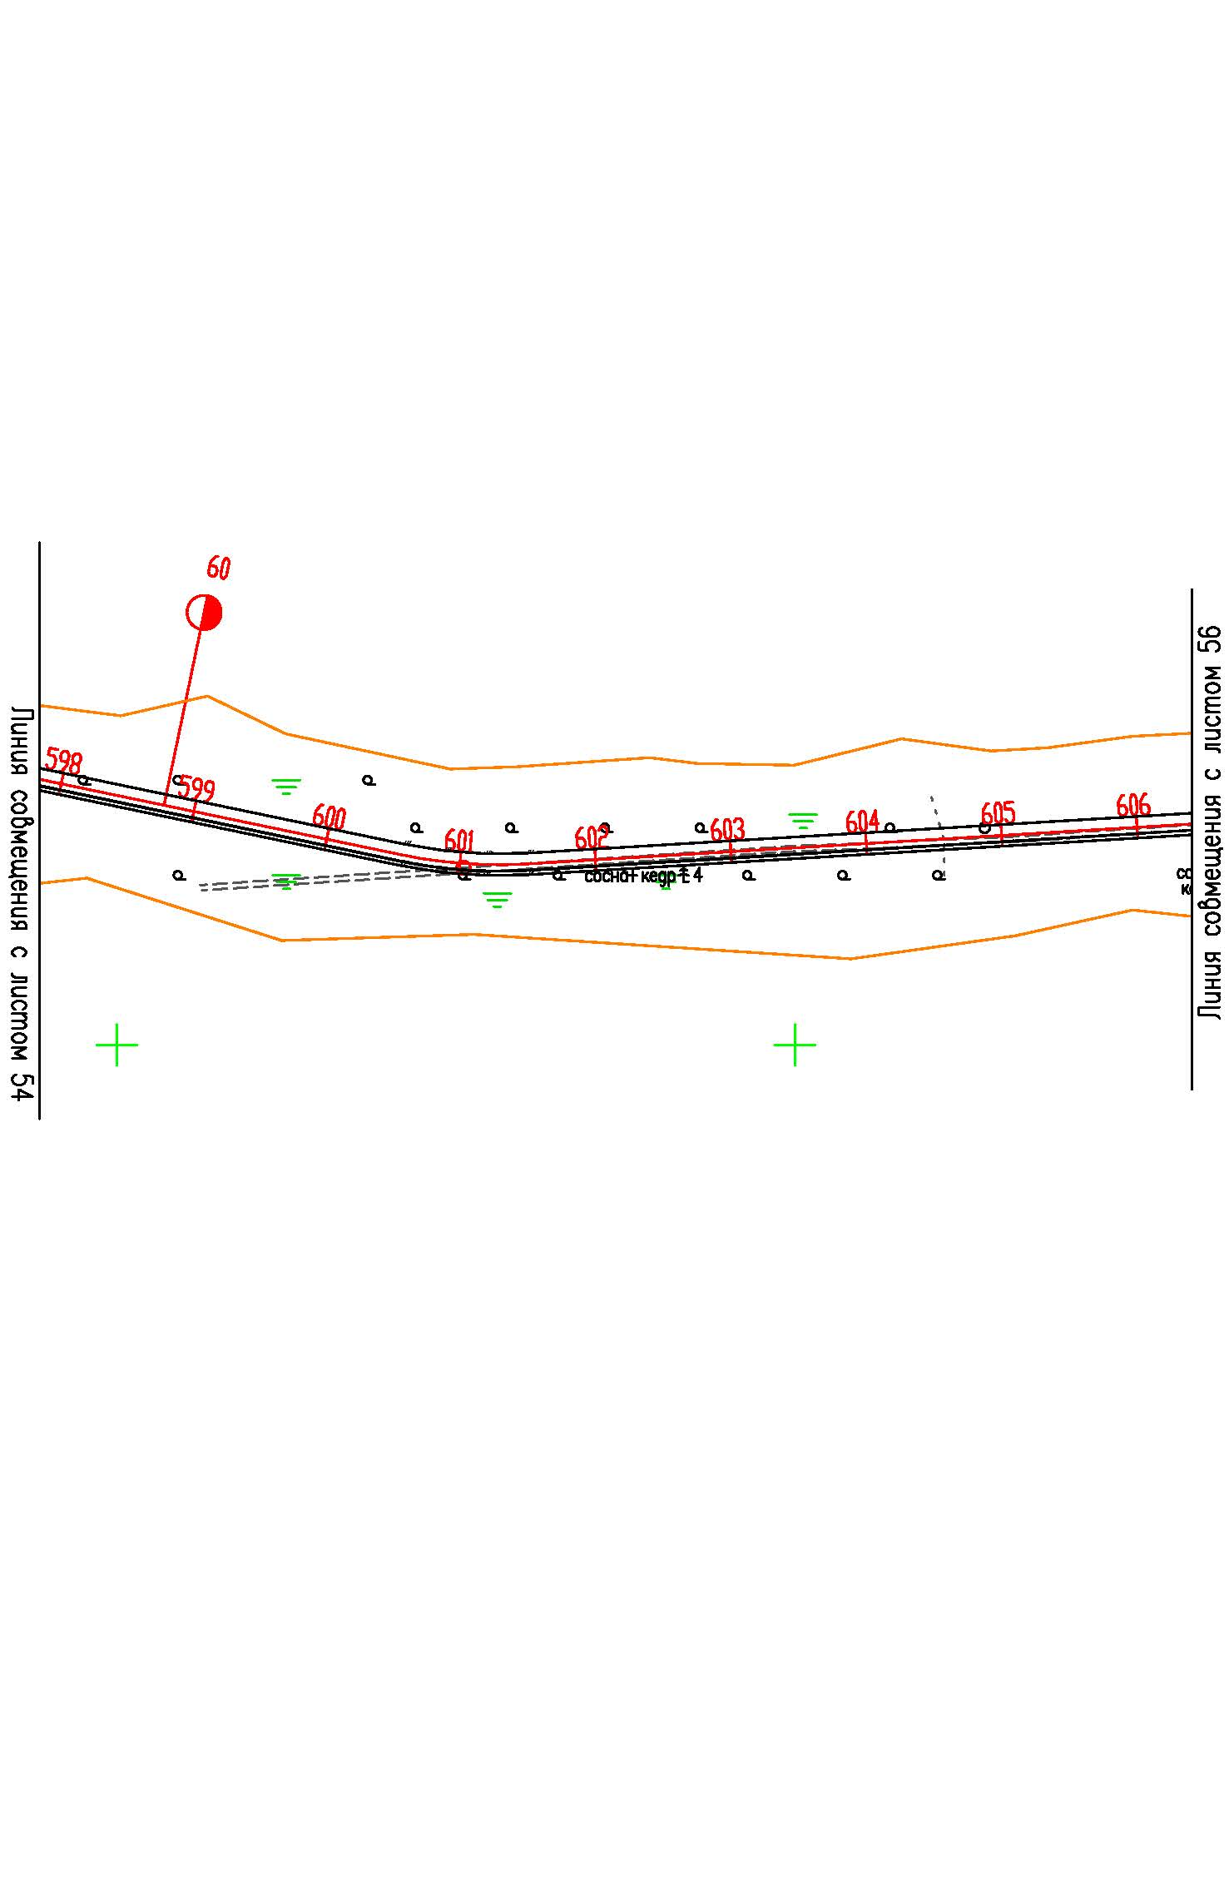

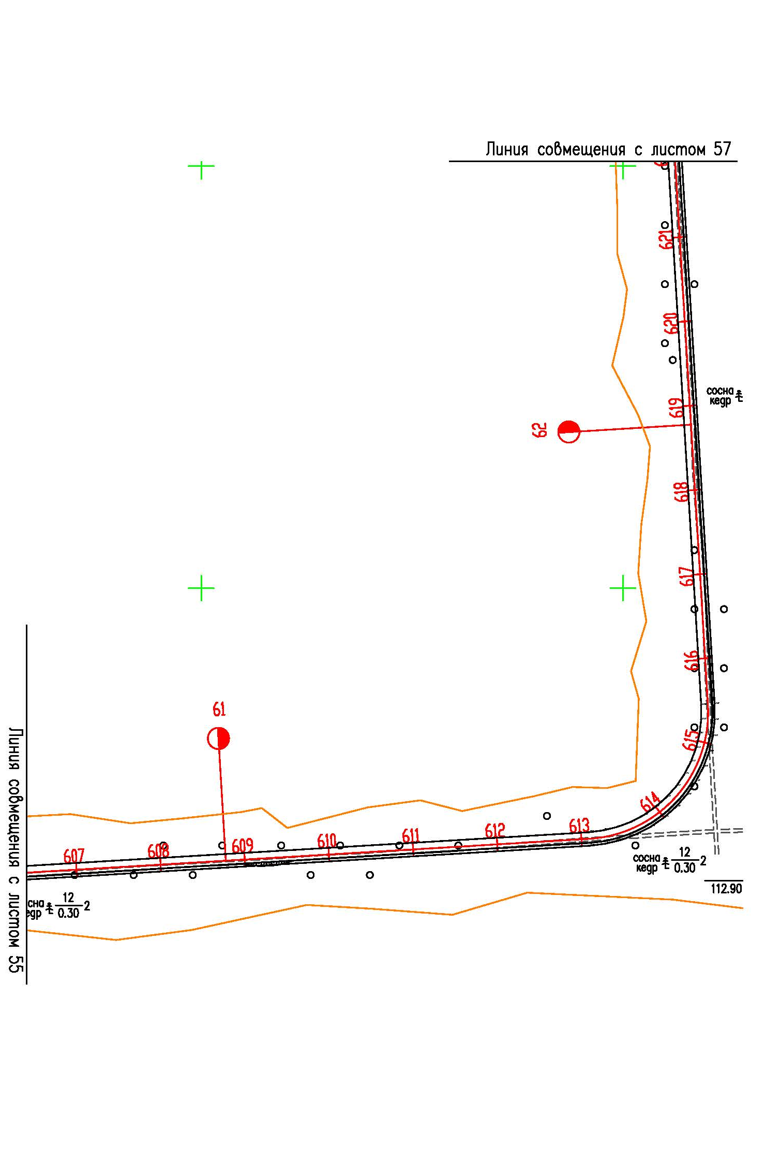

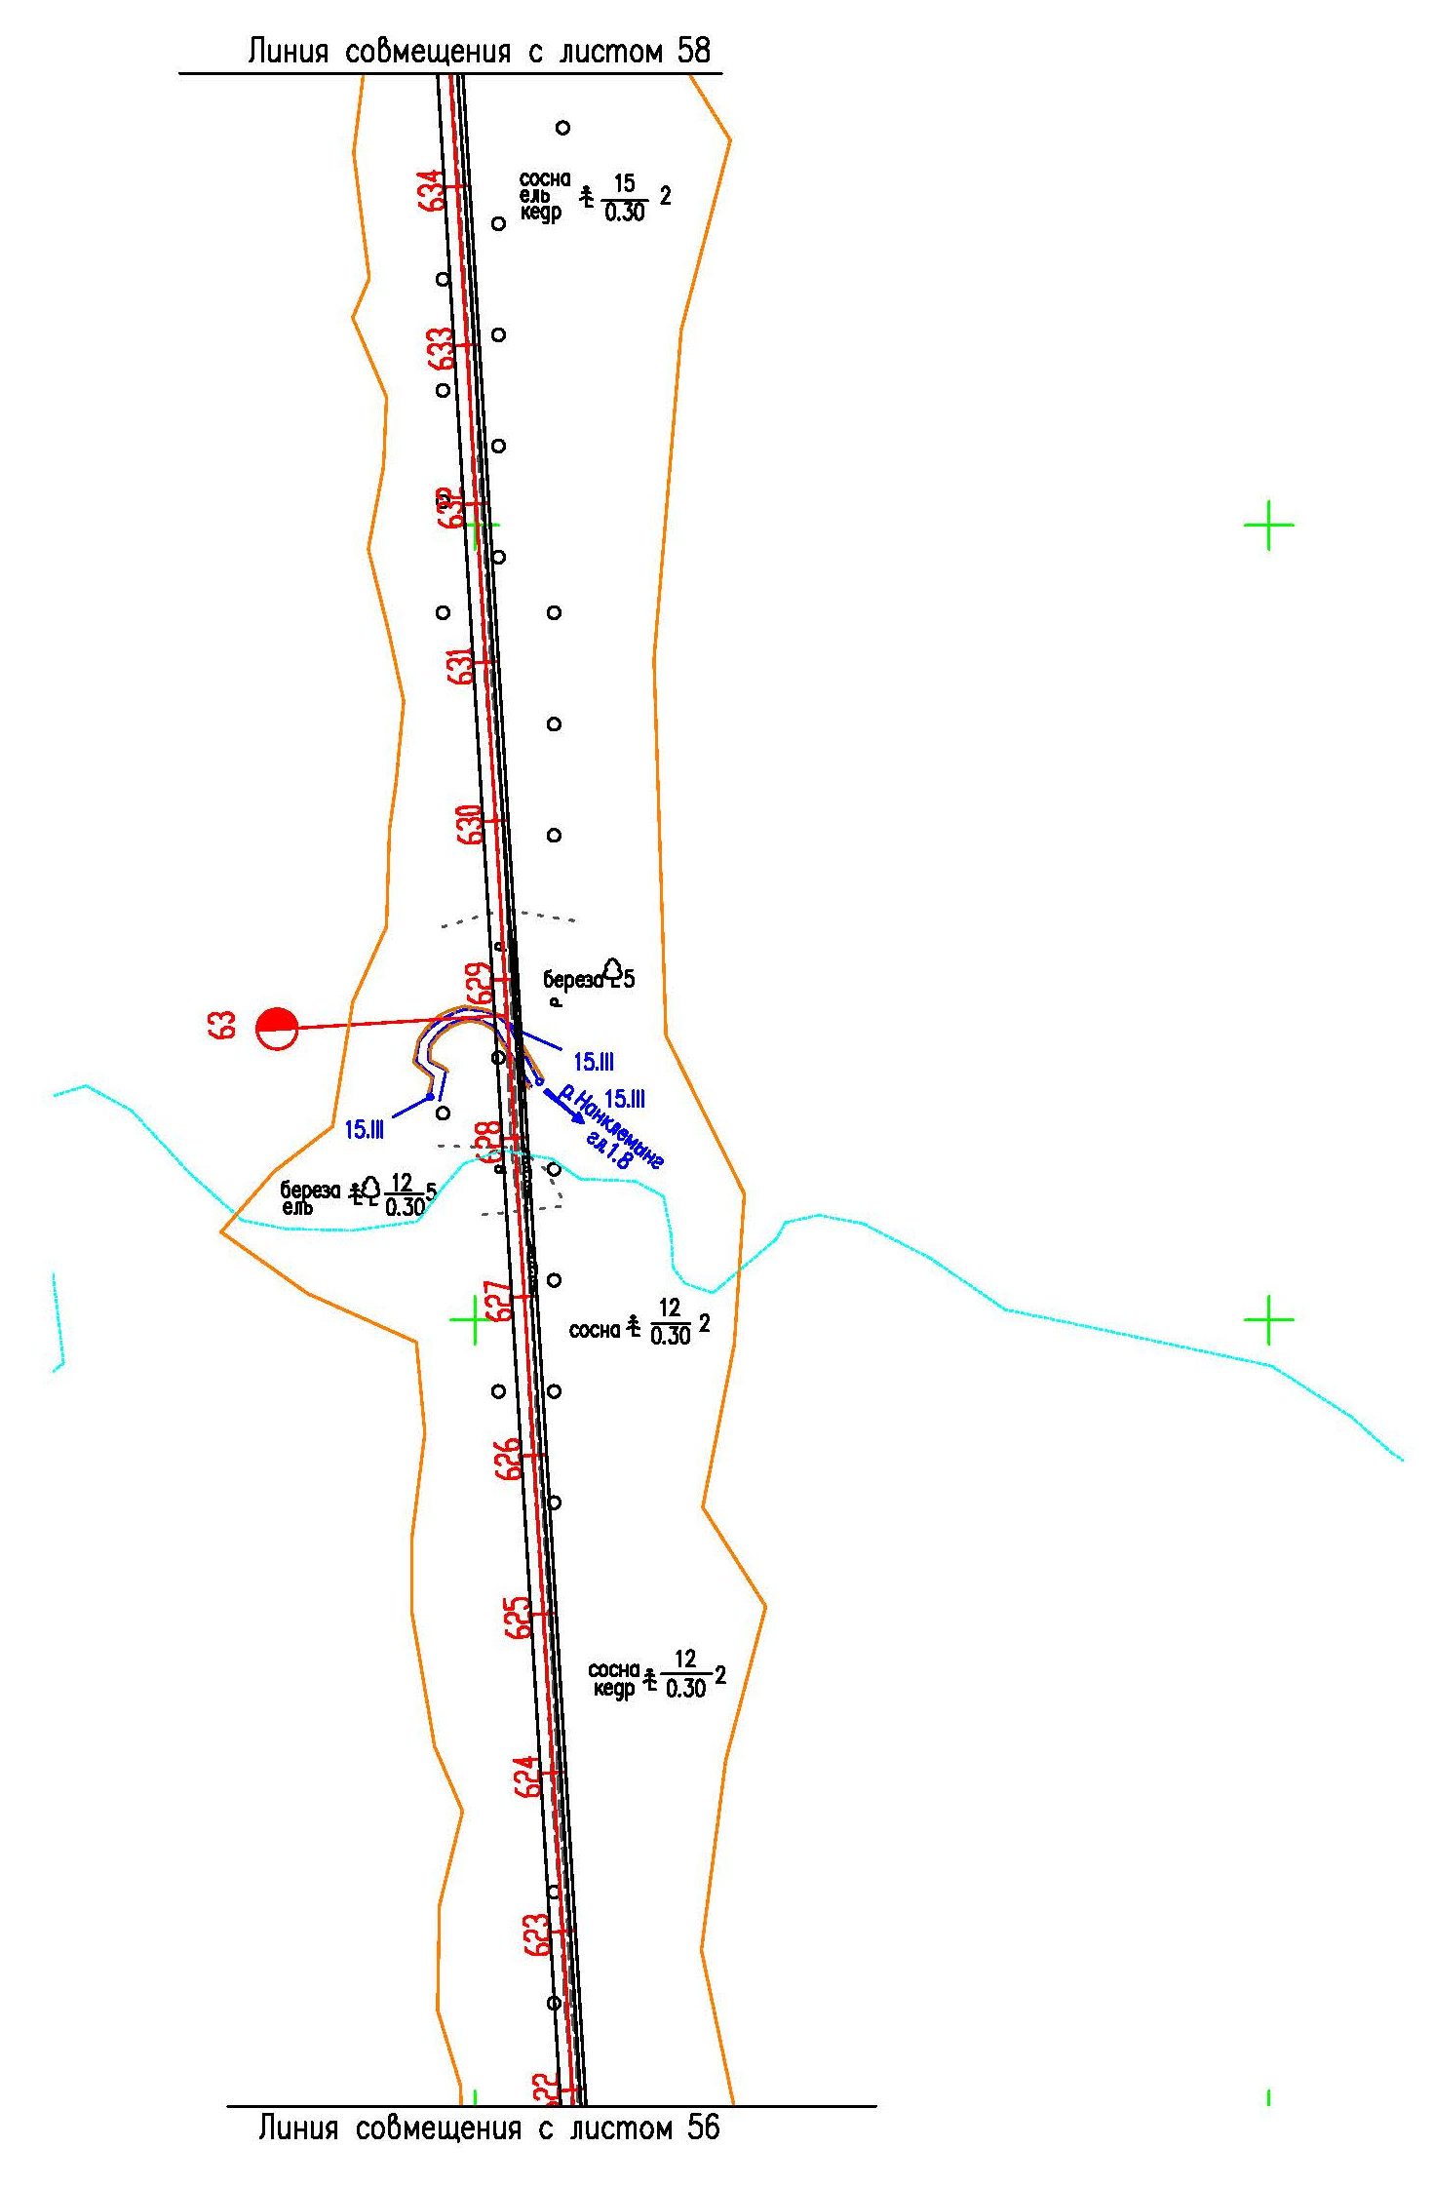

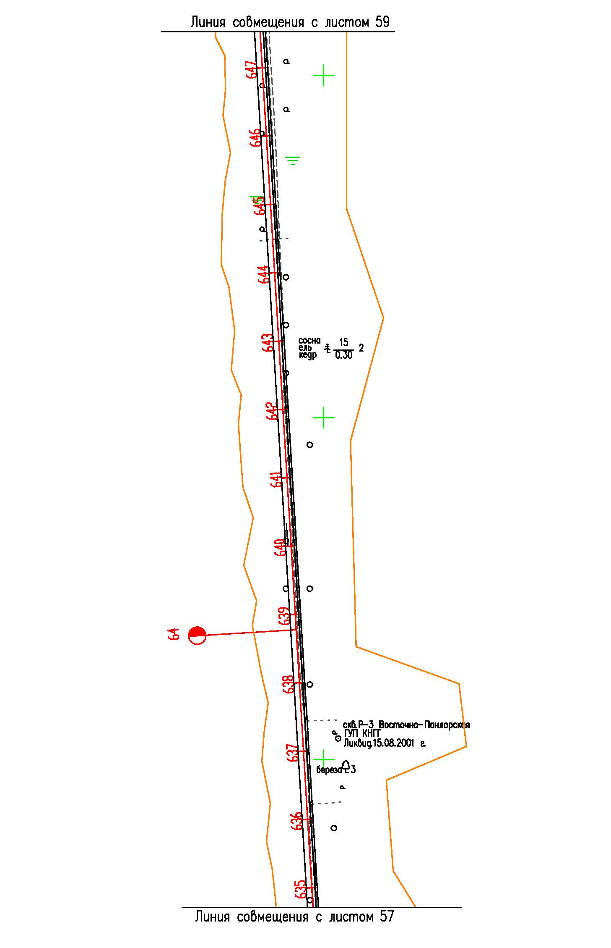

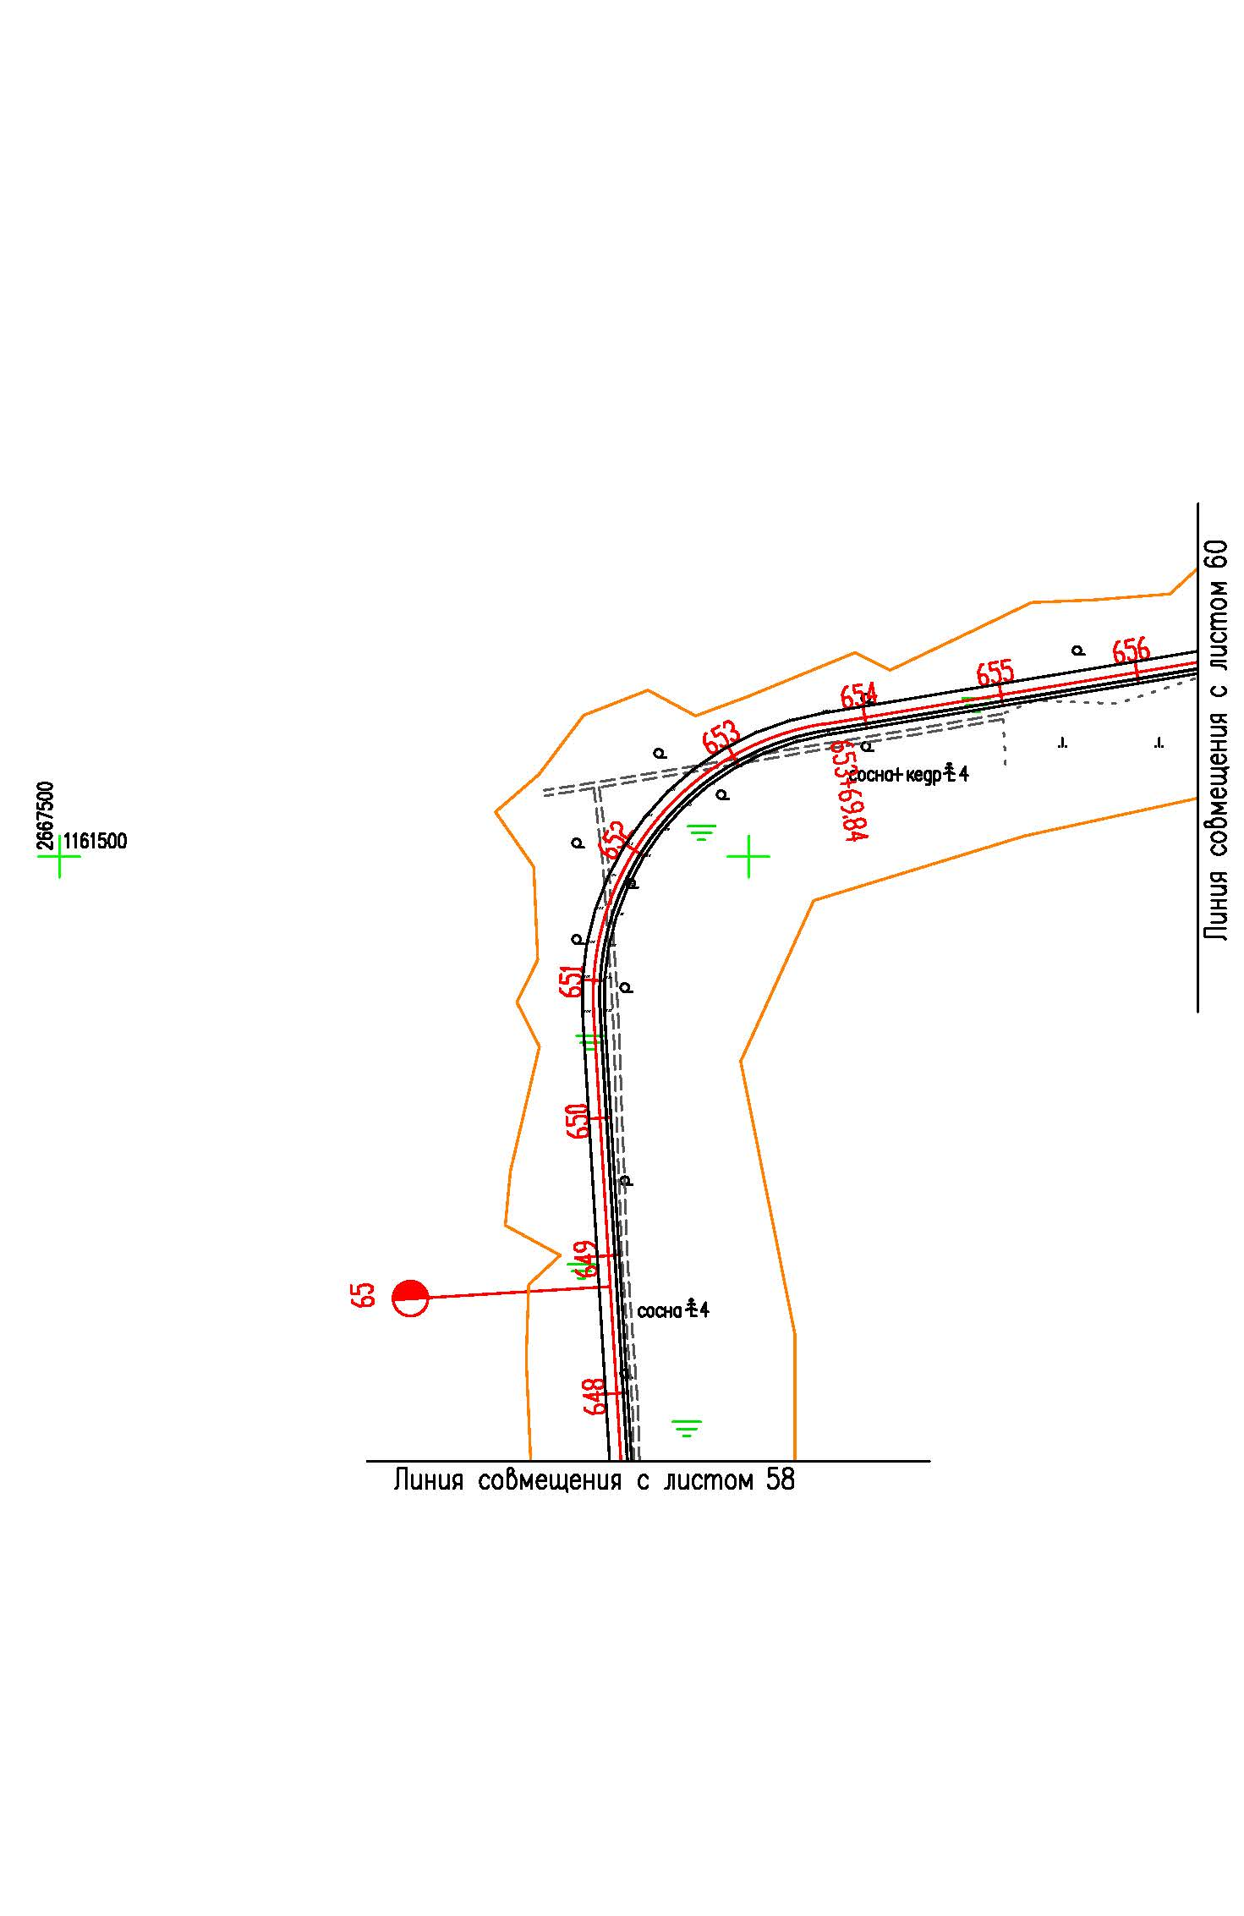

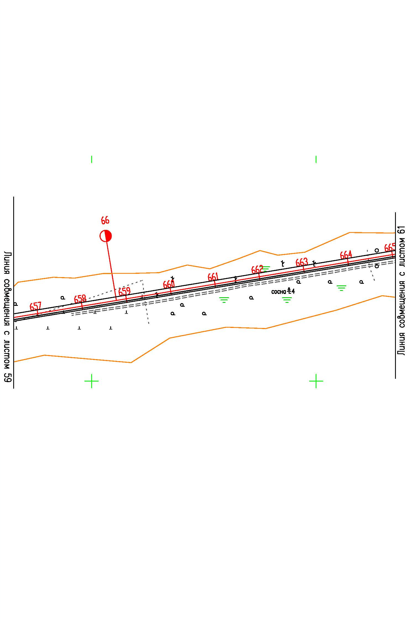

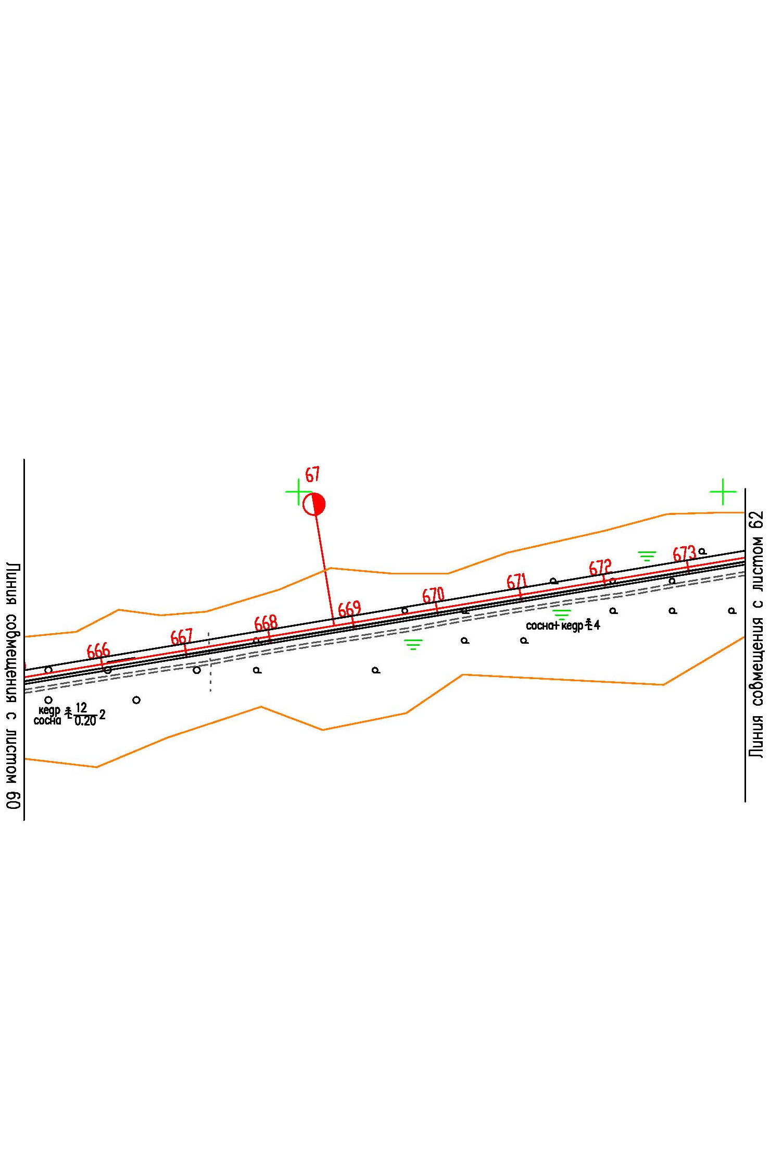

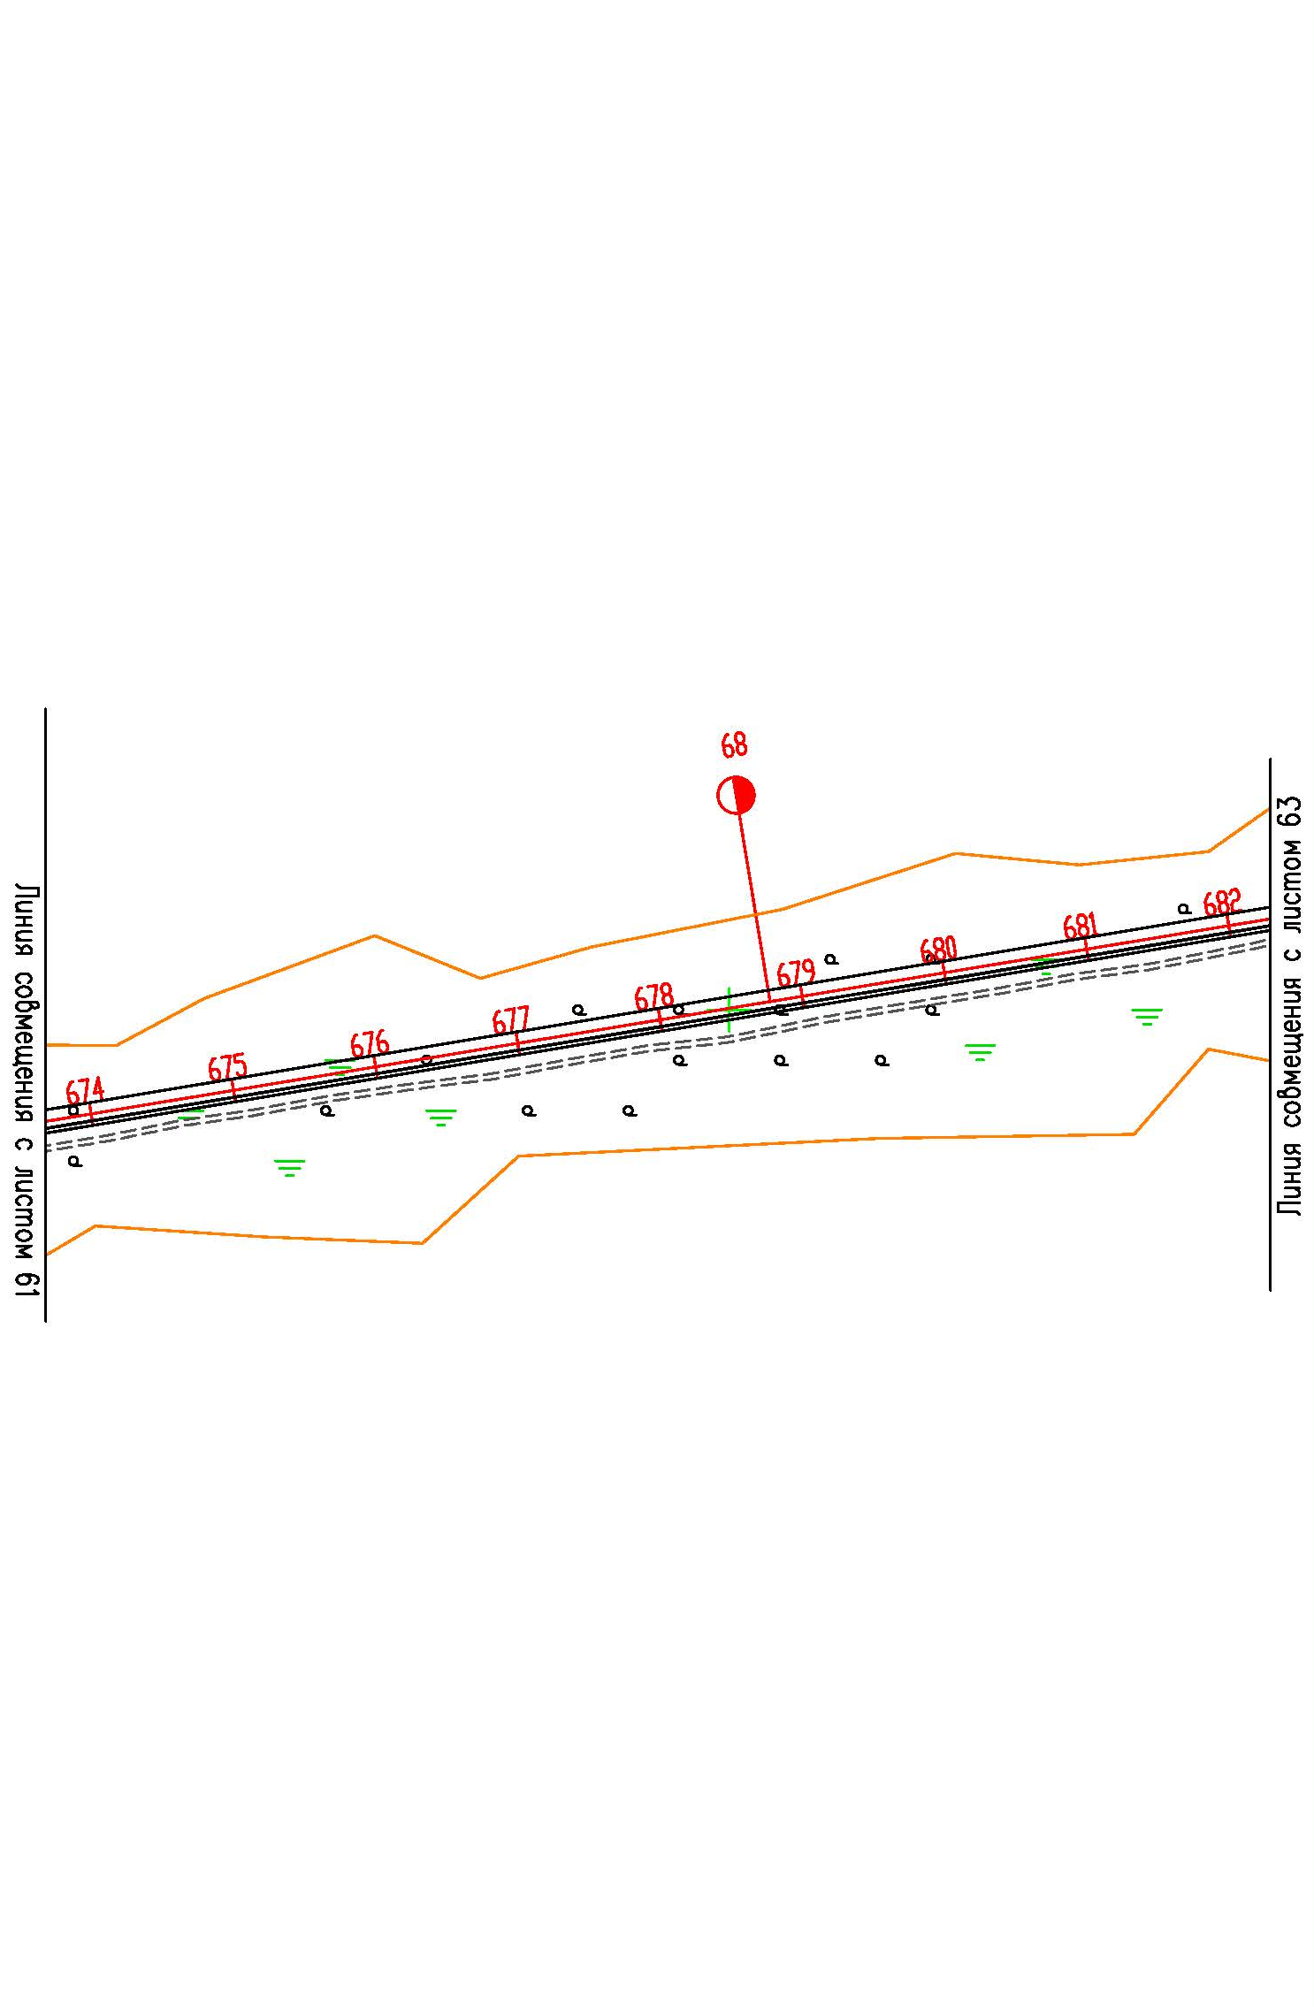

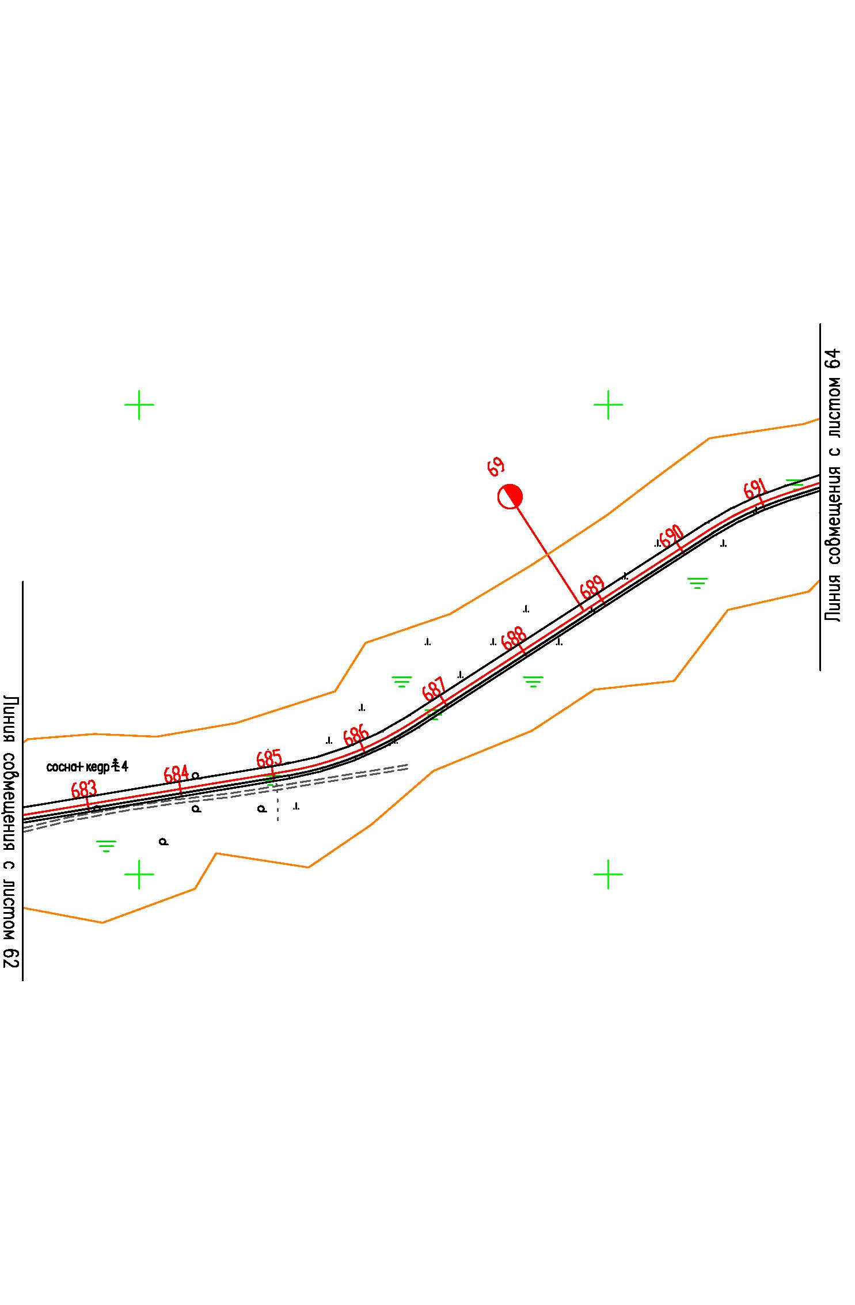

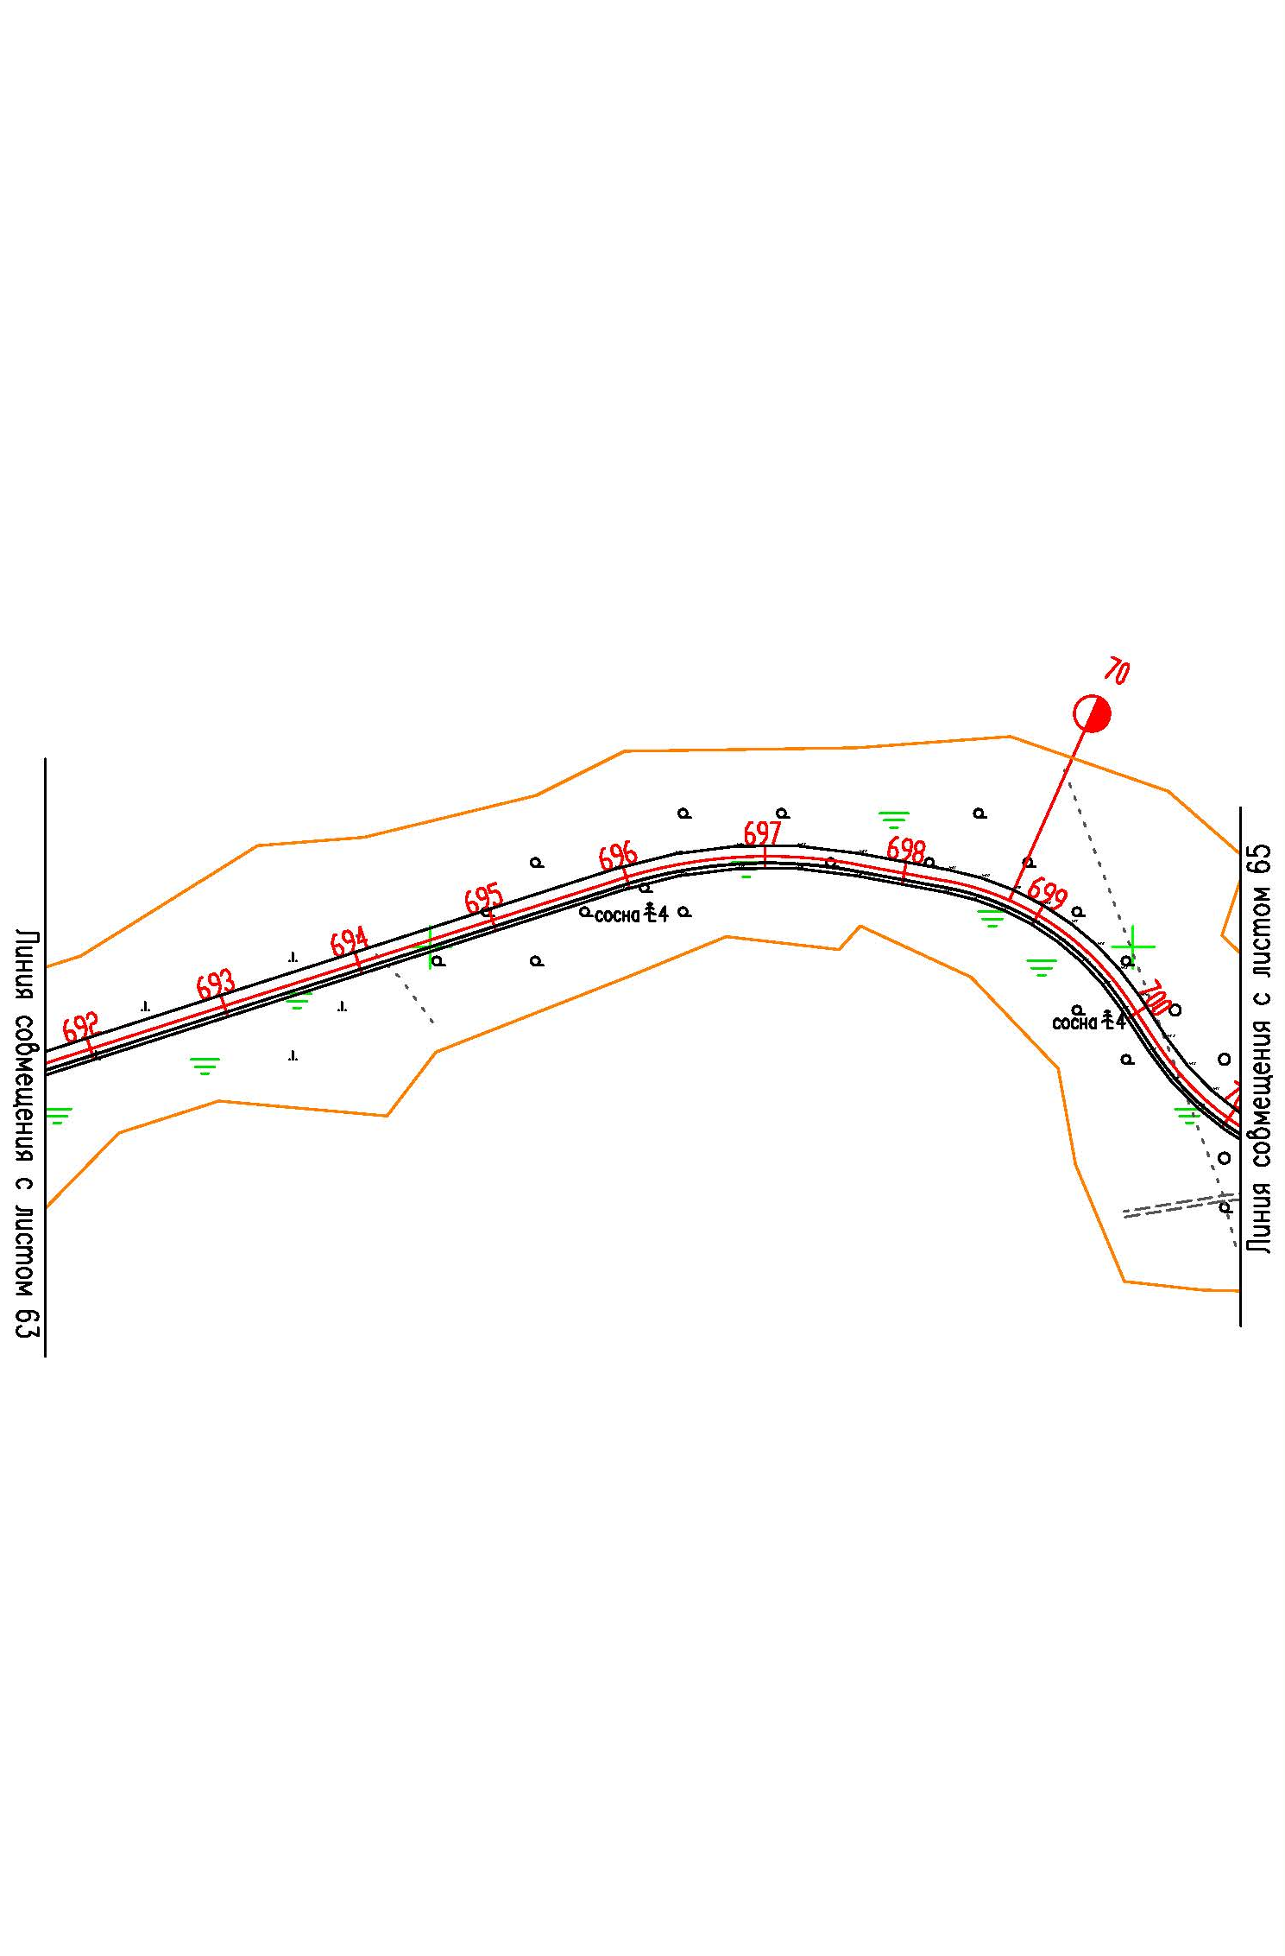

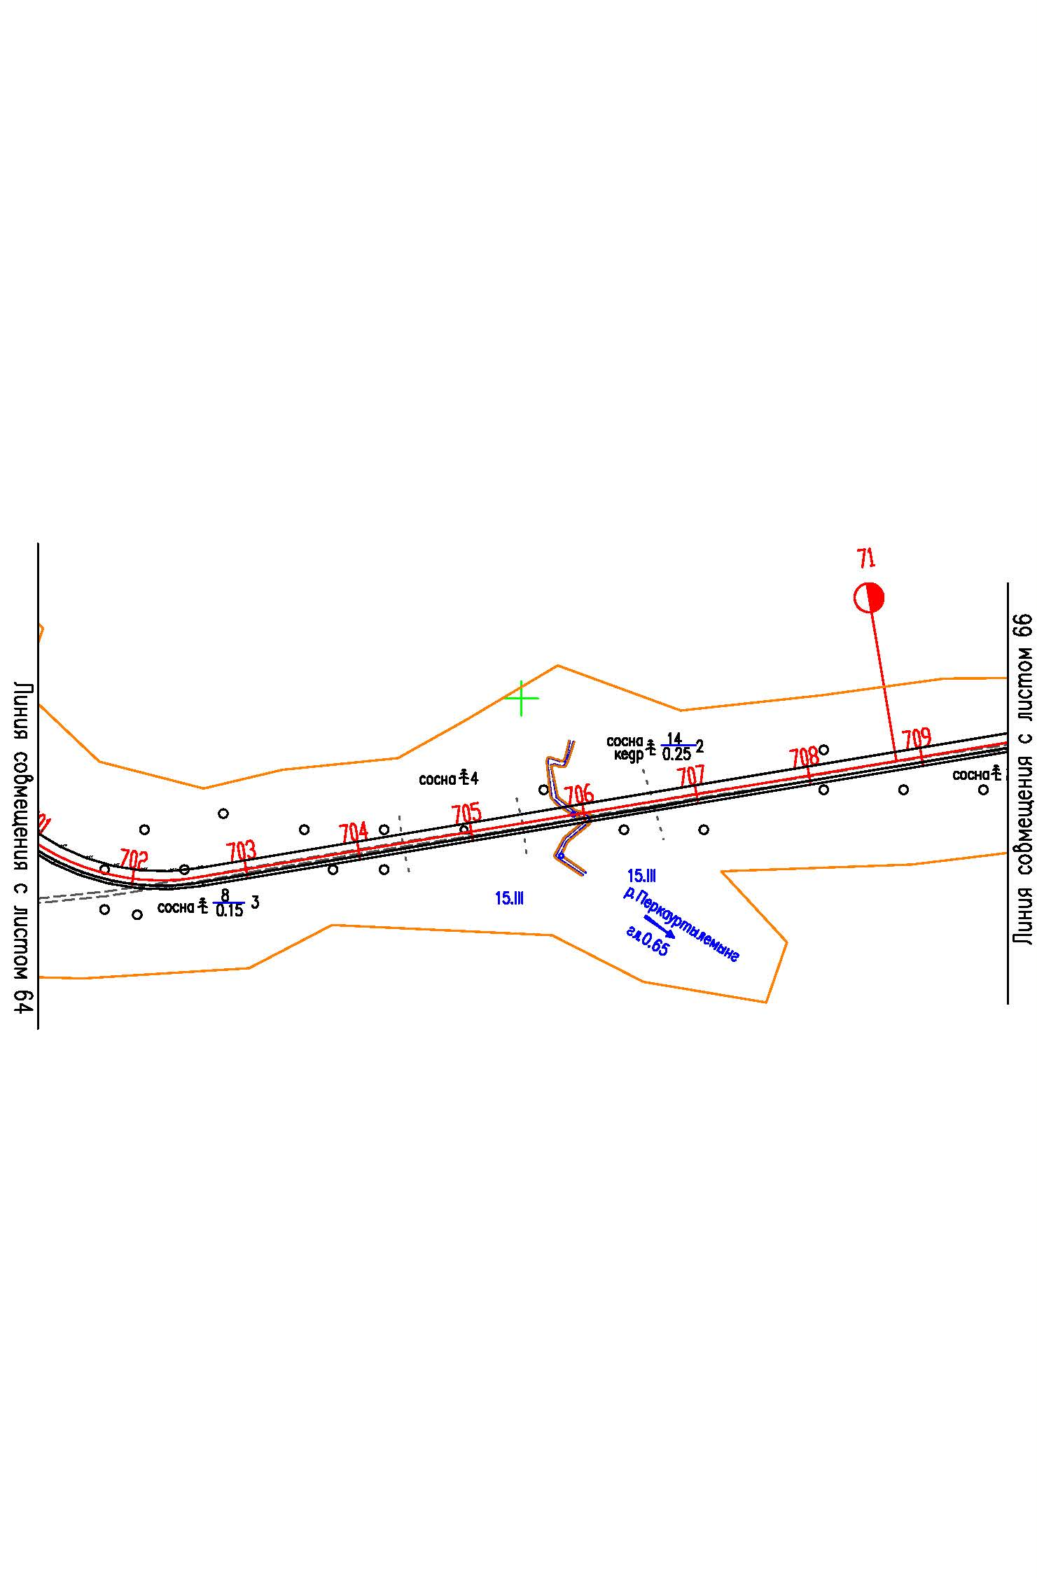

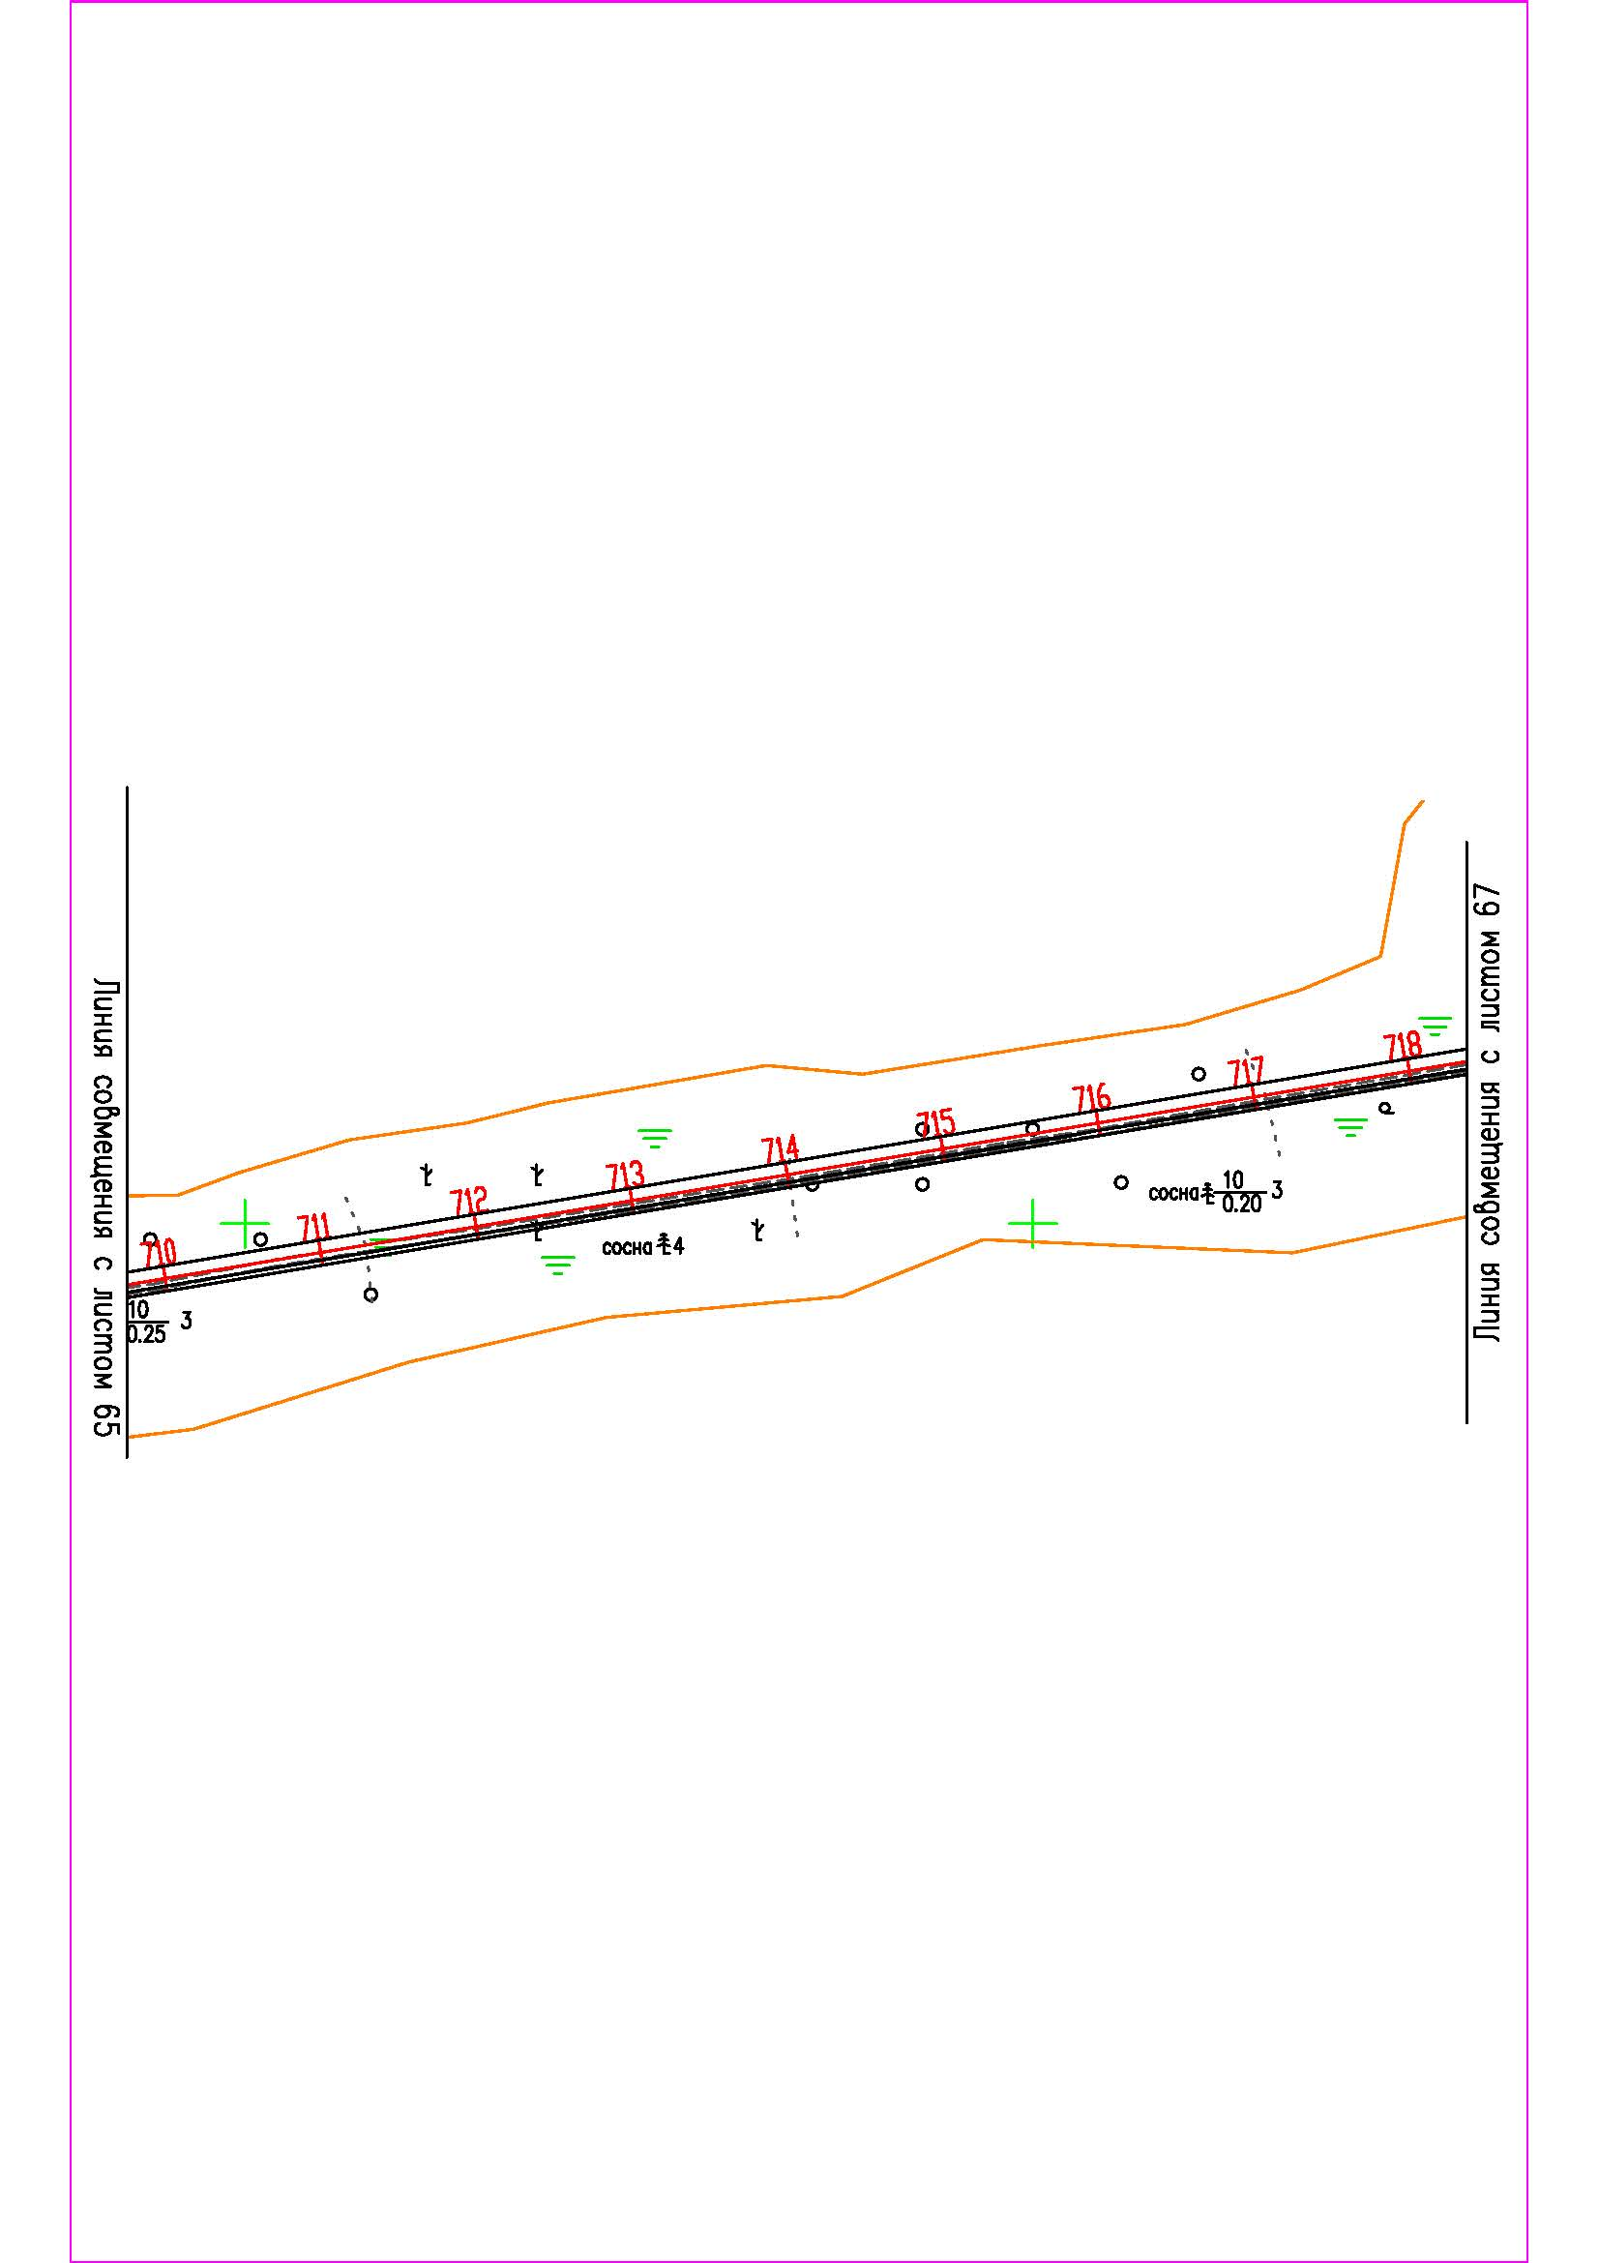

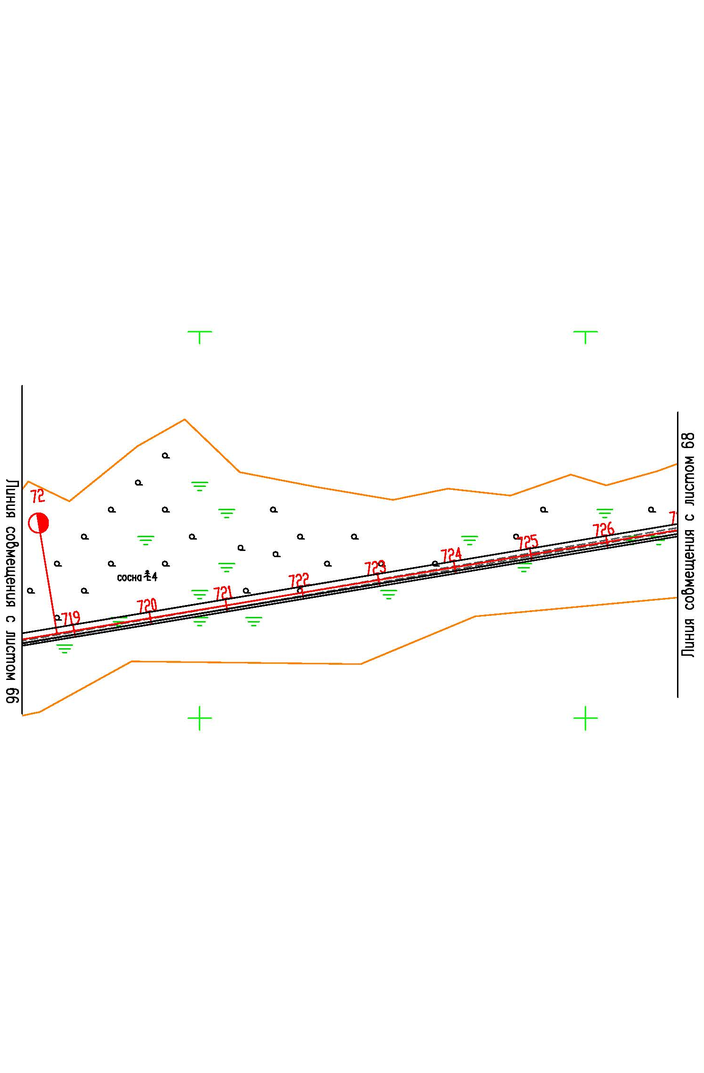

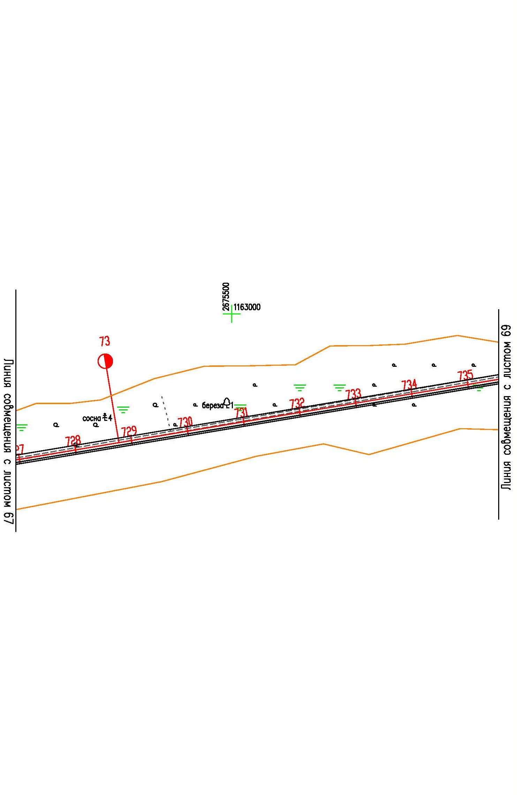

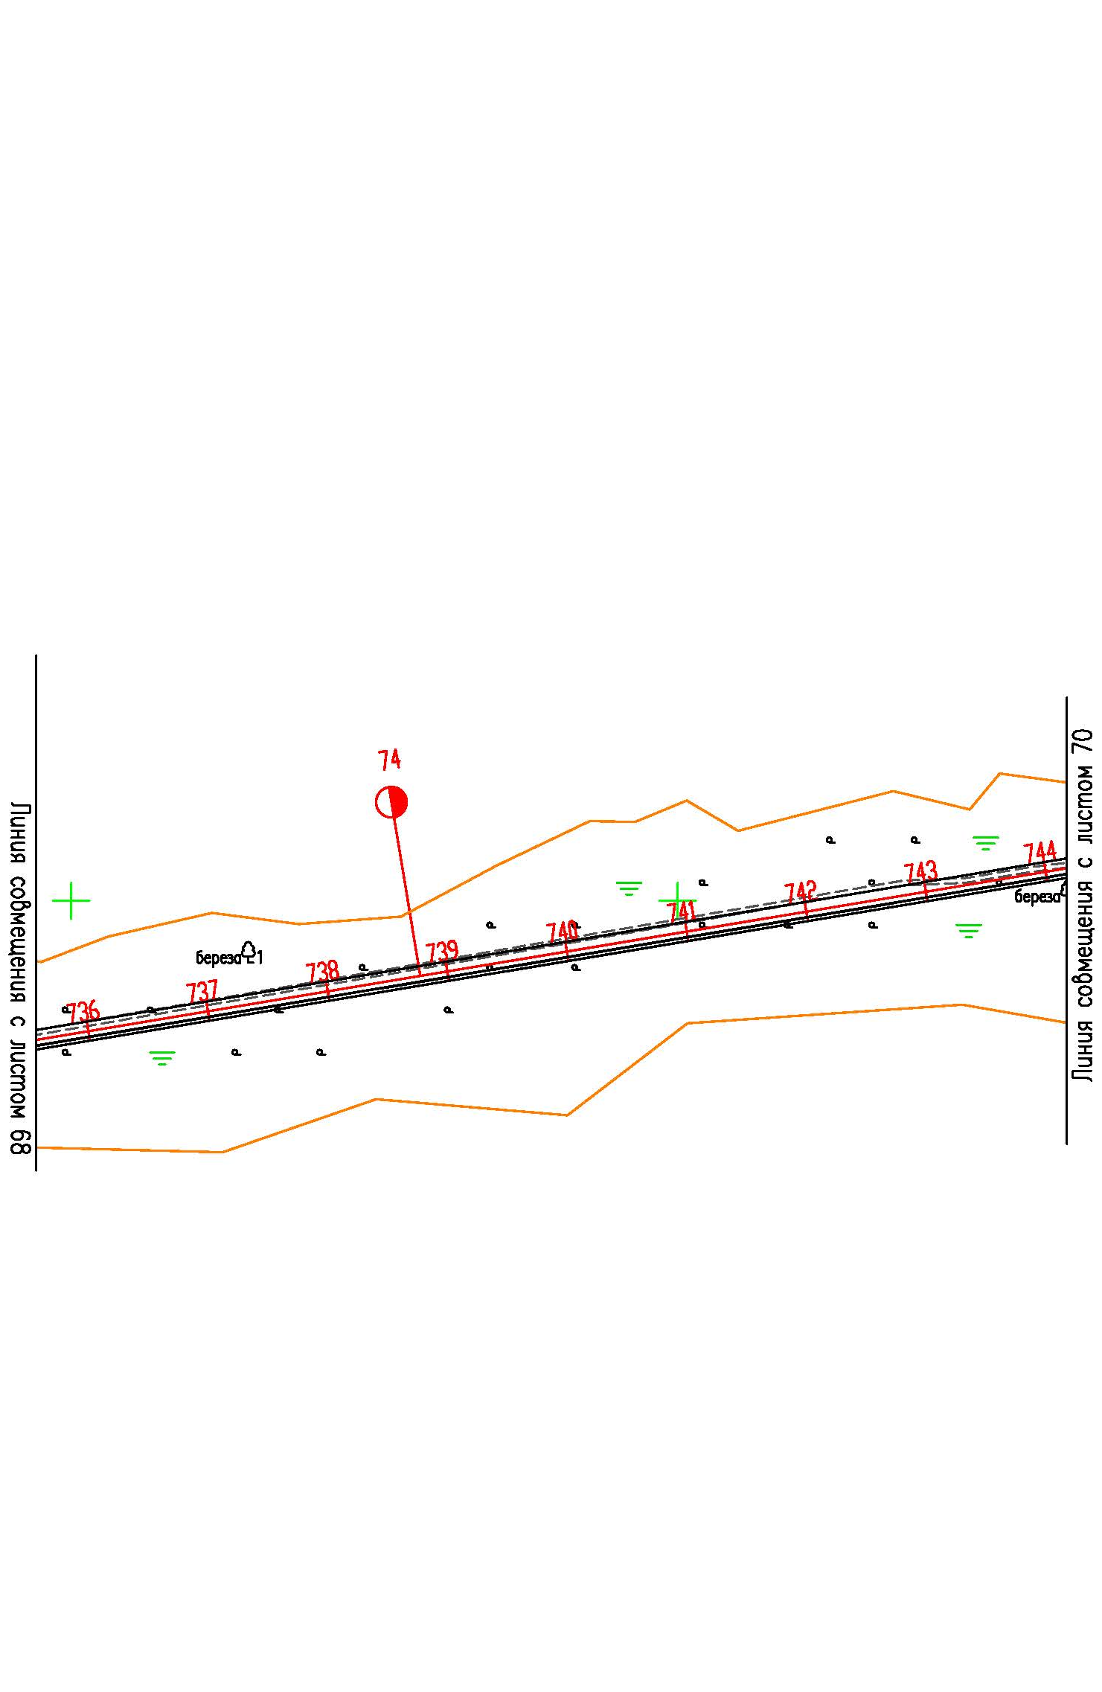

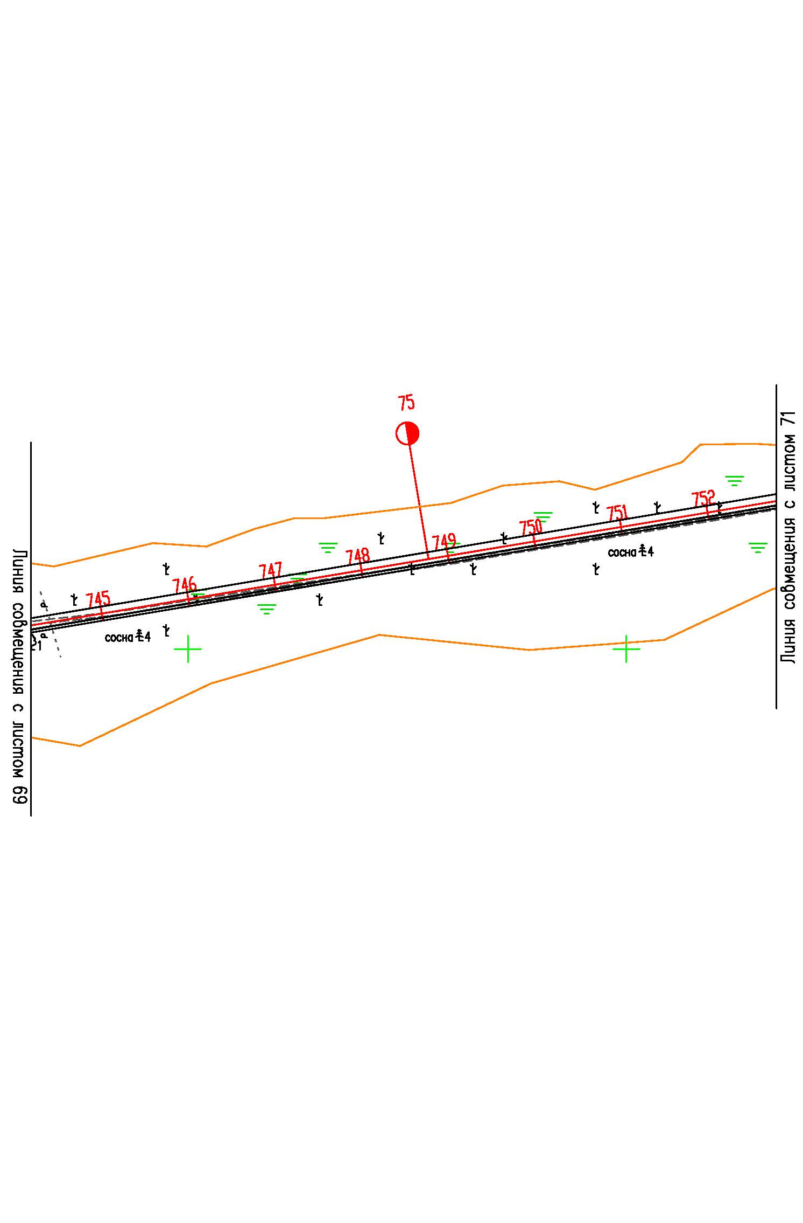

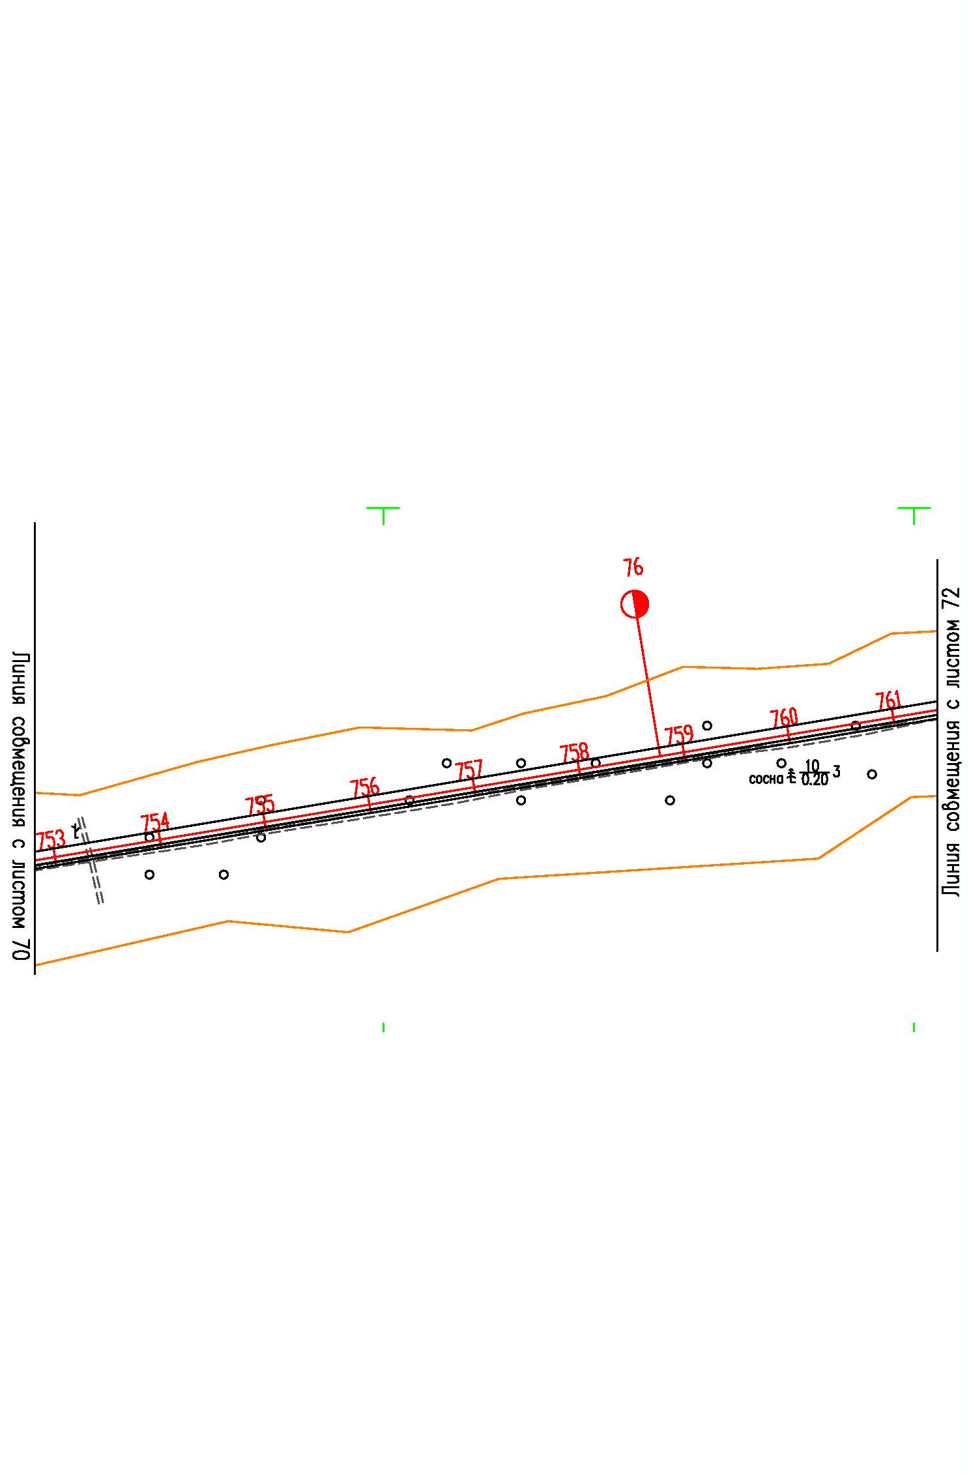

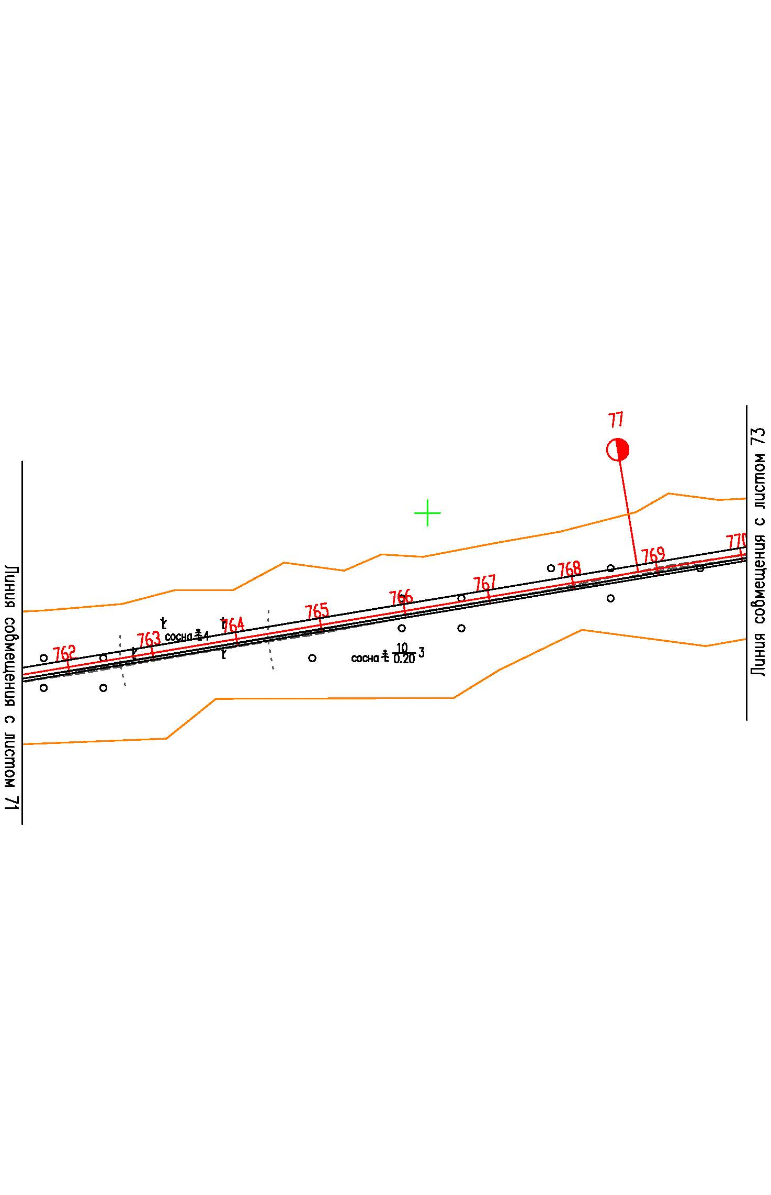

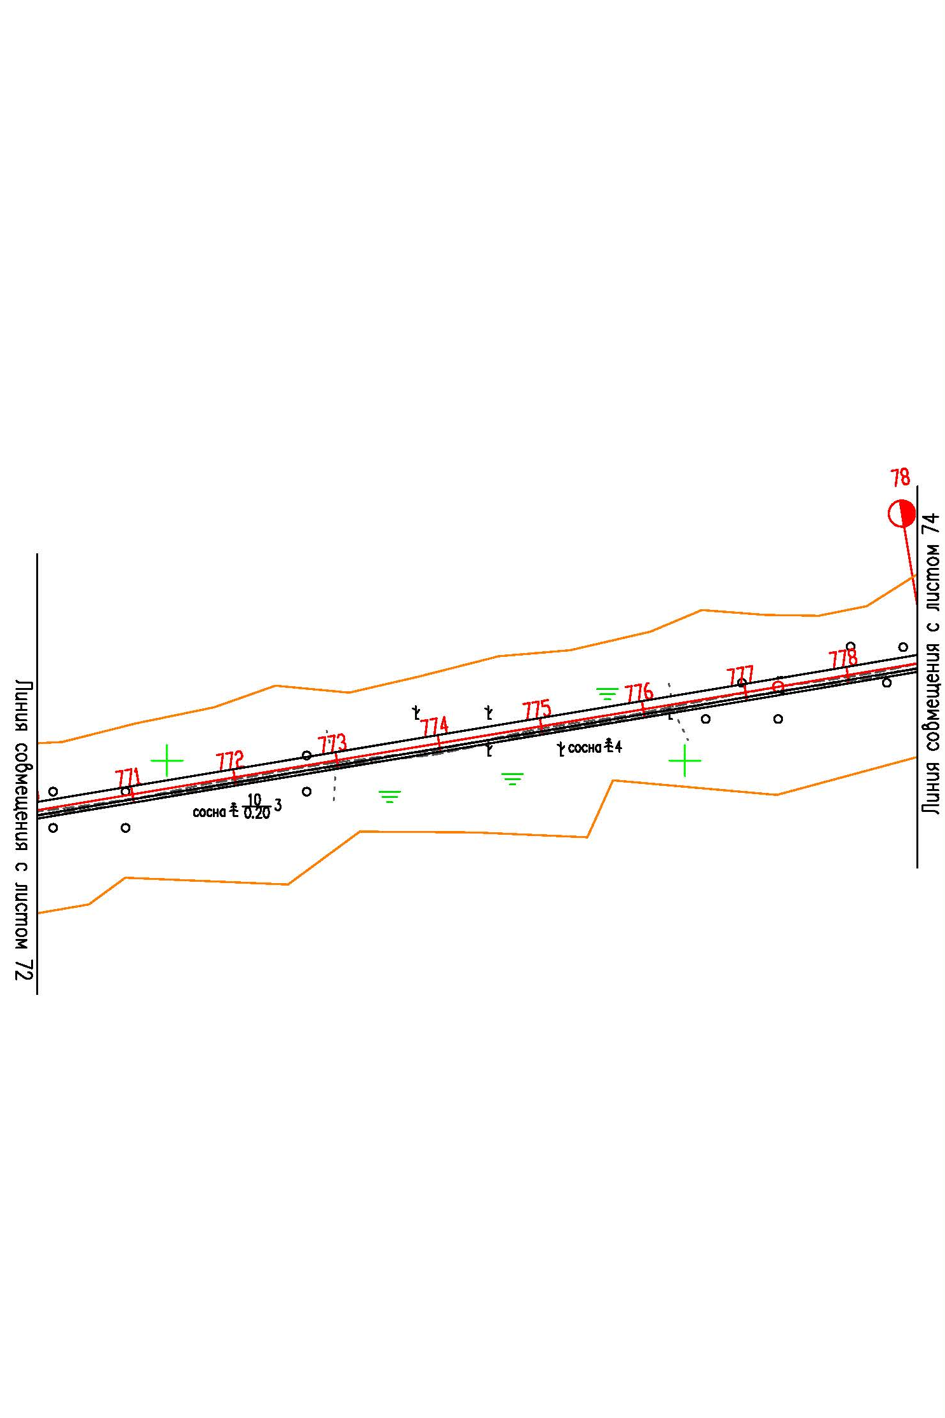

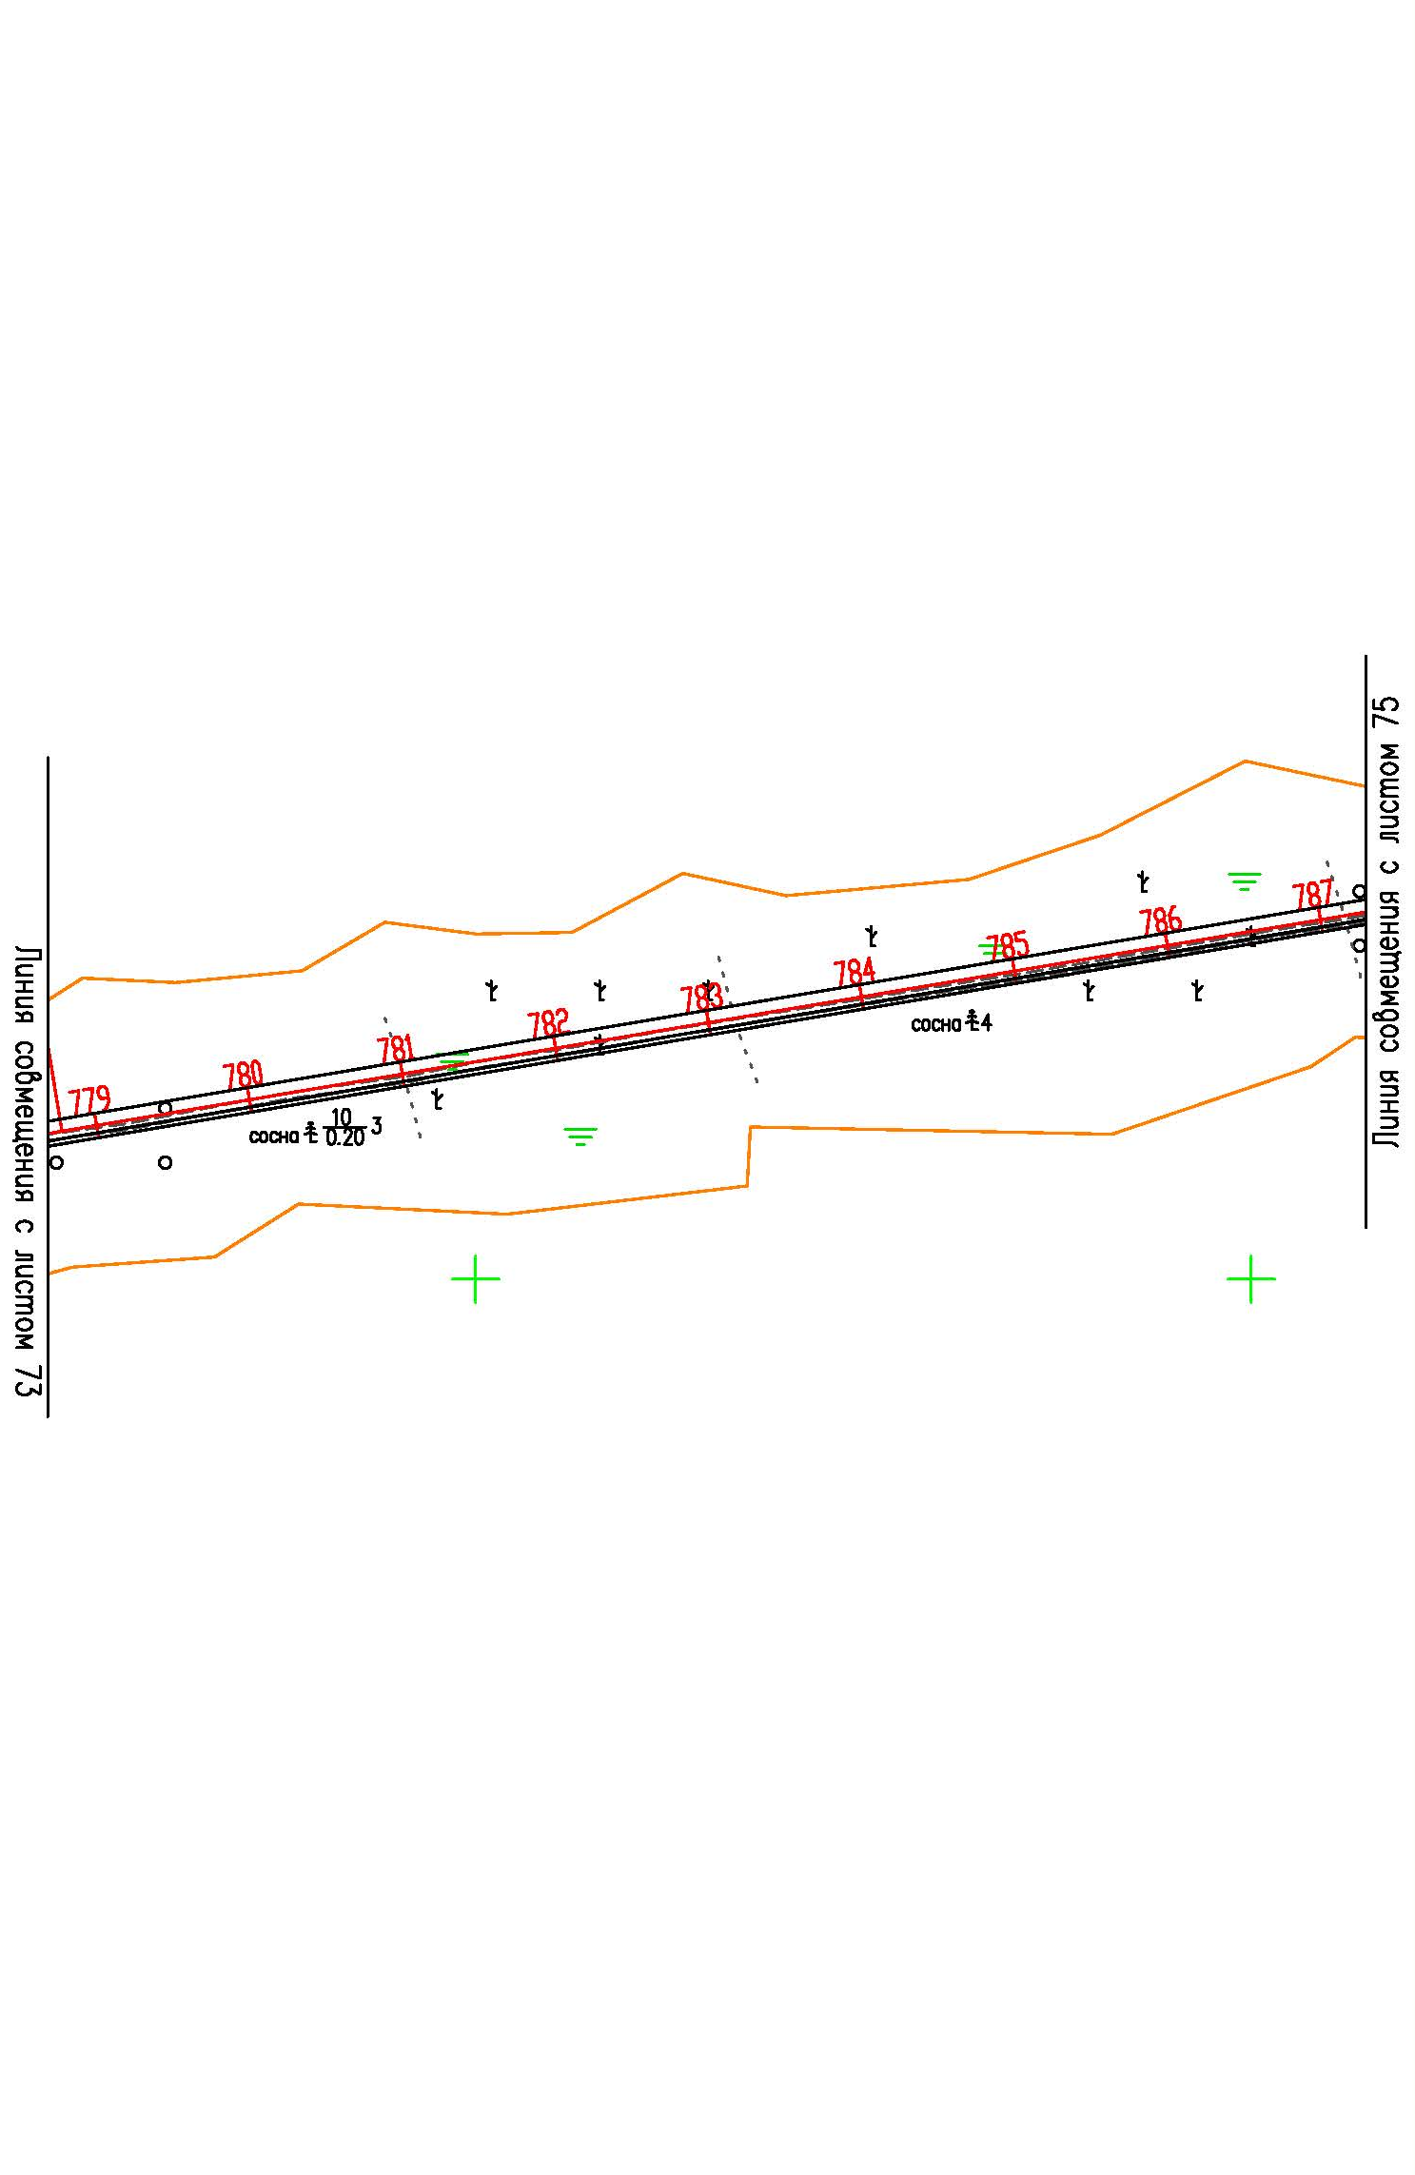

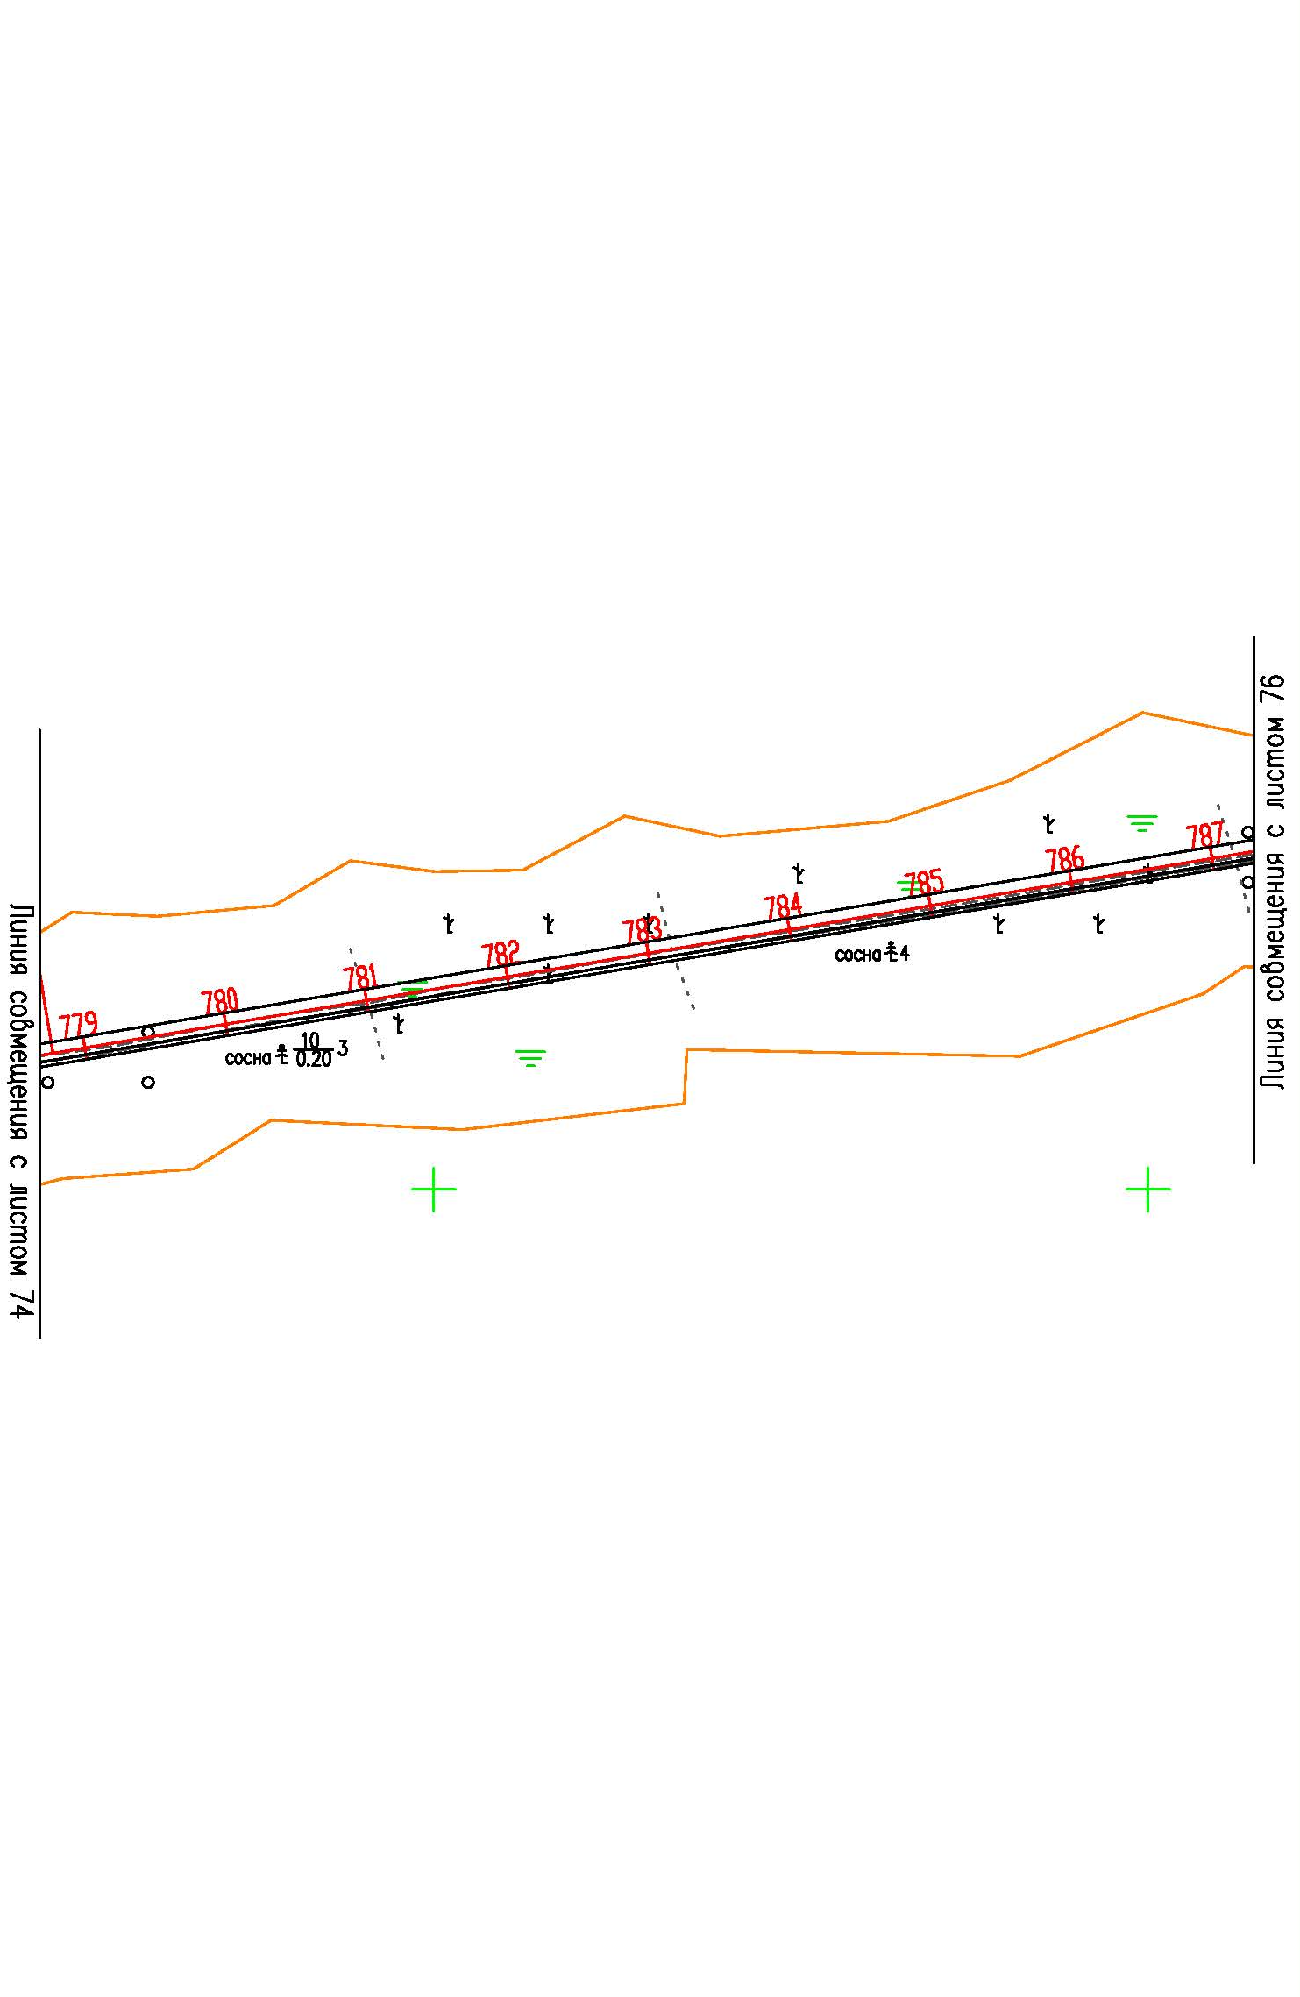
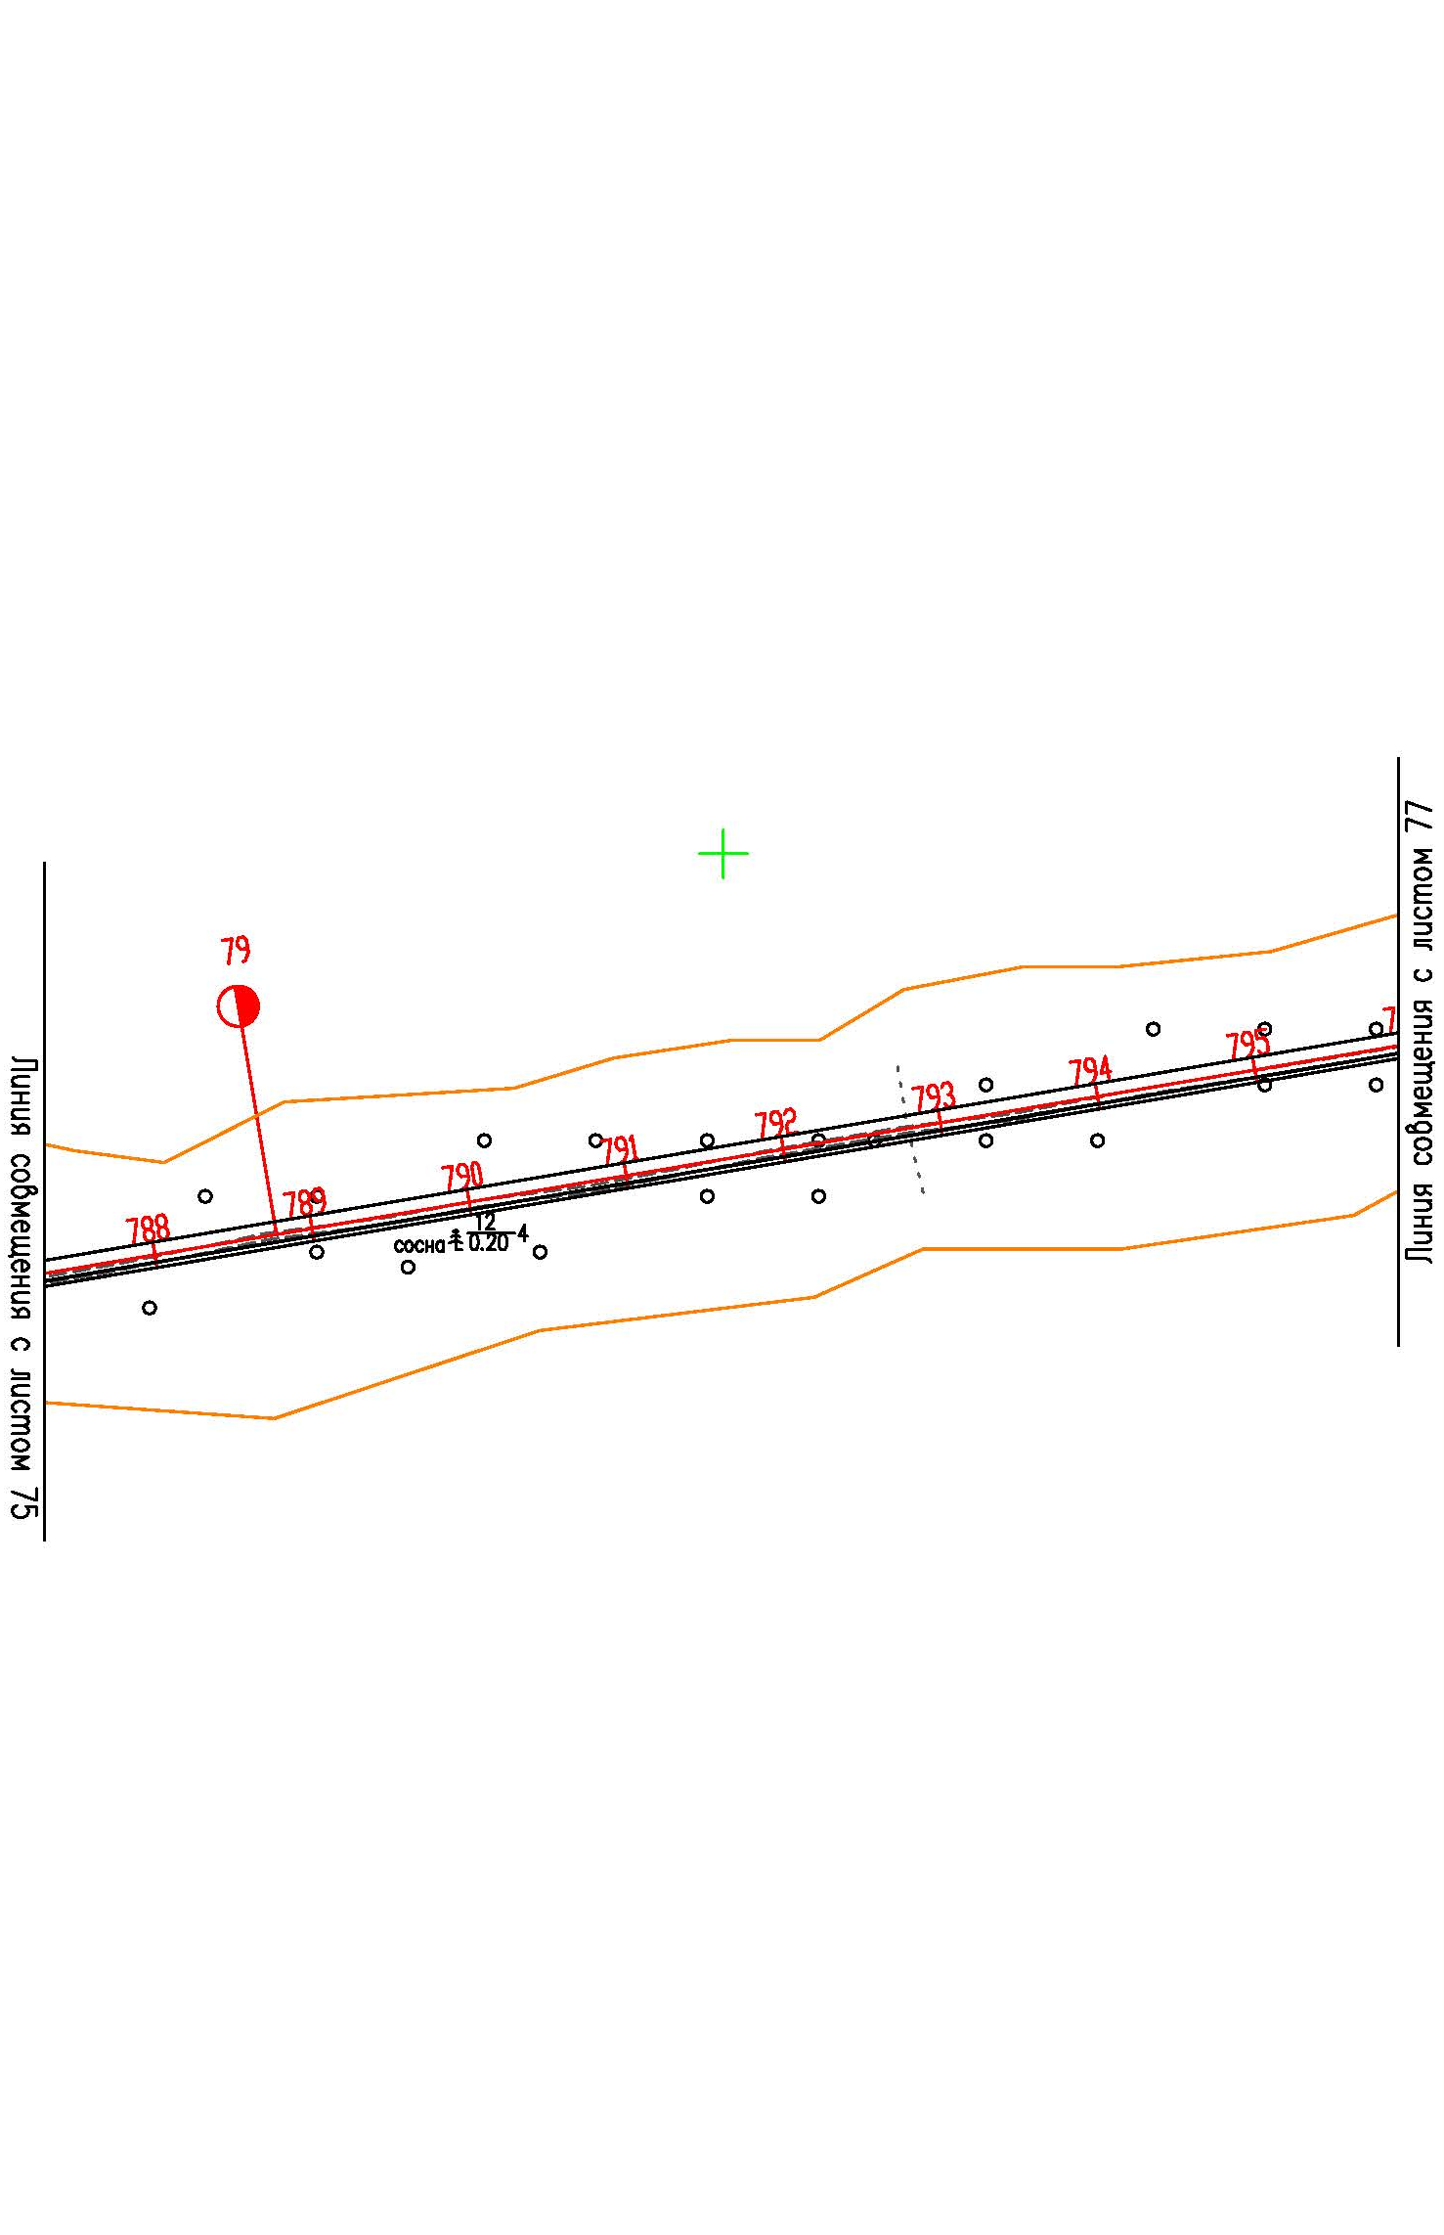

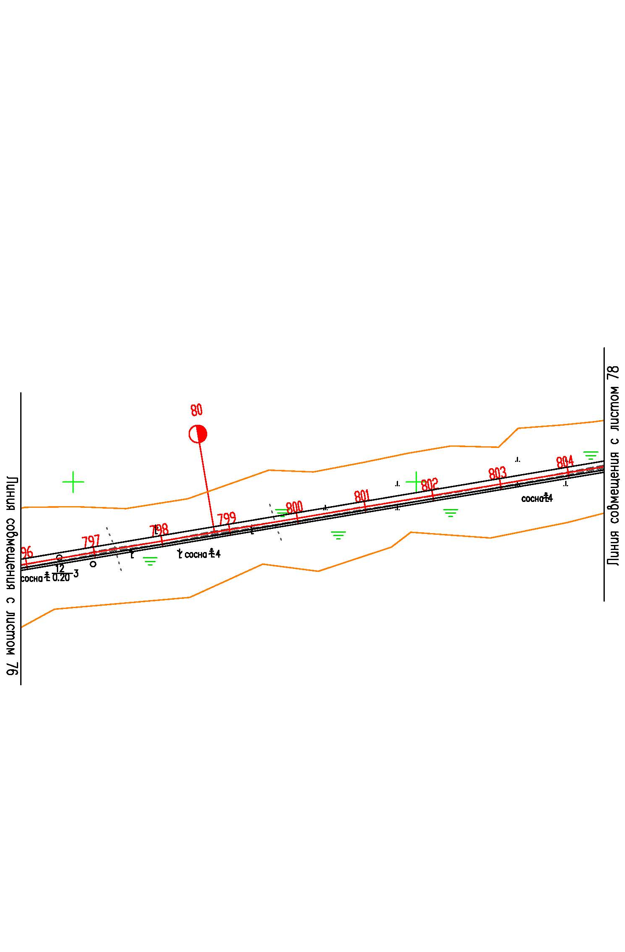

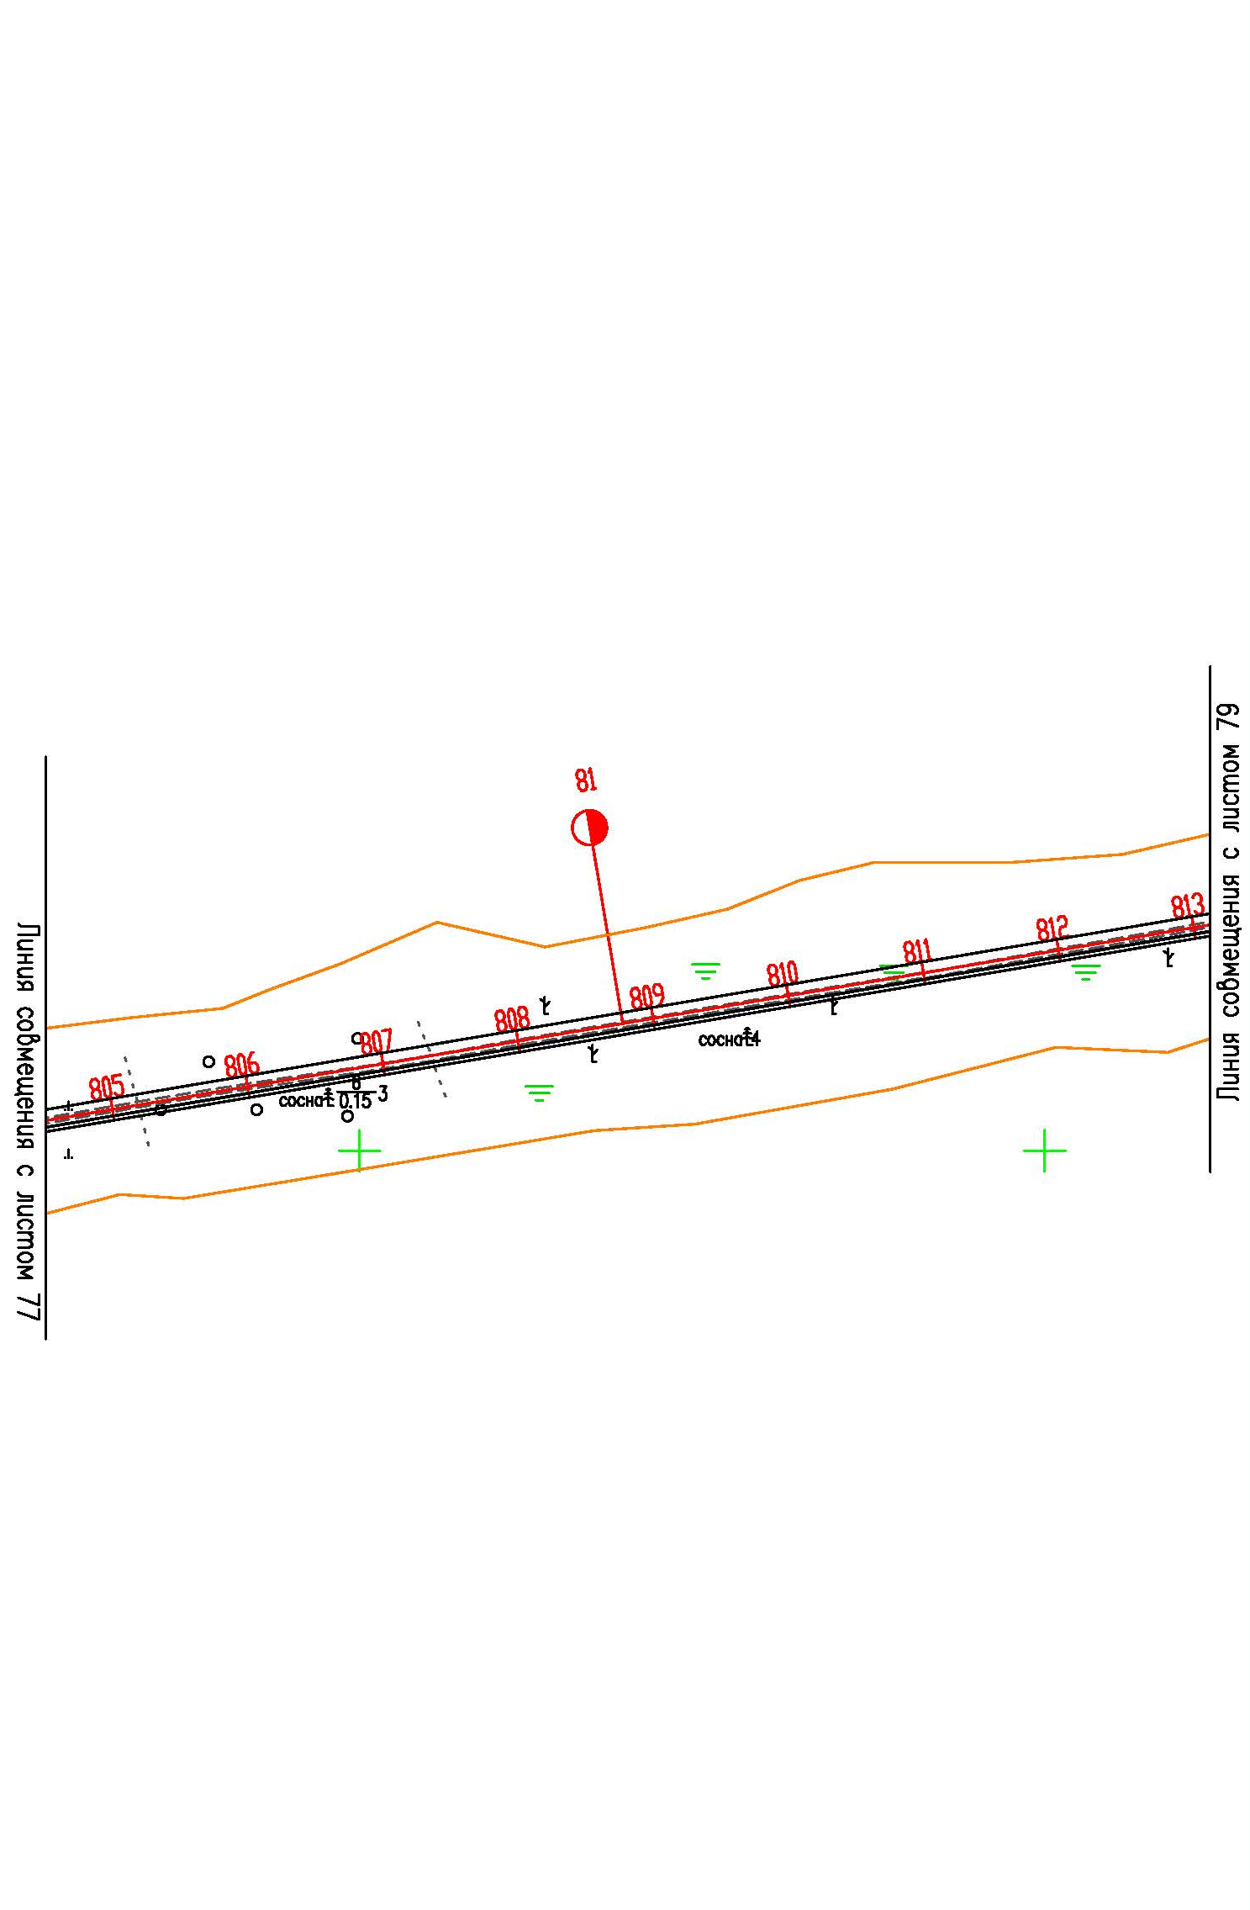

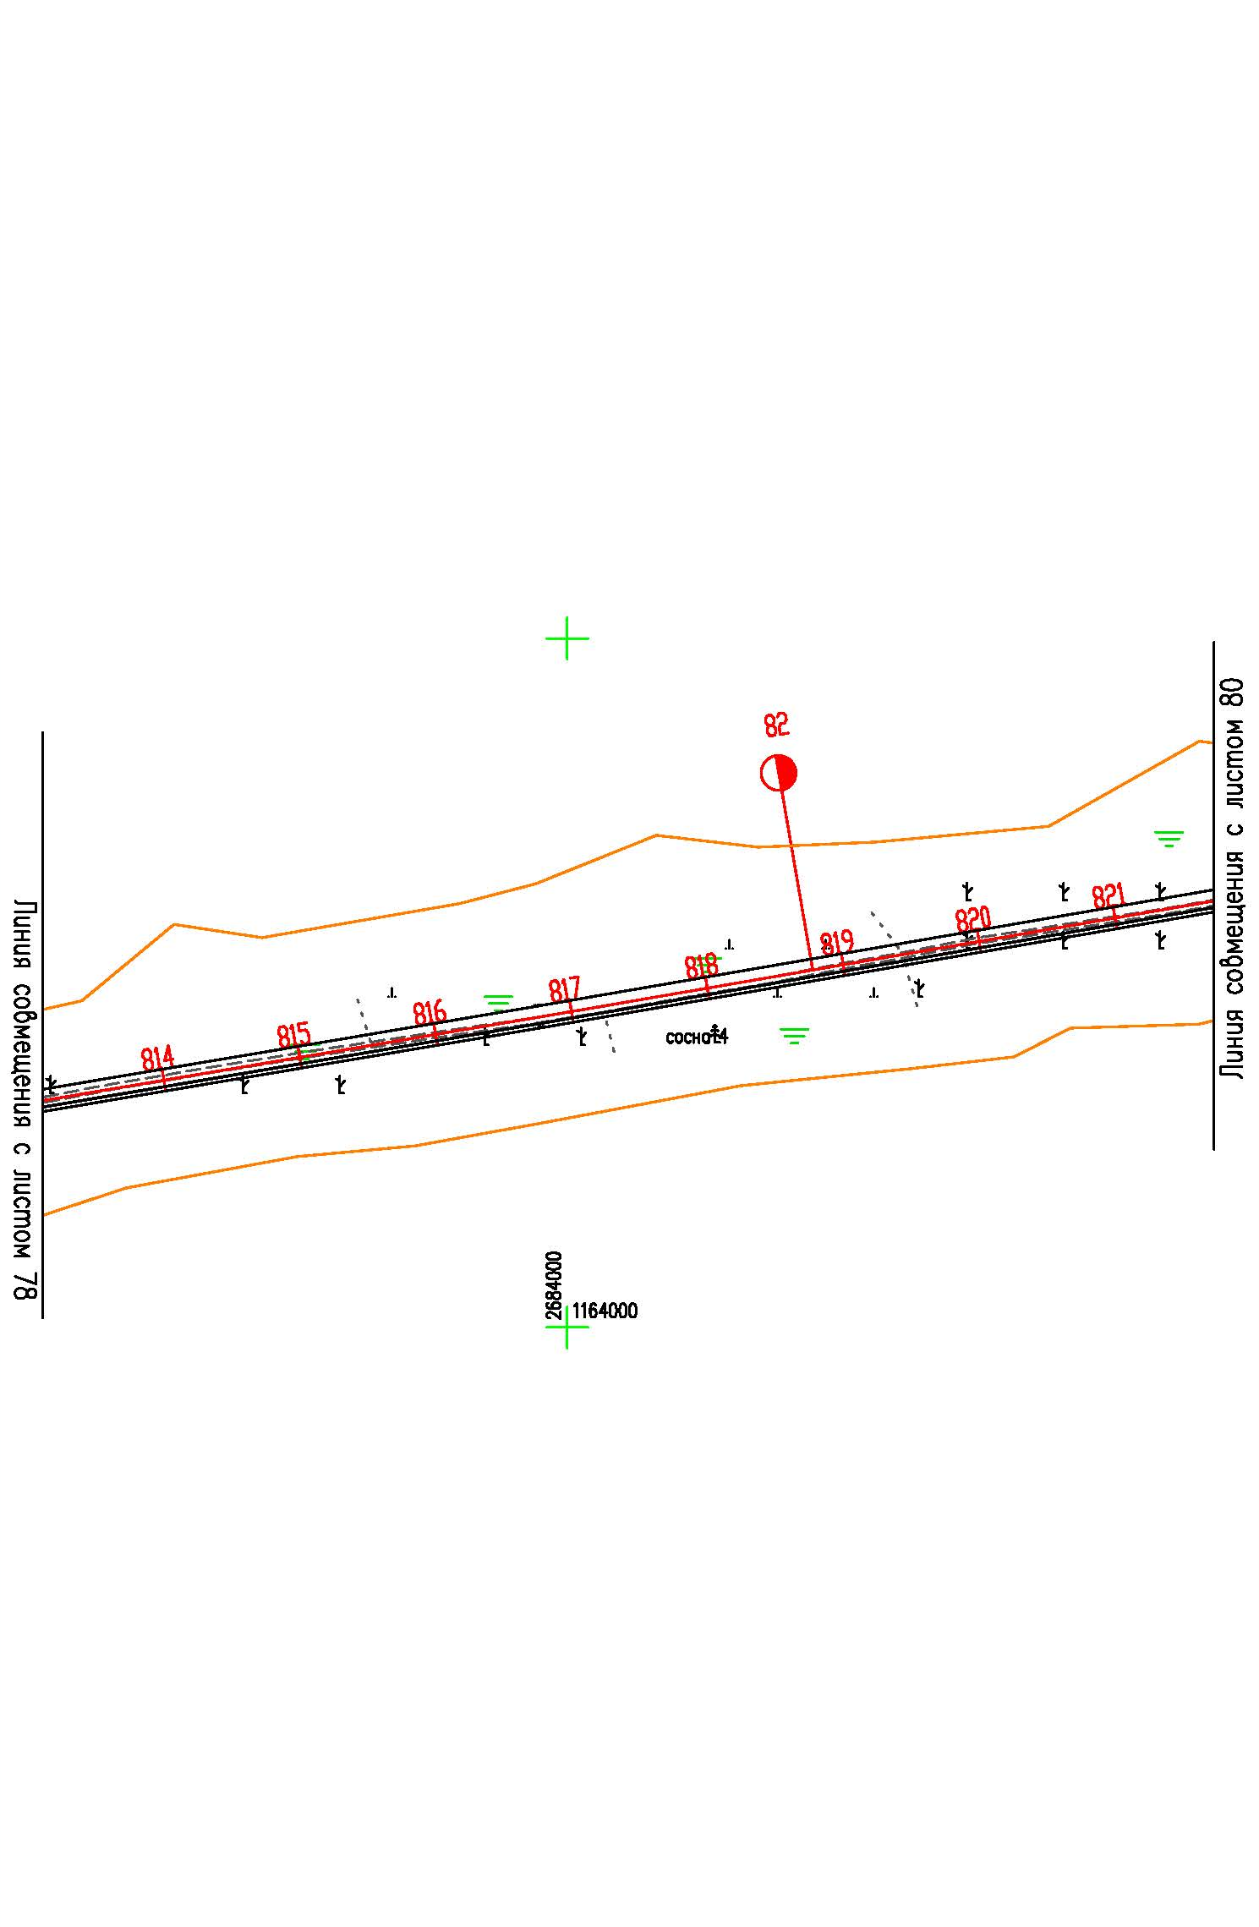

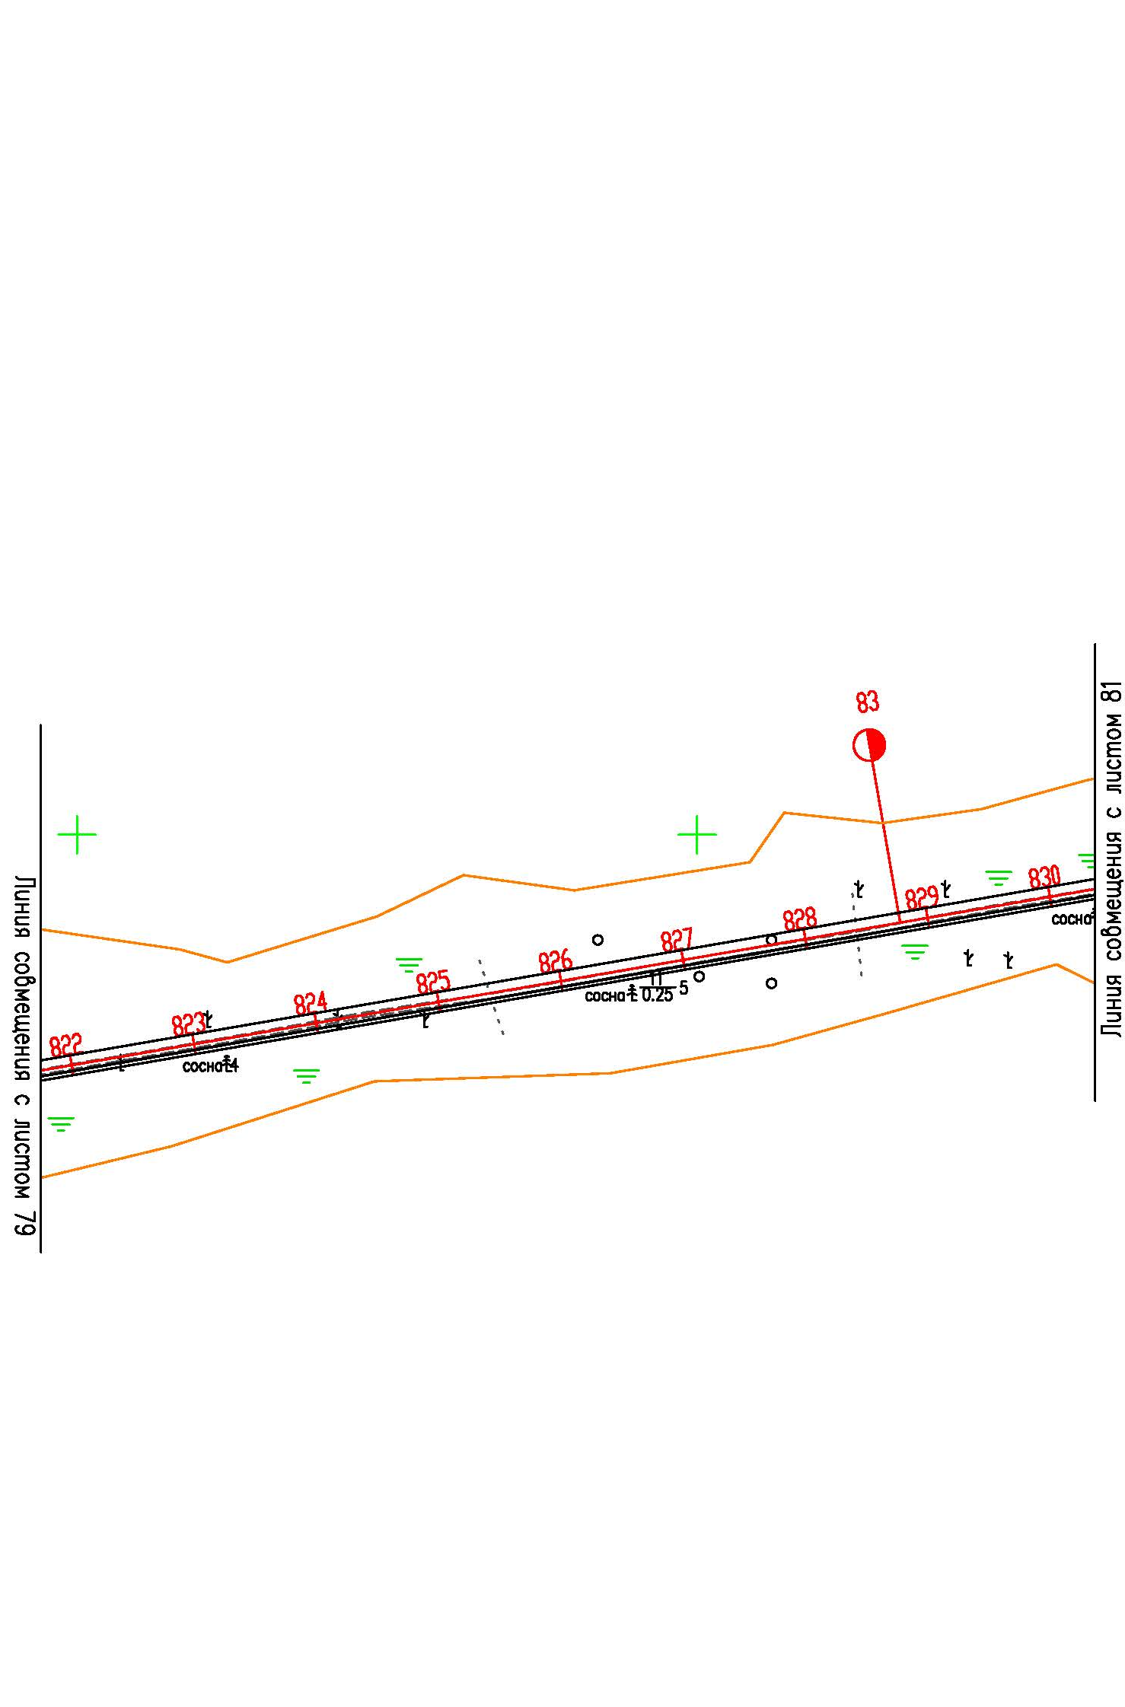

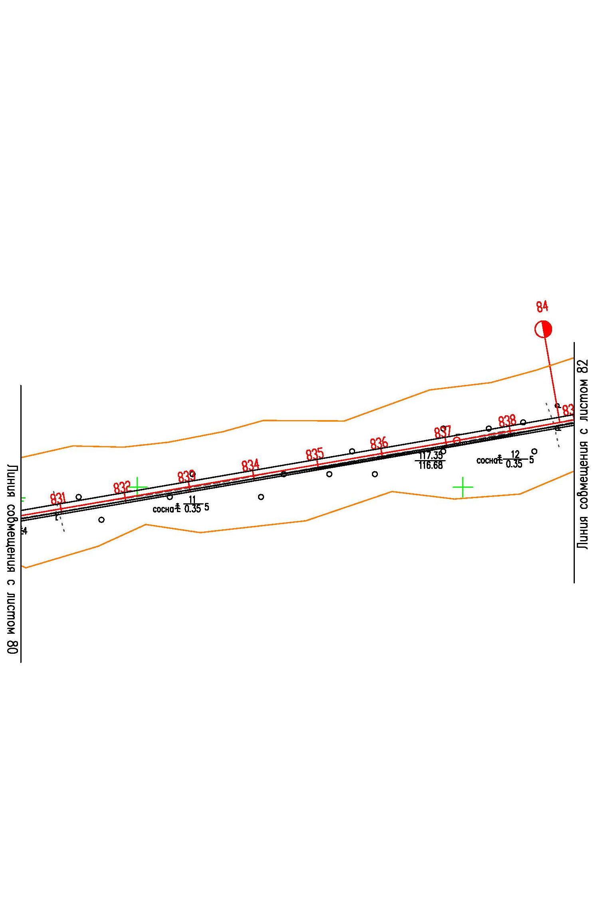

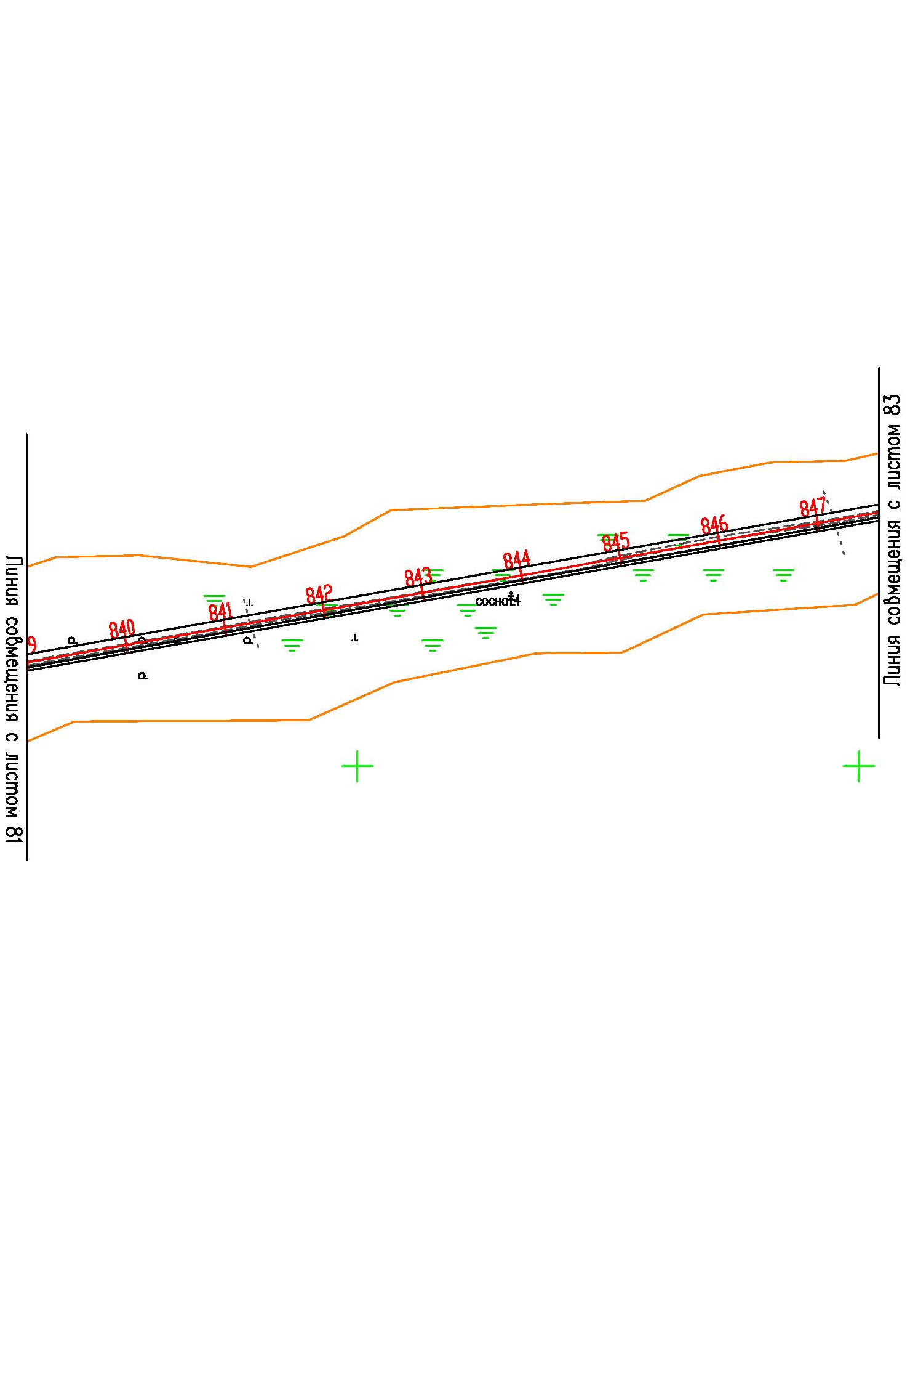

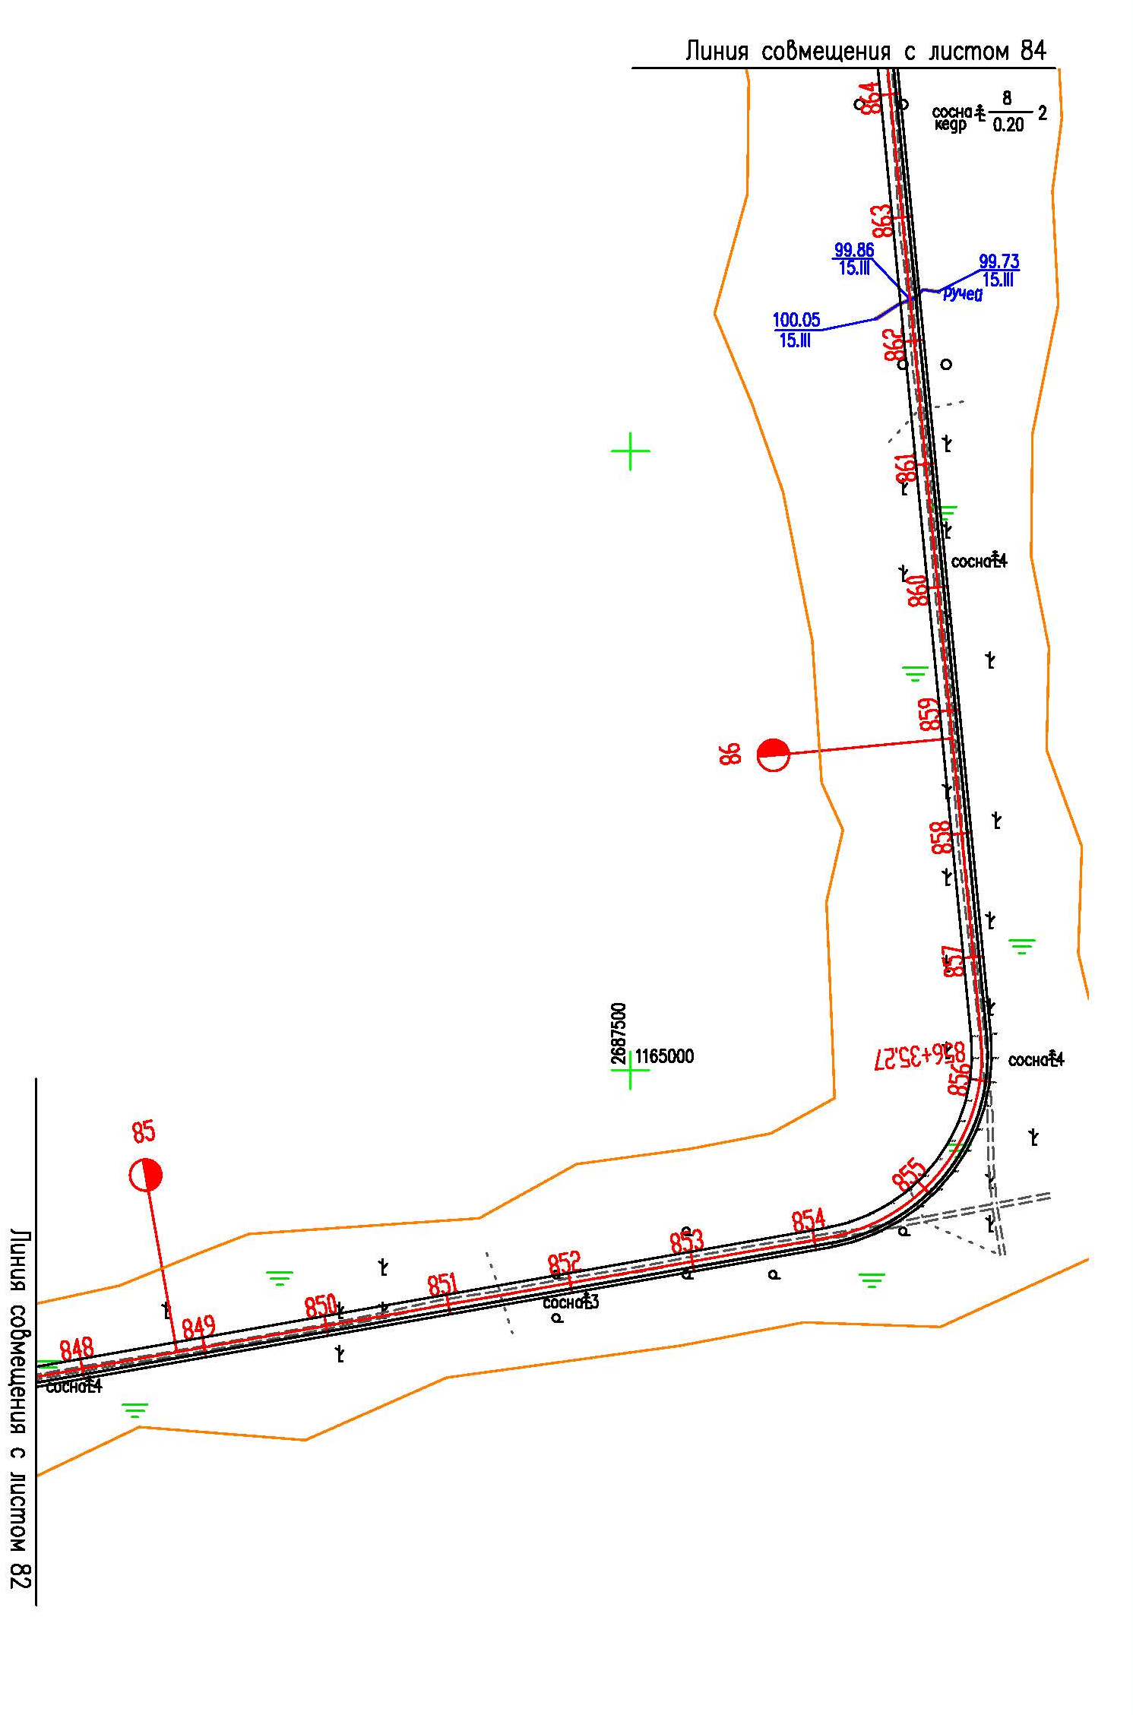

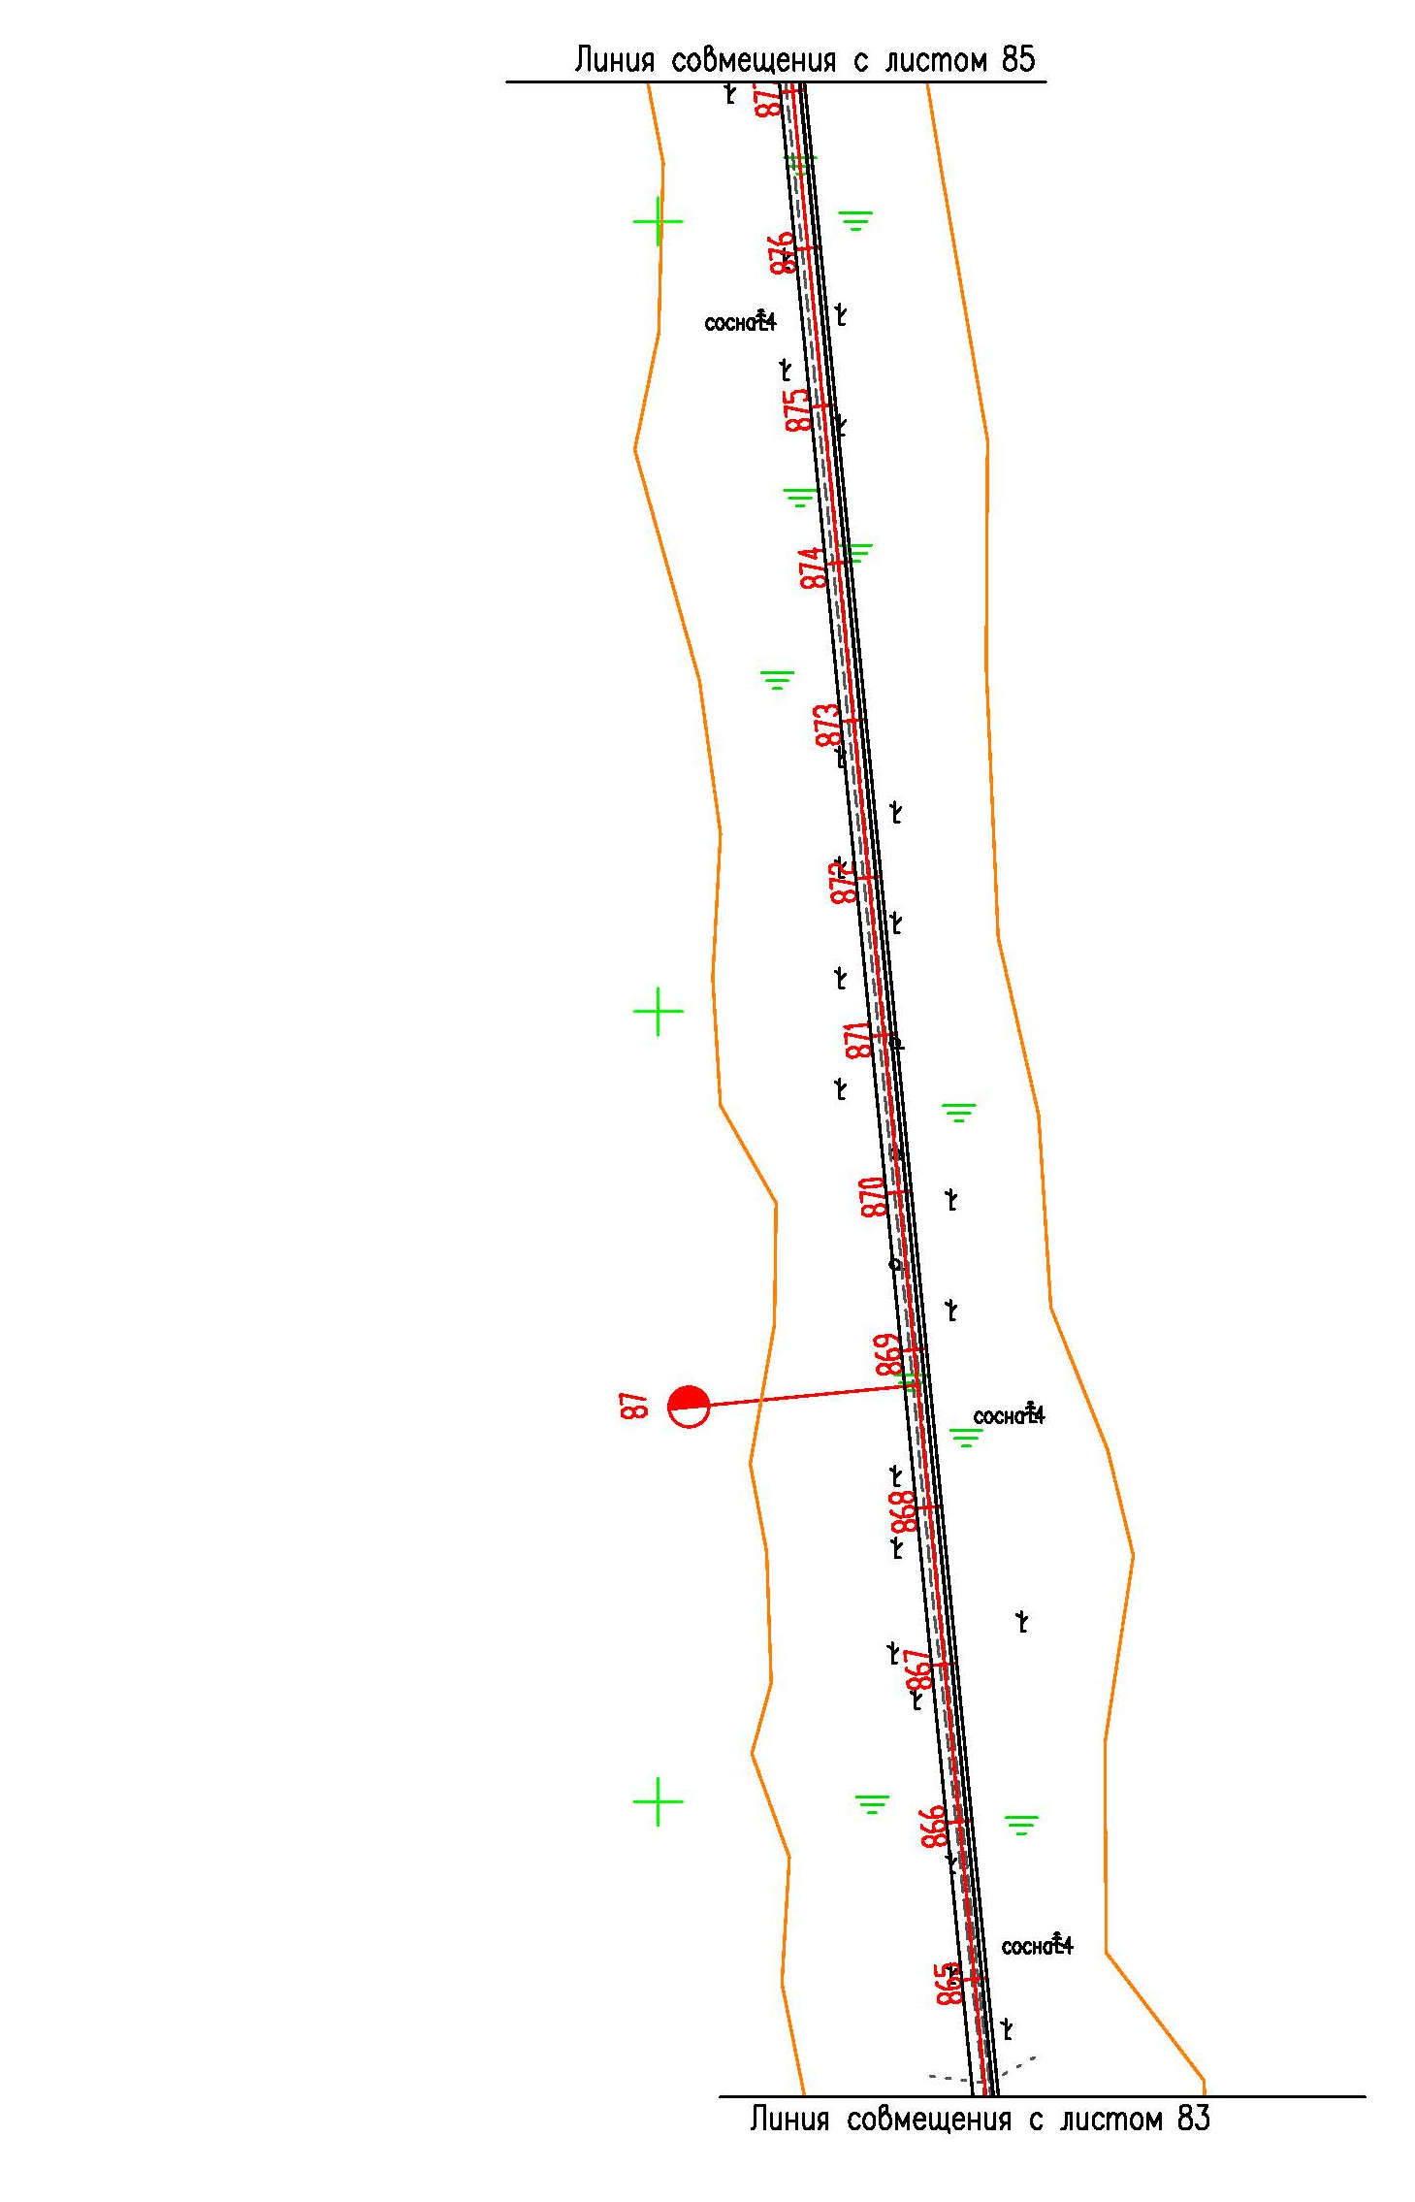

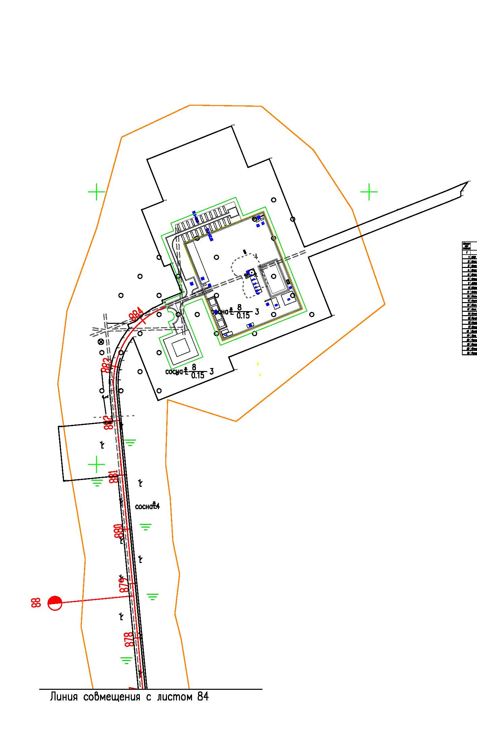

Каталог характерных точек устанавливаемых красных линий
N | X | Y
1 | 1134630,91 | 2643720,89
2 | 1135805,91 | 2644115,83
3 | 1135845,10 | 2644131,76
4 | 1135881,96 | 2644152,35
5 | 1135915,99 | 2644177,33
6 | 1135946,69 | 2644206,30
7 | 1135973,60 | 2644238,84
8 | 1135996,33 | 2644274,53
9 | 1136033,90 | 2644342,42
10 | 1136104,46 | 2644469,95
11 | 1136126,90 | 2644505,41
12 | 1136153,40 | 2644538,06
13 | 1136183,54 | 2644567,38
14 | 1136216,85 | 2644592,91
15 | 1136506,66 | 2644789,16
16 | 1136538,42 | 2644813,49
17 | 1136567,07 | 2644841,29
18 | 1136592,34 | 2644872,30
19 | 1137333,18 | 2645898,67
20 | 1137353,76 | 2645930,81
21 | 1137370,60 | 2645964,96
22 | 1137383,54 | 2646000,77
23 | 1137392,44 | 2646037,88
24 | 1137504,83 | 2646656,84
25 | 1137510,72 | 2646680,97
26 | 1137519,49 | 2646704,31
27 | 1137530,99 | 2646726,43
28 | 1137545,06 | 2646747,03
29 | 1137561,50 | 2646765,78
30 | 1137580,04 | 2646782,43
31 | 1137600,46 | 2646796,75
32 | 1137622,44 | 2646808,52
33 | 1137645,58 | 2646817,54
34 | 1137709,63 | 2646838,17
35 | 1137731,04 | 2646846,51
36 | 1137751,21 | 2646857,28
37 | 1137769,96 | 2646870,38
38 | 1137787,03 | 2646885,62
39 | 1137802,15 | 2646902,78
40 | 1137815,18 | 2646921,69
41 | 1138108,08 | 2647406,13
42 | 1138131,86 | 2647440,70
43 | 1138159,58 | 2647472,32
44 | 1138190,83 | 2647500,45
45 | 1138225,15 | 2647524,73
46 | 1138262,01 | 2647544,78
47 | 1138564,04 | 2647686,76
48 | 1138590,80 | 2647700,82
49 | 1138616,16 | 2647717,13
50 | 1138640,04 | 2647735,67
51 | 1138749,64 | 2647828,74
52 | 1138939,69 | 2648002,45
53 | 1138964,52 | 2648027,61
54 | 1138986,57 | 2648055,14
55 | 1139005,72 | 2648084,86
56 | 1139093,28 | 2648237,53
57 | 1139118,68 | 2648275,87
58 | 1139148,87 | 2648310,70
59 | 1139183,20 | 2648341,31
60 | 1139273,83 | 2648412,16
61 | 1139297,94 | 2648432,88
62 | 1139320,03 | 2648455,74
63 | 1139358,06 | 2648498,95
64 | 1139452,82 | 2648606,63
65 | 1139481,64 | 2648635,82
66 | 1139492,09 | 2648644,22
67 | 1139513,68 | 2648661,56
68 | 1139545,51 | 2648681,60
69 | 1139548,40 | 2648683,42
70 | 1139653,40 | 2648741,39
71 | 1139676,75 | 2648752,44
72 | 1139701,38 | 2648760,53
73 | 1139726,83 | 2648765,49
74 | 1139752,69 | 2648767,25
75 | 1139778,58 | 2648765,78
76 | 1139803,99 | 2648761,12
77 | 1140146,15 | 2648675,99
78 | 1140184,76 | 2648664,03
79 | 1140221,76 | 2648647,79
80 | 1140505,85 | 2648503,40
81 | 1140522,01 | 2648496,41
82 | 1140538,82 | 2648491,48
83 | 1140556,12 | 2648488,67
84 | 1140573,61 | 2648488,00
85 | 1140591,07 | 2648489,49
86 | 1140608,20 | 2648493,12
87 | 1140624,76 | 2648498,83
88 | 1140640,49 | 2648506,54
89 | 1140655,15 | 2648516,12
90 | 1140668,53 | 2648527,44
91 | 1140680,46 | 2648540,38
92 | 1140793,24 | 2648678,94
93 | 1140802,93 | 2648692,36
94 | 1140810,97 | 2648706,74
95 | 1140817,26 | 2648721,95
96 | 1140821,77 | 2648737,79
97 | 1140824,42 | 2648754,04
98 | 1140825,15 | 2648770,58
99 | 1140822,33 | 2648988,87
100 | 1140823,69 | 2649015,42
101 | 1140828,47 | 2649041,68
102 | 1140836,55 | 2649067,11
103 | 1140847,83 | 2649091,30
104 | 1140862,11 | 2649113,84
105 | 1140879,10 | 2649134,29
106 | 1140922,73 | 2649180,44
107 | 1140940,22 | 2649196,91
108 | 1140959,57 | 2649211,30
109 | 1140980,45 | 2649223,35
110 | 1141002,59 | 2649232,91
111 | 1141025,68 | 2649239,84
112 | 1141049,33 | 2649244,03
113 | 1141295,13 | 2649273,05
114 | 1141587,45 | 2649307,58
115 | 1141623,24 | 2649310,00
116 | 1141659,17 | 2649308,81
117 | 1141694,74 | 2649304,03
118 | 1141844,12 | 2649276,25
119 | 1141882,57 | 2649271,33
120 | 1141921,26 | 2649270,79
121 | 1141959,74 | 2649274,62
122 | 1141997,55 | 2649282,76
123 | 1142034,20 | 2649295,13
124 | 1142069,22 | 2649311,56
125 | 1142102,25 | 2649331,88
126 | 1142475,76 | 2649592,01
127 | 1142504,15 | 2649609,87
128 | 1142534,15 | 2649625,01
129 | 1142565,37 | 2649637,25
130 | 1143042,94 | 2649799,04
131 | 1143079,64 | 2649813,88
132 | 1143114,30 | 2649832,81
133 | 1143146,54 | 2649855,61
134 | 1143176,01 | 2649882,04
135 | 1144402,48 | 2651116,93
136 | 1144431,25 | 2651142,92
137 | 1144650,96 | 2651320,59
138 | 1144668,36 | 2651335,66
139 | 1144684,72 | 2651351,86
140 | 1144967,31 | 2651651,34
141 | 1144993,03 | 2651681,99
142 | 1145014,94 | 2651715,36
143 | 1145032,86 | 2651751,13
144 | 1145128,09 | 2651972,64
145 | 1145143,76 | 2652004,60
146 | 1145162,58 | 2652034,91
147 | 1145184,31 | 2652063,19
148 | 1145208,70 | 2652089,11
149 | 1146077,67 | 2652925,08
150 | 1146104,19 | 2652953,67
151 | 1146419,42 | 2653334,71
152 | 1146446,50 | 2653363,94
153 | 1146476,71 | 2653390,03
154 | 1146509,57 | 2653412,56
155 | 1147070,92 | 2653752,78
156 | 1147099,17 | 2653771,89
157 | 1147515,57 | 2654084,69
158 | 1147516,74 | 2654085,58
159 | 1147931,86 | 2654394,73
160 | 1147945,35 | 2654405,45
161 | 1147955,52 | 2654414,19
162 | 1147968,23 | 2654426,38
163 | 1147979,88 | 2654438,62
164 | 1147990,21 | 2654450,57
165 | 1148000,53 | 2654463,83
166 | 1148010,06 | 2654477,21
167 | 1148018,74 | 2654491,23
168 | 1148027,44 | 2654506,01
169 | 1148034,44 | 2654520,00
170 | 1148041,37 | 2654535,23
171 | 1148047,34 | 2654550,71
172 | 1148052,64 | 2654566,31
173 | 1148057,19 | 2654582,16
174 | 1148060,92 | 2654598,46
175 | 1148063,92 | 2654615,24
176 | 1148066,06 | 2654631,04
177 | 1148067,47 | 2654647,70
178 | 1148117,92 | 2655499,98
179 | 1148118,41 | 2655514,94
180 | 1148118,13 | 2655529,77
181 | 1148117,18 | 2655544,47
182 | 1148115,43 | 2655559,26
183 | 1148112,87 | 2655573,96
184 | 1148109,68 | 2655588,21
185 | 1148105,54 | 2655602,74
186 | 1148100,95 | 2655616,79
187 | 1148076,03 | 2655685,61
188 | 1148073,18 | 2655694,64
189 | 1148071,11 | 2655704,04
190 | 1148069,89 | 2655713,62
191 | 1148069,60 | 2655723,32
192 | 1148070,13 | 2655732,98
193 | 1148071,50 | 2655742,33
194 | 1148073,62 | 2655751,70
195 | 1148076,64 | 2655760,58
196 | 1148080,45 | 2655769,32
197 | 1148084,97 | 2655778,05
198 | 1148090,45 | 2655786,21
199 | 1148096,72 | 2655793,97
200 | 1148103,06 | 2655800,48
201 | 1148109,95 | 2655806,58
202 | 1148118,00 | 2655812,39
203 | 1148125,97 | 2655817,30
204 | 1148134,92 | 2655821,59
205 | 1148143,69 | 2655824,90
206 | 1148152,93 | 2655827,51
207 | 1148162,37 | 2655829,30
208 | 1148172,07 | 2655830,18
209 | 1148181,47 | 2655830,28
210 | 1148214,56 | 2655829,16
211 | 1148457,50 | 2655820,14
212 | 1149433,25 | 2655784,31
213 | 1149474,74 | 2655785,30
214 | 1149515,71 | 2655791,28
215 | 1149555,67 | 2655802,18
216 | 1149594,01 | 2655817,82
217 | 1149630,18 | 2655837,98
218 | 1149663,72 | 2655862,42
219 | 1150034,68 | 2656168,74
220 | 1150063,76 | 2656195,74
221 | 1150089,48 | 2656225,85
222 | 1150111,58 | 2656258,80
223 | 1150429,86 | 2656798,27
224 | 1150453,83 | 2656833,83
225 | 1150992,83 | 2657537,88
226 | 1151017,06 | 2657574,11
227 | 1151036,47 | 2657613,05
228 | 1151050,81 | 2657654,22
229 | 1151220,97 | 2658265,42
230 | 1151229,29 | 2658303,59
231 | 1151338,96 | 2658993,14
232 | 1151349,05 | 2659037,83
233 | 1151364,80 | 2659080,96
234 | 1151385,95 | 2659121,71
235 | 1151412,08 | 2659159,35
236 | 1151540,55 | 2659321,15
237 | 1151563,00 | 2659352,99
238 | 1151581,66 | 2659387,08
239 | 1151596,31 | 2659423,08
240 | 1151606,79 | 2659460,50
241 | 1151612,96 | 2659498,87
242 | 1151614,74 | 2659537,70
243 | 1151612,09 | 2659576,56
244 | 1151532,87 | 2660207,62
245 | 1151530,11 | 2660248,82
246 | 1151532,12 | 2660290,15
247 | 1151538,88 | 2660330,97
248 | 1151550,31 | 2660370,74
249 | 1151566,25 | 2660408,92
250 | 1151586,45 | 2660444,93
251 | 1151795,70 | 2660772,13
252 | 1151816,11 | 2660800,84
253 | 1151839,30 | 2660827,43
254 | 1151865,00 | 2660851,63
255 | 1151892,90 | 2660873,13
256 | 1152129,21 | 2661037,36
257 | 1152149,42 | 2661050,42
258 | 1152170,46 | 2661062,09
259 | 1152511,43 | 2661236,41
260 | 1152538,43 | 2661251,79
261 | 1152563,86 | 2661269,52
262 | 1152587,64 | 2661289,52
263 | 1152842,29 | 2661524,25
264 | 1152869,80 | 2661547,16
265 | 1152899,47 | 2661567,21
266 | 1153487,53 | 2661923,05
267 | 1153518,97 | 2661944,55
268 | 1153547,78 | 2661969,36
269 | 1153573,70 | 2661997,27
270 | 1154181,37 | 2662729,05
271 | 1154202,14 | 2662756,81
272 | 1154219,97 | 2662786,46
273 | 1154234,74 | 2662817,83
274 | 1154322,10 | 2663030,74
275 | 1154337,08 | 2663062,65
276 | 1154355,16 | 2663092,99
277 | 1154376,10 | 2663121,34
278 | 1154676,18 | 2663488,28
279 | 1154691,87 | 2663506,22
280 | 1154708,73 | 2663523,07
281 | 1155166,46 | 2663951,06
282 | 1155188,41 | 2663969,98
283 | 1155211,83 | 2663987,06
284 | 1155801,25 | 2664381,31
285 | 1155837,73 | 2664402,70
286 | 1155876,56 | 2664419,67
287 | 1155917,12 | 2664431,92
288 | 1155958,87 | 2664439,30
289 | 1156001,17 | 2664441,70
290 | 1156043,38 | 2664439,08
291 | 1157272,89 | 2664289,41
292 | 1157296,96 | 2664288,00
293 | 1157320,93 | 2664289,60
294 | 1157344,51 | 2664294,19
295 | 1157367,34 | 2664301,68
296 | 1157389,05 | 2664311,96
297 | 1157409,31 | 2664324,89
298 | 1157427,80 | 2664340,22
299 | 1157444,22 | 2664357,75
300 | 1157458,33 | 2664377,20
301 | 1157469,90 | 2664398,26
302 | 1157478,75 | 2664420,59
303 | 1157484,75 | 2664443,86
304 | 1157487,78 | 2664467,78
305 | 1157580,45 | 2665910,65
306 | 1157585,45 | 2665951,51
307 | 1157595,13 | 2665991,61
308 | 1157609,35 | 2666030,24
309 | 1157677,04 | 2666186,02
310 | 1157691,44 | 2666225,67
311 | 1157700,84 | 2666266,70
312 | 1157705,13 | 2666308,57
313 | 1157704,25 | 2666350,65
314 | 1157698,18 | 2666392,40
315 | 1157632,26 | 2666708,21
316 | 1157627,17 | 2666739,44
317 | 1157624,87 | 2666771,06
318 | 1157625,36 | 2666802,70
319 | 1157694,90 | 2667960,79
320 | 1157697,18 | 2667979,65
321 | 1157701,75 | 2667998,18
322 | 1157708,51 | 2668016,03
323 | 1157717,37 | 2668032,93
324 | 1157728,21 | 2668048,64
325 | 1157740,87 | 2668062,93
326 | 1157755,15 | 2668075,59
327 | 1157770,87 | 2668086,44
328 | 1157787,77 | 2668095,31
329 | 1157805,61 | 2668102,08
330 | 1157824,14 | 2668106,64
331 | 1157843,10 | 2668108,94
332 | 1157862,08 | 2668108,94
333 | 1161387,09 | 2667895,28
334 | 1161410,64 | 2667895,31
335 | 1161433,93 | 2667898,17
336 | 1161456,69 | 2667903,87
337 | 1161478,58 | 2667912,29
338 | 1161499,28 | 2667923,33
339 | 1161518,49 | 2667936,81
340 | 1161535,90 | 2667952,53
341 | 1161551,27 | 2667970,25
342 | 1161564,37 | 2667989,72
343 | 1161575,00 | 2668010,64
344 | 1161582,98 | 2668032,70
345 | 1161588,23 | 2668055,65
346 | 1162101,89 | 2671157,87
347 | 1162109,71 | 2671193,62
348 | 1162121,19 | 2671228,47
349 | 1162136,15 | 2671261,96
350 | 1162154,43 | 2671293,67
351 | 1162359,48 | 2671610,71
352 | 1162374,74 | 2671636,75
353 | 1162387,62 | 2671663,97
354 | 1162398,08 | 2671692,28
355 | 1162540,14 | 2672135,92
356 | 1162550,49 | 2672176,73
357 | 1162555,75 | 2672218,43
358 | 1162555,85 | 2672260,46
359 | 1162550,79 | 2672302,26
360 | 1162539,14 | 2672365,59
361 | 1162533,87 | 2672387,18
362 | 1162526,18 | 2672407,94
363 | 1162516,14 | 2672427,67
364 | 1162503,91 | 2672446,12
365 | 1162489,63 | 2672463,04
366 | 1162473,50 | 2672478,20
367 | 1162455,65 | 2672491,45
368 | 1162426,42 | 2672510,66
369 | 1162405,19 | 2672526,64
370 | 1162386,12 | 2672545,28
371 | 1162369,58 | 2672566,21
372 | 1162355,86 | 2672589,07
373 | 1162345,18 | 2672613,49
374 | 1162337,71 | 2672639,09
375 | 1162333,58 | 2672665,43
376 | 1162332,85 | 2672692,09
377 | 1162335,52 | 2672718,52
378 | 1163563,27 | 2680090,80
379 | 1163563,37 | 2680091,36
380 | 1164216,78 | 2683977,17
381 | 1164217,01 | 2683978,54
382 | 1164563,51 | 2685991,14
383 | 1164563,73 | 2685992,38
384 | 1164857,08 | 2687661,06
385 | 1164861,65 | 2687680,06
386 | 1164868,58 | 2687698,44
387 | 1164877,74 | 2687715,82
388 | 1164888,98 | 2687731,93
389 | 1164902,14 | 2687746,51
390 | 1164917,00 | 2687759,35
391 | 1164933,34 | 2687770,25
392 | 1164950,91 | 2687779,04
393 | 1164969,43 | 2687785,59
394 | 1164988,61 | 2687789,77
395 | 1165008,18 | 2687791,56
396 | 1165027,72 | 2687790,89
397 | 1167635,55 | 2687540,02
398 | 1167653,73 | 2687539,44
399 | 1167671,73 | 2687541,16
400 | 1167689,37 | 2687545,16
401 | 1167706,36 | 2687551,36
402 | 1167722,43 | 2687559,68
403 | 1167732,82 | 2687566,86
404 | 1167617,18 | 2687612,90
405 | 1167672,67 | 2687752,26
406 | 1167696,83 | 2687742,65
407 | 1167772,09 | 2687931,68
408 | 1167880,21 | 2687888,63
409 | 1167947,70 | 2688058,13
410 | 1167984,22 | 2688151,29
411 | 1167991,51 | 2688168,31
412 | 1168000,52 | 2688168,35
413 | 1168018,19 | 2688180,87
414 | 1168012,58 | 2688166,70
415 | 1168002,74 | 2688143,69
416 | 1167966,32 | 2688050,78
417 | 1167898,79 | 2687881,23
418 | 1168060,60 | 2687816,81
419 | 1168044,89 | 2687777,89
420 | 1168120,99 | 2687747,59
421 | 1168059,22 | 2687592,44
422 | 1167983,04 | 2687622,77
423 | 1167967,13 | 2687582,82
424 | 1167863,08 | 2687624,25
425 | 1167867,52 | 2687635,40
426 | 1167815,25 | 2687656,21
427 | 1167800,83 | 2687619,97
428 | 1167795,75 | 2687622,00
429 | 1167786,41 | 2687602,95
430 | 1167775,33 | 2687586,13
431 | 1167762,20 | 2687570,88
432 | 1167756,54 | 2687557,42
433 | 1167750,10 | 2687559,98
434 | 1167747,24 | 2687557,41
435 | 1167730,68 | 2687545,96
436 | 1167712,82 | 2687536,70
437 | 1167693,90 | 2687529,80
438 | 1167674,27 | 2687525,35
439 | 1167654,23 | 2687523,43
440 | 1167634,21 | 2687524,09
441 | 1167578,59 | 2687529,46
442 | 1167568,96 | 2687429,93
443 | 1167469,42 | 2687439,56
444 | 1167479,05 | 2687539,01
445 | 1165026,37 | 2687774,95
446 | 1165008,64 | 2687775,54
447 | 1164991,05 | 2687773,95
448 | 1164973,81 | 2687770,19
449 | 1164957,17 | 2687764,30
450 | 1164941,38 | 2687756,40
451 | 1164926,69 | 2687746,61
452 | 1164913,34 | 2687735,07
453 | 1164901,53 | 2687721,96
454 | 1164891,41 | 2687707,48
455 | 1164883,19 | 2687691,87
456 | 1164876,97 | 2687675,35
457 | 1164872,80 | 2687658,10
458 | 1164579,49 | 2685989,62
459 | 1164579,28 | 2685988,42
460 | 1164232,78 | 2683975,83
461 | 1164232,56 | 2683974,51
462 | 1163579,15 | 2680088,71
463 | 1163579,06 | 2680088,18
464 | 1162351,34 | 2672716,08
465 | 1162348,85 | 2672691,50
466 | 1162349,52 | 2672666,89
467 | 1162353,34 | 2672642,58
468 | 1162360,23 | 2672618,95
469 | 1162370,09 | 2672596,40
470 | 1162382,76 | 2672575,30
471 | 1162398,02 | 2672555,99
472 | 1162415,62 | 2672538,79
473 | 1162435,37 | 2672523,93
474 | 1162464,59 | 2672504,73
475 | 1162483,77 | 2672490,47
476 | 1162501,24 | 2672474,05
477 | 1162516,71 | 2672455,72
478 | 1162529,97 | 2672435,74
479 | 1162540,84 | 2672414,36
480 | 1162549,18 | 2672391,87
481 | 1162554,86 | 2672368,66
482 | 1162566,56 | 2672304,97
483 | 1162571,84 | 2672261,39
484 | 1162571,74 | 2672217,40
485 | 1162566,22 | 2672173,76
486 | 1162555,43 | 2672131,21
487 | 1162413,28 | 2671687,27
488 | 1162402,38 | 2671657,77
489 | 1162388,89 | 2671629,27
490 | 1162372,99 | 2671602,13
491 | 1162167,94 | 2671285,11
492 | 1162150,41 | 2671254,69
493 | 1162136,11 | 2671222,69
494 | 1162125,16 | 2671189,42
495 | 1162117,65 | 2671155,10
496 | 1161603,99 | 2668052,86
497 | 1161598,33 | 2668028,17
498 | 1161589,68 | 2668004,28
499 | 1161578,17 | 2667981,61
500 | 1161564,00 | 2667960,52
501 | 1161547,34 | 2667941,33
502 | 1161528,47 | 2667924,29
503 | 1161507,66 | 2667909,69
504 | 1161485,23 | 2667897,73
505 | 1161461,51 | 2667888,60
506 | 1161436,86 | 2667882,43
507 | 1161411,63 | 2667879,32
508 | 1161386,31 | 2667879,30
509 | 1157861,29 | 2668092,96
510 | 1157844,06 | 2668092,96
511 | 1157827,02 | 2668090,90
512 | 1157810,37 | 2668086,79
513 | 1157794,33 | 2668080,71
514 | 1157779,14 | 2668072,73
515 | 1157765,04 | 2668062,99
516 | 1157752,20 | 2668051,61
517 | 1157740,82 | 2668038,77
518 | 1157731,08 | 2668024,65
519 | 1157723,11 | 2668009,46
520 | 1157717,03 | 2667993,42
521 | 1157712,93 | 2667976,77
522 | 1157710,86 | 2667959,65
523 | 1157641,33 | 2666801,87
524 | 1157640,86 | 2666771,52
525 | 1157643,06 | 2666741,31
526 | 1157647,95 | 2666711,35
527 | 1157713,88 | 2666395,49
528 | 1157720,20 | 2666351,97
529 | 1157721,14 | 2666307,92
530 | 1157716,64 | 2666264,09
531 | 1157706,81 | 2666221,14
532 | 1157691,79 | 2666179,82
533 | 1157624,08 | 2666024,02
534 | 1157610,45 | 2665986,96
535 | 1157601,20 | 2665948,65
536 | 1157596,40 | 2665909,46
537 | 1157503,74 | 2664466,57
538 | 1157500,46 | 2664440,84
539 | 1157493,97 | 2664415,64
540 | 1157484,40 | 2664391,44
541 | 1157471,86 | 2664368,63
542 | 1157456,57 | 2664347,56
543 | 1157438,78 | 2664328,56
544 | 1157418,74 | 2664311,94
545 | 1157396,80 | 2664297,95
546 | 1157373,28 | 2664286,81
547 | 1157348,54 | 2664278,69
548 | 1157322,99 | 2664273,72
549 | 1157297,02 | 2664271,99
550 | 1157271,13 | 2664273,52
551 | 1156041,62 | 2664423,18
552 | 1156001,12 | 2664425,69
553 | 1155960,70 | 2664423,40
554 | 1155920,84 | 2664416,35
555 | 1155882,09 | 2664404,64
556 | 1155844,99 | 2664388,44
557 | 1155810,00 | 2664367,91
558 | 1155220,84 | 2663973,83
559 | 1155198,37 | 2663957,44
560 | 1155177,31 | 2663939,29
561 | 1154719,73 | 2663511,45
562 | 1154703,56 | 2663495,28
563 | 1154688,50 | 2663478,07
564 | 1154388,59 | 2663111,33
565 | 1154368,49 | 2663084,13
566 | 1154351,22 | 2663055,14
567 | 1154336,85 | 2663024,53
568 | 1154249,49 | 2662811,62
569 | 1154234,09 | 2662778,92
570 | 1154215,43 | 2662747,88
571 | 1154193,78 | 2662718,95
572 | 1153585,90 | 2661986,92
573 | 1153558,87 | 2661957,83
574 | 1153528,72 | 2661931,86
575 | 1153495,95 | 2661909,45
576 | 1152907,87 | 2661553,60
577 | 1152879,43 | 2661534,36
578 | 1152853,03 | 2661512,38
579 | 1152598,38 | 2661277,67
580 | 1152573,59 | 2661256,82
581 | 1152546,97 | 2661238,26
582 | 1152518,83 | 2661222,23
583 | 1152177,84 | 2661047,89
584 | 1152157,65 | 2661036,70
585 | 1152138,26 | 2661024,17
586 | 1151902,14 | 2660860,07
587 | 1151875,38 | 2660839,45
588 | 1151850,83 | 2660816,33
589 | 1151828,68 | 2660790,92
590 | 1151809,10 | 2660763,39
591 | 1151600,03 | 2660436,46
592 | 1151580,64 | 2660401,91
593 | 1151565,42 | 2660365,43
594 | 1151554,50 | 2660327,44
595 | 1151548,05 | 2660288,45
596 | 1151546,12 | 2660248,97
597 | 1151548,77 | 2660209,44
598 | 1151627,99 | 2659578,39
599 | 1151630,74 | 2659537,88
600 | 1151628,89 | 2659497,24
601 | 1151622,43 | 2659457,07
602 | 1151611,47 | 2659417,89
603 | 1151596,11 | 2659380,21
604 | 1151576,58 | 2659344,51
605 | 1151553,18 | 2659311,33
606 | 1151424,73 | 2659149,55
607 | 1151399,66 | 2659113,44
608 | 1151379,47 | 2659074,51
609 | 1151364,41 | 2659033,31
610 | 1151354,74 | 2658990,43
611 | 1151245,07 | 2658300,91
612 | 1151236,43 | 2658261,29
613 | 1151066,17 | 2657649,74
614 | 1151051,22 | 2657606,83
615 | 1151030,92 | 2657566,07
616 | 1151005,64 | 2657528,31
617 | 1150466,64 | 2656824,26
618 | 1150443,55 | 2656789,99
619 | 1150125,27 | 2656250,52
620 | 1150102,23 | 2656216,17
621 | 1150075,31 | 2656184,65
622 | 1150045,00 | 2656156,53
623 | 1149673,77 | 2655849,97
624 | 1149638,81 | 2655824,49
625 | 1149600,94 | 2655803,39
626 | 1149560,82 | 2655787,01
627 | 1149518,98 | 2655775,61
628 | 1149476,09 | 2655769,34
629 | 1149432,84 | 2655768,32
630 | 1148457,09 | 2655804,14
631 | 1148181,03 | 2655814,28
632 | 1148172,31 | 2655814,16
633 | 1148164,02 | 2655813,39
634 | 1148155,50 | 2655811,69
635 | 1148147,26 | 2655809,21
636 | 1148139,43 | 2655806,10
637 | 1148131,89 | 2655802,12
638 | 1148124,62 | 2655797,49
639 | 1148117,73 | 2655792,21
640 | 1148111,64 | 2655786,43
641 | 1148105,83 | 2655779,96
642 | 1148100,73 | 2655772,95
643 | 1148096,51 | 2655765,78
644 | 1148092,80 | 2655758,26
645 | 1148089,93 | 2655750,34
646 | 1148087,62 | 2655741,84
647 | 1148086,25 | 2655733,41
648 | 1148085,61 | 2655725,02
649 | 1148085,80 | 2655716,10
650 | 1148086,76 | 2655707,69
651 | 1148088,50 | 2655699,34
652 | 1148091,11 | 2655690,94
653 | 1148116,03 | 2655622,16
654 | 1148120,95 | 2655607,38
655 | 1148125,17 | 2655591,97
656 | 1148128,54 | 2655577,24
657 | 1148131,10 | 2655562,11
658 | 1148132,87 | 2655546,42
659 | 1148134,09 | 2655530,48
660 | 1148133,60 | 2655494,59
661 | 1148131,64 | 2655461,01
662 | 1148084,34 | 2654662,28
663 | 1148083,17 | 2654644,67
664 | 1148081,91 | 2654628,91
665 | 1148079,60 | 2654612,13
666 | 1148076,61 | 2654595,18
667 | 1148072,58 | 2654578,12
668 | 1148067,90 | 2654561,82
669 | 1148065,24 | 2654553,52
670 | 1148062,21 | 2654544,79
671 | 1148056,13 | 2654529,28
672 | 1148049,24 | 2654513,94
673 | 1148044,49 | 2654504,51
674 | 1148039,43 | 2654494,93
675 | 1148032,67 | 2654483,03
676 | 1148024,30 | 2654469,98
677 | 1148013,59 | 2654454,72
678 | 1148002,79 | 2654440,77
679 | 1147991,25 | 2654427,31
680 | 1147979,58 | 2654415,16
681 | 1147966,66 | 2654402,82
682 | 1147952,06 | 2654390,28
683 | 1147941,57 | 2654382,01
684 | 1147526,31 | 2654072,75
685 | 1147525,16 | 2654071,89
686 | 1147108,66 | 2653759,01
687 | 1147079,34 | 2653739,18
688 | 1146518,01 | 2653398,97
689 | 1146486,48 | 2653377,35
690 | 1146457,61 | 2653352,43
691 | 1146431,64 | 2653324,38
692 | 1146116,42 | 2652943,34
693 | 1146088,88 | 2652913,67
694 | 1145219,91 | 2652077,69
695 | 1145196,50 | 2652052,81
696 | 1145175,74 | 2652025,79
697 | 1145157,77 | 2651996,84
698 | 1145142,73 | 2651966,18
699 | 1145047,50 | 2651744,65
700 | 1145028,83 | 2651707,36
701 | 1145005,87 | 2651672,43
702 | 1144979,07 | 2651640,48
703 | 1144696,29 | 2651340,81
704 | 1144679,24 | 2651323,92
705 | 1144661,09 | 2651308,21
706 | 1144441,44 | 2651130,58
707 | 1144413,71 | 2651105,54
708 | 1143187,24 | 2649870,64
709 | 1143156,52 | 2649843,10
710 | 1143122,77 | 2649819,23
711 | 1143086,49 | 2649799,41
712 | 1143048,25 | 2649783,94
713 | 1142570,63 | 2649622,14
714 | 1142540,68 | 2649610,40
715 | 1142512,03 | 2649595,93
716 | 1142484,80 | 2649578,80
717 | 1142111,24 | 2649318,65
718 | 1142076,83 | 2649297,47
719 | 1142040,18 | 2649280,27
720 | 1142001,80 | 2649267,33
721 | 1141962,22 | 2649258,80
722 | 1141921,94 | 2649254,79
723 | 1141881,44 | 2649255,36
724 | 1141841,36 | 2649260,49
725 | 1141691,95 | 2649288,27
726 | 1141657,84 | 2649292,85
727 | 1141623,52 | 2649293,99
728 | 1141589,18 | 2649291,68
729 | 1141293,68 | 2649256,78
730 | 1141051,38 | 2649228,16
731 | 1141029,38 | 2649224,26
732 | 1141008,07 | 2649217,86
733 | 1140987,64 | 2649209,04
734 | 1140968,36 | 2649197,92
735 | 1140950,50 | 2649184,64
736 | 1140934,24 | 2649169,32
737 | 1140890,86 | 2649123,44
738 | 1140875,06 | 2649104,42
739 | 1140861,89 | 2649083,61
740 | 1140851,47 | 2649061,29
741 | 1140844,00 | 2649037,82
742 | 1140839,61 | 2649013,58
743 | 1140838,34 | 2648988,88
744 | 1140841,16 | 2648770,61
745 | 1140840,33 | 2648752,39
746 | 1140837,40 | 2648734,31
747 | 1140832,38 | 2648716,68
748 | 1140825,37 | 2648699,76
749 | 1140816,43 | 2648683,76
750 | 1140805,76 | 2648668,98
751 | 1140692,75 | 2648530,14
752 | 1140679,60 | 2648515,88
753 | 1140664,73 | 2648503,28
754 | 1140648,41 | 2648492,62
755 | 1140630,90 | 2648484,04
756 | 1140612,48 | 2648477,69
757 | 1140593,41 | 2648473,65
758 | 1140573,99 | 2648471,99
759 | 1140554,52 | 2648472,73
760 | 1140535,28 | 2648475,87
761 | 1140516,57 | 2648481,35
762 | 1140498,77 | 2648489,06
763 | 1140214,66 | 2648633,45
764 | 1140179,16 | 2648649,03
765 | 1140142,13 | 2648660,50
766 | 1139800,30 | 2648745,55
767 | 1139776,67 | 2648749,89
768 | 1139752,78 | 2648751,24
769 | 1139728,91 | 2648749,62
770 | 1139705,42 | 2648745,04
771 | 1139682,69 | 2648737,57
772 | 1139660,97 | 2648727,29
773 | 1139559,13 | 2648671,07
774 | 1139556,28 | 2648669,49
775 | 1139522,98 | 2648648,52
776 | 1139492,37 | 2648623,93
777 | 1139490,64 | 2648622,18
778 | 1139464,71 | 2648595,93
779 | 1139379,22 | 2648498,79
780 | 1139331,94 | 2648445,07
781 | 1139308,92 | 2648421,24
782 | 1139283,80 | 2648399,64
783 | 1139193,21 | 2648328,82
784 | 1139160,28 | 2648299,46
785 | 1139131,44 | 2648266,18
786 | 1139107,06 | 2648229,40
787 | 1139019,52 | 2648076,76
788 | 1138999,56 | 2648045,79
789 | 1138976,49 | 2648016,97
790 | 1138950,60 | 2647990,74
791 | 1138760,22 | 2647816,74
792 | 1138650,30 | 2647723,38
793 | 1138625,41 | 2647704,07
794 | 1138598,86 | 2647686,99
795 | 1138570,97 | 2647672,34
796 | 1138268,98 | 2647530,37
797 | 1138233,61 | 2647511,14
798 | 1138200,82 | 2647487,95
799 | 1138170,98 | 2647461,06
800 | 1138144,50 | 2647430,87
801 | 1138121,68 | 2647397,70
802 | 1137828,78 | 2646913,26
803 | 1137814,78 | 2646892,92
804 | 1137798,39 | 2646874,34
805 | 1137779,89 | 2646857,83
806 | 1137759,58 | 2646843,65
807 | 1137737,72 | 2646831,96
808 | 1137714,70 | 2646823,00
809 | 1137650,66 | 2646802,37
810 | 1137629,14 | 2646793,98
811 | 1137608,85 | 2646783,11
812 | 1137590,00 | 2646769,90
813 | 1137572,88 | 2646754,53
814 | 1137557,72 | 2646737,21
815 | 1137544,73 | 2646718,21
816 | 1137534,11 | 2646697,79
817 | 1137526,01 | 2646676,25
818 | 1137520,53 | 2646653,80
819 | 1137408,15 | 2646034,86
820 | 1137398,87 | 2645996,18
821 | 1137385,33 | 2645958,69
822 | 1137367,70 | 2645922,95
823 | 1137346,25 | 2645889,44
824 | 1136605,21 | 2644862,80
825 | 1136578,87 | 2644830,47
826 | 1136548,88 | 2644801,37
827 | 1136515,78 | 2644776,01
828 | 1136225,97 | 2644579,77
829 | 1136194,01 | 2644555,27
830 | 1136165,22 | 2644527,26
831 | 1136139,90 | 2644496,07
832 | 1136118,37 | 2644462,05
833 | 1136052,02 | 2644342,14
834 | 1136010,23 | 2644266,62
835 | 1135986,53 | 2644229,42
836 | 1135958,38 | 2644195,36
837 | 1135926,24 | 2644165,03
838 | 1135890,61 | 2644138,88
839 | 1135852,04 | 2644117,33
840 | 1135811,19 | 2644100,72
841 | 1134629,65 | 2643703,59
842 | 1134520,62 | 2643666,94
843 | 1134483,87 | 2643652,17
844 | 1134449,05 | 2643633,25
845 | 1134194,76 | 2643475,39
846 | 1134160,92 | 2643451,44
847 | 1134130,23 | 2643423,57
848 | 1133304,09 | 2642576,98
849 | 1133284,11 | 2642554,62
850 | 1133266,15 | 2642530,60
851 | 1132636,07 | 2641605,86
852 | 1132620,70 | 2641581,11
853 | 1132607,48 | 2641555,12
854 | 1132309,45 | 2640901,78
855 | 1132296,61 | 2640876,35
856 | 1132281,77 | 2640852,03
857 | 1131536,23 | 2639732,58
858 | 1131521,36 | 2639708,09
859 | 1131508,59 | 2639682,46
860 | 1131228,61 | 2639056,08
861 | 1131209,60 | 2639019,41
862 | 1131186,44 | 2638985,10
863 | 1131159,47 | 2638953,69
864 | 1131129,12 | 2638925,67
865 | 1130648,81 | 2638531,14
866 | 1130617,26 | 2638501,71
867 | 1130589,72 | 2638468,62
868 | 1130566,50 | 2638432,25
869 | 1129315,38 | 2636170,15
870 | 1129295,95 | 2636138,93
871 | 1129273,36 | 2636109,80
872 | 1129247,90 | 2636083,16
873 | 1129219,89 | 2636059,32
874 | 1128169,58 | 2635254,86
875 | 1128138,47 | 2635227,92
876 | 1127456,59 | 2634562,09
877 | 1127422,11 | 2634532,47
878 | 1127384,07 | 2634507,41
879 | 1127343,25 | 2634487,43
880 | 1126120,22 | 2633982,53
881 | 1126081,21 | 2633969,01
882 | 1126040,82 | 2633960,06
883 | 1125999,68 | 2633955,82
884 | 1125958,30 | 2633956,37
885 | 1125917,36 | 2633961,67
886 | 1125636,77 | 2634014,65
887 | 1125600,44 | 2634019,52
888 | 1125563,88 | 2634020,47
889 | 1125527,42 | 2634017,52
890 | 1125491,50 | 2634010,69
891 | 1125456,42 | 2634000,04
892 | 1124608,92 | 2633692,27
893 | 1124584,81 | 2633682,46
894 | 1124561,50 | 2633670,85
895 | 1123202,84 | 2632928,06
896 | 1123169,79 | 2632912,13
897 | 1123135,20 | 2632899,66
898 | 1123099,51 | 2632890,79
899 | 1123063,19 | 2632885,65
900 | 1122339,70 | 2632820,85
901 | 1122299,68 | 2632814,86
902 | 1122260,63 | 2632804,20
903 | 1120742,57 | 2632291,63
904 | 1120710,38 | 2632278,92
905 | 1120679,71 | 2632263,06
906 | 1120650,79 | 2632244,19
907 | 1120623,87 | 2632222,45
908 | 1120449,84 | 2632066,82
909 | 1120428,73 | 2632049,31
910 | 1120404,89 | 2632032,71
911 | 1120379,89 | 2632018,21
912 | 1120353,79 | 2632005,68
913 | 1120326,84 | 2631995,32
914 | 1120298,92 | 2631987,15
915 | 1120270,62 | 2631981,27
916 | 1120241,89 | 2631977,74
917 | 1120212,98 | 2631976,49
918 | 1118984,87 | 2631973,96
919 | 1118954,79 | 2631972,60
920 | 1118925,09 | 2631968,57
921 | 1118895,71 | 2631961,93
922 | 1118867,17 | 2631952,81
923 | 1118839,31 | 2631941,11
924 | 1118812,82 | 2631927,07
925 | 1118787,40 | 2631910,74
926 | 1118692,01 | 2631842,99
927 | 1118660,70 | 2631823,06
928 | 1118627,24 | 2631806,42
929 | 1118621,04 | 2631804,11
930 | 1118571,10 | 2631804,44
931 | 1118587,74 | 2631808,75
932 | 1118620,99 | 2631821,16
933 | 1118652,73 | 2631836,98
934 | 1118682,87 | 2631856,12
935 | 1118747,86 | 2631902,28
936 | 1118778,24 | 2631923,87
937 | 1118804,67 | 2631940,88
938 | 1118832,54 | 2631955,65
939 | 1118861,62 | 2631967,88
940 | 1118891,54 | 2631977,44
941 | 1118922,23 | 2631984,32
942 | 1118953,37 | 2631988,49
943 | 1118984,70 | 2631989,96
944 | 1120212,82 | 2631992,49
945 | 1120244,04 | 2631993,94
946 | 1120274,75 | 2631998,25
947 | 1120305,14 | 2632005,37
948 | 1120334,61 | 2632015,14
949 | 1120363,12 | 2632027,61
950 | 1120390,39 | 2632042,57
951 | 1120416,13 | 2632059,95
952 | 1120439,44 | 2632078,98
953 | 1120613,31 | 2632234,49
954 | 1120641,37 | 2632257,14
955 | 1120671,65 | 2632276,89
956 | 1120703,76 | 2632293,49
957 | 1120737,31 | 2632306,74
958 | 1122255,68 | 2632819,42
959 | 1122296,37 | 2632830,53
960 | 1122338,09 | 2632836,77
961 | 1123061,61 | 2632901,57
962 | 1123096,46 | 2632906,51
963 | 1123130,55 | 2632914,97
964 | 1123163,58 | 2632926,89
965 | 1123195,30 | 2632942,17
966 | 1124553,93 | 2633684,94
967 | 1124578,23 | 2633697,04
968 | 1124603,36 | 2633707,27
969 | 1125451,11 | 2634015,13
970 | 1125487,68 | 2634026,23
971 | 1125525,28 | 2634033,38
972 | 1125563,44 | 2634036,47
973 | 1125601,71 | 2634035,48
974 | 1125639,58 | 2634030,40
975 | 1125920,15 | 2633977,43
976 | 1125959,43 | 2633972,34
977 | 1125998,96 | 2633971,82
978 | 1126038,27 | 2633975,86
979 | 1126076,85 | 2633984,41
980 | 1126114,28 | 2633997,39
981 | 1127336,96 | 2634502,14
982 | 1127376,13 | 2634521,32
983 | 1127412,47 | 2634545,25
984 | 1127445,55 | 2634573,67
985 | 1128127,42 | 2635239,50
986 | 1128159,72 | 2635267,45
987 | 1129210,04 | 2636071,93
988 | 1129236,91 | 2636094,80
989 | 1129261,23 | 2636120,25
990 | 1129282,81 | 2636148,07
991 | 1129301,46 | 2636178,03
992 | 1130482,52 | 2638313,48
993 | 1130395,02 | 2638361,87
994 | 1130443,43 | 2638449,38
995 | 1130530,92 | 2638400,98
996 | 1130552,59 | 2638440,16
997 | 1130576,80 | 2638478,07
998 | 1130605,62 | 2638512,71
999 | 1130638,51 | 2638543,40
1000 | 1131118,84 | 2638937,92
1001 | 1131147,95 | 2638964,81
1002 | 1131173,71 | 2638994,81
1003 | 1131195,84 | 2639027,58
1004 | 1131214,08 | 2639062,77
1005 | 1131494,03 | 2639689,10
1006 | 1131507,35 | 2639715,82
1007 | 1131522,84 | 2639741,34
1008 | 1132268,38 | 2640860,80
1009 | 1132282,61 | 2640884,13
1010 | 1132294,94 | 2640908,53
1011 | 1132592,98 | 2641561,87
1012 | 1132606,75 | 2641588,95
1013 | 1132622,78 | 2641614,76
1014 | 1133253,00 | 2642539,72
1015 | 1133271,72 | 2642564,75
1016 | 1133292,55 | 2642588,06
1017 | 1134118,89 | 2643434,87
1018 | 1134150,90 | 2643463,92
1019 | 1134186,16 | 2643488,89
1020 | 1134440,76 | 2643646,94
1021 | 1134477,04 | 2643666,65
1022 | 1134515,36 | 2643682,05
1023 | 1134630,91 | 2643720,89
1 | 1134630,91 | 2643720,89
1024 | 1118520,69 | 2631778,75
1025 | 1118519,53 | 2631778,58
1026 | 1118482,39 | 2631776,90
1027 | 1117217,24 | 2631785,52
1028 | 1117180,14 | 2631787,48
1029 | 1118520,69 | 2631778,75
1024 | 1118520,69 | 2631778,75
1030 | 1116337,01 | 2631868,34
1031 | 1117002,00 | 2631836,26
1032 | 1117034,50 | 2631833,21
1033 | 1117066,74 | 2631827,15
1034 | 1117097,63 | 2631819,87
1035 | 1117153,14 | 2631791,57
1036 | 1117133,25 | 2631795,04
1037 | 1117063,21 | 2631811,55
1038 | 1117032,54 | 2631817,33
1039 | 1117001,09 | 2631820,29
1040 | 1116336,24 | 2631852,36
1041 | 1116337,01 | 2631868,34
1030 | 1116337,01 | 2631868,34

