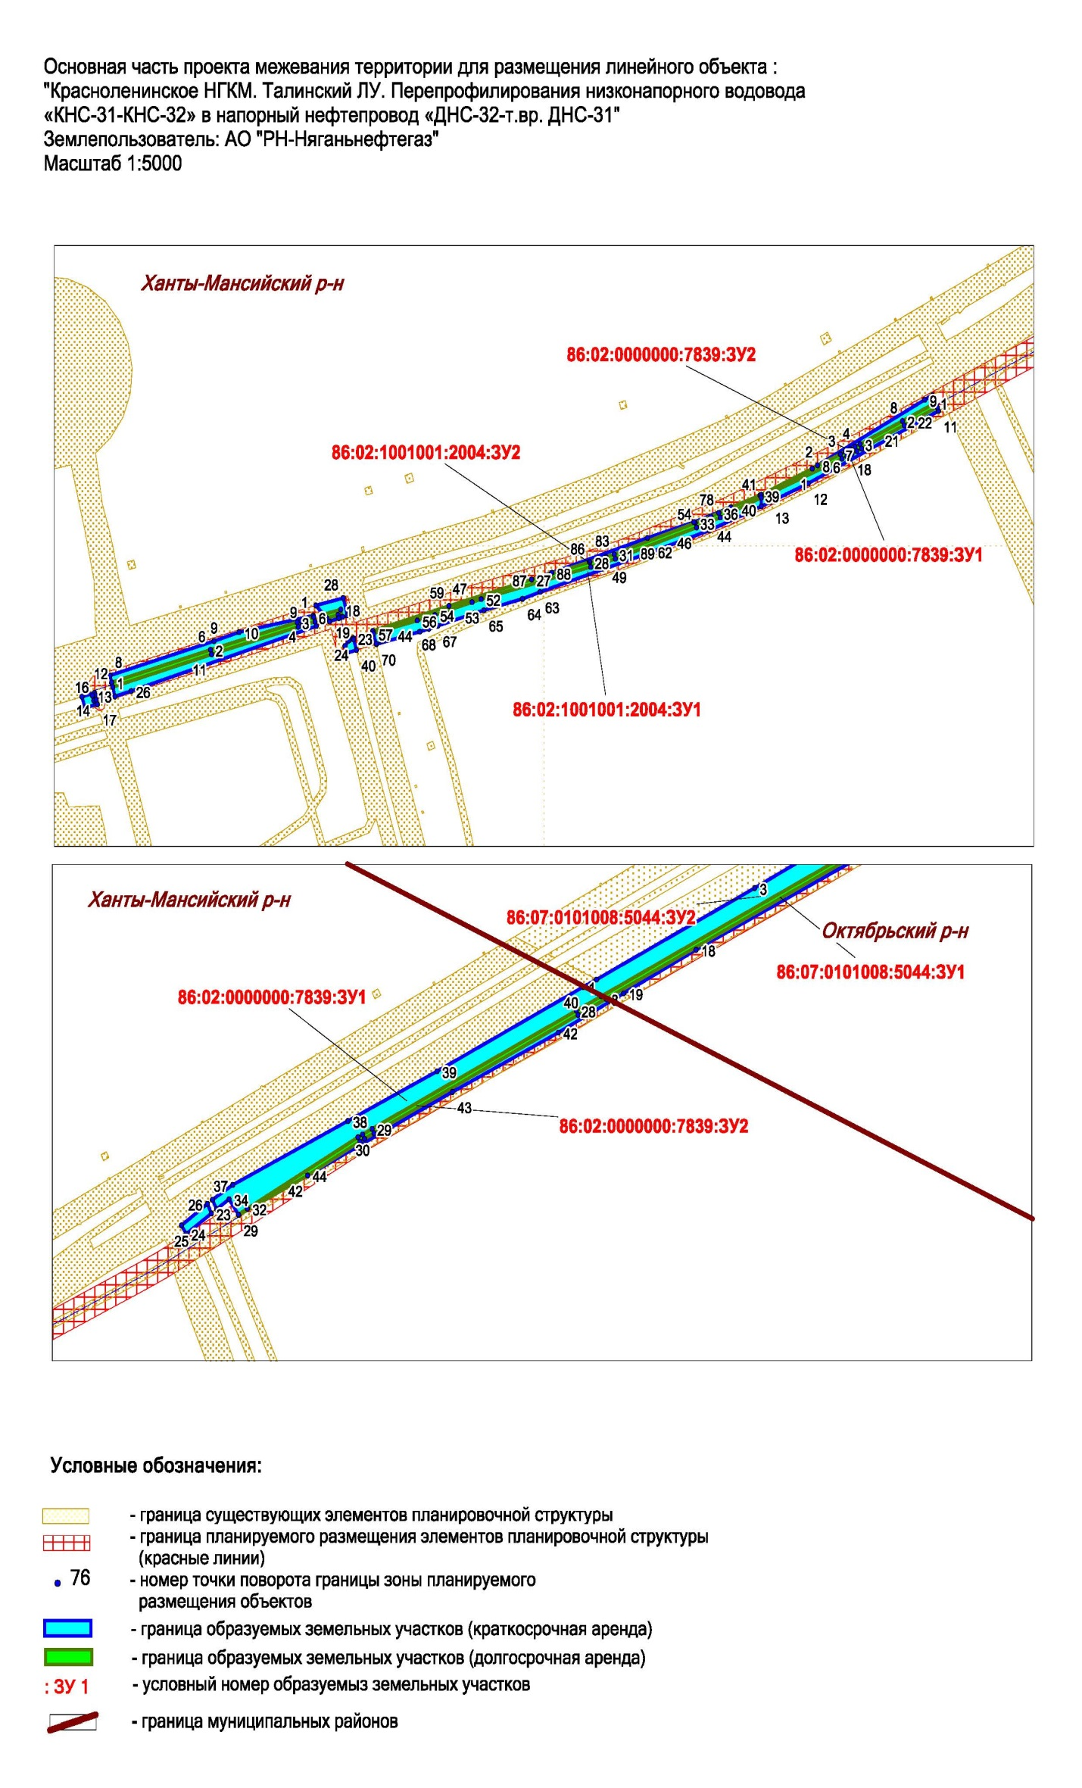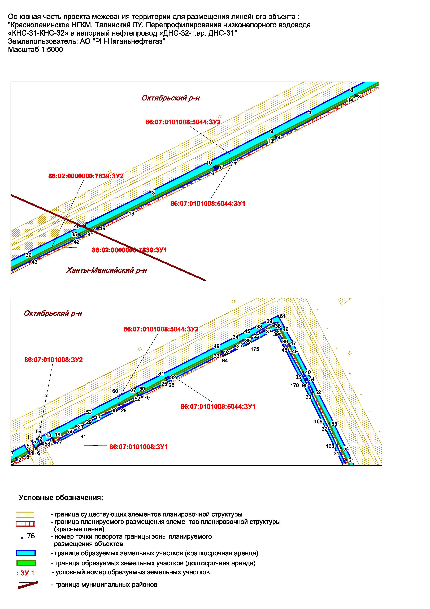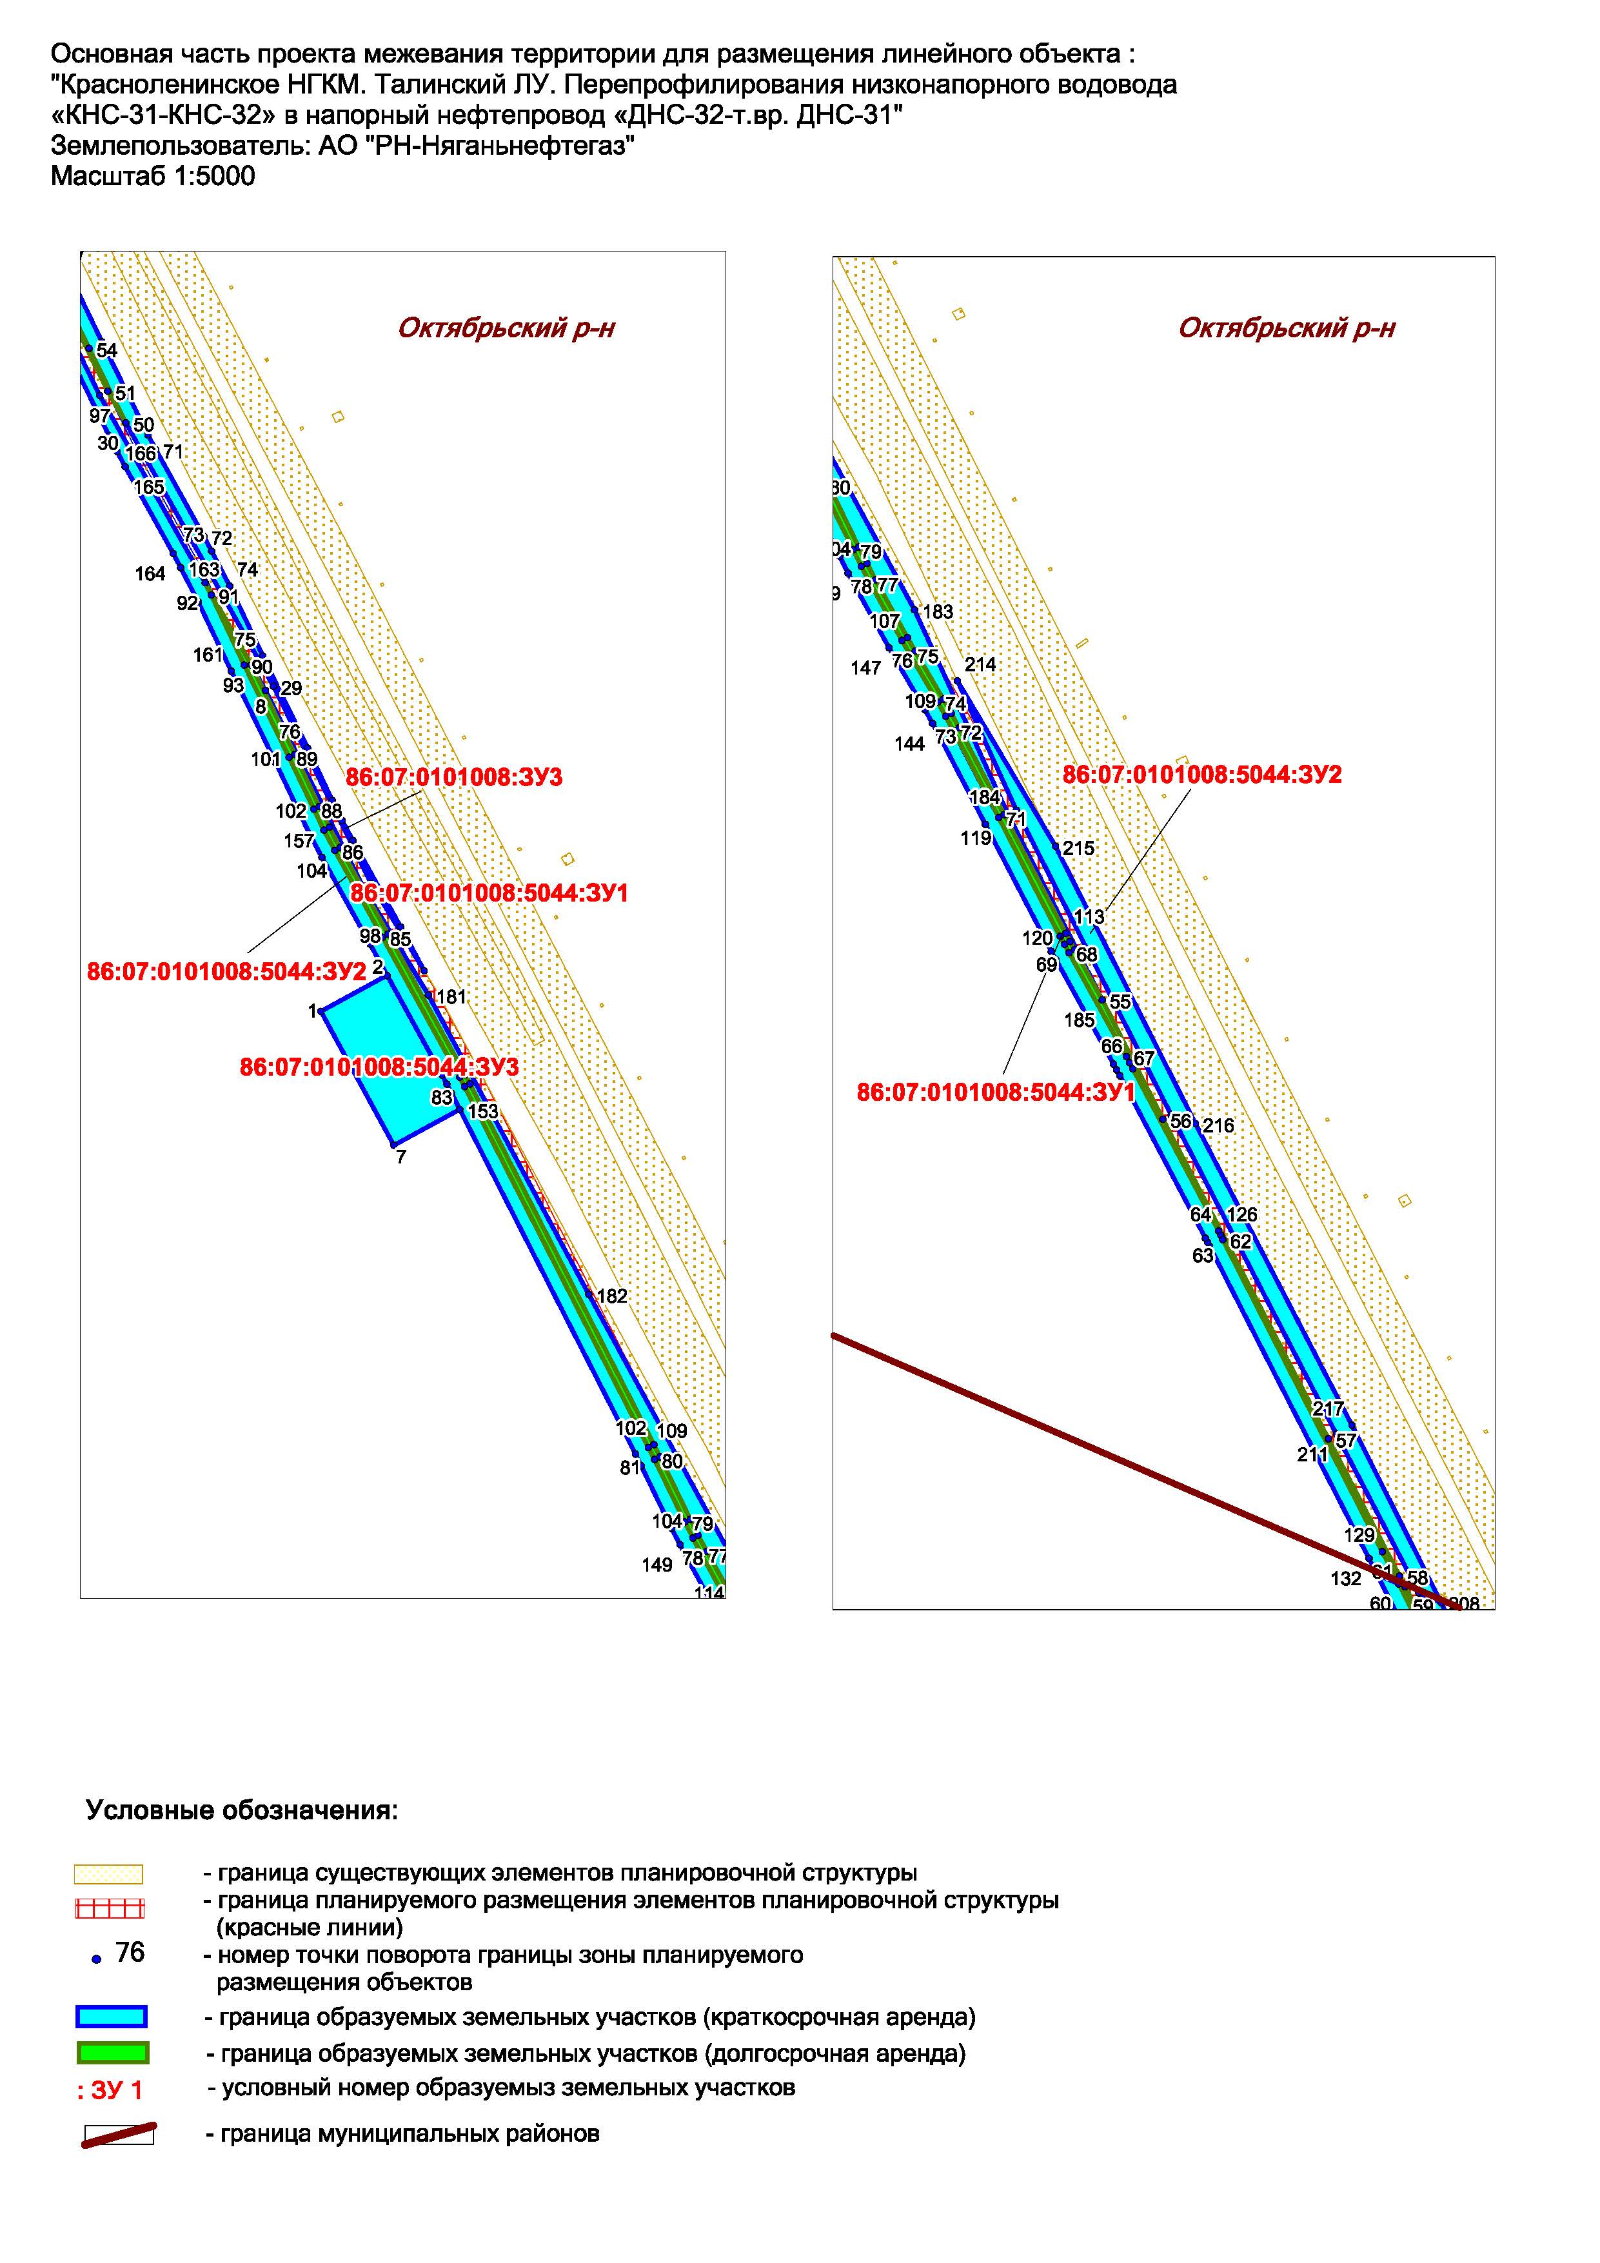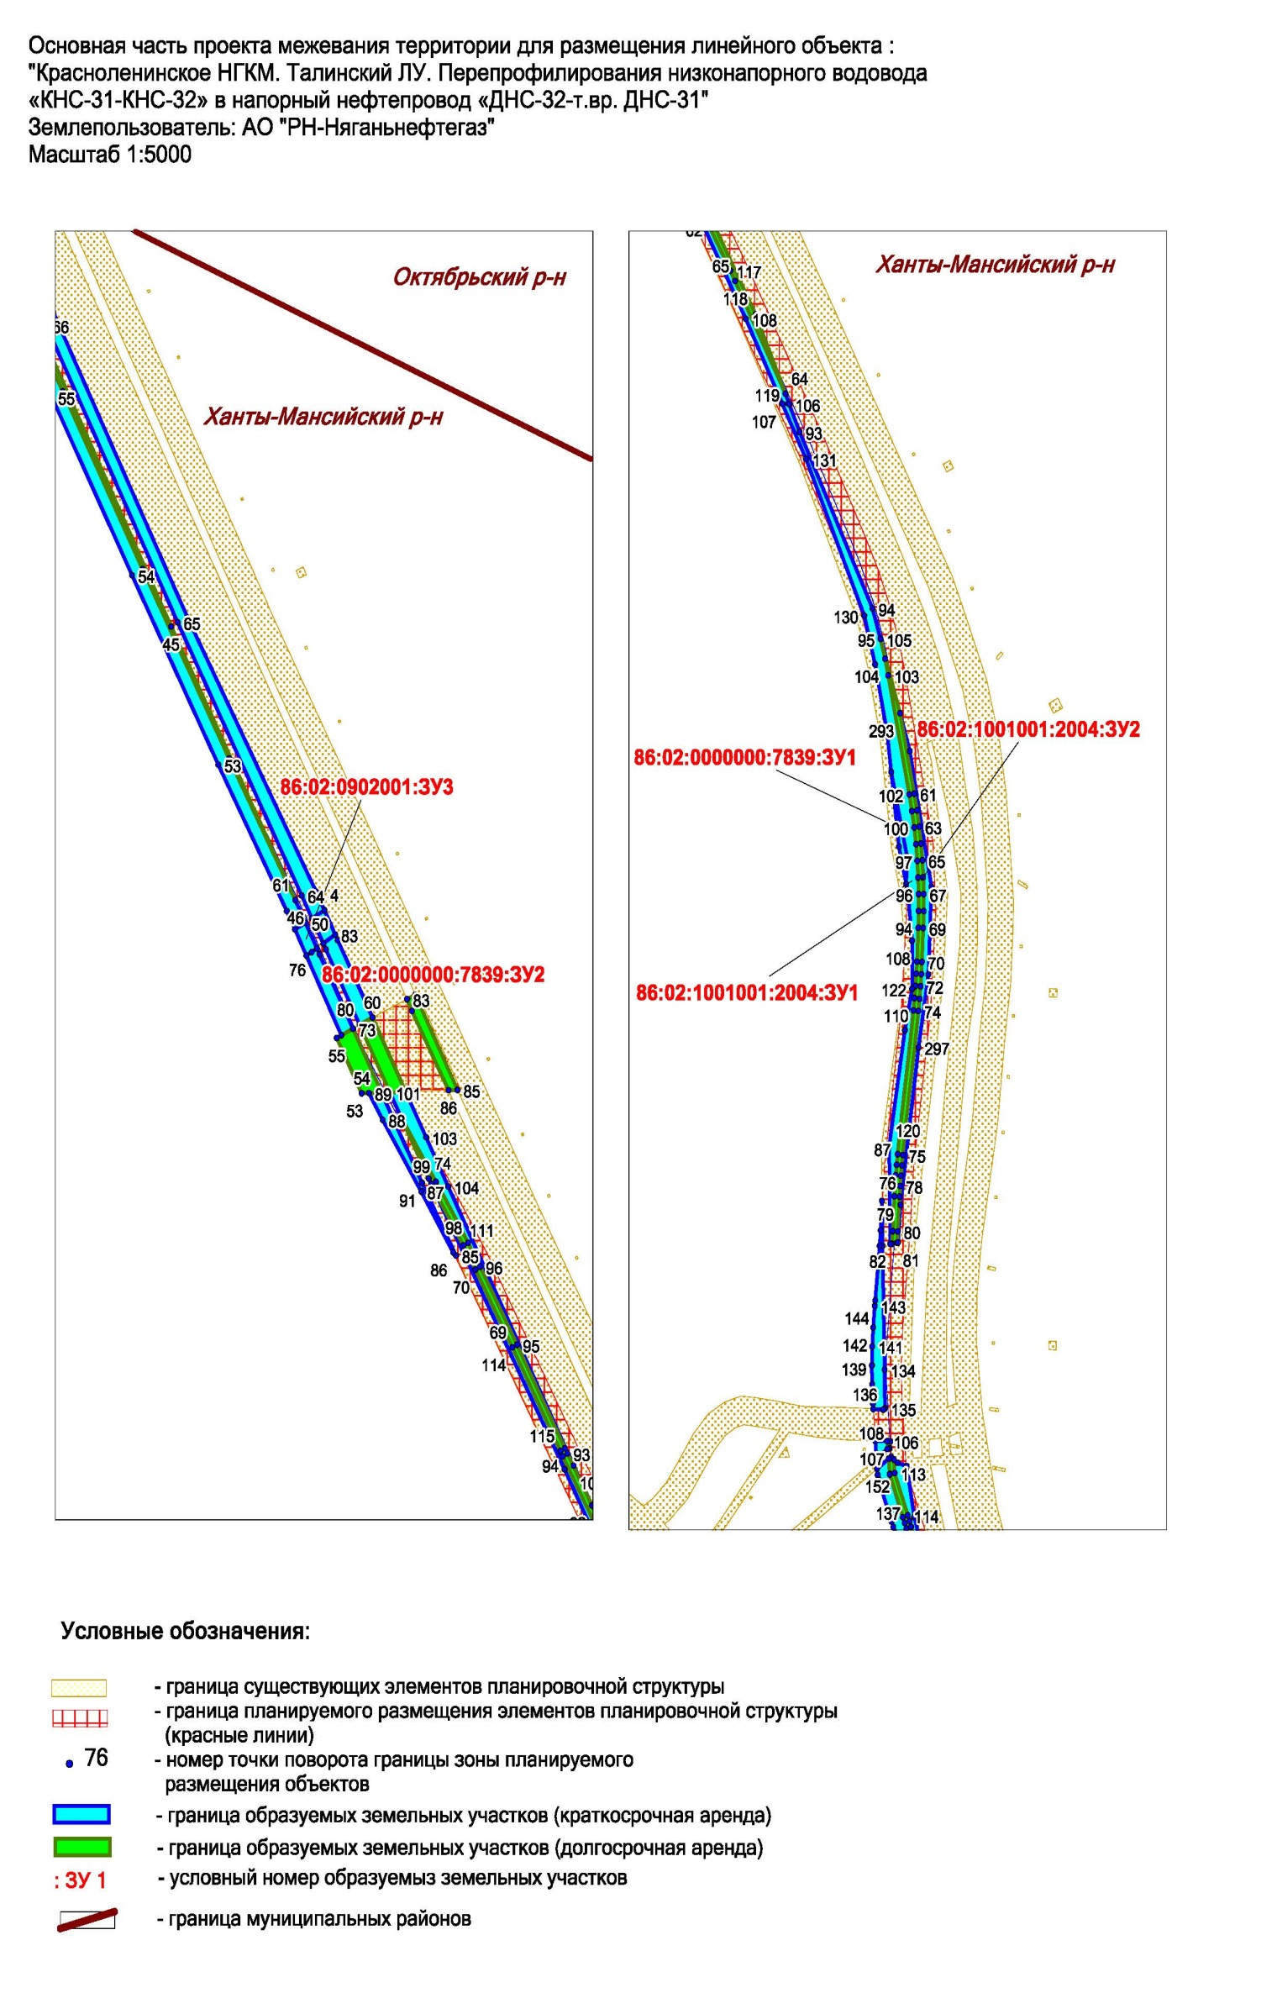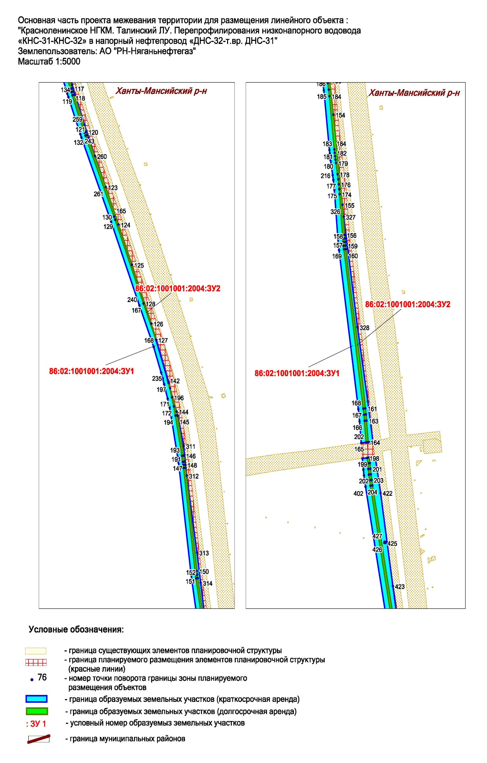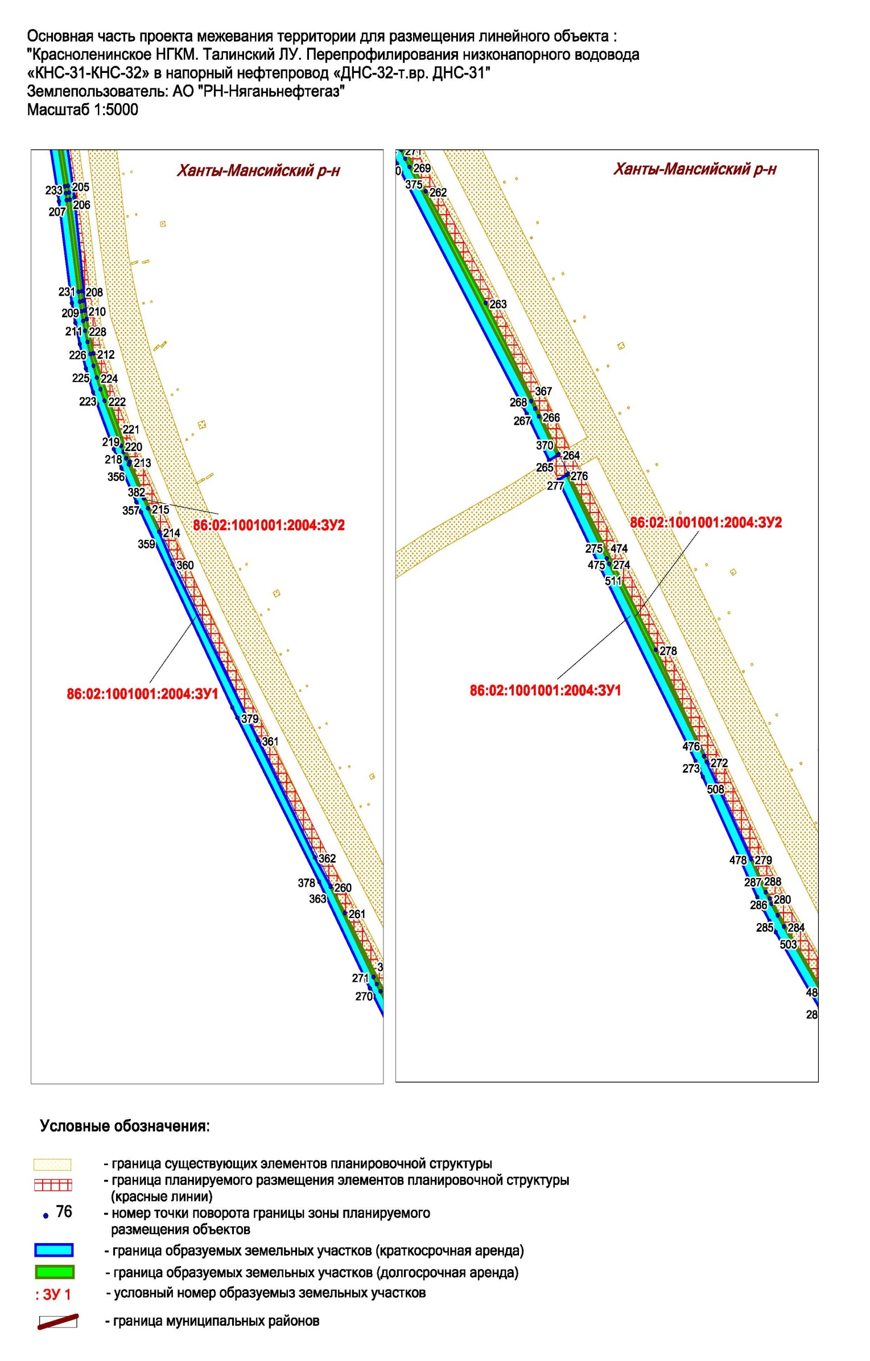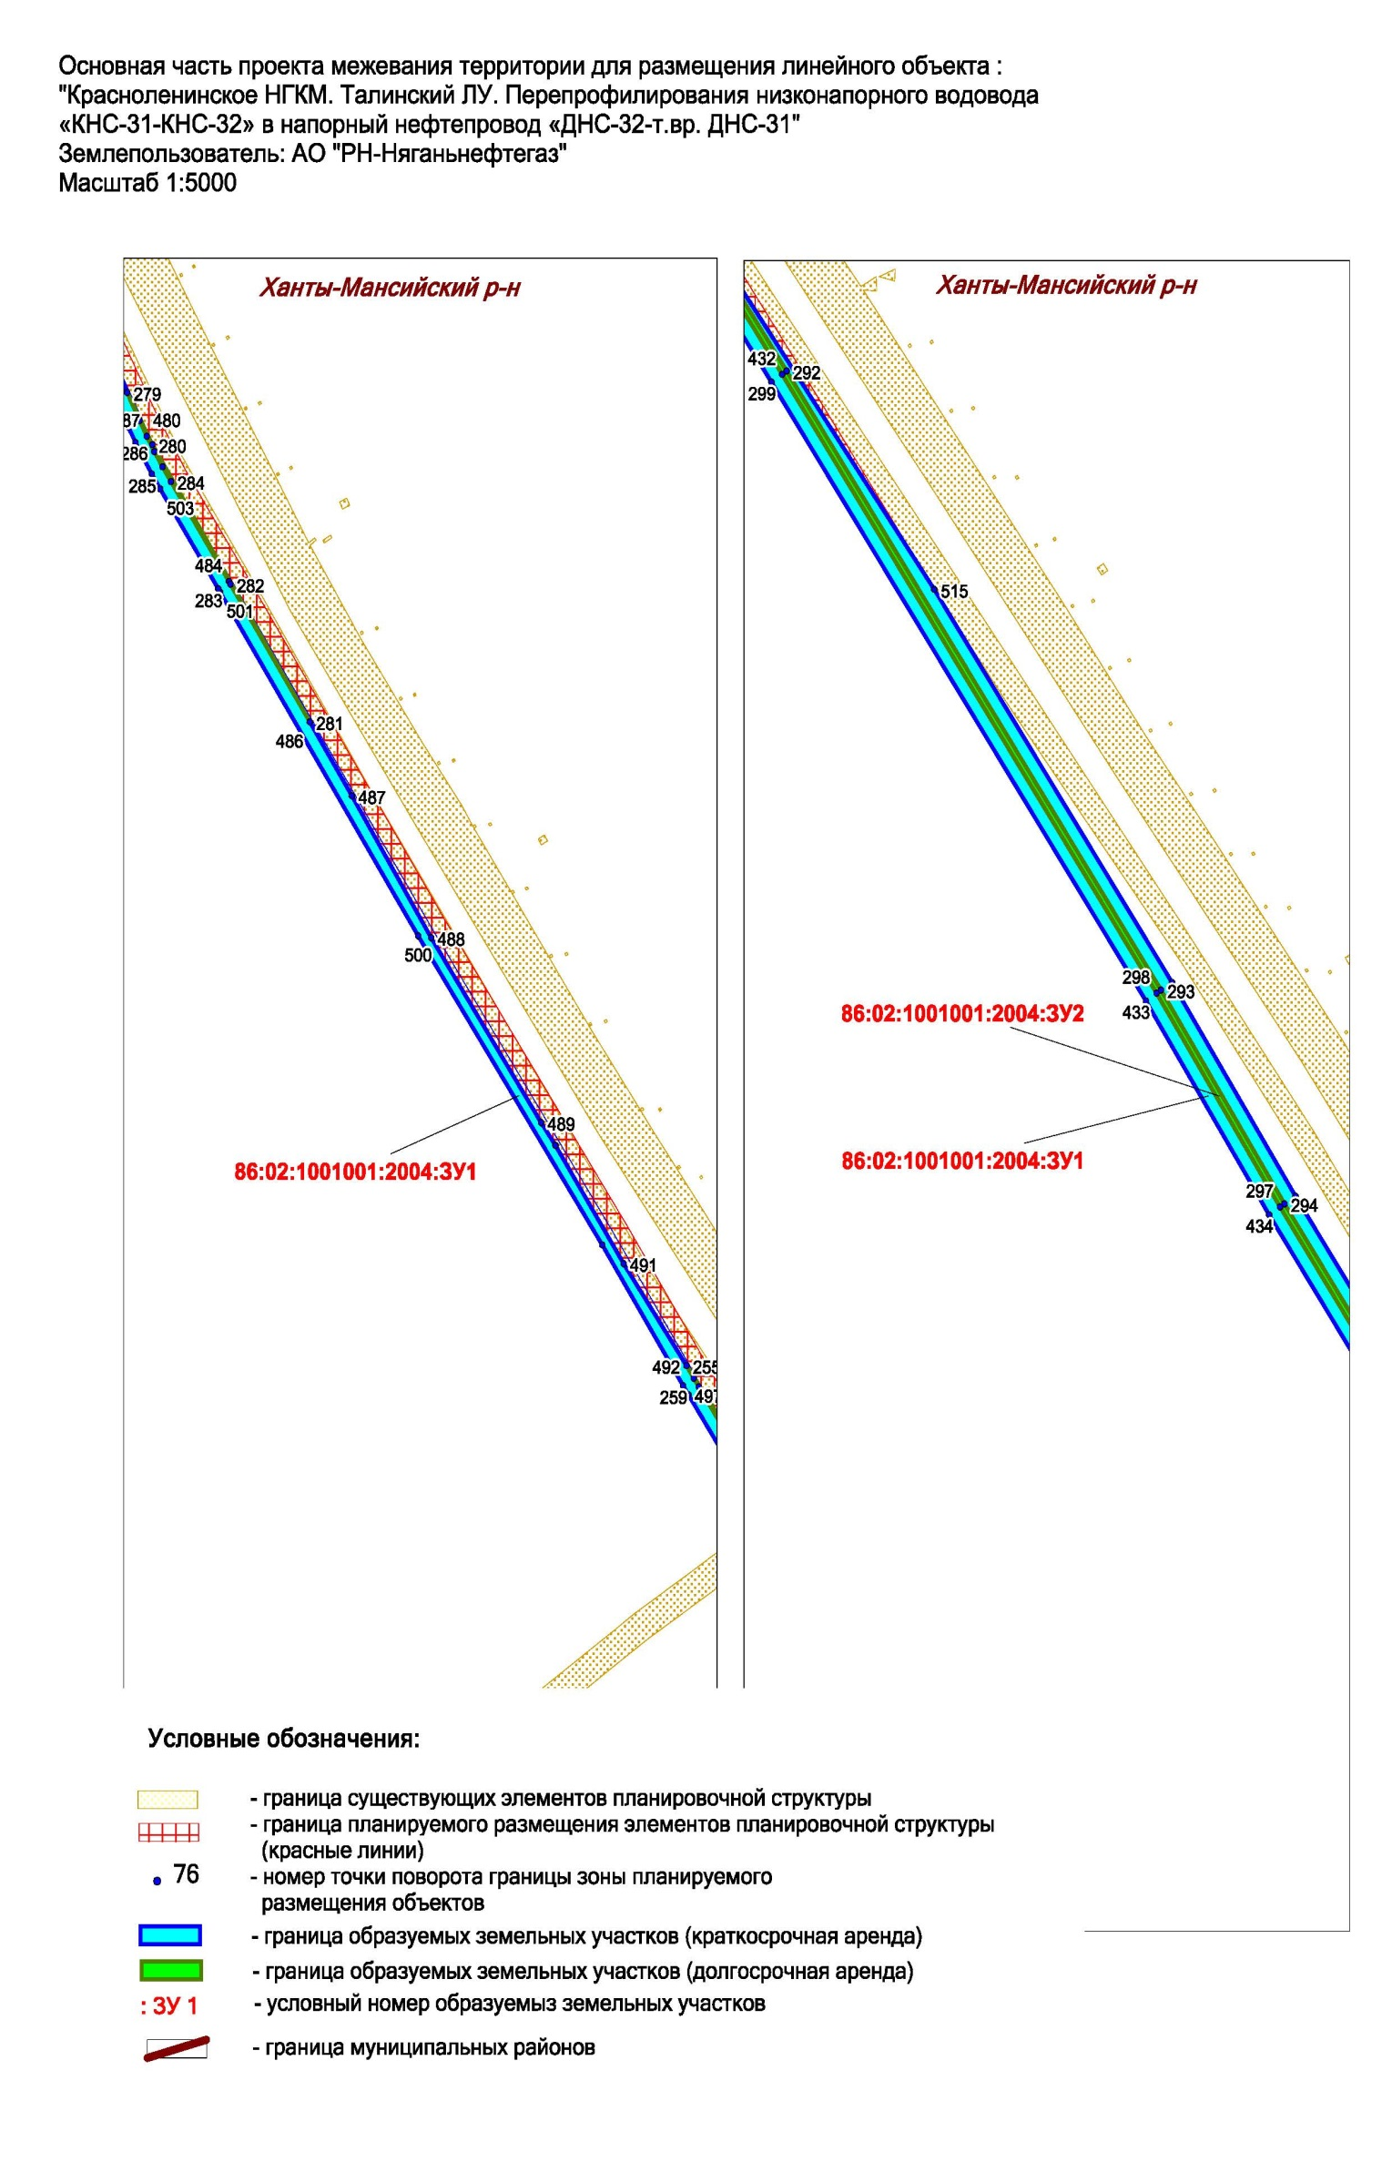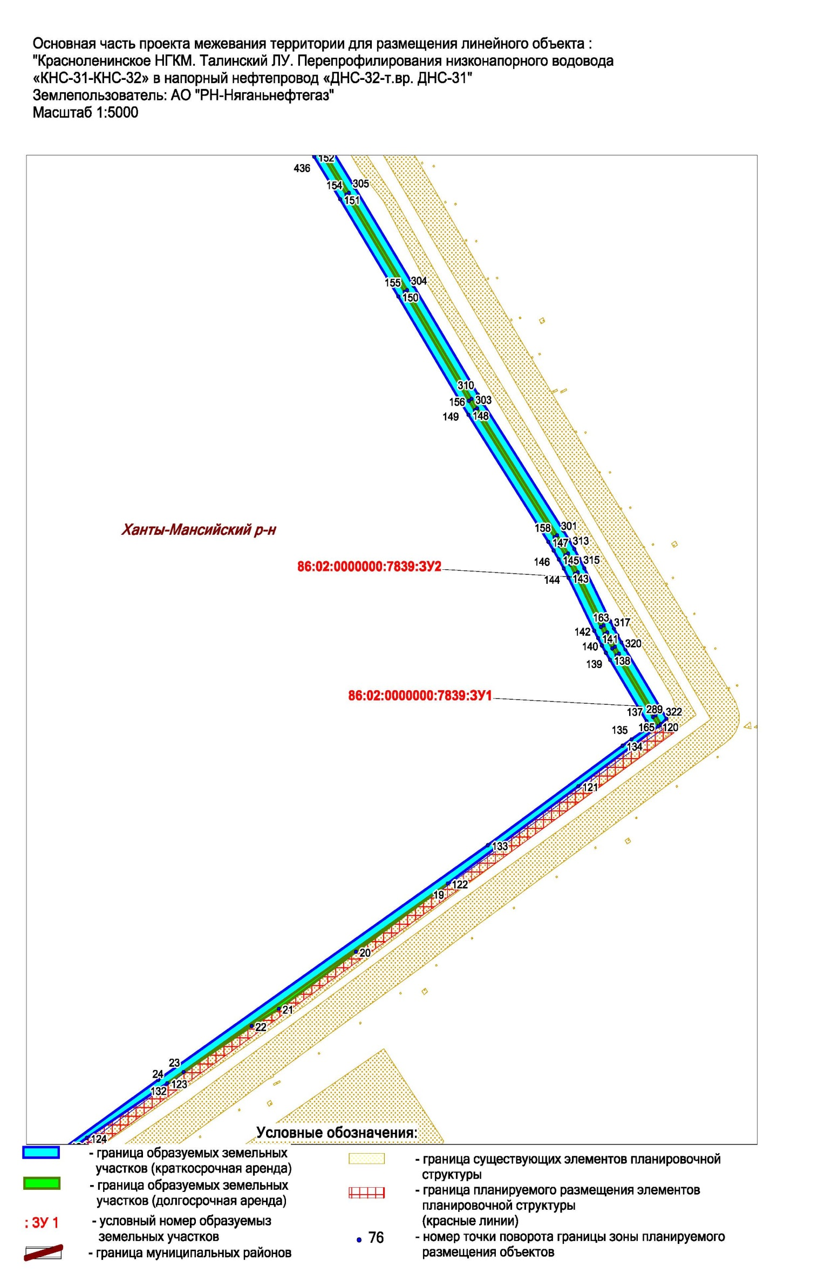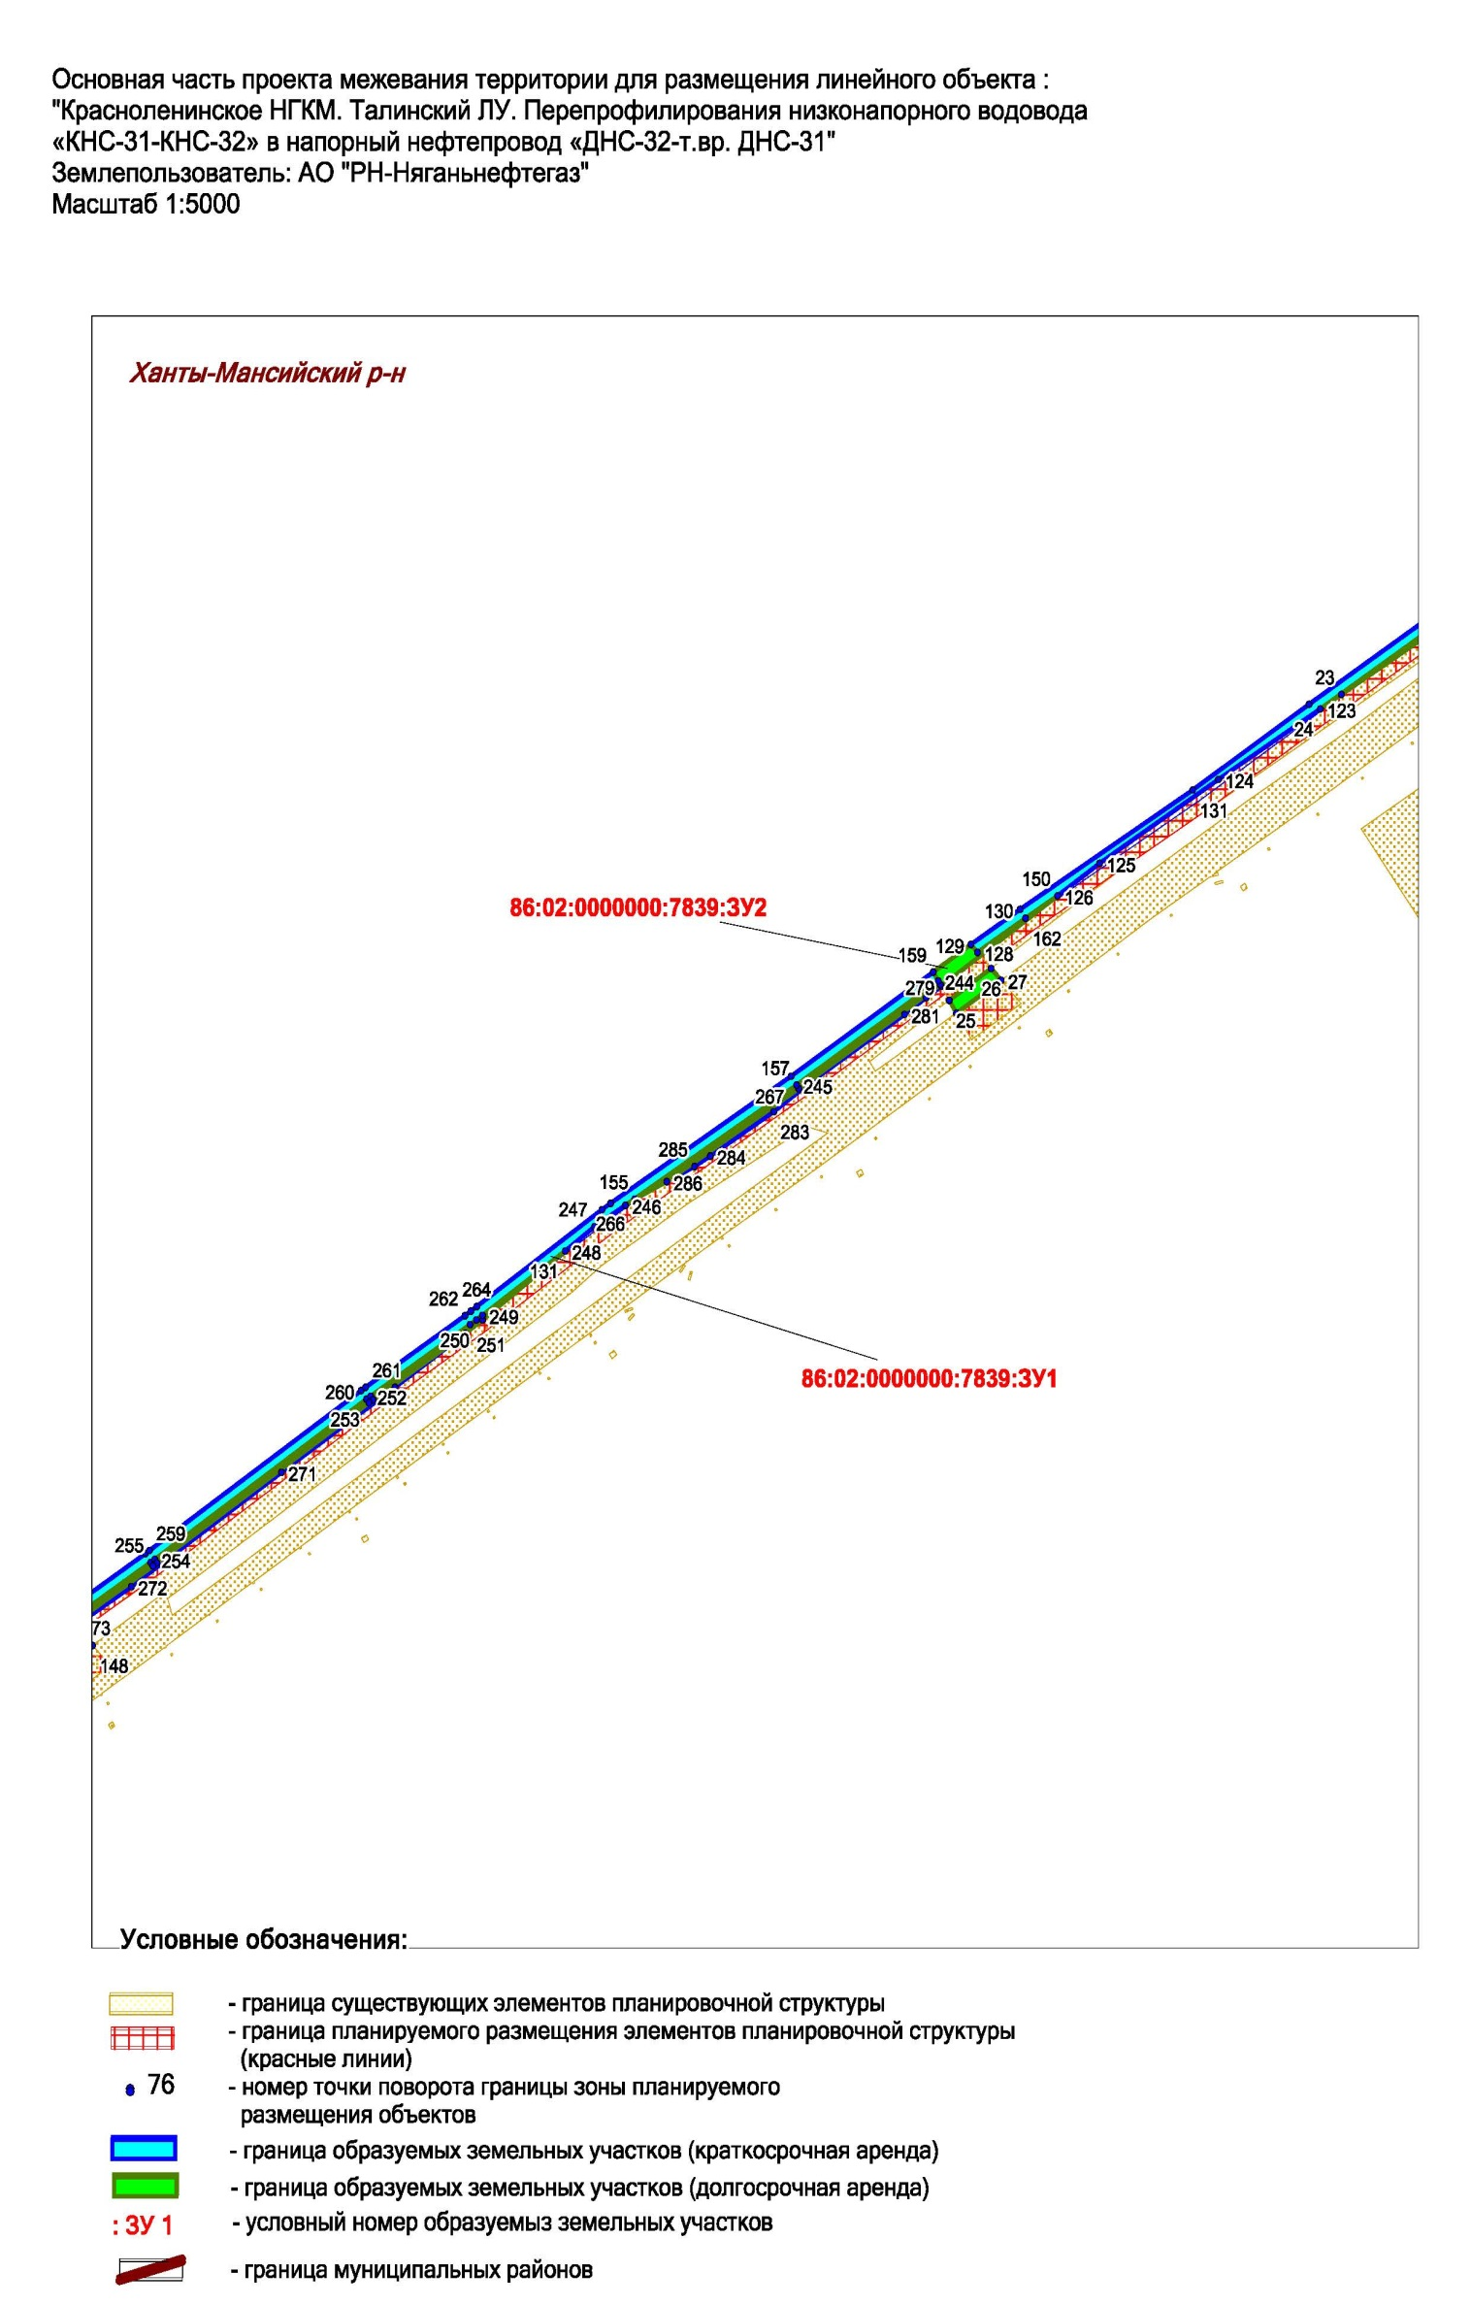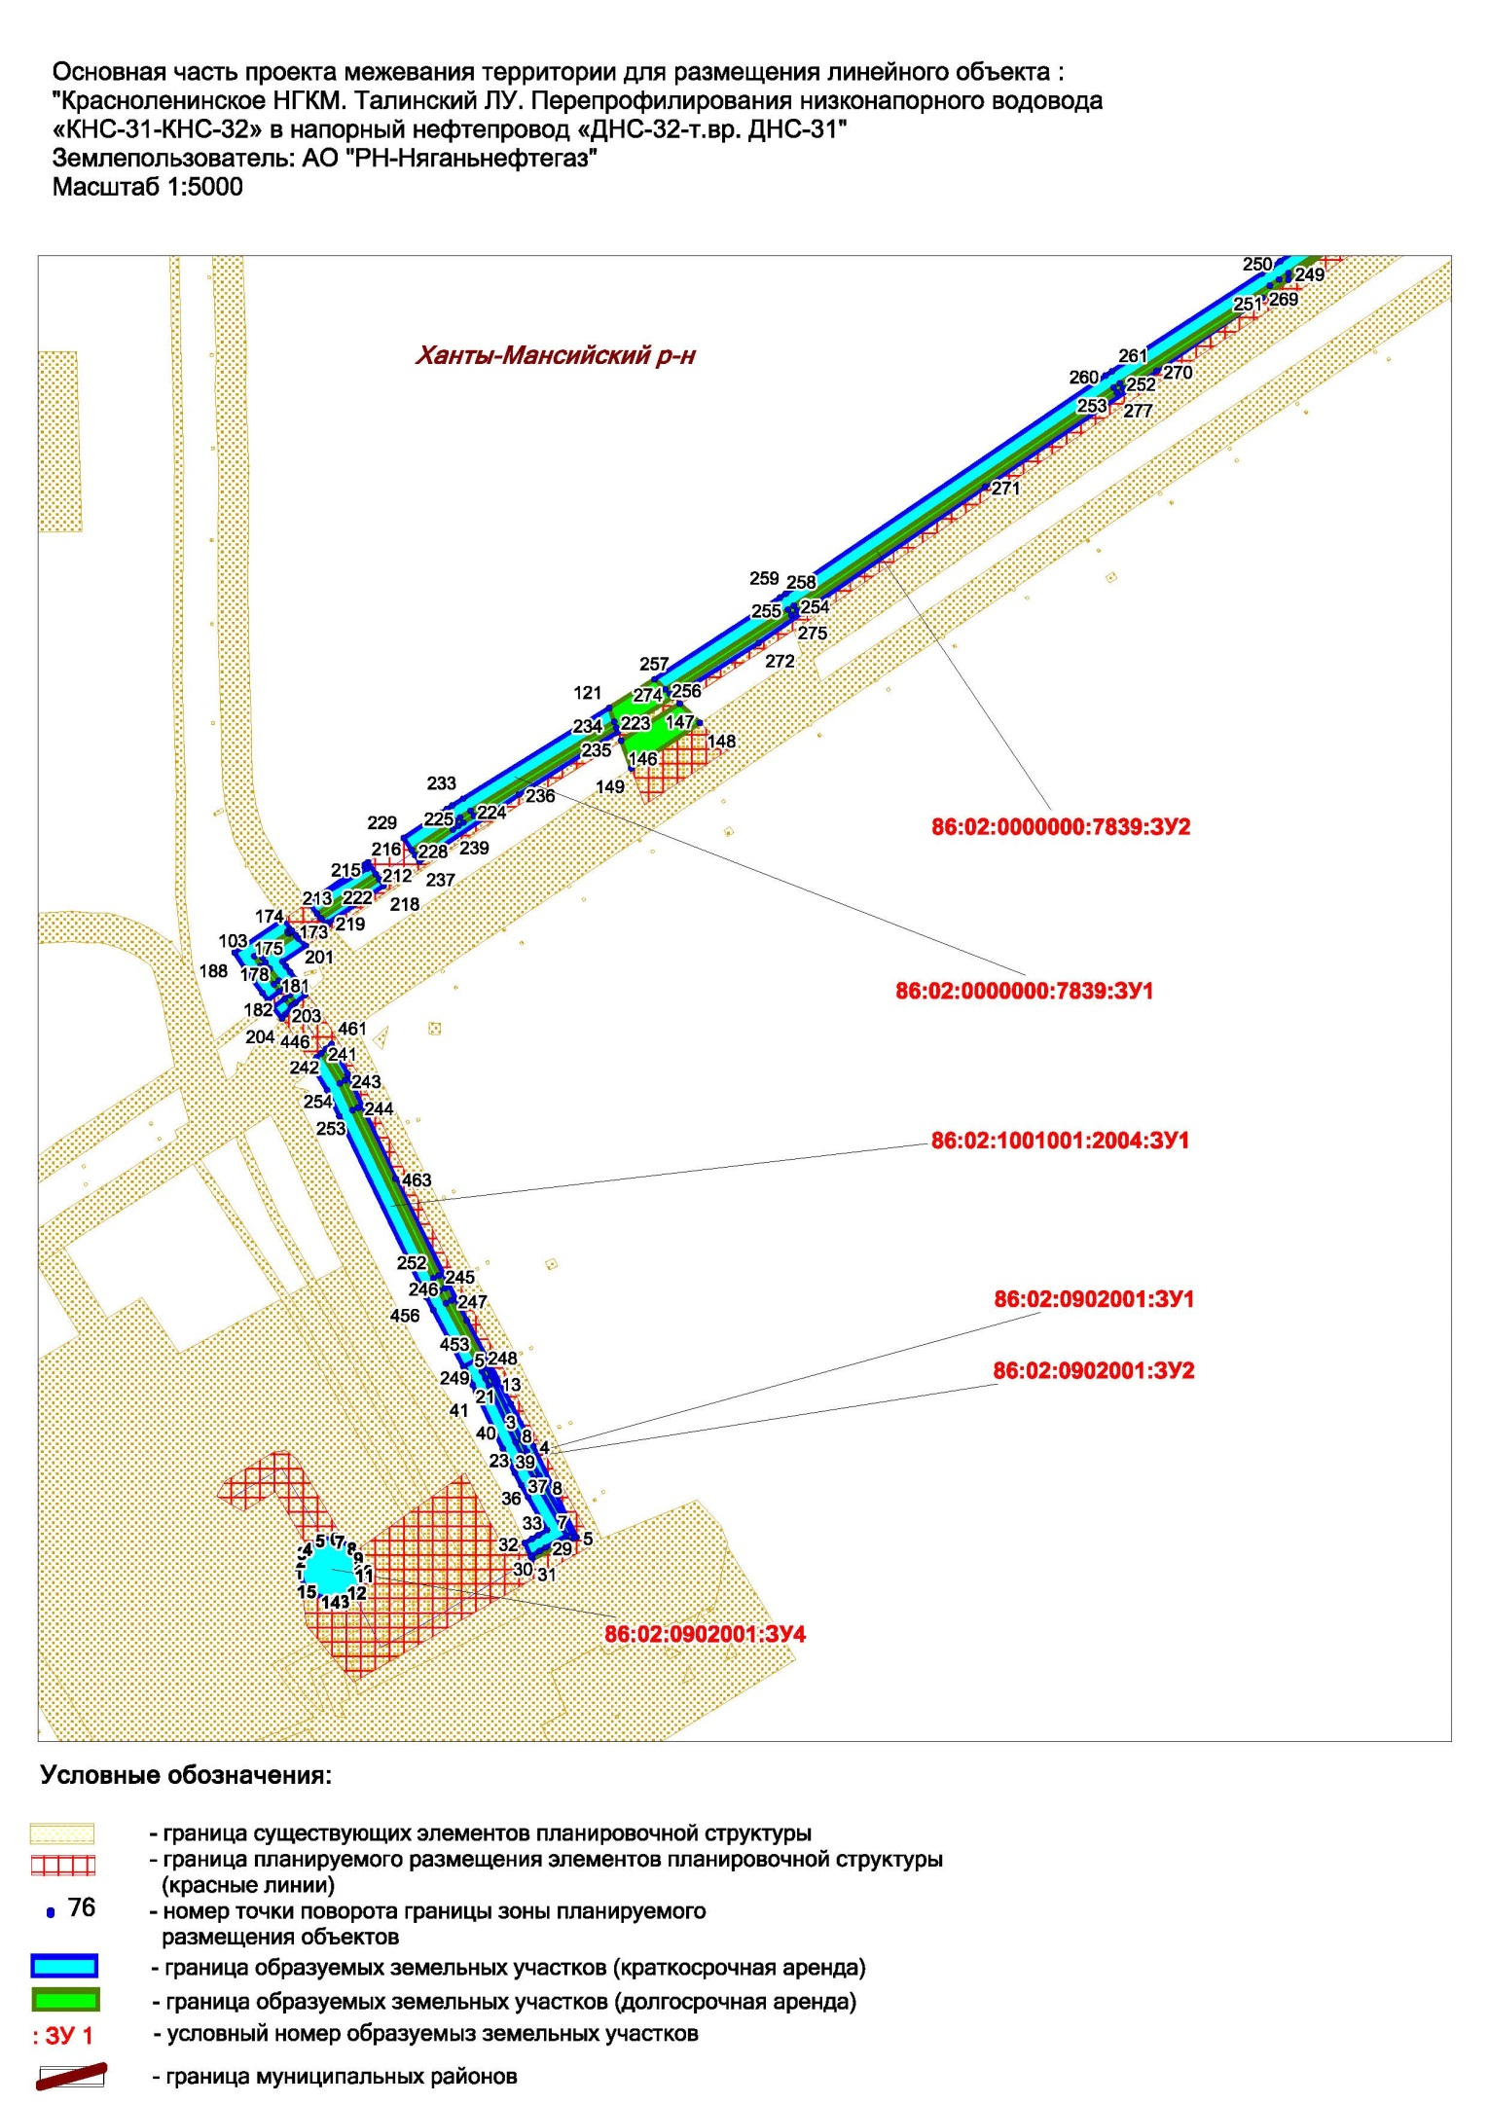
Основная часть проекта межевания территории для размещения объекта капитального строительства, расположенного на территориях двух муниципальных
образования Ханты-Мансийского автономного округа – Югры, «Красноленинское НГКМ. Талинский ЛУ. Перепрофилирования низконапорного водовода «КНС-31-КНС-32» в напорный нефтепровод «ДНС-32-т.вр.ДНС-31»
Землепользователь: АО «РН-Няганьнефтегаз»
Масштаб 1:5000

Приложение 31
к приказу Департамента строительства
Ханты-Мансийского
автономного округа – Югры
от 8 ноября 2018 года № 23-нп

Основная часть проекта межевания территории для размещения объекта капитального строительства, расположенного на территориях двух муниципальных
образования Ханты-Мансийского автономного округа – Югры, «Красноленинское НГКМ. Талинский ЛУ. Перепрофилирования низконапорного водовода «КНС-31-КНС-32» в напорный нефтепровод «ДНС-32-т.вр.ДНС-31»
Землепользователь: АО «РН-Няганьнефтегаз»
Масштаб 1:5000

Основная часть проекта межевания территории для размещения объекта капитального строительства, расположенного на территориях двух муниципальных
образования Ханты-Мансийского автономного округа – Югры, «Красноленинское НГКМ. Талинский ЛУ. Перепрофилирования низконапорного водовода «КНС-31-КНС-32» в напорный нефтепровод «ДНС-32-т.вр.ДНС-31»
Землепользователь: АО «РН-Няганьнефтегаз»
Масштаб 1:5000

Основная часть проекта межевания территории для размещения объекта капитального строительства, расположенного на территориях двух муниципальных
образования Ханты-Мансийского автономного округа – Югры, «Красноленинское НГКМ. Талинский ЛУ. Перепрофилирования низконапорного водовода «КНС-31-КНС-32» в напорный нефтепровод «ДНС-32-т.вр.ДНС-31»
Землепользователь: АО «РН-Няганьнефтегаз»
Масштаб 1:5000

Основная часть проекта межевания территории для размещения объекта капитального строительства, расположенного на территориях двух муниципальных
образования Ханты-Мансийского автономного округа – Югры, «Красноленинское НГКМ. Талинский ЛУ. Перепрофилирования низконапорного водовода «КНС-31-КНС-32» в напорный нефтепровод «ДНС-32-т.вр.ДНС-31»
Землепользователь: АО «РН-Няганьнефтегаз», Масштаб 1:5000

Основная часть проекта межевания территории для размещения объекта капитального строительства, расположенного на территориях двух муниципальных
образования Ханты-Мансийского автономного округа – Югры, «Красноленинское НГКМ. Талинский ЛУ. Перепрофилирования низконапорного водовода «КНС-31-КНС-32» в напорный нефтепровод «ДНС-32-т.вр.ДНС-31»
Землепользователь: АО «РН-Няганьнефтегаз», Масштаб 1:5000

Основная часть проекта межевания территории для размещения объекта капитального строительства, расположенного на территориях двух муниципальных
образования Ханты-Мансийского автономного округа – Югры, «Красноленинское НГКМ. Талинский ЛУ. Перепрофилирования низконапорного водовода «КНС-31-КНС-32» в напорный нефтепровод «ДНС-32-т.вр.ДНС-31»
Землепользователь: АО «РН-Няганьнефтегаз», Масштаб 1:5000

Основная часть проекта межевания территории для размещения объекта капитального строительства, расположенного на территориях двух муниципальных
образования Ханты-Мансийского автономного округа – Югры, «Красноленинское НГКМ. Талинский ЛУ. Перепрофилирования низконапорного водовода «КНС-31-КНС-32» в напорный нефтепровод «ДНС-32-т.вр.ДНС-31»
Землепользователь: АО «РН-Няганьнефтегаз», Масштаб 1:5000

Основная часть проекта межевания территории для размещения объекта капитального строительства, расположенного на территориях двух муниципальных
образования Ханты-Мансийского автономного округа – Югры, «Красноленинское НГКМ. Талинский ЛУ. Перепрофилирования низконапорного водовода «КНС-31-КНС-32» в напорный нефтепровод «ДНС-32-т.вр.ДНС-31»
Землепользователь: АО «РН-Няганьнефтегаз», Масштаб 1:5000

Основная часть проекта межевания территории для размещения объекта капитального строительства, расположенного на территориях двух муниципальных
образования Ханты-Мансийского автономного округа – Югры, «Красноленинское НГКМ. Талинский ЛУ. Перепрофилирования низконапорного водовода «КНС-31-КНС-32» в напорный нефтепровод «ДНС-32-т.вр.ДНС-31»
Землепользователь: АО «РН-Няганьнефтегаз», Масштаб 1:5000

Ханты-Мансийский район

Земли лесного фонда

Обозначение характерных точек | X | Y
86:02:0000000:7839:ЗУ1
1 | 986653.29 | 2527947.72
2 | 986638.23 | 2527915.68
3 | 986618.95 | 2527874.58
4 | 986616.78 | 2527869.85
5 | 986614.67 | 2527865.13
6 | 986612.6 | 2527860.37
7 | 986610.59 | 2527855.58
8 | 986601.44 | 2527833.48
9 | 986655.78 | 2527937.32
10 | 986659.65 | 2527945.03
11 | 986646.47 | 2527950.59
12 | 986586.44 | 2527824.34
13 | 986570.66 | 2527787.14
14 | 986567.37 | 2527778.82
15 | 986574.46 | 2527778.69
16 | 986606.89 | 2527857.11
17 | 986608.93 | 2527861.96
18 | 986611.02 | 2527866.76
19 | 986613.14 | 2527871.51
20 | 986615.32 | 2527876.25
21 | 986634.63 | 2527917.44
22 | 986649.61 | 2527949.28
23 | 986782.19 | 2528184.41
24 | 986765.21 | 2528160.05
25 | 986772.3 | 2528155.42
26 | 986790.12 | 2528180.52
27 | 986962.44 | 2528562.54
28 | 986950.51 | 2528538.3
29 | 986852.44 | 2528340.27
30 | 986847.75 | 2528331.08
31 | 986845.34 | 2528326.54
32 | 986786.09 | 2528219.38
33 | 986781.32 | 2528210.55
34 | 986794.08 | 2528201.49
35 | 986785.69 | 2528189.44
36 | 986793.6 | 2528185.5
37 | 986805.9 | 2528205.12
38 | 986858.99 | 2528316.87
39 | 986900.12 | 2528403.44
40 | 986970.14 | 2528545.12
41 | 986958.42 | 2528571.64
42 | 986932.28 | 2528520.98
43 | 986883.08 | 2528418.16
44 | 986813.74 | 2528277.62
45 | 986841.82 | 2528328.45
46 | 986844.22 | 2528332.95
47 | 986848.86 | 2528342.06
48 | 986946.92 | 2528540.06
49 | 986960.34 | 2528567.3
50 | 985393.95 | 2531144.4
51 | 985389.22 | 2531136.24
52 | 985402.29 | 2531129.75
53 | 985505.71 | 2531075.71
54 | 985639.55 | 2531007.7
55 | 985765.34 | 2530944.64
56 | 985951.79 | 2530850.28
57 | 985945.73 | 2530864
58 | 985769.49 | 2530953.19
59 | 985643.85 | 2531016.17
60 | 985509.99 | 2531084.19
61 | 985409.96 | 2531136.42
62 | 985402.97 | 2531159.27
63 | 985397.08 | 2531149.55
64 | 985413.24 | 2531141.48
65 | 985606.4 | 2531043.76
66 | 985816.12 | 2530940.16
67 | 985929.38 | 2530882.5
68 | 985939.91 | 2530877.04
69 | 985933.6 | 2530891.28
70 | 985825.52 | 2530945.76
71 | 985609.38 | 2531051.68
72 | 985415.8 | 2531152.9
73 | 985319.16 | 2531181.77
74 | 985314.54 | 2531172.67
75 | 985370.89 | 2531145.17
76 | 985373.28 | 2531149.37
77 | 985375.98 | 2531153.37
78 | 985371.68 | 2531155.52
79 | 985326.97 | 2531197.18
80 | 985321.88 | 2531187.13
81 | 985375.08 | 2531160.54
82 | 985379.36 | 2531158.41
83 | 985385.72 | 2531167.85
84 | 985381.52 | 2531169.94
85 | 985158.89 | 2531263.01
86 | 985161.1 | 2531260.72
87 | 985204.08 | 2531235.54
88 | 985254.82 | 2531205.18
89 | 985273.6 | 2531194.44
90 | 985273.95 | 2531204.37
91 | 985210.16 | 2531236.26
92 | 984982.25 | 2531370.08
93 | 985018.8 | 2531350.77
94 | 985022.56 | 2531348.8
95 | 985095.77 | 2531310.99
96 | 985150.89 | 2531281.84
97 | 985159.43 | 2531277.21
98 | 985167.88 | 2531272.39
99 | 985210.94 | 2531247.16
100 | 985257.63 | 2531219.24
101 | 985274.17 | 2531210.97
102 | 985274.59 | 2531223.34
103 | 985242.5 | 2531239.37
104 | 985207.56 | 2531256.82
105 | 985010.3 | 2531355.64
106 | 984846.75 | 2531433.8
107 | 984846.84 | 2531428.51
108 | 984907.04 | 2531399.64
109 | 985007.78 | 2531348.58
110 | 985209.45 | 2531243.4
111 | 985165.87 | 2531268.93
112 | 985157.49 | 2531273.71
113 | 985149.01 | 2531278.31
114 | 985093.93 | 2531307.44
115 | 985020.73 | 2531345.25
116 | 985016.93 | 2531347.24
117 | 984940.94 | 2531387.39
118 | 984933.66 | 2531391.1
119 | 984853.92 | 2531430.8
120 | 978052.02 | 2534194.89
121 | 977982.14 | 2534092.9
122 | 977868.76 | 2533926.75
123 | 977635.77 | 2533569.57
124 | 977572.16 | 2533467.44
125 | 977496.58 | 2533348.96
126 | 977467.18 | 2533306.96
127 | 977447.08 | 2533274.81
128 | 977416.21 | 2533227
129 | 977423.27 | 2533220.4
130 | 977455.06 | 2533269.65
131 | 977562.59 | 2533441.9
132 | 977639.79 | 2533558.33
133 | 977913.46 | 2533977.86
134 | 978029.36 | 2534149.38
135 | 978036.83 | 2534160.79
136 | 978051.52 | 2534183.98
137 | 978057.68 | 2534180.07
138 | 978129.54 | 2534133.42
139 | 978137.88 | 2534128.14
140 | 978146.36 | 2534123.01
141 | 978154.89 | 2534118.11
142 | 978163.47 | 2534113.39
143 | 978225.21 | 2534080.44
144 | 978235.99 | 2534074.48
145 | 978246.57 | 2534068.26
146 | 978256.94 | 2534061.74
147 | 978267.22 | 2534054.9
148 | 978415.15 | 2533953.18
149 | 978426.38 | 2533945.71
150 | 978553.26 | 2533863.83
151 | 978666.66 | 2533789.77
152 | 978716.3 | 2533756.88
153 | 978734.44 | 2533756.26
154 | 978671.86 | 2533797.73
155 | 978558.44 | 2533871.8
156 | 978431.54 | 2533953.69
157 | 978420.53 | 2533961.01
158 | 978272.55 | 2534062.76
159 | 978262.11 | 2534069.71
160 | 978251.5 | 2534076.38
161 | 978240.7 | 2534082.73
162 | 978229.75 | 2534088.79
163 | 978167.96 | 2534121.78
164 | 978159.47 | 2534126.44
165 | 978151.08 | 2534131.25
166 | 978142.8 | 2534136.27
167 | 978134.63 | 2534141.44
168 | 978062.76 | 2534188.1
169 | 984527.02 | 2531526.68
170 | 984507.56 | 2531525.95
171 | 984534.02 | 2531520.28
172 | 984586.67 | 2531514.25
173 | 976653.15 | 2532072.51
174 | 976652.57 | 2532071.66
175 | 976653.68 | 2532070.96
176 | 976652.66 | 2532069.46
177 | 976651.57 | 2532070.2
178 | 976636.22 | 2532047.43
179 | 976629.84 | 2532051.64
180 | 976625.72 | 2532054.55
181 | 976617.6 | 2532060.53
182 | 976612.92 | 2532064.11
183 | 976607.18 | 2532056.53
184 | 976611.92 | 2532052.91
185 | 976620.24 | 2532046.78
186 | 976624.48 | 2532043.8
187 | 976628.62 | 2532040.97
188 | 976638.62 | 2532034.42
189 | 976660.46 | 2532066.71
190 | 976643.11 | 2532081.63
191 | 976632.69 | 2532066.16
192 | 976629.65 | 2532068.39
193 | 976625.73 | 2532071.31
194 | 976621.07 | 2532074.87
195 | 976615.33 | 2532067.29
196 | 976620 | 2532063.73
197 | 976628.03 | 2532057.81
198 | 976632.11 | 2532054.93
199 | 976635.17 | 2532052.84
200 | 976650.07 | 2532074.95
201 | 976647.94 | 2532076.64
202 | 976602.68 | 2532071.85
203 | 976597.72 | 2532067.95
204 | 976594.98 | 2532065.8
205 | 976602.45 | 2532060.11
206 | 976608.18 | 2532067.7
207 | 976610.64 | 2532081.02
208 | 976605.48 | 2532074.78
209 | 976610.59 | 2532070.89
210 | 976615.16 | 2532076.94
211 | 976614.86 | 2532078.78
212 | 976690.58 | 2532128.02
213 | 976664.34 | 2532089.13
214 | 976671.6 | 2532083.4
215 | 976694.38 | 2532122.38
216 | 976697.01 | 2532120.73
217 | 976698.45 | 2532122.82
218 | 976682.99 | 2532133.03
219 | 976658.7 | 2532096.92
220 | 976656.92 | 2532096.26
221 | 976661.28 | 2532091.6
222 | 976687.28 | 2532130.19
223 | 976791.6 | 2532285.84
224 | 976732.58 | 2532190.82
225 | 976728.12 | 2532183.8
226 | 976725.83 | 2532180.28
227 | 976723.53 | 2532176.84
228 | 976706.58 | 2532151.72
229 | 976714.48 | 2532146.51
230 | 976731.41 | 2532171.53
231 | 976733.73 | 2532175
232 | 976736.07 | 2532178.59
233 | 976740.65 | 2532185.81
234 | 976800.71 | 2532282.5
235 | 976784.87 | 2532288.3
236 | 976743.44 | 2532222.9
237 | 976698.96 | 2532156.77
238 | 976703.26 | 2532153.91
239 | 976720.21 | 2532179.07
240 | 976722.5 | 2532182.5
241 | 976724.76 | 2532185.97
242 | 976729.18 | 2532192.94
243 | 976787.76 | 2532287.25
244 | 977390.43 | 2533187.71
245 | 977296.55 | 2533046
246 | 977187.84 | 2532875.16
247 | 977168.66 | 2532844.32
248 | 977146.68 | 2532815.06
249 | 977088.79 | 2532732.24
250 | 977084.6 | 2532726.11
251 | 977080.49 | 2532719.93
252 | 977015.87 | 2532620.68
253 | 977013.09 | 2532616.55
254 | 976868.52 | 2532404.78
255 | 976865.9 | 2532400.79
256 | 976812.94 | 2532319.55
257 | 976819.69 | 2532312.53
258 | 976873.85 | 2532395.59
259 | 976876.43 | 2532399.52
260 | 977020.93 | 2532611.18
261 | 977023.78 | 2532615.42
262 | 977088.43 | 2532714.72
263 | 977092.49 | 2532720.8
264 | 977096.6 | 2532726.81
265 | 977183.98 | 2532851.85
266 | 977189.61 | 2532860.3
267 | 977304.54 | 2533040.86
268 | 977398.46 | 2533182.73
269 | 977072.52 | 2532715.01
270 | 977023.94 | 2532644.96
271 | 976947.2 | 2532531.36
272 | 976843.86 | 2532381.42
273 | 976807.95 | 2532324.73
274 | 976810.09 | 2532322.51
275 | 976862.56 | 2532402.99
276 | 976865.2 | 2532407
277 | 977009.78 | 2532618.79
278 | 977012.54 | 2532622.89
279 | 977385.74 | 2533190.62
280 | 977375.14 | 2533175.48
281 | 977360.12 | 2533154
282 | 977299.18 | 2533060.22
283 | 977272.52 | 2533023.26
284 | 977232.38 | 2532959.88
285 | 977223.08 | 2532944.32
286 | 977209.37 | 2532916.45
287 | 977293.18 | 2533048.16
288 | 977387.03 | 2533189.83
289 | 978060.89 | 2534205.24
290 | 978054.28 | 2534198.09
291 | 978064.9 | 2534191.48
292 | 978136.78 | 2534144.82
293 | 978144.88 | 2534139.68
294 | 978153.1 | 2534134.71
295 | 978161.41 | 2534129.93
296 | 978169.85 | 2534125.3
297 | 978231.64 | 2534092.31
298 | 978242.7 | 2534086.2
299 | 978253.6 | 2534079.78
300 | 978264.31 | 2534073.06
301 | 978274.8 | 2534066.07
302 | 978422.79 | 2533964.31
303 | 978433.7 | 2533957.05
304 | 978560.61 | 2533875.15
305 | 978674.04 | 2533801.08
306 | 978741.99 | 2533756.01
307 | 978760.18 | 2533755.39
308 | 978679.88 | 2533808.61
309 | 978565.76 | 2533883.14
310 | 978438.85 | 2533965.03
311 | 978428.16 | 2533972.15
312 | 978280.18 | 2534073.9
313 | 978269.58 | 2534080.97
314 | 978258.66 | 2534087.83
315 | 978247.25 | 2534094.54
316 | 978236.26 | 2534100.61
317 | 978174.38 | 2534133.65
318 | 978166.06 | 2534138.22
319 | 978157.92 | 2534142.89
320 | 978149.88 | 2534147.75
321 | 978141.91 | 2534152.81
322 | 978069.97 | 2534199.52
Обозначение характерных точек | X | Y
86:02:0000000:7839:ЗУ2
1 | 986598.74 | 2527828.32
2 | 986601.44 | 2527833.48
3 | 986610.59 | 2527855.58
4 | 986612.6 | 2527860.37
5 | 986614.67 | 2527865.13
6 | 986616.78 | 2527869.85
7 | 986618.95 | 2527874.58
8 | 986638.23 | 2527915.68
9 | 986653.29 | 2527947.72
10 | 986649.61 | 2527949.28
11 | 986634.63 | 2527917.44
12 | 986615.32 | 2527876.25
13 | 986613.14 | 2527871.51
14 | 986611.02 | 2527866.76
15 | 986608.93 | 2527861.96
16 | 986606.89 | 2527857.11
17 | 986574.46 | 2527778.69
18 | 986576.93 | 2527778.65
19 | 977868.76 | 2533926.75
20 | 977789.06 | 2533809.96
21 | 977722.72 | 2533711.78
22 | 977702.54 | 2533677.14
23 | 977648.88 | 2533590.62
24 | 977635.77 | 2533569.57
25 | 977372.87 | 2533198.64
26 | 977401.69 | 2533240.59
27 | 977390.91 | 2533250.67
28 | 977361.38 | 2533205.78
29 | 986780.82 | 2528210.9
30 | 986781.32 | 2528210.55
31 | 986786.09 | 2528219.38
32 | 986845.34 | 2528326.54
33 | 986847.75 | 2528331.08
34 | 986852.44 | 2528340.27
35 | 986950.51 | 2528538.3
36 | 986962.44 | 2528562.54
37 | 986960.34 | 2528567.3
38 | 986946.92 | 2528540.06
39 | 986848.86 | 2528342.06
40 | 986844.22 | 2528332.95
41 | 986841.82 | 2528328.45
42 | 986813.74 | 2528277.62
43 | 985926.44 | 2530877.28
44 | 985813.72 | 2530934.72
45 | 985603.34 | 2531038.58
46 | 985409.96 | 2531136.42
47 | 985509.99 | 2531084.19
48 | 985643.85 | 2531016.17
49 | 985769.49 | 2530953.19
50 | 985945.73 | 2530864
51 | 985943.85 | 2530868.25
52 | 985273.95 | 2531204.37
53 | 985273.6 | 2531194.44
54 | 985273.48 | 2531188.75
55 | 985312.69 | 2531169.02
56 | 985314.54 | 2531172.67
57 | 985319.16 | 2531181.77
58 | 985274.17 | 2531210.97
59 | 985321.88 | 2531187.13
60 | 985326.97 | 2531197.18
61 | 985274.59 | 2531223.34
62 | 984982.25 | 2531370.08
63 | 984909.9 | 2531407.34
64 | 984853.92 | 2531430.8
65 | 984933.66 | 2531391.1
66 | 984940.94 | 2531387.39
67 | 985016.93 | 2531347.24
68 | 985020.73 | 2531345.25
69 | 985093.93 | 2531307.44
70 | 985149.01 | 2531278.31
71 | 985157.49 | 2531273.71
72 | 985165.87 | 2531268.93
73 | 985209.45 | 2531243.4
74 | 985213.32 | 2531241.38
75 | 985257.63 | 2531219.24
76 | 985210.94 | 2531247.16
77 | 985167.88 | 2531272.39
78 | 985159.43 | 2531277.21
79 | 985150.89 | 2531281.84
80 | 985095.77 | 2531310.99
81 | 985022.56 | 2531348.8
82 | 985018.8 | 2531350.77
83 | 985340.02 | 2531224.37
84 | 985343.15 | 2531230.93
85 | 985276 | 2531264.26
86 | 985275.76 | 2531257.12
87 | 985331.78 | 2531228.36
88 | 976651.57 | 2532070.2
89 | 976651.22 | 2532070.44
90 | 976652.12 | 2532071.94
91 | 976652.57 | 2532071.66
92 | 976653.15 | 2532072.51
93 | 976650.07 | 2532074.95
94 | 976635.17 | 2532052.84
95 | 976632.11 | 2532054.93
96 | 976628.03 | 2532057.81
97 | 976620 | 2532063.73
98 | 976615.33 | 2532067.29
99 | 976612.92 | 2532064.11
100 | 976617.6 | 2532060.53
101 | 976625.72 | 2532054.55
102 | 976629.84 | 2532051.64
103 | 976636.22 | 2532047.43
104 | 976608.18 | 2532067.7
105 | 976610.59 | 2532070.89
106 | 976605.48 | 2532074.78
107 | 976603.76 | 2532072.7
108 | 976602.68 | 2532071.85
109 | 976664.34 | 2532089.13
110 | 976690.58 | 2532128.02
111 | 976687.28 | 2532130.19
112 | 976661.28 | 2532091.6
113 | 976661.44 | 2532091.42
114 | 976703.26 | 2532153.91
115 | 976706.58 | 2532151.72
116 | 976723.53 | 2532176.84
117 | 976725.83 | 2532180.28
118 | 976728.12 | 2532183.8
119 | 976732.58 | 2532190.82
120 | 976791.6 | 2532285.84
121 | 976800.71 | 2532282.5
122 | 976819.69 | 2532312.53
123 | 976812.94 | 2532319.55
124 | 976865.9 | 2532400.79
125 | 976868.52 | 2532404.78
126 | 977013.09 | 2532616.55
127 | 977015.87 | 2532620.68
128 | 977080.49 | 2532719.93
129 | 977084.6 | 2532726.11
130 | 977088.79 | 2532732.24
131 | 977146.68 | 2532815.06
132 | 977084.48 | 2532732.26
133 | 977072.52 | 2532715.01
134 | 977012.54 | 2532622.89
135 | 977009.78 | 2532618.79
136 | 976865.2 | 2532407
137 | 976862.56 | 2532402.99
138 | 976810.09 | 2532322.51
139 | 976807.95 | 2532324.73
140 | 976784.87 | 2532288.3
141 | 976787.76 | 2532287.25
142 | 976729.18 | 2532192.94
143 | 976724.76 | 2532185.97
144 | 976722.5 | 2532182.5
145 | 976720.21 | 2532179.07
146 | 976779.1 | 2532290.42
147 | 976803.66 | 2532329.2
148 | 976790.83 | 2532342.51
149 | 976760.76 | 2532297.14
150 | 977467.18 | 2533306.96
151 | 977385.74 | 2533190.62
152 | 977387.03 | 2533189.83
153 | 977293.18 | 2533048.16
154 | 977209.37 | 2532916.45
155 | 977193.66 | 2532884.52
156 | 977187.84 | 2532875.16
157 | 977296.55 | 2533046
158 | 977390.43 | 2533187.71
159 | 977398.46 | 2533182.73
160 | 977423.27 | 2533220.4
161 | 977416.21 | 2533227
162 | 977447.08 | 2533274.81
163 | 978054.28 | 2534198.09
164 | 978054.04 | 2534197.84
165 | 978052.02 | 2534194.89
166 | 978062.76 | 2534188.1
167 | 978134.63 | 2534141.44
168 | 978142.8 | 2534136.27
169 | 978151.08 | 2534131.25
170 | 978159.47 | 2534126.44
171 | 978167.96 | 2534121.78
172 | 978229.75 | 2534088.79
173 | 978240.7 | 2534082.73
174 | 978251.5 | 2534076.38
175 | 978262.11 | 2534069.71
176 | 978272.55 | 2534062.76
177 | 978420.53 | 2533961.01
178 | 978431.54 | 2533953.69
179 | 978558.44 | 2533871.8
180 | 978671.86 | 2533797.73
181 | 978734.44 | 2533756.26
182 | 978741.99 | 2533756.01
183 | 978674.04 | 2533801.08
184 | 978560.61 | 2533875.15
185 | 978433.7 | 2533957.05
186 | 978422.79 | 2533964.31
187 | 978274.8 | 2534066.07
188 | 978264.31 | 2534073.06
189 | 978253.6 | 2534079.78
190 | 978242.7 | 2534086.2
191 | 978231.64 | 2534092.31
192 | 978169.85 | 2534125.3
193 | 978161.41 | 2534129.93
194 | 978153.1 | 2534134.71
195 | 978144.88 | 2534139.68
196 | 978136.78 | 2534144.82
197 | 978064.9 | 2534191.48
Обозначение характерных точек | X | Y
86:02:1001001:2004:ЗУ1
1 | 986476.56 | 2527344
2 | 986475.16 | 2527344.47
3 | 986473.17 | 2527336.25
4 | 986472.16 | 2527332.37
5 | 986471.12 | 2527328.48
6 | 986448.17 | 2527244.33
7 | 986421.17 | 2527148.44
8 | 986426.78 | 2527146.84
9 | 986455.44 | 2527247.86
10 | 986462.86 | 2527272.2
11 | 986409.26 | 2527119.67
12 | 986412.46 | 2527131.78
13 | 986410.52 | 2527132.34
14 | 986409.98 | 2527129.96
15 | 986406.12 | 2527131.11
16 | 986406.67 | 2527133.45
17 | 986402.9 | 2527134.54
18 | 986400.2 | 2527122.51
19 | 986417.31 | 2527149.54
20 | 986444.31 | 2527245.41
21 | 986467.26 | 2527329.54
22 | 986468.3 | 2527333.38
23 | 986469.29 | 2527337.24
24 | 986471.44 | 2527345.73
25 | 986467.8 | 2527346.96
26 | 986413.8 | 2527167.42
27 | 986409.44 | 2527151.78
28 | 986491.18 | 2527373.26
29 | 986476.82 | 2527377.18
30 | 986475.43 | 2527372.5
31 | 986481.52 | 2527370.83
32 | 986477.48 | 2527354.11
33 | 986484.94 | 2527346.66
34 | 986474.37 | 2527357.22
35 | 986477.16 | 2527368.24
36 | 986474.37 | 2527368.94
37 | 986471.68 | 2527359.9
38 | 986455.78 | 2527378.63
39 | 986456.91 | 2527383.14
40 | 986447.88 | 2527385.94
41 | 986445.51 | 2527376.43
42 | 986451.08 | 2527374.7
43 | 986461.79 | 2527402.56
44 | 986472.47 | 2527445.13
45 | 986474.74 | 2527453.67
46 | 986477.16 | 2527462.16
47 | 986487.81 | 2527498.24
48 | 986490.24 | 2527507.11
49 | 986516.99 | 2527613.24
50 | 986519.09 | 2527621.25
51 | 986521.34 | 2527629.29
52 | 986523.74 | 2527637.25
53 | 986526.27 | 2527645.12
54 | 986549.78 | 2527715.99
55 | 986552.41 | 2527723.67
56 | 986555.17 | 2527731.31
57 | 986558.08 | 2527738.92
58 | 986561.13 | 2527746.46
59 | 986574.46 | 2527778.69
60 | 986567.36 | 2527778.81
61 | 986547.46 | 2527728.62
62 | 986529.86 | 2527673.64
63 | 986496.14 | 2527564.24
64 | 986490.51 | 2527546.97
65 | 986481.05 | 2527509.52
66 | 986478.67 | 2527500.84
67 | 986468.06 | 2527464.87
68 | 986465.57 | 2527456.14
69 | 986463.27 | 2527447.46
70 | 986452.74 | 2527405.38
71 | 986453.2 | 2527405.26
72 | 986457.6 | 2527411.54
73 | 986455.94 | 2527412
74 | 986455.48 | 2527410.22
75 | 986457.26 | 2527409.84
76 | 986566.57 | 2527749.15
77 | 986564.83 | 2527744.95
78 | 986561.81 | 2527737.47
79 | 986558.92 | 2527729.94
80 | 986556.19 | 2527722.36
81 | 986553.57 | 2527714.72
82 | 986530.07 | 2527643.9
83 | 986527.55 | 2527636.05
84 | 986525.17 | 2527628.16
85 | 986522.95 | 2527620.23
86 | 986520.87 | 2527612.26
87 | 986506.68 | 2527555.9
88 | 986512.04 | 2527575.38
89 | 986541.08 | 2527668.34
90 | 986554.14 | 2527713.44
91 | 984846.84 | 2531428.51
92 | 984846.75 | 2531433.8
93 | 984826.96 | 2531442.1
94 | 984702.34 | 2531499.5
95 | 984680.83 | 2531505.78
96 | 984666.86 | 2531509.27
97 | 984655.12 | 2531511.76
98 | 984570.78 | 2531528.36
99 | 984559.15 | 2531530.48
100 | 984547.47 | 2531532.24
101 | 984535.74 | 2531533.65
102 | 984523.98 | 2531534.71
103 | 984512.19 | 2531535.43
104 | 984500.39 | 2531535.81
105 | 984488.59 | 2531535.82
106 | 984476.76 | 2531535.49
107 | 984452.86 | 2531534.45
108 | 984444.2 | 2531533.98
109 | 984435.56 | 2531533.37
110 | 984426.95 | 2531532.58
111 | 984418.34 | 2531531.61
112 | 984316.61 | 2531519.31
113 | 984309.23 | 2531518.48
114 | 984301.82 | 2531517.77
115 | 984294.4 | 2531517.18
116 | 984286.95 | 2531516.71
117 | 984262.34 | 2531515.36
118 | 984253.45 | 2531514.7
119 | 984253.24 | 2531513.36
120 | 984322.54 | 2531512.56
121 | 984404.34 | 2531525.02
122 | 984433.48 | 2531530.68
123 | 984467.7 | 2531530.74
124 | 984500.88 | 2531527.38
125 | 984507.55 | 2531525.96
126 | 984527.02 | 2531526.68
127 | 984586.67 | 2531514.25
128 | 984614.5 | 2531511.06
129 | 984663 | 2531501.42
130 | 984697.16 | 2531492.9
131 | 984807.94 | 2531447.16
132 | 984283.55 | 2531507
133 | 984252.08 | 2531507.36
134 | 984164.38 | 2531508.94
135 | 984136.96 | 2531509.2
136 | 984136.28 | 2531507.98
137 | 984136.66 | 2531500.12
138 | 984140.49 | 2531499.87
139 | 984154.03 | 2531499.17
140 | 984167.33 | 2531498.98
141 | 984180.72 | 2531499.29
142 | 984194.26 | 2531500.11
143 | 984209.32 | 2531501.32
144 | 984213.33 | 2531501.63
145 | 984251.95 | 2531505.05
146 | 984262.94 | 2531505.88
147 | 984114.03 | 2531501.72
148 | 984113.77 | 2531511.29
149 | 984108.43 | 2531511.65
150 | 984108.34 | 2531511.22
151 | 984101.72 | 2531502.62
152 | 984094.48 | 2531503.12
153 | 984101.41 | 2531512.15
154 | 984090.78 | 2531512.92
155 | 984090.27 | 2531513.02
156 | 984060.17 | 2531523.43
157 | 984056.16 | 2531524.79
158 | 984052.12 | 2531526.11
159 | 983999.28 | 2531543.25
160 | 983992.96 | 2531545.36
161 | 983986.67 | 2531547.55
162 | 983914.02 | 2531573.52
163 | 983907.75 | 2531575.82
164 | 983901.54 | 2531578.19
165 | 983749.66 | 2531637.59
166 | 983743.55 | 2531639.92
167 | 983579.97 | 2531701.16
168 | 983508.92 | 2531728.39
169 | 983429.57 | 2531753.85
170 | 983424.96 | 2531755.11
171 | 983396.53 | 2531762.61
172 | 983378.76 | 2531766.92
173 | 983360.84 | 2531770.5
174 | 983282.13 | 2531784.55
175 | 983270.28 | 2531786.5
176 | 983264.33 | 2531787.37
177 | 983258.37 | 2531788.12
178 | 983056.58 | 2531813.07
179 | 983049.61 | 2531814
180 | 983042.67 | 2531815.02
181 | 982872.47 | 2531841.45
182 | 982861.11 | 2531843.08
183 | 982849.72 | 2531844.39
184 | 982757.07 | 2531853.97
185 | 982751.12 | 2531854.61
186 | 982745.15 | 2531855.35
187 | 982739.21 | 2531856.17
188 | 982733.27 | 2531857.05
189 | 982713.61 | 2531860.15
190 | 982704.95 | 2531861.42
191 | 982696.31 | 2531862.52
192 | 982687.63 | 2531863.46
193 | 982678.94 | 2531864.23
194 | 982607.78 | 2531869.8
195 | 982601.56 | 2531870.32
196 | 982595.28 | 2531870.94
197 | 982589.06 | 2531871.65
198 | 982582.84 | 2531872.44
199 | 982305.42 | 2531909.76
200 | 982294.86 | 2531911.05
201 | 982284.26 | 2531912.1
202 | 982246.66 | 2531915.31
203 | 982245.5 | 2531905.9
204 | 982283.41 | 2531902.64
205 | 982293.83 | 2531901.61
206 | 982304.18 | 2531900.34
207 | 982581.58 | 2531863.02
208 | 982588 | 2531862.21
209 | 982594.2 | 2531861.51
210 | 982600.76 | 2531860.86
211 | 982606.98 | 2531860.33
212 | 982678.15 | 2531854.77
213 | 982686.7 | 2531854.01
214 | 982695.2 | 2531853.08
215 | 982703.66 | 2531852.01
216 | 982712.18 | 2531850.76
217 | 982731.87 | 2531847.65
218 | 982737.92 | 2531846.76
219 | 982743.97 | 2531845.93
220 | 982749.91 | 2531845.19
221 | 982756.1 | 2531844.51
222 | 982848.72 | 2531834.94
223 | 982859.9 | 2531833.65
224 | 982871.04 | 2531832.06
225 | 983041.22 | 2531805.63
226 | 983048.26 | 2531804.59
227 | 983055.42 | 2531803.64
228 | 983257.19 | 2531778.7
229 | 983263.05 | 2531777.96
230 | 983268.85 | 2531777.12
231 | 983280.49 | 2531775.19
232 | 983359.12 | 2531761.15
233 | 983376.71 | 2531757.65
234 | 983394.15 | 2531753.41
235 | 983422.5 | 2531745.92
236 | 983433.76 | 2531742.81
237 | 983444.94 | 2531739.36
238 | 983494.95 | 2531723.22
239 | 983506.38 | 2531719.21
240 | 983576.59 | 2531692.28
241 | 983740.22 | 2531631.03
242 | 983746.2 | 2531628.74
243 | 983898.12 | 2531569.32
244 | 983904.4 | 2531566.93
245 | 983910.83 | 2531564.57
246 | 983983.53 | 2531538.59
247 | 983989.95 | 2531536.35
248 | 983996.35 | 2531534.22
249 | 984049.19 | 2531517.07
250 | 984053.14 | 2531515.78
251 | 984057.09 | 2531514.43
252 | 984087.16 | 2531504.04
253 | 984090.11 | 2531503.44
254 | 984100.96 | 2531516.21
255 | 984098.6 | 2531519.1
256 | 984096.22 | 2531526.46
257 | 984060.5 | 2531532.26
258 | 984007.02 | 2531546.96
259 | 983928.82 | 2531573.8
260 | 983868.28 | 2531596.3
261 | 983807.2 | 2531619.54
262 | 983902.98 | 2531581.92
263 | 983909.16 | 2531579.56
264 | 983915.38 | 2531577.28
265 | 983988 | 2531551.33
266 | 983994.25 | 2531549.15
267 | 984000.52 | 2531547.05
268 | 984053.36 | 2531529.92
269 | 984057.42 | 2531528.58
270 | 984061.46 | 2531527.21
271 | 984091.32 | 2531516.89
272 | 984254.09 | 2531518.78
273 | 984262.11 | 2531519.35
274 | 984286.72 | 2531520.7
275 | 984294.1 | 2531521.17
276 | 984301.46 | 2531521.76
277 | 984308.8 | 2531522.46
278 | 984316.14 | 2531523.28
279 | 984417.87 | 2531535.58
280 | 984426.53 | 2531536.56
281 | 984435.26 | 2531537.37
282 | 984443.94 | 2531537.98
283 | 984452.65 | 2531538.44
284 | 984476.6 | 2531539.48
285 | 984488.56 | 2531539.82
286 | 984500.48 | 2531539.8
287 | 984512.4 | 2531539.42
288 | 984524.31 | 2531538.69
289 | 984536.19 | 2531537.63
290 | 984548.04 | 2531536.2
291 | 984559.78 | 2531534.43
292 | 984571.51 | 2531532.29
293 | 984628.3 | 2531521.12
294 | 984601.52 | 2531528.94
295 | 984505.5 | 2531545.96
296 | 984443.74 | 2531543.5
297 | 984392.08 | 2531535.78
298 | 984280.72 | 2531521.64
299 | 984254.2 | 2531519.5
300 | 982877.2 | 2531844.77
301 | 983043.28 | 2531818.98
302 | 983050.17 | 2531817.96
303 | 983057.08 | 2531817.05
304 | 983258.87 | 2531792.1
305 | 983264.85 | 2531791.34
306 | 983270.87 | 2531790.46
307 | 983282.82 | 2531788.49
308 | 983361.55 | 2531774.43
309 | 983368.82 | 2531773.06
310 | 983360.5 | 2531775.68
311 | 983301.56 | 2531788.4
312 | 983243.56 | 2531794.98
313 | 983093.32 | 2531817.12
314 | 983034.22 | 2531825.12
315 | 982974.22 | 2531832.92
316 | 982895.06 | 2531842.6
317 | 982247.15 | 2531919.27
318 | 982284.62 | 2531916.08
319 | 982295.31 | 2531915.03
320 | 982305.95 | 2531913.72
321 | 982583.37 | 2531876.4
322 | 982589.55 | 2531875.63
323 | 982595.72 | 2531874.92
324 | 982601.91 | 2531874.31
325 | 982608.11 | 2531873.79
326 | 982660.5 | 2531869.69
327 | 982639.8 | 2531872.02
328 | 982447.36 | 2531898.58
329 | 982318.38 | 2531918.48
330 | 982248.28 | 2531928.42
331 | 982218.65 | 2531908.19
332 | 982219.68 | 2531917.64
333 | 982210.11 | 2531918.48
334 | 982200.27 | 2531919.45
335 | 982190.47 | 2531920.63
336 | 982180.69 | 2531922.02
337 | 982170.96 | 2531923.61
338 | 981870.76 | 2531976.23
339 | 981863.34 | 2531977.48
340 | 981855.89 | 2531978.58
341 | 981756.31 | 2531992.61
342 | 981745.62 | 2531994.24
343 | 981734.96 | 2531996.13
344 | 981724.4 | 2531998.29
345 | 981713.82 | 2532000.69
346 | 981701.6 | 2532003.62
347 | 981688.62 | 2532006.95
348 | 981675.64 | 2532010.69
349 | 981662.83 | 2532014.79
350 | 981650.22 | 2532019.26
351 | 981637.69 | 2532024.12
352 | 981595.78 | 2532041.07
353 | 981588.9 | 2532043.92
354 | 981582.05 | 2532046.9
355 | 981575.26 | 2532049.97
356 | 981568.51 | 2532053.16
357 | 981531.75 | 2532070.94
358 | 981520.84 | 2532076.41
359 | 981495.22 | 2532089.67
360 | 981460.22 | 2532105.78
361 | 981268.7 | 2532208.5
362 | 981141.5 | 2532276.52
363 | 981109.59 | 2532295.67
364 | 981011.33 | 2532347.14
365 | 981003.56 | 2532351.32
366 | 980995.87 | 2532355.63
367 | 980783.85 | 2532477.48
368 | 980776.94 | 2532481.37
369 | 980769.95 | 2532485.15
370 | 980734.81 | 2532503.72
371 | 980730.1 | 2532495.46
372 | 980765.49 | 2532476.77
373 | 980772.36 | 2532473.05
374 | 980779.14 | 2532469.23
375 | 980991.12 | 2532347.4
376 | 980999.02 | 2532342.98
377 | 981006.92 | 2532338.73
378 | 981114.97 | 2532282.11
379 | 981293.35 | 2532183.65
380 | 981304.24 | 2532177.82
381 | 981516.46 | 2532067.98
382 | 981527.62 | 2532062.38
383 | 981564.45 | 2532044.57
384 | 981571.34 | 2532041.31
385 | 981578.27 | 2532038.19
386 | 981585.26 | 2532035.14
387 | 981592.22 | 2532032.27
388 | 981634.26 | 2532015.26
389 | 981647.05 | 2532010.31
390 | 981659.66 | 2532005.84
391 | 981672.74 | 2532001.64
392 | 981686.27 | 2531997.74
393 | 981699.38 | 2531994.39
394 | 981711.6 | 2531991.46
395 | 981722.49 | 2531988.98
396 | 981733.06 | 2531986.83
397 | 981743.96 | 2531984.89
398 | 981754.87 | 2531983.22
399 | 981854.54 | 2531969.17
400 | 981861.84 | 2531968.09
401 | 981869.15 | 2531966.87
402 | 982169.32 | 2531914.25
403 | 982179.16 | 2531912.64
404 | 982189.13 | 2531911.22
405 | 982199.14 | 2531910.02
406 | 982209.29 | 2531909.02
407 | 981726.62 | 2532002.6
408 | 981735.73 | 2532000.06
409 | 981746.3 | 2531998.19
410 | 981756.9 | 2531996.57
411 | 981856.47 | 2531982.54
412 | 981863.98 | 2531981.43
413 | 981871.45 | 2531980.17
414 | 982171.64 | 2531927.55
415 | 982181.31 | 2531925.97
416 | 982191.02 | 2531924.59
417 | 982200.73 | 2531923.42
418 | 982210.46 | 2531922.47
419 | 982220.11 | 2531921.59
420 | 982221.7 | 2531936.18
421 | 982217.1 | 2531933.58
422 | 982158.7 | 2531943.2
423 | 981996.42 | 2531966.74
424 | 981858.76 | 2531987.86
425 | 982071.4 | 2531952.2
426 | 982071.72 | 2531950.48
427 | 982073.5 | 2531950.78
428 | 982073.18 | 2531952.54
429 | 979578.72 | 2533187.35
430 | 979584.11 | 2533195.17
431 | 979573.35 | 2533202.23
432 | 979447.82 | 2533286.92
433 | 979031.44 | 2533563.66
434 | 978887.52 | 2533654.82
435 | 978734.44 | 2533756.26
436 | 978716.3 | 2533756.88
437 | 978882.41 | 2533646.81
438 | 979026.26 | 2533555.69
439 | 979442.51 | 2533279.05
440 | 979568.06 | 2533194.33
441 | 976671.61 | 2532083.39
442 | 976671.71 | 2532083.31
443 | 976697.01 | 2532120.73
444 | 976694.38 | 2532122.38
445 | 976565.26 | 2532084.97
446 | 976569.36 | 2532088.76
447 | 976572.11 | 2532091.91
448 | 976552.08 | 2532104.07
449 | 976534.27 | 2532112.47
450 | 976422.94 | 2532165.98
451 | 976414.6 | 2532170.09
452 | 976406.33 | 2532174.39
453 | 976368.87 | 2532194.33
454 | 976364.35 | 2532185.98
455 | 976401.86 | 2532166.02
456 | 976410.38 | 2532161.57
457 | 976418.77 | 2532157.44
458 | 976530.18 | 2532103.9
459 | 976547.58 | 2532095.69
460 | 976574.78 | 2532094.97
461 | 976578.04 | 2532098.7
462 | 976558.2 | 2532109.36
463 | 976488.94 | 2532141.06
464 | 976394.88 | 2532188.2
465 | 976372.08 | 2532200.25
466 | 976370.78 | 2532197.85
467 | 976408.19 | 2532177.93
468 | 976416.39 | 2532173.66
469 | 976424.69 | 2532169.57
470 | 976535.98 | 2532116.09
471 | 976554.07 | 2532107.54
472 | 980712.42 | 2532504.82
473 | 980717.14 | 2532513.08
474 | 980641.38 | 2532553.1
475 | 980636.49 | 2532555.7
476 | 980462.18 | 2532650.58
477 | 980457.11 | 2532653.28
478 | 980368.98 | 2532697.52
479 | 980349.65 | 2532706.92
480 | 980338.97 | 2532712.43
481 | 980328.43 | 2532718.2
482 | 980318.03 | 2532724.27
483 | 980307.81 | 2532730.6
484 | 980239.18 | 2532774.43
485 | 980237.41 | 2532775.57
486 | 980142.66 | 2532835.45
487 | 980091.86 | 2532867.14
488 | 979994.46 | 2532926.88
489 | 979867.52 | 2533009.78
490 | 979851.92 | 2533020.56
491 | 979770.6 | 2533072.1
492 | 979700.5 | 2533119.5
493 | 979691.92 | 2533124.87
494 | 979685.87 | 2533128.75
495 | 979600.87 | 2533184.24
496 | 979595.49 | 2533176.42
497 | 979680.66 | 2533120.82
498 | 979686.8 | 2533116.86
499 | 979783.48 | 2533055.9
500 | 979995.79 | 2532917.05
501 | 980232.13 | 2532767.67
502 | 980234.08 | 2532766.42
503 | 980302.81 | 2532722.52
504 | 980312.99 | 2532716.22
505 | 980323.59 | 2532710.03
506 | 980334.62 | 2532703.98
507 | 980345.42 | 2532698.41
508 | 980443.37 | 2532649.67
509 | 980450.54 | 2532646.01
510 | 980457.65 | 2532642.23
511 | 980631.95 | 2532547.36
512 | 980636.95 | 2532544.7
513 | 979586.38 | 2533198.47
514 | 979587.04 | 2533199.42
515 | 979303.04 | 2533399.38
516 | 979038.81 | 2533574.97
517 | 978894.82 | 2533666.18
518 | 978760.18 | 2533755.39
519 | 978741.99 | 2533756.01
520 | 978889.68 | 2533658.19
521 | 979033.62 | 2533567.01
522 | 979450.06 | 2533290.24
523 | 979575.54 | 2533205.57
Обозначение характерных точек | X | Y
86:02:1001001:2004:ЗУ2
1 | 986421.17 | 2527148.44
2 | 986448.17 | 2527244.33
3 | 986471.12 | 2527328.48
4 | 986472.16 | 2527332.37
5 | 986473.17 | 2527336.25
6 | 986475.16 | 2527344.47
7 | 986471.44 | 2527345.73
8 | 986469.29 | 2527337.24
9 | 986468.3 | 2527333.38
10 | 986467.26 | 2527329.54
11 | 986444.31 | 2527245.41
12 | 986417.31 | 2527149.54
13 | 986409.98 | 2527129.96
14 | 986410.52 | 2527132.34
15 | 986406.67 | 2527133.45
16 | 986406.12 | 2527131.11
17 | 986477.48 | 2527354.11
18 | 986481.52 | 2527370.83
19 | 986475.43 | 2527372.5
20 | 986474.37 | 2527368.94
21 | 986477.16 | 2527368.24
22 | 986474.37 | 2527357.22
23 | 986457.82 | 2527382.86
24 | 986456.91 | 2527383.14
25 | 986455.78 | 2527378.63
26 | 986456.68 | 2527379.38
27 | 986506.68 | 2527555.9
28 | 986520.87 | 2527612.26
29 | 986522.95 | 2527620.23
30 | 986525.17 | 2527628.16
31 | 986527.55 | 2527636.05
32 | 986530.07 | 2527643.9
33 | 986553.57 | 2527714.72
34 | 986556.19 | 2527722.36
35 | 986558.92 | 2527729.94
36 | 986561.81 | 2527737.47
37 | 986564.83 | 2527744.95
38 | 986566.57 | 2527749.15
39 | 986576.48 | 2527777.62
40 | 986576.93 | 2527778.65
41 | 986574.46 | 2527778.69
42 | 986561.13 | 2527746.46
43 | 986558.08 | 2527738.92
44 | 986555.17 | 2527731.31
45 | 986552.41 | 2527723.67
46 | 986549.78 | 2527715.99
47 | 986526.27 | 2527645.12
48 | 986523.74 | 2527637.25
49 | 986521.34 | 2527629.29
50 | 986519.09 | 2527621.25
51 | 986516.99 | 2527613.24
52 | 986490.24 | 2527507.11
53 | 986487.81 | 2527498.24
54 | 986477.16 | 2527462.16
55 | 986474.74 | 2527453.67
56 | 986472.47 | 2527445.13
57 | 986461.79 | 2527402.56
58 | 986463.88 | 2527401.9
59 | 986484.62 | 2527475.8
60 | 984628.3 | 2531521.12
61 | 984571.51 | 2531532.29
62 | 984559.78 | 2531534.43
63 | 984548.04 | 2531536.2
64 | 984536.19 | 2531537.63
65 | 984524.31 | 2531538.69
66 | 984512.4 | 2531539.42
67 | 984500.48 | 2531539.8
68 | 984488.56 | 2531539.82
69 | 984476.6 | 2531539.48
70 | 984452.65 | 2531538.44
71 | 984443.94 | 2531537.98
72 | 984435.26 | 2531537.37
73 | 984426.53 | 2531536.56
74 | 984417.87 | 2531535.58
75 | 984316.14 | 2531523.28
76 | 984308.8 | 2531522.46
77 | 984301.46 | 2531521.76
78 | 984294.1 | 2531521.17
79 | 984286.72 | 2531520.7
80 | 984262.11 | 2531519.35
81 | 984254.09 | 2531518.78
82 | 984253.45 | 2531514.7
83 | 984262.34 | 2531515.36
84 | 984286.95 | 2531516.71
85 | 984294.4 | 2531517.18
86 | 984301.82 | 2531517.77
87 | 984309.23 | 2531518.48
88 | 984316.61 | 2531519.31
89 | 984418.34 | 2531531.61
90 | 984426.95 | 2531532.58
91 | 984435.56 | 2531533.37
92 | 984444.2 | 2531533.98
93 | 984452.86 | 2531534.45
94 | 984476.76 | 2531535.49
95 | 984488.59 | 2531535.82
96 | 984500.39 | 2531535.81
97 | 984512.19 | 2531535.43
98 | 984523.98 | 2531534.71
99 | 984535.74 | 2531533.65
100 | 984547.47 | 2531532.24
101 | 984559.15 | 2531530.48
102 | 984570.78 | 2531528.36
103 | 984655.12 | 2531511.76
104 | 984666.86 | 2531509.27
105 | 984680.83 | 2531505.78
106 | 984113.77 | 2531511.29
107 | 984113.72 | 2531513.38
108 | 984108.7 | 2531512.94
109 | 984108.43 | 2531511.65
110 | 984101.41 | 2531512.15
111 | 984102.8 | 2531513.96
112 | 984100.96 | 2531516.21
113 | 984091.32 | 2531516.89
114 | 984061.46 | 2531527.21
115 | 984057.42 | 2531528.58
116 | 984053.36 | 2531529.92
117 | 984000.52 | 2531547.05
118 | 983994.25 | 2531549.15
119 | 983988 | 2531551.33
120 | 983915.38 | 2531577.28
121 | 983909.16 | 2531579.56
122 | 983902.98 | 2531581.92
123 | 983807.2 | 2531619.54
124 | 983734.24 | 2531647.26
125 | 983655.6 | 2531676.42
126 | 983540.74 | 2531718.18
127 | 983508.92 | 2531728.39
128 | 983579.97 | 2531701.16
129 | 983743.55 | 2531639.92
130 | 983749.66 | 2531637.59
131 | 983901.54 | 2531578.19
132 | 983907.75 | 2531575.82
133 | 983914.02 | 2531573.52
134 | 983986.67 | 2531547.55
135 | 983992.96 | 2531545.36
136 | 983999.28 | 2531543.25
137 | 984052.12 | 2531526.11
138 | 984056.16 | 2531524.79
139 | 984060.17 | 2531523.43
140 | 984090.27 | 2531513.02
141 | 984090.78 | 2531512.92
142 | 983429.57 | 2531753.85
143 | 983414.4 | 2531758.72
144 | 983368.82 | 2531773.06
145 | 983361.55 | 2531774.43
146 | 983282.82 | 2531788.49
147 | 983270.87 | 2531790.46
148 | 983264.85 | 2531791.34
149 | 983258.87 | 2531792.1
150 | 983057.08 | 2531817.05
151 | 983050.17 | 2531817.96
152 | 983043.28 | 2531818.98
153 | 982877.2 | 2531844.77
154 | 982817.7 | 2531852
155 | 982660.5 | 2531869.69
156 | 982608.11 | 2531873.79
157 | 982601.91 | 2531874.31
158 | 982595.72 | 2531874.92
159 | 982589.55 | 2531875.63
160 | 982583.37 | 2531876.4
161 | 982305.95 | 2531913.72
162 | 982295.31 | 2531915.03
163 | 982284.62 | 2531916.08
164 | 982247.15 | 2531919.27
165 | 982246.66 | 2531915.31
166 | 982284.26 | 2531912.1
167 | 982294.86 | 2531911.05
168 | 982305.42 | 2531909.76
169 | 982582.84 | 2531872.44
170 | 982589.06 | 2531871.65
171 | 982595.28 | 2531870.94
172 | 982601.56 | 2531870.32
173 | 982607.78 | 2531869.8
174 | 982678.94 | 2531864.23
175 | 982687.63 | 2531863.46
176 | 982696.31 | 2531862.52
177 | 982704.95 | 2531861.42
178 | 982713.61 | 2531860.15
179 | 982733.27 | 2531857.05
180 | 982739.21 | 2531856.17
181 | 982745.15 | 2531855.35
182 | 982751.12 | 2531854.61
183 | 982757.07 | 2531853.97
184 | 982849.72 | 2531844.39
185 | 982861.11 | 2531843.08
186 | 982872.47 | 2531841.45
187 | 983042.67 | 2531815.02
188 | 983049.61 | 2531814
189 | 983056.58 | 2531813.07
190 | 983258.37 | 2531788.12
191 | 983264.33 | 2531787.37
192 | 983270.28 | 2531786.5
193 | 983282.13 | 2531784.55
194 | 983360.84 | 2531770.5
195 | 983378.76 | 2531766.92
196 | 983396.53 | 2531762.61
197 | 983424.96 | 2531755.11
198 | 982219.68 | 2531917.64
199 | 982220.11 | 2531921.59
200 | 982210.46 | 2531922.47
201 | 982200.73 | 2531923.42
202 | 982191.02 | 2531924.59
203 | 982181.31 | 2531925.97
204 | 982171.64 | 2531927.55
205 | 981871.45 | 2531980.17
206 | 981863.98 | 2531981.43
207 | 981856.47 | 2531982.54
208 | 981756.9 | 2531996.57
209 | 981746.3 | 2531998.19
210 | 981735.73 | 2532000.06
211 | 981726.62 | 2532002.6
212 | 981689.26 | 2532010.54
213 | 981571.42 | 2532054.6
214 | 981495.22 | 2532089.67
215 | 981520.84 | 2532076.41
216 | 981531.75 | 2532070.94
217 | 981568.51 | 2532053.16
218 | 981575.26 | 2532049.97
219 | 981582.05 | 2532046.9
220 | 981588.9 | 2532043.92
221 | 981595.78 | 2532041.07
222 | 981637.69 | 2532024.12
223 | 981650.22 | 2532019.26
224 | 981662.83 | 2532014.79
225 | 981675.64 | 2532010.69
226 | 981688.62 | 2532006.95
227 | 981701.6 | 2532003.62
228 | 981713.82 | 2532000.69
229 | 981724.4 | 2531998.29
230 | 981734.96 | 2531996.13
231 | 981745.62 | 2531994.24
232 | 981756.31 | 2531992.61
233 | 981855.89 | 2531978.58
234 | 981863.34 | 2531977.48
235 | 981870.76 | 2531976.23
236 | 982170.96 | 2531923.61
237 | 982180.69 | 2531922.02
238 | 982190.47 | 2531920.63
239 | 982200.27 | 2531919.45
240 | 982210.11 | 2531918.48
241 | 976572.11 | 2532091.91
242 | 976574.78 | 2532094.97
243 | 976554.07 | 2532107.54
244 | 976535.98 | 2532116.09
245 | 976424.69 | 2532169.57
246 | 976416.39 | 2532173.66
247 | 976408.19 | 2532177.93
248 | 976370.78 | 2532197.85
249 | 976368.87 | 2532194.33
250 | 976406.33 | 2532174.39
251 | 976414.6 | 2532170.09
252 | 976422.94 | 2532165.98
253 | 976534.27 | 2532112.47
254 | 976552.08 | 2532104.07
255 | 979700.5 | 2533119.5
256 | 979603.4 | 2533187.92
257 | 979600.87 | 2533184.24
258 | 979685.87 | 2533128.75
259 | 979691.92 | 2533124.87
260 | 981109.59 | 2532295.67
261 | 981080.88 | 2532312.9
262 | 980973.98 | 2532371.9
263 | 980872.68 | 2532431.9
264 | 980735.62 | 2532505.14
265 | 980734.81 | 2532503.72
266 | 980769.95 | 2532485.15
267 | 980776.94 | 2532481.37
268 | 980783.85 | 2532477.48
269 | 980995.87 | 2532355.63
270 | 981003.56 | 2532351.32
271 | 981011.33 | 2532347.14
272 | 980457.11 | 2532653.28
273 | 980462.18 | 2532650.58
274 | 980636.49 | 2532555.7
275 | 980641.38 | 2532553.1
276 | 980717.14 | 2532513.08
277 | 980718.1 | 2532514.76
278 | 980558.56 | 2532602.36
279 | 980368.98 | 2532697.52
280 | 980333.28 | 2532716.54
281 | 980142.66 | 2532835.45
282 | 980237.41 | 2532775.57
283 | 980239.18 | 2532774.43
284 | 980307.81 | 2532730.6
285 | 980318.03 | 2532724.27
286 | 980328.43 | 2532718.2
287 | 980338.97 | 2532712.43
288 | 980349.65 | 2532706.92
289 | 979584.11 | 2533195.17
290 | 979586.38 | 2533198.47
291 | 979575.54 | 2533205.57
292 | 979450.06 | 2533290.24
293 | 979033.62 | 2533567.01
294 | 978889.68 | 2533658.19
295 | 978741.99 | 2533756.01
296 | 978734.44 | 2533756.26
297 | 978887.52 | 2533654.82
298 | 979031.44 | 2533563.66
299 | 979447.82 | 2533286.92
300 | 979573.35 | 2533202.23

Земли запаса Администрации Ханты-мансийского района

Обозначение характерных точек | X | Y
86:02:0902001:ЗУ1
1 | 976370.78 | 2532197.85
2 | 976372.08 | 2532200.25
3 | 976339.64 | 2532217.4
4 | 976311.7 | 2532232.18
5 | 976251.34 | 2532260.82
6 | 976248.71 | 2532255.46
7 | 976250.95 | 2532259.32
8 | 976284.68 | 2532240.45
9 | 976292.37 | 2532236.15
10 | 976300.14 | 2532232.01
11 | 976307.97 | 2532228.04
12 | 976315.9 | 2532224.21
13 | 976353.37 | 2532206.52
14 | 976358.31 | 2532204.18
15 | 976363.27 | 2532201.72
16 | 976368.15 | 2532199.23
17 | 976364.35 | 2532185.98
18 | 976368.87 | 2532194.33
19 | 976366.32 | 2532195.68
20 | 976361.46 | 2532198.15
21 | 976356.58 | 2532200.58
22 | 976351.65 | 2532202.91
23 | 976314.19 | 2532220.6
24 | 976306.21 | 2532224.45
25 | 976298.31 | 2532228.46
26 | 976290.47 | 2532232.63
27 | 976282.72 | 2532236.96
28 | 976252.48 | 2532254.24
29 | 976244.57 | 2532240.39
30 | 976242.22 | 2532236.35
31 | 976238.82 | 2532230.62
32 | 976247.51 | 2532226.67
33 | 976250.44 | 2532231.58
34 | 976252.82 | 2532235.68
35 | 976256.02 | 2532241.28
36 | 976278.09 | 2532228.67
37 | 976286 | 2532224.25
38 | 976294 | 2532219.99
39 | 976302.08 | 2532215.89
40 | 976310.13 | 2532212
41 | 976347.59 | 2532194.32
42 | 976352.43 | 2532192.03
43 | 976357.19 | 2532189.67
44 | 976361.95 | 2532187.24
Обозначение характерных точек | X | Y
86:02:0902001:ЗУ2
1 | 976368.87 | 2532194.33
2 | 976370.78 | 2532197.85
3 | 976368.15 | 2532199.23
4 | 976363.27 | 2532201.72
5 | 976358.31 | 2532204.18
6 | 976353.37 | 2532206.52
7 | 976315.9 | 2532224.21
8 | 976307.97 | 2532228.04
9 | 976300.14 | 2532232.01
10 | 976292.37 | 2532236.15
11 | 976284.68 | 2532240.45
12 | 976250.95 | 2532259.32
13 | 976248.71 | 2532255.46
14 | 976236.92 | 2532231.48
15 | 976238.82 | 2532230.62
16 | 976242.22 | 2532236.35
17 | 976244.57 | 2532240.39
18 | 976252.48 | 2532254.24
19 | 976282.72 | 2532236.96
20 | 976290.47 | 2532232.63
21 | 976298.31 | 2532228.46
22 | 976306.21 | 2532224.45
23 | 976314.19 | 2532220.6
24 | 976351.65 | 2532202.91
25 | 976356.58 | 2532200.58
26 | 976361.46 | 2532198.15
27 | 976366.32 | 2532195.68
Обозначение характерных точек | X | Y
86:02:0902001:ЗУ3
1 | 985385.73 | 2531167.84
2 | 985379.37 | 2531158.4
3 | 985397.08 | 2531149.55
4 | 985402.96 | 2531159.28
5 | 985389.22 | 2531136.25
6 | 985393.94 | 2531144.41
7 | 985375.99 | 2531153.37
8 | 985373.31 | 2531149.39
9 | 985370.9 | 2531145.16
Обозначение характерных точек | X | Y
86:02:0902001:ЗУ4
1 | 976228.91 | 2532077.01
2 | 976236.27 | 2532078.18
3 | 976241.55 | 2532079.02
4 | 976244.23 | 2532082.78
5 | 976250.07 | 2532090.96
6 | 976251.07 | 2532100.93
7 | 976249.22 | 2532104.17
8 | 976244.6 | 2532112.13
9 | 976238.22 | 2532116.56
10 | 976229.61 | 2532119.58
11 | 976226.99 | 2532120.51
12 | 976215.54 | 2532115.33
13 | 976209.82 | 2532104.04
14 | 976209.27 | 2532098.06
15 | 976216.3 | 2532081.93

Октябрьский район

Земли лесного фонда

Обозначение характерных точек | X | Y
86:07:0101008:5044:ЗУ1
1 | 987365.89 | 2529367.04
2 | 987350.56 | 2529337.91
3 | 987286.75 | 2529214.57
4 | 987186.73 | 2529019.03
5 | 987113.29 | 2528877.37
6 | 987111.22 | 2528873.31
7 | 987109.17 | 2528869.19
8 | 986960.36 | 2528567.33
9 | 986962.46 | 2528562.57
10 | 987112.75 | 2528867.42
11 | 987114.78 | 2528871.5
12 | 987116.85 | 2528875.55
13 | 987190.29 | 2529017.2
14 | 987290.3 | 2529212.74
15 | 987354.1 | 2529336.05
16 | 987369.43 | 2529365.16
17 | 987452.83 | 2529522.97
18 | 987397.67 | 2529426.43
19 | 987399.37 | 2529425.51
20 | 987400.81 | 2529424.73
21 | 987430.59 | 2529481.26
22 | 987649.83 | 2529907.85
23 | 987624.33 | 2529866.31
24 | 987609.51 | 2529835.8
25 | 987546.11 | 2529707.14
26 | 987543.22 | 2529701.46
27 | 987506.5 | 2529631.97
28 | 987481.8 | 2529585.69
29 | 987453.75 | 2529524.58
30 | 987510.07 | 2529630.17
31 | 987546.77 | 2529699.62
32 | 987549.69 | 2529705.35
33 | 987613.09 | 2529834.02
34 | 987635.41 | 2529879.96
35 | 987638.72 | 2529886.66
36 | 987642.17 | 2529893.32
37 | 987660.73 | 2529937.09
38 | 987674.18 | 2529959.01
39 | 987673.8 | 2529961.88
40 | 987562.29 | 2530031.64
41 | 987679.17 | 2529966.97
42 | 987679.55 | 2529964.15
43 | 987681.28 | 2529967.37
44 | 987681.25 | 2529969.31
45 | 987680.46 | 2529970.08
46 | 987666.14 | 2529977.73
47 | 987631.95 | 2529996
48 | 987628.12 | 2529998.04
49 | 987624.27 | 2530000.02
50 | 987328.45 | 2530148.34
51 | 987349.34 | 2530136.62
52 | 987513.8 | 2530056.41
53 | 987437.05 | 2530095.6
54 | 987377.49 | 2530124.28
55 | 986319.28 | 2530674.47
56 | 986242.94 | 2530713.16
57 | 986038.64 | 2530819.03
58 | 985950.7 | 2530864.67
59 | 985944.06 | 2530868.14
60 | 985945.96 | 2530863.88
61 | 985966.29 | 2530853.59
62 | 986165.96 | 2530751.73
63 | 986168.69 | 2530750.34
64 | 986171.38 | 2530748.92
65 | 986275.31 | 2530694.11
66 | 986279.16 | 2530692.05
67 | 986282.98 | 2530689.96
68 | 986349.52 | 2530653.2
69 | 986354.76 | 2530650.33
70 | 986360.08 | 2530647.55
71 | 986435.89 | 2530608.23
72 | 986491.51 | 2530579.25
73 | 986500.67 | 2530574.35
74 | 986509.69 | 2530569.23
75 | 986540.32 | 2530551.42
76 | 986549.2 | 2530546.39
77 | 986586.13 | 2530526.01
78 | 986596.59 | 2530520.41
79 | 986607.18 | 2530515.12
80 | 986648.18 | 2530495.22
81 | 986656.09 | 2530491.29
82 | 986892.86 | 2530370.6
83 | 986898.99 | 2530367.43
84 | 986905.08 | 2530364.14
85 | 986991.02 | 2530316.94
86 | 987047.88 | 2530285.47
87 | 987061.26 | 2530278.34
88 | 987074.9 | 2530271.69
89 | 987109.14 | 2530255.6
90 | 987169.55 | 2530226.15
91 | 987215.47 | 2530204.39
92 | 987223.45 | 2530200.36
93 | 987169.48 | 2530230.64
94 | 987110.87 | 2530259.21
95 | 987076.61 | 2530275.3
96 | 987063.1 | 2530281.9
97 | 987049.81 | 2530288.98
98 | 986992.97 | 2530320.43
99 | 986907 | 2530367.65
100 | 986900.86 | 2530370.97
101 | 986894.68 | 2530374.17
102 | 986657.9 | 2530494.86
103 | 986649.94 | 2530498.81
104 | 986608.94 | 2530518.71
105 | 986598.42 | 2530523.97
106 | 986588.04 | 2530529.53
107 | 986551.14 | 2530549.89
108 | 986542.32 | 2530554.89
109 | 986511.69 | 2530572.7
110 | 986502.62 | 2530577.84
111 | 986493.36 | 2530582.8
112 | 986437.71 | 2530611.8
113 | 986361.92 | 2530651.1
114 | 986356.67 | 2530653.85
115 | 986351.45 | 2530656.7
Обозначение характерных точек | X | Y
86:07:0101008:5044:ЗУ2
1 | 986970.15 | 2528545.14
2 | 986976.48 | 2528557.94
3 | 987052.42 | 2528711.43
4 | 987247.57 | 2529093.65
5 | 987384.54 | 2529357.13
6 | 987369.43 | 2529365.16
7 | 987354.1 | 2529336.05
8 | 987290.3 | 2529212.74
9 | 987190.29 | 2529017.2
10 | 987116.85 | 2528875.55
11 | 987114.78 | 2528871.5
12 | 987112.75 | 2528867.42
13 | 986962.46 | 2528562.57
14 | 987365.89 | 2529367.04
15 | 987364.37 | 2529367.85
16 | 987286.83 | 2529216.55
17 | 987122.33 | 2528905.22
18 | 987001.06 | 2528654.46
19 | 986964.86 | 2528584.16
20 | 986958.43 | 2528571.69
21 | 986960.36 | 2528567.33
22 | 987109.17 | 2528869.19
23 | 987111.22 | 2528873.31
24 | 987113.29 | 2528877.37
25 | 987186.73 | 2529019.03
26 | 987286.75 | 2529214.57
27 | 987350.56 | 2529337.91
28 | 987108.24 | 2530270.94
29 | 987155.51 | 2530245.36
30 | 987328.45 | 2530148.34
31 | 987377.49 | 2530124.28
32 | 987437.05 | 2530095.6
33 | 987513.8 | 2530056.41
34 | 987545.21 | 2530041.09
35 | 987562.29 | 2530031.64
36 | 987624.27 | 2530000.02
37 | 987628.12 | 2529998.04
38 | 987631.95 | 2529996
39 | 987666.14 | 2529977.73
40 | 987680.46 | 2529970.08
41 | 987681.25 | 2529969.31
42 | 987681.28 | 2529967.37
43 | 987679.55 | 2529964.15
44 | 987680.42 | 2529957.68
45 | 987649.83 | 2529907.85
46 | 987642.17 | 2529893.32
47 | 987638.72 | 2529886.66
48 | 987635.41 | 2529879.96
49 | 987613.09 | 2529834.02
50 | 987549.69 | 2529705.35
51 | 987546.77 | 2529699.62
52 | 987510.07 | 2529630.17
53 | 987453.75 | 2529524.58
54 | 987452.83 | 2529522.97
55 | 987430.59 | 2529481.26
56 | 987400.81 | 2529424.73
57 | 987402.08 | 2529424.04
58 | 987389.36 | 2529400.59
59 | 987403.62 | 2529393.81
60 | 987504.69 | 2529588.24
61 | 987698.13 | 2529970.95
62 | 987670.62 | 2529986.11
63 | 987636.43 | 2530004.38
64 | 987632.55 | 2530006.44
65 | 987628.59 | 2530008.48
66 | 987553.11 | 2530046.99
67 | 987441.22 | 2530104.13
68 | 987381.67 | 2530132.81
69 | 987330.18 | 2530158.08
70 | 987320.46 | 2530162.99
71 | 987310.89 | 2530168.13
72 | 987253.93 | 2530199.65
73 | 987244.35 | 2530204.8
74 | 987221.45 | 2530216.49
75 | 987175.43 | 2530238.3
76 | 987114.98 | 2530267.77
77 | 987392.38 | 2529429.3
78 | 987448.39 | 2529527.29
79 | 987500.92 | 2529641.75
80 | 987498.18 | 2529636.56
81 | 987418.68 | 2529487.61
82 | 987388.94 | 2529431.17
83 | 987624.33 | 2529866.31
84 | 987602.51 | 2529830.77
85 | 987519.68 | 2529668.22
86 | 987481.8 | 2529585.69
87 | 987506.5 | 2529631.97
88 | 987543.22 | 2529701.46
89 | 987546.11 | 2529707.14
90 | 987609.51 | 2529835.8
91 | 987600.35 | 2529838.68
92 | 987604.28 | 2529845.08
93 | 987660.73 | 2529937.09
94 | 987673.8 | 2529961.88
95 | 987673.63 | 2529963.18
96 | 987542.5 | 2530035.75
97 | 987346.49 | 2530131.33
98 | 987223.45 | 2530200.36
99 | 987215.47 | 2530204.39
100 | 987169.55 | 2530226.15
101 | 987109.14 | 2530255.6
102 | 987074.9 | 2530271.69
103 | 987061.26 | 2530278.34
104 | 987047.88 | 2530285.47
105 | 986991.02 | 2530316.94
106 | 986905.08 | 2530364.14
107 | 986898.99 | 2530367.43
108 | 986892.86 | 2530370.6
109 | 986656.09 | 2530491.29
110 | 986648.18 | 2530495.22
111 | 986607.18 | 2530515.12
112 | 986596.59 | 2530520.41
113 | 986586.13 | 2530526.01
114 | 986549.2 | 2530546.39
115 | 986540.32 | 2530551.42
116 | 986509.69 | 2530569.23
117 | 986500.67 | 2530574.35
118 | 986491.51 | 2530579.25
119 | 986435.89 | 2530608.23
120 | 986360.08 | 2530647.55
121 | 986354.76 | 2530650.33
122 | 986349.52 | 2530653.2
123 | 986282.98 | 2530689.96
124 | 986279.16 | 2530692.05
125 | 986275.31 | 2530694.11
126 | 986171.38 | 2530748.92
127 | 986168.69 | 2530750.34
128 | 986165.96 | 2530751.73
129 | 985966.29 | 2530853.59
130 | 985945.96 | 2530863.88
131 | 985952 | 2530850.18
132 | 985961.94 | 2530845.15
133 | 986161.65 | 2530743.27
134 | 986164.29 | 2530741.91
135 | 986166.94 | 2530740.52
136 | 986270.86 | 2530685.72
137 | 986274.66 | 2530683.69
138 | 986278.39 | 2530681.64
139 | 986344.93 | 2530644.88
140 | 986350.39 | 2530641.9
141 | 986355.71 | 2530639.11
142 | 986431.52 | 2530599.79
143 | 986487.1 | 2530570.85
144 | 986496.09 | 2530566.02
145 | 986504.94 | 2530561.01
146 | 986535.56 | 2530543.2
147 | 986544.62 | 2530538.06
148 | 986581.53 | 2530517.7
149 | 986592.28 | 2530511.95
150 | 986603 | 2530506.59
151 | 986644.02 | 2530486.68
152 | 986651.79 | 2530482.82
153 | 986888.54 | 2530362.15
154 | 986894.54 | 2530359.04
155 | 986900.53 | 2530355.8
156 | 986986.42 | 2530308.63
157 | 987043.37 | 2530277.12
158 | 987057.04 | 2530269.83
159 | 987070.86 | 2530263.08
160 | 987105.05 | 2530247.02
161 | 987165.46 | 2530217.58
162 | 987211.28 | 2530195.87
163 | 987233.6 | 2530184.47
164 | 987242.81 | 2530179.51
165 | 987299.78 | 2530147.99
166 | 987309.77 | 2530142.62
167 | 987320.02 | 2530137.44
168 | 987371.5 | 2530112.18
169 | 987431.02 | 2530083.51
170 | 987542.65 | 2530026.5
171 | 987618.12 | 2529987.99
172 | 987621.87 | 2529986.07
173 | 987625.58 | 2529984.09
174 | 987663.95 | 2529963.58
175 | 987630.21 | 2529899.57
176 | 987626.66 | 2529892.72
177 | 987623.28 | 2529885.89
178 | 987169.48 | 2530230.64
179 | 987152.78 | 2530240.01
180 | 987023.26 | 2530304.3
181 | 986952.99 | 2530346.91
182 | 986756.62 | 2530452.21
183 | 986568.69 | 2530554.34
184 | 986438.36 | 2530614.12
185 | 986319.28 | 2530674.47
186 | 986351.45 | 2530656.7
187 | 986356.67 | 2530653.85
188 | 986361.92 | 2530651.1
189 | 986437.71 | 2530611.8
190 | 986493.36 | 2530582.8
191 | 986502.62 | 2530577.84
192 | 986511.69 | 2530572.7
193 | 986542.32 | 2530554.89
194 | 986551.14 | 2530549.89
195 | 986588.04 | 2530529.53
196 | 986598.42 | 2530523.97
197 | 986608.94 | 2530518.71
198 | 986649.94 | 2530498.81
199 | 986657.9 | 2530494.86
200 | 986894.68 | 2530374.17
201 | 986900.86 | 2530370.97
202 | 986907 | 2530367.65
203 | 986992.97 | 2530320.43
204 | 987049.81 | 2530288.98
205 | 987063.1 | 2530281.9
206 | 987076.61 | 2530275.3
207 | 987110.87 | 2530259.21
208 | 985933.94 | 2530891.13
209 | 985940.22 | 2530876.88
210 | 985946.8 | 2530873.46
211 | 986041.39 | 2530824.35
212 | 986245.64 | 2530718.52
213 | 986440.74 | 2530619.63
214 | 986523.34 | 2530581.75
215 | 986417.61 | 2530644.65
216 | 986240.14 | 2530734.05
217 | 986047.18 | 2530834.1
Обозначение характерных точек | X | Y
86:07:0101008:5044:ЗУ3
1 | 986965.86 | 2530319.92
2 | 986900.53 | 2530355.8
3 | 986894.54 | 2530359.04
4 | 986888.54 | 2530362.15
5 | 986877.94 | 2530367.55
6 | 986854.39 | 2530324.36
7 | 986942.19 | 2530276.49

Земли запаса Администрации Октябрьского района

Обозначение характерных точек | X |  | Y
86:07:0101008:ЗУ3
1 | 987108.24 |  | 2530270.94
2 | 987080.67 |  | 2530283.89
3 | 987067.43 |  | 2530290.36
4 | 987054.37 |  | 2530297.31
5 | 986997.64 |  | 2530328.71
6 | 986968.92 |  | 2530344.27
7 | 987026.16 |  | 2530309.56
8 | 987155.51 |  | 2530245.36
Обозначение характерных точек | X |  | Y
86:07:0101008:ЗУ1
1 | 987393.77 |  | 2529374.87
2 | 987400.85 |  | 2529388.49
3 | 987386.49 |  | 2529395.31
4 | 987384.69 |  | 2529391.96
5 | 987382.59 |  | 2529390.15
6 | 987378.76 |  | 2529382.86
Обозначение характерных точек | X |  | Y
86:07:0101008:ЗУ2
1 | 987378.76 |  | 2529382.86
2 | 987382.59 |  | 2529390.15
3 | 987375.9 |  | 2529384.38
Обозначение точек | X |  | Y
86:02:0902001:ЗУ4
1 |  | 976228.91 |  | 2532077.01
2 |  | 976236.27 |  | 2532078.18
3 |  | 976241.55 |  | 2532079.02
4 |  | 976244.23 |  | 2532082.78
5 |  | 976250.07 |  | 2532090.96
6 |  | 976251.07 |  | 2532100.93
7 |  | 976249.22 |  | 2532104.17
8 |  | 976244.6 |  | 2532112.13
9 |  | 976238.22 |  | 2532116.56
10 |  | 976229.61 |  | 2532119.58
11 |  | 976226.99 |  | 2532120.51
12 |  | 976215.54 |  | 2532115.33
13 |  | 976209.82 |  | 2532104.04
14 |  | 976209.27 |  | 2532098.06
15 |  | 976216.3 |  | 2532081.93

