Приложение 5
к приказу Департамента строительства
Ханты-Мансийского
автономного округа – Югры
от 8 ноября 2018 года № 23-нп

Основная часть проекта планировки территории для размещения объекта капитального строительства, расположенного на
территории двух муниципальных образований
Ханты-Мансийского автономного округа – Югры
«Обустройство Чапровского месторождения.
Кусты 14, 14а, 15, 15а, 17, 17а и коридоры коммуникаций».
Землепользователь: АО «НК «Конданефть»

Приложение 1
к постановлению Правительства
Ханты-Мансийского
автономного округа – Югры
от ________________ №________

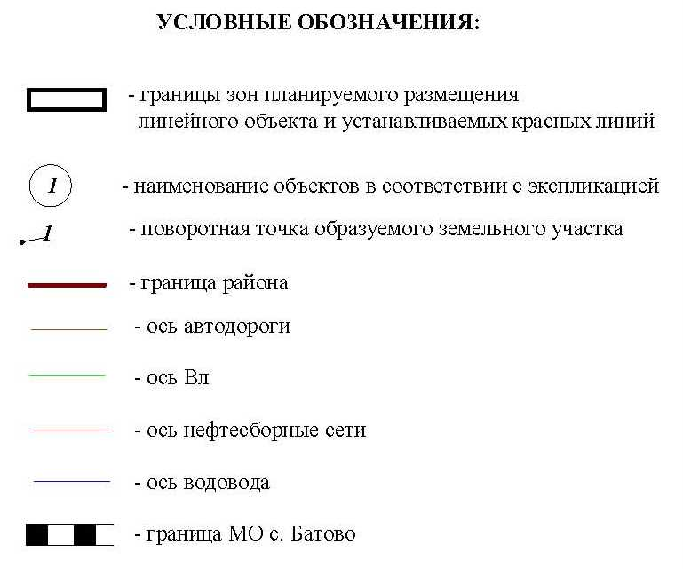

Основная часть проекта планировки территории для размещения объекта капитального строительства, расположенного
на территории двух муниципальных образований
Ханты-Мансийского автономного округа – Югры
«Обустройство Чапровского месторождения.
Кусты 14, 14а, 15, 15а, 17, 17а и коридоры коммуникаций».
Землепользователь: АО «НК «Конданефть»
Масштаб 1:2000

Основная часть проекта планировки территории для размещения линейного объекта Ханты-Мансийского автономного округа - Югры
«Обустройство Чапровского месторождения.
Кусты 14, 14а, 15, 15а, 17, 17а и коридоры коммуникаций».
Землепользователь: АО «НК «Конданефть»

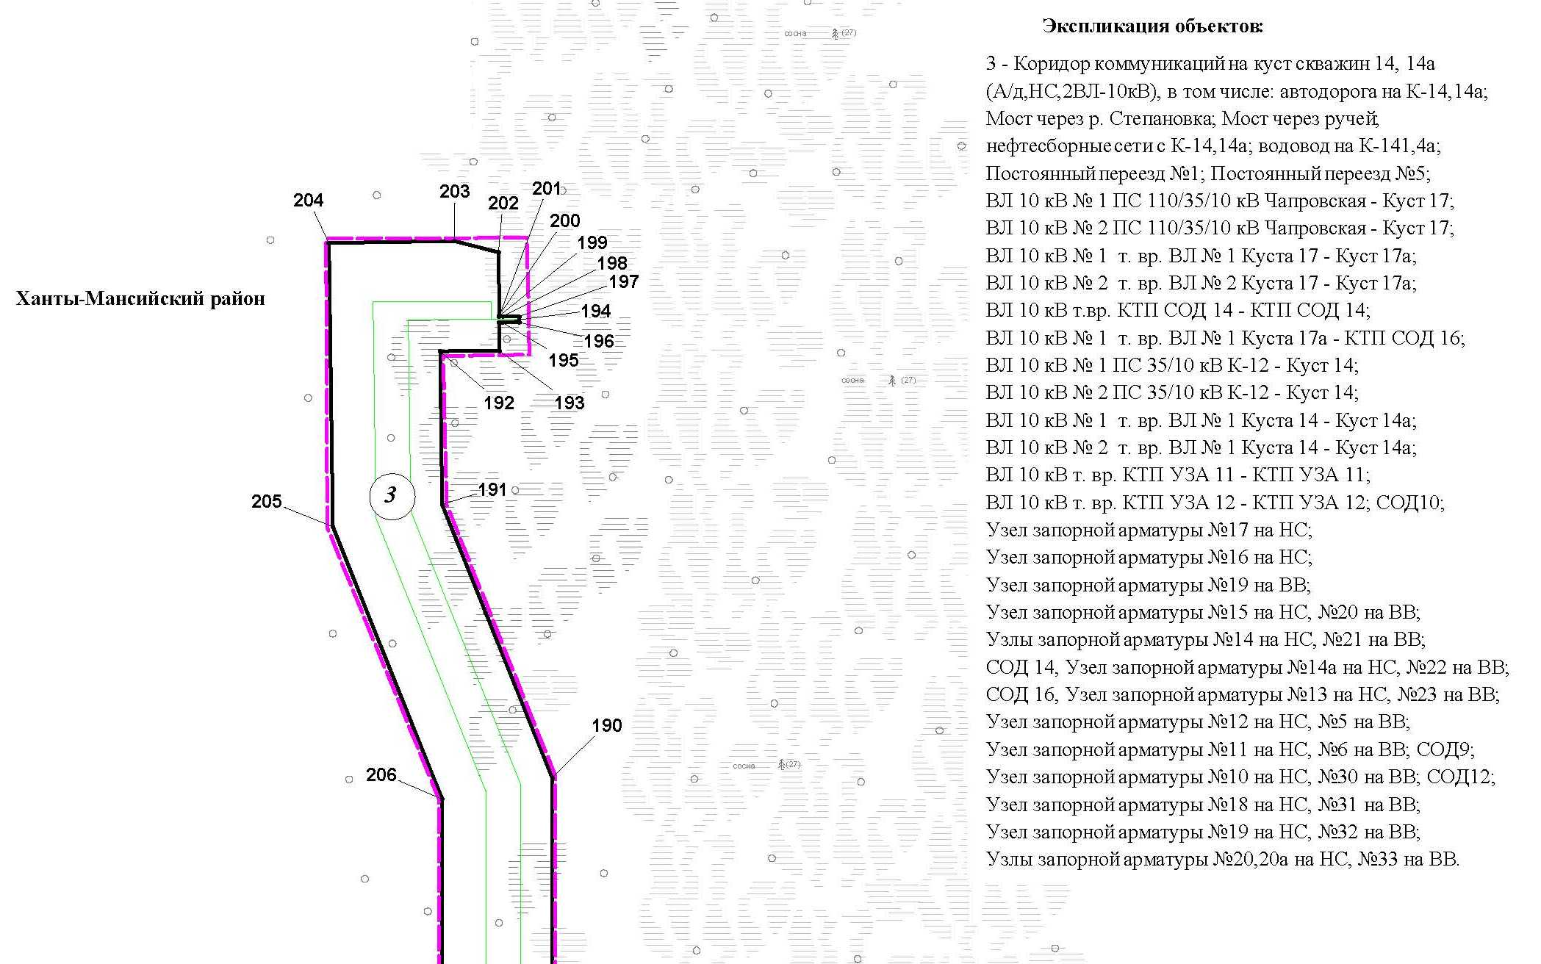
Линия совмещения с листом 3

Основная часть проекта планировки территории для размещения объекта капитального строительства, расположенного
на территории двух муниципальных образований
Ханты-Мансийского автономного округа – Югры
«Обустройство Чапровского месторождения.
Кусты 14, 14а, 15, 15а, 17, 17а и коридоры коммуникаций».
Землепользователь: АО «НК «Конданефть»
Масштаб 1:2000

Линия совмещения с листом 2

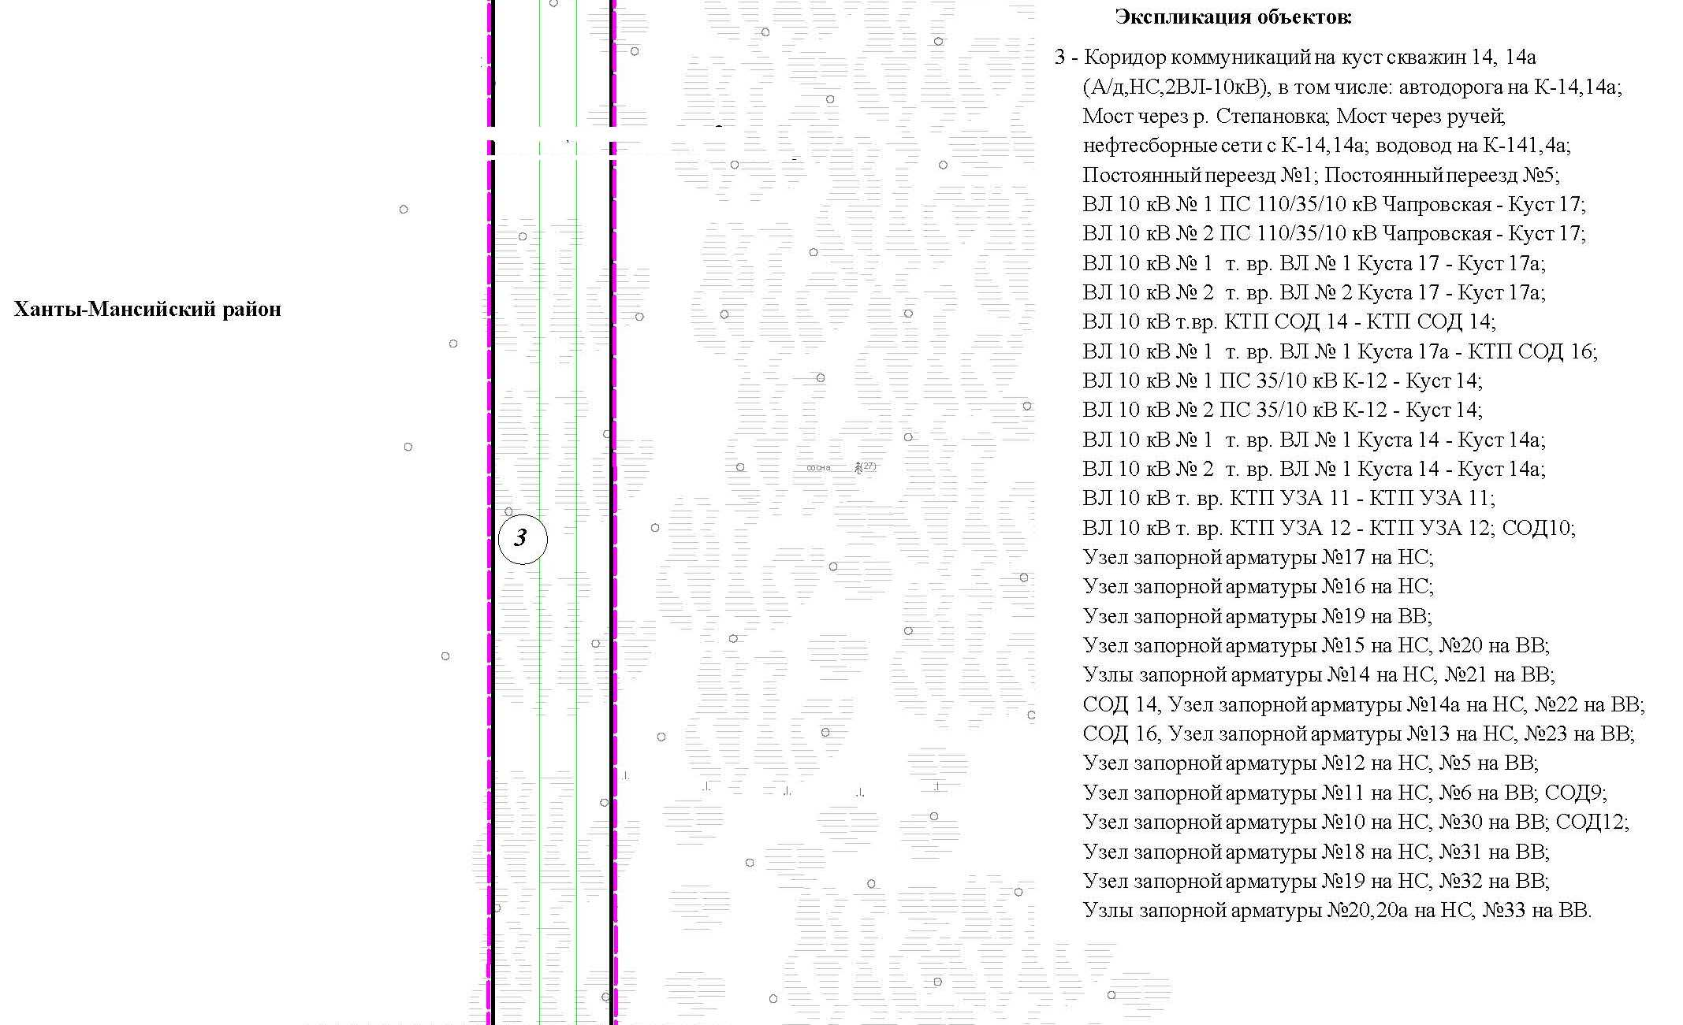

Основная часть проекта планировки территории для размещения объекта капитального строительства, расположенного
на территории двух муниципальных образований
Ханты-Мансийского автономного округа – Югры
«Обустройство Чапровского месторождения.
Кусты 14, 14а, 15, 15а, 17, 17а и коридоры коммуникаций».
Землепользователь: АО «НК «Конданефть»
Масштаб 1:2000

Линия совмещения с листом
5

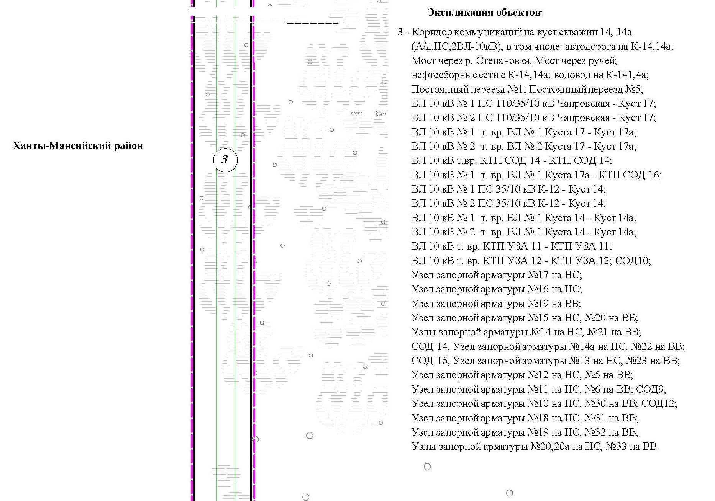
Линия совмещения с листом 5

Линия совмещения с листом 5

Основная часть проекта планировки территории для размещения объекта капитального строительства, расположенного
на территории двух муниципальных образований
Ханты-Мансийского автономного округа – Югры
«Обустройство Чапровского месторождения.
Кусты 14, 14а, 15, 15а, 17, 17а и коридоры коммуникаций».
Землепользователь: АО «НК «Конданефть»
Масштаб 1:2000

Основная часть проекта планировки территории для размещения линейного объекта Ханты-Мансийского автономного округа - Югры
«Обустройство Чапровского месторождения.
Кусты 14, 14а, 15, 15а, 17, 17а и коридоры коммуникаций».
Землепользователь: АО «НК «Конданефть»

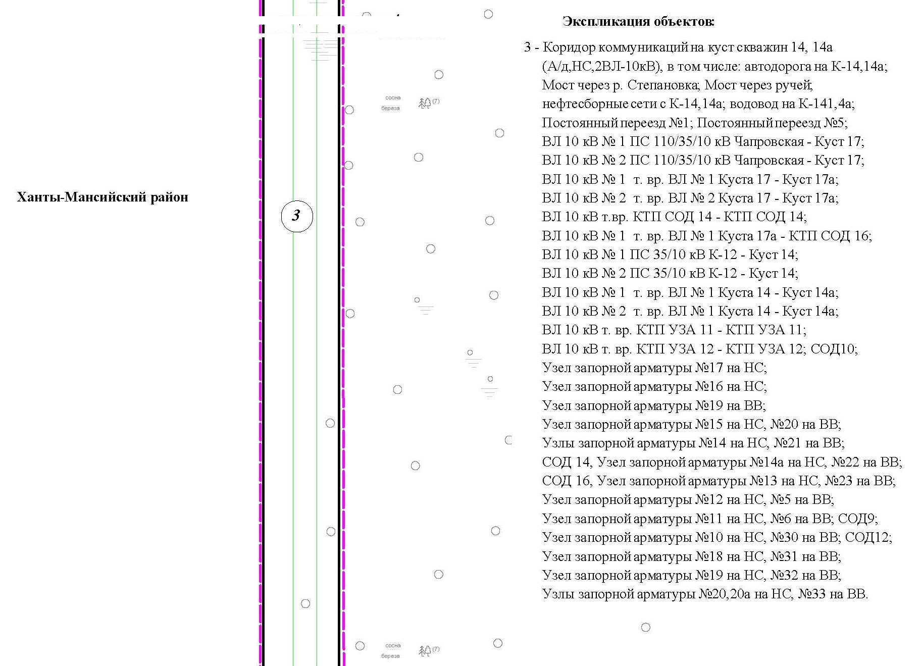

Основная часть проекта планировки территории для размещения объекта капитального строительства, расположенного
на территории двух муниципальных образований
Ханты-Мансийского автономного округа – Югры
«Обустройство Чапровского месторождения.
Кусты 14, 14а, 15, 15а, 17, 17а и коридоры коммуникаций».
Землепользователь: АО «НК «Конданефть»
Масштаб 1:2000

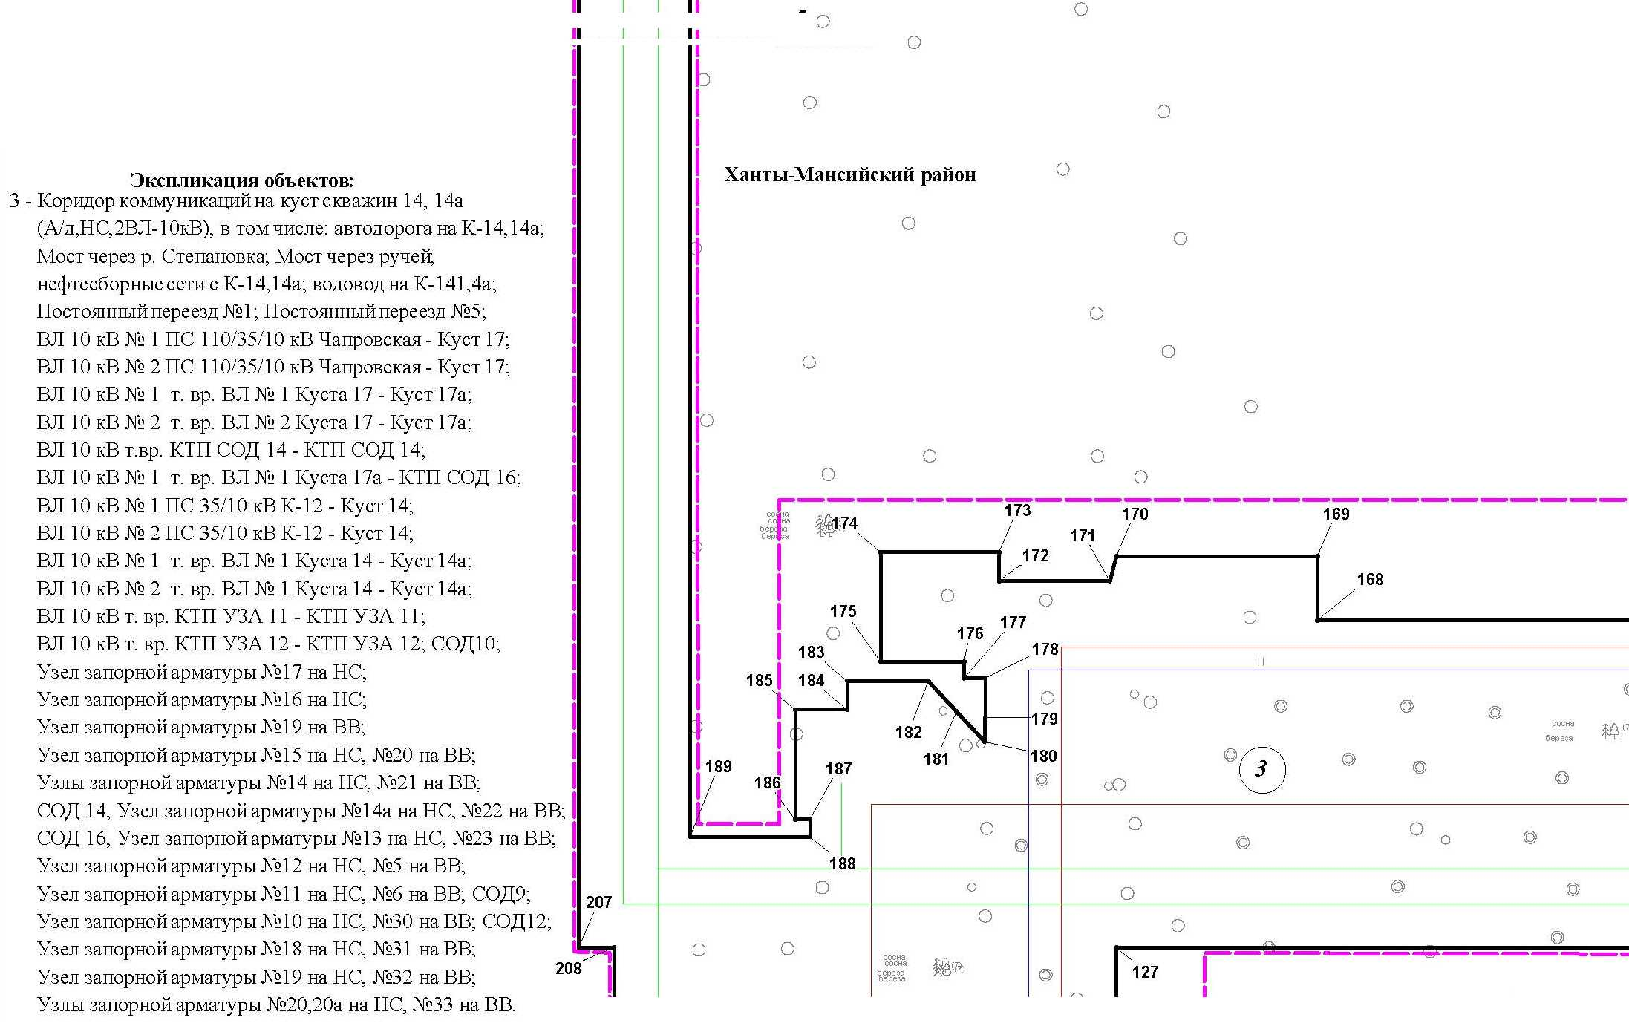
Линия совмещения с листом 86

Основная часть проекта планировки территории для размещения объекта капитального строительства, расположенного
на территории двух муниципальных образований
Ханты-Мансийского автономного округа – Югры
«Обустройство Чапровского месторождения.
Кусты 14, 14а, 15, 15а, 17, 17а и коридоры коммуникаций».
Землепользователь: АО «НК «Конданефть»
Масштаб 1:2000

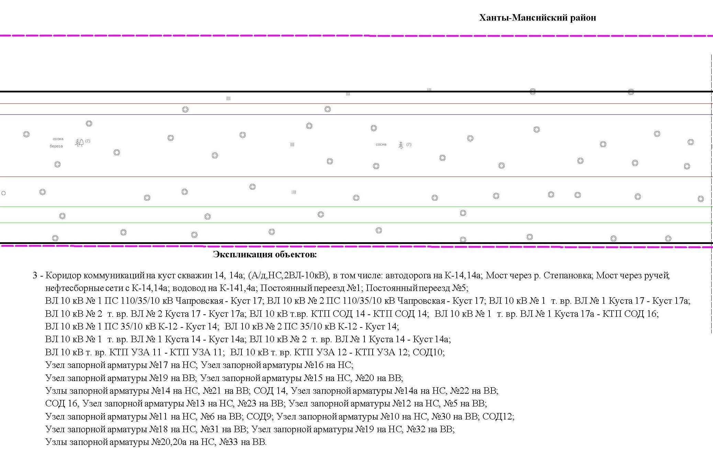

Основная часть проекта планировки территории для размещения объекта капитального строительства, расположенного
на территории двух муниципальных образований
Ханты-Мансийского автономного округа – Югры
«Обустройство Чапровского месторождения.
Кусты 14, 14а, 15, 15а, 17, 17а и коридоры коммуникаций».
Землепользователь: АО «НК «Конданефть»
Масштаб 1:2000

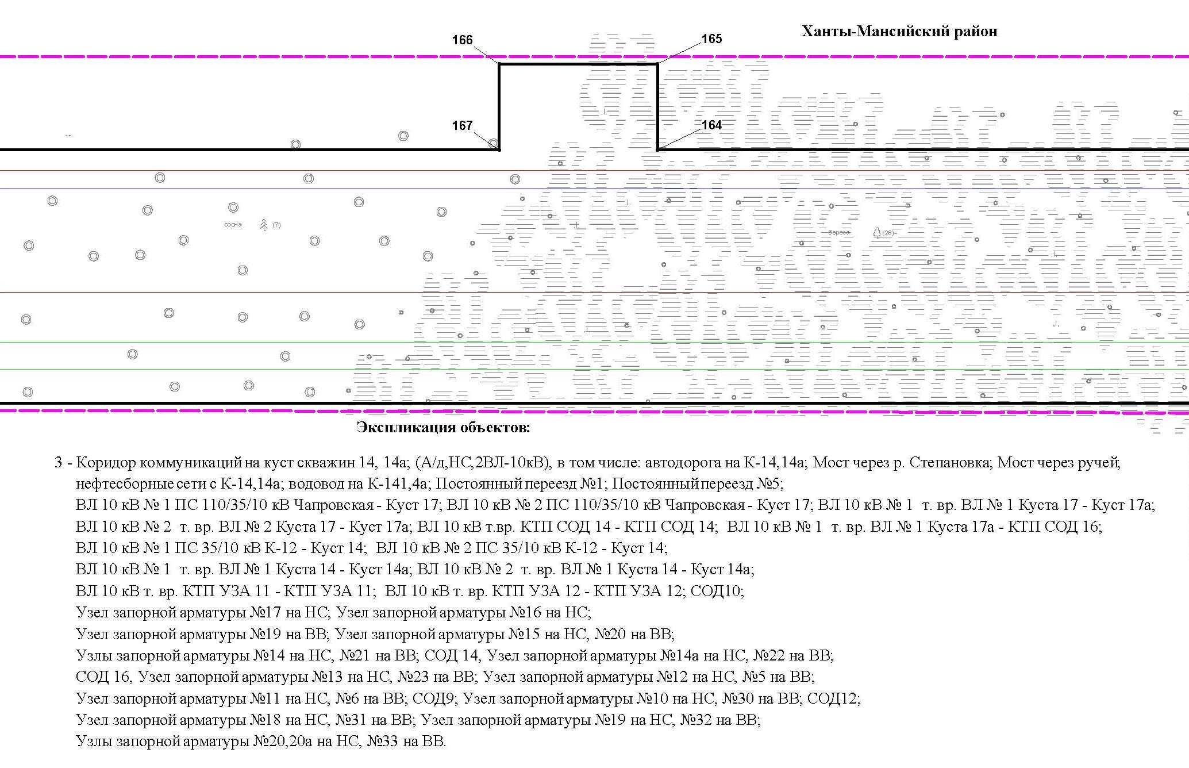

Основная часть проекта планировки территории для размещения объекта капитального строительства, расположенного
на территории двух муниципальных образований
Ханты-Мансийского автономного округа – Югры
«Обустройство Чапровского месторождения.
Кусты 14, 14а, 15, 15а, 17, 17а и коридоры коммуникаций».
Землепользователь: АО «НК «Конданефть»
Масштаб 1:2000

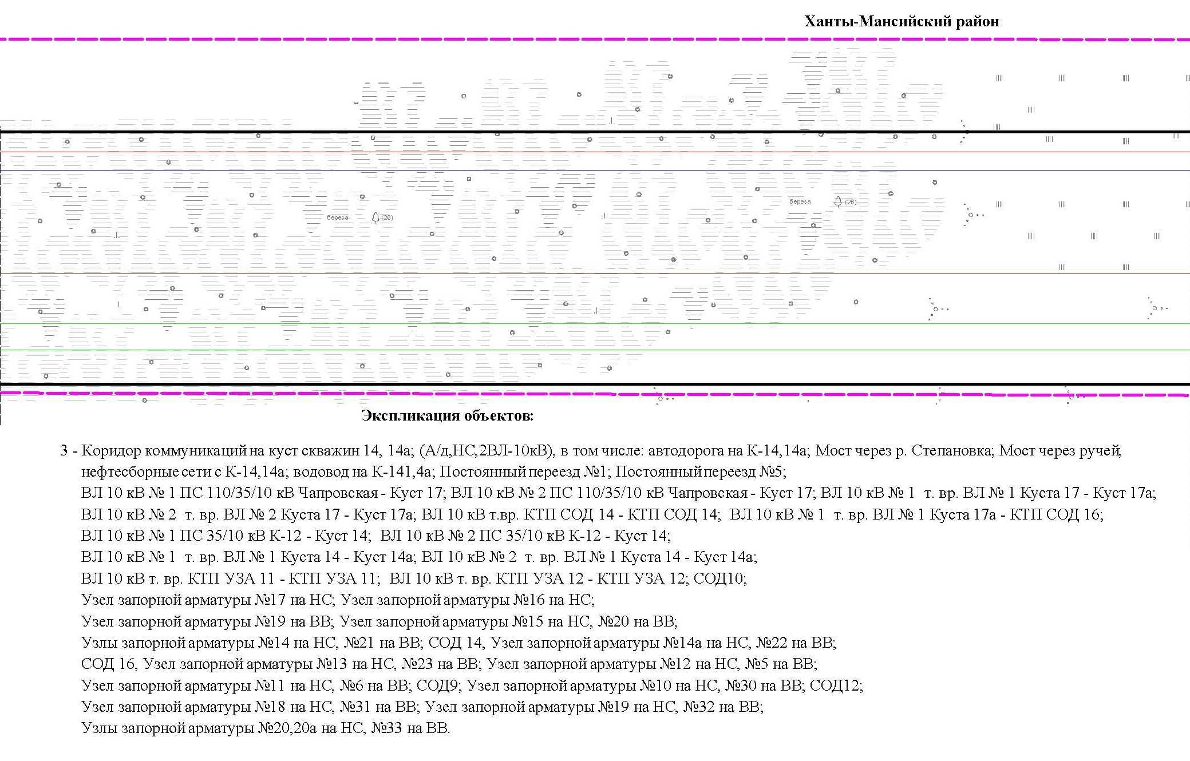

Основная часть проекта планировки территории для размещения объекта капитального строительства, расположенного
на территории двух муниципальных образований
Ханты-Мансийского автономного округа – Югры
«Обустройство Чапровского месторождения.
Кусты 14, 14а, 15, 15а, 17, 17а и коридоры коммуникаций».
Землепользователь: АО «НК «Конданефть»
Масштаб 1:2000

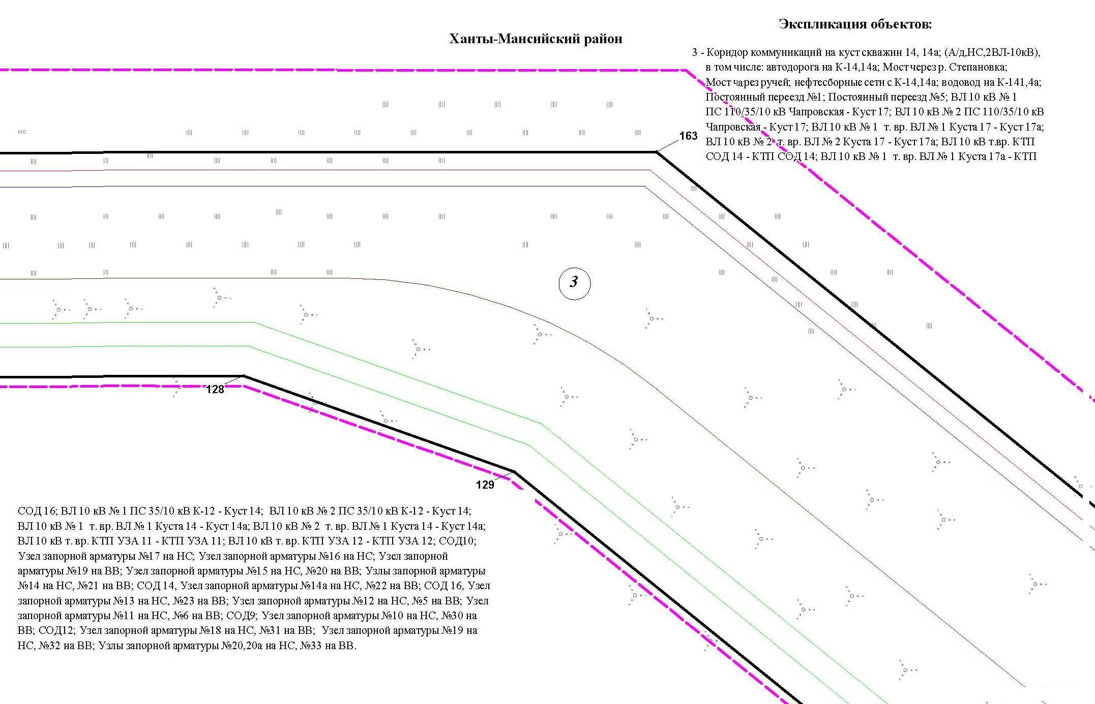

Линия совмещения с листом 11

Основная часть проекта планировки территории для размещения объекта капитального строительства, расположенного
на территории двух муниципальных образований
Ханты-Мансийского автономного округа – Югры
«Обустройство Чапровского месторождения.
Кусты 14, 14а, 15, 15а, 17, 17а и коридоры коммуникаций».
Землепользователь: АО «НК «Конданефть»
Масштаб 1:2000

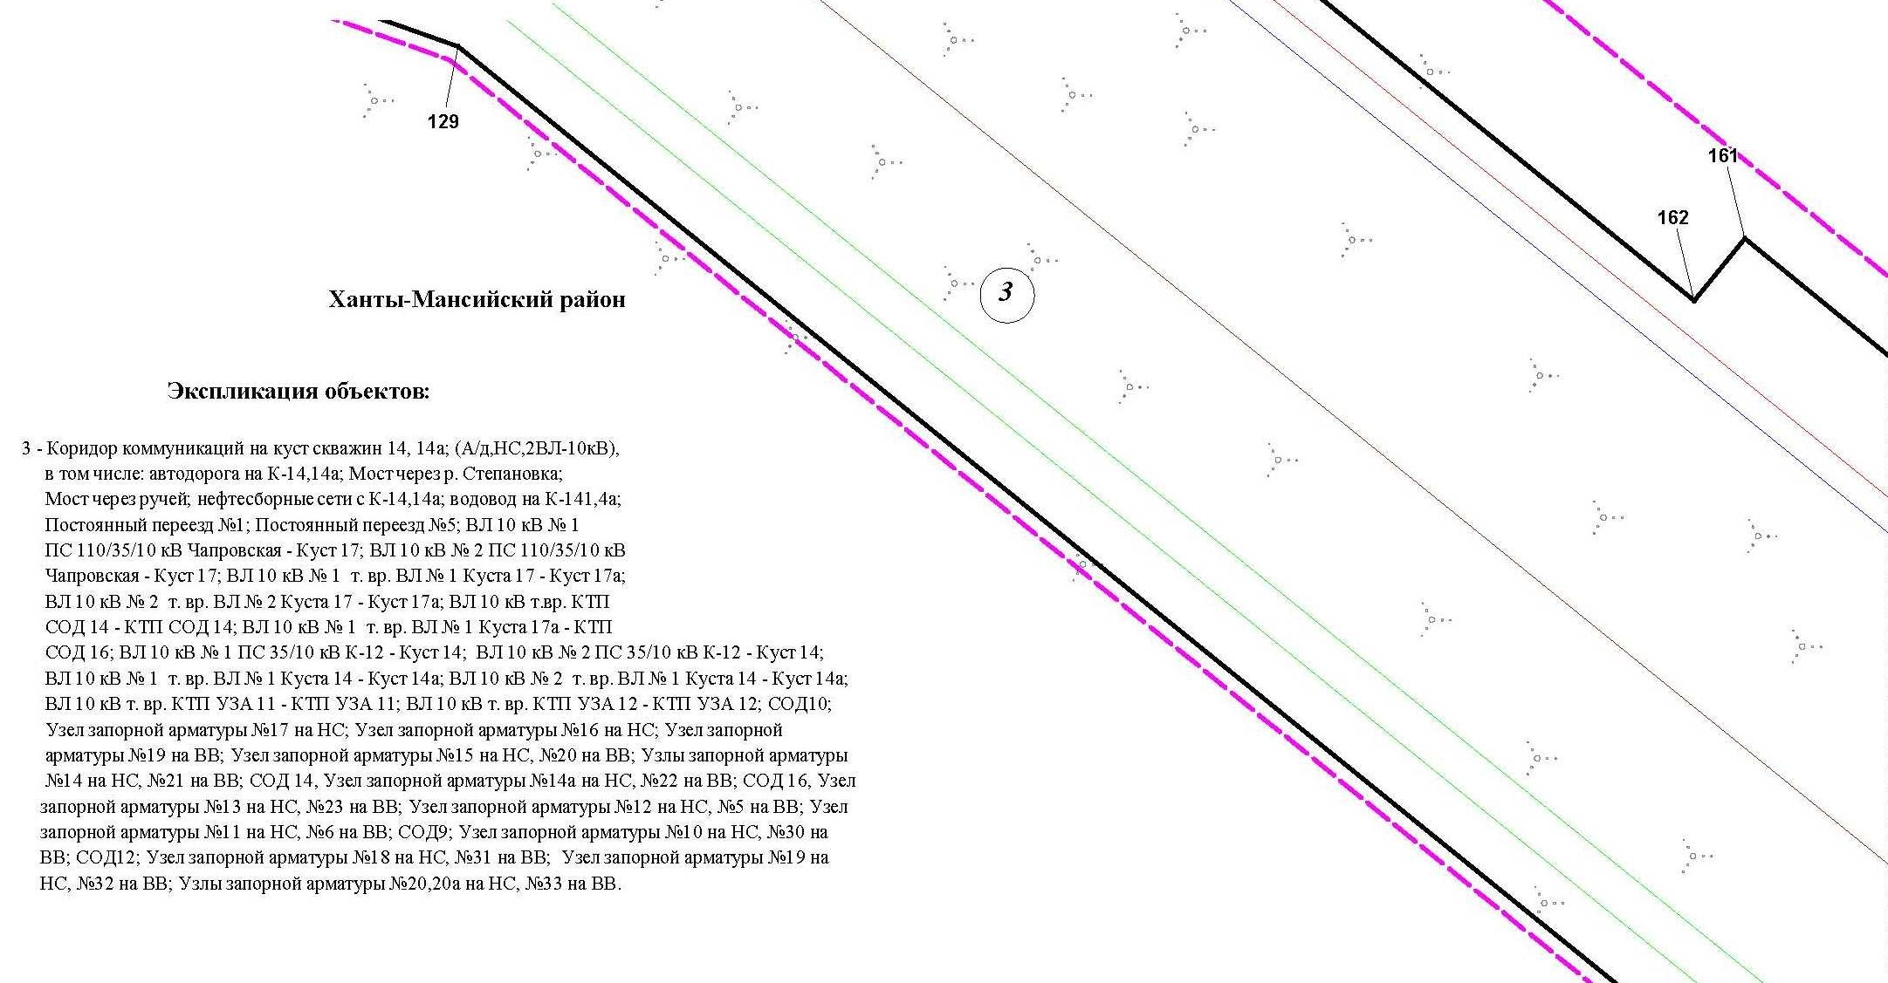

Линия совмещения с листом 12

Основная часть проекта планировки территории для размещения объекта капитального строительства, расположенного
на территории двух муниципальных образований
Ханты-Мансийского автономного округа – Югры
«Обустройство Чапровского месторождения.
Кусты 14, 14а, 15, 15а, 17, 17а и коридоры коммуникаций».
Землепользователь: АО «НК «Конданефть»
Масштаб 1:2000

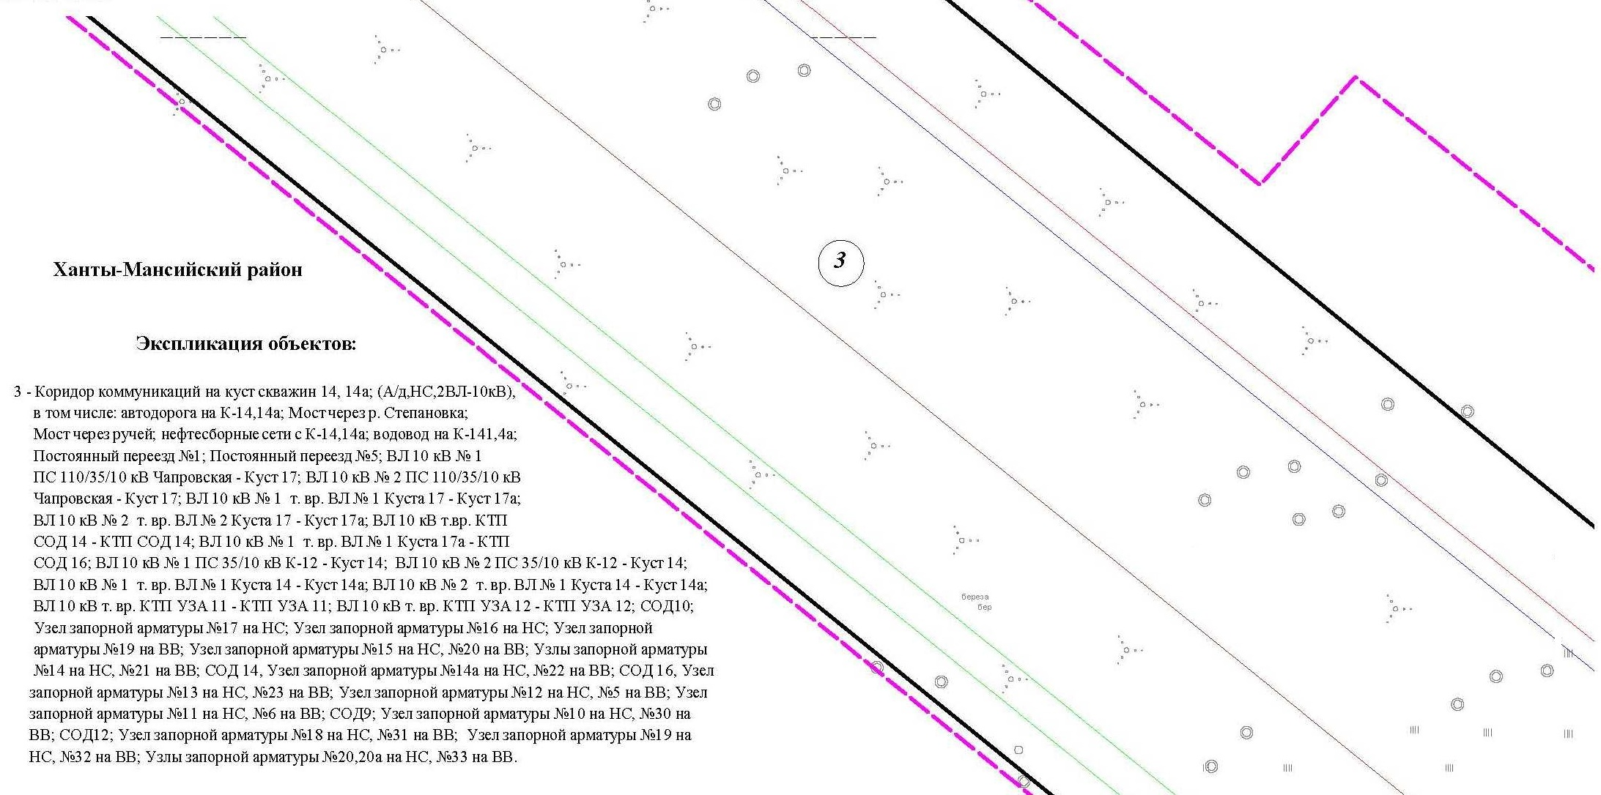

Линия совмещения с листом 13

Основная часть проекта планировки территории для размещения объекта капитального строительства, расположенного
на территории двух муниципальных образований
Ханты-Мансийского автономного округа – Югры
«Обустройство Чапровского месторождения.
Кусты 14, 14а, 15, 15а, 17, 17а и коридоры коммуникаций».
Землепользователь: АО «НК «Конданефть»
Масштаб 1:2000

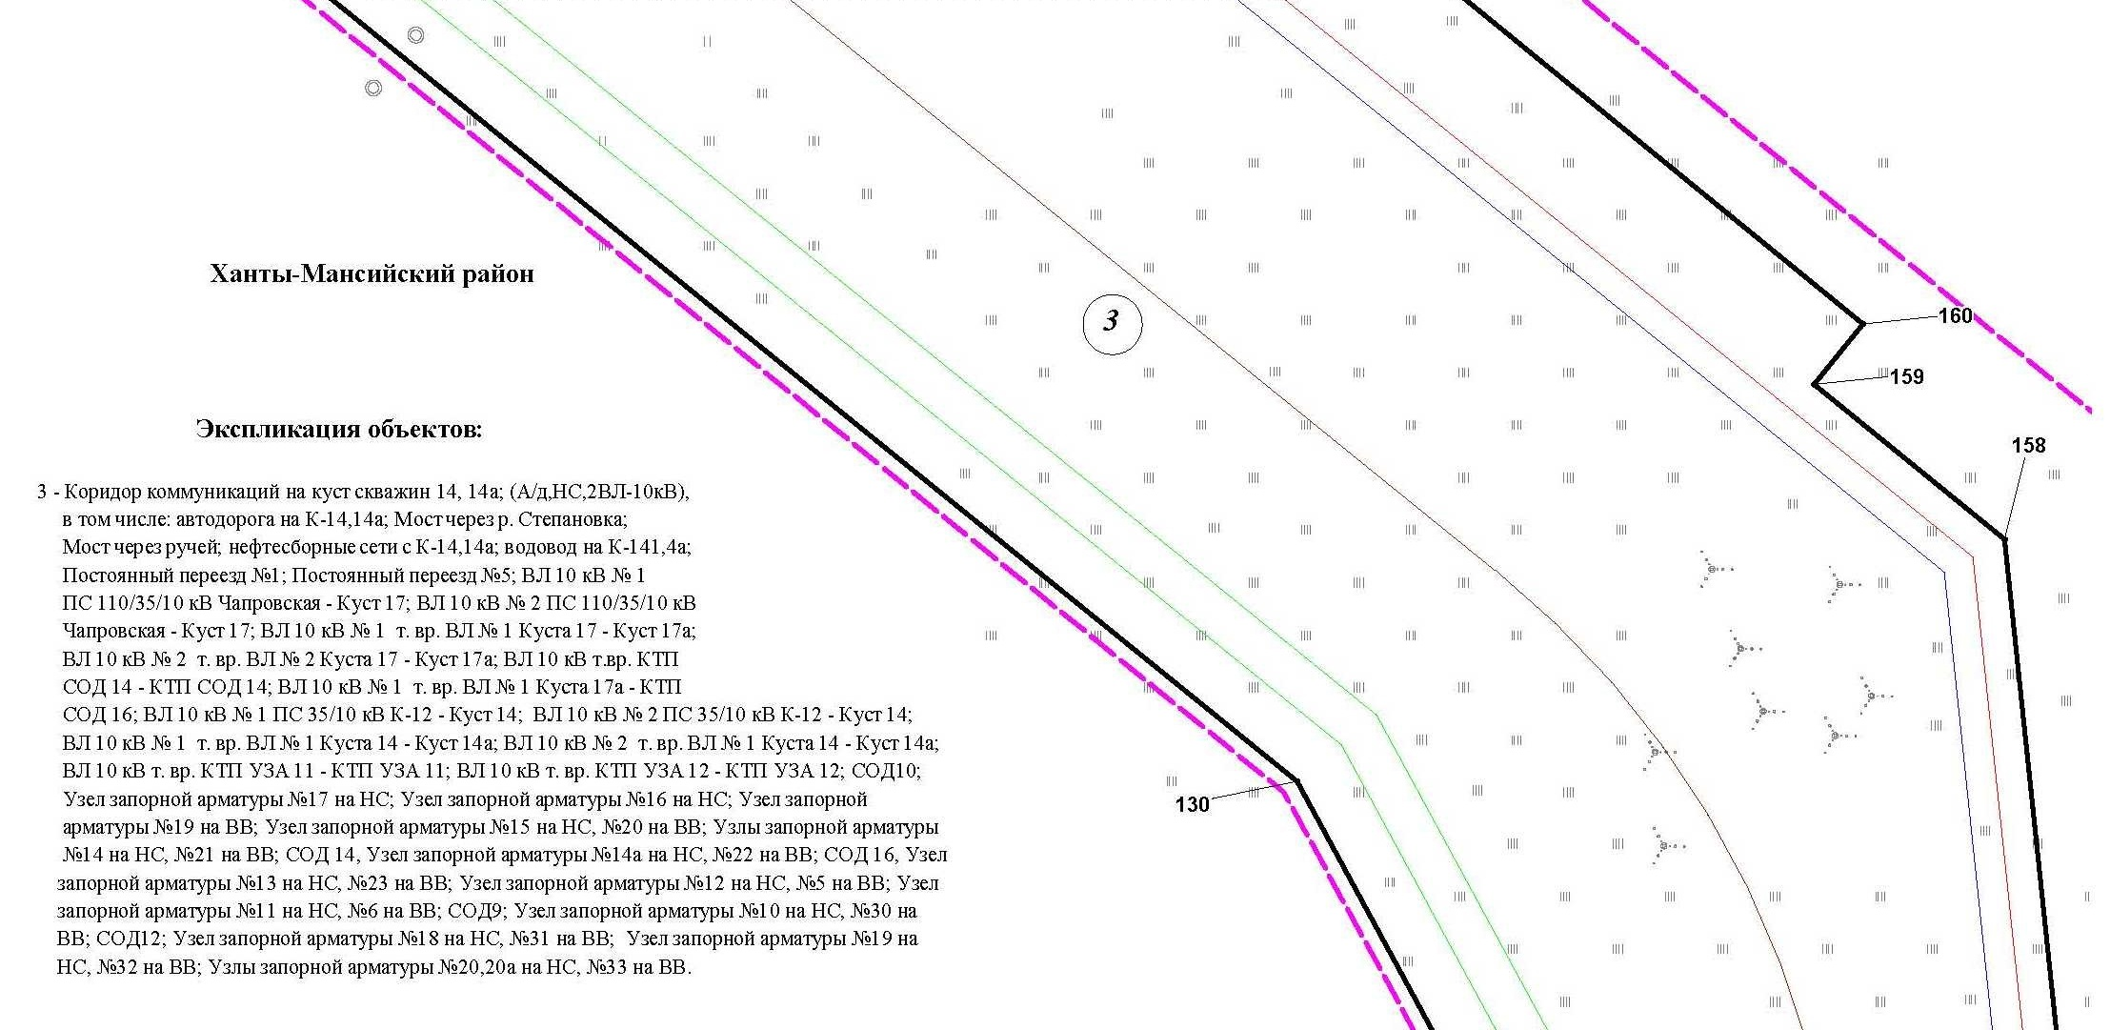
Линия совмещения с листом 14

Линия совмещения с листом 14

Основная часть проекта планировки территории для размещения объекта капитального строительства, расположенного
на территории двух муниципальных образований
Ханты-Мансийского автономного округа – Югры
«Обустройство Чапровского месторождения.
Кусты 14, 14а, 15, 15а, 17, 17а и коридоры коммуникаций».
Землепользователь: АО «НК «Конданефть»
Масштаб 1:2000

Линия совмещения с листом 13

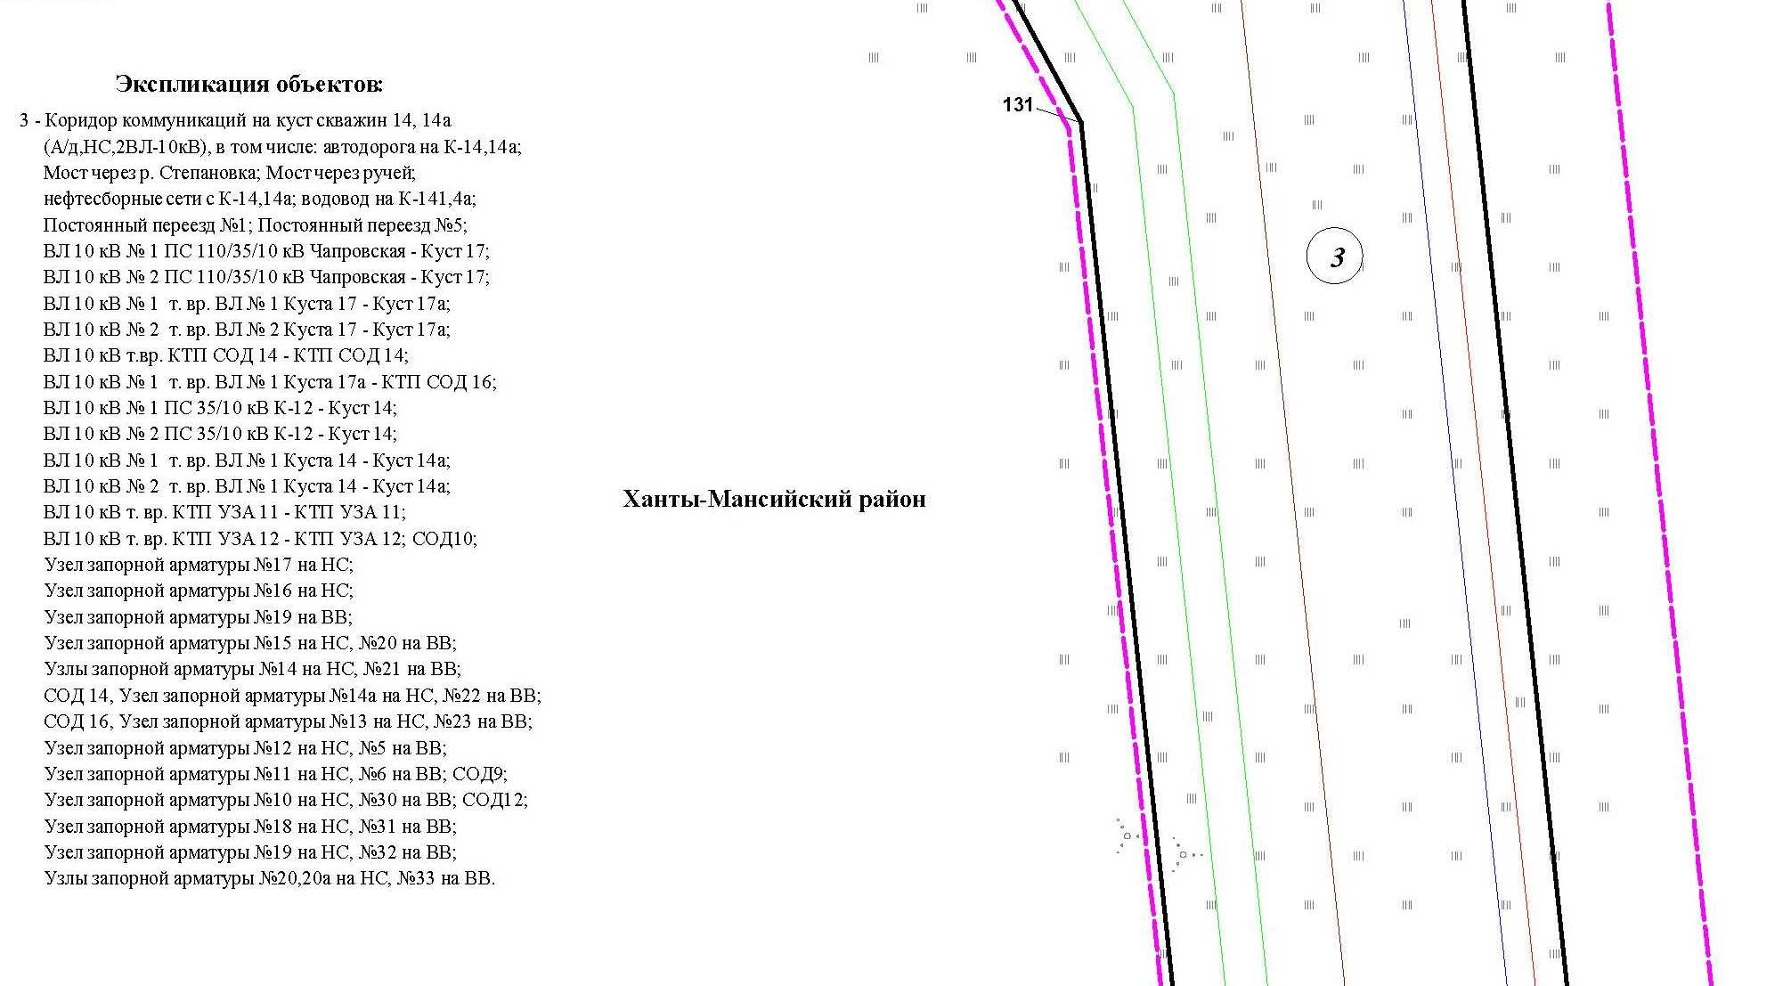
Линия совмещения с листом 15

Линия совмещения с листом 15

Основная часть проекта планировки территории для размещения объекта капитального строительства, расположенного
на территории двух муниципальных образований
Ханты-Мансийского автономного округа – Югры
«Обустройство Чапровского месторождения.
Кусты 14, 14а, 15, 15а, 17, 17а и коридоры коммуникаций».
Землепользователь: АО «НК «Конданефть»
Масштаб 1:2000

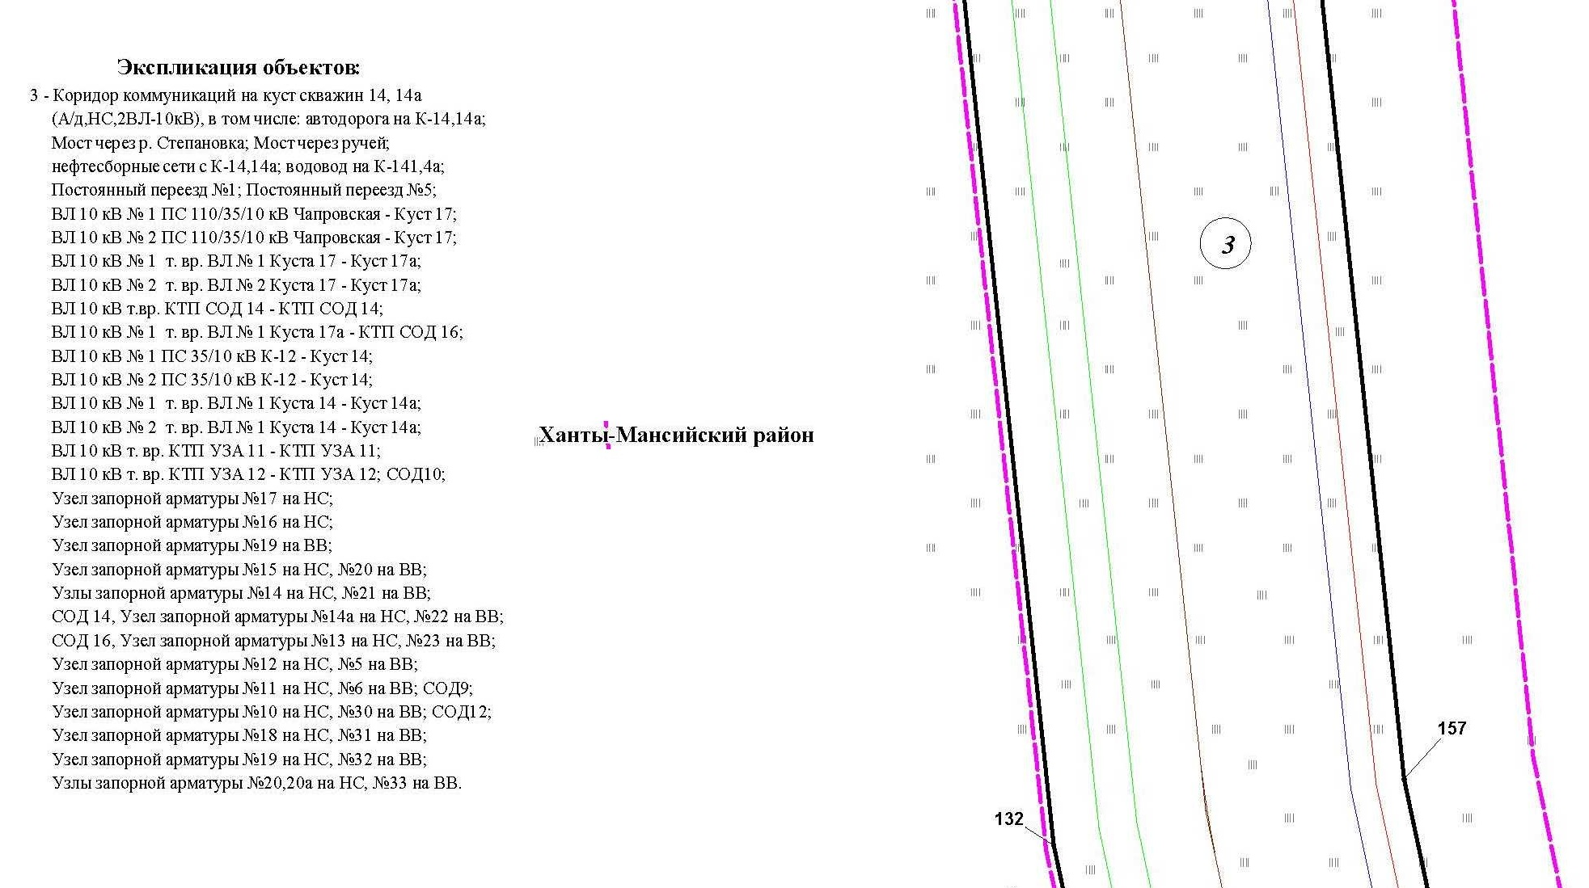

Линия совмещения с листом 16

Основная часть проекта планировки территории для размещения объекта капитального строительства, расположенного
на территории двух муниципальных образований
Ханты-Мансийского автономного округа – Югры
«Обустройство Чапровского месторождения.
Кусты 14, 14а, 15, 15а, 17, 17а и коридоры коммуникаций».
Землепользователь: АО «НК «Конданефть»
Масштаб 1:2000

Линия совмещения с листом 17
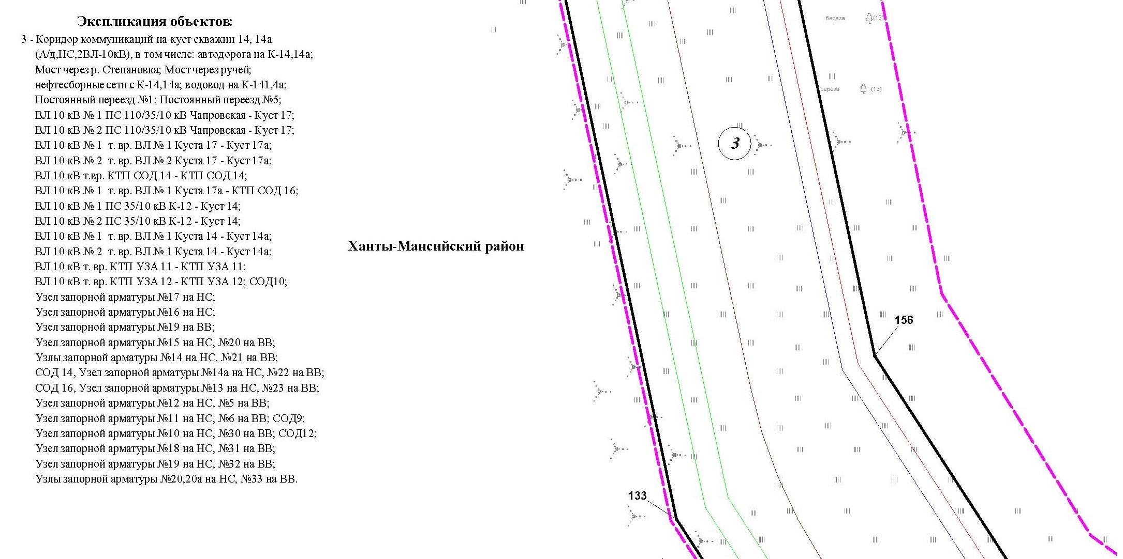

Линия совмещения с листом 17

Основная часть проекта планировки территории для размещения объекта капитального строительства, расположенного
на территории двух муниципальных образований
Ханты-Мансийского автономного округа – Югры
«Обустройство Чапровского месторождения.
Кусты 14, 14а, 15, 15а, 17, 17а и коридоры коммуникаций».
Землепользователь: АО «НК «Конданефть»
Масштаб 1:2000

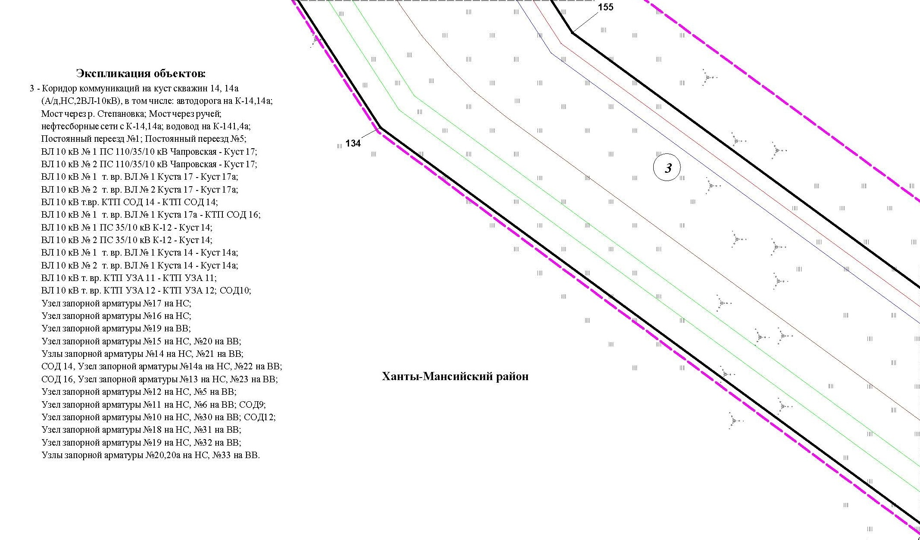

Основная часть проекта планировки территории для размещения объекта капитального строительства, расположенного
на территории двух муниципальных образований
Ханты-Мансийского автономного округа – Югры
«Обустройство Чапровского месторождения.
Кусты 14, 14а, 15, 15а, 17, 17а и коридоры коммуникаций».
Землепользователь: АО «НК «Конданефть»
Масштаб 1:2000

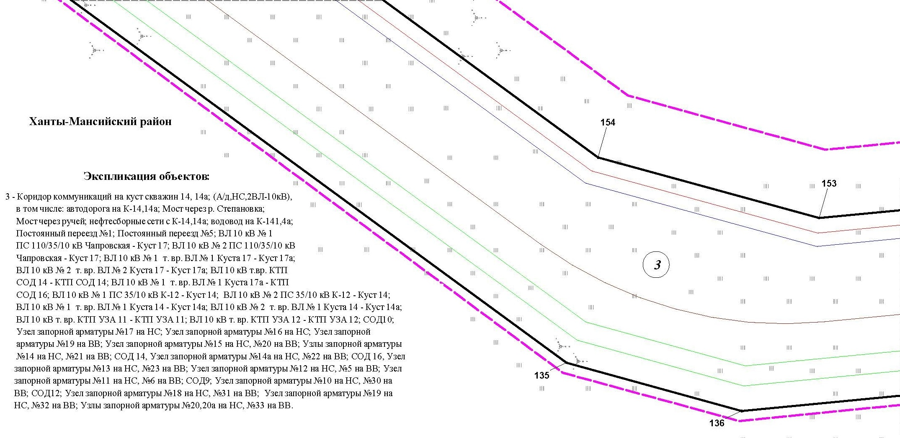

Основная часть проекта планировки территории для размещения объекта капитального строительства, расположенного
на территории двух муниципальных образований
Ханты-Мансийского автономного округа – Югры
«Обустройство Чапровского месторождения.
Кусты 14, 14а, 15, 15а, 17, 17а и коридоры коммуникаций».
Землепользователь: АО «НК «Конданефть»
Масштаб 1:2000

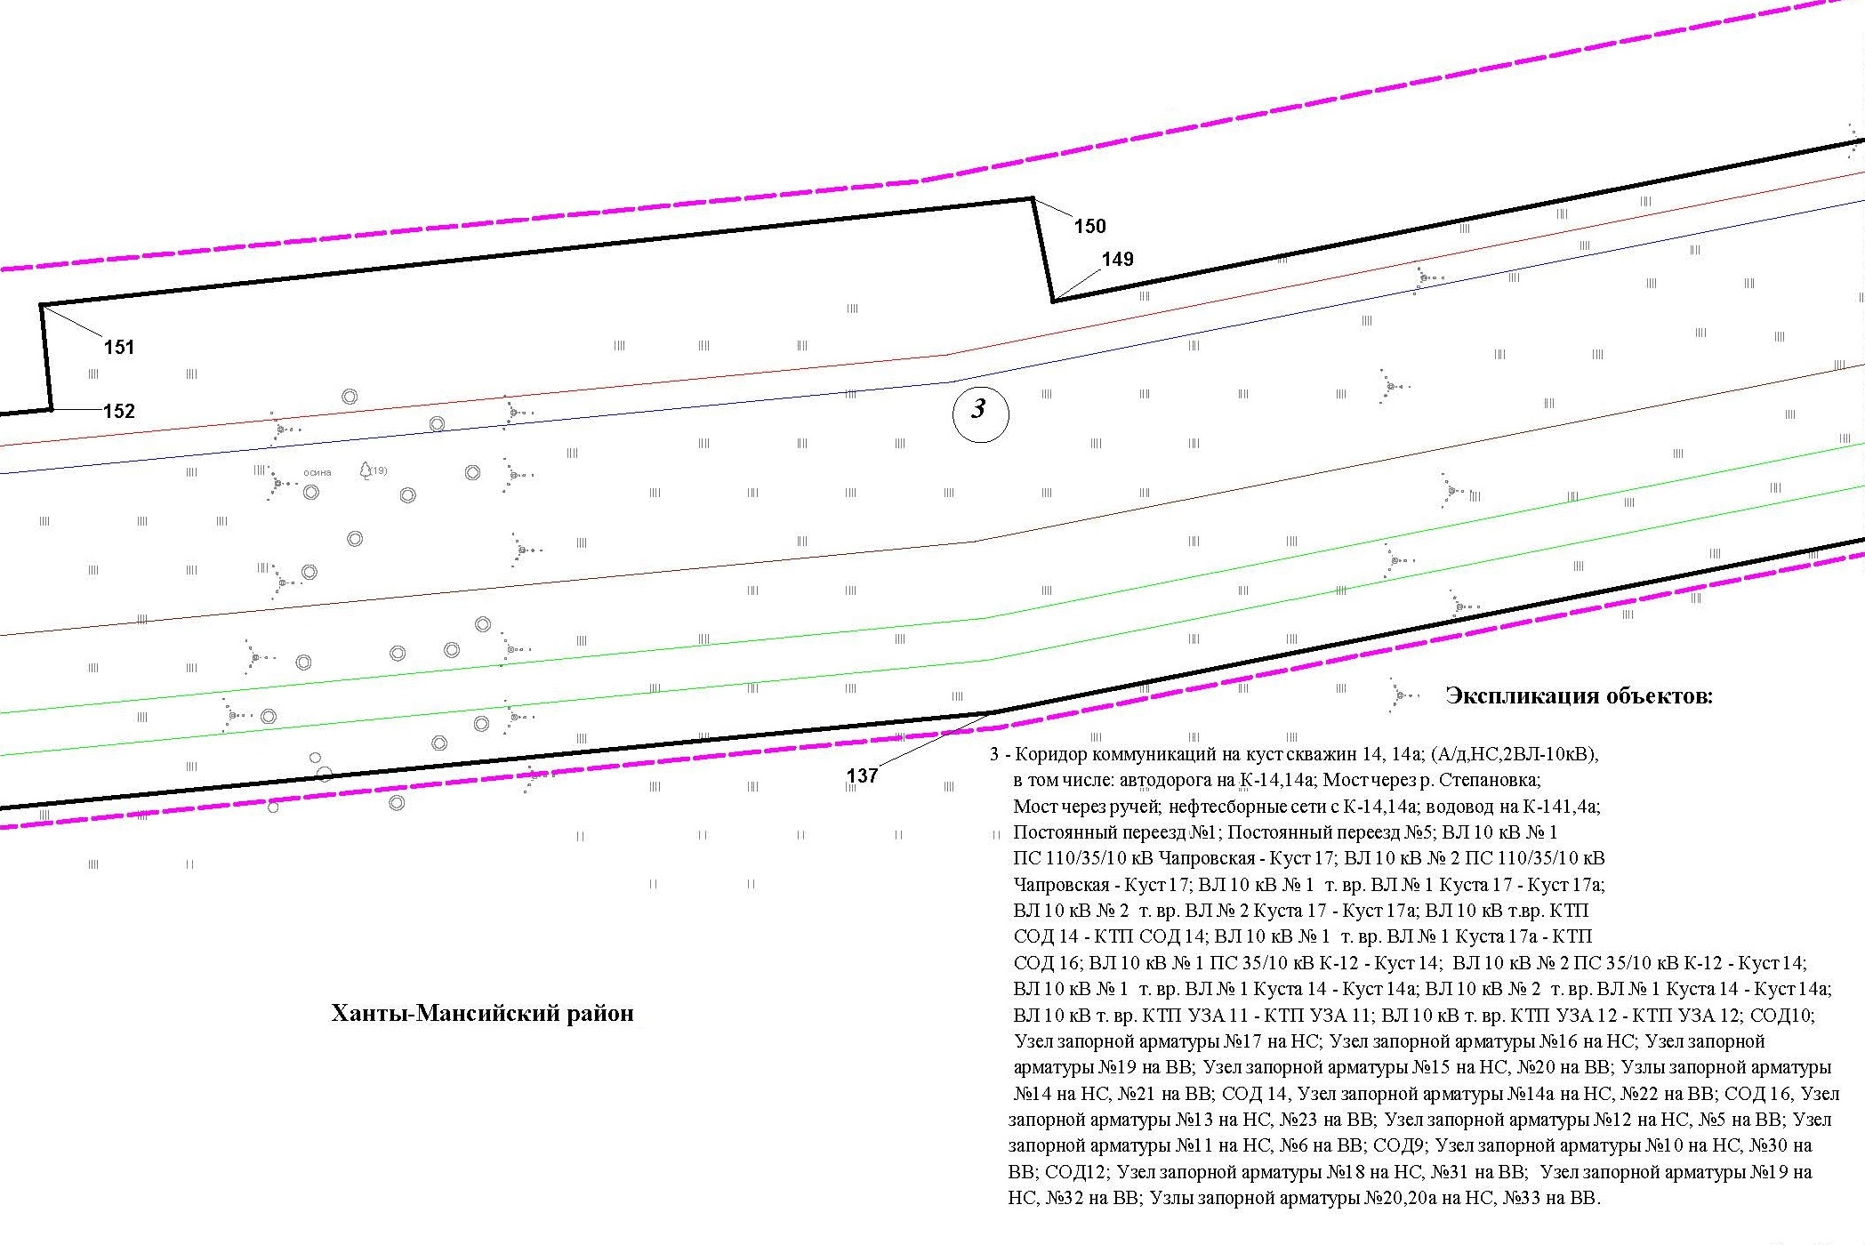

Основная часть проекта планировки территории для размещения объекта капитального строительства, расположенного
на территории двух муниципальных образований
Ханты-Мансийского автономного округа – Югры
«Обустройство Чапровского месторождения.
Кусты 14, 14а, 15, 15а, 17, 17а и коридоры коммуникаций».
Землепользователь: АО «НК «Конданефть»
Масштаб 1:2000

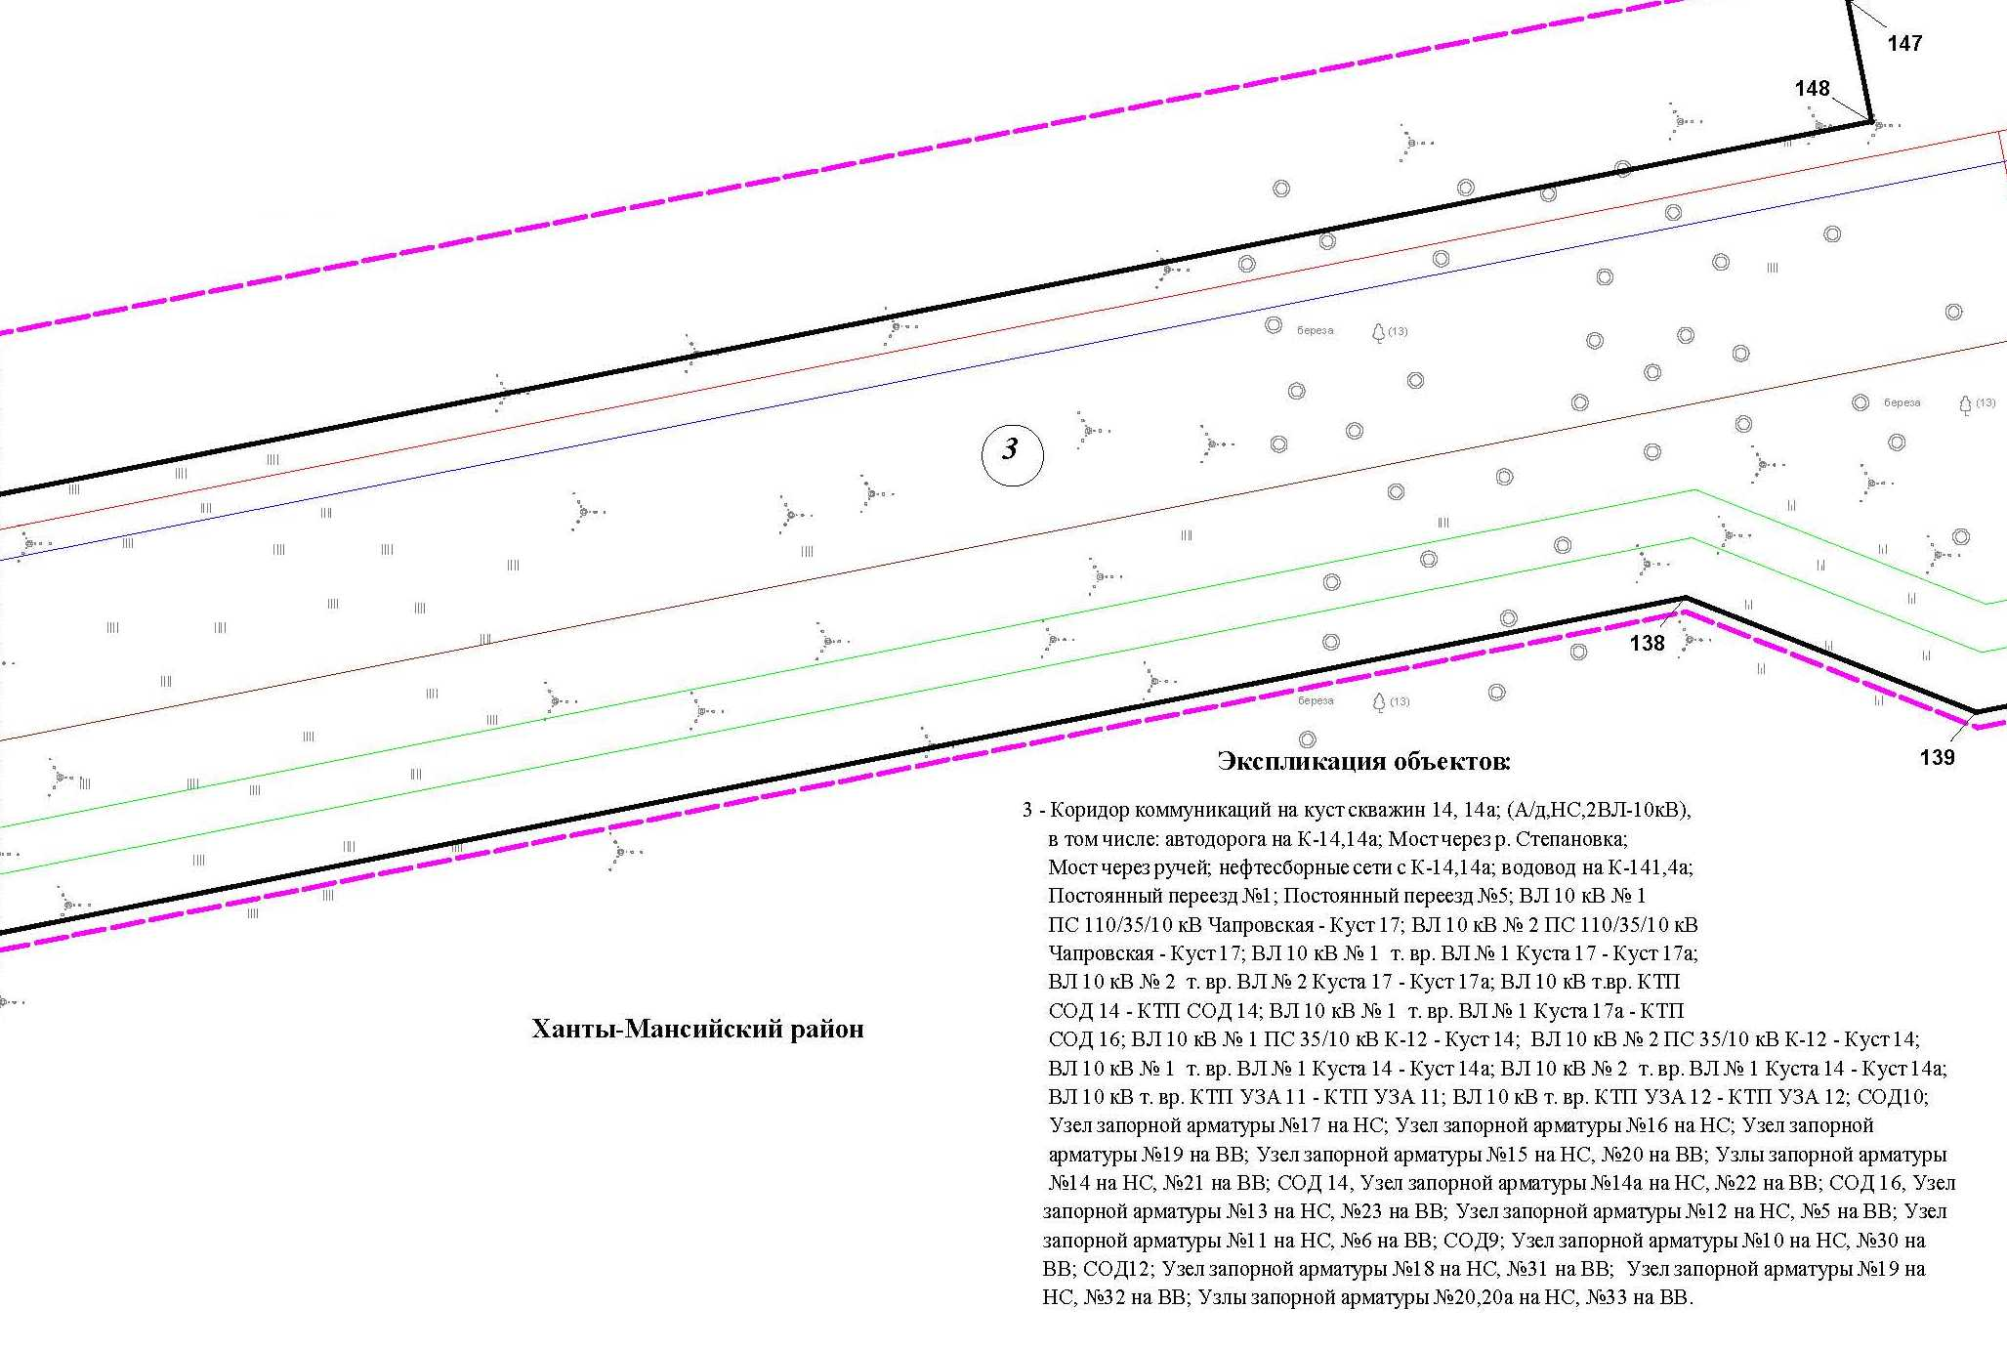
Линия совмещения с листом
19

Линия совмещения с листом
2
1

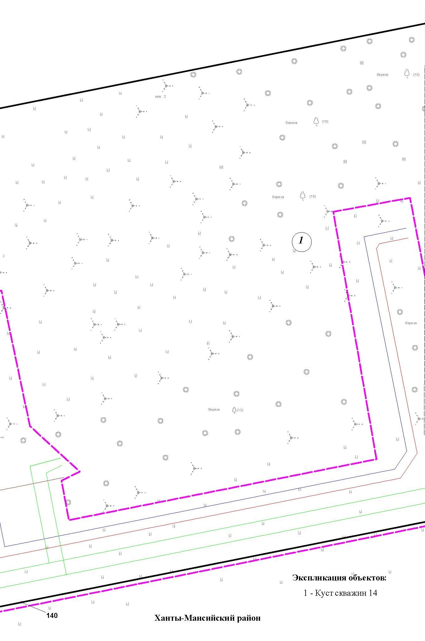
Основная часть проекта планировки территории для размещения объекта капитального строительства, расположенного
на территории двух муниципальных образований
Ханты-Мансийского автономного округа – Югры
«Обустройство Чапровского месторождения.
Кусты 14, 14а, 15, 15а, 17, 17а и коридоры коммуникаций».
Землепользователь: АО «НК «Конданефть»
Масштаб 1:2000

Линия совмещения с листом
2
6

Основная часть проекта планировки территории для размещения объекта капитального строительства, расположенного
на территории двух муниципальных образований
Ханты-Мансийского автономного округа – Югры
«Обустройство Чапровского месторождения.
Кусты 14, 14а, 15, 15а, 17, 17а и коридоры коммуникаций».
Землепользователь: АО «НК «Конданефть»
Масштаб 1:2000

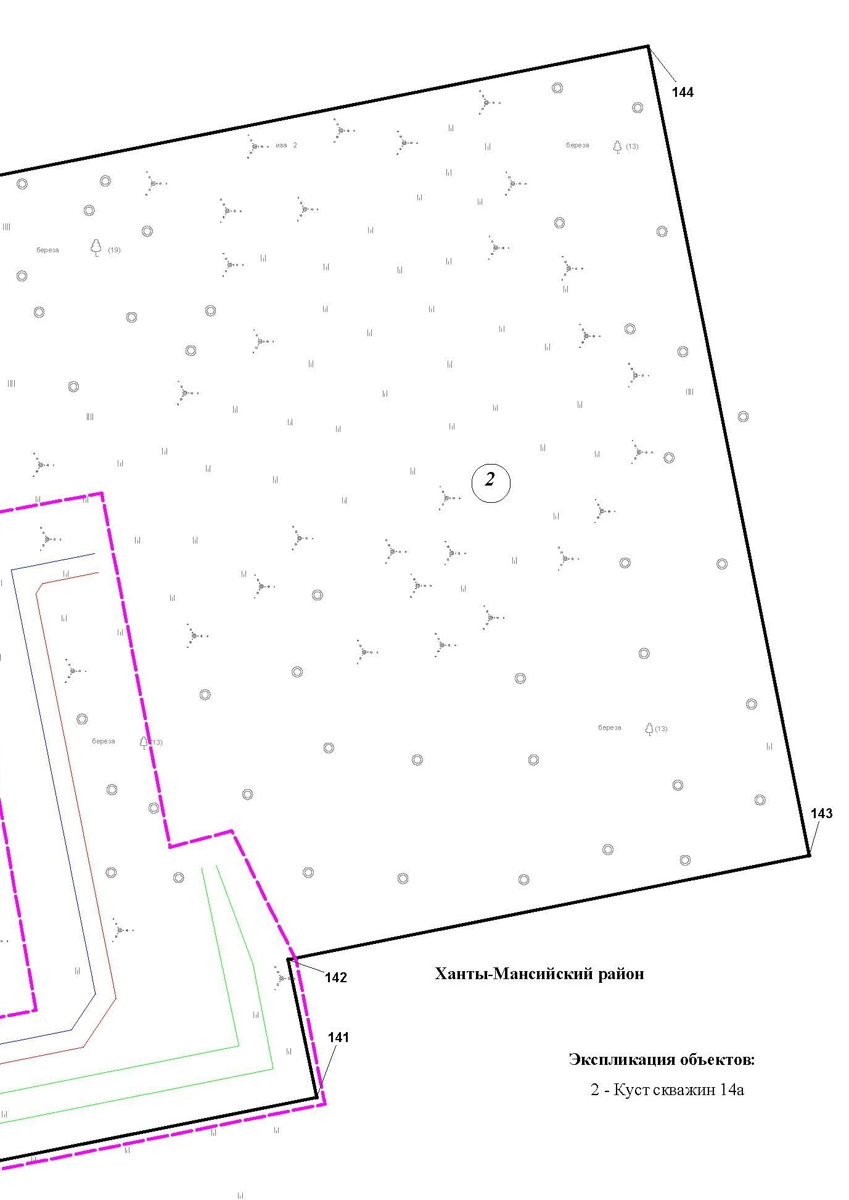

Линия совмещения с листом
2
1

Линия совмещения с листом 24

Основная часть проекта планировки территории для размещения объекта капитального строительства, расположенного
на территории двух муниципальных образований
Ханты-Мансийского автономного округа – Югры
«Обустройство Чапровского месторождения.
Кусты 14, 14а, 15, 15а, 17, 17а и коридоры коммуникаций».
Землепользователь: АО «НК «Конданефть»
Масштаб 1:2000

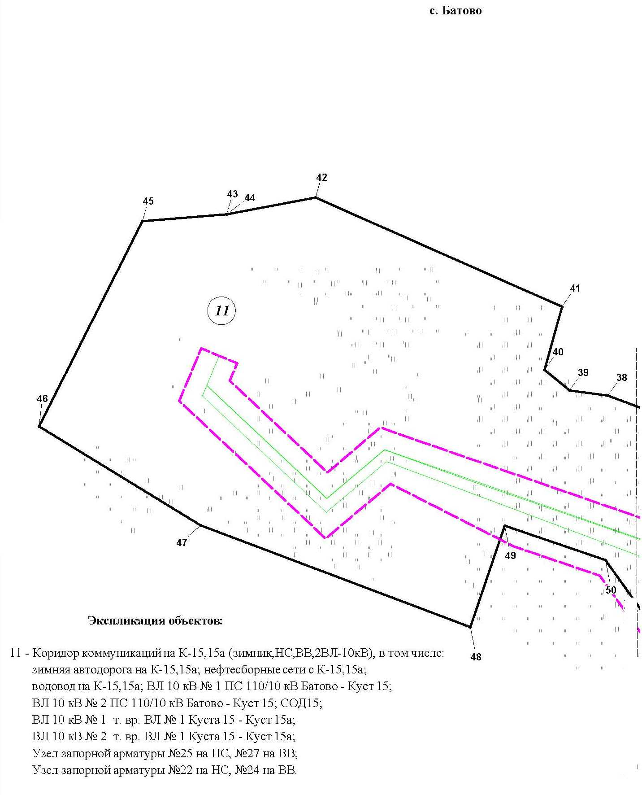

Основная часть проекта планировки территории для размещения объекта капитального строительства, расположенного
на территории двух муниципальных образований
Ханты-Мансийского автономного округа – Югры
«Обустройство Чапровского месторождения.
Кусты 14, 14а, 15, 15а, 17, 17а и коридоры коммуникаций».
Землепользователь: АО «НК «Конданефть»
Масштаб 1:2000

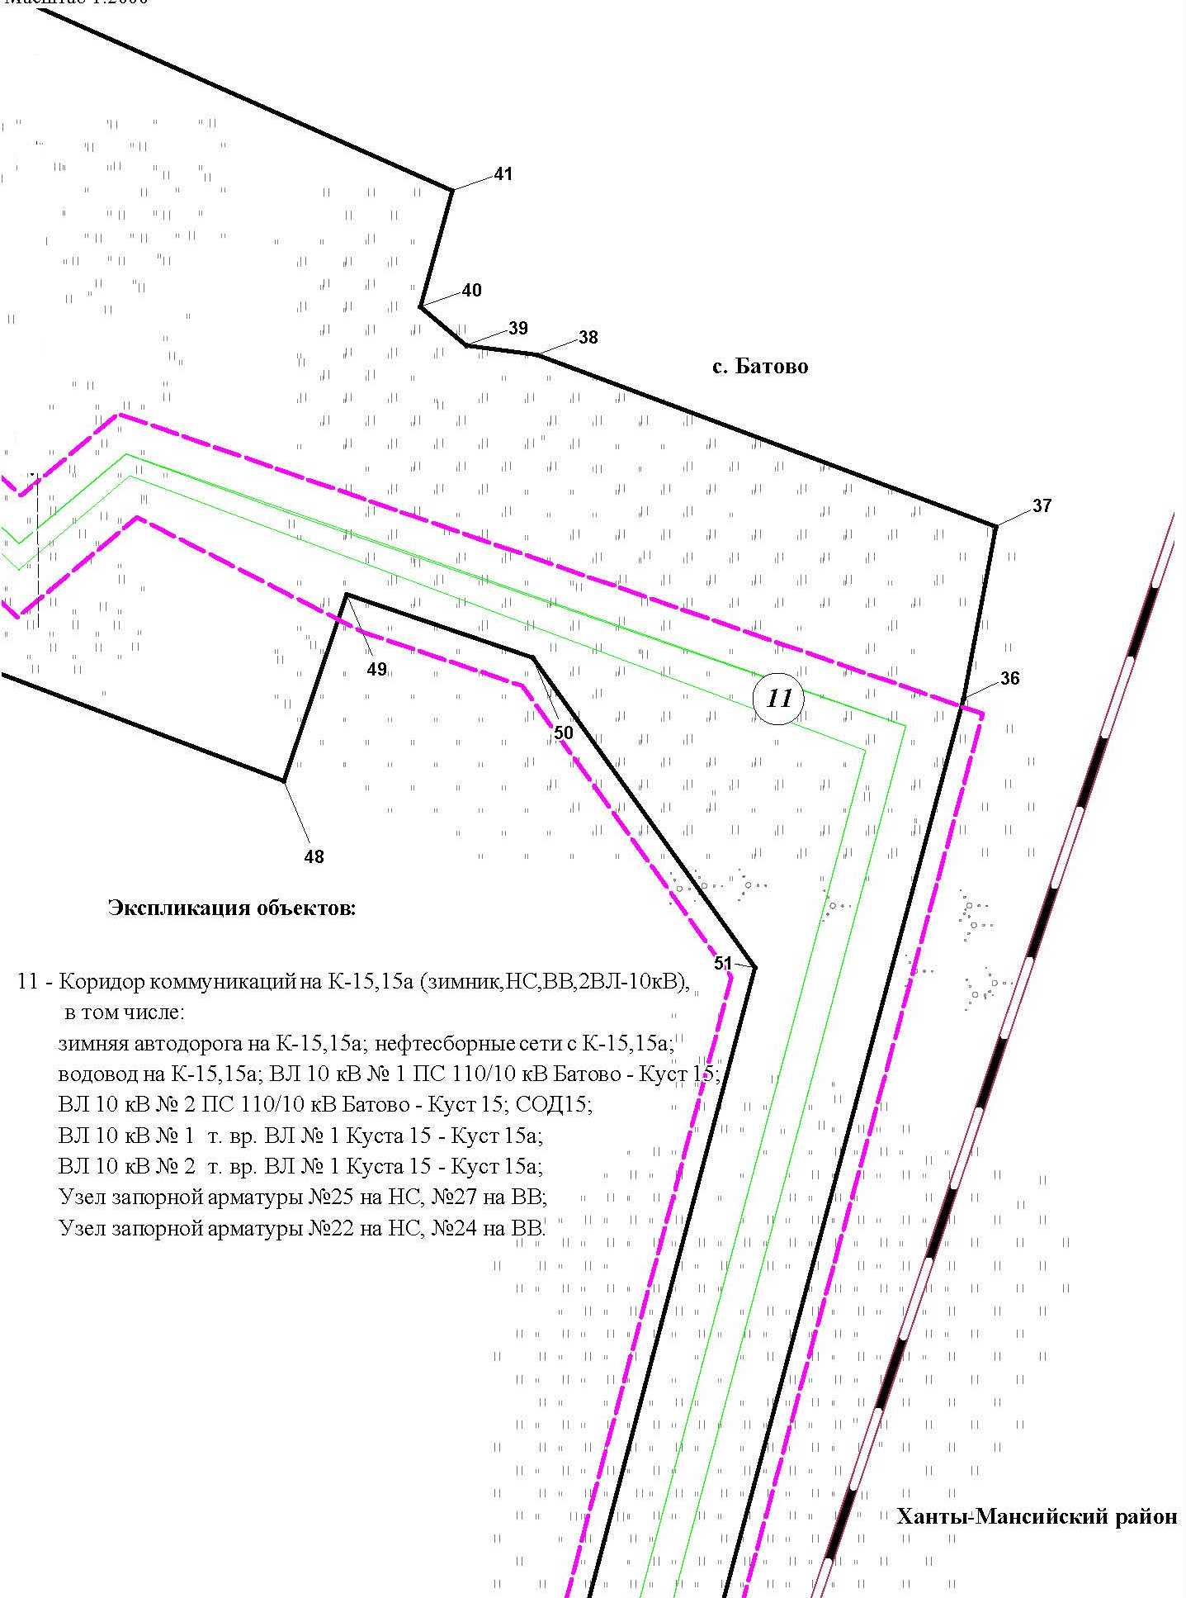
Линия совмещения с листом
2
3

Основная часть проекта планировки территории для размещения объекта капитального строительства, расположенного
на территории двух муниципальных образований
Ханты-Мансийского автономного округа – Югры
«Обустройство Чапровского месторождения.
Кусты 14, 14а, 15, 15а, 17, 17а и коридоры коммуникаций».
Землепользователь: АО «НК «Конданефть»
Масштаб 1:2000

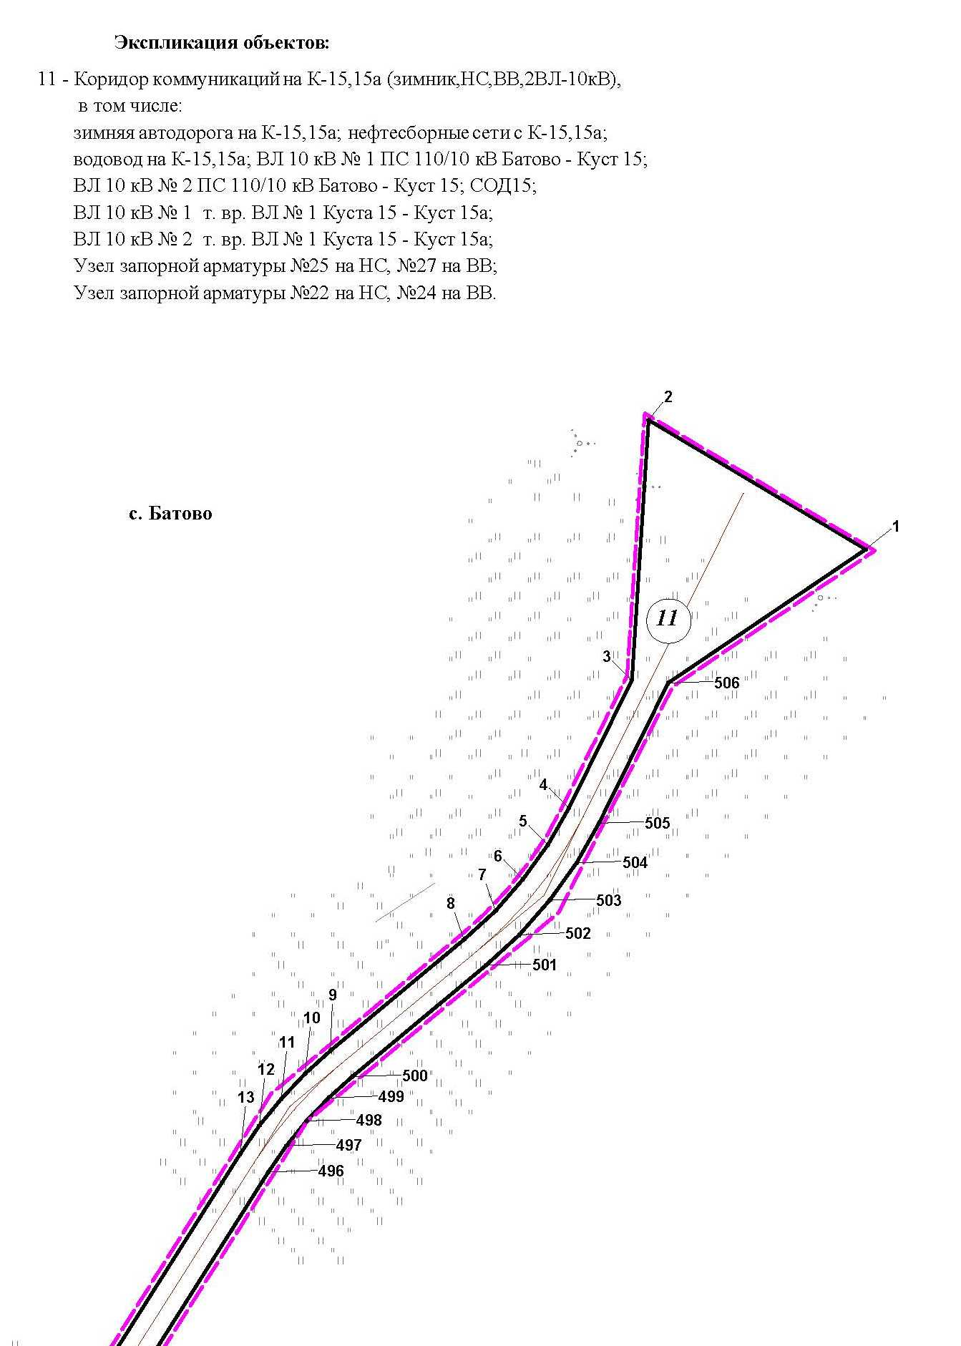

Основная часть проекта планировки территории для размещения объекта капитального строительства, расположенного
на территории двух муниципальных образований
Ханты-Мансийского автономного округа – Югры
«Обустройство Чапровского месторождения.
Кусты 14, 14а, 15, 15а, 17, 17а и коридоры коммуникаций».
Землепользователь: АО «НК «Конданефть»
Масштаб 1:2000

Линия совмещения с листом 26

Линия совмещения с листом 20

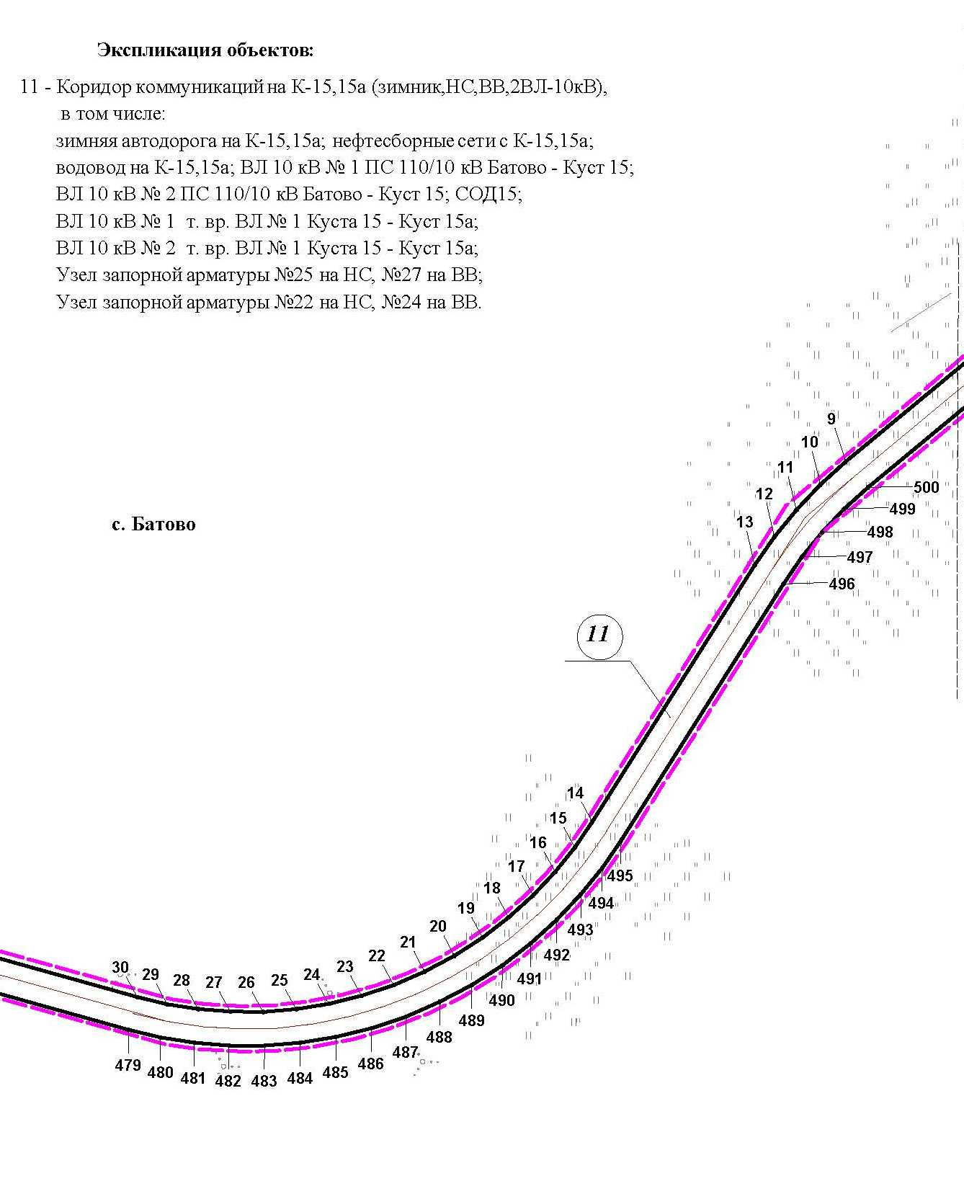

Основная часть проекта планировки территории для размещения объекта капитального строительства, расположенного
на территории двух муниципальных образований
Ханты-Мансийского автономного округа – Югры
«Обустройство Чапровского месторождения.
Кусты 14, 14а, 15, 15а, 17, 17а и коридоры коммуникаций».
Землепользователь: АО «НК «Конданефть»
Масштаб 1:2000

Линия совмещения с листом 26

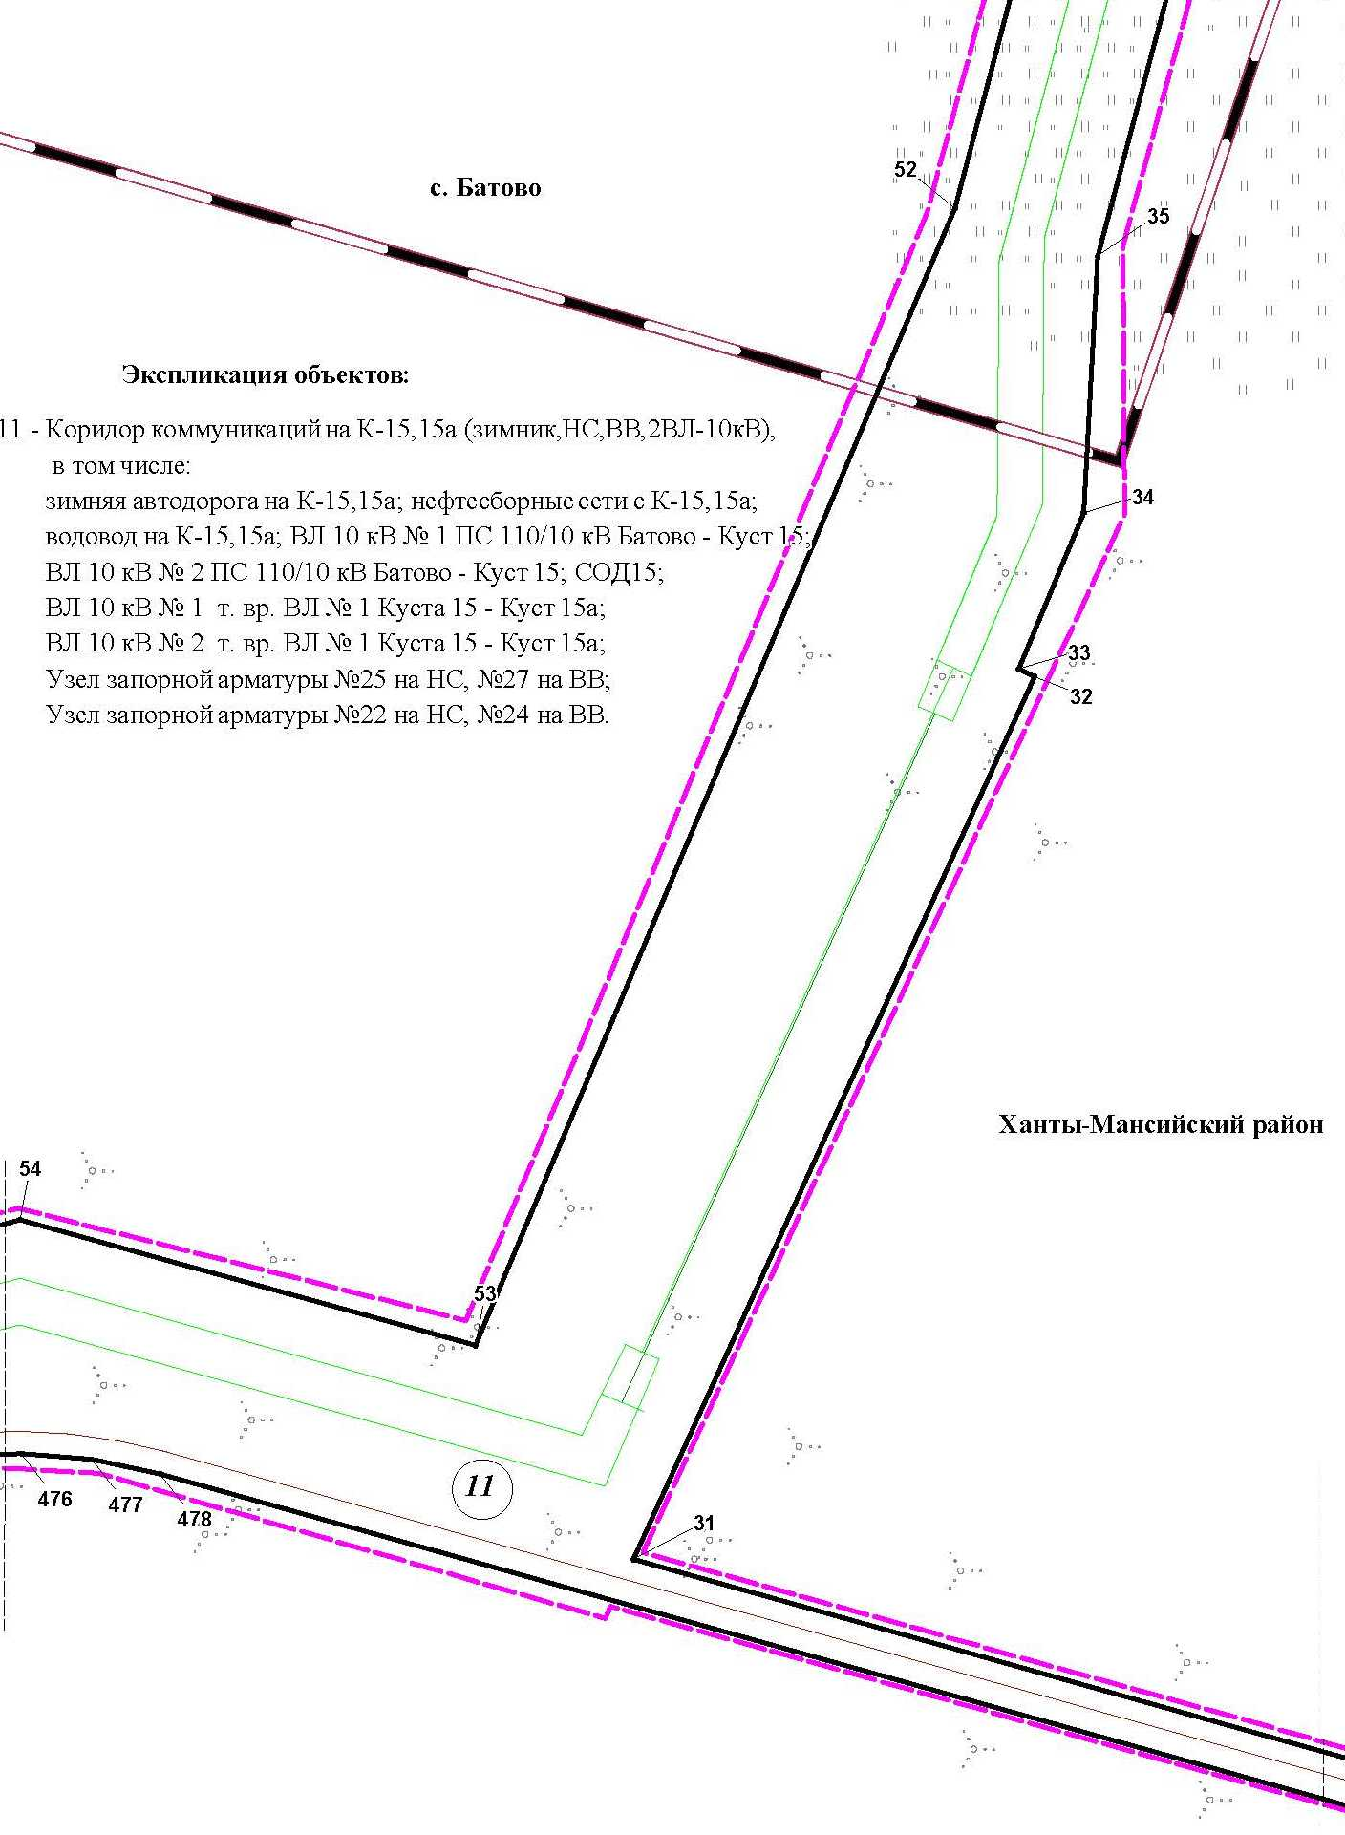

Основная часть проекта планировки территории для размещения объекта капитального строительства, расположенного
на территории двух муниципальных образований
Ханты-Мансийского автономного округа – Югры
«Обустройство Чапровского месторождения.
Кусты 14, 14а, 15, 15а, 17, 17а и коридоры коммуникаций».
Землепользователь: АО «НК «Конданефть»
Масштаб 1:2000

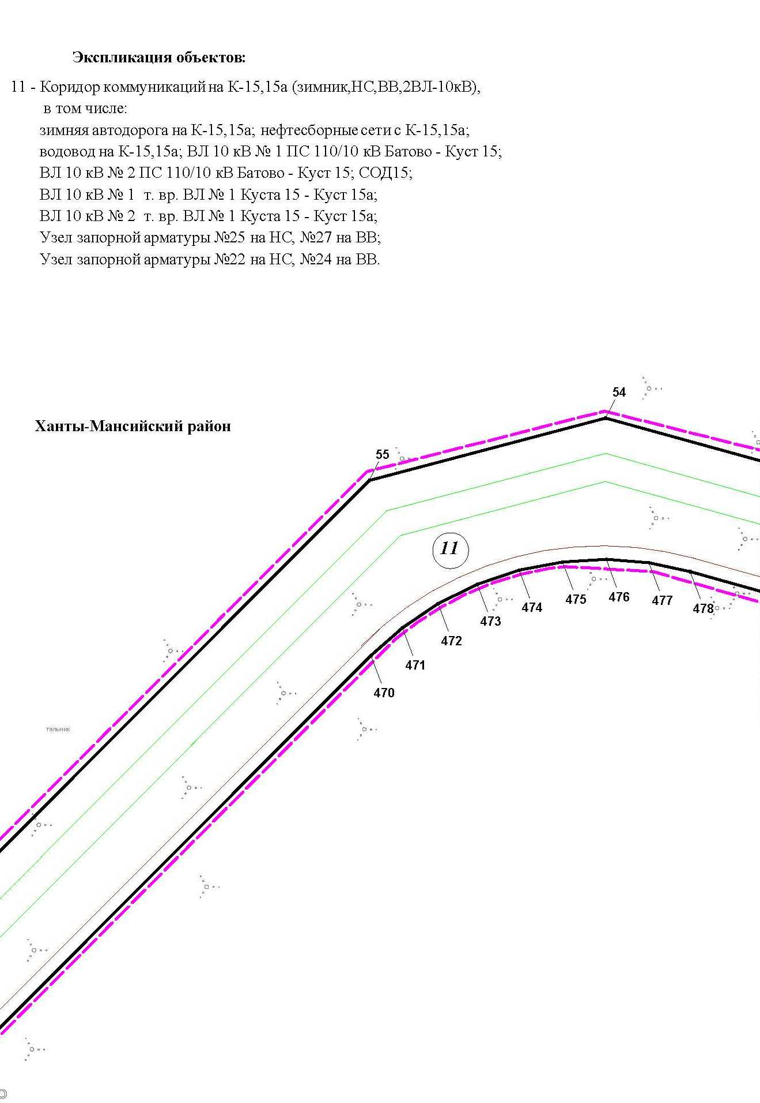

Лист 27 из 119

Основная часть проекта планировки территории для размещения объекта капитального строительства, расположенного
на территории двух муниципальных образований
Ханты-Мансийского автономного округа – Югры
«Обустройство Чапровского месторождения.
Кусты 14, 14а, 15, 15а, 17, 17а и коридоры коммуникаций».
Землепользователь: АО «НК «Конданефть»
Масштаб 1:2000

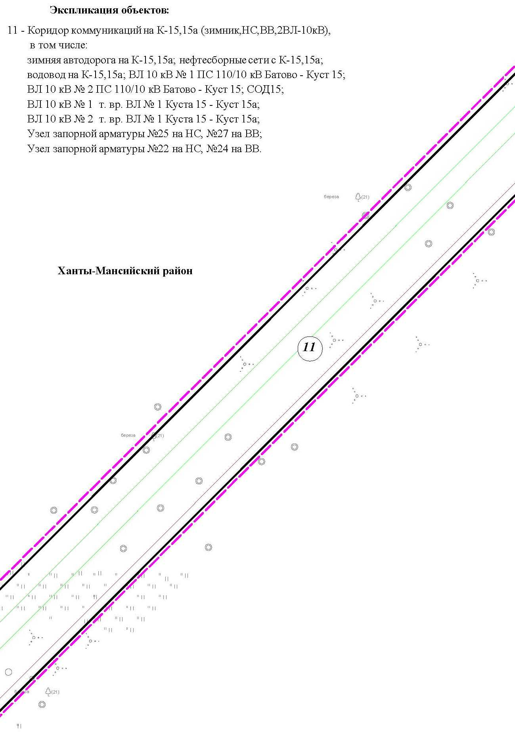

Основная часть проекта планировки территории для размещения объекта капитального строительства, расположенного
на территории двух муниципальных образований
Ханты-Мансийского автономного округа – Югры
«Обустройство Чапровского месторождения.
Кусты 14, 14а, 15, 15а, 17, 17а и коридоры коммуникаций».
Землепользователь: АО «НК «Конданефть»
Масштаб 1:2000

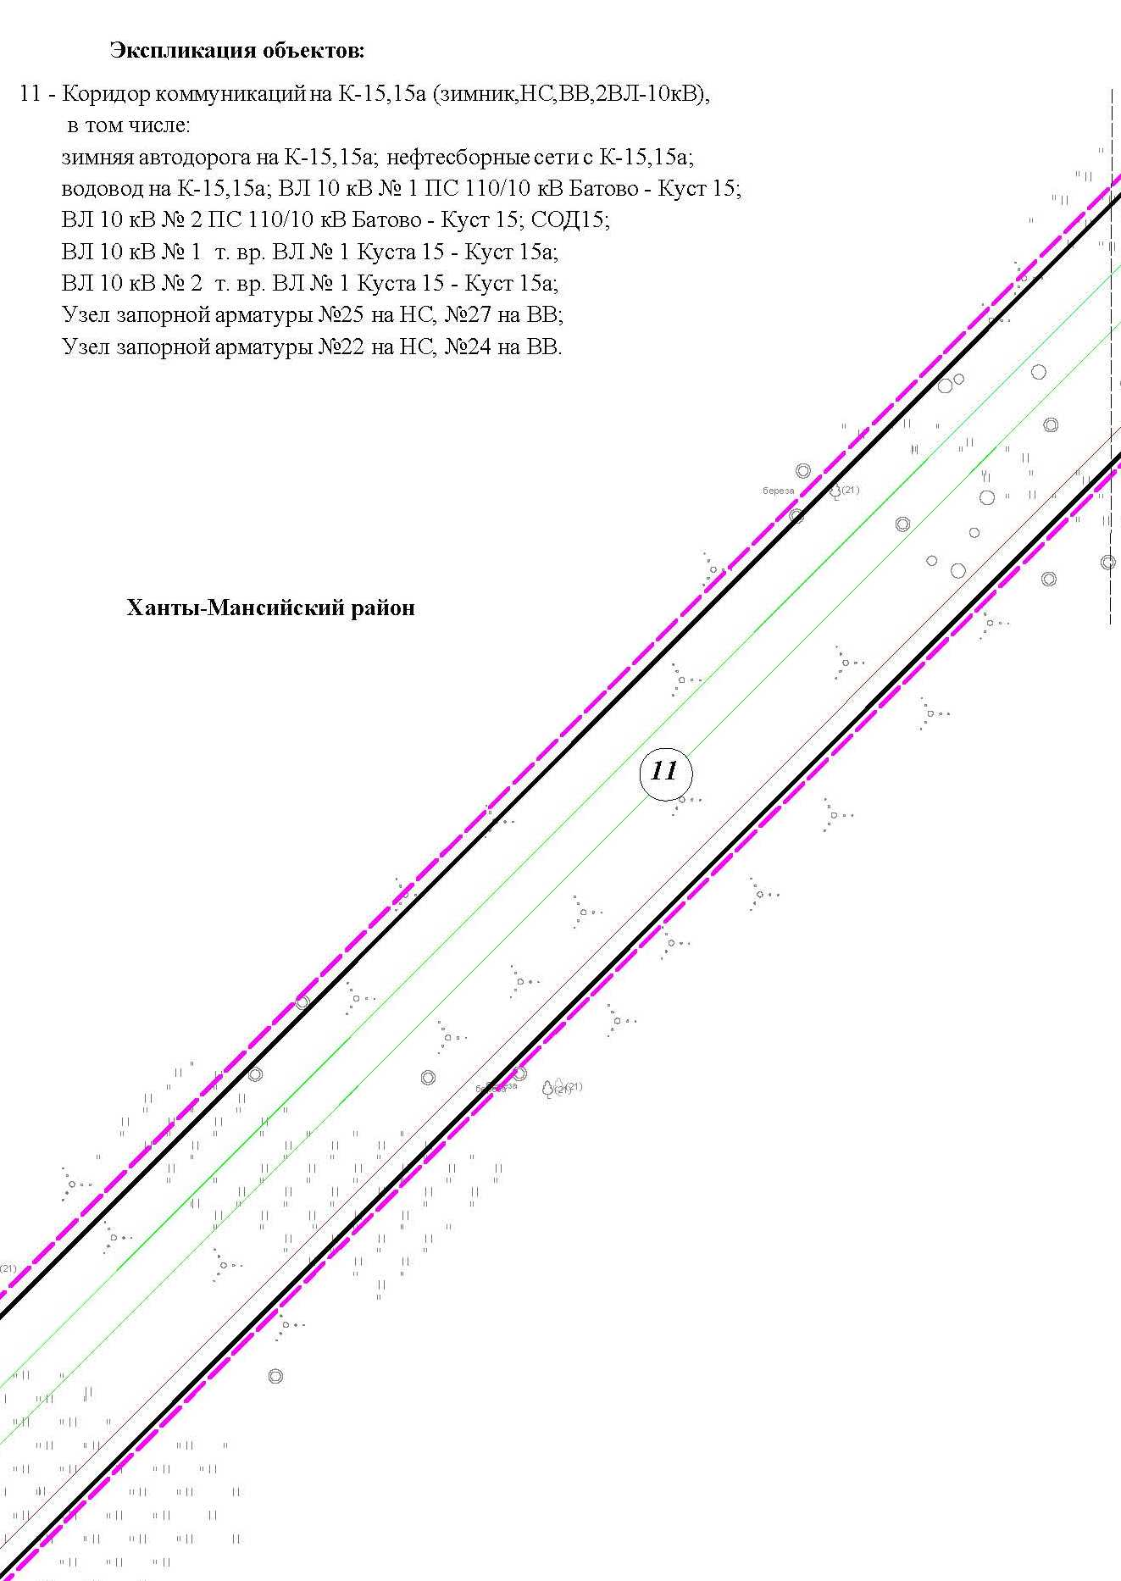

Основная часть проекта планировки территории для размещения объекта капитального строительства, расположенного
на территории двух муниципальных образований
Ханты-Мансийского автономного округа – Югры
«Обустройство Чапровского месторождения.
Кусты 14, 14а, 15, 15а, 17, 17а и коридоры коммуникаций».
Землепользователь: АО «НК «Конданефть»
Масштаб 1:2000

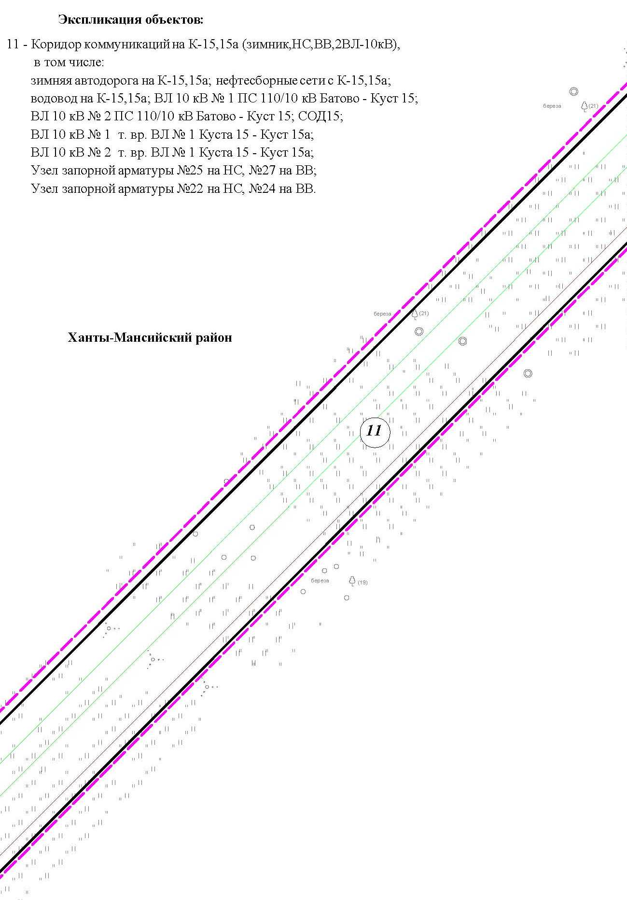

Основная часть проекта планировки территории для размещения объекта капитального строительства, расположенного
на территории двух муниципальных образований
Ханты-Мансийского автономного округа – Югры
«Обустройство Чапровского месторождения.
Кусты 14, 14а, 15, 15а, 17, 17а и коридоры коммуникаций».
Землепользователь: АО «НК «Конданефть»
Масштаб 1:2000

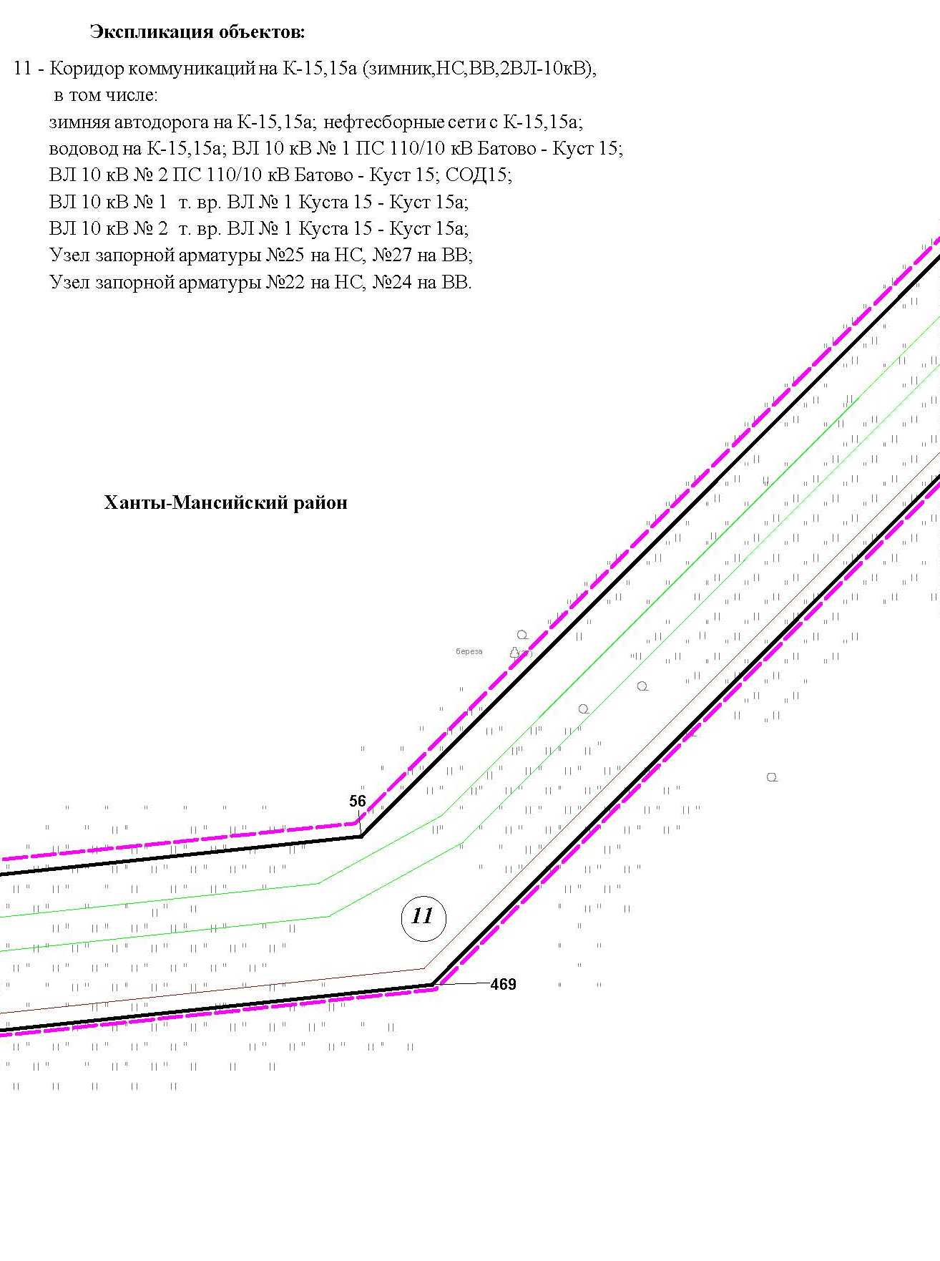

Линия совмещения с листом
31

Основная часть проекта планировки территории для размещения объекта капитального строительства, расположенного
на территории двух муниципальных образований
Ханты-Мансийского автономного округа – Югры
«Обустройство Чапровского месторождения.
Кусты 14, 14а, 15, 15а, 17, 17а и коридоры коммуникаций».
Землепользователь: АО «НК «Конданефть»
Масштаб 1:2000

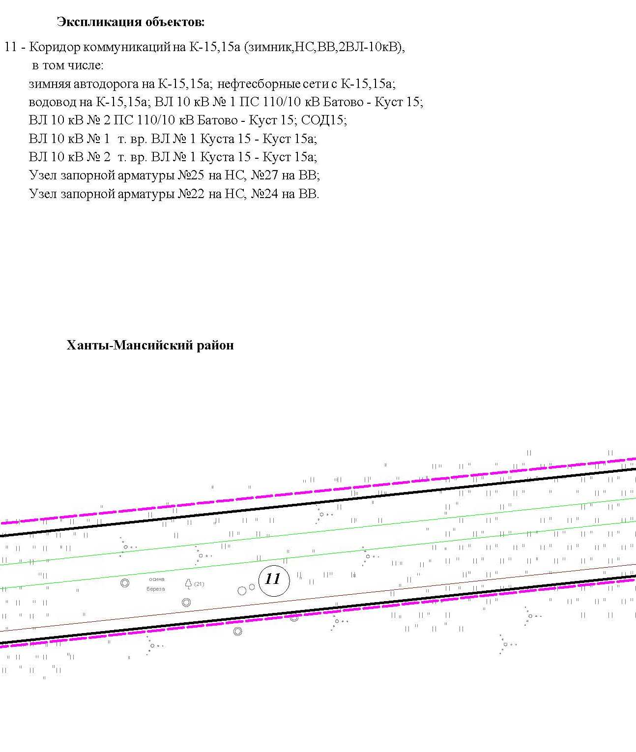

Основная часть проекта планировки территории для размещения объекта капитального строительства, расположенного
на территории двух муниципальных образований
Ханты-Мансийского автономного округа – Югры
«Обустройство Чапровского месторождения.
Кусты 14, 14а, 15, 15а, 17, 17а и коридоры коммуникаций».
Землепользователь: АО «НК «Конданефть»
Масштаб 1:2000

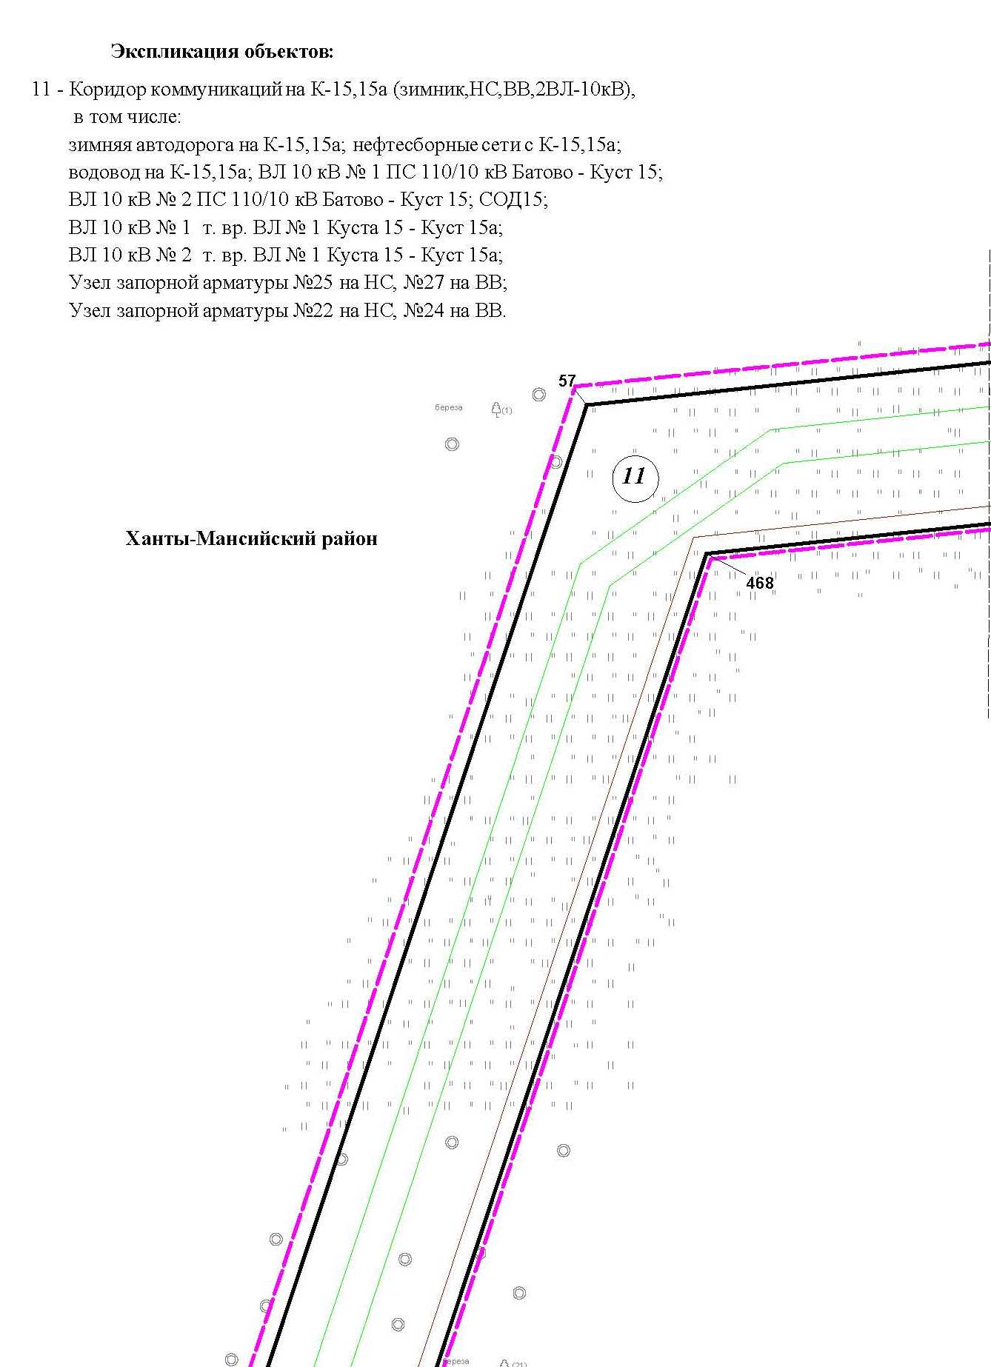

Основная часть проекта планировки территории для размещения объекта капитального строительства, расположенного
на территории двух муниципальных образований
Ханты-Мансийского автономного округа – Югры
«Обустройство Чапровского месторождения.
Кусты 14, 14а, 15, 15а, 17, 17а и коридоры коммуникаций».
Землепользователь: АО «НК «Конданефть»
Масштаб 1:2000

Линия совмещения с листом 35

3

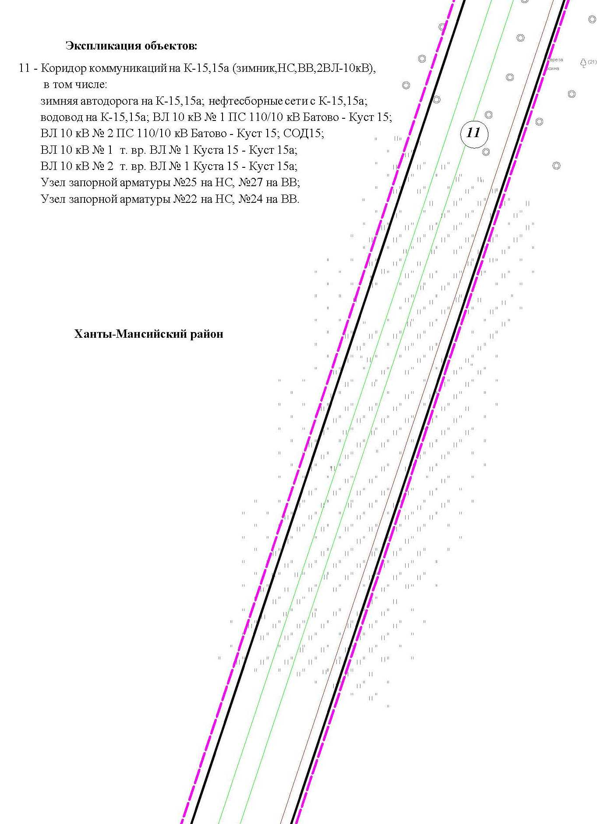

Основная часть проекта планировки территории для размещения объекта капитального строительства, расположенного
на территории двух муниципальных образований
Ханты-Мансийского автономного округа – Югры
«Обустройство Чапровского месторождения.
Кусты 14, 14а, 15, 15а, 17, 17а и коридоры коммуникаций».
Землепользователь: АО «НК «Конданефть»
Масштаб 1:2000

Линия совмещения с листом 36

3

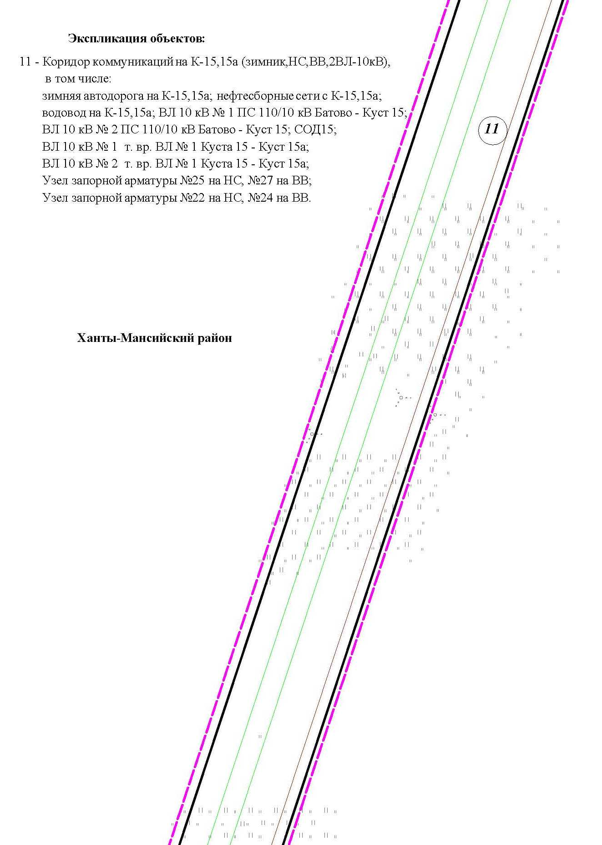

Основная часть проекта планировки территории для размещения объекта капитального строительства, расположенного
на территории двух муниципальных образований
Ханты-Мансийского автономного округа – Югры
«Обустройство Чапровского месторождения.
Кусты 14, 14а, 15, 15а, 17, 17а и коридоры коммуникаций».
Землепользователь: АО «НК «Конданефть»
Масштаб 1:2000

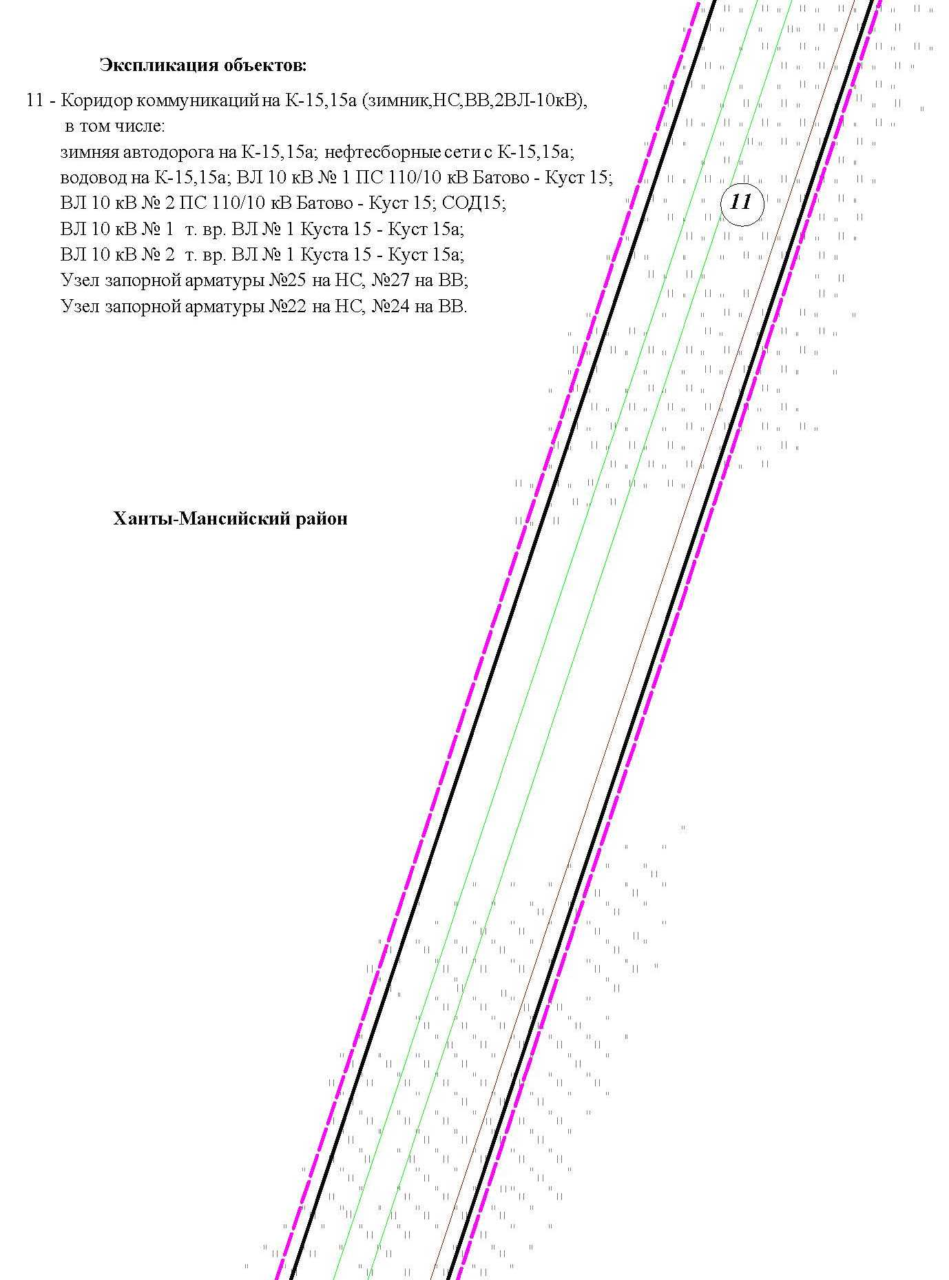

Линия совмещения с листом 37

3

Основная часть проекта планировки территории для размещения объекта капитального строительства, расположенного
на территории двух муниципальных образований
Ханты-Мансийского автономного округа – Югры
«Обустройство Чапровского месторождения.
Кусты 14, 14а, 15, 15а, 17, 17а и коридоры коммуникаций».
Землепользователь: АО «НК «Конданефть»
Масштаб 1:2000

Линия совмещения с листом 38

3

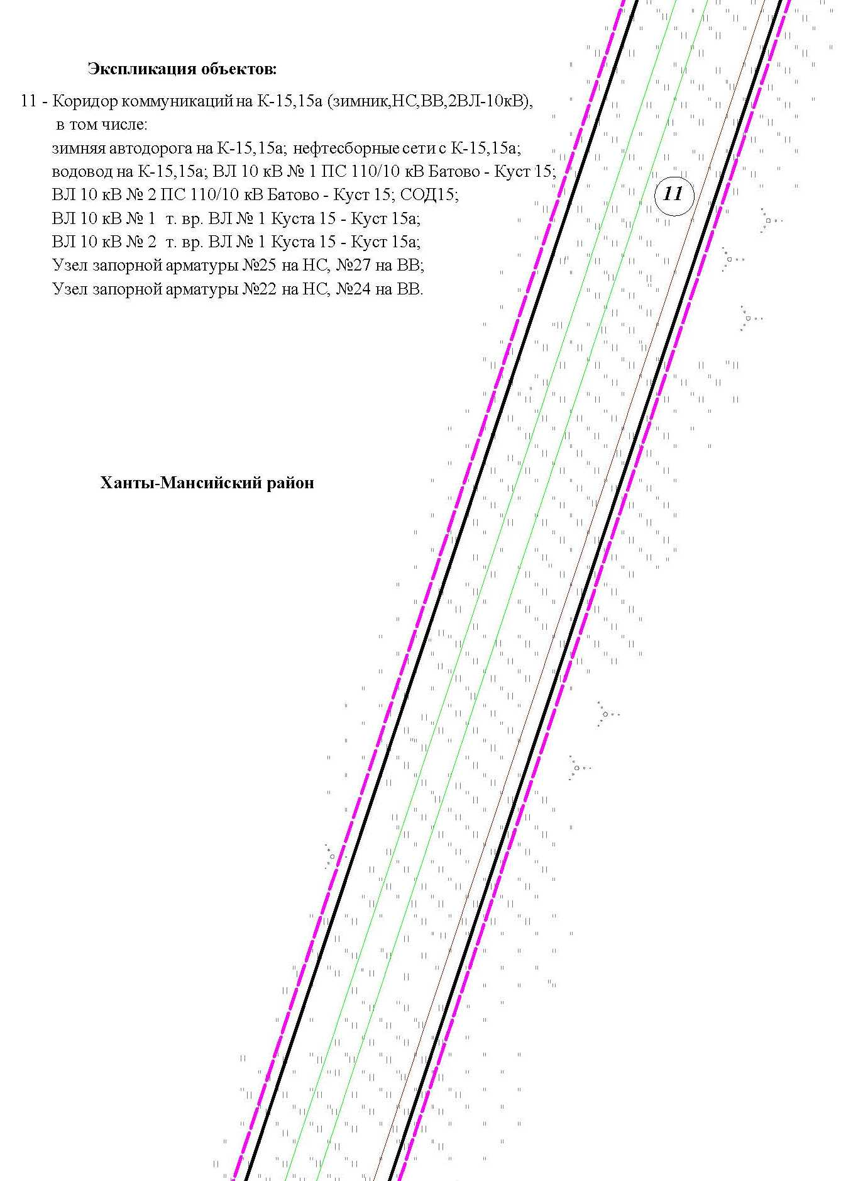

Основная часть проекта планировки территории для размещения объекта капитального строительства, расположенного
на территории двух муниципальных образований
Ханты-Мансийского автономного округа – Югры
«Обустройство Чапровского месторождения.
Кусты 14, 14а, 15, 15а, 17, 17а и коридоры коммуникаций».
Землепользователь: АО «НК «Конданефть»
Масштаб 1:2000

Линия совмещения с листом 39

3

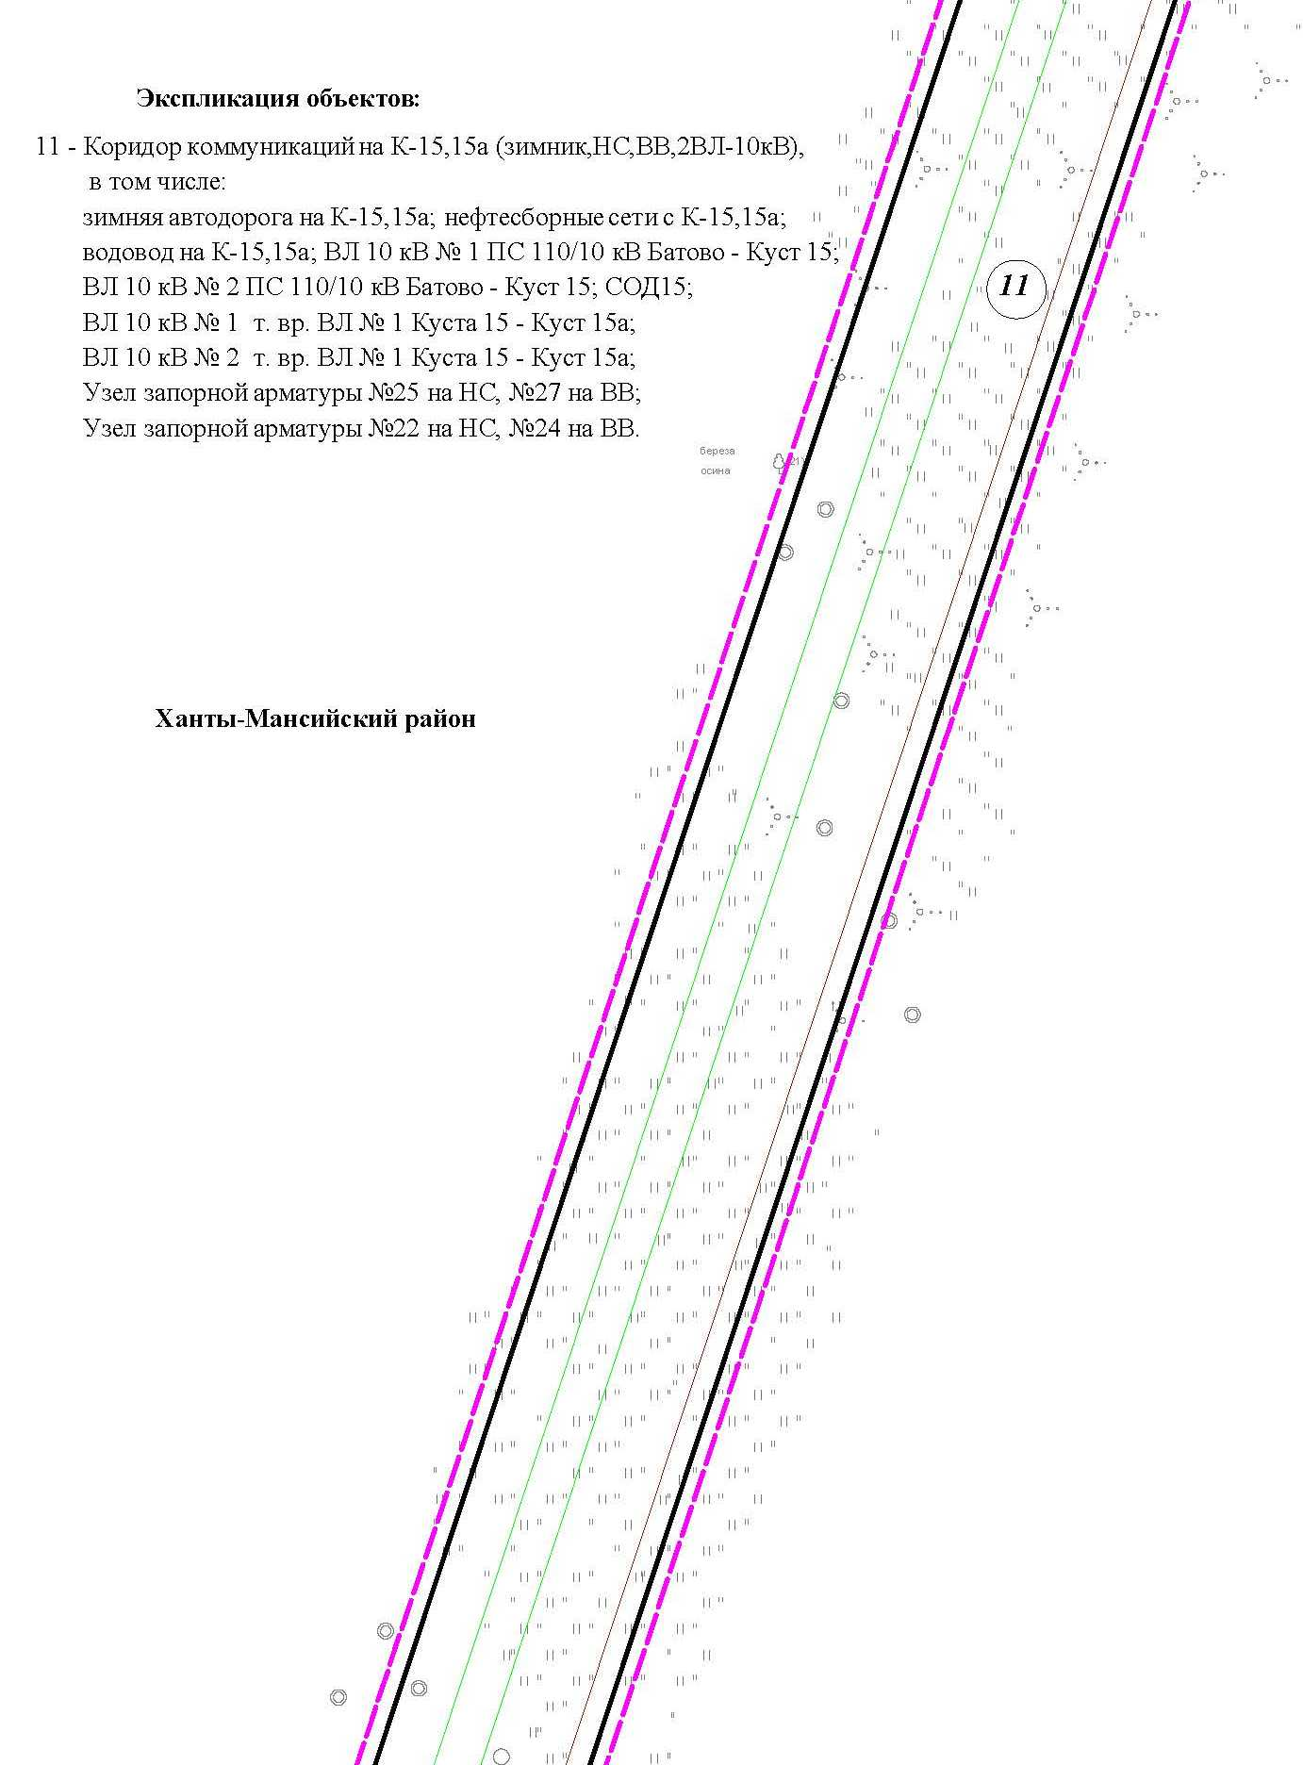

Основная часть проекта планировки территории для размещения объекта капитального строительства, расположенного
на территории двух муниципальных образований
Ханты-Мансийского автономного округа – Югры
«Обустройство Чапровского месторождения.
Кусты 14, 14а, 15, 15а, 17, 17а и коридоры коммуникаций».
Землепользователь: АО «НК «Конданефть»
Масштаб 1:2000

Основная часть проекта планировки территории для размещения объекта капитального строительства, расположенного
на территории двух муниципальных образований
Ханты-Мансийского автономного округа – Югры
«Обустройство Чапровского месторождения.
Кусты 14, 14а, 15, 15а, 17, 17а и коридоры коммуникаций».
Землепользователь: АО «НК «Конданефть»
Масштаб 1:2000

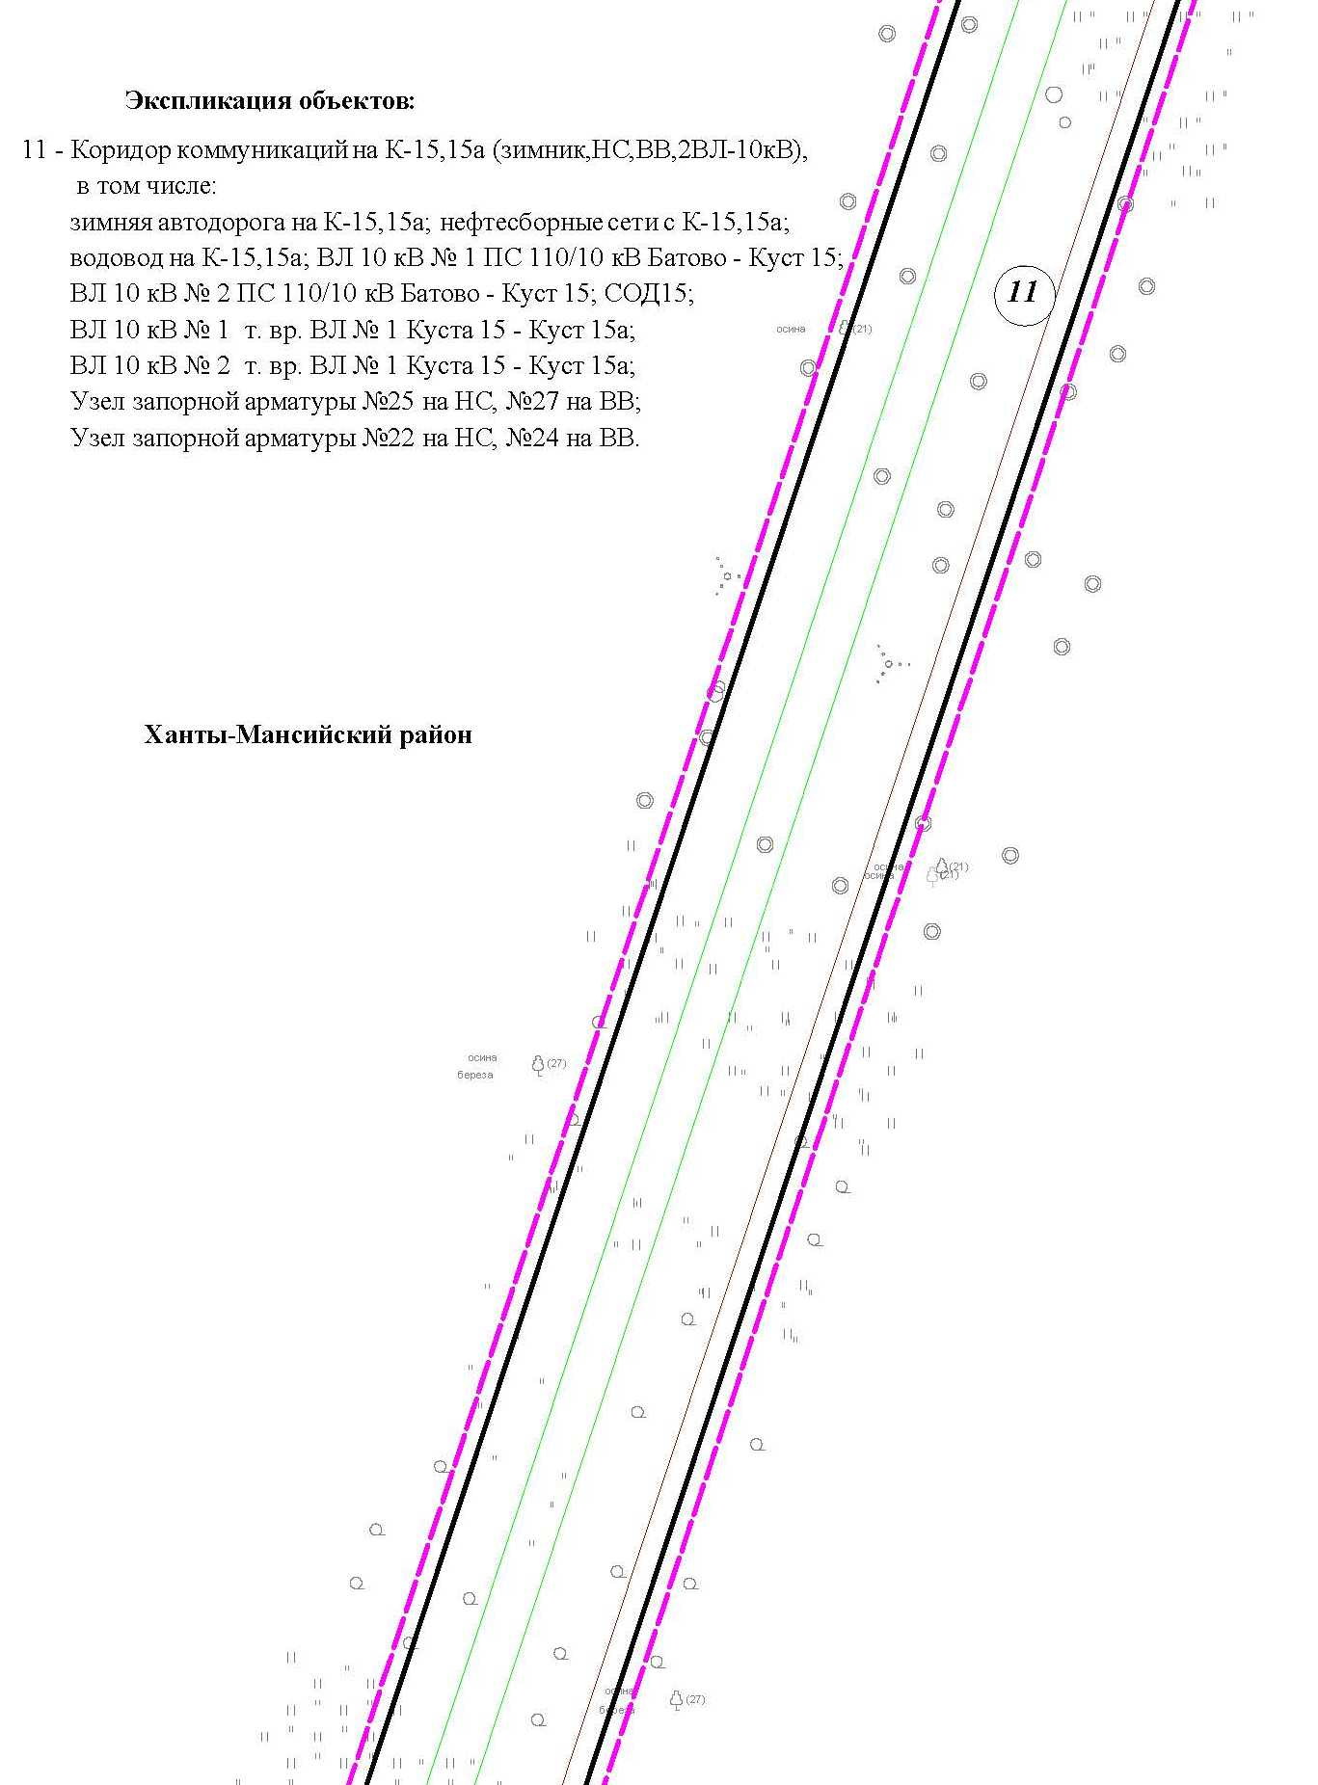

Линия совмещения с листом 40

3

Основная часть проекта планировки территории для размещения объекта капитального строительства, расположенного
на территории двух муниципальных образований
Ханты-Мансийского автономного округа – Югры
«Обустройство Чапровского месторождения.
Кусты 14, 14а, 15, 15а, 17, 17а и коридоры коммуникаций».
Землепользователь: АО «НК «Конданефть»
Масштаб 1:2000

Линия совмещения с листом 41

3

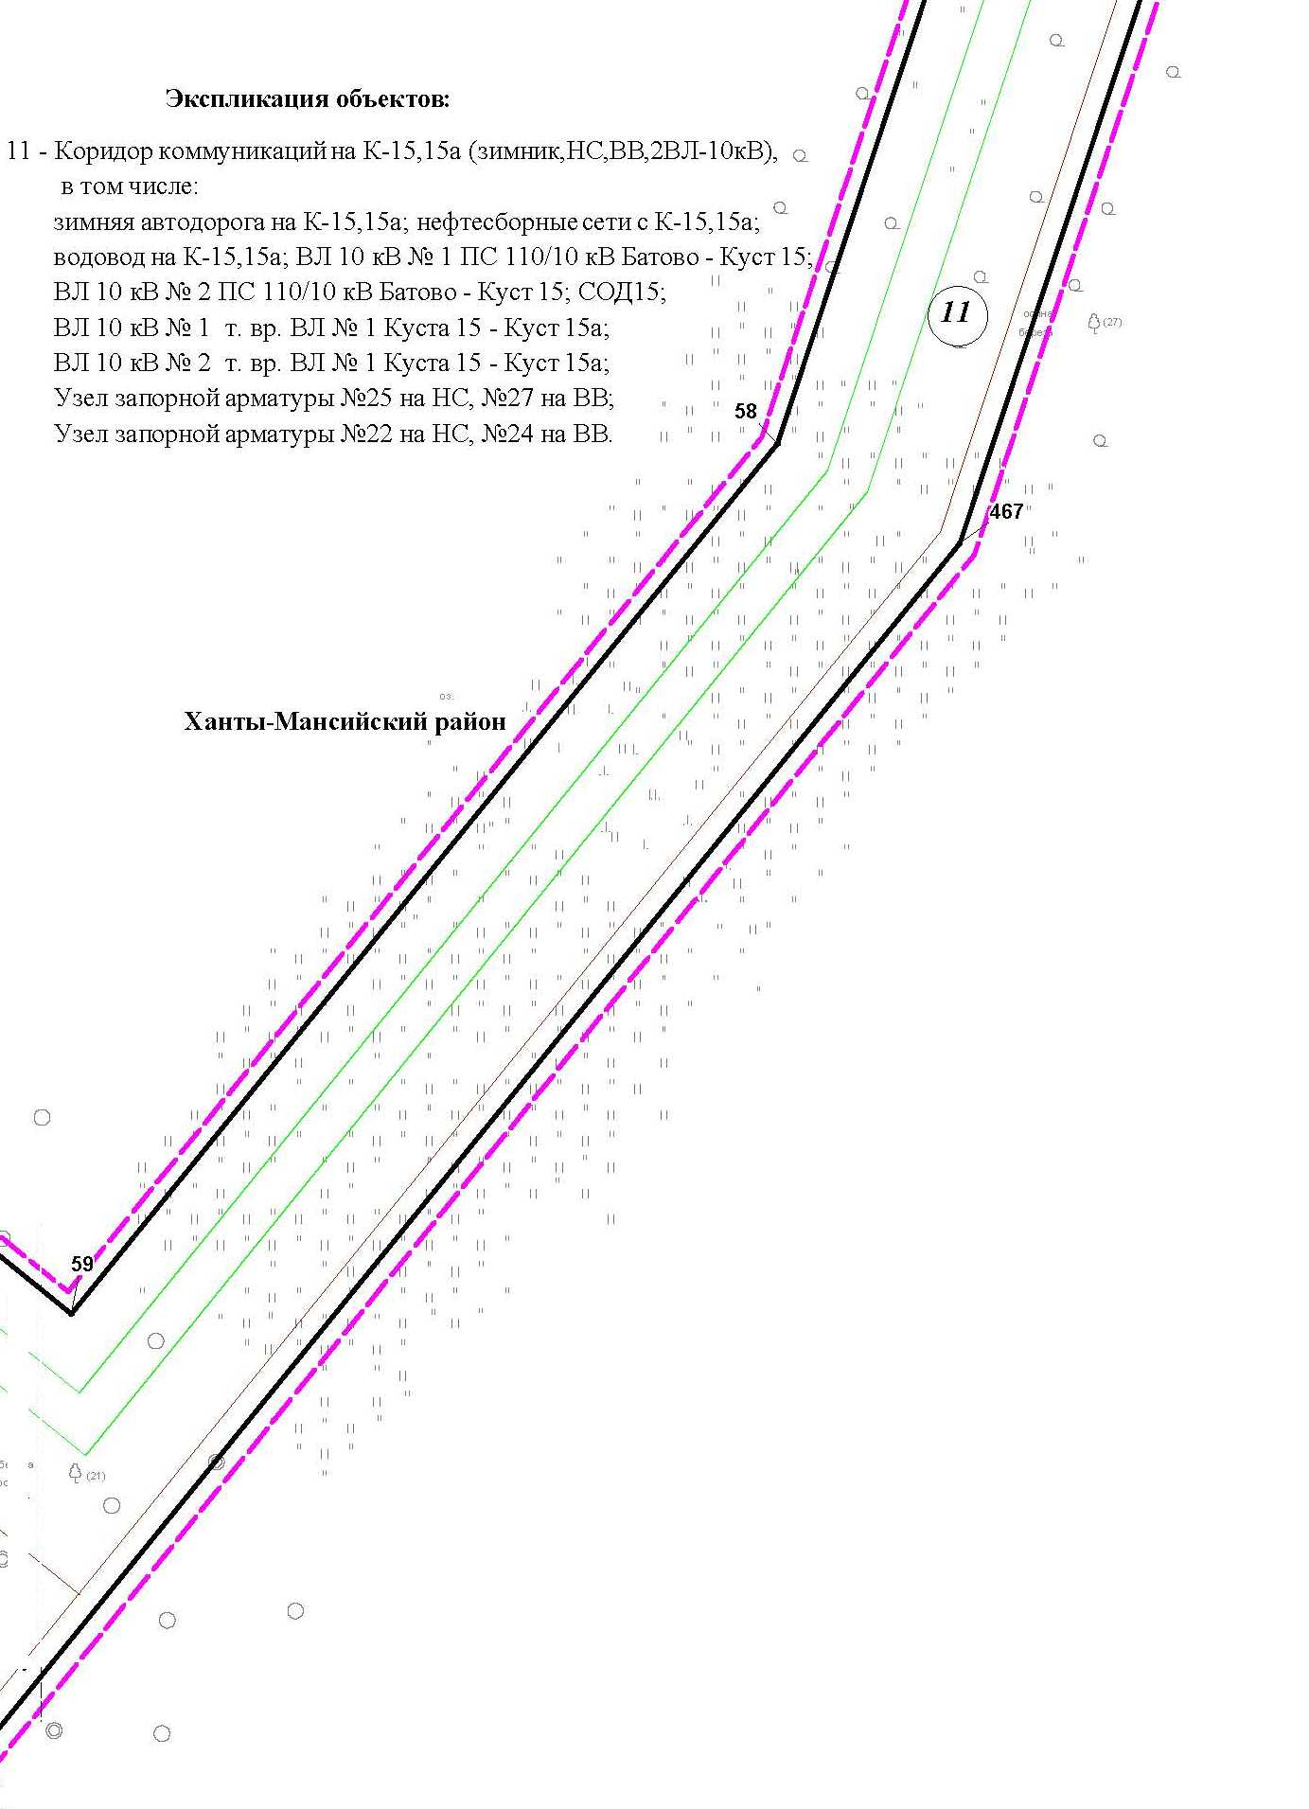

Основная часть проекта планировки территории для размещения объекта капитального строительства, расположенного
на территории двух муниципальных образований
Ханты-Мансийского автономного округа – Югры
«Обустройство Чапровского месторождения.
Кусты 14, 14а, 15, 15а, 17, 17а и коридоры коммуникаций».
Землепользователь: АО «НК «Конданефть»
Масштаб 1:2000

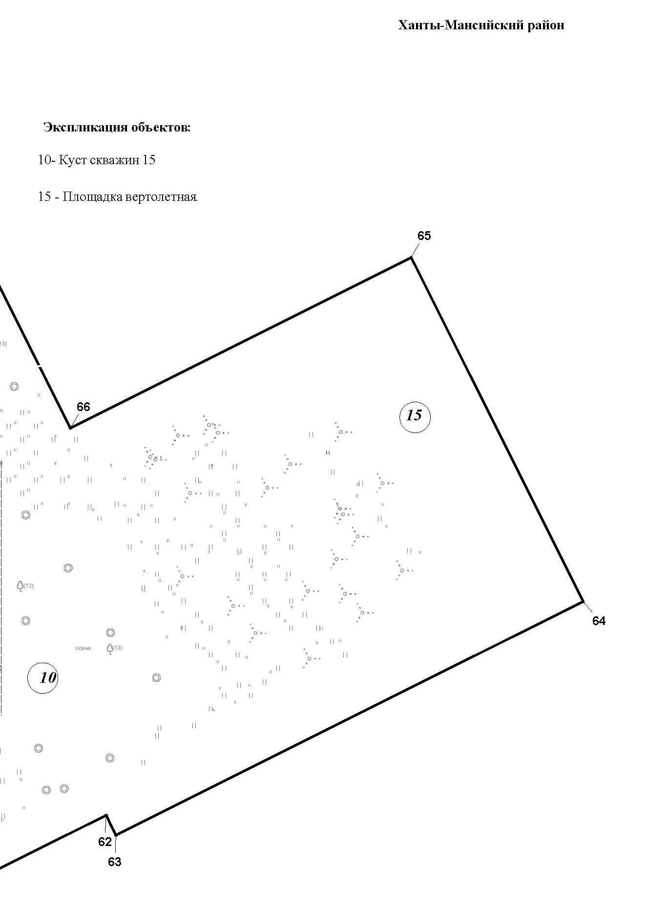

Основная часть проекта планировки территории для размещения объекта капитального строительства, расположенного
на территории двух муниципальных образований
Ханты-Мансийского автономного округа – Югры
«Обустройство Чапровского месторождения.
Кусты 14, 14а, 15, 15а, 17, 17а и коридоры коммуникаций».
Землепользователь: АО «НК «Конданефть»
Масштаб 1:2000

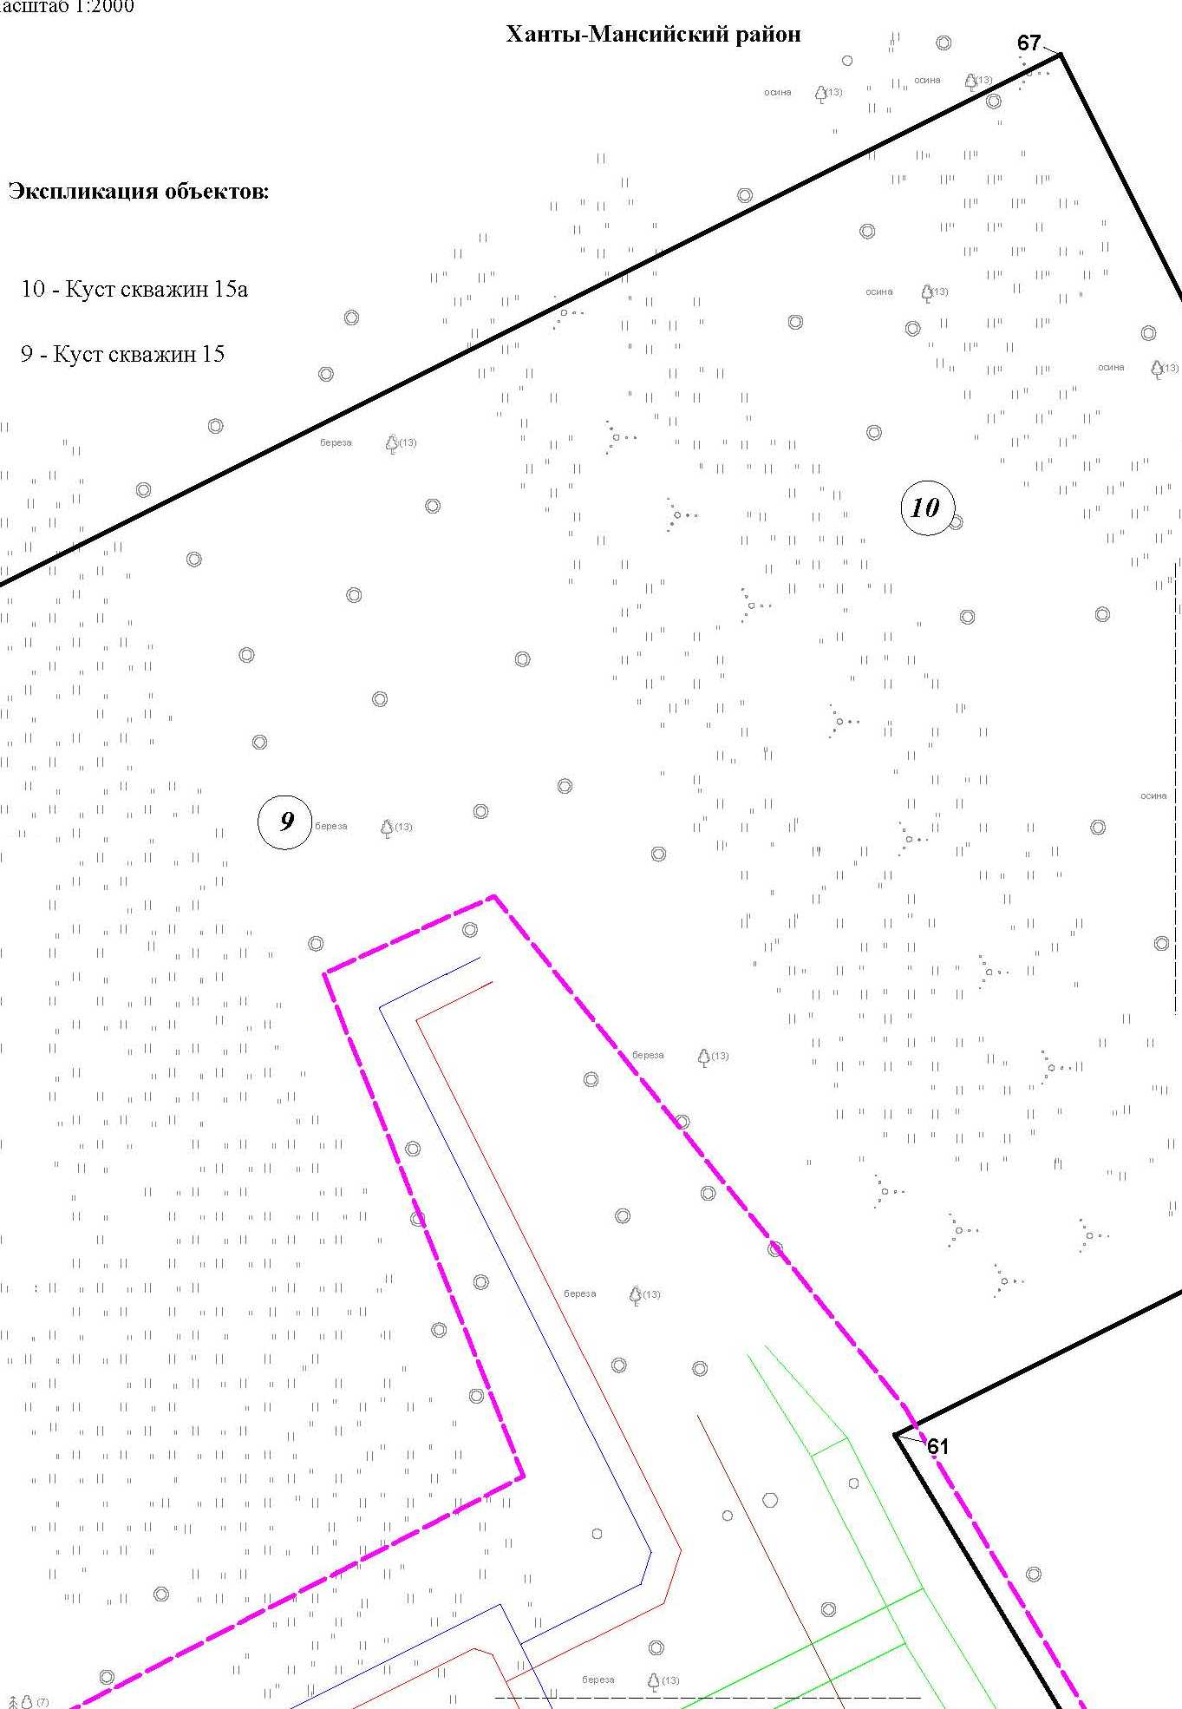

Основная часть проекта планировки территории для размещения объекта капитального строительства, расположенного
на территории двух муниципальных образований
Ханты-Мансийского автономного округа – Югры
«Обустройство Чапровского месторождения.
Кусты 14, 14а, 15, 15а, 17, 17а и коридоры коммуникаций».
Землепользователь: АО «НК «Конданефть»
Масштаб 1:2000

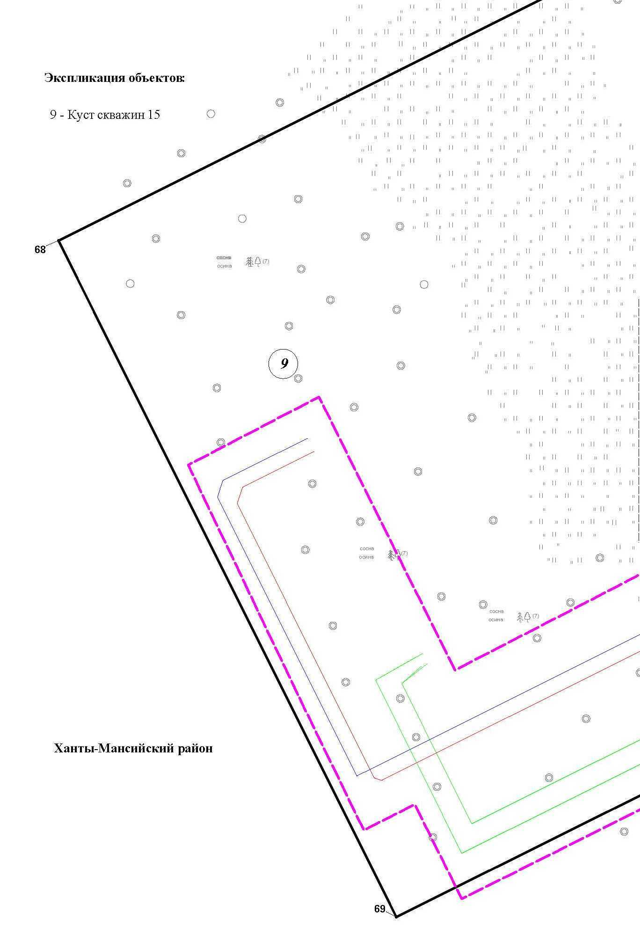

Основная часть проекта планировки территории для размещения объекта капитального строительства, расположенного
на территории двух муниципальных образований
Ханты-Мансийского автономного округа – Югры
«Обустройство Чапровского месторождения.
Кусты 14, 14а, 15, 15а, 17, 17а и коридоры коммуникаций».
Землепользователь: АО «НК «Конданефть»
Масштаб 1:2000

Основная часть проекта планировки территории для размещения объекта капитального строительства, расположенного
на территории двух муниципальных образований
Ханты-Мансийского автономного округа – Югры
«Обустройство Чапровского месторождения.
Кусты 14, 14а, 15, 15а, 17, 17а и коридоры коммуникаций».
Землепользователь: АО «НК «Конданефть»
Масштаб 1:2000

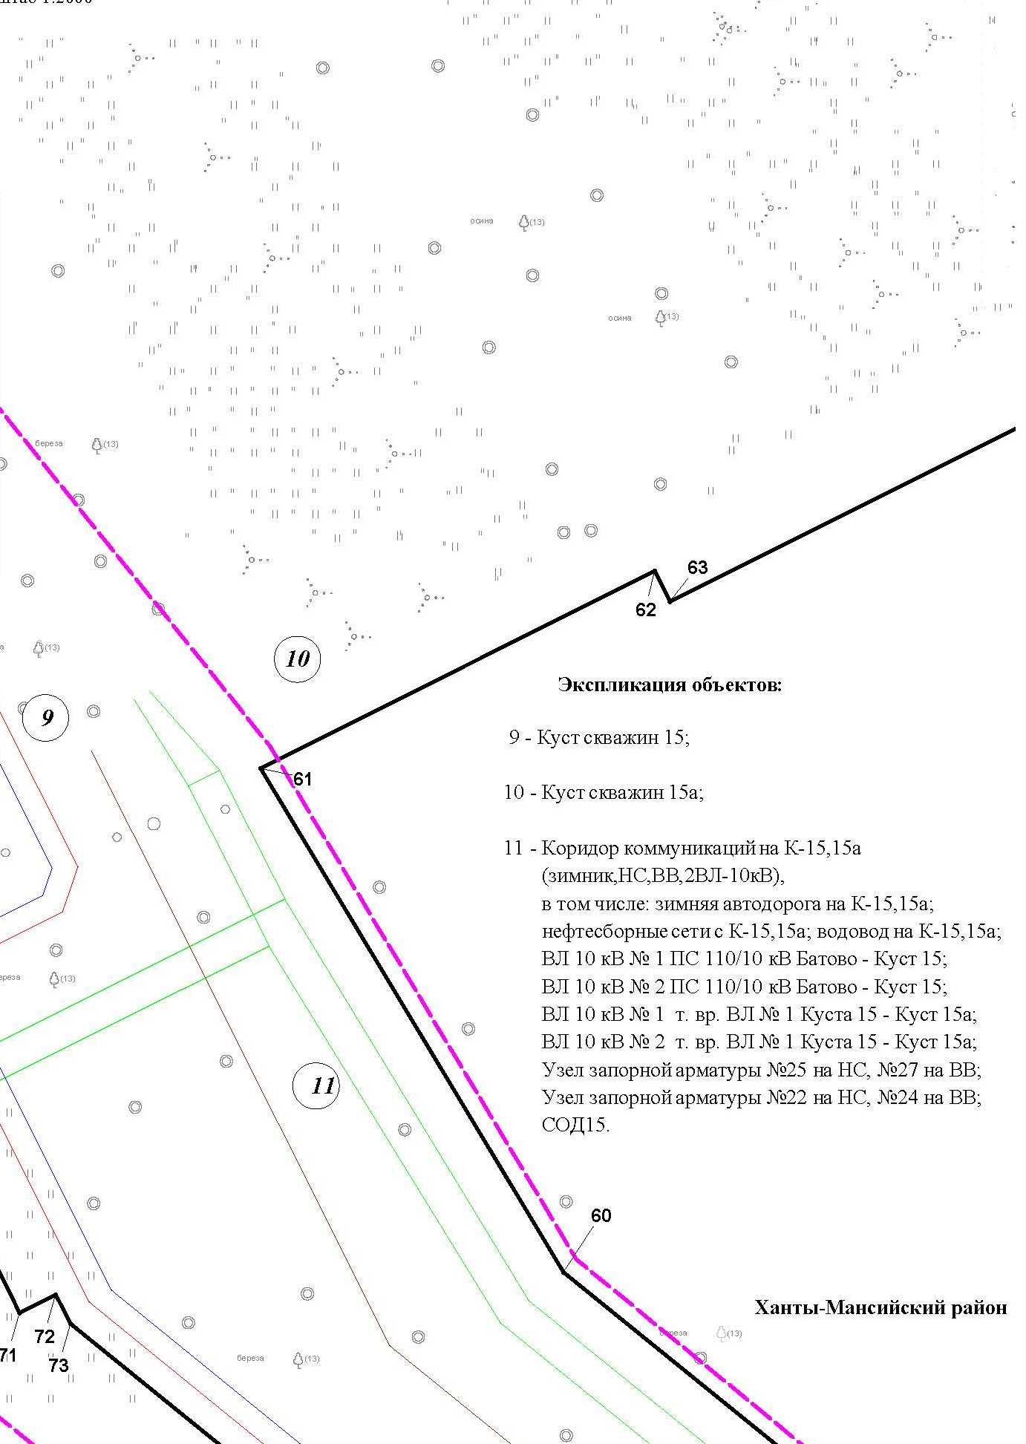

Основная часть проекта планировки территории для размещения объекта капитального строительства, расположенного
на территории двух муниципальных образований
Ханты-Мансийского автономного округа – Югры
«Обустройство Чапровского месторождения.
Кусты 14, 14а, 15, 15а, 17, 17а и коридоры коммуникаций».
Землепользователь: АО «НК «Конданефть»
Масштаб 1:2000

Линия совмещения с листом 47

43

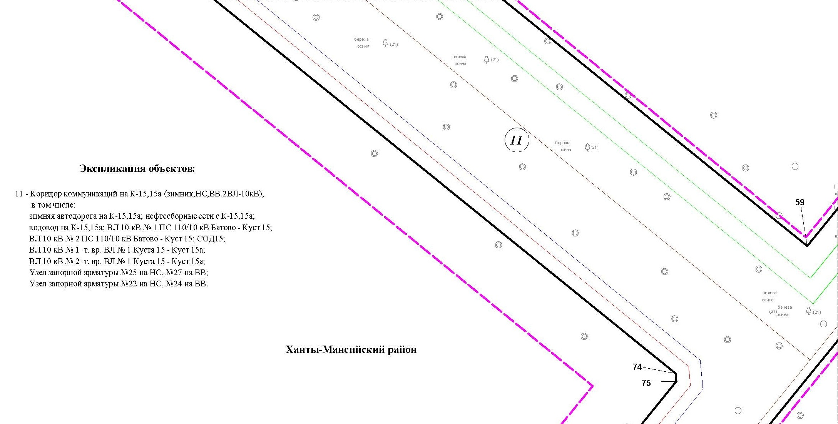

Основная часть проекта планировки территории для размещения объекта капитального строительства, расположенного
на территории двух муниципальных образований
Ханты-Мансийского автономного округа – Югры
«Обустройство Чапровского месторождения.
Кусты 14, 14а, 15, 15а, 17, 17а и коридоры коммуникаций».
Землепользователь: АО «НК «Конданефть»
Масштаб 1:2000

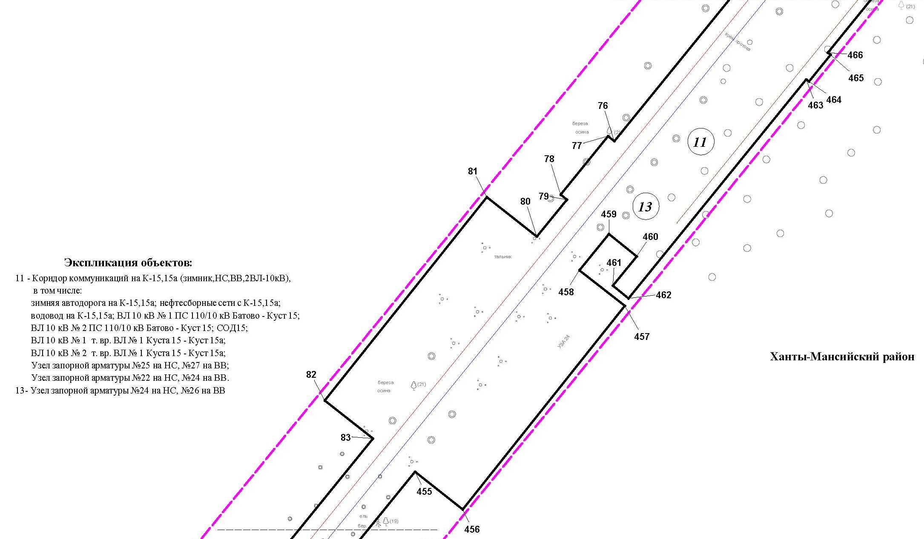
Линия совмещения с листом 48

43

Основная часть проекта планировки территории для размещения объекта капитального строительства, расположенного
на территории двух муниципальных образований
Ханты-Мансийского автономного округа – Югры
«Обустройство Чапровского месторождения.
Кусты 14, 14а, 15, 15а, 17, 17а и коридоры коммуникаций».
Землепользователь: АО «НК «Конданефть»
Масштаб 1:2000

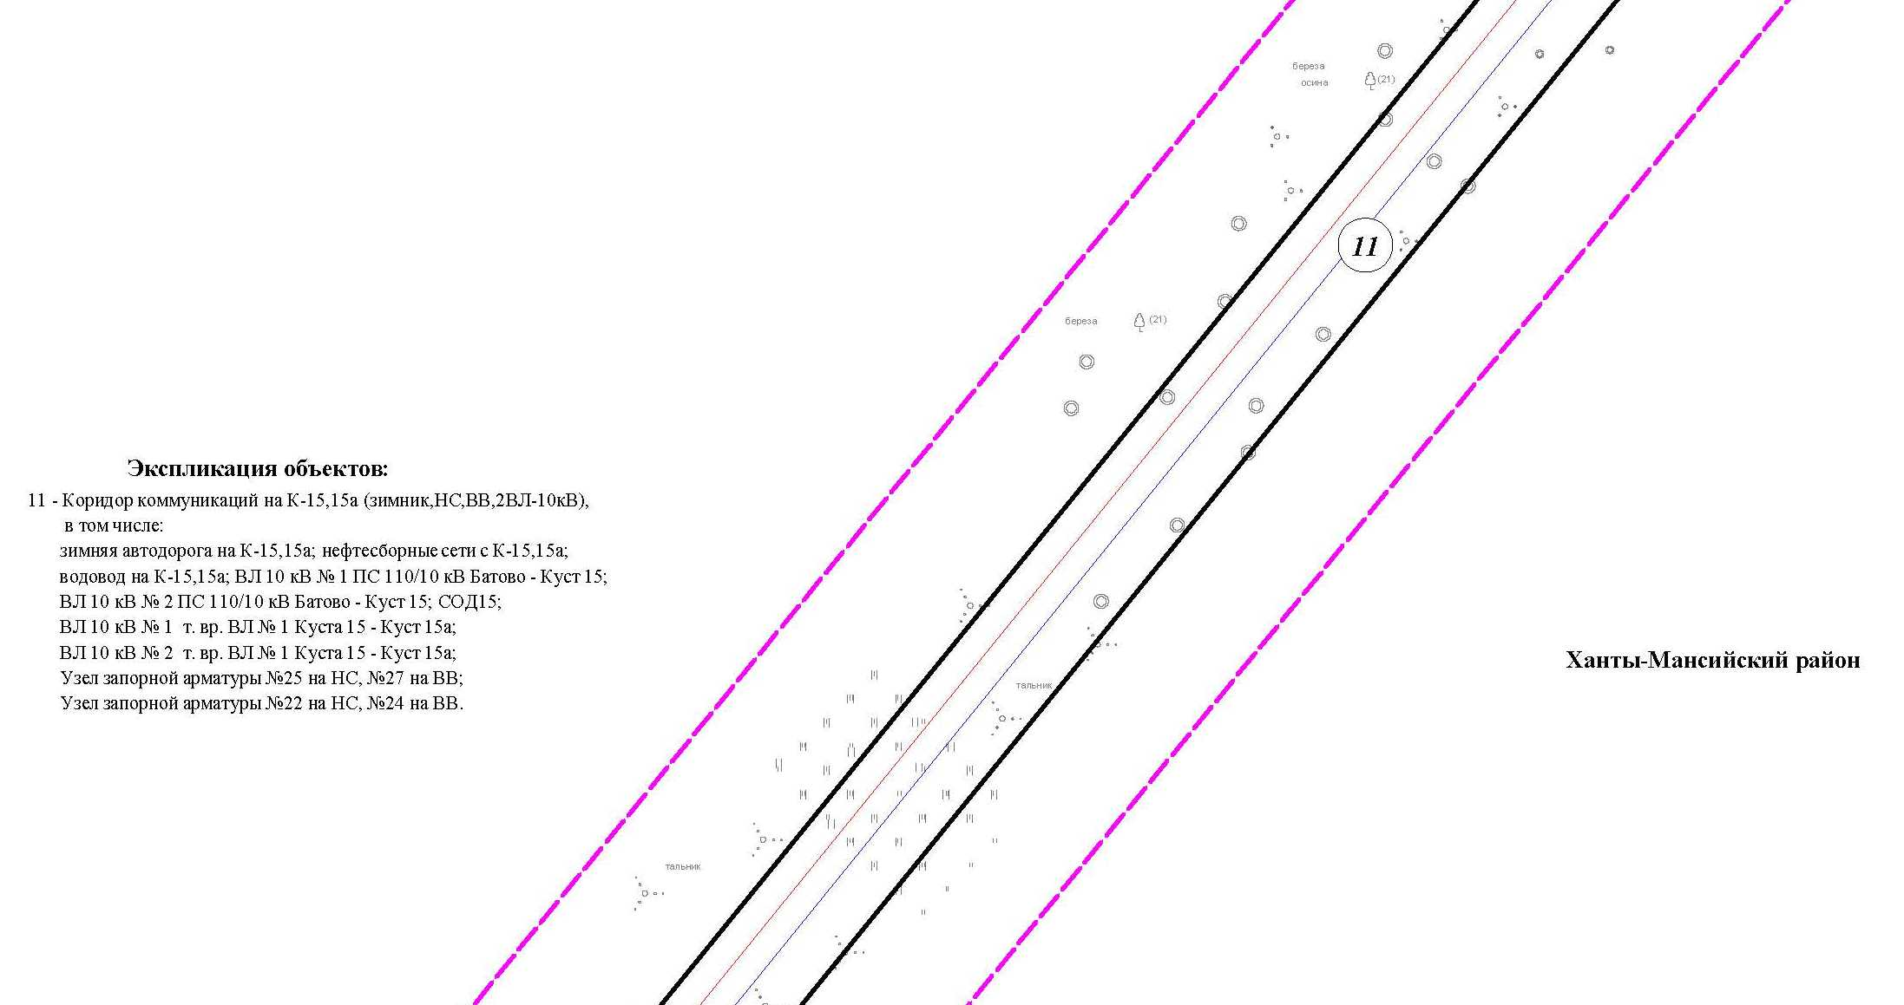
Линия совмещения с листом 49

43

Основная часть проекта планировки территории для размещения объекта капитального строительства, расположенного
на территории двух муниципальных образований
Ханты-Мансийского автономного округа – Югры
«Обустройство Чапровского месторождения.
Кусты 14, 14а, 15, 15а, 17, 17а и коридоры коммуникаций».
Землепользователь: АО «НК «Конданефть»
Масштаб 1:2000

Основная часть проекта планировки территории для размещения объекта капитального строительства, расположенного
на территории двух муниципальных образований
Ханты-Мансийского автономного округа – Югры
«Обустройство Чапровского месторождения.
Кусты 14, 14а, 15, 15а, 17, 17а и коридоры коммуникаций».
Землепользователь: АО «НК «Конданефть»
Масштаб 1:2000

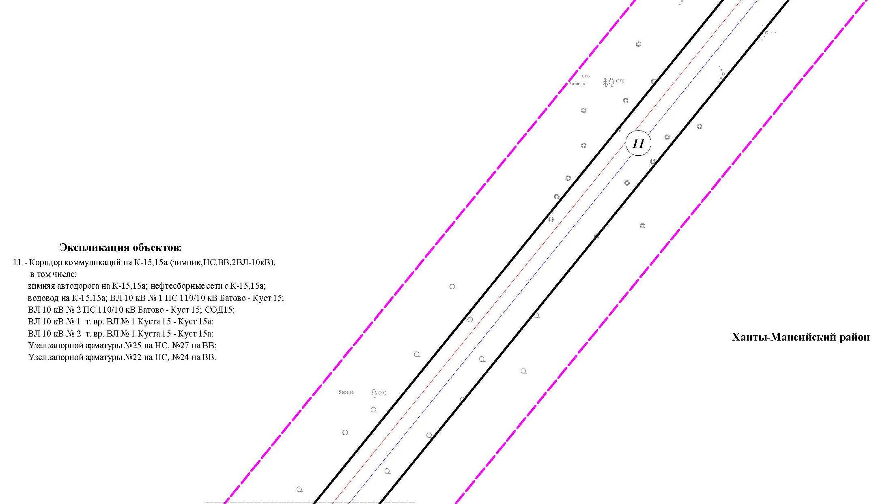
Линия совмещения с листом 50

43

Основная часть проекта планировки территории для размещения объекта капитального строительства, расположенного
на территории двух муниципальных образований
Ханты-Мансийского автономного округа – Югры
«Обустройство Чапровского месторождения.
Кусты 14, 14а, 15, 15а, 17, 17а и коридоры коммуникаций».
Землепользователь: АО «НК «Конданефть»
Масштаб 1:2000

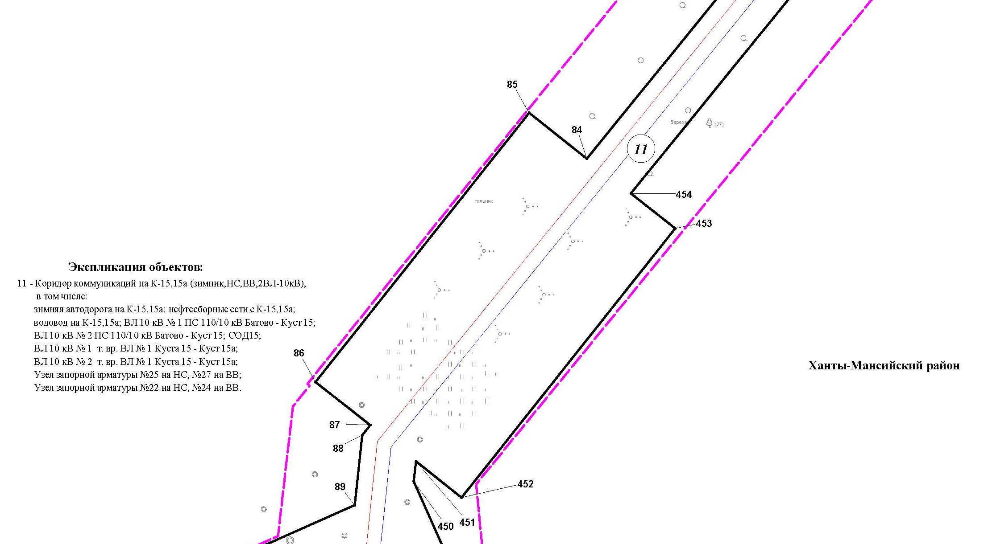

Основная часть проекта планировки территории для размещения объекта капитального строительства, расположенного
на территории двух муниципальных образований
Ханты-Мансийского автономного округа – Югры
«Обустройство Чапровского месторождения.
Кусты 14, 14а, 15, 15а, 17, 17а и коридоры коммуникаций».
Землепользователь: АО «НК «Конданефть»
Масштаб 1:2000

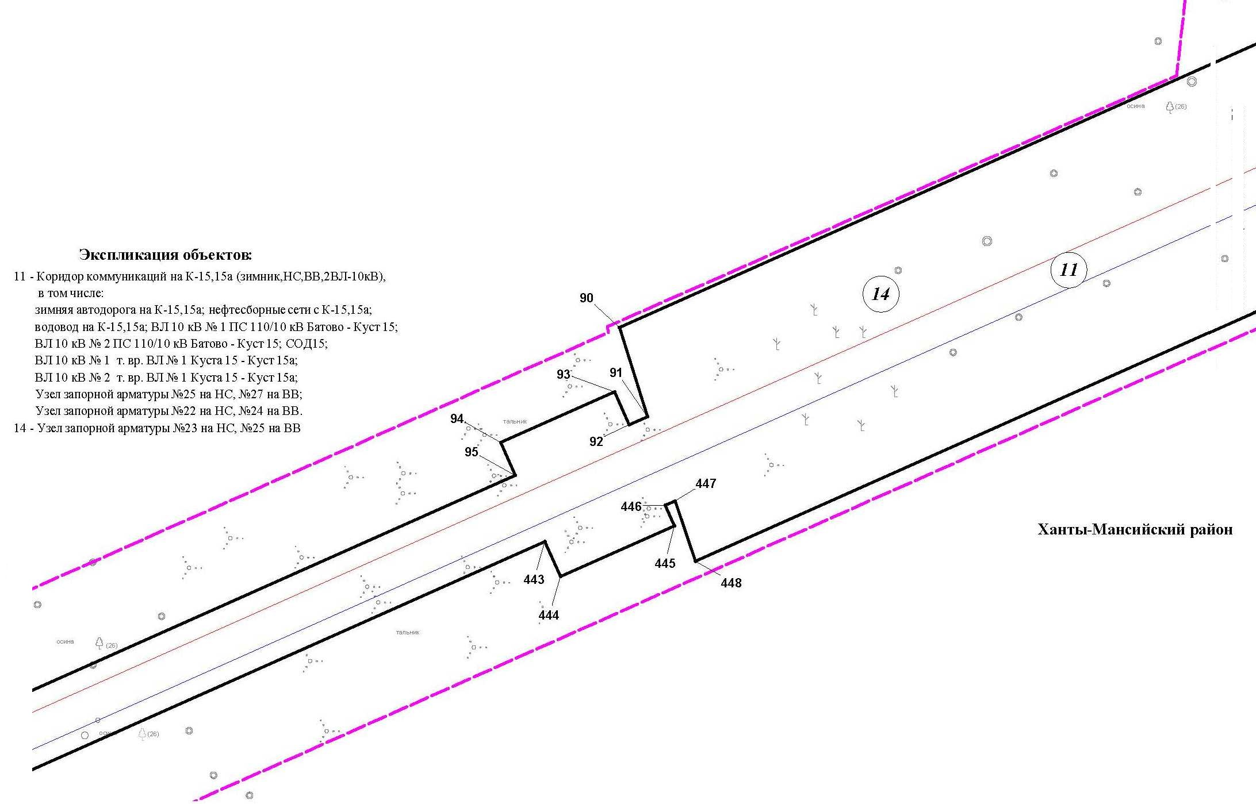

Основная часть проекта планировки территории для размещения объекта капитального строительства, расположенного
на территории двух муниципальных образований
Ханты-Мансийского автономного округа – Югры
«Обустройство Чапровского месторождения.
Кусты 14, 14а, 15, 15а, 17, 17а и коридоры коммуникаций».
Землепользователь: АО «НК «Конданефть»
Масштаб 1:2000

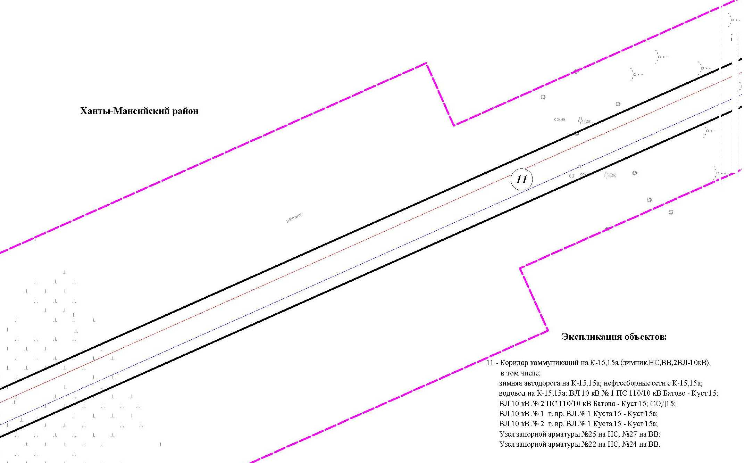

Основная часть проекта планировки территории для размещения объекта капитального строительства, расположенного
на территории двух муниципальных образований
Ханты-Мансийского автономного округа – Югры
«Обустройство Чапровского месторождения.
Кусты 14, 14а, 15, 15а, 17, 17а и коридоры коммуникаций».
Землепользователь: АО «НК «Конданефть»
Масштаб 1:2000

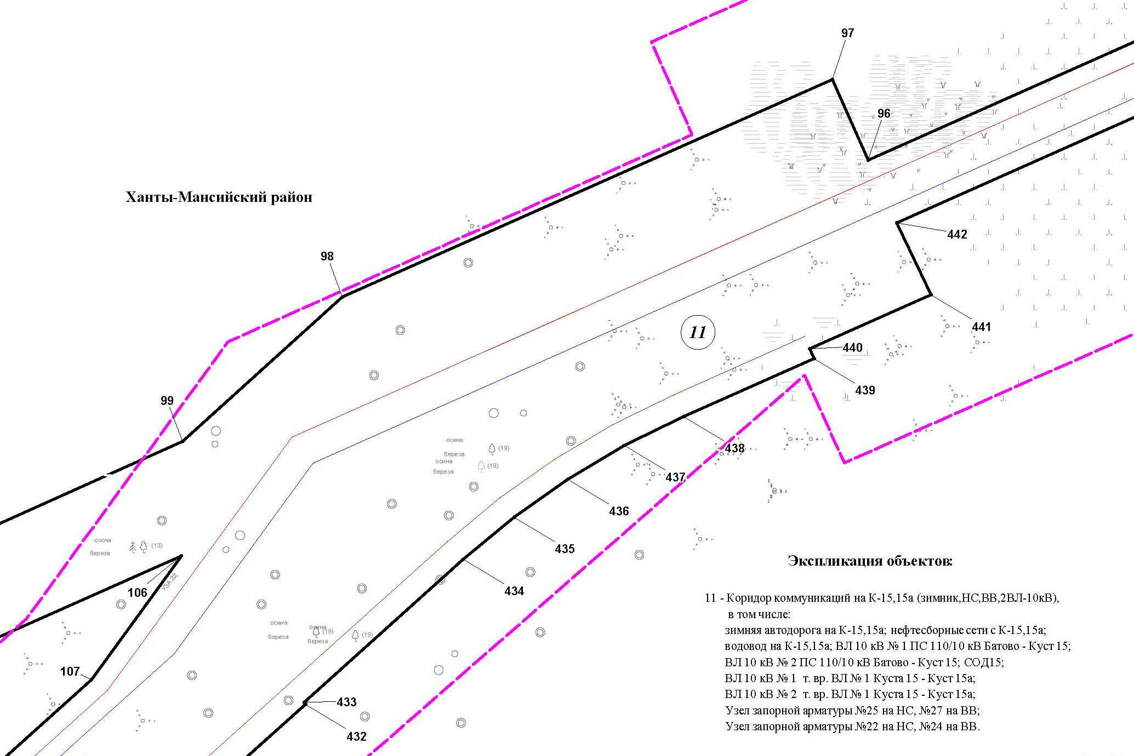

Основная часть проекта планировки территории для размещения объекта капитального строительства, расположенного
на территории двух муниципальных образований
Ханты-Мансийского автономного округа – Югры
«Обустройство Чапровского месторождения.
Кусты 14, 14а, 15, 15а, 17, 17а и коридоры коммуникаций».
Землепользователь: АО «НК «Конданефть»
Масштаб 1:2000

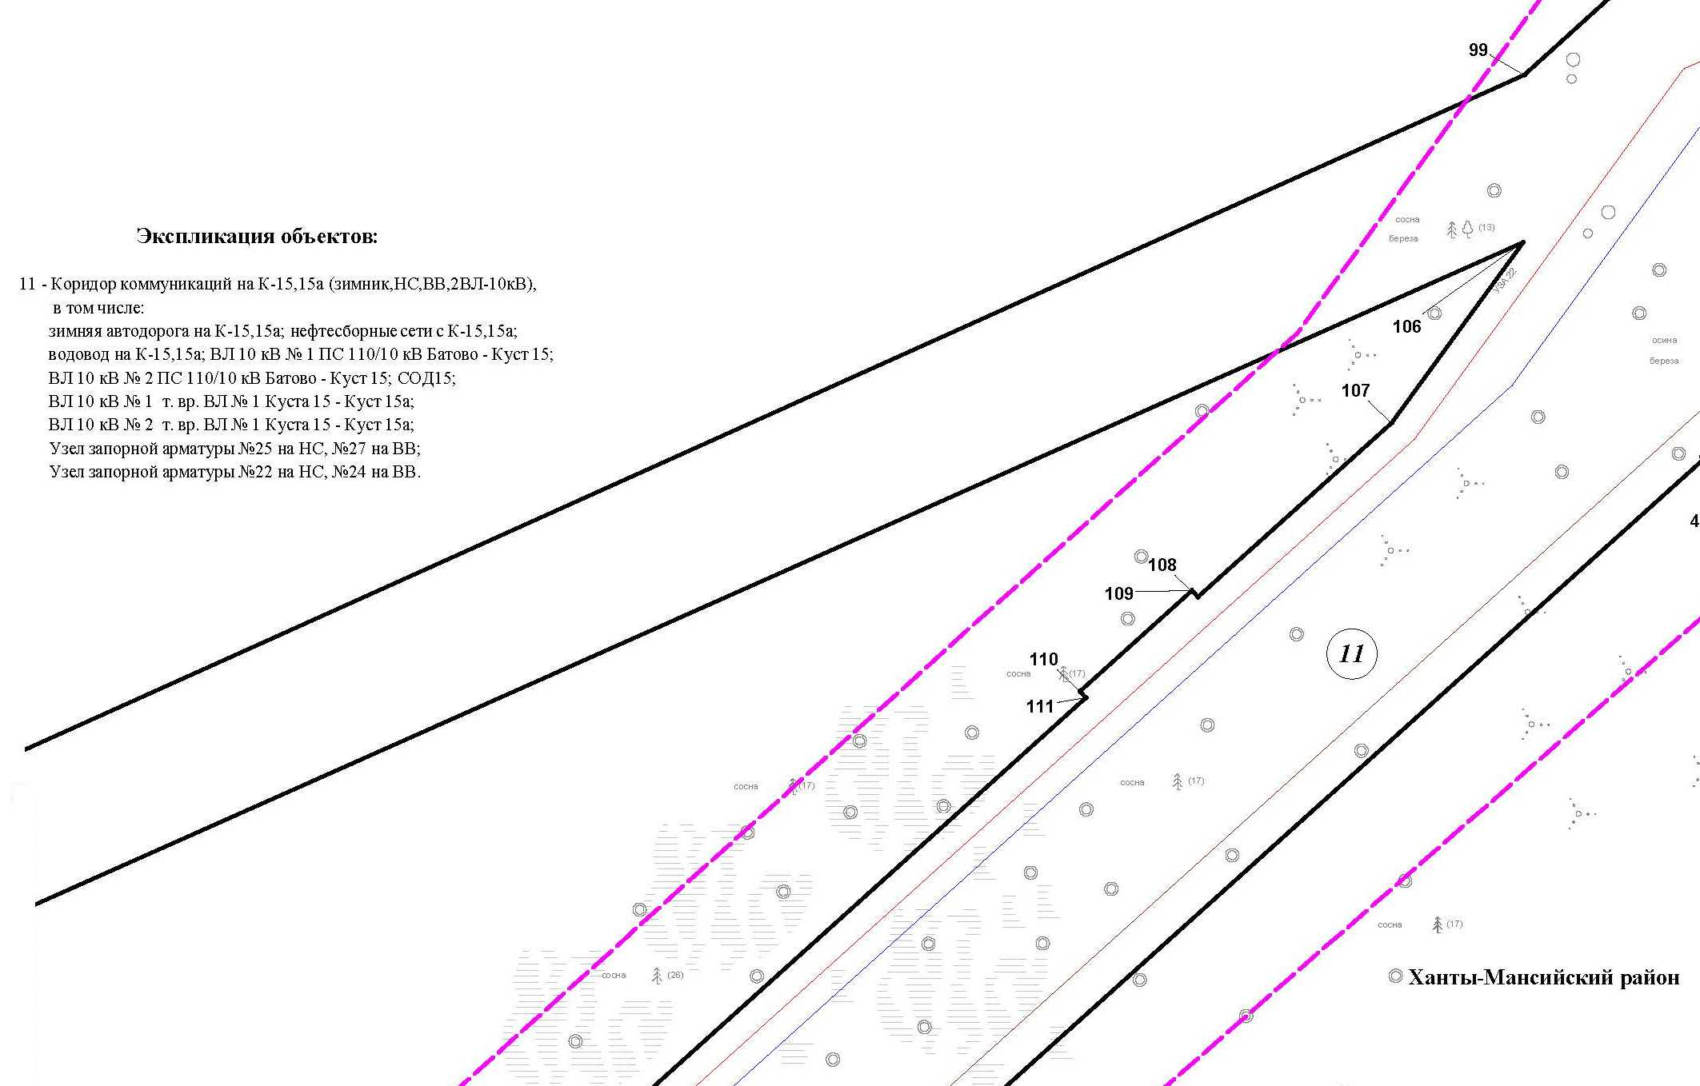
Линия совмещения с листом 55

Основная часть проекта планировки территории для размещения объекта капитального строительства, расположенного
на территории двух муниципальных образований
Ханты-Мансийского автономного округа – Югры
«Обустройство Чапровского месторождения.
Кусты 14, 14а, 15, 15а, 17, 17а и коридоры коммуникаций».
Землепользователь: АО «НК «Конданефть»
Масштаб 1:2000

Основная часть проекта планировки территории для размещения объекта капитального строительства, расположенного
на территории двух муниципальных образований
Ханты-Мансийского автономного округа – Югры
«Обустройство Чапровского месторождения.
Кусты 14, 14а, 15, 15а, 17, 17а и коридоры коммуникаций».
Землепользователь: АО «НК «Конданефть»
Масштаб 1:2000

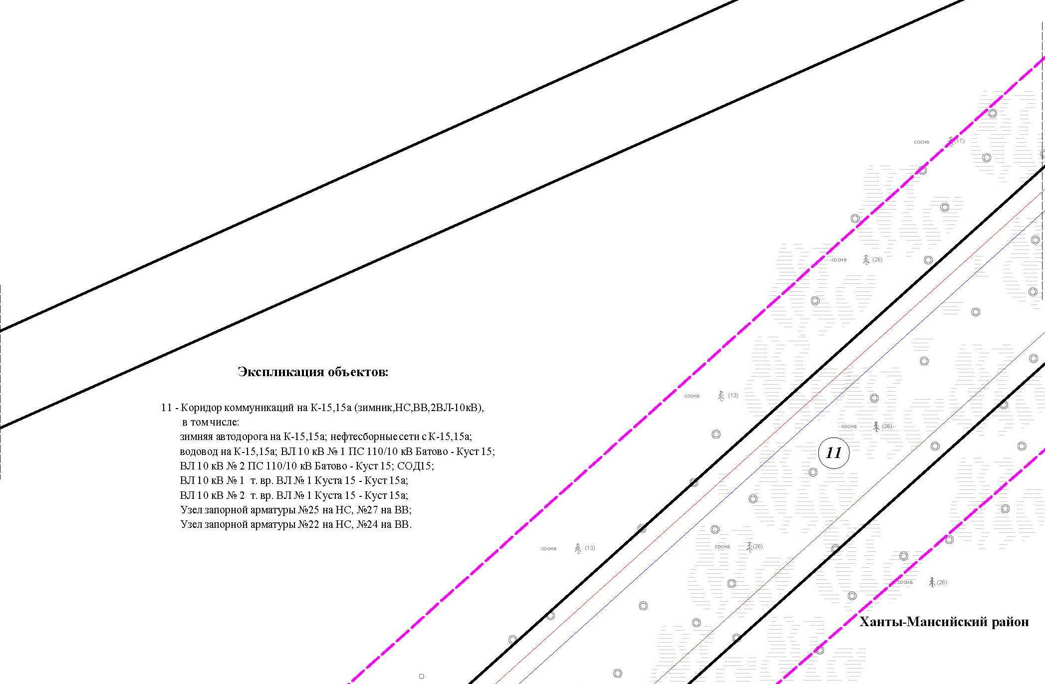

Основная часть проекта планировки территории для размещения объекта капитального строительства, расположенного
на территории двух муниципальных образований
Ханты-Мансийского автономного округа – Югры
«Обустройство Чапровского месторождения.
Кусты 14, 14а, 15, 15а, 17, 17а и коридоры коммуникаций».
Землепользователь: АО «НК «Конданефть»
Масштаб 1:2000

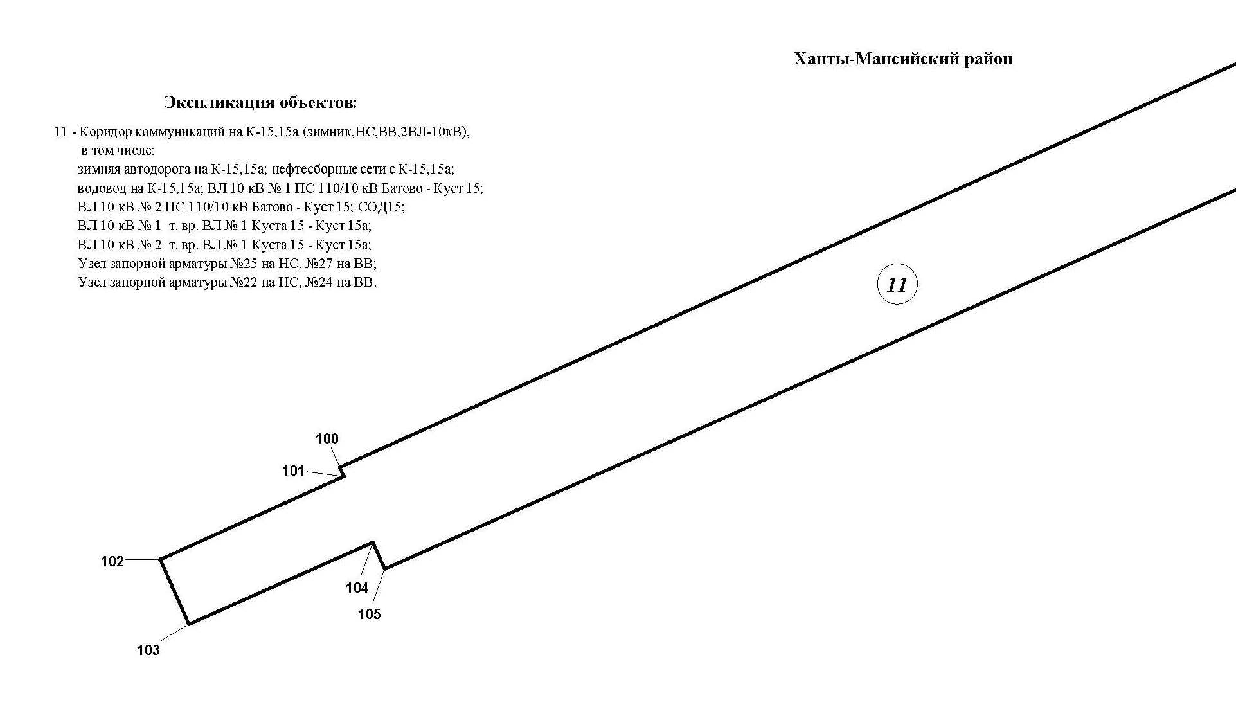

Основная часть проекта планировки территории для размещения объекта капитального строительства, расположенного
на территории двух муниципальных образований
Ханты-Мансийского автономного округа – Югры
«Обустройство Чапровского месторождения.
Кусты 14, 14а, 15, 15а, 17, 17а и коридоры коммуникаций».
Землепользователь: АО «НК «Конданефть»
Масштаб 1:2000

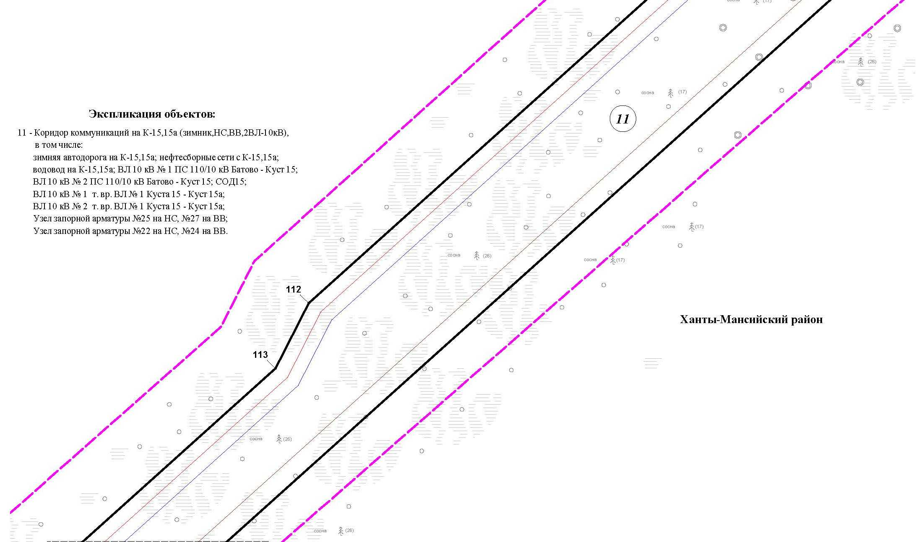
Линия совмещения с листом 58

Основная часть проекта планировки территории для размещения объекта капитального строительства, расположенного
на территории двух муниципальных образований
Ханты-Мансийского автономного округа – Югры
«Обустройство Чапровского месторождения.
Кусты 14, 14а, 15, 15а, 17, 17а и коридоры коммуникаций».
Землепользователь: АО «НК «Конданефть»
Масштаб 1:2000

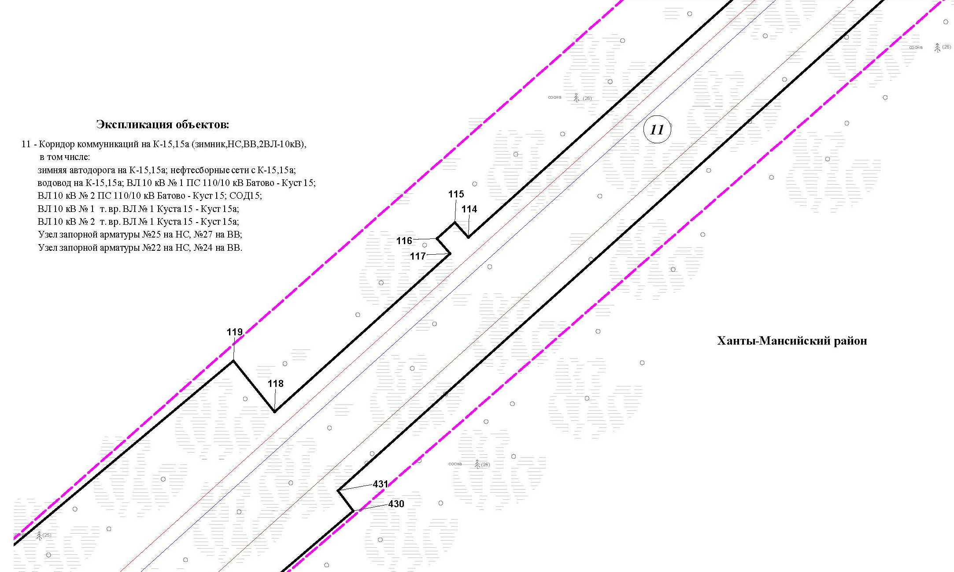
Линия совмещения с листом 59

Основная часть проекта планировки территории для размещения объекта капитального строительства, расположенного
на территории двух муниципальных образований
Ханты-Мансийского автономного округа – Югры
«Обустройство Чапровского месторождения.
Кусты 14, 14а, 15, 15а, 17, 17а и коридоры коммуникаций».
Землепользователь: АО «НК «Конданефть»
Масштаб 1:2000

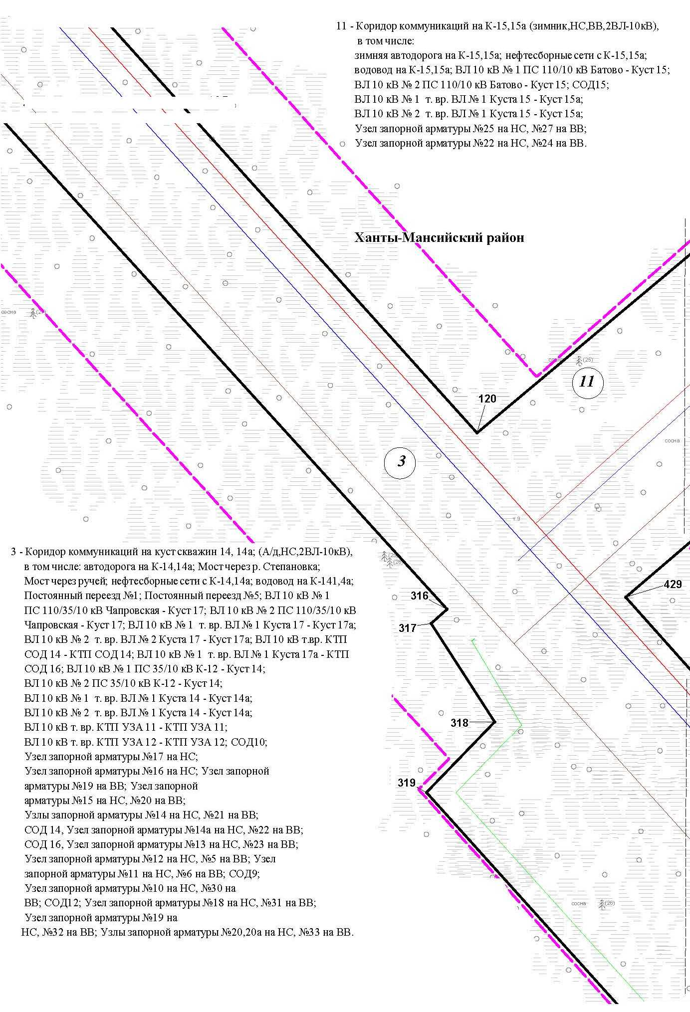

Основная часть проекта планировки территории для размещения объекта капитального строительства, расположенного
на территории двух муниципальных образований
Ханты-Мансийского автономного округа – Югры
«Обустройство Чапровского месторождения.
Кусты 14, 14а, 15, 15а, 17, 17а и коридоры коммуникаций».
Землепользователь: АО «НК «Конданефть»
Масштаб 1:2000

Основная часть проекта планировки территории для размещения объекта капитального строительства, расположенного
на территории двух муниципальных образований
Ханты-Мансийского автономного округа – Югры
«Обустройство Чапровского месторождения.
Кусты 14, 14а, 15, 15а, 17, 17а и коридоры коммуникаций».
Землепользователь: АО «НК «Конданефть»
Масштаб 1:2000

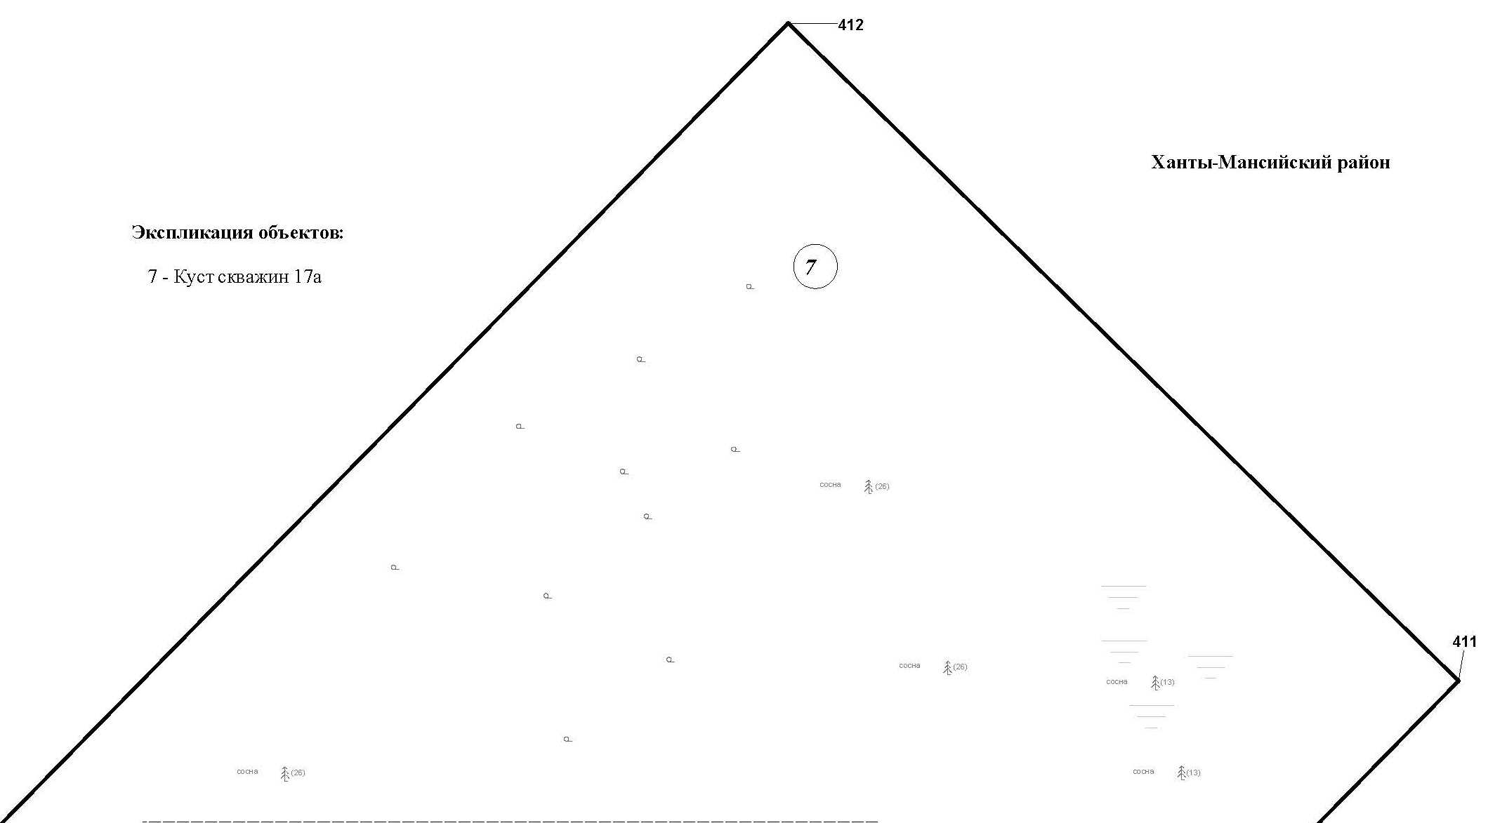

Основная часть проекта планировки территории для размещения объекта капитального строительства, расположенного
на территории двух муниципальных образований
Ханты-Мансийского автономного округа – Югры
«Обустройство Чапровского месторождения.
Кусты 14, 14а, 15, 15а, 17, 17а и коридоры коммуникаций».
Землепользователь: АО «НК «Конданефть»
Масштаб 1:2000

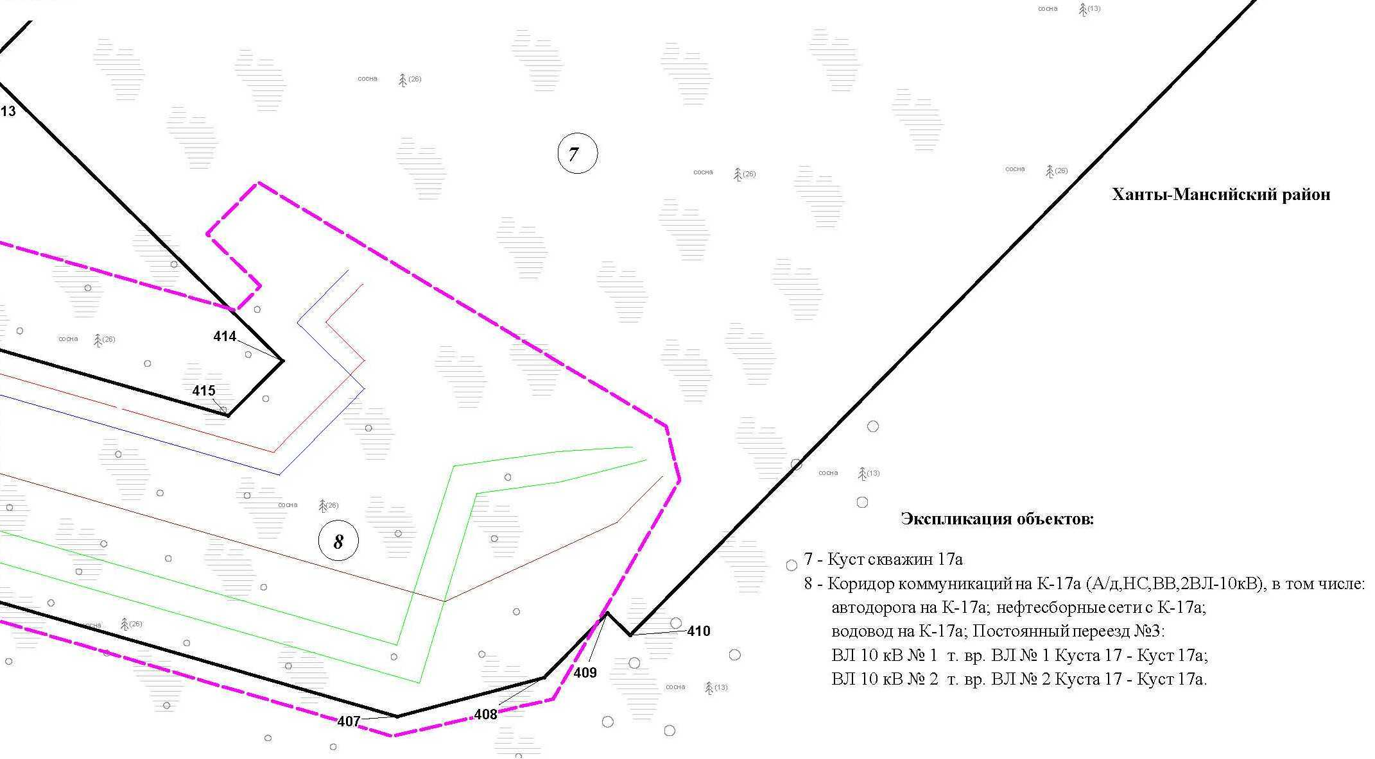

Основная часть проекта планировки территории для размещения объекта капитального строительства, расположенного
на территории двух муниципальных образований
Ханты-Мансийского автономного округа – Югры
«Обустройство Чапровского месторождения.
Кусты 14, 14а, 15, 15а, 17, 17а и коридоры коммуникаций».
Землепользователь: АО «НК «Конданефть»
Масштаб 1:2000

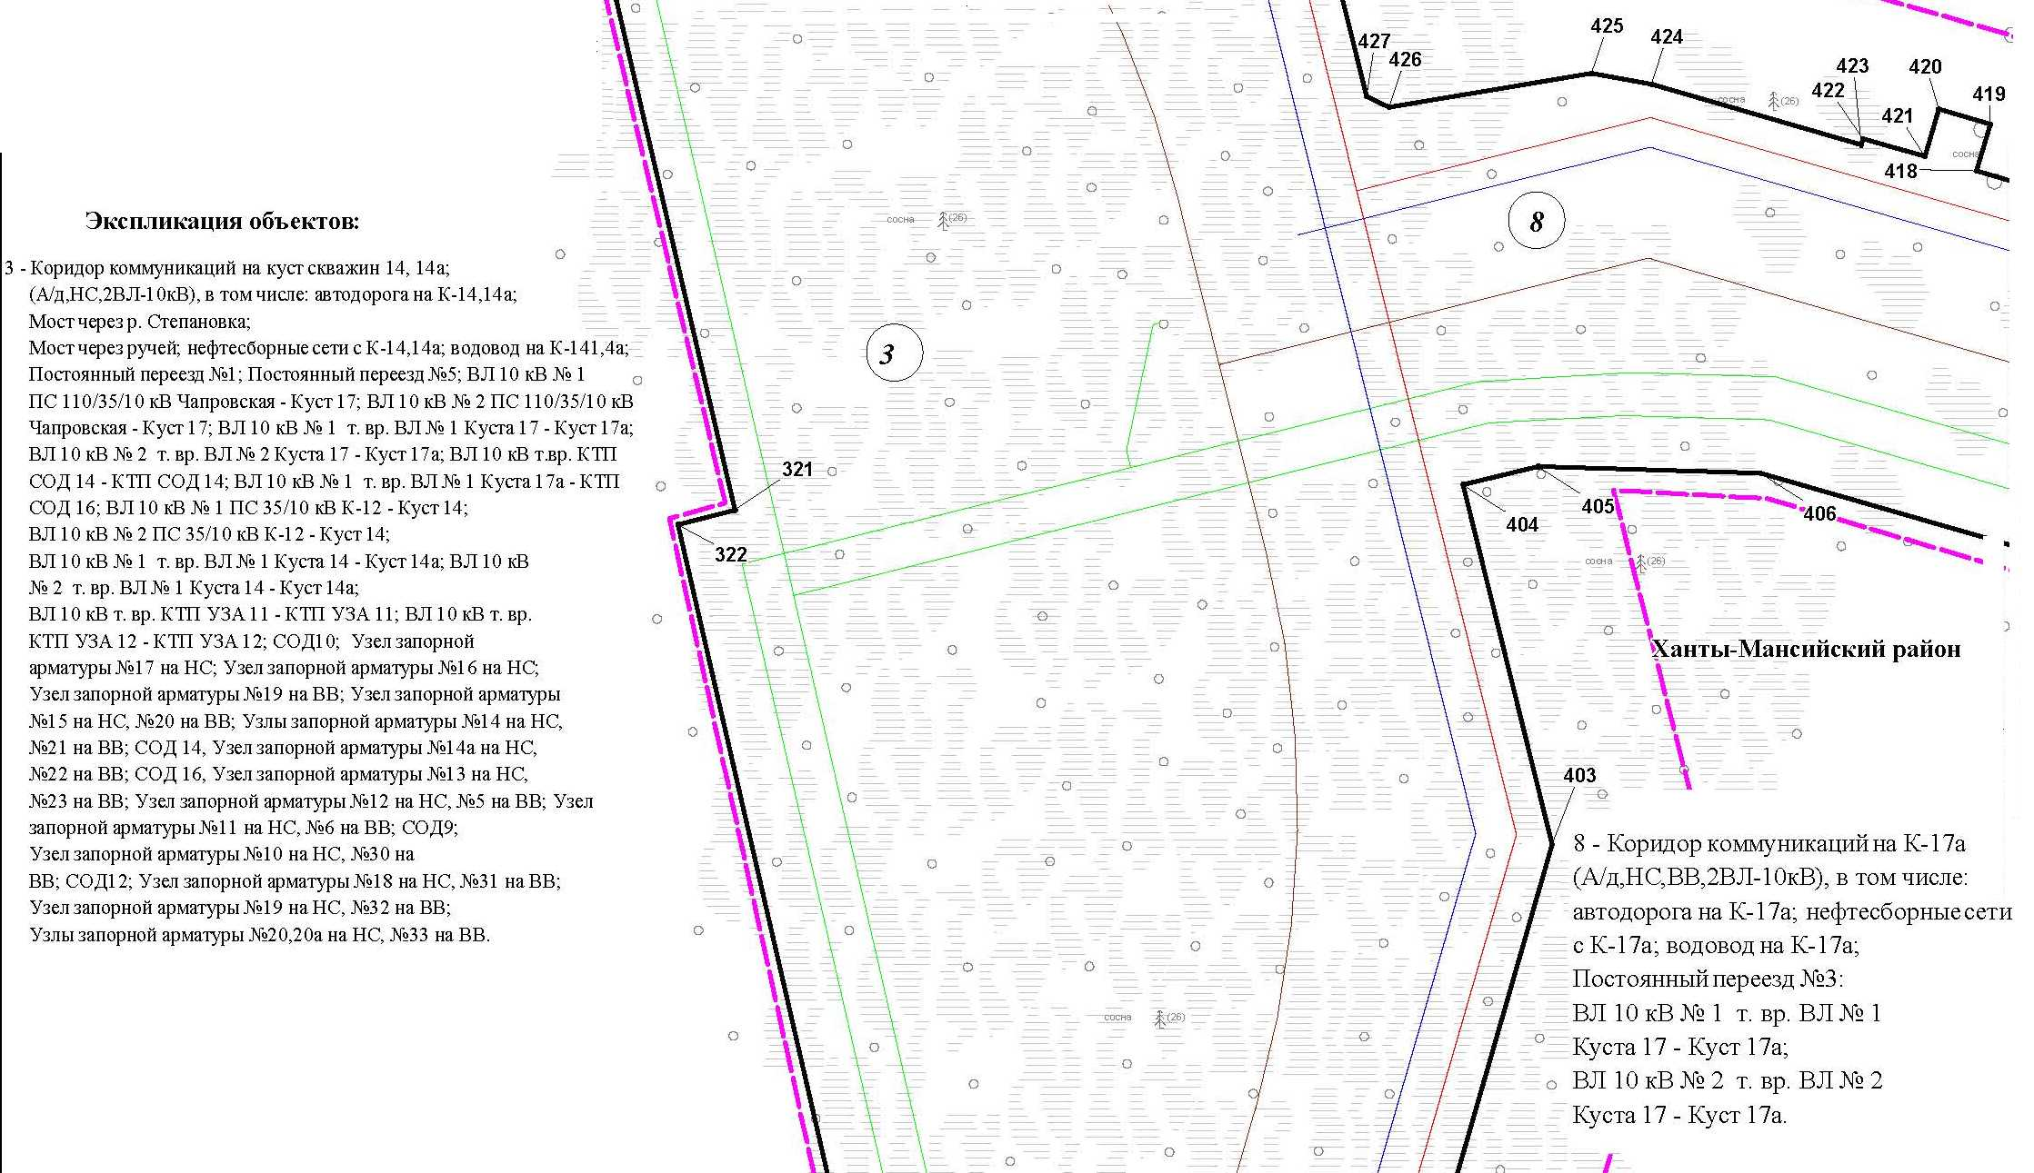

Основная часть проекта планировки территории для размещения объекта капитального строительства, расположенного
на территории двух муниципальных образований
Ханты-Мансийского автономного округа – Югры
«Обустройство Чапровского месторождения.
Кусты 14, 14а, 15, 15а, 17, 17а и коридоры коммуникаций».
Землепользователь: АО «НК «Конданефть»
Масштаб 1:2000

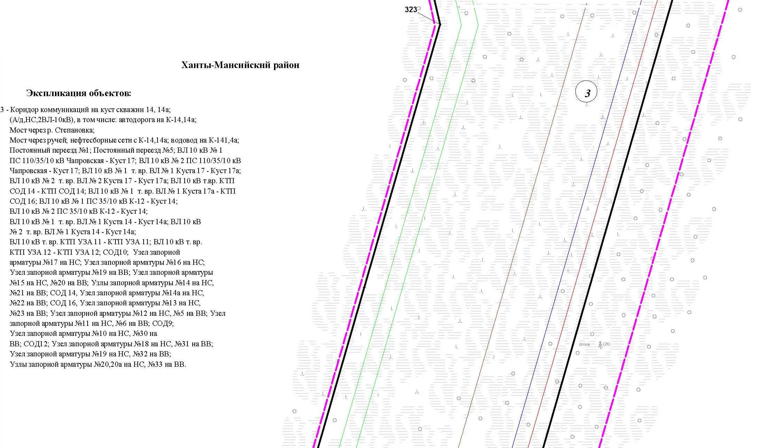

Основная часть проекта планировки территории для размещения объекта капитального строительства, расположенного
на территории двух муниципальных образований
Ханты-Мансийского автономного округа – Югры
«Обустройство Чапровского месторождения.
Кусты 14, 14а, 15, 15а, 17, 17а и коридоры коммуникаций».
Землепользователь: АО «НК «Конданефть»
Масштаб 1:2000

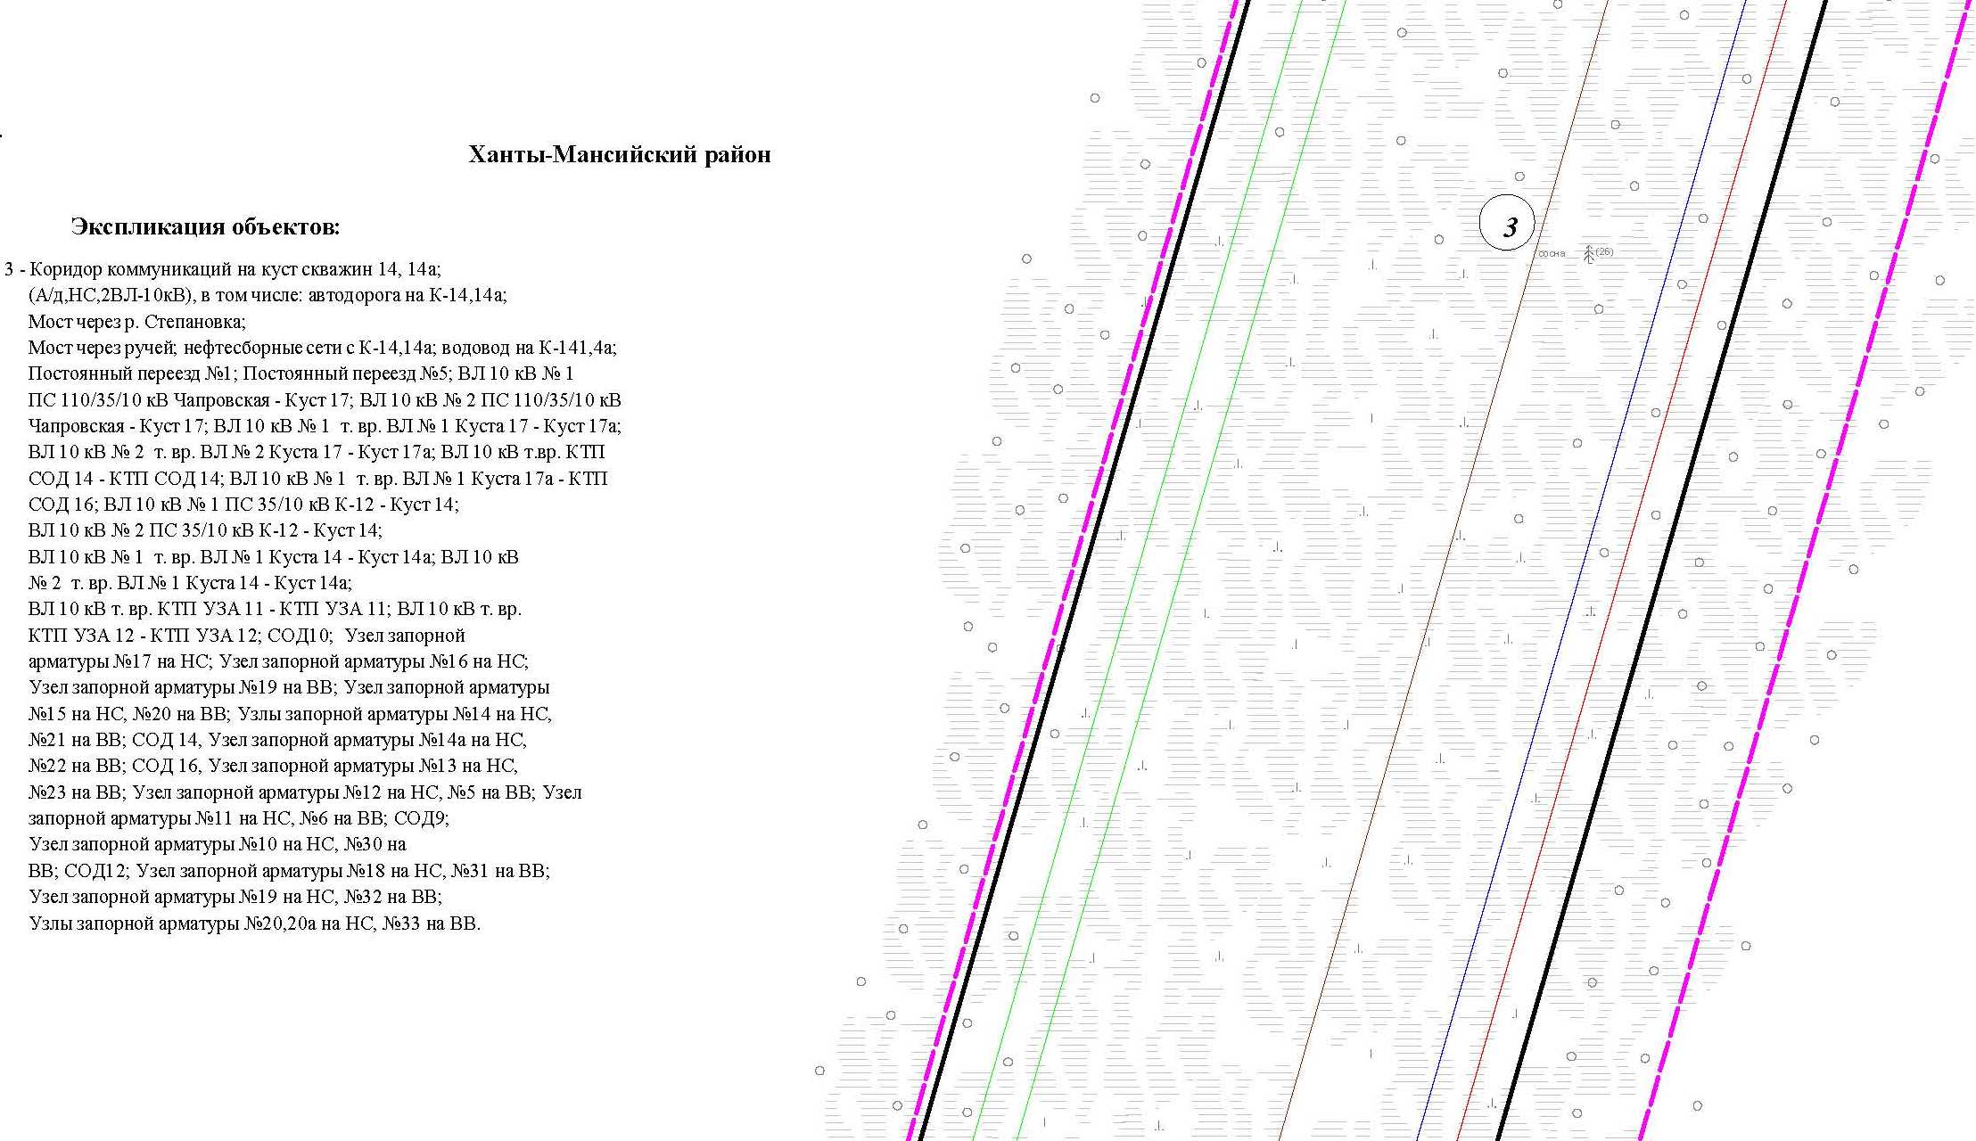

Основная часть проекта планировки территории для размещения объекта капитального строительства, расположенного
на территории двух муниципальных образований
Ханты-Мансийского автономного округа – Югры
«Обустройство Чапровского месторождения.
Кусты 14, 14а, 15, 15а, 17, 17а и коридоры коммуникаций».
Землепользователь: АО «НК «Конданефть»
Масштаб 1:2000

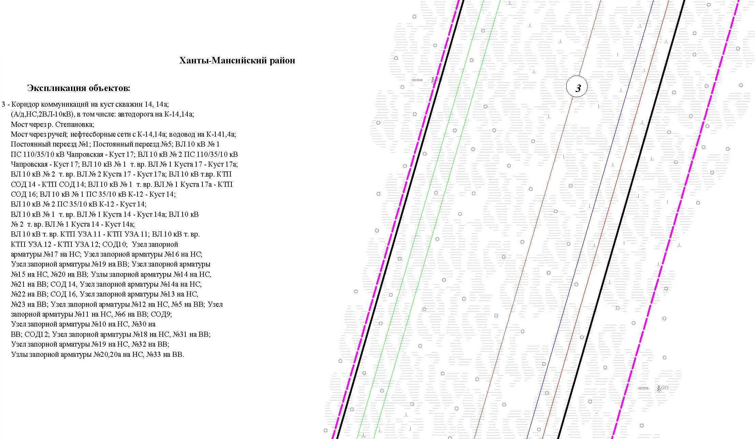

Основная часть проекта планировки территории для размещения объекта капитального строительства, расположенного
на территории двух муниципальных образований
Ханты-Мансийского автономного округа – Югры
«Обустройство Чапровского месторождения.
Кусты 14, 14а, 15, 15а, 17, 17а и коридоры коммуникаций».
Землепользователь: АО «НК «Конданефть»
Масштаб 1:2000

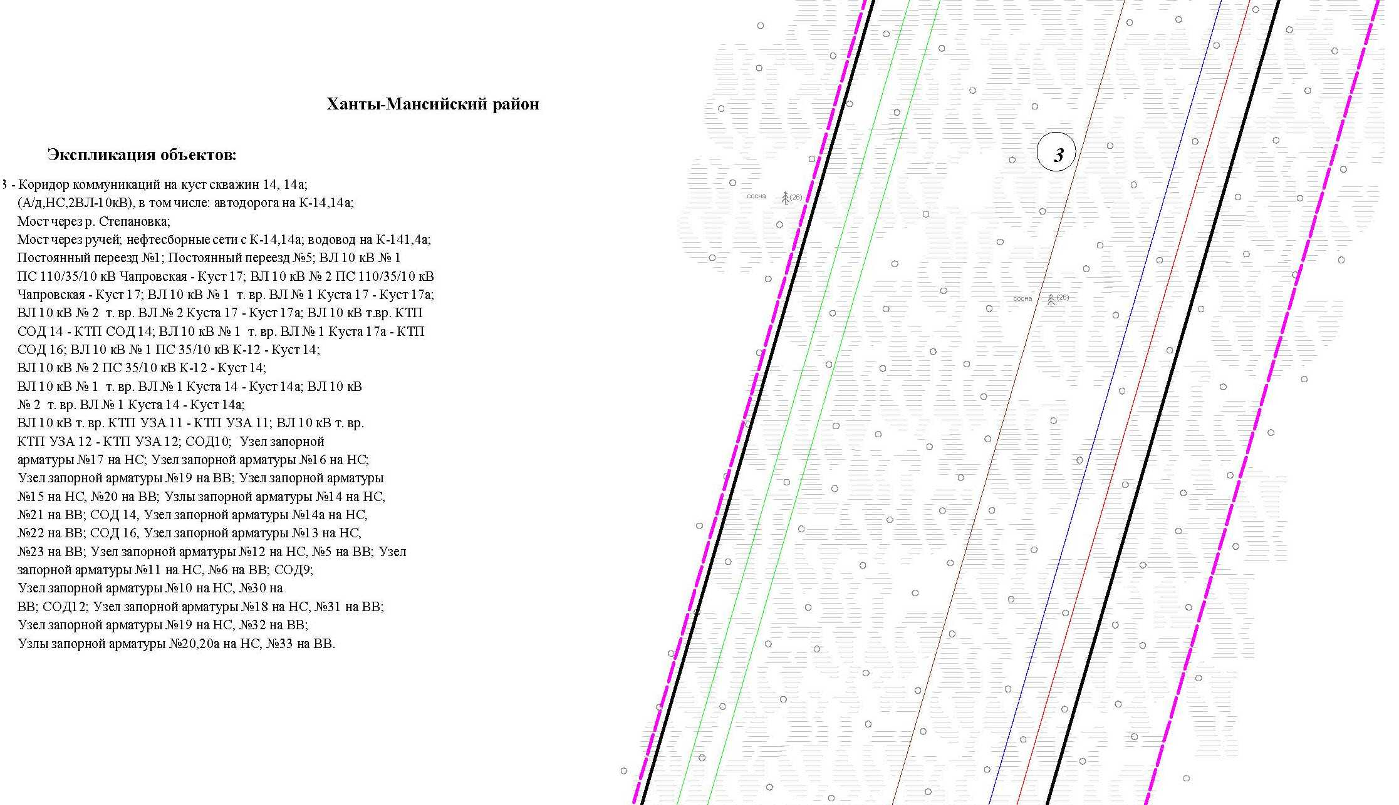

Основная часть проекта планировки территории для размещения объекта капитального строительства, расположенного
на территории двух муниципальных образований
Ханты-Мансийского автономного округа – Югры
«Обустройство Чапровского месторождения.
Кусты 14, 14а, 15, 15а, 17, 17а и коридоры коммуникаций».
Землепользователь: АО «НК «Конданефть»
Масштаб 1:2000

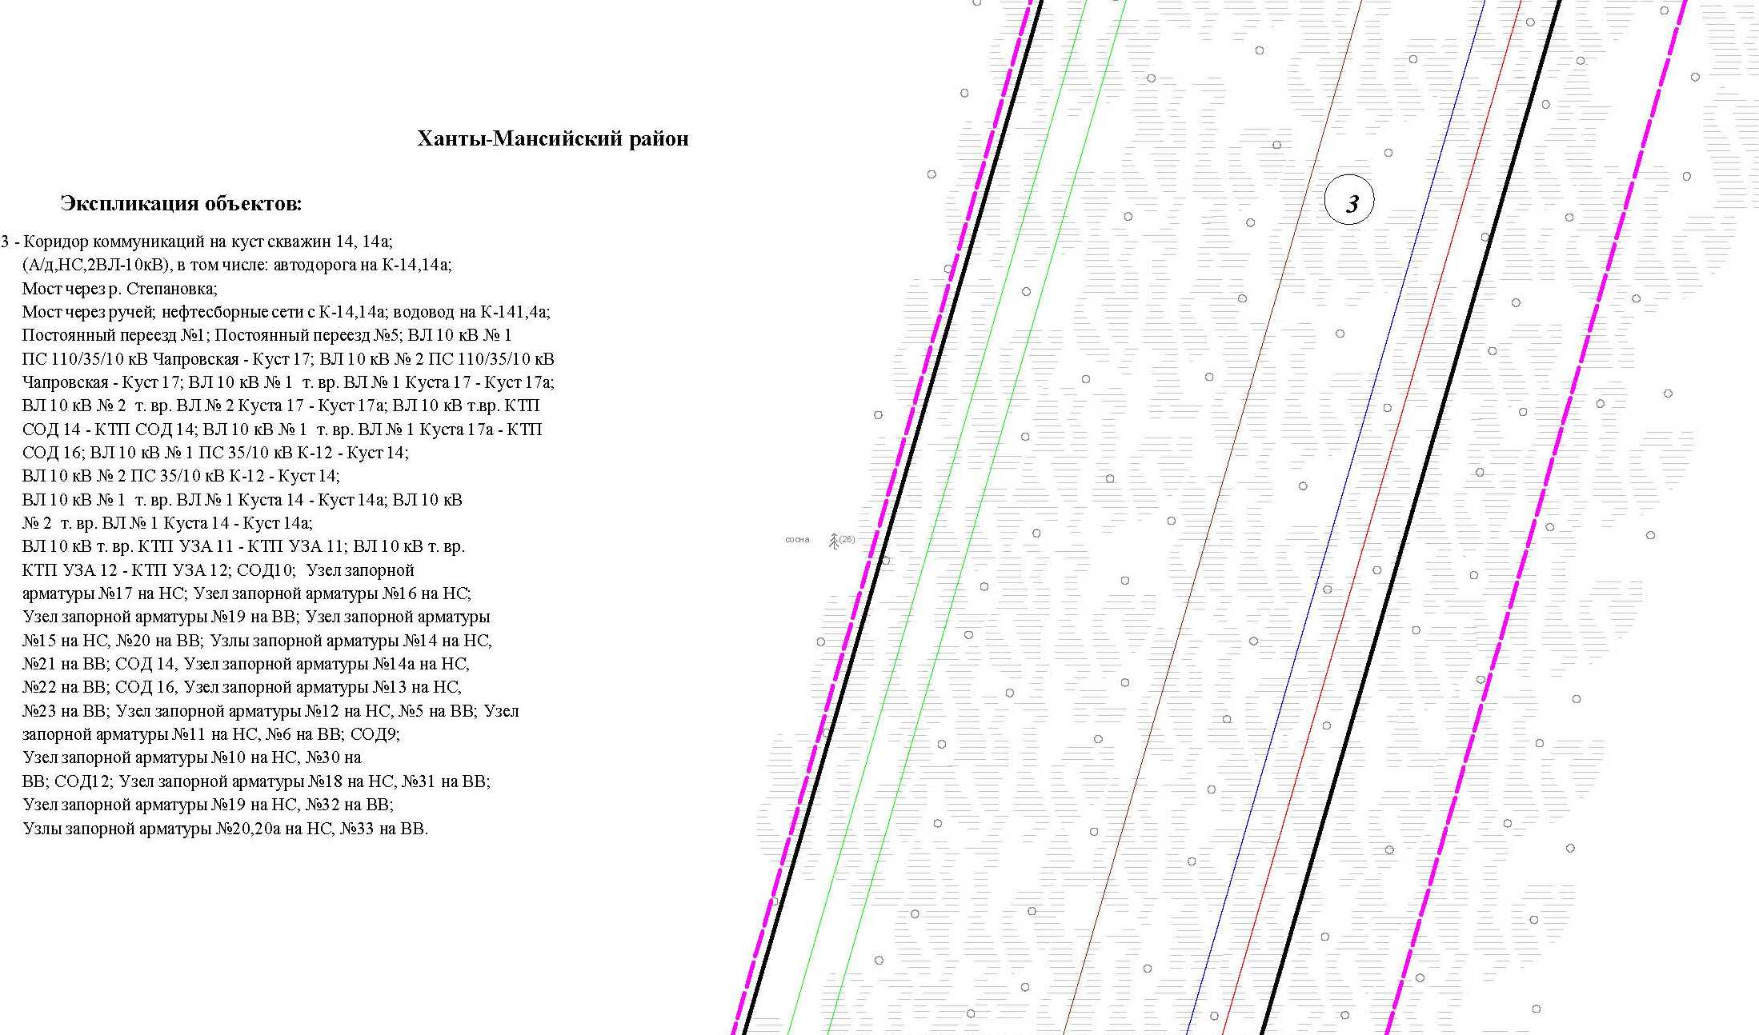

Основная часть проекта планировки территории для размещения объекта капитального строительства, расположенного
на территории двух муниципальных образований
Ханты-Мансийского автономного округа – Югры
«Обустройство Чапровского месторождения.
Кусты 14, 14а, 15, 15а, 17, 17а и коридоры коммуникаций».
Землепользователь: АО «НК «Конданефть»
Масштаб 1:2000

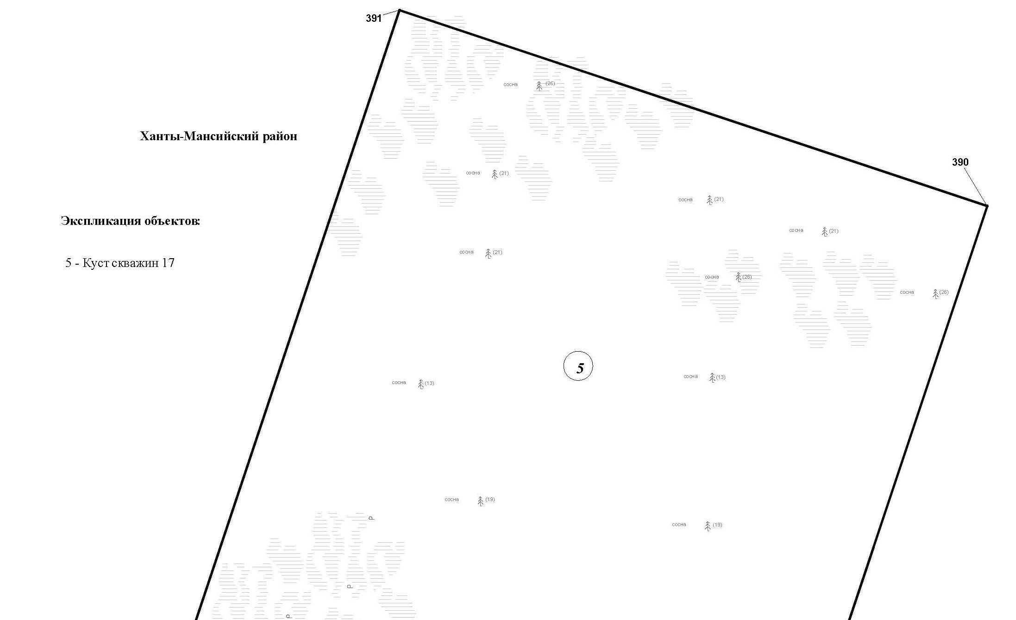

Основная часть проекта планировки территории для размещения объекта капитального строительства, расположенного
на территории двух муниципальных образований
Ханты-Мансийского автономного округа – Югры
«Обустройство Чапровского месторождения.
Кусты 14, 14а, 15, 15а, 17, 17а и коридоры коммуникаций».
Землепользователь: АО «НК «Конданефть»
Масштаб 1:2000

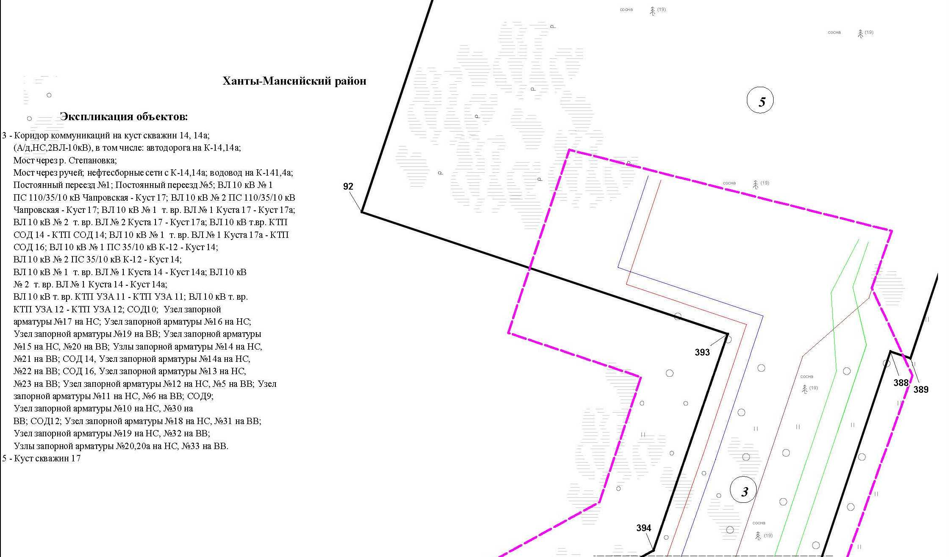

Основная часть проекта планировки территории для размещения объекта капитального строительства, расположенного
на территории двух муниципальных образований
Ханты-Мансийского автономного округа – Югры
«Обустройство Чапровского месторождения.
Кусты 14, 14а, 15, 15а, 17, 17а и коридоры коммуникаций».
Землепользователь: АО «НК «Конданефть»
Масштаб 1:2000

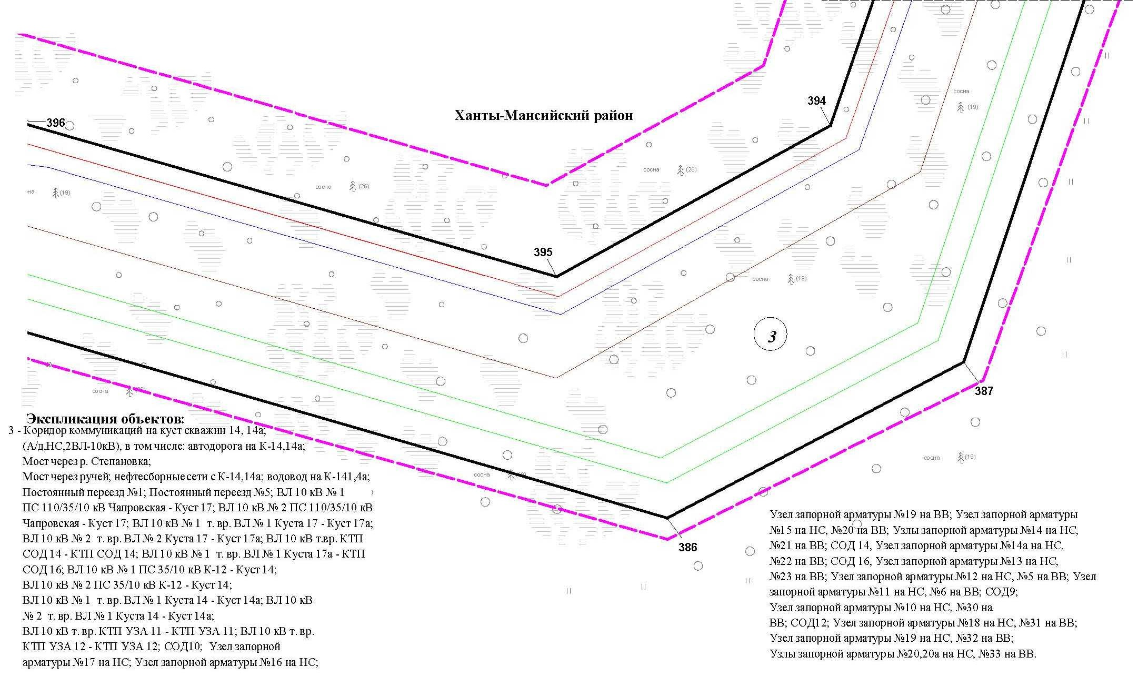

Основная часть проекта планировки территории для размещения объекта капитального строительства, расположенного
на территории двух муниципальных образований
Ханты-Мансийского автономного округа – Югры
«Обустройство Чапровского месторождения.
Кусты 14, 14а, 15, 15а, 17, 17а и коридоры коммуникаций».
Землепользователь: АО «НК «Конданефть»
Масштаб 1:2000

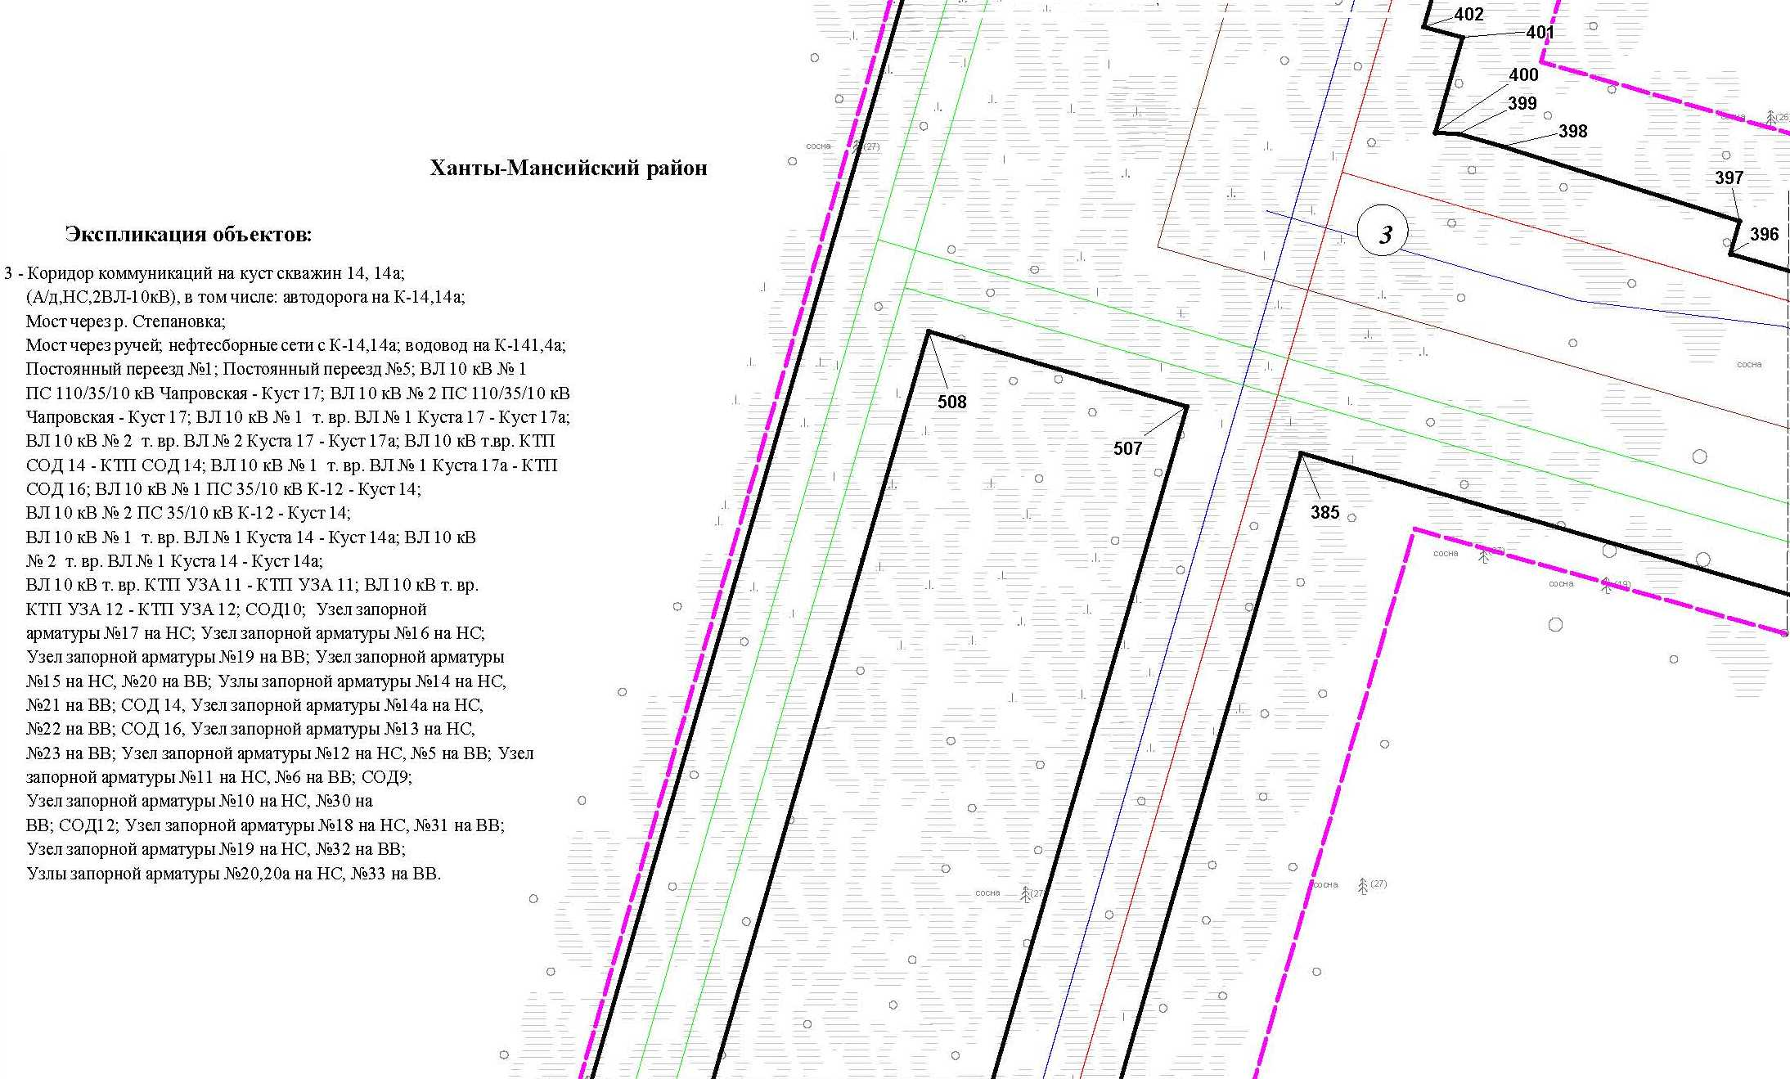

Основная часть проекта планировки территории для размещения объекта капитального строительства, расположенного
на территории двух муниципальных образований
Ханты-Мансийского автономного округа – Югры
«Обустройство Чапровского месторождения.
Кусты 14, 14а, 15, 15а, 17, 17а и коридоры коммуникаций».
Землепользователь: АО «НК «Конданефть»
Масштаб 1:2000

Основная часть проекта планировки территории для размещения объекта капитального строительства, расположенного
на территории двух муниципальных образований
Ханты-Мансийского автономного округа – Югры
«Обустройство Чапровского месторождения.
Кусты 14, 14а, 15, 15а, 17, 17а и коридоры коммуникаций».
Землепользователь: АО «НК «Конданефть»
Масштаб 1:2000

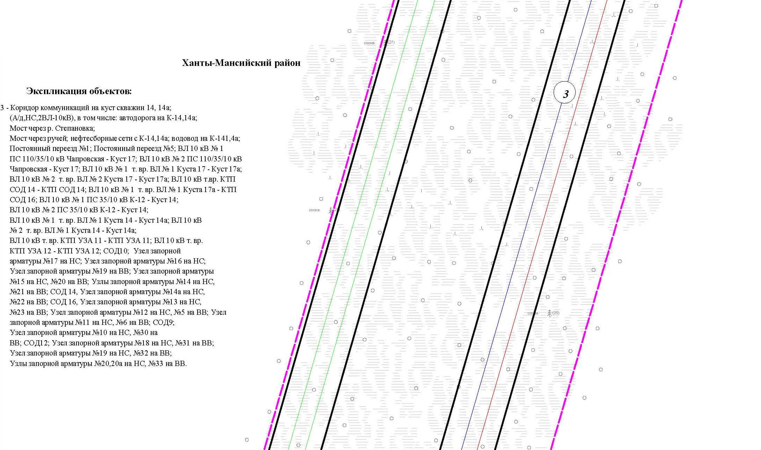

Основная часть проекта планировки территории для размещения объекта капитального строительства, расположенного
на территории двух муниципальных образований
Ханты-Мансийского автономного округа – Югры
«Обустройство Чапровского месторождения.
Кусты 14, 14а, 15, 15а, 17, 17а и коридоры коммуникаций».
Землепользователь: АО «НК «Конданефть»
Масштаб 1:2000

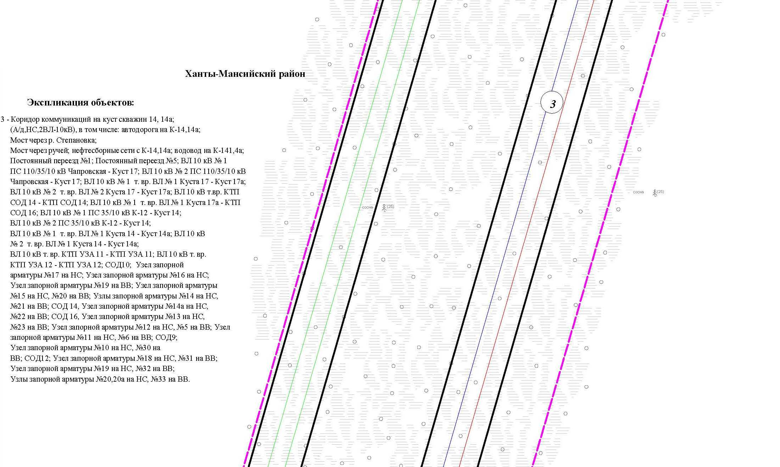

Основная часть проекта планировки территории для размещения объекта капитального строительства, расположенного
на территории двух муниципальных образований
Ханты-Мансийского автономного округа – Югры
«Обустройство Чапровского месторождения.
Кусты 14, 14а, 15, 15а, 17, 17а и коридоры коммуникаций».
Землепользователь: АО «НК «Конданефть»
Масштаб 1:2000

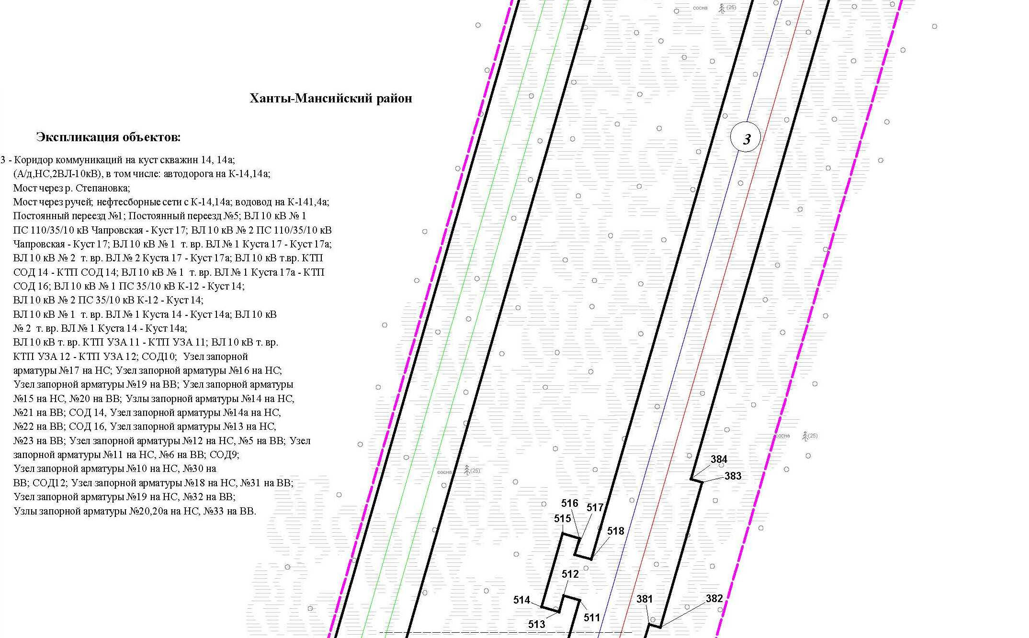

Основная часть проекта планировки территории для размещения объекта капитального строительства, расположенного
на территории двух муниципальных образований
Ханты-Мансийского автономного округа – Югры
«Обустройство Чапровского месторождения.
Кусты 14, 14а, 15, 15а, 17, 17а и коридоры коммуникаций».
Землепользователь: АО «НК «Конданефть»
Масштаб 1:2000

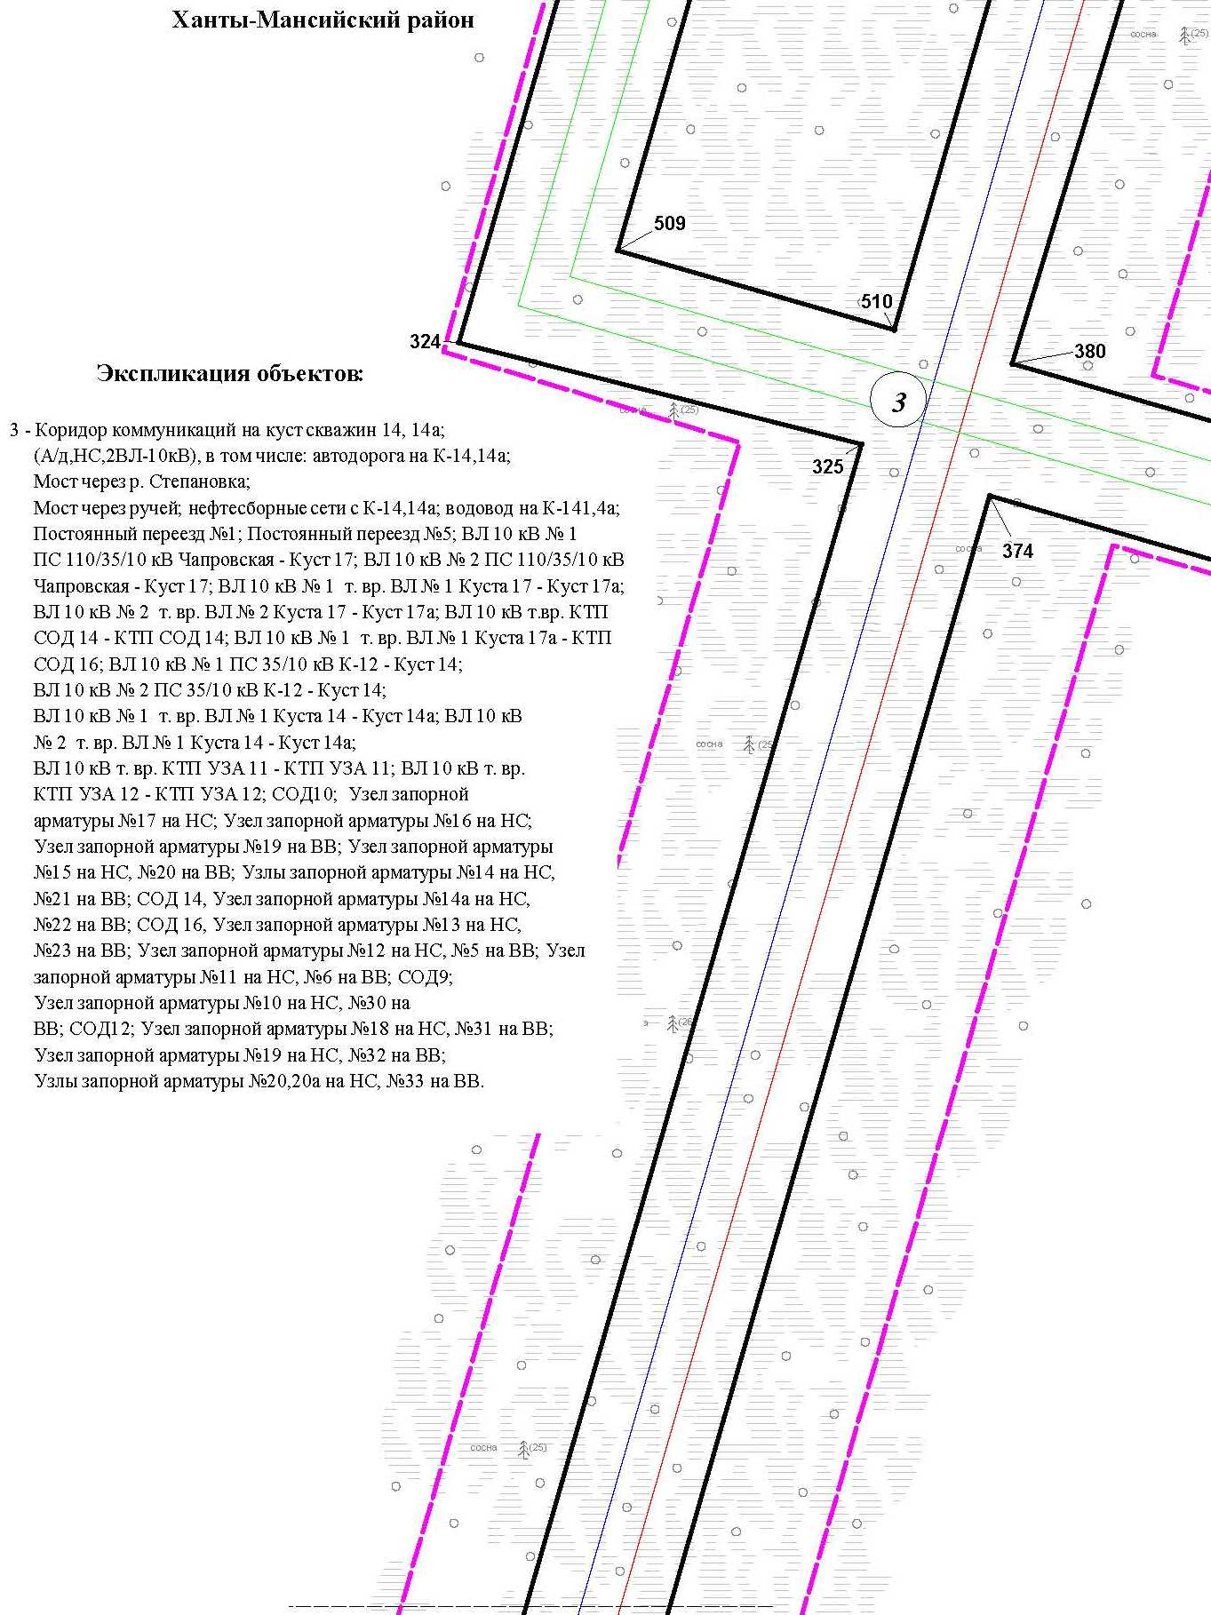

Основная часть проекта планировки территории для размещения объекта капитального строительства, расположенного
на территории двух муниципальных образований
Ханты-Мансийского автономного округа – Югры
«Обустройство Чапровского месторождения.
Кусты 14, 14а, 15, 15а, 17, 17а и коридоры коммуникаций».
Землепользователь: АО «НК «Конданефть»
Масштаб 1:2000

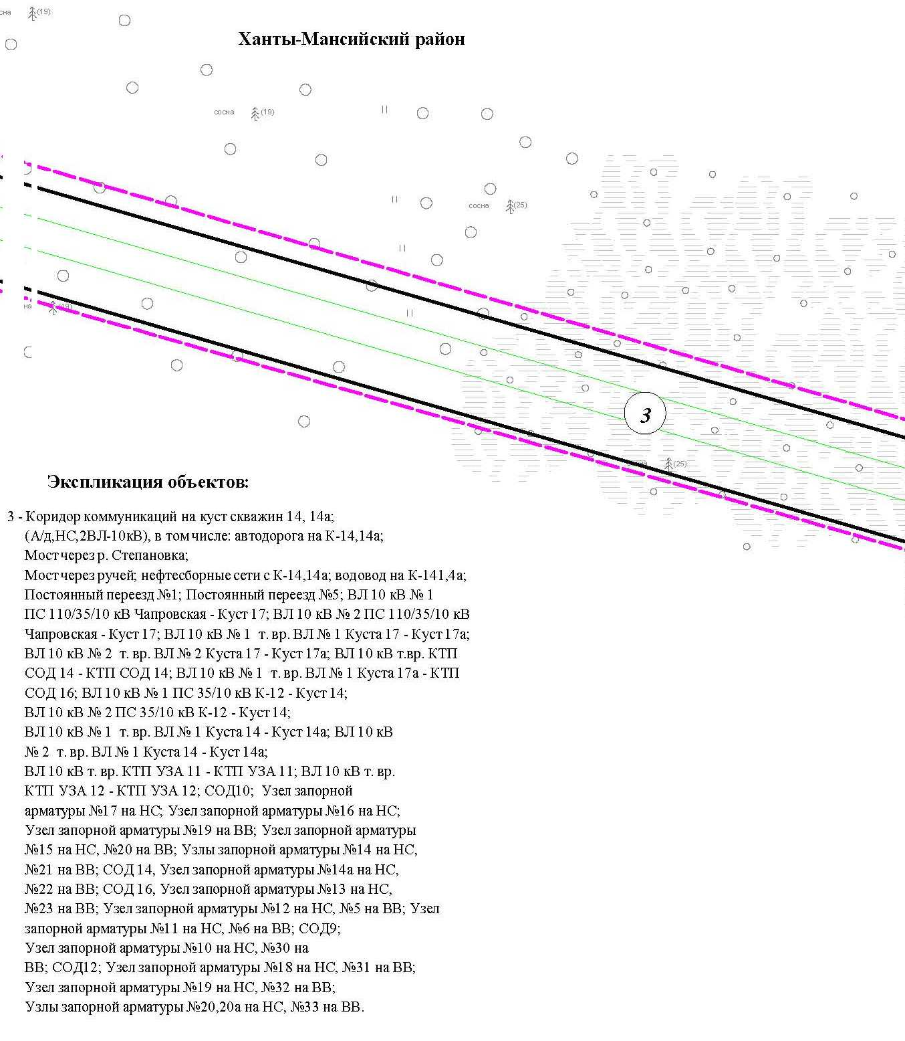

Основная часть проекта планировки территории для размещения объекта капитального строительства, расположенного
на территории двух муниципальных образований
Ханты-Мансийского автономного округа – Югры
«Обустройство Чапровского месторождения.
Кусты 14, 14а, 15, 15а, 17, 17а и коридоры коммуникаций».
Землепользователь: АО «НК «Конданефть»
Масштаб 1:2000

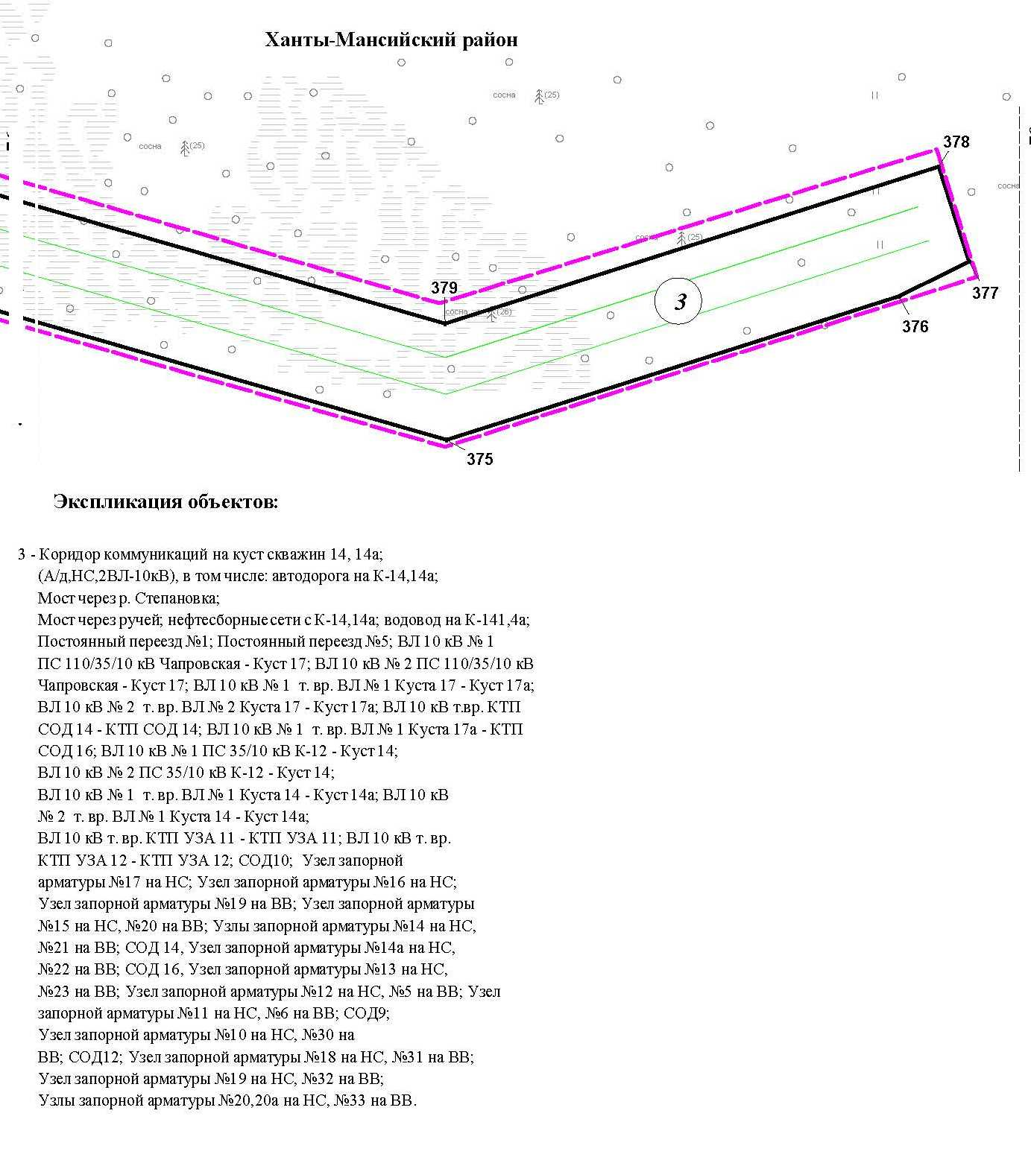

Линия совмещения с листом 76

Основная часть проекта планировки территории для размещения объекта капитального строительства, расположенного
на территории двух муниципальных образований
Ханты-Мансийского автономного округа – Югры
«Обустройство Чапровского месторождения.
Кусты 14, 14а, 15, 15а, 17, 17а и коридоры коммуникаций».
Землепользователь: АО «НК «Конданефть»
Масштаб 1:2000

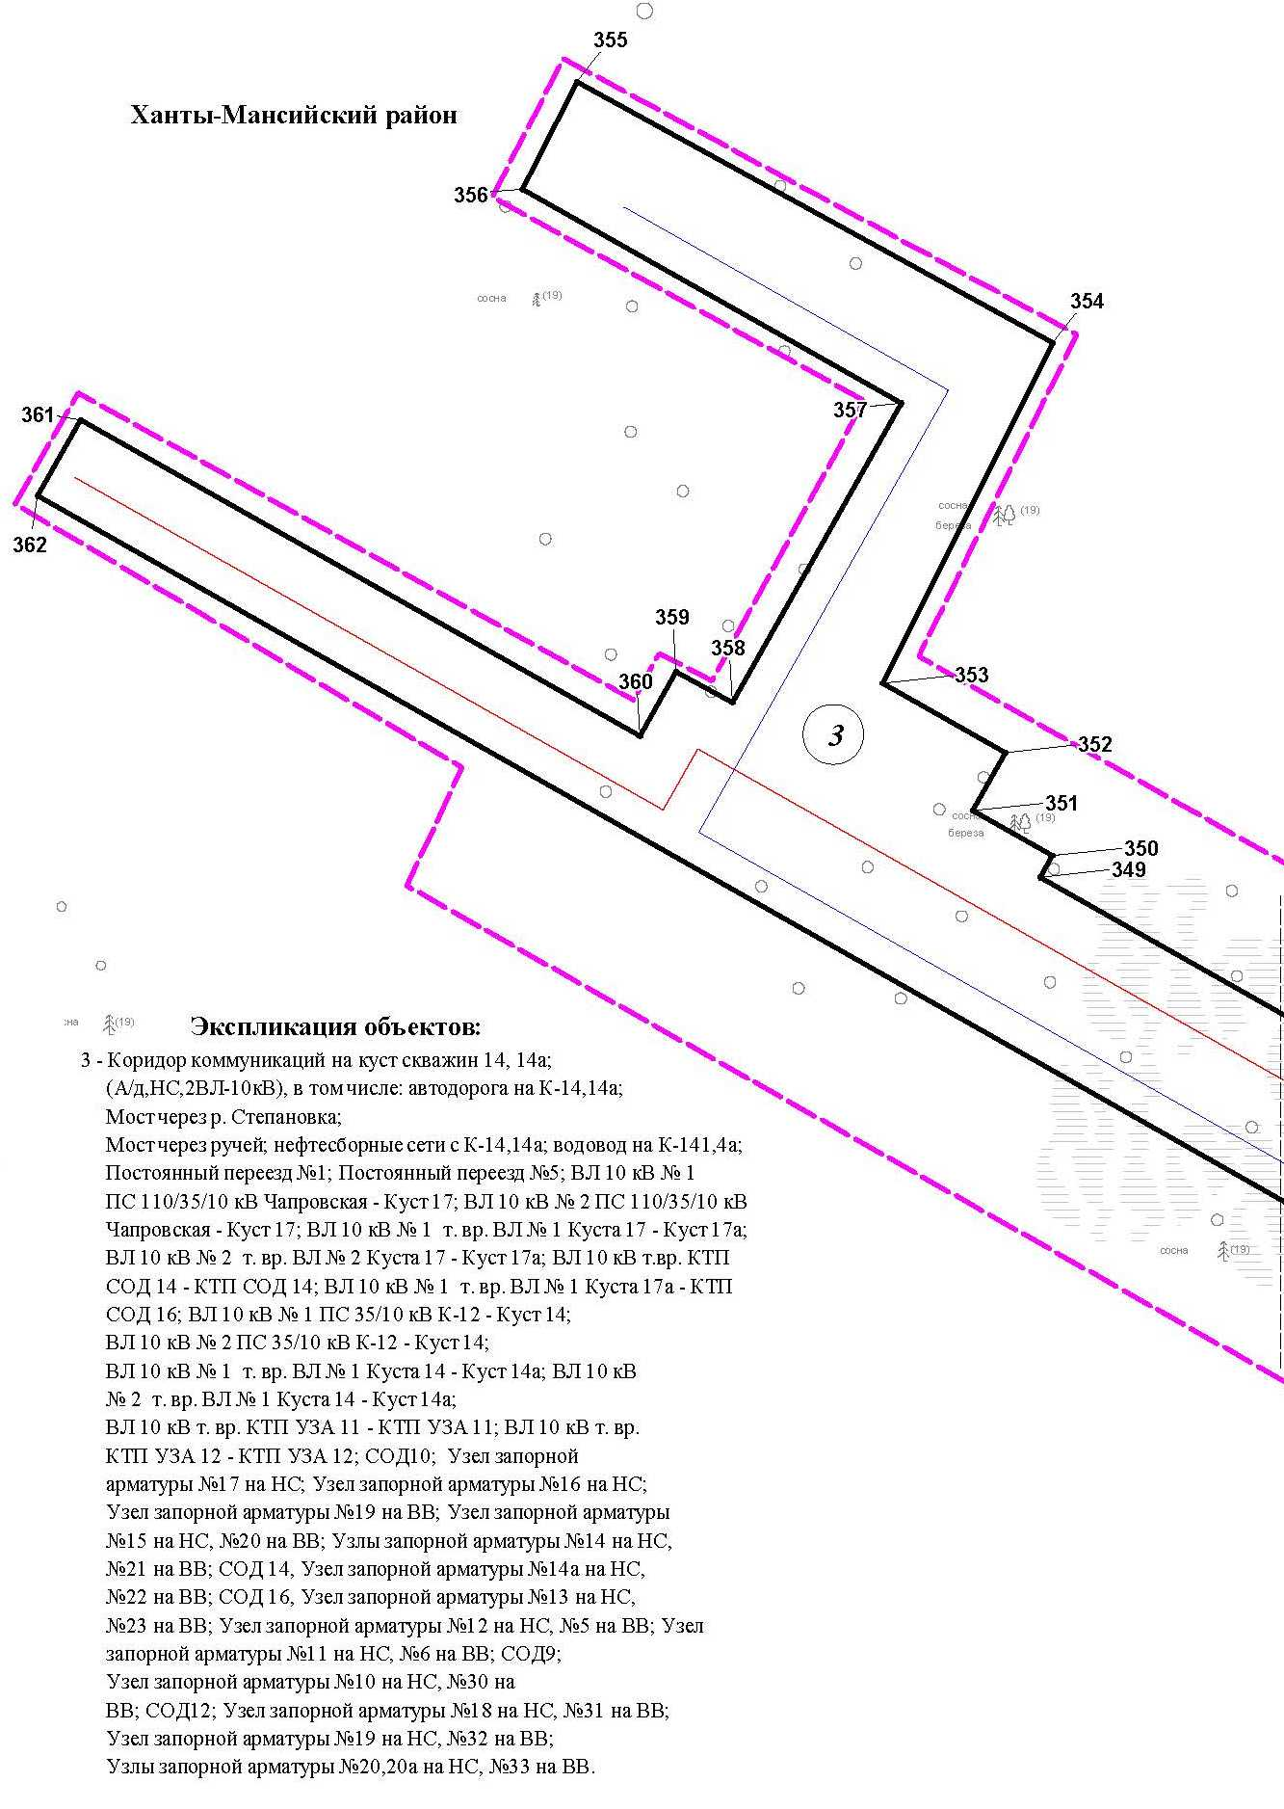

Основная часть проекта планировки территории для размещения объекта капитального строительства, расположенного
на территории двух муниципальных образований
Ханты-Мансийского автономного округа – Югры
«Обустройство Чапровского месторождения.
Кусты 14, 14а, 15, 15а, 17, 17а и коридоры коммуникаций».
Землепользователь: АО «НК «Конданефть»
Масштаб 1:2000

Основная часть проекта планировки территории для размещения объекта капитального строительства, расположенного
на территории двух муниципальных образований
Ханты-Мансийского автономного округа – Югры
«Обустройство Чапровского месторождения.
Кусты 14, 14а, 15, 15а, 17, 17а и коридоры коммуникаций».
Землепользователь: АО «НК «Конданефть»
Масштаб 1:2000

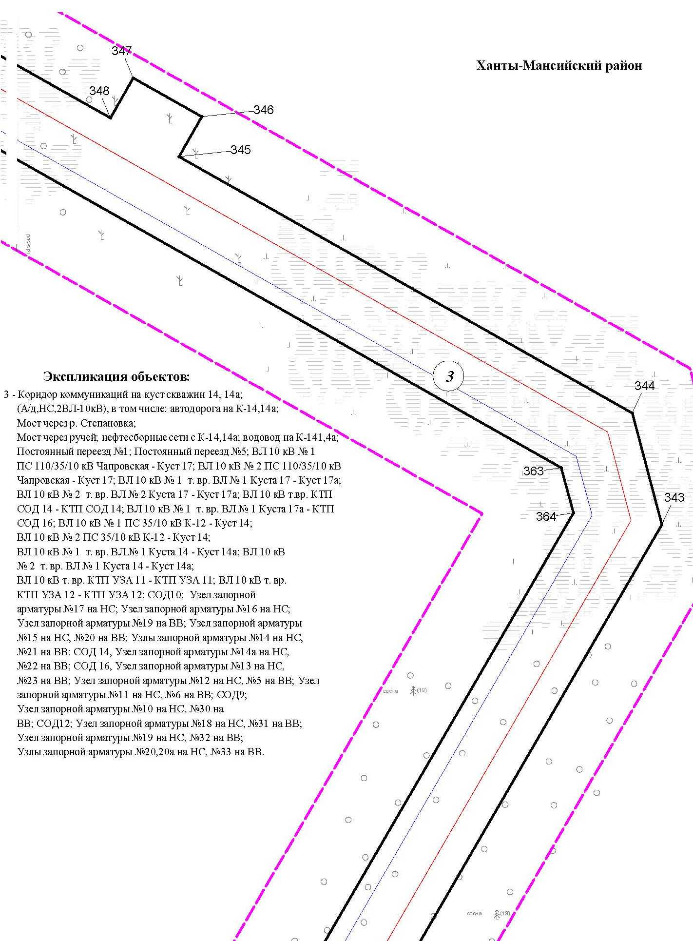

Основная часть проекта планировки территории для размещения объекта капитального строительства, расположенного
на территории двух муниципальных образований
Ханты-Мансийского автономного округа – Югры
«Обустройство Чапровского месторождения.
Кусты 14, 14а, 15, 15а, 17, 17а и коридоры коммуникаций».
Землепользователь: АО «НК «Конданефть»
Масштаб 1:2000

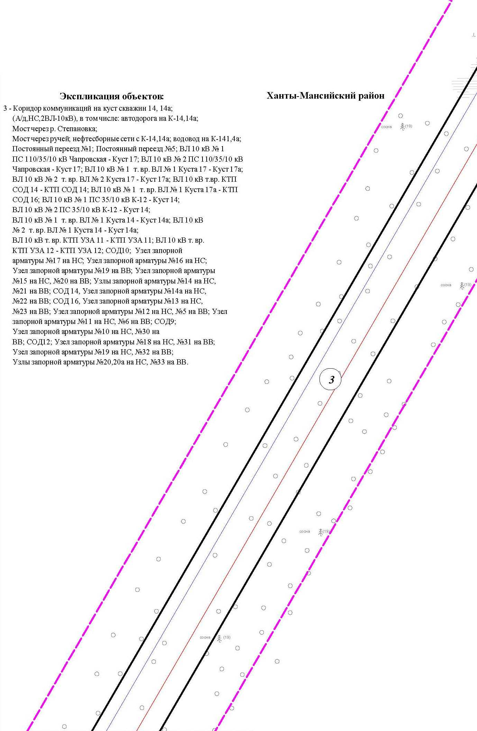

Основная часть проекта планировки территории для размещения объекта капитального строительства, расположенного
на территории двух муниципальных образований
Ханты-Мансийского автономного округа – Югры
«Обустройство Чапровского месторождения.
Кусты 14, 14а, 15, 15а, 17, 17а и коридоры коммуникаций».
Землепользователь: АО «НК «Конданефть»
Масштаб 1:2000

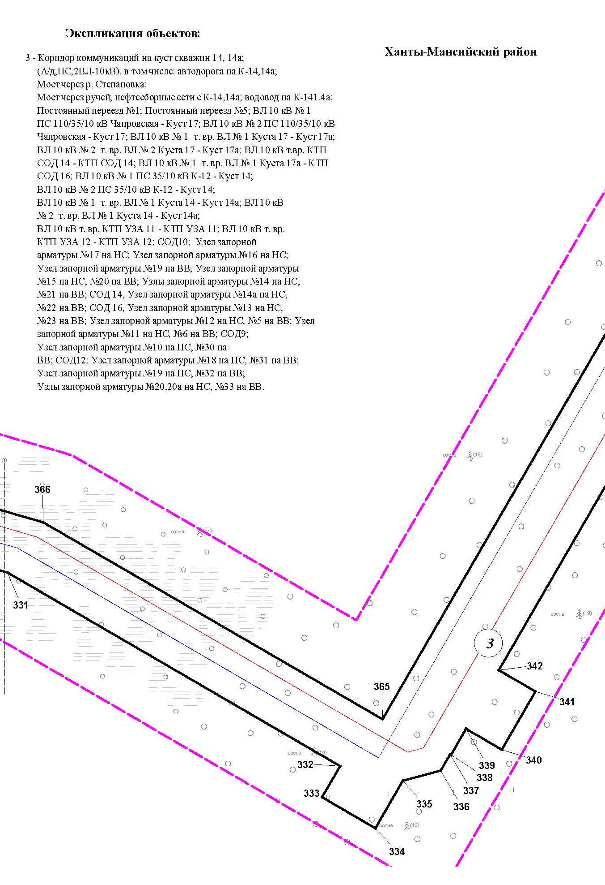

Основная часть проекта планировки территории для размещения объекта капитального строительства, расположенного
на территории двух муниципальных образований
Ханты-Мансийского автономного округа – Югры
«Обустройство Чапровского месторождения.
Кусты 14, 14а, 15, 15а, 17, 17а и коридоры коммуникаций».
Землепользователь: АО «НК «Конданефть»
Масштаб 1:2000

Основная часть проекта планировки территории для размещения объекта капитального строительства, расположенного
на территории двух муниципальных образований
Ханты-Мансийского автономного округа – Югры
«Обустройство Чапровского месторождения.
Кусты 14, 14а, 15, 15а, 17, 17а и коридоры коммуникаций».
Землепользователь: АО «НК «Конданефть»
Масштаб 1:2000

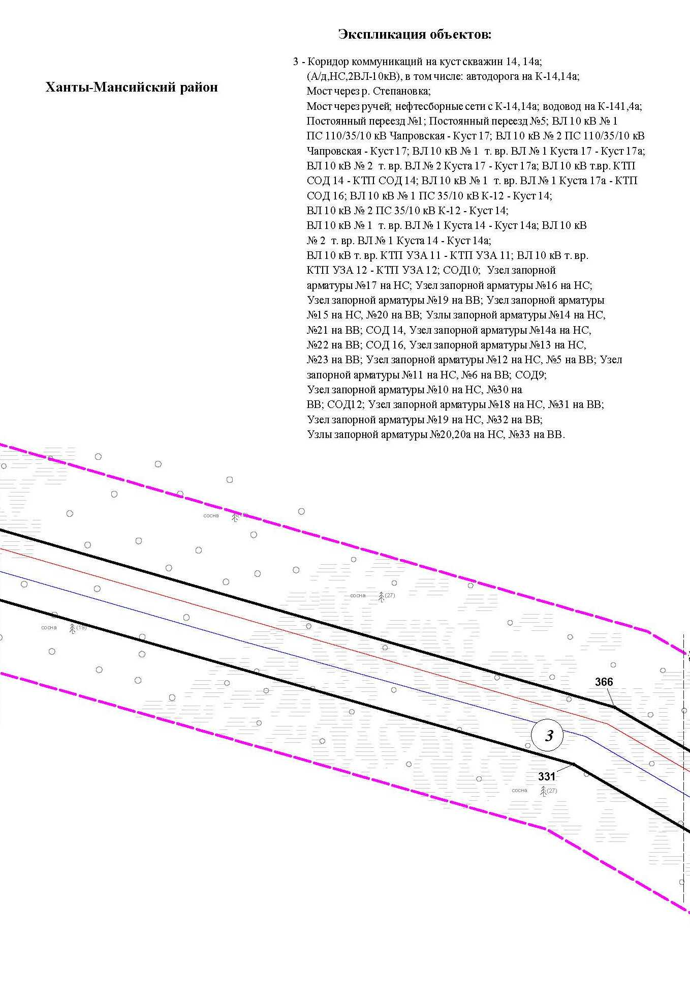

Основная часть проекта планировки территории для размещения объекта капитального строительства, расположенного
на территории двух муниципальных образований
Ханты-Мансийского автономного округа – Югры
«Обустройство Чапровского месторождения.
Кусты 14, 14а, 15, 15а, 17, 17а и коридоры коммуникаций».
Землепользователь: АО «НК «Конданефть»
Масштаб 1:2000

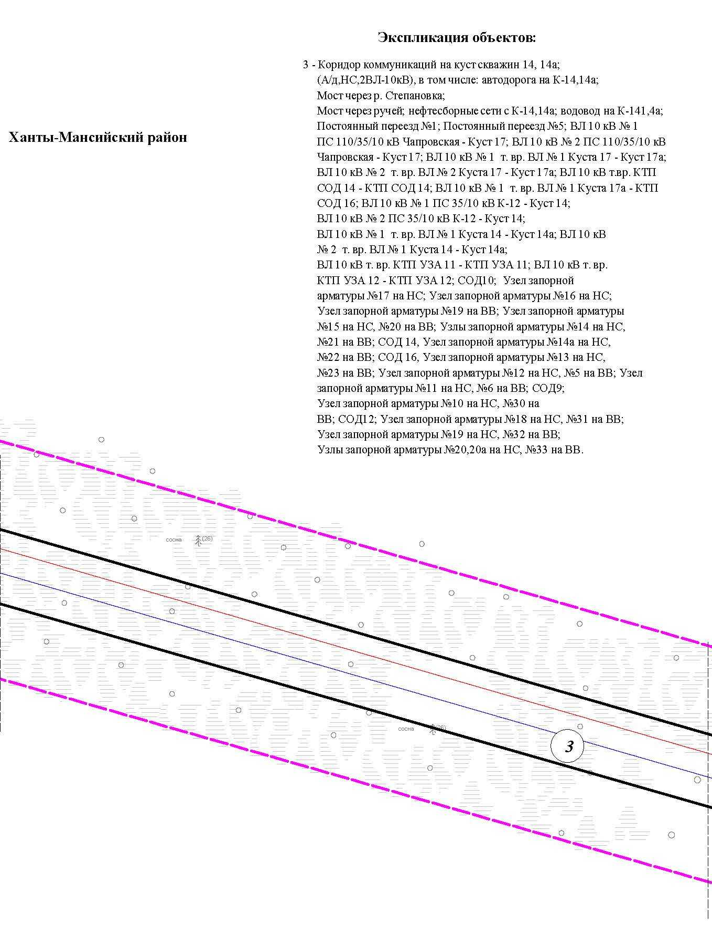

Основная часть проекта планировки территории для размещения объекта капитального строительства, расположенного
на территории двух муниципальных образований
Ханты-Мансийского автономного округа – Югры
«Обустройство Чапровского месторождения.
Кусты 14, 14а, 15, 15а, 17, 17а и коридоры коммуникаций».
Землепользователь: АО «НК «Конданефть»
Масштаб 1:2000

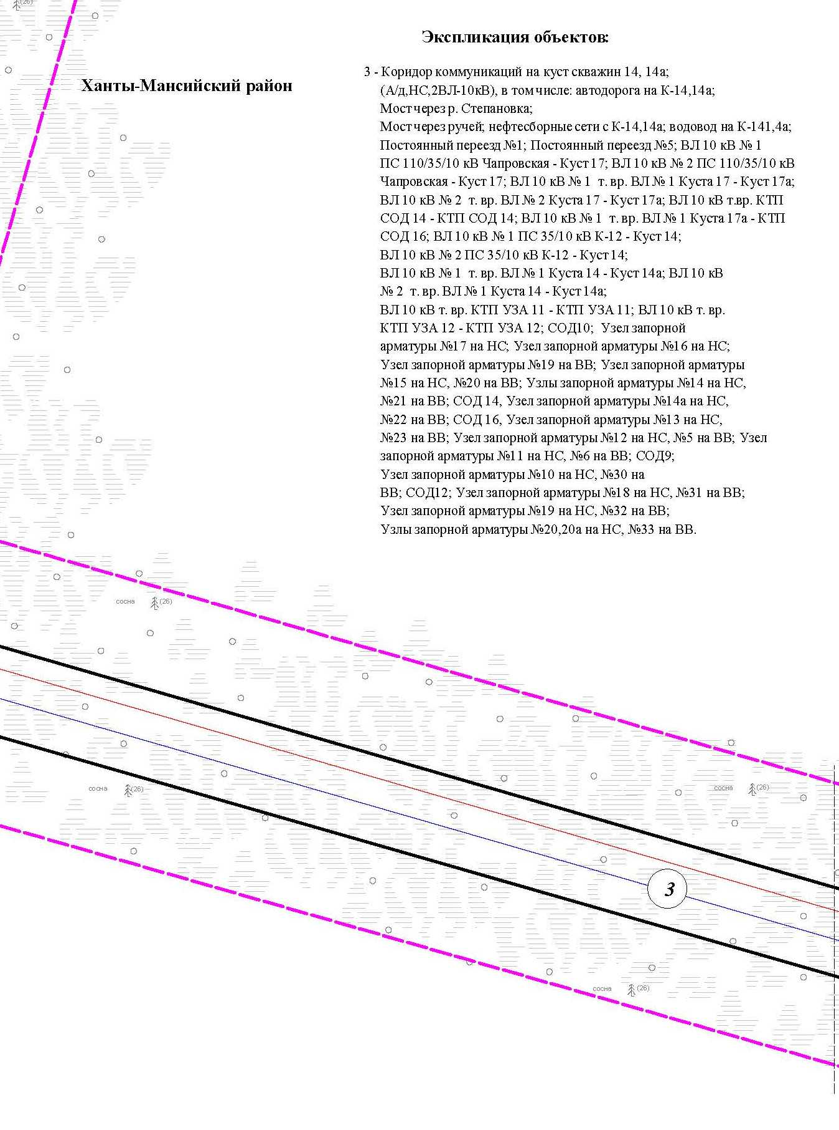

Основная часть проекта планировки территории для размещения объекта капитального строительства, расположенного
на территории двух муниципальных образований
Ханты-Мансийского автономного округа – Югры
«Обустройство Чапровского месторождения.
Кусты 14, 14а, 15, 15а, 17, 17а и коридоры коммуникаций».
Землепользователь: АО «НК «Конданефть»
Масштаб 1:2000

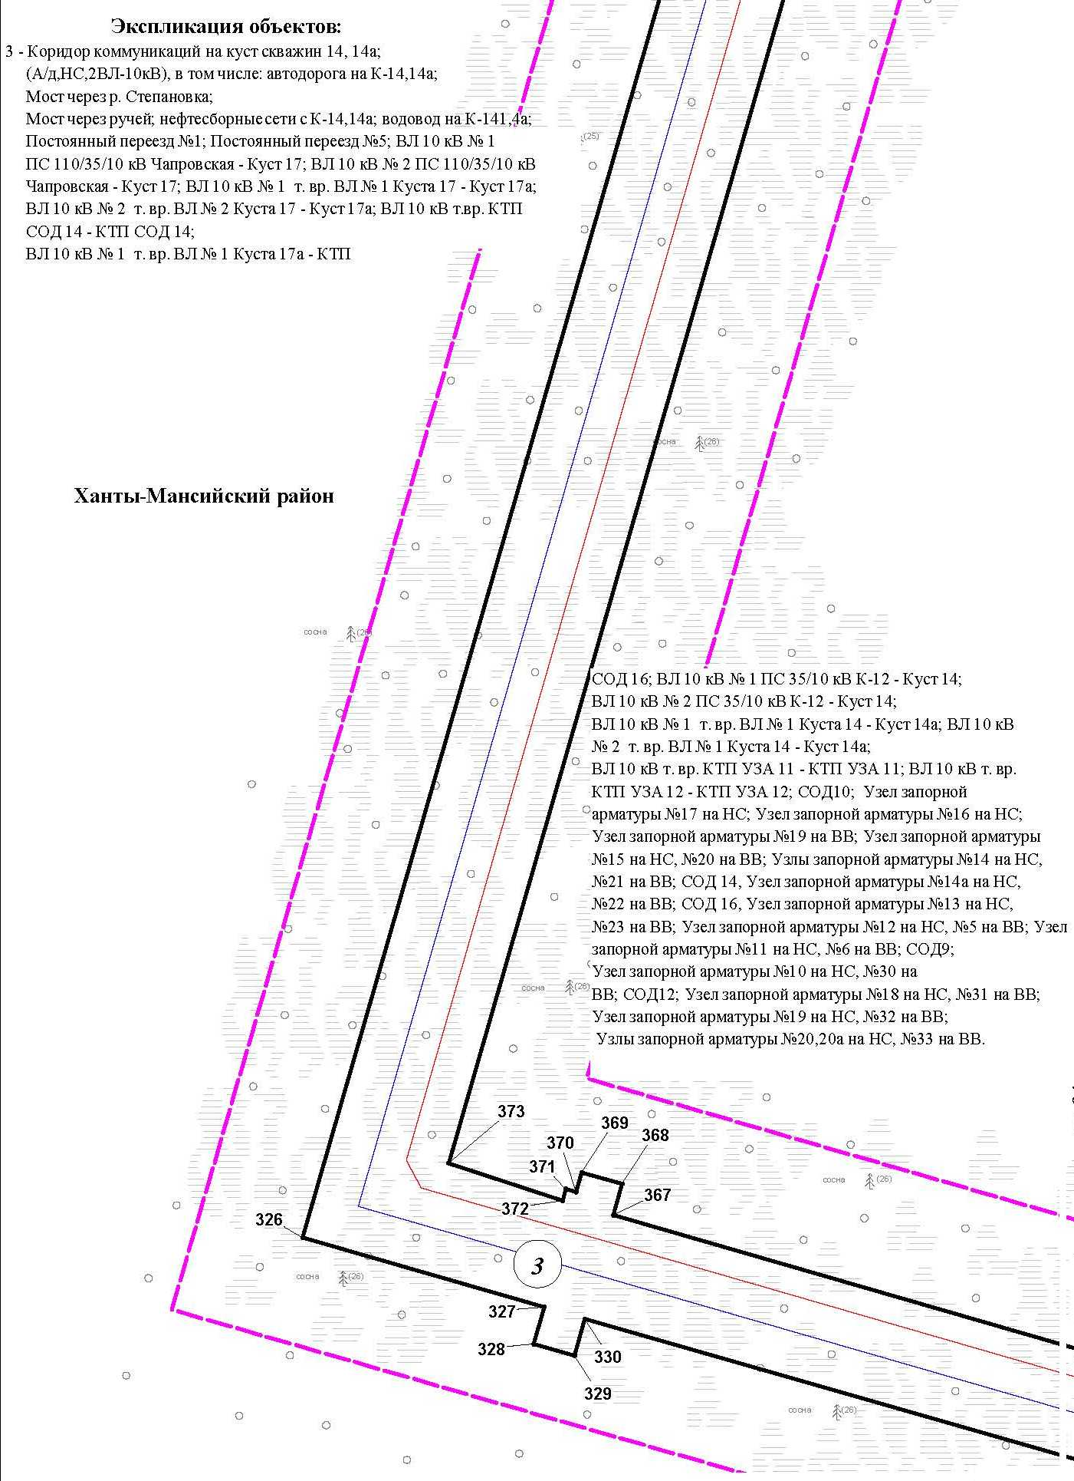

Основная часть проекта планировки территории для размещения объекта капитального строительства, расположенного
на территории двух муниципальных образований
Ханты-Мансийского автономного округа – Югры
«Обустройство Чапровского месторождения.
Кусты 14, 14а, 15, 15а, 17, 17а и коридоры коммуникаций».
Землепользователь: АО «НК «Конданефть»
Масштаб 1:2000

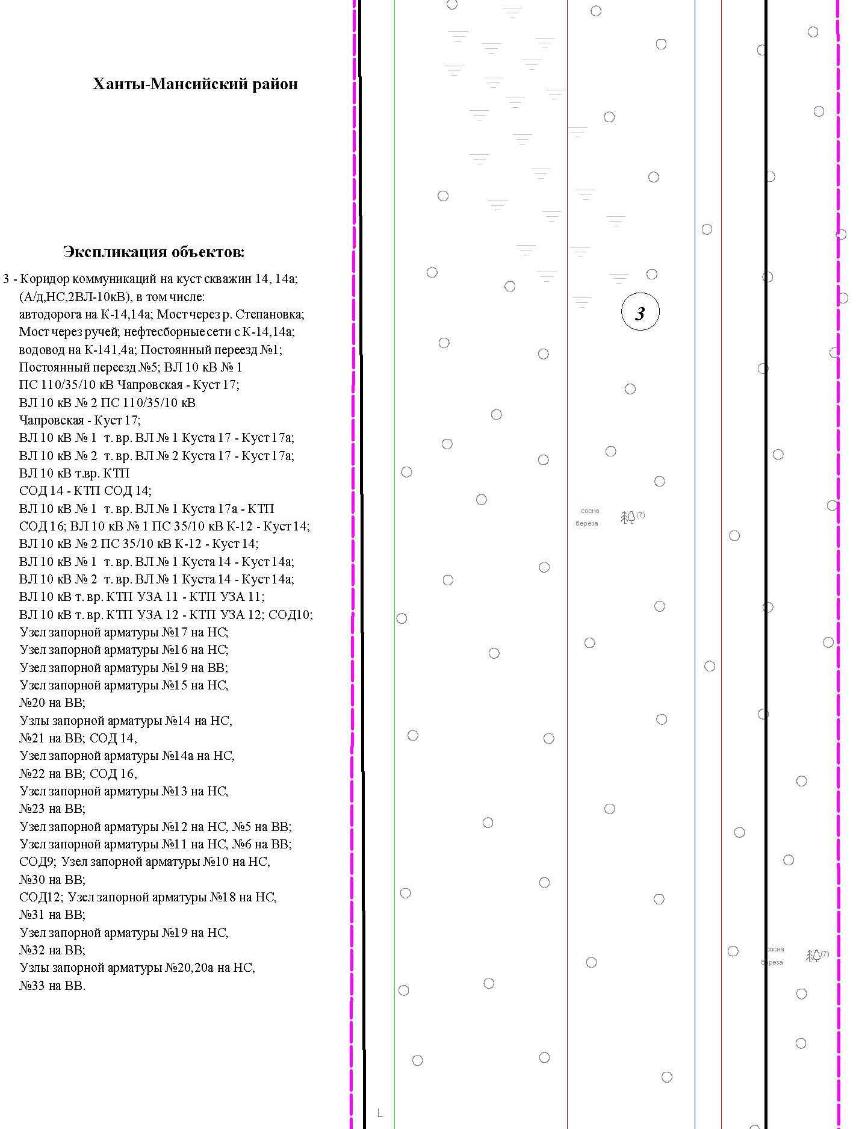

Основная часть проекта планировки территории для размещения объекта капитального строительства, расположенного
на территории двух муниципальных образований
Ханты-Мансийского автономного округа – Югры
«Обустройство Чапровского месторождения.
Кусты 14, 14а, 15, 15а, 17, 17а и коридоры коммуникаций».
Землепользователь: АО «НК «Конданефть»
Масштаб 1:2000

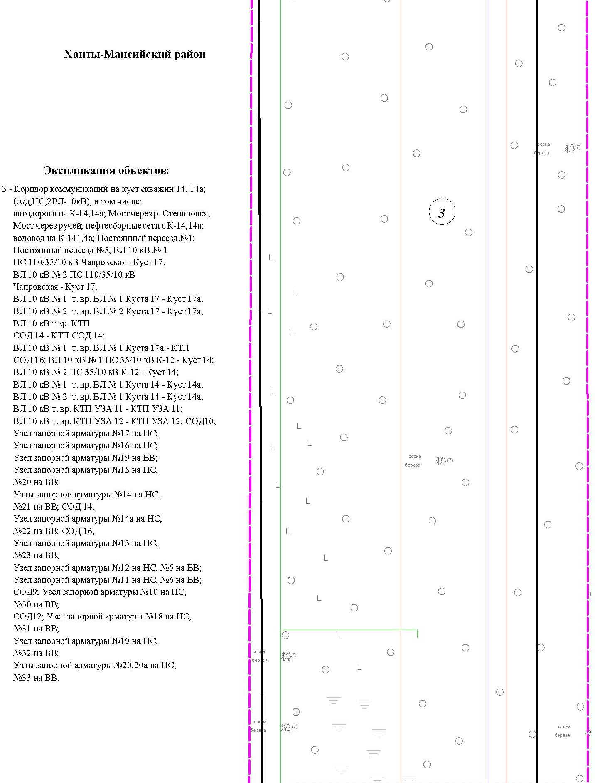

Основная часть проекта планировки территории для размещения объекта капитального строительства, расположенного
на территории двух муниципальных образований
Ханты-Мансийского автономного округа – Югры
«Обустройство Чапровского месторождения.
Кусты 14, 14а, 15, 15а, 17, 17а и коридоры коммуникаций».
Землепользователь: АО «НК «Конданефть»
Масштаб 1:2000

Основная часть проекта планировки территории для размещения объекта капитального строительства, расположенного
на территории двух муниципальных образований
Ханты-Мансийского автономного округа – Югры
«Обустройство Чапровского месторождения.
Кусты 14, 14а, 15, 15а, 17, 17а и коридоры коммуникаций».
Землепользователь: АО «НК «Конданефть»
Масштаб 1:2000

Линия совмещения с листом 88

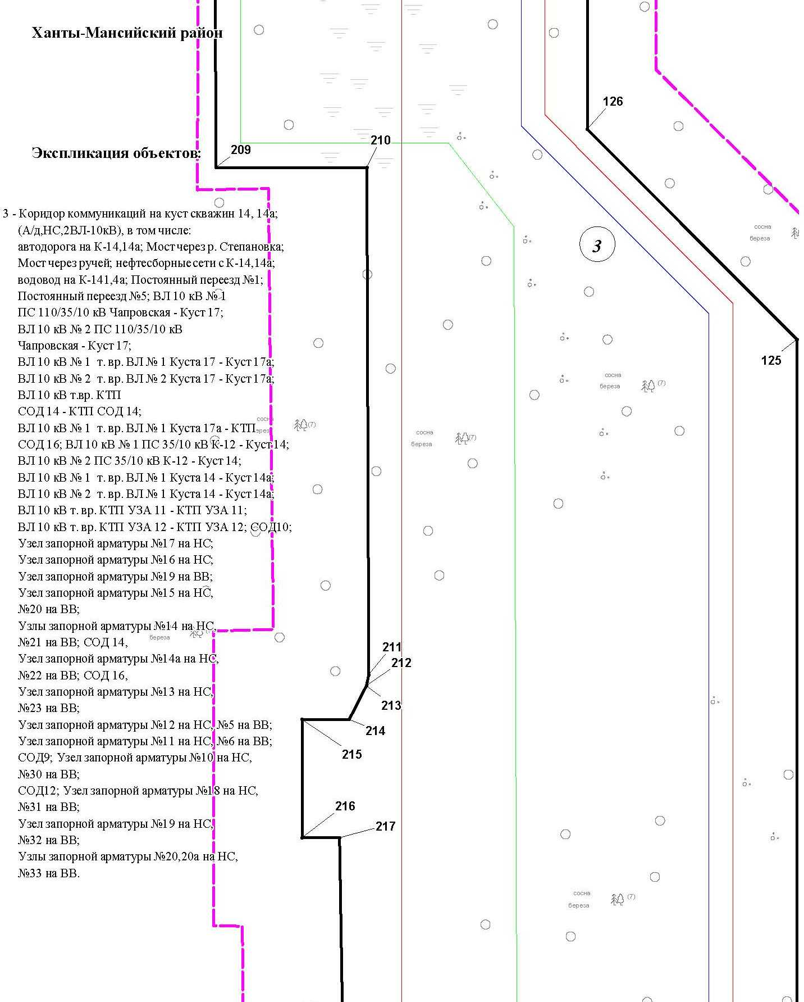

Основная часть проекта планировки территории для размещения объекта капитального строительства, расположенного
на территории двух муниципальных образований
Ханты-Мансийского автономного округа – Югры
«Обустройство Чапровского месторождения.
Кусты 14, 14а, 15, 15а, 17, 17а и коридоры коммуникаций».
Землепользователь: АО «НК «Конданефть»
Масштаб 1:2000

Линия совмещения с листом 89

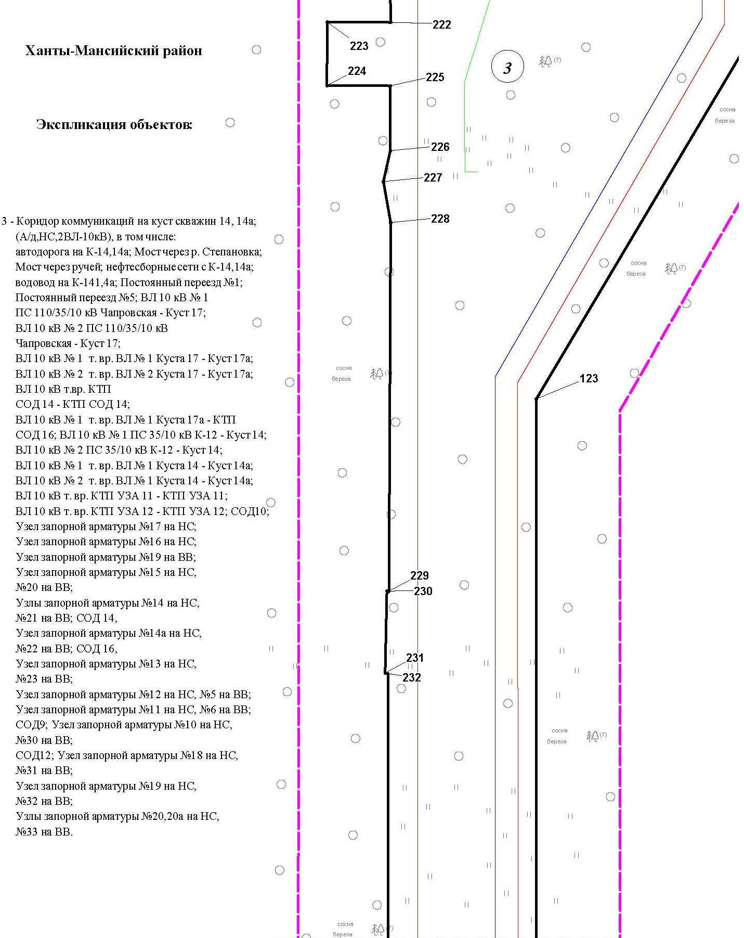

Основная часть проекта планировки территории для размещения объекта капитального строительства, расположенного
на территории двух муниципальных образований
Ханты-Мансийского автономного округа – Югры
«Обустройство Чапровского месторождения.
Кусты 14, 14а, 15, 15а, 17, 17а и коридоры коммуникаций».
Землепользователь: АО «НК «Конданефть»
Масштаб 1:2000

Линия совмещения с листом 90

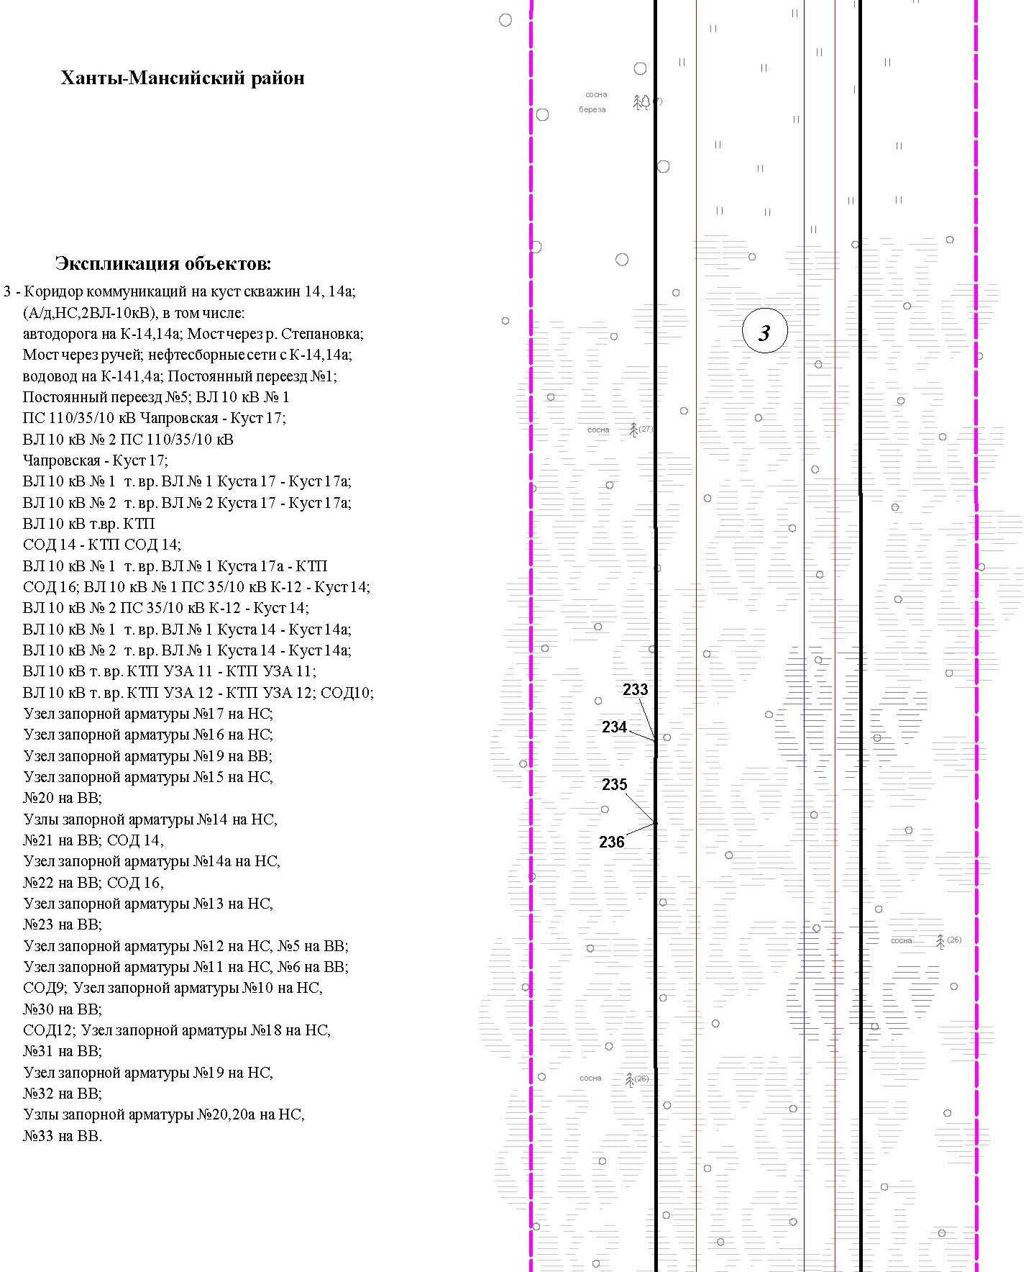

Основная часть проекта планировки территории для размещения объекта капитального строительства, расположенного
на территории двух муниципальных образований
Ханты-Мансийского автономного округа – Югры
«Обустройство Чапровского месторождения.
Кусты 14, 14а, 15, 15а, 17, 17а и коридоры коммуникаций».
Землепользователь: АО «НК «Конданефть»
Масштаб 1:2000

Линия совмещения с листом 91

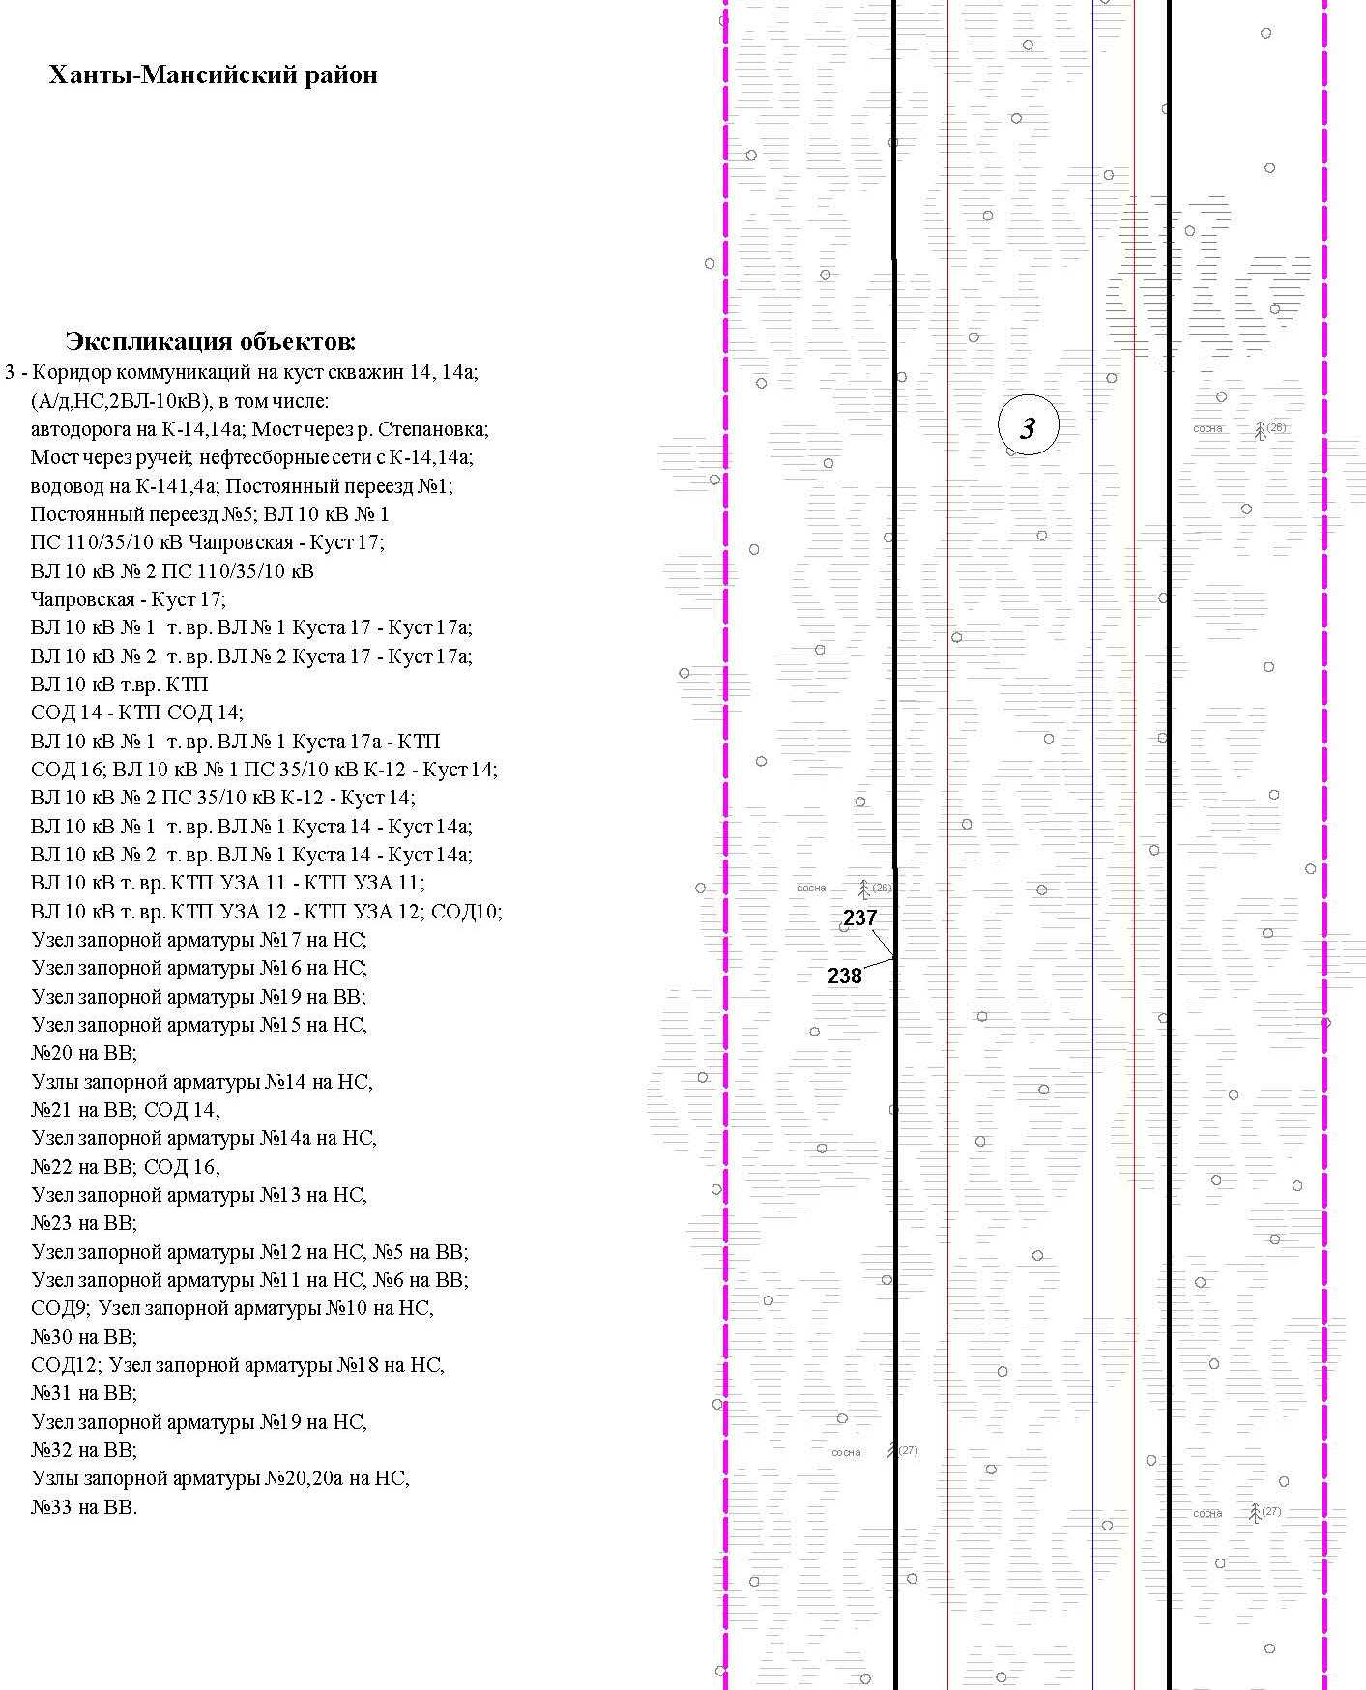

Основная часть проекта планировки территории для размещения объекта капитального строительства, расположенного
на территории двух муниципальных образований
Ханты-Мансийского автономного округа – Югры
«Обустройство Чапровского месторождения.
Кусты 14, 14а, 15, 15а, 17, 17а и коридоры коммуникаций».
Землепользователь: АО «НК «Конданефть»
Масштаб 1:2000

Линия совмещения с листом 92

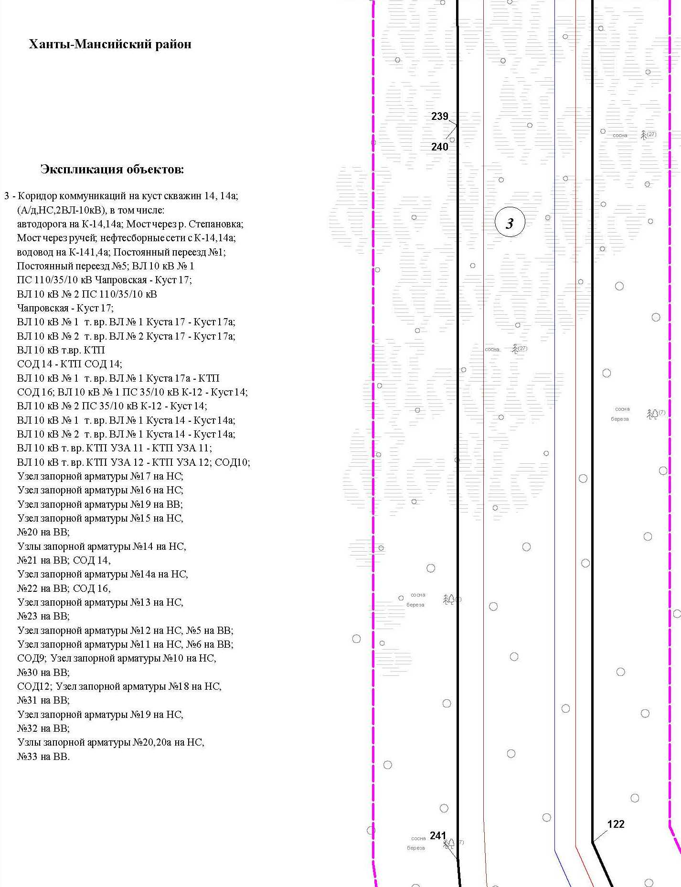

Основная часть проекта планировки территории для размещения объекта капитального строительства, расположенного
на территории двух муниципальных образований
Ханты-Мансийского автономного округа – Югры
«Обустройство Чапровского месторождения.
Кусты 14, 14а, 15, 15а, 17, 17а и коридоры коммуникаций».
Землепользователь: АО «НК «Конданефть»
Масштаб 1:2000

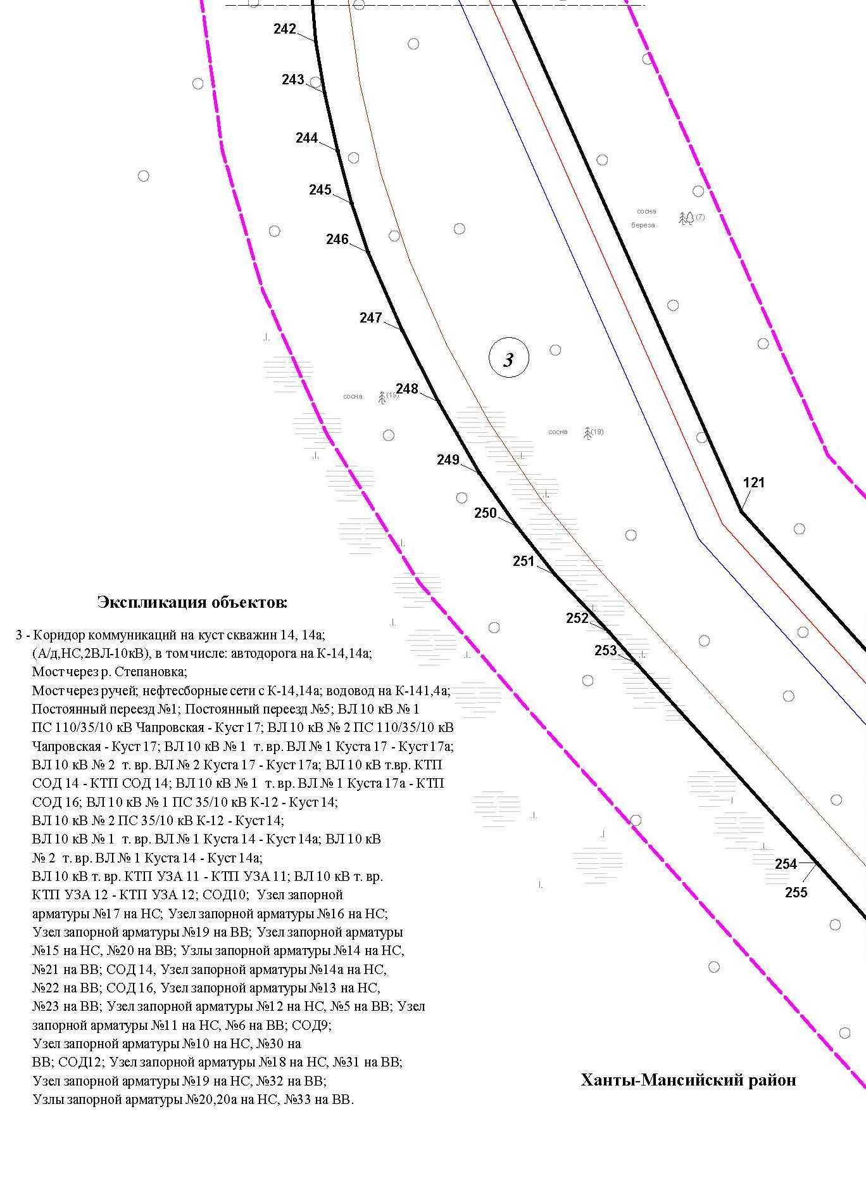

Линия совмещения с листом 93

Основная часть проекта планировки территории для размещения объекта капитального строительства, расположенного
на территории двух муниципальных образований
Ханты-Мансийского автономного округа – Югры
«Обустройство Чапровского месторождения.
Кусты 14, 14а, 15, 15а, 17, 17а и коридоры коммуникаций».
Землепользователь: АО «НК «Конданефть»
Масштаб 1:2000

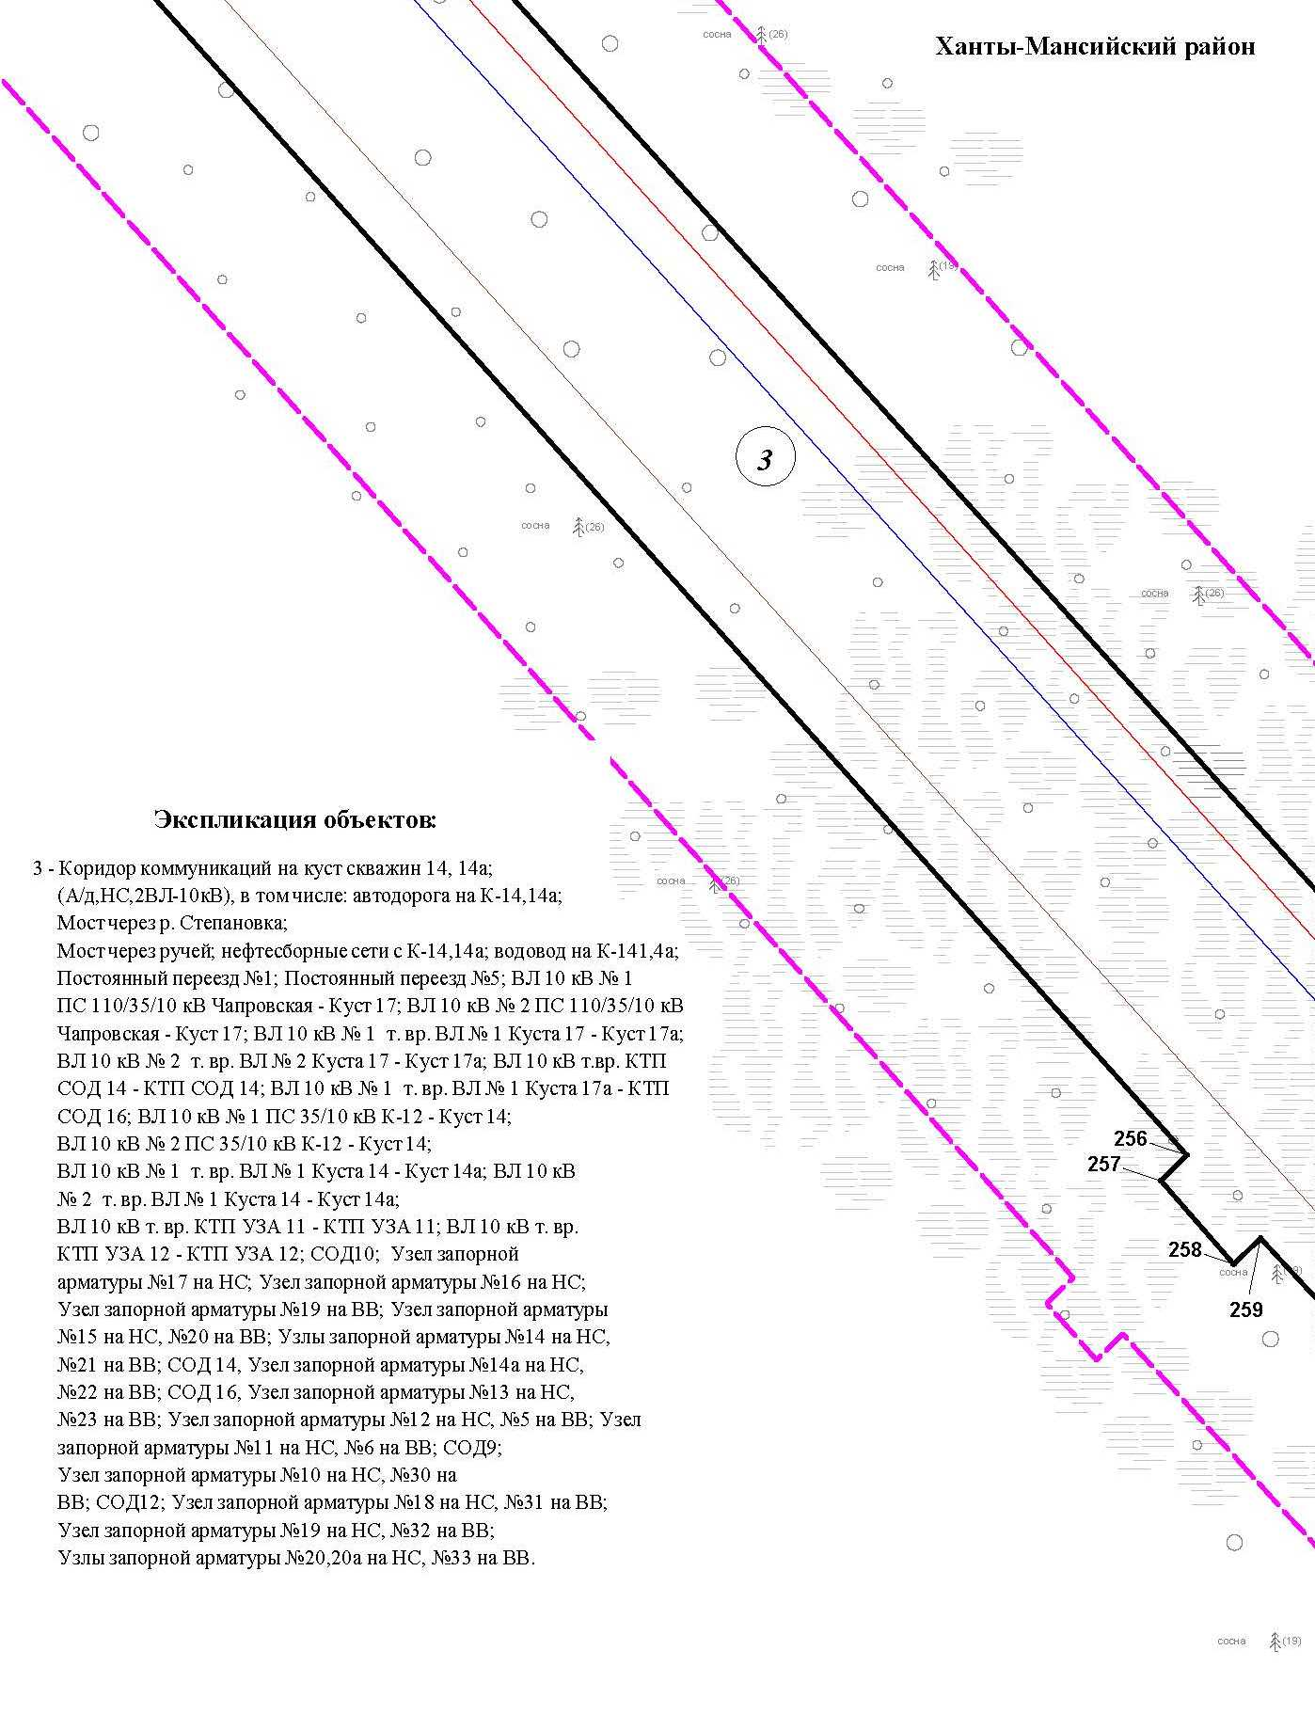

Основная часть проекта планировки территории для размещения объекта капитального строительства, расположенного
на территории двух муниципальных образований
Ханты-Мансийского автономного округа – Югры
«Обустройство Чапровского месторождения.
Кусты 14, 14а, 15, 15а, 17, 17а и коридоры коммуникаций».
Землепользователь: АО «НК «Конданефть»
Масштаб 1:2000

Основная часть проекта планировки территории для размещения объекта капитального строительства, расположенного
на территории двух муниципальных образований
Ханты-Мансийского автономного округа – Югры
«Обустройство Чапровского месторождения.
Кусты 14, 14а, 15, 15а, 17, 17а и коридоры коммуникаций».
Землепользователь: АО «НК «Конданефть»
Масштаб 1:2000

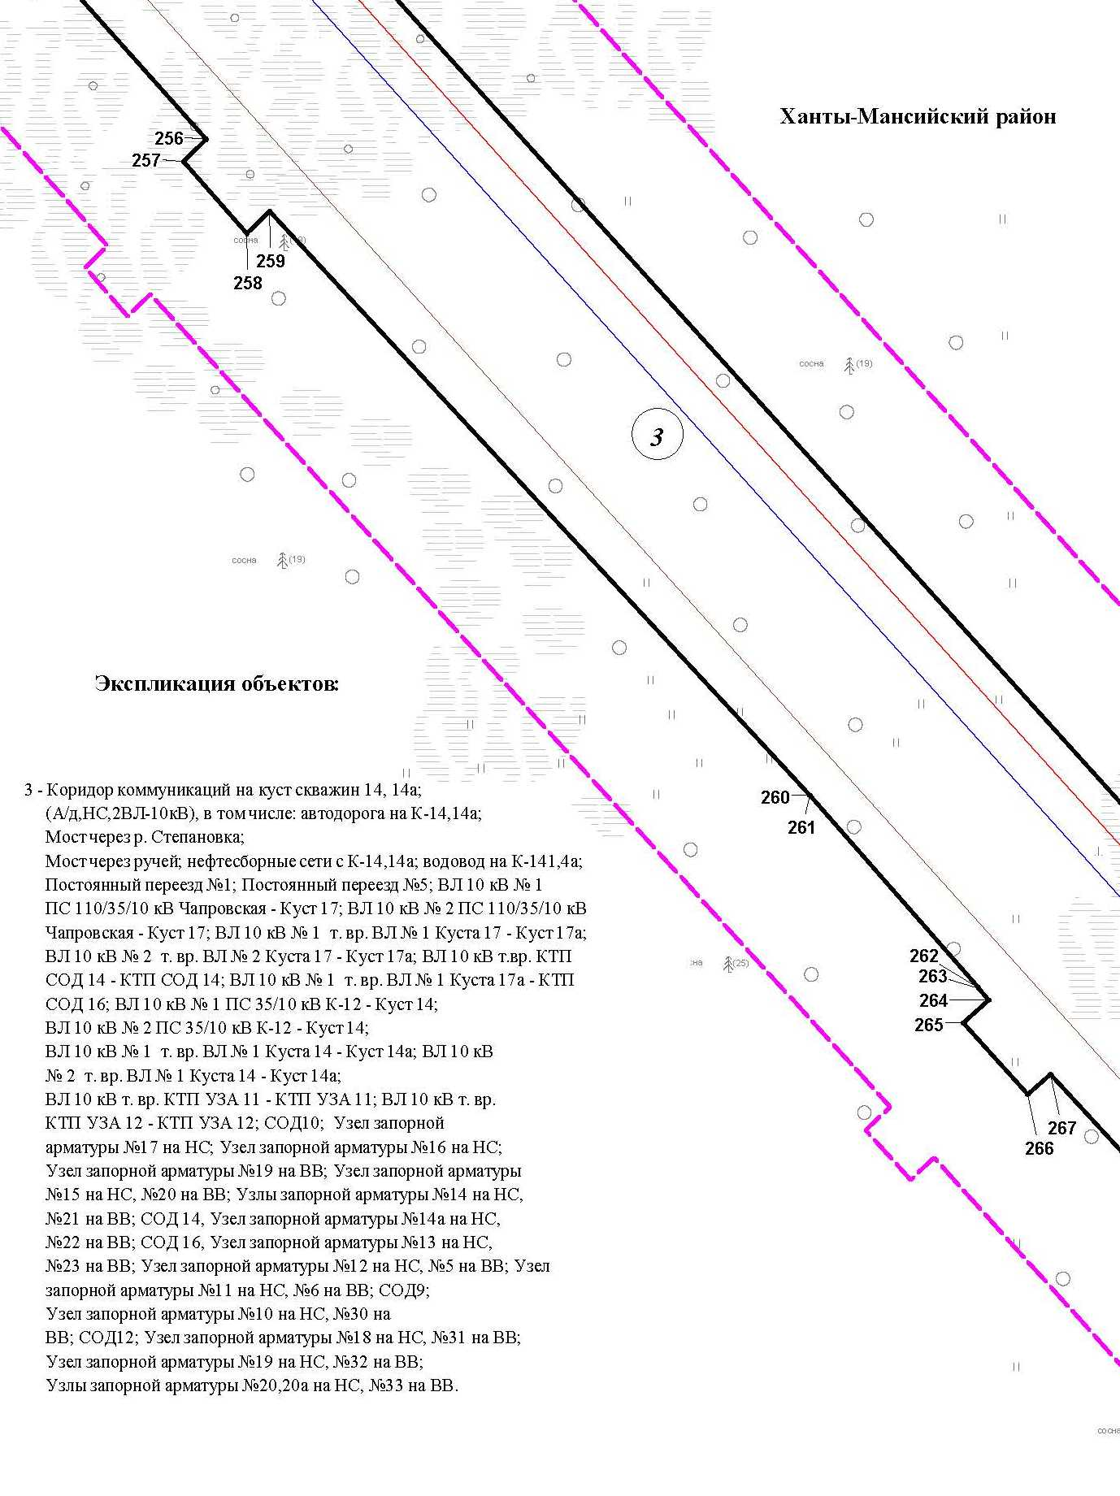

Основная часть проекта планировки территории для размещения объекта капитального строительства, расположенного
на территории двух муниципальных образований
Ханты-Мансийского автономного округа – Югры
«Обустройство Чапровского месторождения.
Кусты 14, 14а, 15, 15а, 17, 17а и коридоры коммуникаций».
Землепользователь: АО «НК «Конданефть»
Масштаб 1:2000

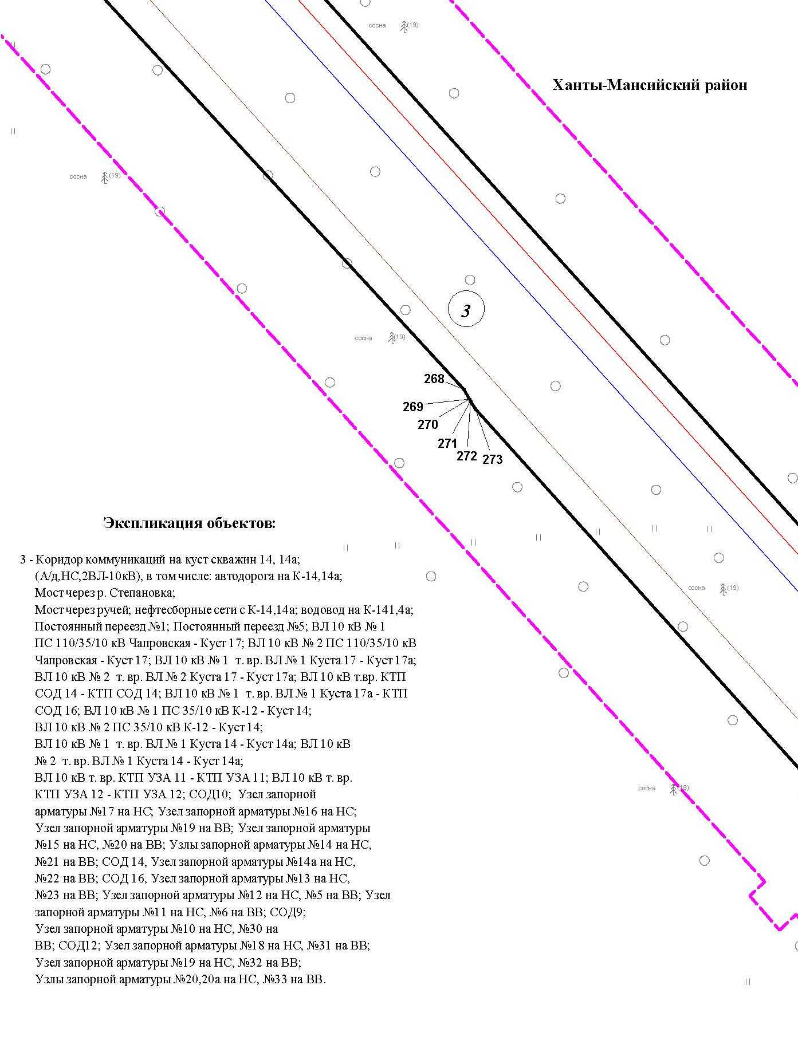

Основная часть проекта планировки территории для размещения объекта капитального строительства, расположенного
на территории двух муниципальных образований
Ханты-Мансийского автономного округа – Югры
«Обустройство Чапровского месторождения.
Кусты 14, 14а, 15, 15а, 17, 17а и коридоры коммуникаций».
Землепользователь: АО «НК «Конданефть»
Масштаб 1:2000

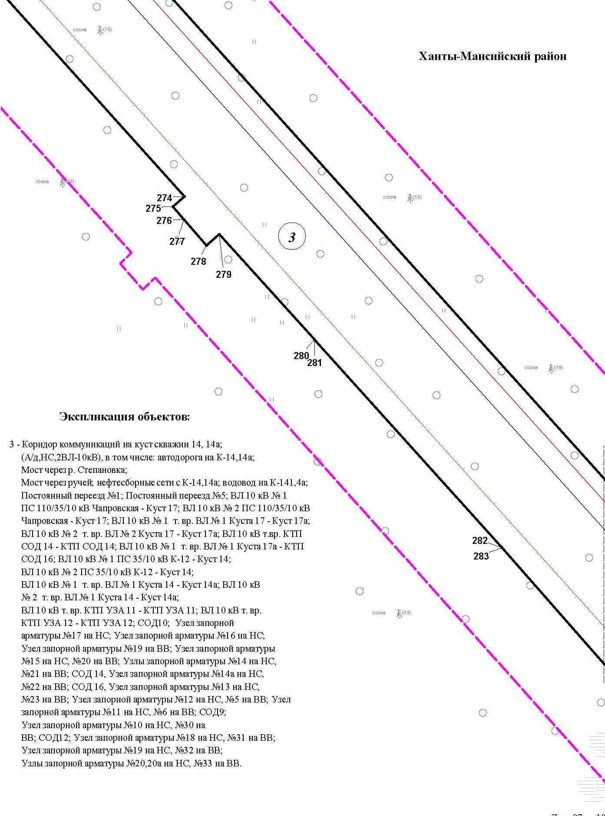

Основная часть проекта планировки территории для размещения объекта капитального строительства, расположенного
на территории двух муниципальных образований
Ханты-Мансийского автономного округа – Югры
«Обустройство Чапровского месторождения.
Кусты 14, 14а, 15, 15а, 17, 17а и коридоры коммуникаций».
Землепользователь: АО «НК «Конданефть»
Масштаб 1:2000

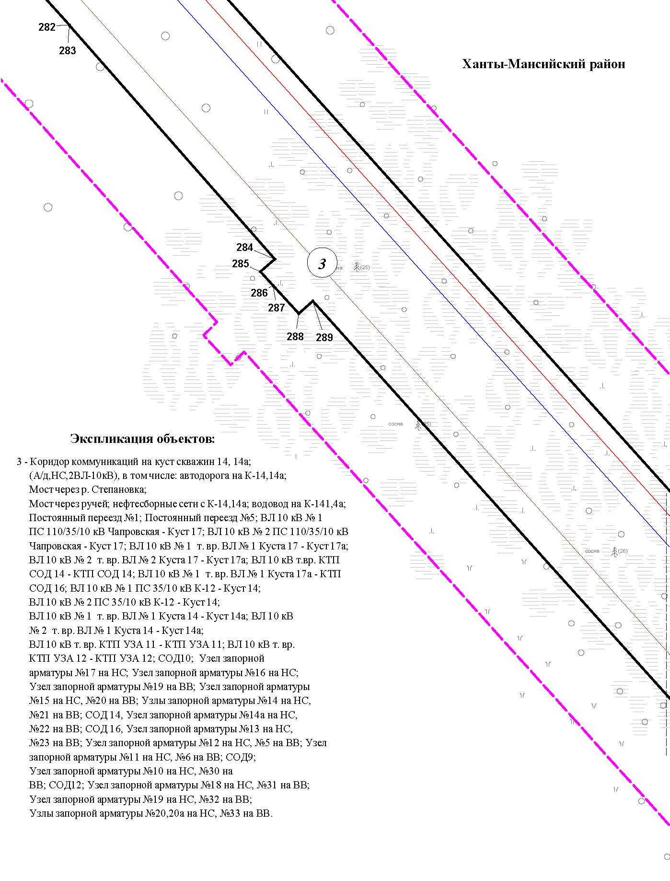

Основная часть проекта планировки территории для размещения объекта капитального строительства, расположенного
на территории двух муниципальных образований
Ханты-Мансийского автономного округа – Югры
«Обустройство Чапровского месторождения.
Кусты 14, 14а, 15, 15а, 17, 17а и коридоры коммуникаций».
Землепользователь: АО «НК «Конданефть»
Масштаб 1:2000

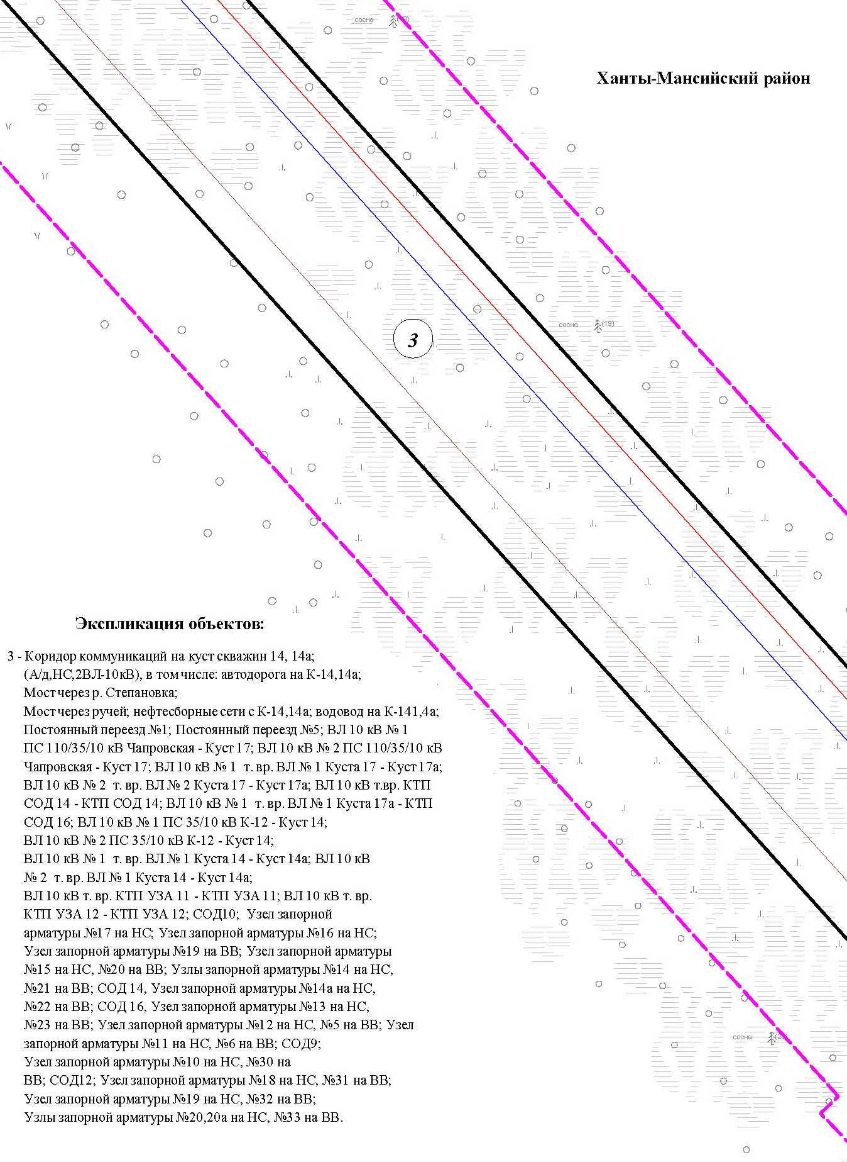

Основная часть проекта планировки территории для размещения объекта капитального строительства, расположенного
на территории двух муниципальных образований
Ханты-Мансийского автономного округа – Югры
«Обустройство Чапровского месторождения.
Кусты 14, 14а, 15, 15а, 17, 17а и коридоры коммуникаций».
Землепользователь: АО «НК «Конданефть»
Масштаб 1:2000

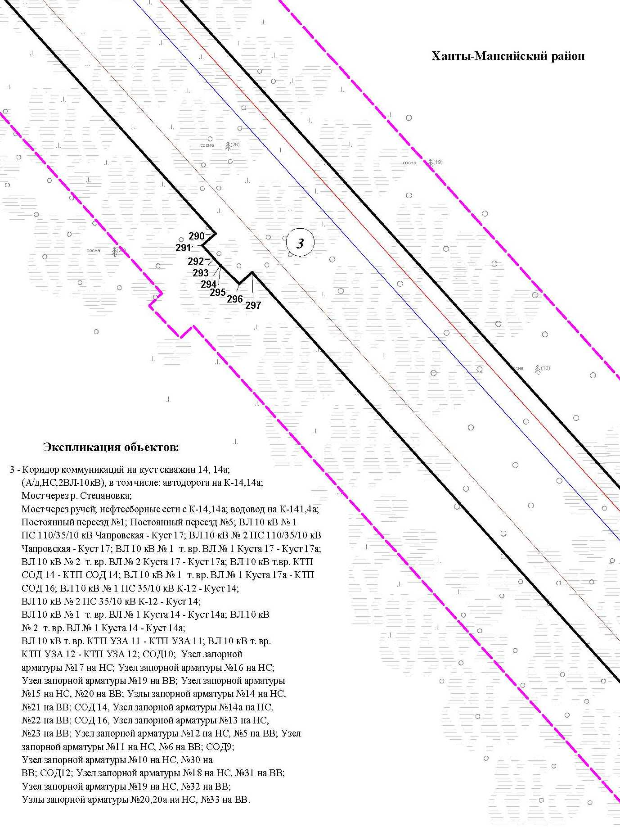

Основная часть проекта планировки территории для размещения объекта капитального строительства, расположенного
на территории двух муниципальных образований
Ханты-Мансийского автономного округа – Югры
«Обустройство Чапровского месторождения.
Кусты 14, 14а, 15, 15а, 17, 17а и коридоры коммуникаций».
Землепользователь: АО «НК «Конданефть»
Масштаб 1:2000

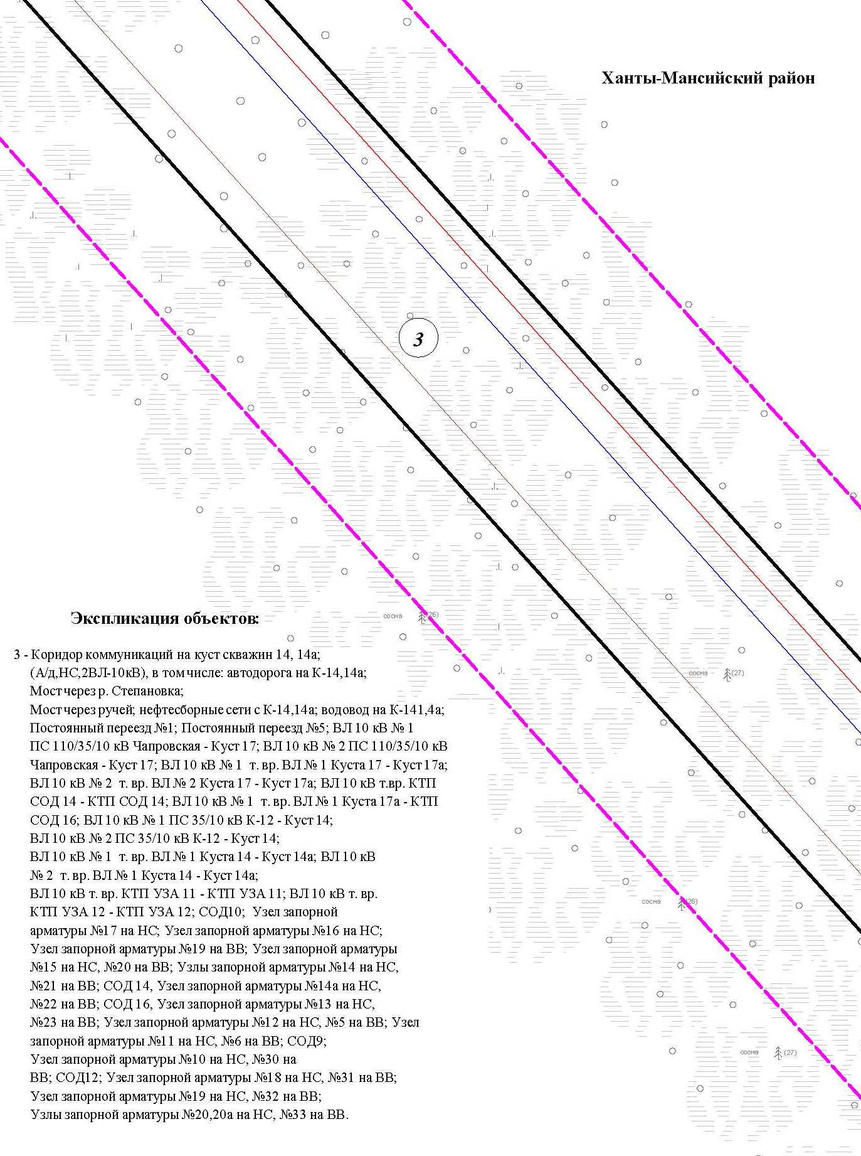

Основная часть проекта планировки территории для размещения объекта капитального строительства, расположенного
на территории двух муниципальных образований
Ханты-Мансийского автономного округа – Югры
«Обустройство Чапровского месторождения.
Кусты 14, 14а, 15, 15а, 17, 17а и коридоры коммуникаций».
Землепользователь: АО «НК «Конданефть»
Масштаб 1:2000

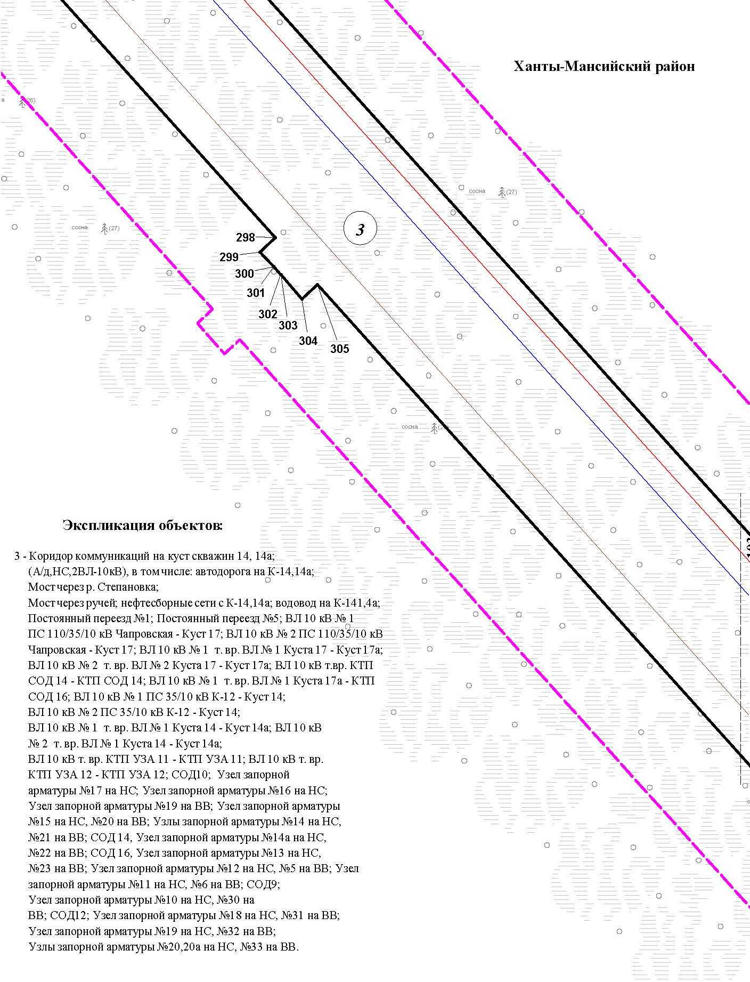

Основная часть проекта планировки территории для размещения объекта капитального строительства, расположенного
на территории двух муниципальных образований
Ханты-Мансийского автономного округа – Югры
«Обустройство Чапровского месторождения.
Кусты 14, 14а, 15, 15а, 17, 17а и коридоры коммуникаций».
Землепользователь: АО «НК «Конданефть»
Масштаб 1:2000

Основная часть проекта планировки территории для размещения объекта капитального строительства, расположенного
на территории двух муниципальных образований
Ханты-Мансийского автономного округа – Югры
«Обустройство Чапровского месторождения.
Кусты 14, 14а, 15, 15а, 17, 17а и коридоры коммуникаций».
Землепользователь: АО «НК «Конданефть»
Масштаб 1:2000

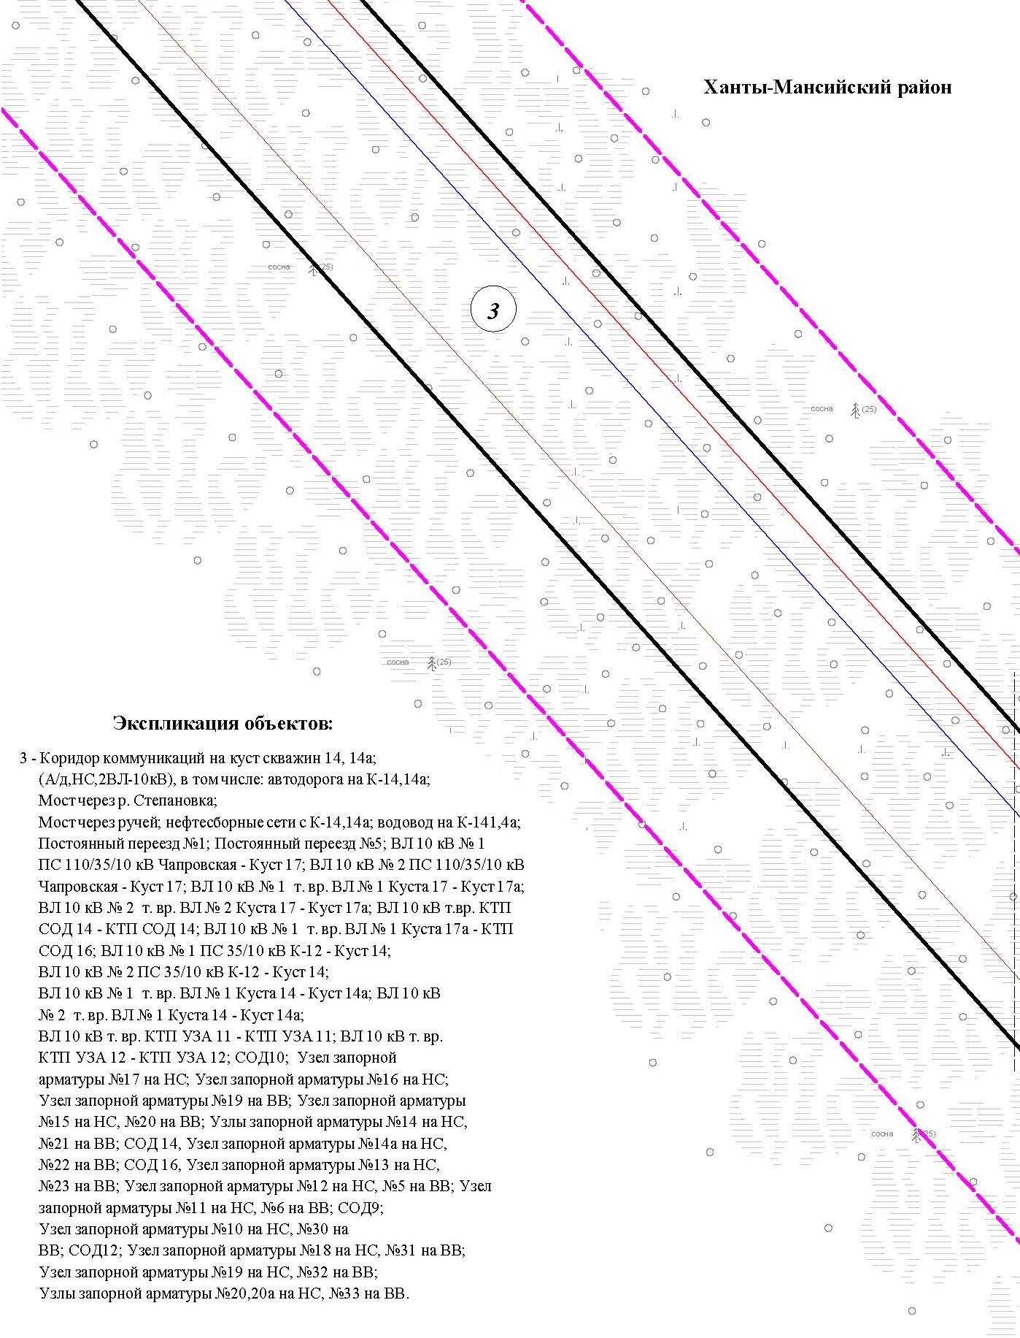

Основная часть проекта планировки территории для размещения объекта капитального строительства, расположенного
на территории двух муниципальных образований
Ханты-Мансийского автономного округа – Югры
«Обустройство Чапровского месторождения.
Кусты 14, 14а, 15, 15а, 17, 17а и коридоры коммуникаций».
Землепользователь: АО «НК «Конданефть»
Масштаб 1:2000

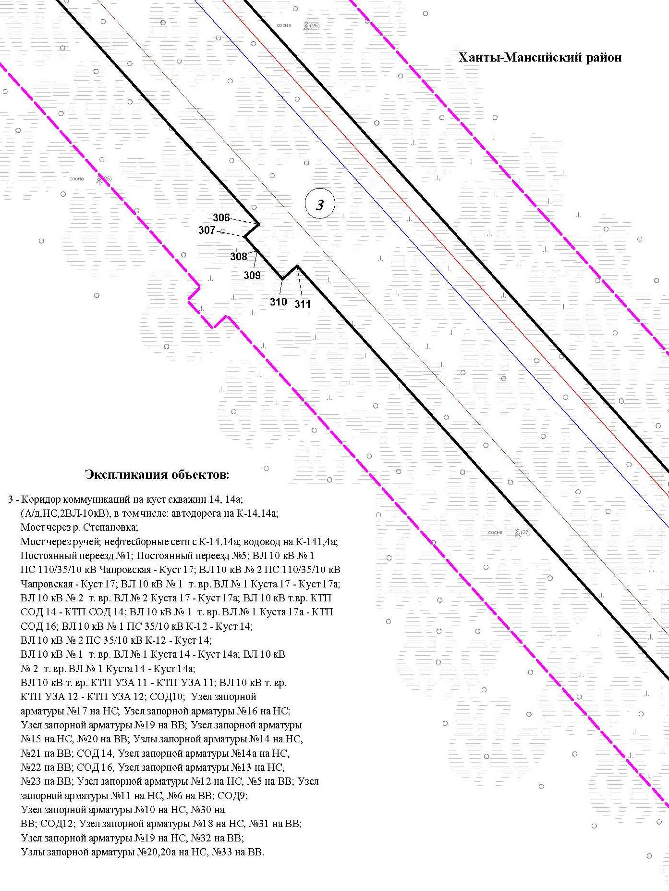

Основная часть проекта планировки территории для размещения объекта капитального строительства, расположенного
на территории двух муниципальных образований
Ханты-Мансийского автономного округа – Югры
«Обустройство Чапровского месторождения.
Кусты 14, 14а, 15, 15а, 17, 17а и коридоры коммуникаций».
Землепользователь: АО «НК «Конданефть»
Масштаб 1:2000

Линия совмещения с листом 105

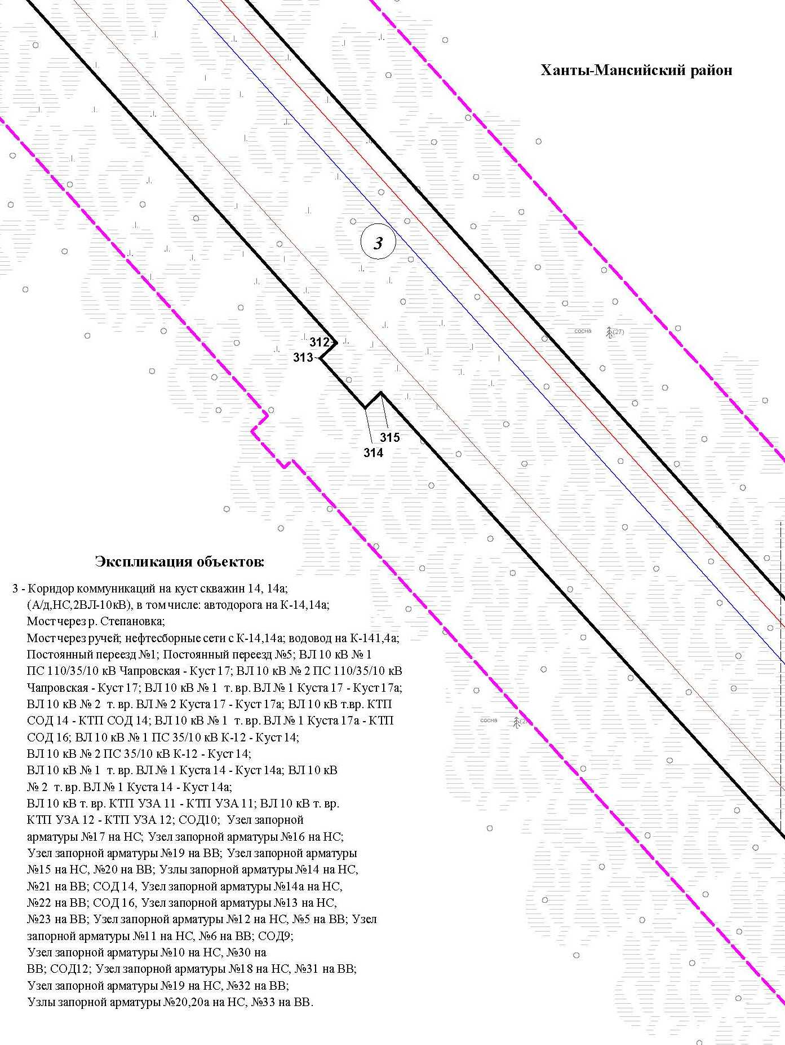

Основная часть проекта планировки территории для размещения объекта капитального строительства, расположенного
на территории двух муниципальных образований
Ханты-Мансийского автономного округа – Югры
«Обустройство Чапровского месторождения.
Кусты 14, 14а, 15, 15а, 17, 17а и коридоры коммуникаций».
Землепользователь: АО «НК «Конданефть»

Основная часть проекта планировки территории для размещения объекта капитального строительства, расположенного
на территории двух муниципальных образований
Ханты-Мансийского автономного округа – Югры
«Обустройство Чапровского месторождения.
Кусты 14, 14а, 15, 15а, 17, 17а и коридоры коммуникаций».
Землепользователь: АО «НК «Конданефть»

Каталог координатных точек зоны планируемого размещения объекта
№ точки | Х | У
1 | 2 | 3
1 | 893844.58 | 2709982.32
2 | 893890.48 | 2709905.30
3 | 893798.30 | 2709899.38
4 | 893752.90 | 2709876.86
5 | 893739.78 | 2709869.48
6 | 893727.50 | 2709860.76
7 | 893716.20 | 2709850.82
8 | 893706.00 | 2709839.74
9 | 893666.58 | 2709792.26
10 | 893658.46 | 2709783.22
11 | 893649.56 | 2709774.76
12 | 893640.04 | 2709767.04
13 | 893630.04 | 2709760.14
14 | 893539.54 | 2709702.90
15 | 893530.52 | 2709696.70
16 | 893521.88 | 2709689.74
17 | 893513.64 | 2709681.96
18 | 893505.90 | 2709673.42
19 | 893498.80 | 2709664.16
20 | 893492.40 | 2709654.26
21 | 893486.80 | 2709643.78
22 | 893482.06 | 2709632.86
23 | 893478.26 | 2709621.56
24 | 893475.40 | 2709610.04
25 | 893473.50 | 2709598.40
26 | 893472.58 | 2709586.76
27 | 893472.60 | 2709575.24
28 | 893473.50 | 2709563.96
29 | 893475.26 | 2709552.98
30 | 893477.80 | 2709542.34
31 | 893536.52 | 2709332.30
32 | 893771.26 | 2709439.12
33 | 893773.20 | 2709434.86
34 | 893814.74 | 2709452.04
Основная часть проекта планировки территории для размещения объекта капитального строительства, расположенного
на территории двух муниципальных образований
Ханты-Мансийского автономного округа – Югры
«Обустройство Чапровского месторождения.
Кусты 14, 14а, 15, 15а, 17, 17а и коридоры коммуникаций».
Землепользователь: АО «НК «Конданефть»

1 | 2 | 3
35 | 893883.02 | 2709455.90
36 | 894224.98 | 2709547.02
37 | 894278.02 | 2709556.98
38 | 894330.88 | 2709415.76
39 | 894333.76 | 2709393.94
40 | 894345.52 | 2709379.84
41 | 894381.28 | 2709389.72
42 | 894443.06 | 2709250.06
43 | 894433.52 | 2709199.64
44 | 894433.52 | 2709199.74
45 | 894429.68 | 2709151.86
46 | 894313.40 | 2709093.32
47 | 894257.48 | 2709184.96
48 | 894199.72 | 2709337.86
49 | 894257.18 | 2709357.24
50 | 894237.68 | 2709414.42
51 | 894142.24 | 2709482.82
52 | 893895.86 | 2709417.92
53 | 893593.40 | 2709290.36
54 | 893626.72 | 2709169.24
55 | 893599.34 | 2709064.98
56 | 892260.20 | 2707727.76
57 | 892201.46 | 2707171.90
58 | 889139.06 | 2706156.36
59 | 888905.40 | 2705966.84
60 | 889132.20 | 2705687.24
61 | 889304.70 | 2705583.52
62 | 889372.14 | 2705718.40
63 | 889361.78 | 2705723.58
64 | 889483.30 | 2705966.62
65 | 889662.18 | 2705877.16
66 | 889573.52 | 2705699.88
67 | 889709.12 | 2705632.08
68 | 889430.36 | 2705074.60
69 | 889063.16 | 2705258.04
70 | 889171.26 | 2705474.98
71 | 889118.36 | 2705501.08
72 | 889124.54 | 2705513.46

Основная часть проекта планировки территории для размещения объекта капитального строительства, расположенного
на территории двух муниципальных образований
Ханты-Мансийского автономного округа – Югры
«Обустройство Чапровского месторождения.
Кусты 14, 14а, 15, 15а, 17, 17а и коридоры коммуникаций».
Землепользователь: АО «НК «Конданефть»

1 | 2 | 3
73 | 889114.60 | 2705518.44
74 | 888821.30 | 2705880.02
75 | 888816.00 | 2705880.58
76 | 888676.82 | 2705767.68
77 | 888679.84 | 2705763.94
78 | 888644.90 | 2705735.60
79 | 888641.88 | 2705739.34
80 | 888619.78 | 2705721.42
81 | 888643.36 | 2705691.50
82 | 888521.90 | 2705594.80
83 | 888499.18 | 2705623.60
84 | 887733.56 | 2705002.56
85 | 887759.62 | 2704969.64
86 | 887606.20 | 2704848.12
87 | 887581.54 | 2704879.26
88 | 887575.86 | 2704874.66
89 | 887536.06 | 2704870.48
90 | 887407.00 | 2704580.62
91 | 887367.62 | 2704592.96
92 | 887364.02 | 2704584.86
93 | 887378.64 | 2704578.36
94 | 887356.26 | 2704528.12
95 | 887341.64 | 2704534.62
96 | 887035.80 | 2703847.68
97 | 887073.28 | 2703831.04
98 | 886972.22 | 2703604.04
99 | 886905.08 | 2703529.94
100 | 886464.72 | 2702551.50
101 | 886461.16 | 2702553.08
102 | 886428.20 | 2702480.52
103 | 886402.62 | 2702491.90
104 | 886434.96 | 2702564.66
105 | 886424.52 | 2702569.40
106 | 886851.98 | 2703529.46
107 | 886794.56 | 2703487.76
108 | 886739.22 | 2703426.26
109 | 886741.32 | 2703424.38
110 | 886709.30 | 2703388.82
Основная часть проекта планировки территории для размещения объекта капитального строительства, расположенного
на территории двух муниципальных образований
Ханты-Мансийского автономного округа – Югры
«Обустройство Чапровского месторождения.
Кусты 14, 14а, 15, 15а, 17, 17а и коридоры коммуникаций».
Землепользователь: АО «НК «Конданефть»

1 | 2 | 3
111 | 886707.22 | 2703390.68
112 | 886182.86 | 2702808.08
113 | 886143.08 | 2702787.82
114 | 885935.00 | 2702556.72
115 | 885943.66 | 2702549.02
116 | 885934.34 | 2702538.56
117 | 885925.64 | 2702546.32
118 | 885834.32 | 2702444.90
119 | 885863.90 | 2702421.30
120 | 885726.24 | 2702257.18
121 | 889487.40 | 2698870.98
122 | 889715.78 | 2698769.42
123 | 891300.14 | 2698769.32
124 | 891503.80 | 2698890.32
125 | 891876.98 | 2698890.32
126 | 891971.98 | 2698795.32
127 | 892895.86 | 2698795.32
128 | 892895.86 | 2700440.56
129 | 892848.02 | 2700575.66
130 | 892240.52 | 2701325.86
131 | 892051.14 | 2701428.68
132 | 891468.52 | 2701490.22
133 | 891096.26 | 2701569.66
134 | 891003.84 | 2701629.44
135 | 890641.20 | 2702124.20
136 | 890612.02 | 2702230.42
137 | 890651.80 | 2702642.84
138 | 890761.94 | 2703196.50
139 | 890732.08 | 2703271.98
140 | 890743.80 | 2703330.92
141 | 890824.50 | 2703736.02
142 | 890881.22 | 2703724.12
143 | 890923.98 | 2703938.94
144 | 891257.44 | 2703872.56
145 | 891129.98 | 2703232.38
146 | 890924.38 | 2703273.20
147 | 890917.50 | 2703238.38
148 | 890885.68 | 2703244.66
Основная часть проекта планировки территории для размещения объекта капитального строительства, расположенного
на территории двух муниципальных образований
Ханты-Мансийского автономного округа – Югры
«Обустройство Чапровского месторождения.
Кусты 14, 14а, 15, 15а, 17, 17а и коридоры коммуникаций».
Землепользователь: АО «НК «Конданефть»

1 | 2 | 3
149 | 890769.18 | 2702659.52
150 | 890798.60 | 2702653.66
151 | 890768.18 | 2702370.40
152 | 890738.32 | 2702373.28
153 | 890729.08 | 2702277.60
154 | 890765.96 | 2702143.46
155 | 891059.78 | 2701742.56
156 | 891176.52 | 2701667.06
157 | 891489.12 | 2701600.38
158 | 892305.14 | 2701514.60
159 | 892346.32 | 2701463.74
160 | 892362.50 | 2701476.84
161 | 892792.08 | 2700950.26
162 | 892773.98 | 2700935.62
163 | 893007.86 | 2700646.82
164 | 893007.86 | 2699748.32
165 | 893045.86 | 2699748.32
166 | 893045.86 | 2699678.32
167 | 893007.86 | 2699678.32
168 | 893007.86 | 2698864.06
169 | 893029.92 | 2698864.06
170 | 893029.92 | 2698795.32
171 | 893021.44 | 2698792.98
172 | 893021.44 | 2698755.10
173 | 893031.32 | 2698755.10
174 | 893031.32 | 2698714.60
175 | 892993.82 | 2698714.60
176 | 892993.82 | 2698743.10
177 | 892988.12 | 2698743.10
178 | 892988.12 | 2698750.32
179 | 892974.62 | 2698750.32
180 | 892966.34 | 2698750.22
181 | 892976.72 | 2698740.52
182 | 892987.10 | 2698730.80
183 | 892987.12 | 2698703.16
184 | 892977.32 | 2698703.10
185 | 892977.32 | 2698685.34
186 | 892939.82 | 2698685.34
187 | 892939.82 | 2698690.30

Основная часть проекта планировки территории для размещения объекта капитального строительства, расположенного
на территории двух муниципальных образований
Ханты-Мансийского автономного округа – Югры
«Обустройство Чапровского месторождения.
Кусты 14, 14а, 15, 15а, 17, 17а и коридоры коммуникаций».
Землепользователь: АО «НК «Конданефть»

1 | 2 | 3
188 | 892933.86 | 2698690.30
189 | 892933.86 | 2698649.32
190 | 894300.00 | 2698649.32
191 | 894394.52 | 2698611.32
192 | 894447.54 | 2698610.66
193 | 894447.80 | 2698631.04
194 | 894457.60 | 2698630.90
195 | 894457.52 | 2698632.16
196 | 894457.52 | 2698637.84
197 | 894459.52 | 2698637.84
198 | 894459.52 | 2698632.22
199 | 894459.60 | 2698630.88
200 | 894459.80 | 2698630.88
201 | 894459.80 | 2698631.00
202 | 894481.80 | 2698630.72
203 | 894485.60 | 2698615.56
204 | 894485.06 | 2698572.20
205 | 894386.94 | 2698573.42
206 | 894292.66 | 2698611.32
207 | 892895.86 | 2698611.32
208 | 892895.86 | 2698623.32
209 | 891954.70 | 2698627.32
210 | 891954.70 | 2698695.68
211 | 891725.32 | 2698696.52
212 | 891720.40 | 2698695.44
213 | 891720.38 | 2698695.42
214 | 891705.08 | 2698687.64
215 | 891705.08 | 2698666.34
216 | 891651.58 | 2698666.34
217 | 891651.58 | 2698683.24
218 | 891569.40 | 2698684.66
219 | 891569.32 | 2698684.66
220 | 891564.40 | 2698684.68
221 | 891551.40 | 2698697.36
222 | 891484.16 | 2698698.14
223 | 891484.30 | 2698667.12
224 | 891453.30 | 2698666.98
225 | 891453.16 | 2698697.98

Основная часть проекта планировки территории для размещения объекта капитального строительства, расположенного
на территории двух муниципальных образований
Ханты-Мансийского автономного округа – Югры
«Обустройство Чапровского месторождения.
Кусты 14, 14а, 15, 15а, 17, 17а и коридоры коммуникаций».
Землепользователь: АО «НК «Конданефть»

1 | 2 | 3
226 | 891421.40 | 2698697.98
227 | 891406.40 | 2698694.56
228 | 891386.40 | 2698698.12
229 | 891206.40 | 2698697.34
230 | 891206.32 | 2698696.32
231 | 891166.32 | 2698695.38
232 | 891166.08 | 2698696.82
233 | 890815.40 | 2698696.90
234 | 890815.32 | 2698696.90
235 | 890786.40 | 2698696.84
236 | 890786.32 | 2698696.84
237 | 890352.40 | 2698697.42
238 | 890352.32 | 2698697.42
239 | 890097.40 | 2698697.52
240 | 890097.32 | 2698697.52
241 | 889706.56 | 2698697.72
242 | 889675.58 | 2698700.36
243 | 889655.12 | 2698703.76
244 | 889631.90 | 2698709.12
245 | 889610.86 | 2698714.68
246 | 889591.24 | 2698721.36
247 | 889559.84 | 2698735.00
248 | 889531.36 | 2698749.52
249 | 889502.62 | 2698765.98
250 | 889481.54 | 2698781.00
251 | 889462.04 | 2698796.42
252 | 889439.10 | 2698817.84
253 | 889426.36 | 2698829.08
254 | 889346.28 | 2698901.56
255 | 889346.22 | 2698901.62
256 | 889002.06 | 2699208.70
257 | 888995.22 | 2699201.62
258 | 888972.60 | 2699221.40
259 | 888979.56 | 2699228.58
260 | 888796.98 | 2699397.40
261 | 888796.92 | 2699397.46
262 | 888736.84 | 2699450.16
263 | 888736.76 | 2699450.20
Основная часть проекта планировки территории для размещения объекта капитального строительства, расположенного
на территории двух муниципальных образований
Ханты-Мансийского автономного округа – Югры
«Обустройство Чапровского месторождения.
Кусты 14, 14а, 15, 15а, 17, 17а и коридоры коммуникаций».
Землепользователь: АО «НК «Конданефть»

1 | 2 | 3
264 | 888732.92 | 2699453.46
265 | 888725.76 | 2699445.40
266 | 888703.48 | 2699465.50
267 | 888709.80 | 2699472.62
268 | 888503.80 | 2699662.12
269 | 888499.40 | 2699664.68
270 | 888499.32 | 2699664.72
271 | 888498.50 | 2699665.20
272 | 888498.44 | 2699665.24
273 | 888495.06 | 2699667.36
274 | 888318.04 | 2699826.54
275 | 888312.10 | 2699819.84
276 | 888304.76 | 2699826.20
277 | 888304.70 | 2699826.26
278 | 888289.46 | 2699839.52
279 | 888296.06 | 2699846.98
280 | 888234.56 | 2699902.58
281 | 888234.48 | 2699902.64
282 | 888112.76 | 2700012.42
283 | 888112.70 | 2700012.48
284 | 887988.80 | 2700121.38
285 | 887982.18 | 2700113.86
286 | 887974.72 | 2700120.50
287 | 887974.66 | 2700120.56
288 | 887960.04 | 2700134.12
289 | 887966.64 | 2700141.62
290 | 887394.18 | 2700656.40
291 | 887387.56 | 2700648.88
292 | 887379.98 | 2700655.76
293 | 887379.92 | 2700655.82
294 | 887376.26 | 2700659.14
295 | 887376.20 | 2700659.20
296 | 887365.98 | 2700669.78
297 | 887372.44 | 2700677.10
298 | 886873.80 | 2701125.14
299 | 886866.94 | 2701117.86
300 | 886859.88 | 2701124.30
301 | 886859.84 | 2701124.34
302 | 886856.18 | 2701127.64

Основная часть проекта планировки территории для размещения объекта капитального строительства, расположенного
на территории двух муниципальных образований
Ханты-Мансийского автономного округа – Югры
«Обустройство Чапровского месторождения.
Кусты 14, 14а, 15, 15а, 17, 17а и коридоры коммуникаций».
Землепользователь: АО «НК «Конданефть»

1 | 2 | 3
303 | 886856.12 | 2701127.70
304 | 886844.54 | 2701137.84
305 | 886851.42 | 2701145.14
306 | 886279.26 | 2701660.00
307 | 886272.64 | 2701652.62
308 | 886265.22 | 2701659.24
309 | 886265.16 | 2701659.30
310 | 886250.28 | 2701672.62
311 | 886257.22 | 2701680.38
312 | 885958.18 | 2701949.78
313 | 885951.28 | 2701942.62
314 | 885928.90 | 2701962.64
315 | 885935.86 | 2701969.86
316 | 885636.56 | 2702241.86
317 | 885629.22 | 2702233.72
318 | 885579.08 | 2702266.12
319 | 885543.22 | 2702231.40
320 | 885371.70 | 2702385.74
321 | 885167.76 | 2702433.22
322 | 885163.62 | 2702417.24
323 | 884959.74 | 2702464.20
324 | 880765.26 | 2701256.96
325 | 880736.28 | 2701372.10
326 | 880084.34 | 2701184.00
327 | 880061.30 | 2701264.10
328 | 880048.98 | 2701260.68
329 | 880045.22 | 2701274.16
330 | 880057.42 | 2701277.56
331 | 879774.72 | 2702266.54
332 | 879664.98 | 2702455.56
333 | 879647.24 | 2702445.26
334 | 879629.68 | 2702475.54
335 | 879656.56 | 2702491.12
336 | 879662.44 | 2702512.68
337 | 879671.66 | 2702518.18
338 | 879671.40 | 2702518.64
339 | 879686.10 | 2702527.18
340 | 879674.30 | 2702547.50
341 | 879707.18 | 2702566.58
Основная часть проекта планировки территории для размещения объекта капитального строительства, расположенного на территории двух муниципальных образований Ханты-Мансийского автономного округа – Югры «Обустройство Чапровского месторождения.
Кусты 14, 14а, 15, 15а, 17, 17а и коридоры коммуникаций».
Землепользователь: АО «НК «Конданефть»

1 | 2 | 3
342 | 879719.30 | 2702545.70
343 | 880376.52 | 2702927.02
344 | 880434.72 | 2702911.56
345 | 880568.22 | 2702675.22
346 | 880589.12 | 2702687.04
347 | 880609.28 | 2702651.34
348 | 880588.38 | 2702639.52
349 | 880655.76 | 2702520.24
350 | 880661.42 | 2702523.44
351 | 880673.24 | 2702502.56
352 | 880688.56 | 2702511.20
353 | 880706.88 | 2702478.78
354 | 880796.64 | 2702523.62
355 | 880865.32 | 2702398.20
356 | 880837.16 | 2702383.74
357 | 880780.62 | 2702483.74
358 | 880701.72 | 2702439.14
359 | 880709.96 | 2702424.28
360 | 880693.00 | 2702414.68
361 | 880776.30 | 2702267.20
362 | 880756.28 | 2702255.90
363 | 880406.18 | 2702874.46
364 | 880382.64 | 2702880.86
365 | 879691.54 | 2702479.64
366 | 879803.22 | 2702286.98
367 | 880091.66 | 2701287.10
368 | 880102.06 | 2701289.98
369 | 880105.82 | 2701276.50
370 | 880099.36 | 2701274.70
371 | 880100.32 | 2701271.22
372 | 880096.54 | 2701270.22
373 | 880108.88 | 2701232.46
374 | 880721.56 | 2701408.80
375 | 880530.88 | 2702071.36
376 | 880579.96 | 2702225.54
377 | 880591.72 | 2702249.34
378 | 880624.12 | 2702239.04
379 | 880570.58 | 2702070.80
380 | 880759.28 | 2701415.16
Основная часть проекта планировки территории для размещения объекта капитального строительства, расположенного на территории двух муниципальных образований
Ханты-Мансийского автономного округа – Югры «Обустройство Чапровского месторождения. Кусты 14, 14а, 15, 15а, 17, 17а и коридоры коммуникаций».
Землепользователь: АО «НК «Конданефть»

1 | 2 | 3
381 | 881051.36 | 2701503.72
382 | 881049.68 | 2701509.60
383 | 881126.86 | 2701531.80
384 | 881128.56 | 2701525.94
385 | 882525.06 | 2701927.88
386 | 882395.02 | 2702376.62
387 | 882470.28 | 2702519.64
388 | 882703.92 | 2702597.50
389 | 882699.94 | 2702609.46
390 | 883070.40 | 2702732.94
391 | 883177.92 | 2702410.40
392 | 882787.66 | 2702280.32
393 | 882714.50 | 2702499.84
394 | 882584.54 | 2702455.36
395 | 882511.44 | 2702323.16
396 | 882586.86 | 2702061.08
397 | 882597.08 | 2702064.02
398 | 882620.20 | 2701990.24
399 | 882624.06 | 2701976.78
400 | 882624.42 | 2701969.42
401 | 882654.18 | 2701978.00
402 | 882657.42 | 2701965.98
403 | 885074.26 | 2702661.58
404 | 885174.82 | 2702636.62
405 | 885180.02 | 2702657.58
406 | 885178.14 | 2702719.72
407 | 885087.02 | 2703036.30
408 | 885102.32 | 2703094.38
409 | 885127.98 | 2703119.52
410 | 885119.18 | 2703128.48
411 | 885444.96 | 2703448.28
412 | 885683.12 | 2703205.64
413 | 885343.96 | 2702872.70
414 | 885227.88 | 2702990.86
415 | 885206.16 | 2702969.46
416 | 885257.14 | 2702792.36
417 | 885258.86 | 2702792.86
418 | 885262.54 | 2702780.12
419 | 885275.62 | 2702783.92
420 | 885279.82 | 2702769.52
Основная часть проекта планировки территории для размещения объекта капитального строительства, расположенного
на территории двух муниципальных образований
Ханты-Мансийского автономного округа – Югры
«Обустройство Чапровского месторождения.
Кусты 14, 14а, 15, 15а, 17, 17а и коридоры коммуникаций».
Землепользователь: АО «НК «Конданефть»

1 | 2 | 3
421 | 885266.68 | 2702765.70
422 | 885271.68 | 2702748.34
423 | 885269.94 | 2702747.84
424 | 885286.80 | 2702689.28
425 | 885289.86 | 2702672.52
426 | 885280.46 | 2702616.02
427 | 885283.50 | 2702609.60
428 | 885351.40 | 2702592.78
429 | 885642.64 | 2702332.84
430 | 885777.38 | 2702490.30
431 | 885788.92 | 2702481.50
432 | 886783.06 | 2703586.78
433 | 886783.80 | 2703586.14
434 | 886850.44 | 2703660.08
435 | 886869.94 | 2703683.54
436 | 886887.60 | 2703708.52
437 | 886903.24 | 2703734.80
438 | 886916.72 | 2703762.16
439 | 886943.66 | 2703822.68
440 | 886948.24 | 2703820.68
441 | 886973.24 | 2703876.82
442 | 887006.70 | 2703860.98
443 | 887312.42 | 2704547.64
444 | 887296.88 | 2704554.54
445 | 887319.26 | 2704604.80
446 | 887328.38 | 2704600.72
447 | 887330.34 | 2704605.14
448 | 887303.70 | 2704614.14
449 | 887452.10 | 2704947.42
450 | 887549.48 | 2704904.06
451 | 887560.90 | 2704905.30
452 | 887540.28 | 2704931.34
453 | 887693.72 | 2705052.86
454 | 887713.68 | 2705027.66
455 | 888479.38 | 2705648.74
456 | 888456.94 | 2705677.18
457 | 888578.42 | 2705773.90
458 | 888599.74 | 2705746.84
459 | 888621.42 | 2705764.44
460 | 888608.04 | 2705781.04

Основная часть проекта планировки территории для размещения объекта капитального строительства, расположенного
на территории двух муниципальных образований
Ханты-Мансийского автономного округа – Югры
«Обустройство Чапровского месторождения.
Кусты 14, 14а, 15, 15а, 17, 17а и коридоры коммуникаций».
Землепользователь: АО «НК «Конданефть»

1 | 2 | 3
461 | 888590.48 | 2705766.76
462 | 888582.92 | 2705776.08
463 | 888713.66 | 2705882.14
464 | 888712.48 | 2705883.74
465 | 888728.34 | 2705896.60
466 | 888729.60 | 2705895.06
467 | 889112.22 | 2706205.40
468 | 892150.48 | 2707212.94
469 | 892207.56 | 2707752.90
470 | 893522.24 | 2709065.72
471 | 893534.50 | 2709079.64
472 | 893545.08 | 2709095.36
473 | 893553.62 | 2709112.66
474 | 893559.82 | 2709131.10
475 | 893563.48 | 2709150.24
476 | 893564.54 | 2709169.50
477 | 893563.06 | 2709188.38
478 | 893559.22 | 2709206.54
479 | 893466.22 | 2709539.22
480 | 893463.50 | 2709550.62
481 | 893461.60 | 2709562.52
482 | 893460.60 | 2709574.76
483 | 893460.58 | 2709587.24
484 | 893461.60 | 2709599.84
485 | 893463.64 | 2709612.44
486 | 893466.74 | 2709624.94
487 | 893470.86 | 2709637.16
488 | 893476.00 | 2709649.00
489 | 893482.06 | 2709660.34
490 | 893488.98 | 2709671.08
491 | 893496.68 | 2709681.10
492 | 893505.06 | 2709690.36
493 | 893513.98 | 2709698.78
494 | 893523.36 | 2709706.34
495 | 893533.02 | 2709712.98
496 | 893623.52 | 2709770.22
497 | 893632.86 | 2709776.66
498 | 893641.64 | 2709783.78
Основная часть проекта планировки территории для размещения объекта капитального строительства, расположенного
на территории двух муниципальных образований
Ханты-Мансийского автономного округа – Югры
«Обустройство Чапровского месторождения.
Кусты 14, 14а, 15, 15а, 17, 17а и коридоры коммуникаций».
Землепользователь: АО «НК «Конданефть»

1 | 2 | 3
499 | 893649.84 | 2709791.58
500 | 893657.42 | 2709800.02
501 | 893696.86 | 2709847.52
502 | 893707.80 | 2709859.40
503 | 893720.06 | 2709870.18
504 | 893733.36 | 2709879.62
505 | 893747.42 | 2709887.54
506 | 893797.22 | 2709912.24
507 | 882539.52 | 2701892.36
508 | 882562.78 | 2701812.12
509 | 880791.74 | 2701302.38
510 | 880768.96 | 2701381.54
511 | 881064.28 | 2701466.74
512 | 881066.70 | 2701458.36
513 | 881058.06 | 2701455.86
514 | 881060.72 | 2701446.62
515 | 881099.64 | 2701457.84
516 | 881097.06 | 2701466.78
517 | 881088.42 | 2701464.28
518 | 881085.92 | 2701472.98

