Основная часть проекта планировки территории для размещения объекта капитального строительства, расположенного на территории двух муниципальных образований
Ханты-Мансийского автономного округа – Югры,
«Промысловый нефтепровод «ЦПС Кондинское – ДНС с УПСВ Западно-Эргинское»
Землепользователь: АО «НК «Конданефть»

Приложение 1
к постановлению Правительства
Ханты-Мансийского
автономного округа – Югры
от ________________ №________

Приложение 13
к приказу Департамента строительства
Ханты-Мансийского
автономного округа – Югры
от 1 октября 2018 года № 22-нп

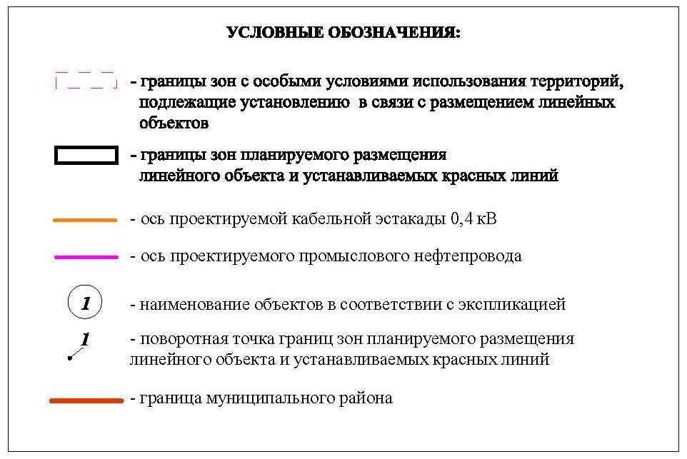

Основная часть проекта планировки территории для размещения объекта капитального строительства, расположенного на территории двух муниципальных образований
Ханты-Мансийского автономного округа – Югры,
«Промысловый нефтепровод «ЦПС Кондинское – ДНС с УПСВ Западно-Эргинское»
Землепользователь: АО «НК «Конданефть»
Масштаб 1:2000

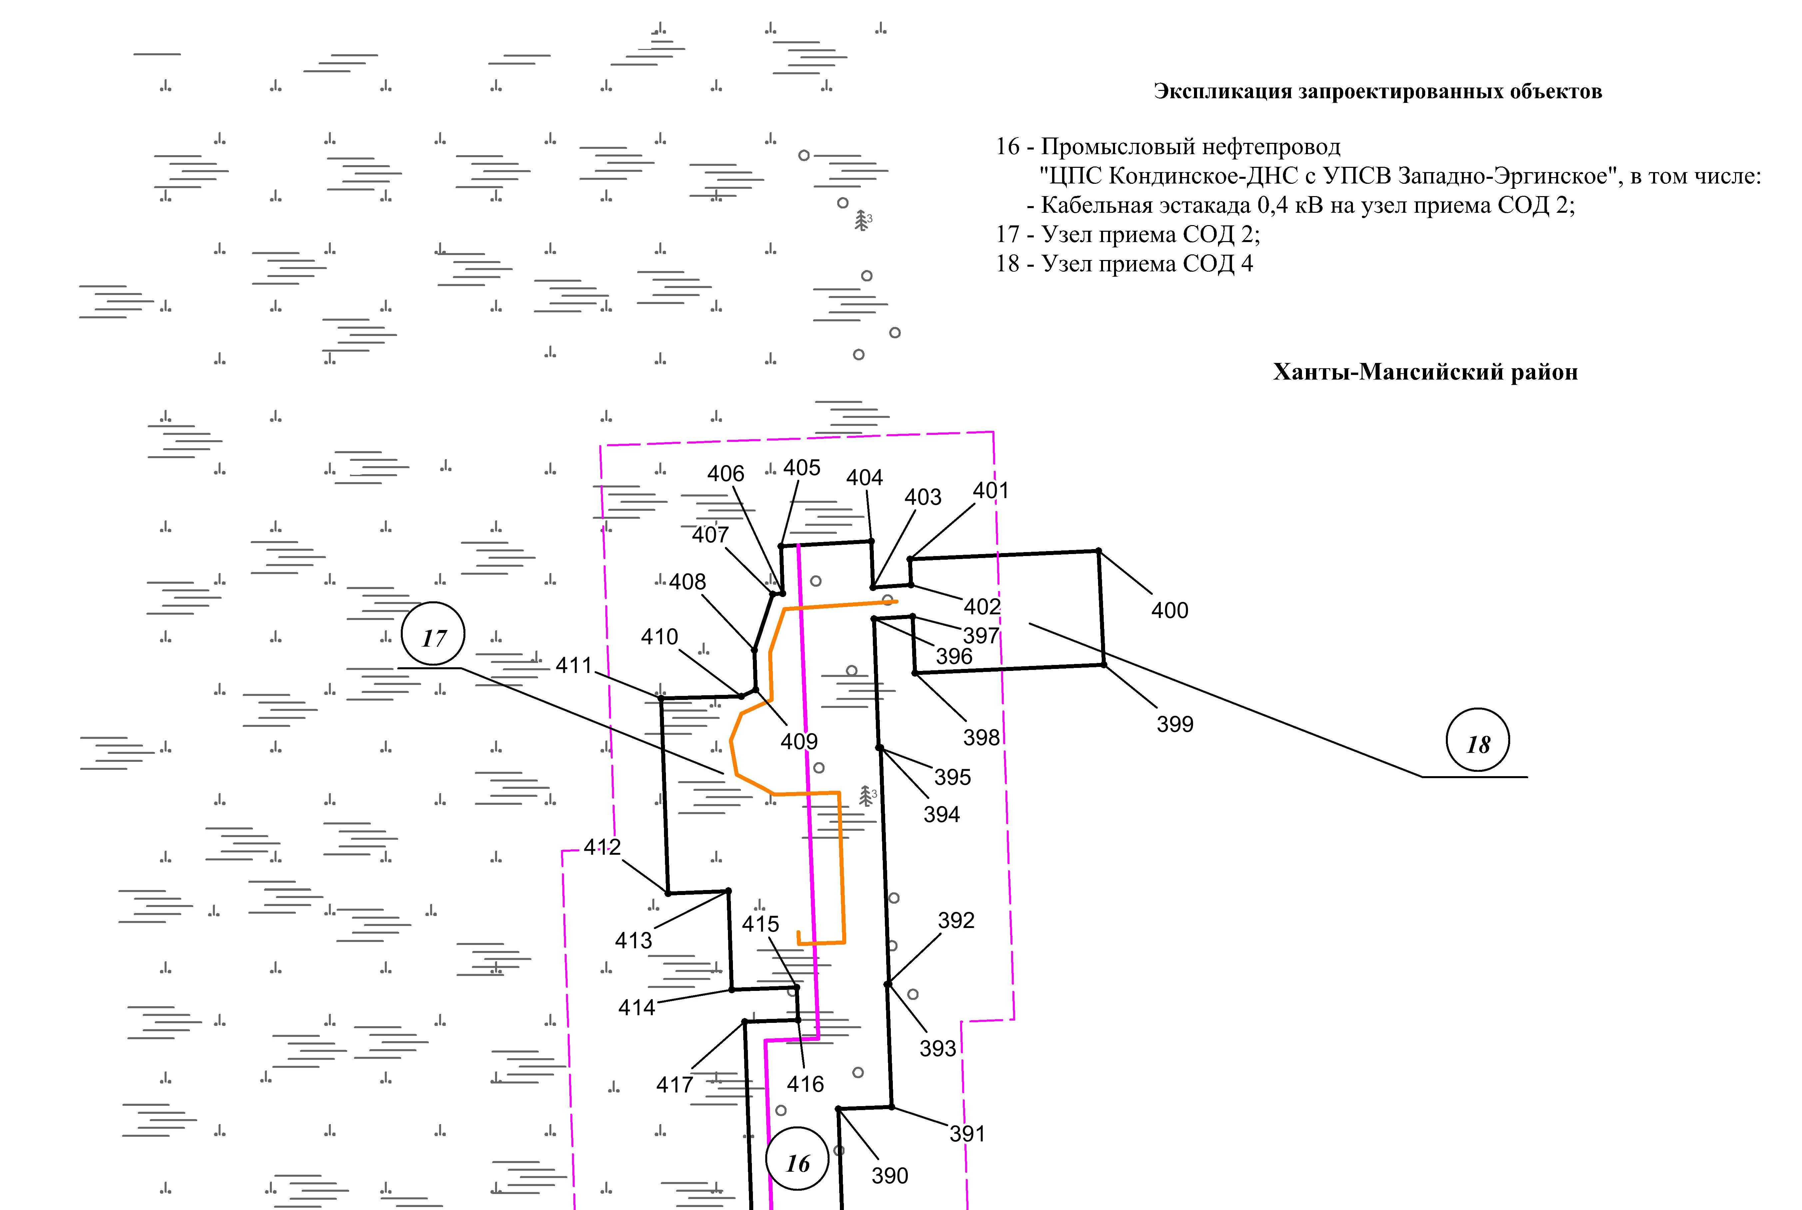

Линия совмещения с листом 3

Основная часть проекта планировки территории для размещения объекта капитального строительства, расположенного на территории двух муниципальных образований
Ханты-Мансийского автономного округа – Югры,
«Промысловый нефтепровод «ЦПС Кондинское – ДНС с УПСВ Западно-Эргинское»
Землепользователь: АО «НК «Конданефть»
Масштаб 1:2000

Линия совмещения с листом 3

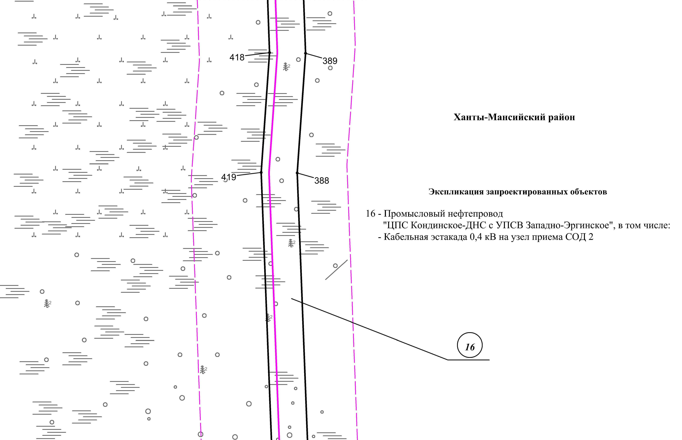

Линия совмещения с листом 4

Лист 3 из 65
Линия совмещения с листом 4

Основная часть проекта планировки территории для размещения объекта капитального строительства, расположенного на территории двух муниципальных образований
Ханты-Мансийского автономного округа – Югры
«Промысловый нефтепровод «ЦПС Кондинское-ДНС с УПСВ Западно-Эргинское»
Землепользователь: АО «НК «Конданефть»

Линия совмещения с листом 3

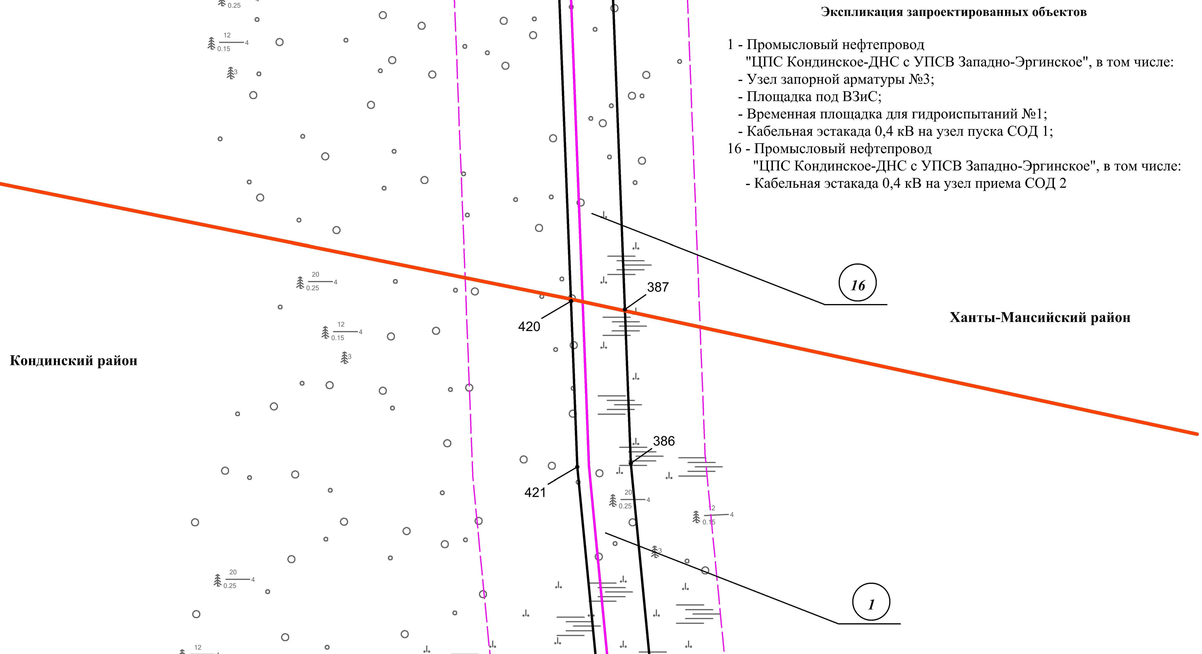
Линия совмещения с листом 5
Линия совмещения с листом 5

Основная часть проекта планировки территории для размещения объекта капитального строительства, расположенного на территории двух муниципальных образований
Ханты-Мансийского автономного округа – Югры,
«Промысловый нефтепровод «ЦПС Кондинское – ДНС с УПСВ Западно-Эргинское»
Землепользователь: АО «НК «Конданефть»
Масштаб 1:2000

Основная часть проекта планировки территории для размещения объекта капитального строительства, расположенного на территории двух муниципальных образований
Ханты-Мансийского автономного округа – Югры,
«Промысловый нефтепровод «ЦПС Кондинское – ДНС с УПСВ Западно-Эргинское»
Землепользователь: АО «НК «Конданефть»
Масштаб 1:2000

Линия совмещения с листом 4

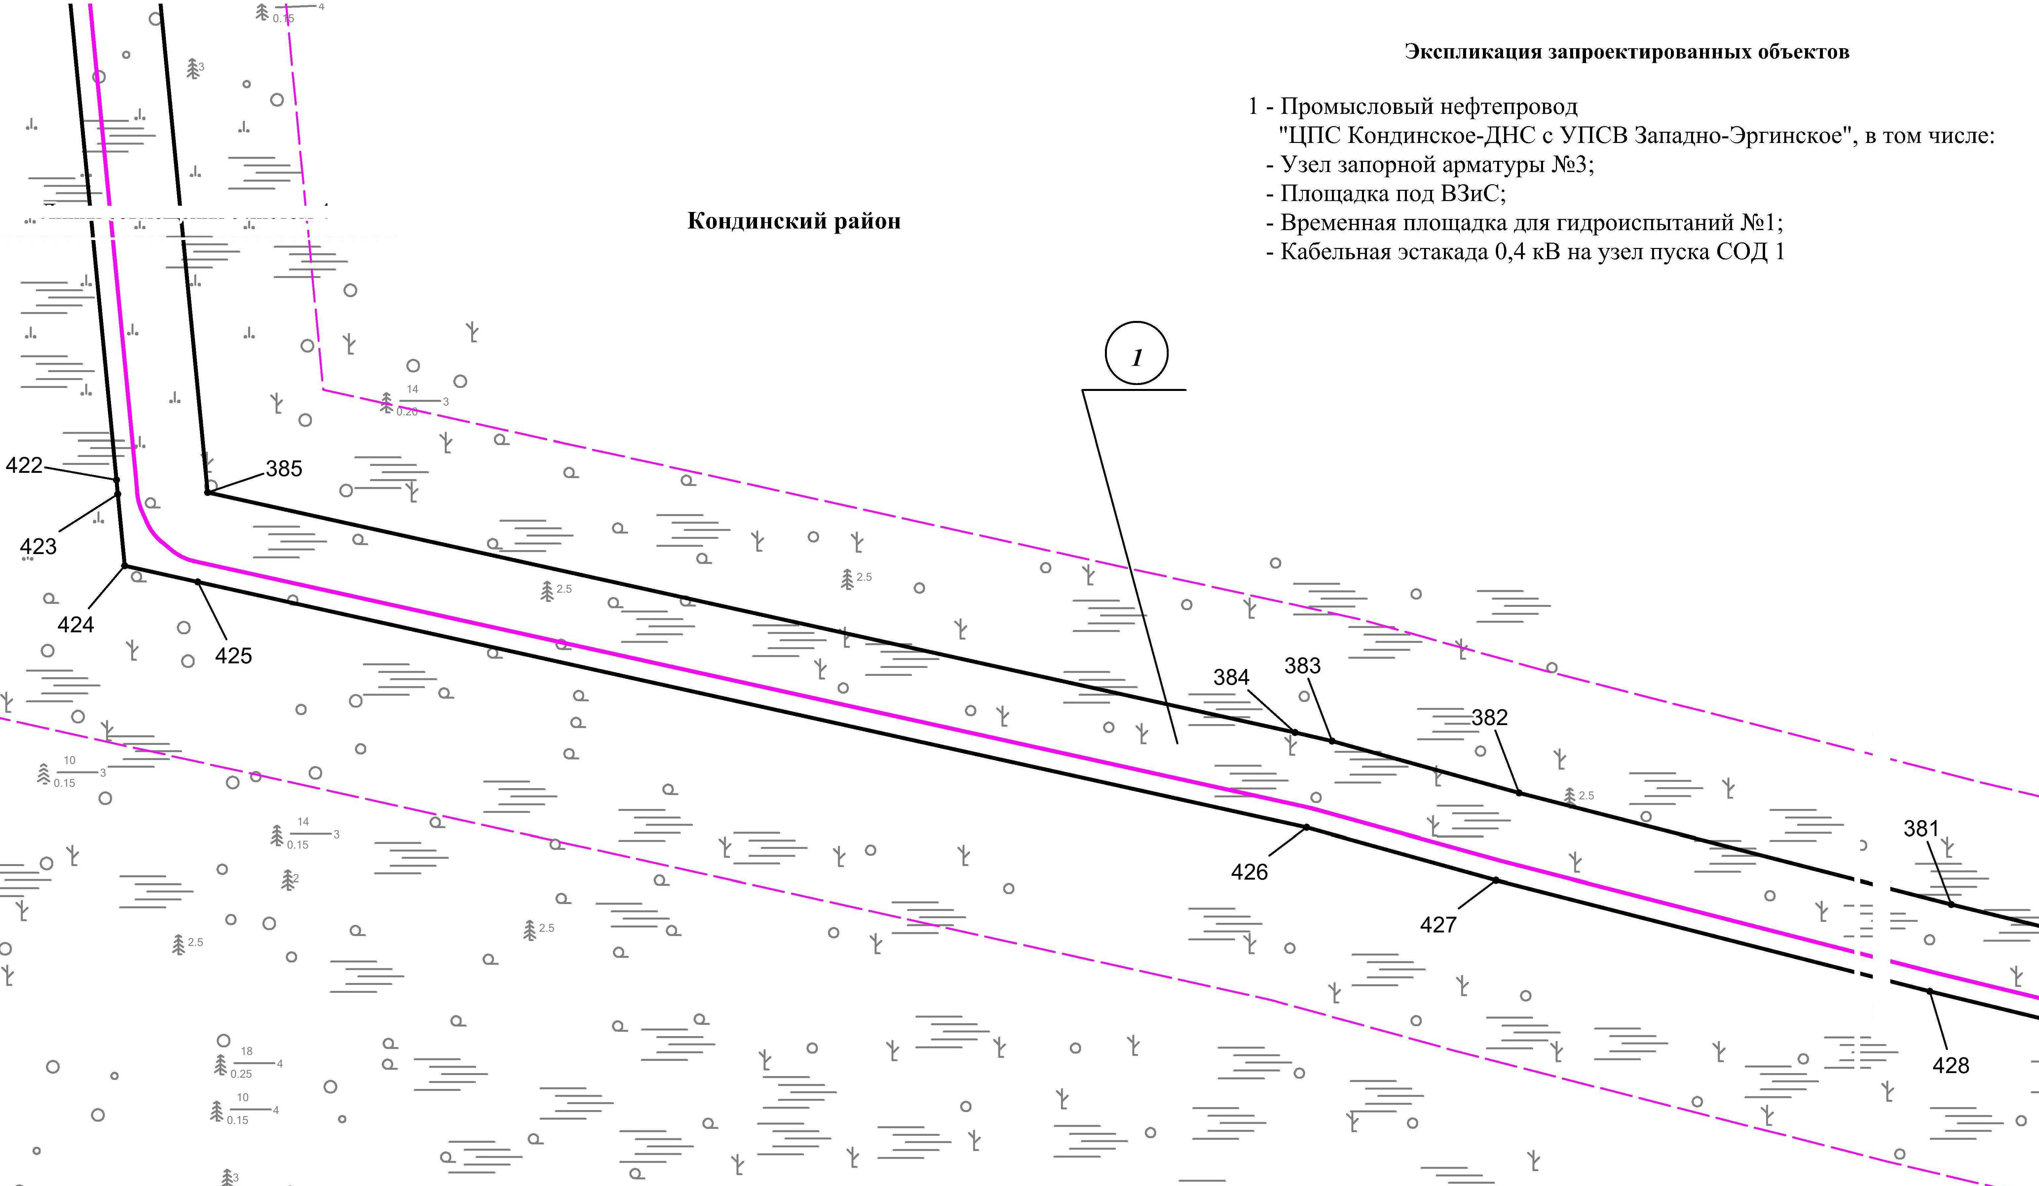

Линия совмещения с листом
6

Линия совмещения с листом
7

Основная часть проекта планировки территории для размещения объекта капитального строительства, расположенного на территории двух муниципальных образований
Ханты-Мансийского автономного округа – Югры,
«Промысловый нефтепровод «ЦПС Кондинское – ДНС с УПСВ Западно-Эргинское»
Землепользователь: АО «НК «Конданефть»
Масштаб 1:2000

Линия совмещения с листом
5

Линия совмещения с листом
5

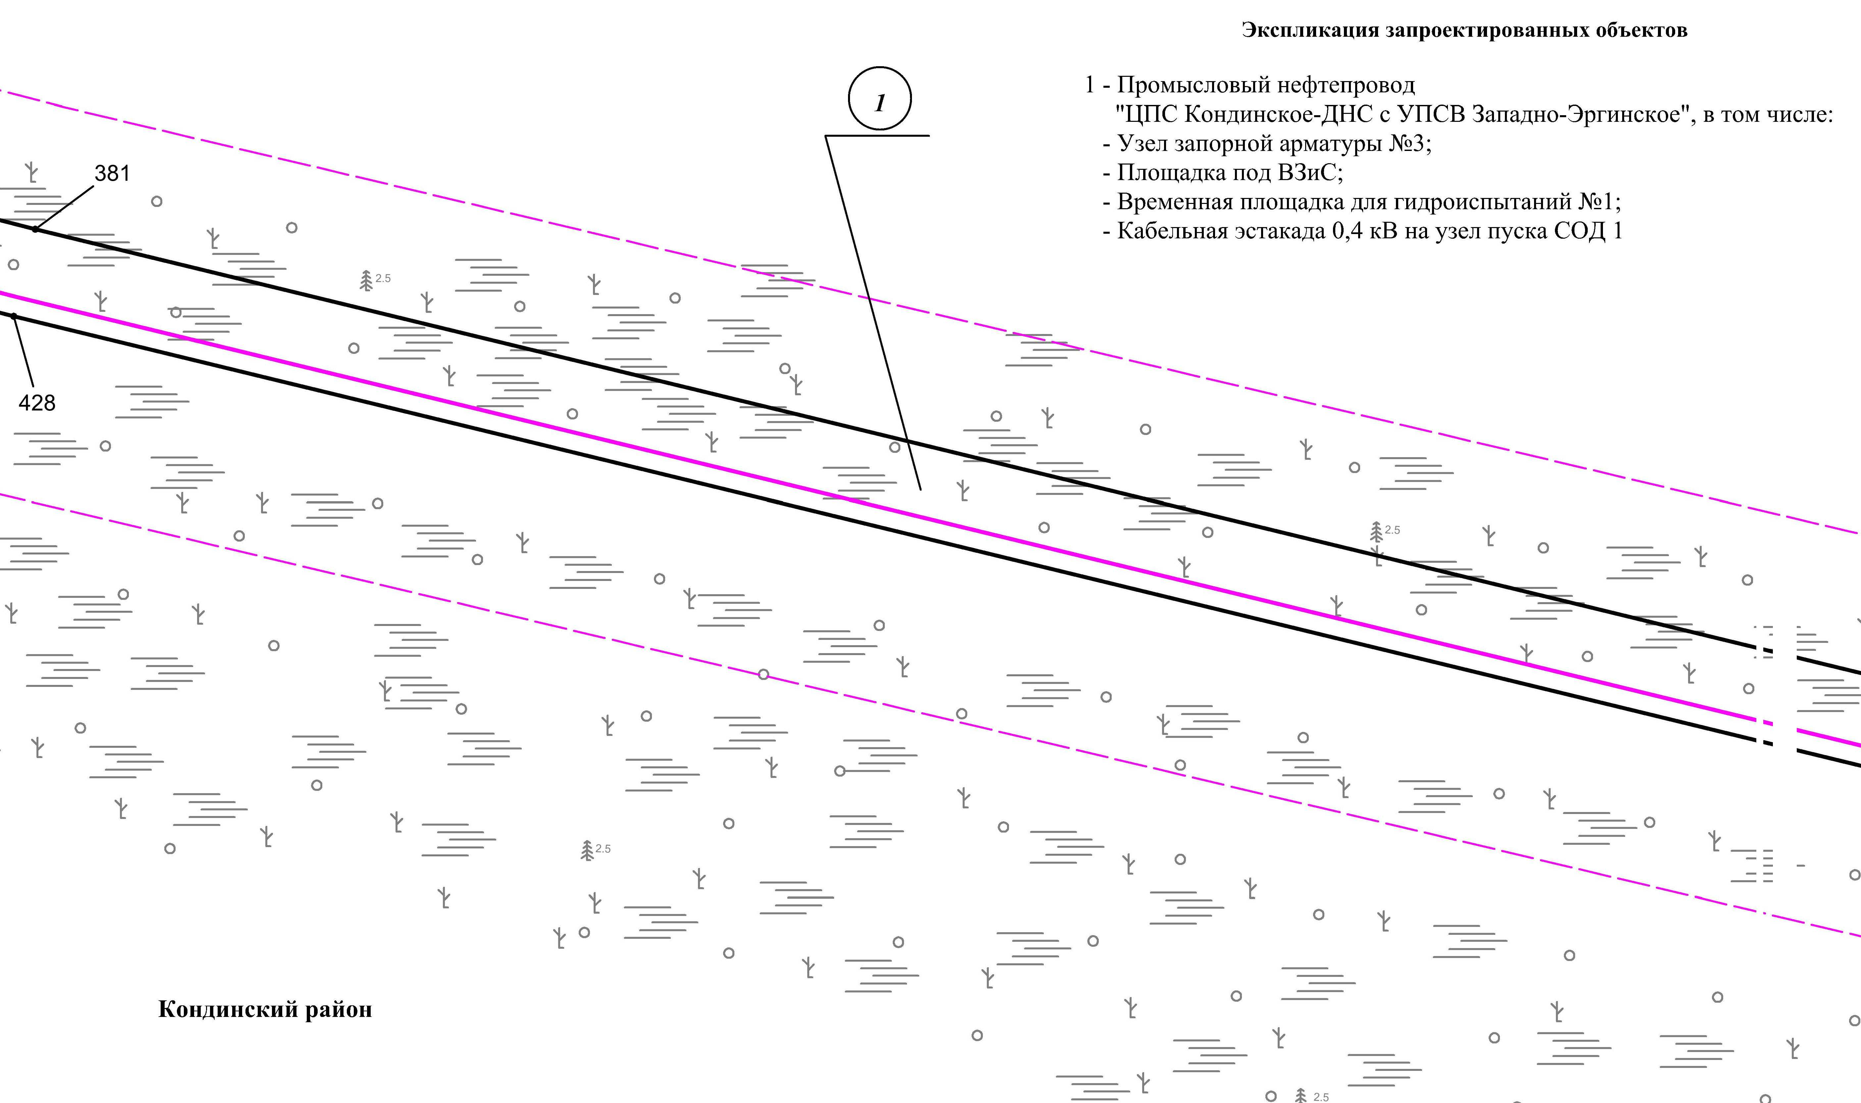
Линия совмещения с листом
7

Основная часть проекта планировки территории для размещения объекта капитального строительства, расположенного на территории двух муниципальных образований
Ханты-Мансийского автономного округа – Югры,
«Промысловый нефтепровод «ЦПС Кондинское – ДНС с УПСВ Западно-Эргинское»
Землепользователь: АО «НК «Конданефть»
Масштаб 1:2000

Линия совмещения с листом
6

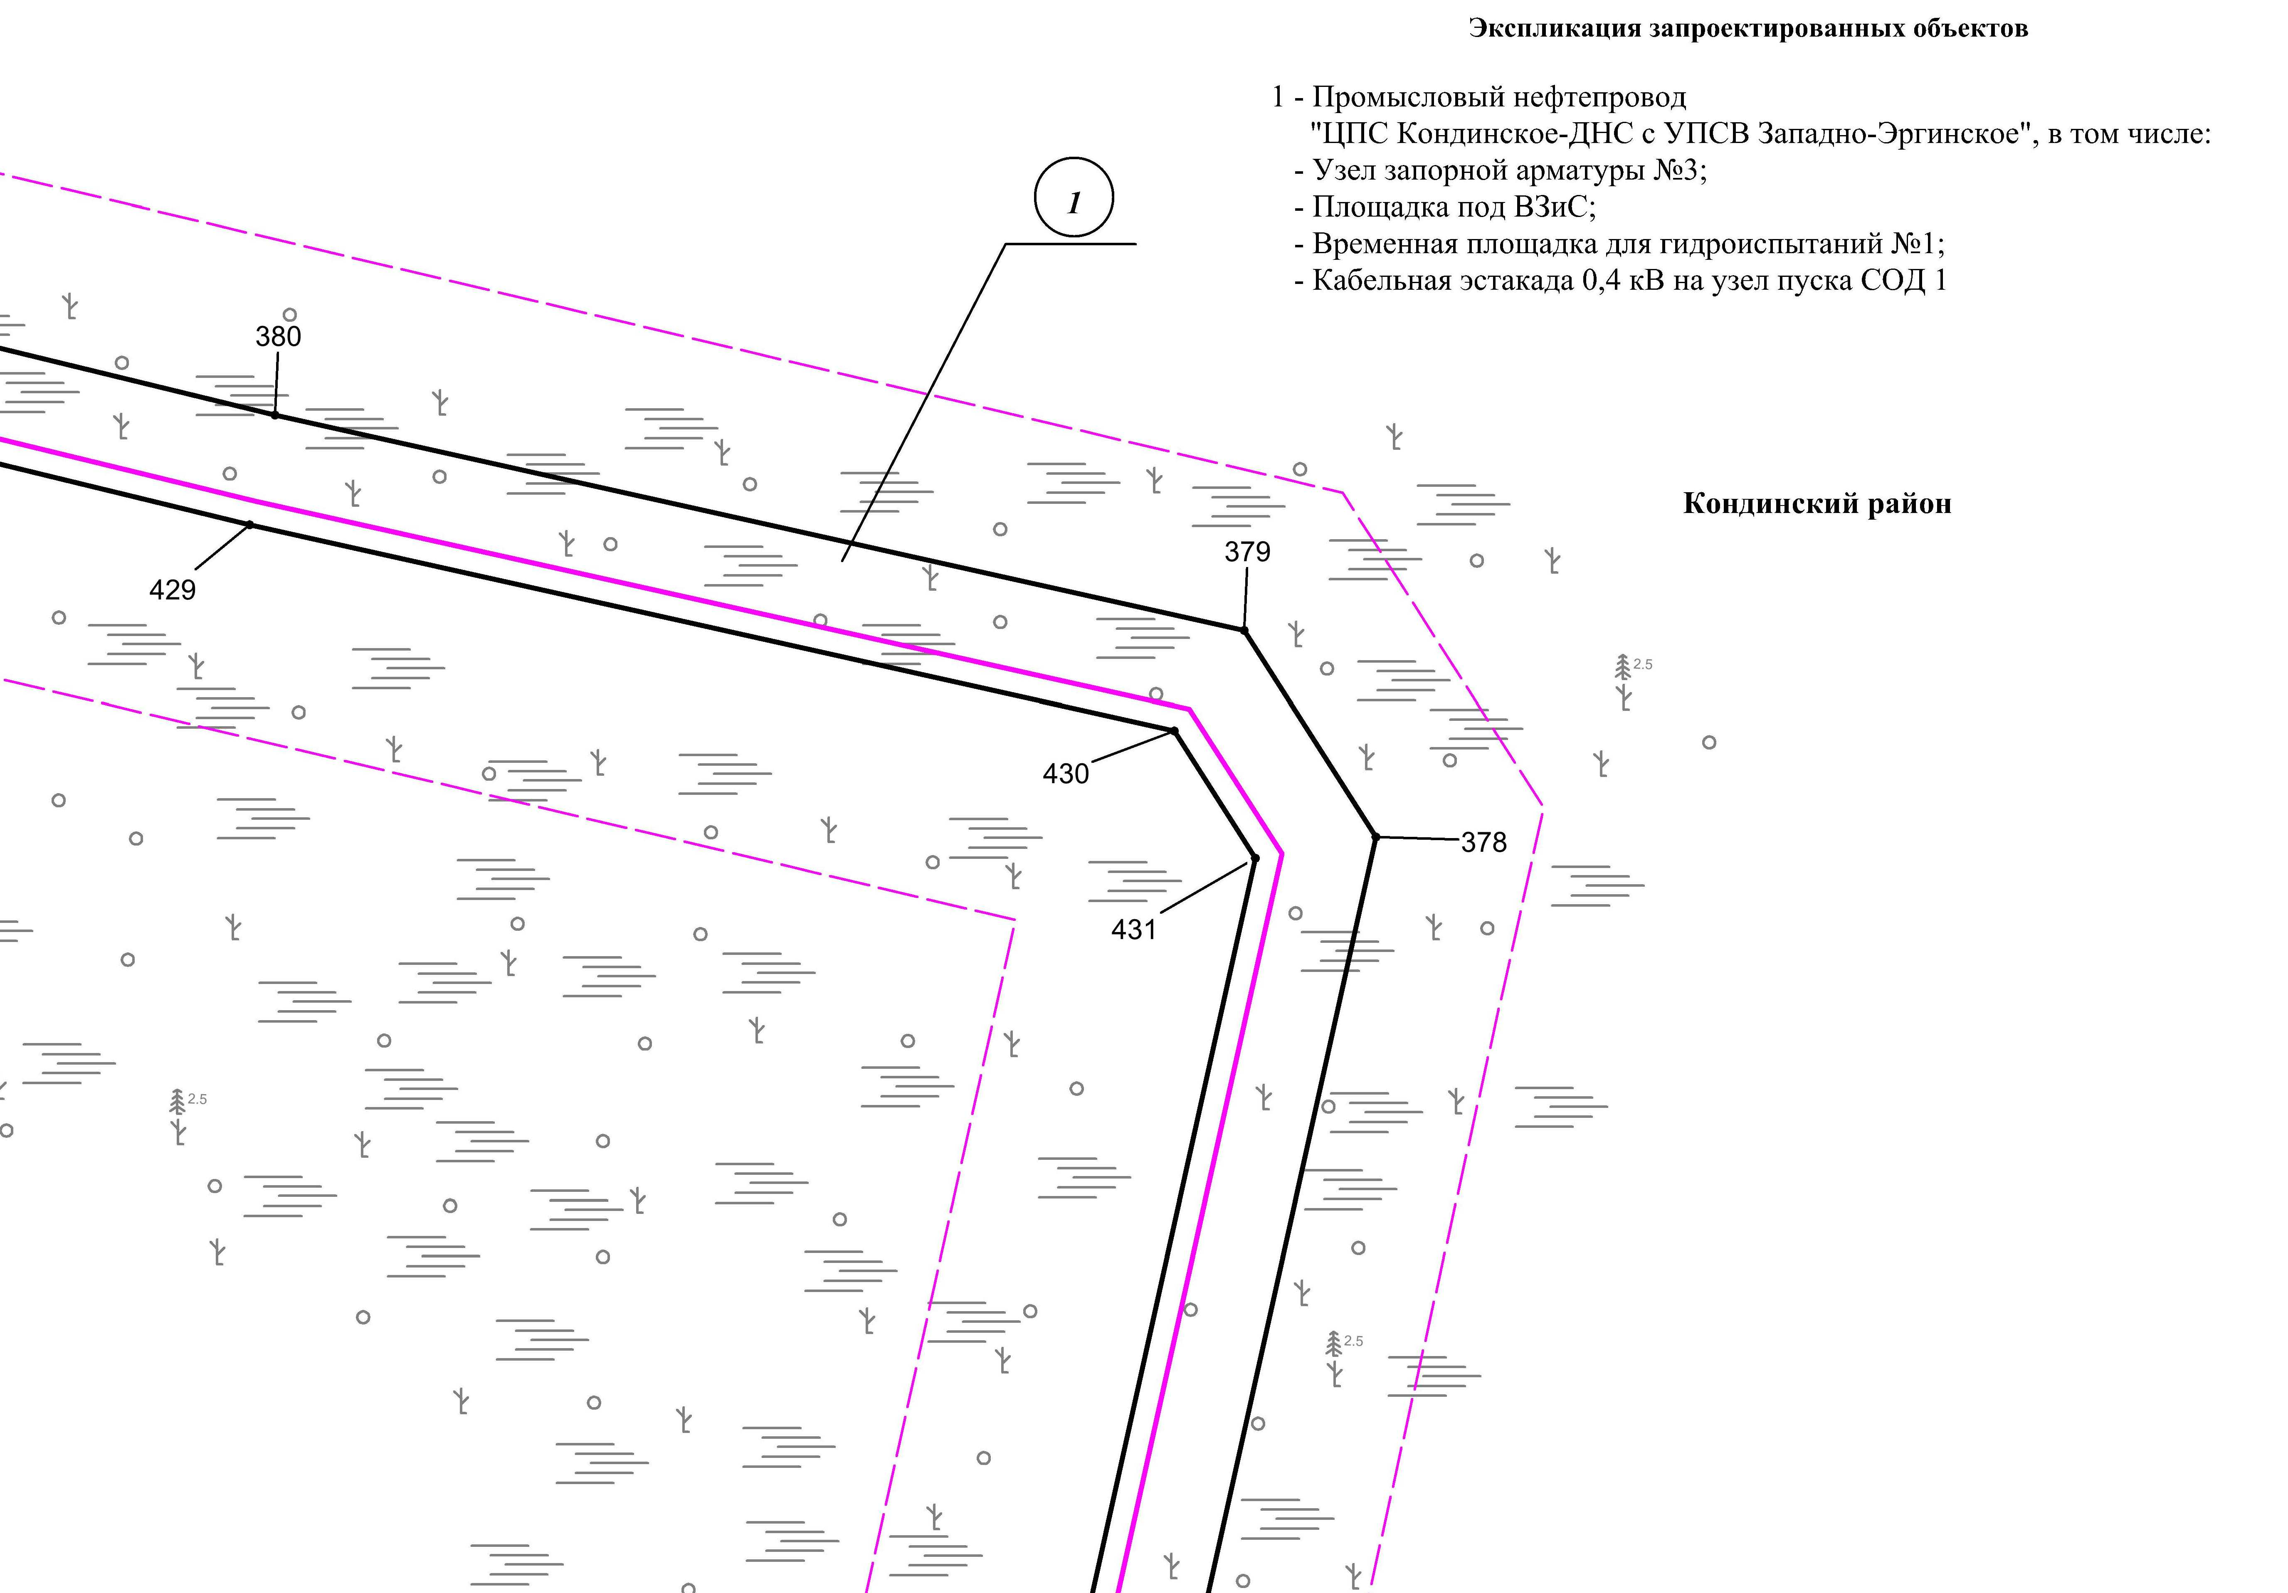

Линия совмещения с листом 8

Основная часть проекта планировки территории для размещения объекта капитального строительства, расположенного на территории двух муниципальных образований
Ханты-Мансийского автономного округа – Югры,
«Промысловый нефтепровод «ЦПС Кондинское – ДНС с УПСВ Западно-Эргинское»
Землепользователь: АО «НК «Конданефть»
Масштаб 1:2000

Линия совмещения с листом 7

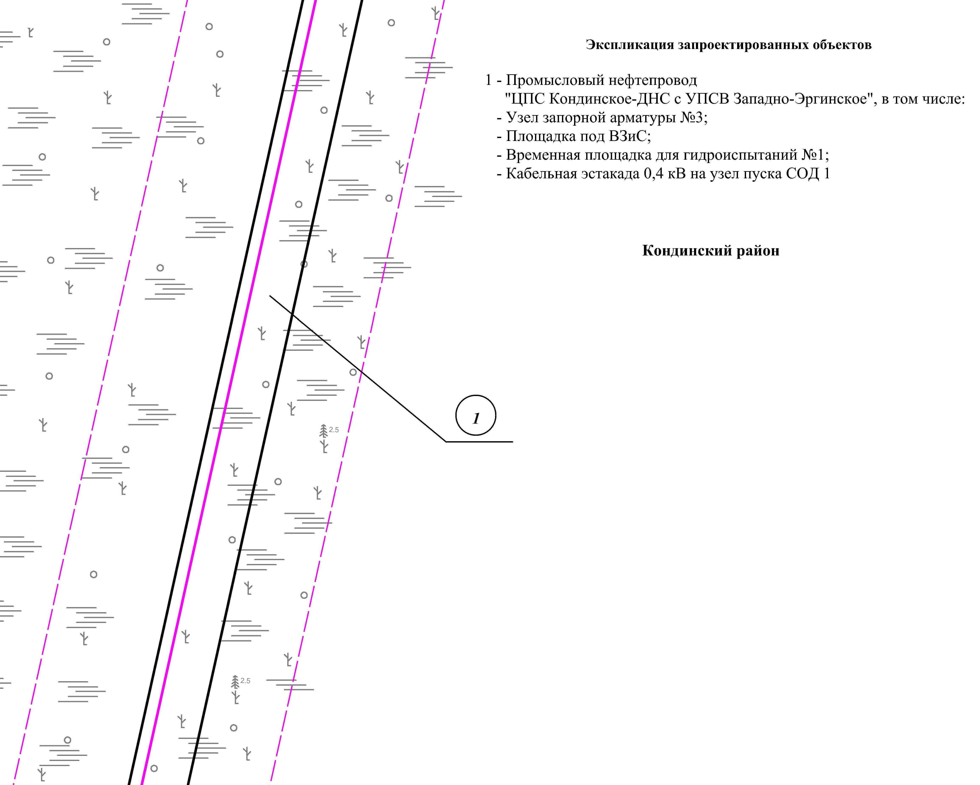

Линия совмещения с листом 9

Линия совмещения с листом 9

Основная часть проекта планировки территории для размещения объекта капитального строительства, расположенного на территории двух муниципальных образований
Ханты-Мансийского автономного округа – Югры,
«Промысловый нефтепровод «ЦПС Кондинское – ДНС с УПСВ Западно-Эргинское»
Землепользователь: АО «НК «Конданефть»
Масштаб 1:2000

Линия совмещения с листом 8
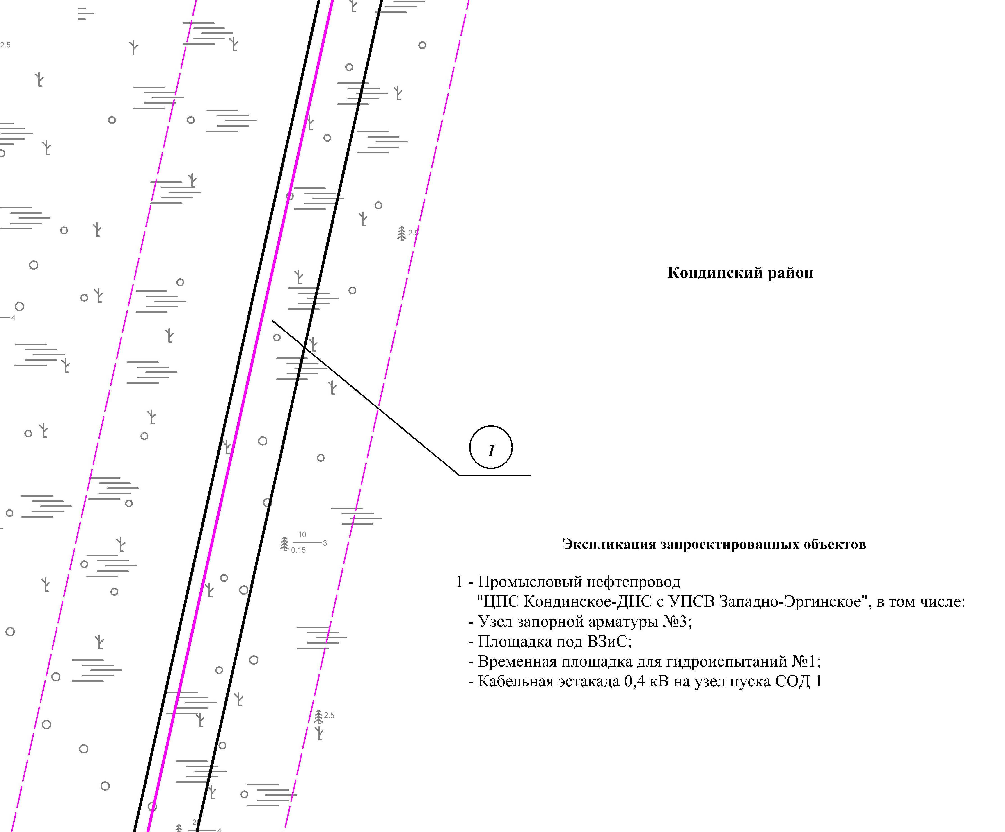

Линия совмещения с листом 10

Основная часть проекта планировки территории для размещения объекта капитального строительства, расположенного на территории двух муниципальных образований
Ханты-Мансийского автономного округа – Югры,
«Промысловый нефтепровод «ЦПС Кондинское – ДНС с УПСВ Западно-Эргинское»
Землепользователь: АО «НК «Конданефть»
Масштаб 1:2000

Линия совмещения с листом 9

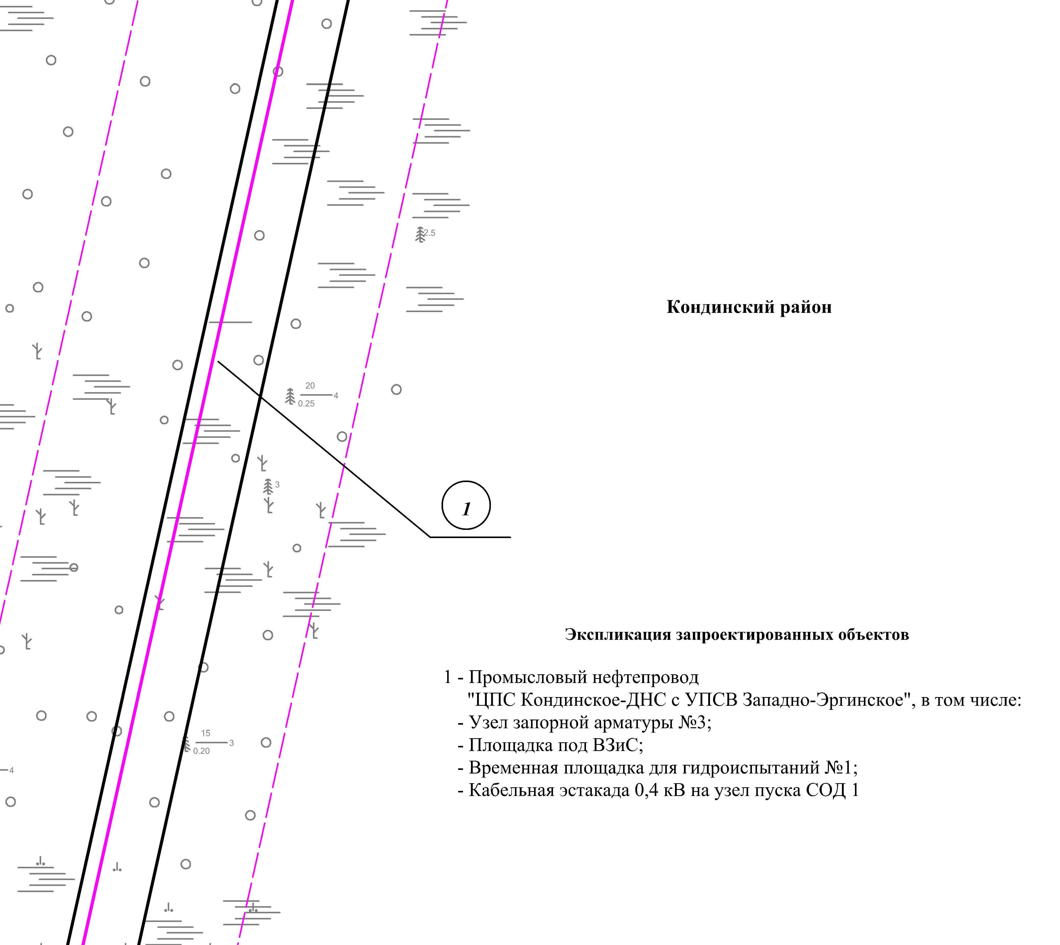

Линия совмещения с листом 11

Основная часть проекта планировки территории для размещения объекта капитального строительства, расположенного на территории двух муниципальных образований
Ханты-Мансийского автономного округа – Югры,
«Промысловый нефтепровод «ЦПС Кондинское – ДНС с УПСВ Западно-Эргинское»
Землепользователь: АО «НК «Конданефть»
Масштаб 1:2000

Линия совмещения с листом 10

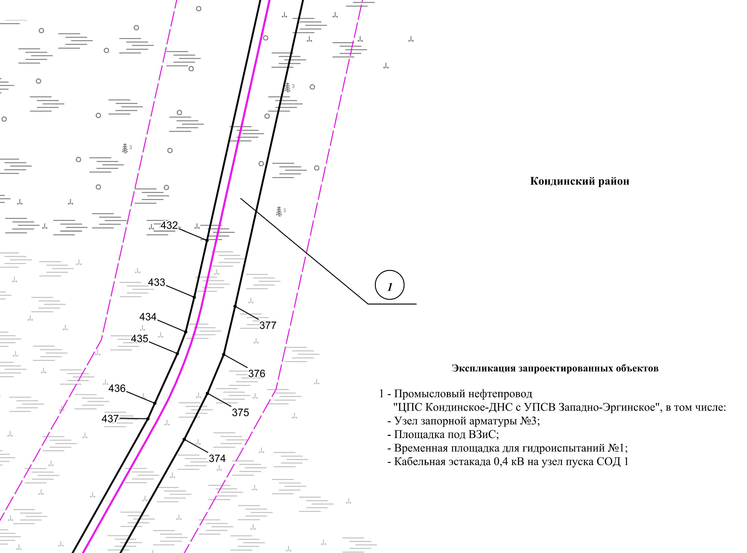

Линия совмещения с листом 12

Основная часть проекта планировки территории для размещения объекта капитального строительства, расположенного на территории двух муниципальных образований
Ханты-Мансийского автономного округа – Югры,
«Промысловый нефтепровод «ЦПС Кондинское – ДНС с УПСВ Западно-Эргинское»
Землепользователь: АО «НК «Конданефть»
Масштаб 1:2000

Линия совмещения с листом 12

Линия совмещения с листом 11
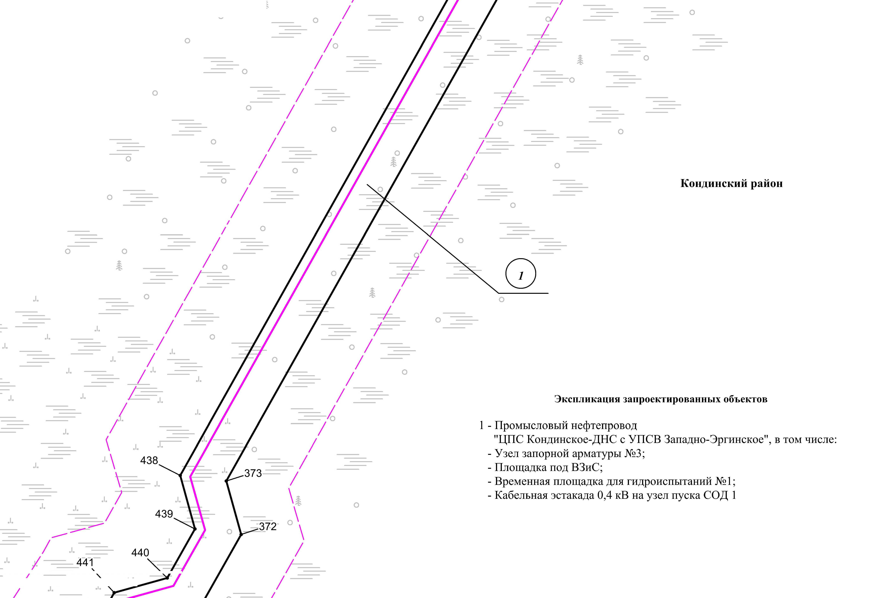

Линия совмещения с листом 13

Основная часть проекта планировки территории для размещения объекта капитального строительства, расположенного на территории двух муниципальных образований
Ханты-Мансийского автономного округа – Югры,
«Промысловый нефтепровод «ЦПС Кондинское – ДНС с УПСВ Западно-Эргинское»
Землепользователь: АО «НК «Конданефть»
Масштаб 1:2000

Линия совмещения с листом 12
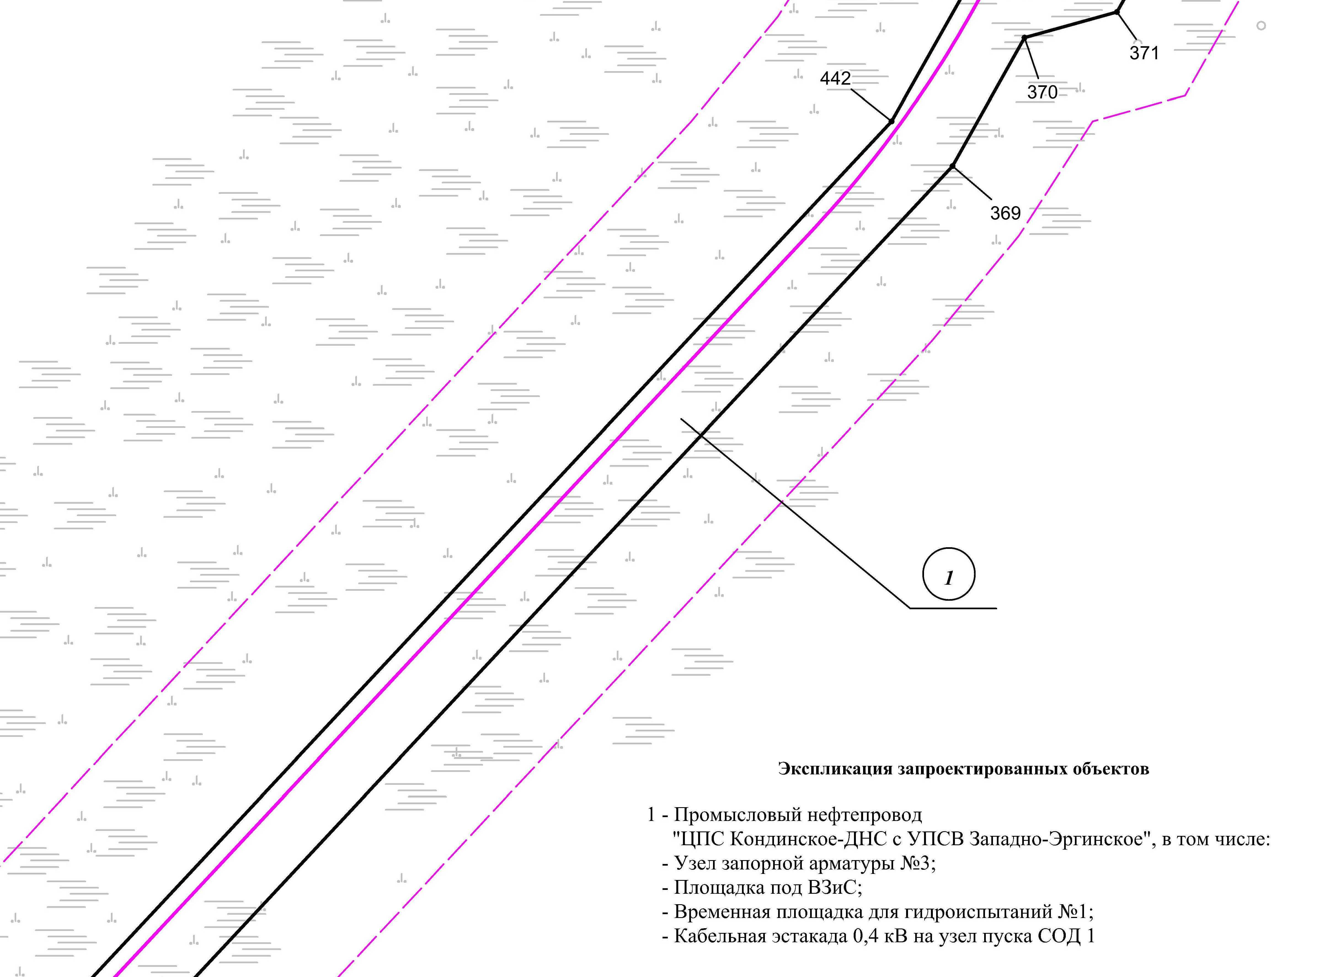

Линия совмещения с листом 14
Линия совмещения с листом 15
Линия совмещения с листом 15

Линия совмещения с листом 13
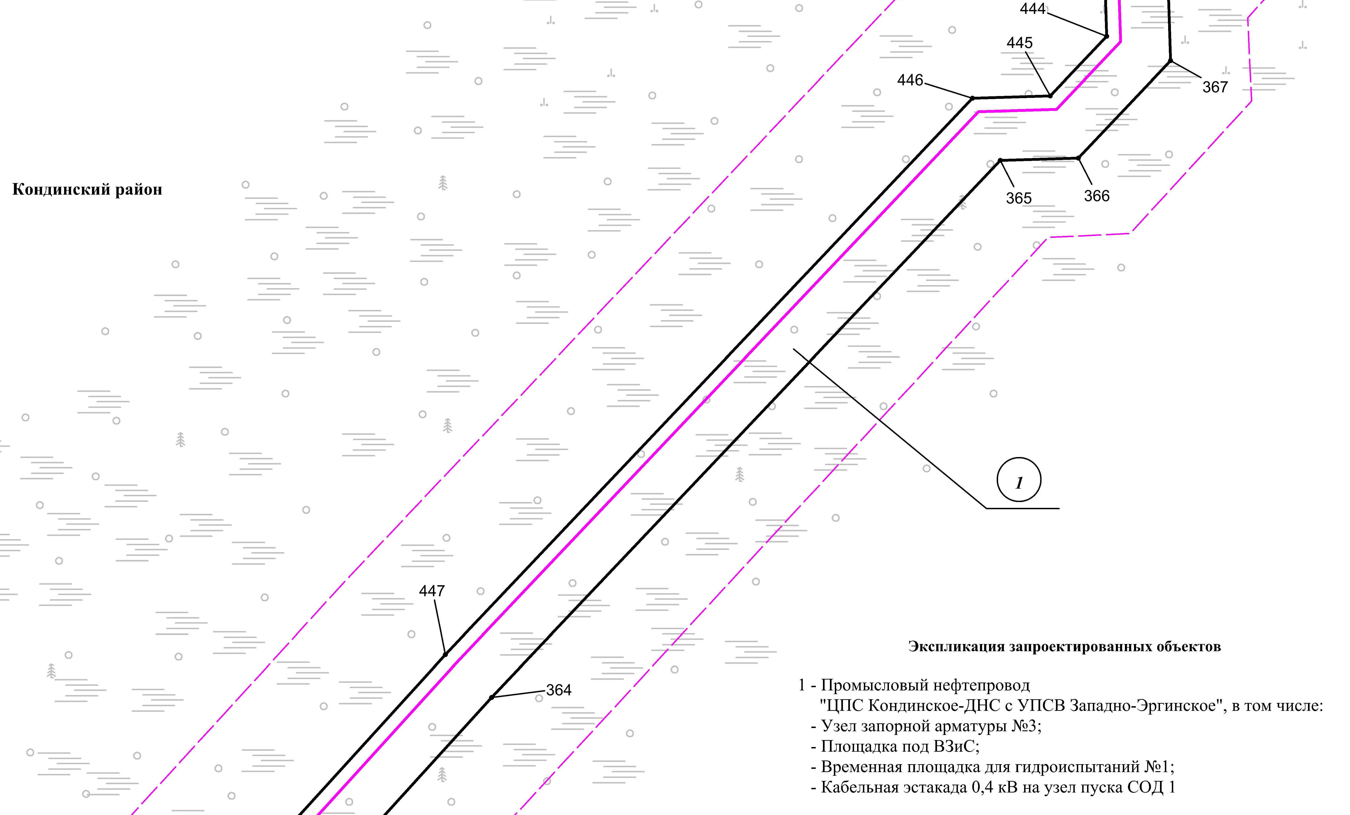

Линия совмещения с листом 16

Линия совмещения с листом 15

Основная часть проекта планировки территории для размещения объекта капитального строительства, расположенного на территории двух муниципальных образований
Ханты-Мансийского автономного округа – Югры,
«Промысловый нефтепровод «ЦПС Кондинское – ДНС с УПСВ Западно-Эргинское»
Землепользователь: АО «НК «Конданефть»
Масштаб 1:2000

Линия совмещения с листом 14
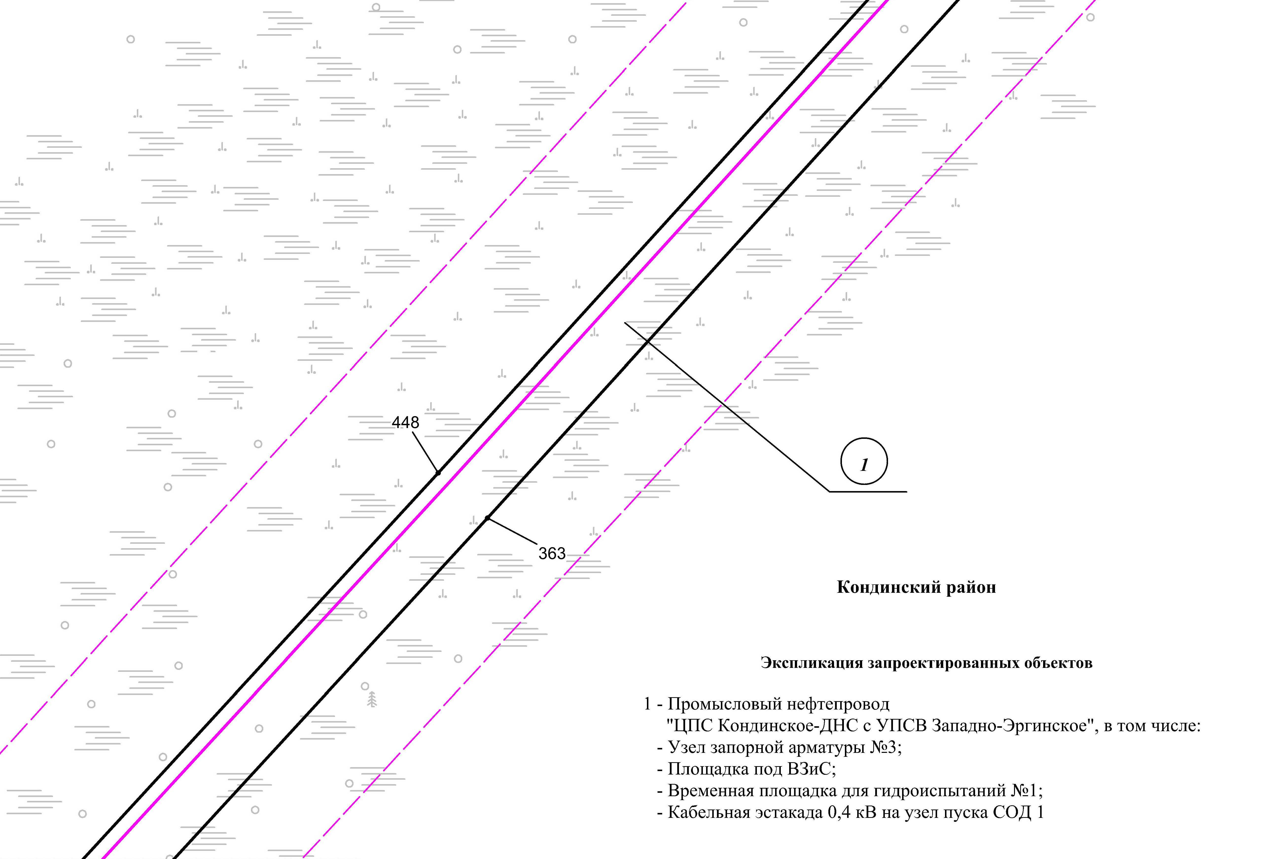

Линия совмещения с листом 16

Основная часть проекта планировки территории для размещения объекта капитального строительства, расположенного на территории двух муниципальных образований
Ханты-Мансийского автономного округа – Югры,
«Промысловый нефтепровод «ЦПС Кондинское – ДНС с УПСВ Западно-Эргинское»
Землепользователь: АО «НК «Конданефть»
Масштаб 1:2000

Основная часть проекта планировки территории для размещения объекта капитального строительства, расположенного на территории двух муниципальных образований
Ханты-Мансийского автономного округа – Югры,
«Промысловый нефтепровод «ЦПС Кондинское – ДНС с УПСВ Западно-Эргинское»
Землепользователь: АО «НК «Конданефть»
Масштаб 1:2000

Линия совмещения с листом 15
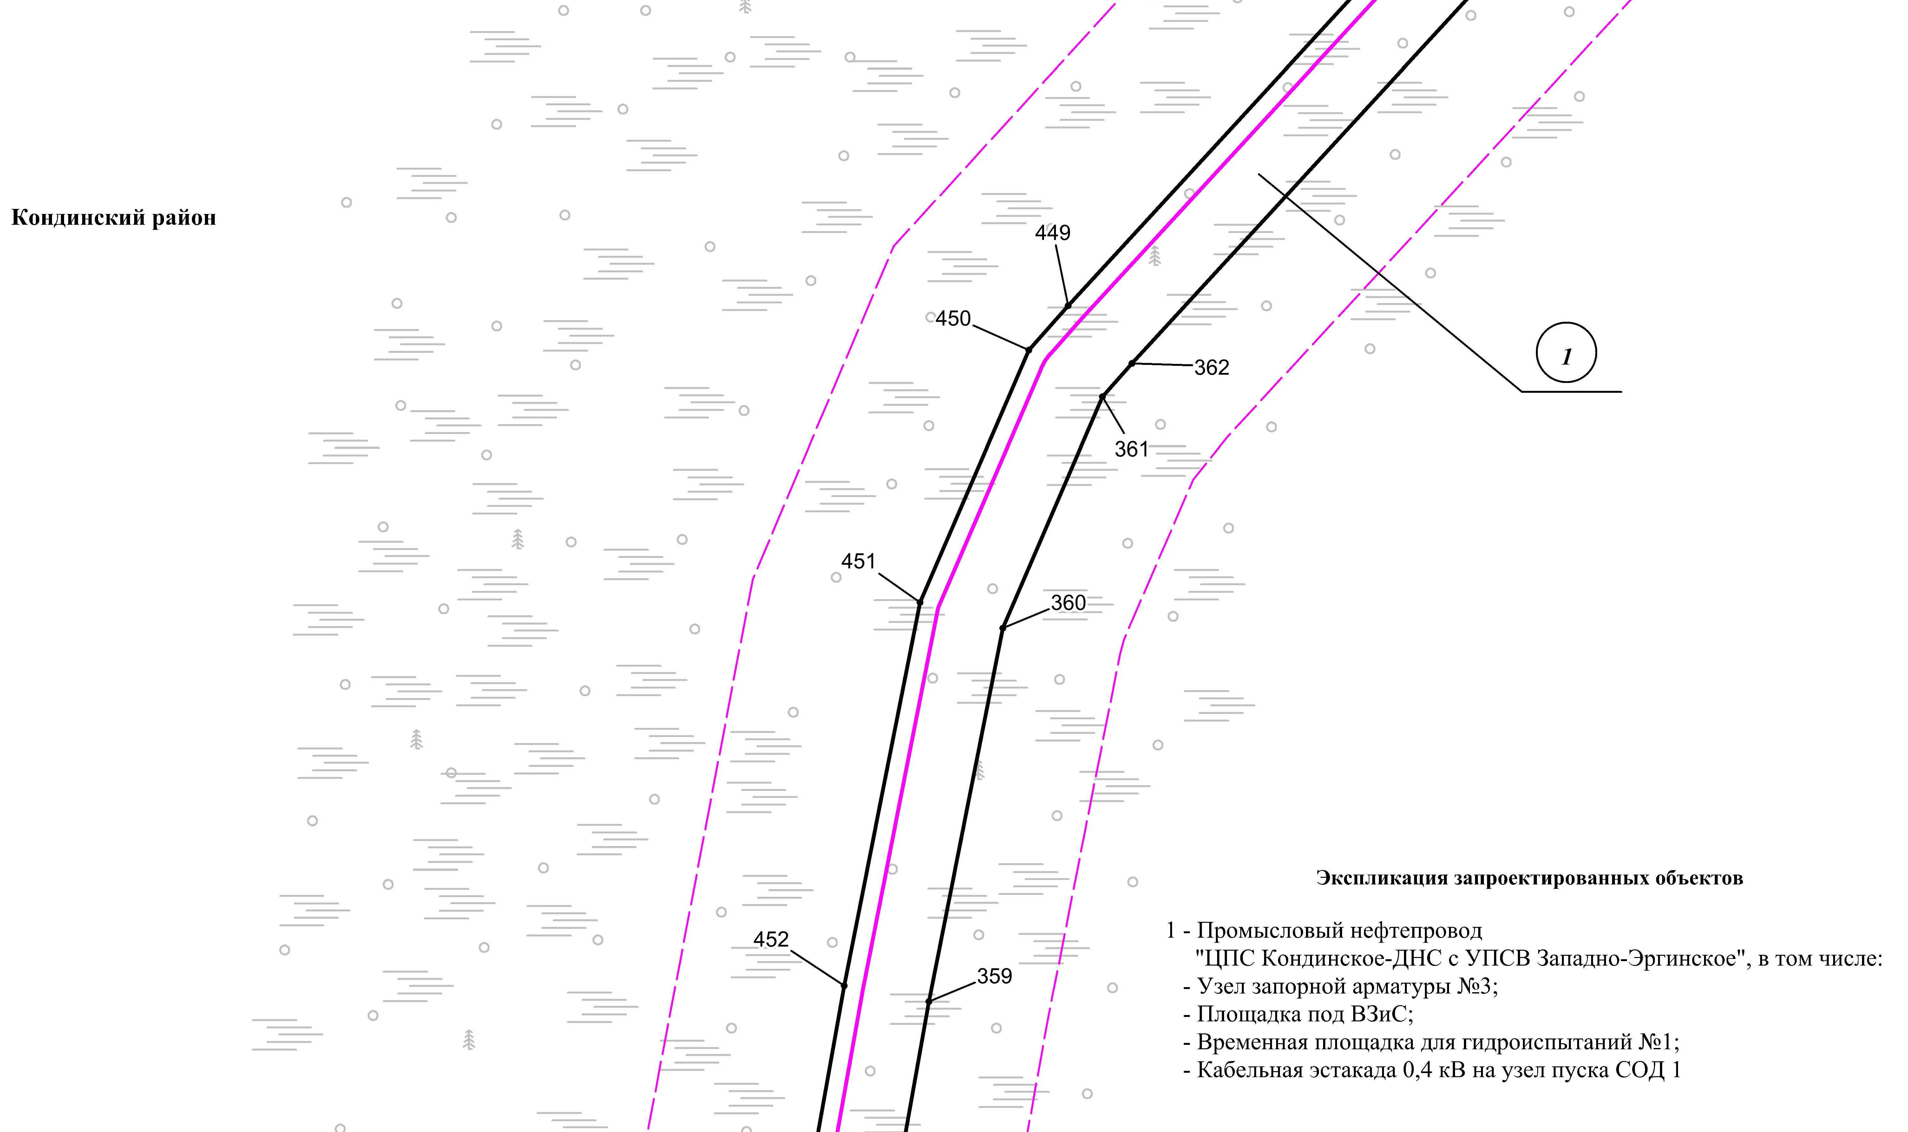

Линия совмещения с листом 18

Линия совмещения с листом 17

Основная часть проекта планировки территории для размещения объекта капитального строительства, расположенного на территории двух муниципальных образований
Ханты-Мансийского автономного округа – Югры
«Промысловый нефтепровод «ЦПС Кондинское-ДНС с УПСВ Западно-Эргинское»
Землепользователь: АО «НК «Конданефть»

Линия совмещения с листом 17

Линия совмещения с листом 16
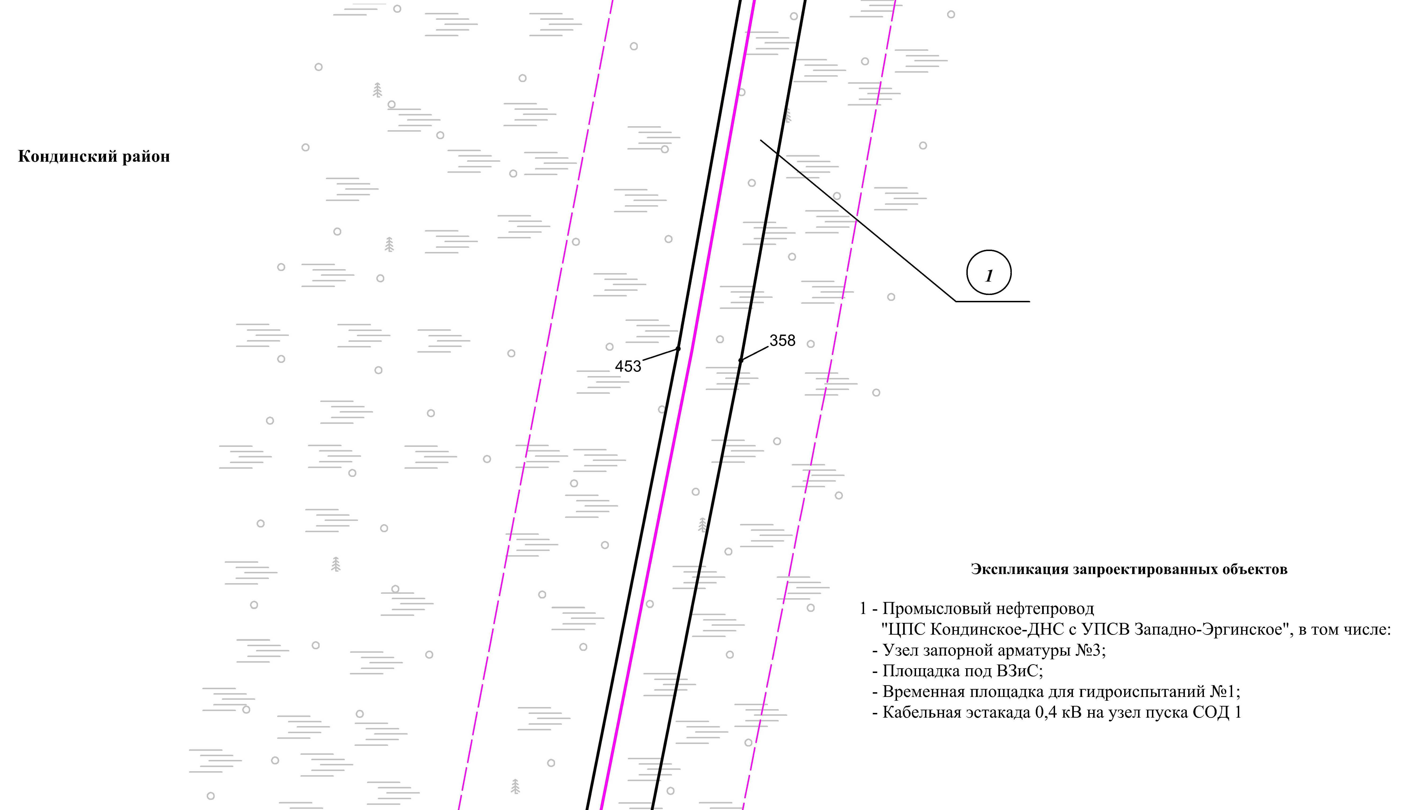

Линия совмещения с листом 18

Основная часть проекта планировки территории для размещения объекта капитального строительства, расположенного на территории двух муниципальных образований
Ханты-Мансийского автономного округа – Югры,
«Промысловый нефтепровод «ЦПС Кондинское – ДНС с УПСВ Западно-Эргинское»
Землепользователь: АО «НК «Конданефть»
Масштаб 1:2000

Основная часть проекта планировки территории для размещения объекта капитального строительства, расположенного на территории двух муниципальных образований
Ханты-Мансийского автономного округа – Югры,
«Промысловый нефтепровод «ЦПС Кондинское – ДНС с УПСВ Западно-Эргинское»
Землепользователь: АО «НК «Конданефть»
Масштаб 1:2000

Линия совмещения с листом 17

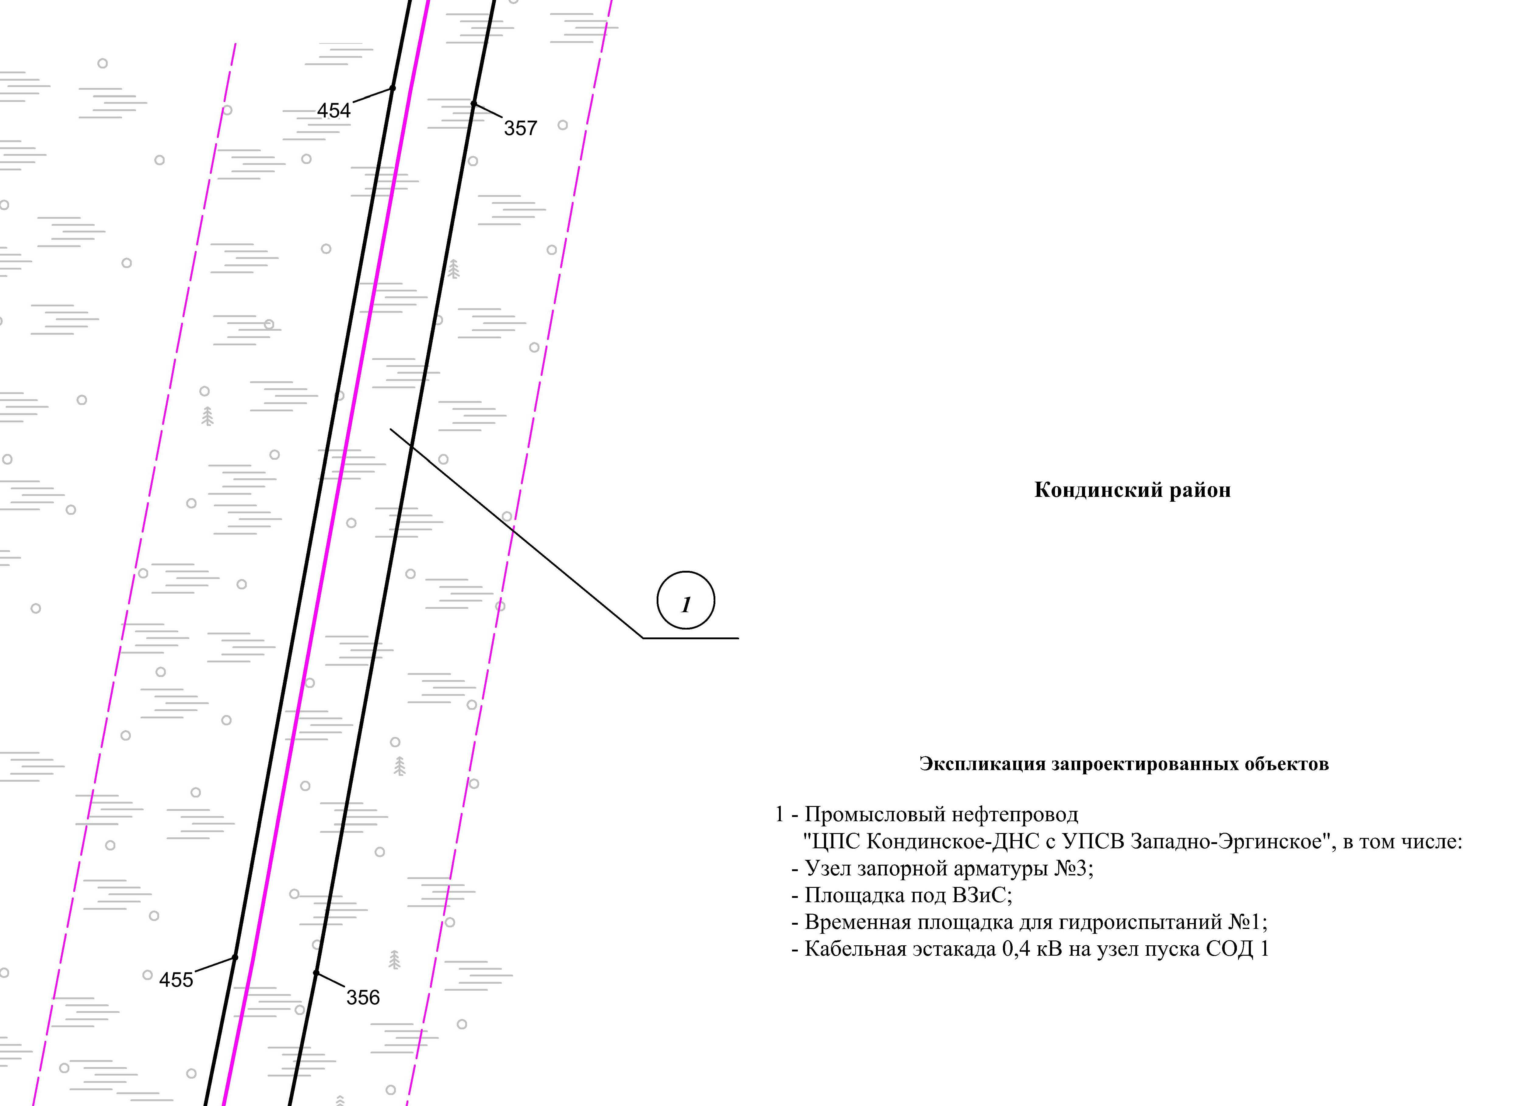

Линия совмещения с листом 19

Основная часть проекта планировки территории для размещения объекта капитального строительства, расположенного на территории двух муниципальных образований
Ханты-Мансийского автономного округа – Югры,
«Промысловый нефтепровод «ЦПС Кондинское – ДНС с УПСВ Западно-Эргинское»
Землепользователь: АО «НК «Конданефть»
Масштаб 1:2000

Линия совмещения с листом
219

Линия совмещения с листом 18
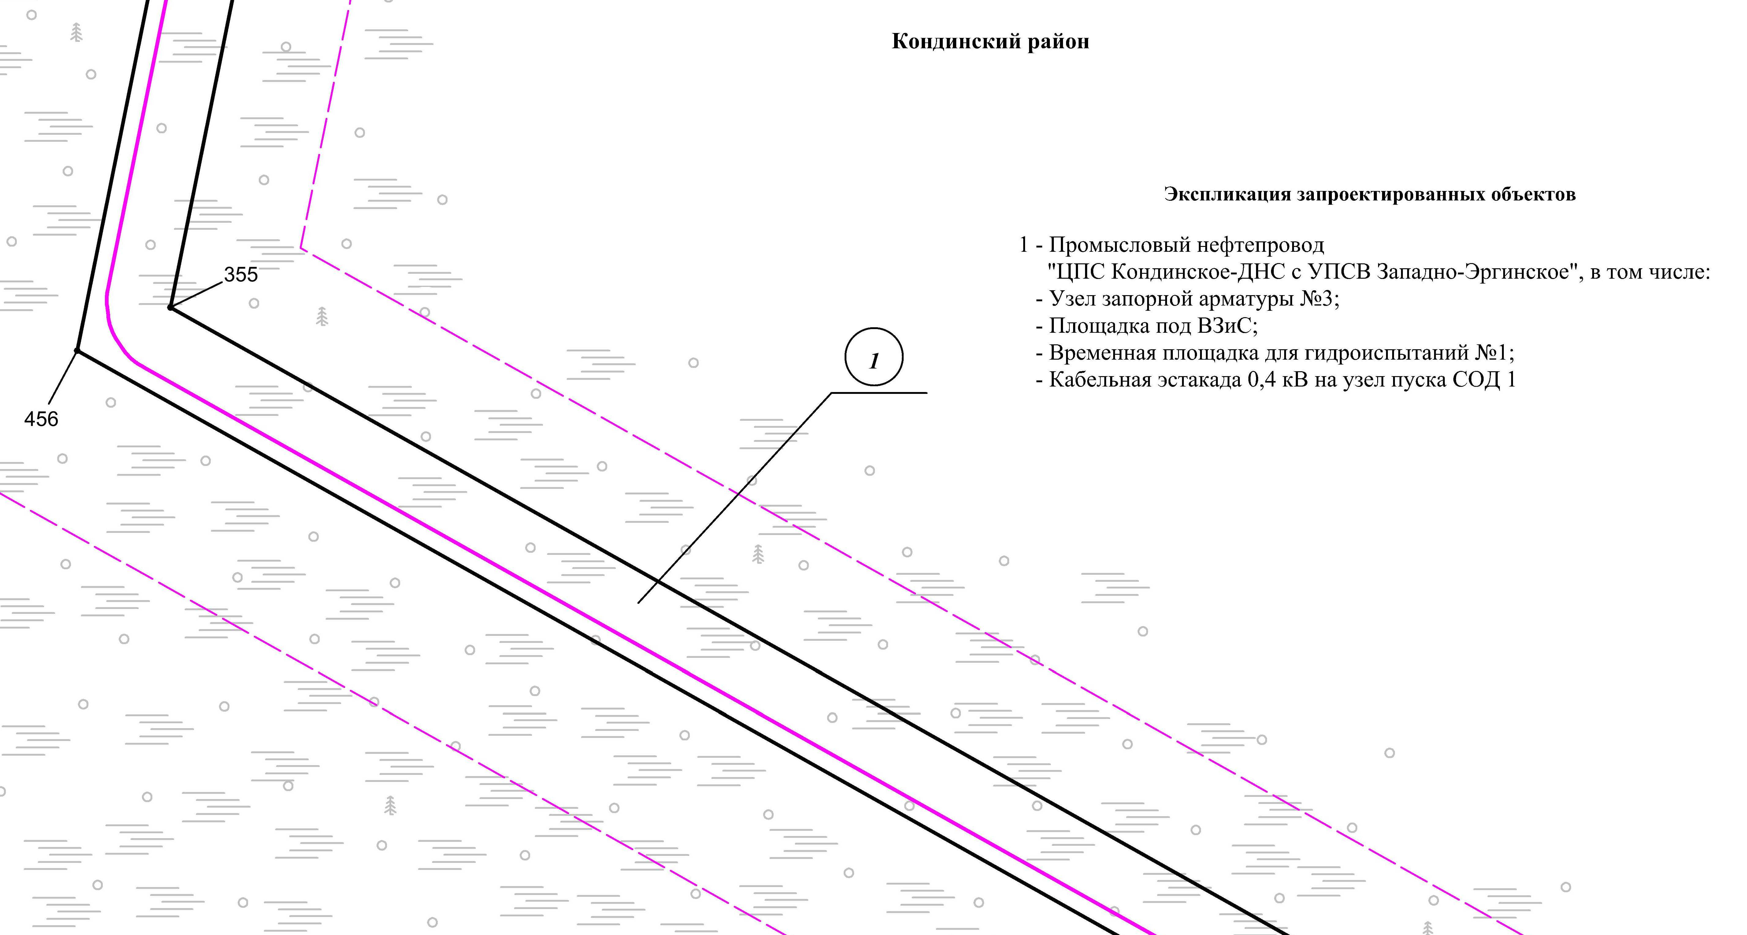

Линия совмещения с листом 20

Основная часть проекта планировки территории для размещения объекта капитального строительства, расположенного на территории двух муниципальных образований
Ханты-Мансийского автономного округа – Югры,
«Промысловый нефтепровод «ЦПС Кондинское – ДНС с УПСВ Западно-Эргинское»
Землепользователь: АО «НК «Конданефть»
Масштаб 1:2000

Линия совмещения с листом 19
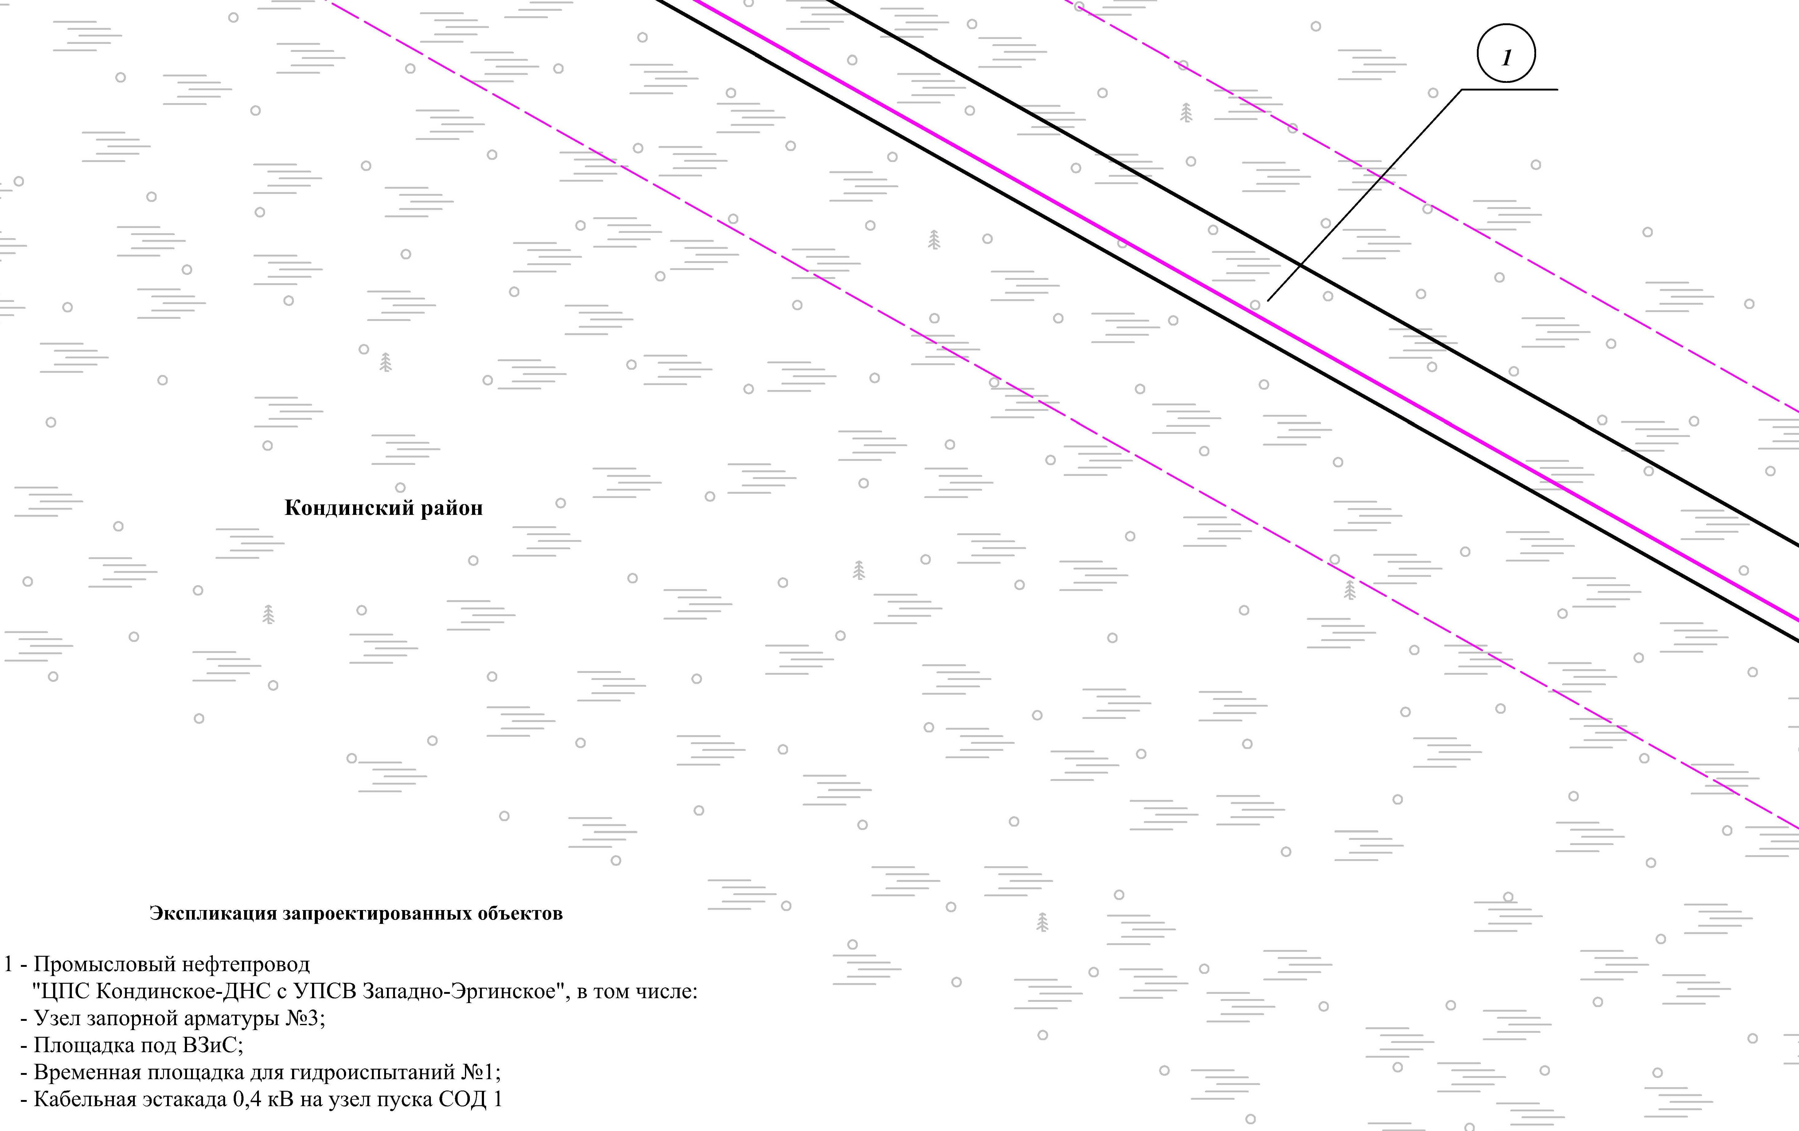
Линия совмещения с листом 21

Основная часть проекта планировки территории для размещения объекта капитального строительства, расположенного на территории двух муниципальных образований
Ханты-Мансийского автономного округа – Югры,
«Промысловый нефтепровод «ЦПС Кондинское – ДНС с УПСВ Западно-Эргинское»
Землепользователь: АО «НК «Конданефть»
Масштаб 1:2000

Линия совмещения с листом
2
0

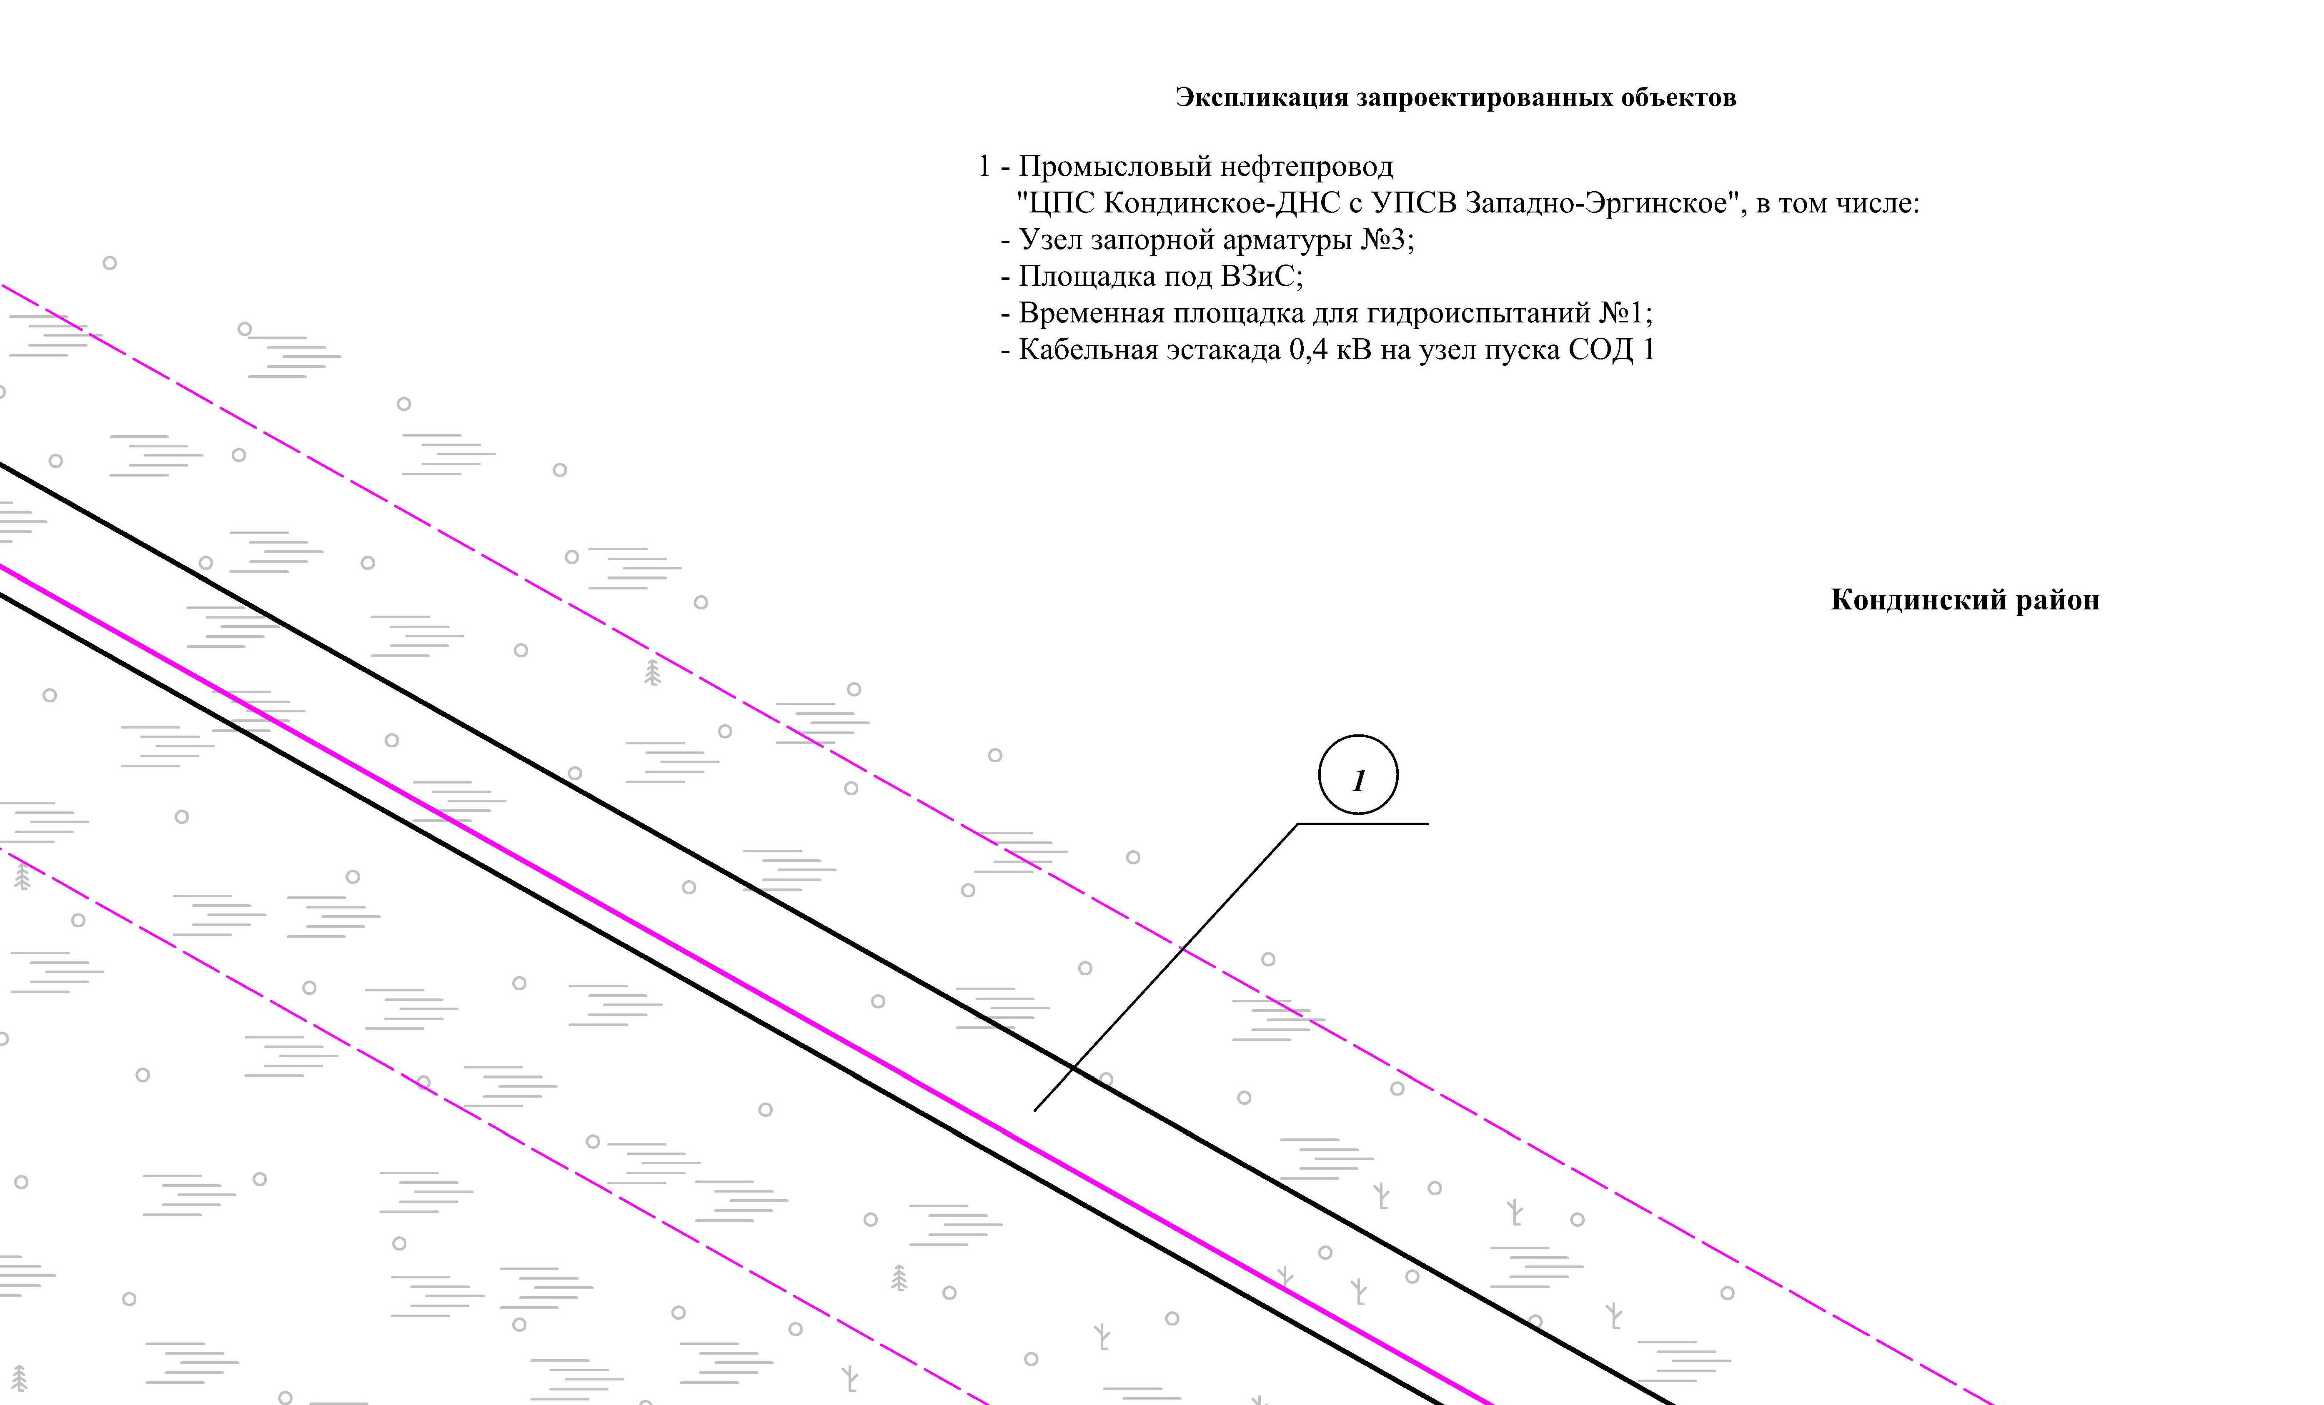
Линия совмещения с листом
2
1

Линия совмещения с листом 22

Основная часть проекта планировки территории для размещения объекта капитального строительства, расположенного на территории двух муниципальных образований
Ханты-Мансийского автономного округа – Югры,
«Промысловый нефтепровод «ЦПС Кондинское – ДНС с УПСВ Западно-Эргинское»
Землепользователь: АО «НК «Конданефть»
Масштаб 1:2000

Линия совмещения с листом 21
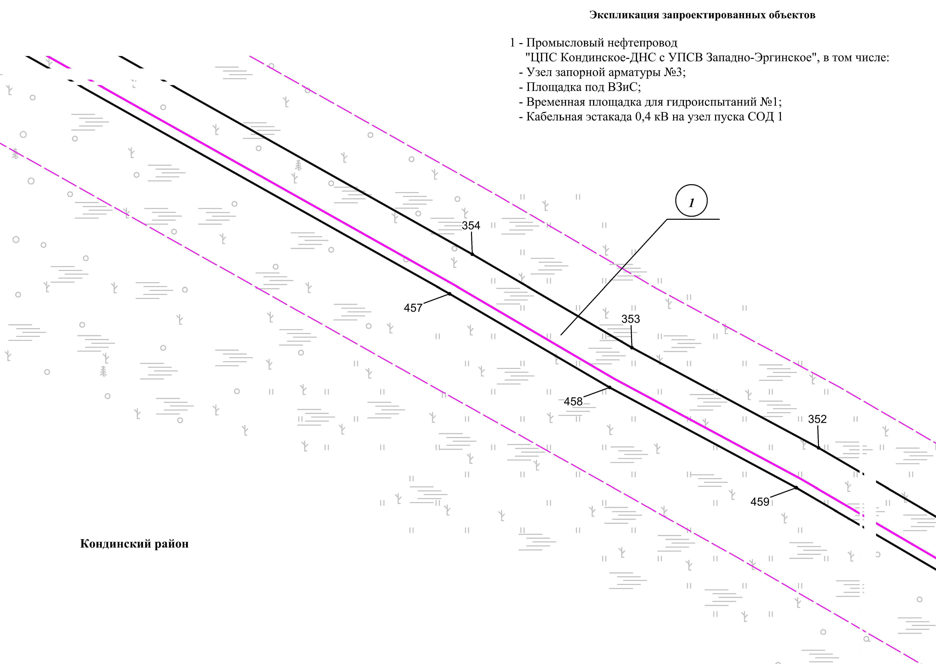

Линия совмещения с листом
2
3

Основная часть проекта планировки территории для размещения объекта капитального строительства, расположенного на территории двух муниципальных образований
Ханты-Мансийского автономного округа – Югры,
«Промысловый нефтепровод «ЦПС Кондинское - ДНС с УПСВ Западно-Эргинское»
Землепользователь: АО «НК «Конданефть»
Масштаб 1:2000

Линия совмещения с листом
2
3

Линия совмещения с листом
2
3

Линия совмещения с листом 22

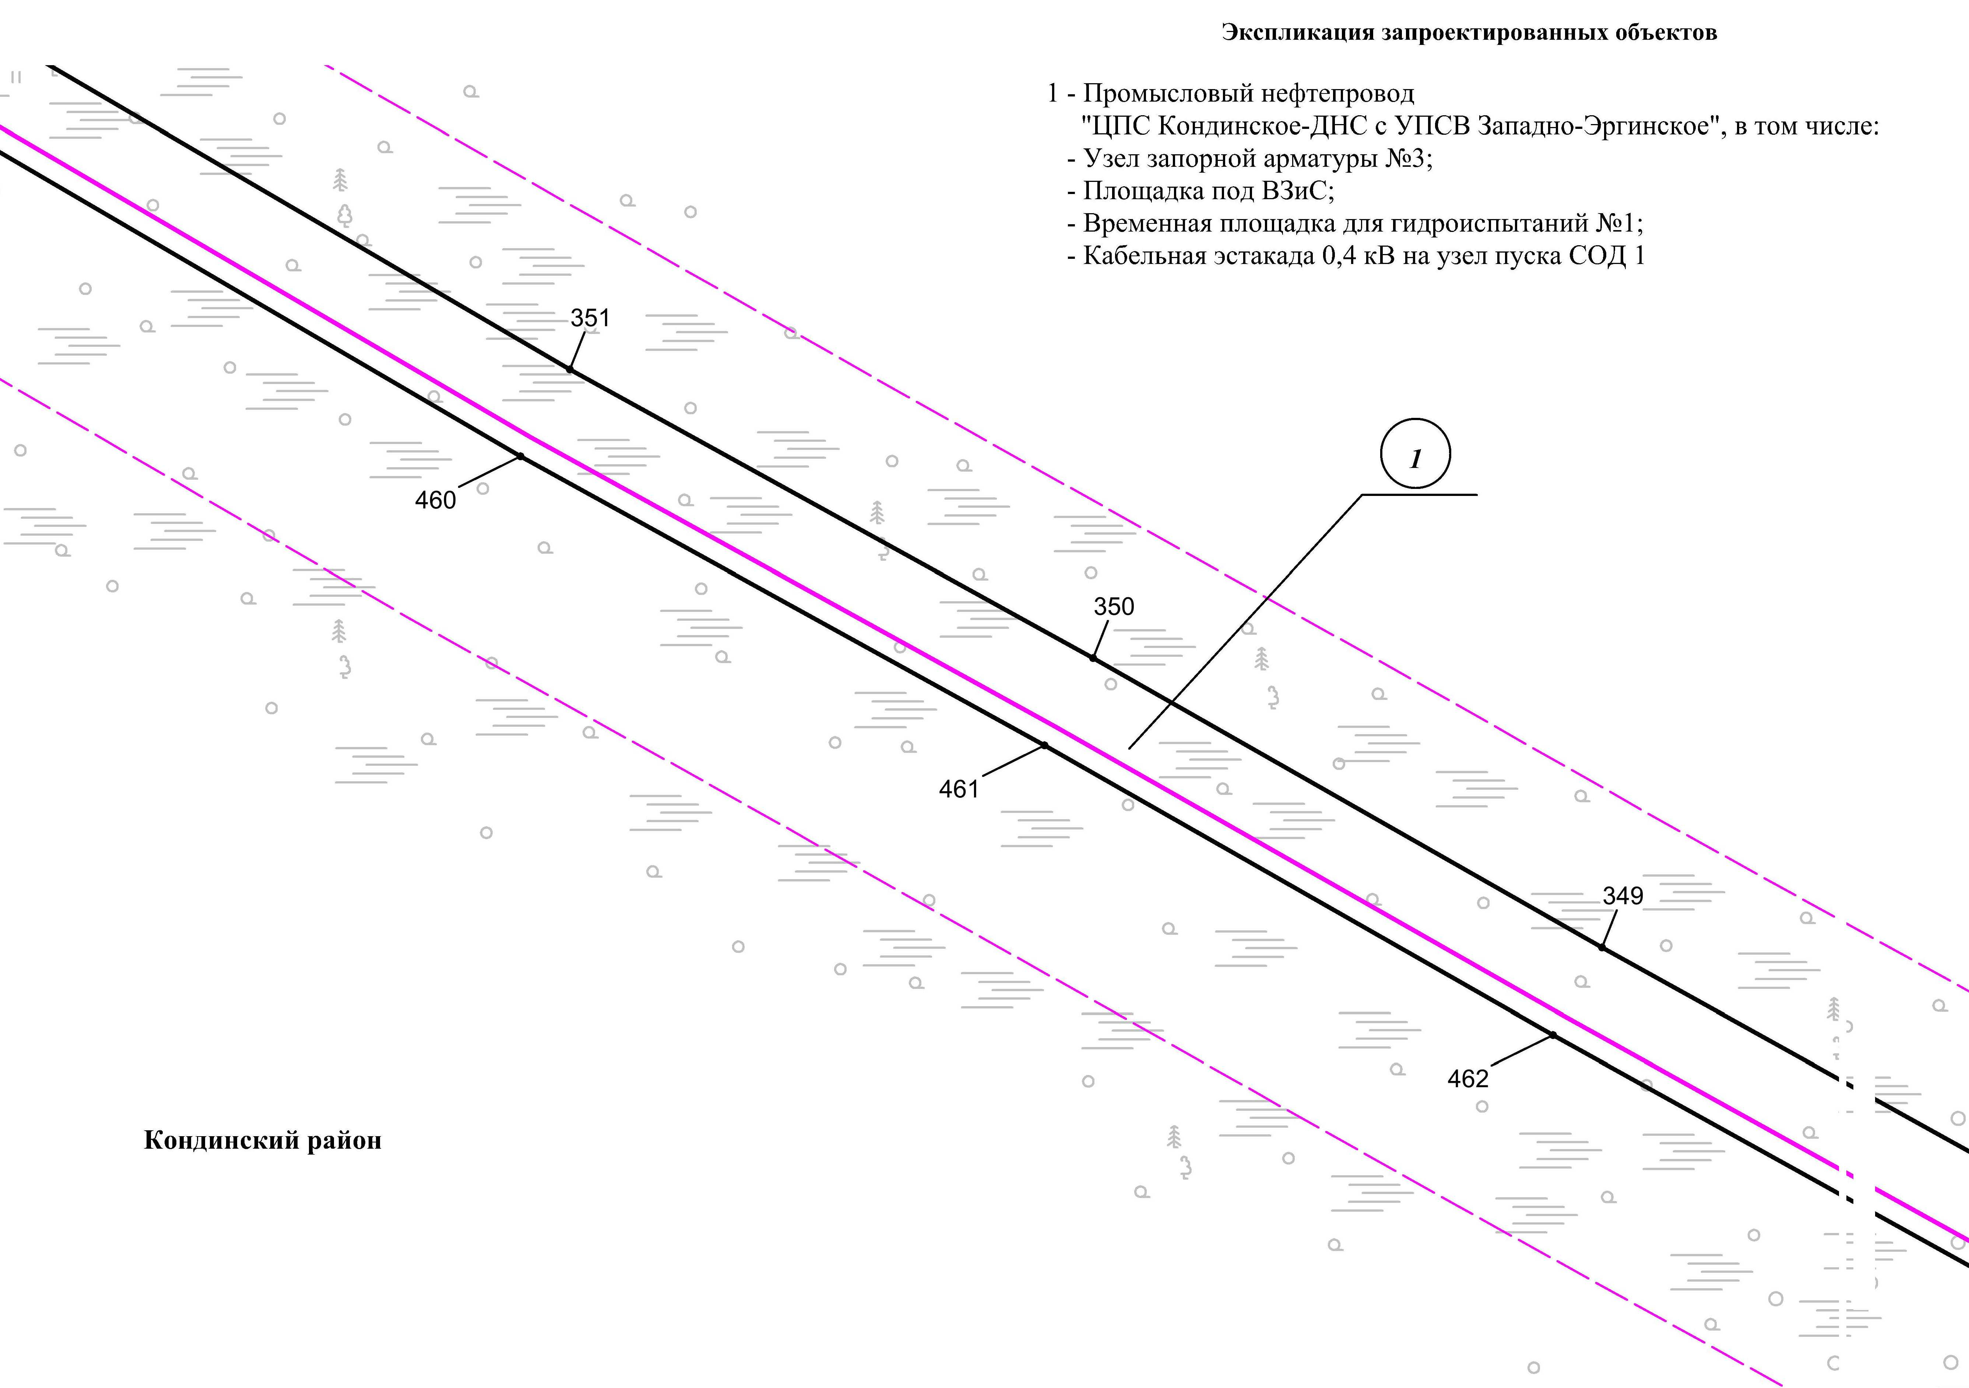
Линия совмещения с листом
2
4

Основная часть проекта планировки территории для размещения объекта капитального строительства, расположенного на территории двух муниципальных образований
Ханты-Мансийского автономного округа – Югры,
«Промысловый нефтепровод «ЦПС Кондинское - ДНС с УПСВ Западно-Эргинское»
Землепользователь: АО «НК «Конданефть»
Масштаб 1:2000

Линия совмещения с листом 24

Линия совмещения с листом
2
3

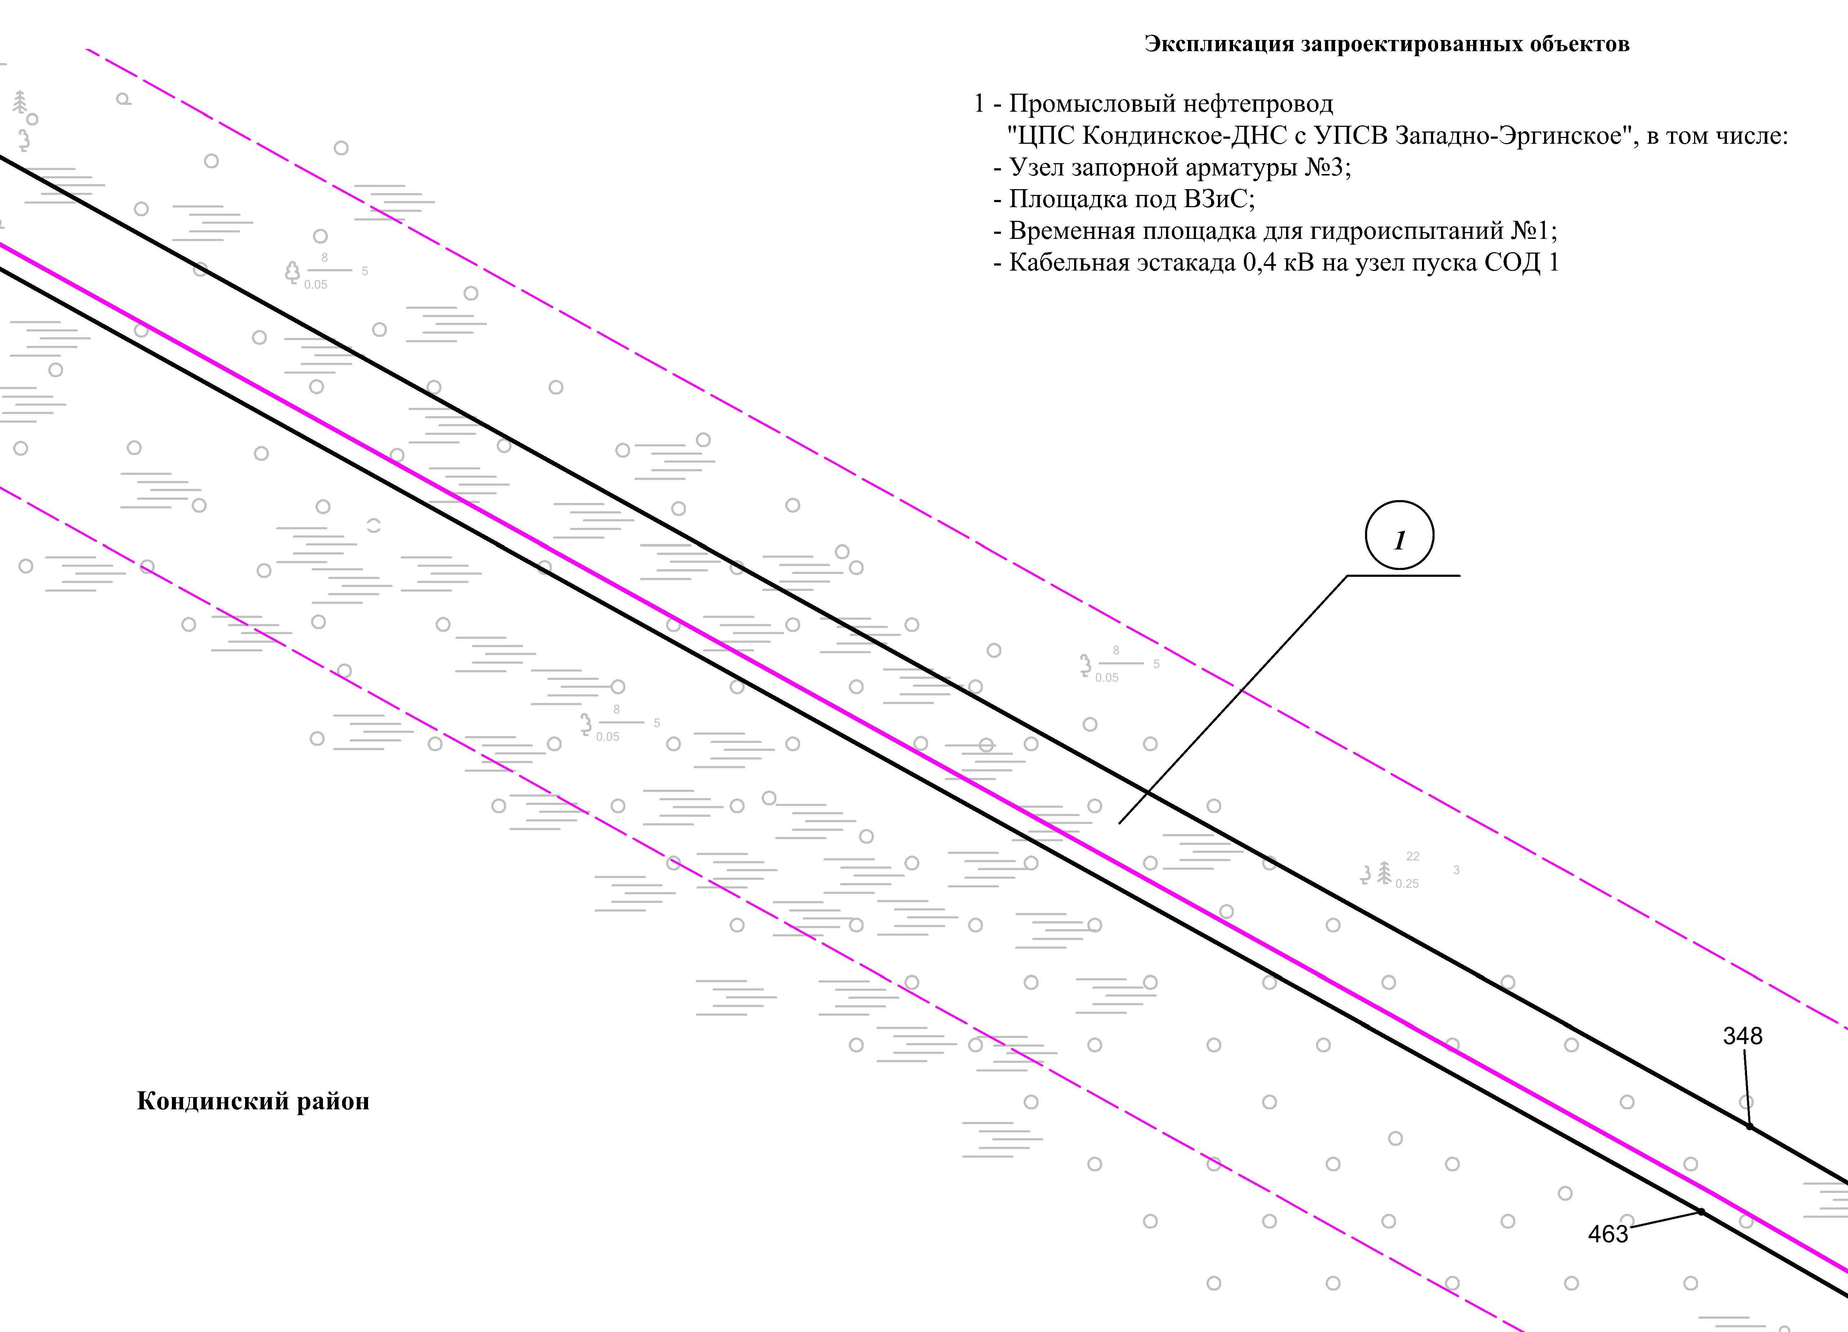
Линия совмещения с листом
2
5

Линия совмещения с листом 26

Основная часть проекта планировки территории для размещения объекта капитального строительства, расположенного на территории двух муниципальных образований
Ханты-Мансийского автономного округа – Югры,
«Промысловый нефтепровод «ЦПС Кондинское - ДНС с УПСВ Западно-Эргинское»
Землепользователь: АО «НК «Конданефть»
Масштаб 1:2000

Линия совмещения с листом
2
4

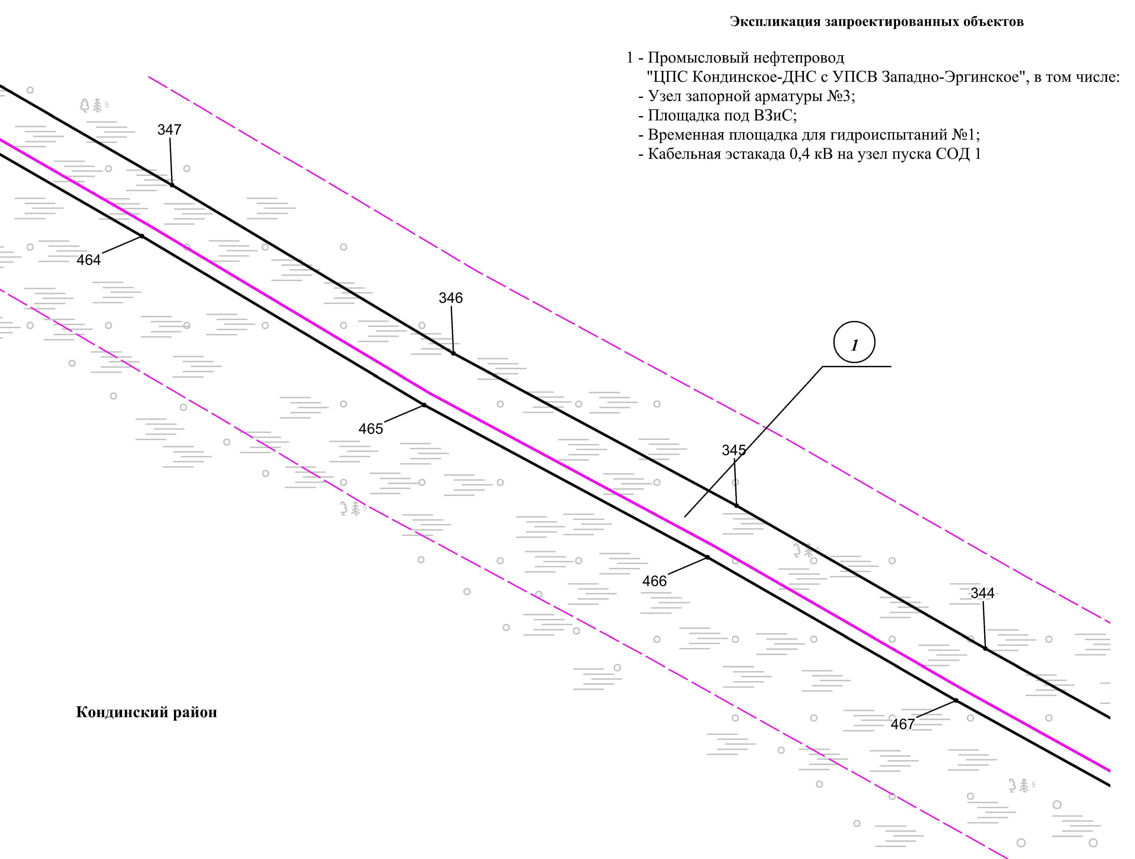
Линия совмещения с листом
2
6

Основная часть проекта планировки территории для размещения объекта капитального строительства, расположенного на территории двух муниципальных образований
Ханты-Мансийского автономного округа – Югры,
«Промысловый нефтепровод «ЦПС Кондинское - ДНС с УПСВ Западно-Эргинское»
Землепользователь: АО «НК «Конданефть»
Масштаб 1:2000

Линия совмещения с листом
2
6

Линия совмещения с листом
2
6

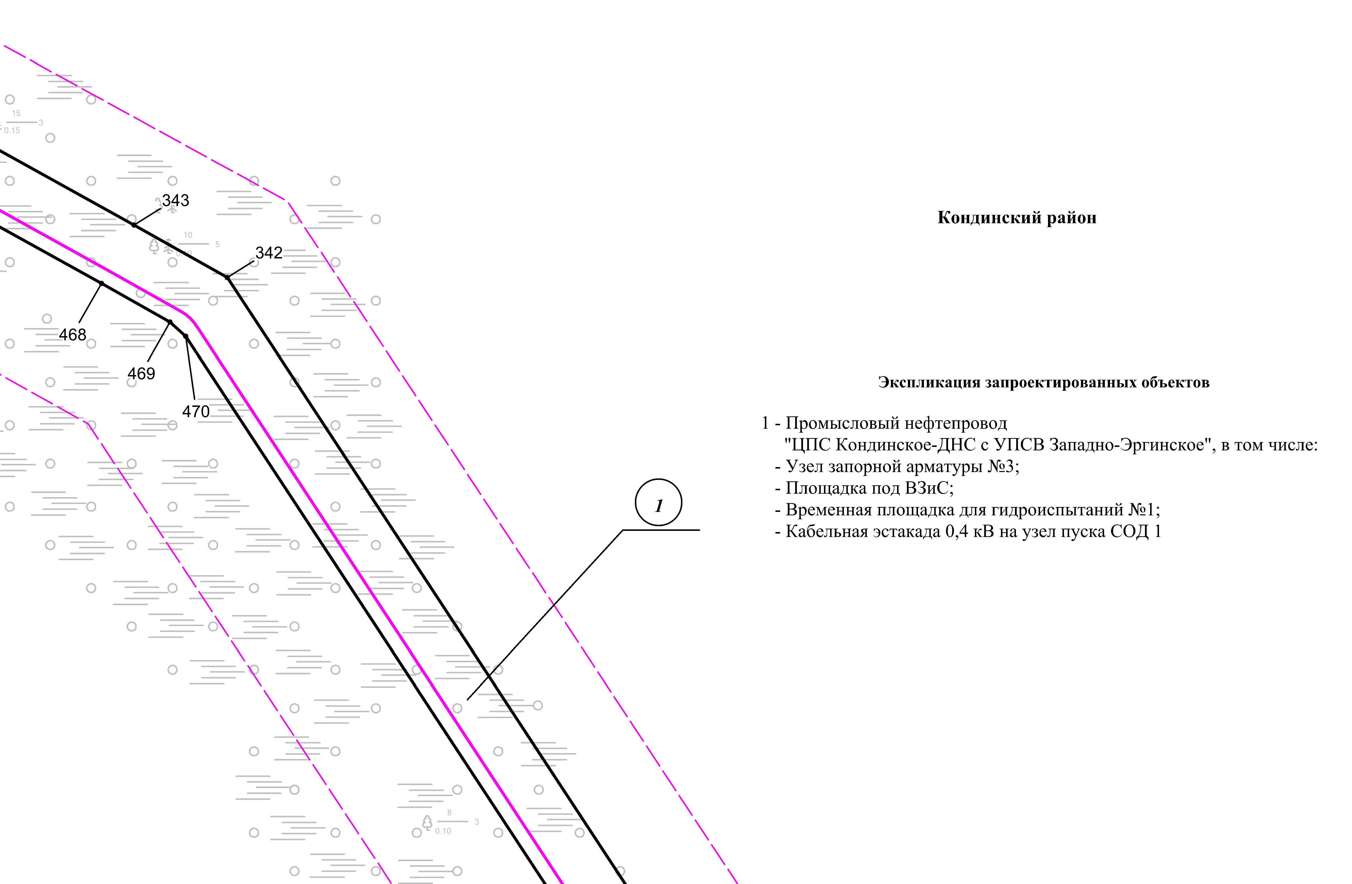

Линия совмещения с листом 28

Основная часть проекта планировки территории для размещения объекта капитального строительства, расположенного на территории двух муниципальных образований
Ханты-Мансийского автономного округа – Югры,
«Промысловый нефтепровод «ЦПС Кондинское - ДНС с УПСВ Западно-Эргинское»
Землепользователь: АО «НК «Конданефть»
Масштаб 1:2000

Линия совмещения с листом 26
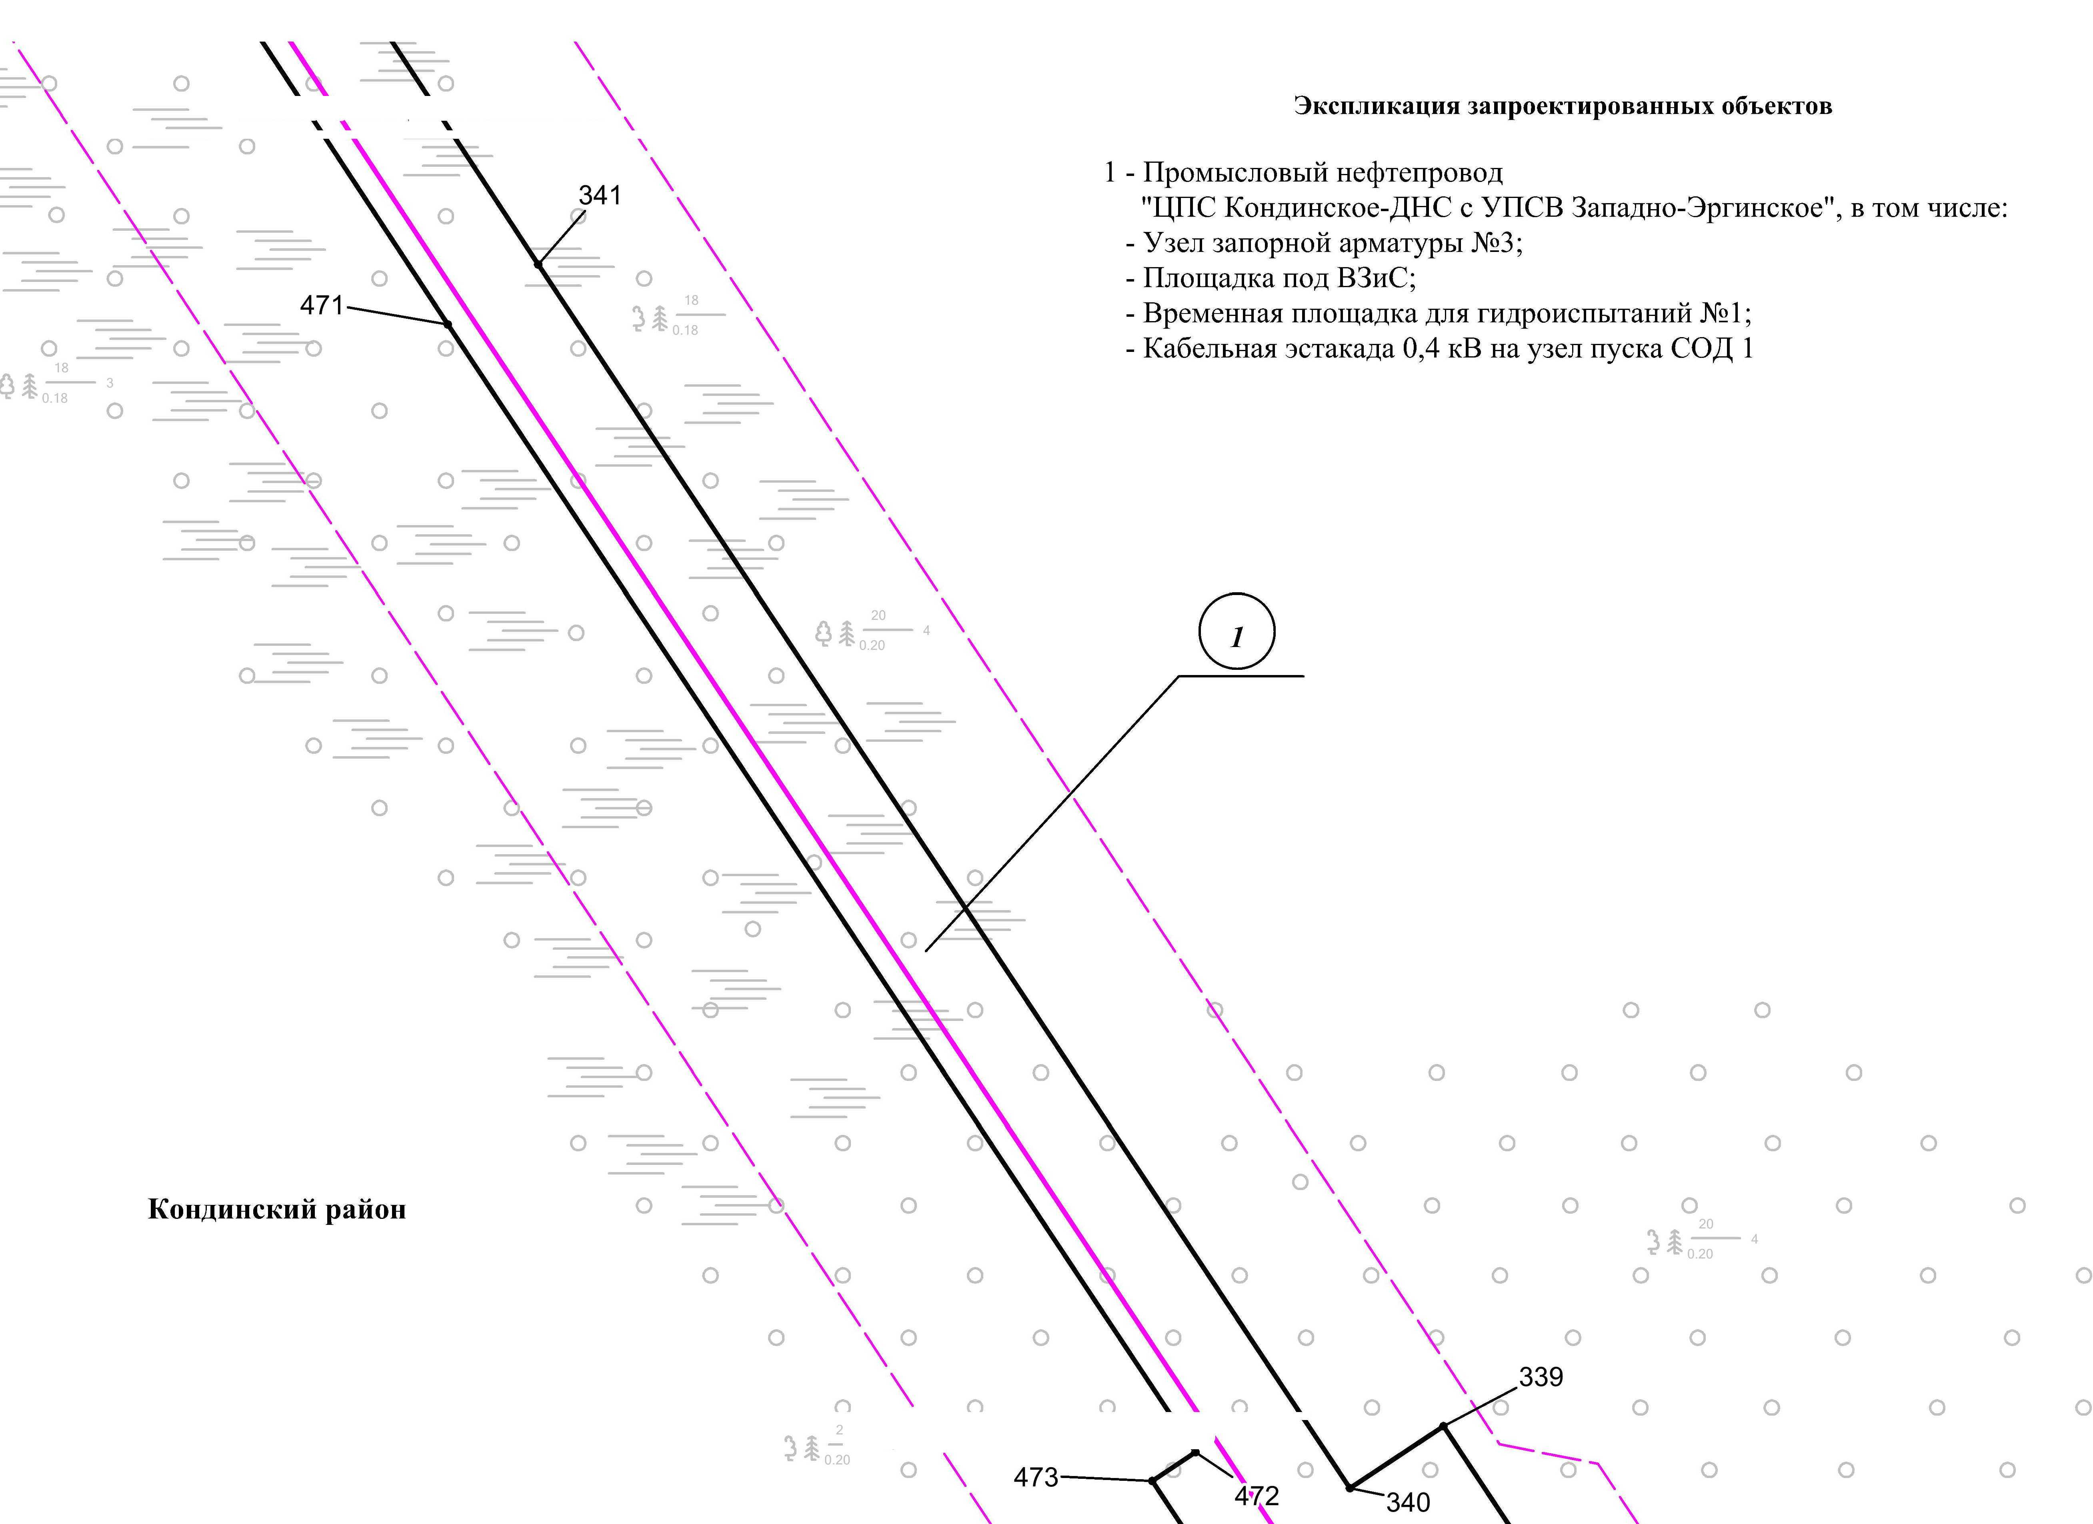

Линия совмещения с листом 28

Основная часть проекта планировки территории для размещения объекта капитального строительства, расположенного на территории двух муниципальных образований
Ханты-Мансийского автономного округа – Югры,
«Промысловый нефтепровод «ЦПС Кондинское - ДНС с УПСВ Западно-Эргинское»
Землепользователь: АО «НК «Конданефть»
Масштаб 1:2000

Линия совмещения с листом
28

Линия совмещения с листом
30

Линия совмещения с листом 27
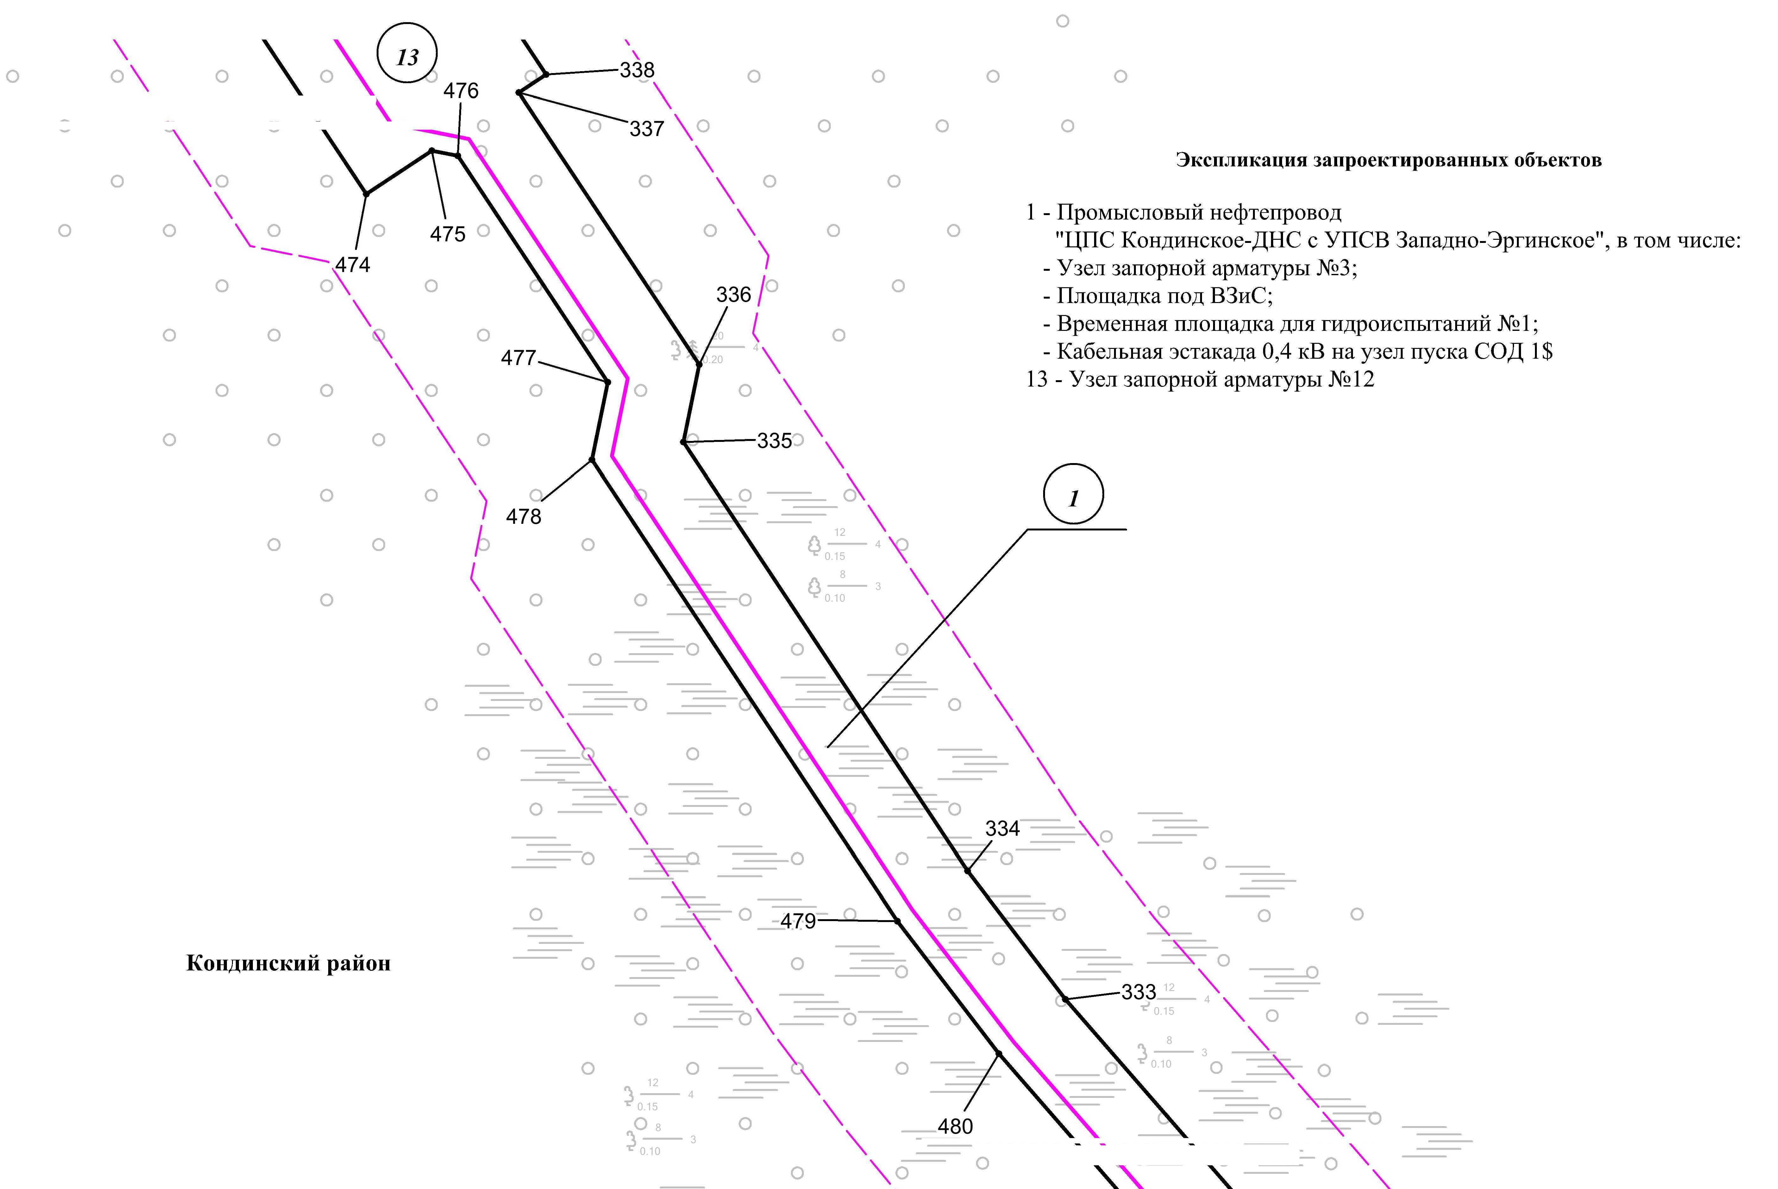

Линия совмещения с листом 29

Основная часть проекта планировки территории для размещения объекта капитального строительства, расположенного на территории двух муниципальных образований
Ханты-Мансийского автономного округа – Югры,
«Промысловый нефтепровод «ЦПС Кондинское - ДНС с УПСВ Западно-Эргинское»
Землепользователь: АО «НК «Конданефть»
Масштаб 1:2000

Линия совмещения с листом 28
Линия совмещения с листом
29

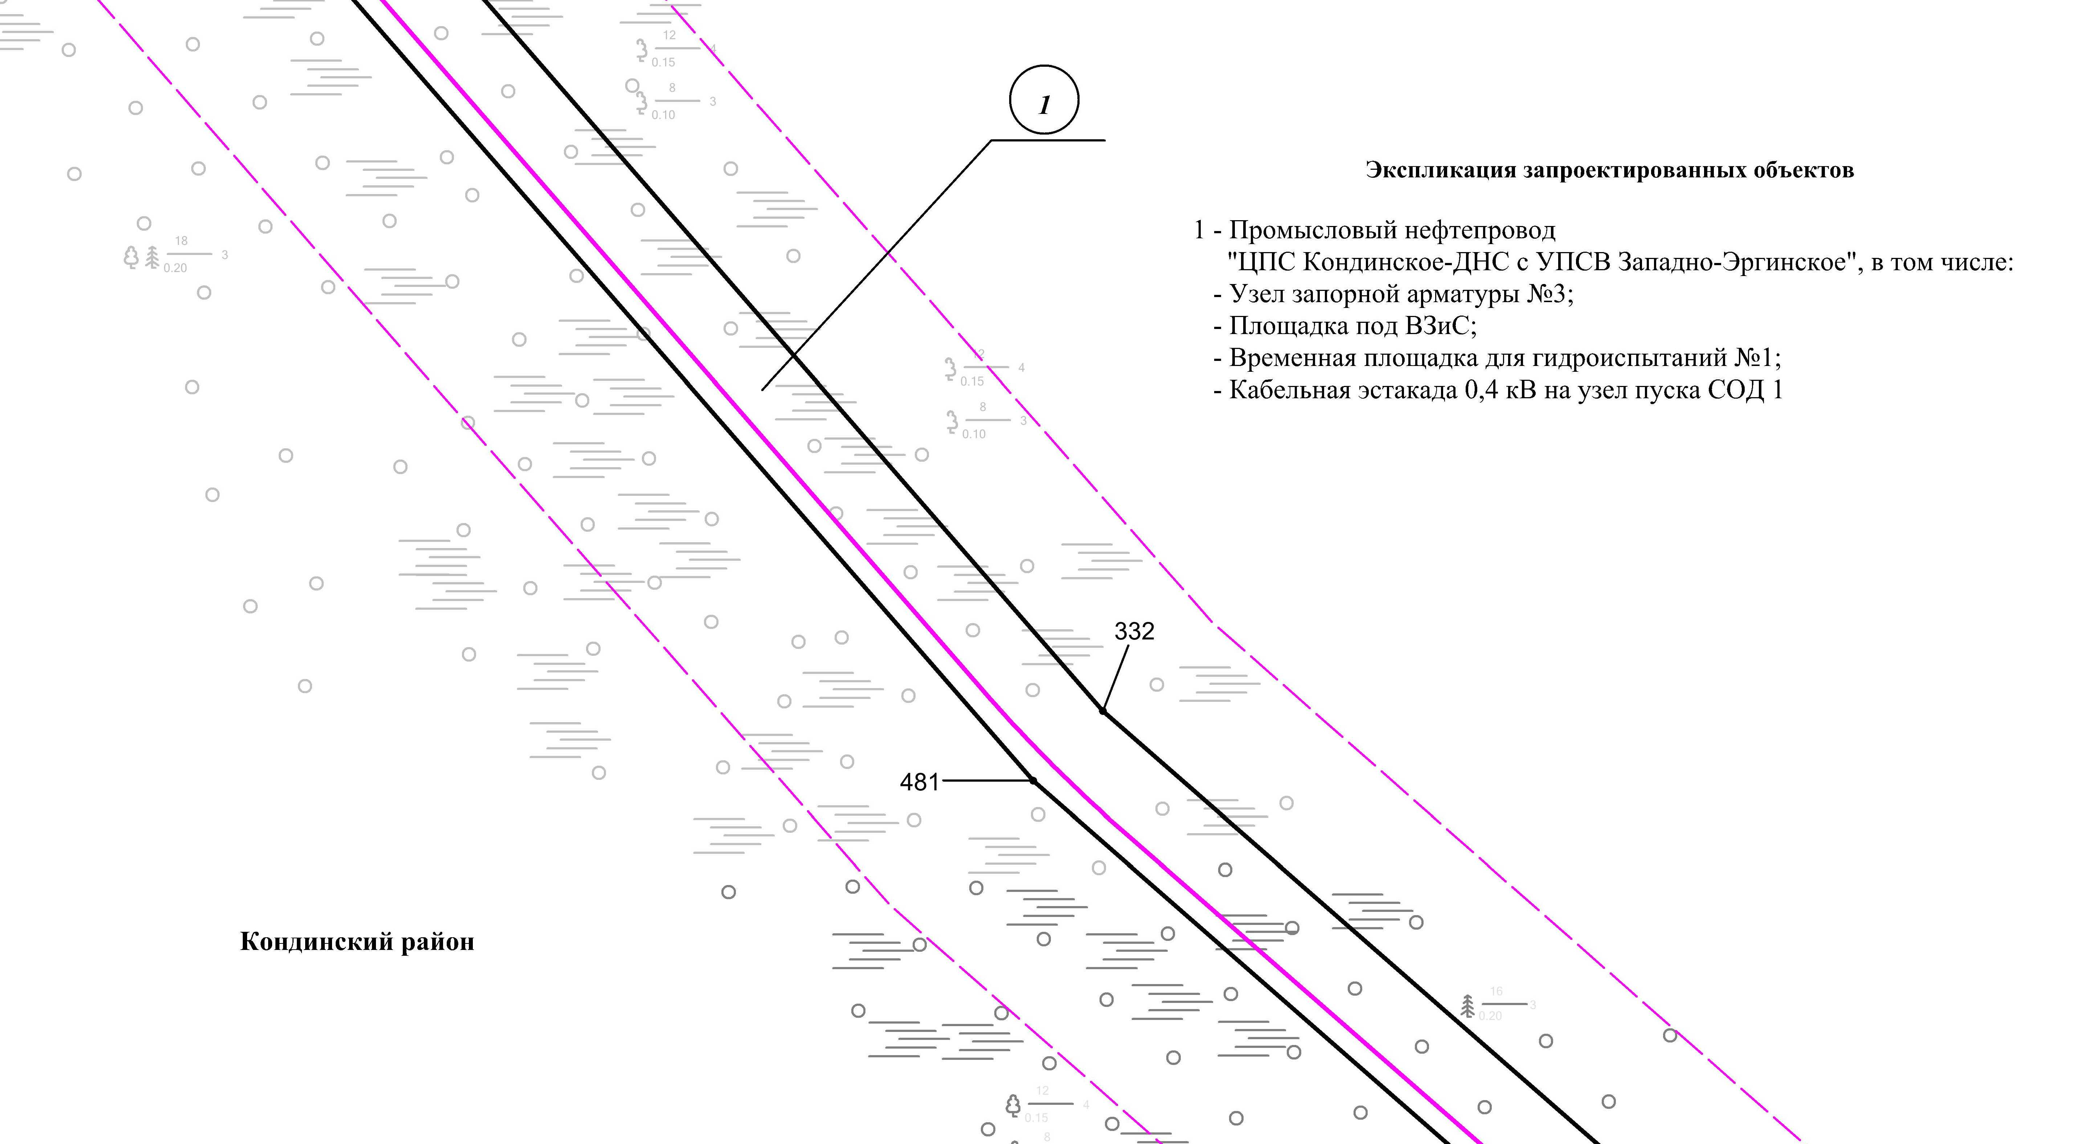
Линия совмещения с листом
31

Линия совмещения с листом 30
Линия совмещения с листом 31

Основная часть проекта планировки территории для размещения объекта капитального строительства, расположенного на территории двух муниципальных образований
Ханты-Мансийского автономного округа – Югры,
«Промысловый нефтепровод «ЦПС Кондинское-ДНС с УПСВ Западно-Эргинское»
Землепользователь: АО «НК «Конданефть»
Масштаб 1:2000

Линия совмещения с листом
30

Линия совмещения с листом 29
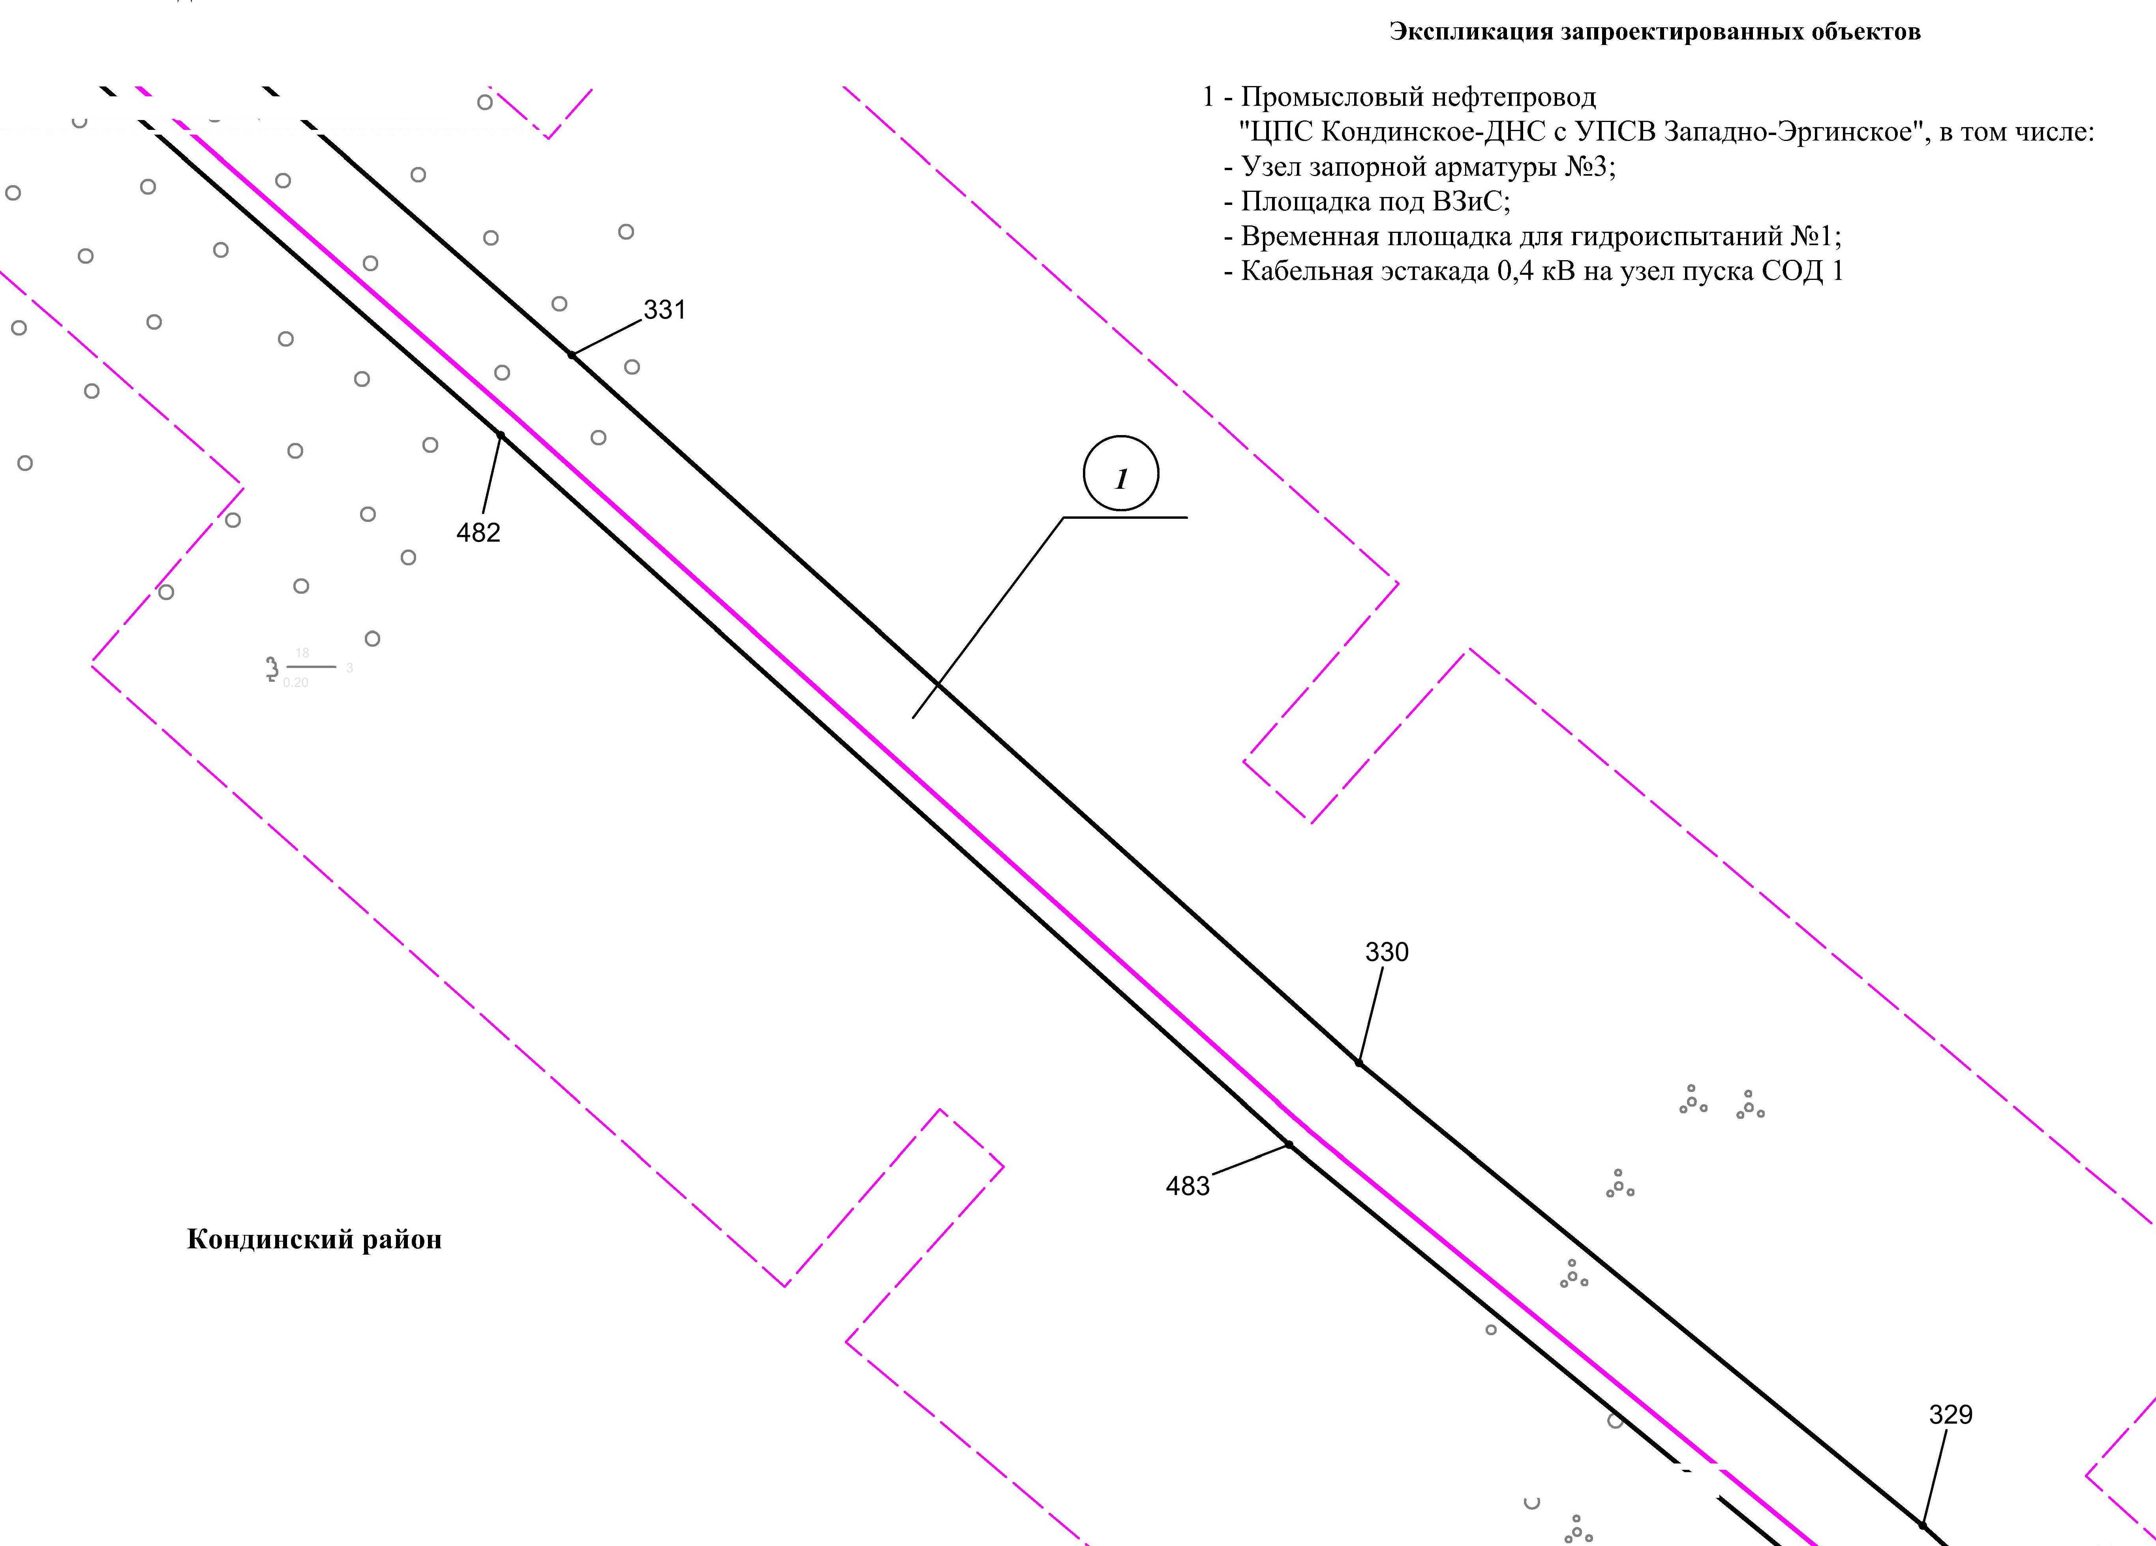

Линия совмещения с листом 31

Основная часть проекта планировки территории для размещения объекта капитального строительства, расположенного на территории двух муниципальных образований
Ханты-Мансийского автономного округа – Югры,
«Промысловый нефтепровод «ЦПС Кондинское-ДНС с УПСВ Западно-Эргинское»
Землепользователь: АО «НК «Конданефть»
Масштаб 1:2000

Линия совмещения с листом
31

Линия совмещения с листом
31

Линия совмещения с листом 30
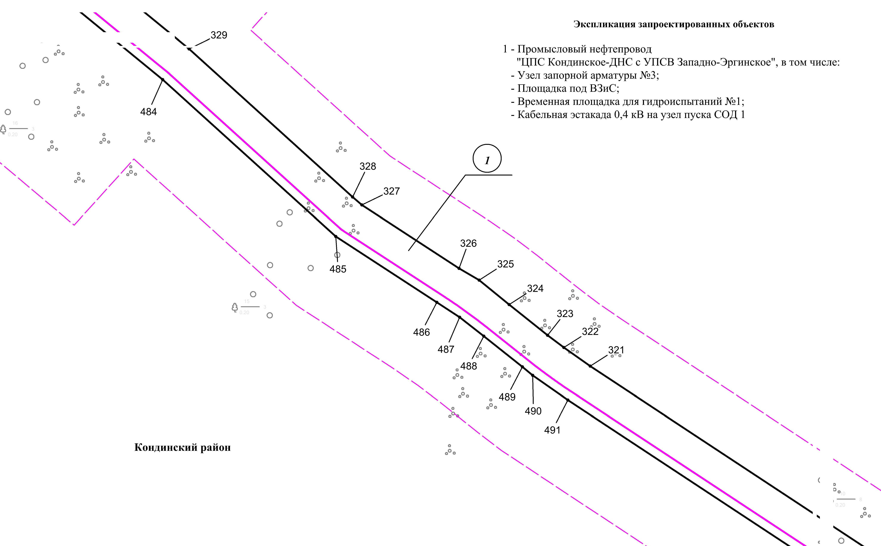
Линия совмещения с листом 32

Линия совмещения с листом 33

Основная часть проекта планировки территории для размещения объекта капитального строительства, расположенного на территории двух муниципальных образований
Ханты-Мансийского автономного округа – Югры,
«Промысловый нефтепровод «ЦПС Кондинское - ДНС с УПСВ Западно-Эргинское»
Землепользователь: АО «НК «Конданефть»
Масштаб 1:2000

Линия совмещения с листом
32

Линия совмещения с листом
31

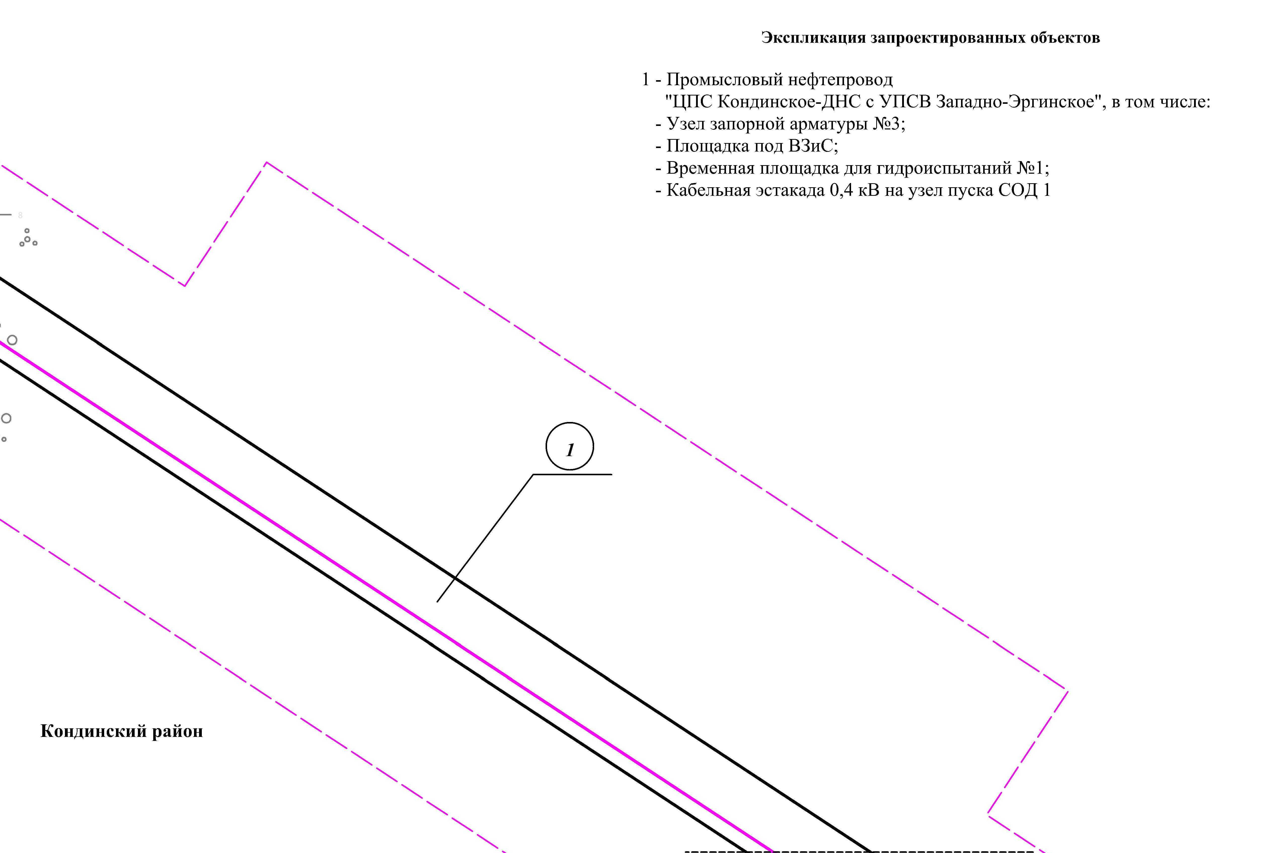

Линия совмещения с листом 33

Основная часть проекта планировки территории для размещения объекта капитального строительства, расположенного на территории двух муниципальных образований
Ханты-Мансийского автономного округа – Югры,
«Промысловый нефтепровод «ЦПС Кондинское - ДНС с УПСВ Западно-Эргинское»
Землепользователь: АО «НК «Конданефть»
Масштаб 1:2000

Линия совмещения с листом
33

Линия совмещения с листом
32

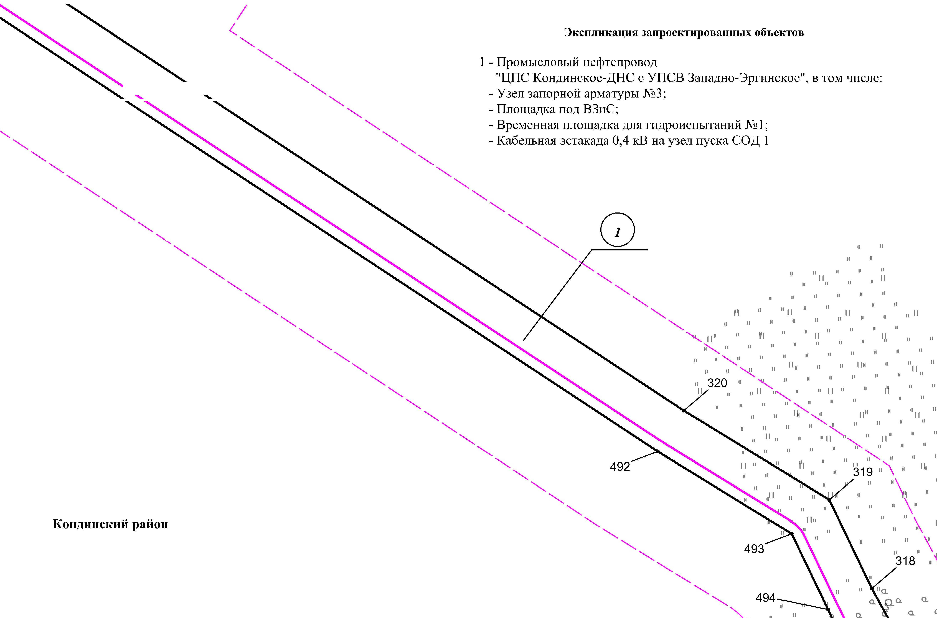

Линия совмещения с листом
35

Линия совмещения с листом 34

Основная часть проекта планировки территории для размещения объекта капитального строительства, расположенного на территории двух муниципальных образований
Ханты-Мансийского автономного округа – Югры,
«Промысловый нефтепровод «ЦПС Кондинское - ДНС с УПСВ Западно-Эргинское»
Землепользователь: АО «НК «Конданефть»
Масштаб 1:2000

Линия совмещения с листом
34

Линия совмещения с листом 33
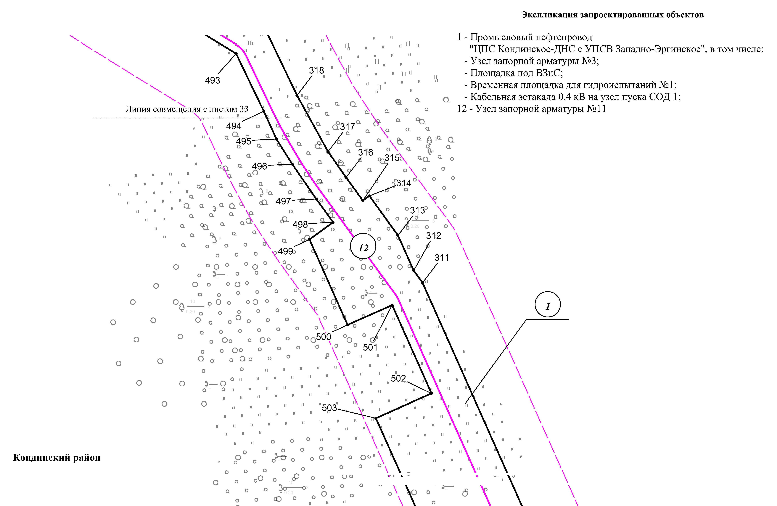

Линия совмещения с листом 35

Основная часть проекта планировки территории для размещения объекта капитального строительства, расположенного на территории двух муниципальных образований
Ханты-Мансийского автономного округа – Югры,
«Промысловый нефтепровод «ЦПС Кондинское - ДНС с УПСВ Западно-Эргинское»
Землепользователь: АО «НК «Конданефть»
Масштаб 1:2000

Линия совмещения с листом
35

Линия совмещения с листом 34
Линия совмещения с листом 36
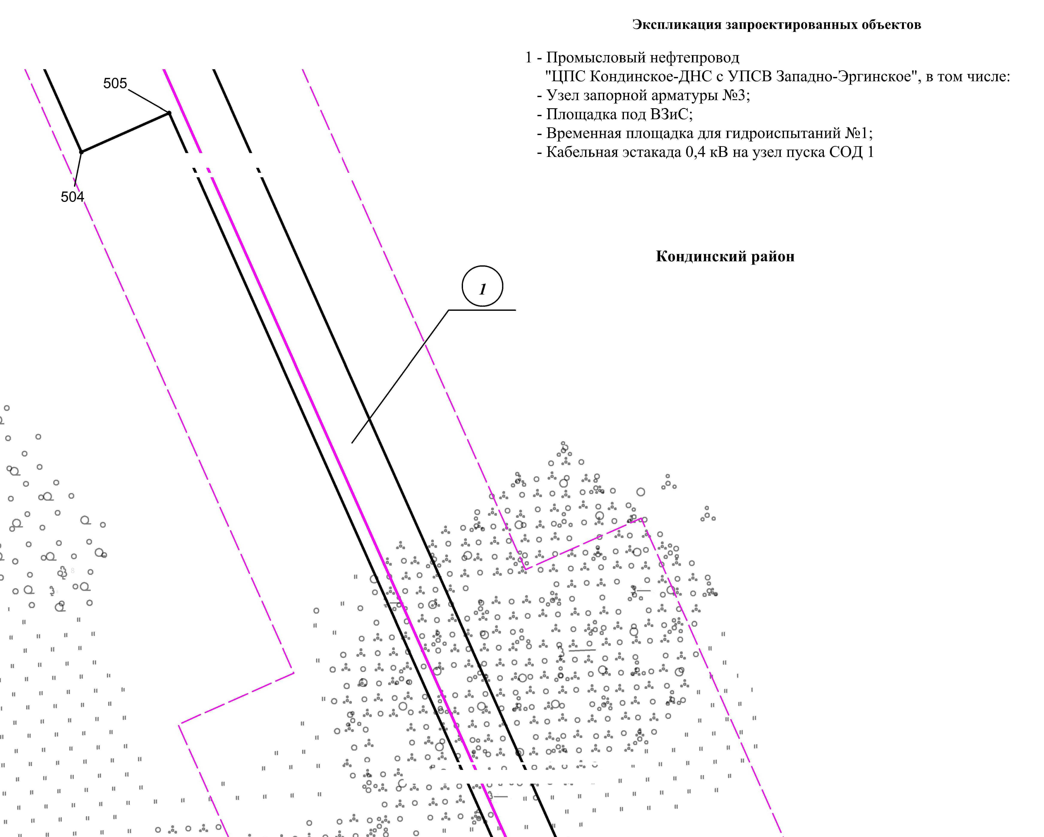

Основная часть проекта планировки территории для размещения объекта капитального строительства, расположенного на территории двух муниципальных образований
Ханты-Мансийского автономного округа – Югры,
«Промысловый нефтепровод «ЦПС Кондинское - ДНС с УПСВ Западно-Эргинское»
Землепользователь: АО «НК «Конданефть»
Масштаб 1:2000

Линия совмещения с листом
36

Линия совмещения с листом 35
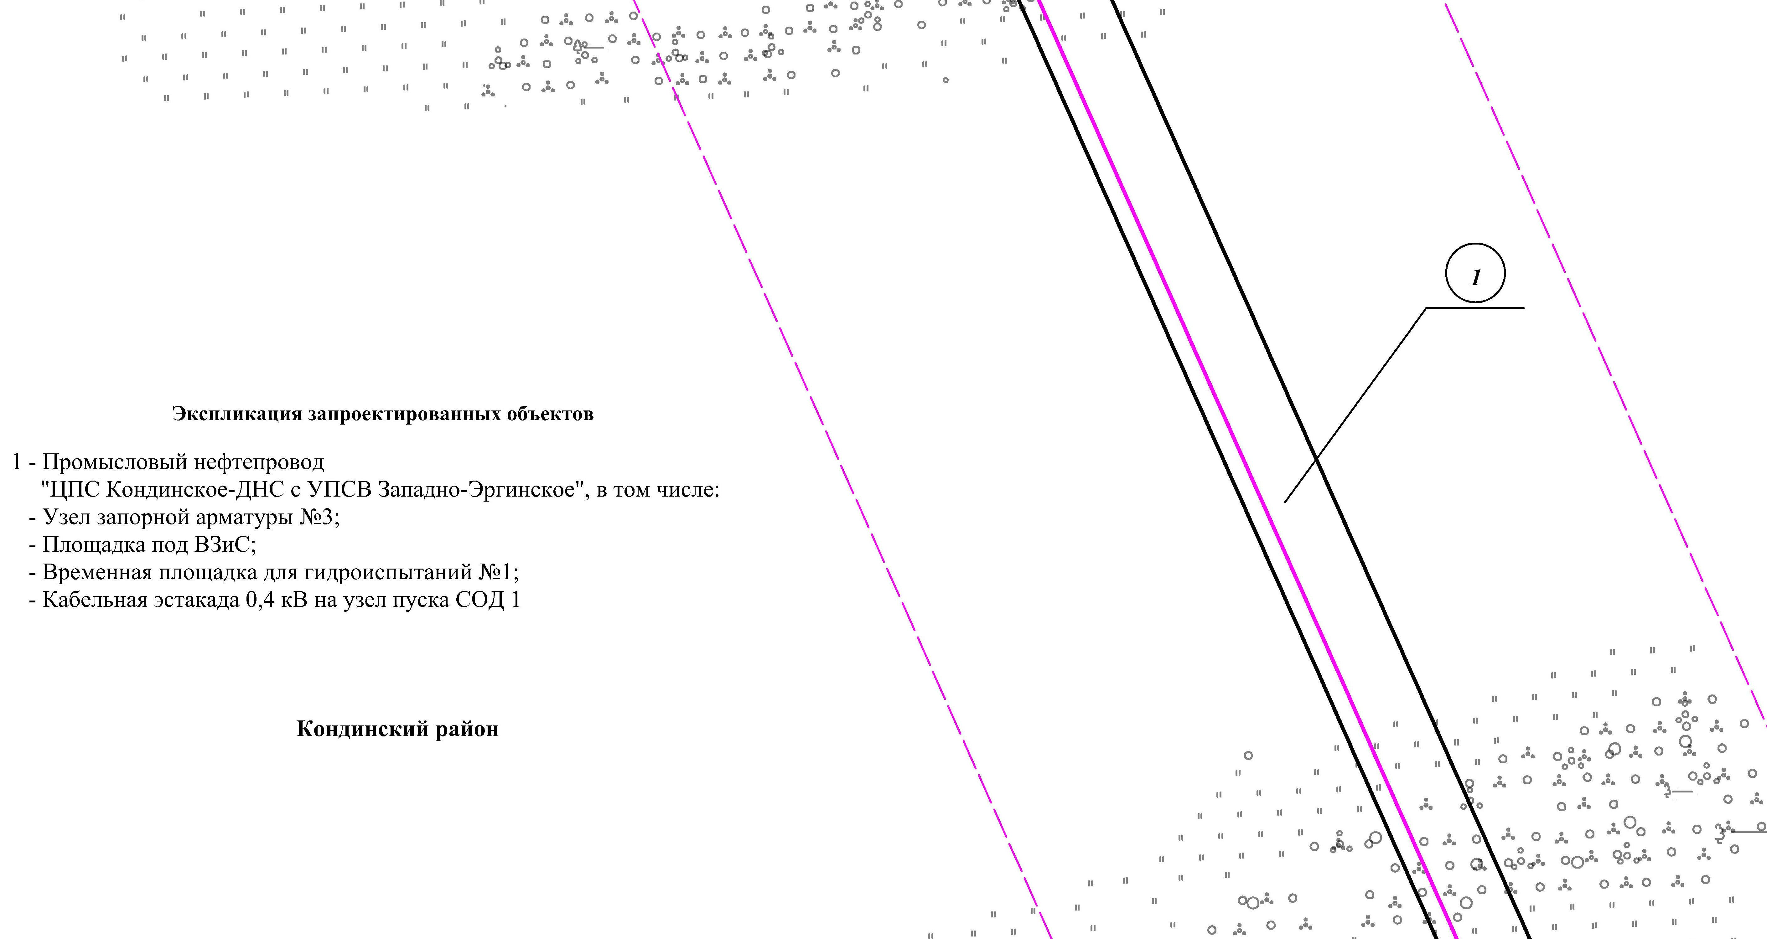

Линия совмещения с листом
38

Линия совмещения с листом 37

Основная часть проекта планировки территории для размещения объекта капитального строительства, расположенного на территории двух муниципальных образований
Ханты-Мансийского автономного округа – Югры,
«Промысловый нефтепровод «ЦПС Кондинское - ДНС с УПСВ Западно-Эргинское»
Землепользователь: АО «НК «Конданефть»
Масштаб 1:2000

Линия совмещения с листом
37

Линия совмещения с листом 36
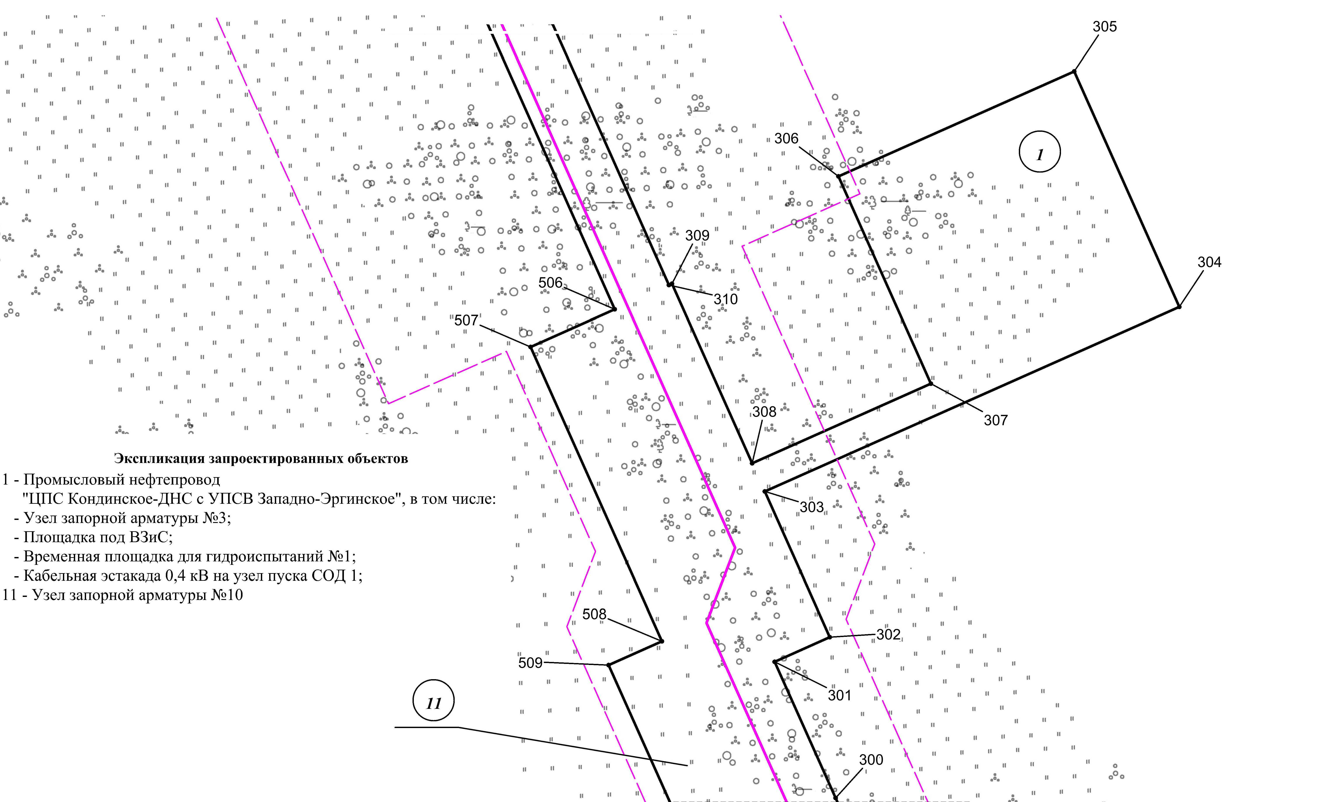
Линия совмещения с листом 39

Линия совмещения с листом 39

Основная часть проекта планировки территории для размещения объекта капитального строительства, расположенного на территории двух муниципальных образований
Ханты-Мансийского автономного округа – Югры,
«Промысловый нефтепровод «ЦПС Кондинское - ДНС с УПСВ Западно-Эргинское»
Землепользователь: АО «НК «Конданефть»
Масштаб 1:2000

Линия совмещения с листом
38

Линия совмещения с листом 37

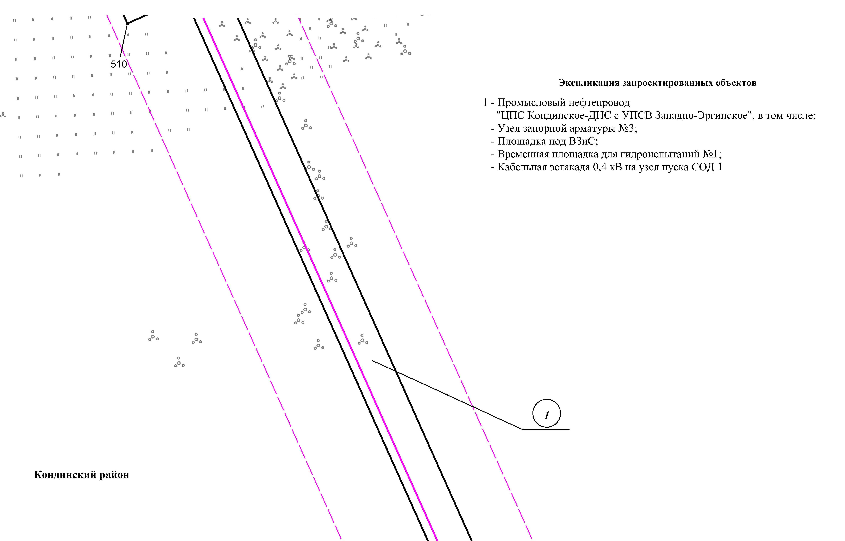

Линия совмещения с листом 39

Основная часть проекта планировки территории для размещения объекта капитального строительства, расположенного на территории двух муниципальных образований
Ханты-Мансийского автономного округа – Югры,
«Промысловый нефтепровод «ЦПС Кондинское - ДНС с УПСВ Западно-Эргинское»
Землепользователь: АО «НК «Конданефть»
Масштаб 1:2000

Линия совмещения с листом
39

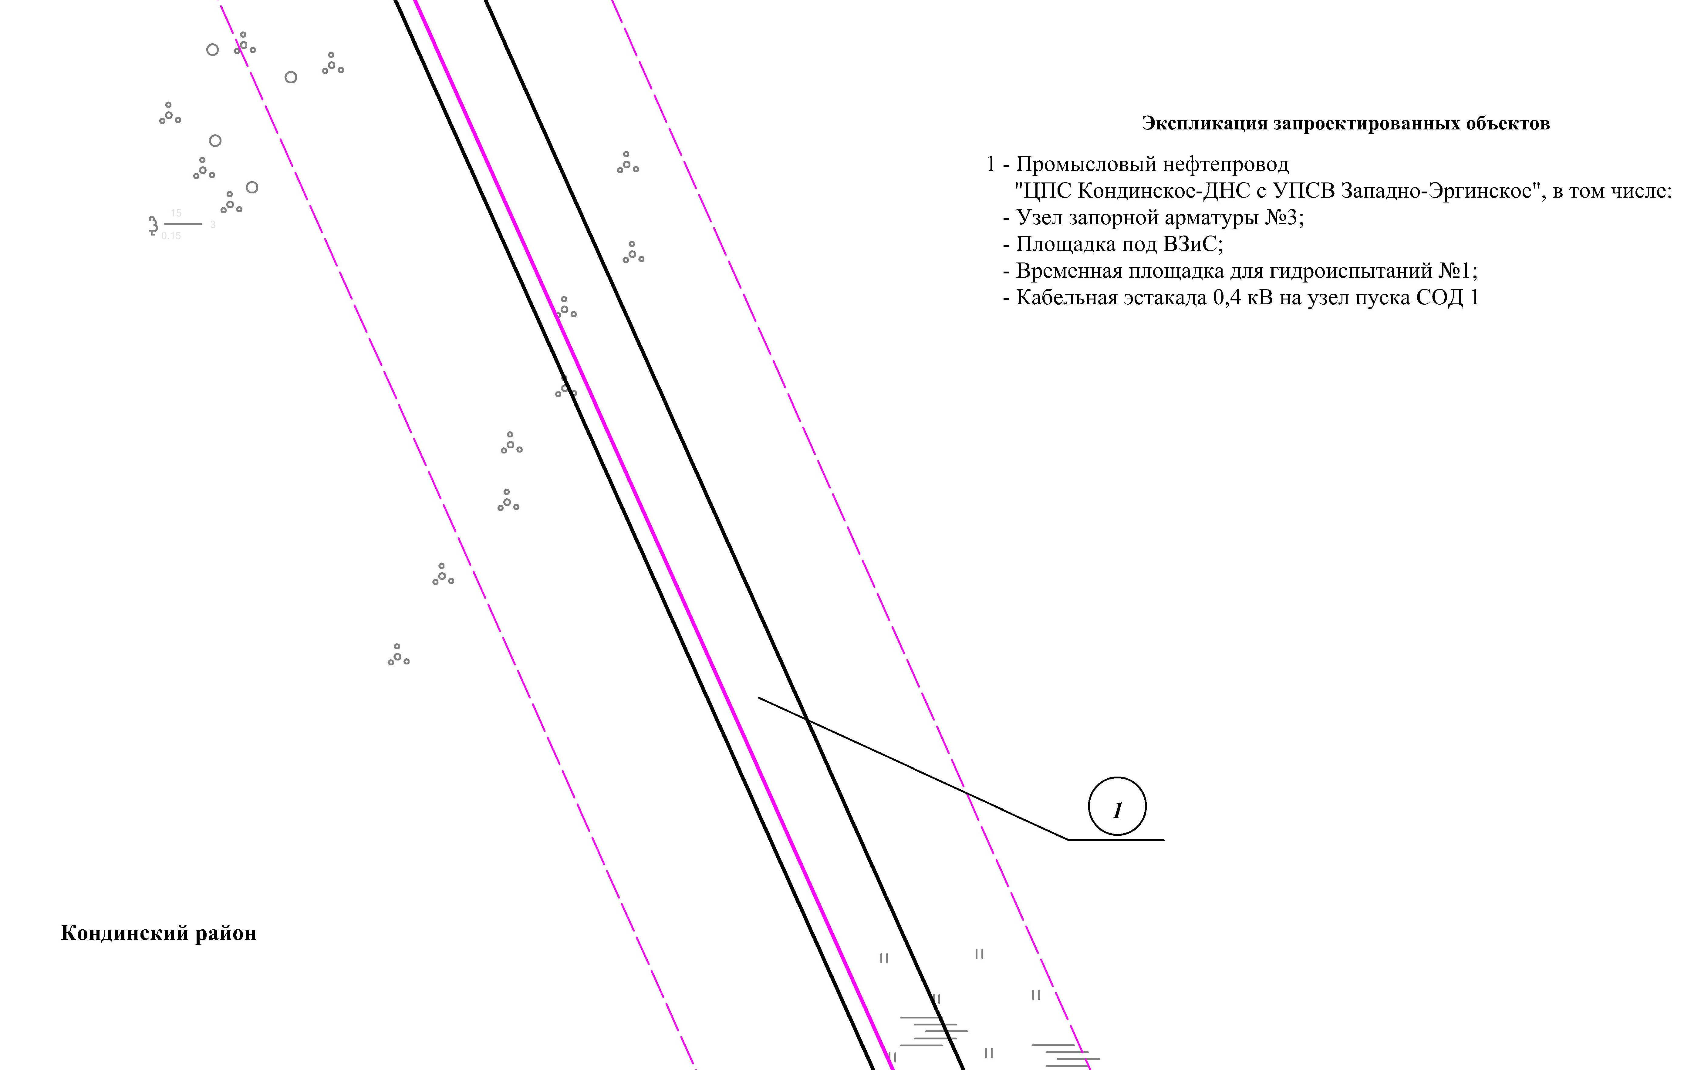
Линия совмещения с листом 38
Линия совмещения с листом 40

Основная часть проекта планировки территории для размещения объекта капитального строительства, расположенного на территории двух муниципальных образований
Ханты-Мансийского автономного округа – Югры,
«Промысловый нефтепровод «ЦПС Кондинское - ДНС с УПСВ Западно-Эргинское»
Землепользователь: АО «НК «Конданефть»
Масштаб 1:2000

Линия совмещения с листом
40

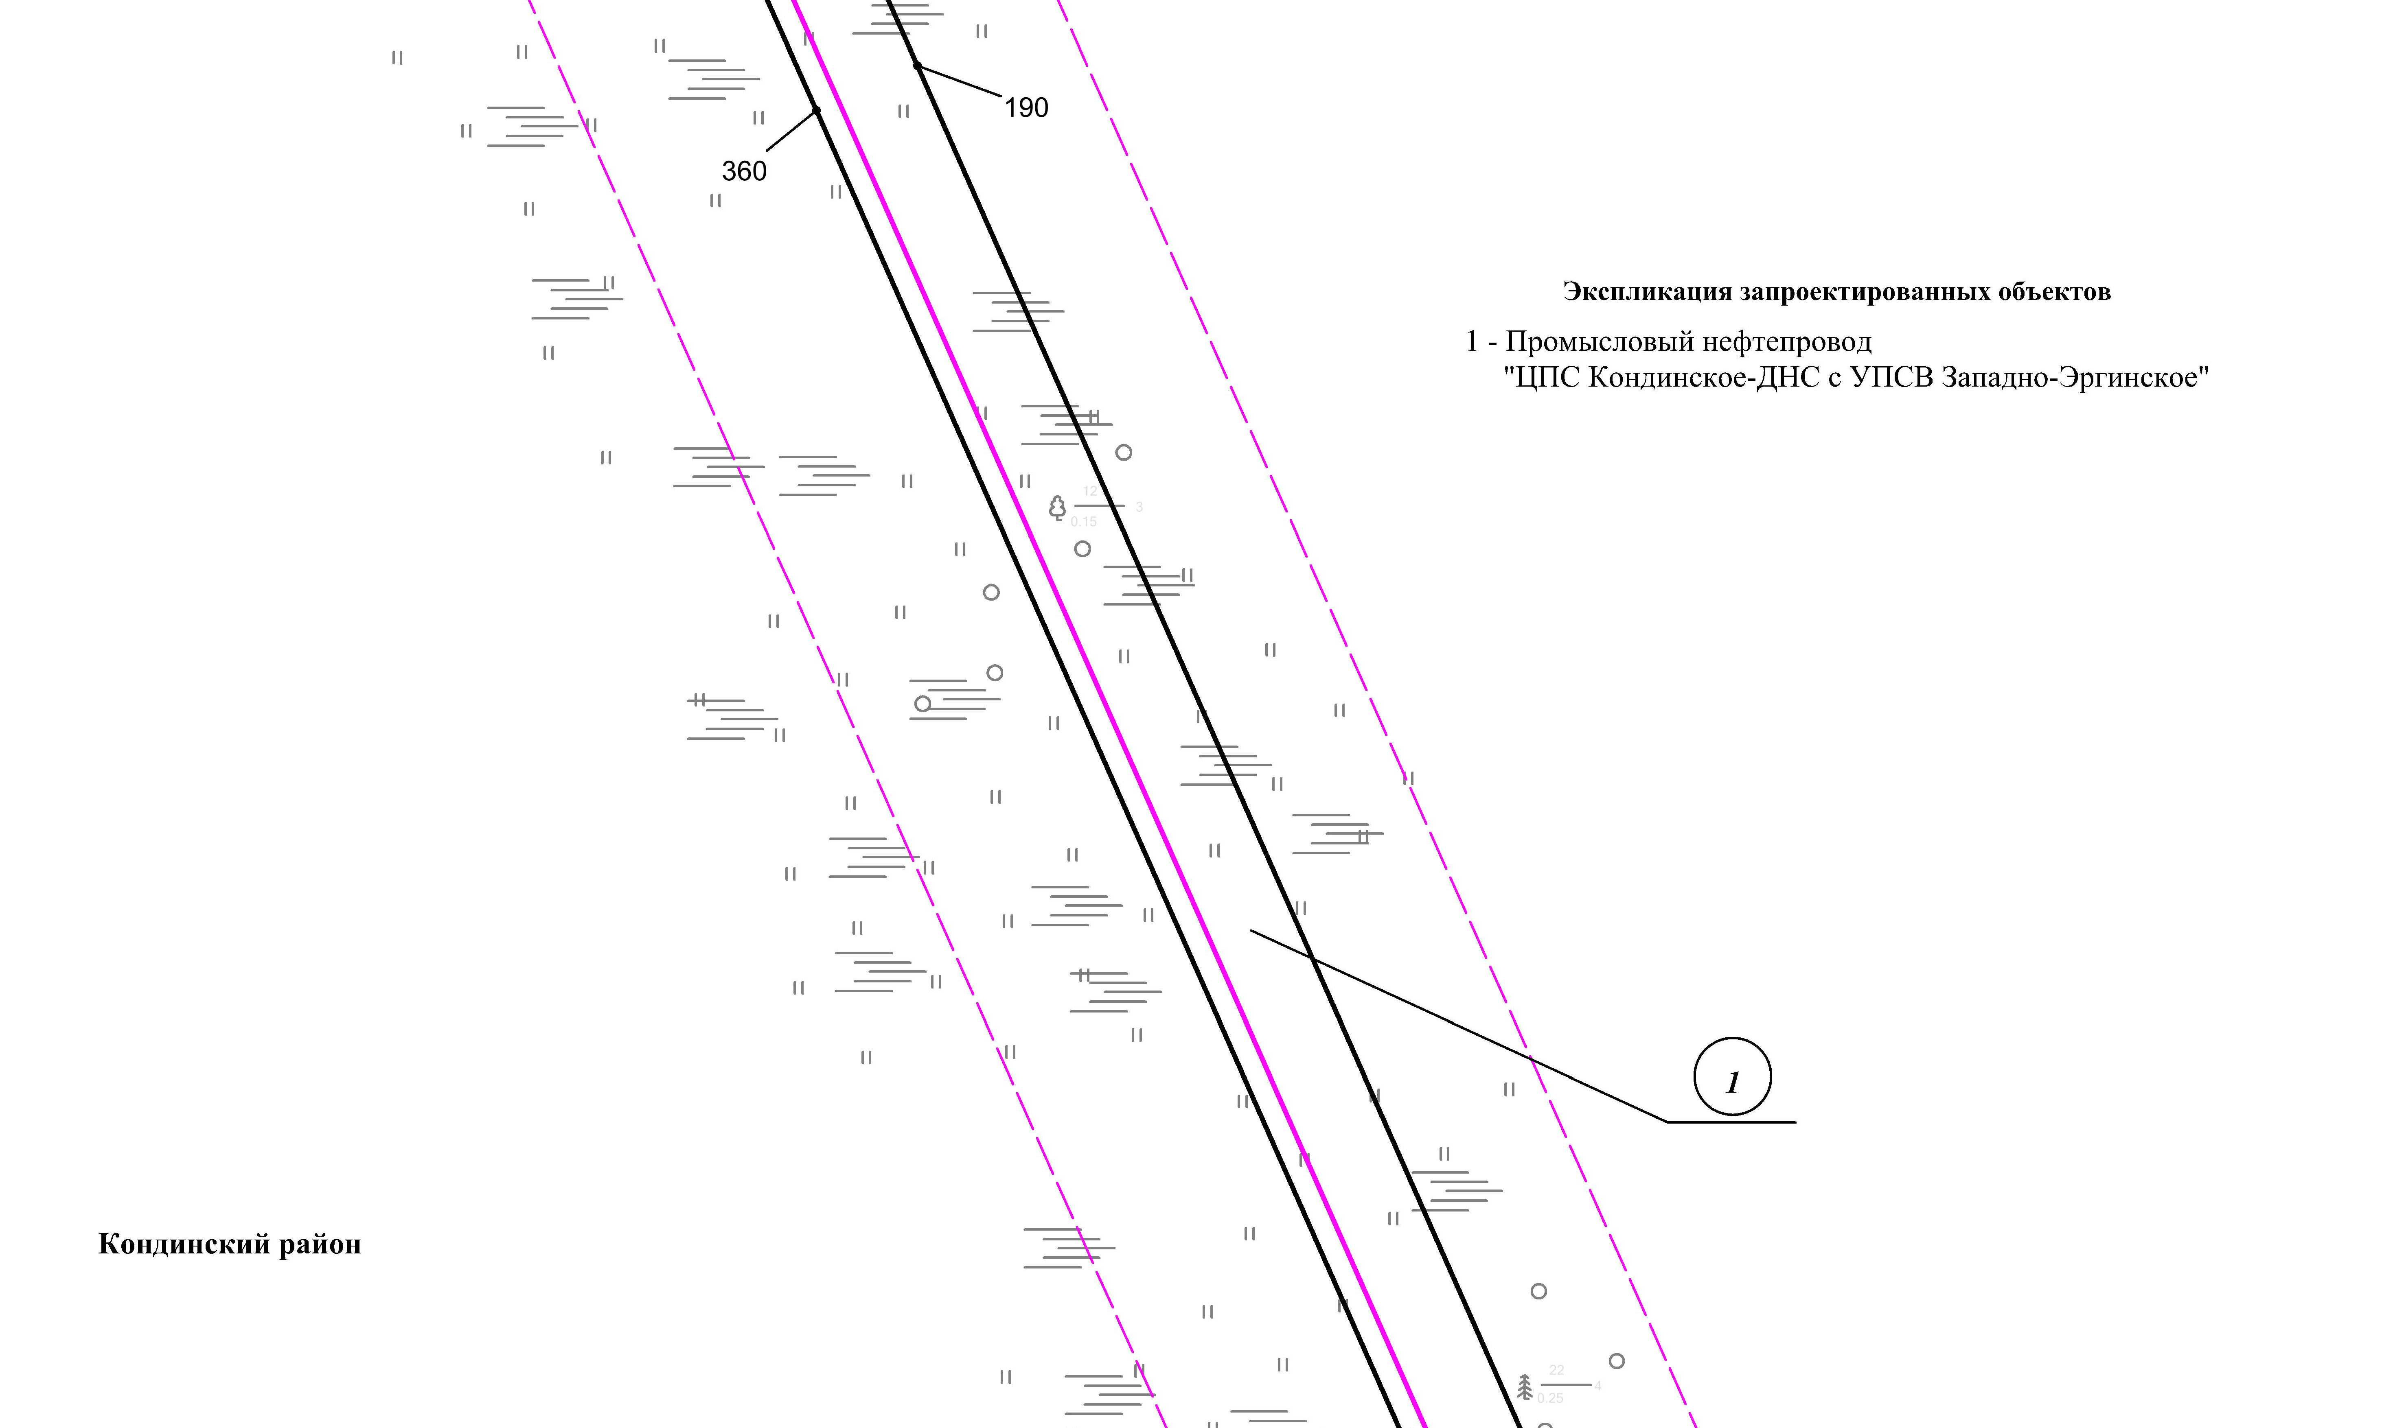
Линия совмещения с листом 41
Линия совмещения с листом 39
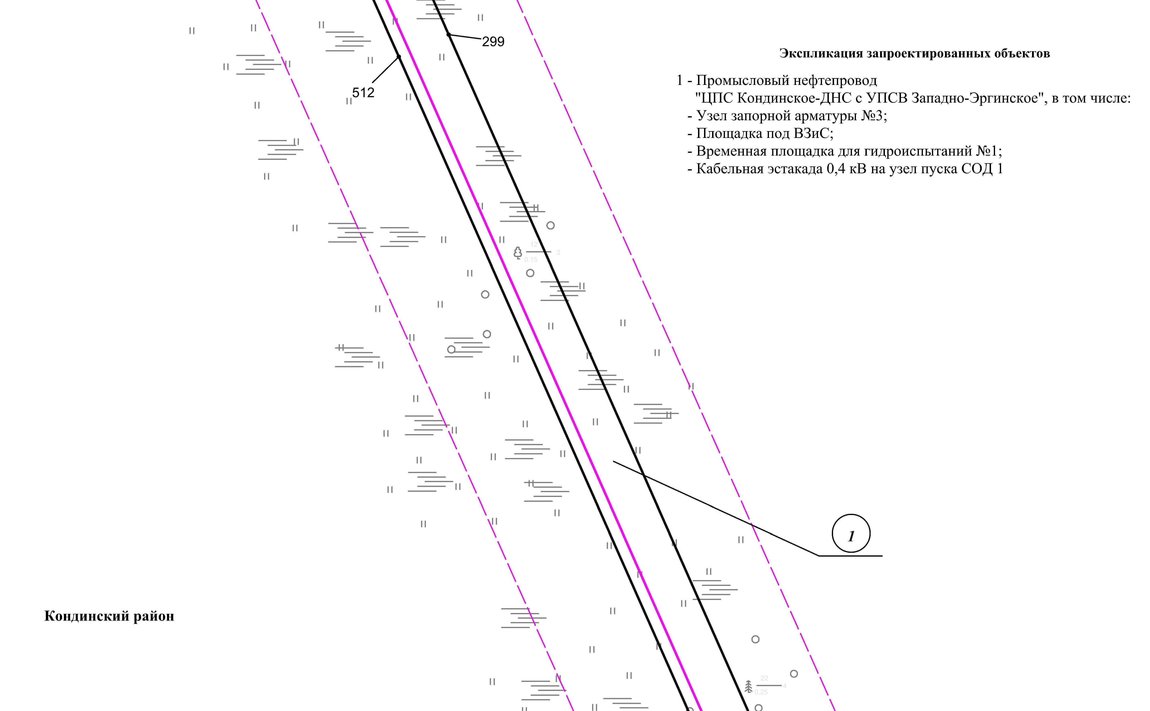

Линия совмещения с листом
43

Основная часть проекта планировки территории для размещения объекта капитального строительства, расположенного на территории двух муниципальных образований
Ханты-Мансийского автономного округа – Югры,
«Промысловый нефтепровод «ЦПС Кондинское - ДНС с УПСВ Западно-Эргинское»
Землепользователь: АО «НК «Конданефть»
Масштаб 1:2000

Линия совмещения с листом 40
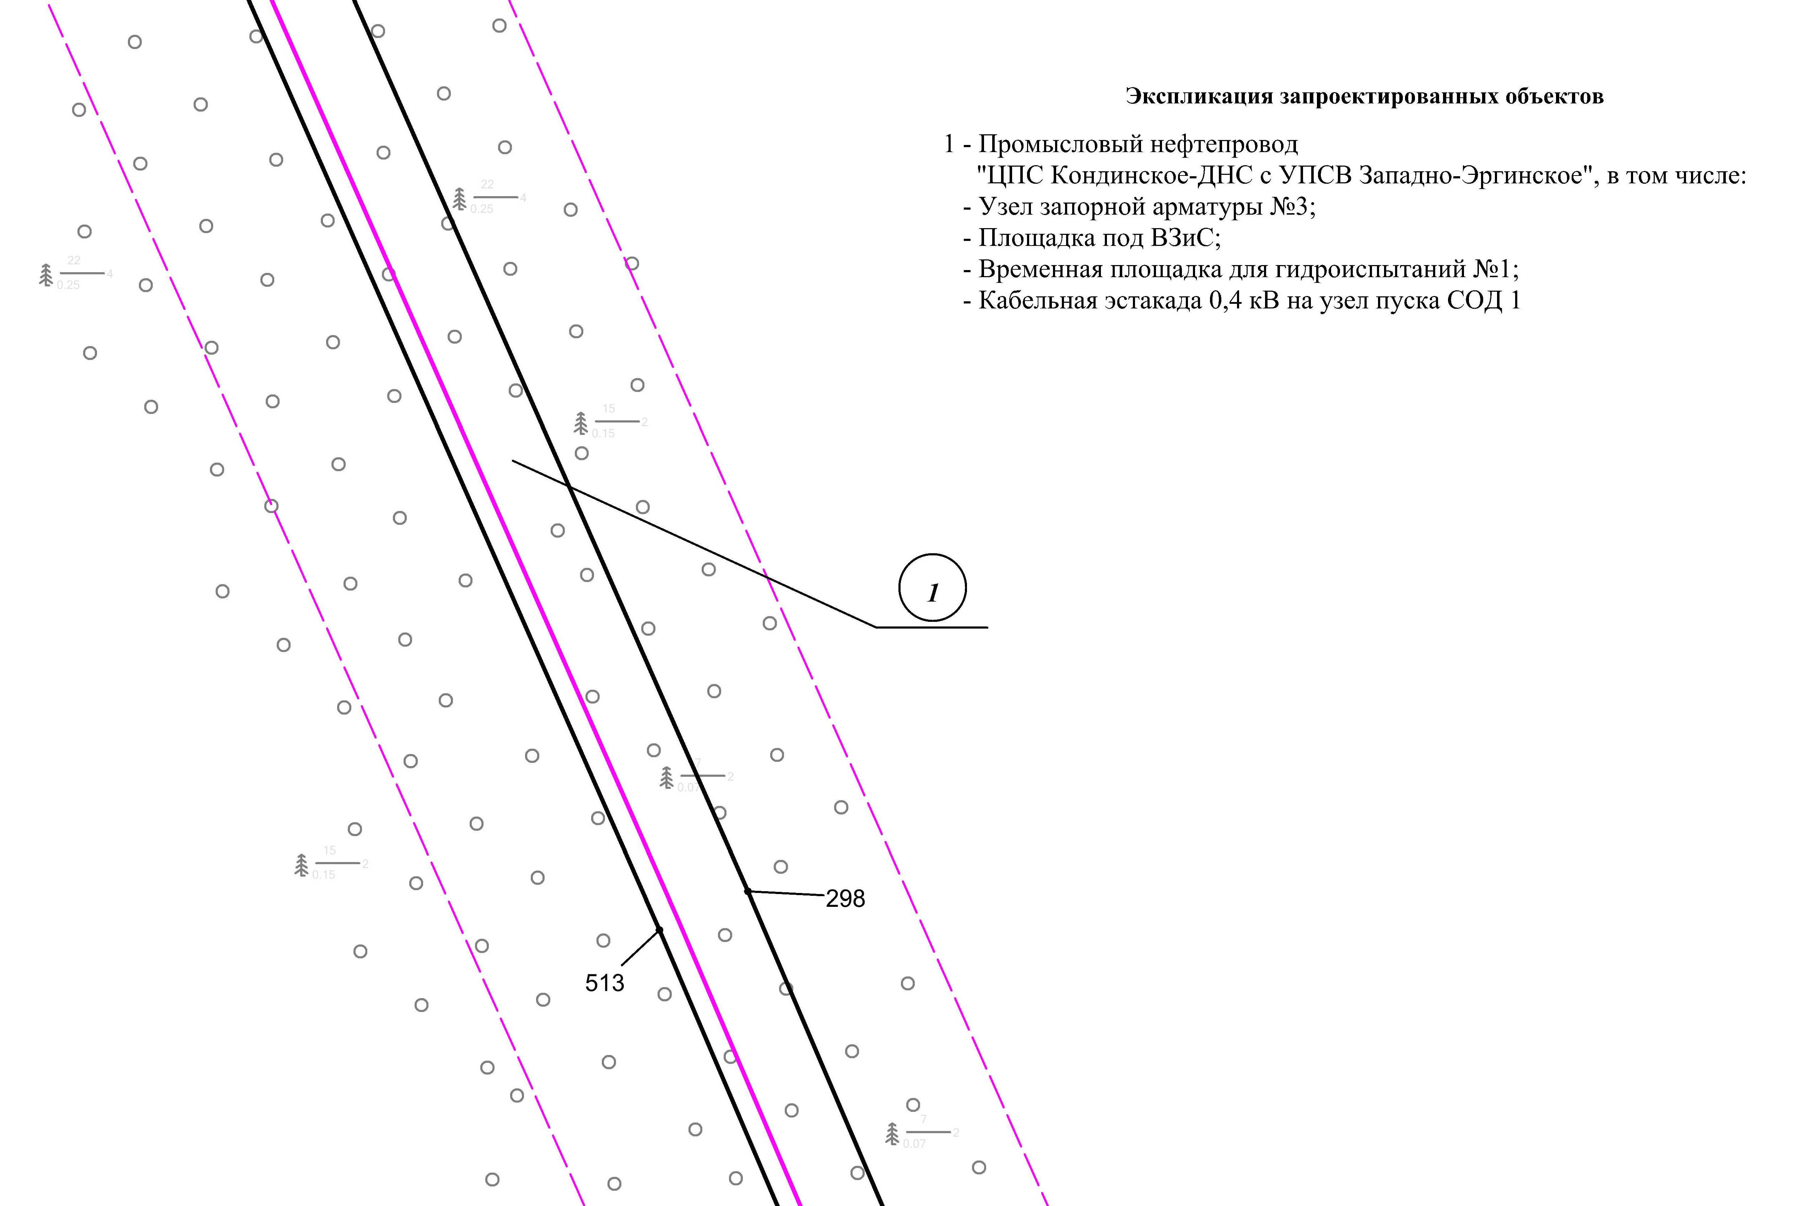

Линия совмещения с листом 42

Основная часть проекта планировки территории для размещения объекта капитального строительства, расположенного на территории двух муниципальных образований
Ханты-Мансийского автономного округа – Югры,
«Промысловый нефтепровод «ЦПС Кондинское - ДНС с УПСВ Западно-Эргинское»
Землепользователь: АО «НК «Конданефть»
Масштаб 1:2000

Линия совмещения с листом 41
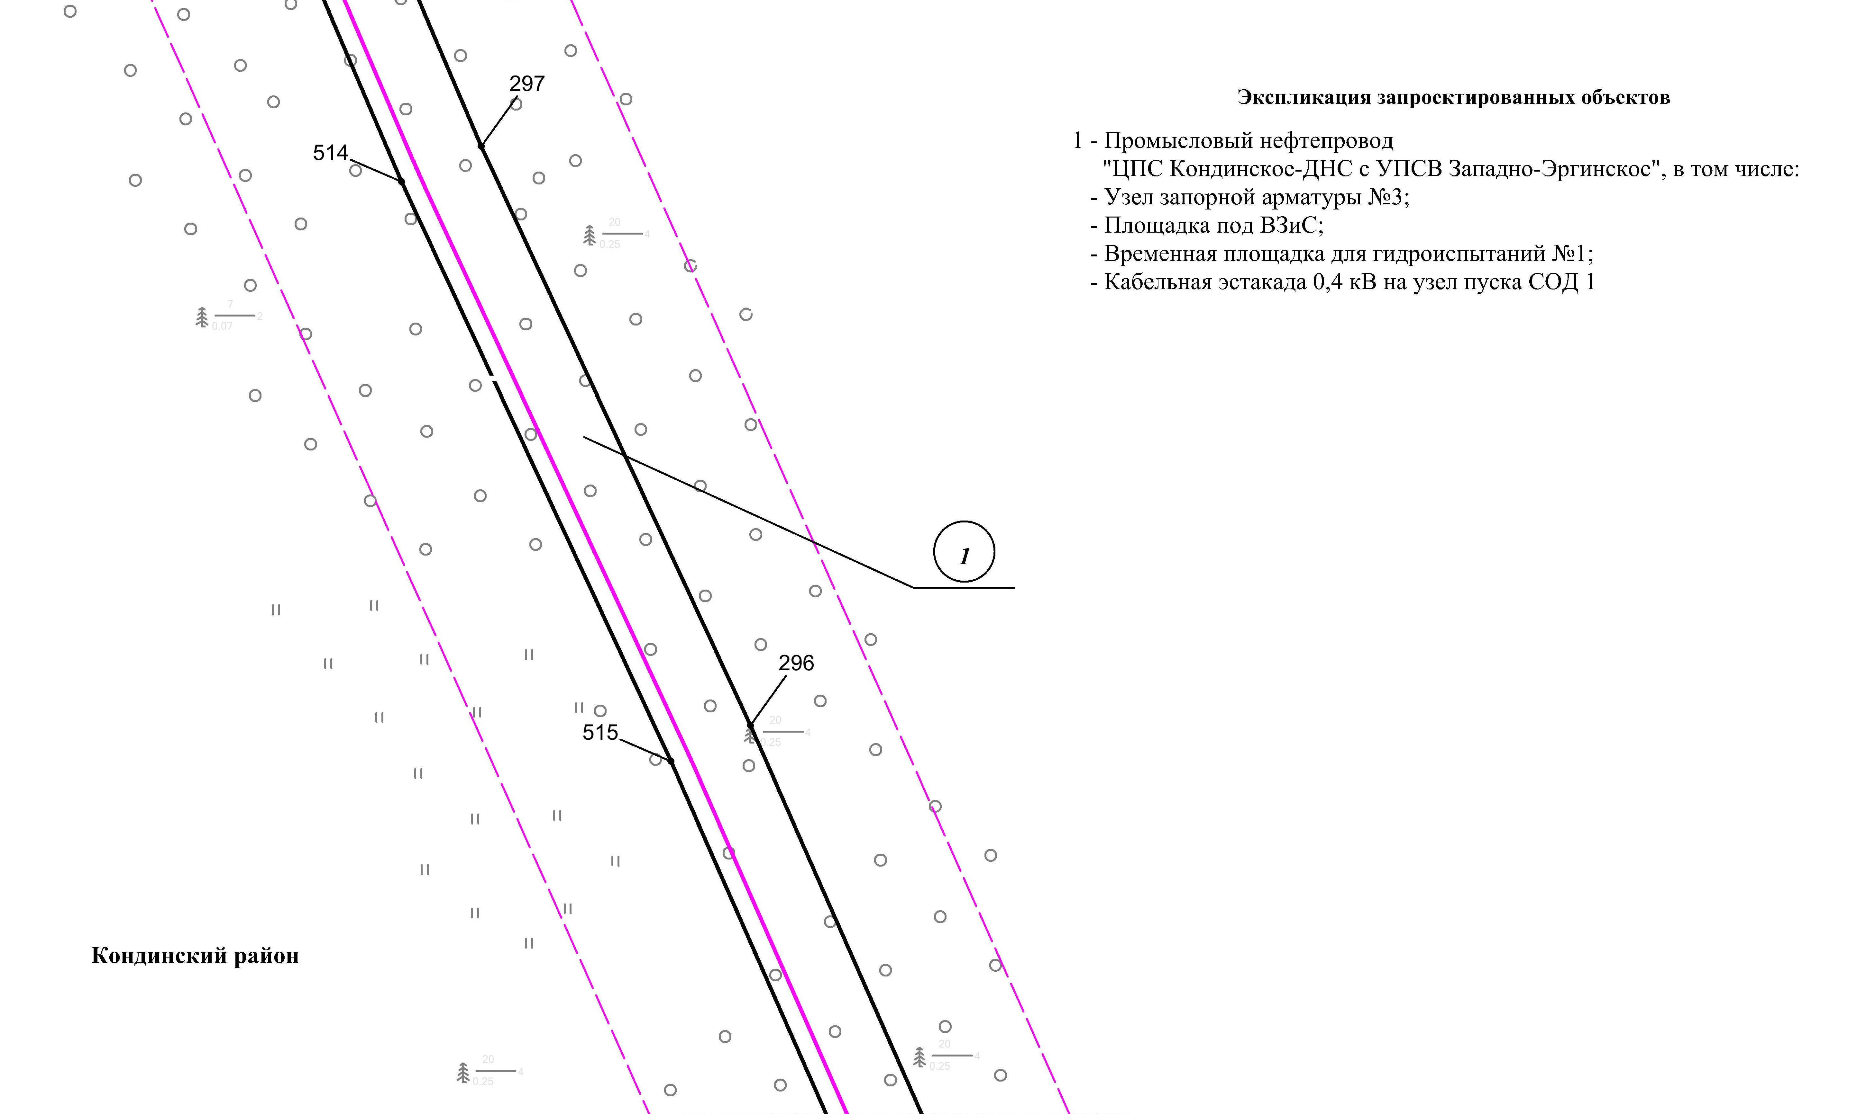

Линия совмещения с листом 43

Основная часть проекта планировки территории для размещения объекта капитального строительства, расположенного на территории двух муниципальных образований
Ханты-Мансийского автономного округа – Югры,
«Промысловый нефтепровод «ЦПС Кондинское - ДНС с УПСВ Западно-Эргинское»
Землепользователь: АО «НК «Конданефть»
Масштаб 1:2000

Линия совмещения с листом 42
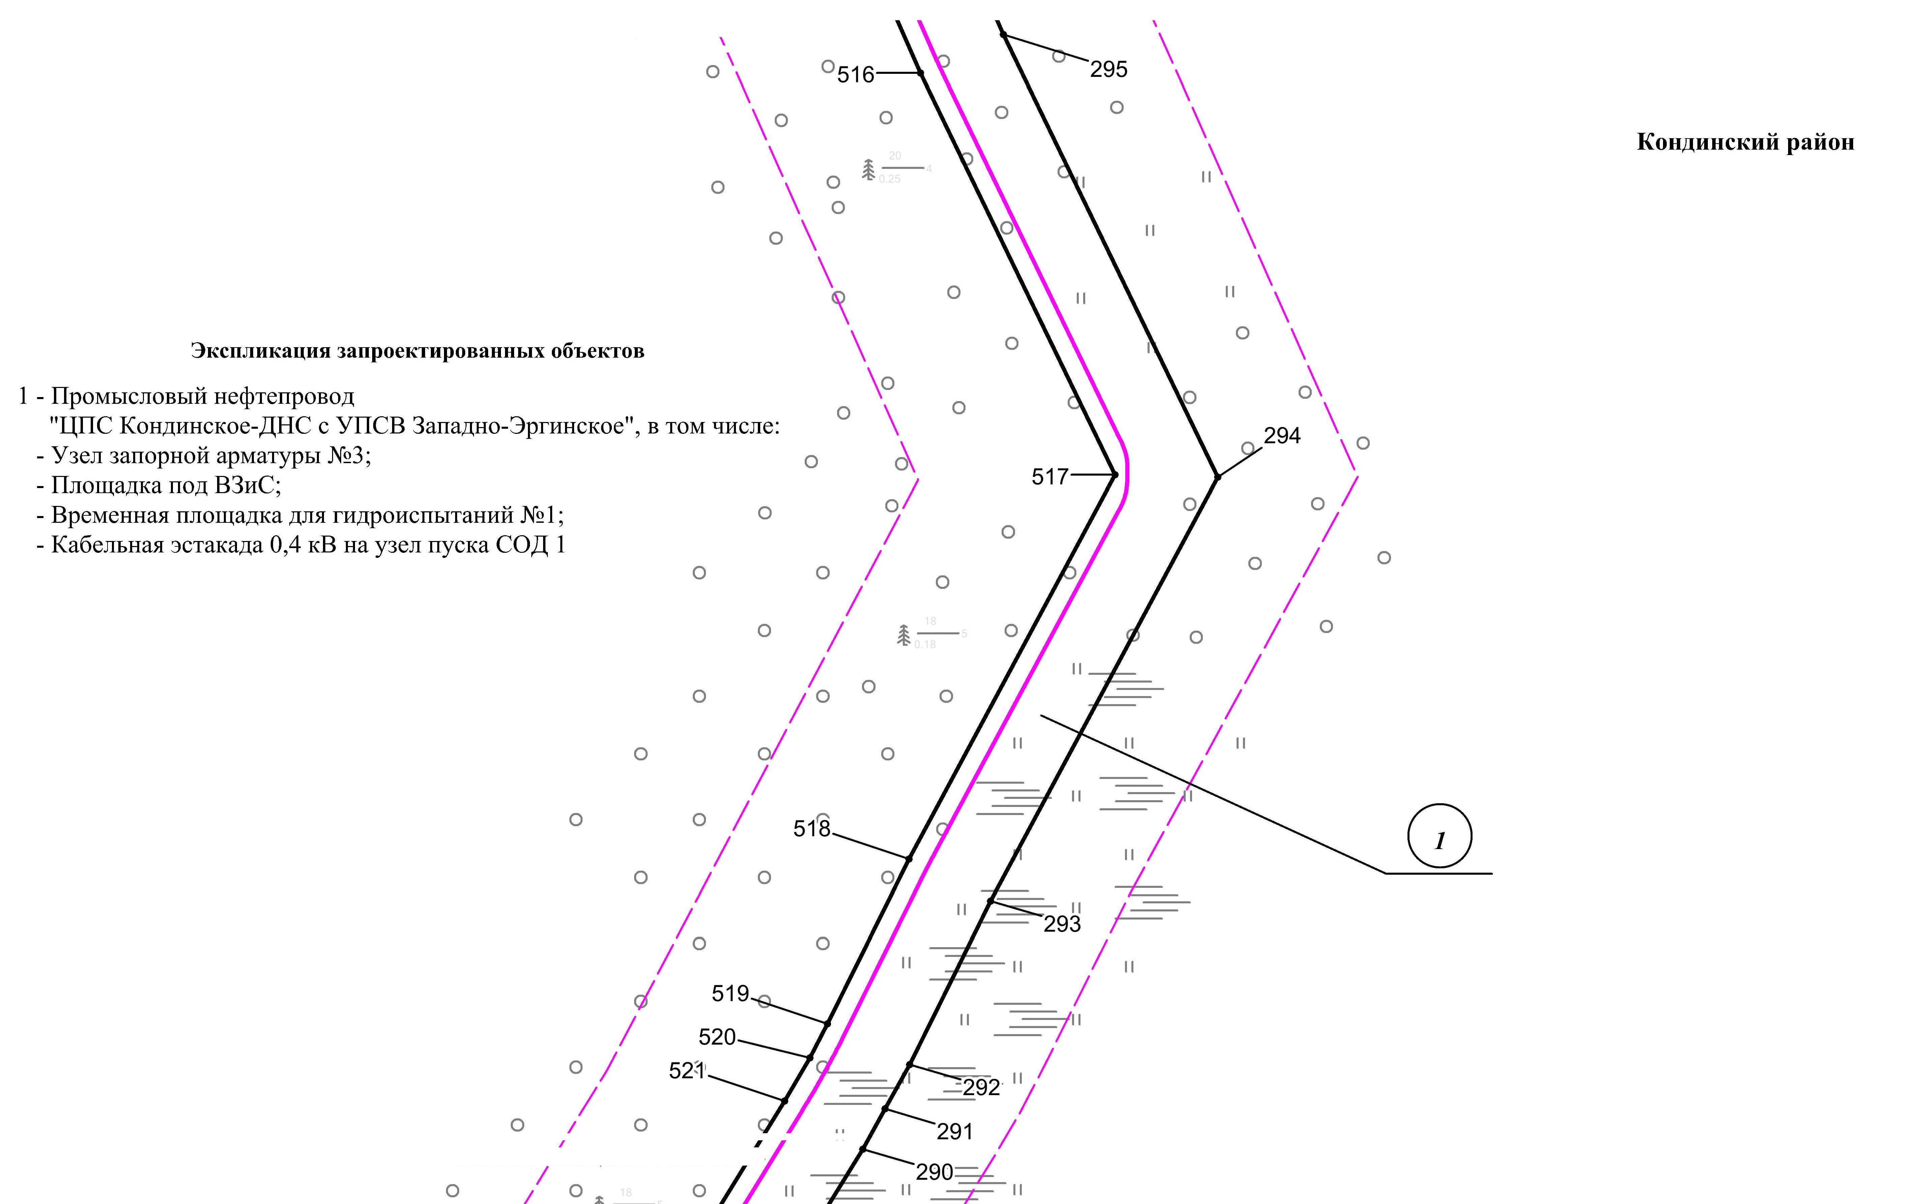

Линия совмещения с листом 44

Основная часть проекта планировки территории для размещения объекта капитального строительства, расположенного на территории двух муниципальных образований
Ханты-Мансийского автономного округа – Югры
«Промысловый нефтепровод «ЦПС Кондинское-ДНС с УПСВ Западно-Эргинское»
Землепользователь: АО «НК «Конданефть»

Линия совмещения с листом
45

Линия совмещения с листом 43

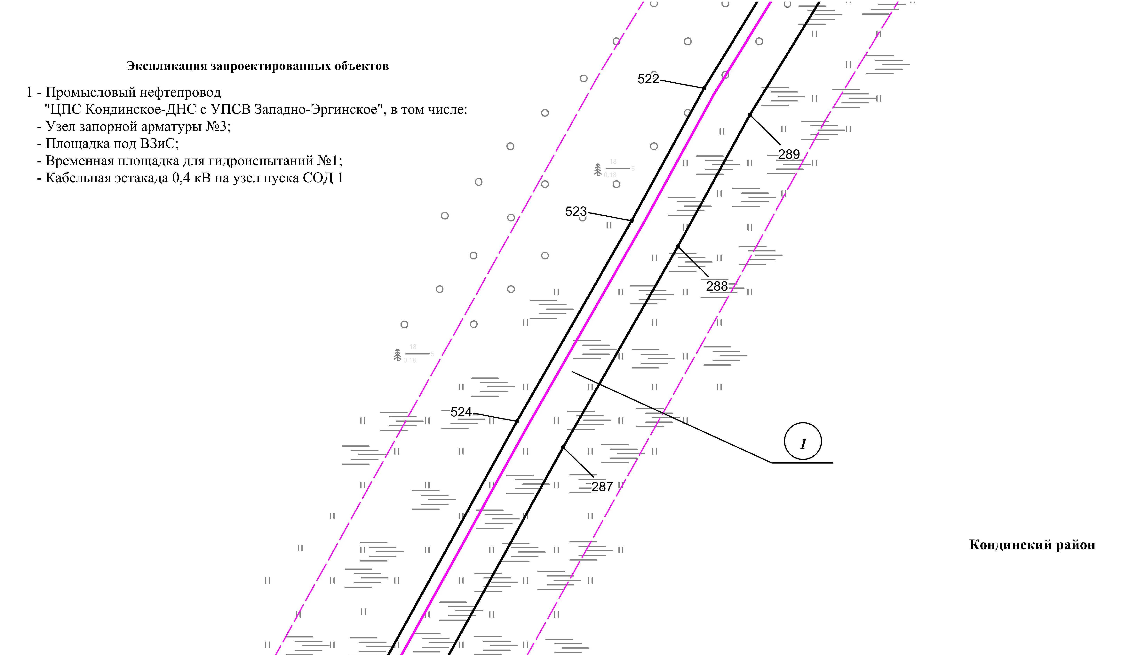

Линия совмещения с листом 45

Основная часть проекта планировки территории для размещения объекта капитального строительства, расположенного на территории двух муниципальных образований
Ханты-Мансийского автономного округа – Югры,
«Промысловый нефтепровод «ЦПС Кондинское - ДНС с УПСВ Западно-Эргинское»
Землепользователь: АО «НК «Конданефть»
Масштаб 1:2000

Линия совмещения с листом 46

Линия совмещения с листом 44
Линия совмещения с листом 46
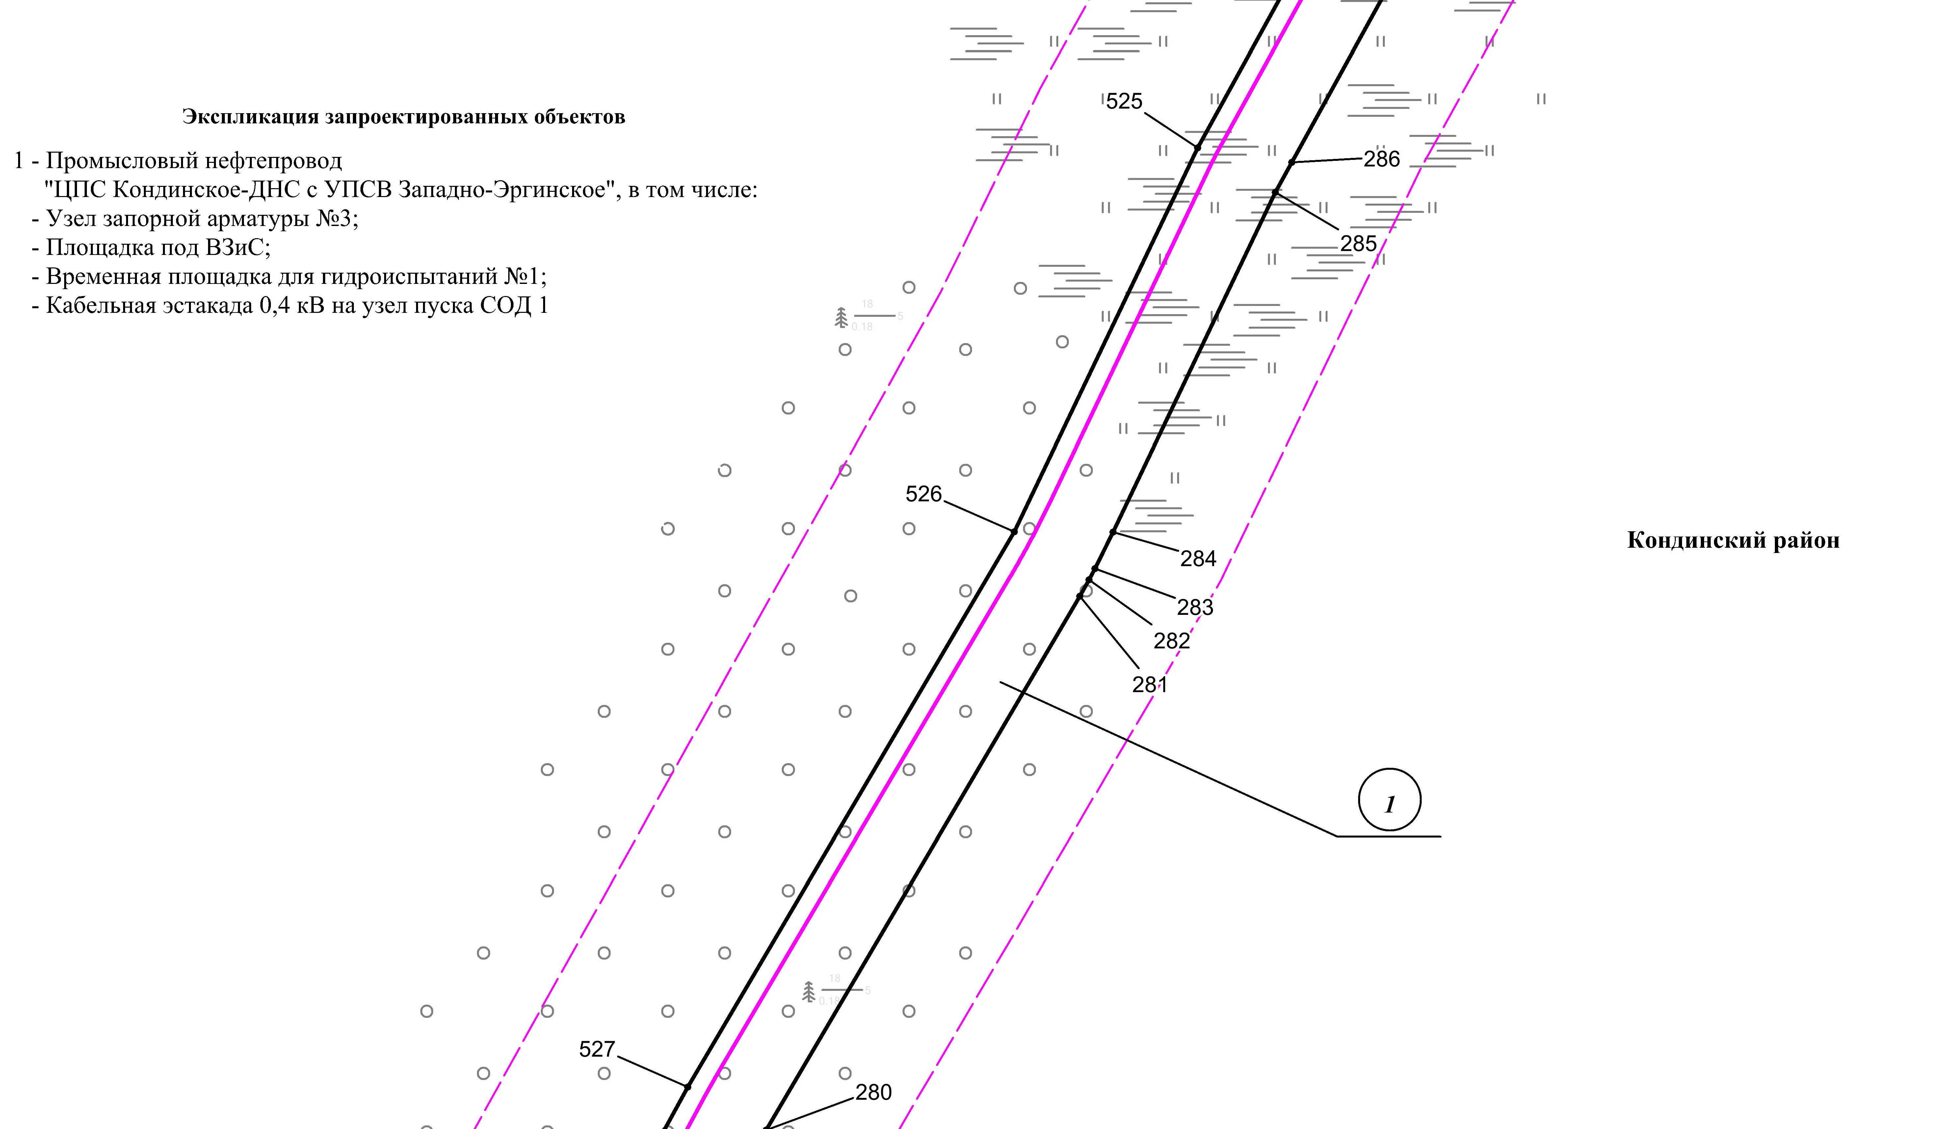

Основная часть проекта планировки территории для размещения объекта капитального строительства, расположенного на территории двух муниципальных образований
Ханты-Мансийского автономного округа – Югры,
«Промысловый нефтепровод «ЦПС Кондинское - ДНС с УПСВ Западно-Эргинское»
Землепользователь: АО «НК «Конданефть»
Масштаб 1:2000

Линия совмещения с листом 47

Линия совмещения с листом 45
Линия совмещения с листом 47
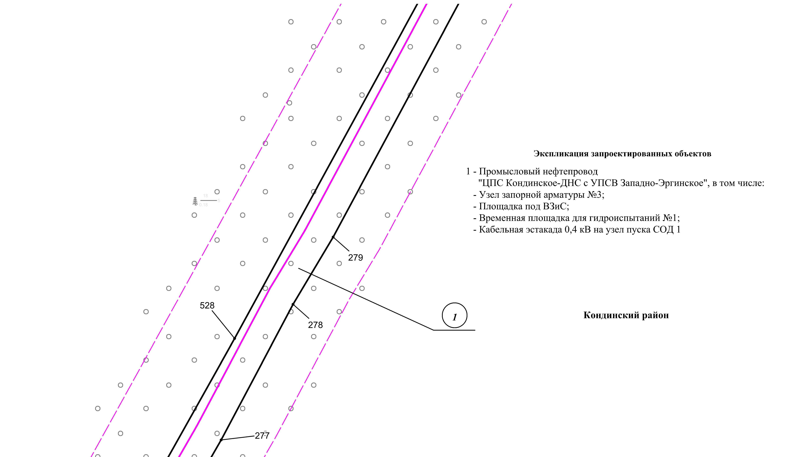

Основная часть проекта планировки территории для размещения объекта капитального строительства, расположенного на территории двух муниципальных образований
Ханты-Мансийского автономного округа – Югры,
«Промысловый нефтепровод «ЦПС Кондинское-ДНС с УПСВ Западно-Эргинское»
Землепользователь: АО «НК «Конданефть»
Масштаб 1:2000

Линия совмещения с листом
48

Линия совмещения с листом 46
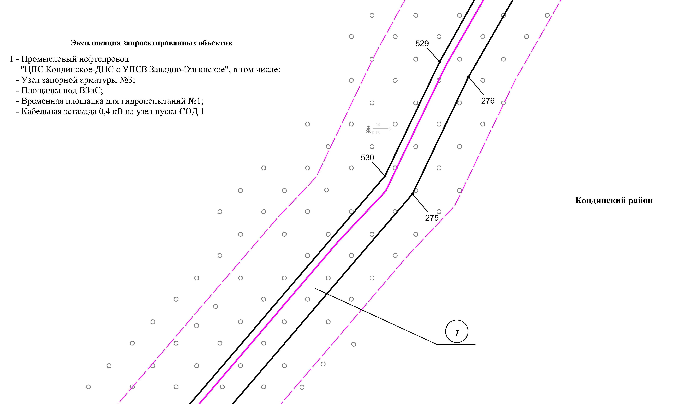

Линия совмещения с листом 48

Основная часть проекта планировки территории для размещения объекта капитального строительства, расположенного на территории двух муниципальных образований
Ханты-Мансийского автономного округа – Югры,
«Промысловый нефтепровод «ЦПС Кондинское-ДНС с УПСВ Западно-Эргинское»
Землепользователь: АО «НК «Конданефть»
Масштаб 1:2000

Линия совмещения с листом 49

Линия совмещения с листом 47
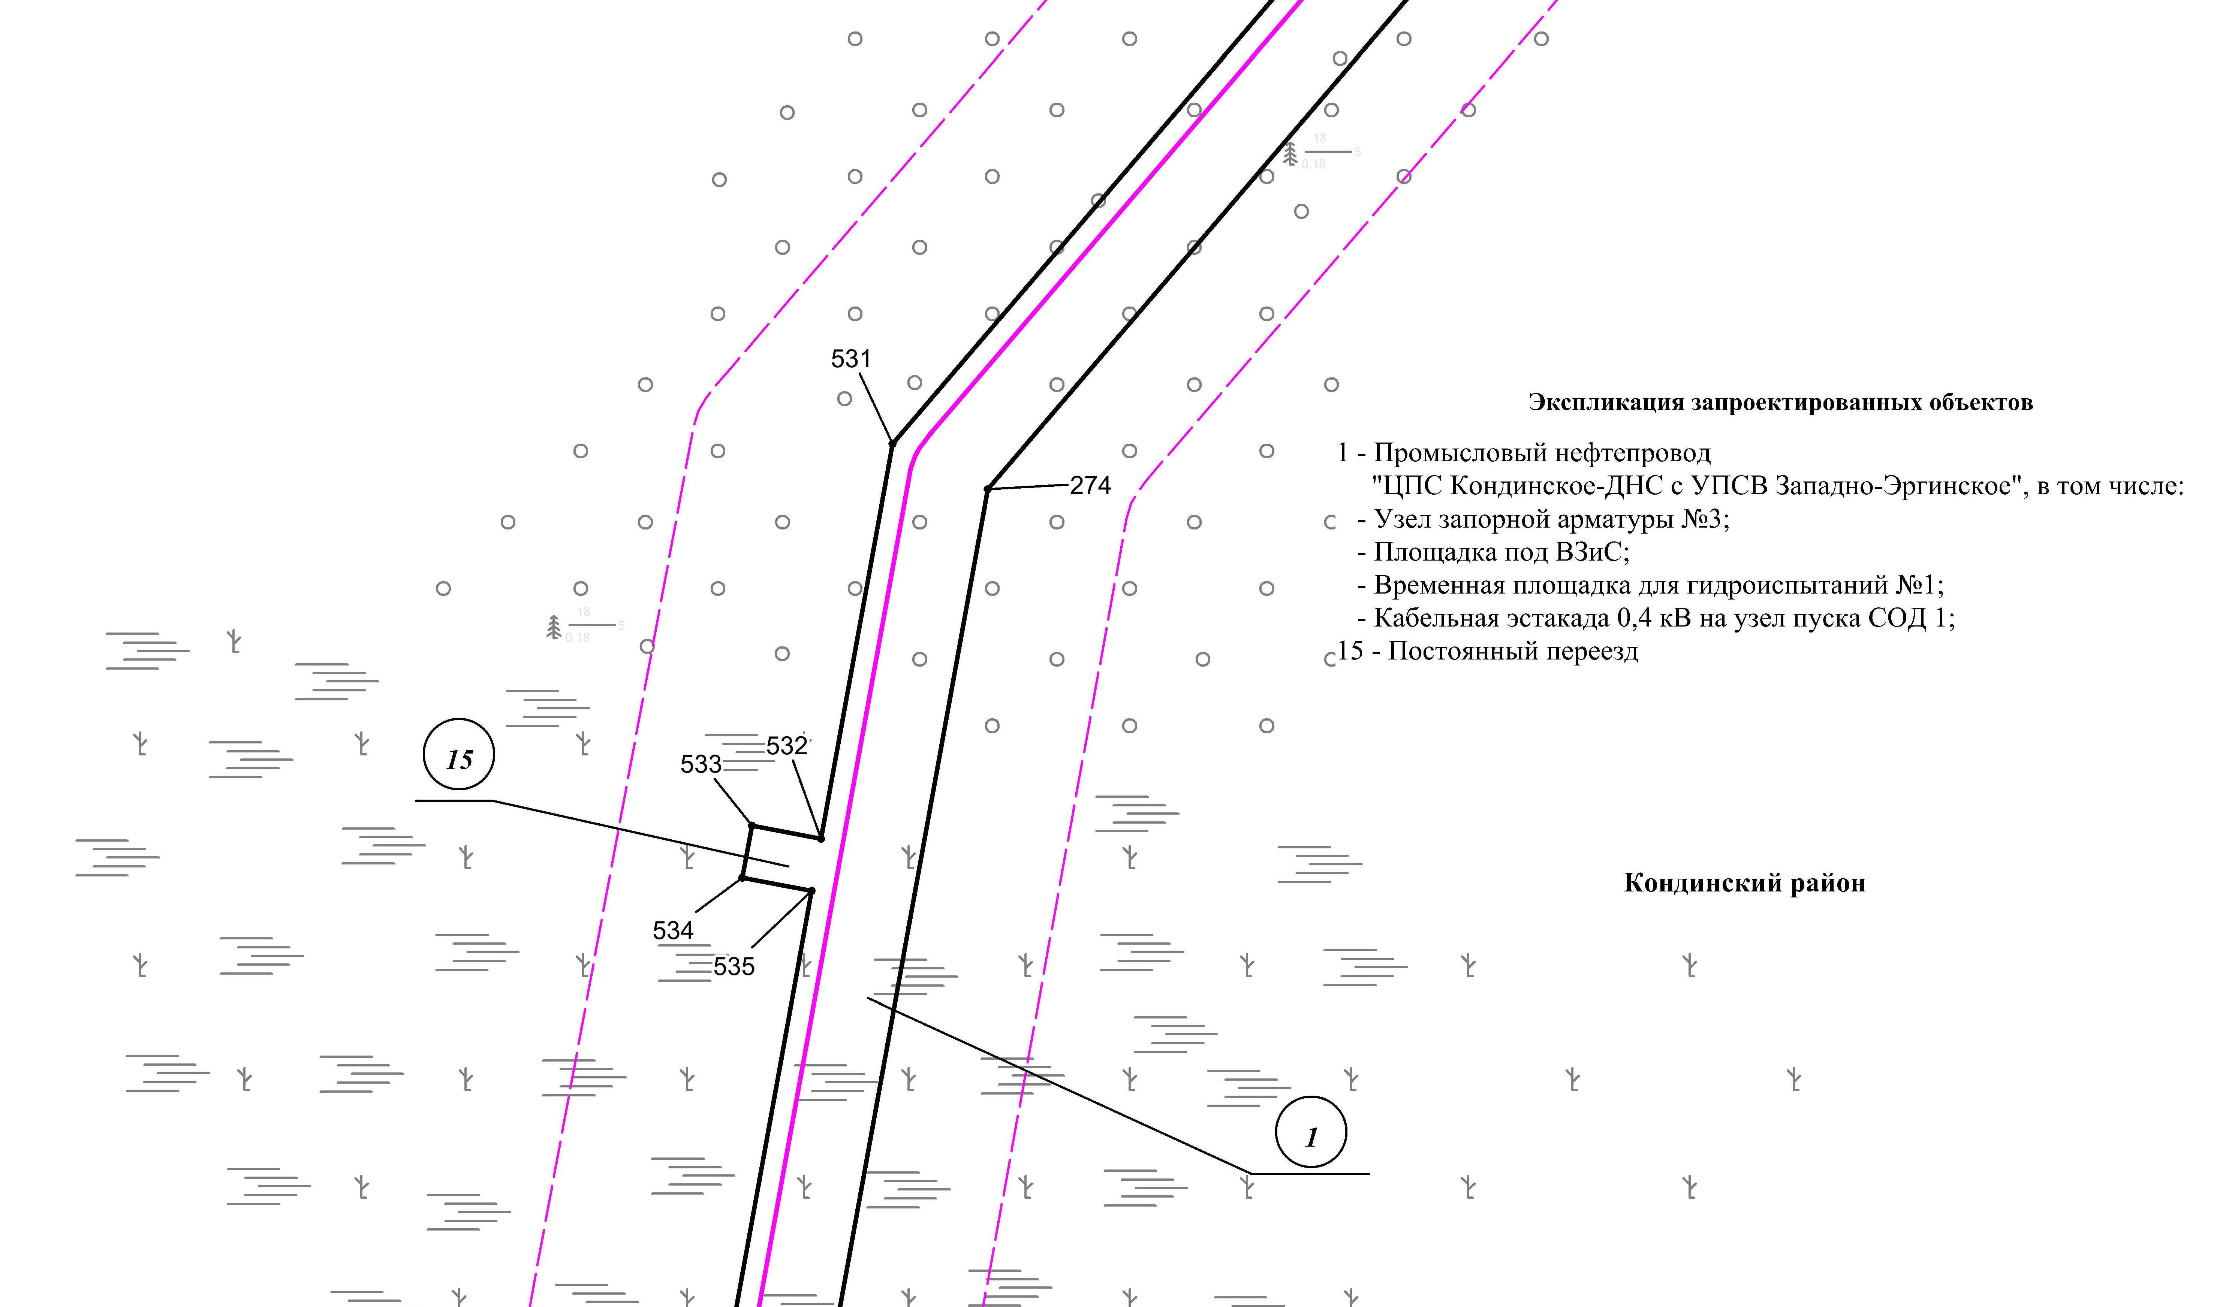
Линия совмещения с листом 49

Основная часть проекта планировки территории для размещения объекта капитального строительства, расположенного на территории двух муниципальных образований
Ханты-Мансийского автономного округа – Югры,
«Промысловый нефтепровод «ЦПС Кондинское-ДНС с УПСВ Западно-Эргинское»
Землепользователь: АО «НК «Конданефть»
Масштаб 1:2000

Основная часть проекта планировки территории для размещения объекта капитального строительства, расположенного на территории двух муниципальных образований
Ханты-Мансийского автономного округа – Югры,
«Промысловый нефтепровод «ЦПС Кондинское-ДНС с УПСВ Западно-Эргинское»
Землепользователь: АО «НК «Конданефть»
Масштаб 1:2000

Линия совмещения с листом 48
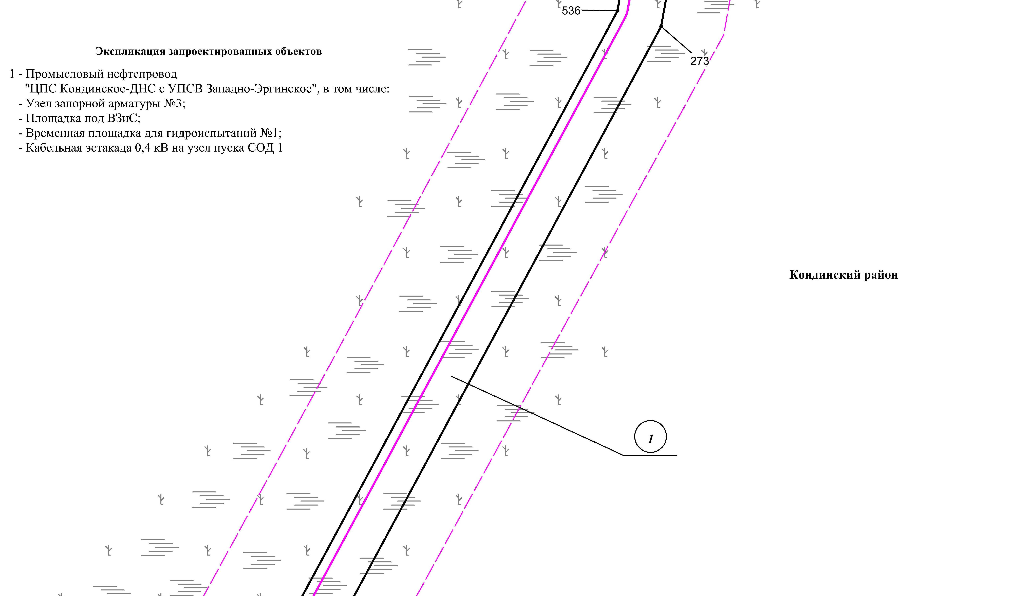

Линия совмещения с листом 50

Основная часть проекта планировки территории для размещения объекта капитального строительства, расположенного на территории двух муниципальных образований
Ханты-Мансийского автономного округа – Югры
«Промысловый нефтепровод «ЦПС Кондинское-ДНС с УПСВ Западно-Эргинское»
Землепользователь: АО «НК «Конданефть»

Линия совмещения с листом
51

Линия совмещения с листом 49
Линия совмещения с листом 51
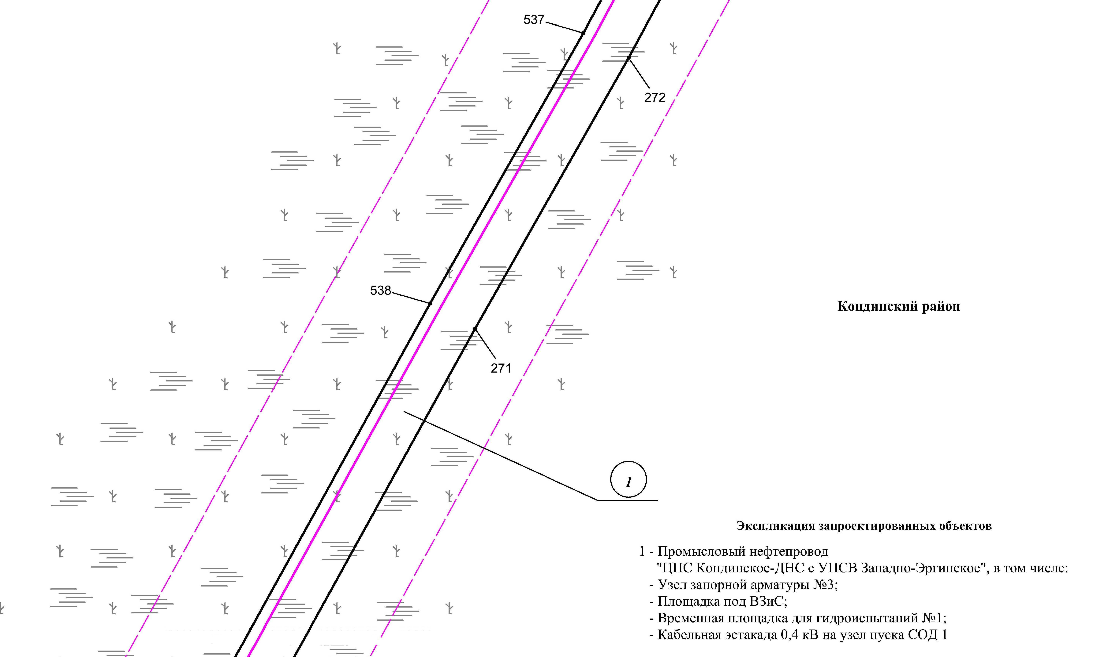

Основная часть проекта планировки территории для размещения объекта капитального строительства, расположенного на территории двух муниципальных образований
Ханты-Мансийского автономного округа – Югры,
«Промысловый нефтепровод «ЦПС Кондинское - ДНС с УПСВ Западно-Эргинское»
Землепользователь: АО «НК «Конданефть»
Масштаб 1:2000

Линия совмещения с листом 50
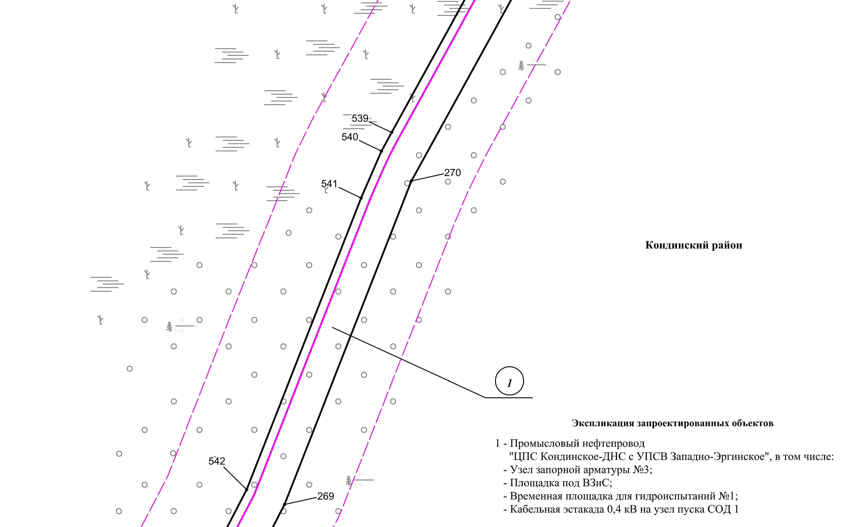

Линия совмещения с листом 52

Основная часть проекта планировки территории для размещения объекта капитального строительства, расположенного на территории двух муниципальных образований
Ханты-Мансийского автономного округа – Югры,
«Промысловый нефтепровод «ЦПС Кондинское - ДНС с УПСВ Западно-Эргинское»
Землепользователь: АО «НК «Конданефть»
Масштаб 1:2000

Линия совмещения с листом
53

Линия совмещения с листом 51
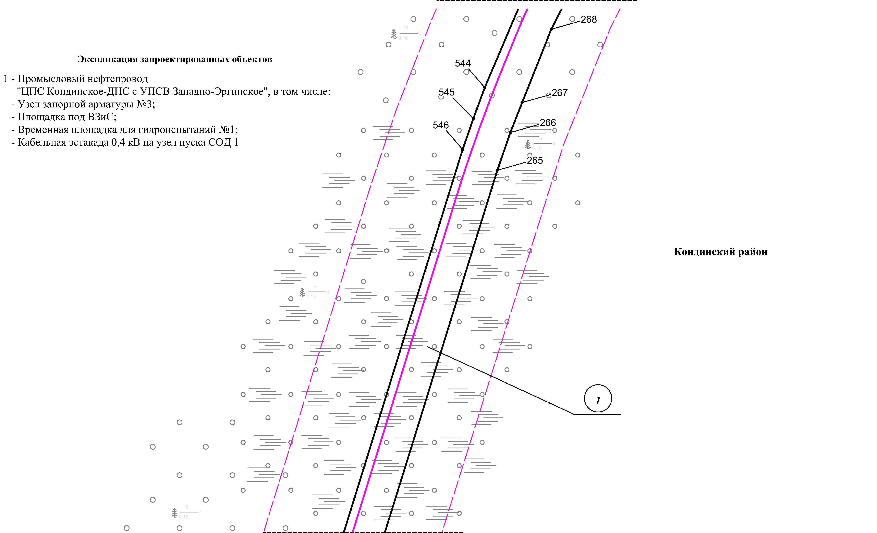

Линия совмещения с листом 53

Основная часть проекта планировки территории для размещения объекта капитального строительства, расположенного на территории двух муниципальных образований
Ханты-Мансийского автономного округа – Югры,
«Промысловый нефтепровод «ЦПС Кондинское-ДНС с УПСВ Западно-Эргинское»
Землепользователь: АО «НК «Конданефть»
Масштаб 1:2000

Линия совмещения с листом
54

Линия совмещения с листом 52
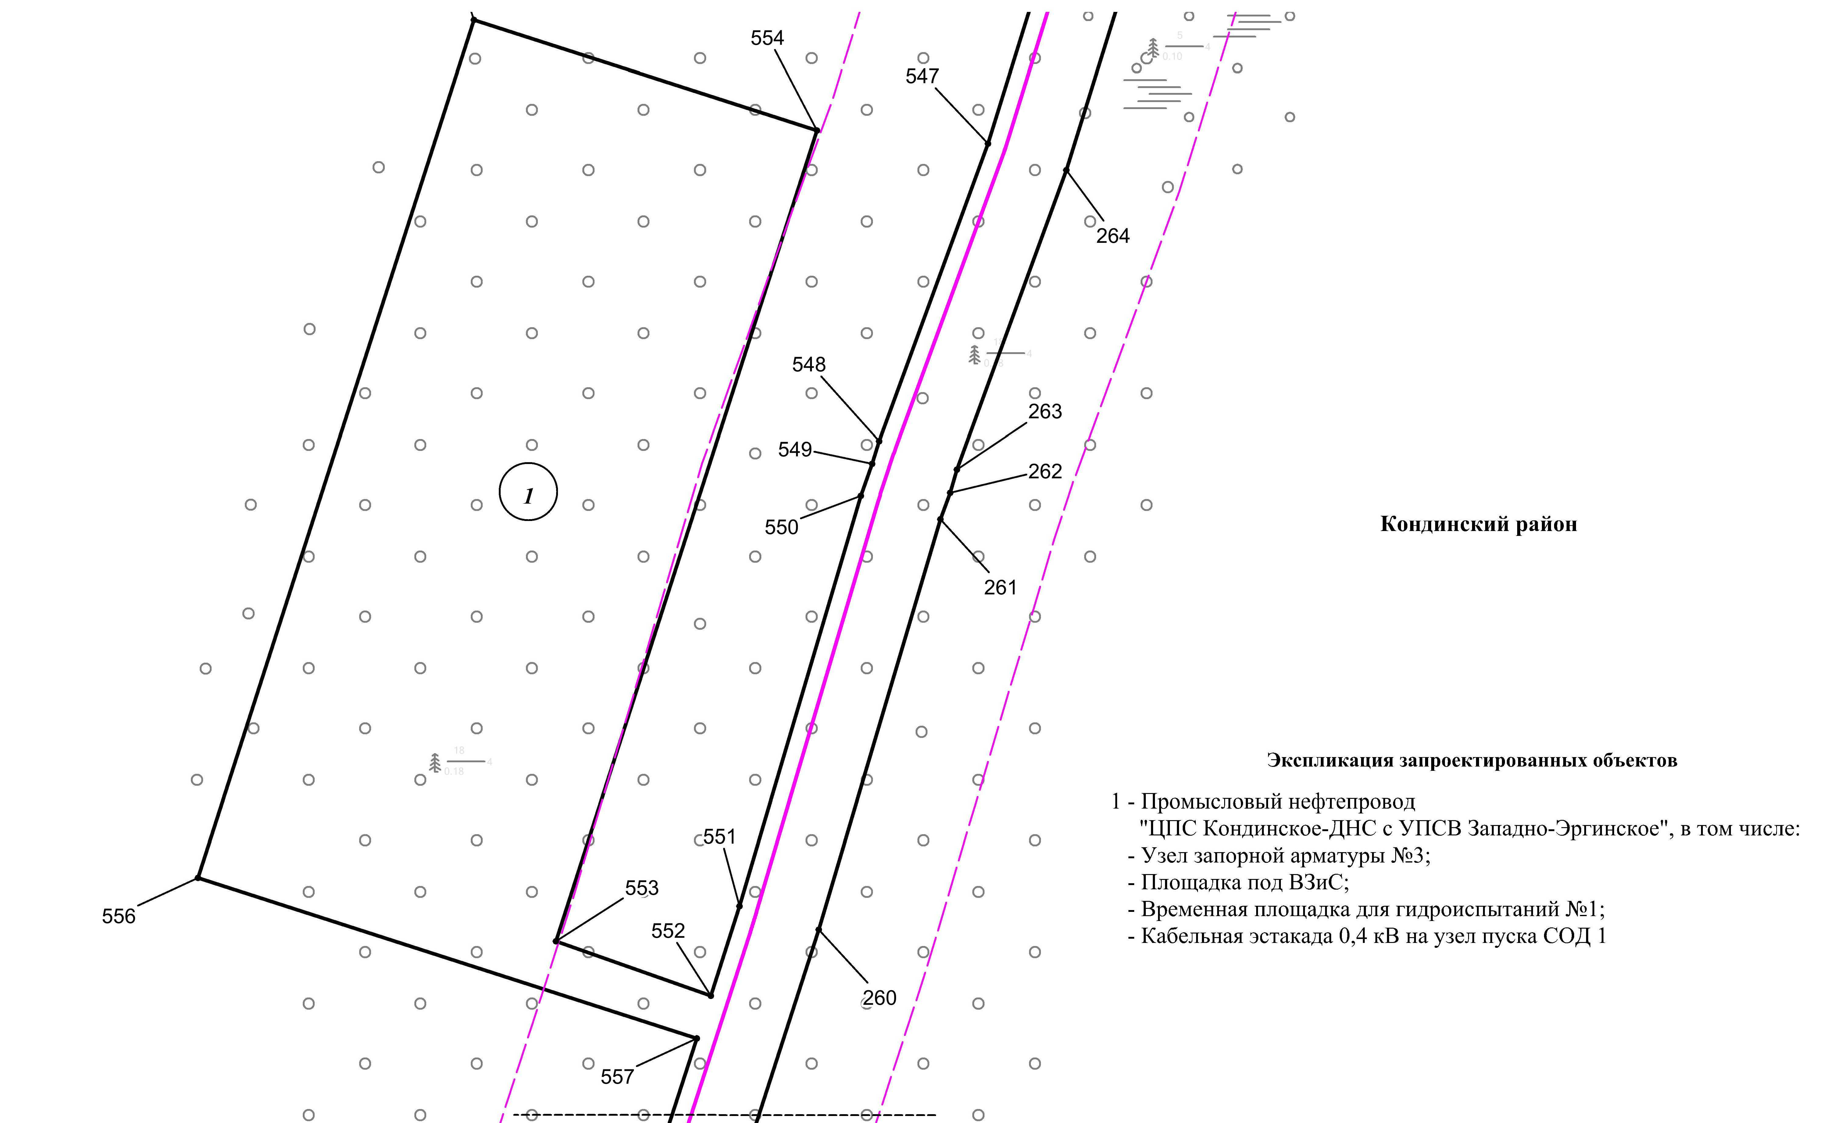

Линия совмещения с листом 54

Основная часть проекта планировки территории для размещения объекта капитального строительства, расположенного на территории двух муниципальных образований
Ханты-Мансийского автономного округа – Югры,
«Промысловый нефтепровод «ЦПС Кондинское - ДНС с УПСВ Западно-Эргинское»
Землепользователь: АО «НК «Конданефть»
Масштаб 1:2000

Основная часть проекта планировки территории для размещения объекта капитального строительства, расположенного на территории двух муниципальных образований
Ханты-Мансийского автономного округа – Югры,
«Промысловый нефтепровод «ЦПС Кондинское - ДНС с УПСВ Западно-Эргинское»
Землепользователь: АО «НК «Конданефть»
Масштаб 1:2000

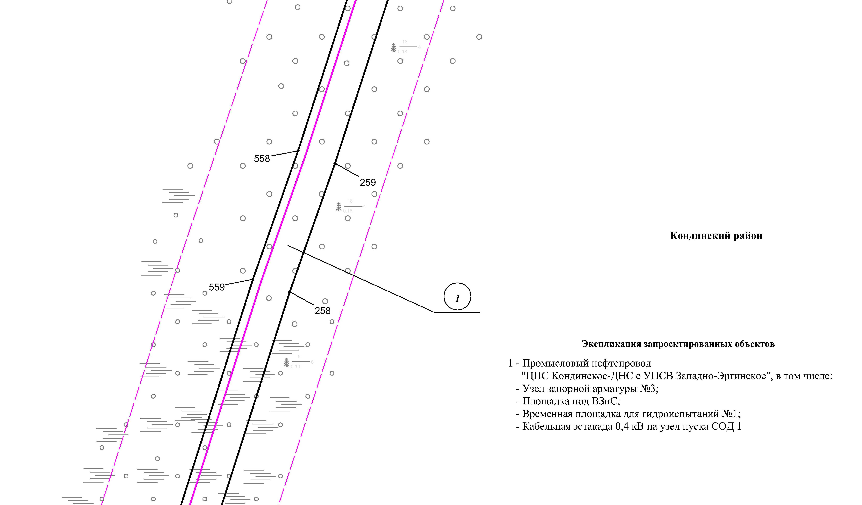
Линия совмещения с листом 53
Линия совмещения с листом 55

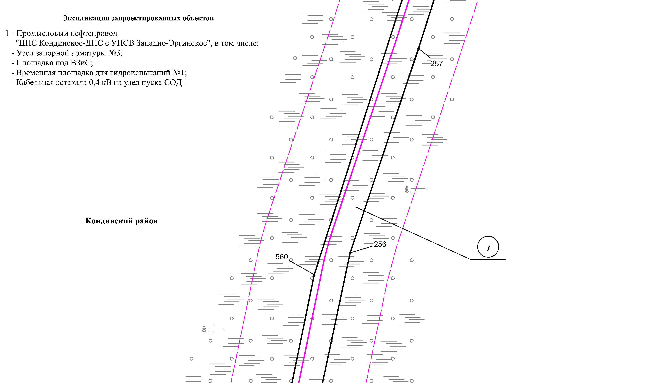
Линия совмещения с листом 56
Линия совмещения с листом 54
Основная часть проекта планировки территории для размещения объекта капитального строительства, расположенного на территории двух муниципальных образований
Ханты-Мансийского автономного округа – Югры,
«Промысловый нефтепровод «ЦПС Кондинское - ДНС с УПСВ Западно-Эргинское»
Землепользователь: АО «НК «Конданефть»
Масштаб 1:2000

Основная часть проекта планировки территории для размещения объекта капитального строительства, расположенного на территории двух муниципальных образований
Ханты-Мансийского автономного округа – Югры,
«Промысловый нефтепровод «ЦПС Кондинское - ДНС с УПСВ Западно-Эргинское»
Землепользователь: АО «НК «Конданефть»
Масштаб 1:2000

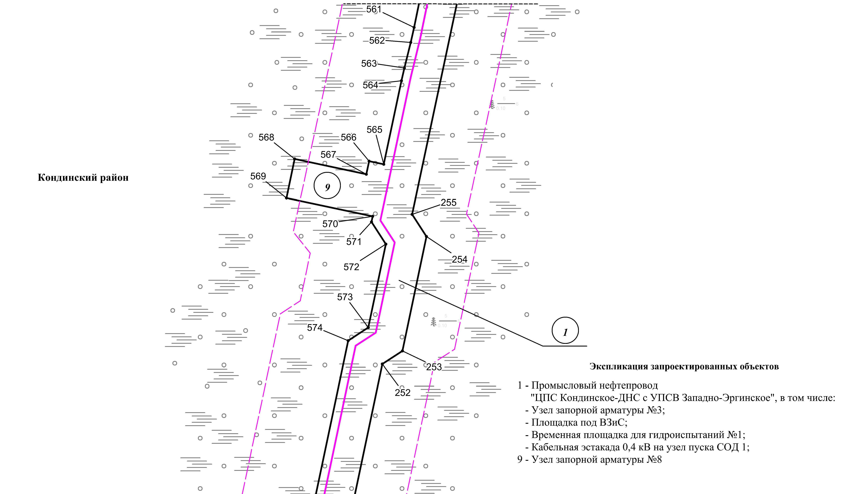
Линия совмещения с листом 55
Линия совмещения с листом 57

Основная часть проекта планировки территории для размещения объекта капитального строительства, расположенного на территории двух муниципальных образований
Ханты-Мансийского автономного округа – Югры,
«Промысловый нефтепровод «ЦПС Кондинское-ДНС с УПСВ Западно-Эргинское»
Землепользователь: АО «НК «Конданефть»
Масштаб 1:2000

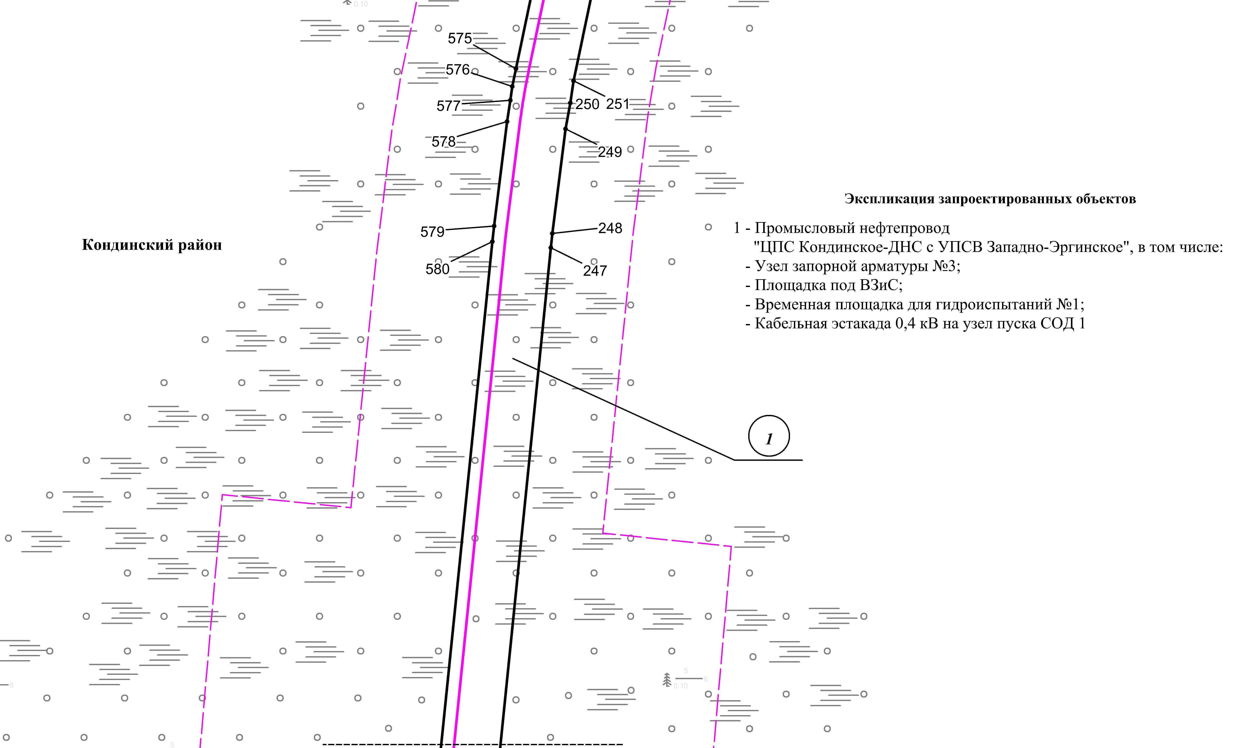
Линия совмещения с листом 57
Линия совмещения с листом 58

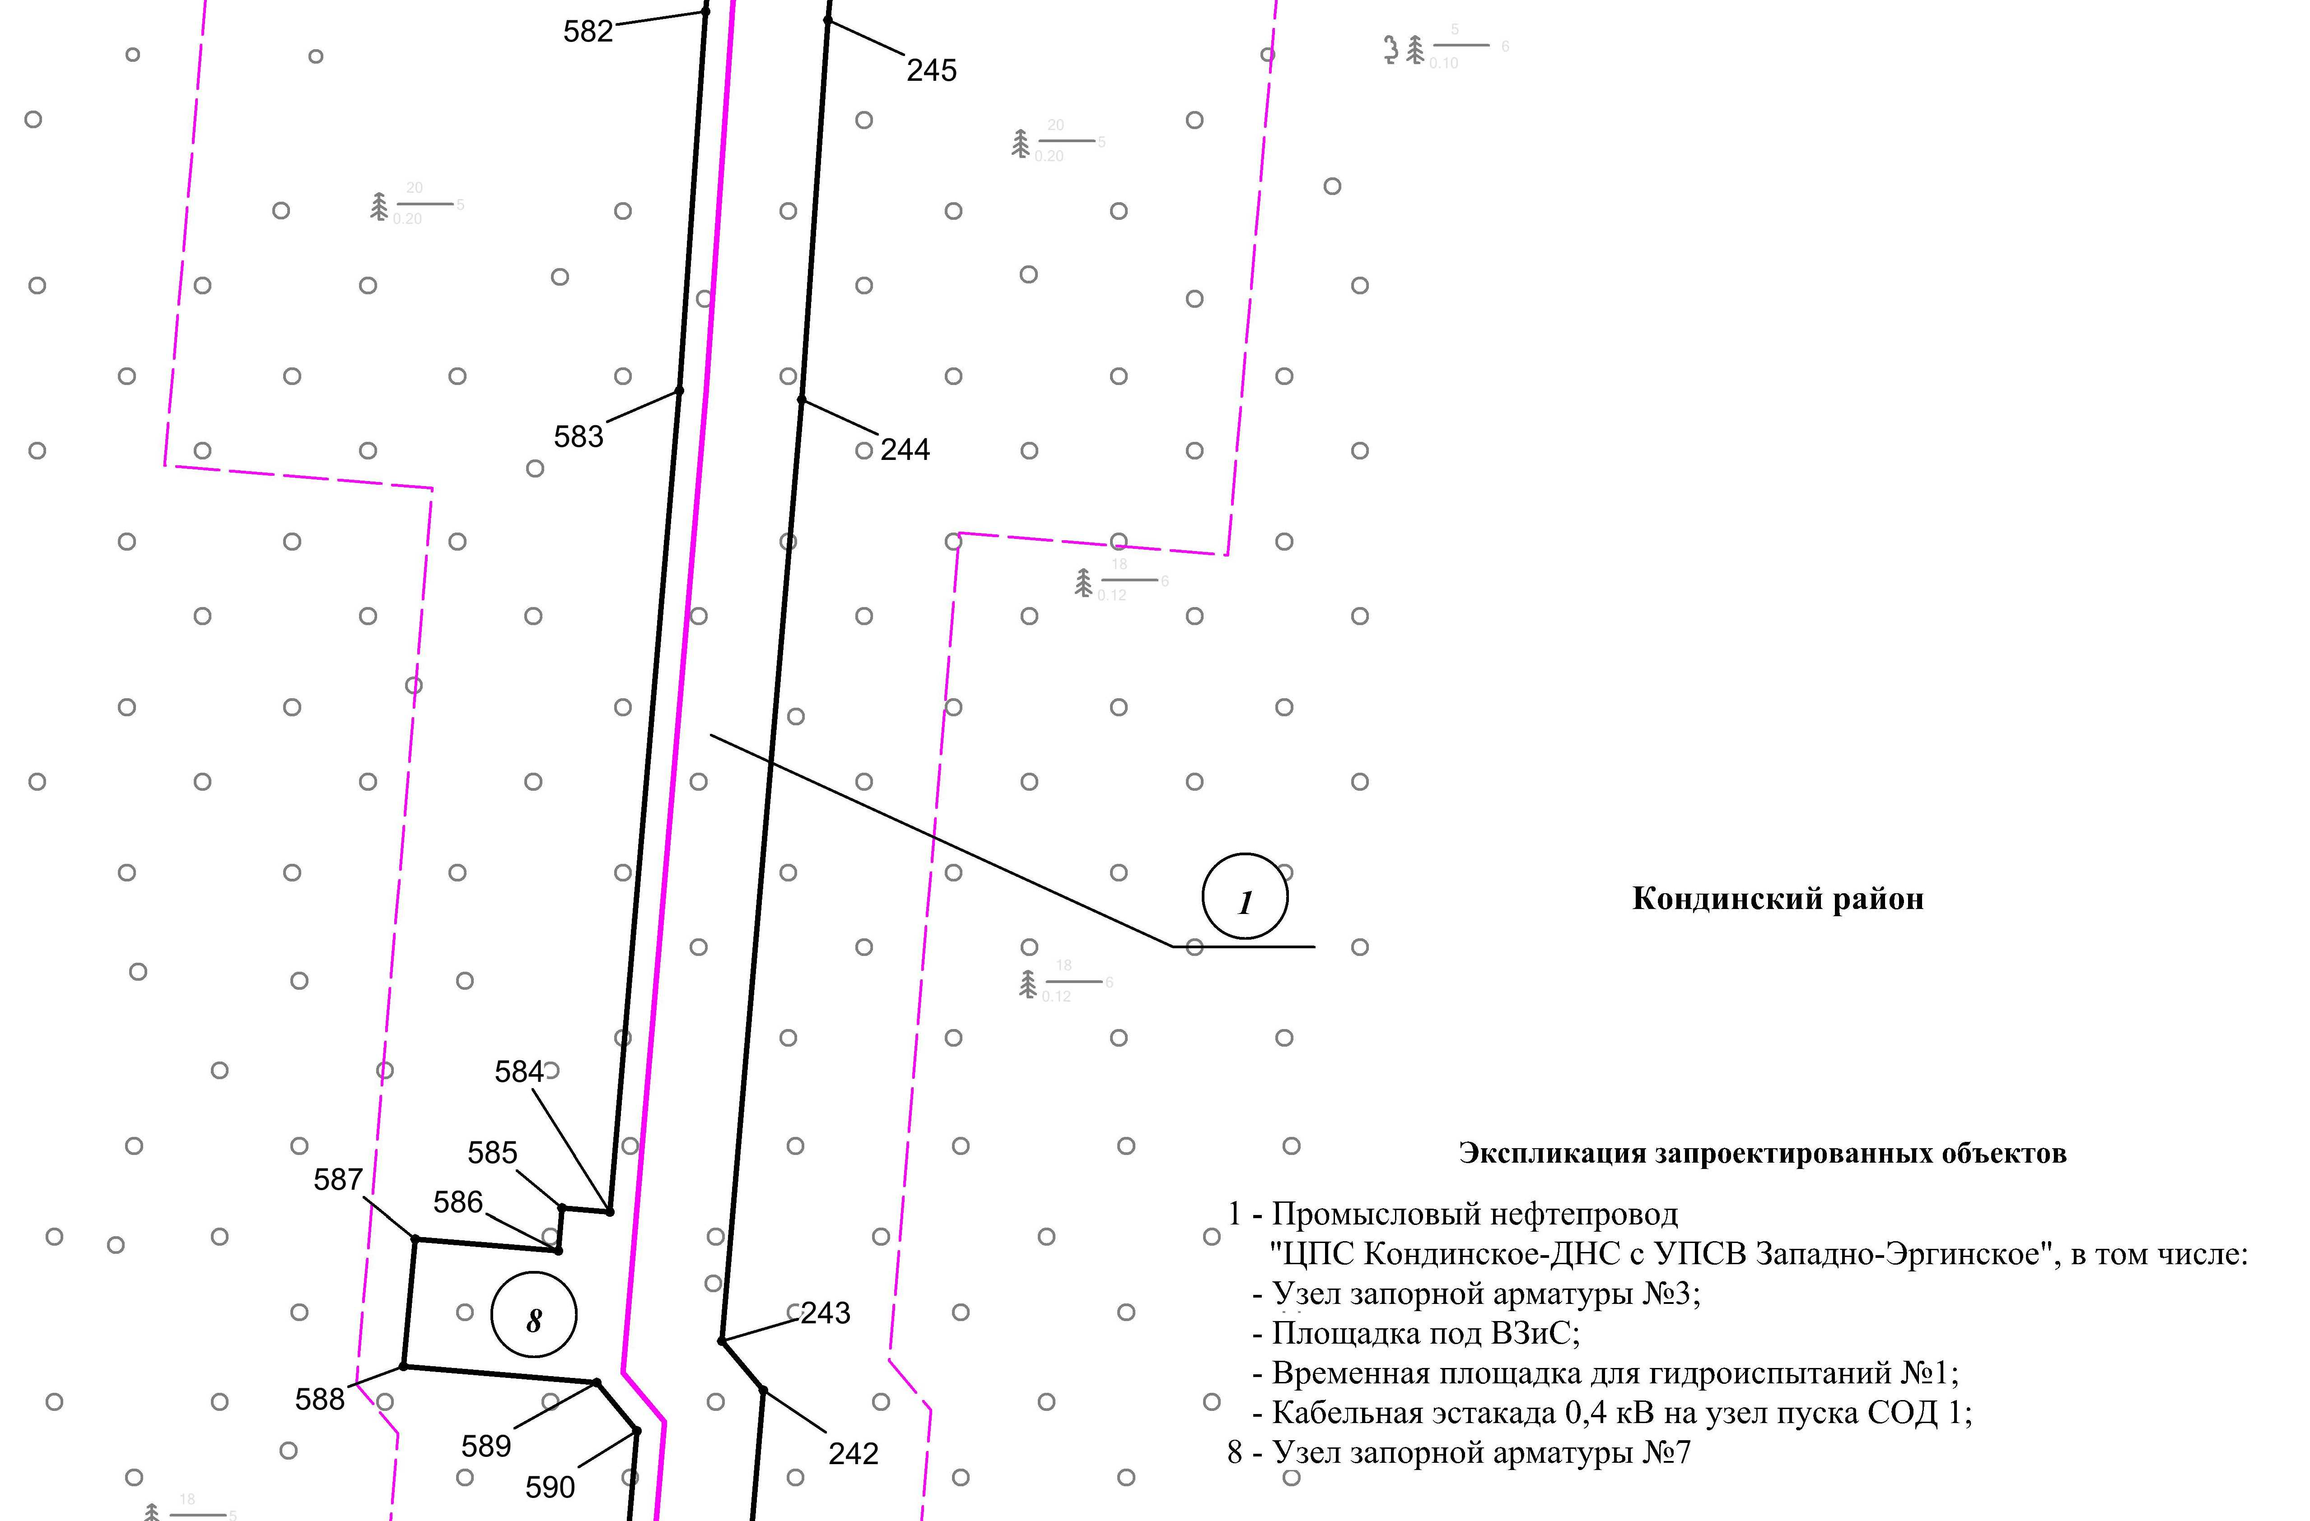
Линия совмещения с листом 57
Линия совмещения с листом 59

Основная часть проекта планировки территории для размещения объекта капитального строительства, расположенного на территории двух муниципальных образований
Ханты-Мансийского автономного округа – Югры,
«Промысловый нефтепровод «ЦПС Кондинское-ДНС с УПСВ Западно-Эргинское»
Землепользователь: АО «НК «Конданефть»
Масштаб 1:2000

Основная часть проекта планировки территории для размещения объекта капитального строительства, расположенного на территории двух муниципальных образований
Ханты-Мансийского автономного округа – Югры,
«Промысловый нефтепровод «ЦПС Кондинское-ДНС с УПСВ Западно-Эргинское»
Землепользователь: АО «НК «Конданефть»
Масштаб 1:2000

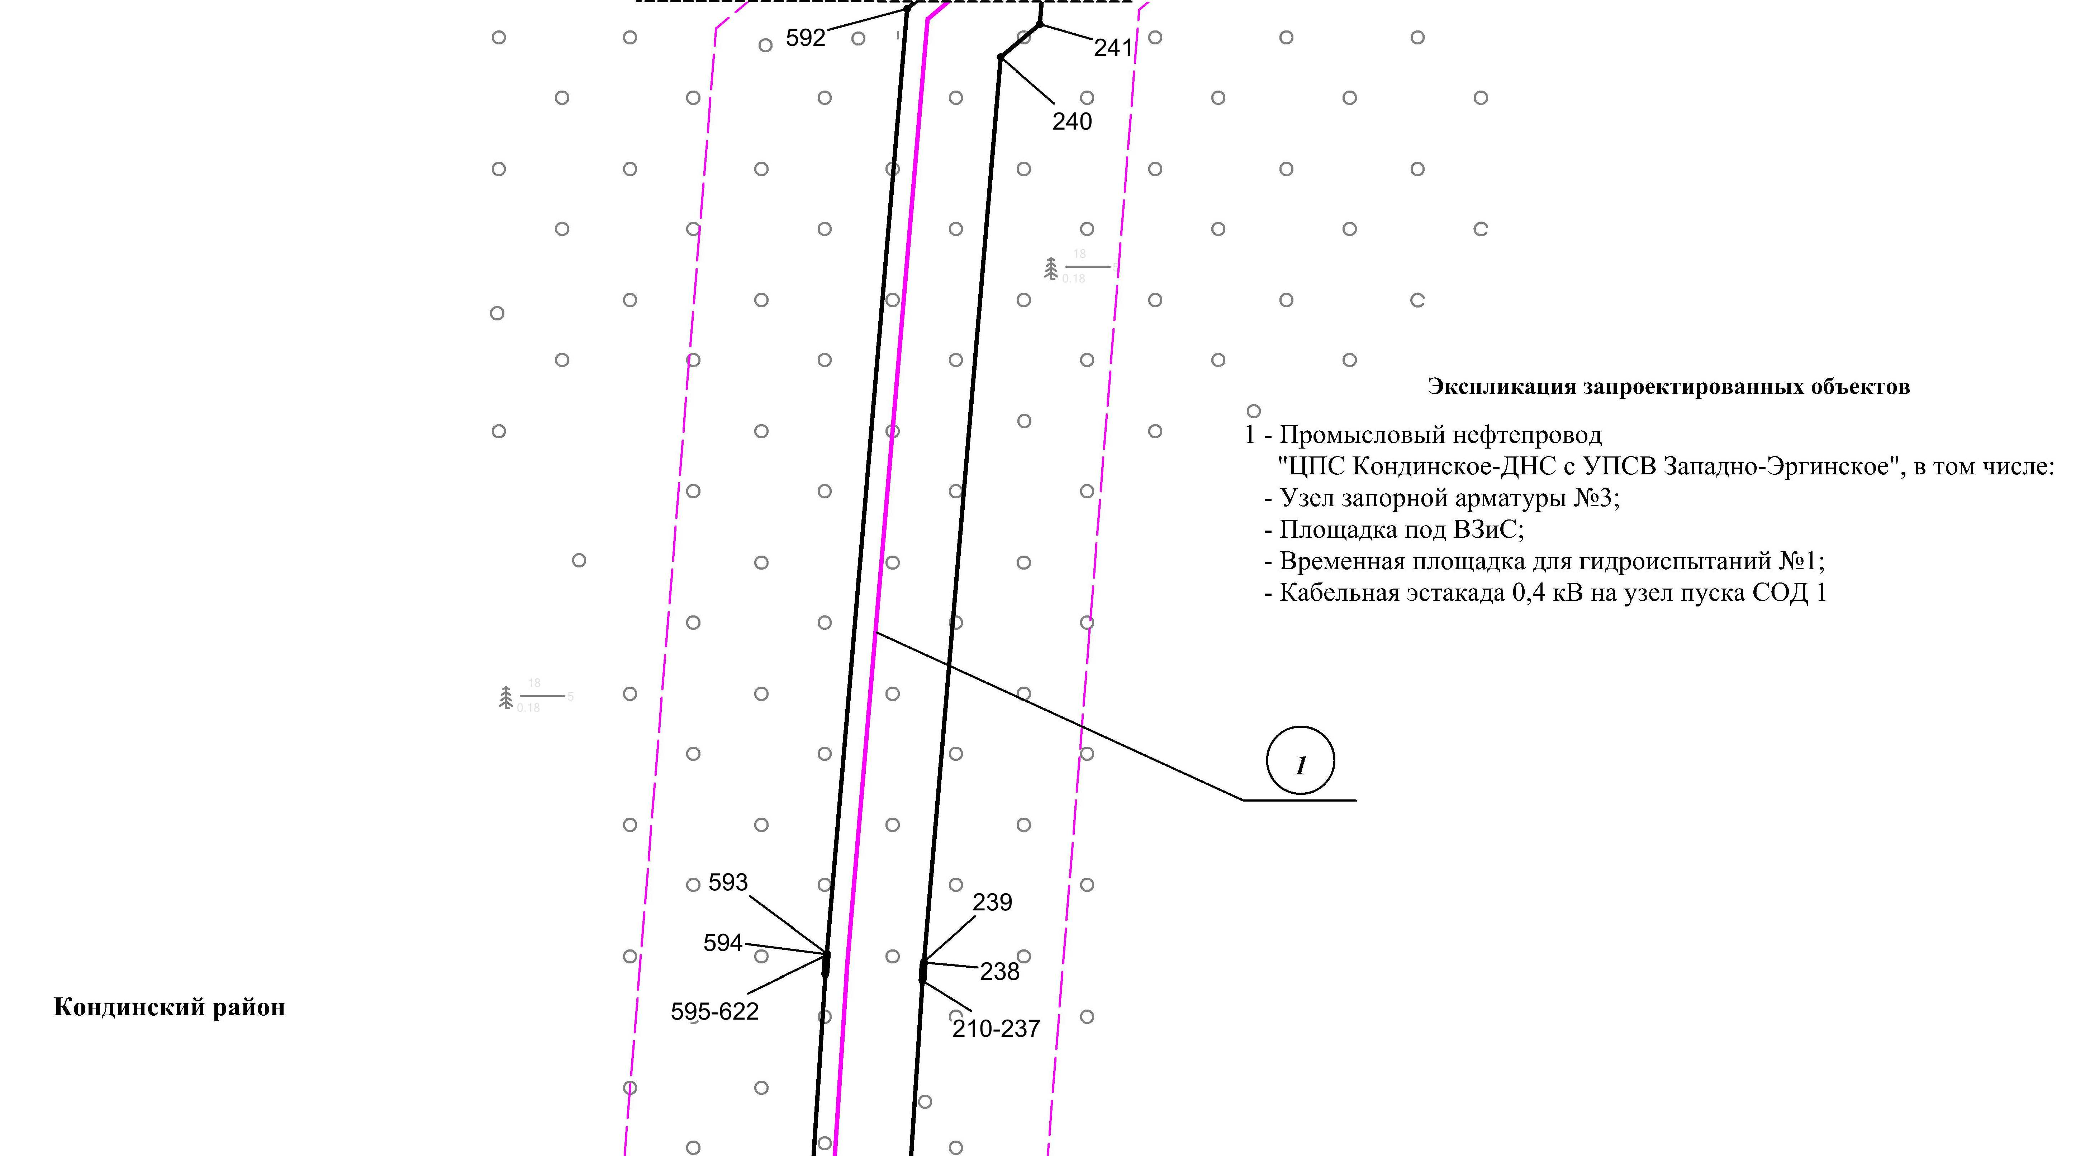
Линия совмещения с листом 58
Линия совмещения с листом 60

Линия совмещения с листом 59
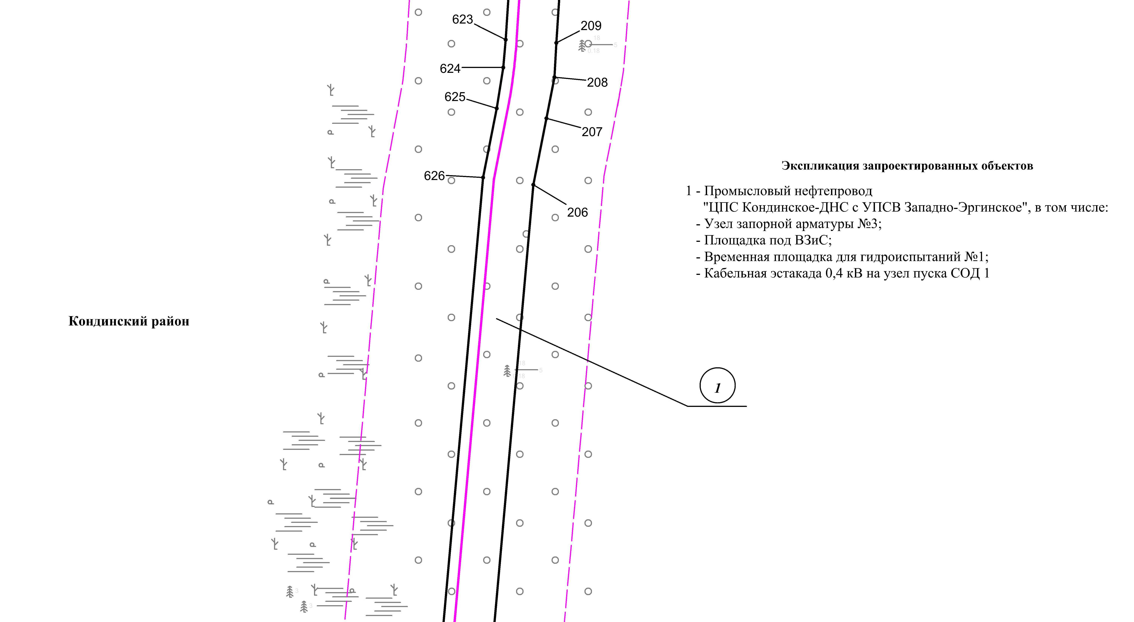
Линия совмещения с листом 61

Основная часть проекта планировки территории для размещения объекта капитального строительства, расположенного на территории двух муниципальных образований
Ханты-Мансийского автономного округа – Югры,
«Промысловый нефтепровод «ЦПС Кондинское-ДНС с УПСВ Западно-Эргинское»
Землепользователь: АО «НК «Конданефть»
Масштаб 1:2000

Основная часть проекта планировки территории для размещения объекта капитального строительства, расположенного на территории двух муниципальных образований
Ханты-Мансийского автономного округа – Югры,
«Промысловый нефтепровод «ЦПС Кондинское-ДНС с УПСВ Западно-Эргинское»
Землепользователь: АО «НК «Конданефть»
Масштаб 1:2000

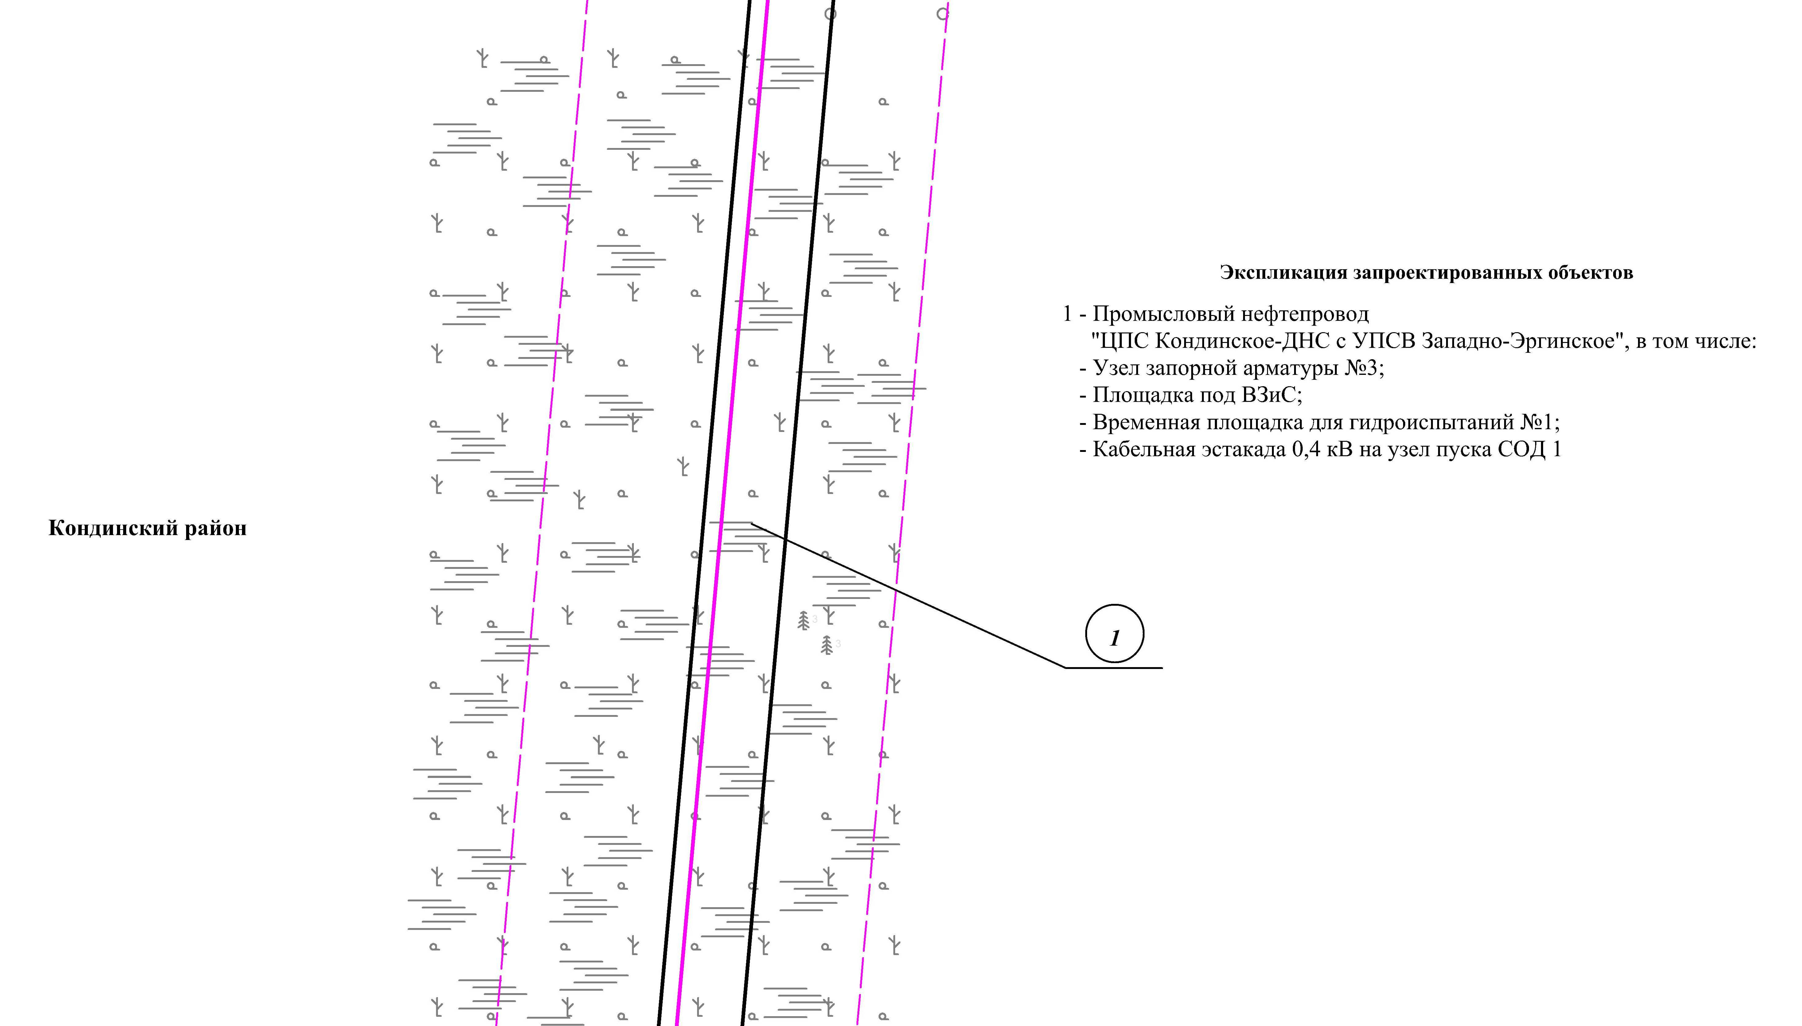
Линия совмещения с листом 60
Линия совмещения с листом 62

Основная часть проекта планировки территории для размещения объекта капитального строительства, расположенного на территории двух муниципальных образований
Ханты-Мансийского автономного округа – Югры
«Промысловый нефтепровод «ЦПС Кондинское-ДНС с УПСВ Западно-Эргинское»
Землепользователь: АО «НК «Конданефть»

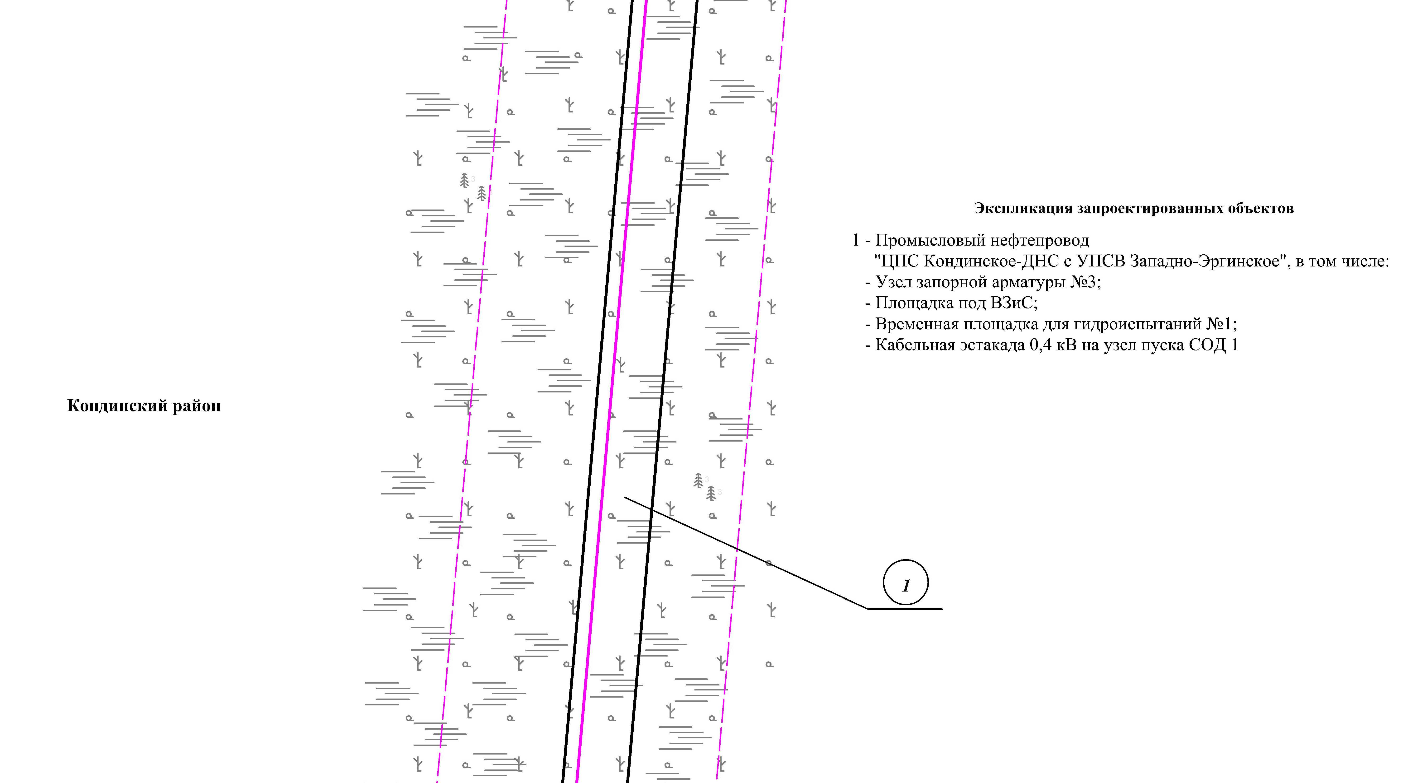
Линия совмещения с листом 61
Линия совмещения с листом 63

Основная часть проекта планировки территории для размещения объекта капитального строительства, расположенного на территории двух муниципальных образований
Ханты-Мансийского автономного округа – Югры,
«Промысловый нефтепровод «ЦПС Кондинское-ДНС с УПСВ Западно-Эргинское»
Землепользователь: АО «НК «Конданефть»
Масштаб 1:2000

Основная часть проекта планировки территории для размещения объекта капитального строительства, расположенного на территории двух муниципальных образований
Ханты-Мансийского автономного округа – Югры,
«Промысловый нефтепровод «ЦПС Кондинское-ДНС с УПСВ Западно-Эргинское»
Землепользователь: АО «НК «Конданефть»
Масштаб 1:2000

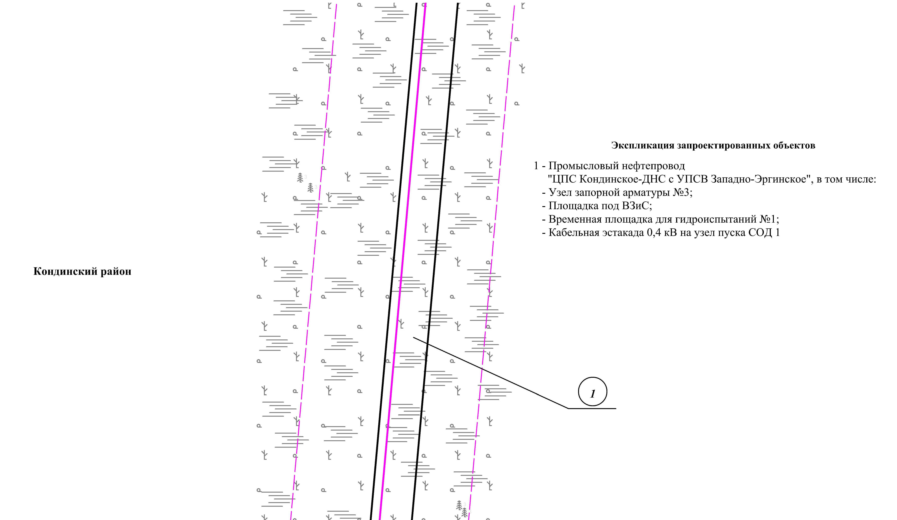
Линия совмещения с листом 62
Линия совмещения с листом 64

Основная часть проекта планировки территории для размещения объекта капитального строительства, расположенного на территории двух муниципальных образований
Ханты-Мансийского автономного округа – Югры,
«Промысловый нефтепровод «ЦПС Кондинское-ДНС с УПСВ Западно-Эргинское»
Землепользователь: АО «НК «Конданефть»
Масштаб 1:2000

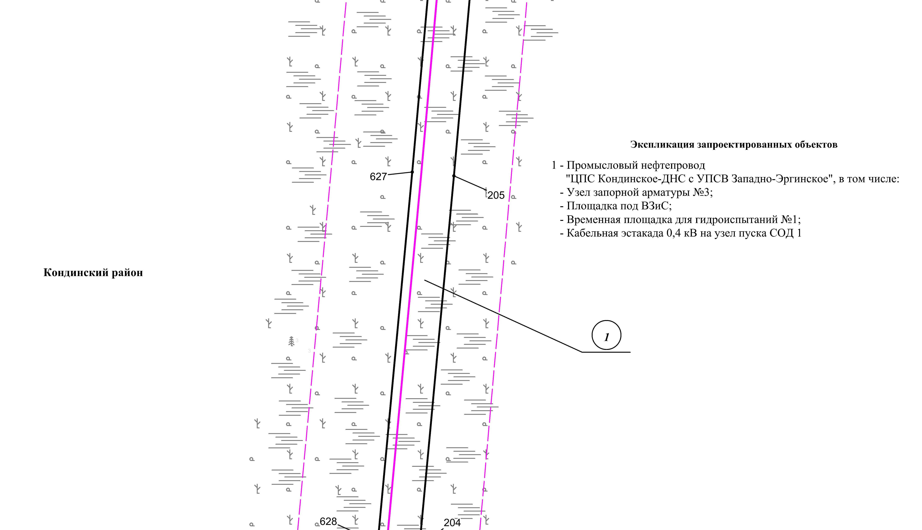
Линия совмещения с листом 63
Линия совмещения с листом 65

Основная часть проекта планировки территории для размещения объекта капитального строительства, расположенного на территории двух муниципальных образований
Ханты-Мансийского автономного округа – Югры,
«Промысловый нефтепровод «ЦПС Кондинское-ДНС с УПСВ Западно-Эргинское»
Землепользователь: АО «НК «Конданефть»
Масштаб 1:2000

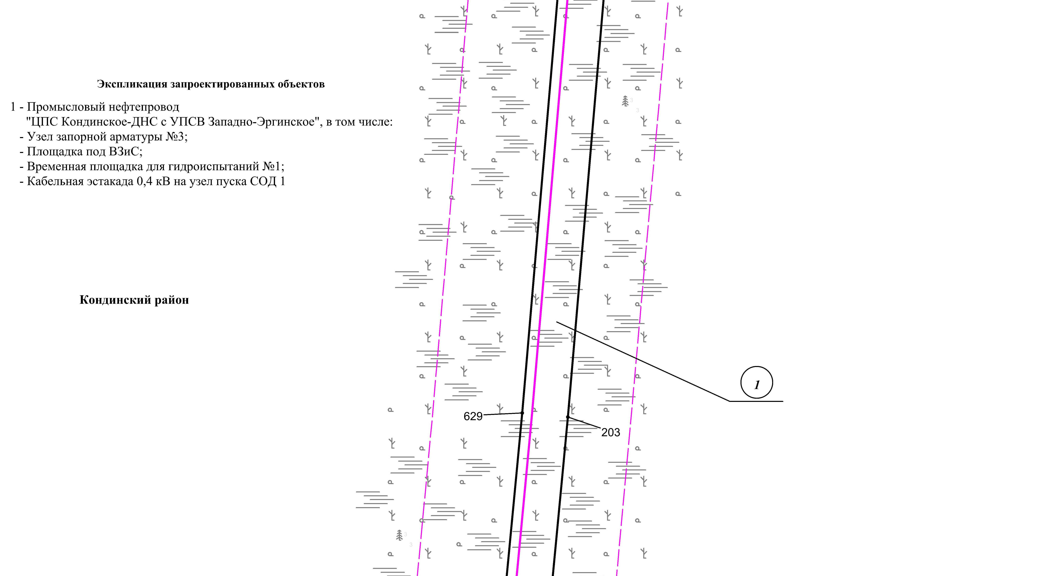
Линия совмещения с листом 64
Линия совмещения с листом 66

Основная часть проекта планировки территории для размещения объекта капитального строительства, расположенного на территории двух муниципальных образований
Ханты-Мансийского автономного округа – Югры,
«Промысловый нефтепровод «ЦПС Кондинское-ДНС с УПСВ Западно-Эргинское»
Землепользователь: АО «НК «Конданефть»
Масштаб 1:2000

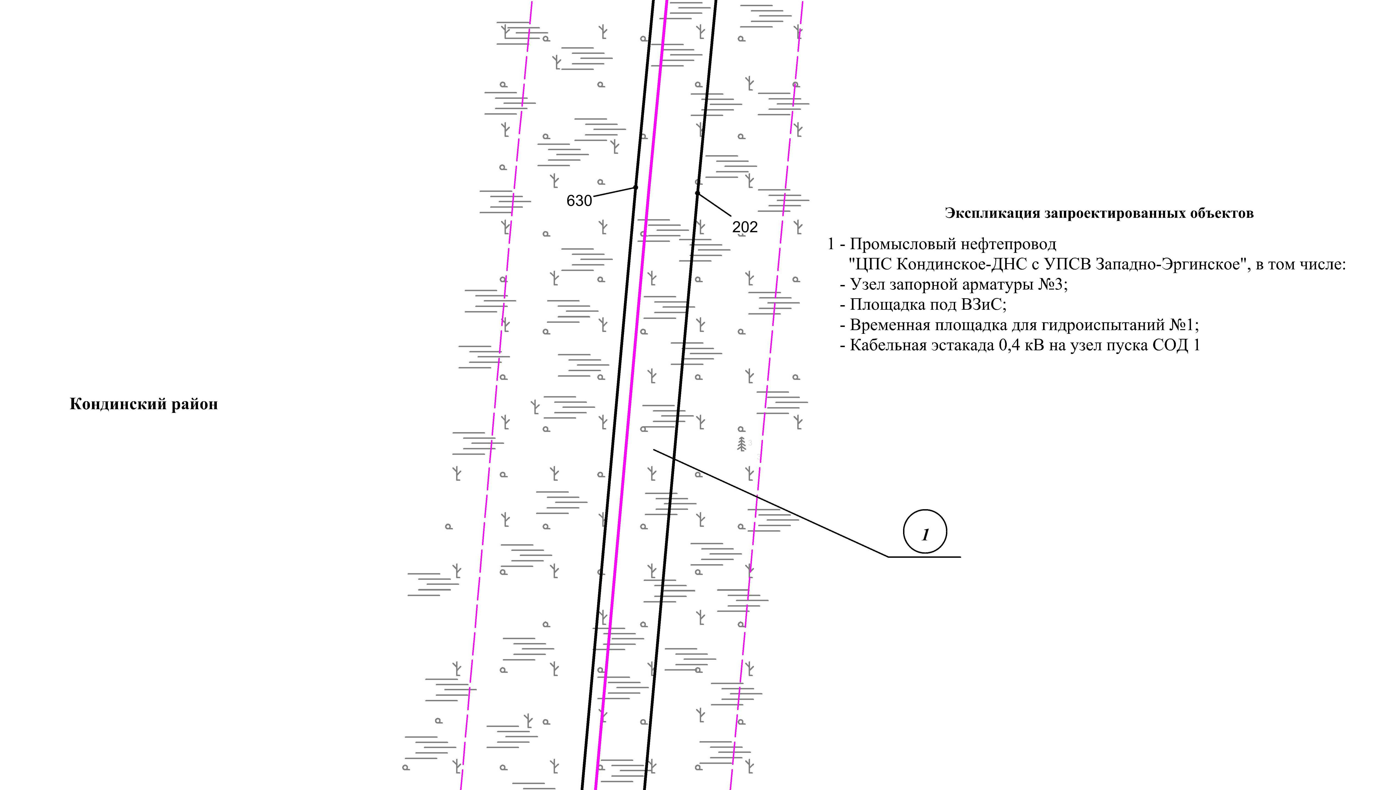
Линия совмещения с листом 65
Линия совмещения с листом 67

Основная часть проекта планировки территории для размещения объекта капитального строительства, расположенного на территории двух муниципальных образований
Ханты-Мансийского автономного округа – Югры,
«Промысловый нефтепровод «ЦПС Кондинское-ДНС с УПСВ Западно-Эргинское»
Землепользователь: АО «НК «Конданефть»
Масштаб 1:2000

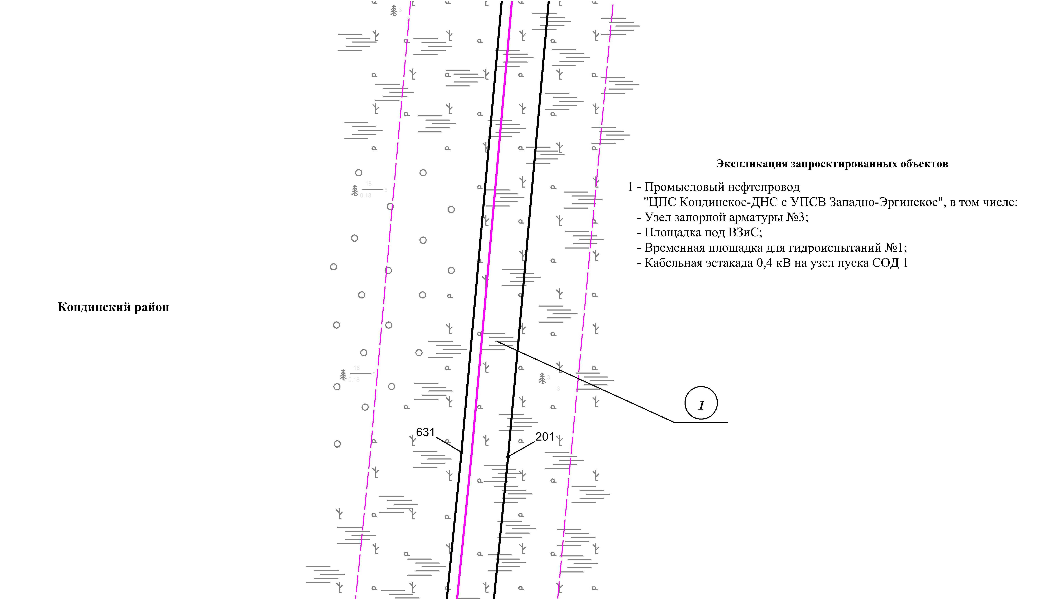
Линия совмещения с листом 68
Линия совмещения с листом 66

Основная часть проекта планировки территории для размещения объекта капитального строительства, расположенного на территории двух муниципальных образований
Ханты-Мансийского автономного округа – Югры,
«Промысловый нефтепровод «ЦПС Кондинское-ДНС с УПСВ Западно-Эргинское»
Землепользователь: АО «НК «Конданефть»
Масштаб 1:2000

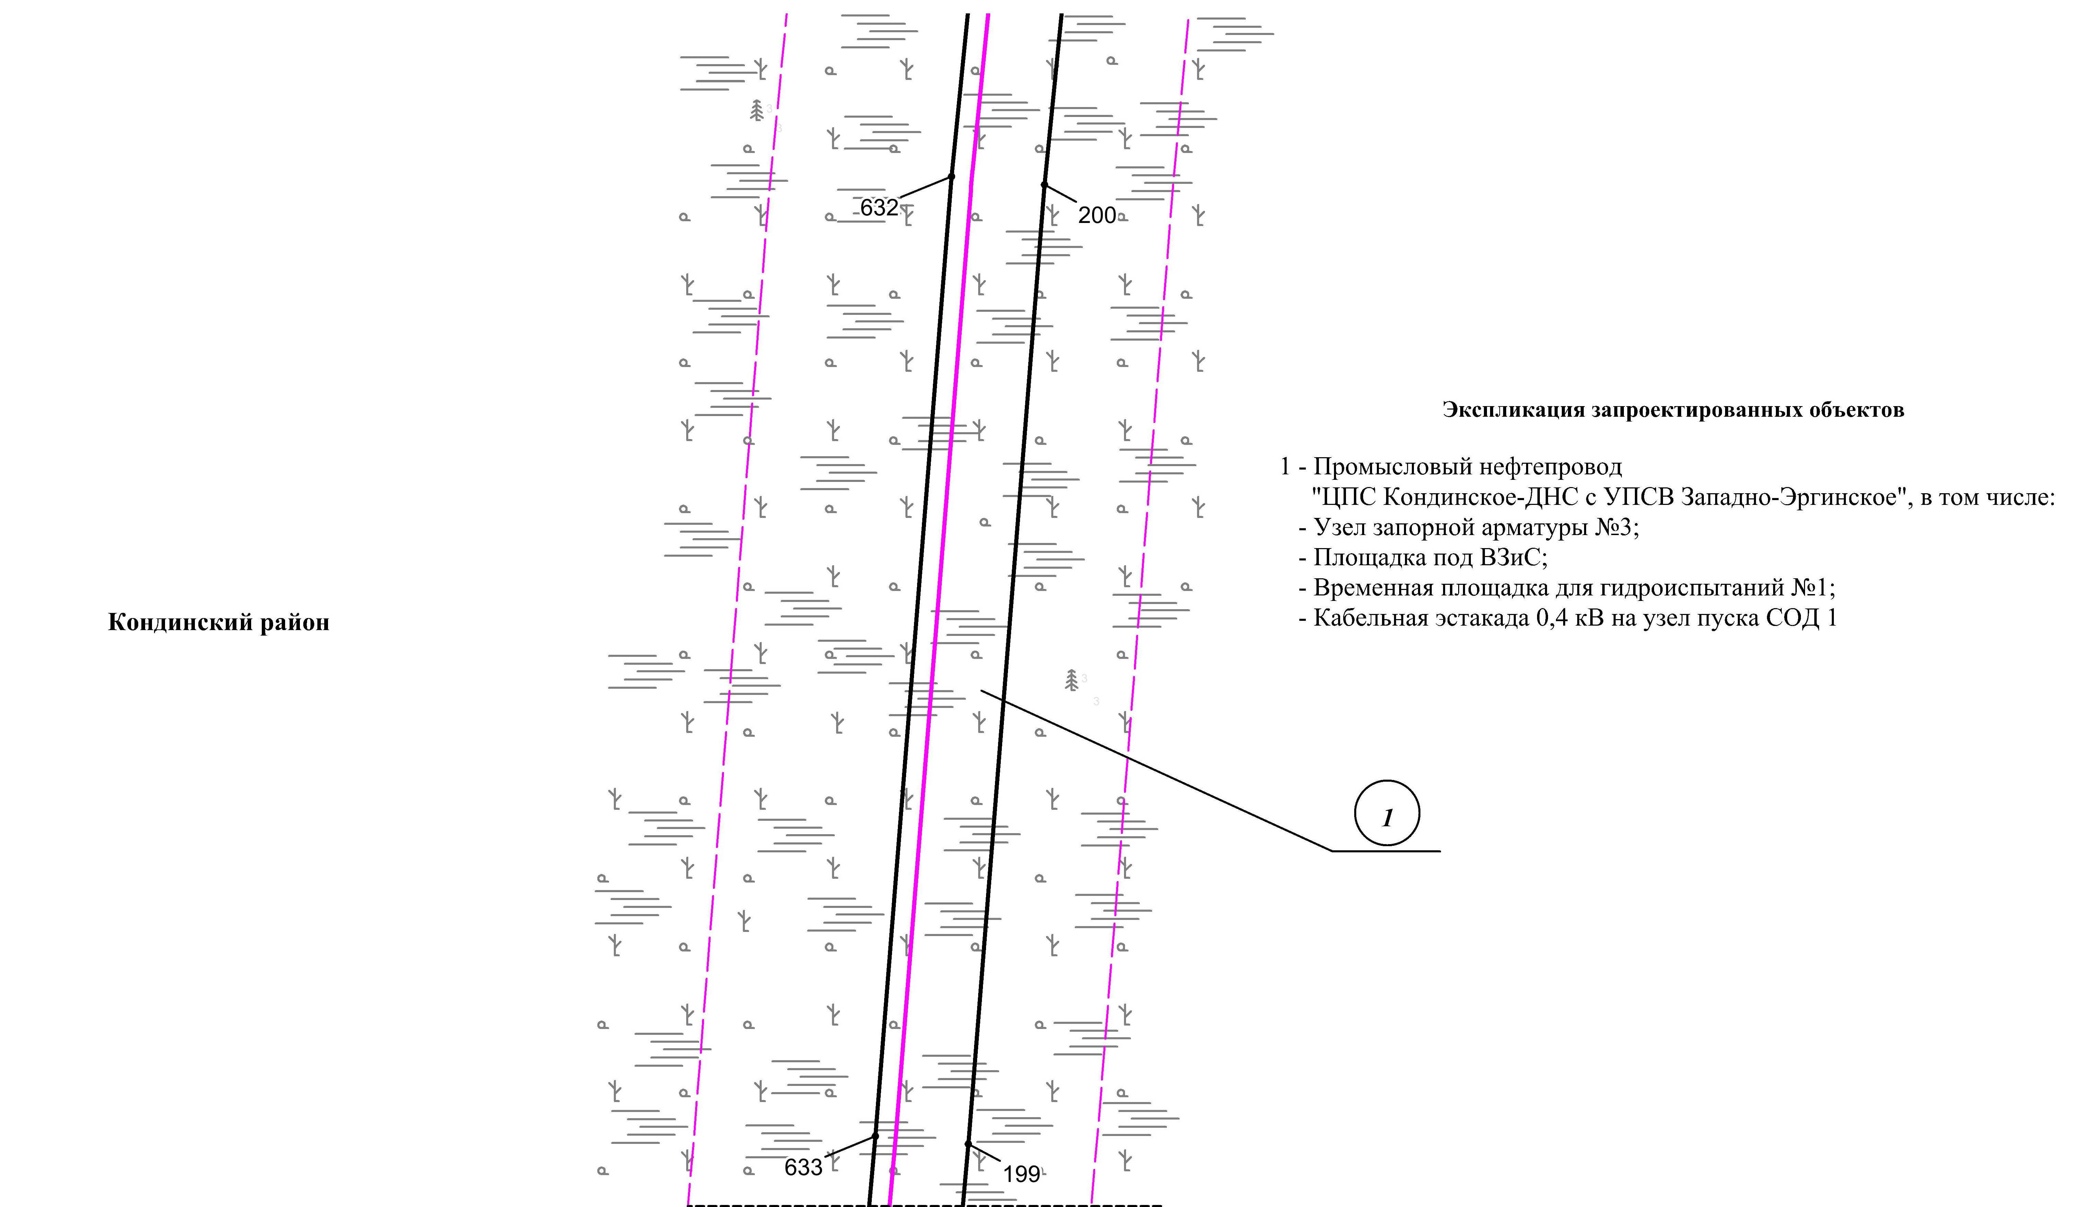
Линия совмещения с листом 67
Линия совмещения с листом 69

Основная часть проекта планировки территории для размещения объекта капитального строительства, расположенного на территории двух муниципальных образований
Ханты-Мансийского автономного округа – Югры
«Промысловый нефтепровод «ЦПС Кондинское-ДНС с УПСВ Западно-Эргинское»
Землепользователь: АО «НК «Конданефть»

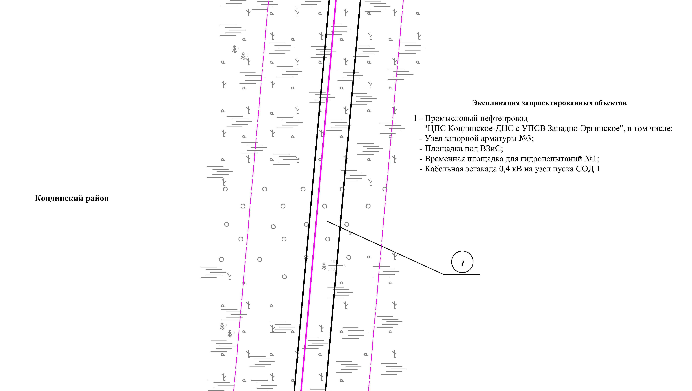
Линия совмещения с листом 68
Линия совмещения с листом 70

Основная часть проекта планировки территории для размещения объекта капитального строительства, расположенного на территории двух муниципальных образований
Ханты-Мансийского автономного округа – Югры,
«Промысловый нефтепровод «ЦПС Кондинское-ДНС с УПСВ Западно-Эргинское»
Землепользователь: АО «НК «Конданефть»
Масштаб 1:2000

Основная часть проекта планировки территории для размещения объекта капитального строительства, расположенного на территории двух муниципальных образований
Ханты-Мансийского автономного округа – Югры,
«Промысловый нефтепровод «ЦПС Кондинское-ДНС с УПСВ Западно-Эргинское»
Землепользователь: АО «НК «Конданефть»
Масштаб 1:2000

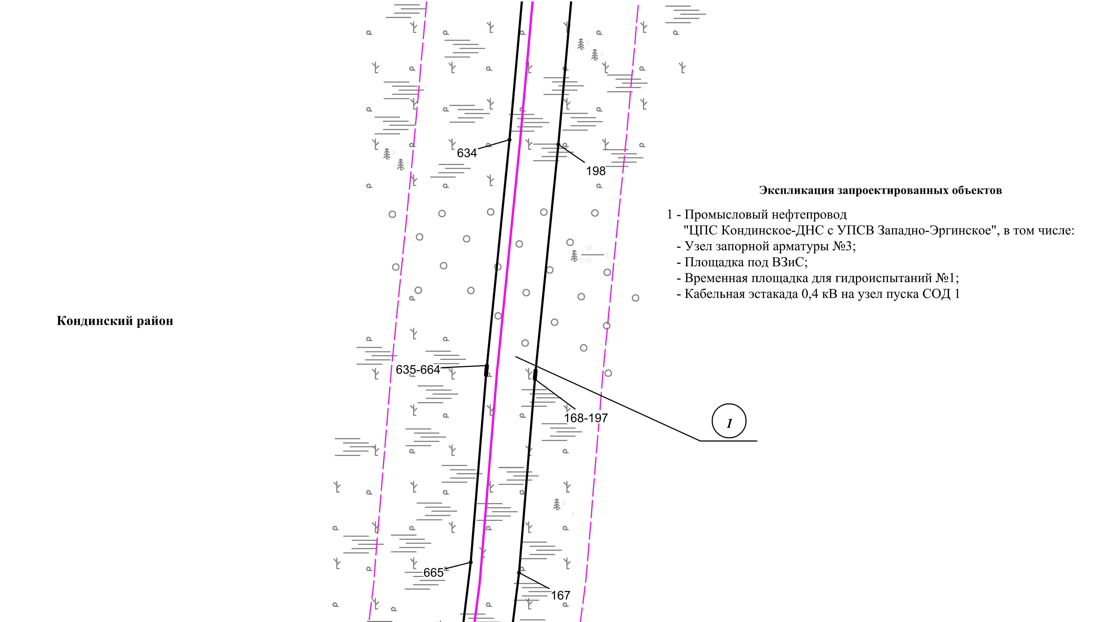
Линия совмещения с листом 69
Линия совмещения с листом 71

Основная часть проекта планировки территории для размещения объекта капитального строительства, расположенного на территории двух муниципальных образований
Ханты-Мансийского автономного округа – Югры
«Промысловый нефтепровод «ЦПС Кондинское-ДНС с УПСВ Западно-Эргинское»
Землепользователь: АО «НК «Конданефть»

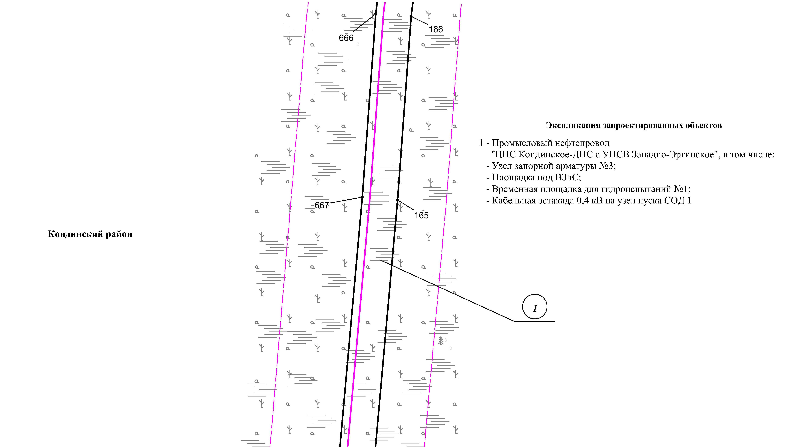
Линия совмещения с листом 70
Линия совмещения с листом 72

Основная часть проекта планировки территории для размещения объекта капитального строительства, расположенного на территории двух муниципальных образований
Ханты-Мансийского автономного округа – Югры,
«Промысловый нефтепровод «ЦПС Кондинское-ДНС с УПСВ Западно-Эргинское»
Землепользователь: АО «НК «Конданефть»
Масштаб 1:2000

Основная часть проекта планировки территории для размещения объекта капитального строительства, расположенного на территории двух муниципальных образований
Ханты-Мансийского автономного округа – Югры,
«Промысловый нефтепровод «ЦПС Кондинское-ДНС с УПСВ Западно-Эргинское»
Землепользователь: АО «НК «Конданефть»
Масштаб 1:2000

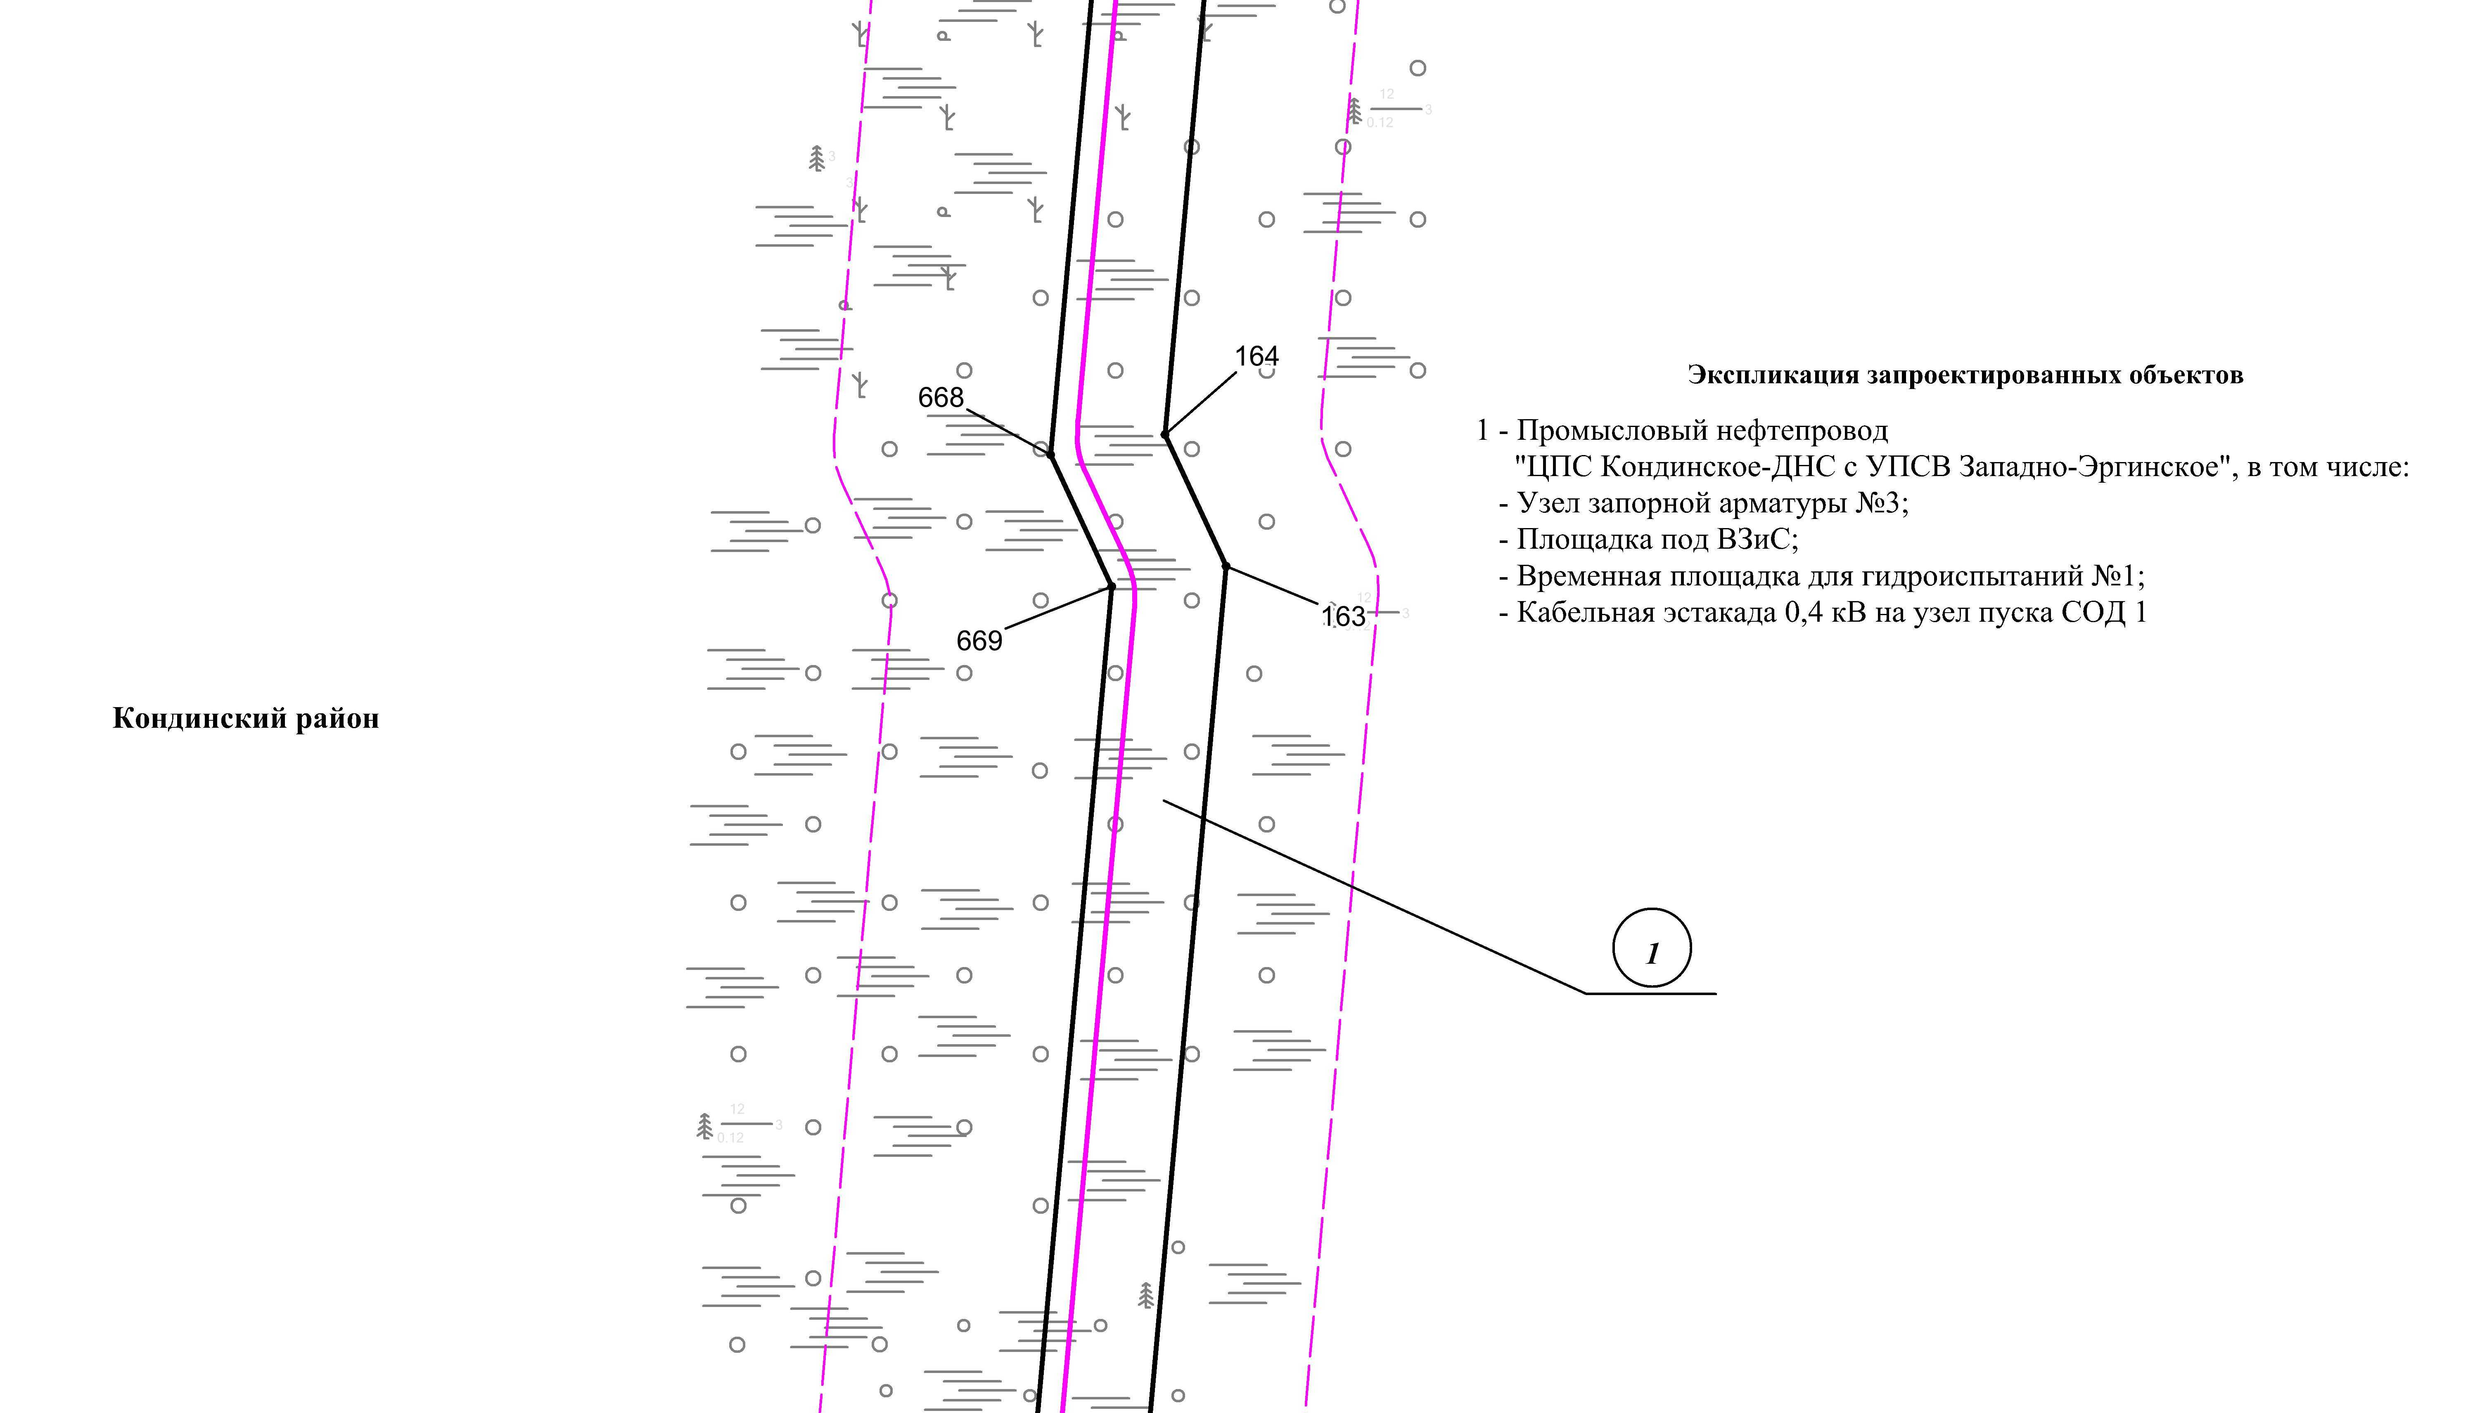
Линия совмещения с листом 71
Линия совмещения с листом 73

Основная часть проекта планировки территории для размещения объекта капитального строительства, расположенного на территории двух муниципальных образований
Ханты-Мансийского автономного округа – Югры,
«Промысловый нефтепровод «ЦПС Кондинское-ДНС с УПСВ Западно-Эргинское»
Землепользователь: АО «НК «Конданефть»
Масштаб 1:2000

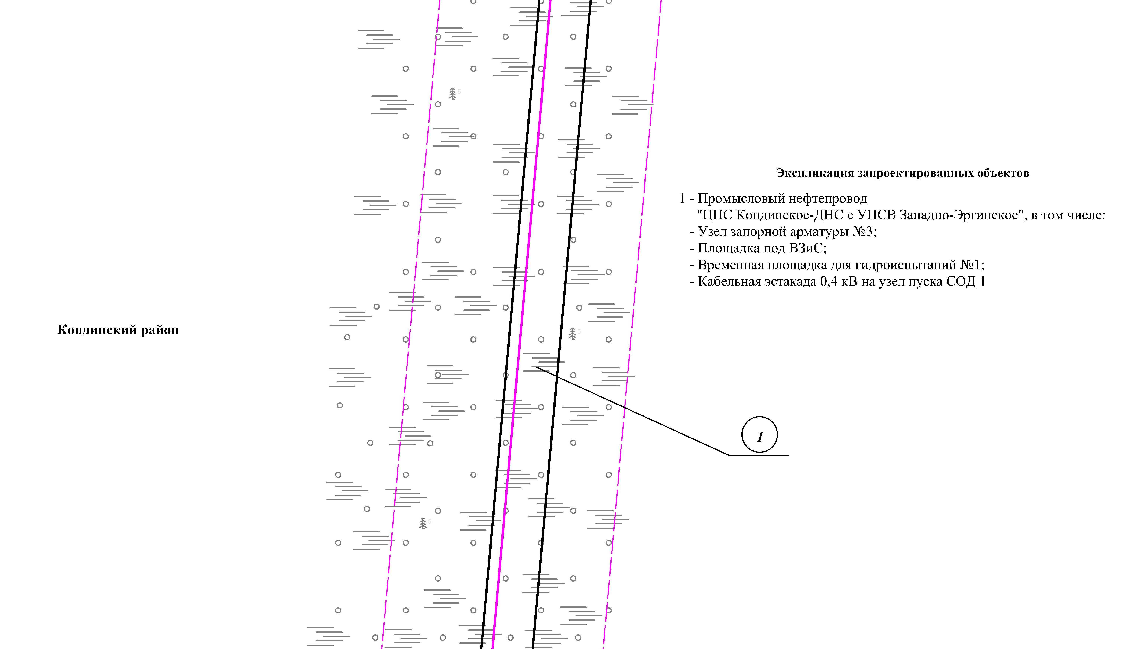
Линия совмещения с листом 72
Линия совмещения с листом 74

Основная часть проекта планировки территории для размещения объекта капитального строительства, расположенного на территории двух муниципальных образований
Ханты-Мансийского автономного округа – Югры,
«Промысловый нефтепровод «ЦПС Кондинское-ДНС с УПСВ Западно-Эргинское»
Землепользователь: АО «НК «Конданефть»
Масштаб 1:2000

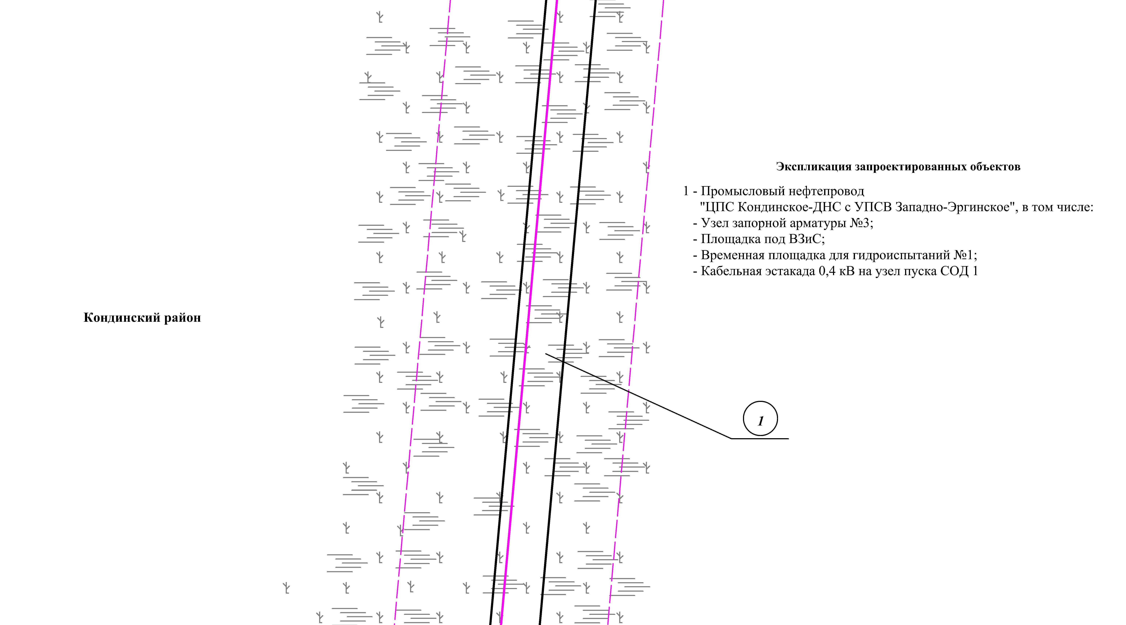
Линия совмещения с листом 73
Линия совмещения с листом 75

Основная часть проекта планировки территории для размещения объекта капитального строительства, расположенного на территории двух муниципальных образований
Ханты-Мансийского автономного округа – Югры,
«Промысловый нефтепровод «ЦПС Кондинское-ДНС с УПСВ Западно-Эргинское»
Землепользователь: АО «НК «Конданефть»
Масштаб 1:2000

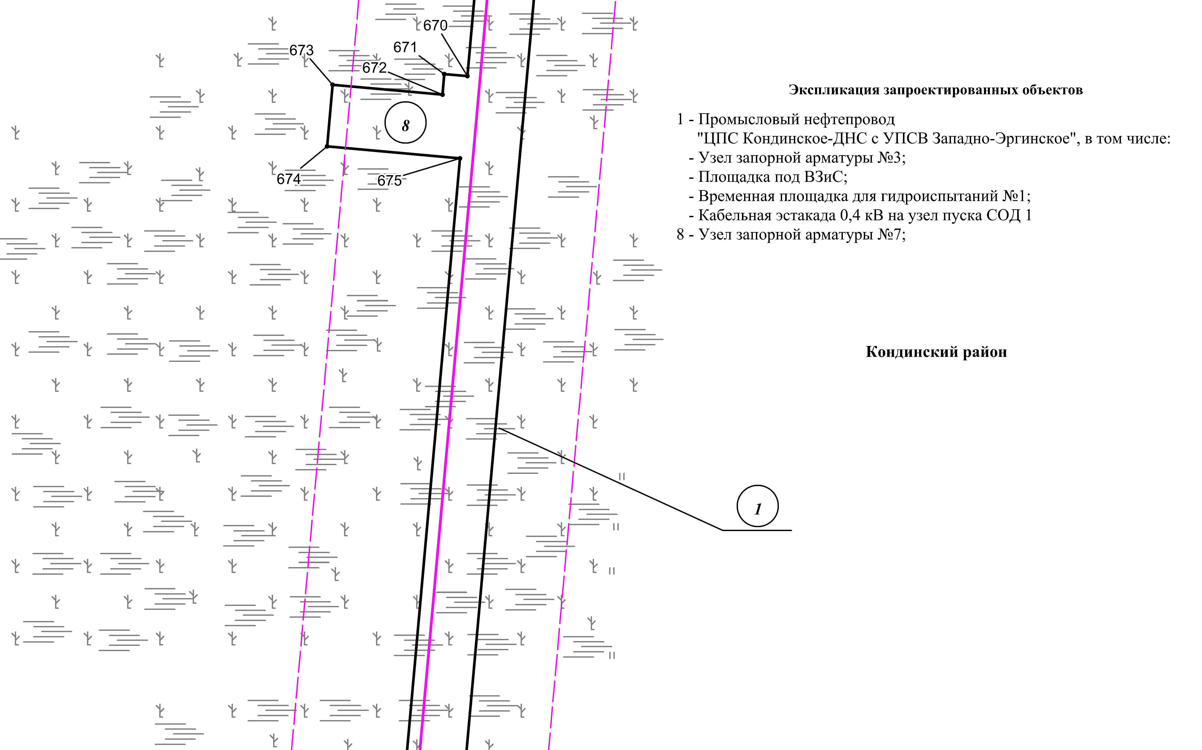
Линия совмещения с листом 76
Линия совмещения с листом 74

Основная часть проекта планировки территории для размещения объекта капитального строительства, расположенного на территории двух муниципальных образований
Ханты-Мансийского автономного округа – Югры
«Промысловый нефтепровод «ЦПС Кондинское-ДНС с УПСВ Западно-Эргинское»
Землепользователь: АО «НК «Конданефть»

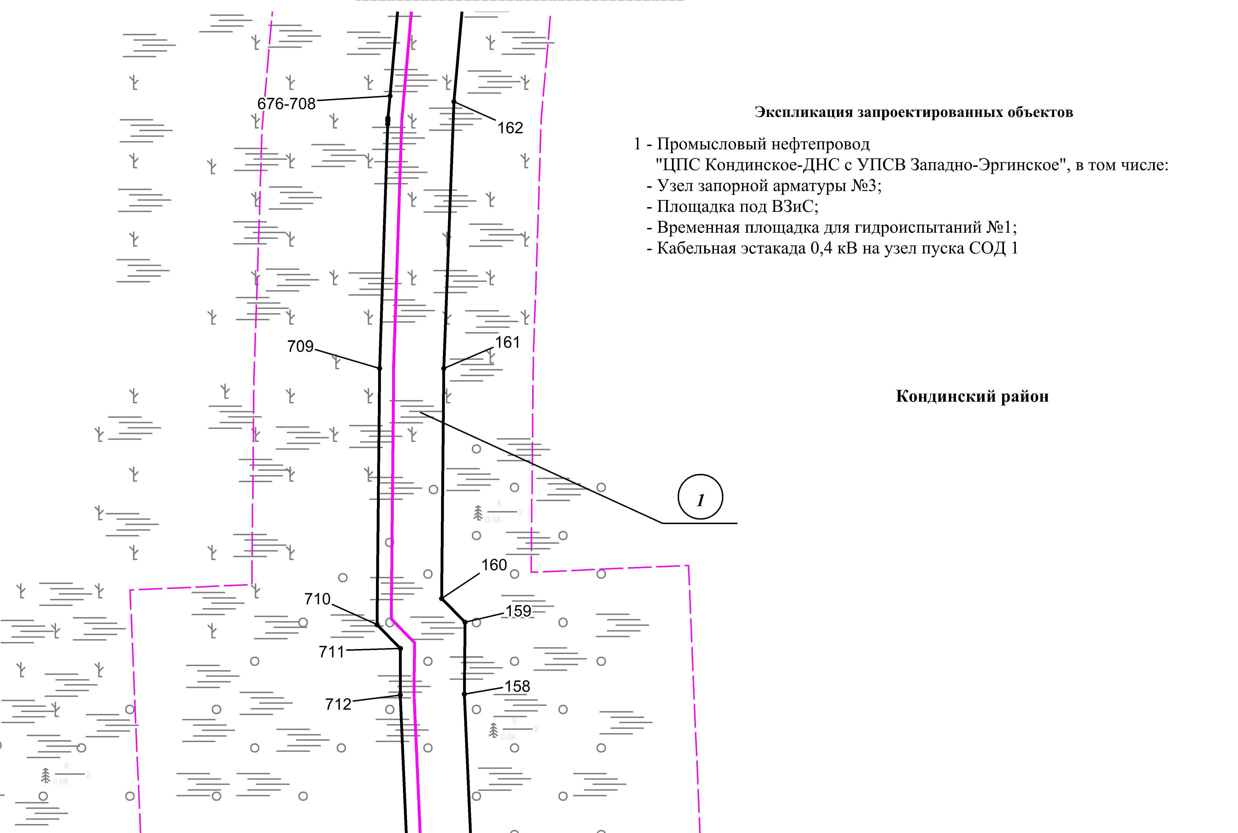
Линия совмещения с листом 77
Линия совмещения с листом 75

Основная часть проекта планировки территории для размещения объекта капитального строительства, расположенного на территории двух муниципальных образований
Ханты-Мансийского автономного округа – Югры,
«Промысловый нефтепровод «ЦПС Кондинское-ДНС с УПСВ Западно-Эргинское»
Землепользователь: АО «НК «Конданефть»
Масштаб 1:2000

Основная часть проекта планировки территории для размещения объекта капитального строительства, расположенного на территории двух муниципальных образований
Ханты-Мансийского автономного округа – Югры,
«Промысловый нефтепровод «ЦПС Кондинское-ДНС с УПСВ Западно-Эргинское»
Землепользователь: АО «НК «Конданефть»
Масштаб 1:2000

Линия совмещения с листом 78
Линия совмещения с листом 76
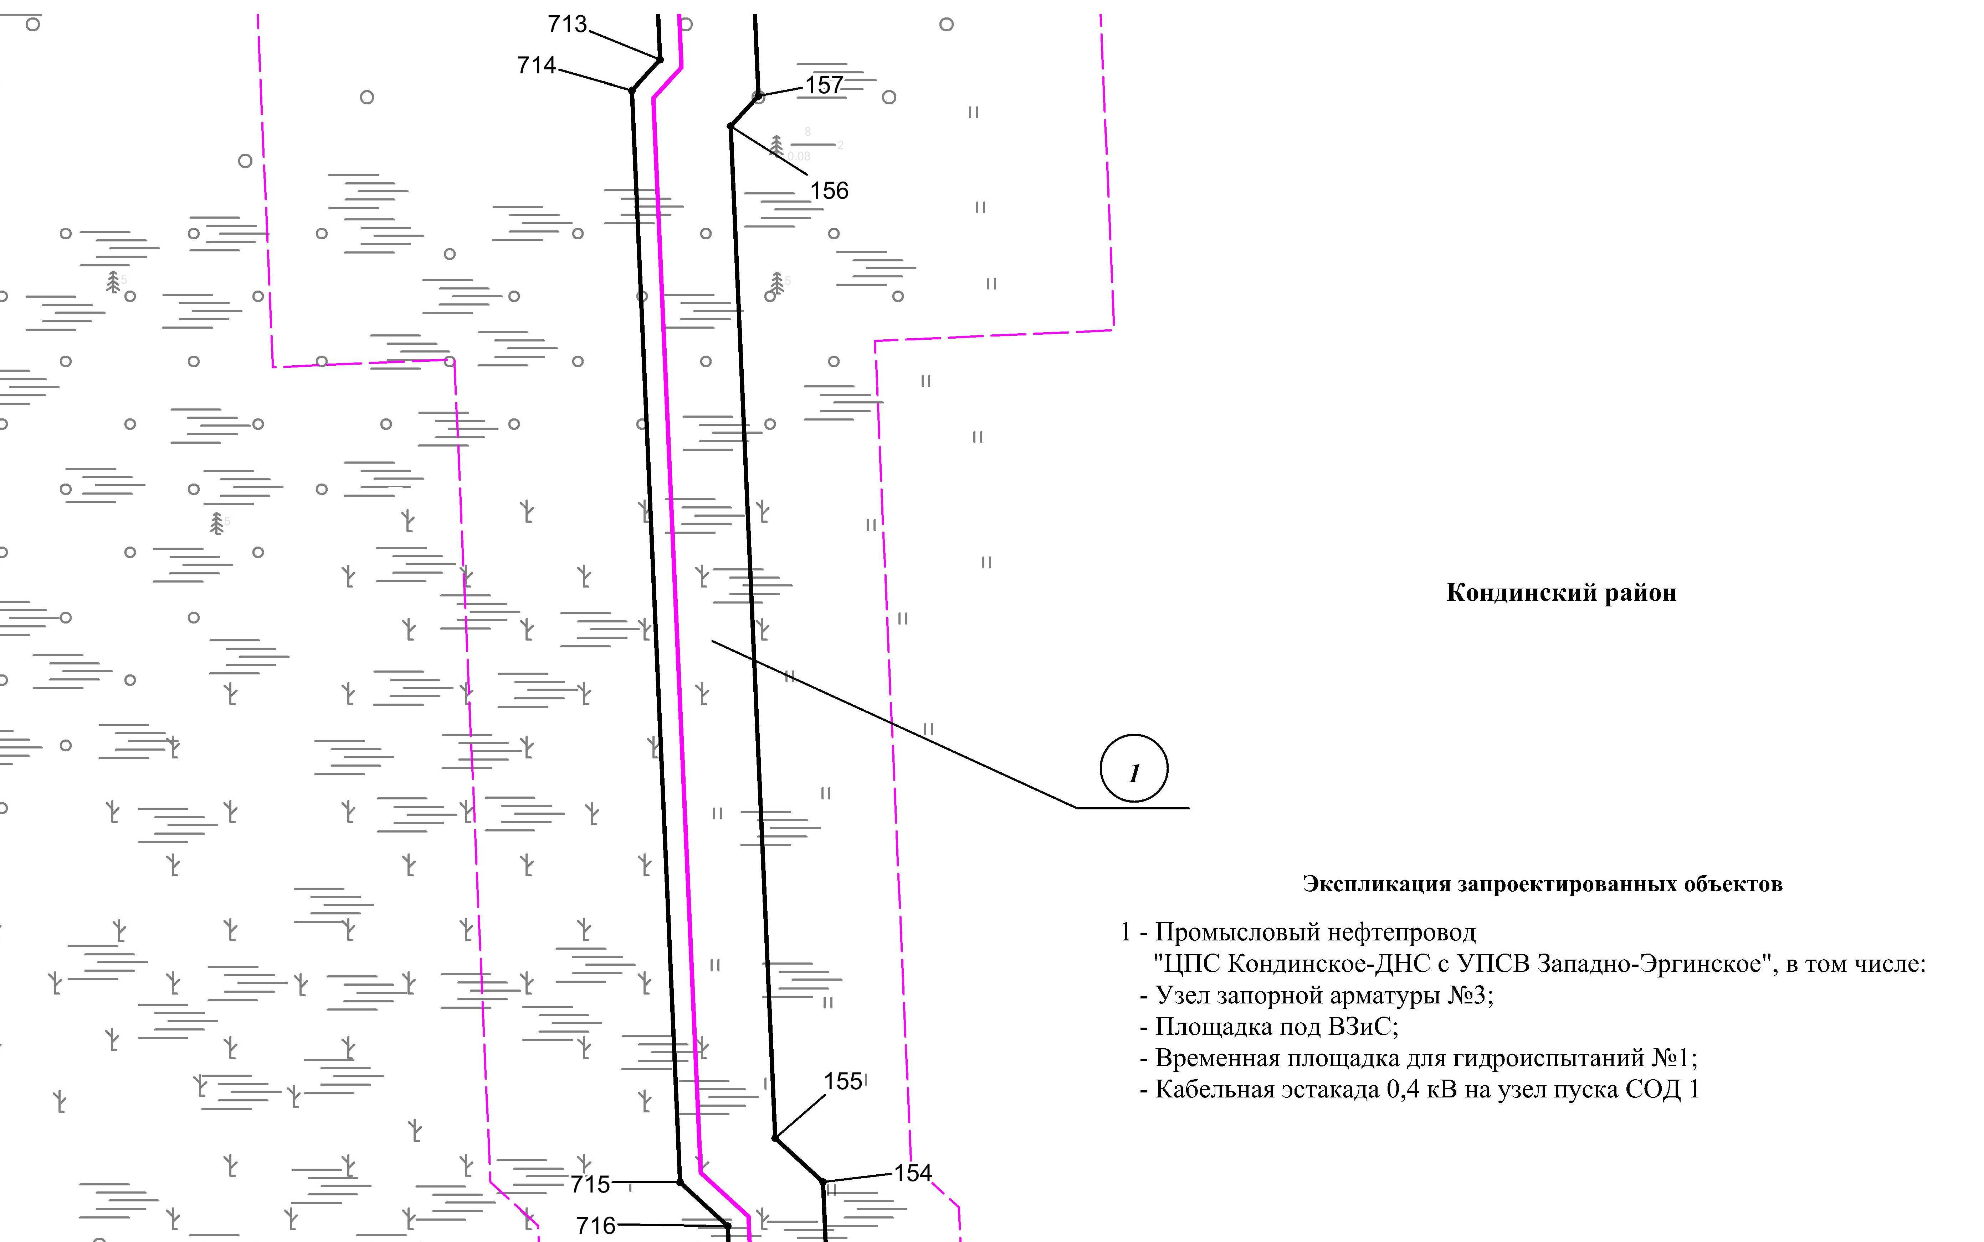

Основная часть проекта планировки территории для размещения объекта капитального строительства, расположенного на территории двух муниципальных образований
Ханты-Мансийского автономного округа – Югры
«Промысловый нефтепровод «ЦПС Кондинское-ДНС с УПСВ Западно-Эргинское»
Землепользователь: АО «НК «Конданефть»

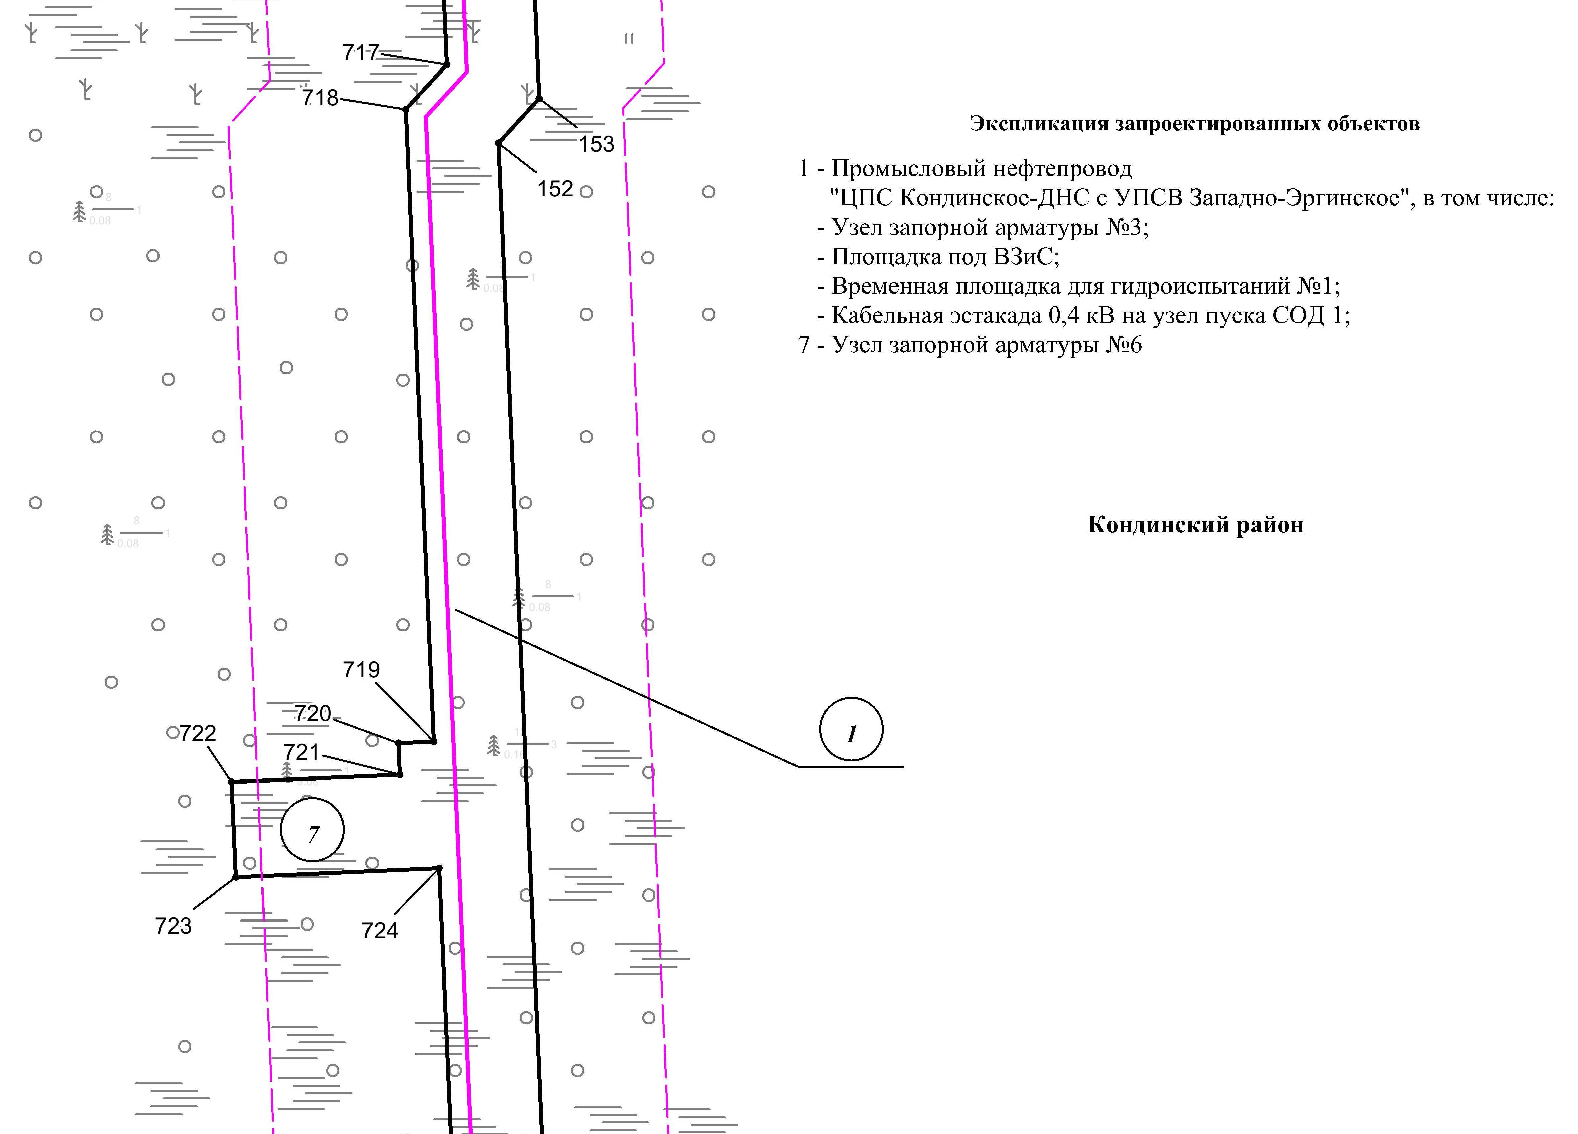
Линия совмещения с листом 77
Линия совмещения с листом 79

Основная часть проекта планировки территории для размещения объекта капитального строительства, расположенного на территории двух муниципальных образований
Ханты-Мансийского автономного округа – Югры,
«Промысловый нефтепровод «ЦПС Кондинское-ДНС с УПСВ Западно-Эргинское»
Землепользователь: АО «НК «Конданефть»
Масштаб 1:2000

Линия совмещения с листом 80

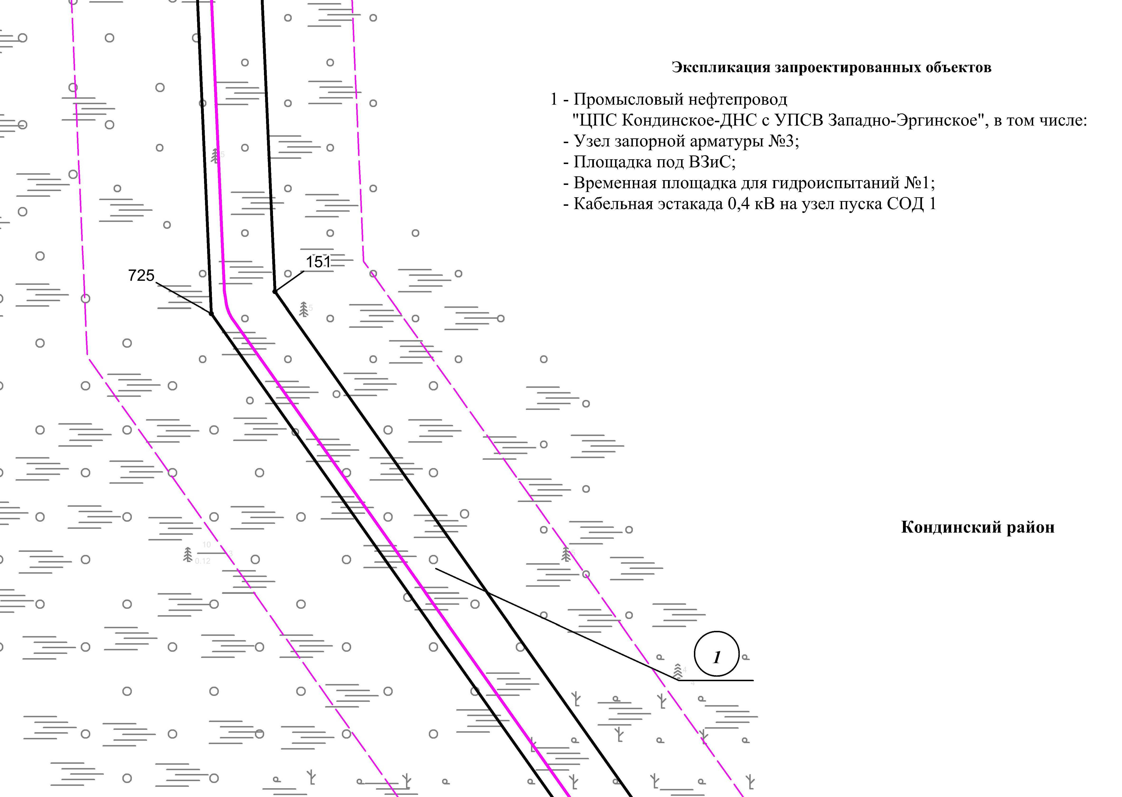
Линия совмещения с листом 78
Линия совмещения с листом 80
Основная часть проекта планировки территории для размещения объекта капитального строительства, расположенного на территории двух муниципальных образований
Ханты-Мансийского автономного округа – Югры,
«Промысловый нефтепровод «ЦПС Кондинское-ДНС с УПСВ Западно-Эргинское»
Землепользователь: АО «НК «Конданефть»
Масштаб 1:2000

Основная часть проекта планировки территории для размещения объекта капитального строительства, расположенного на территории двух муниципальных образований
Ханты-Мансийского автономного округа – Югры,
«Промысловый нефтепровод «ЦПС Кондинское-ДНС с УПСВ Западно-Эргинское»
Землепользователь: АО «НК «Конданефть»
Масштаб 1:2000

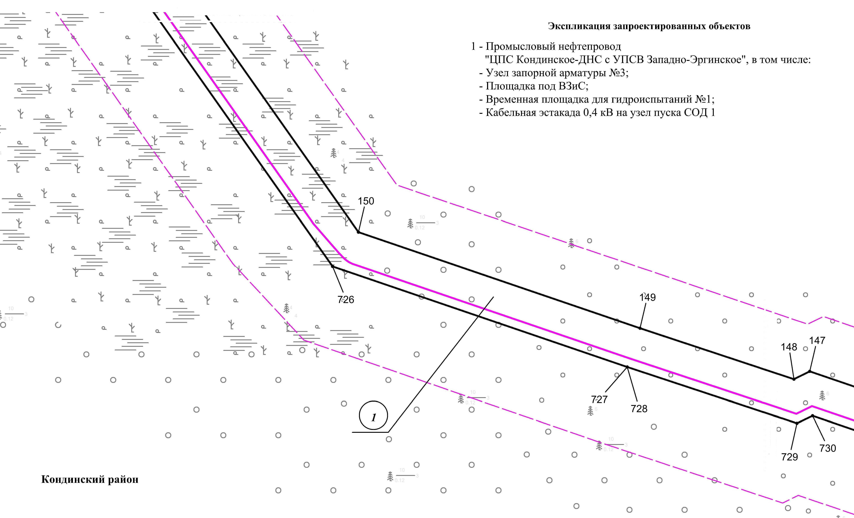
Линия совмещения с листом
81

Линия совмещения с листом 79

Основная часть проекта планировки территории для размещения объекта капитального строительства, расположенного на территории двух муниципальных образований
Ханты-Мансийского автономного округа – Югры,
«Промысловый нефтепровод «ЦПС Кондинское-ДНС с УПСВ Западно-Эргинское»
Землепользователь: АО «НК «Конданефть»
Масштаб 1:2000

Линия совмещения с листом
80

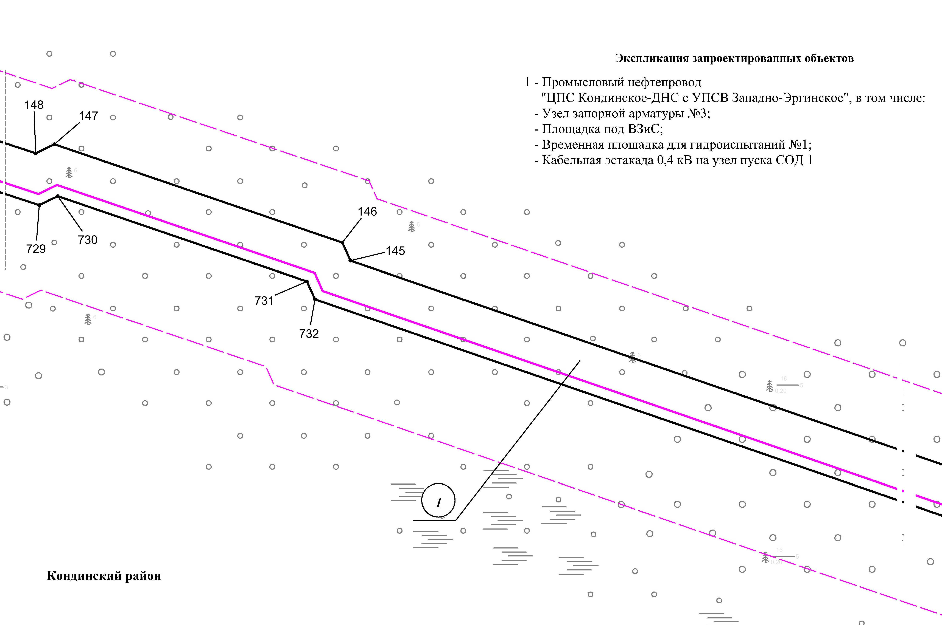
Линия совмещения с листом
82

Основная часть проекта планировки территории для размещения объекта капитального строительства, расположенного на территории двух муниципальных образований
Ханты-Мансийского автономного округа – Югры
«Промысловый нефтепровод «ЦПС Кондинское-ДНС с УПСВ Западно-Эргинское»
Землепользователь: АО «НК «Конданефть»

Линия совмещения с листом
81

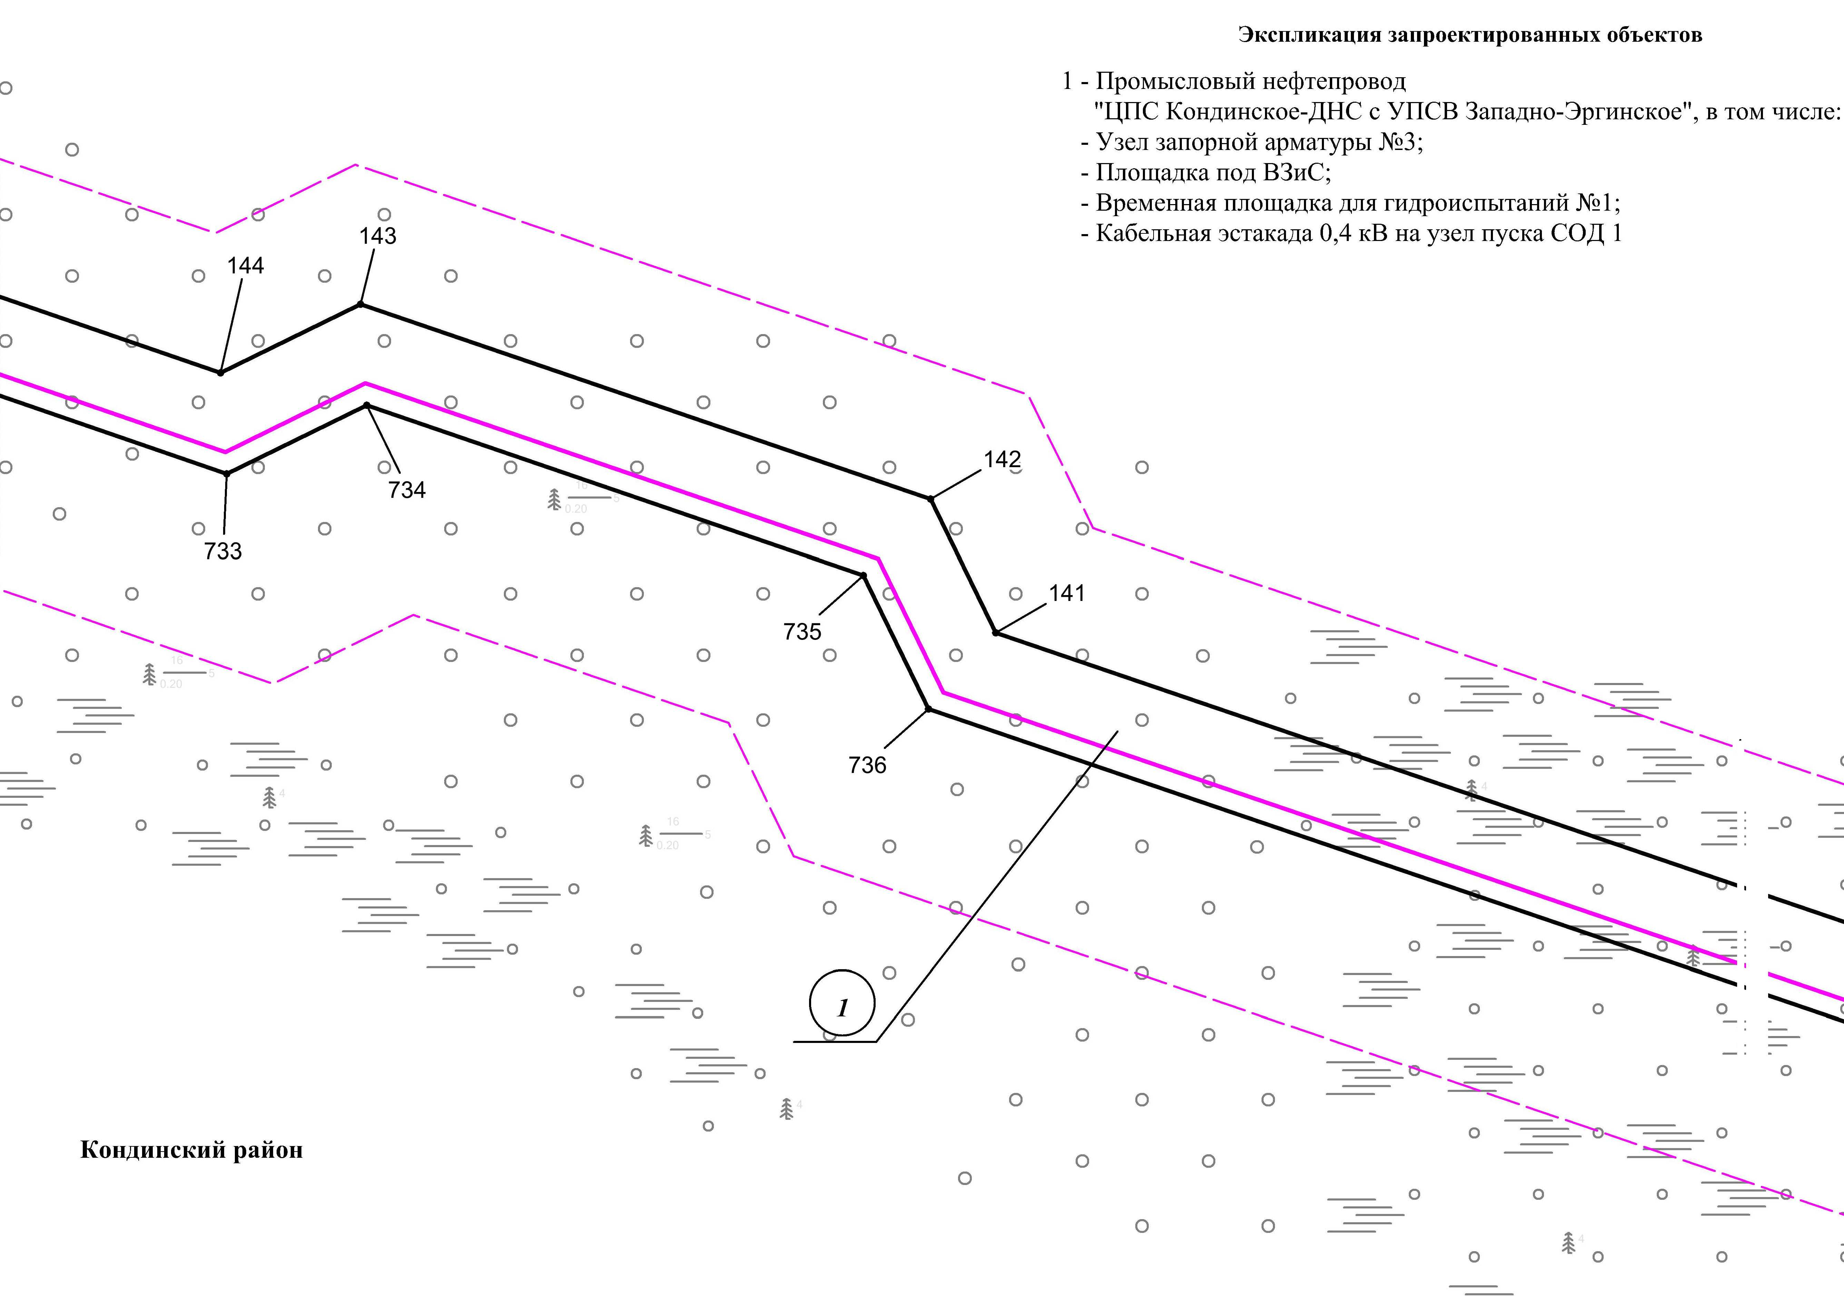

Линия совмещения с листом
83

Основная часть проекта планировки территории для размещения объекта капитального строительства, расположенного на территории двух муниципальных образований
Ханты-Мансийского автономного округа – Югры,
«Промысловый нефтепровод «ЦПС Кондинское-ДНС с УПСВ Западно-Эргинское»
Землепользователь: АО «НК «Конданефть»
Масштаб 1:2000

Основная часть проекта планировки территории для размещения объекта капитального строительства, расположенного на территории двух муниципальных образований
Ханты-Мансийского автономного округа – Югры,
«Промысловый нефтепровод «ЦПС Кондинское-ДНС с УПСВ Западно-Эргинское»
Землепользователь: АО «НК «Конданефть»
Масштаб 1:2000

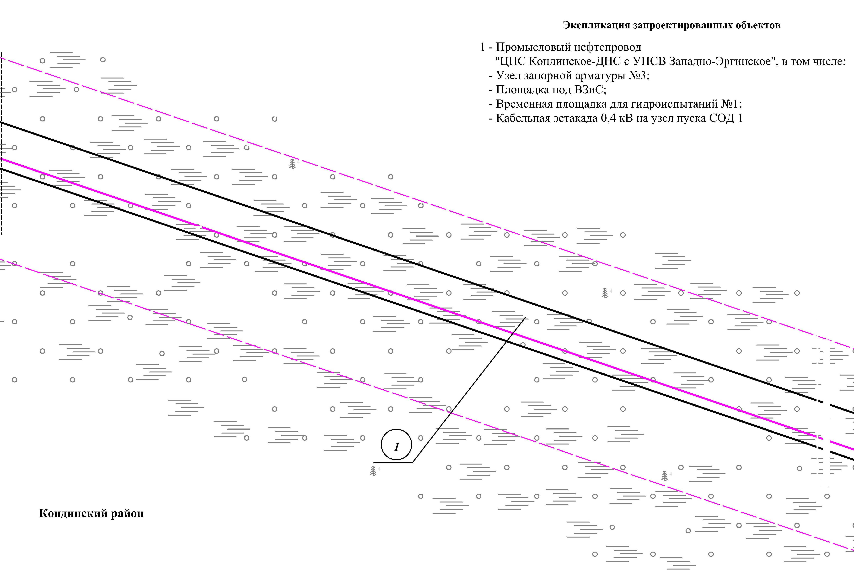
Линия совмещения с листом
84

Линия совмещения с листом
82

Основная часть проекта планировки территории для размещения объекта капитального строительства, расположенного на территории двух муниципальных образований
Ханты-Мансийского автономного округа – Югры,
«Промысловый нефтепровод «ЦПС Кондинское-ДНС с УПСВ Западно-Эргинское»
Землепользователь: АО «НК «Конданефть»
Масштаб 1:2000

Линия совмещения с листом
83

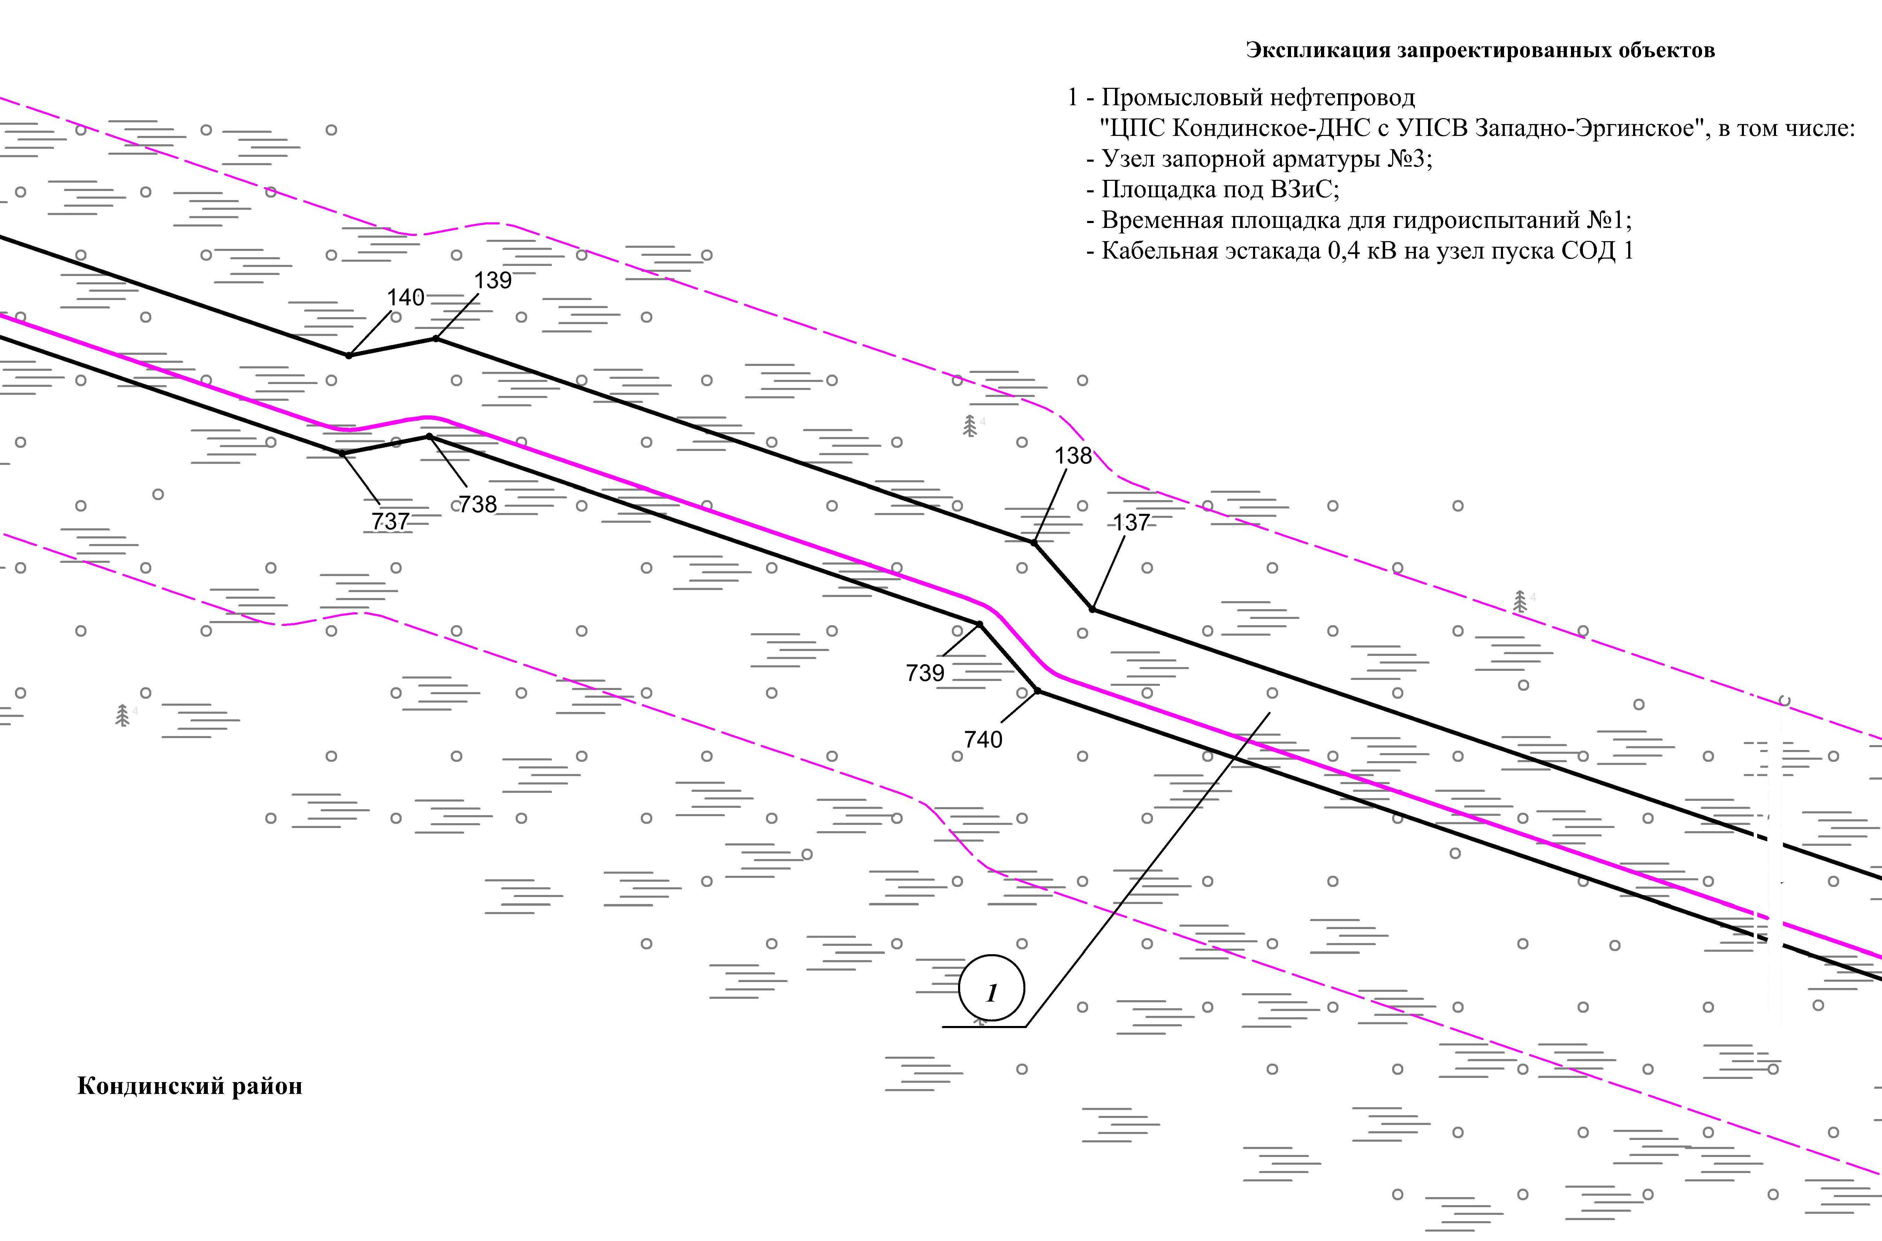
Линия совмещения с листом
85

Основная часть проекта планировки территории для размещения объекта капитального строительства, расположенного на территории двух муниципальных образований
Ханты-Мансийского автономного округа – Югры,
«Промысловый нефтепровод «ЦПС Кондинское-ДНС с УПСВ Западно-Эргинское»
Землепользователь: АО «НК «Конданефть»
Масштаб 1:2000

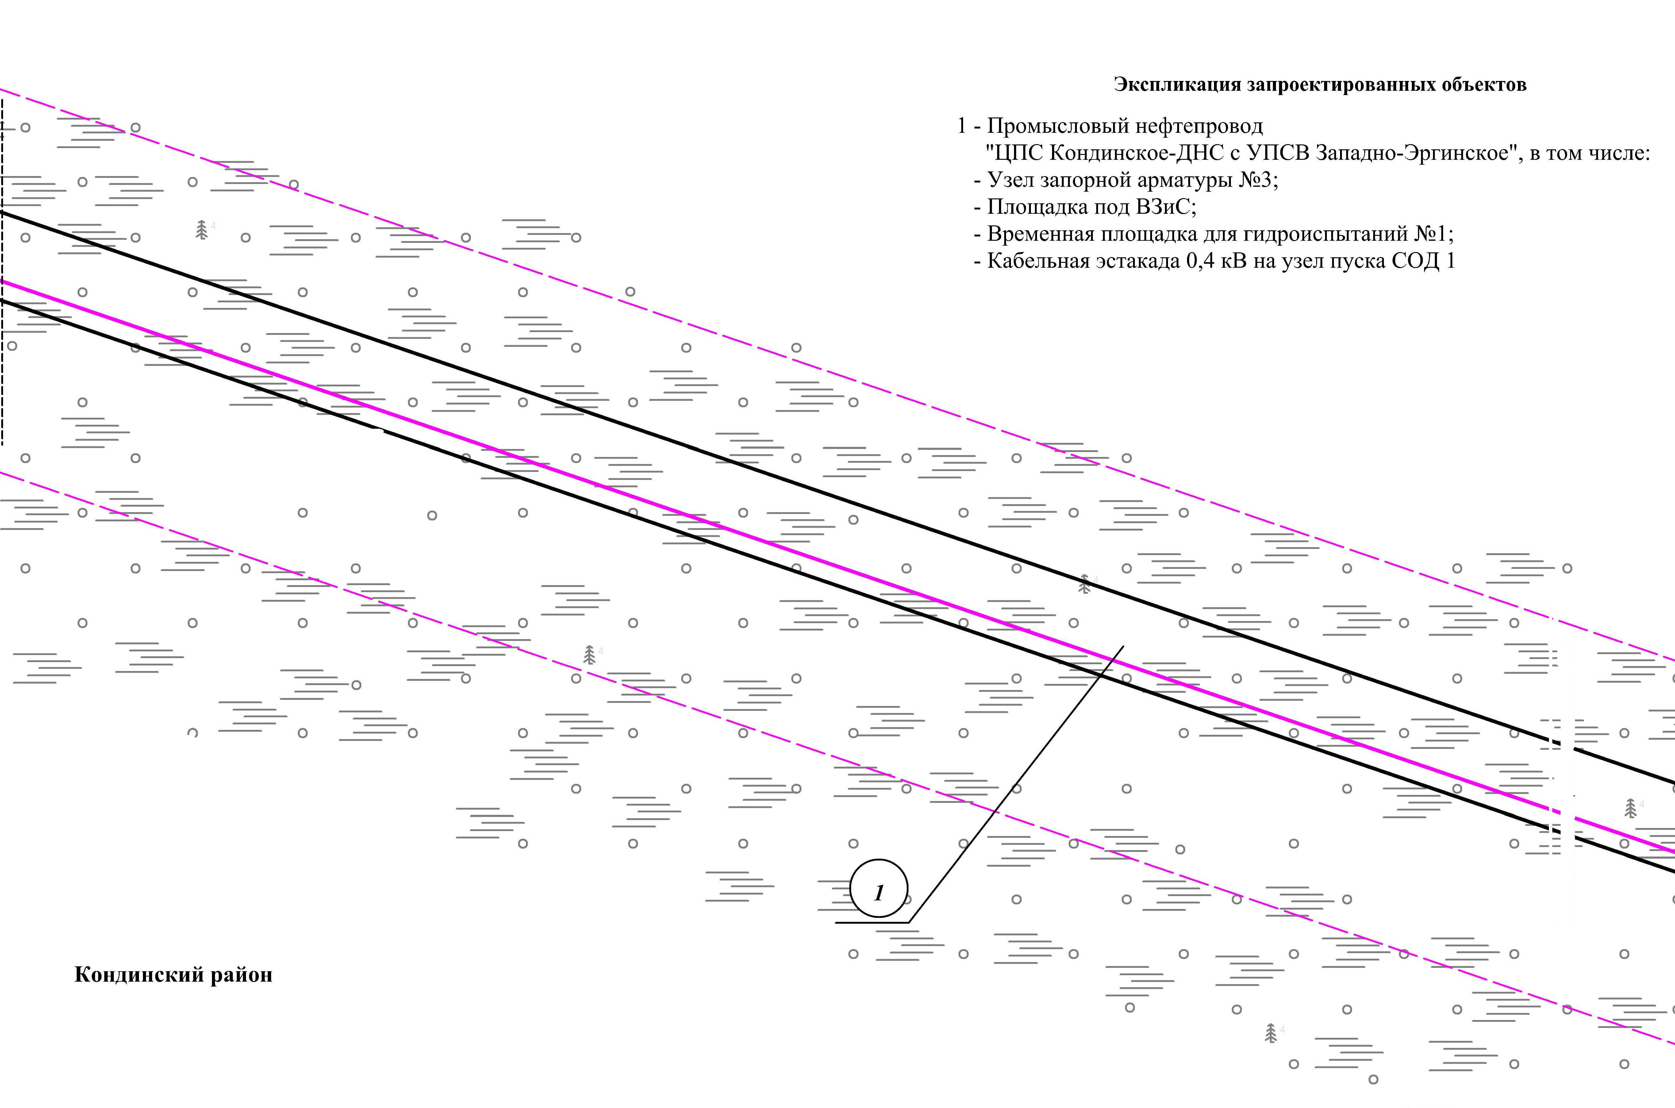
Линия совмещения с листом
86

Линия совмещения с листом
84

Основная часть проекта планировки территории для размещения объекта капитального строительства, расположенного на территории двух муниципальных образований
Ханты-Мансийского автономного округа – Югры,
«Промысловый нефтепровод «ЦПС Кондинское-ДНС с УПСВ Западно-Эргинское»
Землепользователь: АО «НК «Конданефть»
Масштаб 1:2000

Линия совмещения с листом
85

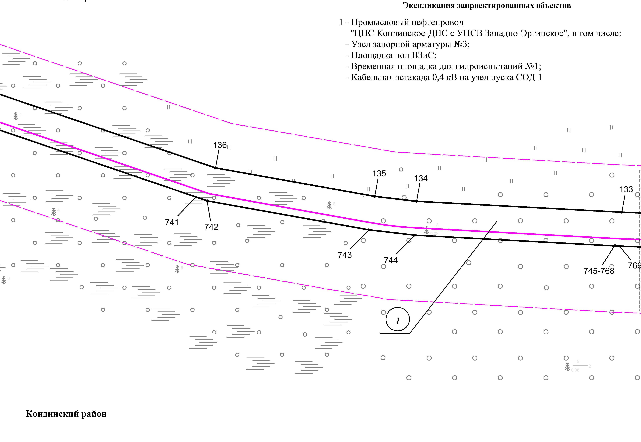
Линия совмещения с листом
87

Основная часть проекта планировки территории для размещения объекта капитального строительства, расположенного на территории двух муниципальных образований
Ханты-Мансийского автономного округа – Югры,
«Промысловый нефтепровод «ЦПС Кондинское-ДНС с УПСВ Западно-Эргинское»
Землепользователь: АО «НК «Конданефть»
Масштаб 1:2000

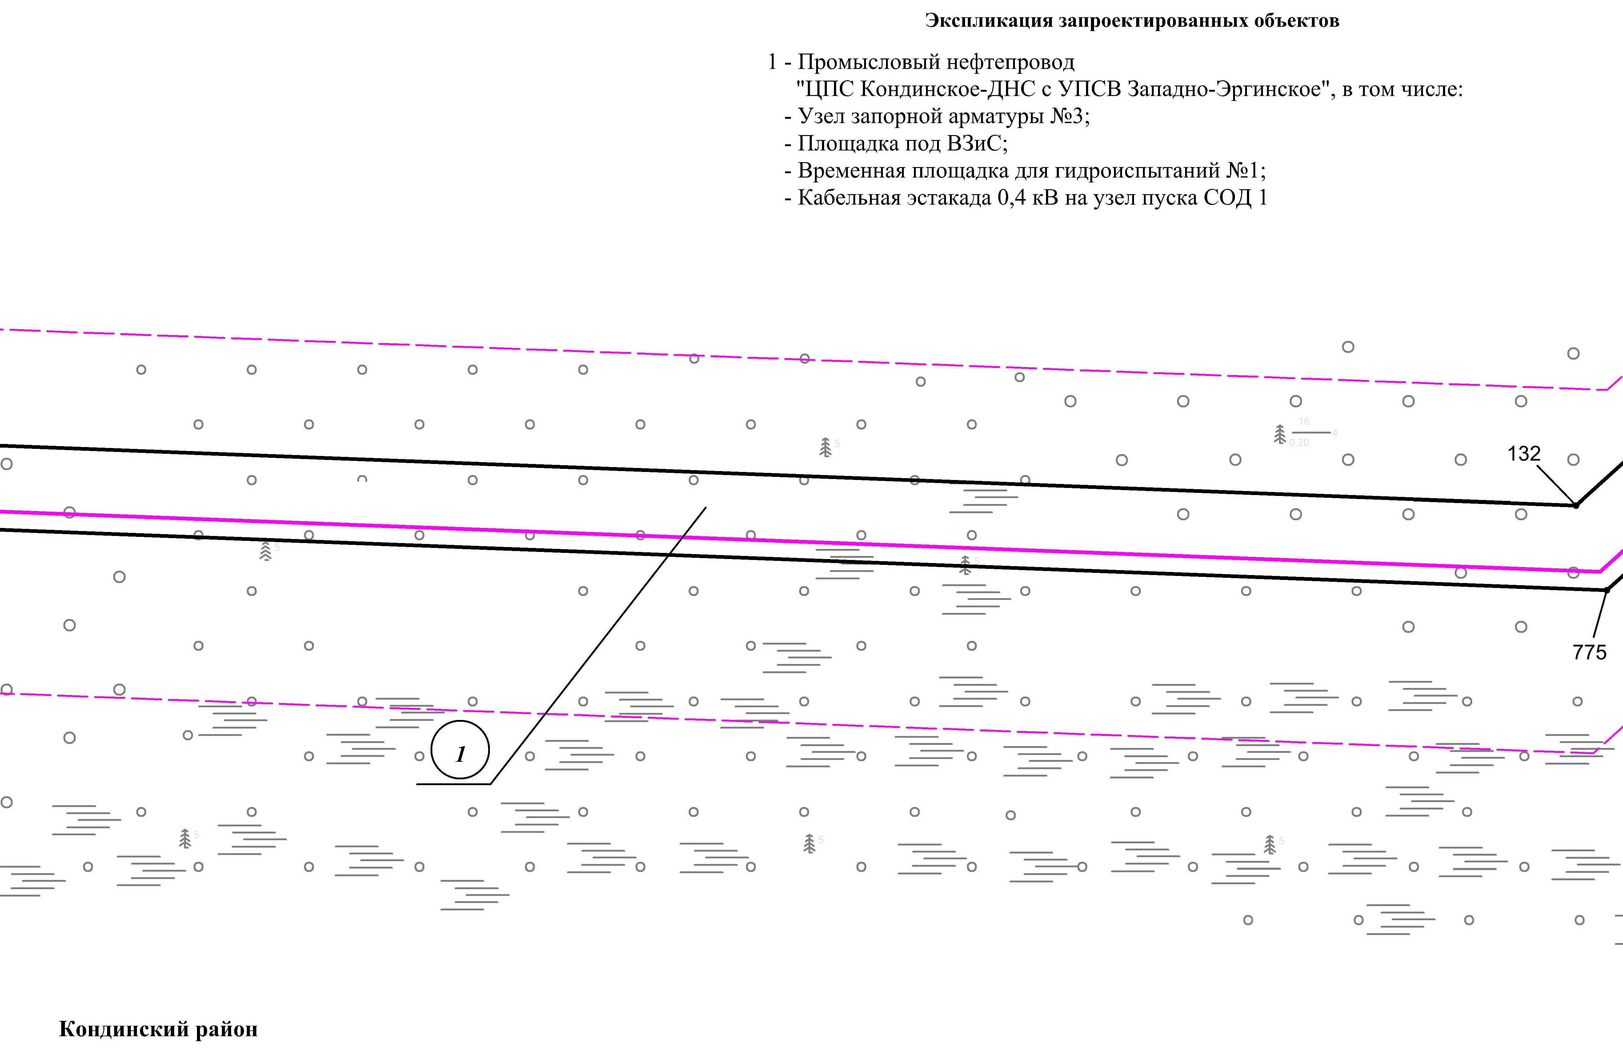
Линия совмещения с листом
88

Линия совмещения с листом
86

Основная часть проекта планировки территории для размещения объекта капитального строительства, расположенного на территории двух муниципальных образований
Ханты-Мансийского автономного округа – Югры,
«Промысловый нефтепровод «ЦПС Кондинское-ДНС с УПСВ Западно-Эргинское»
Землепользователь: АО «НК «Конданефть»
Масштаб 1:2000

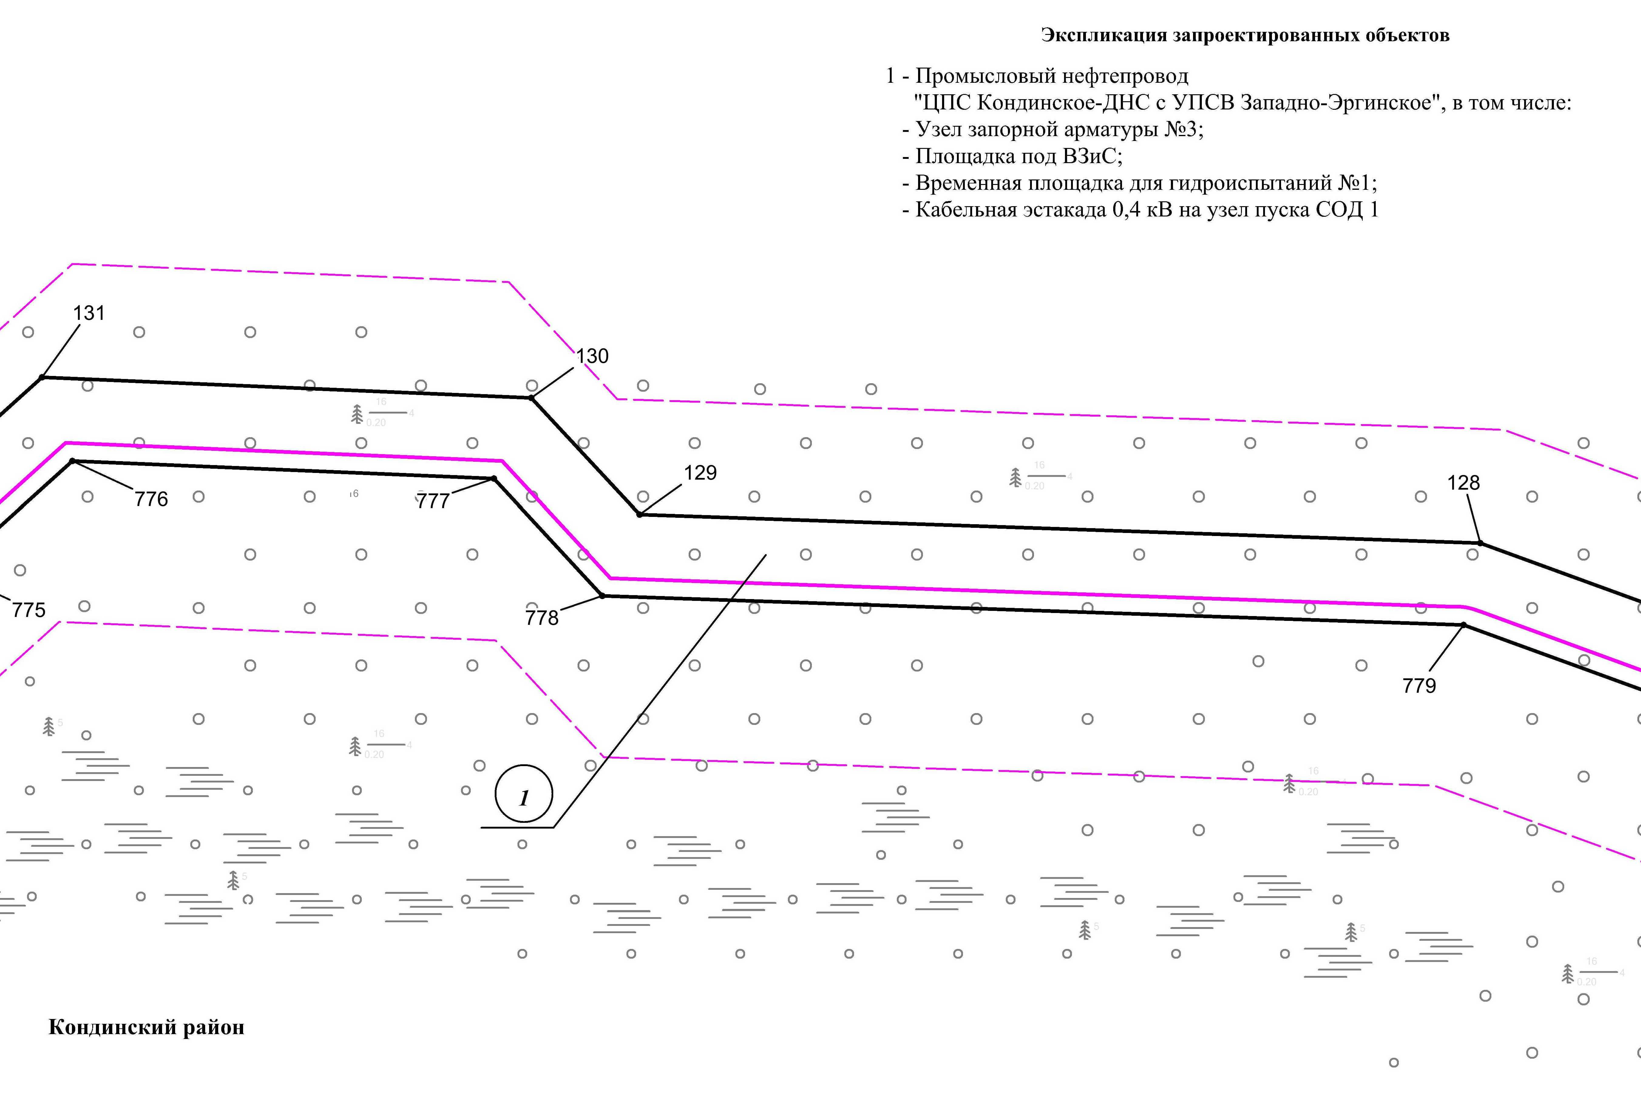
Линия совмещения с листом
89

Линия совмещения с листом
87

Основная часть проекта планировки территории для размещения объекта капитального строительства, расположенного на территории двух муниципальных образований
Ханты-Мансийского автономного округа – Югры,
«Промысловый нефтепровод «ЦПС Кондинское-ДНС с УПСВ Западно-Эргинское»
Землепользователь: АО «НК «Конданефть»
Масштаб 1:2000

Линия совмещения с листом
88

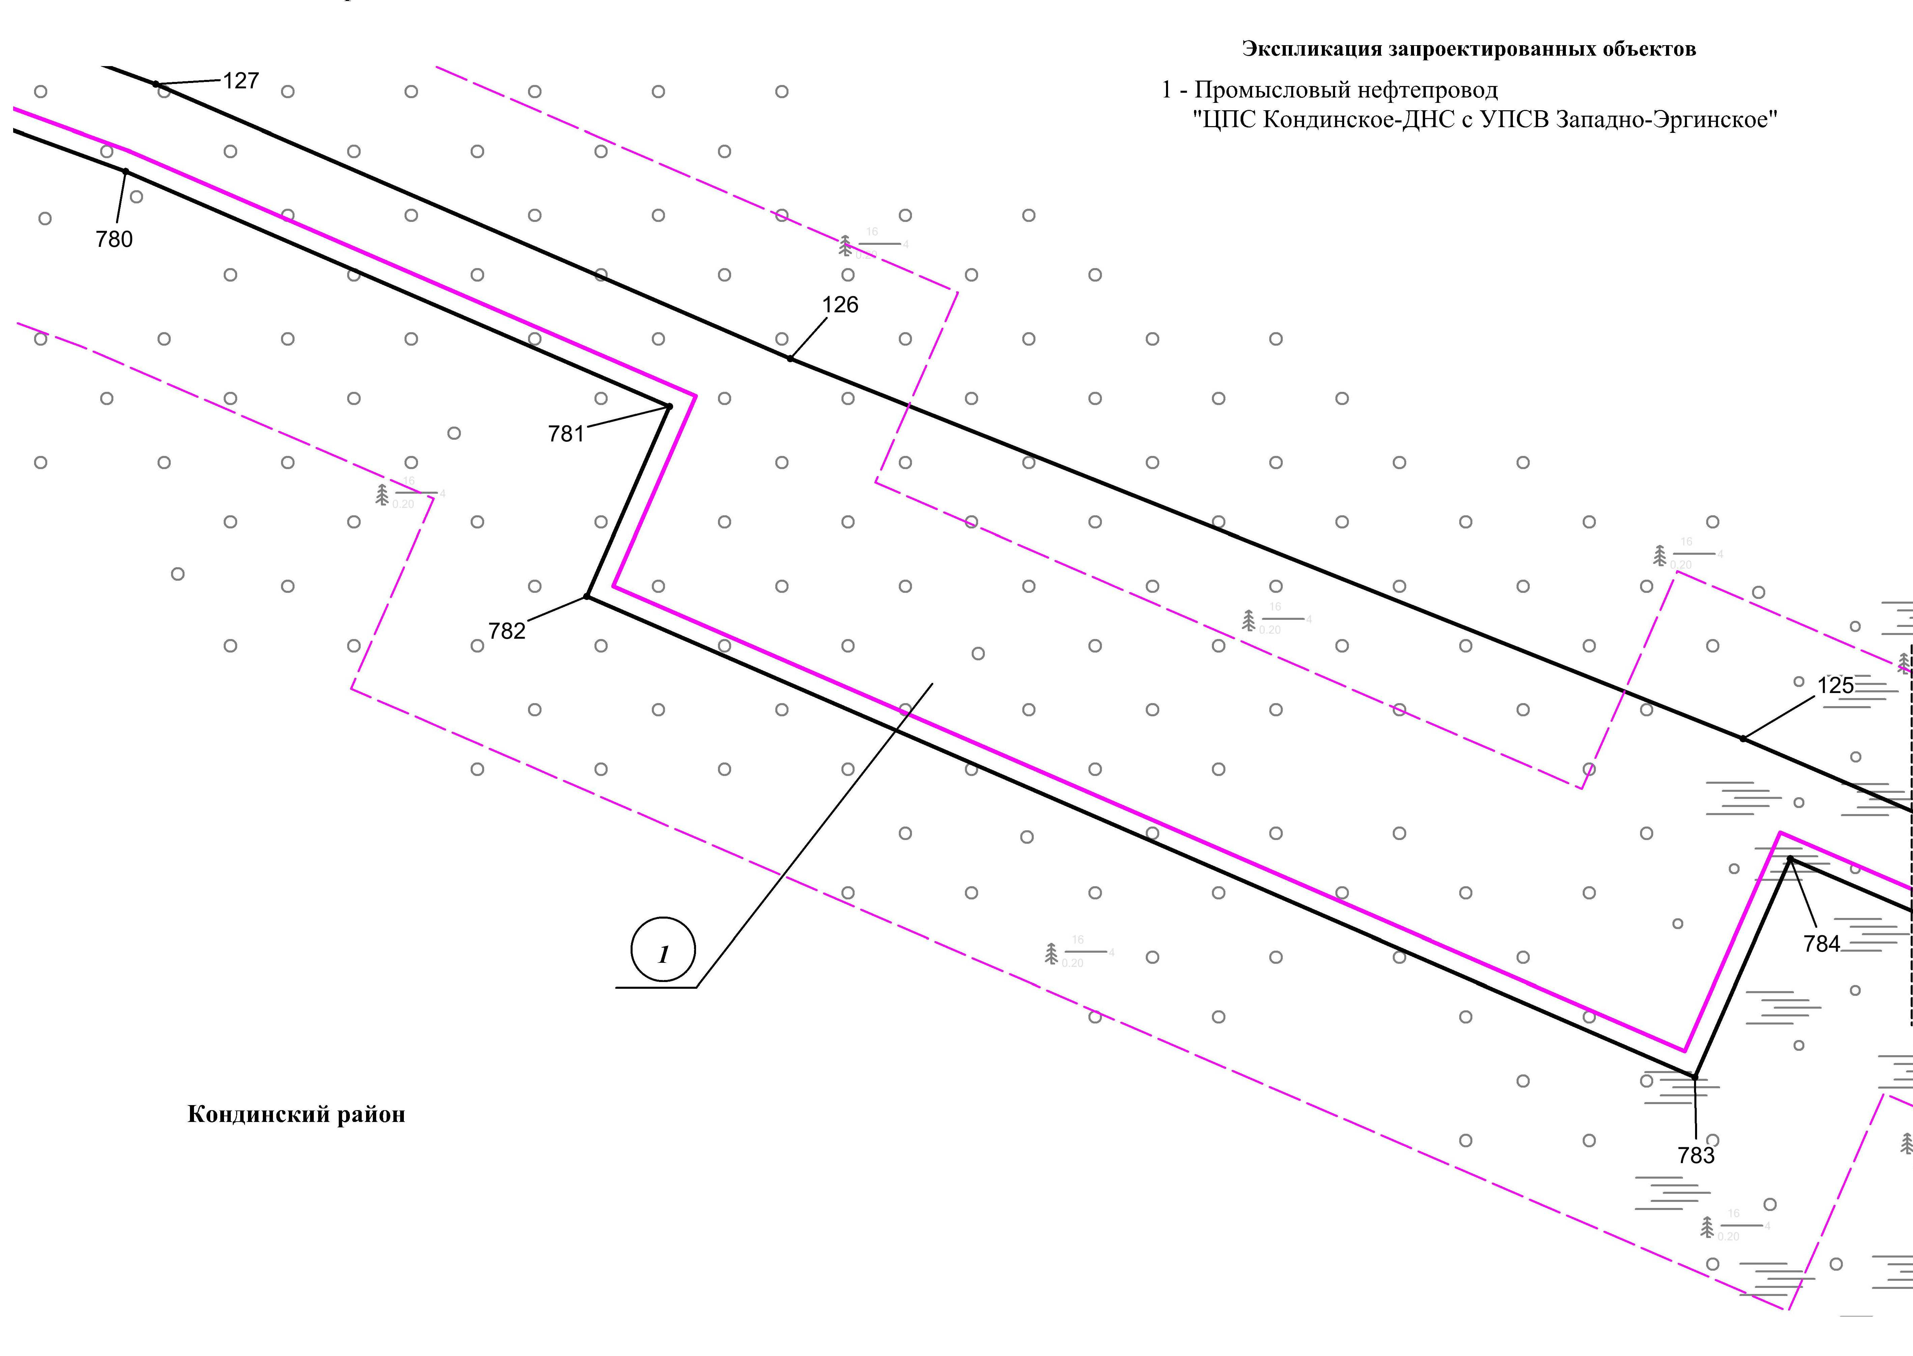
Линия совмещения с листом
90

Основная часть проекта планировки территории для размещения объекта капитального строительства, расположенного на территории двух муниципальных образований
Ханты-Мансийского автономного округа – Югры,
«Промысловый нефтепровод «ЦПС Кондинское-ДНС с УПСВ Западно-Эргинское»
Землепользователь: АО «НК «Конданефть»
Масштаб 1:2000

Линия совмещения с листом
89

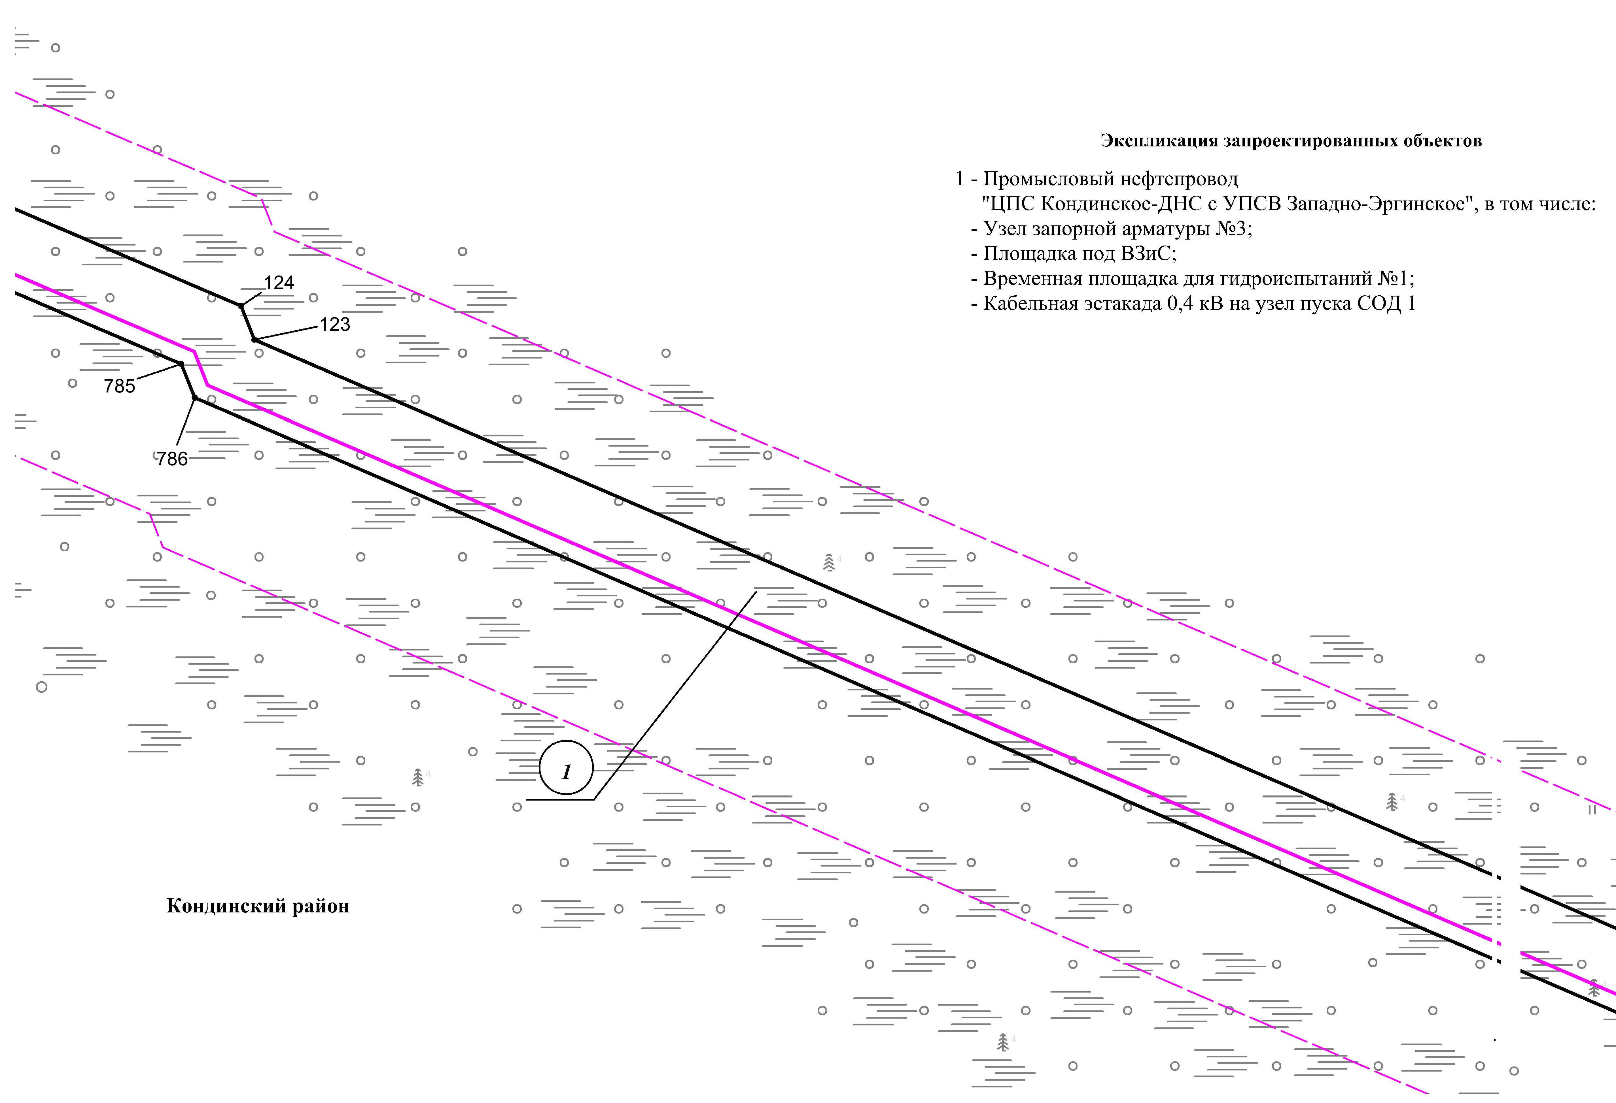
Линия совмещения с листом
91

Основная часть проекта планировки территории для размещения объекта капитального строительства, расположенного на территории двух муниципальных образований
Ханты-Мансийского автономного округа – Югры,
«Промысловый нефтепровод «ЦПС Кондинское-ДНС с УПСВ Западно-Эргинское»
Землепользователь: АО «НК «Конданефть»
Масштаб 1:2000

Линия совмещения с листом
90

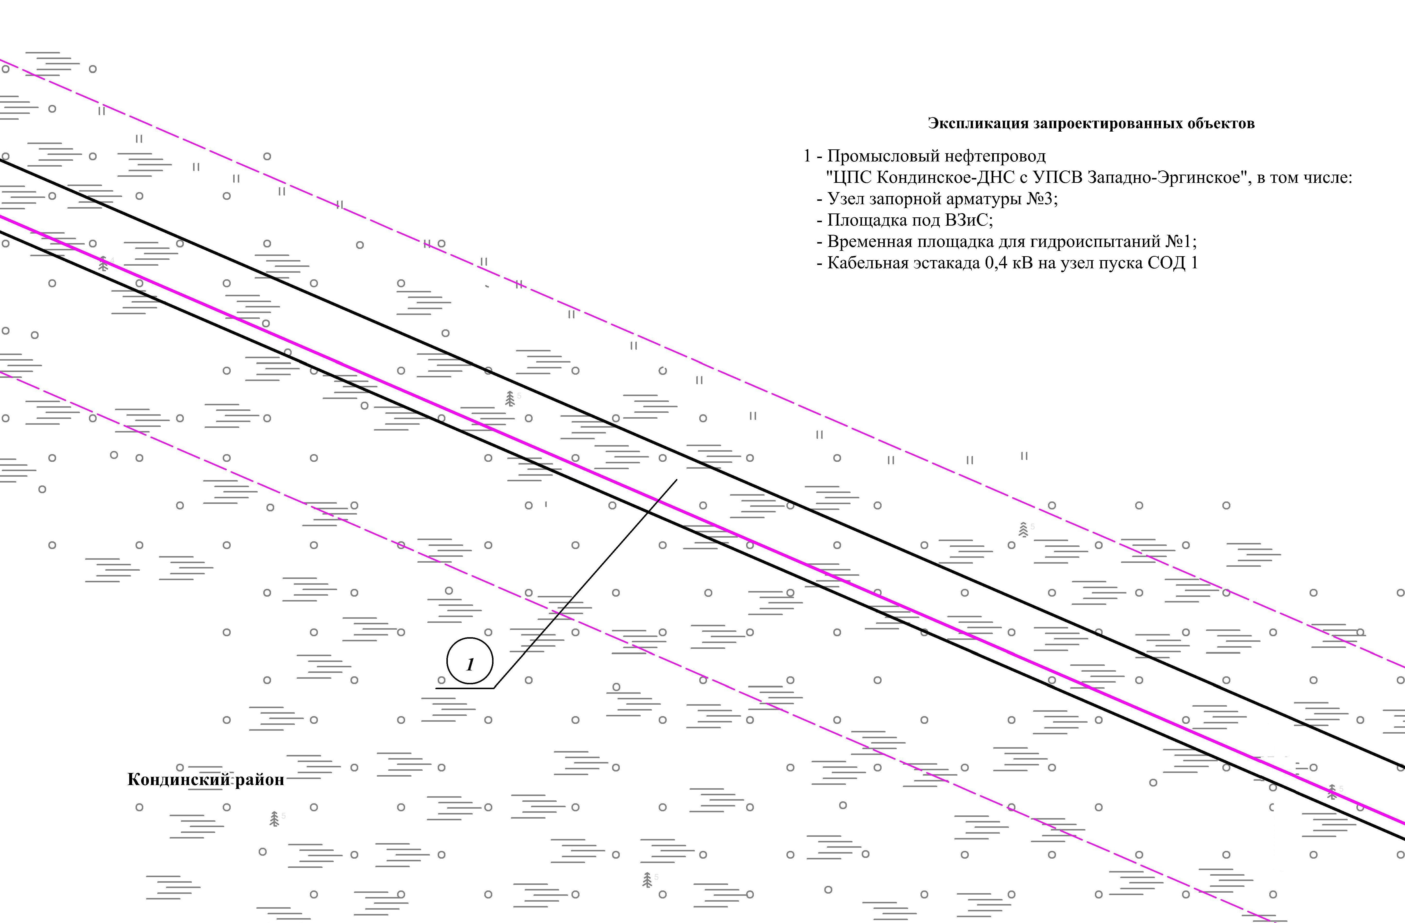
Линия совмещения с листом
92

Основная часть проекта планировки территории для размещения объекта капитального строительства, расположенного на территории двух муниципальных образований
Ханты-Мансийского автономного округа – Югры,
«Промысловый нефтепровод «ЦПС Кондинское-ДНС с УПСВ Западно-Эргинское»
Землепользователь: АО «НК «Конданефть»
Масштаб 1:2000

Линия совмещения с листом
91

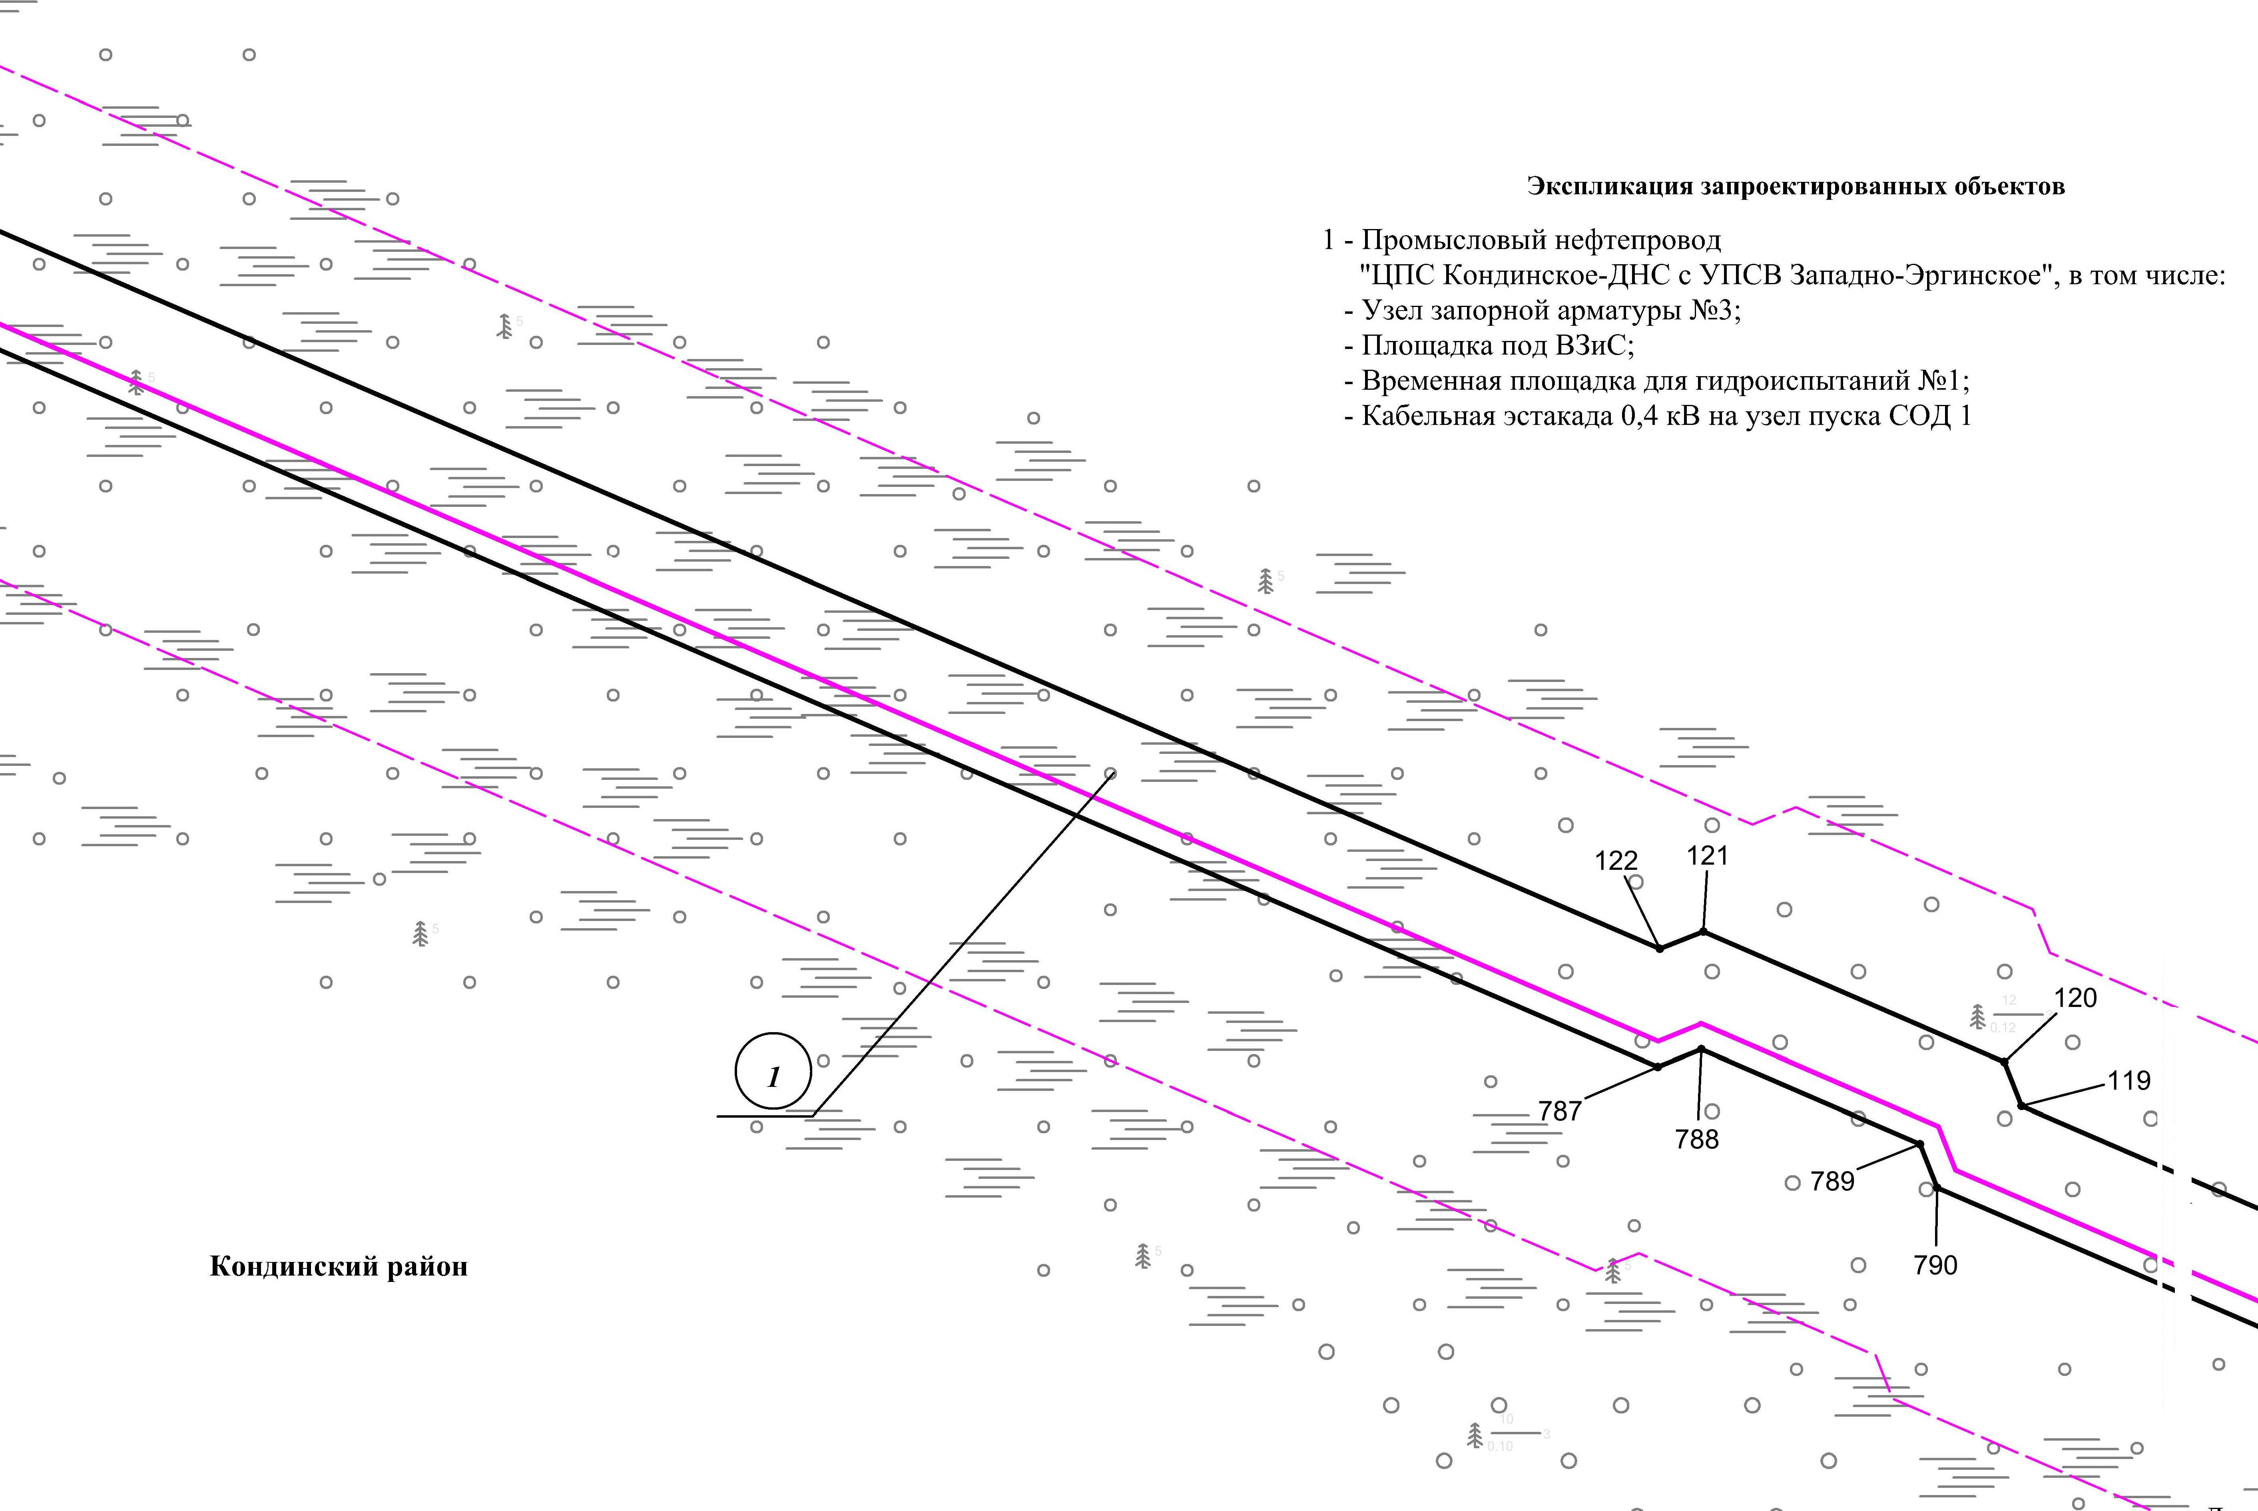
Линия совмещения с листом
93

Основная часть проекта планировки территории для размещения объекта капитального строительства, расположенного на территории двух муниципальных образований
Ханты-Мансийского автономного округа – Югры,
«Промысловый нефтепровод «ЦПС Кондинское-ДНС с УПСВ Западно-Эргинское»
Землепользователь: АО «НК «Конданефть»
Масштаб 1:2000

Линия совмещения с листом
92

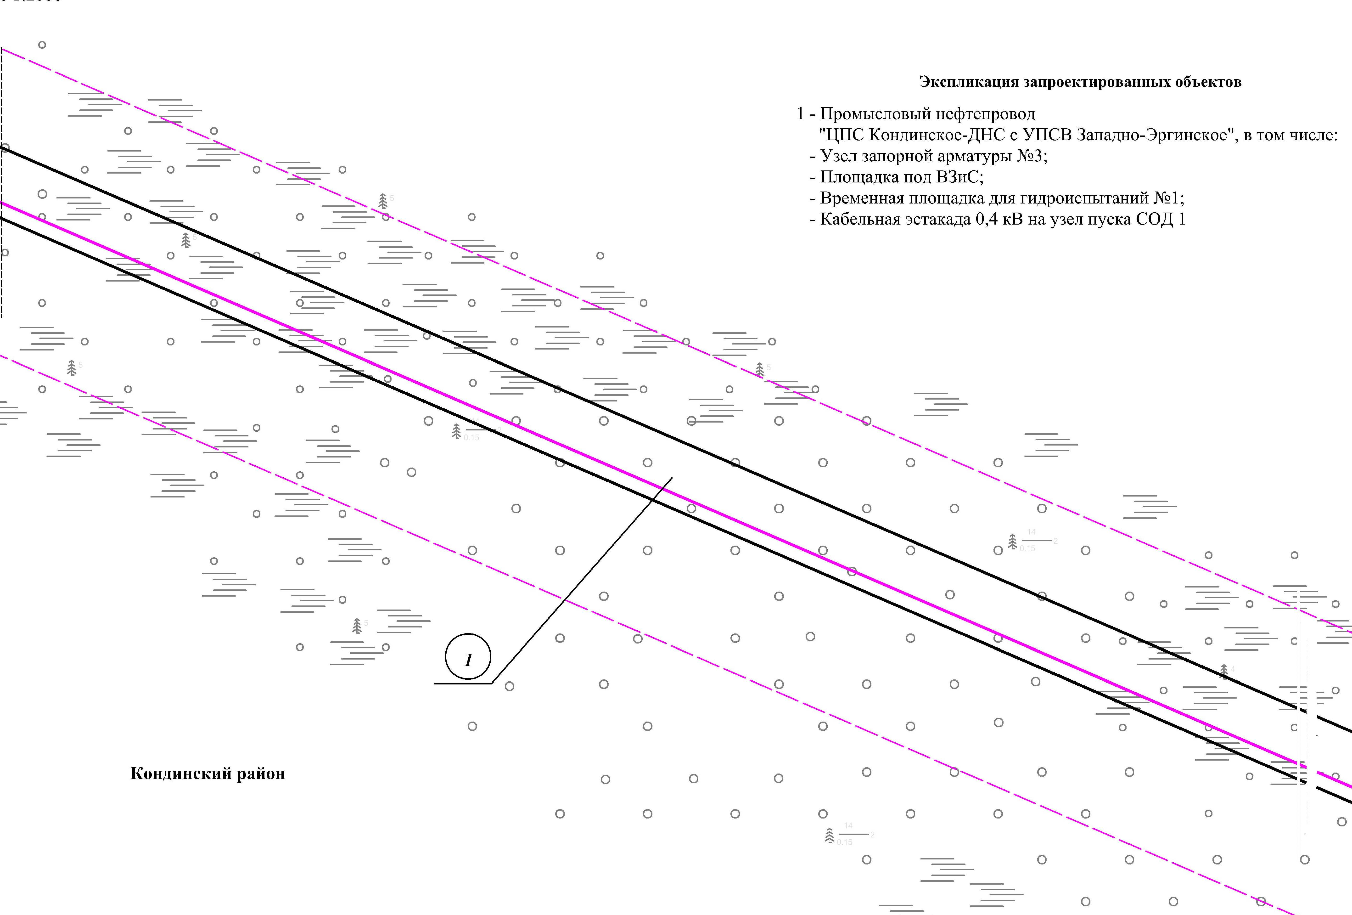
Линия совмещения с листом
94

Основная часть проекта планировки территории для размещения объекта капитального строительства, расположенного на территории двух муниципальных образований
Ханты-Мансийского автономного округа – Югры,
«Промысловый нефтепровод «ЦПС Кондинское-ДНС с УПСВ Западно-Эргинское»
Землепользователь: АО «НК «Конданефть»
Масштаб 1:2000

Линия совмещения с листом
93

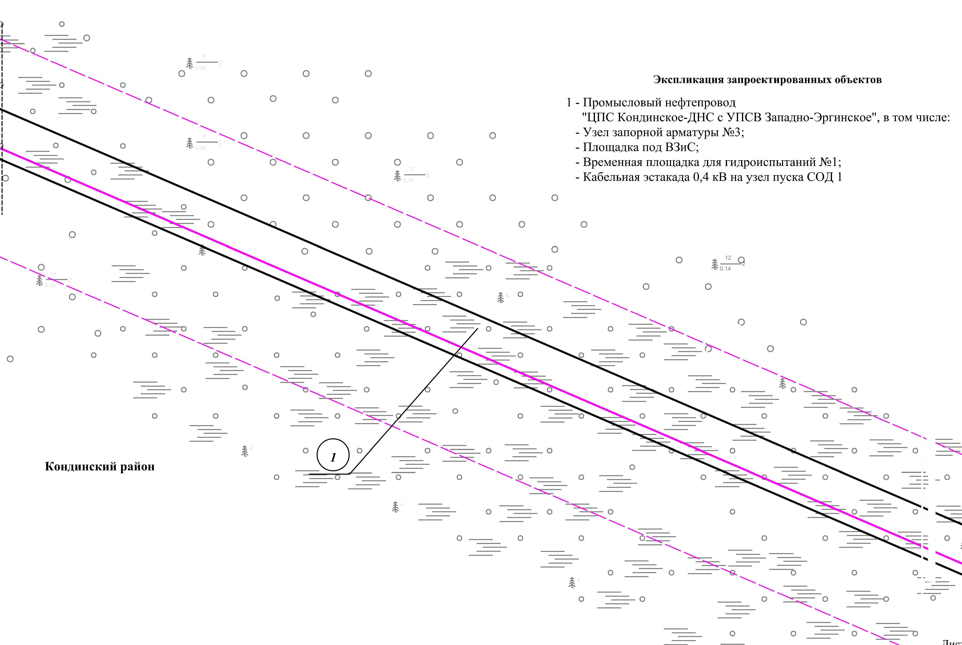
Линия совмещения с листом
95

Основная часть проекта планировки территории для размещения объекта капитального строительства, расположенного на территории двух муниципальных образований
Ханты-Мансийского автономного округа – Югры,
«Промысловый нефтепровод «ЦПС Кондинское-ДНС с УПСВ Западно-Эргинское»
Землепользователь: АО «НК «Конданефть»
Масштаб 1:2000

Линия совмещения с листом
94

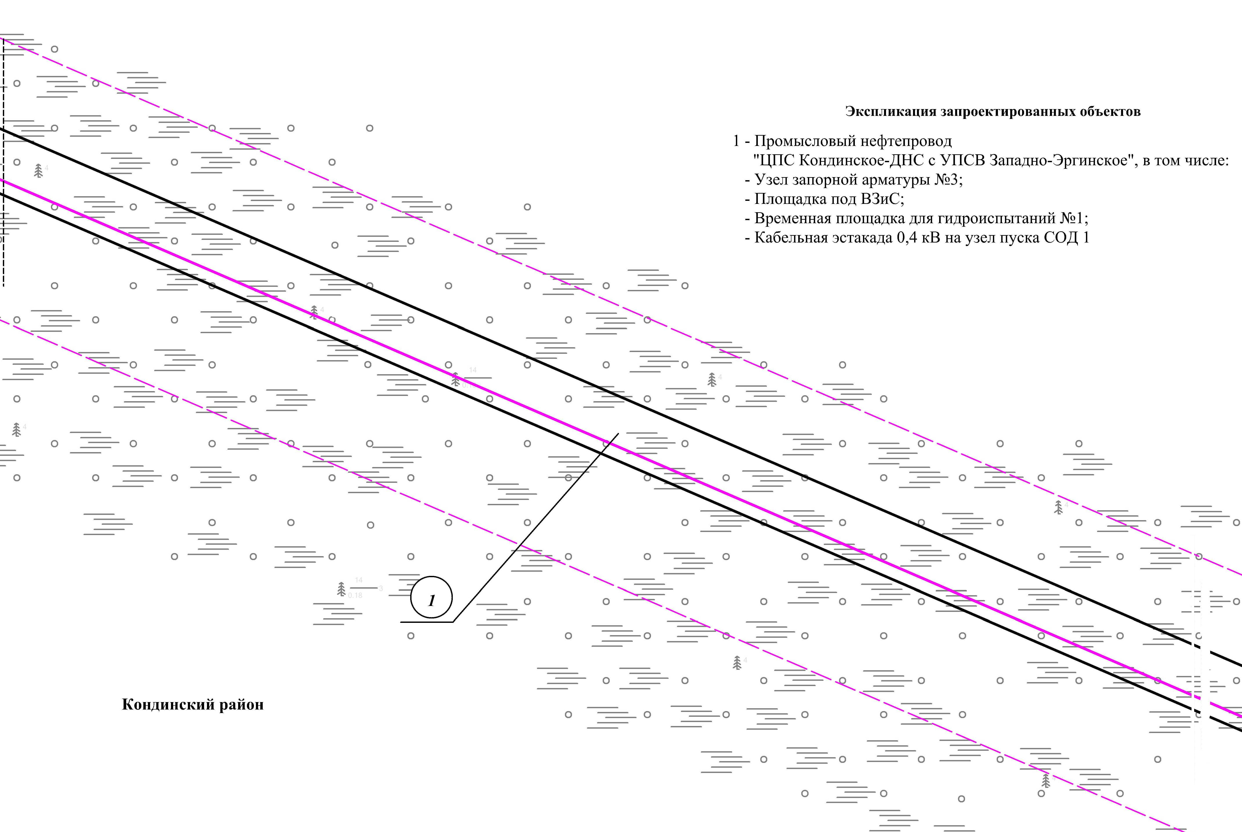
Линия совмещения с листом
96

Основная часть проекта планировки территории для размещения объекта капитального строительства, расположенного на территории двух муниципальных образований
Ханты-Мансийского автономного округа – Югры,
«Промысловый нефтепровод «ЦПС Кондинское-ДНС с УПСВ Западно-Эргинское»
Землепользователь: АО «НК «Конданефть»
Масштаб 1:2000

Линия совмещения с листом
95

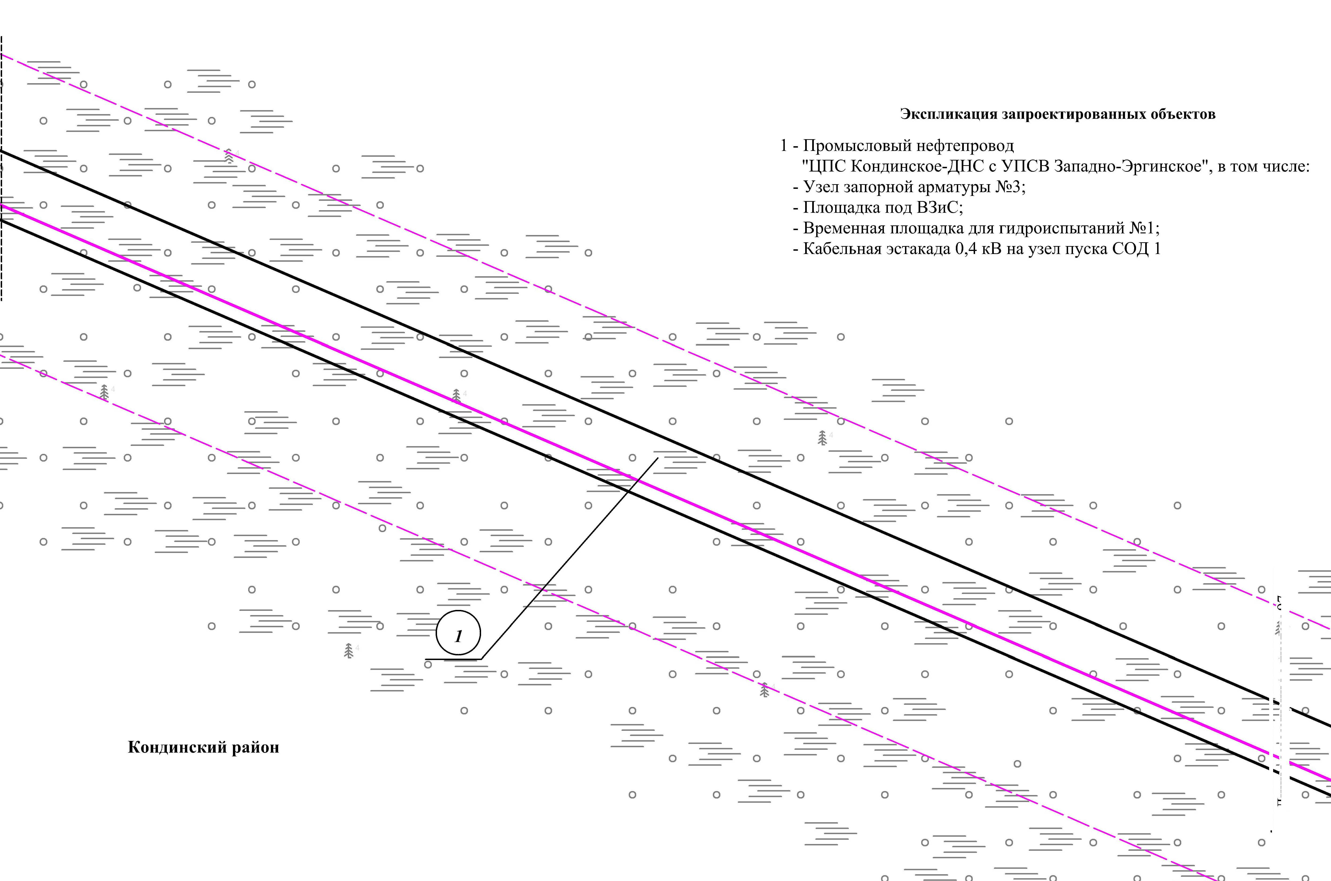
Линия совмещения с листом
97

Основная часть проекта планировки территории для размещения объекта капитального строительства, расположенного на территории двух муниципальных образований
Ханты-Мансийского автономного округа – Югры,
«Промысловый нефтепровод «ЦПС Кондинское-ДНС с УПСВ Западно-Эргинское»
Землепользователь: АО «НК «Конданефть»
Масштаб 1:2000

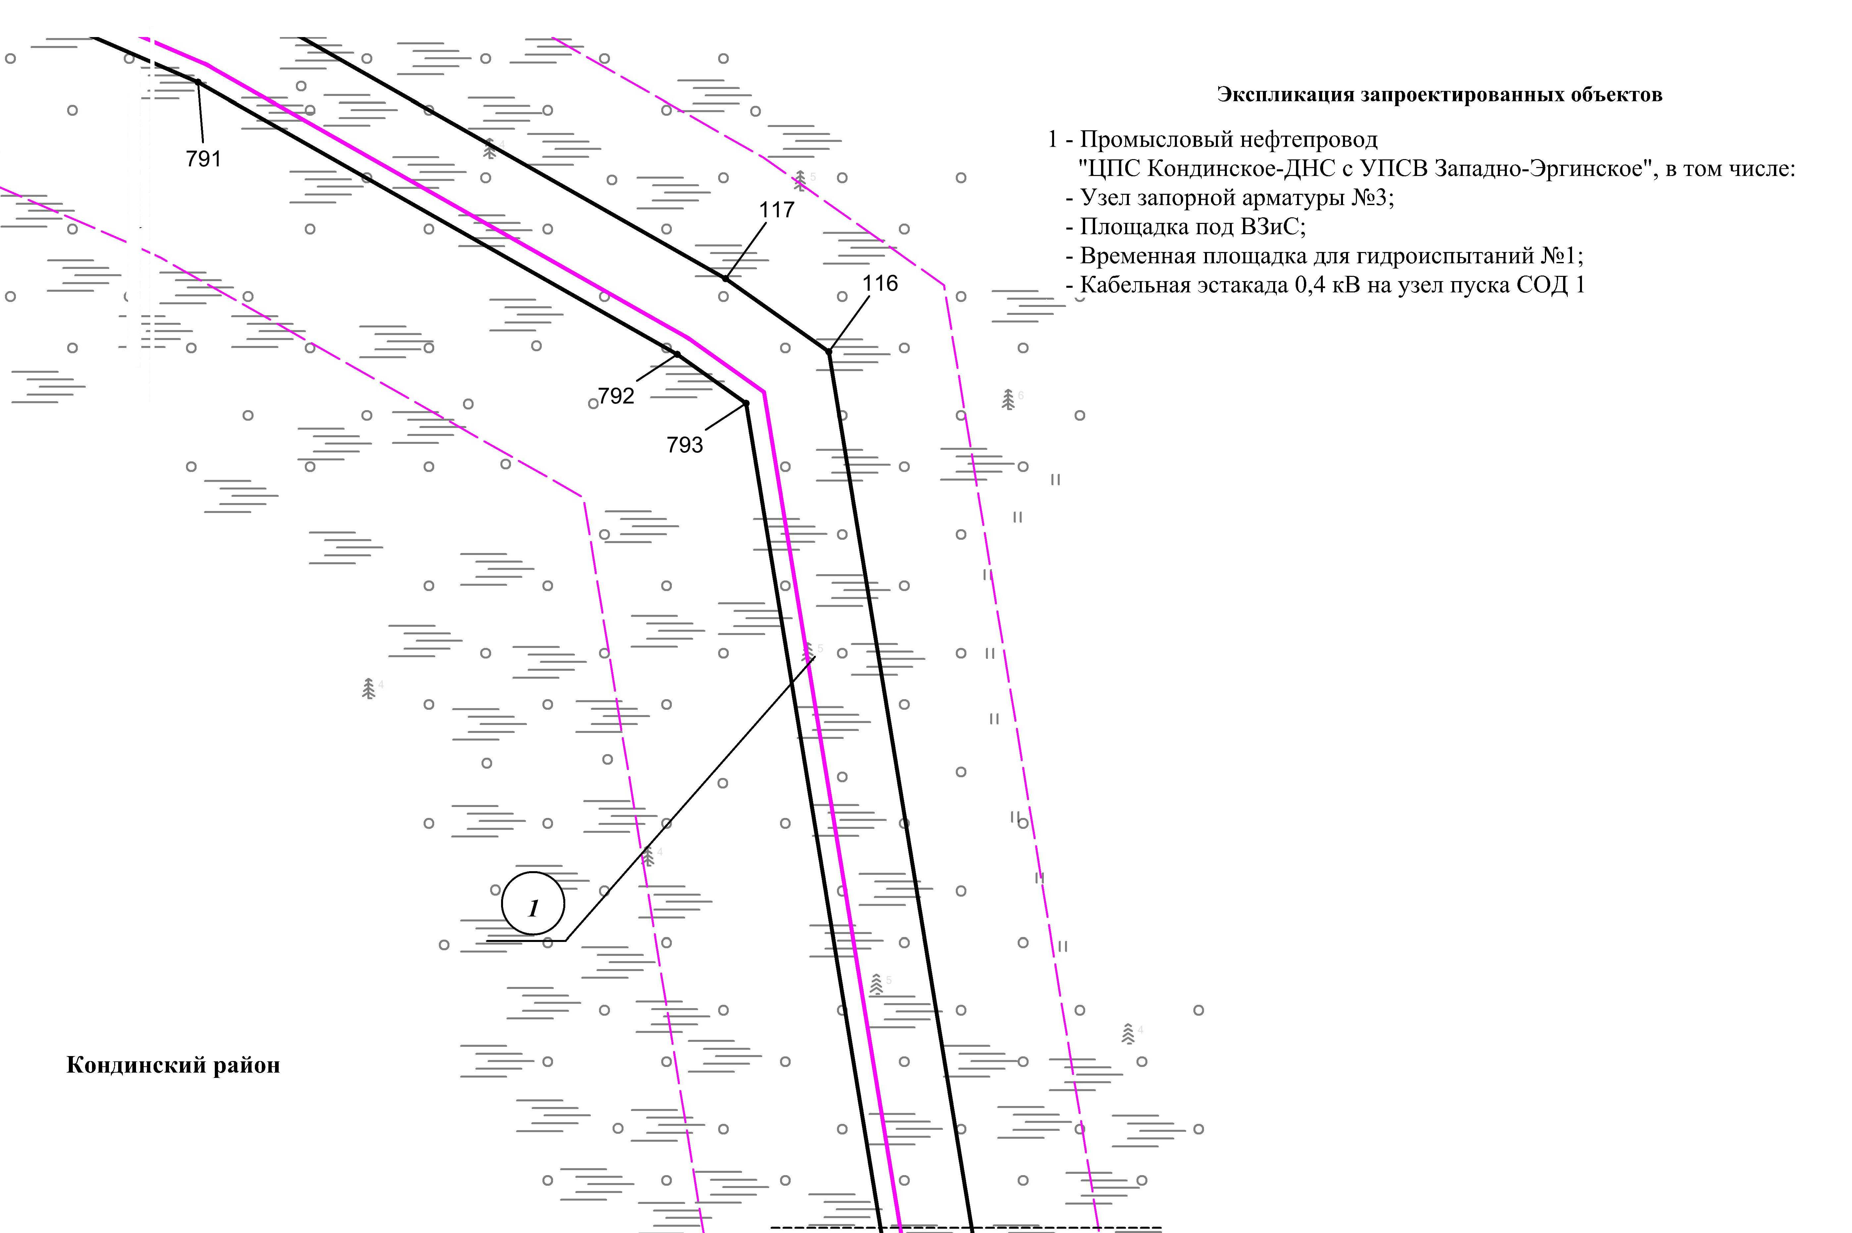
Линия совмещения с листом
96

Линия совмещения с листом 98

Основная часть проекта планировки территории для размещения объекта капитального строительства, расположенного на территории двух муниципальных образований
Ханты-Мансийского автономного округа – Югры,
«Промысловый нефтепровод «ЦПС Кондинское - ДНС с УПСВ Западно-Эргинское»
Землепользователь: АО «НК «Конданефть»
Масштаб 1:2000

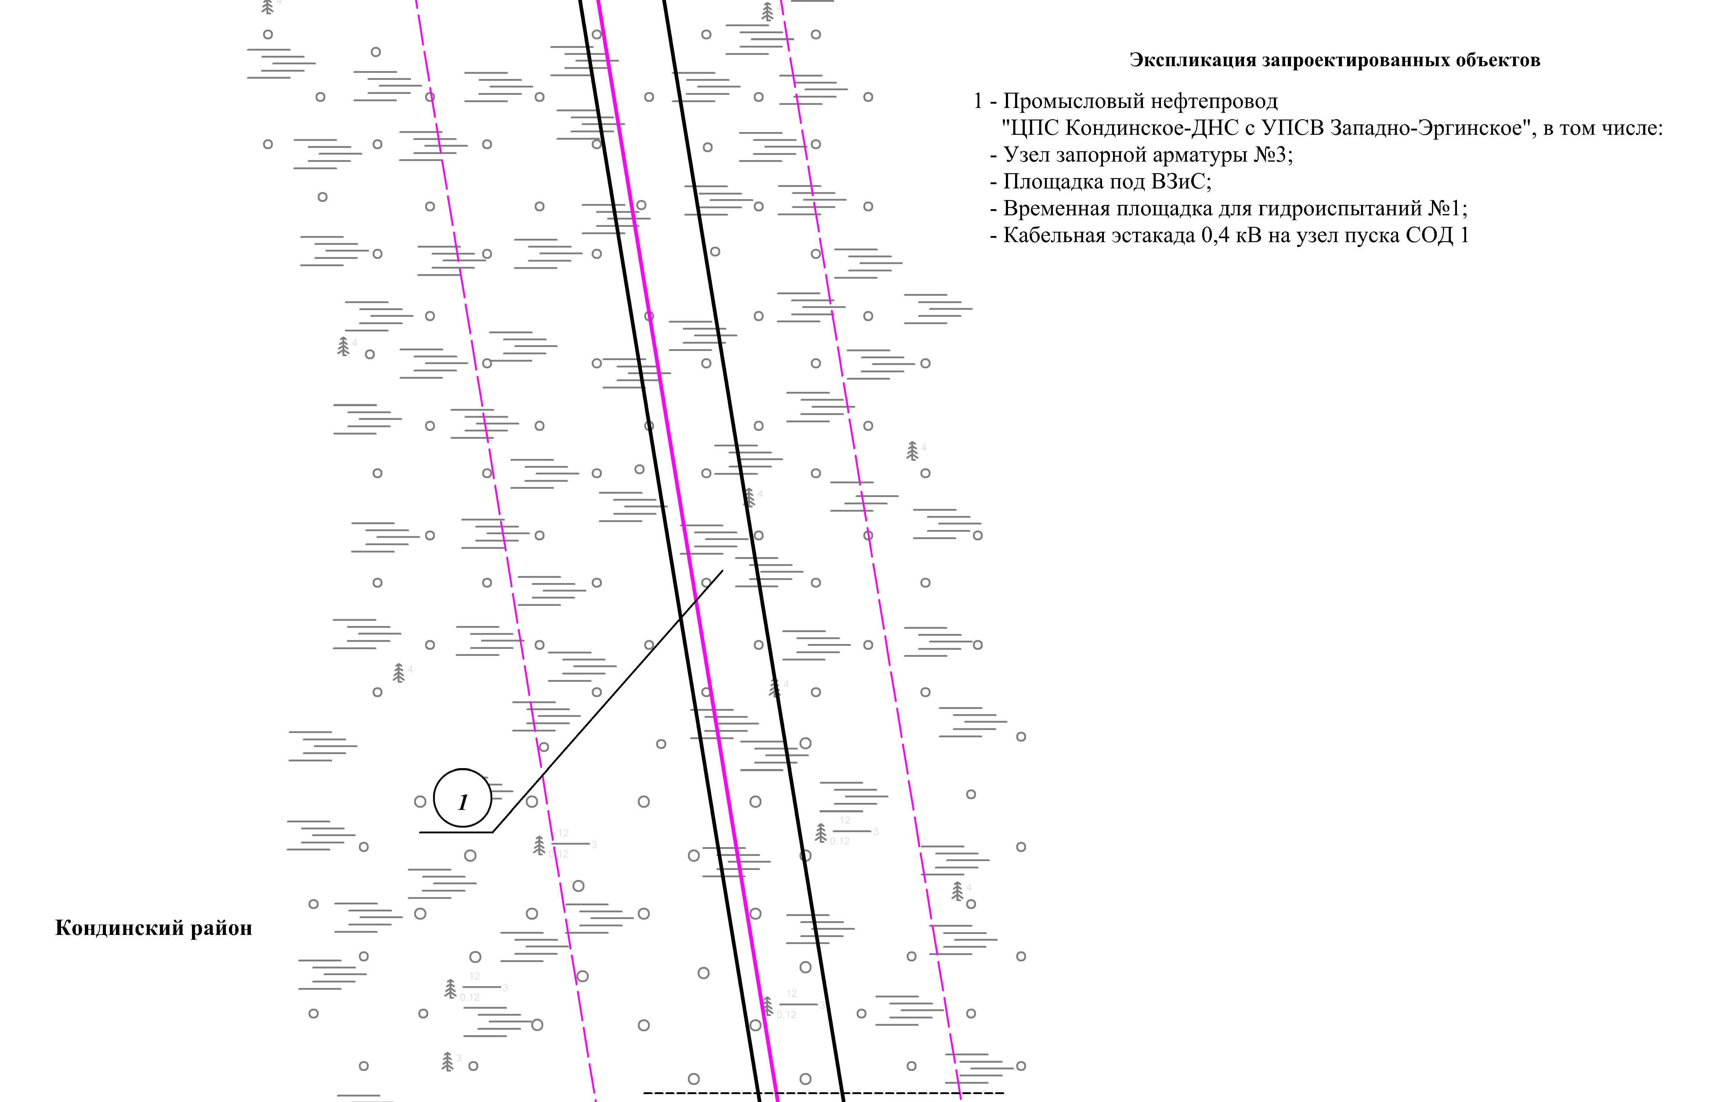
Линия совмещения с листом 97
Линия совмещения с листом 99

Основная часть проекта планировки территории для размещения объекта капитального строительства, расположенного на территории двух муниципальных образований
Ханты-Мансийского автономного округа – Югры,
«Промысловый нефтепровод «ЦПС Кондинское - ДНС с УПСВ Западно-Эргинское»
Землепользователь: АО «НК «Конданефть»
Масштаб 1:2000

Линия совмещения с листом 98
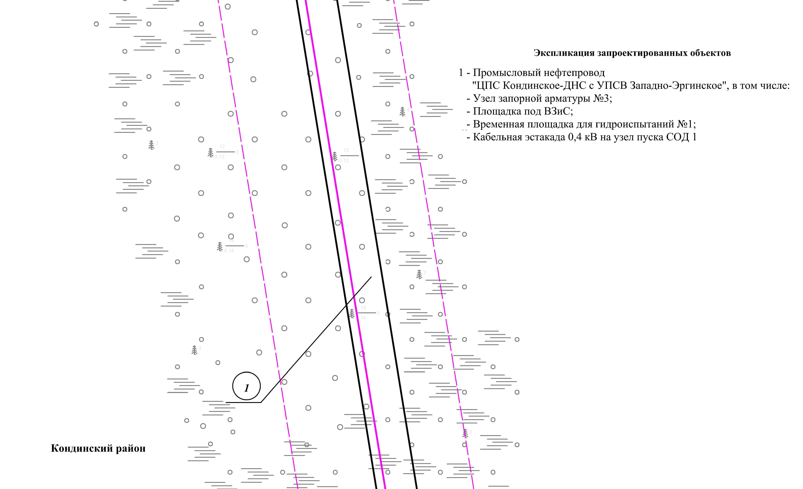
Линия совмещения с листом 100

Основная часть проекта планировки территории для размещения объекта капитального строительства, расположенного на территории двух муниципальных образований
Ханты-Мансийского автономного округа – Югры,
«Промысловый нефтепровод «ЦПС Кондинское - ДНС с УПСВ Западно-Эргинское»
Землепользователь: АО «НК «Конданефть»
Масштаб 1:2000

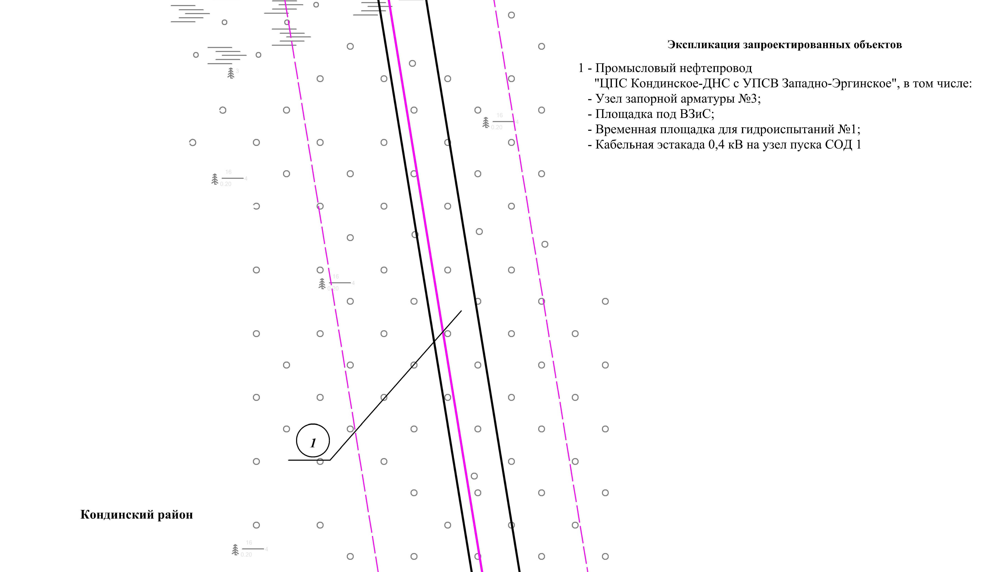
Линия совмещения с листом 99
Линия совмещения с листом 101

Основная часть проекта планировки территории для размещения объекта капитального строительства, расположенного на территории двух муниципальных образований
Ханты-Мансийского автономного округа – Югры,
«Промысловый нефтепровод «ЦПС Кондинское - ДНС с УПСВ Западно-Эргинское»
Землепользователь: АО «НК «Конданефть»
Масштаб 1:2000

Линия совмещения с листом 100
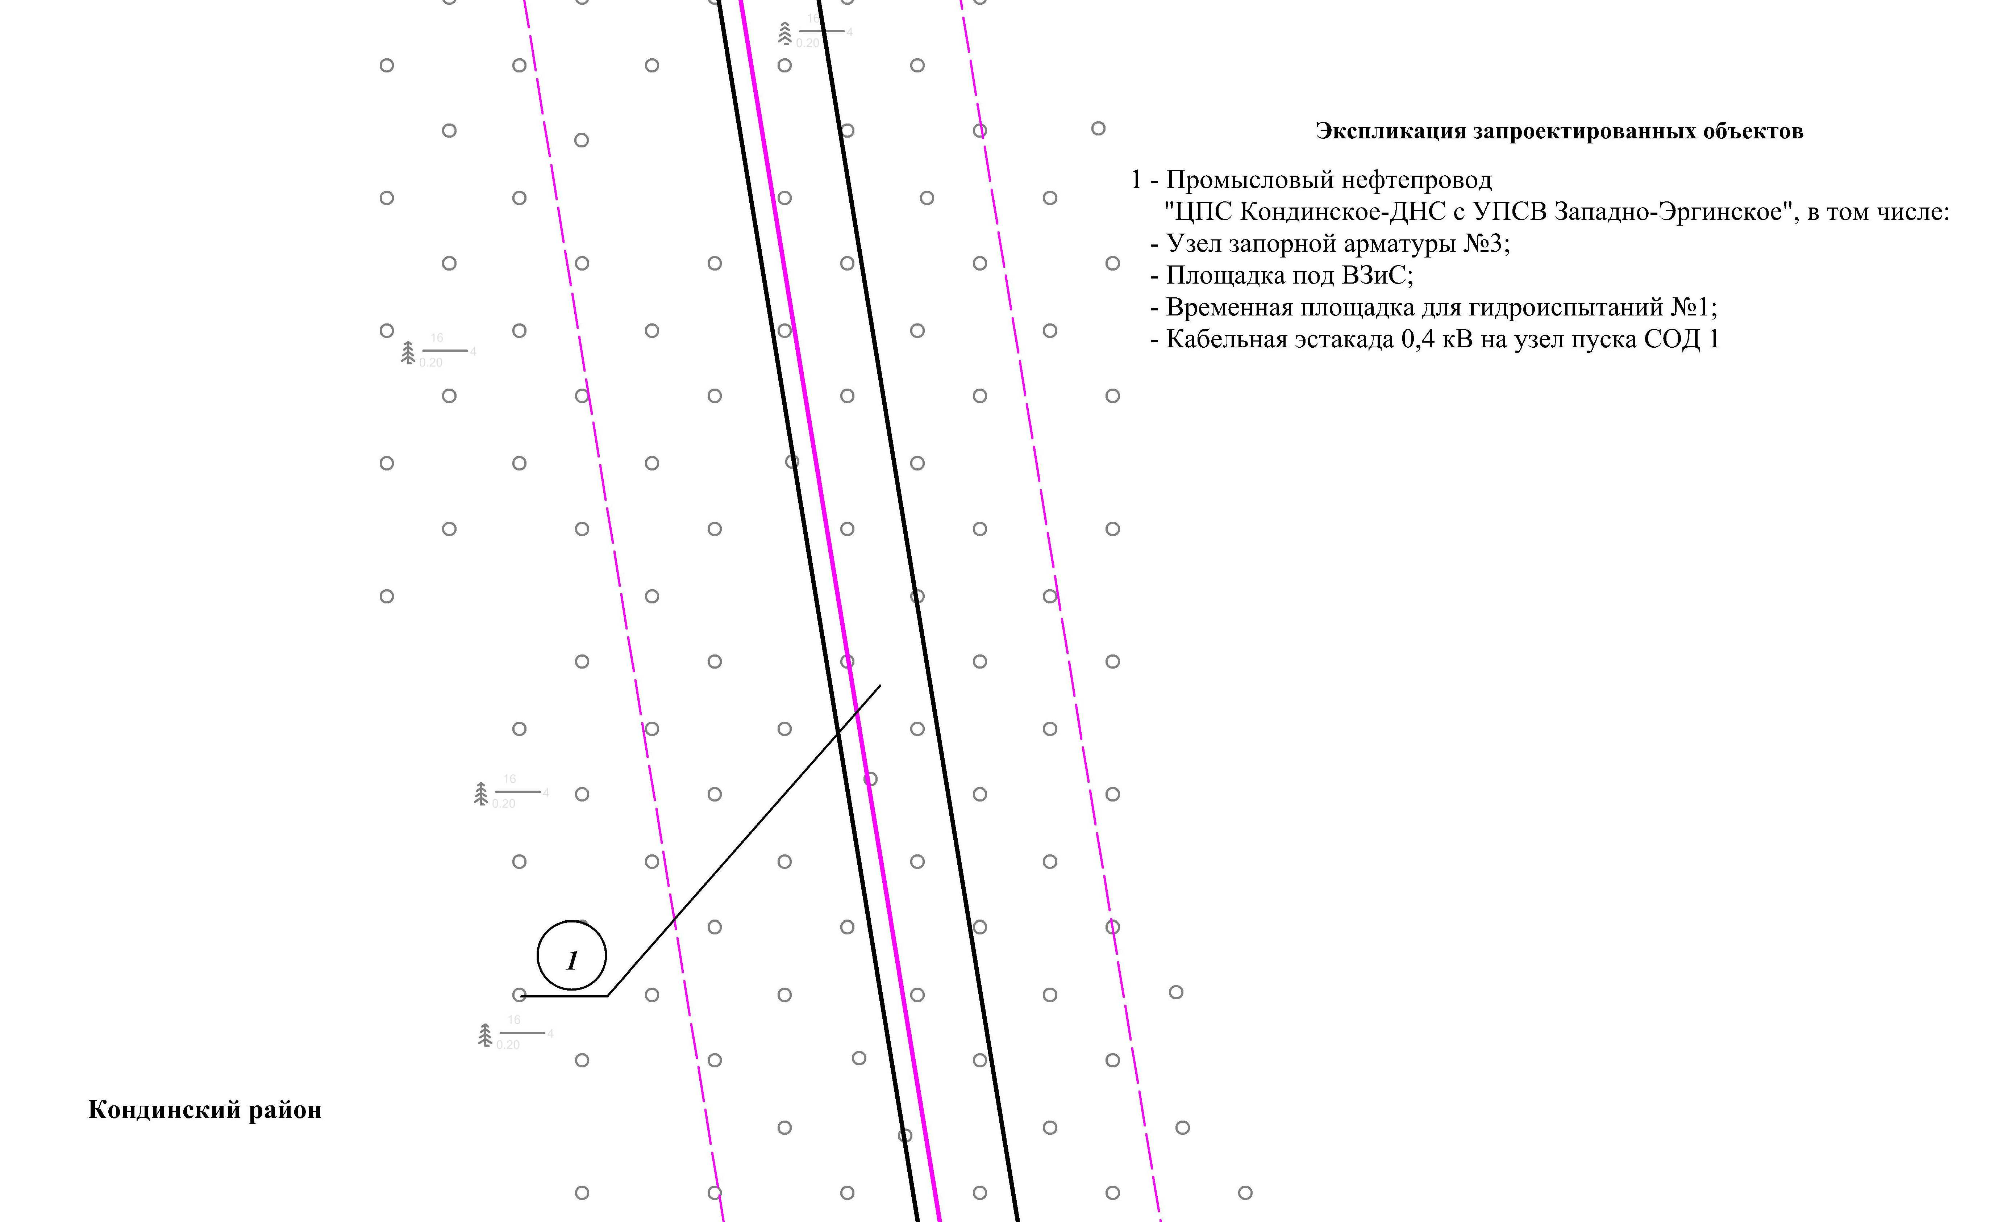
Линия совмещения с листом 102

Основная часть проекта планировки территории для размещения объекта капитального строительства, расположенного на территории двух муниципальных образований
Ханты-Мансийского автономного округа – Югры,
«Промысловый нефтепровод «ЦПС Кондинское-ДНС с УПСВ Западно-Эргинское»
Землепользователь: АО «НК «Конданефть»
Масштаб 1:2000

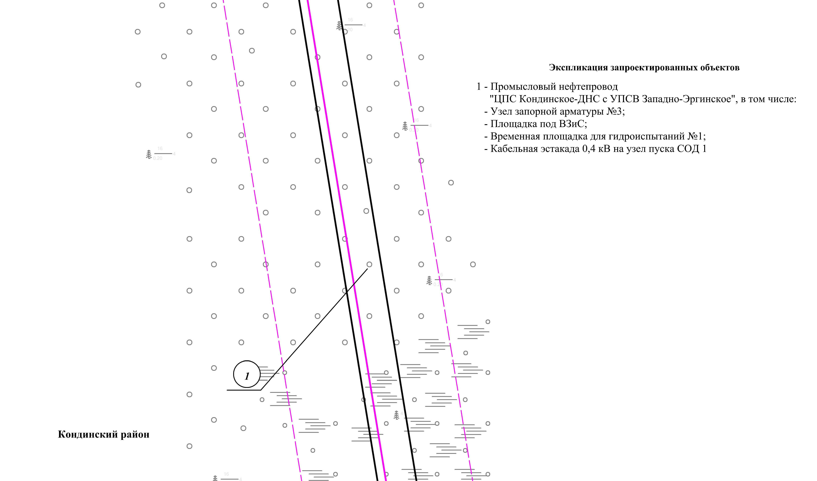
Линия совмещения с листом 101
Линия совмещения с листом 103

Основная часть проекта планировки территории для размещения объекта капитального строительства, расположенного на территории двух муниципальных образований
Ханты-Мансийского автономного округа – Югры,
«Промысловый нефтепровод «ЦПС Кондинское-ДНС с УПСВ Западно-Эргинское»
Землепользователь: АО «НК «Конданефть»
Масштаб 1:2000

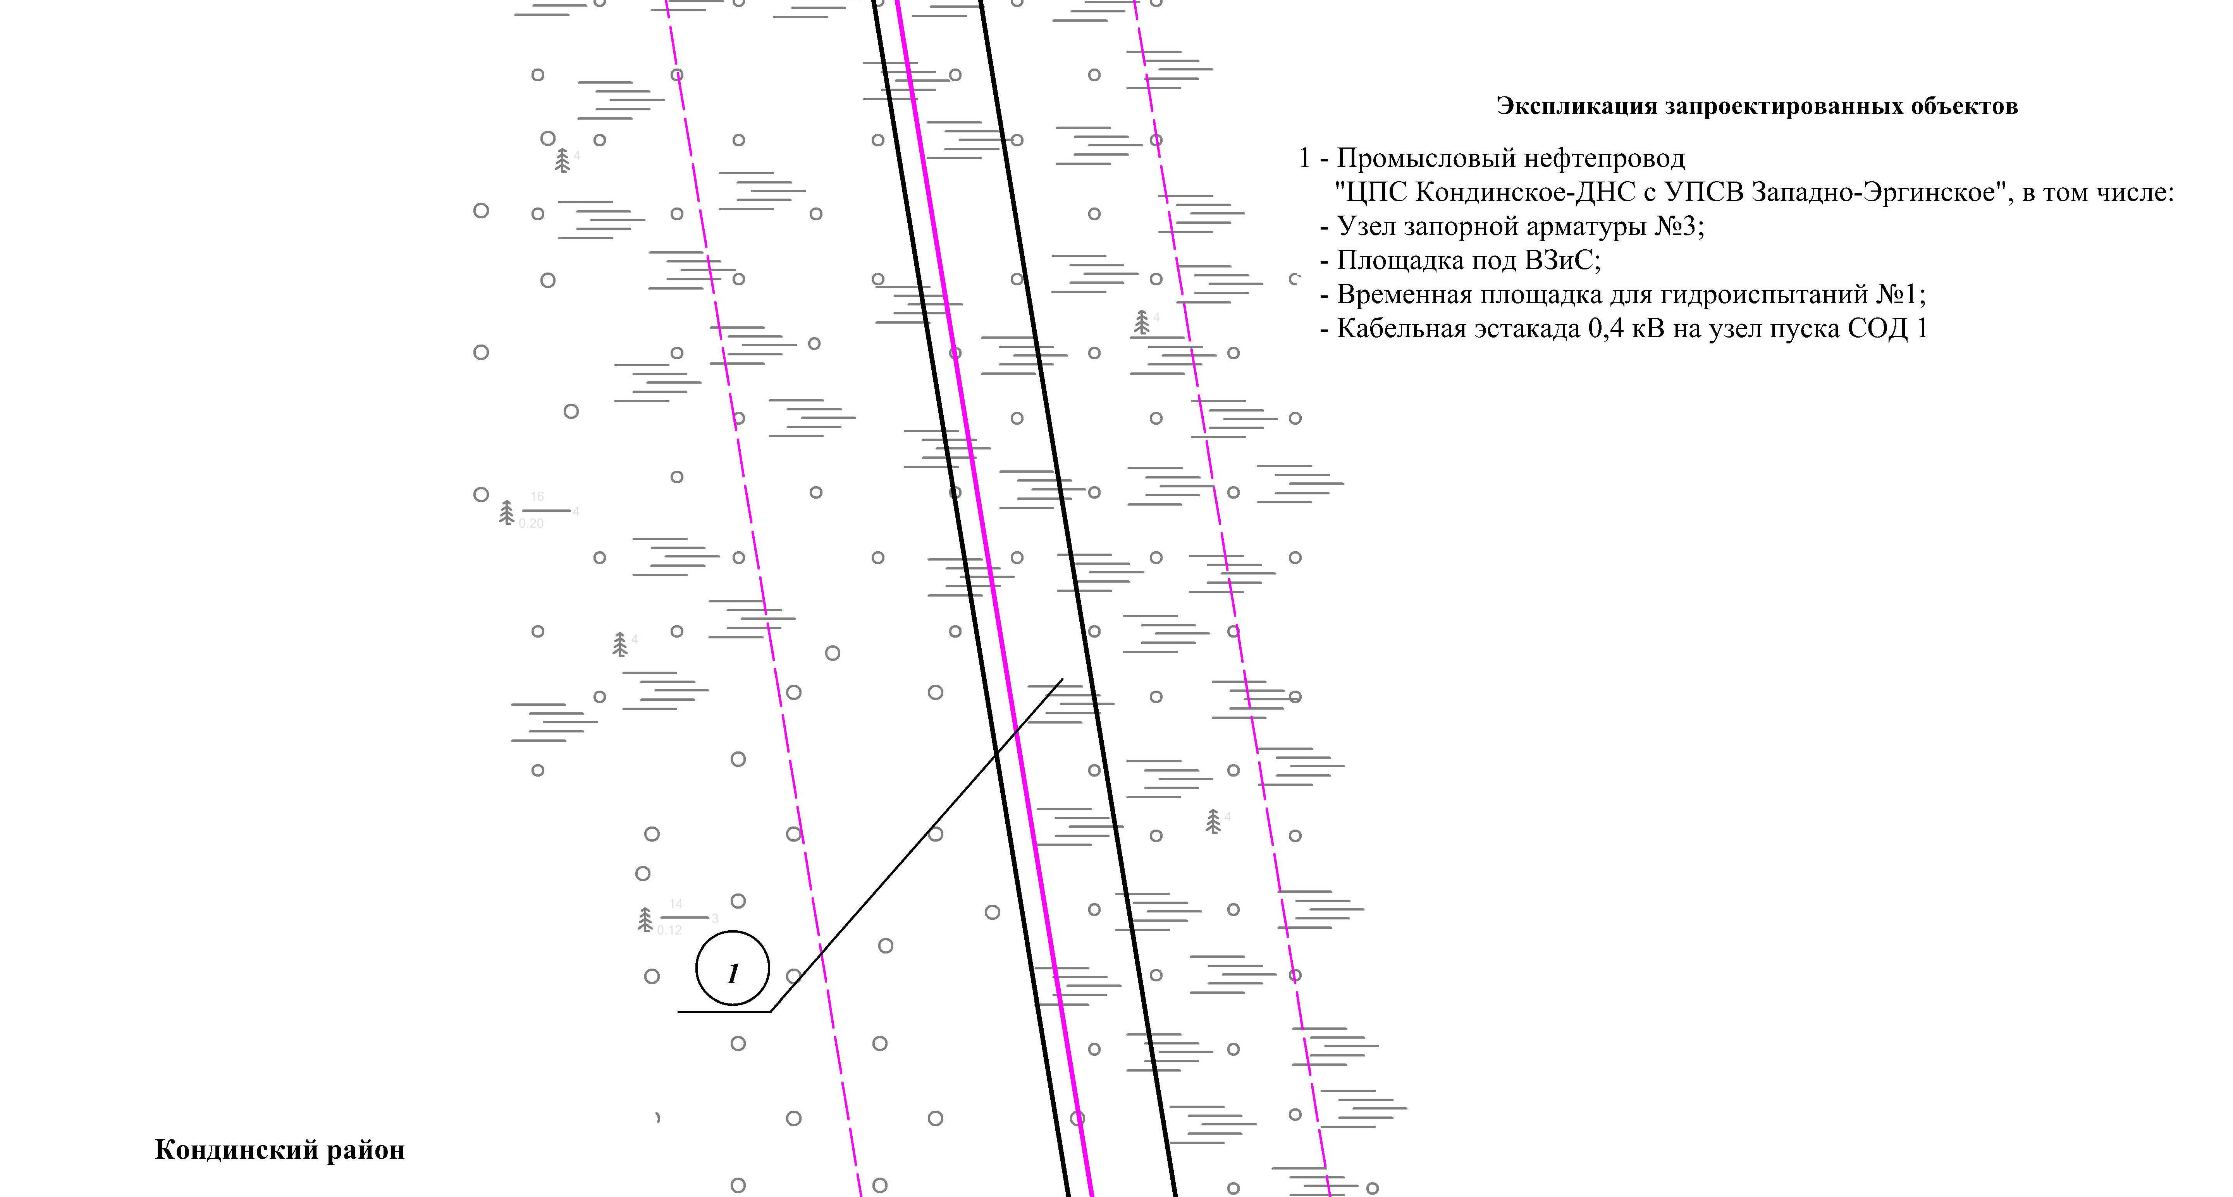
Линия совмещения с листом 102
Линия совмещения с листом 104

Основная часть проекта планировки территории для размещения объекта капитального строительства, расположенного на территории двух муниципальных образований
Ханты-Мансийского автономного округа – Югры,
«Промысловый нефтепровод «ЦПС Кондинское-ДНС с УПСВ Западно-Эргинское»
Землепользователь: АО «НК «Конданефть»
Масштаб 1:2000

Линия совмещения с листом 103
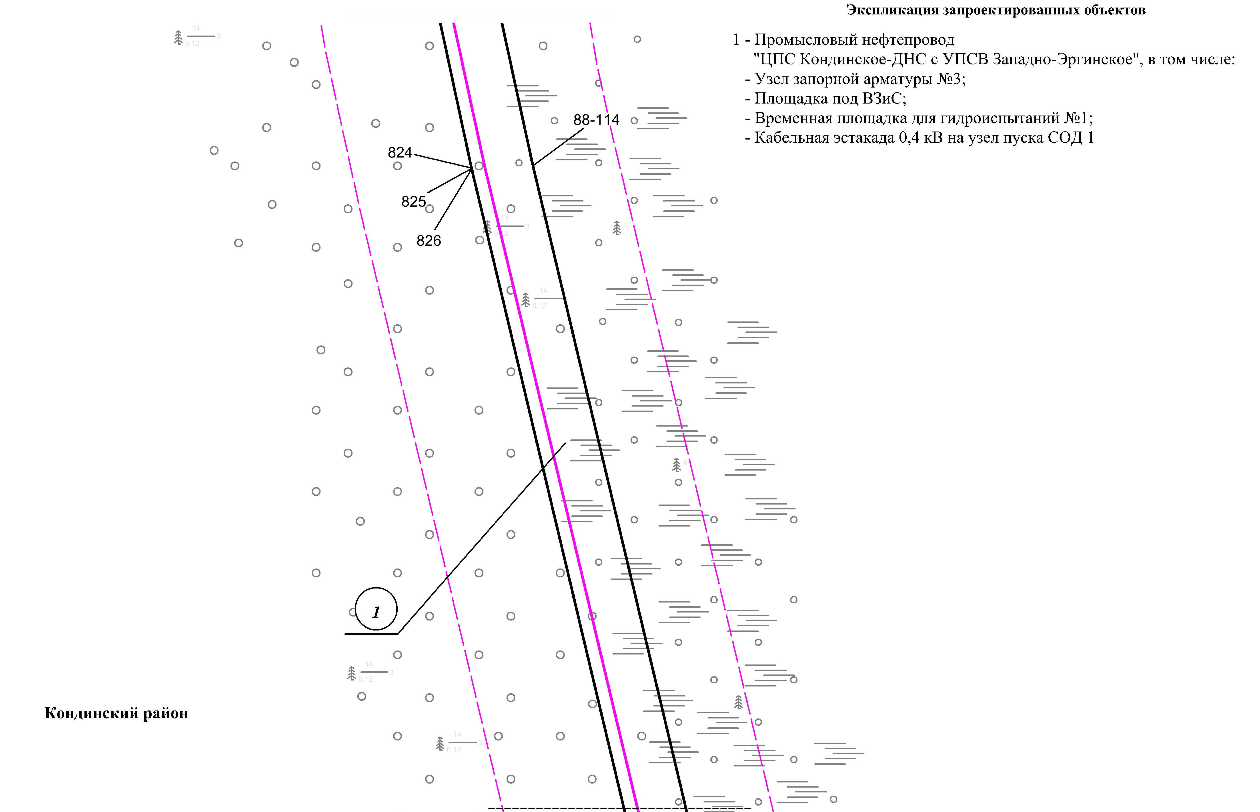
Линия совмещения с листом 105

Основная часть проекта планировки территории для размещения объекта капитального строительства, расположенного на территории двух муниципальных образований
Ханты-Мансийского автономного округа – Югры,
«Промысловый нефтепровод «ЦПС Кондинское-ДНС с УПСВ Западно-Эргинское»
Землепользователь: АО «НК «Конданефть»
Масштаб 1:2000

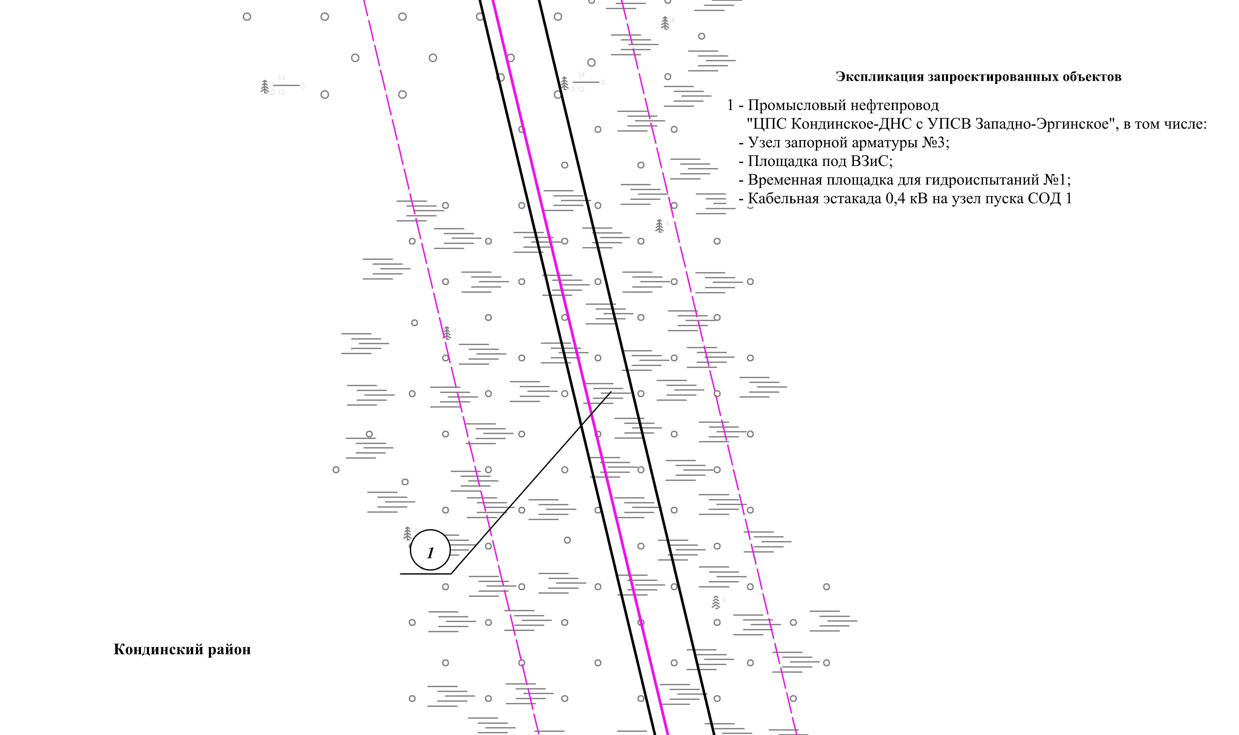
Линия совмещения с листом 104

Линия совмещения с листом 106

Основная часть проекта планировки территории для размещения объекта капитального строительства, расположенного на территории двух муниципальных образований
Ханты-Мансийского автономного округа – Югры,
«Промысловый нефтепровод «ЦПС Кондинское-ДНС с УПСВ Западно-Эргинское»
Землепользователь: АО «НК «Конданефть»
Масштаб 1:2000

Линия совмещения с листом 105
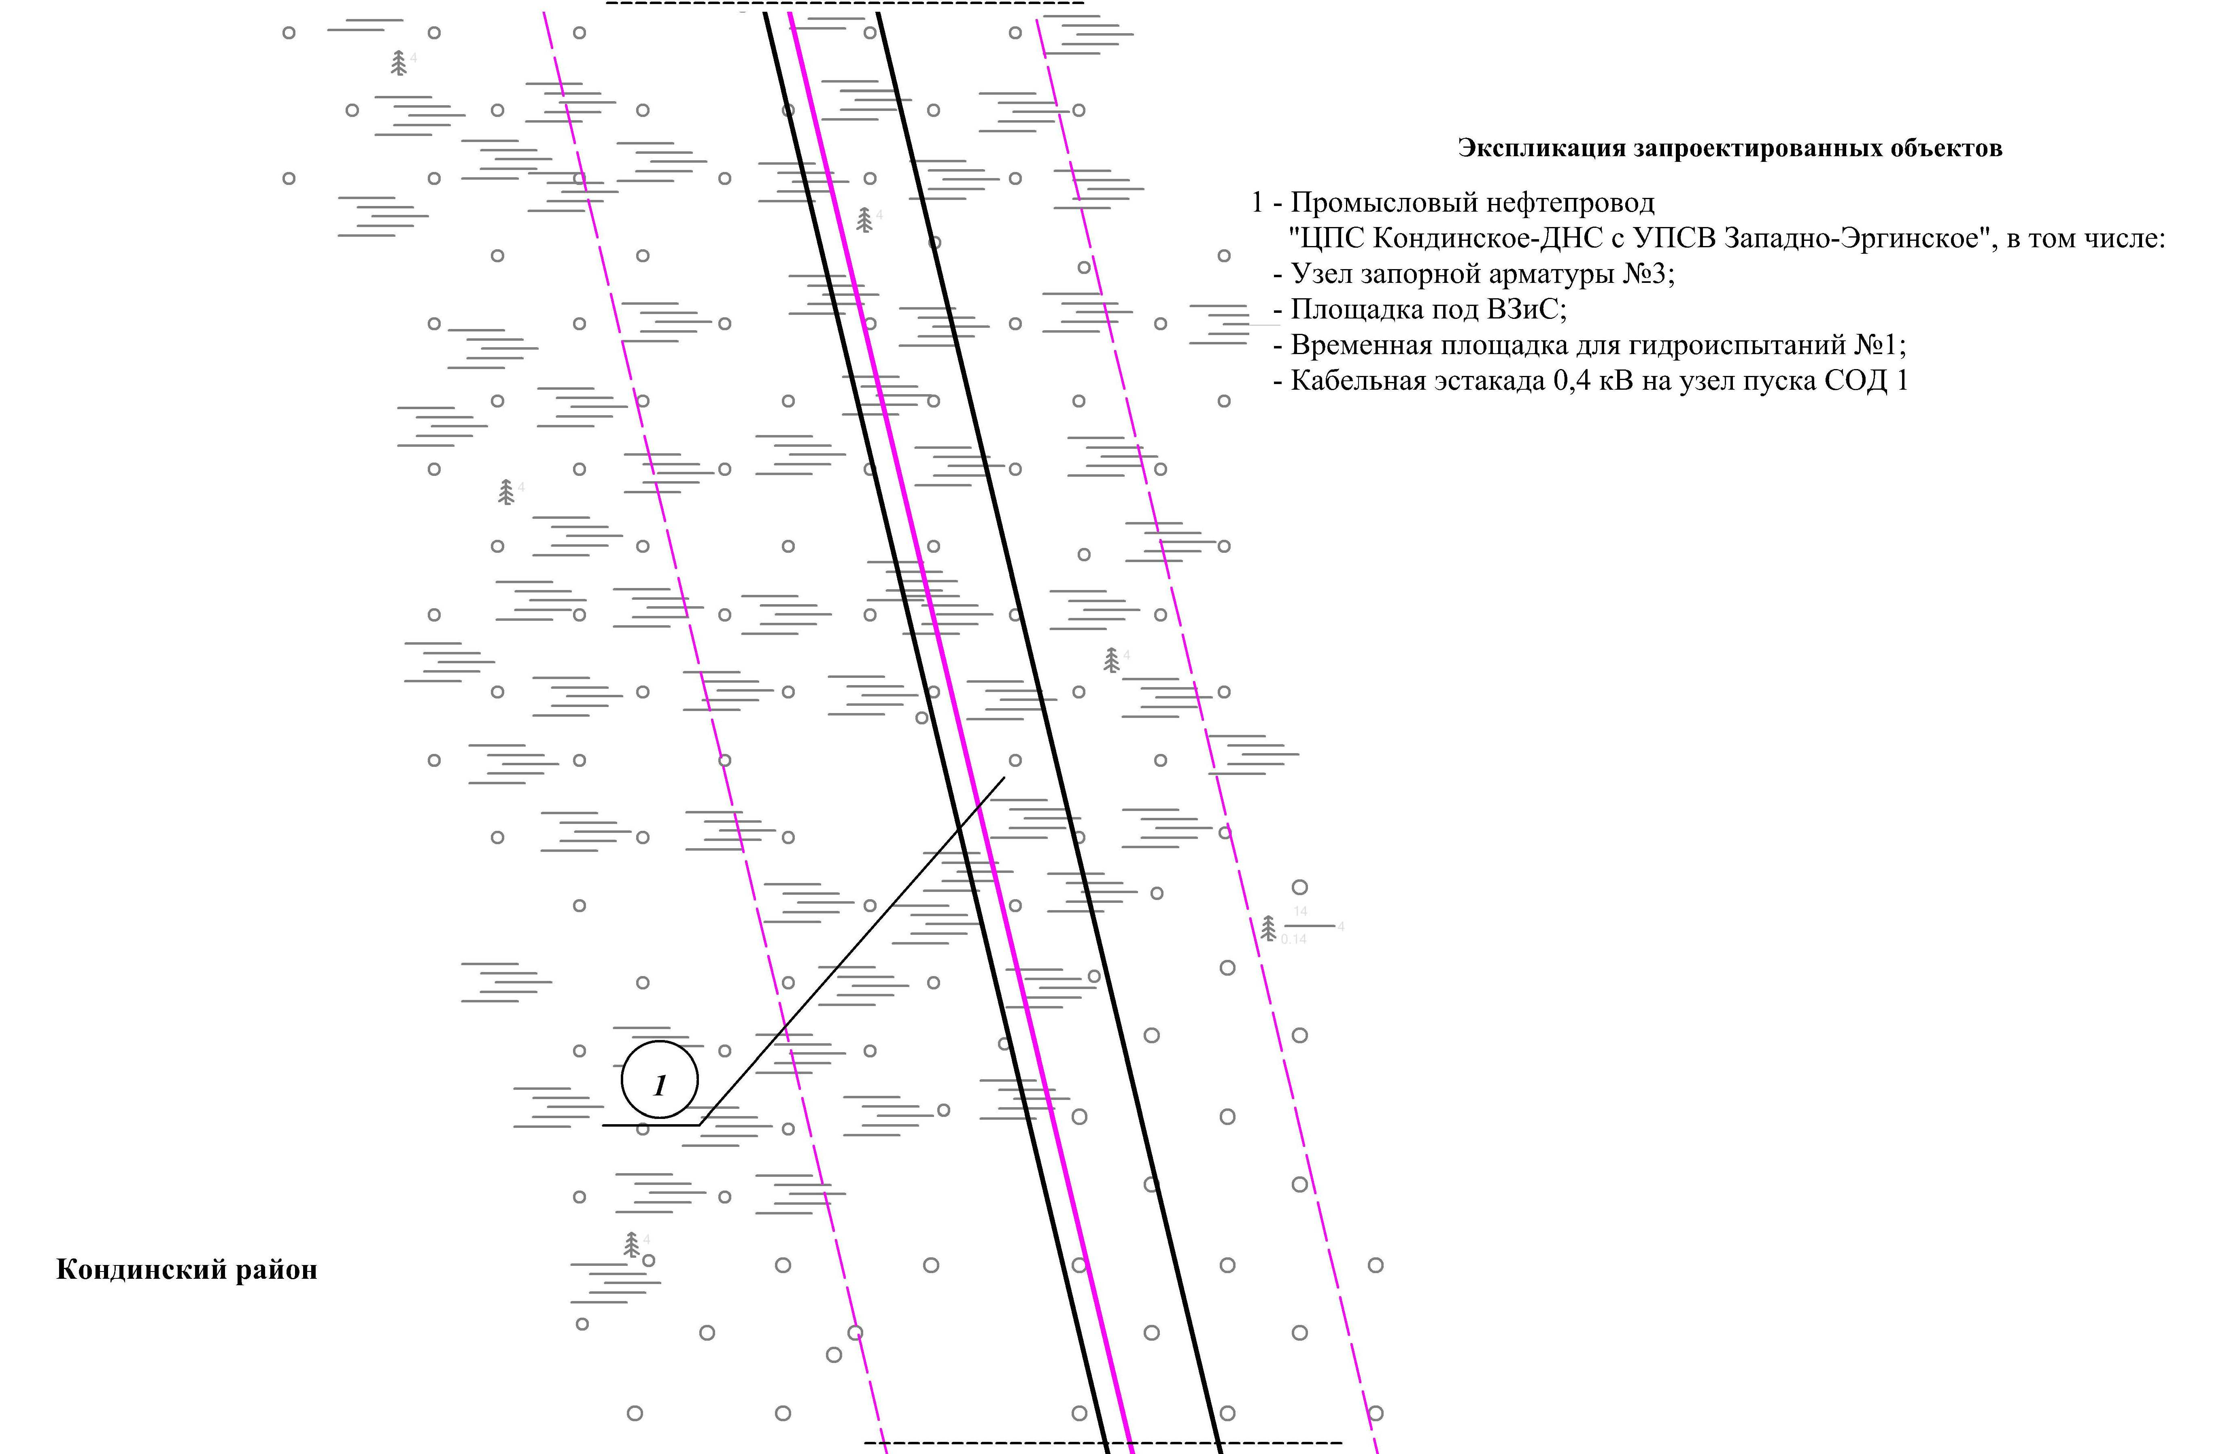
Линия совмещения с листом 107

Основная часть проекта планировки территории для размещения объекта капитального строительства, расположенного на территории двух муниципальных образований
Ханты-Мансийского автономного округа – Югры,
«Промысловый нефтепровод «ЦПС Кондинское-ДНС с УПСВ Западно-Эргинское»
Землепользователь: АО «НК «Конданефть»
Масштаб 1:2000

Линия совмещения с листом 106
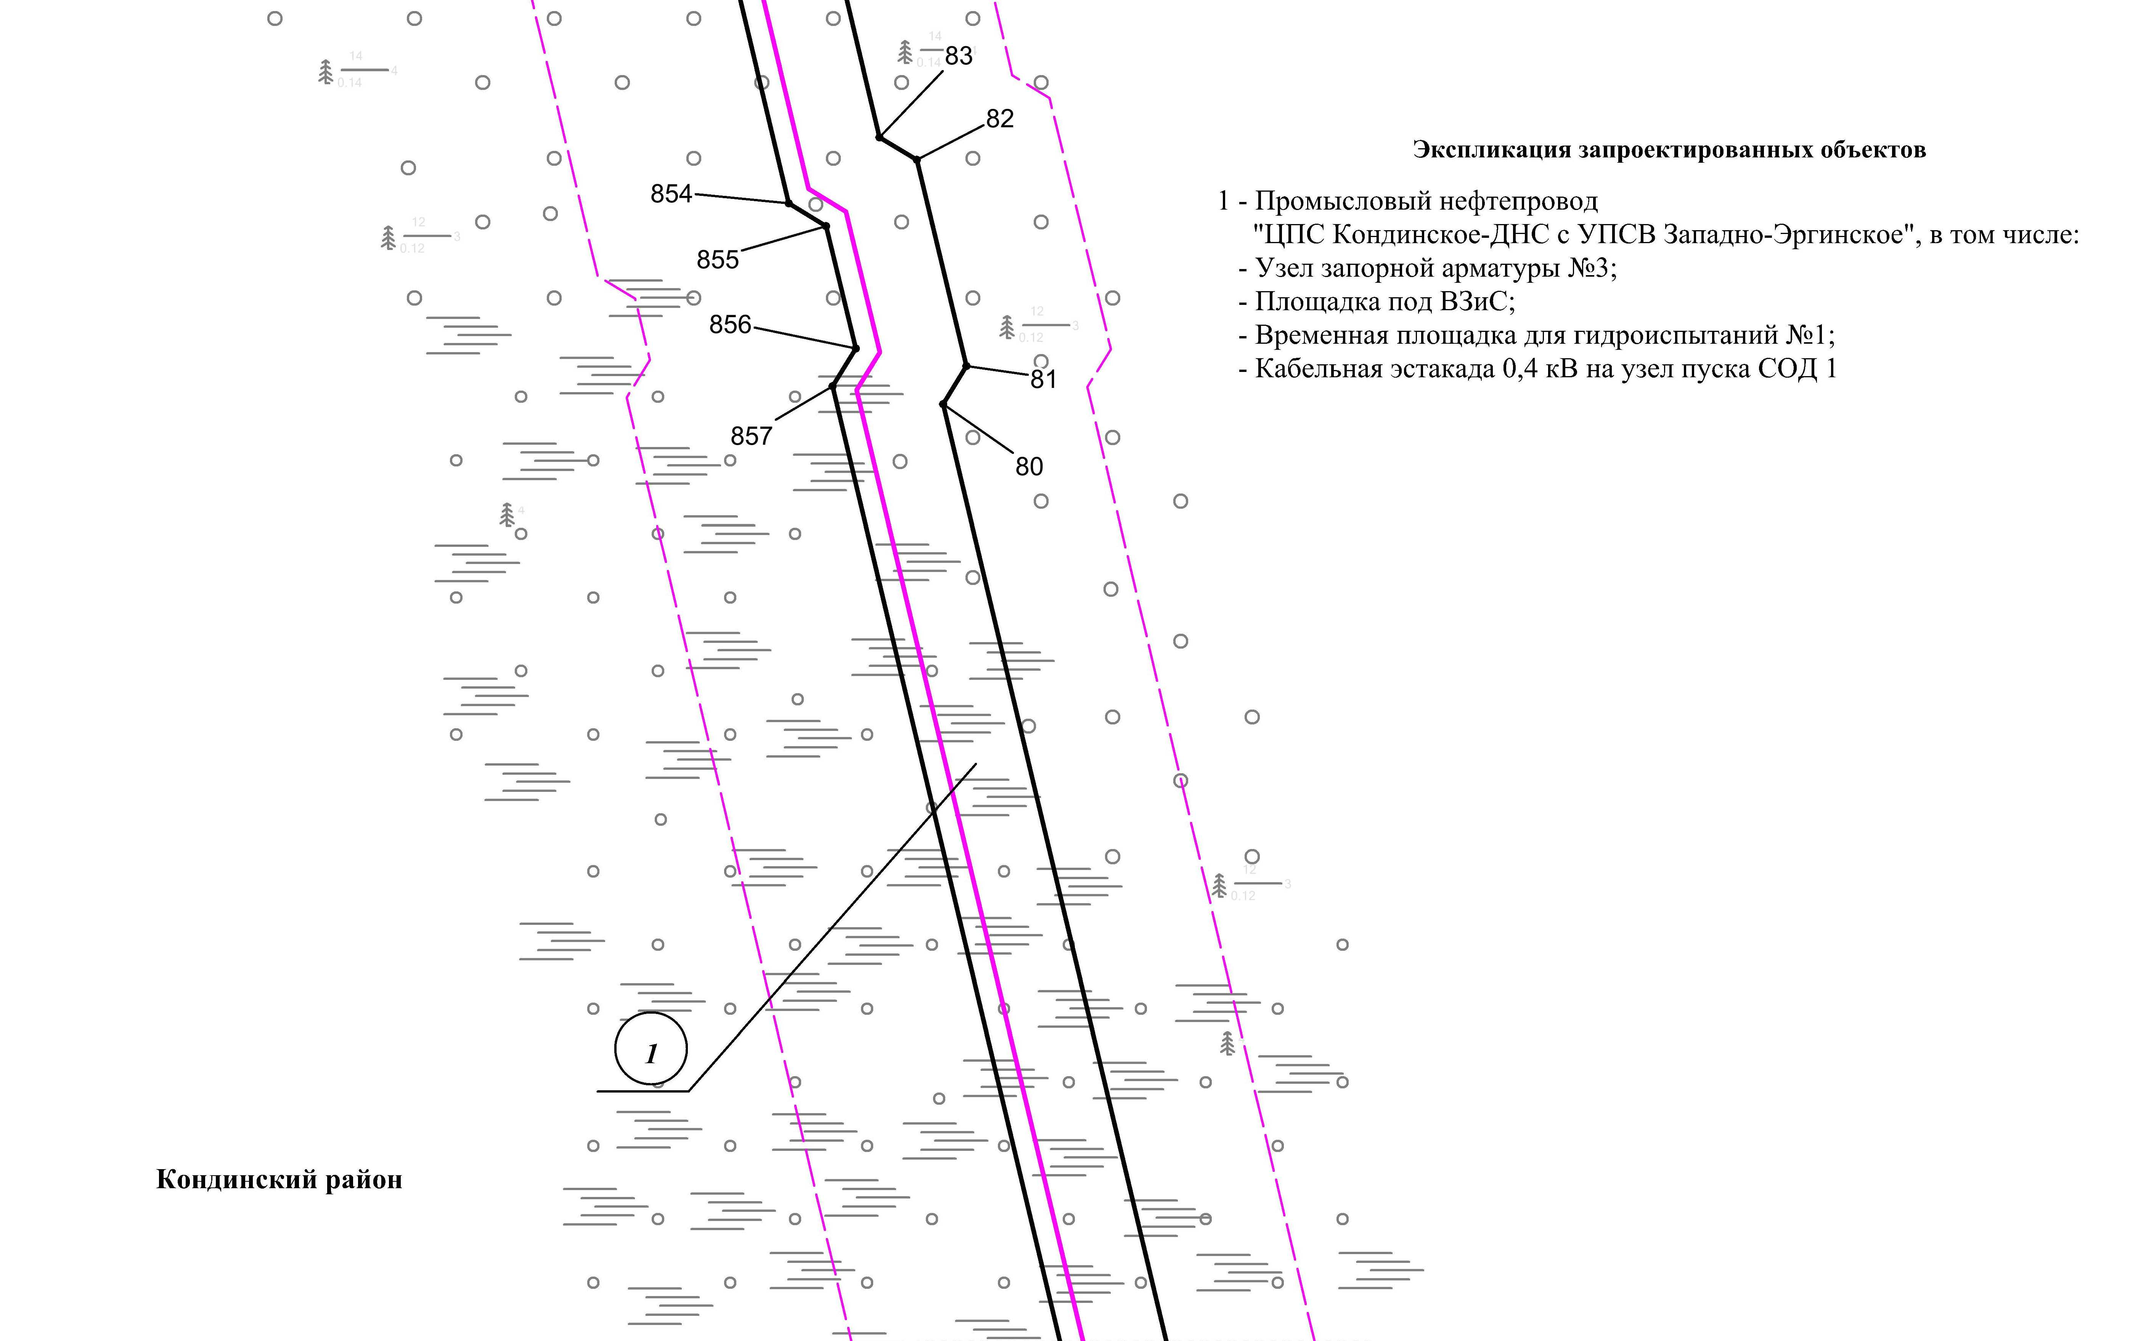
Линия совмещения с листом 108

Основная часть проекта планировки территории для размещения объекта капитального строительства, расположенного на территории двух муниципальных образований
Ханты-Мансийского автономного округа – Югры,
«Промысловый нефтепровод «ЦПС Кондинское - ДНС с УПСВ Западно-Эргинское»
Землепользователь: АО «НК «Конданефть»
Масштаб 1:2000

Линия совмещения с листом 107
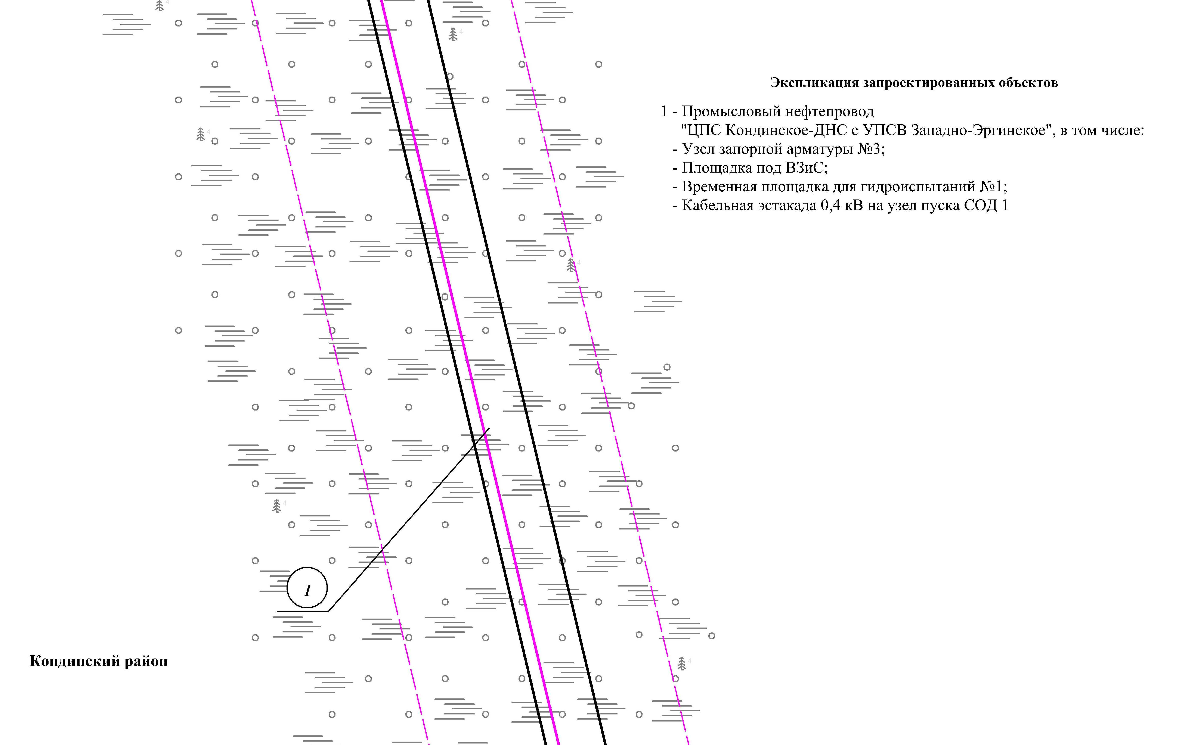
Линия совмещения с листом 109

Основная часть проекта планировки территории для размещения объекта капитального строительства, расположенного на территории двух муниципальных образований
Ханты-Мансийского автономного округа – Югры,
«Промысловый нефтепровод «ЦПС Кондинское - ДНС с УПСВ Западно-Эргинское»
Землепользователь: АО «НК «Конданефть»
Масштаб 1:2000

Линия совмещения с листом 108
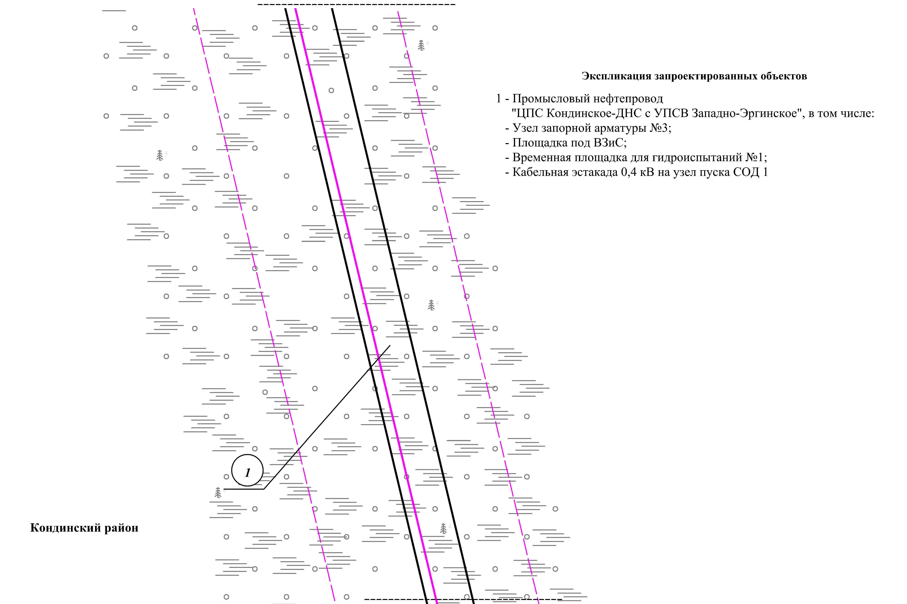
Линия совмещения с листом 110

Основная часть проекта планировки территории для размещения объекта капитального строительства, расположенного на территории двух муниципальных образований
Ханты-Мансийского автономного округа – Югры,
«Промысловый нефтепровод «ЦПС Кондинское - ДНС с УПСВ Западно-Эргинское»
Землепользователь: АО «НК «Конданефть»
Масштаб 1:2000

Линия совмещения с листом 109
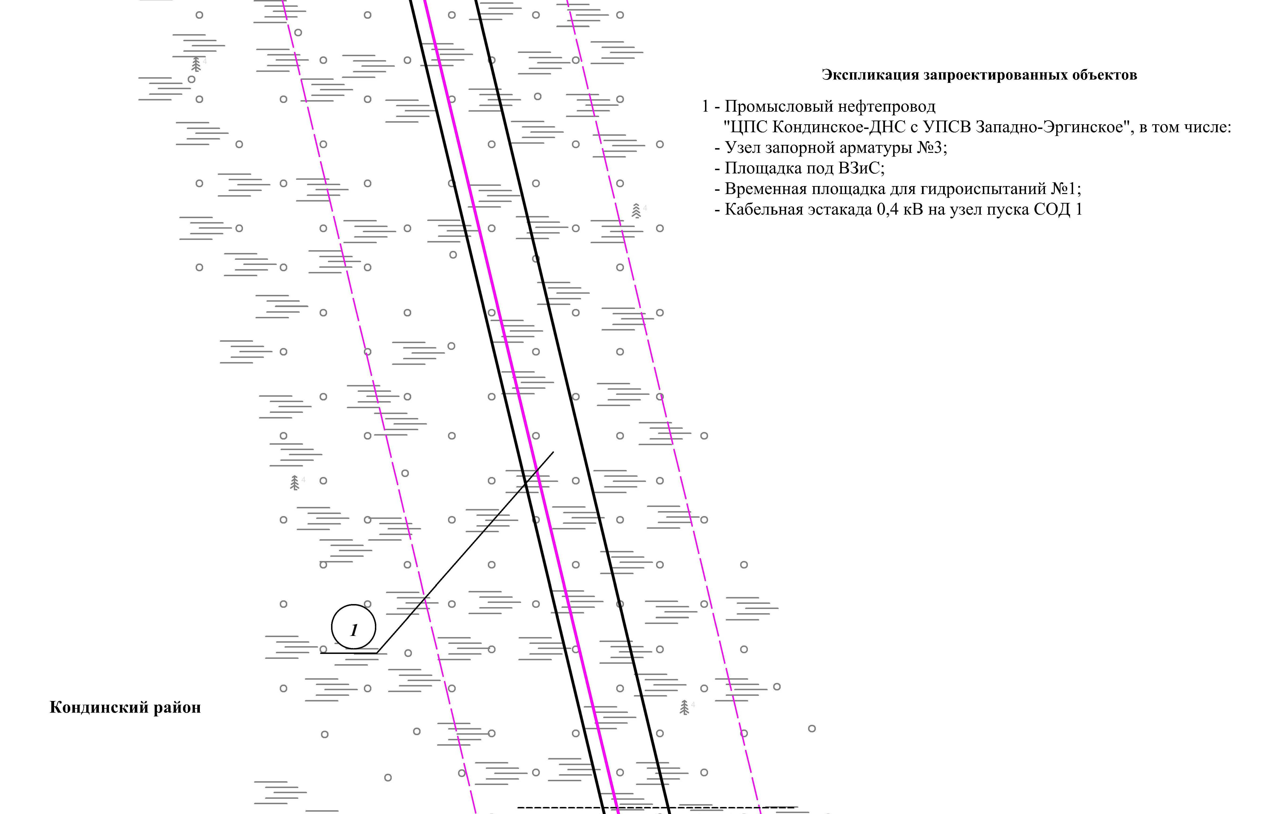
Линия совмещения с листом 111

Основная часть проекта планировки территории для размещения объекта капитального строительства, расположенного на территории двух муниципальных образований
Ханты-Мансийского автономного округа – Югры,
«Промысловый нефтепровод «ЦПС Кондинское - ДНС с УПСВ Западно-Эргинское»
Землепользователь: АО «НК «Конданефть»
Масштаб 1:2000

Линия совмещения с листом 110
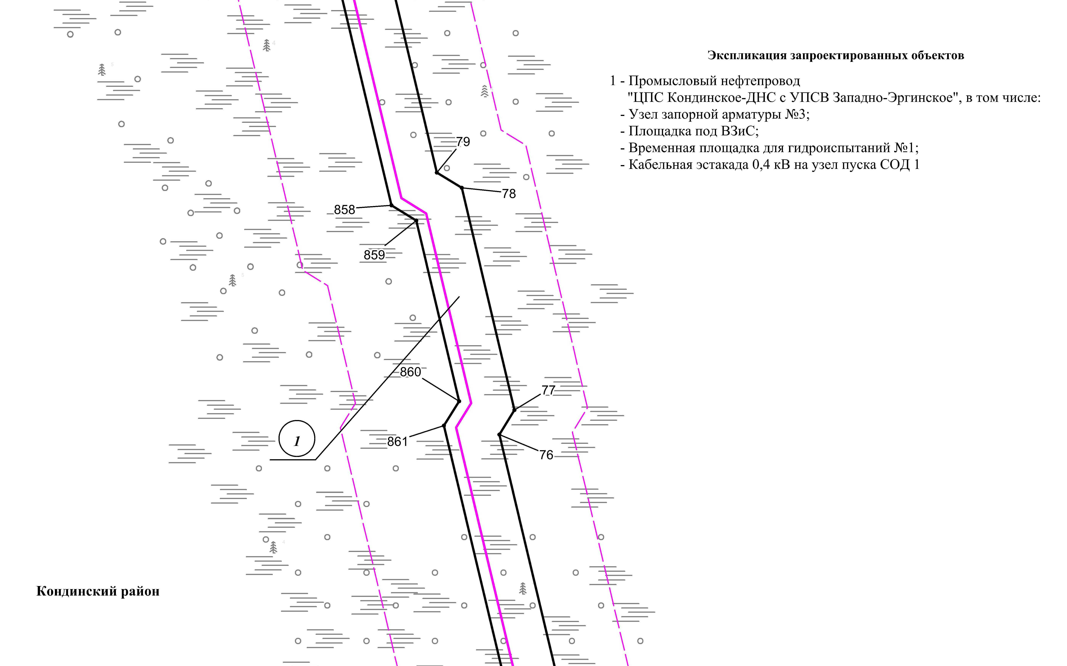
Линия совмещения с листом 112

Основная часть проекта планировки территории для размещения объекта капитального строительства, расположенного на территории двух муниципальных образований
Ханты-Мансийского автономного округа – Югры,
«Промысловый нефтепровод «ЦПС Кондинское - ДНС с УПСВ Западно-Эргинское»
Землепользователь: АО «НК «Конданефть»
Масштаб 1:2000

Линия совмещения с листом 111
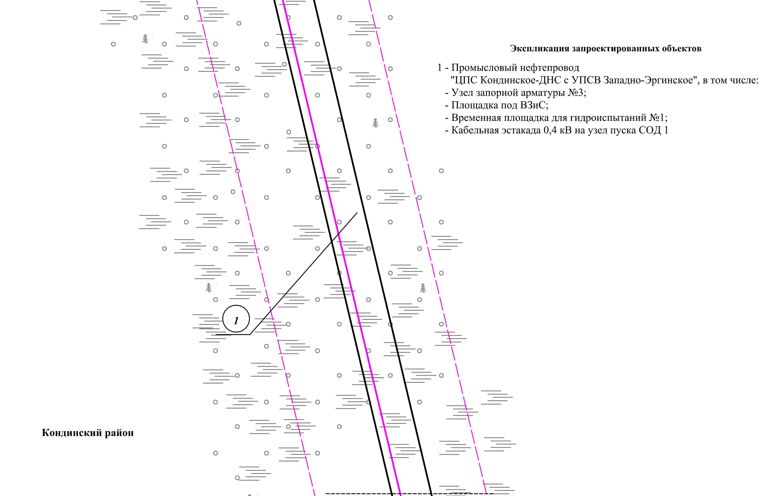
Линия совмещения с листом 113

Основная часть проекта планировки территории для размещения объекта капитального строительства, расположенного на территории двух муниципальных образований
Ханты-Мансийского автономного округа – Югры,
«Промысловый нефтепровод «ЦПС Кондинское - ДНС с УПСВ Западно-Эргинское»
Землепользователь: АО «НК «Конданефть»
Масштаб 1:2000

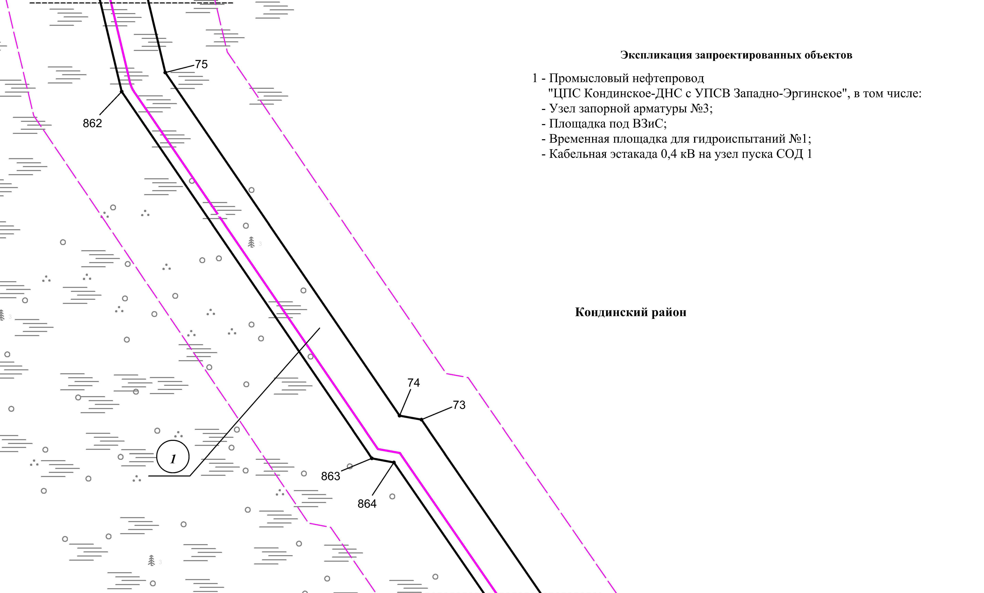
Линия совмещения с листом 112
Линия совмещения с листом 114

Основная часть проекта планировки территории для размещения объекта капитального строительства, расположенного на территории двух муниципальных образований
Ханты-Мансийского автономного округа – Югры,
«Промысловый нефтепровод «ЦПС Кондинское - ДНС с УПСВ Западно-Эргинское»
Землепользователь: АО «НК «Конданефть»
Масштаб 1:2000

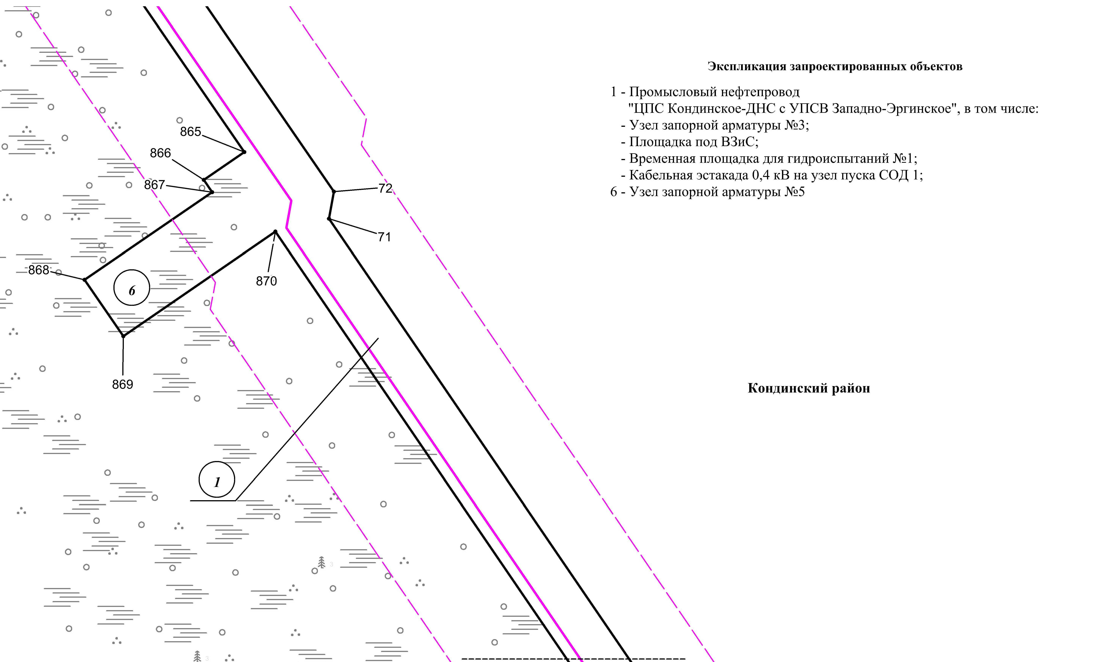

Линия совмещения с листом 113

Линия совмещения с листом 115

Основная часть проекта планировки территории для размещения объекта капитального строительства, расположенного на территории двух муниципальных образований
Ханты-Мансийского автономного округа – Югры,
«Промысловый нефтепровод «ЦПС Кондинское - ДНС с УПСВ Западно-Эргинское»
Землепользователь: АО «НК «Конданефть»
Масштаб 1:2000

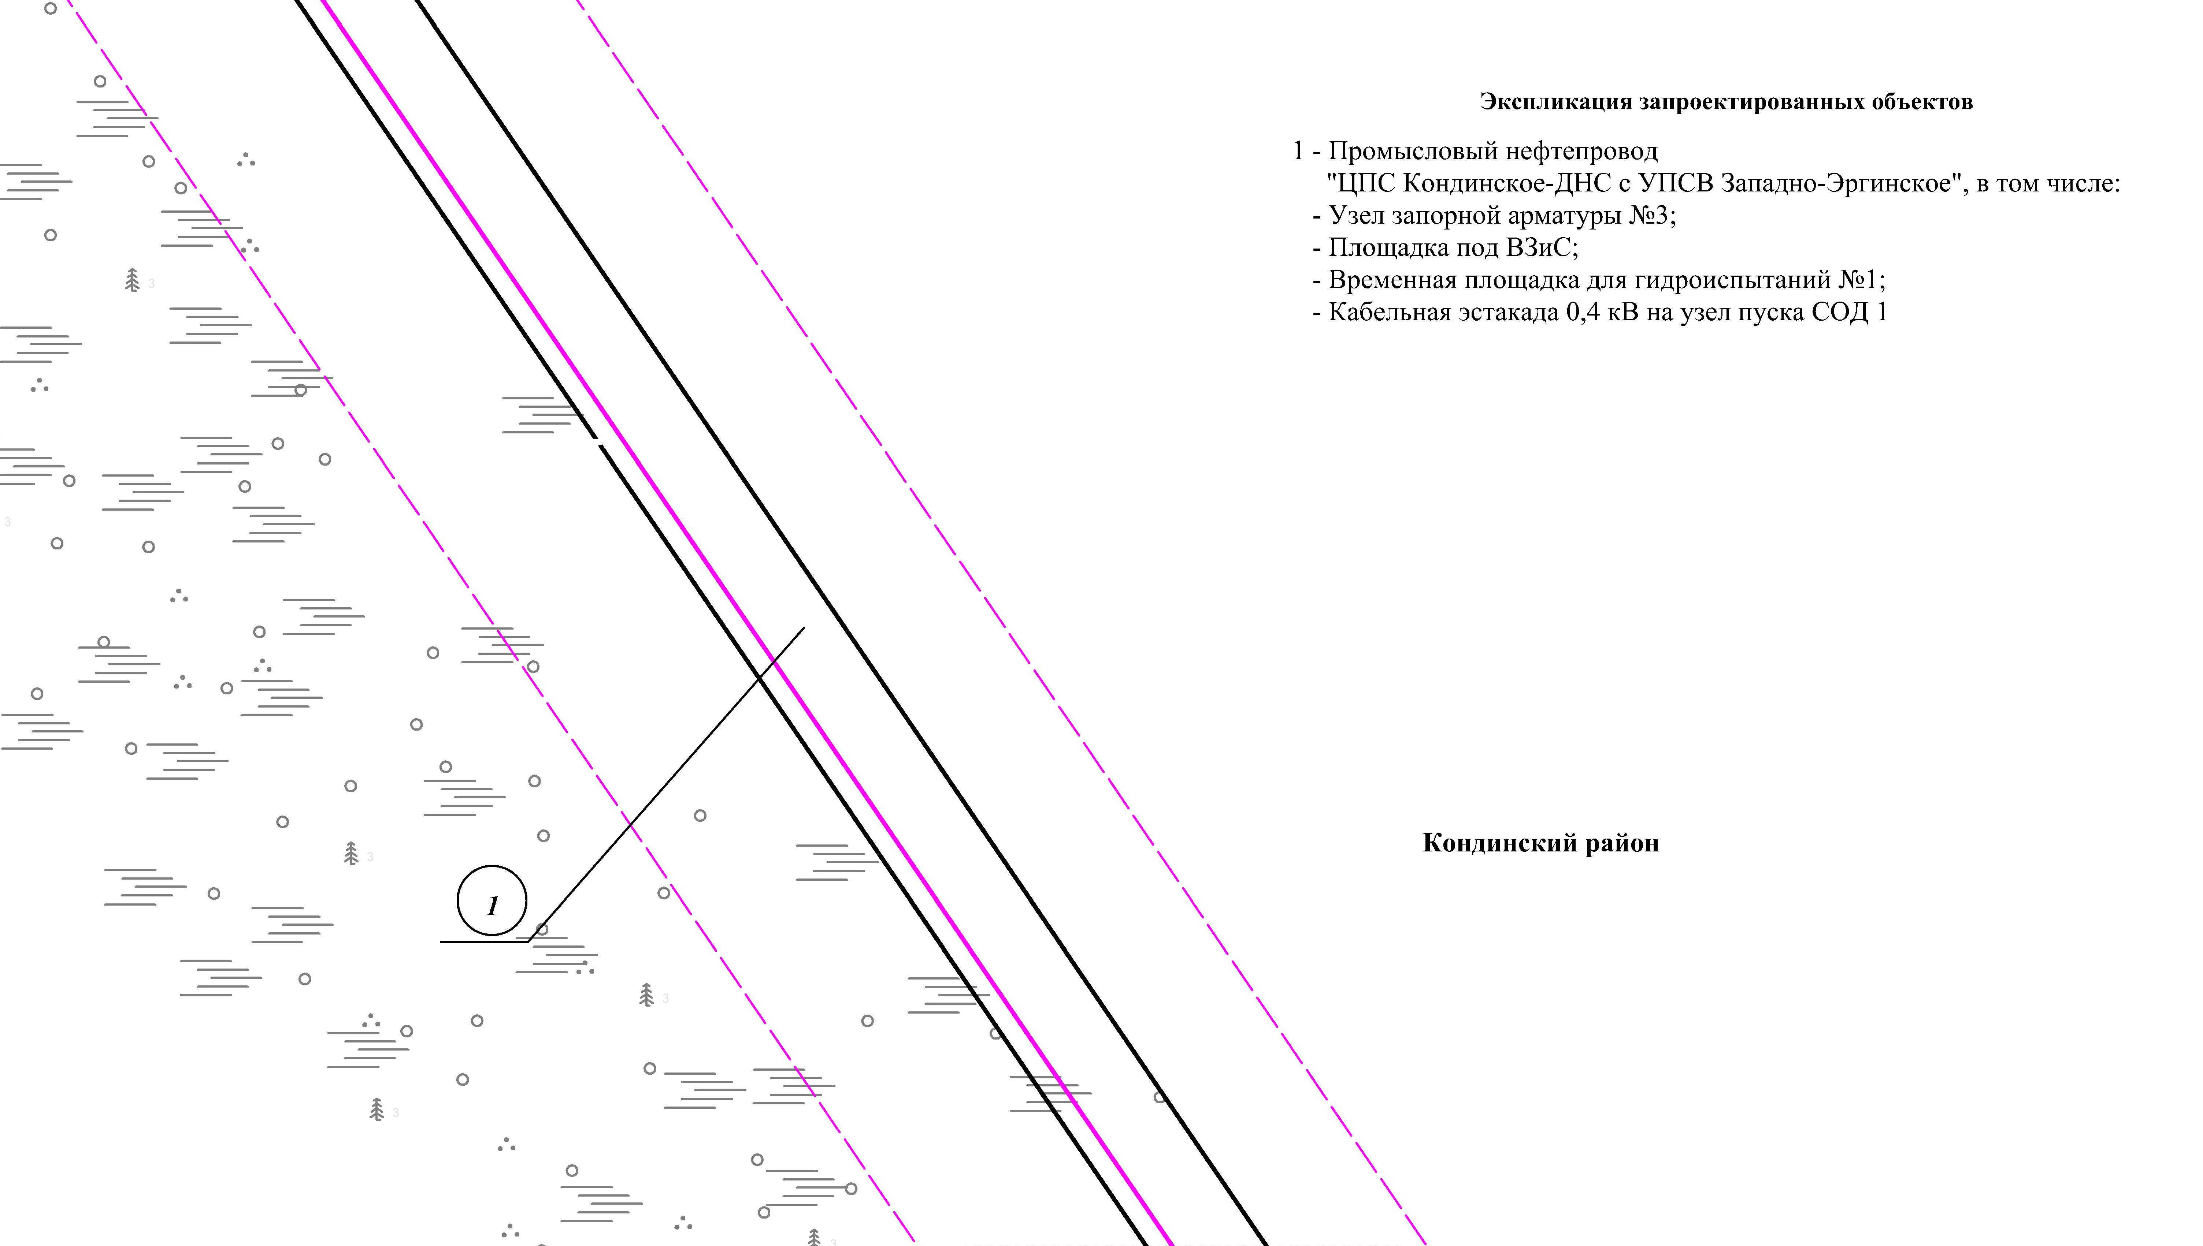
Линия совмещения с листом 114

Линия совмещения с листом 116

Основная часть проекта планировки территории для размещения объекта капитального строительства, расположенного на территории двух муниципальных образований
Ханты-Мансийского автономного округа – Югры,
«Промысловый нефтепровод «ЦПС Кондинское - ДНС с УПСВ Западно-Эргинское»
Землепользователь: АО «НК «Конданефть»
Масштаб 1:2000

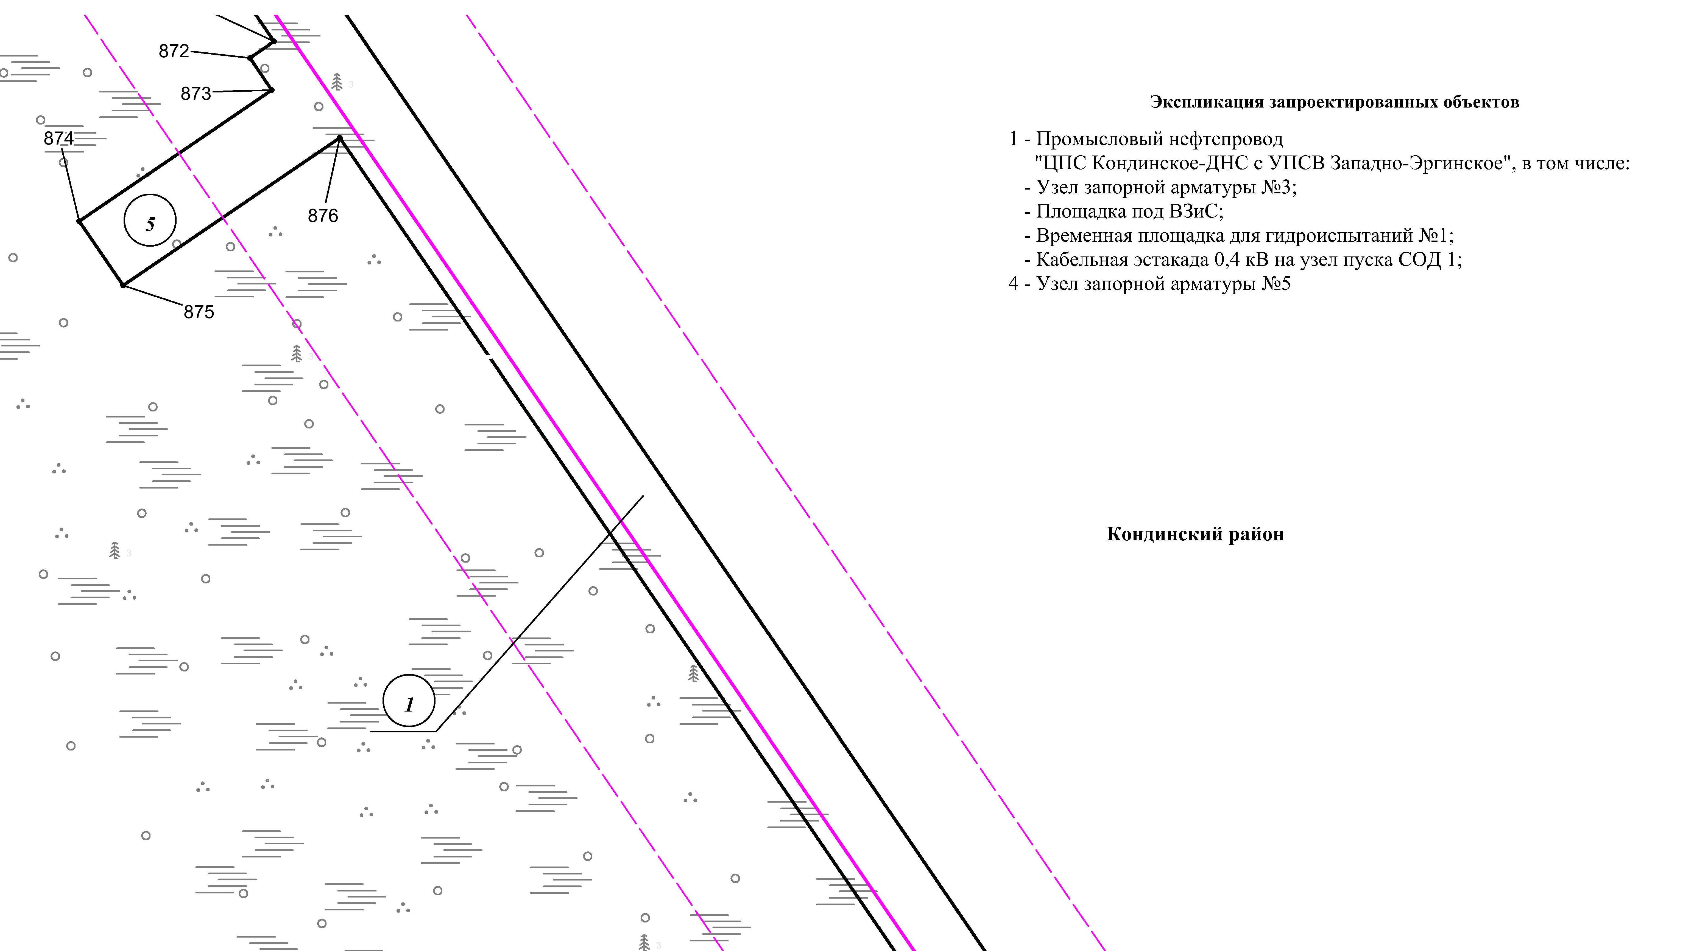
Линия совмещения с листом 115

Линия совмещения с листом 117

Основная часть проекта планировки территории для размещения объекта капитального строительства, расположенного на территории двух муниципальных образований
Ханты-Мансийского автономного округа – Югры
«Промысловый нефтепровод «ЦПС Кондинское-ДНС с УПСВ Западно-Эргинское»
Землепользователь: АО «НК «Конданефть»

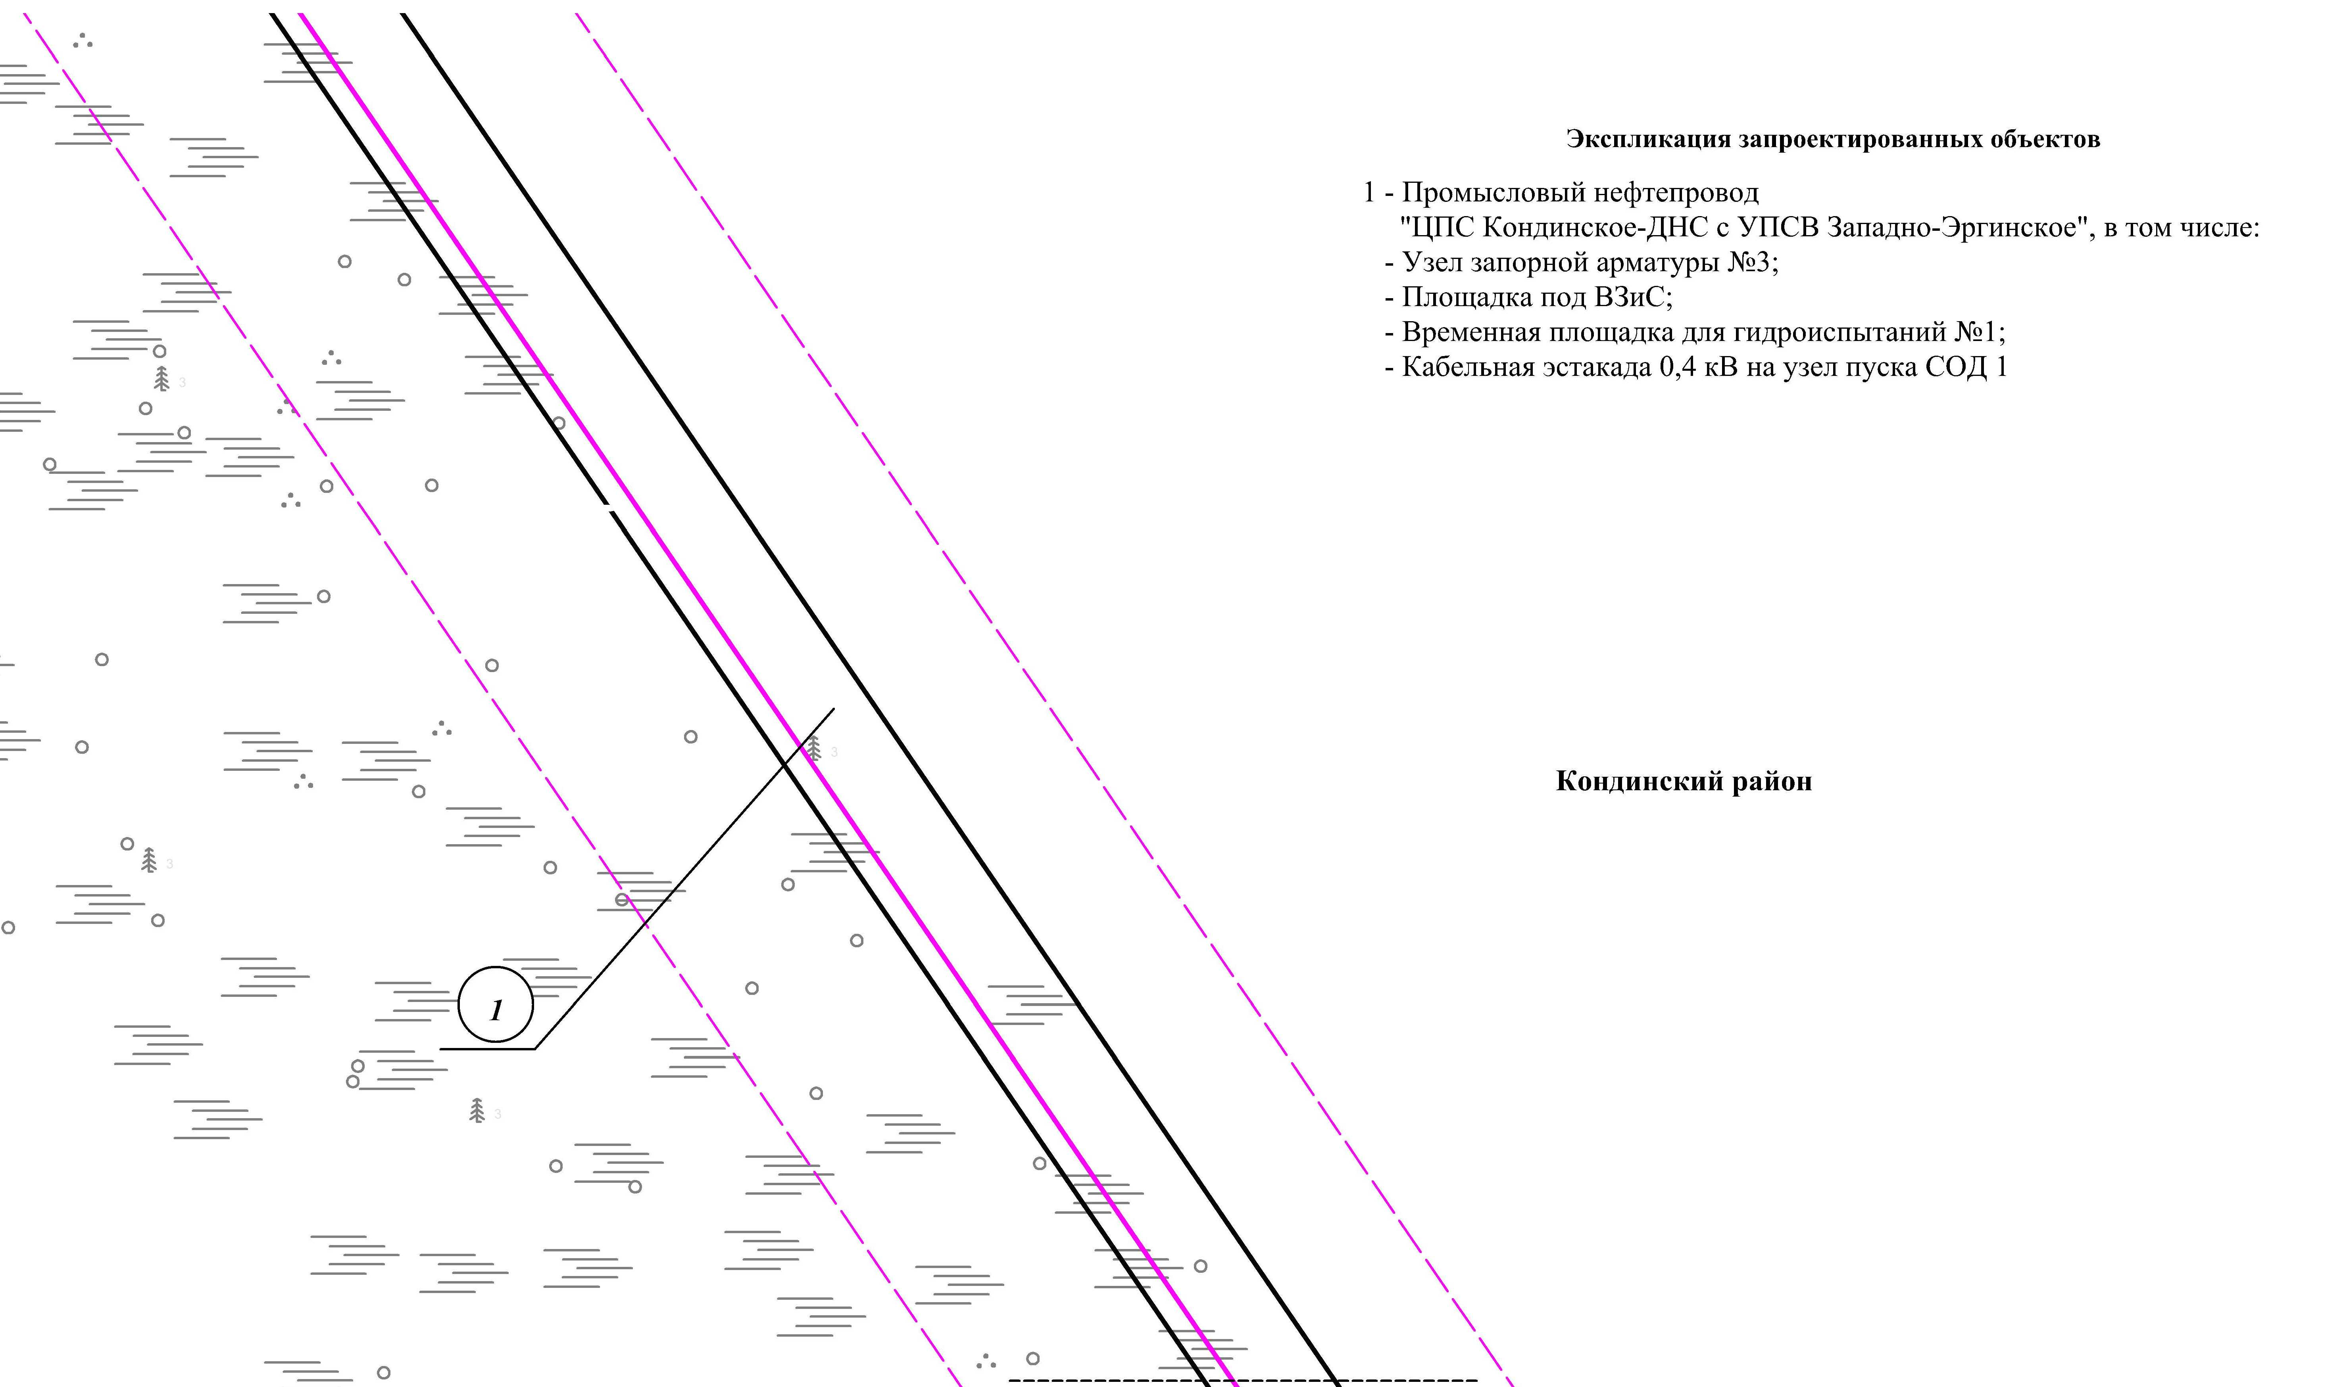
Линия совмещения с листом 116

Линия совмещения с листом 118

Основная часть проекта планировки территории для размещения объекта капитального строительства, расположенного на территории двух муниципальных образований
Ханты-Мансийского автономного округа – Югры,
«Промысловый нефтепровод «ЦПС Кондинское-ДНС с УПСВ Западно-Эргинское»
Землепользователь: АО «НК «Конданефть»
Масштаб 1:2000

Основная часть проекта планировки территории для размещения объекта капитального строительства, расположенного на территории двух муниципальных образований
Ханты-Мансийского автономного округа – Югры,
«Промысловый нефтепровод «ЦПС Кондинское-ДНС с УПСВ Западно-Эргинское»
Землепользователь: АО «НК «Конданефть»
Масштаб 1:2000

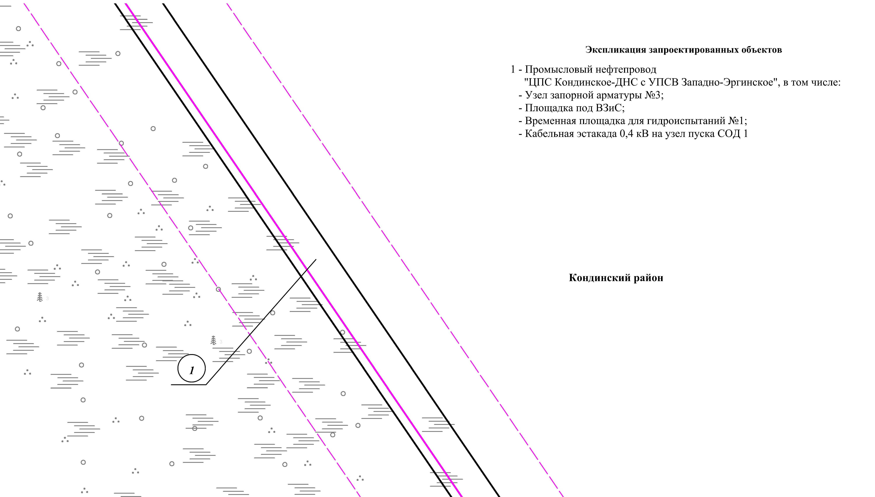
Линия совмещения с листом 117

Линия совмещения с листом 119

Основная часть проекта планировки территории для размещения объекта капитального строительства, расположенного на территории двух муниципальных образований
Ханты-Мансийского автономного округа – Югры,
«Промысловый нефтепровод «ЦПС Кондинское-ДНС с УПСВ Западно-Эргинское»
Землепользователь: АО «НК «Конданефть»
Масштаб 1:2000

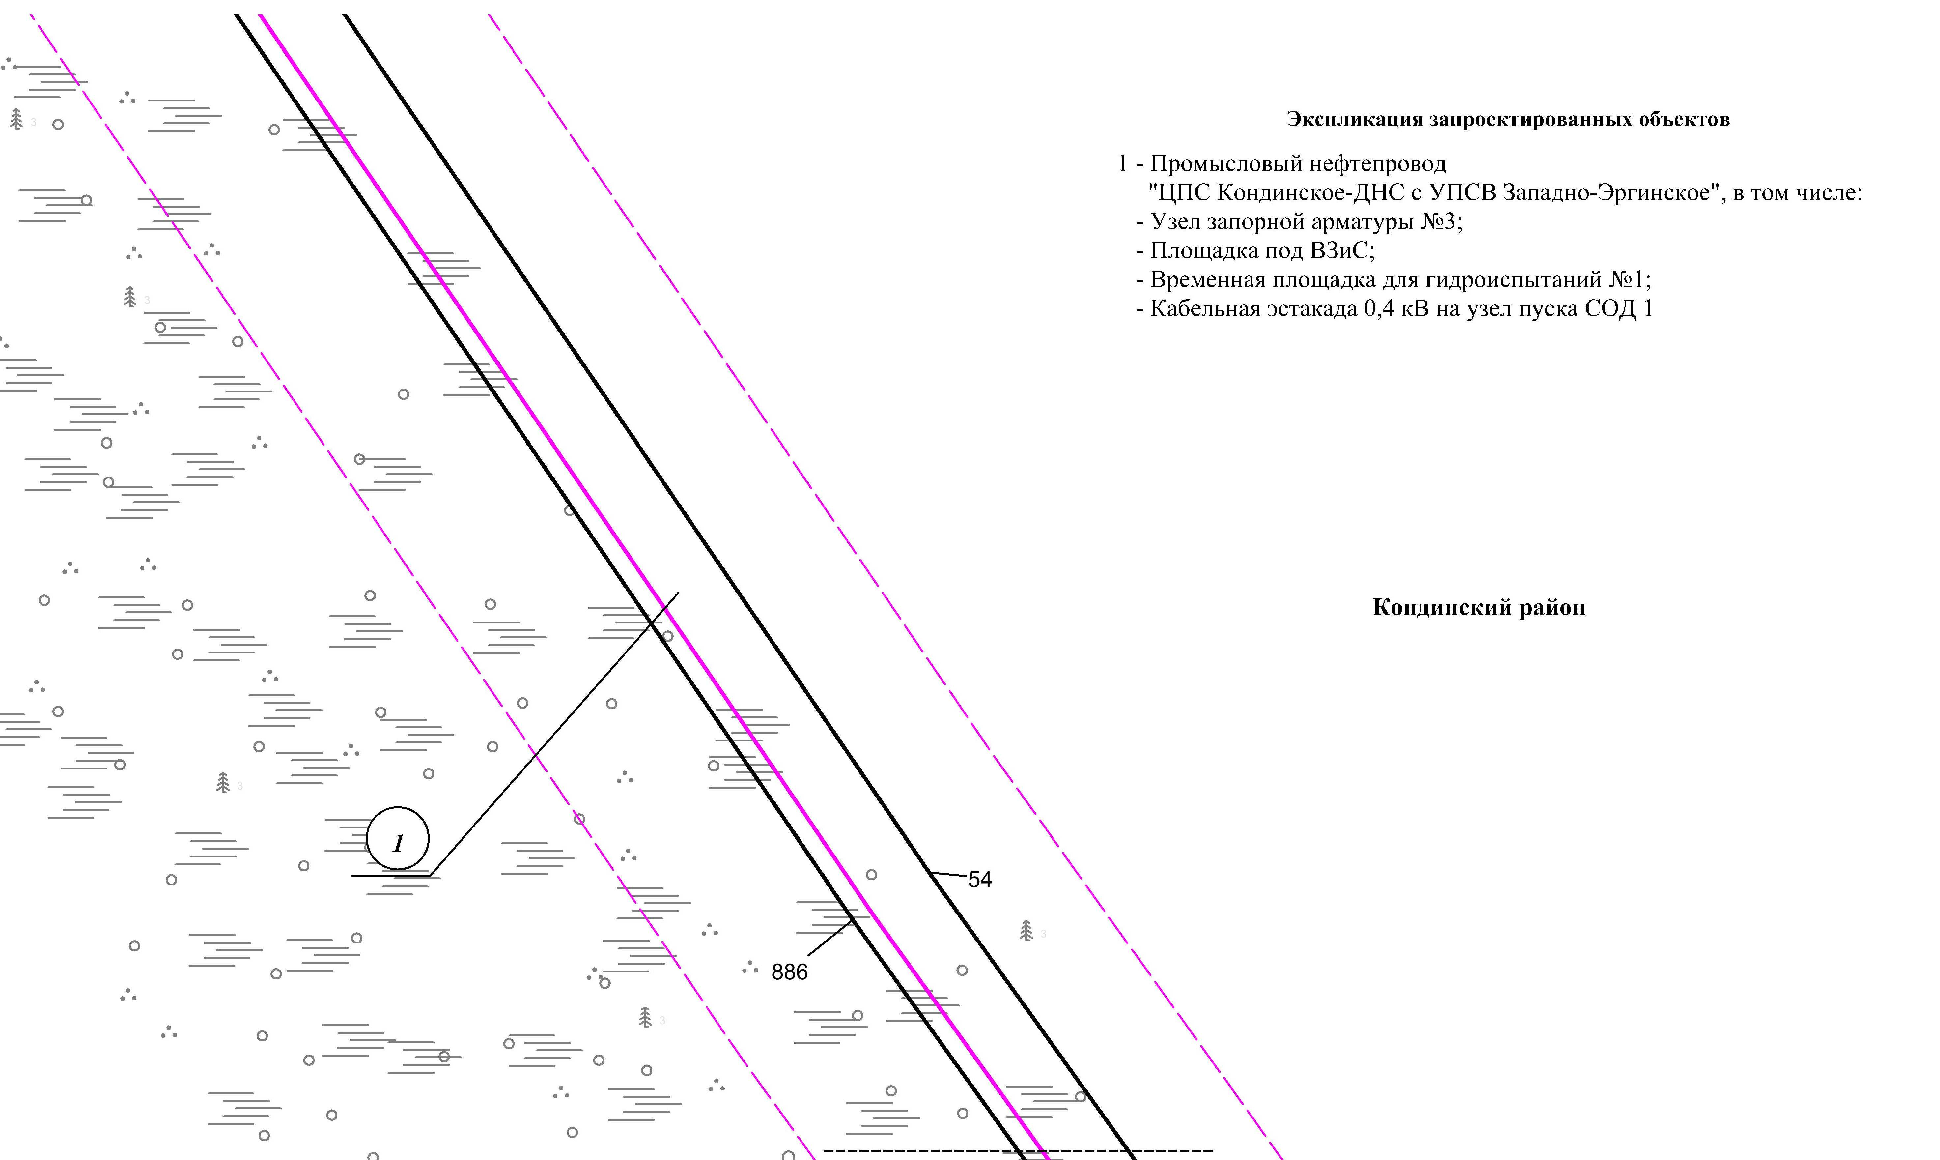
Линия совмещения с листом 118

Линия совмещения с листом 120

Основная часть проекта планировки территории для размещения объекта капитального строительства, расположенного на территории двух муниципальных образований
Ханты-Мансийского автономного округа – Югры
«Промысловый нефтепровод «ЦПС Кондинское-ДНС с УПСВ Западно-Эргинское»
Землепользователь: АО «НК «Конданефть»

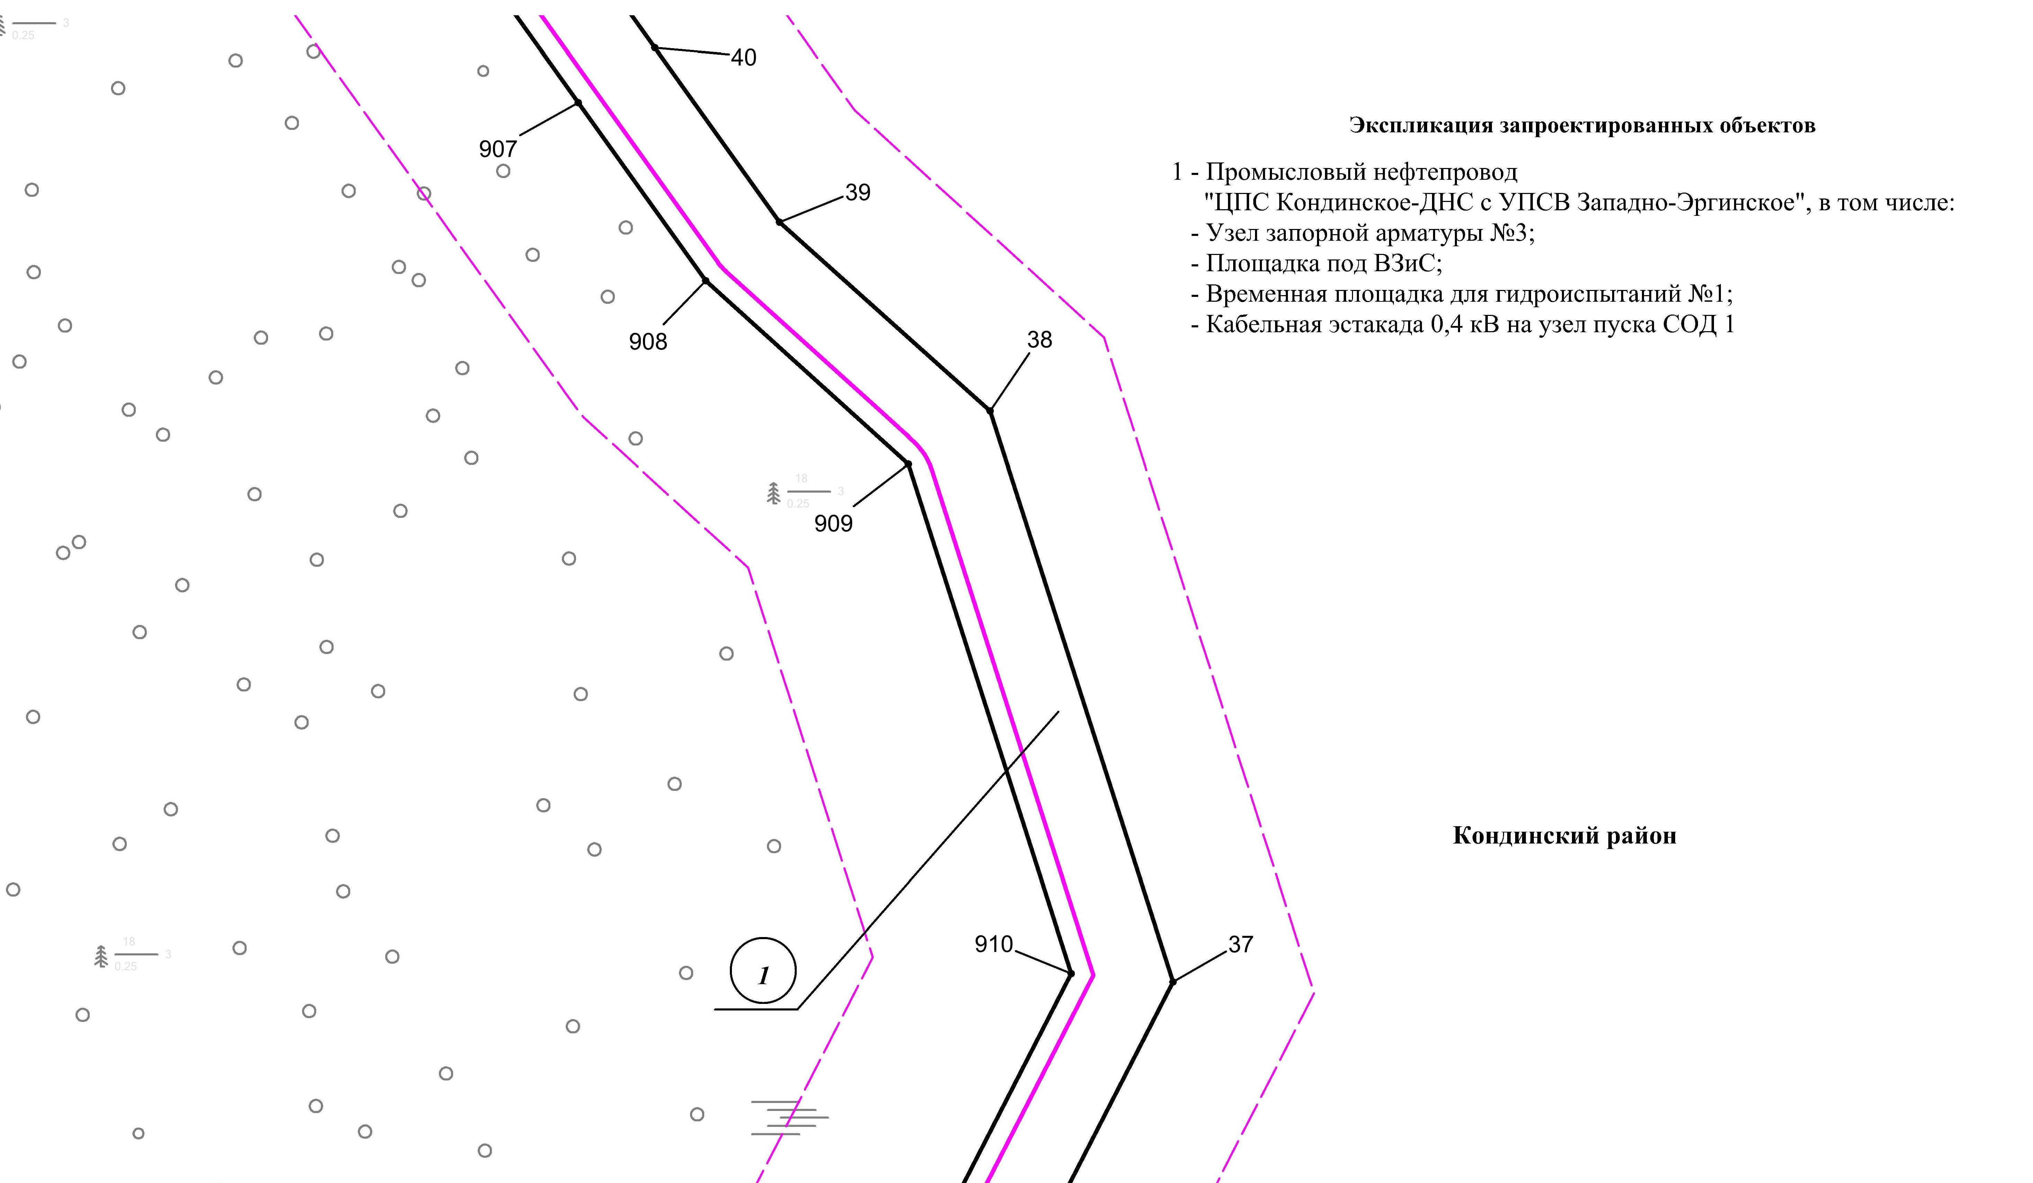

Линия совмещения с листом 119

Линия совмещения с листом 121

Основная часть проекта планировки территории для размещения объекта капитального строительства, расположенного на территории двух муниципальных образований
Ханты-Мансийского автономного округа – Югры,
«Промысловый нефтепровод «ЦПС Кондинское - ДНС с УПСВ Западно-Эргинское»
Землепользователь: АО «НК «Конданефть»
Масштаб 1:2000

Основная часть проекта планировки территории для размещения объекта капитального строительства, расположенного на территории двух муниципальных образований
Ханты-Мансийского автономного округа – Югры,
«Промысловый нефтепровод «ЦПС Кондинское - ДНС с УПСВ Западно-Эргинское»
Землепользователь: АО «НК «Конданефть»
Масштаб 1:2000

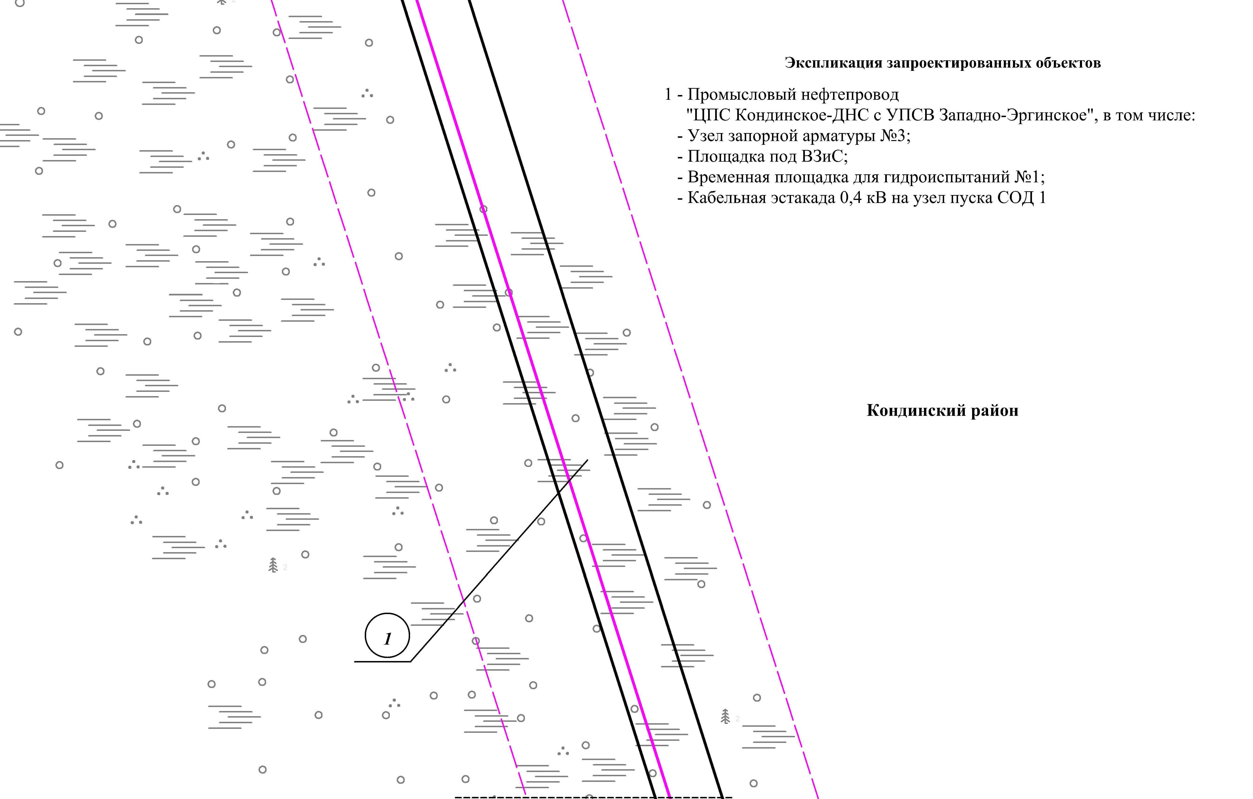
Линия совмещения с листом 120

Линия совмещения с листом 122

Основная часть проекта планировки территории для размещения объекта капитального строительства, расположенного на территории двух муниципальных образований
Ханты-Мансийского автономного округа – Югры,
«Промысловый нефтепровод «ЦПС Кондинское-ДНС с УПСВ Западно-Эргинское»
Землепользователь: АО «НК «Конданефть»
Масштаб 1:2000

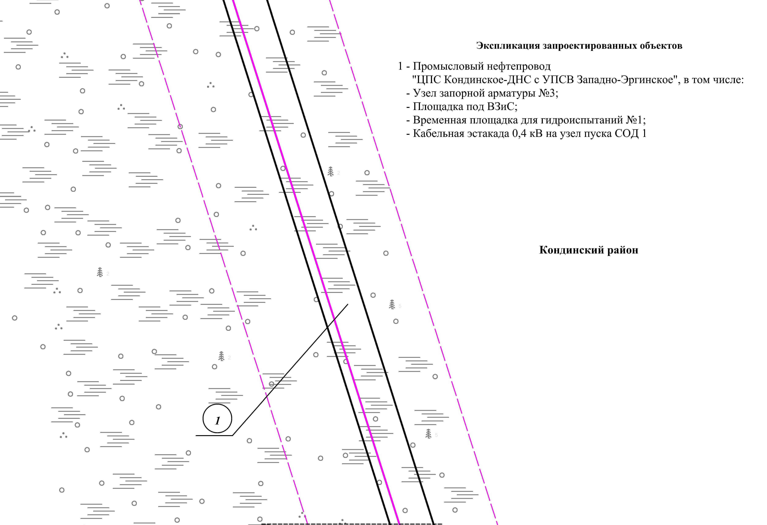
Линия совмещения с листом 121
Линия совмещения с листом 123

Основная часть проекта планировки территории для размещения объекта капитального строительства, расположенного на территории двух муниципальных образований
Ханты-Мансийского автономного округа – Югры,
«Промысловый нефтепровод «ЦПС Кондинское-ДНС с УПСВ Западно-Эргинское»
Землепользователь: АО «НК «Конданефть»
Масштаб 1:2000

Линия совмещения с листом 122
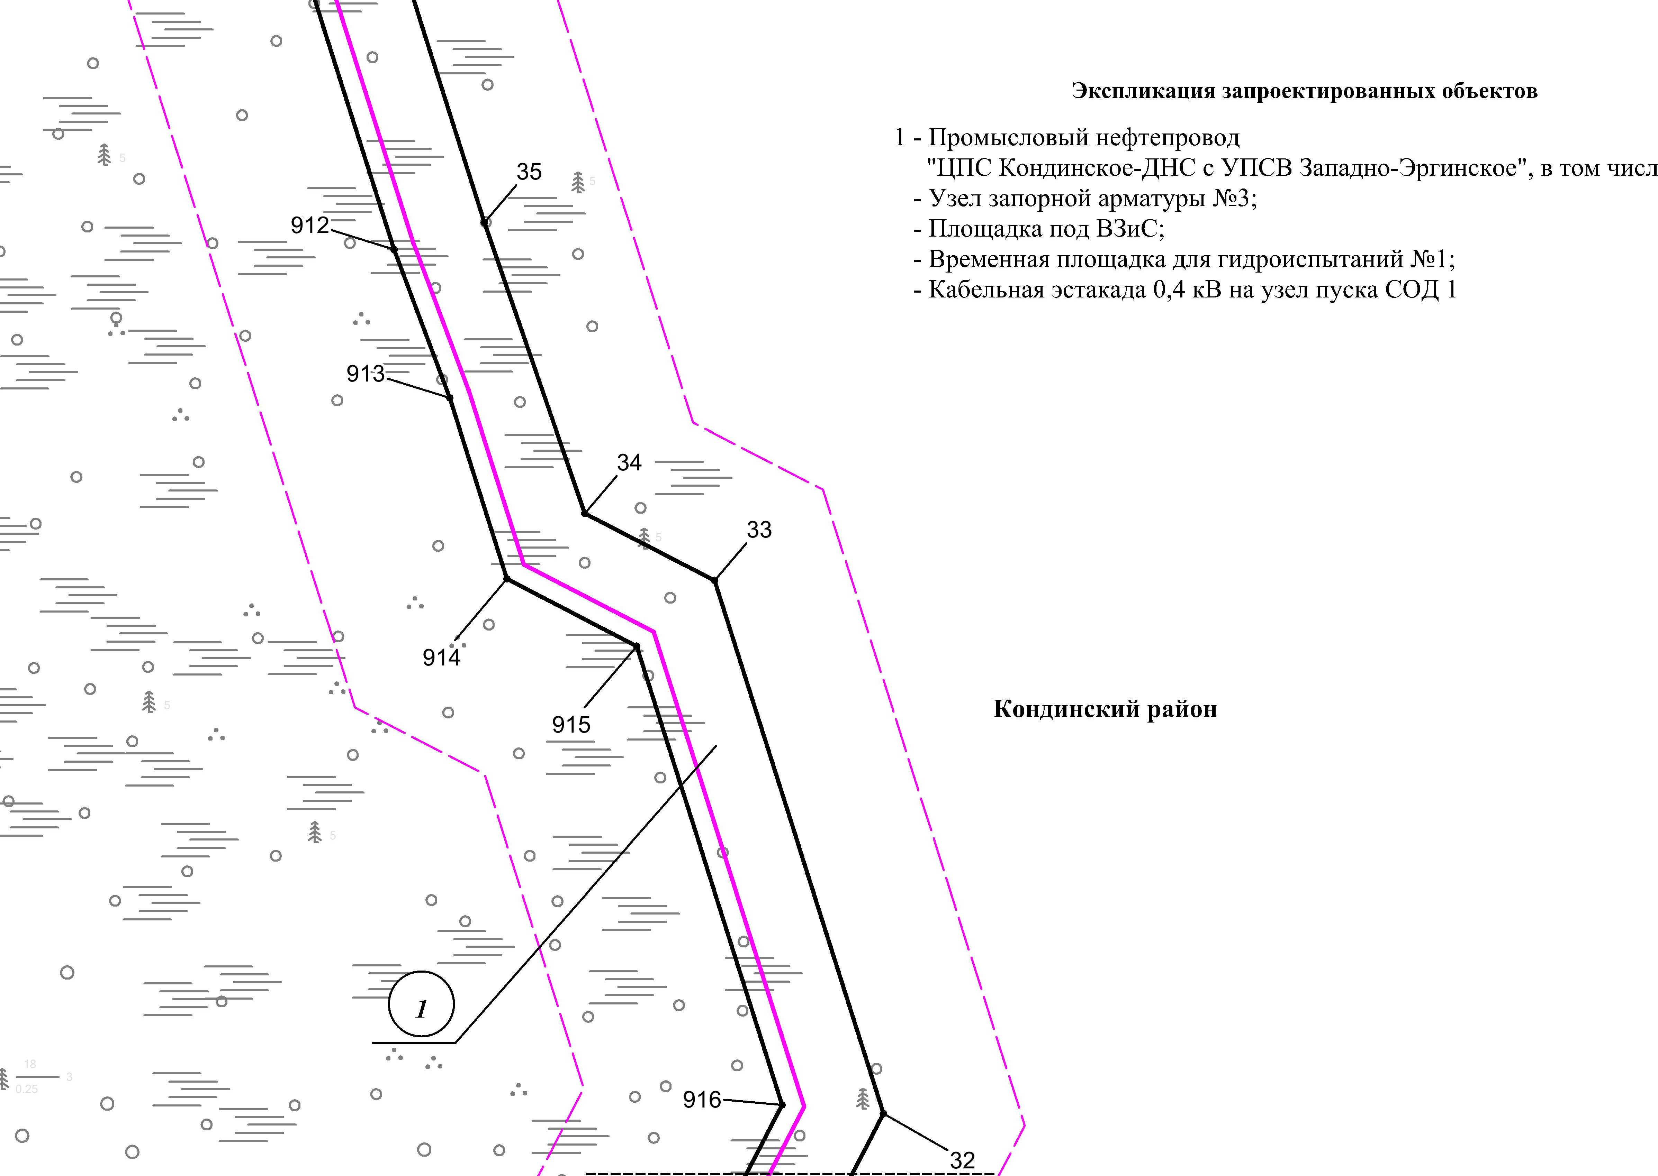
Линия совмещения с листом 124

Основная часть проекта планировки территории для размещения объекта капитального строительства, расположенного на территории двух муниципальных образований
Ханты-Мансийского автономного округа – Югры,
«Промысловый нефтепровод «ЦПС Кондинское-ДНС с УПСВ Западно-Эргинское»
Землепользователь: АО «НК «Конданефть»
Масштаб 1:2000

Линия совмещения с листом 123

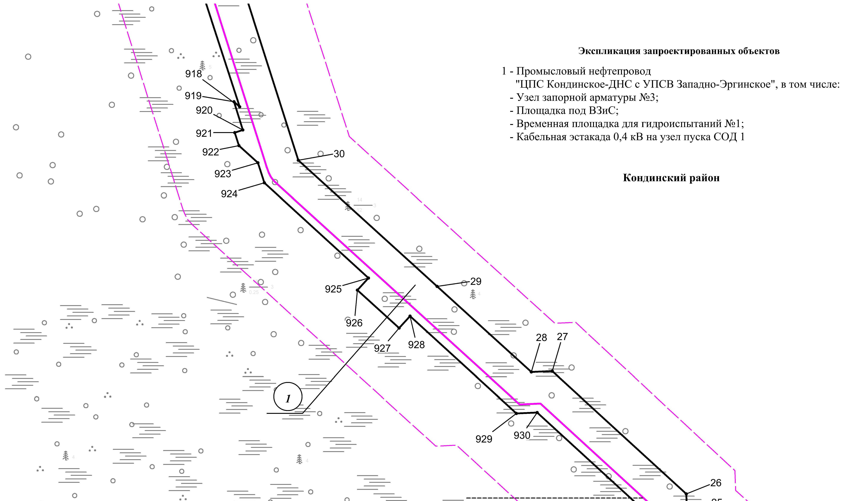
Линия совмещения с листом 125

Основная часть проекта планировки территории для размещения объекта капитального строительства, расположенного на территории двух муниципальных образований
Ханты-Мансийского автономного округа – Югры,
«Промысловый нефтепровод «ЦПС Кондинское-ДНС с УПСВ Западно-Эргинское»
Землепользователь: АО «НК «Конданефть»
Масштаб 1:2000

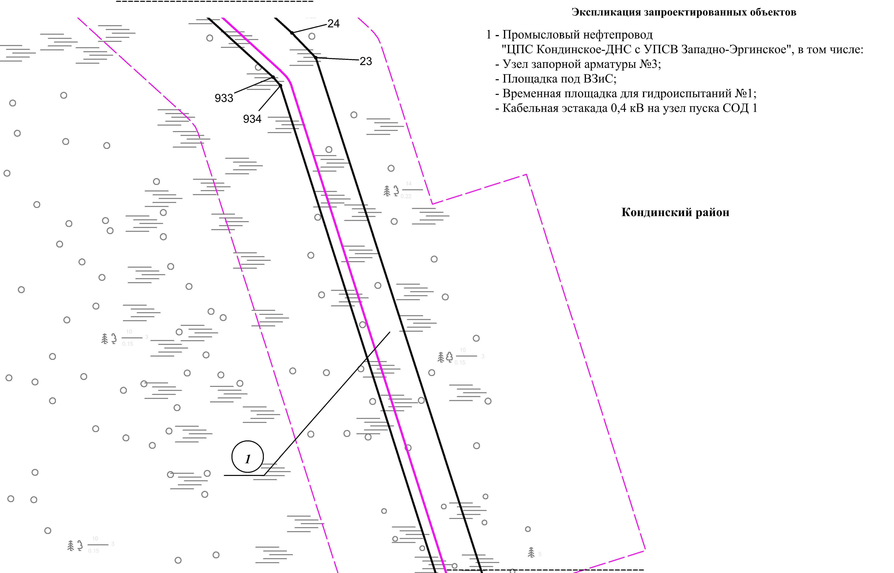
Линия совмещения с листом 124

Линия совмещения с листом 126

Основная часть проекта планировки территории для размещения объекта капитального строительства, расположенного на территории двух муниципальных образований
Ханты-Мансийского автономного округа – Югры,
«Промысловый нефтепровод «ЦПС Кондинское-ДНС с УПСВ Западно-Эргинское»
Землепользователь: АО «НК «Конданефть»
Масштаб 1:2000

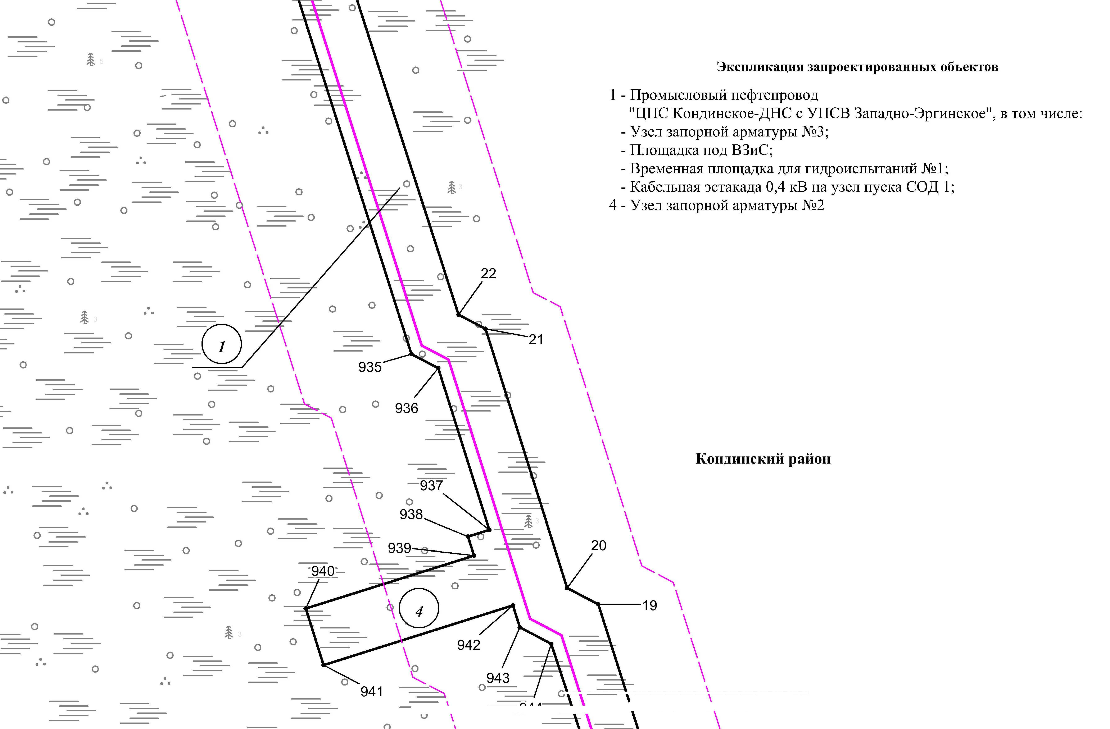
Линия совмещения с листом 125
Линия совмещения с листом 127

Основная часть проекта планировки территории для размещения объекта капитального строительства, расположенного на территории двух муниципальных образований
Ханты-Мансийского автономного округа – Югры,
«Промысловый нефтепровод «ЦПС Кондинское-ДНС с УПСВ Западно-Эргинское»
Землепользователь: АО «НК «Конданефть»
Масштаб 1:2000

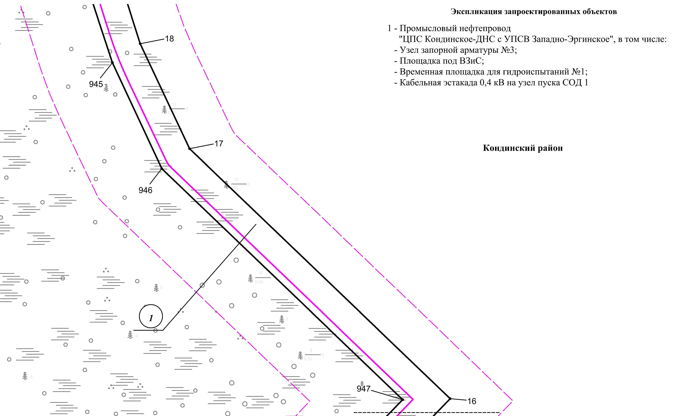
Линия совмещения с листом 126

Линия совмещения с листом 128

Основная часть проекта планировки территории для размещения объекта капитального строительства, расположенного на территории двух муниципальных образований
Ханты-Мансийского автономного округа – Югры,
«Промысловый нефтепровод «ЦПС Кондинское-ДНС с УПСВ Западно-Эргинское»
Землепользователь: АО «НК «Конданефть»
Масштаб 1:2000

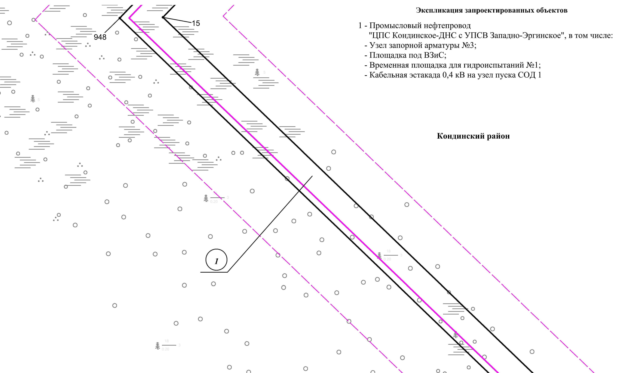
Линия совмещения с листом 127

Линия совмещения с листом 129

Основная часть проекта планировки территории для размещения объекта капитального строительства, расположенного на территории двух муниципальных образований
Ханты-Мансийского автономного округа – Югры,
«Промысловый нефтепровод «ЦПС Кондинское-ДНС с УПСВ Западно-Эргинское»
Землепользователь: АО «НК «Конданефть»
Масштаб 1:2000

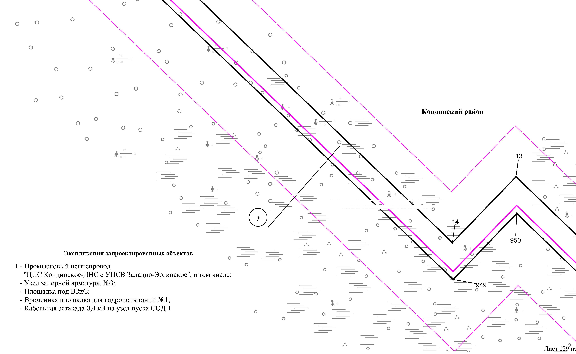
Линия совмещения с листом
130

Линия совмещения с листом 128

Основная часть проекта планировки территории для размещения объекта капитального строительства, расположенного на территории двух муниципальных образований
Ханты-Мансийского автономного округа – Югры,
«Промысловый нефтепровод «ЦПС Кондинское-ДНС с УПСВ Западно-Эргинское»
Землепользователь: АО «НК «Конданефть»
Масштаб 1:2000

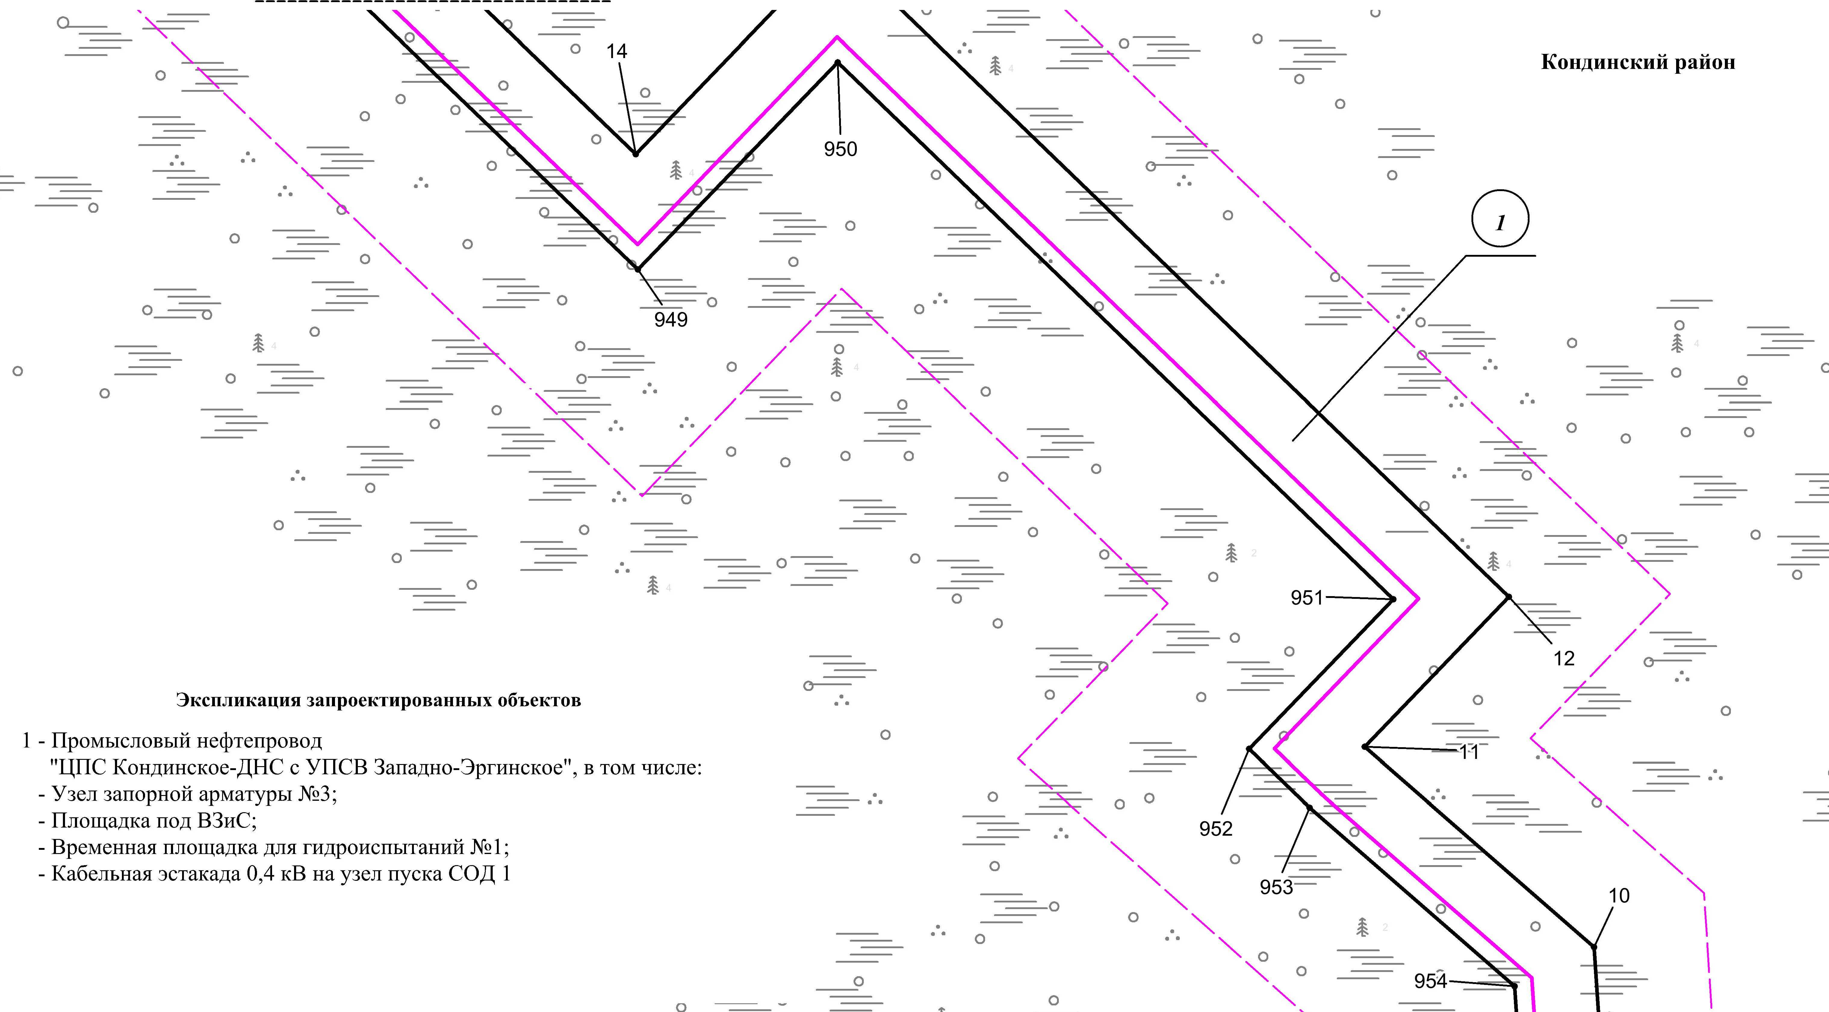
Линия совмещения с листом 129
Линия совмещения с листом 131

Основная часть проекта планировки территории для размещения объекта капитального строительства, расположенного на территории двух муниципальных образований
Ханты-Мансийского автономного округа – Югры
«Промысловый нефтепровод «ЦПС Кондинское-ДНС с УПСВ Западно-Эргинское»
Землепользователь: АО «НК «Конданефть»

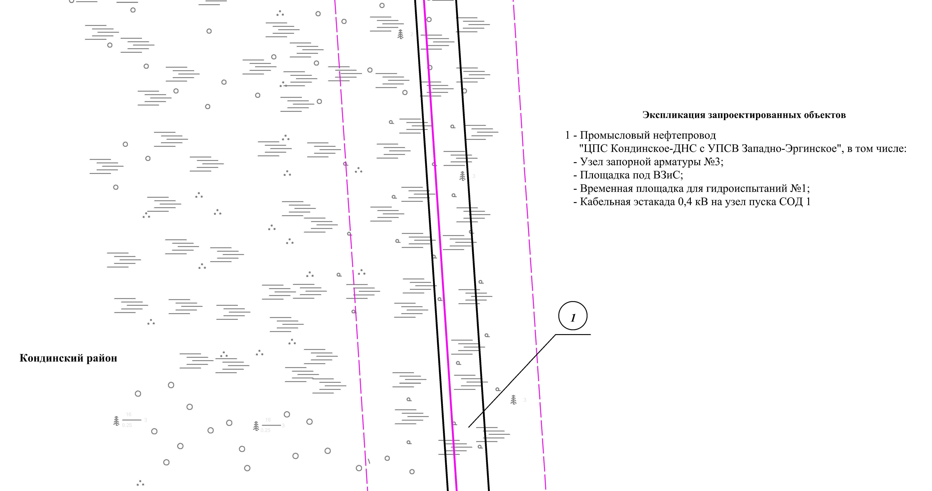

Линия совмещения с листом 130

Линия совмещения с листом 132

Основная часть проекта планировки территории для размещения объекта капитального строительства, расположенного на территории двух муниципальных образований
Ханты-Мансийского автономного округа – Югры,
«Промысловый нефтепровод «ЦПС Кондинское-ДНС с УПСВ Западно-Эргинское»
Землепользователь: АО «НК «Конданефть»
Масштаб 1:2000

Основная часть проекта планировки территории для размещения объекта капитального строительства, расположенного на территории двух муниципальных образований
Ханты-Мансийского автономного округа – Югры,
«Промысловый нефтепровод «ЦПС Кондинское-ДНС с УПСВ Западно-Эргинское»
Землепользователь: АО «НК «Конданефть»
Масштаб 1:2000

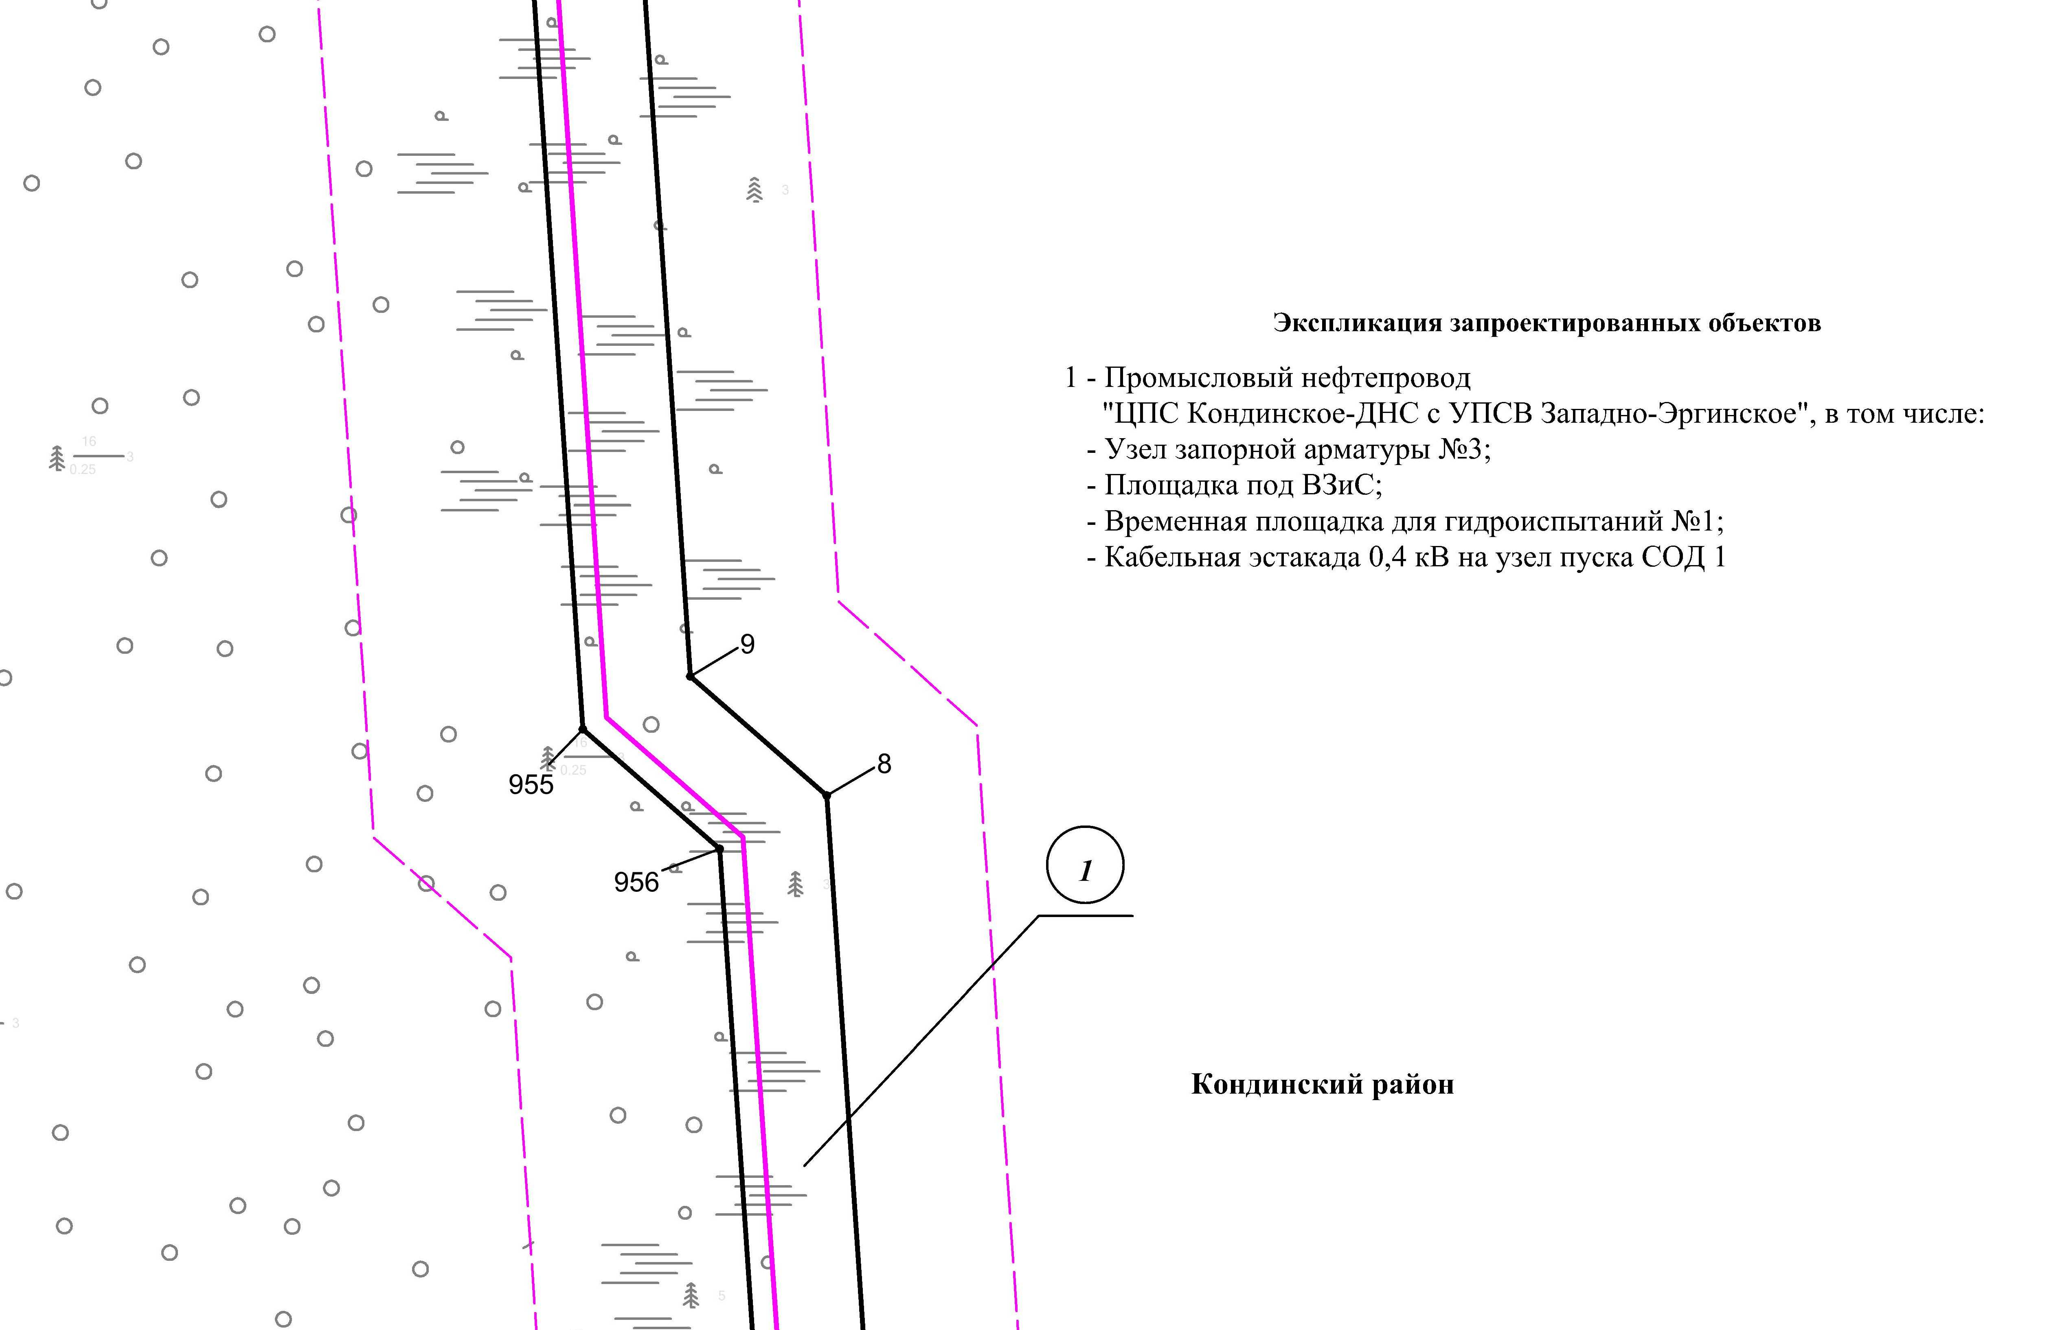
Линия совмещения с листом 131
Линия совмещения с листом 133

Основная часть проекта планировки территории для размещения объекта капитального строительства, расположенного на территории двух муниципальных образований
Ханты-Мансийского автономного округа – Югры
«Промысловый нефтепровод «ЦПС Кондинское-ДНС с УПСВ Западно-Эргинское»
Землепользователь: АО «НК «Конданефть»

Линия совмещения с листом
134

Линия совмещения с листом 132

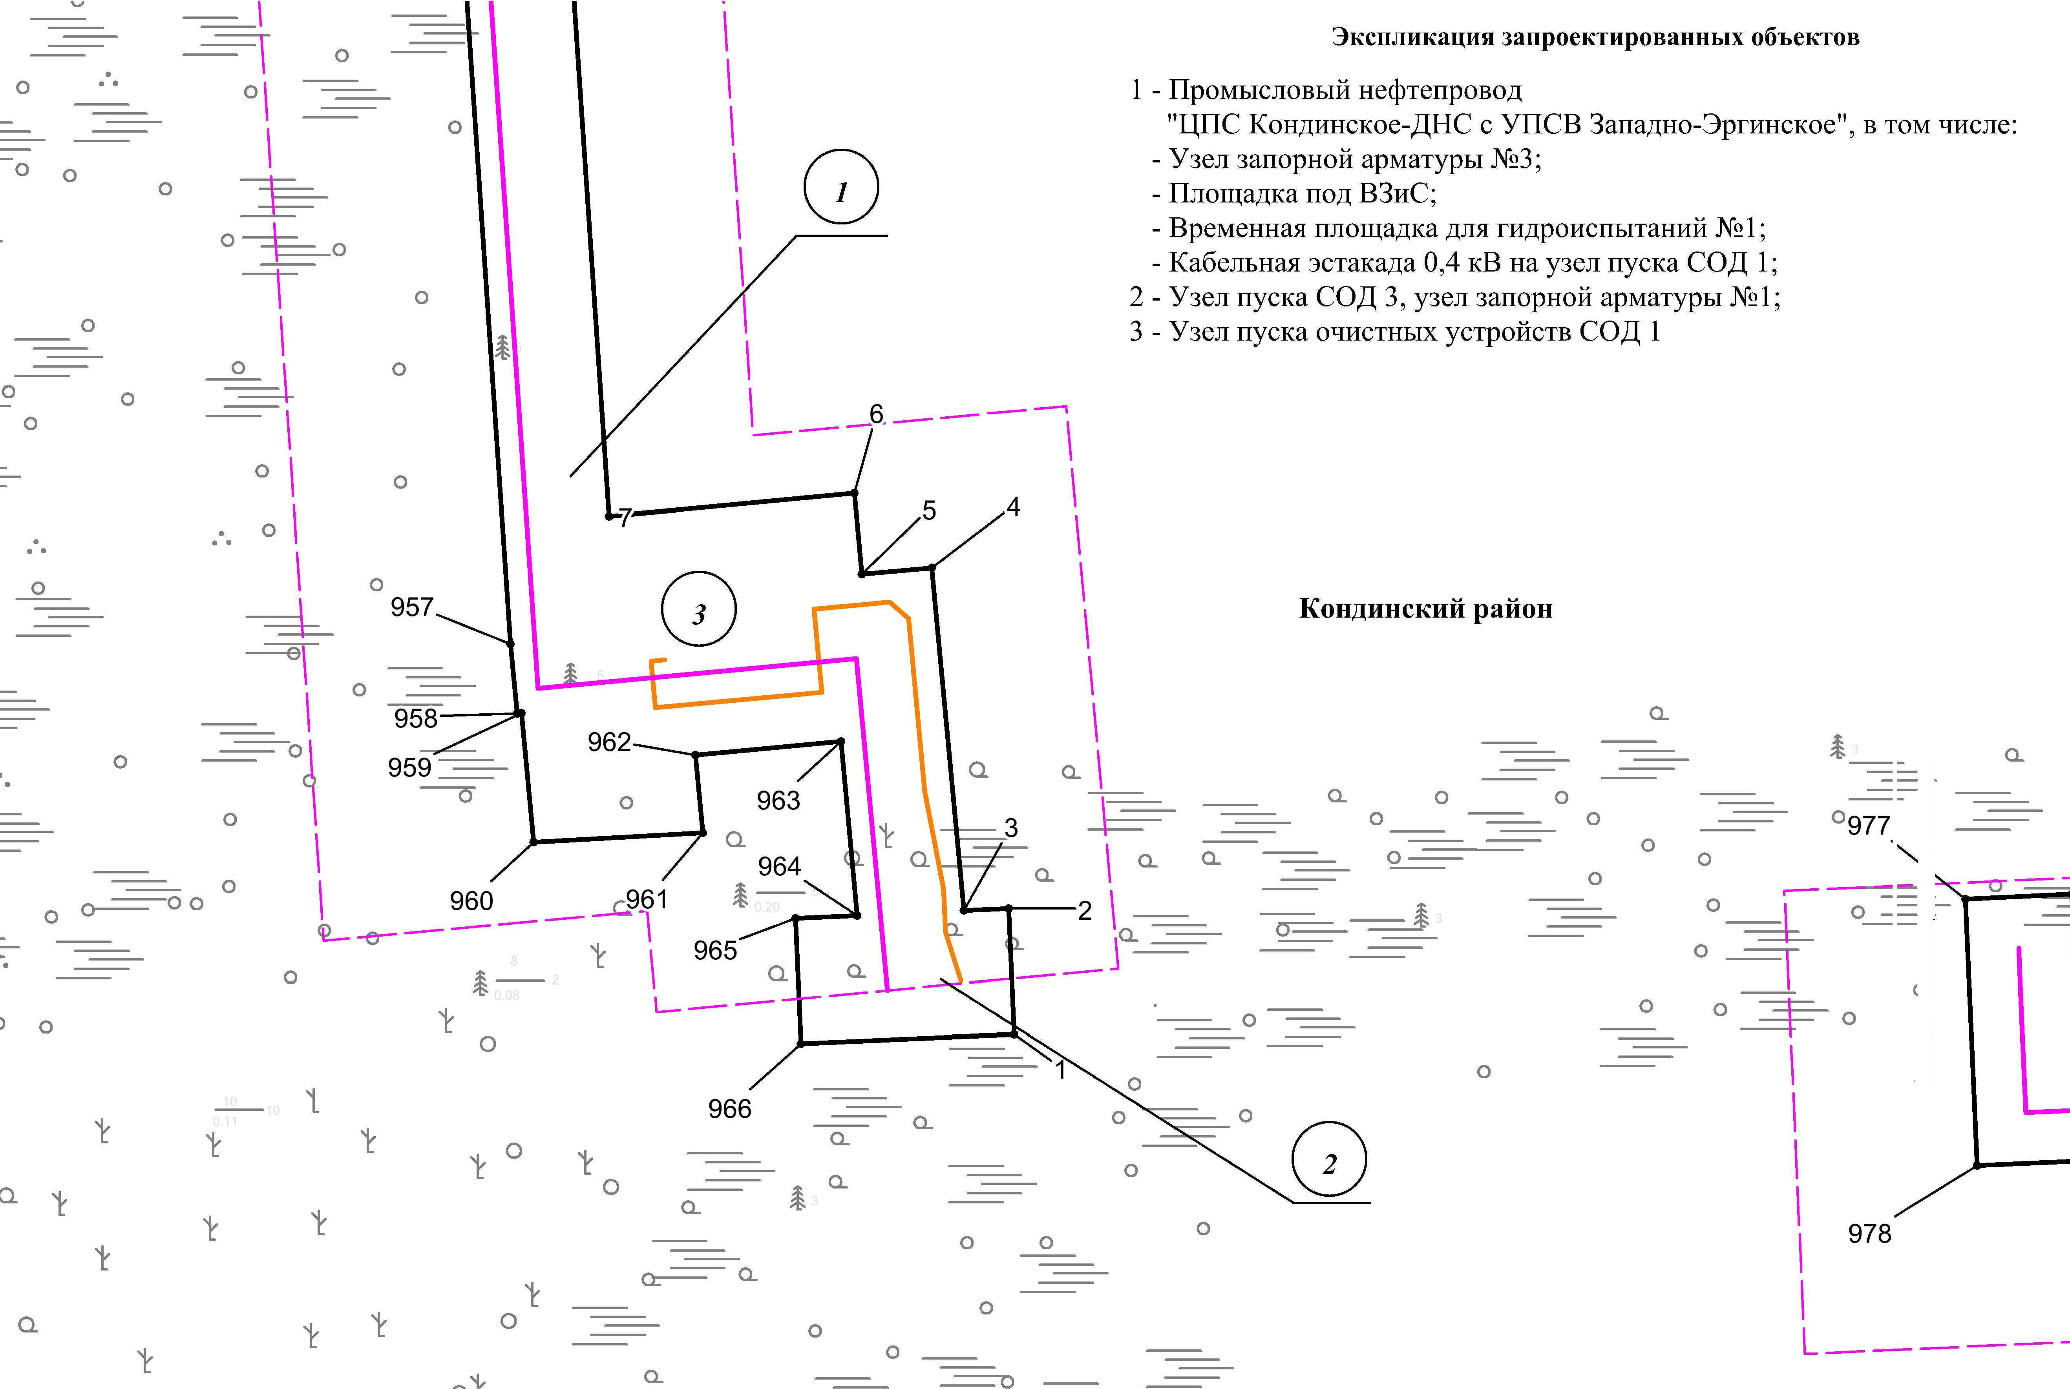

Линия совмещения с листом
134

Основная часть проекта планировки территории для размещения объекта капитального строительства, расположенного на территории двух муниципальных образований
Ханты-Мансийского автономного округа – Югры,
«Промысловый нефтепровод «ЦПС Кондинское-ДНС с УПСВ Западно-Эргинское»
Землепользователь: АО «НК «Конданефть»
Масштаб 1:2000

Основная часть проекта планировки территории для размещения объекта капитального строительства, расположенного на территории двух муниципальных образований
Ханты-Мансийского автономного округа – Югры,
«Промысловый нефтепровод «ЦПС Кондинское-ДНС с УПСВ Западно-Эргинское»
Землепользователь: АО «НК «Конданефть»
Масштаб 1:2000

Линия совмещения с листом
133

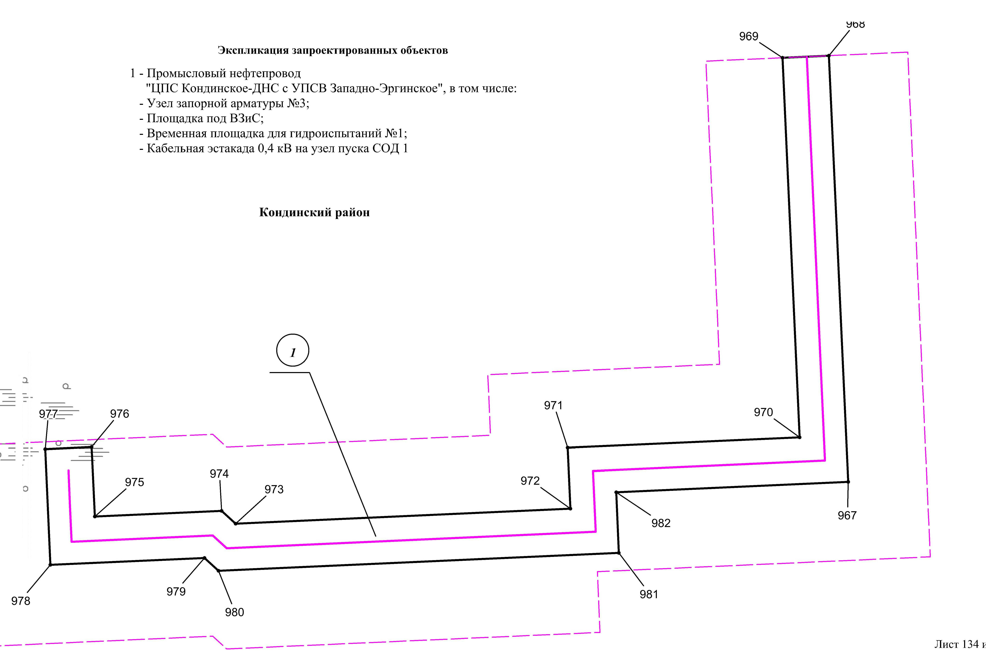

Основная часть проекта планировки территории для размещения объекта капитального строительства, расположенного на территории двух муниципальных образований
Ханты-Мансийского автономного округа – Югры
«Промысловый нефтепровод «ЦПС Кондинское-ДНС с УПСВ Западно-Эргинское»
Землепользователь: АО «НК «Конданефть»

Основная часть проекта планировки территории для размещения объекта капитального строительства, расположенного на территории двух муниципальных образований
Ханты-Мансийского автономного округа – Югры,
«Промысловый нефтепровод «ЦПС Кондинское-ДНС с УПСВ Западно-Эргинское»
Землепользователь: АО «НК «Конданефть»

Каталог координатных точек зоны планируемого размещения объекта
№ точки | Х | У
1 | 2 | 3
1 | 867370.00 | 2679426.26
2 | 867396.98 | 2679425.06
3 | 867396.54 | 2679415.36
4 | 867470.50 | 2679408.48
5 | 867469.10 | 2679393.40
6 | 867486.54 | 2679391.78
7 | 867481.62 | 2679338.82
8 | 867777.12 | 2679318.78
9 | 867802.00 | 2679290.38
10 | 868329.58 | 2679255.20
11 | 868385.78 | 2679190.74
12 | 868427.90 | 2679231.26
13 | 868610.80 | 2679041.86
14 | 868552.44 | 2678985.64
15 | 869128.44 | 2678387.62
16 | 869152.84 | 2678411.16
17 | 869324.24 | 2678232.42
18 | 869396.30 | 2678198.56
19 | 869484.22 | 2678170.68
20 | 869490.86 | 2678158.02
21 | 869595.68 | 2678124.98
22 | 869601.38 | 2678114.12
23 | 870001.08 | 2677985.14
24 | 870013.58 | 2677973.04
25 | 870059.48 | 2677922.56
26 | 870070.68 | 2677922.10
27 | 870140.26 | 2677846.22
28 | 870139.76 | 2677834.38
29 | 870188.24 | 2677781.10
30 | 870259.74 | 2677702.52
31 | 870379.24 | 2677664.40
32 | 870411.02 | 2677680.86
33 | 870541.30 | 2677639.50

1 | 2 | 3
34 | 870557.74 | 2677607.78
35 | 870628.82 | 2677583.20
36 | 871331.80 | 2677360.00
37 | 871399.62 | 2677394.76
38 | 871538.86 | 2677350.08
39 | 871585.04 | 2677298.60
40 | 871627.62 | 2677268.14
41 | 871721.52 | 2677200.88
42 | 871721.68 | 2677200.76
43 | 871721.82 | 2677200.66
44 | 871721.98 | 2677200.56
45 | 871722.12 | 2677200.44
46 | 871722.28 | 2677200.34
47 | 871722.42 | 2677200.24
48 | 871722.58 | 2677200.12
49 | 871722.72 | 2677200.02
50 | 871722.88 | 2677199.92
51 | 871723.02 | 2677199.80
52 | 871723.18 | 2677199.70
53 | 871723.32 | 2677199.60
54 | 871723.48 | 2677199.50
55 | 871723.62 | 2677199.38
56 | 871723.78 | 2677199.28
57 | 871723.92 | 2677199.18
58 | 871724.08 | 2677199.08
59 | 871724.22 | 2677198.96
60 | 871724.38 | 2677198.86
61 | 871724.52 | 2677198.76
62 | 871724.68 | 2677198.66
63 | 871724.82 | 2677198.54
64 | 871724.98 | 2677198.44
65 | 871725.14 | 2677198.34
66 | 871725.28 | 2677198.24
67 | 871725.44 | 2677198.14
Основная часть проекта планировки территории для размещения объекта капитального строительства, расположенного на территории двух муниципальных образований
Ханты-Мансийского автономного округа – Югры
«Промысловый нефтепровод «ЦПС Кондинское-ДНС с УПСВ Западно-Эргинское»
Землепользователь: АО «НК «Конданефть»

Основная часть проекта планировки территории для размещения объекта капитального строительства, расположенного на территории двух муниципальных образований
Ханты-Мансийского автономного округа – Югры,
«Промысловый нефтепровод «ЦПС Кондинское-ДНС с УПСВ Западно-Эргинское»
Землепользователь: АО «НК «Конданефть»

Основная часть проекта планировки территории для размещения объекта капитального строительства, расположенного на территории двух муниципальных образований
Ханты-Мансийского автономного округа – Югры,
«Промысловый нефтепровод «ЦПС Кондинское-ДНС с УПСВ Западно-Эргинское»
Землепользователь: АО «НК «Конданефть»

1 | 2 | 3
68 | 871725.58 | 2677198.02
69 | 871725.74 | 2677197.92
70 | 871725.88 | 2677197.82
71 | 873425.32 | 2676038.46
72 | 873437.44 | 2676040.70
73 | 873647.60 | 2675896.26
74 | 873649.60 | 2675885.46
75 | 873818.36 | 2675770.32
76 | 874307.72 | 2675653.74
77 | 874318.60 | 2675660.44
78 | 874417.36 | 2675637.04
79 | 874424.16 | 2675625.98
80 | 875670.42 | 2675329.08
81 | 875678.90 | 2675334.28
82 | 875724.64 | 2675323.22
83 | 875729.68 | 2675314.96
84 | 876656.56 | 2675094.14
85 | 876656.72 | 2675094.10
86 | 876656.88 | 2675094.06
87 | 876657.04 | 2675094.04
88 | 876657.20 | 2675094.00
89 | 876657.36 | 2675093.96
90 | 876657.52 | 2675093.92
91 | 876657.66 | 2675093.88
92 | 876657.82 | 2675093.84
93 | 876657.98 | 2675093.80
94 | 876658.14 | 2675093.78
95 | 876658.30 | 2675093.74
96 | 876658.46 | 2675093.70
97 | 876658.62 | 2675093.66
98 | 876658.78 | 2675093.62
99 | 876658.94 | 2675093.60
100 | 876659.10 | 2675093.56
101 | 876659.24 | 2675093.52
102 | 876659.40 | 2675093.48
103 | 876659.56 | 2675093.44
104 | 876659.72 | 2675093.42

Основная часть проекта планировки территории для размещения объекта капитального строительства, расположенного на территории двух муниципальных образований
Ханты-Мансийского автономного округа – Югры,
«Промысловый нефтепровод «ЦПС Кондинское-ДНС с УПСВ Западно-Эргинское»
Землепользователь: АО «НК «Конданефть»

1 | 2 | 3
105 | 876659.88 | 2675093.38
106 | 876660.04 | 2675093.34
107 | 876660.20 | 2675093.30
108 | 876660.36 | 2675093.28
109 | 876660.52 | 2675093.24
110 | 876660.68 | 2675093.20
111 | 876660.84 | 2675093.16
112 | 876661.00 | 2675093.14
113 | 876661.14 | 2675093.10
114 | 876717.54 | 2675080.86
115 | 876725.34 | 2675079.60
116 | 878814.14 | 2674738.86
117 | 878832.90 | 2674712.48
118 | 878903.72 | 2674587.76
119 | 879767.38 | 2672588.26
120 | 879776.58 | 2672584.62
121 | 879804.16 | 2672520.80
122 | 879800.50 | 2672511.58
123 | 880297.80 | 2671360.26
124 | 880307.88 | 2671356.24
125 | 880356.84 | 2671242.26
126 | 880452.12 | 2671003.16
127 | 880521.00 | 2670843.92
128 | 880553.34 | 2670755.24
129 | 880561.26 | 2670520.66
130 | 880593.82 | 2670490.50
131 | 880599.52 | 2670354.00
132 | 880568.62 | 2670319.76
133 | 880585.82 | 2669863.74
134 | 880593.26 | 2669724.50
135 | 880596.54 | 2669696.10
136 | 880615.86 | 2669588.06
137 | 880874.44 | 2668829.48
138 | 880890.62 | 2668815.32
139 | 880940.14 | 2668670.08
140 | 880935.98 | 2668648.94
141 | 881174.30 | 2667949.60

Основная часть проекта планировки территории для размещения объекта капитального строительства, расположенного на территории двух муниципальных образований
Ханты-Мансийского автономного округа – Югры,
«Промысловый нефтепровод «ЦПС Кондинское-ДНС с УПСВ Западно-Эргинское»
Землепользователь: АО «НК «Конданефть»

1 | 2 | 3
142 | 881207.06 | 2667933.60
143 | 881254.94 | 2667793.64
144 | 881238.08 | 2667759.30
145 | 881347.18 | 2667442.68
146 | 881355.80 | 2667438.82
147 | 881402.78 | 2667301.20
148 | 881398.44 | 2667292.34
149 | 881427.08 | 2667205.66
150 | 881481.24 | 2667047.02
151 | 881794.94 | 2666825.80
152 | 882182.18 | 2666808.74
153 | 882193.54 | 2666819.12
154 | 882246.78 | 2666816.78
155 | 882257.18 | 2666805.42
156 | 882497.54 | 2666794.84
157 | 882504.76 | 2666801.50
158 | 882602.94 | 2666797.18
159 | 882628.48 | 2666797.42
160 | 882637.00 | 2666789.06
161 | 882719.26 | 2666789.84
162 | 882814.60 | 2666793.46
163 | 883961.90 | 2666896.18
164 | 883988.80 | 2666883.62
165 | 884274.78 | 2666909.26
166 | 884393.68 | 2666918.04
167 | 884445.48 | 2666924.46
168 | 884536.44 | 2666931.90
169 | 884536.58 | 2666931.90
170 | 884536.72 | 2666931.92
171 | 884536.88 | 2666931.92
172 | 884537.02 | 2666931.94
173 | 884537.16 | 2666931.94
174 | 884537.30 | 2666931.96
175 | 884537.44 | 2666931.98
176 | 884537.58 | 2666931.98
177 | 884537.72 | 2666932.00
178 | 884537.86 | 2666932.02
179 | 884538.00 | 2666932.02

Основная часть проекта планировки территории для размещения объекта капитального строительства, расположенного на территории двух муниципальных образований
Ханты-Мансийского автономного округа – Югры,
«Промысловый нефтепровод «ЦПС Кондинское-ДНС с УПСВ Западно-Эргинское»
Землепользователь: АО «НК «Конданефть»

1 | 2 | 3
180 | 884538.14 | 2666932.04
181 | 884538.30 | 2666932.04
182 | 884538.44 | 2666932.06
183 | 884538.58 | 2666932.08
184 | 884538.72 | 2666932.08
185 | 884538.86 | 2666932.10
186 | 884539.00 | 2666932.12
187 | 884539.14 | 2666932.12
188 | 884539.28 | 2666932.14
189 | 884539.42 | 2666932.16
190 | 884539.56 | 2666932.16
191 | 884539.72 | 2666932.18
192 | 884539.86 | 2666932.20
193 | 884540.00 | 2666932.20
194 | 884540.14 | 2666932.22
195 | 884540.28 | 2666932.24
196 | 884540.42 | 2666932.26
197 | 884540.56 | 2666932.26
198 | 884646.86 | 2666942.88
199 | 885065.94 | 2666980.30
200 | 885302.48 | 2666999.06
201 | 885431.10 | 2667011.92
202 | 885902.42 | 2667053.88
203 | 886082.94 | 2667071.06
204 | 886307.36 | 2667090.26
205 | 886510.98 | 2667109.22
206 | 887763.48 | 2667220.52
207 | 887793.60 | 2667226.44
208 | 887812.24 | 2667230.12
209 | 887827.76 | 2667230.90
210 | 887928.92 | 2667237.52
211 | 887929.06 | 2667237.54
212 | 887929.22 | 2667237.54
213 | 887929.38 | 2667237.56
214 | 887929.52 | 2667237.56
215 | 887929.68 | 2667237.58
216 | 887929.84 | 2667237.60
217 | 887929.98 | 2667237.60

Основная часть проекта планировки территории для размещения объекта капитального строительства, расположенного на территории двух муниципальных образований
Ханты-Мансийского автономного округа – Югры,
«Промысловый нефтепровод «ЦПС Кондинское-ДНС с УПСВ Западно-Эргинское»
Землепользователь: АО «НК «Конданефть»

1 | 2 | 3
218 | 887930.14 | 2667237.62
219 | 887930.28 | 2667237.62
220 | 887930.44 | 2667237.64
221 | 887930.60 | 2667237.64
222 | 887930.74 | 2667237.66
223 | 887930.90 | 2667237.66
224 | 887931.06 | 2667237.68
225 | 887931.20 | 2667237.70
226 | 887931.36 | 2667237.70
227 | 887931.50 | 2667237.72
228 | 887931.66 | 2667237.72
229 | 887931.82 | 2667237.74
230 | 887931.96 | 2667237.74
231 | 887932.12 | 2667237.76
232 | 887932.28 | 2667237.78
233 | 887932.42 | 2667237.78
234 | 887932.58 | 2667237.80
235 | 887932.72 | 2667237.80
236 | 887932.88 | 2667237.82
237 | 887933.04 | 2667237.84
238 | 887933.18 | 2667237.84
239 | 887933.34 | 2667237.86
240 | 888147.04 | 2667255.98
241 | 888154.84 | 2667265.20
242 | 888215.88 | 2667270.38
243 | 888225.10 | 2667262.60
244 | 888401.46 | 2667277.54
245 | 888472.58 | 2667282.50
246 | 888479.88 | 2667283.12
247 | 888687.84 | 2667304.22
248 | 888693.38 | 2667304.86
249 | 888734.30 | 2667310.00
250 | 888744.44 | 2667311.90
251 | 888753.08 | 2667313.16
252 | 888879.00 | 2667339.64
253 | 888886.90 | 2667351.74
254 | 888955.90 | 2667366.24
255 | 888969.20 | 2667357.60
256 | 889218.44 | 2667410.52

Основная часть проекта планировки территории для размещения объекта капитального строительства, расположенного на территории двух муниципальных образований
Ханты-Мансийского автономного округа – Югры,
«Промысловый нефтепровод «ЦПС Кондинское-ДНС с УПСВ Западно-Эргинское»
Землепользователь: АО «НК «Конданефть»

1 | 2 | 3
257 | 889373.14 | 2667462.14
258 | 889565.12 | 2667523.30
259 | 889641.06 | 2667549.98
260 | 889815.12 | 2667606.22
261 | 889929.00 | 2667639.96
262 | 889936.38 | 2667642.68
263 | 889942.80 | 2667644.54
264 | 890025.98 | 2667674.96
265 | 890297.36 | 2667759.36
266 | 890319.50 | 2667766.98
267 | 890337.04 | 2667773.90
268 | 890379.82 | 2667790.92
269 | 890436.76 | 2667820.30
270 | 890619.50 | 2667892.00
271 | 890865.94 | 2668027.70
272 | 890986.84 | 2668096.18
273 | 891355.10 | 2668294.40
274 | 891574.16 | 2668334.06
275 | 891843.52 | 2668564.40
276 | 891926.42 | 2668604.04
277 | 892027.76 | 2668662.28
278 | 892114.68 | 2668708.48
279 | 892157.92 | 2668734.22
280 | 892327.42 | 2668825.32
281 | 892464.72 | 2668906.06
282 | 892468.96 | 2668908.40
283 | 892471.82 | 2668909.92
284 | 892481.20 | 2668914.64
285 | 892568.60 | 2668956.36
286 | 892576.28 | 2668960.54
287 | 892749.08 | 2669055.74
288 | 892836.26 | 2669105.52
289 | 892893.54 | 2669136.76
290 | 892966.84 | 2669181.84
291 | 892976.94 | 2669187.50
292 | 892988.10 | 2669193.62
293 | 893029.02 | 2669213.92
294 | 893135.40 | 2669271.06
295 | 893246.48 | 2669217.22

Основная часть проекта планировки территории для размещения объекта капитального строительства, расположенного на территории двух муниципальных образований
Ханты-Мансийского автономного округа – Югры,
«Промысловый нефтепровод «ЦПС Кондинское-ДНС с УПСВ Западно-Эргинское»
Землепользователь: АО «НК «Конданефть»

1 | 2 | 3
296 | 893405.88 | 2669147.02
297 | 893558.42 | 2669076.14
298 | 893706.02 | 2669013.02
299 | 894236.32 | 2668778.38
300 | 894934.32 | 2668466.42
301 | 894987.18 | 2668442.80
302 | 894996.72 | 2668464.16
303 | 895053.14 | 2668438.96
304 | 895124.64 | 2668599.58
305 | 895216.04 | 2668558.90
306 | 895175.34 | 2668467.50
307 | 895094.92 | 2668503.30
308 | 895064.08 | 2668434.06
309 | 895133.66 | 2668402.98
310 | 895133.16 | 2668401.84
311 | 895963.82 | 2668031.82
312 | 895971.36 | 2668026.34
313 | 895993.40 | 2668016.52
314 | 896018.04 | 2667998.62
315 | 896015.10 | 2667994.58
316 | 896029.60 | 2667984.06
317 | 896045.74 | 2667972.84
318 | 896080.96 | 2667953.42
319 | 896123.02 | 2667933.22
320 | 896165.28 | 2667864.14
321 | 896623.00 | 2667169.94
322 | 896633.58 | 2667154.96
323 | 896640.56 | 2667145.78
324 | 896658.00 | 2667123.88
325 | 896671.88 | 2667106.90
326 | 896678.54 | 2667095.42
327 | 896714.50 | 2667040.26
328 | 896719.04 | 2667035.02
329 | 896803.16 | 2666942.14
330 | 896902.26 | 2666821.26
331 | 897053.98 | 2666652.48
332 | 897238.98 | 2666440.94
333 | 897468.36 | 2666241.42
334 | 897502.66 | 2666215.18

Основная часть проекта планировки территории для размещения объекта капитального строительства, расположенного на территории двух муниципальных образований
Ханты-Мансийского автономного округа – Югры,
«Промысловый нефтепровод «ЦПС Кондинское-ДНС с УПСВ Западно-Эргинское»
Землепользователь: АО «НК «Конданефть»

1 | 2 | 3
335 | 897617.28 | 2666139.16
336 | 897638.06 | 2666143.38
337 | 897710.76 | 2666095.18
338 | 897715.60 | 2666102.46
339 | 897739.16 | 2666086.84
340 | 897726.02 | 2666067.02
341 | 897984.88 | 2665895.30
342 | 898241.88 | 2665726.54
343 | 898259.92 | 2665694.50
344 | 898322.38 | 2665581.84
345 | 898377.82 | 2665485.34
346 | 898436.82 | 2665375.50
347 | 898502.10 | 2665266.38
348 | 898555.84 | 2665173.08
349 | 898810.36 | 2664713.44
350 | 898876.86 | 2664596.44
351 | 898943.20 | 2664476.10
352 | 899038.04 | 2664313.74
353 | 899088.58 | 2664219.60
354 | 899135.72 | 2664139.12
355 | 899808.06 | 2662943.66
356 | 899988.12 | 2662979.84
357 | 900229.76 | 2663023.70
358 | 900413.74 | 2663060.08
359 | 900608.66 | 2663094.86
360 | 900708.28 | 2663114.58
361 | 900769.96 | 2663141.12
362 | 900778.90 | 2663149.04
363 | 901020.42 | 2663371.18
364 | 901272.88 | 2663600.46
365 | 901468.66 | 2663785.92
366 | 901469.52 | 2663814.32
367 | 901505.00 | 2663847.94
368 | 901536.94 | 2663846.94
369 | 901807.80 | 2664099.98
370 | 901847.12 | 2664122.08
371 | 901855.00 | 2664150.40
372 | 901897.86 | 2664174.62
373 | 901926.46 | 2664166.68
Основная часть проекта планировки территории для размещения объекта капитального строительства, расположенного на территории двух муниципальных образований
Ханты-Мансийского автономного округа – Югры,
«Промысловый нефтепровод «ЦПС Кондинское-ДНС с УПСВ Западно-Эргинское»
Землепользователь: АО «НК «Конданефть»

1 | 2 | 3
374 | 902291.56 | 2664371.86
375 | 902316.76 | 2664384.64
376 | 902338.20 | 2664393.62
377 | 902364.78 | 2664399.86
378 | 903735.52 | 2664704.12
379 | 903777.50 | 2664677.28
380 | 903821.38 | 2664479.94
381 | 903945.18 | 2663970.82
382 | 903973.62 | 2663860.08
383 | 903986.92 | 2663812.08
384 | 903989.06 | 2663802.62
385 | 904050.68 | 2663524.04
386 | 904197.12 | 2663509.88
387 | 904263.24 | 2663507.34
388 | 904596.62 | 2663494.60
389 | 904673.30 | 2663499.90
390 | 904745.06 | 2663497.36
391 | 904745.56 | 2663510.84
392 | 904776.76 | 2663509.72
393 | 904776.78 | 2663510.22
394 | 904836.74 | 2663508.08
395 | 904836.72 | 2663507.58
396 | 904869.50 | 2663506.40
397 | 904870.14 | 2663516.16
398 | 904855.70 | 2663516.80
399 | 904857.84 | 2663564.76
400 | 904886.80 | 2663563.46
401 | 904884.68 | 2663515.52
402 | 904878.14 | 2663515.80
403 | 904877.50 | 2663506.12
404 | 904889.22 | 2663505.70
405 | 904887.94 | 2663482.72
406 | 904875.96 | 2663483.16
407 | 904875.80 | 2663480.62
408 | 904861.52 | 2663475.94
409 | 904851.46 | 2663476.30
410 | 904849.76 | 2663472.66
411 | 904849.24 | 2663452.24
412 | 904799.78 | 2663454.02
Основная часть проекта планировки территории для размещения объекта капитального строительства, расположенного на территории двух муниципальных образований
Ханты-Мансийского автономного округа – Югры,
«Промысловый нефтепровод «ЦПС Кондинское-ДНС с УПСВ Западно-Эргинское»
Землепользователь: АО «НК «Конданефть»

1 | 2 | 3
413 | 904800.32 | 2663469.36
414 | 904775.34 | 2663470.26
415 | 904775.94 | 2663486.74
416 | 904767.70 | 2663487.04
417 | 904767.20 | 2663473.56
418 | 904673.68 | 2663476.86
419 | 904596.98 | 2663471.56
420 | 904266.80 | 2663484.20
421 | 904195.58 | 2663486.92
422 | 904053.88 | 2663500.62
423 | 904050.26 | 2663500.96
424 | 904031.82 | 2663502.74
425 | 904027.68 | 2663521.48
426 | 903964.84 | 2663805.64
427 | 903951.38 | 2663854.14
428 | 903922.88 | 2663965.26
429 | 903798.98 | 2664474.72
430 | 903757.12 | 2664663.02
431 | 903731.18 | 2664679.60
432 | 902401.08 | 2664384.36
433 | 902369.76 | 2664377.40
434 | 902350.66 | 2664372.64
435 | 902338.66 | 2664368.04
436 | 902311.22 | 2664355.58
437 | 902302.82 | 2664351.80
438 | 901929.46 | 2664141.98
439 | 901900.88 | 2664149.92
440 | 901874.60 | 2664135.06
441 | 901866.72 | 2664106.72
442 | 901821.48 | 2664081.28
443 | 901545.70 | 2663823.66
444 | 901513.86 | 2663824.66
445 | 901492.22 | 2663804.14
446 | 901491.36 | 2663775.76
447 | 901288.52 | 2663583.60
448 | 901035.92 | 2663354.20
449 | 900794.30 | 2663131.96
450 | 900782.44 | 2663121.46
451 | 900715.14 | 2663092.48
Основная часть проекта планировки территории для размещения объекта капитального строительства, расположенного на территории двух муниципальных образований
Ханты-Мансийского автономного округа – Югры,
«Промысловый нефтепровод «ЦПС Кондинское-ДНС с УПСВ Западно-Эргинское»
Землепользователь: АО «НК «Конданефть»

1 | 2 | 3
452 | 900612.92 | 2663072.26
453 | 900418.00 | 2663037.48
454 | 900234.06 | 2663001.10
455 | 899992.44 | 2662957.24
456 | 899796.20 | 2662917.82
457 | 899115.76 | 2664127.68
458 | 899068.52 | 2664208.34
459 | 899017.98 | 2664302.50
460 | 898923.20 | 2664464.74
461 | 898856.80 | 2664585.22
462 | 898790.30 | 2664702.18
463 | 898535.82 | 2665161.78
464 | 898482.26 | 2665254.72
465 | 898416.82 | 2665364.16
466 | 898357.72 | 2665474.18
467 | 898302.34 | 2665570.54
468 | 898239.84 | 2665683.28
469 | 898226.56 | 2665706.88
470 | 898221.66 | 2665712.30
471 | 897972.20 | 2665876.10
472 | 897733.64 | 2666034.36
473 | 897727.56 | 2666025.20
474 | 897683.66 | 2666054.32
475 | 897695.28 | 2666071.84
476 | 897693.88 | 2666078.78
477 | 897633.30 | 2666118.94
478 | 897612.52 | 2666114.72
479 | 897489.30 | 2666196.44
480 | 897453.82 | 2666223.60
481 | 897222.70 | 2666424.62
482 | 897036.76 | 2666637.22
483 | 896884.80 | 2666806.28
484 | 896785.74 | 2666927.12
485 | 896696.68 | 2667025.46
486 | 896659.28 | 2667082.86
487 | 896650.76 | 2667095.82
488 | 896640.02 | 2667109.54
489 | 896622.56 | 2667131.44
490 | 896617.78 | 2667137.32
Основная часть проекта планировки территории для размещения объекта капитального строительства, расположенного на территории двух муниципальных образований
Ханты-Мансийского автономного округа – Югры
«Промысловый нефтепровод «ЦПС Кондинское-ДНС с УПСВ Западно-Эргинское»
Землепользователь: АО «НК «Конданефть»

Основная часть проекта планировки территории для размещения объекта капитального строительства, расположенного на территории двух муниципальных образований
Ханты-Мансийского автономного округа – Югры,
«Промысловый нефтепровод «ЦПС Кондинское-ДНС с УПСВ Западно-Эргинское»
Землепользователь: АО «НК «Конданефть»

1 | 2 | 3
491 | 896603.80 | 2667157.28
492 | 896145.86 | 2667851.80
493 | 896106.94 | 2667915.42
494 | 896071.00 | 2667932.68
495 | 896053.58 | 2667940.58
496 | 896037.90 | 2667950.48
497 | 896016.08 | 2667965.44
498 | 896001.60 | 2667975.96
499 | 895990.88 | 2667961.22
500 | 895937.44 | 2667985.02
501 | 895949.84 | 2668012.86
502 | 895894.70 | 2668037.42
503 | 895879.18 | 2668002.68
504 | 895769.62 | 2668051.62
505 | 895785.08 | 2668086.26
506 | 895123.78 | 2668380.84
507 | 895109.20 | 2668348.20
508 | 894995.16 | 2668399.14
509 | 894985.92 | 2668378.46
510 | 894910.14 | 2668412.34
511 | 894924.94 | 2668445.42
512 | 894226.98 | 2668757.38
513 | 893696.84 | 2668991.94
514 | 893549.06 | 2669055.14
515 | 893396.40 | 2669126.06
516 | 893236.82 | 2669196.34
517 | 893135.94 | 2669245.24
518 | 893039.56 | 2669193.48
519 | 892998.32 | 2669173.02
520 | 892989.74 | 2669168.60
521 | 892978.90 | 2669162.26
522 | 892905.08 | 2669116.86
523 | 892847.48 | 2669085.44
524 | 892760.32 | 2669035.68
525 | 892579.98 | 2668936.32
526 | 892481.30 | 2668889.18
527 | 892338.50 | 2668805.18
528 | 892092.76 | 2668670.92
529 | 891937.12 | 2668583.66

Основная часть проекта планировки территории для размещения объекта капитального строительства, расположенного на территории двух муниципальных образований
Ханты-Мансийского автономного округа – Югры,
«Промысловый нефтепровод «ЦПС Кондинское-ДНС с УПСВ Западно-Эргинское»
Землепользователь: АО «НК «Конданефть»

1 | 2 | 3
530 | 891856.18 | 2668544.96
531 | 891584.38 | 2668312.54
532 | 891495.30 | 2668296.42
533 | 891498.22 | 2668280.84
534 | 891486.42 | 2668278.62
535 | 891483.50 | 2668294.28
536 | 891362.80 | 2668272.42
537 | 890997.96 | 2668076.06
538 | 890877.16 | 2668007.62
539 | 890646.86 | 2667880.82
540 | 890636.32 | 2667875.02
541 | 890609.80 | 2667863.50
542 | 890445.14 | 2667798.88
543 | 890396.30 | 2667773.52
544 | 890345.80 | 2667752.00
545 | 890327.58 | 2667745.30
546 | 890309.58 | 2667739.08
547 | 890033.34 | 2667653.16
548 | 889950.70 | 2667622.94
549 | 889944.44 | 2667621.00
550 | 889935.54 | 2667617.92
551 | 889821.66 | 2667584.16
552 | 889796.80 | 2667576.20
553 | 889811.90 | 2667533.22
554 | 890036.94 | 2667605.70
555 | 890067.60 | 2667510.48
556 | 889829.54 | 2667433.80
557 | 889784.92 | 2667572.36
558 | 889648.42 | 2667528.18
559 | 889572.44 | 2667501.50
560 | 889201.90 | 2667383.44
561 | 889081.82 | 2667358.74
562 | 889072.86 | 2667356.72
563 | 889057.46 | 2667352.94
564 | 889049.74 | 2667351.18
565 | 888999.34 | 2667340.48
566 | 889001.22 | 2667331.68
567 | 888993.38 | 2667330.02
568 | 889002.56 | 2667286.84
Основная часть проекта планировки территории для размещения объекта капитального строительства, расположенного на территории двух муниципальных образований
Ханты-Мансийского автономного округа – Югры
«Промысловый нефтепровод «ЦПС Кондинское-ДНС с УПСВ Западно-Эргинское»
Землепользователь: АО «НК «Конданефть»

Основная часть проекта планировки территории для размещения объекта капитального строительства, расположенного на территории двух муниципальных образований
Ханты-Мансийского автономного округа – Югры,
«Промысловый нефтепровод «ЦПС Кондинское-ДНС с УПСВ Западно-Эргинское»
Землепользователь: АО «НК «Конданефть»

1 | 2 | 3
569 | 888979.08 | 2667281.86
570 | 888968.04 | 2667333.84
571 | 888964.64 | 2667333.12
572 | 888951.32 | 2667341.78
573 | 888900.96 | 2667331.18
574 | 888893.06 | 2667319.08
575 | 888757.82 | 2667290.64
576 | 888750.90 | 2667289.20
577 | 888745.48 | 2667288.38
578 | 888737.18 | 2667287.18
579 | 888696.24 | 2667282.04
580 | 888690.16 | 2667281.34
581 | 888482.20 | 2667260.24
582 | 888474.18 | 2667259.56
583 | 888403.22 | 2667254.62
584 | 888249.22 | 2667241.56
585 | 888249.98 | 2667232.60
586 | 888242.02 | 2667231.92
587 | 888244.30 | 2667205.08
588 | 888220.40 | 2667202.86
589 | 888217.32 | 2667239.08
590 | 888208.32 | 2667246.66
591 | 888166.26 | 2667243.10
592 | 888158.48 | 2667233.86
593 | 887935.28 | 2667214.94
594 | 887935.12 | 2667214.92
595 | 887934.94 | 2667214.92
596 | 887934.78 | 2667214.90
597 | 887934.62 | 2667214.88
598 | 887934.44 | 2667214.88
599 | 887934.28 | 2667214.86
600 | 887934.10 | 2667214.84
601 | 887933.94 | 2667214.84
602 | 887933.78 | 2667214.82
603 | 887933.60 | 2667214.80
604 | 887933.44 | 2667214.80
605 | 887933.28 | 2667214.78
606 | 887933.10 | 2667214.76

Основная часть проекта планировки территории для размещения объекта капитального строительства, расположенного на территории двух муниципальных образований
Ханты-Мансийского автономного округа – Югры,
«Промысловый нефтепровод «ЦПС Кондинское-ДНС с УПСВ Западно-Эргинское»
Землепользователь: АО «НК «Конданефть»

1 | 2 | 3
607 | 887932.94 | 2667214.76
608 | 887932.76 | 2667214.74
609 | 887932.60 | 2667214.72
610 | 887932.44 | 2667214.72
611 | 887932.26 | 2667214.70
612 | 887932.10 | 2667214.70
613 | 887931.94 | 2667214.68
614 | 887931.76 | 2667214.66
615 | 887931.60 | 2667214.66
616 | 887931.42 | 2667214.64
617 | 887931.26 | 2667214.64
618 | 887931.10 | 2667214.62
619 | 887930.92 | 2667214.62
620 | 887930.76 | 2667214.60
621 | 887930.58 | 2667214.58
622 | 887930.42 | 2667214.58
623 | 887829.26 | 2667207.94
624 | 887816.62 | 2667206.84
625 | 887798.04 | 2667203.88
626 | 887766.74 | 2667197.72
627 | 886513.08 | 2667086.30
628 | 886309.42 | 2667067.34
629 | 886085.00 | 2667048.14
630 | 885904.54 | 2667030.98
631 | 885433.26 | 2666989.02
632 | 885304.52 | 2666976.14
633 | 885067.88 | 2666957.38
634 | 884649.02 | 2666919.98
635 | 884542.84 | 2666909.38
636 | 884542.70 | 2666909.36
637 | 884542.54 | 2666909.34
638 | 884542.38 | 2666909.34
639 | 884542.22 | 2666909.32
640 | 884542.06 | 2666909.30
641 | 884541.92 | 2666909.28
642 | 884541.76 | 2666909.28
643 | 884541.60 | 2666909.26
644 | 884541.44 | 2666909.24
645 | 884541.28 | 2666909.22

Основная часть проекта планировки территории для размещения объекта капитального строительства, расположенного на территории двух муниципальных образований
Ханты-Мансийского автономного округа – Югры,
«Промысловый нефтепровод «ЦПС Кондинское-ДНС с УПСВ Западно-Эргинское»
Землепользователь: АО «НК «Конданефть»

1 | 2 | 3
646 | 884541.14 | 2666909.22
647 | 884540.98 | 2666909.20
648 | 884540.82 | 2666909.18
649 | 884540.66 | 2666909.16
650 | 884540.50 | 2666909.16
651 | 884540.34 | 2666909.14
652 | 884540.20 | 2666909.12
653 | 884540.04 | 2666909.12
654 | 884539.88 | 2666909.10
655 | 884539.72 | 2666909.08
656 | 884539.56 | 2666909.08
657 | 884539.42 | 2666909.06
658 | 884539.26 | 2666909.04
659 | 884539.10 | 2666909.04
660 | 884538.94 | 2666909.02
661 | 884538.78 | 2666909.00
662 | 884538.64 | 2666909.00
663 | 884538.48 | 2666908.98
664 | 884538.32 | 2666908.96
665 | 884450.38 | 2666901.78
666 | 884395.36 | 2666895.10
667 | 884276.66 | 2666886.34
668 | 883984.68 | 2666860.16
669 | 883957.78 | 2666872.72
670 | 883123.36 | 2666798.00
671 | 883124.16 | 2666789.04
672 | 883116.18 | 2666788.32
673 | 883119.98 | 2666745.80
674 | 883096.08 | 2666743.66
675 | 883091.48 | 2666795.16
676 | 882816.66 | 2666770.54
677 | 882808.78 | 2666769.84
678 | 882808.76 | 2666769.84
679 | 882808.72 | 2666769.84
680 | 882808.68 | 2666769.84
681 | 882808.64 | 2666769.82
682 | 882808.60 | 2666769.82
683 | 882808.58 | 2666769.82
684 | 882808.54 | 2666769.82
Основная часть проекта планировки территории для размещения объекта капитального строительства, расположенного на территории двух муниципальных образований
Ханты-Мансийского автономного округа – Югры,
«Промысловый нефтепровод «ЦПС Кондинское-ДНС с УПСВ Западно-Эргинское»
Землепользователь: АО «НК «Конданефть»

1 | 2 | 3
685 | 882808.50 | 2666769.82
686 | 882808.46 | 2666769.82
687 | 882808.42 | 2666769.82
688 | 882808.40 | 2666769.82
689 | 882808.36 | 2666769.80
690 | 882808.32 | 2666769.80
691 | 882808.28 | 2666769.80
692 | 882808.24 | 2666769.80
693 | 882808.22 | 2666769.80
694 | 882808.18 | 2666769.80
695 | 882808.14 | 2666769.80
696 | 882808.10 | 2666769.80
697 | 882808.06 | 2666769.80
698 | 882808.04 | 2666769.78
699 | 882808.00 | 2666769.78
700 | 882807.96 | 2666769.78
701 | 882807.92 | 2666769.78
702 | 882807.88 | 2666769.78
703 | 882807.86 | 2666769.78
704 | 882807.82 | 2666769.78
705 | 882807.78 | 2666769.78
706 | 882807.74 | 2666769.78
707 | 882807.70 | 2666769.78
708 | 882806.60 | 2666769.74
709 | 882719.30 | 2666766.84
710 | 882627.68 | 2666765.96
711 | 882619.16 | 2666774.34
712 | 882602.62 | 2666774.18
713 | 882513.30 | 2666778.10
714 | 882506.06 | 2666771.44
715 | 882246.66 | 2666782.86
716 | 882236.26 | 2666794.22
717 | 882202.04 | 2666795.72
718 | 882190.70 | 2666785.34
719 | 882030.60 | 2666792.40
720 | 882030.20 | 2666783.40
721 | 882022.22 | 2666783.76
722 | 882020.34 | 2666741.22

Основная часть проекта планировки территории для размещения объекта капитального строительства, расположенного на территории двух муниципальных образований
Ханты-Мансийского автономного округа – Югры,
«Промысловый нефтепровод «ЦПС Кондинское-ДНС с УПСВ Западно-Эргинское»
Землепользователь: АО «НК «Конданефть»

1 | 2 | 3
723 | 881996.36 | 2666742.28
724 | 881998.64 | 2666793.80
725 | 881787.20 | 2666803.12
726 | 881461.90 | 2667032.52
727 | 881405.26 | 2667198.40
728 | 881405.24 | 2667198.44
729 | 881373.64 | 2667294.06
730 | 881377.94 | 2667302.80
731 | 881337.28 | 2667421.90
732 | 881328.70 | 2667425.74
733 | 881213.22 | 2667760.84
734 | 881230.10 | 2667795.22
735 | 881188.40 | 2667917.14
736 | 881155.62 | 2667933.14
737 | 880912.22 | 2668647.32
738 | 880916.38 | 2668668.48
739 | 880870.84 | 2668802.08
740 | 880854.66 | 2668816.24
741 | 880596.08 | 2669574.80
742 | 880593.52 | 2669582.32
743 | 880573.90 | 2669692.04
744 | 880570.28 | 2669723.28
745 | 880563.02 | 2669858.80
746 | 880563.00 | 2669858.94
747 | 880563.00 | 2669859.08
748 | 880563.00 | 2669859.22
749 | 880562.98 | 2669859.36
750 | 880562.98 | 2669859.50
751 | 880562.96 | 2669859.64
752 | 880562.96 | 2669859.78
753 | 880562.96 | 2669859.92
754 | 880562.94 | 2669860.06
755 | 880562.94 | 2669860.20
756 | 880562.94 | 2669860.34
757 | 880562.92 | 2669860.48
758 | 880562.92 | 2669860.62
759 | 880562.92 | 2669860.76

Основная часть проекта планировки территории для размещения объекта капитального строительства, расположенного на территории двух муниципальных образований
Ханты-Мансийского автономного округа – Югры,
«Промысловый нефтепровод «ЦПС Кондинское-ДНС с УПСВ Западно-Эргинское»
Землепользователь: АО «НК «Конданефть»

1 | 2 | 3
760 | 880562.90 | 2669860.90
761 | 880562.90 | 2669861.04
762 | 880562.90 | 2669861.18
763 | 880562.88 | 2669861.32
764 | 880562.88 | 2669861.46
765 | 880562.88 | 2669861.60
766 | 880562.88 | 2669861.74
767 | 880562.86 | 2669861.88
768 | 880562.86 | 2669862.02
769 | 880562.86 | 2669862.16
770 | 880562.84 | 2669862.30
771 | 880562.84 | 2669862.44
772 | 880562.84 | 2669862.58
773 | 880562.84 | 2669862.72
774 | 880562.82 | 2669862.86
775 | 880545.28 | 2670328.24
776 | 880576.16 | 2670362.44
777 | 880571.24 | 2670480.06
778 | 880538.60 | 2670510.30
779 | 880530.48 | 2670750.60
780 | 880499.18 | 2670836.40
781 | 880440.16 | 2670972.86
782 | 880392.54 | 2670952.14
783 | 880271.96 | 2671230.20
784 | 880326.70 | 2671254.16
785 | 880290.52 | 2671338.40
786 | 880280.46 | 2671342.42
787 | 879775.60 | 2672511.22
788 | 879779.26 | 2672520.42
789 | 879759.26 | 2672566.74
790 | 879750.04 | 2672570.38
791 | 878883.10 | 2674577.48
792 | 878813.48 | 2674700.10
793 | 878800.96 | 2674717.70
794 | 876713.82 | 2675058.16
795 | 876713.80 | 2675058.18
796 | 876713.76 | 2675058.18

Основная часть проекта планировки территории для размещения объекта капитального строительства, расположенного на территории двух муниципальных образований
Ханты-Мансийского автономного округа – Югры,
«Промысловый нефтепровод «ЦПС Кондинское-ДНС с УПСВ Западно-Эргинское»
Землепользователь: АО «НК «Конданефть»

1 | 2 | 3
797 | 876713.72 | 2675058.18
798 | 876713.68 | 2675058.18
799 | 876713.66 | 2675058.20
800 | 876713.62 | 2675058.20
801 | 876713.58 | 2675058.20
802 | 876713.54 | 2675058.22
803 | 876713.50 | 2675058.22
804 | 876713.48 | 2675058.22
805 | 876713.44 | 2675058.24
806 | 876713.40 | 2675058.24
807 | 876713.36 | 2675058.24
808 | 876713.34 | 2675058.26
809 | 876713.30 | 2675058.26
810 | 876713.26 | 2675058.26
811 | 876713.22 | 2675058.28
812 | 876713.20 | 2675058.28
813 | 876713.16 | 2675058.28
814 | 876713.12 | 2675058.30
815 | 876713.08 | 2675058.30
816 | 876713.04 | 2675058.30
817 | 876713.02 | 2675058.32
818 | 876712.98 | 2675058.32
819 | 876712.94 | 2675058.32
820 | 876712.90 | 2675058.34
821 | 876712.88 | 2675058.34
822 | 876712.84 | 2675058.36
823 | 876712.80 | 2675058.36
824 | 876656.28 | 2675070.62
825 | 876656.10 | 2675070.66
826 | 876655.92 | 2675070.70
827 | 876655.76 | 2675070.74
828 | 876655.58 | 2675070.78
829 | 876655.40 | 2675070.82
830 | 876655.22 | 2675070.86
831 | 876655.06 | 2675070.90
832 | 876654.88 | 2675070.92
833 | 876654.70 | 2675070.96
834 | 876654.54 | 2675071.00
835 | 876654.36 | 2675071.04
Основная часть проекта планировки территории для размещения объекта капитального строительства, расположенного на территории двух муниципальных образований
Ханты-Мансийского автономного округа – Югры,
«Промысловый нефтепровод «ЦПС Кондинское-ДНС с УПСВ Западно-Эргинское»
Землепользователь: АО «НК «Конданефть»

1 | 2 | 3
836 | 876654.18 | 2675071.08
837 | 876654.02 | 2675071.12
838 | 876653.84 | 2675071.16
839 | 876653.66 | 2675071.20
840 | 876653.50 | 2675071.24
841 | 876653.32 | 2675071.28
842 | 876653.14 | 2675071.32
843 | 876652.98 | 2675071.36
844 | 876652.80 | 2675071.40
845 | 876652.62 | 2675071.44
846 | 876652.44 | 2675071.48
847 | 876652.28 | 2675071.52
848 | 876652.10 | 2675071.56
849 | 876651.92 | 2675071.60
850 | 876651.76 | 2675071.64
851 | 876651.58 | 2675071.68
852 | 876651.40 | 2675071.72
853 | 876651.24 | 2675071.76
854 | 875715.04 | 2675294.80
855 | 875709.96 | 2675303.12
856 | 875682.78 | 2675309.68
857 | 875674.34 | 2675304.50
858 | 874409.58 | 2675605.82
859 | 874402.78 | 2675616.86
860 | 874322.56 | 2675635.86
861 | 874311.66 | 2675629.14
862 | 873808.90 | 2675748.92
863 | 873628.72 | 2675871.84
864 | 873626.72 | 2675882.70
865 | 873455.14 | 2676000.64
866 | 873442.68 | 2675982.52
867 | 873437.22 | 2675986.26
868 | 873398.10 | 2675929.20
869 | 873372.88 | 2675946.50
870 | 873419.62 | 2676014.50
871 | 872865.10 | 2676392.80
872 | 872860.04 | 2676385.36
873 | 872850.12 | 2676392.12

Основная часть проекта планировки территории для размещения объекта капитального строительства, расположенного на территории двух муниципальных образований
Ханты-Мансийского автономного округа – Югры,
«Промысловый нефтепровод «ЦПС Кондинское-ДНС с УПСВ Западно-Эргинское»
Землепользователь: АО «НК «Конданефть»

1 | 2 | 3
874 | 872809.62 | 2676332.76
875 | 872789.80 | 2676346.30
876 | 872835.36 | 2676413.08
877 | 871712.92 | 2677178.82
878 | 871712.76 | 2677178.94
879 | 871712.60 | 2677179.04
880 | 871712.42 | 2677179.16
881 | 871712.26 | 2677179.28
882 | 871712.10 | 2677179.40
883 | 871711.92 | 2677179.50
884 | 871711.76 | 2677179.62
885 | 871711.60 | 2677179.74
886 | 871711.42 | 2677179.84
887 | 871711.26 | 2677179.96
888 | 871711.10 | 2677180.08
889 | 871710.94 | 2677180.20
890 | 871710.76 | 2677180.32
891 | 871710.60 | 2677180.42
892 | 871710.44 | 2677180.54
893 | 871710.28 | 2677180.66
894 | 871710.10 | 2677180.78
895 | 871709.94 | 2677180.88
896 | 871709.78 | 2677181.00
897 | 871709.60 | 2677181.12
898 | 871709.44 | 2677181.24
899 | 871709.28 | 2677181.36
900 | 871709.12 | 2677181.48
901 | 871708.96 | 2677181.58
902 | 871708.78 | 2677181.70
903 | 871708.62 | 2677181.82
904 | 871708.46 | 2677181.94
905 | 871708.30 | 2677182.06
906 | 871708.12 | 2677182.18
907 | 871614.24 | 2677249.44
908 | 871570.72 | 2677280.58
909 | 871525.94 | 2677330.08
910 | 871401.64 | 2677369.94
911 | 871333.86 | 2677335.22

Основная часть проекта планировки территории для размещения объекта капитального строительства, расположенного на территории двух муниципальных образований
Ханты-Мансийского автономного округа – Югры,
«Промысловый нефтепровод «ЦПС Кондинское – ДНС с УПСВ Западно-Эргинское»
Землепользователь: АО «НК «Конданефть»

1 | 2 | 3
912 | 870622.24 | 2677561.10
913 | 870585.90 | 2677574.74
914 | 870541.70 | 2677588.74
915 | 870525.26 | 2677620.46
916 | 870413.14 | 2677656.06
917 | 870381.38 | 2677639.60
918 | 870289.98 | 2677669.30
919 | 870292.88 | 2677666.10
920 | 870276.86 | 2677671.08
921 | 870275.40 | 2677666.50
922 | 870268.02 | 2677668.90
923 | 870258.28 | 2677679.60
924 | 870246.92 | 2677683.30
925 | 870193.02 | 2677742.18
926 | 870186.10 | 2677735.90
927 | 870164.58 | 2677759.56
928 | 870171.40 | 2677765.78
929 | 870116.36 | 2677825.92
930 | 870116.88 | 2677837.70
931 | 870060.18 | 2677899.52
932 | 870048.94 | 2677899.98
933 | 869991.24 | 2677963.44
934 | 869986.90 | 2677967.22
935 | 869585.42 | 2678095.06
936 | 869579.72 | 2678105.90
937 | 869514.30 | 2678126.52
938 | 869511.58 | 2678117.94
939 | 869503.96 | 2678120.34
940 | 869482.50 | 2678052.30
941 | 869459.62 | 2678059.52
942 | 869483.76 | 2678136.14
943 | 869474.90 | 2678138.94
944 | 869468.24 | 2678151.64
945 | 869383.26 | 2678179.54
946 | 869310.56 | 2678213.44
947 | 869152.22 | 2678378.58
948 | 869127.86 | 2678355.08
949 | 868519.94 | 2678986.26

Основная часть проекта планировки территории для размещения объекта капитального строительства, расположенного на территории двух муниципальных образований
Ханты-Мансийского автономного округа – Югры,
«Промысловый нефтепровод «ЦПС Кондинское – ДНС с УПСВ Западно-Эргинское»
Землепользователь: АО «НК «Конданефть»

1 | 2 | 3
950 | 868578.26 | 2679042.46
951 | 868427.30 | 2679198.78
952 | 868385.16 | 2679158.22
953 | 868368.78 | 2679175.24
954 | 868318.52 | 2679232.90
955 | 867790.96 | 2679268.06
956 | 867766.08 | 2679296.46
957 | 867454.10 | 2679317.62
958 | 867439.10 | 2679319.02
959 | 867439.18 | 2679320.00
960 | 867411.34 | 2679322.58
961 | 867413.38 | 2679359.06
962 | 867430.12 | 2679357.50
963 | 867433.04 | 2679388.86
964 | 867395.52 | 2679392.34
965 | 867394.92 | 2679379.10
966 | 867367.96 | 2679380.30
967 | 867382.88 | 2680028.80
968 | 867594.06 | 2680019.24
969 | 867593.02 | 2679996.26
970 | 867404.82 | 2680004.78
971 | 867399.70 | 2679889.96
972 | 867369.60 | 2679891.26
973 | 867362.18 | 2679725.62
974 | 867368.52 | 2679718.68
975 | 867365.70 | 2679655.88
976 | 867400.10 | 2679654.34
977 | 867399.00 | 2679631.38
978 | 867341.70 | 2679633.92
979 | 867345.12 | 2679710.20
980 | 867338.78 | 2679717.12
981 | 867347.64 | 2679915.24
982 | 867377.74 | 2679913.94

